1. Left corner LOGO doesn’t have any function but appears to be a hyperlink. Need to change the colour scheme.

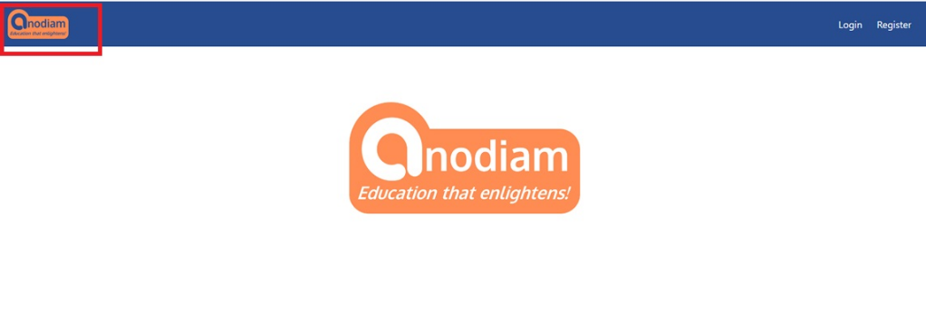

1. While doing registration through mobile, before typing user id, caps lock is selected by default. Caps lock should be off.

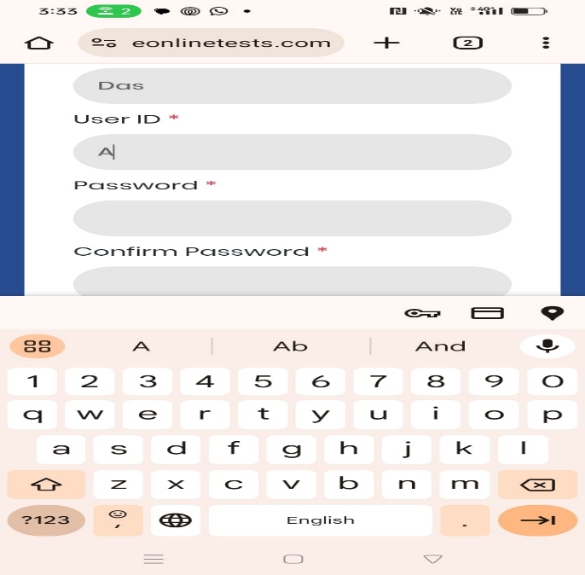

1. Is student information is kept in college door’s system?

We need this information in future.

1. There is no provision for entering the phone number while doing registration.

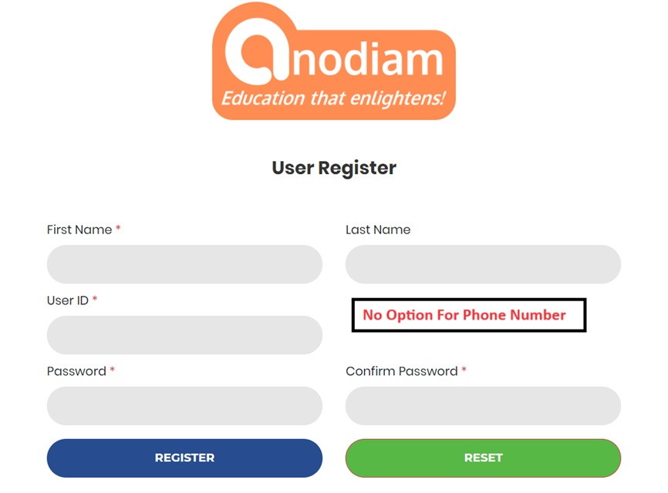

5) Login should happen after successful registration; it should not get logged out.

Again, we need to do login.

6) Successful message after registration is not right.

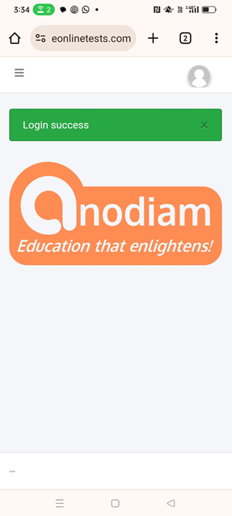

The message is mentioned below in enclosed double quotes.

**“**

Dear [student name],

Thank you for registering!

We conduct monthly mock tests for all popular exams across all classes and disciplines. Test schedules are available at [www.anodiam.com](http://www.anodiam.com).

Call up **9073700094** To enroll for you exam.

Good luck!

**Anirban Chakrabarty**

**C.E.O., Anodiam**

**Email: anirban@anodiam.com**

**Address: N-1/25 Patuli, Kolkata 700094**

**“**

7. Logo doesn’t have to be dynamic.

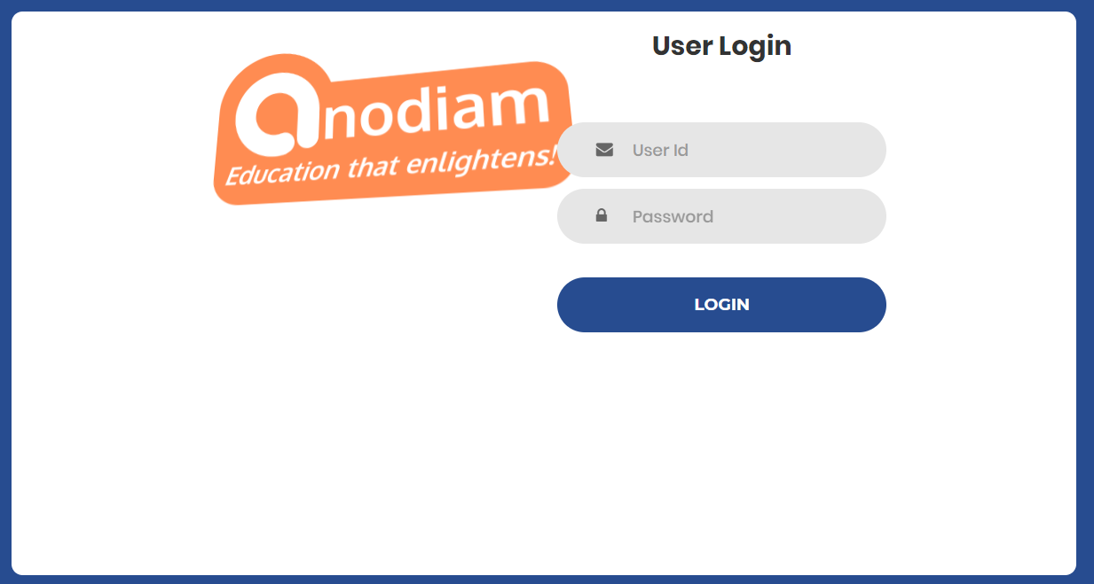

8. Anodiam Logo is overlapping with User Id text box in login page.

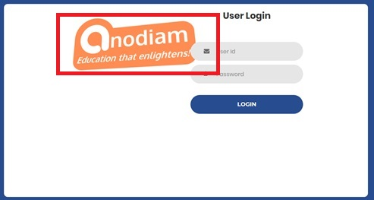

9. There is no option for Forget Password in the login page

Forget password button required

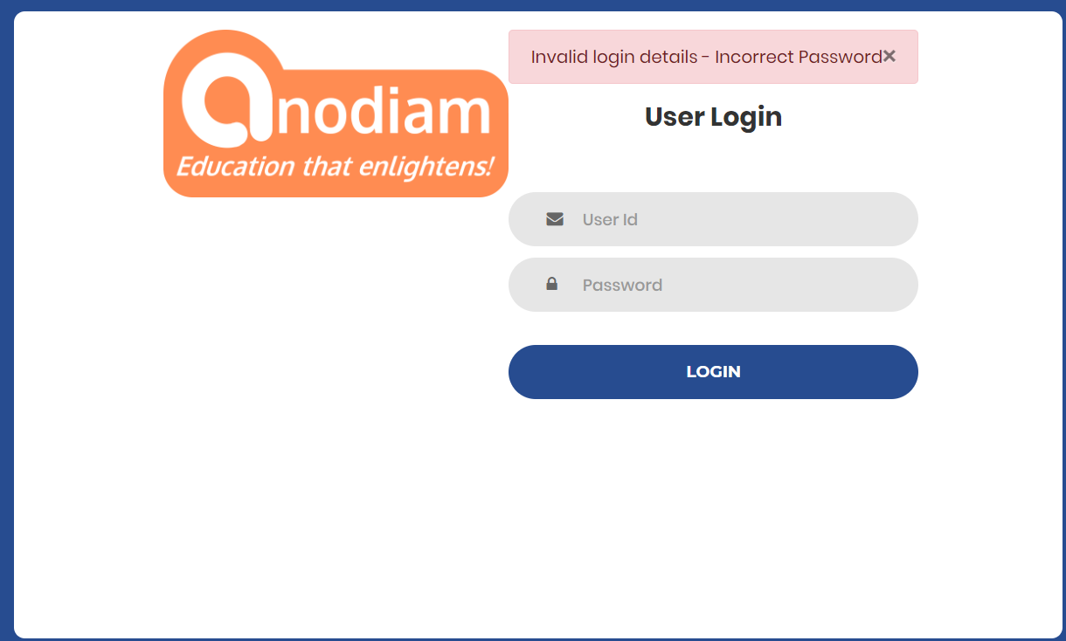

10. If an unregistered user clicks on login button, then the user should get an option for registration in the login page. Otherwise, unregistered user has to hit the back button to go to the landing page.

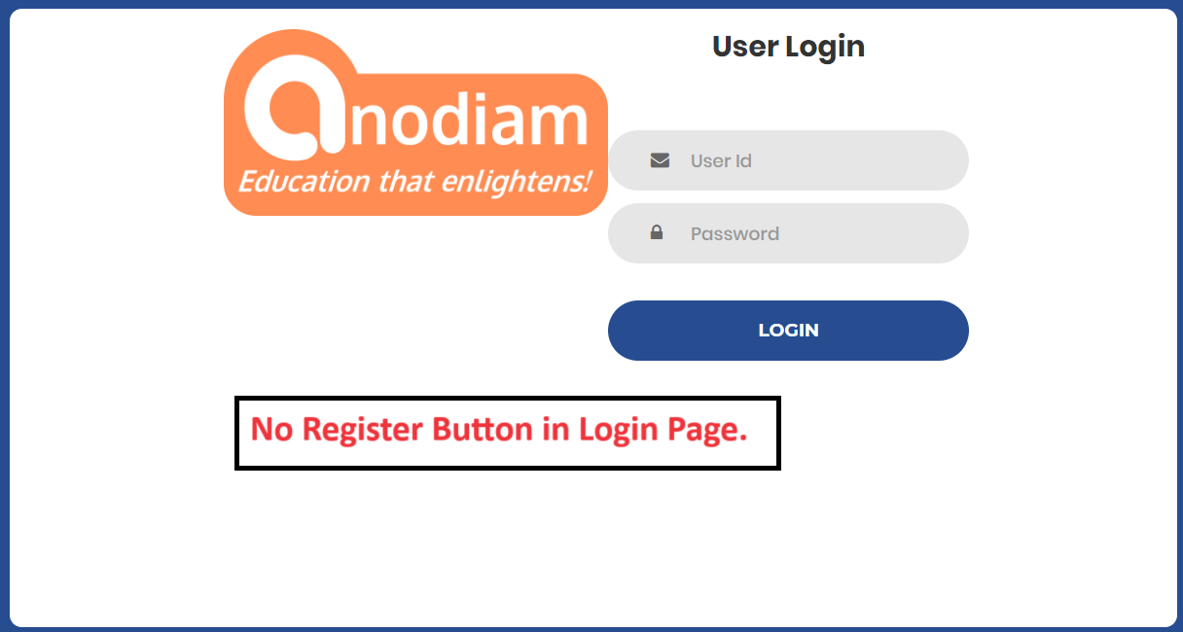

11. While doing registration, password strength should be strong.

The system is allowing user to create password like abc123.

Password strength and complexity required to be displayed

The system has to follow password policy rule.

1. Length of password should be minimum 8.
2. The password should contain at least 1 upper case letter
3. The password should contain at least 1 lower case letter
4. The password should contain at least 1 special case letter
5. The password should contain at least 1 numeric letter

12. When clicking on the fields, green halo effect coming which is not required

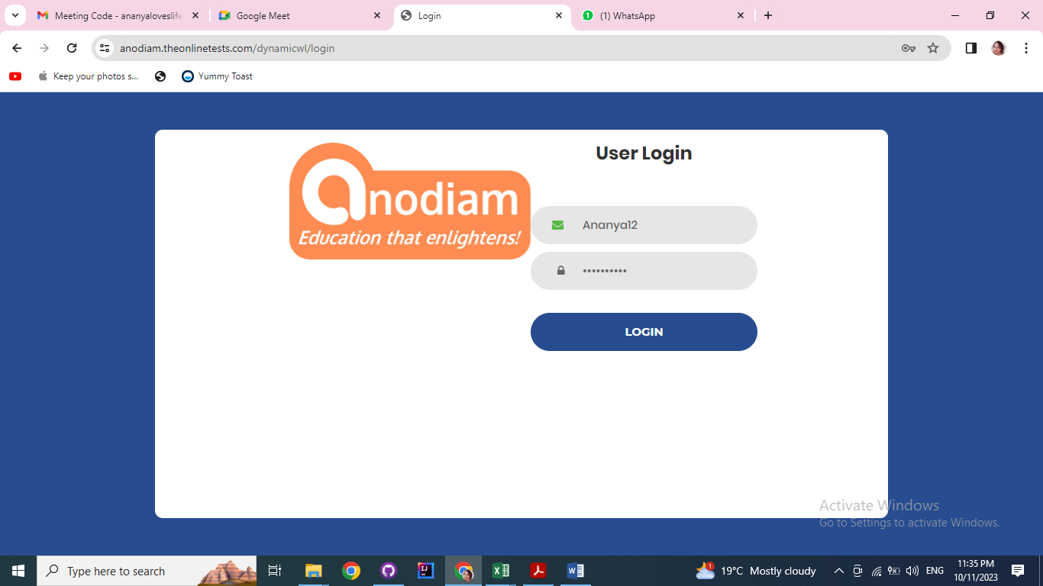

13. In the dashboard page, the image of student is not required and “You need to take off” not necessary



14. We need an admin user. As per our communication admin user credential should be

User id: anodiam

Password: anodiam.

On hitting the login button, system is failed to do login.

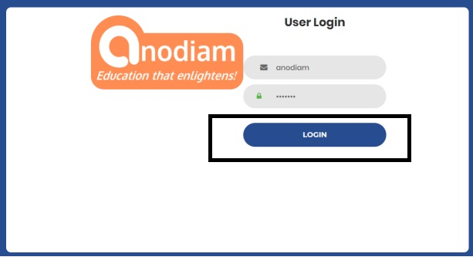

15. What is the function of the subscribe button? If clicked leading to 404 not found

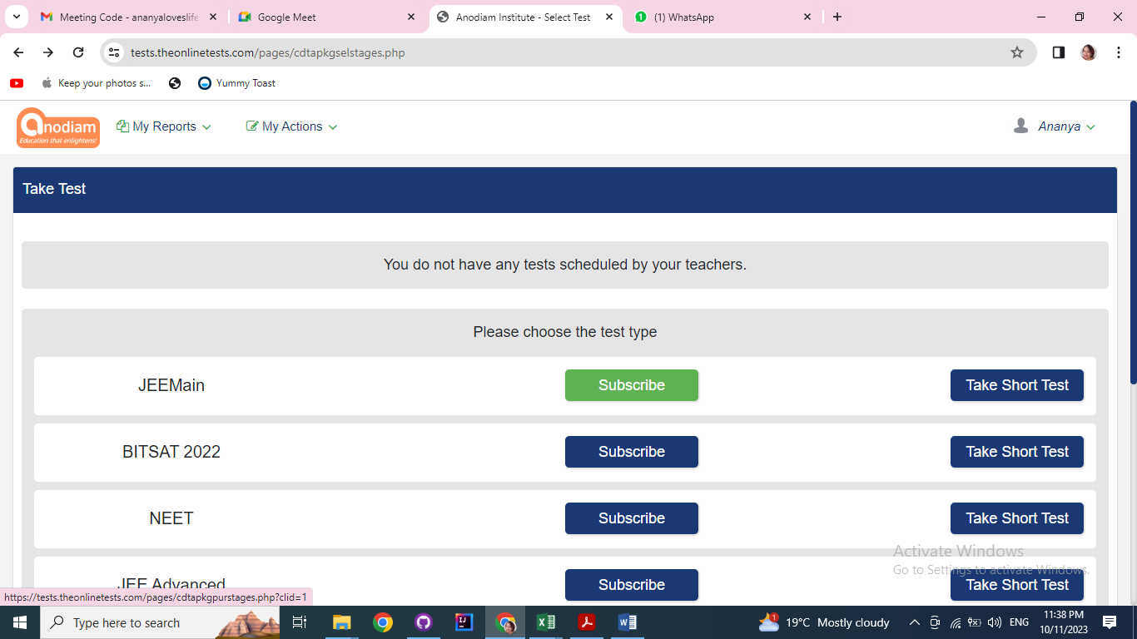

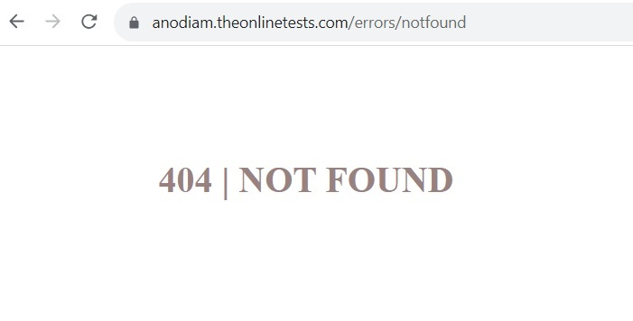

16) If student wants to come out of the test without submitting the paper, what’s the way?

No back button available.

