|  |  |  |  |
| --- | --- | --- | --- |
| SlNo | Contact Name | Phone No | Email |
| 1 | Indrani | 97480 18932 | IndraniT@sulekha.com |
|  |  |  |  |

<https://www.sulekha.com/school-tuitions/kolkata>

https://www.sulekha.com/entrance-exam-coaching/kolkata

**WORK FLOW OF CLASSPLUS**

* **BATCH CREATION IN CLASSPLUS**

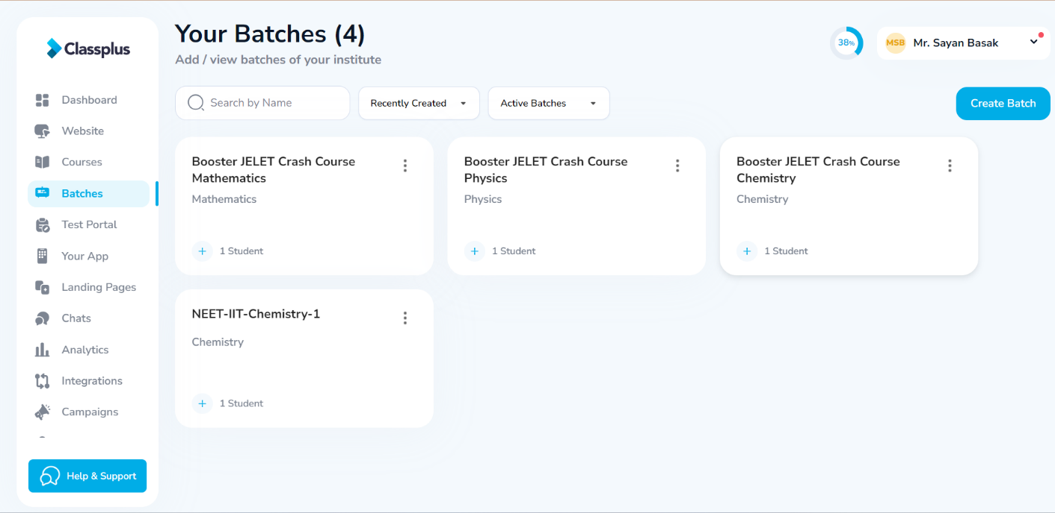

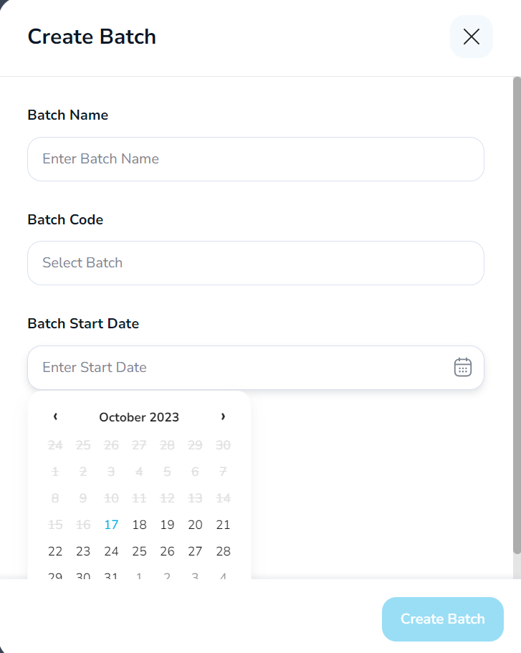

* **DELETING BATCHES**

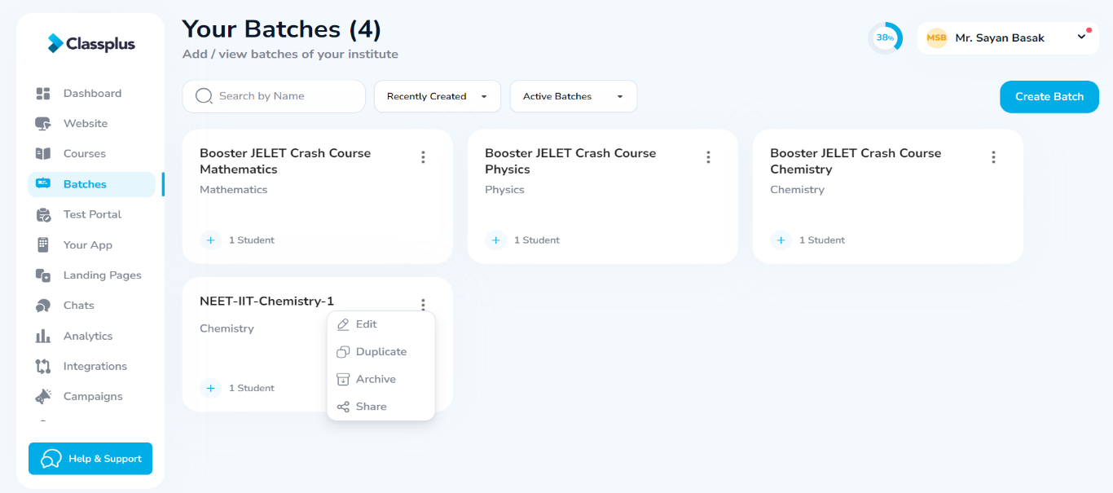

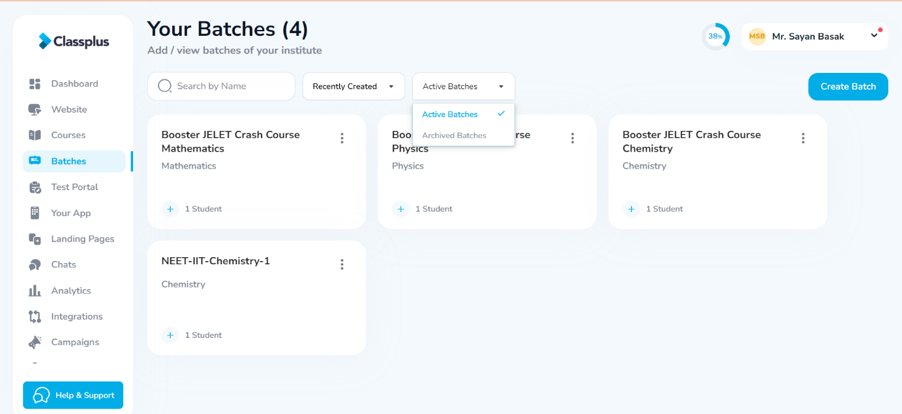

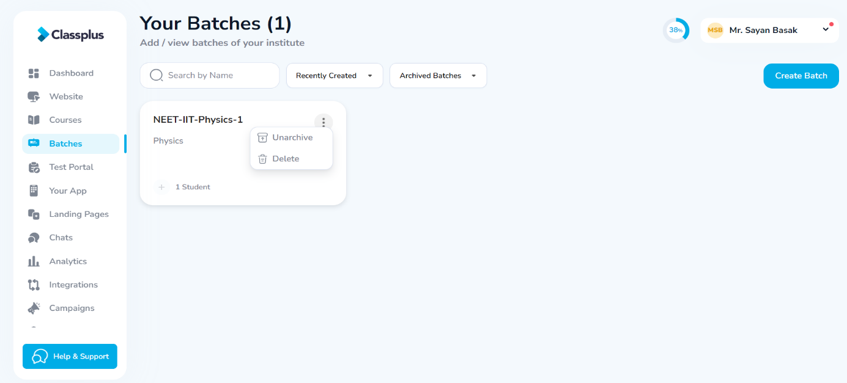

**N.B. – TO RESTORE AN ARCHIVED BATCH, CLICK ON UNARCHIVE**

* **CREATING BATCH CLASSES**

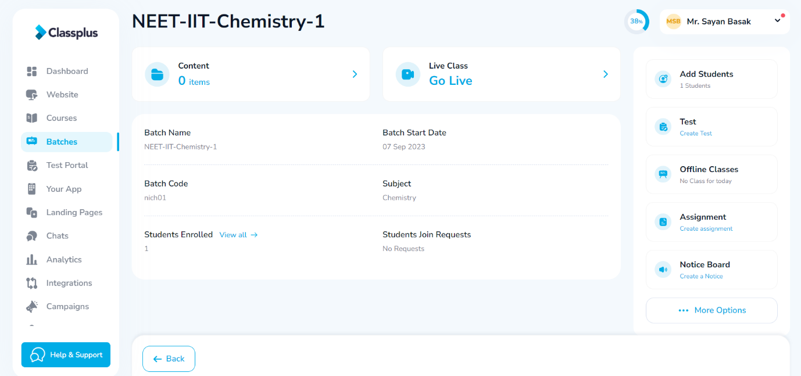

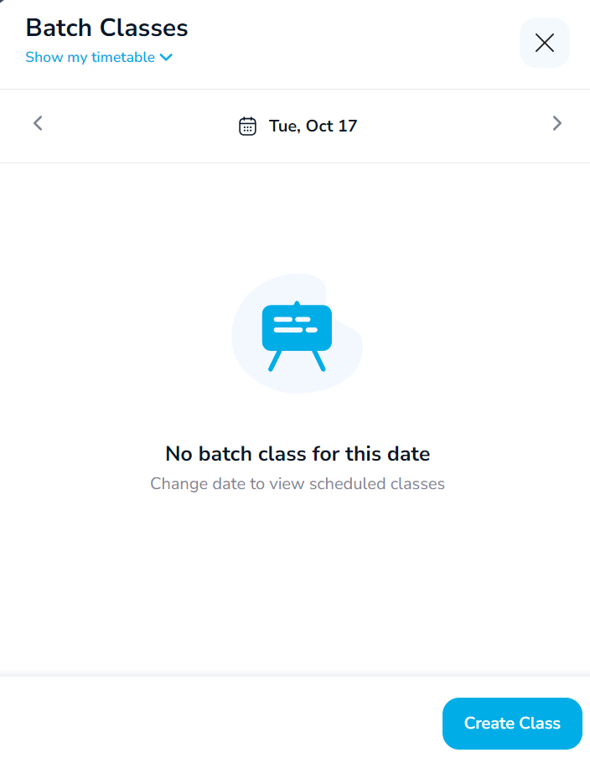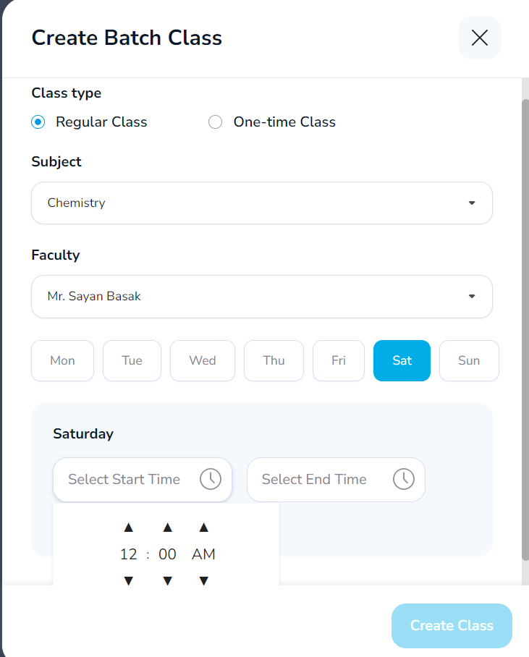

**TOGGLE TO SHOW ORG TIMETABLE TO VIEW SCHEDULED CLASSES.**

* **HOW TO FETCH ATTENDANCE DATA FROM THE CLASSPLUS APP**

