

# Force of Friction

**Friction**

* Friction is the force which develops at the surfaces of contact of two bodies and opposes their relative motion.

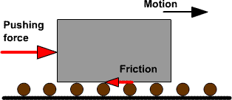

* It always acts in the direction opposite to the applied force.

# Factors Affecting Friction

* The factors which affect friction are
  1. The nature of the two surfaces in contact.
  2. The force with which the two surfaces are pressed together.
* A rough surface produces greater friction as compared to a smooth surface.
* It is caused by irregularities on the surfaces of the objects in contact.

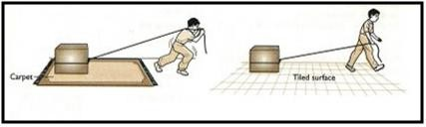

* We are more likely to slip while walking on a wet floor, because the wet floor is slippery and produces less friction.
* The force of friction increases if the surfaces are pressed harder.

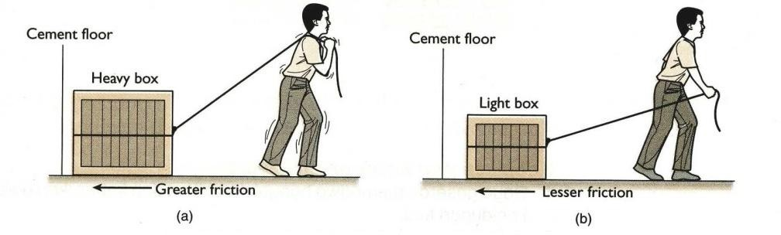

o A heavier object exerts a greater frictional force as it presses the floor harder.

# Types of Friction

* There are three types of friction:

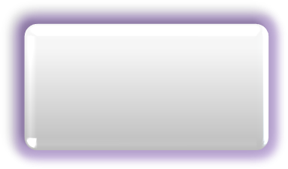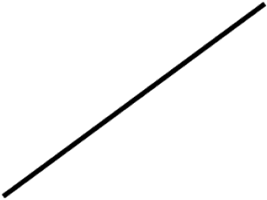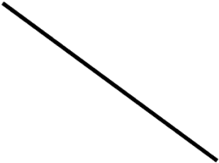

**Static**

(Pushing a wall)

**Friction**

**Sliding**

(Slipping on a wet floor)

**Rolling**

(Riding a bicycle)

## Static Friction

* The force required to overcome friction at the instant an object starts moving from rest is the measure of static friction.

## Sliding Friction

* The force required to keep an object moving with the same speed is the measure of sliding friction.
* Sliding friction is always lesser than static friction.

## Rolling Friction

* The frictional force which comes into action when an object rolls over a surface is called rolling friction.
* This force slows down the motion of a rolling object.

# Friction: A Necessary Evil

* Friction is a necessary evil. There are instances in daily life where friction is a necessity.
* Without friction, we cannot hold objects in our hands, we cannot walk and we cannot light a matchstick.
* Friction has both advantages and disadvantages.

## Advantages of Friction

* Construction of buildings is possible only because of friction.
* We are able to write because of the friction between the paper and the tip of a pen.
* Without friction between our shoes and the ground, we will not be able to walk.
* We can also change the direction of a car because of friction.

## Disadvantages of Friction

* Friction produces heat in the moving parts of machines which causes wear and tear of the parts.
* A lot of energy is wasted in overcoming friction.
* It causes the wear and tear of the soles of the shoes.
* It also causes the damage of various parts of machines and equipment.

## Increase and Decrease in Friction

* Ways to increase friction:
* Providing grooves to shoes and grips to balls

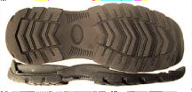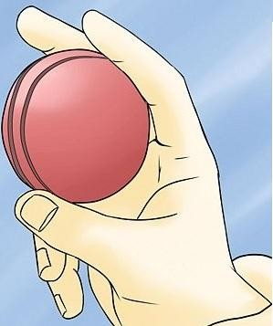

* Treading tyres of vehicles

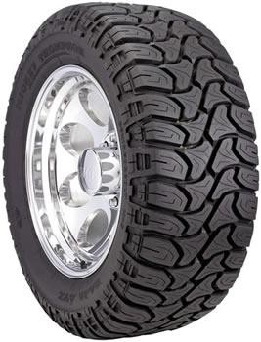

* Threading screws

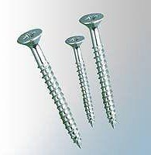

* Using brake pads in the brake system of bicycles and automobiles

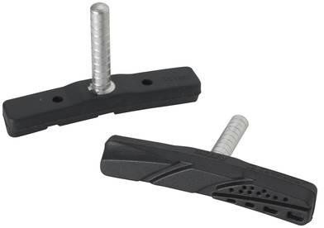

* Ways to decrease friction:
* By lubricants (i.e. grease, oil and graphite)

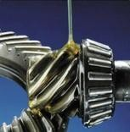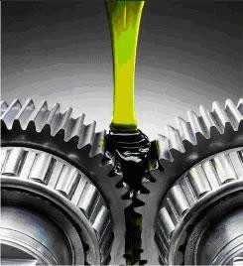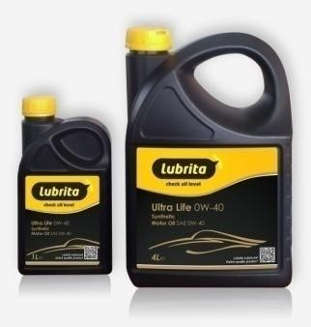

* By polishing surfaces
  + Example: Sprinkling powder on a carom board to make it smooth

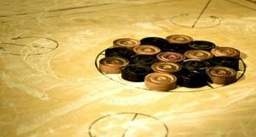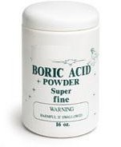

* By using wheels
  + Example: Using ball bearings or roller wheels in luggage

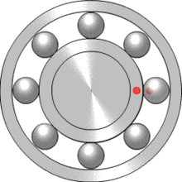

# Fluid Friction

* Liquids and gases are together known as fluids.
* Substances which are able to flow easily are called fluids.
* The frictional force exerted by fluids is known as drag.
* The frictional force on an object moving through a fluid depends on its speed with respect to the fluid.
* When objects move through a fluid, the friction
* Reduces the speed of the object
* Leads to losing some of the energy possessed by the object in overcoming it
* Fluid friction is reduced by designing streamlined shapes.
* An aeroplane has a streamlined shape in order to reduce air drag.
* Speed boats are provided with streamlined shapes in order to reduce water drag.