

**Sound**

* Sound is a form of energy which produces the sensation of hearing in our ears.

# Production of Sound

## Sound Produced by a Vibrating Body

* The rapid to-and-fro or back-and-forth motion of an object is called vibration.
* A vibrating object produces sound.
* To produce pleasant sounds, several musical instruments have been developed.



* Some instruments produce sound due to the vibration of membranes, some due to the vibration of strings and some produce sound due to the vibration of an air column.
* The sitar, violin, guitar and ektara are stringed instruments. The tabla, manjira (cymbals), ghatam and kartal work on the vibration of a membrane. Instruments such as the flute and trumpet produce sound due to the vibration of an air column.

## Sound Produced by Humans

* In humans, the sound is produced by the voice box or the larynx.

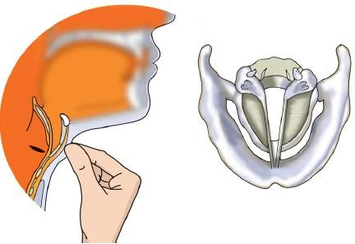

* The voice box is at the upper end of the windpipe.
* When we speak, the two vocal cords in the larynx vibrate and produce sound.
* These vocal cords are stretched across the voice box or larynx so that there is a narrow slit between them for the passage of air.
* The vocal cords are about 20 mm long in men, 15 mm long in women (5 mm shorter) and they are very short in children.

# Propagation of Sound

* Sound needs a material medium to travel.
* It cannot travel through vacuum. Example:
  + An electric bell suspended inside an airtight glass bell jar is connected to a vacuum pump.

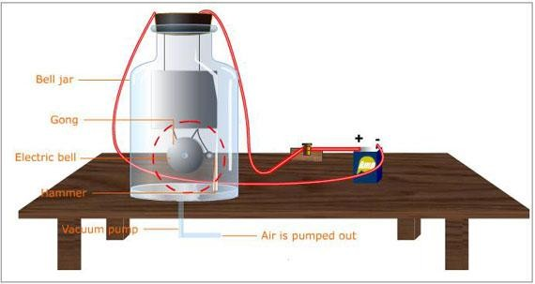

* + As the electric bell circuit is completed, the sound is heard.
  + If the air is slowly removed from the bell jar by using a vacuum pump, then the intensity of sound goes on decreasing and no sound is heard when all the air is removed.
* Sound travels through solids, liquids and gases.
* The speed of sound is the maximum in solids, less in liquids and the least in gases.

# Human Ear

* We hear sound with our ears.
* The shape of the outer part of the ear is like a funnel.
* When sound enters the ear, it travels down a canal which has a thin stretched membrane at its end. It is called the eardrum.

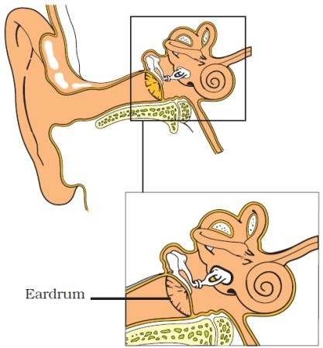

* The ear drum sends the vibrations to the inner ear and the signals are then carried to the brain.

# Characteristics of Sound

* The to-and-fro motion of a vibrating object is called oscillatory motion.
* The number of oscillations per second is called the frequency of oscillation. It is expressed in hertz (Hz).
* The time taken by the vibrating particle for one full vibration or oscillation is called the time period of oscillation.
* The properties by which sounds can be differentiated are amplitude and frequency.
* The various characteristics of sound are loudness, pitch or shrillness and quality or timbre.

## Loudness

* The loudness of sound is proportional to the square of the amplitude.
* Larger the amplitude of sound, more is its loudness. Example: The roar of a lion is more than that of a person.
* The loudness of sound is measured in decibel (dB).
* If loudness exceeds 80 dB, then the sound becomes physically painful.

## Pitch

* The pitch or shrillness of sound depends on its frequency.
* If the frequency is more, then the pitch or shrillness is more. Example:

A whistle has a high frequency, so it produces a sound of a higher pitch.



* If the frequency is low, then the pitch or shrillness is less. Example:

A drum vibrates with a low frequency, so it produces a low-pitched sound.

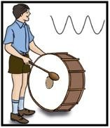

# Audible and Inaudible Sound

* Not all sound produced by vibrating bodies is audible.
* The human ear can only recognise sounds of frequencies between 20 Hz and 20,000 Hz, and this range of frequency is called audible sound frequencies.
* Sound of frequencies outside this range is called inaudible sound.
* Some animals such as dogs and snakes can hear sounds of frequencies greater than 20,000 Hz.
* Sounds of frequencies less than 20 Hz are called infrasonic sounds, while sounds of frequencies greater than 20,000 Hz are called ultrasonic sounds.

# Noise and Music

* Any unpleasant, intolerable and irritating sound is called noise.
* Music refers to any sound which is pleasant to the ear.
* Sound produced by musical instruments is pleasing to the ear. However, if the intensity of the sound exceeds a certain limit, then it becomes intolerable and is noise.



# Noise Pollution

* The presence of excessive or unwanted sounds in the environment is called noise pollution.
* Noise pollution may cause high blood pressure, panic attacks and lack of sleep in those exposed.
* Continuous exposure to loud noise may cause temporary or permanent hearing impairment.
* To reduce noise pollution, trees should be planted along roads and in residential areas. Factories should not be set up in residential areas. Vehicles should not blow horns around schools, hospitals and residential areas. TVs and music systems should not be played at a high volume.