**Some Natural Phenomena**

* Natural phenomena which cause damage to human life and property can be harmful and destructive.
* Some natural disasters or calamities are storms, cyclones, earthquakes, lightning and landslides.

# Lightning

* Lightning is caused by accumulation of charges in the clouds.

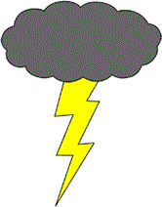

* In 1752, Benjamin Franklin, an American scientist, showed lightning as static charge which is the same as the electric sparks produced with crackling sound while taking off woollen or polyester clothes, especially in the dark.

## Occurrence of Lightning

* The formation of clouds involves friction between the water particles in the atmosphere.
* This friction charges the particles.
* There are two types of charges:
  + Positive charge
  + Negative charge
* The negative charge accumulates at the bottom of the cloud, and the positive charge at its top.
* As the accumulation of the charge increases, the cloud will create a positive charge on the ground.
* This creation of charges tends to make a path towards the ground which results in a narrow streak of electrical discharge which is called lightning.

# Types of Changes and their Interaction

* Like charges repel and unlike charges attract each other.



### Like charges repel



**Unlike charges attract**

* An electroscope detects the type of charge on a body.

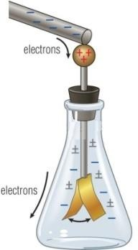

* + It consists of a glass jar fitted with a cork lid and a metallic wire passing through it.
  + There are two metallic strips at the bottom of the wire.
  + The upper end of the wire is connected to a metal disc.
  + A positively charged object is touched to the metal disc, so that the charge is transferred to the metal strips through the wire and they diverge from each other on gaining a like charge.
  + A negatively charged object is brought into contact with the disc so that the strips converge towards each other, indicating the unlike charge on the body.
  + If the metal disc of the electroscope is touched with the hand, then it loses its charge to the ground by transfer of charge through the human body. This is called earthing.

# Lightning Safety

* Lightning is caused by the heavy electric discharge from the clouds to the Earth.
* If lightning is not controlled, it can cause heavy damage to life and property.
* Buildings are safe places to protect ourselves from lightning strikes, so we must take shelter in buildings and not stay in open areas.
* We must not take shelter under trees or go to an open area if we are outside.
* If we are in a vehicle, then we should not come out of it. The doors and windows of the vehicle should also be closed.
* Tall buildings are provided with a lightning conductor which is a metal rod that is erected at the top of a building.

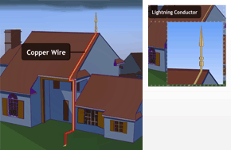

# Earthquakes

* An earthquake is a natural phenomenon which cannot be predicted. It is a sudden shaking or trembling of the Earth which lasts for a short time.
* It can cause large-scale damage to human life and property.
* It can cause floods, landslides and tsunamis.
* A major tsunami occurred in the Indian Ocean on 26 December 2004.

## Cause of Earthquakes

* Tremors are caused by a disturbance in the uppermost layer of the Earth called the crust.
* The Earth consists of three major layers—core, mantle and crust.

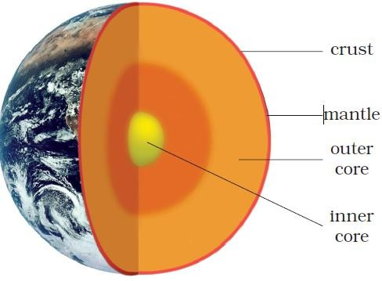

* The core is divided into the inner core and the outer core.
* The mantle consists of a semi-solid material above which the crust floats.
* The crust consists of oceans and continents and it is fragmented.
* Each fragment is called a plate, and these plates are in continuous motion.
* When these plates brush against each other or collide, they cause disturbance in the Earth’s crust.

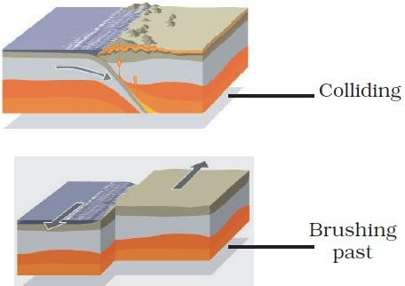

* The region where one plate slides against the other is referred to as a fault zone. This is where an earthquake occurs. Hence, such zones are referred to as seismic zones.
* The place in the interior of the Earth where an earthquake occurs is called the focus, and the region on the surface of the Earth which is the closest to the focus is called the epicentre of the earthquake.
* The instrument which measures the severity of an earthquake is called a seismograph.
* The severity of an earthquake is measured on the Richter scale.
* A major earthquake measures 7 or more on the Richter scale.
* A major earthquake occurred on 8 October 2005 in Uri and Tangdhar towns of North Kashmir and on 26 January 2001 in Bhuj District of Gujarat.

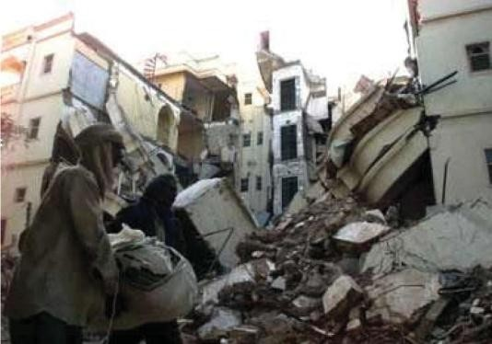

## Protection against Earthquakes

* We should take necessary precautions to protect ourselves from earthquakes.

### If you are at home:

* Take shelter under a table and stay there till the shaking stops.
* Stay away from tall and heavy objects which may fall on you.
* If you are in bed, then do not get up but protect your head with a pillow.

### If you are outdoors:

* Find a clear place away from buildings, trees and overhead power lines.
* If you are in a car or a bus, do not come out till the tremors stop and ask the driver to drive slowly to a clear spot.