# Force

**Force and Pressure**

* Force is a push or a pull on an object.
* It changes or tends to change the state of rest or the state of motion of an object by a push or pull.
* It cannot be seen, but its effect can be seen or felt.
* It is caused by an interaction. An interaction of one object with another object produces a force between the two objects.

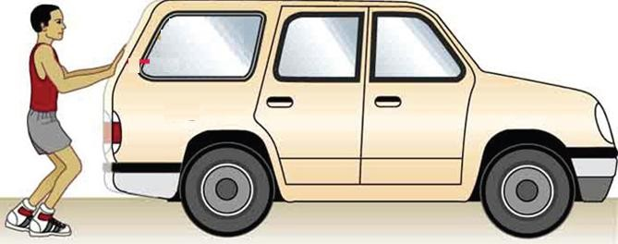

* The forces acting on an object in the same direction add to each other.
* If the forces acting on an object are in opposite directions, then the net force acting on it is the difference between the two forces.
* The strength of force is called its magnitude.
* The SI unit of force is Newton.

## Effects of Force

A force can change the state of motion of an object.

* A force can change the speed as well as direction of an object.
* If the force is applied in the direction of the motion, then the speed of the object increases.
* If the force is applied opposite to the direction of the motion, then the speed of the object decreases.

A force can change the shape

and size of the object.

* A force can change the shape of an

object.

* It can change the size of an object.
* It can change both the shape and the size of an object.

# Types of Forces

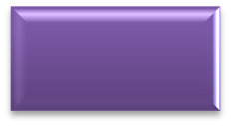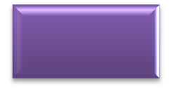

**Forces**

**Contact**

**forces**

**Non-contact forces**

Muscular force

Friction

Magnetic

force

Electrostatic force

Gravitational force

## Contact Forces

* + A force which can cause or change the motion of an object by physical touching is called a contact force.

### Types of Contact Forces

#### Muscular Force

* + The force caused by the action of muscles is called muscular force.
  + Activities such as bending, movement, breathing and digestion of food involve muscular force.
  + The point where the force is applied on an object is called the point of contact.

#### Friction

* + The force responsible for changing the state of motion of an object is called friction.
  + It always acts on all moving objects in the direction opposite to that of motion.
  + It arises due to the contact between surfaces. If these surfaces are rough, then there is more friction.

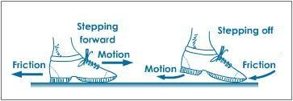

* + To reduce friction, the surfaces in contact are kept smooth and polished.

## Non-contact Forces

* + These forces act at a distance without any physical contact.

### Types of Non-contact Forces

#### Magnetic Force

* + The force exerted by a magnet is known as magnetic force.
  + There is attraction or repulsion between the poles of magnets.
  + Like poles of two magnets repel each other and unlike poles attract each other.

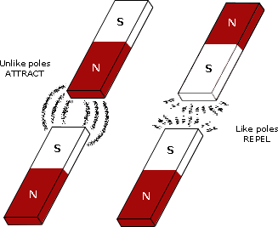

* + A magnet can exert a force on another magnet without being in contact with it. Hence, it is known as a non-contact force.

#### Electrostatic Force

* + The force exerted by a charged body on another charged or uncharged body is known as electrostatic force.
  + It enables the charged substances to attract neutral substances.
  + Example: Small pieces of paper attracted to a balloon
  + Substances with unlike charges attract each other, and those with like charges repel each other.

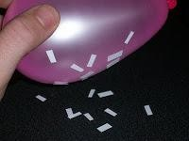

#### Gravitational Force

* + The attraction of objects towards the Earth is known as force of gravity or gravity.
  + This force acts on all objects in the Universe.
  + Every object in the Universe, whether small or large, exerts a force on every other object.

# Pressure

* + Pressure is the force per unit area applied in a direction perpendicular to the surface of an object.
  + It is given as

Pressure  Force

Area

* + It is also defined as the thrust acting per unit area.
    - Example: A force applied perpendicular to the board.

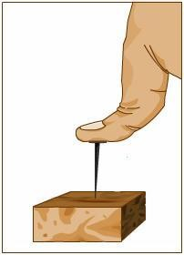

* + For pressure, we have
    - Pressure is directly proportional to the thrust or force, i.e. the more the thrust, more will be the pressure.
    - Pressure is inversely proportional to the area on which the force (thrust) is applied, i.e. lesser the area of contact, more is the pressure.
    - Examples:
      * Heavy trucks have six to eight tyres instead of the conventional four in order to increase the area of contact between the tyres and the road. Thus, the pressure on the ground is reduced.
      * Camels can walk easily in the desert as compared to the other animals because they have broader feet which exert less pressure on the sandy ground enabling them to walk properly.
      * Skiers use long flat skies to slide over the snow. The larger the area of contact, the lesser is the pressure on the snow. This helps the skier to slide comfortably without sinking in the snow.
  + The unit of pressure is Newton/metre2 (N/m2 or Nm−2), which is equal to 1 Pascal (Pa).
  + Liquids and gases exert pressure on the walls of the vessel.
  + Air exerts pressure on all objects, and it is called the atmospheric pressure.

# Pressure Exerted by Liquids and Gases

* + A liquid exerts pressure on the base of the container (vessel) because of its weight.
  + If the molecules of a liquid are in motion, then they strike (collide) with the walls of the container. In every collision, these molecules exert a thrust on the walls of the container.
  + Gases also exert pressure on the walls of the container.
    - Example: Air filled in a balloon exerts pressure on the inner wall of the balloon.

## Characteristics of Liquid Pressure

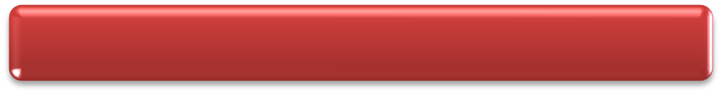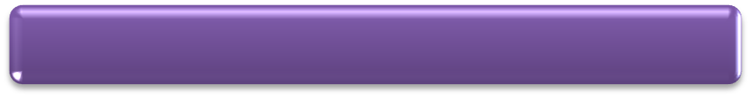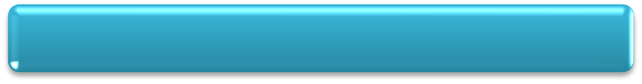

It increases with depth.

It remains the same in all directions at a given depth.

It depends on the density of the liquid.

A liquid exerts pressure on the sides of the container.

A liquid seeks its own level.

**Atmospheric Pressure**

* + The Earth is surrounded by a layer of air up to a certain height, and this layer of air is called the atmosphere.
  + As we gradually move up, the density of the layer of air decreases. At a particular height, it reduces to zero.
  + Air has mass, so it exerts force on the Earth’s surface and on the different objects. This force acting on a unit area is called atmospheric pressure.
  + Atmospheric pressure is the weight of air in a column of unit area.
  + Atmospheric pressure decreases as we go up in the atmosphere.
  + Its SI unit is pascal (Pa).
  + The pressure inside our body is equal to the atmospheric pressure outside. So, we are not crushed because of this air pressure.