

**UAT-Defect Images: Business Site**

|  |  |  |  |
| --- | --- | --- | --- |
| **Created By** | Sayan Basak | **Date** | 1-Feb-24 |
| **Reviewed by** | Anirban Chakrabarty | **Date** | 2-Feb-24 |
| **Approved By** | Debasish Nath | **Date** | 3-Feb-24 |

# Page Header

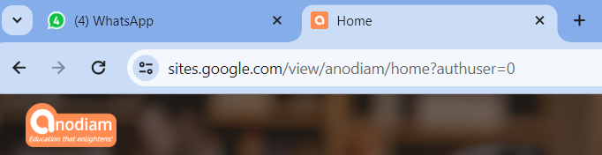

Image-1



Image-2



Image-3



Image-4

Image-5

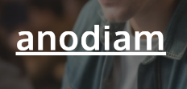

On the home page, the word **anodiam** should be removed.We will give you a new background image.

**N.B. – The replacement image will be mailed**

1. Provide a login button on the header menu bar which should lead to the following url:

<https://www.anodiam.com/login>

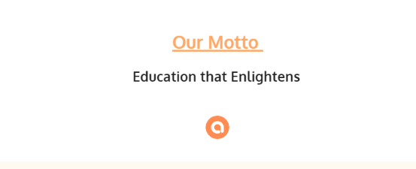

Delete the above section as it is not required.

1. Remove the above logo which is marked inside red square
2. **USE THIS SAME FONT STYLE (Font should be Oxygen) FOR WRITING ALL PAGE HEADERS, NO UNDERLINES, NO BOLD.**



1. The tooltip text is moving up and down while scrolling for all buttons. We have no need for tooltip, remove them.

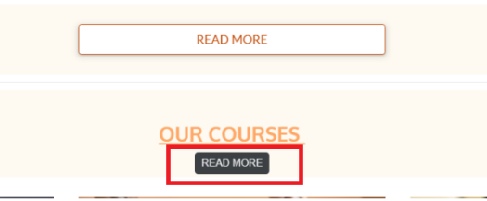

1. We do not need this part on home page, remove it.

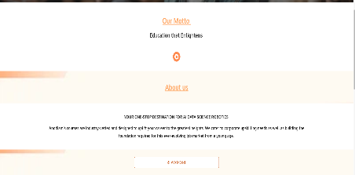

1. We need to transform the courses to clickable cards. Which should lead to:

<https://www.anodiam.com/login>

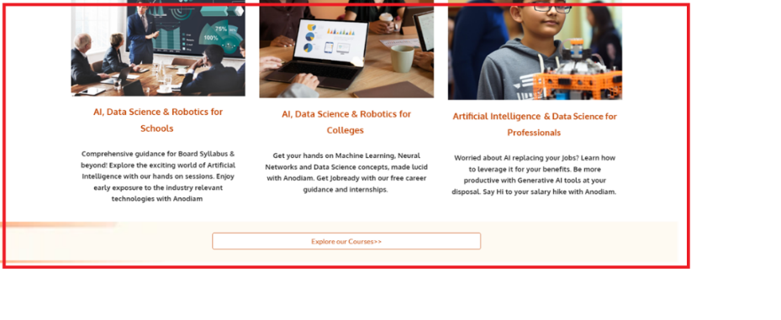

1. **We need to reconsider this and finalize the contents.**
2. **About Us**

Whole page should be removed

1. **Courses**
2. New background image and other images are mailed.



1. Remove the underline from **Courses.** Do not bold it out. Font should be oxygen.
2. Make the para spacing uniform (Write the course name heading like : “**AI & Data Science**

**For Professionals**”

If necessary**)**



1. All the courses are to be turned into **CARDS.**
2. All course images are to be changed.
3. Delete numberings 1,2,3…

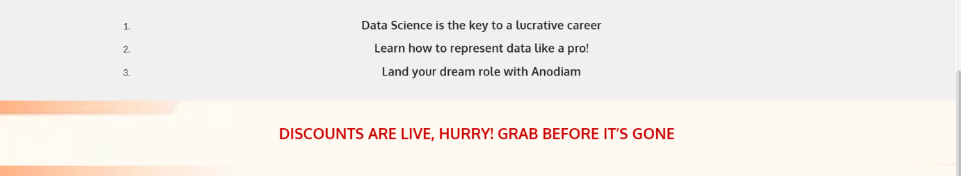

1. Delete the part (“Discounts are live….”) marked in red rectangle.
2. **Gallery**
3. Page name should be changed to **Free Materials**
4. Background image will be different and new images are attached.
5. Youtube video links will be there in form of video thumbnails.
6. **Contact Us**
7. **Contact Us.** Not in bold case, same font (Oxygen)

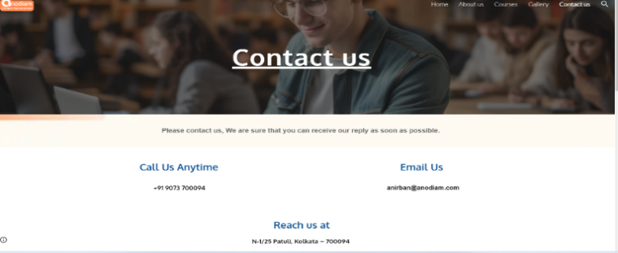

1. Call Us Anytime, Email Us, Reach Us at sections are to be removed.
2. Only this part to be kept. Visit Us should be changed to **Locate Us.**

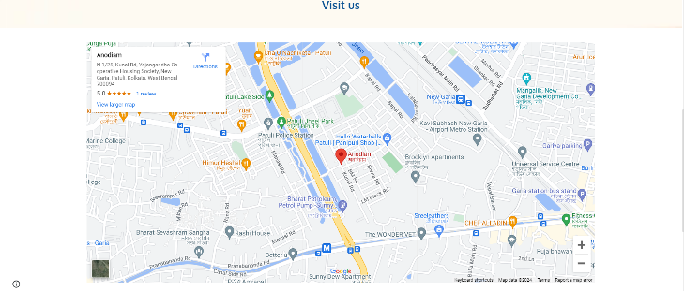

1. **Footer**

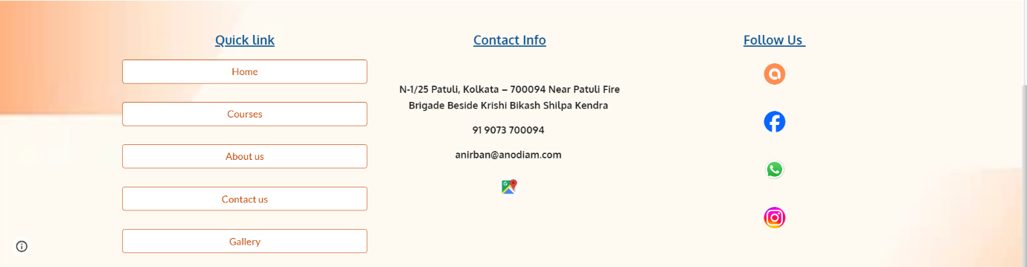

1. Delete the quick link part which is marked in red square as it is not required.
2. Give icons for address, mobile no. and email ID. Also turn them into hyperlinks so that clicking on them leads to the respective stuff.
3. Replace our app icon with playstore’s icon.
4. Find a better theme color and design for the footer.
5. Only two columns. Contacts & Follow Us. Youtube Icon to be included.
6. Whatsapp icon looks smaller than the rest. Keep all of them uniformly sized.
7. No need for the map icon at bottom marked in red square.
8. Adress should be: **N-1/25 Patuli, Kolkata - 700094**