Q1) What is AMC (Annual Maintenance Cost) of this product after 30 months? 🡪 Rs 10,000.

1% above Rs 10 Lakhs

Q2) Explain all the cost models in detail.

1. App cost (Rs 19,000)
2. Platform fee
3. For batch upload no charge

For store upload there is charge of 4.9%.

In the internet

Q3) Is the service included in cost of the product? 🡪 30 Months

Q4) What are your NFR (Non-Functional Requirement)? 🡪 Technical Team Question

1. Security
2. Scalability/Load Test report
3. Penetration test and Authentication/DLP (Data Loss Prevention)/SSL

You need to give us the reports and specifications.

Q5) You need to notify us before you change anything in product.

What is the guarantee of feature stability, against breaking changes?

Q7) Will they expose any rest API for Anodiam specific data extraction and how they are secured? 🡪 Technical Team Question

Q8) What is Service Level Agreement (SLA)?

Suppose if the software is down what will you do?

If scalability fails or security gets breached

If you cannot resolve any issue in stipulated time then what will be penalty?

🡪Just a call or message at WhatsApp on contact person.

Q9) Physical address of organization

Q10) If you close your organization after 5 years then will you give source code or not?

How will you phase out of the business?

Q11) Will you people able to see the data as our data will be sensitive?

Data Encryption at rest and in flight. 🡪 Technical Team Question

Q12) Will you share your backlog of your future product space with us? 🡪 Yes (1 Week)

1. Link the chat bot
2. For batch upload no charge

For store upload there is charge of 4.9%

1. Down time 10 minutes
2. Tencent Cloud 🡪 server
3. HMS

Kindly transfer the amount and share the screenshot of the transaction ID

\*Payment Modes

1. Razorpay(For Debit/Credit Card Payment) : https://rzp.io/l/classpluspay

2. Paytm: 7290085269

3. HDFC Bank account (For IMPS/NEFT)

Beneficiary Name: BUNCH MICROTECHNOLOGIES PVT LTD

Account Number: 50200058786322

IFSC code: HDFC0000088

4. UPI ID: 036596b@citi (Phone Pe/Gpay)

5. PhonePay/Gpay Number: 7400076000

Client Name:

Institute Name:

Address:

Premium (main) phone number:

Inquiry phone number:

Email id:

App Name:

App Logo:

Experience (In years)

Social Media Platform Link

1. Why is Multiple Validity option not showing in Course Validity dropdown?

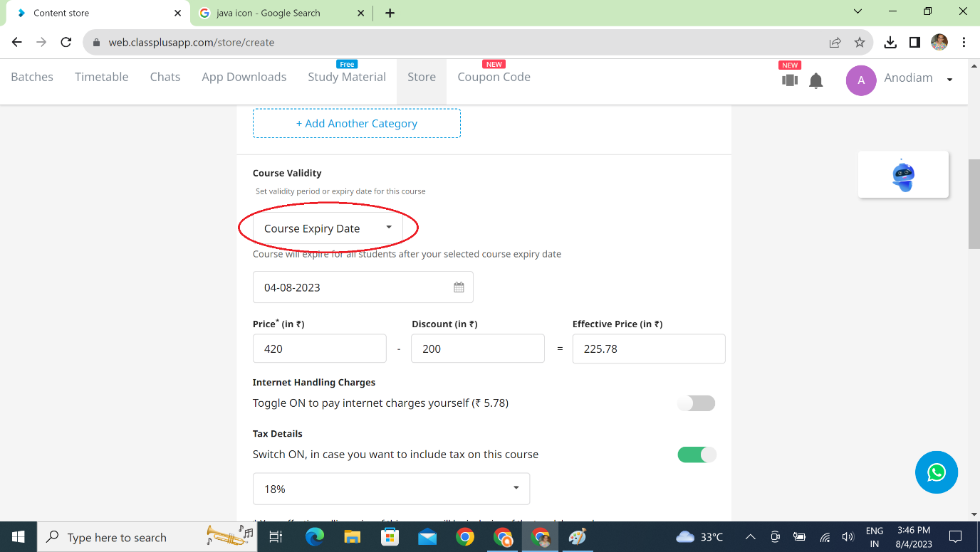

1. How come is Internet Handling charge showing 5.78% instead of 2.63% as promised by sales people and also shown in the video?

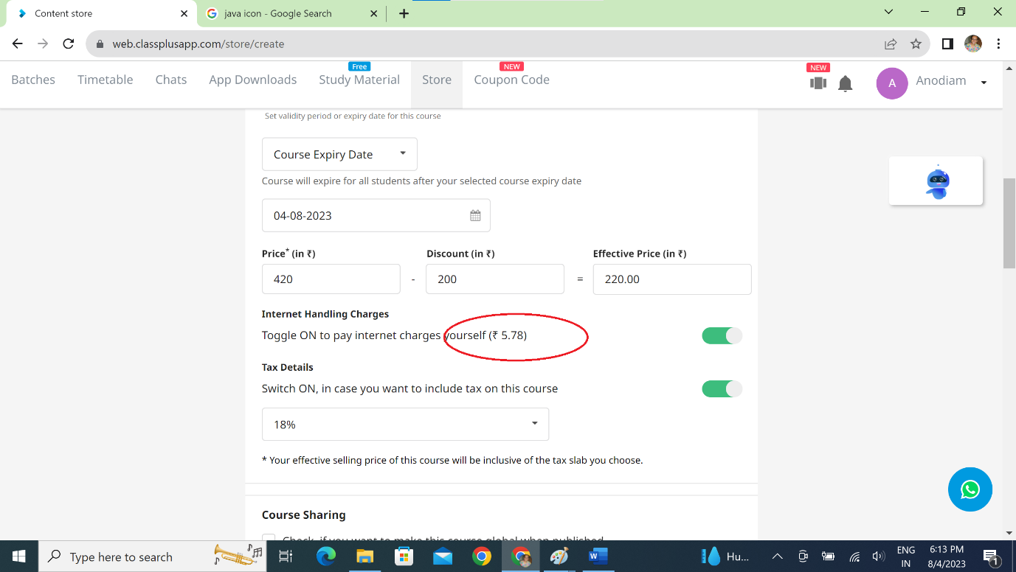

1. Auto Send Certificates – Is the date calculated from completion of the course r just from the purchase of the course? In the later case the certificate will have no academic value altogether.

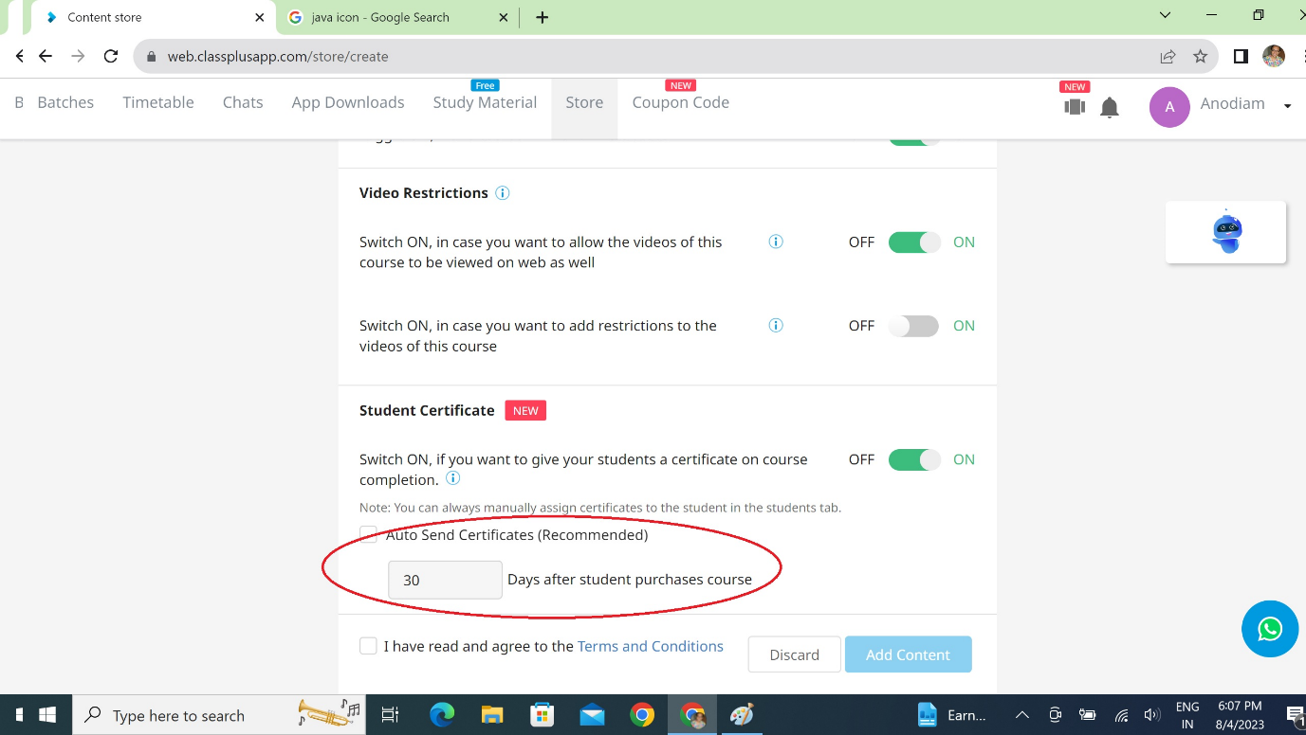

1. Overview section of a course is not pulling up. Showing blank page. This bug is a show-stopper. Please resolve.

