1. Left corner LOGO doesn’t have any function but appears to be a hyperlink. Need to change the colour scheme.  
   **Reply: This is done.**

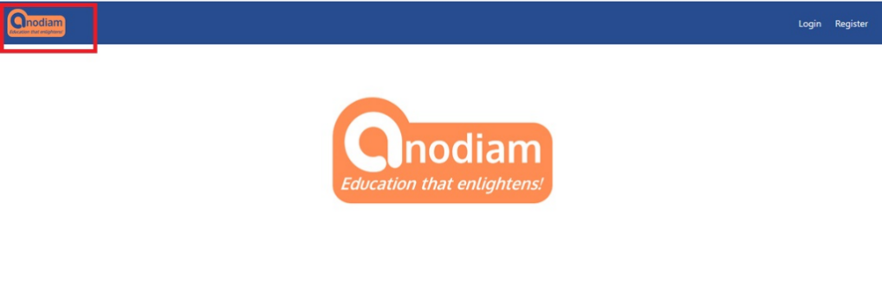

1. While doing registration through mobile, before typing user id, caps lock is selected by default. Caps lock should be off. **Reply: This is hardware setting and can’t be controlled from our side.**

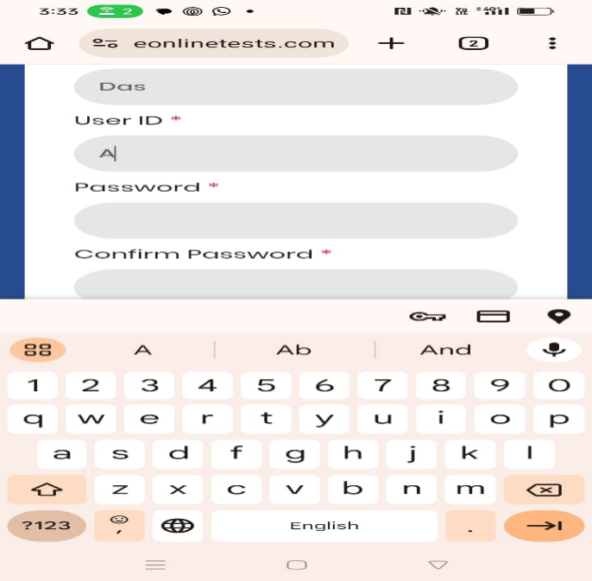

1. Is student information is kept in college door’s system?

**Reply:** **This information is stored on Admin ID.**

1. There is no provision for entering the phone number while doing registration.   
   **Reply: This is done.**

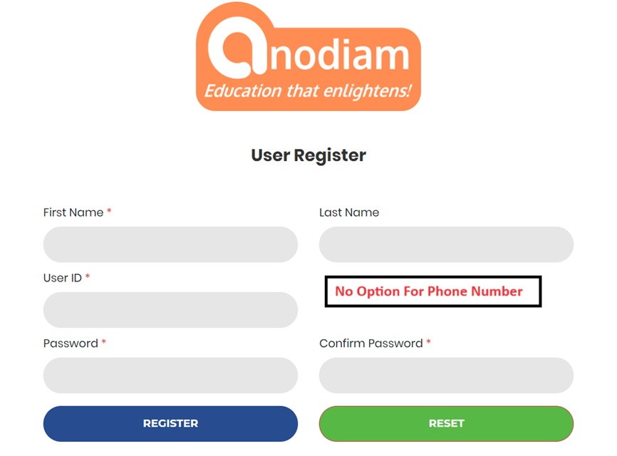

5) Login should happen after successful registration; it should not get logged out.

**Reply: This is not possible.**

6) Successful message after registration is not right.   
**Reply: We can’t have the dynamic one-time message. We can have one fixed page on the home page along with the schedule. We don’t need to direct them to another website.  
  
”**Dear Student,

Thank you for registering!

We conduct monthly mock tests for all popular exams across all classes and disciplines. Test schedules are available at [www.anodiam.com](http://www.anodiam.com).

Call up **9073700094** To enroll for you exam.

Good luck!

**Anirban Chakrabarty**

**C.E.O., Anodiam**

**Email: anirban@anodiam.com**

**Address: N-1/25 Patuli, Kolkata 700094**

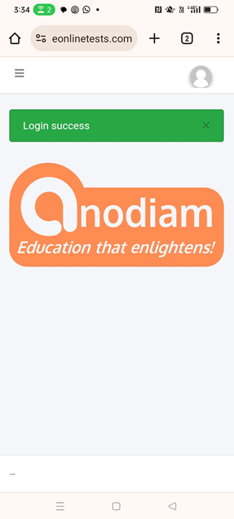

The message is mentioned below in enclosed double quotes.

**“**

Dear [student name],

Thank you for registering!

We conduct monthly mock tests for all popular exams across all classes and disciplines. Test schedules are available at [www.anodiam.com](http://www.anodiam.com).

Call up **9073700094** To enroll for you exam.

Good luck!

**Anirban Chakrabarty**

**C.E.O., Anodiam**

**Email: anirban@anodiam.com**

**Address: N-1/25 Patuli, Kolkata 700094**

**“**

7. Logo doesn’t have to be dynamic. **Reply: This will be done and made static.**

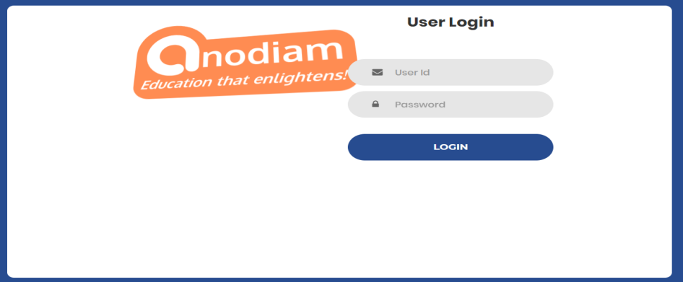

8. Anodiam Logo is overlapping with User Id text box in login page.  
**Reply: This will be done and made static.**

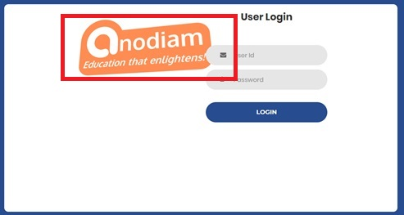

1. There is no option for Forget Password in the login page.

**Reply: This will be done and have been put in process.**

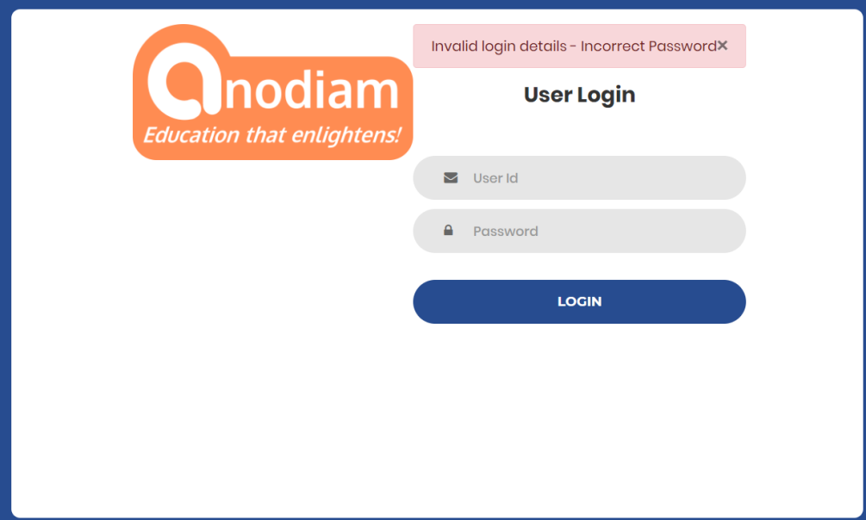

10. If an unregistered user clicks on login button, then the user should get an option for registration in the login page. Otherwise, unregistered user has to hit the back button to go to the landing page.  
**Reply: This is done.**

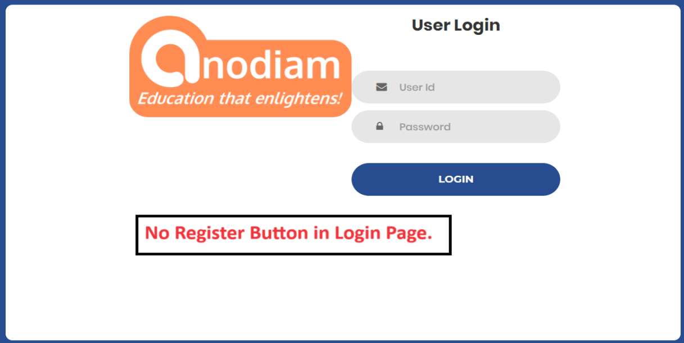

11. While doing registration, password strength should be strong.

The system is allowing user to create password like abc123.   
**Reply: This will be done but not on priority as it will take time.**

Password strength and complexity required to be displayed

The system has to follow password policy rule.

1. Length of password should be minimum 8.
2. The password should contain at least 1 upper case letter
3. The password should contain at least 1 lower case letter
4. The password should contain at least 1 special case letter
5. The password should contain at least 1 numeric letter

12. When clicking on the fields, green halo effect coming which is not required.  
**Reply: This is fine.**

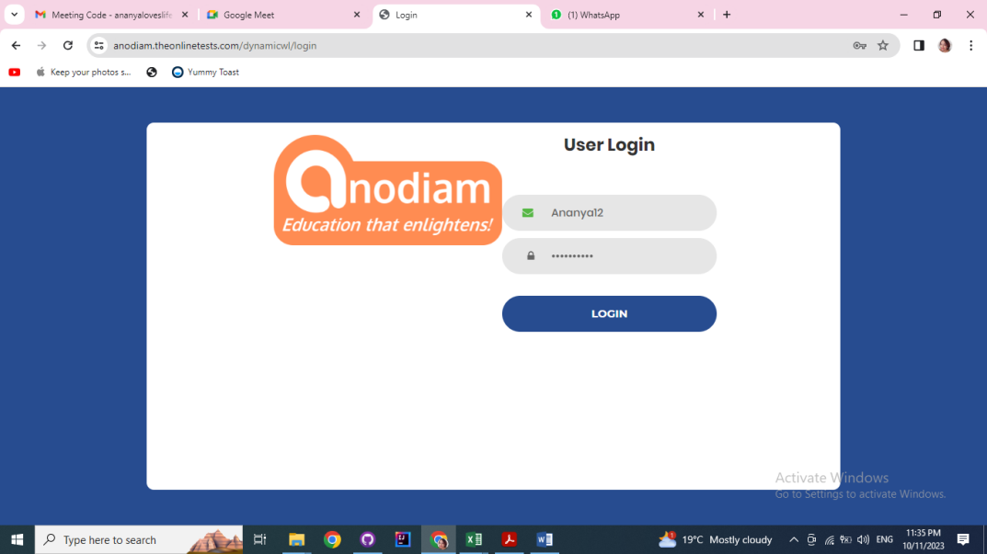

13. In the dashboard page, the image of student is not required and “You need to take off” not necessary.  
**Reply: This can’t be changed for one separate platform.**



14. We need an admin user. As per our communication admin user credential should be

User id: anodiam

Password: anodiam.

On hitting the login button, system is failed to do login.  
**Reply: This is done now. Admin can access from the mentioned ID & password.**

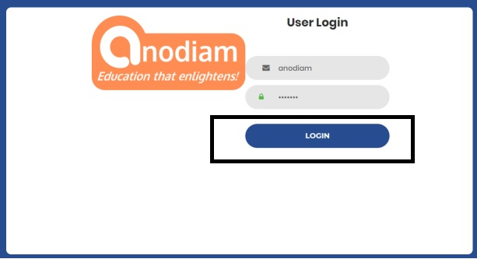

15. What is the function of the subscribe button? If clicked leading to 404 not found   
**Reply: Subscribe button will be removed. New packages for the test series as discussed will be kept.**

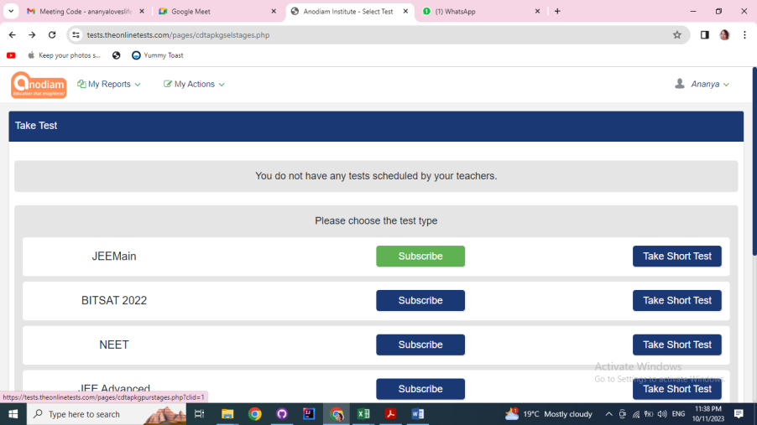

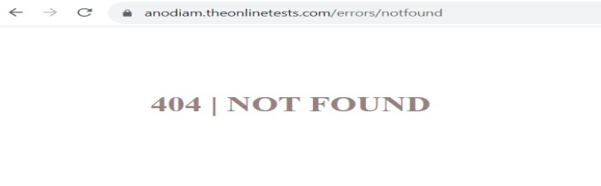

16) If student wants to come out of the test without submitting the paper, what’s the way?

No back button available.  
**Reply: This is not needed.**

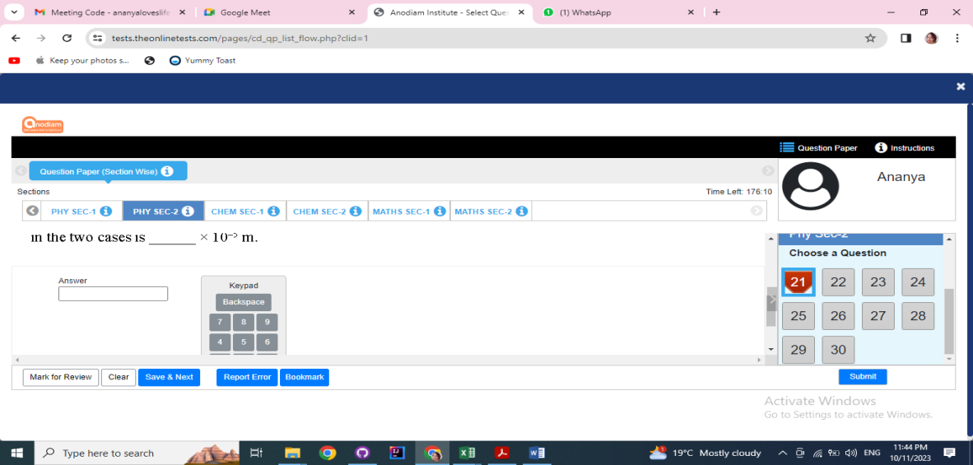

17) After clicking “Error Report System” button under “My Actions” menu, the page is opening in new tab after each click. It should open in same tab no matter how many times the click is made.  
**Reply: This will open on new page only and it can’t be changed.**

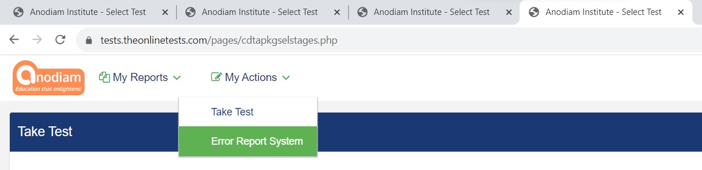

18. Click on “Start test” and “continue test” buttons don’t work  
**Reply: This is done.**

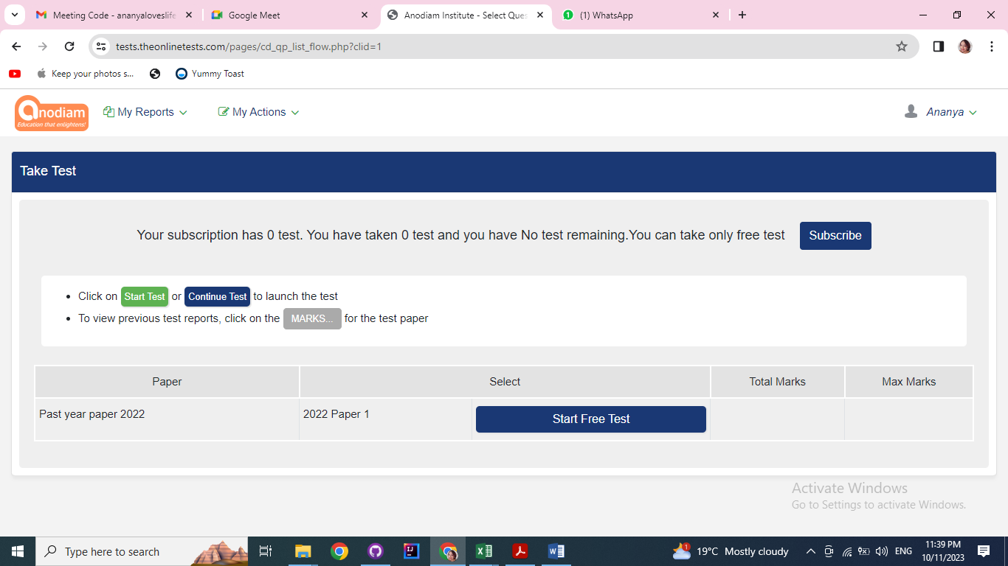

19. “Report error” button used. Who will see the comment and how to take action.  
**Reply: Question owner will get the report on what all errors have been reported. Admin would be able to see all the errors raised.**

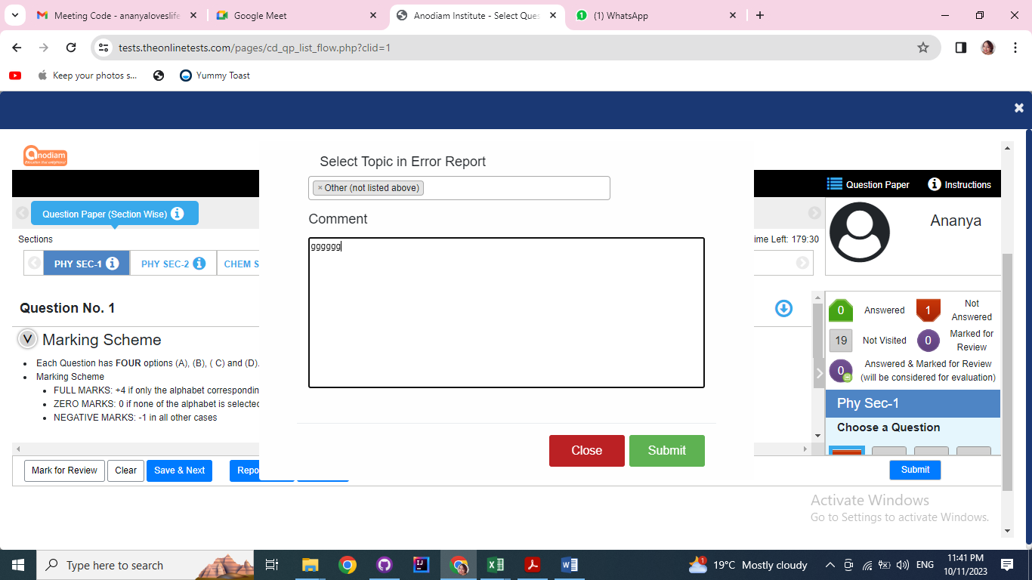

20. This page doesn’t have any correspondence. Once we got this page and now it is not coming.  
**Reply: This page is to view all the bookmarked questions.**

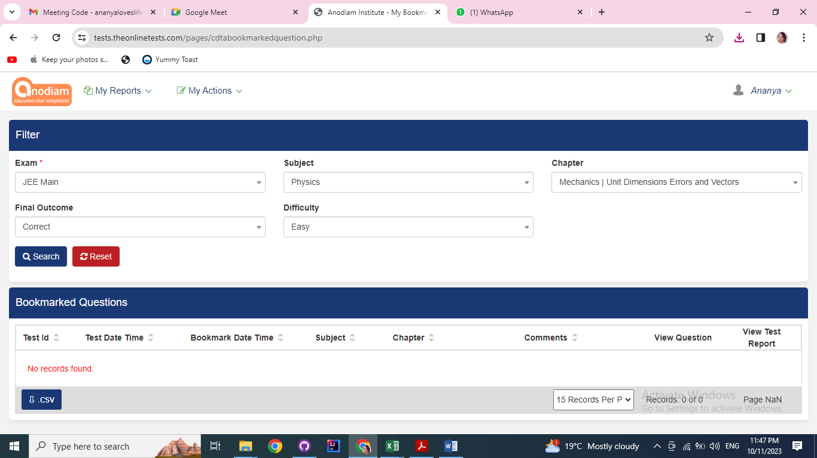

21. Who will receive the report and how to take action.  
**Reply: Coaching will receive the mail and the institute has to take the action**

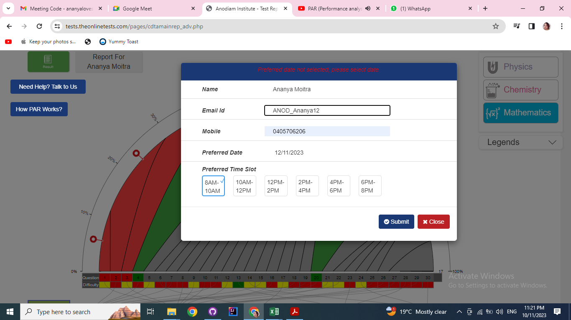

22. As a registered user I have given JEE main examination for 2 times.

When in the third time I tried to give then it is showing the message “Free Test not available”

Is the free test have some limitations.  
**Reply: There won’t be any free test.**

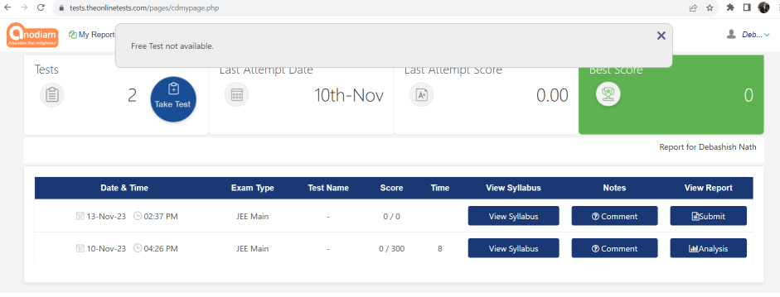

23. Comments are only added but not able to modify the existing comment.  **Reply: Edit not possible. You can add more comments.**

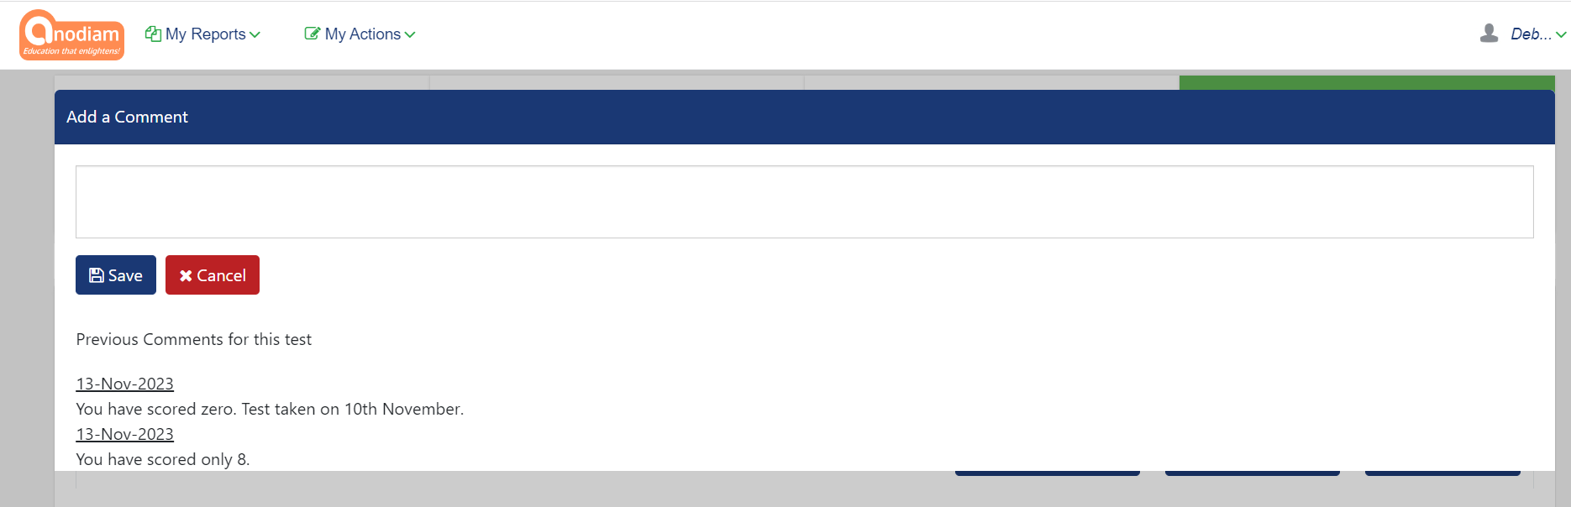

24. On hitting back button of the browser from the above page we are getting show stopper.  
**Reply: This issue is not there.**

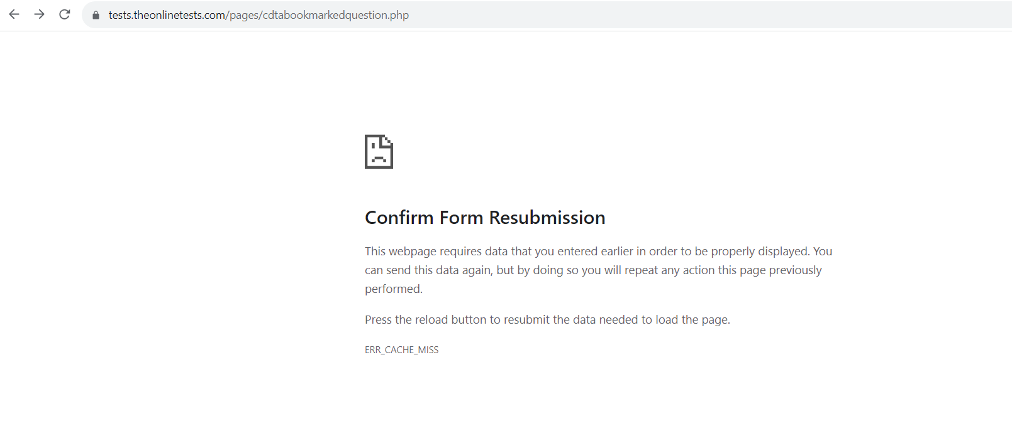

25. While giving test, I was not selecting any option and hitting “Save & next” button randomly, the system was selecting answer automatically. In the image below 2nd option was not selected by me, the system selected it.

System should not select it.   
**Reply: This issue is not there. Debashish Sir will come again if he face any issue.**

