**Coal and Petroleum**

# Classification of Natural Resources

Natural resources can be classified into two types:

* **Inexhaustible Natural Resources**: The resources which are present in unlimited quantity in nature and are not likely to be exhausted by human activities are called inexhaustible natural resources. Examples: Sunlight, air
* **Exhaustible Natural Resources:** The resources which are present in a limited quantity in nature and can be exhausted by human activities are called exhaustible natural resources.

Examples: Forests, wildlife, minerals, coal, petroleum

**Fossil fuels**: The natural fuels formed from the remains of living organisms buried under the Earth long, long ago are called fossil fuels.

# Coal

* Coal is a hard, black, combustible mineral which consists mainly of carbon.
* It is found in deep coal mines under the surface of the Earth.

## Formation of Coal

* Coal was formed by the decomposition of large land plants and trees buried under the Earth about 300 million years ago.
* About 300 million years ago, the Earth had dense forests in the low-lying wet areas.
* Due to natural calamities such as earthquakes, volcanoes and floods, these forests were buried under the surface of the Earth.
* As more soil got deposited on them, they were compressed.
* As a result, the temperature also rose as they sank deeper and deeper.
* Due to high pressure and temperature and the absence of air, the wood of the buried forest plants and trees slowly got converted into coal.
* The slow process by which the dead plants buried under the Earth have become coal is called carbonization.
* Because coal was formed from the remains of the plants, it is called a fossil fuel.
* On heating, coal, which is mainly carbon, produces carbon dioxide gas and a lot of heat energy. C + O2  CO2 + Heat

**Uses of Coal**

* As a fuel in homes and industries.
* As a fuel in thermal power plants to generate electricity.
* Earlier, it was used in railway engines to produce steam to run the engine.

## Products of Coal

The coal obtained is processed in the industry to obtain useful products such as coke, coal tar and coal gas.

### Coke

* + It is a tough, porous and black substance.
  + It is an almost pure form of carbon.
  + It is used in the manufacture of steel and in the extraction of metals.

### Coal Tar

* + It is a black liquid with an unpleasant smell.
  + It is a mixture of approximately 200 substances.
  + The products of coal are used to make synthetic fibres, drugs, plastics, synthetic dyes, perfumes, paints, varnishes, pesticides, photographic materials and roofing materials.
  + Bitumen, a petroleum product, is used in place of coal tar for metalling roads.

### Coal Gas

* + Coal gas is obtained during the processing of coal to get coke.
  + It is used as a fuel in many industries situated near coal processing plants.

# Petroleum

* It is a dark-colored, thick crude oil found deep below the ground in certain areas.
* Petroleum means rock oil (petra = rock, oleum = oil).
* Just like coal, petroleum is also a fossil fuel.

## Formation of Petroleum

* Petroleum was formed from organisms living in the sea.
* As these organisms died, their bodies settled at the bottom of the sea and got covered with layers of sand and clay.
* Due to high pressure, heat, action of bacteria and the absence of air, the dead remains of the tiny plants and animals were slowly converted into petroleum.
* The petroleum thus formed got trapped between two layers of impervious rocks, forming an oil deposit.

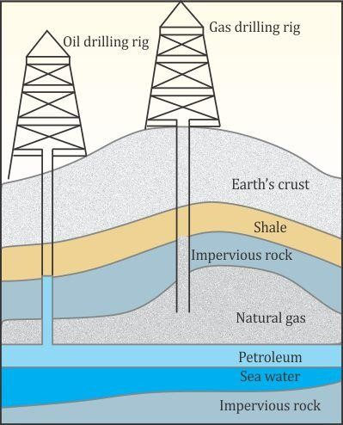

## Refining of Petroleum

* Petroleum is a mixture of various constituents such as petroleum gas, petrol, diesel, lubricating oil and paraffin wax.
* The process of separating the various constituents/fractions of petroleum is known as refining.
* Refining is carried out in a petroleum refinery.

## Constituents of Petroleum and their Uses

|  |  |
| --- | --- |
| **Constituents of Petroleum** | **Uses** |
| Liquid Petroleum Gas | Fuel for home and industry |
| Petrol | Motor and aviation fuel, solvent for dry  cleaning |
| Kerosene | Fuel for stoves, lamps and jet aircraft |
| Diesel | Fuel for heavy motor vehicles, electric  generators |
| Lubricating oil | Lubrication |
| Paraffin wax | Making ointments, candles, *Vaseline* |
| Bitumen | In paints and road surfacing |

**Natural Gas**

* Natural gas mainly consists of methane with small quantities of ethane and propane.
* When natural gas is compressed by applying pressure, it is called compressed natural gas (CNG).
* It is a very important fossil fuel because it is easy to transport through pipes.
* It is a clean fuel.

## Uses

* CNG is used for power generation.
* It is used as a fuel for transport vehicles because it is less polluting.
* It is used directly for burning in homes and factories through a network of underground pipes.
* It is also used as a starting material for the manufacture of several chemicals and fertilisers.

## Conservation of Natural Resources

* The amount of coal, petroleum and natural gas present in the Earth is limited.
* The burning of fossil fuels is a major source of air pollution and is also linked to global warming.
* So, we should use fossil fuels only when necessary. This will result in a better environment, lesser risk of global warming and fossil fuel availability for a longer period of time.
* Tips from the Petroleum Conservation Research Association to save petrol/diesel:
* Drive at constant and moderate speed as far as possible
* Turn off the engine at traffic signals or at places where one has to wait
* Ensure correct tyre pressure
* Ensure regular maintenance of vehicles