# Light

* Light is a form of energy.
* It helps us see different colorful objects around us.
* The natural source of light is the Sun.
* We see objects around us because light is either emitted by objects or reflected from objects and enters our eyes.
* Luminous objects give or emit light of their own. Example: Sun
* Non-luminous objects reflect light. Examples: Moon, mirrors

# Reflection

* It is the process where the incident light on an object bounces back into the same medium.
* All objects reflect light incident on them to different extents.
* Objects which have a smooth surface reflect the incident light to the maximum extent.
* An object which reflects 100% of the incident light is called a mirror.
* A mirror changes the direction of light which falls on it.
* The light ray which falls on a mirror is called the incident light ray.
* The ray which gets reflected from the surface is called the reflected light ray.
* The point where the incident ray strikes the reflecting surface is called the point of incidence.
* A line drawn perpendicular to the mirror at the point of incidence is called the normal.
* The angle between the normal and the incident ray is known as the angle of incidence ( i).



* The angle between the normal and the reflected ray is known as the angle of reflection ( r).

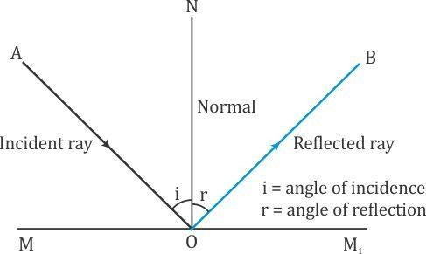

## Laws of Reflection

* The angle of incidence is equal to the angle of reflection.
* The incident ray, the reflected ray and the corresponding normal all lie in a plane.

## Lateral Inversion

* Lateral inversion is the effect produced by a plane mirror in reversing images from left to right, i.e. the right part of an object appears to the left in its image, and the left part of the object appears to the right.

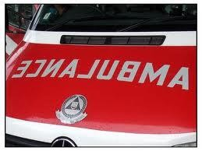

# Regular and Diffused Reflection

* Light rays are visualized as parallel rays.
* If the reflected rays from a surface are parallel, then the reflection is termed regular reflection.
  + Example: Reflection from a plane mirror

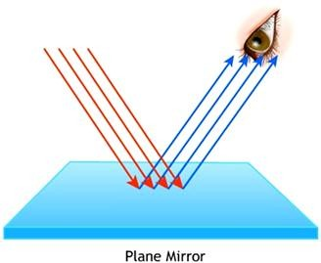

* If the surface is not a plane surface, then the reflected rays are not parallel to each other and the reflection is called diffused reflection or irregular reflection.

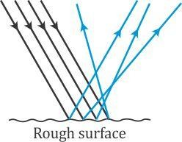

# Multiple Reflection

* If a reflected light ray is reflected again on being incident on another surface, it is termed multiple reflection.
* Multiple reflection is used in periscopes.
* Periscopes are used in submarines, war tanks and by soldiers in bunkers to see objects which are not visible directly.

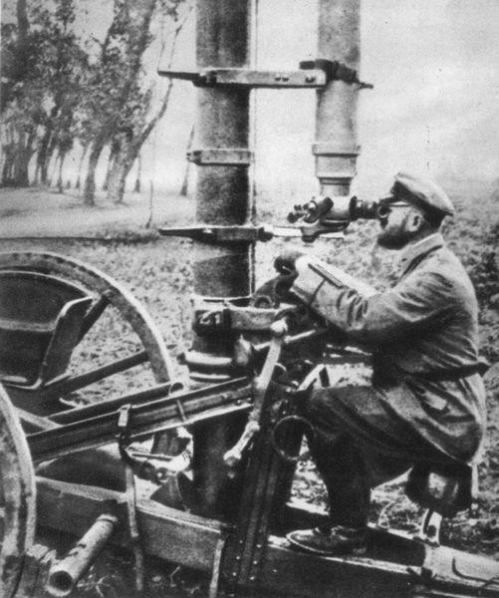

* Multiple reflection is also seen in kaleidoscopes.

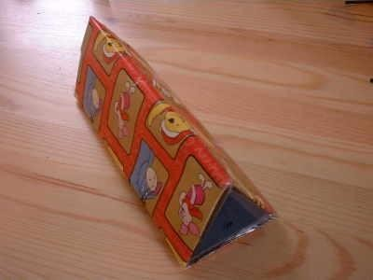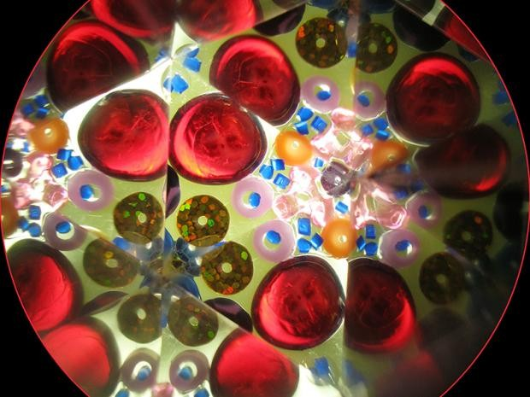

# Sunlight–White or Colored

* A rainbow is arch-shaped and appears after the rain in the morning or evening when the Sun is low in the sky.
* It is formed when sunlight passes through tiny prism-like water droplets and splits into different colors. This indicates that sunlight is made of different colored lights.
* The order of colors from the lower end is violet, indigo, blue, green, yellow, orange and red, i.e. VIBGYOR.
* The phenomenon of splitting of a beam of white light into its constituent colors on passing through a prism is called the dispersion of light.

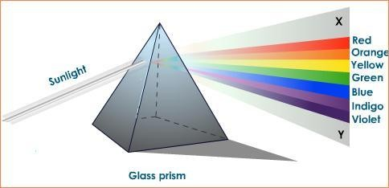

# Light and Eyes

## The Human Eye

* We see objects around us with our eyes.
* The eye is an important sense organ and is roughly spherical.

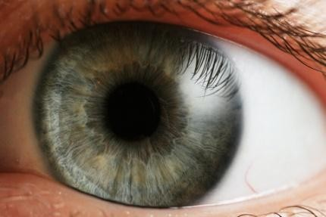

* Its transparent front part is called the cornea.
* Behind the cornea, there is a dark muscular structure called the iris.
* In the Iris, there is a small opening called the pupil. The iris controls the size of the pupil. It also controls the amount of light entering the eye.
* The iris also provides color to the eyes.

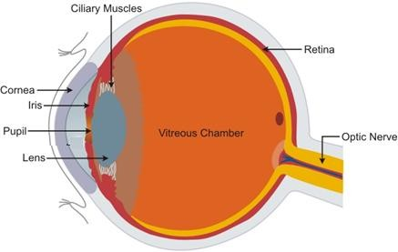

* Behind the pupil, the eye has a lens, which is thicker in the center.
* The lens focuses the light on the retina, which has several nerve cells.
* The nerve cells carry the sensations to the brain through the optic nerve.
* It contains two types of cells:
  + Cones are sensitive to bright light and distinguish the color of an object.
  + Rods are sensitive to dim light.
* The small region where the optic nerve and the retina meet has no sensory cells. This region is called the blind spot.
* The impression of an image does not vanish immediately from the retina. It persists there for about 1/16th of a second.
* The eye lids protect the eye from dust.
* The eye has the ability to form a clear image of a near and far object, and it is called its power of accommodation.

# Taking Care of the Eyes

* If advised by a doctor, use suitable spectacles.
* Too little or too much light is bad for the eyes. Do not look at the Sun or a powerful light directly.
* Never rub your eyes if any dust particles go into them. Wash your eyes with clean water.
* Always read at the normal distance for vision. Do not read by bringing the book too close or by keeping it too far.
* Eat a well-balanced diet. It should include vegetables and fruits which are rich in Vitamin A such as raw carrots, broccoli, spinach, papaya and mango. Cod liver oil can be taken as a Vitamin A supplement.

# Defects of Human Eye

* For a normal eye, the distance for clear vision is 25 cm. This distance differs from person to person and varies with age.
* Some people see near objects clearly and some see distant objects clearly.
* The defects can be corrected using suitable corrective lenses.
* Eyesight of people becomes foggy in their old age, and objects appear dim because of cataract.

# Visual Impairment

* Some people, including children, are visually handicapped, i.e. they have very limited vision and some have no vision, since birth.
* Visually handicapped people develop their other senses more sharply. They use Braille to read and communicate.

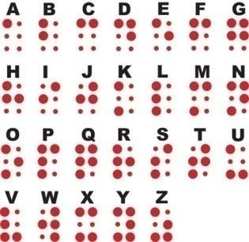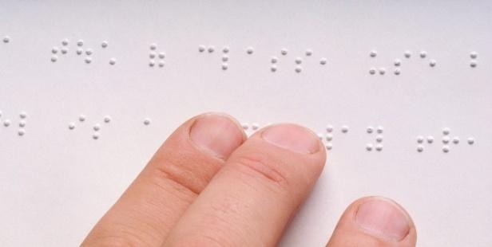

* Braille was developed in 1821 by Louis Braille, a visually challenged person.

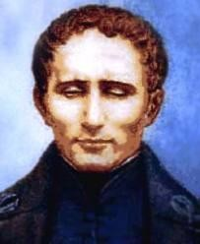

* This system was adopted in 1932. Braille code is used for common languages, Mathematics and scientific notations.
* Many Indian languages can be read using the Braille system. It has dot patterns or characters, and each character represents a letter or a combination of letters, a common word or a grammatical sign.