**Stars and the Solar System**

* The stars, planets, the Moon and the other objects which we see in the sky are called celestial bodies.

# The Stars

* When we see the dark sky at night, we see many stars shining brighter than the others.
* Stars are bodies which emit their own light.
* They are also present in the sky during the day time, but they are not visible because of the bright sunlight.
* The Sun is also a star.
* The star nearest to the Earth is the Sun, which is the source of most of the energy on the Earth.
* Stars appear to move from east to west as Earth rotates from west to east.
* The Sun, being a star, appears to rise in the east and set in the west.

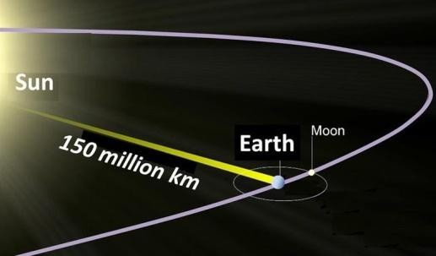

* The huge distances between the Earth and other celestial bodies are measured in light years.
* A light year is the distance covered by light in one year.
* The Pole star is situated in the direction of the Earth’s axis, and hence, it does not appear to move.

# Constellations

* The stars which form a group which has a recognizable shape of an identifiable object like an animal or a known object is called a constellation.

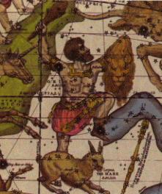

* To identify the stars, constellations were given their names many hundreds of years ago.
* We use constellations to divide the sky because they move so slowly that in our lifetime, they will always be found in about the same place.
* The stars contained in a constellation are not at the same distance. They just appear at the same line of sight.
* Orion (appears like a human figure with a belt, often referred to as ‘The Hunter’)
  + It can be seen in the late evenings during winter.
  + The belt with three bright stars in a row is usually the easiest part of Orion to spot.
  + It has seven or eight bright stars. The two brightest are Betelgeuse (shoulder) and Rigel (foot).

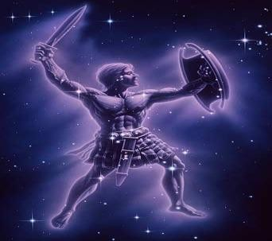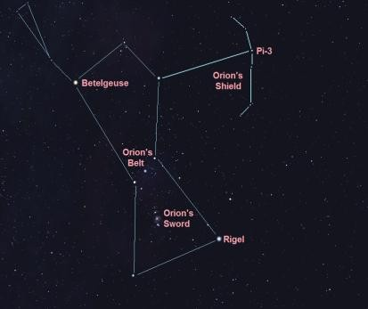

* + The brightest star Sirius is located close to Orion.
* Ursa Major (Big Dipper, Great Bear, Saptarshi)
  + It can be seen at night in the summer sky.

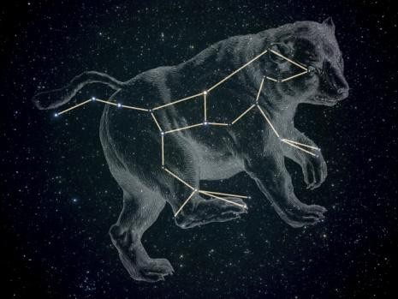

* + It has seven prominent stars and appears like a big ladle or a question mark.
  + There are three stars in the handle of the ladle and four in its bowl.
* Cassiopeia
  + Cassiopeia is a prominent constellation in the northern sky.
  + It is visible during winter in the early part of the night.
  + It looks like a distorted letter ‘W’ or ‘M’.

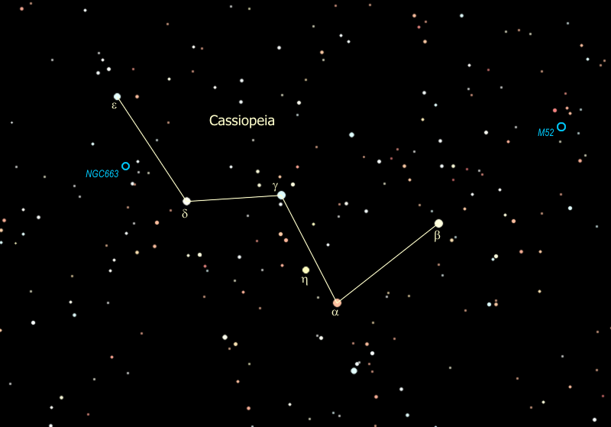

# The Solar System

* The Sun and the celestial bodies which revolve around it form the Solar System.
* The Sun is a major source of heat and light for all the planets in the Solar System.
* The Solar System consists of a large number of bodies such as planets, comets, asteroids and meteors.
* The gravitational attraction between the Sun and these objects keeps them revolving around it.
* Earth is the only planet on which life is known to exist.
* There are eight planets which revolve around the Sun.

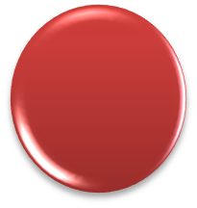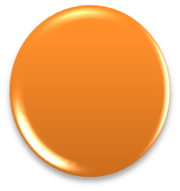

Mercury

Neptune

Venus

Uranus

**Sun**

Earth

Saturn

Mars

Jupiter

# The Sun

* The Sun is the nearest star from us.
* It is of average size, mass and brightness. Therefore, it appears bigger, brighter and hotter than other stars.
* It is continuously emitting huge amounts of heat and light.
* Light from the Sun reaches the Earth in approximately 8 minutes and 20 seconds.
* Its distance from the Earth is about 1.49 × 108 km.

# The Planets

* The planets look like stars, but they do not have light of their own. They reflect sunlight which is incident on them.
* They have definite paths called orbits in which they revolve around the Sun.
* The time taken by a planet to complete one full revolution around the Sun is called its period of revolution.
* The time taken by a planet to rotate a full 360° on its axis is called its period of rotation.
* A celestial body which revolves around another celestial body is called a satellite. Some planets have their own satellites.

## Mercury (Budh)

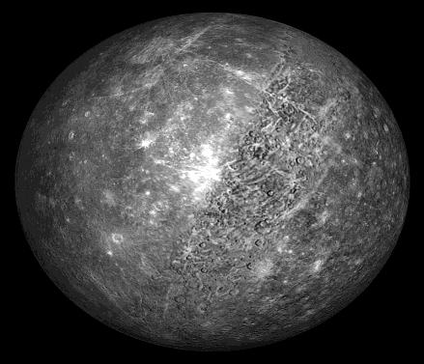

* It is the smallest planet in the Solar System and the closest to the Sun.
* It takes about 88 days to complete one revolution around the Sun.
* Mercury has no satellite of its own.

## Venus (Shukra)

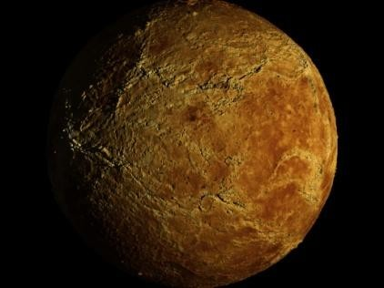

* The second closest planet to the Sun.
* It takes about 225 days to complete one revolution around the Sun.
* It has no satellite of its own.
* It rotates from east to west.
* It appears in the eastern sky before sunrise and in the western sky after sunset. So, it is also called morning or evening star.
* Venus also shows phases just like our Moon.

## Earth (Prithvi)

* It is the only planet to support life in the Solar System.
* This is because
  + It is at the right distance from the Sun, so its temperature range is ideal for life to exist.
  + It has presence of liquid water.
  + It has an atmosphere.
* Earth appears blue-green from space.
* It has one Moon.

## Mars (Mangal)

* It is the first planet outside the orbit of the Earth.
* It completes one revolution around the Sun in about 687 days.
* It has two moons (natural satellites) of its own.
* It appears slightly reddish and is therefore called the red planet.

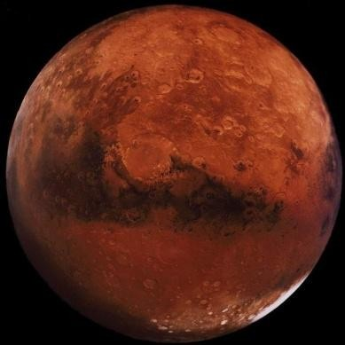

## Jupiter (Brihaspati)

* It is the largest planet in the Solar System.

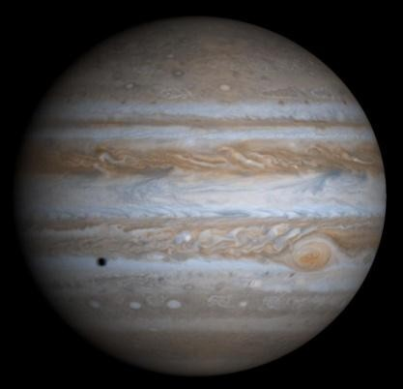

* It is so large that about 1300 earths can be placed inside this giant planet.
* It rotates the fastest among all planets.
* The mass of Jupiter is about 318 times that of the Earth.
* It has many moons. However, the four largest moons are called Io, Europa, Callisto and Ganymede.
* It also has a very faint ring.

## Saturn (Shani)

* Saturn is yellowish and is the second largest planet.

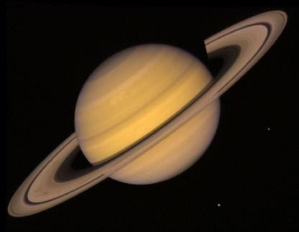

* The rings of Saturn are made of ice particles and dust.
* It is the only planet which is lighter than water.
* The largest of Saturn’s moons is Titan.

## Uranus

* It is a very cold planet and is much bigger than the Earth.

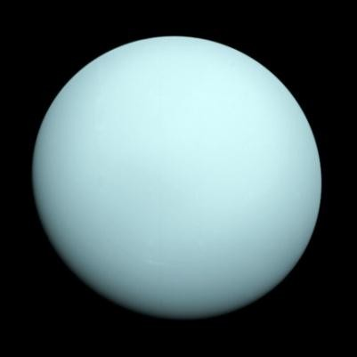

* It has 27 natural satellites.
* It also rotates from east to west.

## Neptune

* It is very far away from the Sun, and it is very cold.
* It looks like a small bluish circle through a powerful telescope.

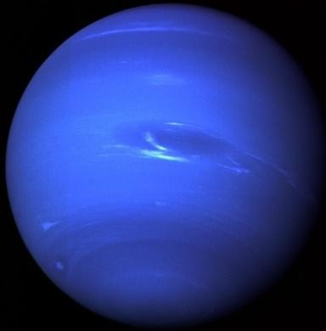

* It was discovered through mathematical calculation.
* Mercury, Venus, Earth and Mars are called the inner planets. Jupiter, Saturn, Uranus and Neptune are called the outer planets.
* The outer planets have several moons and a system of rings.

# The Moon

* The Moon is the brightest object in the night sky.
* It is the only natural satellite of Earth and the fifth largest satellite in the Solar System.
* The average centre-to-centre distance from the Earth to the Moon is 384,000 km, about thirty times the diameter of the Earth.
* The various shapes of the bright part of the Moon seen during a month are called the phases of the Moon.

## Phases of the Moon

* We see parts of the Moon on different days because the Moon does not produce its own light.
* We see only that part of the Moon from which the light of the Sun is reflected towards us.

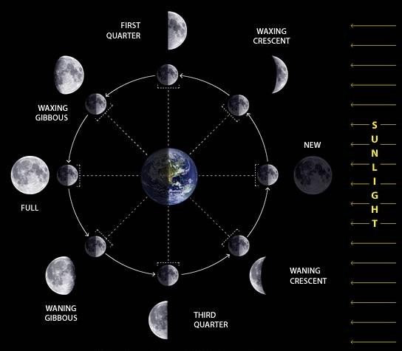

### Full Moon Day

* + The day on which the whole disc of the Moon is visible is known as a Full Moon day.
  + Thereafter, every night, the size of the bright part of the Moon appears to become thinner and thinner.

### New Moon Day

* + On the fifteenth day after the Full Moon, the Moon is not visible. This day is known as the New Moon day.

### Crescent Moon

* + The small portion of the Moon which appears in the sky is known as the crescent Moon.
  + The Moon grows larger every after the New Moon and again on the fifteenth day, we see the full view of the Moon.
* The Moon completes one rotation on its axis as it completes one revolution around the Earth.

## The Moon’s Surface

* The Moon’s surface is dusty and barren.

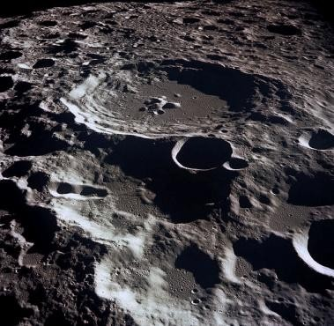

* The surface has many craters of different sizes.
* It has a large number of steep and high mountains and some of these are as high as the highest mountains on the Earth.
* It has no atmosphere and no water.
* The first man to land on the surface of the Moon was American astronaut Neil Armstrong who landed on 21 July 1969, and he was followed by Edwin Aldrin.

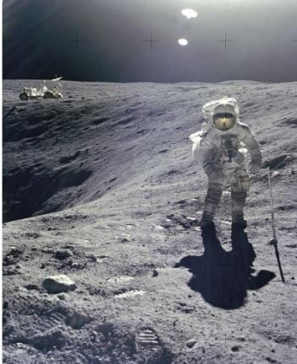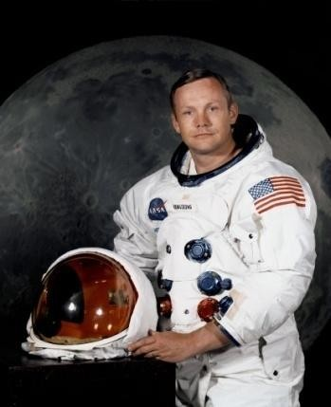

# Other Members of the Solar System

* Apart from the Sun and the planets, the Solar System also consists of celestial bodies such as asteroids, meteors, comets and artificial satellites.



Asteroids

Comets

Meteors and Meteorites

Artificial satellites

## Asteroids

* These are large pieces of rock or rock and metal.
* They are found in the gap between the orbits of Mars and Jupiter.
* This gap is called the Asteroid belt.

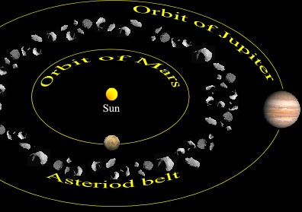

* They can only be seen through large telescopes.

## Comets

* A comet is a luminous heavenly body which revolves around the Sun in an elliptical orbit.
* It appears generally as a bright head with a long tail.
* When it is close to the Sun, its nucleus—which consists of frozen gases, ice and dust—melts and emits a large amount of gas and dust.

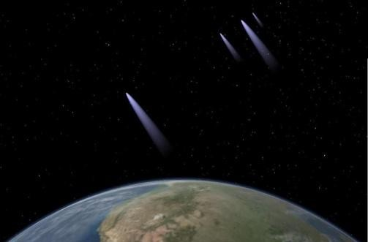

* The tail of a comet is always directed away from the Sun.
* One of the best known comets is the Halley’s Comet, which appears after nearly every 76 years.
* It is named after Edmund Halley and was last seen in 1986.

## Meteors and Meteorites

* A meteor is made of debris.
* It enters the Earth’s atmosphere at a very high speed.

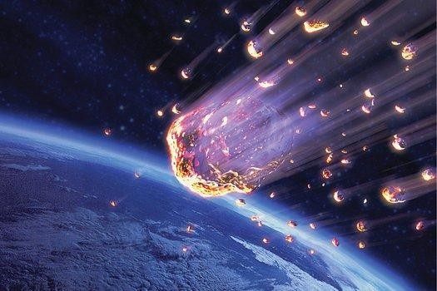

* The friction with the atmosphere makes the meteor hot and it burns till it disintegrates.
* As it falls to the ground, it glows brightly. This is why it is called a shooting star.
* Some meteors reach the ground before burning completely and evaporating.
* These are called meteorites.

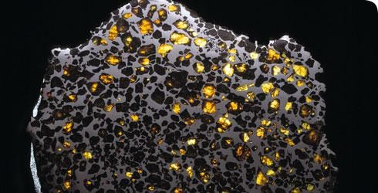

* They help scientists in investigating the nature of the material from which the Solar System was formed.
* When the Earth crosses the tail of a comet, swarms of meteors are seen. These are known as meteor showers.

## Artificial Satellites

* Artificial satellites are man-made devices which orbit the Earth, Moon and Sun.
* They are launched from the Earth and they revolve around it much closer than the Moon.
* They gather information about the bodies they orbit.

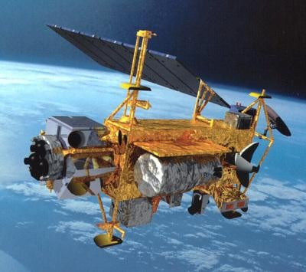

* There are about 5,000 artificial satellites orbiting the Earth.
* They are used for transmission of television and radio signals, telecommunications, weather forecasting and remote sensing.
* India has built and launched several artificial satellites.
* Aryabhata was the first Indian satellite.

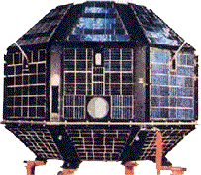

* The other Indian satellites are INSAT, IRS, Kalpana-1 and EDUSAT.