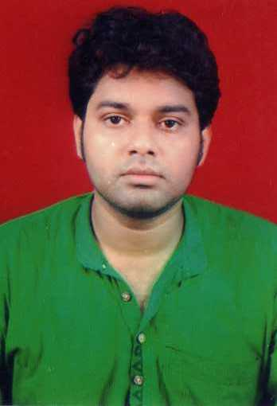
NSB ROAD
SHITALA GOLI
PO- RANIGANJ
DIST-BURDWAN
PIN-713347
WEST BENGAL
PH: 09732313208
E-MAIL:arns_23@rediffmail.com

CAREER OBJECTIVES:

To be associated with an organization that will give me scope to work
& to update my knowledge & skill & be the part of the team that dynamically
works towards the growth & enhancement of the organization. I also want to
be a good human being to be fitted in the society.

Strengths:

Strong in oral and written skills in ENGLISH.
I can communicate with people of diverse outlook for a particular aspect. I have strong leading capability & decision taking ability. I am a quick learner, punctual,
Creative & possess the ability to work under presser to deliver on time.

EDUCATIONAL QUALIFICATIONS:

IIT JAM 2023 AIR 168. SELECTED IN IIT ROORKEE IN THE FIRST ROUND ITSELF.

MSc qualified from IIT HYDERABAD (ALL INDIA IIT JAM RANK 255, 2018).
That year only selected in TIFR HYDERABAD for integrated PhD. Also selected in IIT MADRAS for internship in BIO-INORGANIC & POLYMER CHEMISTRY. This is also to mention that even in the year 2022 IIT JAM rank was 260 & missed IIT GUWAHATI just by 1 rank. IIT GUWAHATI is of choice for its special care in ORGANIC CHEMISTRY & association of Nobel laureate RESPECTED BENJAMIN LIST.

- CHEMISTRY HONOURS from SINDRI COLLEGE, SINDRI.
PERCENTAGE: 71.25 (HONOURS )
- B.TECH from HERITAGE INSTTUTE OF TECHNOLOGY,
KOLKATA .
CGPA: 7.5/10 (FINAL YEAR COMBINED)

H.S from RANIGANJ BOYS’ HIGH SCHOOL under W.B.C.H.S.E.

MARKS OBTAIND: 82.2%

- MADHYAMIK from RANIGANJ BOYS’ HIGH SCHOOL under W.B.B.S.E.

MARKS OBTAIND: 88.75%

INDUSTRIAL WORK EXPERIENCE:

INFOSYS TECHNOLOGIES LIMITED, MYSORE AS A SYSTEM ENGINEER.

EDUCATIONAL WORK EXPERIENCE:

PRESENTLY THE HOD CHEMISTRY & RECRUITMENT DECISION MAKER IN NARAYANA EDUCATIONAL INSTITUTE.
SUCCESSFULLY MAKING STUDENTS READY FOR IIT JEE & NEET.
TRACK RECORD IS VERY HIGH INCLUDING TWO DIGIT RANKS.
previously these are the accolades
- Two years in Gyan Bharati School, RANIGANJ.
- One year in St.Patric's HS School, Asansol.
- One year in HEM SHEELA MODEL SCHOOL, DURGAPUR
- IIT JEE SECTION HEAD OF THE DEPARTMENT IN TECHMAN INSTITUTE
- PATHFINDER, KOLKATA
- Selected in FIITJEE for IITJEE LEVEL coaching.
- Selected in AAKASH INSTITUTE (2023)
- Aakash Digital (AESL)(2022)
- PHYSICS WALLAH (2023)

PUBLICATIONS:

(1) I am a writer in CHEMISTRY TODAY MAGAZINE, MTG PUBLICATION.
(2) I am also a writer in IIT BUZZWORD
MAGAZINE, ARIHANT PUBLICATION.
(3) My book on ORGANIC CHEMISTRY & PHYSICAL CHEMISTRY are coming next year from the largest publication of the country in IITJEE & NEET SEGMENT.

SPECIAL TRAINING:

I have completed CAMPUS CONNECT PROGRAMME CONDUCTED BY INFOSYS TECHNOLOGIES LIMITED IN MY COLLEGE.

ACHIEVEMENTS:
- Participated in many quiz competitions & won prizes. Special award was given by “PASCHIM BANGA VIGYAN MANCHA” for becoming ZONAL CHAMPION in MATHEMATICS, ENGLISH & QUIZ competitions.
- Won several SCHOLARSHIPS for outstanding ACADEMIC PERFORMANCES in school.
- “CERTIFICATE OF RECOGNITION” from LIONS CLUB OF RANIGANJ.

OUTSTANDING ACHIEVEMENT:

TIFR entrance exam qualified.

IIT JAM 2023 CHEMISTRY AIR 168

PERSONAL PROFILE:

FATHER’S NAME: GOPAL SARKAR

MOTHER’S NAME: LATE SIKHA SARKAR

NATIONALITY: INDIAN
RELIGION: HINDU
DATE OF BIRTH: 23rd AUGUST, 1986

GENDER: MALE

HOBBIES: PLAYING CRICKET, LISTENING TO MUSIC, WATCHING MOVIES

LANGUAGES KNOWN: BENGALI, HINDI & ENGLISH

I solemnly declare that to the best of my knowledge & belief, the information given above & the statements accompanying it are correct, complete & truly stated.

ARUNAVA SARKAR

