**HR Policy Utilization Strategy for Performance Enabling of Employees with Different Levels of Work-Life-Balance**



# Introduction:

**Anodiam** is a moderately large startup with 2000 employees working on many cutting-edge technological projects. They immensely value their talented employees and their HR policies are largely aimed at improving employee satisfaction, performance and work-life-balance.

The recent year-end appraisal cycle of June-2024 has generated the following results:

|  |  |  |  |
| --- | --- | --- | --- |
|  | | | There are 2 types of employees. Refer to Fig-1, left:   1. Those who finish the weeks work within 40 hours, subsequently referred to as “**work-life-balance**” group. 2. Those who work more than 40 hours per week or the “**over-workers**”. |
|  | | |  |
| Both employee satisfaction and performance ratings are measured in a level of 0 to 5, (fractions included) 0 being worst and 5 being best.  Further analysis of employee satisfaction survey shows that, more quickly any employee can finish their week’s job, the more satisfied they are. Refer to Fig-2, right. |  | | |
|  |  | | |
|  | | Also, the work-life-balance group seems to be the better performers at work. Refer to Fig-3, left.  Amodiam’s management is keen to have a competitive work environment between both work-life-balance and the over-workers group. | |

# Simultaneous Utilization of HR Policies by Employee Groups:

Anodiam’s HR has introduced different employee enabling policies. E.g. extensive trainings, Agile management, remote working, flexible timing etc. The better an employee utilizes these policies, the more satisfied they are.

Both, work-life-balance and over-worker groups have “simultaneously” utilized these policies like strategies throughout the past year. This has rewarded or “paid off” the employees with increased motivation, enabling and performance.

To understand how effective these strategies are on the performance of both groups, the mean performance ratings according to employee satisfaction levels of both the groups were drawn against each other in Fig-4, below:

1. High Satisfaction: uses HR strategies most effectively.
2. Medium Satisfaction: uses moderately.
3. Low Satisfaction.

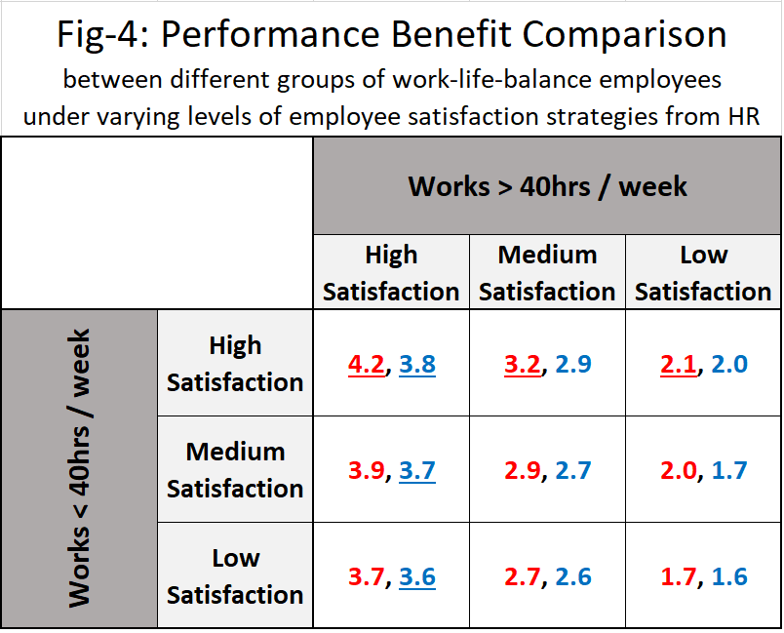

Each cell, contains 2 values of mean performance ratings. The left one in **red** is of the work-life-balance group with the corresponding level of satisfaction from HR policy as per rows. The right one in **blue** is of the over-working group with the respective level of satisfaction as per columns.

# Observation:

It is observed that, for both the groups, namely the work-life-balance and over-workers, while in a competitive environment to perform their best; high employee satisfaction is everyone’s key strategy. There is no rational reason for any employee to move away from this strategy.

It can thus be concluded that those employees who are better inclined to the HR policies, utilize those policies to their satisfaction and feel more enabled to perform their best, irrespective of how many hours they work during the week.

# References:

* Data simulation & visualization program:

<https://github.com/anodiamadmin/AIML/blob/main/01StrategicDecision/Nashpy/13GameTheoryIdealHoursPerWeek.py>

* Simulation data: <https://github.com/anodiamadmin/AIML/blob/main/01StrategicDecision/Nashpy/data/13GameTheoryIdealHoursPerWeek.csv>
* Data visualization:

<https://github.com/anodiamadmin/AIML/blob/main/01StrategicDecision/Nashpy/image/Assignment2a.png>