|  |  |  |  |  |  |  |  |  |  |  |
| --- | --- | --- | --- | --- | --- | --- | --- | --- | --- | --- |
| **Question #** |  |  |  | | |  | | | |  |
| **Q1.a** |  |  |  | | | **Contingency Table** | | | | |
|  |  |  |  | | | or **Confusion Matrix** | | | | |
|  |  |  |  | | |  | | | |  |
|  |  |  |  | | | **Actual values** | | | | |
|  |  |  |  | | | Class P (40) | | | | Class N (60) |
|  |  | **Predicted Values** | Class P | | | 10 | | | | 10 |
|  |  | Class N | | | 30 | | | | 50 |
|  |  | | |  |  | |  |  |  | | |  |

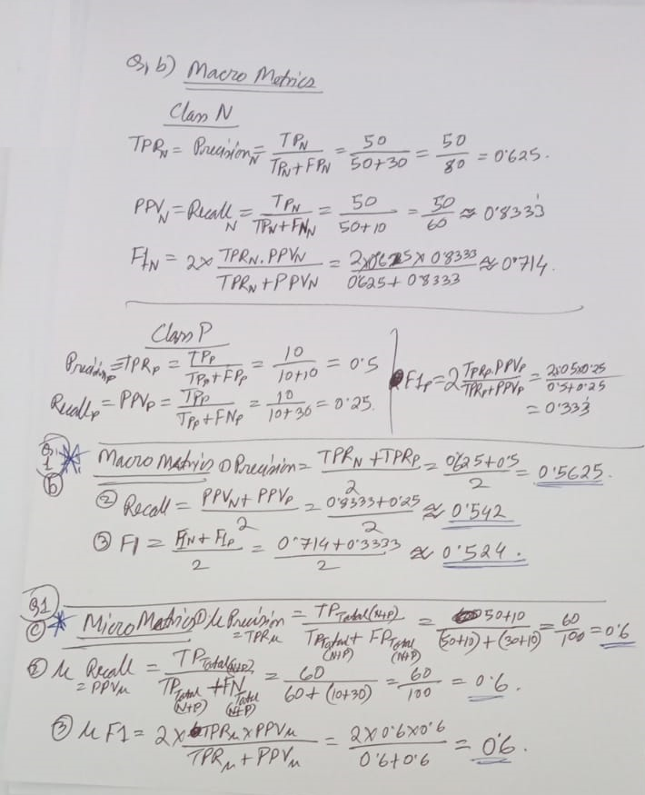

|  |  |  |  |  |  |  |  |  |  |  |
| --- | --- | --- | --- | --- | --- | --- | --- | --- | --- | --- |
|  |  |  |  | | |  | | | |  |
|  |  |  |  | | |  | | | | |
|  |  |  |  | | |  | | | | |
|  |  |  |  | | |  | | | |  |
|  |  |  |  | | |  | | | | |
|  |  |  |  | | |  | | | |  |
|  |  |  |  | | |  | | | |  |
|  |  |  | | |  | | | |  |
|  |  | | |  |  | |  |  |  | | |  |  |
|  |  | | |  |  | |  |  |  | | |  |  |
| **Q1.b** |  | | |  |  | |  |  | **MACRO Metrics** (2 classes, P & N => k=2) | | | | |
|  | **Metric Class .** | | | **TP** | **FP** | | **FN** | **TN** | **Precision TPR** | | | **Recall PPV** | **F1** |
|  | TP/(TP+FP) | | | TP/(TP+FN) | 2*RPR*PPV/(TPR+PPV) |
|  | **P** | | | 10 | 10 | | 30 | 50 | 0.5 | | | 0.25 | 0.333333333 |
|  | **N** | | | 50 | 30 | | 10 | 10 | 0.625 | | | 0.833333333 | 0.714285714 |
|  |  | | |  | **Metric** | | | | **Precision TPR** | | | **Recall PPV** | **F1** |
|  |  | | |  | **Formula** | | | | (TPR_P+TPR_N)/2 | | | (PPV_P+PPV_N)/2 | (F1_P+F1_N)/2 |
|  |  | | |  | **Value** | | | | **0.5625** | | | **0.541666667** | **0.523809524** |
|  |  | | |  |  | |  |  |  | | |  |  |
| **Q1.c** |  | | |  |  | |  |  | **MICRO Metrics** | | | | |
|  | **Metric Class .** | | | **TP** | **FP** | | **FN** | **TN** | **Precision TPR** | | | **Recall PPV** | **F1** |
|  | TP/(TP+FP) | | | TP/(TP+FN) | 2*RPR*PPV/(TPR+PPV) |
|  | **P** | | | 10 | 10 | | 30 | 50 | 0.5 | | | 0.25 | 0.333333333 |
|  | **N** | | | 50 | 30 | | 10 | 10 | 0.625 | | | 0.833333333 | 0.714285714 |
|  | **Total (P+N)** | | | 60 | 40 | | 40 | 60 | 0.6 | | | 0.6 | 0.6 |
|  |  | | |  | **Metric** | | | | **Precision TPR** | | | **Recall PPV** | **F1** |
|  |  | | |  | **Formula** | | | | TPR_Total | | | PPV_Total | F1_Total |
|  |  | | |  | **Value** | | | | 0.6 | | | 0.6 | 0.6 |