**Q 2. a)**

Here's the decision tree for the given dataset. (Diagram drawn in MS PowerPoint)

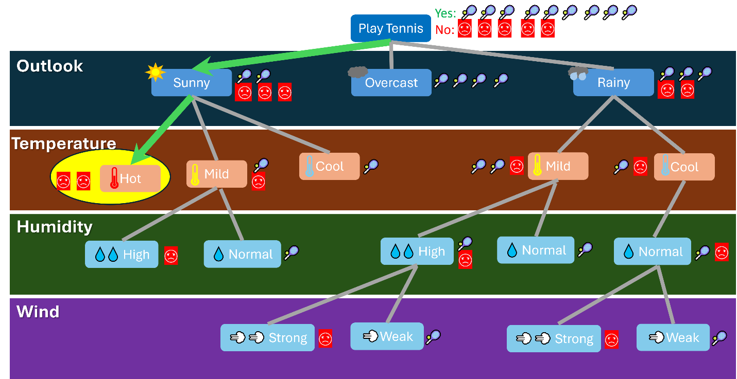

Therefore, according to the conditions of D15 {Sunny, Hot, High, Weak}, the class assigned = **No**

The tree is constructed by choosing the correct attribute at each node so that information gain is maximized (Entropy minimized) at every node.

**Q 2.b)**

**Step 1:** Calculate Probabilities of Label column (PlayTennis: Yes or no)

1. P(PlayTennis = Yes) = 9 / 14
2. P(PlayTennis = No) = 5 / 14

**Step 2:** Calculate Conditional Probabilities for D15 {Sunny, Hot, High, Weak}

1. P(Outlook = Sunny | PlayTennis = Yes) = 2 / 9
2. P(Outlook = Sunny | PlayTennis = No) = 3 / 5
3. P(Temperature = Hot | PlayTennis = Yes) = 2 / 9
4. P(Temperature = Hot | PlayTennis = No) = 2 / 5
5. P(Humidity = High | PlayTennis = Yes) = 3 / 9
6. P(Humidity = High | PlayTennis = No) = 3 / 5
7. P(Wind = Weak | PlayTennis = Yes) = 6 / 9
8. P(Wind = Weak | PlayTennis = No) = 2 / 5

**Step 3:** Calculate Conditional Probabilities of Play Tennis or not, given the conditions of D15 {Sunny, Hot, High, Weak}:

1. **P(PlayTennis = Yes | D15)** = P(PlayTennis = Yes) * P(Outlook = Sunny | PlayTennis = Yes) * P(Temperature = Hot | PlayTennis = Yes) * P(Humidity = High | PlayTennis = Yes) * P(Wind = Weak | PlayTennis = Yes) = (9/14) * (2/9) * (2/9) * (3/9) * (6/9) = 0.0114
2. **P(PlayTennis = No | D15)** = P(PlayTennis = No) * P(Outlook = Sunny | PlayTennis = No) * P(Temperature = Hot | PlayTennis = No) * P(Humidity = High | PlayTennis = No) * P(Wind = Weak | PlayTennis = No) = (5/14) * (3/5) * (2/5) * (3/5) * (2/5) = 0.0206

**Step 3:** Prediction: **No**

Since P(PlayTennis = No | D15) = 0.0206 > P(PlayTennis = Yes | D15) = 0.0114, the Naive Bayes classifier for PlayTennis, given the conditions of D15 {Sunny, Hot, High, Weak} assigns **No**.