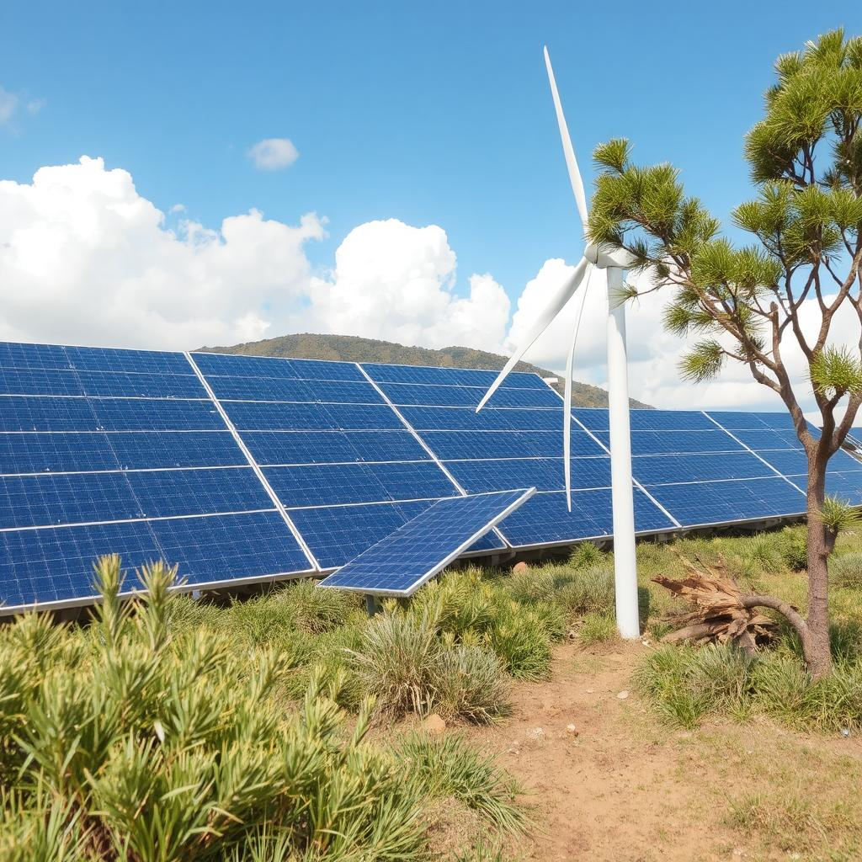

**Critical Analysis of Visualizations**

**on Renewable Vs Nonrenewable Energy Statistics in Australia**

|  |  |
| --- | --- |
| **Author** | Anirban Chakrabarty |
| **zlD** | z5626947 |
| **Course** | ZZBU6507-Data Visualization and Communication (H325 Online) |
| **Tutorial Time** | May - June 2025 |
| **Tutor** | Dr. Khimji Vaghjiani |
| **Date** | 2/June/2025 |

Contents

Presentation of Data Visualizations 3

1. Per Capita GDP vs Energy Consumption 3

2. Sector-Wise Consumption: Reusable vs Nonreusable Energy 4

Analysis and Critique 5

1. Per Capita GDP vs Energy Consumption 5

Design, Legibility, and Usability 5

Overall Efficacy 5

Recommendations 5

2. Sector-Wise Consumption: Renewable vs Nonrenewable 6

Design, Legibility, and Usability 6

Overall Efficacy 6

Recommendations 6

Self-Reflection 6

Conclusion 7

References 7

# Presentation of Data Visualizations

This interactive Tableau story explores renewable energy adoption in Australia using data from the Australian Energy Statistics – States and Territories (Department of Climate Change, Energy, the Environment and Water). The visualizations address key trends, disparities, and policy implications to support Australia’s low-carbon transition.

Aimed at policymakers and the public, the portfolio promotes transparency and awareness to drive behavioral and policy change. It combines dashboards, maps, and narratives for use in policy briefings or stakeholder pitches, spotlighting both achievements and areas needing action.

## Per Capita GDP vs Energy Consumption

This dual-axis chart compares GDP per capita (AU$) and energy consumption per capita (GJ) from 2003–04 to 2022–23. Bars show energy use, while a line represents GDP.

Over 20 years, energy use per capita fell by 15–20%—driven by efficiency gains, the rise of service industries, growth in rooftop solar, higher energy prices, and supportive policies. Meanwhile, GDP rose by ~20%, indicating higher energy productivity and reduced energy intensity.

## Sector-Wise Consumption: Reusable vs Nonreusable Energy

A stacked bar chart breaks down 2022–23 energy use by fuel type across five sectors (e.g., Transport, Residential), contrasting renewables (green: Solar, Wind, Biofuels) and fossil fuels (brown/grey: Coal, Petroleum).

Fossil fuels dominate the Energy Conversion and Supply sector, but renewables significantly contribute to electricity generation, leading to a -532 PJ surplus. Petroleum remains the main transport fuel. In mining and agriculture, renewables make up less than 25% of use, while manufacturing and commercial sectors reach 45%. Although residential use is low overall, nearly two-third comes from renewable sources.

# Analysis and Critique

These visualizations are well-suited to a public and policy-focused audience, offering clear design, interactivity, and alignment with themes of energy-economic dynamics and sectoral fuel usage.

## Per Capita GDP vs Energy Consumption

Design, Legibility, and Usability

The use of gold bars for energy and a red line for GDP ensures visual distinction. Dual y-axes are correctly aligned and clearly labelled. Typography and layout are strong, with well-positioned titles, legends, and axis labels. Interactive filters enhance user engagement and allow exploration by year.

However, the energy consumption y-axis starts at 200 rather than zero, which may visually exaggerate small changes. While intended to highlight trends, this could mislead less data-literate users. A brief annotation explaining this design choice would improve transparency.

Overall Efficacy

This chart communicates a key trend: while Australia’s GDP per capita has grown steadily since 2003–04, energy use per capita has declined since 2008. This indicates improved energy efficiency, economic restructuring, or greater reliance on renewables. The message supports the portfolio’s goal of highlighting sustainable progress and is relevant for both public and policy maker audiences.

Still, the visualization could benefit from more context. Tooltips could highlight key events (e.g., carbon tax in 2012) that influenced trends.

Recommendations

* Add annotations for key policies or economic events.
* Consider rescaling the y-axis or adding a disclaimer to reduce misinterpretation.
* Enable hover-to-compare and drill-down to explore regional trends.
* Add trendlines to visually emphasize the divergence between GDP and energy use.

## Sector-Wise Consumption: Renewable vs Nonrenewable

### Design, Legibility, and Usability

The color palette — green, teal for renewables, brown, grey for fossil fuels — aligns with user expectations and aids comprehension. Clear labelling supports readability. Filters for year and fuel type enhance user control and comparison.

However, vertically stacked format makes it difficult to compare individual fuels across sectors. Petroleum’s dominance visually overshadows smaller but important contributions from renewables. The negative value in “Energy Conversion and Supply” (e.g., –532 PJ) reflects net generation surplus, but it lacks explanation, which could confuse users.

### Overall Efficacy

This visualization illustrates Australia’s sectoral energy landscape effectively. Transport and energy supply rely heavily on fossil fuels, while residential energy is more renewable-based — insights that support behavioral nudges and policy design.

That said, the meaning of negative values and proportional differences across sectors could be clearer. Without supporting legends or tooltips, these nuances may be lost or misinterpreted.

### Recommendations

* Separate renewable and nonrenewable bars could be used for easier comparison.
* Add legends or tooltips to clarify negative values and their implications.
* Include brief sector-specific commentary to assist non-expert users.
* Allow drill-down into states or sub-sectors to enhance granularity and decision-making relevance.

# Self-Reflection

Feedback and course content significantly shaped this project. Initial drafts were dense and lacked interactivity. Applying principles from the course — like design heuristics, UX best practices, and color theory — led to clearer, more accessible dashboards.

Suggestions such as simplifying legends, enhancing year filters, and refining label placement were implemented to improve usability. Replacing technical terms with more familiar units (e.g., kAU$ instead of scientific notation) made the visualizations more relatable to non-technical audiences.

Targeting the right tone and level of complexity was also key. Course guidance helped shift the narrative from purely analytical to insight-driven, making the portfolio more impactful and accessible.

# Conclusion

Both visualizations contribute to a compelling, data-driven narrative on Australia’s renewable energy transition. The GDP vs Energy Consumption chart underscores the decoupling of economic growth from energy intensity, while the Sector-Wise Consumption chart reveals ongoing fossil fuel reliance and growing renewable uptake.

Together, they fulfill the portfolio’s mission: to inform, motivate, and support behavioral and policy shifts toward sustainability. Future refinements — improved layouts, contextual cues, and deeper interaction — will further elevate their power to inform and inspire.

References  
Department of Climate Change, Energy, the Environment and Water. *Australian Energy Statistics*

*– States and Territories*.  
<https://www.energy.gov.au/energy-data/australian-energy-statistics/states-and-territories>