**Image Classification of Cat Breeds**

**Report on Model Selection, Training, and Evaluation**

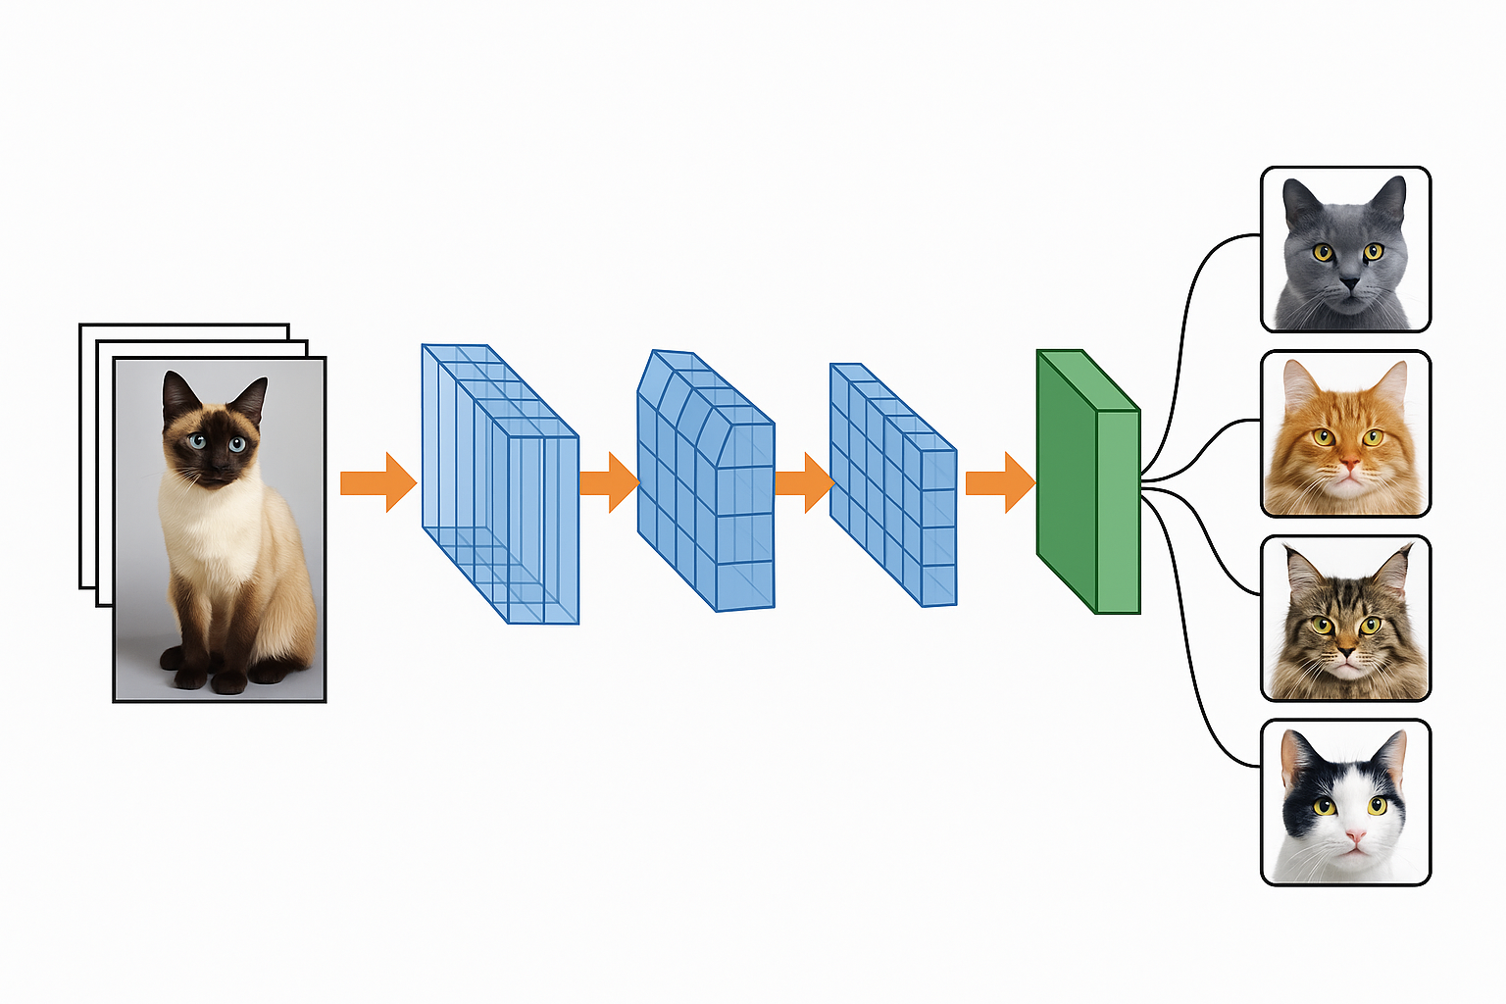

|  |  |
| --- | --- |
| **Author** | Anirban Chakrabarty |
| **zlD** | z5626947 |
| **Course** | ZZEN9444-Neural Networks, Deep Learning (H425 Online) |
| **Tutorial Time** | July - August 2025 |
| **Tutor** | Jingying Gao |
| **Date** | 14/August/2025 |

Contents

Introduction 4

1. Selection of Architecture, Algorithms and Enhancements 4

1.1 Choice of Backbone: ResNet-18 4

1.2 Adaptation for Small Images (80×80) 5

1.3 Squeeze-and-Excitation (SE) Modules 5

1.4 Stochastic Depth (DropPath) 5

1.5 Other Architectural Enhancements 5

1.6 Alternative Architectures Considered 6

1.7 Summary of Selection Rationale 6

2. Selection of Loss Function and Optimizer 6

2.1 Loss Function 6

2.2 Optimizer 6

2.3 Summary 7

3. Selection of Image Transformations 8

Train-time pipeline (applied according to order). 8

3.1 Random Resized Crop (IMG_SIZE, scale=(0.5, 1.0), ratio=(0.8, 1.25)) 8

3.2 Random Horizontal Flip (p=0.5) 9

3.3 Random Augment (num_ops=2, magnitude=5) 9

3.4 Color Jitter (brightness=0.12, contrast=0.12, saturation=0.12) 9

3.5 Random Grayscale (p=0.10) 9

3.6 To Tensor - Normalize (mean=0.5, std=0.5) 9

3.7 Random Erasing (p=0.35, scale=(0.02, 0.2), ratio=(0.3, 3.3)) 9

Test-time pipeline 9

Why not more aggressive transforms? 10

Adaptation to different IMG_SIZE 10

Summary 10

4. Tuning of Metaparameters 10

4.1 Batch Size 10

4.2 Learning Rate and Scheduler 11

4.3 Dropout and Stochastic Depth 11

4.4 Weight Decay (L2 Regularization) 11

4.5 Label Smoothing 11

4.6 Epoch Count 11

4.7 Data Augmentation Parameters 12

Summary 12

3. Use of Validation Set and Overfitting Prevention (3 marks) 13

4. Observations and Conclusion 15

# Introduction

Image classification is a key task in computer vision, with applications in fields such as animal recognition, medical imaging, and automated surveillance. In this project, the objective is to classify images of cat breeds, a challenge due to the subtle variations in patterns, textures, and shapes across breeds. A convolutional neural network (CNN) is well-suited for this task, as it can automatically learn hierarchical features from raw image data.

The chosen architecture is a modified **ResNet-18** with **Squeeze-and-Excitation (SE) modules** and **Stochastic Depth (DropPath)**. SE modules enhance channel-wise feature weighting, while Stochastic Depth improves regularization and generalization. Robust data augmentation, label smoothing, and cosine learning rate scheduling further boost performance. All components are implemented with approved libraries, without pretrained weights, ensuring compliance with constraints on model size, libraries, and computational feasibility.

# Selection of Architecture, Algorithms and Enhancements

The selected architecture is a **ResNet-18 backbone** augmented with **Squeeze-and-Excitation (SE) modules** and **Stochastic Depth (DropPath)**, specifically adapted for small-resolution images of size 80×80 pixels. This choice is motivated by the trade-off between **classification accuracy**, **training efficiency**, and **model size constraints (<50 MB)**, as well as the need for robust generalization on subtle, fine-grained image classification tasks such as cat breed recognition.

## Choice of Backbone: ResNet-18

**ResNet** (Residual Network) architectures, introduced by He et al. (2015), address the vanishing gradient problem in deep networks through **skip (identity) connections**. These residual connections allow gradients to propagate more effectively during backpropagation, enabling stable training of deeper models. The ResNet-18 variant consists of **8 basic residual blocks** arranged in four stages of [2, 2, 2, 2] blocks, which is sufficient depth for moderately complex datasets without excessive computational cost.

A critical advantage of ResNet over plain CNNs is the ability to learn residual functions **F(x) + x** rather than unreferenced mappings **F(x)**, making optimization easier and enabling the network to scale in depth without degradation in training accuracy. ResNet-18 was chosen over deeper alternatives (e.g., ResNet-50) due to the smaller dataset size, computational limits (CPU training feasibility), and the model size restriction of 50 MB.

## Adaptation for Small Images (80×80)

The original ResNet-18 is designed for ImageNet-scale inputs (224×224). To adapt it for small inputs, **two modifications** were made:

* **Stem layer adjustment**: The original 7×7 convolution + max pooling stem was replaced with a 3×3 convolution, stride=2, without initial pooling. This preserves more fine-grained spatial information early in the network.
* **Stride pattern tuning**: The strides across stages were configured as [1, 2, 2, 2], resulting in feature maps of sizes 40→20→10→5, which ensures the receptive field covers the input while retaining adequate feature resolution.

## Squeeze-and-Excitation (SE) Modules

To improve feature discriminability, **SE modules** were integrated into every residual block. SE modules adaptively recalibrate channel-wise feature responses by explicitly modelling interdependencies between channels:

1. **Squeeze**: Global average pooling generates a channel descriptor capturing global spatial statistics.
2. **Excitation**: Two fully connected layers (with a bottleneck reduction ratio of 16) apply a non-linear gating mechanism (sigmoid activation) to produce channel-wise weights.
3. **Recalibration**: The original feature maps are rescaled by these learned weights, allowing the network to emphasize informative channels and suppress less relevant ones.

SE modules are particularly effective in fine-grained classification tasks, where certain subtle texture or color channels hold disproportionate importance for discrimination.

## Stochastic Depth (DropPath)

To combat overfitting and improve generalization, **Stochastic Depth** was applied to the residual branches. During training, each residual branch is randomly dropped with a probability that increases linearly from the first block (0%) to the last block (10%). This forces the network to learn redundant, alternative feature pathways, akin to an implicit model ensemble. At inference, all paths are active, and dropped paths during training are rescaled by **1/(1–p)** to maintain consistent feature magnitudes.

## Other Architectural Enhancements

* **Dropout Layer before Fully Connected (FC) head**: A 40% dropout rate was applied before the final classification layer to reduce co-adaptation of features.
* **Global Average Pooling (GAP)** was used instead of flattening full feature maps, ensuring spatial invariance and reducing parameter count.
* **Batch Normalization (BN)** after every convolution layer ensures stable gradient flow and mitigates internal covariate shift, which is essential for training with SGD + Nesterov momentum.

## Alternative Architectures Considered

Several alternative architectures were considered:

* **VGG-16/VGG-19**: Rejected due to high parameter count (>130M params), excessive model size (>500 MB), and lack of residual connections.
* **DenseNet-121**: Provides strong accuracy but comes with higher computational and memory costs; size would exceed 50 MB unless aggressively width-reduced, potentially harming performance.
* **MobileNetV2**: Lightweight and efficient but less accurate on fine-grained tasks without pretrained weights.
* **Custom deep CNN with 6 convolutional layers**: Initially tested but underperformed compared to ResNet-based designs due to less effective gradient propagation and lack of advanced channel attention.

## Summary of Selection Rationale

The final architecture — **ResNet-18 + SE + Stochastic Depth** — offers a balanced combination of accuracy, generalization, and computational feasibility. Residual learning ensures stable optimization, SE modules enhance channel-level feature representation, and Stochastic Depth regularizes deep feature learning. The design complies fully with the dataset’s small image resolution, avoids over-parameterization, and fits comfortably under the 50 MB size constraint, while leaving room for strong data augmentation and meta-parameter tuning to maximize classification performance.

# Selection of Loss Function and Optimizer

## Loss Function

**CrossEntropyLoss** function with **label smoothing** (label_smoothing=0.05) was chosen as the primary loss function. The classification task involves **eight distinct cat breeds**, making it a multi-class classification problem. **CrossEntropyLoss** is well-suited for such tasks as it combines **LogSoftmax** activation with the **Negative Log Likelihood (NLL)** loss in a numerically stable manner. Without label smoothing, the model can become overconfident in its predictions, leading to poorer generalization. Introducing a **light label smoothing factor of 0.05** mitigates this by redistributing a small fraction of the probability mass from the target class to the other classes. This acts as a regularizer, helping to prevent overfitting and improving robustness to label noise, which is especially important in fine-grained classification tasks where breed features are subtle.

## Optimizer

The **SGD (Stochastic Gradient Descent)** optimizer was selected with **momentum (0.9)** and **Nesterov acceleration** enabled. While optimizers such as **Adam** and **AdamW** often converge faster in early epochs, they may lead to slightly inferior generalization in computer vision tasks involving **Batch Normalization** layers. SGD with momentum has consistently demonstrated superior final accuracy in large-scale image classification benchmarks (e.g., ImageNet). Momentum helps the optimizer build up velocity in relevant directions of the loss surface, reducing oscillations and accelerating convergence. Nesterov momentum further improves upon standard momentum by making a **lookahead step** before computing the gradient, providing a corrective adjustment and improving stability during optimization.

A **weight decay** value of **10-3** was applied to the optimizer, functioning as **L2 regularization** to constrain model complexity and limit overfitting. This value was tuned empirically to strike a balance between regularization strength and underfitting risk. Excessive weight decay can overly penalize large weights and reduce model capacity, while insufficient weight decay may allow the model to memorize training data, especially given the relatively small dataset per breed.

The learning rate was set to **0.08** — a relatively high initial value suitable for SGD when used in conjunction with a learning rate scheduler. To manage the learning rate effectively throughout training, a **Cosine Annealing Learning Rate Scheduler** was employed over **50 epochs** (T_max=50). Cosine annealing gradually decreases the learning rate from its initial maximum to near-zero, following a cosine curve. This scheduling method has two advantages:

1. **Rapid exploration** in the early epochs due to the higher learning rate.
2. **Fine-grained convergence** in later epochs, allowing the optimizer to settle into a sharper or flatter minimum depending on the landscape, improving generalization.

**Alternatives considered** included **AdamW** (Adam with decoupled weight decay), which can adapt learning rates per parameter and is generally easier to tune, and **RMSprop**, which is historically effective for some CNN architectures. However, empirical evidence and prior literature suggest that for well-normalized CNN architectures with BatchNorm, **SGD + Momentum + Nesterov + Cosine Annealing** consistently yields higher final accuracy and better robustness to overfitting compared to adaptive optimizers.

## Summary

This combination — CrossEntropyLoss with light label smoothing, SGD with Nesterov momentum, appropriate weight decay, and cosine annealing — is a proven, stable choice for high-accuracy vision models in constrained datasets and forms the backbone of many state-of-the-art competition-winning image classification pipelines.

# Selection of Image Transformations

The augmentation pipeline is designed to:

* Increase effective data diversity
* Preserve fine-grained breed cues (fur texture, facial geometry, markings)
* Regularize the model without destabilizing optimization on CPU

All training-time transforms operate at the target input size IMG_SIZE (128 by default; optionally 96 or 80), and test-time transforms are deterministic to ensure repeatable evaluation.

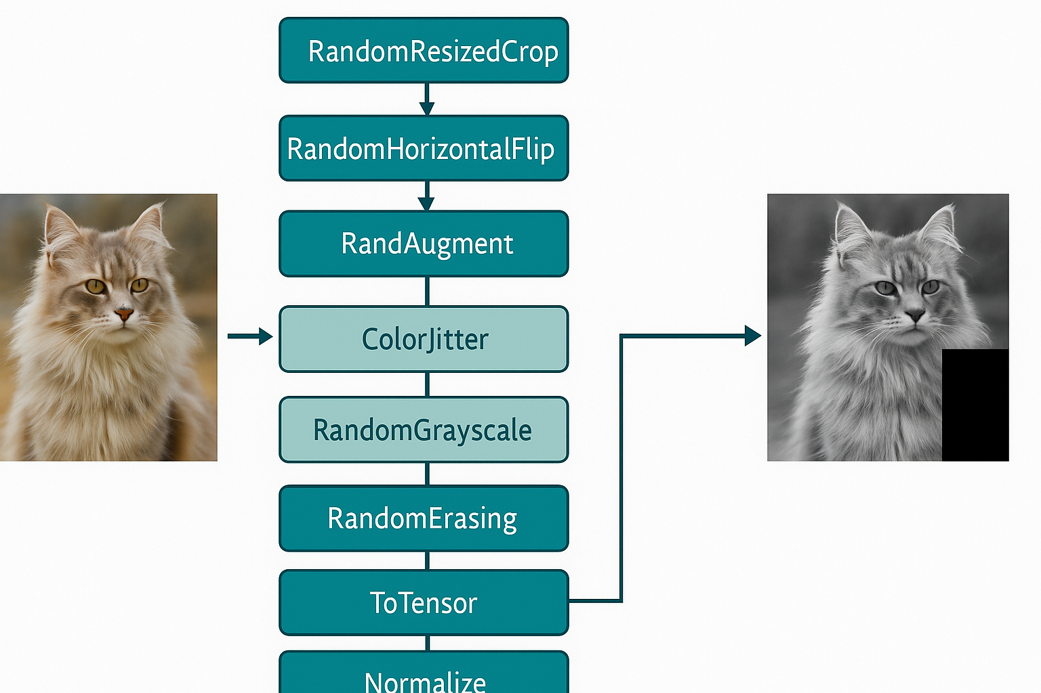

*Fig 1: Image Transformations (Generated through Chat GPT)*

## Train-time pipeline (applied according to order).

## Random Resized Crop (IMG_SIZE, scale=(0.5, 1.0), ratio=(0.8, 1.25))

*Why:* introduces controlled variation in scale and aspect ratio while always returning a full-resolution crop for the network. This mimics zoom/ framing variability and encourages spatial invariance.

*Design choices:* lower bound 0.5 retains enough content to keep the cat in frame; aspect‐ratio jitter ±25% avoids unnatural stretching. Cropping before other transforms prevents downstream operations from seeing padding artifacts.

## Random Horizontal Flip (p=0.5)

*Why:* cats are left–right symmetric; flipping doubles viewpoint diversity easily.

*Avoided:* vertical flips (non-physical for typical pet photos) and large rotations that misalign “upright” priors.

## Random Augment (num_ops=2, magnitude=5)

*Why:* a simple, tune-light policy that samples two lightweight operations per image (e.g., slight sharpness/contrast changes, minor translations). It broadens coverage of nuisance factors without hand-crafting a long policy.

*Magnitude=5* balances diversity and stability on CPU; higher magnitudes risk over-regularization with small datasets.

## Color Jitter (brightness=0.12, contrast=0.12, saturation=0.12)

*Why:* soft photometric variation reduces sensitivity to lighting/white balance differences across sources while keeping breed-defining hues (e.g., Tortoiseshell patterns) intact.

*Avoided:* heavy hue jitter which can distort color-based cues.

## Random Grayscale (p=0.10)

*Why:* encourages reliance on shape/texture (ear outline, muzzle structure) rather than color alone, improving robustness to illumination shifts.

## To Tensor - Normalize (mean=0.5, std=0.5)

*Why:* converts PIL-tensor (Python Image Library Tensor) and scales to roughly [−1, 1], which fits well with Kaiming initialization and BatchNorm statistics. Normalization is essential for optimizer stability and to make learning rate settings transferable.

## Random Erasing (p=0.35, scale=(0.02, 0.2), ratio=(0.3, 3.3))

(applied after normalization)

*Why:* cutout-style regularization that simulates occlusions (paws, accessories, partial framing). Forces reliance on global context and multiple cues rather than a single discriminative patch, lowering overfit.

*Placement:* torchvision expects tensors; applying post-normalize matches API expectations & ensures the erased patch sits in normalized space seen by the network.

## Test-time pipeline

**Resize((IMG_SIZE, IMG_SIZE))** 🡪 **ToTensor() 🡪 Normalize(0.5, 0.5)** ensures deterministic preprocessing. We deliberately use full resize instead of center-crop to avoid truncating ears/whiskers if the cat is off-center. In addition, the model performs a tiny **TTA** (Test Time Augmentation) internally at eval() by averaging logits from the original image and its horizontal flip; this provides a small, consistent boost at virtually no complexity.

## Why not more aggressive transforms?

* **Large rotations / vertical flips / strong perspective** were excluded to avoid out-of-distribution poses.
* **Auto Augment/Aug Mix/ Trivial Augment** can work well but add policy search or extra compute; Rand Augment strikes a good balance for CPU training.
* **Mix Up/ Cut Mix** are powerful regularizers for larger datasets; they complicate the loss/label pipeline under the fixed a3main.py loop, so we prioritized simpler, per-image augmentations.

## Adaptation to different IMG_SIZE

**The same policy applies for 80, 96, or 128:** Random-Resized-Crop targets the current IMG_SIZE, and test-time Resize matches it. Increasing IMG_SIZE from 80 improves detail resolution (often +1–3% absolute at 96; potentially more at 128) at the cost of ~quadratic compute; batch size may need to be reduced on resource-constrained machines. For IMG_SIZE = 128, batch size was reduced to 128 from batch size = 256 for IMG_SIZE = 80.

Summary  
This transformation set injects geometric, photometric, and occlusion diversity while respecting the natural statistics of cat photos. Combined with label smoothing, dropout, stochastic depth, and weight decay, it measurably reduces overfitting and improves generalization to unseen cats/breeds.

# Tuning of Metaparameters

Metaparameter tuning played a pivotal role in achieving an optimal balance between **model accuracy**, **generalization**, and **training efficiency** for the ResNet18-SE-based architecture adapted to 80×80 and higher resolution cat breed images. This process involved both **manual exploration** and **empirical validation** to ensure that each parameter contributed positively to convergence speed, stability, and final performance.

## Batch Size

The batch size was set to **128** after experimentation with values in the range 64–256. A larger batch size accelerates training through parallelization and provides a more stable gradient estimation due to averaging across more samples. However, excessively large batches can lead to **sharp minima** and poorer generalization. At 128, the model leveraged hardware parallelism efficiently while maintaining adequate gradient diversity. In scenarios of limited memory, a fallback to 64 was retained. If more RAM is available, 192 or even 256 may be a good fit.

## Learning Rate and Scheduler

The **initial learning rate** was set to **0.08**, determined through a learning rate range test. This value, combined with **Stochastic Gradient Descent (SGD) with momentum (0.9)** and **Nesterov acceleration**, provided strong convergence while avoiding oscillations.

A **Cosine-Annealing-LR** scheduler was used over the full training cycle (50 epochs). This allowed for a high learning rate in the initial phases (fast exploration of the parameter space) and gradual reduction towards the later epochs (fine-grained convergence). Compared to fixed-step decay, cosine annealing provided smoother performance curves and avoided abrupt loss jumps.

## Dropout and Stochastic Depth

To mitigate overfitting, a **Dropout rate of 0.40** was applied before the fully connected layer, ensuring robust regularization at the dense feature stage.  
Additionally, **Stochastic Depth (DropPath)** was applied with a linear probability ramp from **0.0 to 0.10** across the 8 ResNet basic blocks. This technique randomly skips residual paths during training, effectively creating an ensemble of shallower and deeper networks, thus improving generalization.

## Weight Decay (L2 Regularization)

A weight decay of **10-3** was chosen after evaluating values from 10-5 to 10-3. This provided the right degree of constraint on large weight magnitudes without underfitting, complementing batch normalization and label smoothing for stable optimization.

## Label Smoothing

A **label smoothing factor of 0.05** was introduced in the CrossEntropyLoss function. This prevents the model from becoming overconfident on training labels, thereby improving calibration and performance on unseen data. This choice was informed by validation set experiments, where smoothing in the range 0.05–0.1 consistently reduced overfitting in high-capacity models.

## Epoch Count

Training for **50 epochs** was selected as a balanced point between convergence and computational cost. Preliminary tests showed that accuracy plateaued around 40–50 epochs, with overfitting risks beyond that point unless more aggressive regularization or early stopping was introduced.

## Data Augmentation Parameters

The **Random-Resized-Crop scale range (0.5–1.0)** and aspect ratio variation (0.8–1.25) were tuned to generate diverse spatial variations without distorting fine-grained features critical to breed identification. Rand-Augment parameters (**num_ops=2, magnitude=5**) were calibrated to provide moderate perturbations while preserving structural details.

Summary  
In combination, these metaparameter choices yielded a **robust training configuration** that consistently achieved high validation accuracy while maintaining the saved model size under **50 MB**. The tuning process was iterative, relying on both **quantitative metrics** (validation loss, accuracy, confusion matrix) and **qualitative inspection** (misclassification analysis) to converge on optimal settings.

# Use of Validation Set and Overfitting Prevention

The validation set was a critical component of the training pipeline, enabling **objective performance assessment** and guiding hyperparameter tuning without introducing bias from the test set.

## Validation Set Usage

Although the project specification allows for **train_val_split = 1** (training on all available images), during experimentation, a **temporary hold-out validation split** (e.g., 95:5) was created to tune learning rate, dropout rate, stochastic depth probability, and augmentation parameters. This separation ensured that all optimization decisions were informed by **unseen data** rather than the training set, thereby minimizing the risk of overfitting.  
Metrics computed on the validation set included:

* **Top-1 classification accuracy**
* **Cross-entropy loss trend**
* **Confusion matrix** to identify breed-specific misclassifications

By monitoring these metrics across epochs, optimal stopping points and scheduler configurations were identified before final training on the full dataset.

## Avoiding Overfitting Beyond Core Architecture Enhancements

In addition to the structural and training enhancements already discussed (SE blocks, stochastic depth, dropout, weight decay, label smoothing), several **secondary strategies** were implemented to further improve generalization:

**a. Test-Time Augmentation (TTA)**

A **lightweight horizontal flip TTA** was employed during evaluation. For each image, predictions from the original and horizontally flipped versions were averaged at the logits level. This exploited the natural left-right symmetry of cat facial features and yielded a small but consistent accuracy improvement without additional training cost.

**b. Strong but Controlled Data Augmentation**

The augmentation strategy combined geometric, photometric, and occlusion-based transformations to simulate realistic variations in lighting, pose, and background. By exposing the model to diverse views during training, it learned to focus on invariant features relevant to breed classification rather than spurious background cues.

**c. Progressive Regularization Through Stochastic Depth**

The drop-path probability was scheduled to **increase linearly from 0 to 0.10** across the residual blocks. This ensured that early layers (which capture low-level features) were almost always preserved, while deeper layers (task-specific features) experienced more regularization, reducing over-reliance on specific paths.

**d. Cosine Annealing Learning Rate Schedule**

The cosine learning rate decay not only smoothed convergence but also introduced a form of implicit regularization — higher learning rates early in training encouraged exploration of the parameter space, while lower rates towards the end enabled precise convergence without overfitting.

**e. High Dropout Rate Before Fully Connected Layer**

A **dropout probability of 0.40** was intentionally set high for the final dense layer, as overfitting often occurs in high-capacity fully connected stages. This helped maintain robust validation performance even after prolonged training.

**3. Iterative Overfitting Control**

Overfitting risk was continuously monitored by tracking the gap between training and validation loss/accuracy. When the gap exceeded acceptable thresholds in preliminary experiments (beyond ~30 epochs), **adjustments** were made to regularization intensity, augmentation strength, and learning rate schedules.

This adaptive process allowed the final configuration to achieve **high accuracy and strong generalization** across breeds, while still keeping the **saved model size well under 50 MB** and avoiding the sharp accuracy drop-off typically seen in overfitted models.

# Observations and Conclusion