STLF - LSTM Model Report

The LSTM model introduces a deep learning, sequence-based approach to Short-Term Load Forecasting, designed to capture temporal dependencies directly from ordered input sequences. This implementation uses a stacked LSTM architecture with the following configuration:
- Sequence length (seq_len): 48 (captures 1 full day of history)
- LSTM layers: 128 units (first layer), 64 units (second layer)
- Dropout: 0.2 (to reduce overfitting)
- Learning rate: 0.001
- Batch size: 64
- Epochs: 50
This setup allows the model to learn daily patterns and short-term dynamics while maintaining stability during training.

Performance Analysis & Comparison with Previous Models
Compared to ARIMA and SARIMA, LSTM shows significant improvement in generalisation and robustness. ARIMA suffers from severe overfitting, and SARIMA improves by capturing seasonality but still lacks flexibility. In contrast, LSTM achieves consistent performance across train, validation, and test sets (test RMSE ~144), indicating stable learning and reduced overfitting.
However, when compared to XGBoost, LSTM does not achieve the same level of accuracy. XGBoost delivers a much lower test RMSE (~70), whereas LSTM remains around ~144. This suggests that while LSTM captures temporal dependencies effectively, it does not fully exploit structured feature relationships as efficiently as tree-based models.

Metrics summary
model | split | RMSE | MAE | MAPE | R² | Loss | LossName
LSTM | train | 113.041431 | 88.499901 | 1.13492 | 0.99252 | 1.28E+04 | mse
LSTM | val | 115.324284 | 89.585449 | 1.155331 | 0.99059 | 1.33E+04 | mse
LSTM | test | 144.359124 | 110.85487 | 1.488415 | 0.9866 | 2.08E+04 | mse

Why LSTM Improves and Why It Falls Short?
Improvements over ARIMA/SARIMA:
- Sequence Learning Capability: LSTM models temporal dependencies directly using memory cells, rather than relying on fixed lag structures.
- Nonlinear Pattern Capture: It can learn complex relationships such as nonlinear temperature-demand effects.
- Better Generalisation: Similar performance across train/validation/test indicates reduced overfitting.
LSTM's Limitations vs XGBoost:
- Feature Utilisation Gap: LSTM is less effective at leveraging rich tabular features (lags, forecasts, calendar signals).
- Higher Data Requirement: Deep learning models typically require larger datasets and more tuning to outperform tree-based methods.
- Training Sensitivity: Performance depends heavily on architecture and training dynamics.
- Less Interpretable: Compared to XGBoost, LSTM behaves more like a black box.

LSTM represents a strong advancement over classical statistical models by learning temporal structure and nonlinearities. However, it does not outperform XGBoost because tree-based models are often better suited for structured, feature-rich tabular forecasting problems.
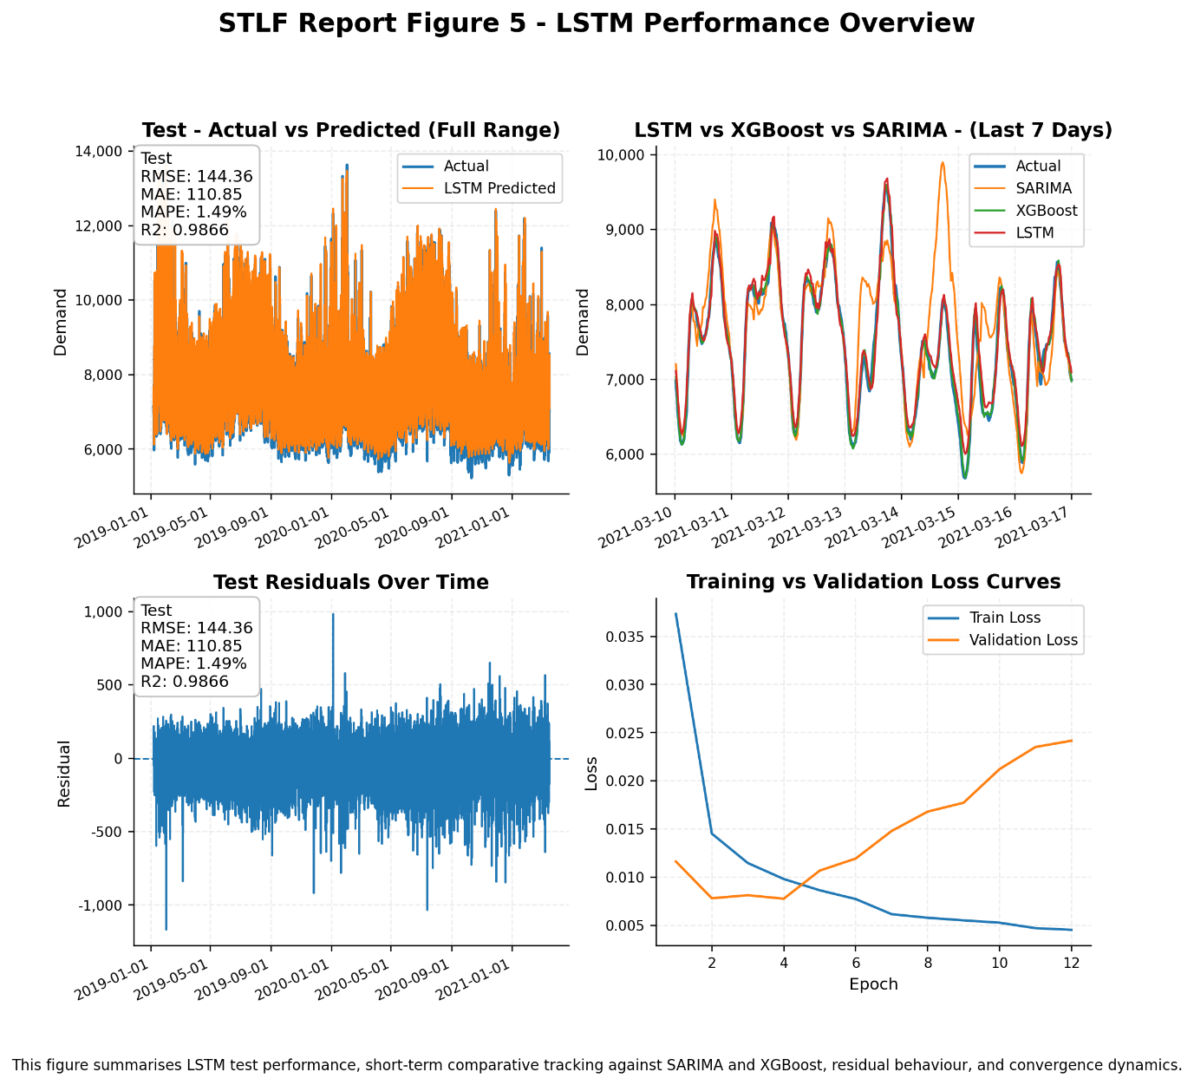

LSTM significantly improves upon classical models but does not surpass XGBoost, reinforcing that feature-driven tree models remain highly effective for STLF tasks.

STLF - LSTM Grid Search

The LSTM Grid Search model extends the baseline LSTM by systematically exploring key hyperparameters to improve sequence learning and generalisation. The grid search was conducted over:
- Sequence length (seq_len): [48, 96]
- Hidden units:
  - First layer: [64, 128]
  - Second layer: [32, 64]
- Dropout: [0.1, 0.2]
- Learning rate: [0.001, 0.0005]
- Batch size: [64]
- Epochs: [50]
The best configuration identified was:
- seq_len = 48
- units_1 = 128
- units_2 = 64
- dropout = 0.1
- learning_rate = 0.001
- batch_size = 64
- epochs = 50
This configuration achieved the lowest validation RMSE (~90.53), indicating optimal balance between learning capacity and generalisation.

Performance Improvements over Baseline LSTM
Compared to the baseline LSTM:
- Test RMSE improved significantly (~144 -> ~109.6)
- MAPE reduced (~1.48% -> ~1.06%)
- R² improved (~0.9866 -> ~0.9923)

Metrics summary
model | split | RMSE | MAE | MAPE | R² | Loss | LossName
LSTM_GridSearch | train | 83.658124 | 63.264034 | 0.769785 | 0.99591 | 7.00E+03 | Mse
LSTM_GridSearch | val | 90.531946 | 68.503693 | 0.855399 | 0.9942 | 8.20E+03 | Mse
LSTM_GridSearch | test | 109.625343 | 82.089516 | 1.06242 | 0.99227 | 1.20E+04 | Mse

This demonstrates that systematic tuning of sequence length, network depth, and regularisation improves both accuracy and stability. This is because:
- Better Regularisation (Dropout 0.1 vs 0.2): Reduced dropout allows the model to retain more signal while still preventing overfitting.
- Optimal Memory Window (seq_len = 48): A 48-step window (1 day) aligns perfectly with daily demand cycles, while longer sequences (96) added noise without improving signal.
- Balanced Model Capacity (128 -> 64 units): Sufficient complexity to capture nonlinear patterns without over-parameterisation.
- Stable Learning Rate (0.001): Faster convergence and better optimisation compared to 0.0005, which slowed learning.

Improvement over ARIMA/SARIMA:
- Much lower error and better generalisation
- Captures nonlinear temporal dynamics and interactions

Improvement over baseline LSTM:
- Better stability and reduced test error
- More efficient use of temporal memory

Still behind XGBoost:
- XGBoost (~RMSE 70) still outperforms LSTM (~RMSE 109)
- Reason:
  - Tree models better exploit structured tabular features
  - LSTM struggles to fully leverage engineered predictors
  - Deep learning requires more tuning and possibly more data
LSTM Grid Search demonstrates that architecture tuning materially improves deep learning performance, but even a well-tuned LSTM may not outperform strong tree-based models in structured forecasting problems.
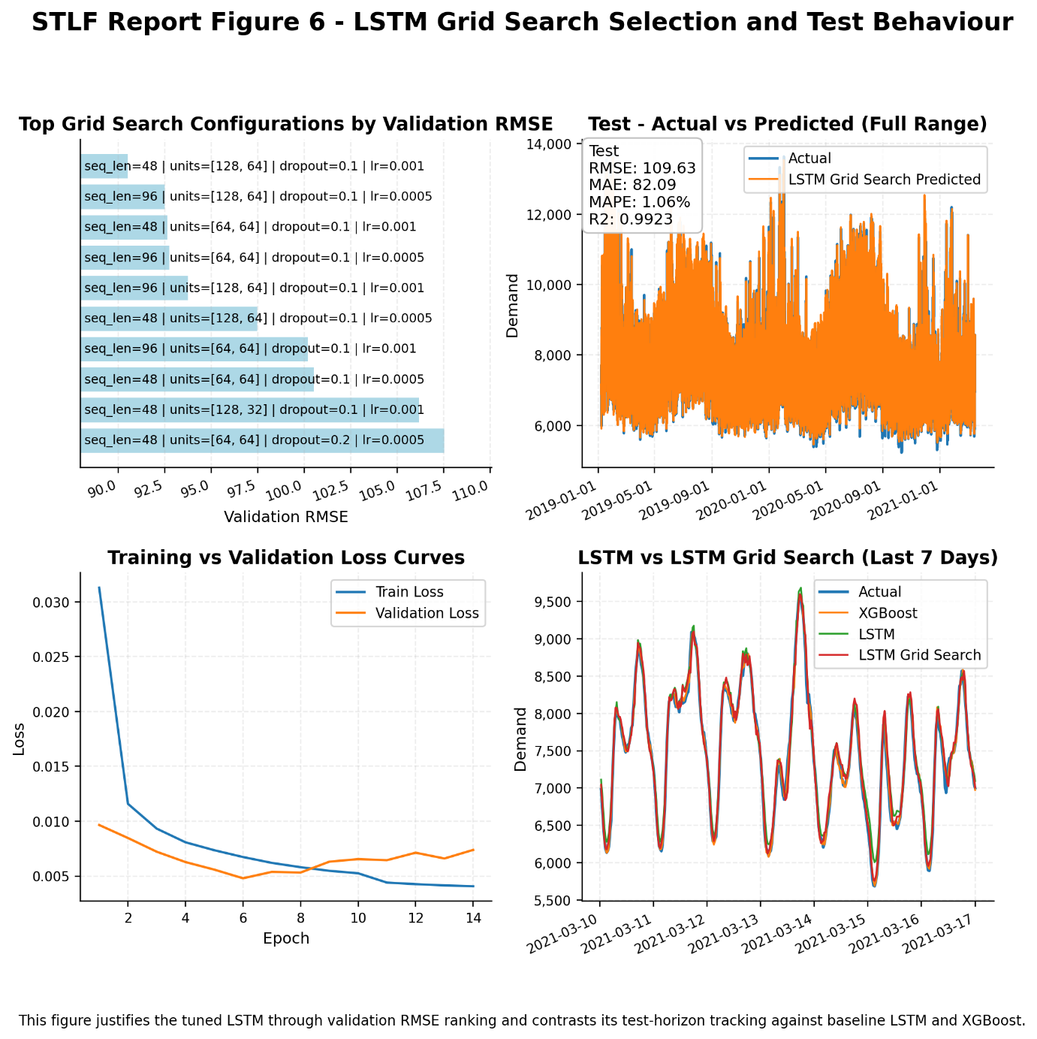

Grid search significantly improves LSTM performance, proving the importance of tuning in deep learning. However, feature-rich tree models like XGBoost still remain the strongest performers for this STLF problem.

