Contents
1. Primary Data Acquisition, Cleaning and Validation 2
2. Exploratory Data Analysis (EDA) 3
2.1 Temporal Relationship between Temperature and Electricity Demand 3
2.2 Non-linear Relationship between Temperature and Demand 3
2.3 Average Intraday Demand Patterns 4
2.4 Weekly Demand Patterns and Workweek Effects 4
2.5 Hourly–Weekly Demand Interaction Patterns 4
2.6 Seasonal Demand and Temperature Trends 5
2.7 Seasonal Demand and Temperature Trends 5
2.8 Weekly Forecast and Intraday Variability 5
2.9 Monthly Forecast and Trend Alignment 6
2.10 Correlation Analysis of Demand, Forecast and Forecast-Error 6
3. Feature Engineering 7
3.1 Adding Public Holidays and Creating Weekend Indicator 7
3.2 Time-based Feature Transformation 7
3.3 Forecast Error Features 7
3.4 Covid-19 Lockdown Indicator 7
3.5 Feature Organisation and Dataset Structuring 7
3.6 Lag and Rolling Features for Demand and Temperature 8
3.7 Interaction Features 8
3.8 External Features: Macroeconomic and Energy Related 10
3.9 Feature Selection Strategy based on Importance & Correlation Analysis 12
3.10 Preprocessing Data: Normalization and Encoding 13
4. Data Sources and References 14
5. Acknowledgement of Generative AI Usage 17

Primary Data Acquisition, Cleaning and Validation
The dataset was constructed by integrating electricity demand, temperature, and forecast demand data obtained from the Endgame Economics GitHub repository and the National Electricity Market (NEM) datasets published by the Australian Energy Market Operator (AEMO, n.d.; Endgame Economics, n.d.).
Each dataset was loaded using pandas, and irrelevant attributes such as REGIONID and LOCATION were removed to retain analytically meaningful variables. The time series spans from 1 January 2010 to 18 March 2021, with a 30-minute interval frequency (48 observations per day).
A comprehensive validation process confirmed:
- Complete timestamp continuity
- No duplicate records
- No missing values
- Accurate alignment across datasets
Missing values in temperature and forecast datasets were handled using time-based interpolation, while demand data was verified to be complete.
The final dataset includes:
- TOTALDEMAND (target variable)
- DATETIME (time index)
- TEMPERATURE
- LAST_FORECAST_DEMAND
- AVERAGE_FORECAST_DEMAND
These preprocessing steps ensure a clean, temporally consistent, and model-ready dataset.
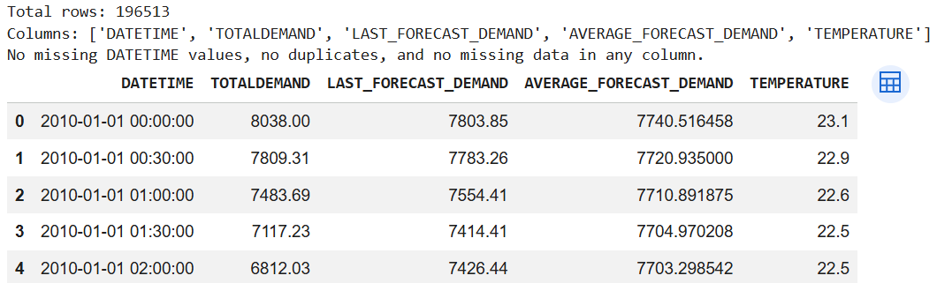
Figure 1: Dataset Structure, Validity Checks, and Sample Records

Exploratory Data Analysis (EDA)
Exploratory Data Analysis was undertaken to understand the underlying structure, temporal patterns, and relationships within the dataset. Given the time-series nature of electricity demand, particular emphasis was placed on identifying seasonality, trends, and the influence of temperature on demand.

Temperature-Demand Relationship
To examine how electricity demand responds to weather, a dual-axis time-series visualization was created. Temperature was shown in segmented colour bands (cold, comfortable, hot), while demand was plotted on a separate axis in the same panel, ensuring clear, non-overlapping comparison with aligned timelines. (BoM, n.d.)
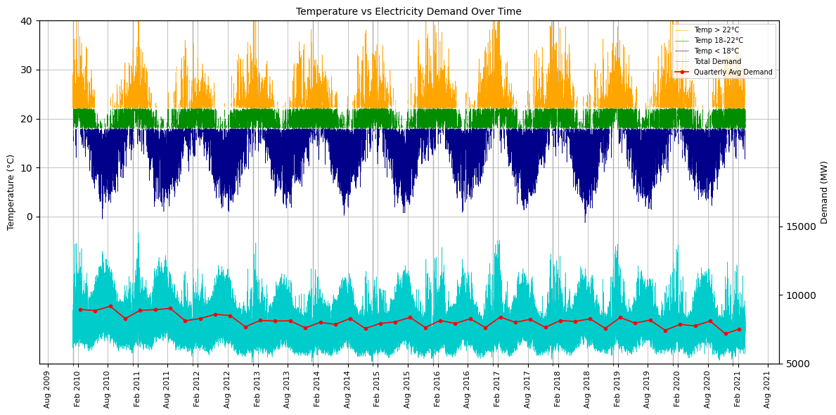
Figure 2: Temperature vs Electricity Demand over Time
This highlights a clear non-linear relationship between temperature and electricity demand. Demand rises during extreme temperatures (both hot and cold) due to increased cooling and heating usage, while remaining relatively stable in the comfortable range (18–22°C). Seasonal patterns are evident, with recurring peaks in summers and winters, confirming temperature as a key driver of demand.

Non-linear Relationship of Temperature vs Demand
A scatter plot of temperature versus electricity demand was used to examine their relationship, with data segmented into cold, comfortable, and hot ranges. Quadratic and spline models were fitted to capture underlying patterns. The results show a clear U-shaped relationship, with higher demand at extreme temperatures and lower demand in moderate conditions, confirming strong non-linearity (EIA, n.d.). | 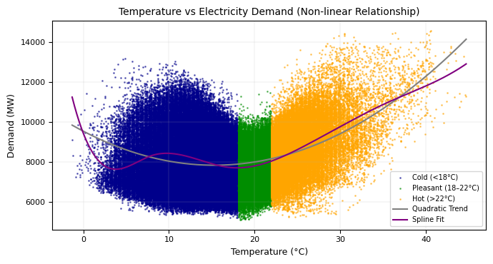  Figure 2: Temperature-Demand Non-linearity

Intraday Demand Patterns
Demand troughs occur in early morning (2–5 AM) when most people are asleep and industrial activity is minimal. Demand rises after 6 AM as households wake, peaking mid-morning. A secondary peak in the evening (6–8 PM) reflects residential usage—cooking, lighting, and cooling/heating—before declining again as activity reduces overnight. | 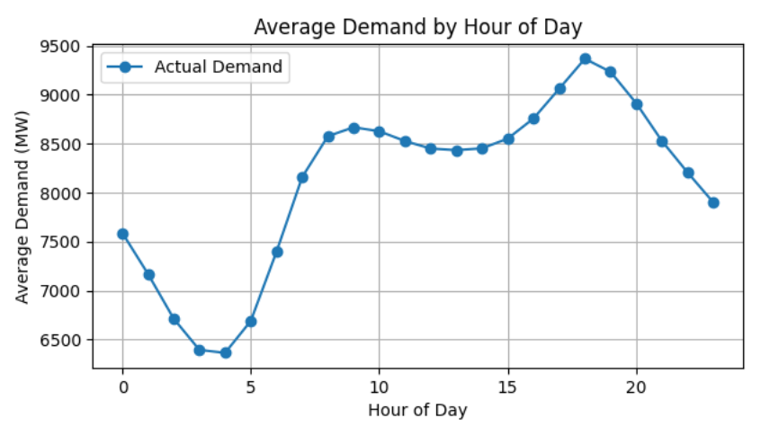  Figure 3: Average Demand by Hour of Day

Weekly Demand Patterns
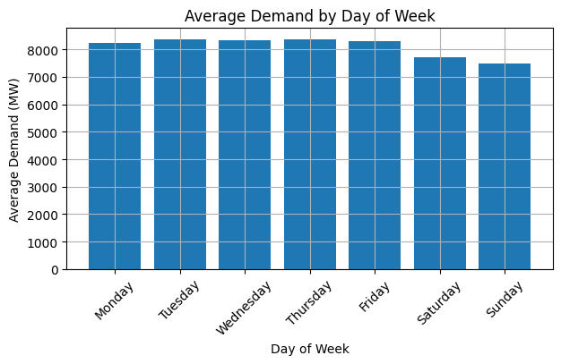  Figure 4: Average Demand by Day of Week | Average electricity demand remains relatively high and stable from Monday to Friday, reflecting consistent commercial, industrial, and institutional activity during the workweek. A noticeable decline occurs over the weekend, particularly on Sunday, due to reduced business operations and lower overall activity levels. This pattern highlights the strong influence of economic and social routines on electricity consumption.

Demand Pattern across Hours of the Week
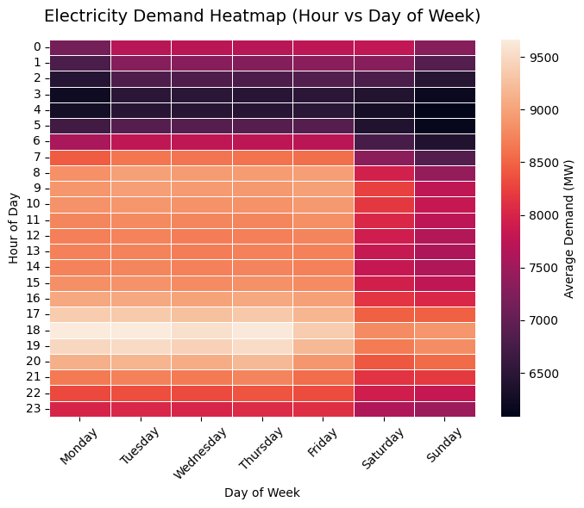  Figure 5: Electricity Demand Heatmap by Hour and Day | The heatmap reveals intra-day and weekly demand patterns. Demand is lowest during early hours (2–5 AM) across all days and rises steadily from morning to evening. Peak demand consistently occurs in the late afternoon and early evening (17:00–20:00). Weekdays exhibit higher demand intensity compared to weekends, reflecting commercial activity, while weekends show relatively muted peaks. This visualization highlights strong temporal regularity, reinforcing the importance of both hour-of-day and day-of-week features in forecasting models.

Seasonal and Temperature Dependent Demand Trends
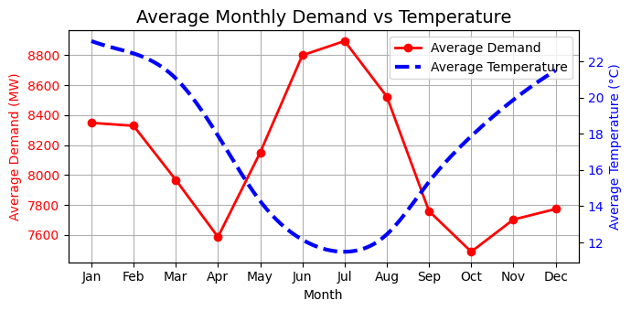
Figure 6: Monthly Demand vs Temperature
The monthly analysis highlights a clear seasonal relationship between temperature & demand. Demand peaks during summer (Jan–Feb) and winter (Jun–Jul), corresponding to higher cooling/ heating needs. While, is lowest during mild months (Apr–May, Sep–Oct). Inverse temperature vs demand movement during transitional seasons further confirms a U-shaped relationship, emphasizing strong influence of seasonal weather patterns on electric consumption. (BoM, n.d.) | 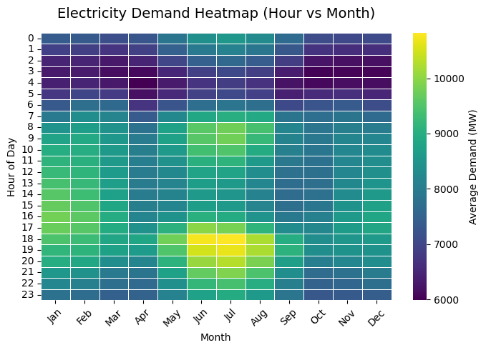  Figure 7: Electricity Demand Heatmap by Hour and Month

Validating AEMO Forecast Demand over a Sample 1 Week Cycle
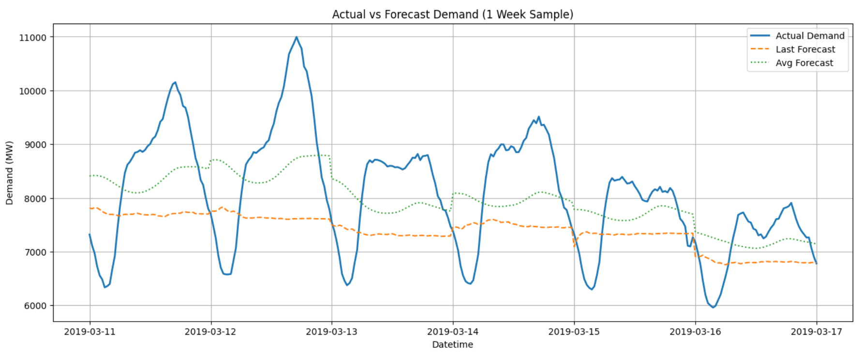
Figure 8: Actual vs Forecast Demand (1 Week Comparison)
A one-week sample comparison between actual demand and AEMO forecast values highlights discrepancies in both magnitude and temporal patterns. While forecasts capture general trends, they fail to accurately reflect peak and trough variations. This validation step helps identify inconsistencies and assess forecast reliability before downstream modelling.

Monthly Forecast and Demand Trend Alignment
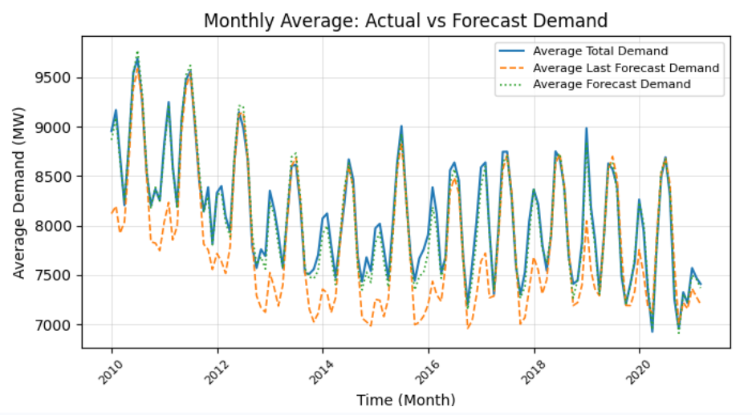
Figure 9: Monthly Average Actual vs Forecast Demand
The monthly comparison reveals that the provided demand forecasts perform poorly in capturing actual demand levels. While they loosely follow the general direction of demand, they fail to accurately represent magnitude and variability across months. Significant deviations are observed throughout the timeline, indicating weak alignment with actual patterns. Although some long-term trends are faintly reflected, the forecasts lack precision and consistency, making them unreliable predictors even at an aggregated monthly level.

Correlation Analysis of Demand, Forecast and Forecast-Error
The correlation heatmap highlights relationships between actual demand, forecast values, temperature, and forecast error. Actual Demand shows only a moderate correlation with Demand Forecast, indicating limited predictive capability. Temperature has a weak linear relationship with demand, suggesting underlying non-linear effects. Forecast Error is positively correlated with demand, implying larger errors during high demand periods. The negative relationship between forecast and error indicates systematic inaccuracies. Overall, the results reinforce that simple linear relationships are insufficient, motivating the use of more advanced, non-linear modelling techniques. | 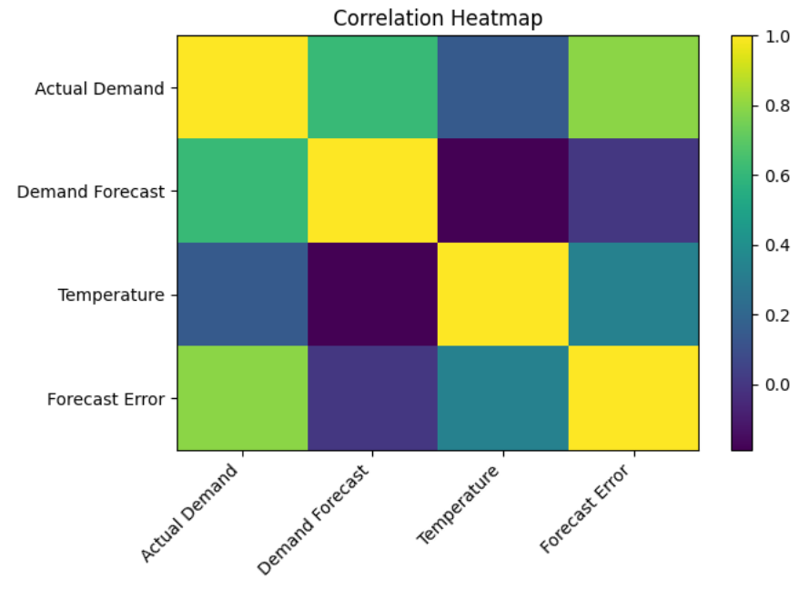  Figure 10: Correlation Heatmap of Demand, Forecast and Forecast-Error

Feature Engineering
Following feature engineering was performed to enhance predictive capability by incorporating relevant external variables and transforming existing features. This includes temporal, economic, and behavioural indicators, along with hybrid transformations and interaction terms, to better capture demand dynamics and improve model accuracy.

Adding Public Holidays and Creating Weekend Indicator
A holiday indicator feature (ISHOLIDAY) was created to capture calendar-driven variations in electricity demand. Public holiday data from official sources was integrated & aligned with the dataset using date matching. Weekends were additionally identified using day-of-week information. The feature assigns a value of 1 for holidays and weekends, and 0 otherwise. This enables the model to distinguish between working and non-working days, improving its ability to capture behavioural demand shifts. (NSW Government, n.d.; Fair Work Ombudsman, n.d.).

Time-based Feature Transformation
Cyclical Encoding Better Represents Time Features Than Sawtooth Patterns. Core datetime fields were recomputed and extended using cyclical transformations (sine and cosine) for hour, day, and month. This eliminates artificial discontinuities (e.g., 23→0 hours) and enables the model to capture periodic patterns in electricity demand more effectively. | 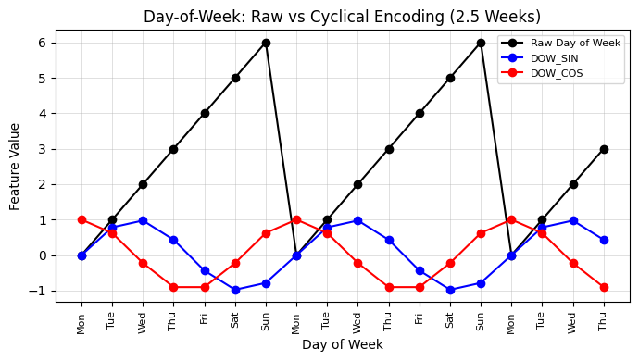  Figure 11: Cyclical Encoding Better Represents Time Features

Forecast Error Features
Error-based features (ERROR_LAST and ERROR_AVG) were computed to quantify deviations between actual and forecast demand. These features help the model learn systematic biases and improve predictive accuracy.

Covid-19 Lockdown Indicator
A COVID_PERIOD indicator variable was created to capture demand disruptions during lockdown (March–May 2020). This binary feature enables the model to account for abnormal consumption patterns caused by restricted economic and social activity (Australian Government, 2020).

Feature Organisation and Dataset Structuring
The dataset was reorganized with TOTALDEMAND as the target variable, followed by high-priority predictors, engineered features, and lower-priority attributes. Missing values introduced by lag and rolling operations were removed, resulting in a clean, model-ready dataset suitable for downstream analysis and forecasting.

Lag and Rolling Features for Demand and Temperature
Lagged variables for demand and temperature were created at multiple intervals (30 minutes, hourly, daily, and weekly) to capture temporal dependencies. Additionally, 7-day rolling averages were introduced to smooth short-term fluctuations and represent longer-term trends. Together, these engineered variables help the model capture persistence, recurring cycles, and underlying long-term movement in electricity demand. | 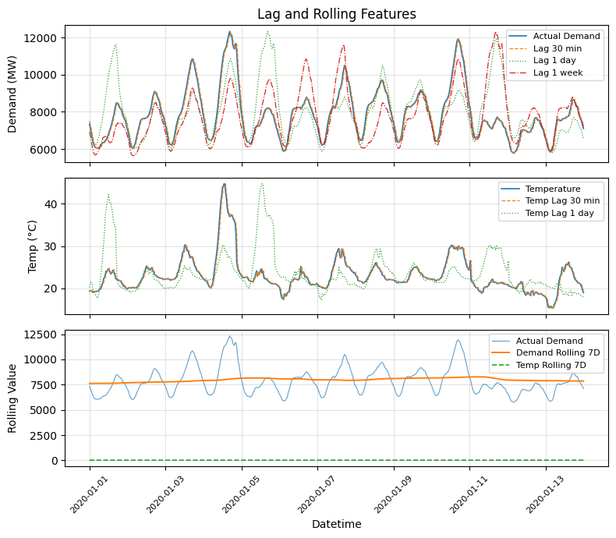  Figure 11: Lag & Rolling Demand & Temperatures

Interaction Features
To better capture non-linear and behaviour-driven demand patterns, additional hybrid features were engineered from temperature and time variables. These transformations were designed to reflect how electricity usage changes under thermal stress and at specific times of day.
A squared temperature term (TEMP_SQ) was created to represent the non-linear relationship between temperature and electricity demand. This is important because demand typically rises at both low and high temperatures due to heating and cooling needs. In addition, Cooling Degree Days (CDD) and Heating Degree Days (HDD) were introduced to measure deviation from a comfortable temperature band. CDD captures excess heat above 22°C, while HDD captures cold conditions below 18°C. These features provide interpretable measures of likely cooling and heating demand (EIA, n.d.). | 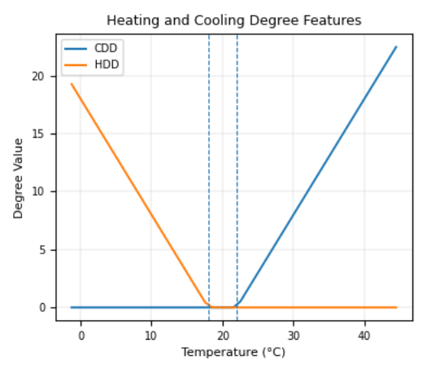  Figure 12: CDD & HDD
Temperature-based transformations
Temperature X Hour  A hybrid interaction term, TEMP_HOUR_INTERACTION, was created by multiplying temperature with the cyclical hour feature (HOUR_SIN). This enables the model to capture behavioural effects where the impact of temperature may vary across the day, such as stronger cooling demand in hot afternoons or reduced sensitivity during night-time hours. |  | 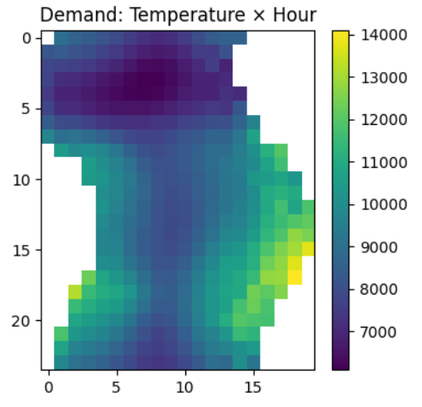  Figure 13: Temperature X Sine of Time
Peak-hour  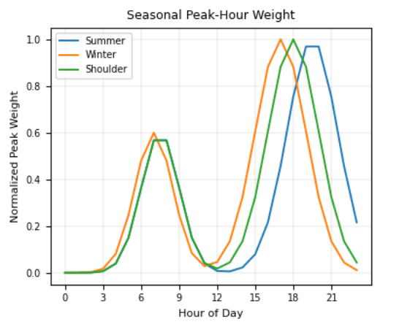  Figure 14: Peak Hour feature | A smooth peak-weight feature was also engineered to represent expected demand concentration during morning and evening peak periods. The feature was made season-sensitive so that peak timing shifts slightly across summer, winter, and shoulder months. Stronger weighting was assigned to evening demand, reflecting observed residential consumption patterns.
Following exploratory data analysis and feature engineering, a structured modelling dataset was developed to enhance electricity demand forecasting. Key variables incorporated include weekends and holidays, COVID-19 effects, forecast errors, and advanced engineered features such as cyclical time transformations, lagged demand and temperature variables, rolling averages, and temperature-based transformations (CDD, HDD, and interaction terms). These features capture temporal dependencies, behavioural patterns, and non-linear relationships.
The dataset was reorganized with TOTALDEMAND as the target variable and 35 feature variables arranged by priority. This clean, feature-rich structure ensures modelling readiness and provides a strong foundation for capturing complex demand dynamics and improving forecasting accuracy.
Target Column:
TOTALDEMAND
Feature Columns (35):  DATETIME  HOUR_SIN  HOUR_COS  DOW_SIN  DOW_COS  MON_SIN  MON_COS  LAST_FORECAST_DEMAND  AVERAGE_FORECAST_DEMAND  TEMPERATURE  IS_WEEKEND  ISHOLIDAY | DEMAND_LAG_1  DEMAND_LAG_2  DEMAND_LAG_3  DEMAND_LAG_48  DEMAND_LAG_336  ERROR_LAST  ERROR_AVG  TEMP_LAG_1  TEMP_LAG_2  TEMP_LAG_48  DEMAND_ROLLING_7D  TEMP_ROLLING_7D | MINUTE  HOUR  DATE  DAY_OF_WEEK  DOW_INT  MONTH  MONTH_NAME  YEAR  ISHOLIDAY_ONLY  ABS_ERROR_LAST  ABS_ERROR_AVG

External Features: Macroeconomic and Energy Related
Following external macroeconomic and energy-related variables were considered to enhance the predictive capability of the model. These include interest rates, ASX index, GDP, inflation, population, electricity cost, and renewable energy share.
Interest Rate Feature Engineering  Interest rate data was incorporated using a step-function approach, assigning each timestamp the most recent cash rate to reflect policy persistence. An additional feature capturing rate changes was created to model policy shocks. These variables help capture macroeconomic influences that may indirectly affect electricity demand patterns (RBA, n.d.). | 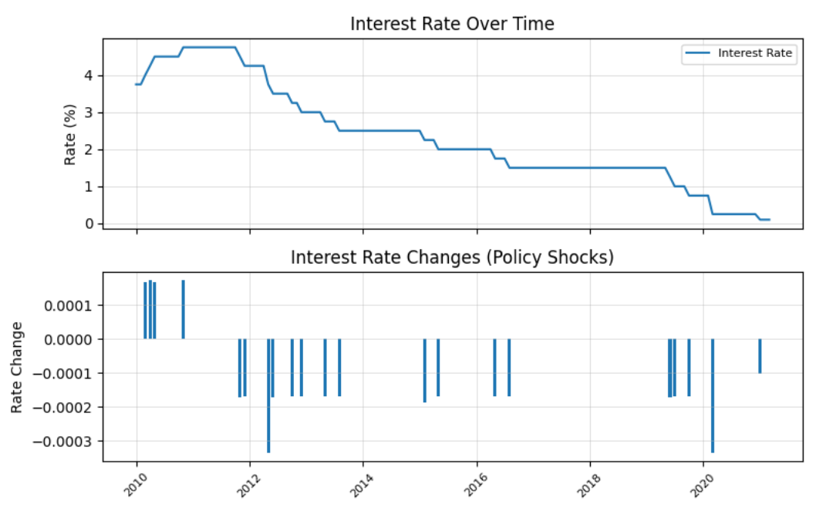  Figure 15: Interest Rate feature engineering
ASX Index  ASX-based macroeconomic features were incorporated to capture broader market conditions. Monthly ASX 200 data was transformed into log returns and 3-month rolling volatility, representing market movement and uncertainty. These features were aligned to the demand dataset using backward month-end matching, enabling the model to incorporate external economic signals (ASX, n.d.; Yahoo Finance, n.d.). | 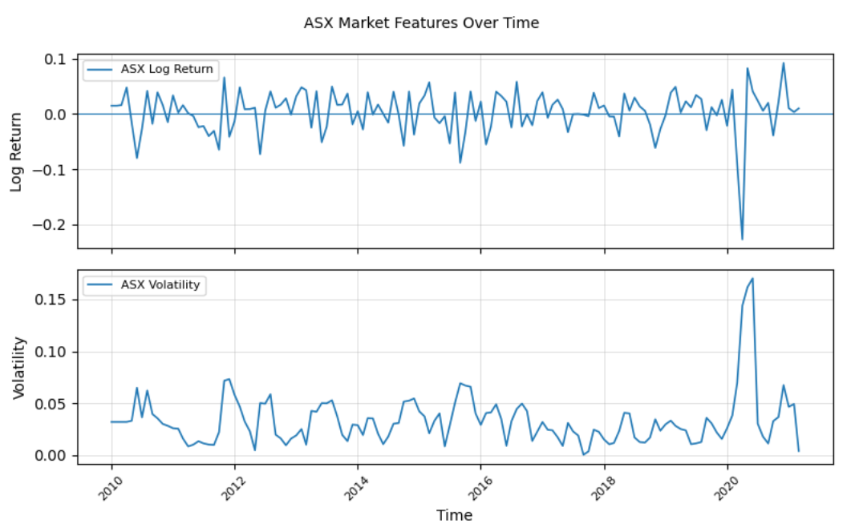  Figure 16: ASX Macroeconomic features - Log Returns and Volatility
Inflation Feature Integration  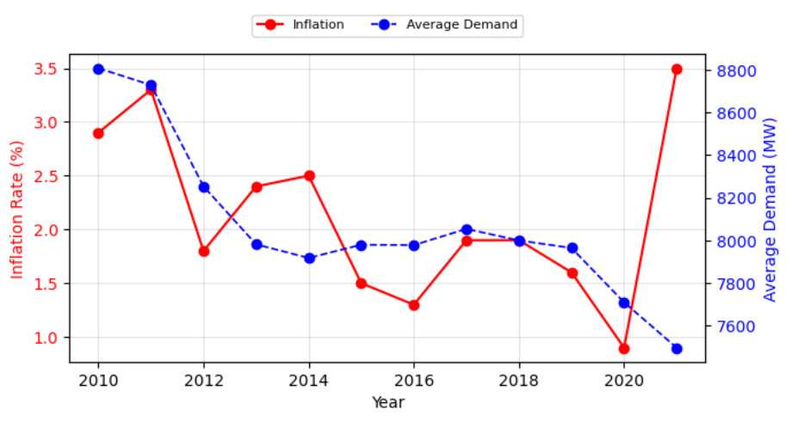  Figure 17: Inflation and Electricity Demand by Year |  |  |  | Inflation was incorporated as a long-term macroeconomic feature using annual Australian inflation data. Each timestamp was assigned the inflation rate for its corresponding year. This variable was included to capture broader economic conditions that may influence electricity consumption patterns over time, particularly through long-run changes in prices and household behaviour (ABS, n.d.).
Quarterly GDP  Quarterly Australian GDP was incorporated as a macroeconomic feature using quarter-wise alignment. Each timestamp was assigned the GDP value of its corresponding calendar quarter, preserving the natural reporting frequency of national accounts data. This enables the model to capture broad economic conditions that may influence electricity demand over time (ABS, n.d.). |  | 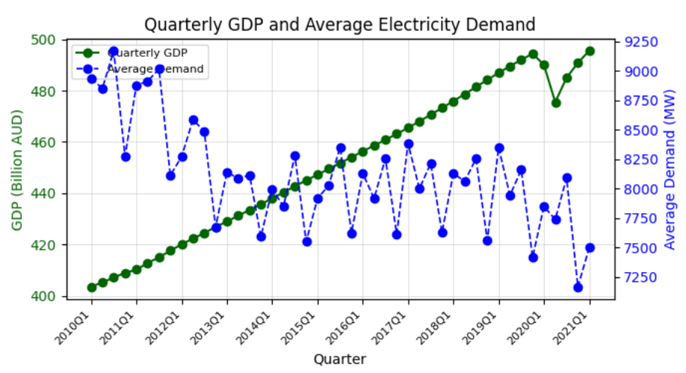  Figure 18: Quarterly GDP and Electricity Demand
Population Growth of Bankstown  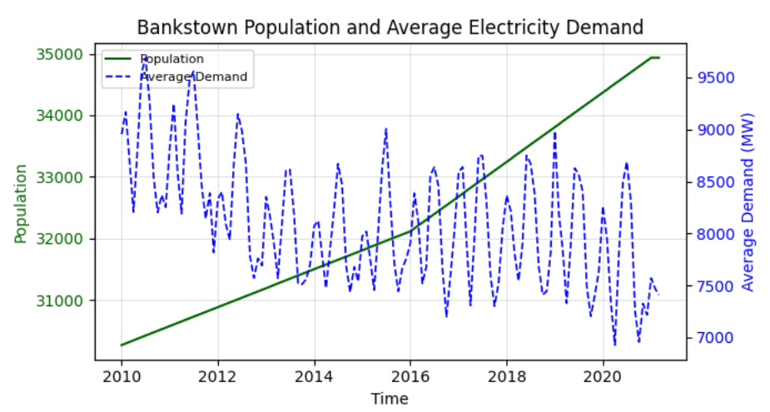Figure 19: Bankstown Population and Electricity Demand |  |  | Bankstown population was incorporated as a slowly varying demographic feature using interpolated monthly estimates anchored to Census benchmarks. This variable is intended to capture long-term structural growth in electricity demand rather than short-term variation. Monthly population values were aligned with each timestamp, ensuring consistent integration into the modelling dataset (ABS, 2017; ABS, 2022).
Electricity Cost  Electricity cost was incorporated using the Sydney electricity CPI index as a proxy for Bankstown, since suburb-level tariff data was unavailable. Quarterly index values were aligned with each timestamp by calendar quarter. This feature captures longer-term price-related effects on electricity demand while maintaining consistency with official ABS data sources (ABS, n.d.). |  | 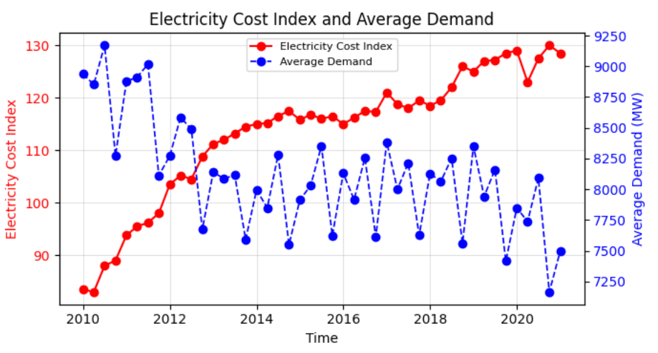  Figure 20: Electricity Cost vs Electricity Demand
Renewable and Solar Share  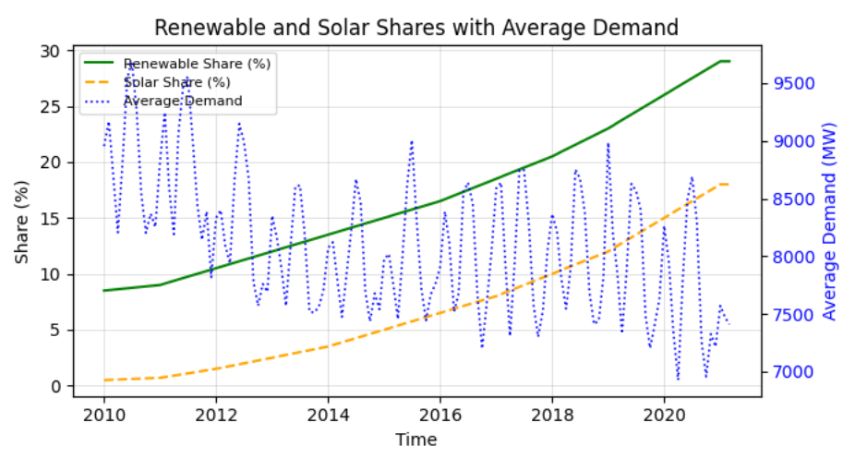Figure 21: Renewable, Solar vs Demand Trends |  |  | Renewable and solar share variables were incorporated using interpolated monthly estimates from official trends, capturing long-term shifts in the energy mix and enabling the model to reflect evolving grid composition influencing electricity demand behaviour (DCCEEW, 2025; NSW EPA, 2024).

Feature Selection Strategy based on Importance & Correlation Analysis
Correlation analysis assessed relationships between features and TOTALDEMAND, with Pearson rankings highlighting strong temporal dependencies, particularly lagged and rolling demand variables (James et al., 2021; Kuhn & Johnson, 2019).
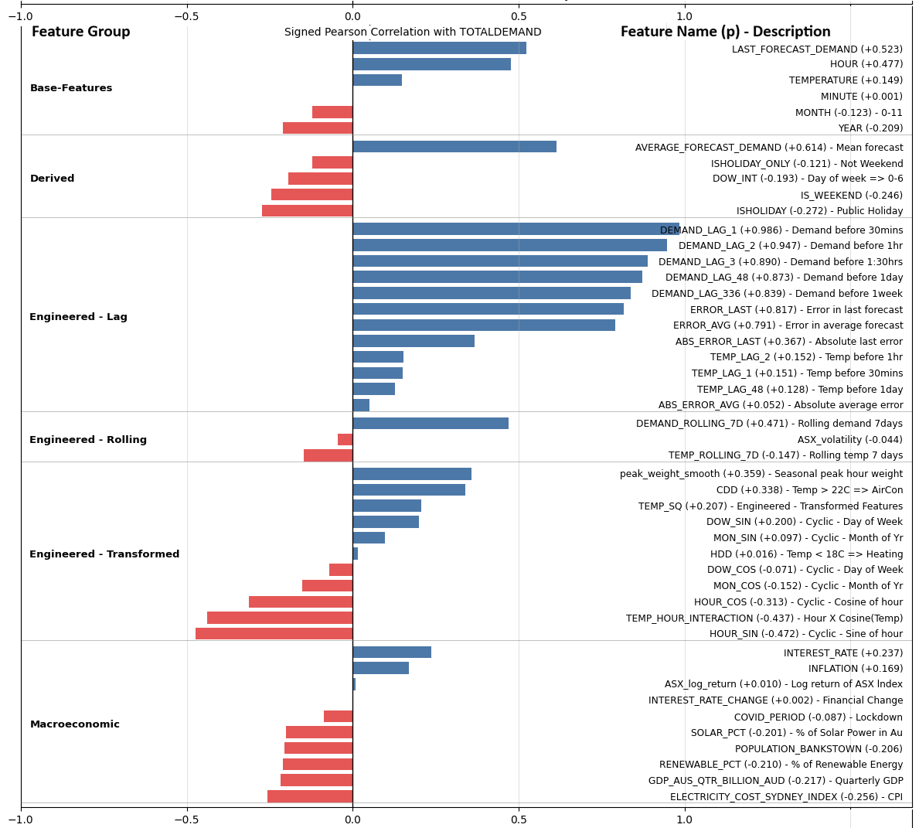
Figure 22: Correlation of Features with Electricity Demand
While high-correlation features indicate strong linear relationships, features with lower correlation were not discarded, as they may contribute through non-linear effects and interactions. Features were grouped into original, derived, engineered, and macroeconomic categories to provide structured insight. This analysis serves as a preliminary screening step, informing subsequent modelling using advanced methods such as XGBoost and neural networks.

Preprocessing Data: Normalization and Encoding
Numerical features were normalized to ensure comparable scales and stable model training. Categorical variables were transformed using one-hot encoding to enable model interpretability and compatibility. These preprocessing steps ensure the dataset is fully model-ready for processing with advanced methods such as XGBoost and neural networks based machine learning algorithms.

Data Sources and References
- Australian Bureau of Statistics (ABS) 2017, 2016 Census QuickStats: Bankstown, ABS, viewed 2 April 2026, https://www.abs.gov.au/census/find-census-data/quickstats/2016/SSC10180.
- Australian Bureau of Statistics (ABS) 2022, 2021 Census QuickStats: Bankstown, ABS, viewed 2 April 2026, https://www.abs.gov.au/census/find-census-data/quickstats/2021/SAL10181.
- Australian Bureau of Statistics (ABS) n.d., Consumer Price Index, Australia, ABS, viewed 2 April 2026, https://www.abs.gov.au/statistics/economy/price-indexes-and-inflation/consumer-price-index-australia.
- Australian Bureau of Statistics (ABS) n.d., Australian National Accounts: GDP, population and inflation, ABS, viewed 2 April 2026, https://www.abs.gov.au.
- Australian Energy Market Operator (AEMO) n.d., Electricity demand and market data (NEM), AEMO, viewed 2 April 2026, https://aemo.com.au.
- Australian Energy Regulator (AER) n.d., Electricity pricing and market performance, AER, viewed 2 April 2026, https://www.aer.gov.au.
- Australian Government 2020, Coronavirus (COVID-19) restrictions timeline, Australian Government, viewed 2 April 2026, https://www.australia.gov.au.
- Australian Government Bureau of Meteorology (BoM) n.d., Climate data and temperature statistics, BoM, viewed 2 April 2026, http://www.bom.gov.au/climate/data.
- Australian Securities Exchange (ASX) n.d., S&P/ASX 200 historical data, ASX, viewed 2 April 2026, https://www.asx.com.au.
- Department of Climate Change, Energy, the Environment and Water (DCCEEW) 2025, Energy supply statistics, Australian Government, viewed 3 April 2026, https://www.dcceew.gov.au/energy/supply.
- Endgame Economics n.d., NEM historical datasets (GitHub repository).
- Fair Work Ombudsman n.d., Public holidays, Fair Work Ombudsman, viewed 2 April 2026, https://www.fairwork.gov.au/employment-conditions/public-holidays.
- Hastie, T, Tibshirani, R & Friedman, J 2009, The Elements of Statistical Learning, Springer, New York.
- Hyndman, RJ & Athanasopoulos, G 2021, Forecasting: Principles and Practice, 3rd edn, OTexts, Melbourne, viewed 2 April 2026, https://otexts.com/fpp3/.
- James, G, Witten, D, Hastie, T & Tibshirani, R 2021, An Introduction to Statistical Learning, 2nd edn, Springer, New York.
- Kuhn, M & Johnson, K 2019, Feature Engineering and Selection, CRC Press, Boca Raton.
- NSW Climate and Energy Action n.d., Solar energy in NSW, NSW Government, viewed 3 April 2026, https://www.energy.nsw.gov.au.
- NSW Environment Protection Authority (EPA) 2024, State of the Environment: Energy consumption, NSW Government, viewed 3 April 2026, https://www.soe.epa.nsw.gov.au.
- NSW Government n.d., Public holidays in NSW, NSW Government, viewed 2 April 2026, https://www.nsw.gov.au.
- Reserve Bank of Australia (RBA) n.d., Statistical tables and interest rates, RBA, viewed 2 April 2026, https://www.rba.gov.au/statistics/.
- U.S. Energy Information Administration (EIA) n.d., Degree days explained, EIA, viewed 2 April 2026, https://www.eia.gov/energyexplained/units-and-calculators/degree-days.php.
- Yahoo Finance n.d., S&P/ASX 200 historical data, viewed 2 April 2026, https://finance.yahoo.com/quote/%5EAXJO/history.
- Your Investment Property Magazine n.d., Bankstown suburb profile, viewed 2 April 2026, https://www.yourinvestmentpropertymag.com.au/top-suburbs/nsw/2200-bankstown.
- Géron, A 2019, Hands-On Machine Learning with Scikit-Learn, Keras, and TensorFlow, 2nd edn, O’Reilly Media, Sebastopol.
- Bishop, CM 2006, Pattern Recognition and Machine Learning, Springer, New York.

Acknowledgement of Generative AI Usage
Generative AI tools, specifically ChatGPT, were used in a supportive and assistive capacity throughout this project. The use of GenAI was limited to:
- Structuring and refining Python code
- Debugging and improving data pipelines
- Suggesting advanced feature engineering techniques
- Enhancing clarity of visualisations
- Assisting in drafting structured report sections
Importantly:
- All data collection was independently performed
- All transformations were manually designed and implemented
- All modelling logic and feature engineering decisions were derived through independent analysis and validation
- All results were critically evaluated by the author
Thus, GenAI was used as a productivity and clarity enhancement tool, not as a substitute for analytical reasoning or technical implementation.

