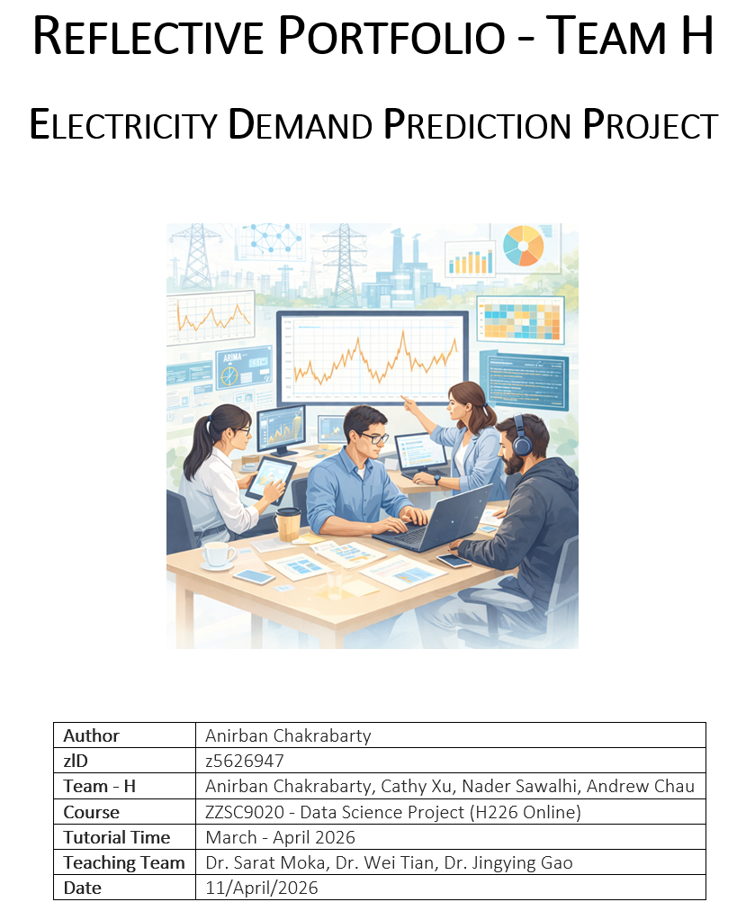

Contents
Week 1 – Foundation and Role Clarity 3
Week 2 – Efficiency and Parallel Progress 3
Week 3 – Coordination vs. Contribution 3
Week 4 – Execution Risk and Quality Focus 4
Key Learnings and Future Improvements 4
Further Improvement and Future Steps 4
References 5

This reflective portfolio synthesises my learning across Weeks 1–4 of the ongoing Data Science project, focusing on teamwork, process maturity, and applied data science practice. The project centres on forecasting electricity demand using temperature, historical demand, and engineered features, requiring coordinated interdisciplinary collaboration.
Week 1 – Foundation and Role Clarity
In Week 1, we established a structured team framework with roles aligned to individual strengths. Cathy Xu led as Project Lead, while I focused on feature engineering and neural network modelling. A coordinated tool ecosystem—Microsoft Teams, WhatsApp, GitHub, and SharePoint—enabled efficient communication and task visibility. Early alignment reduced ambiguity, reflecting Agile principles (Schwaber and Sutherland, 2020). However, scheduling conflicts exposed limitations in relying on synchronous engagement, highlighting the need for more flexible coordination.
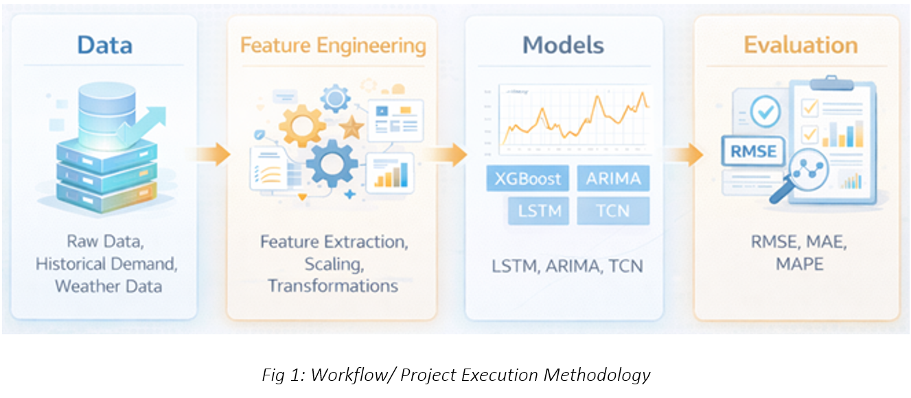
Week 2 – Efficiency and Parallel Progress
By Week 2, the team demonstrated strong efficiency through parallel work streams in EDA and modelling. We progressed to a structured dataset (~196k rows, 70+ features), enabling deeper analysis. Contributions were well aligned: Nader and I led EDA, with Nader focusing on ARIMA/SARIMA models; Andrew worked on XGBoost; and I advanced LSTM modelling and feature engineering. Cathy coordinated the team, ensuring alignment. Documented meeting minutes maintained continuity, reinforcing the importance of traceability in collaborative workflows (Wickham and Grolemund, 2017). This phase highlighted that productivity depends on integration rather than equal effort.
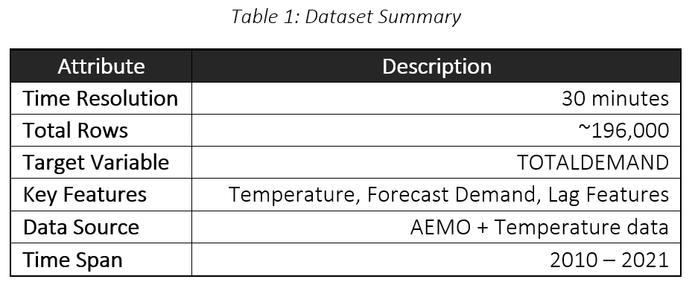
Week 3 – Coordination vs. Contribution
Week 3 marked a transition from execution to integration. While contributions remained balanced, challenges arose in version control and output consistency. This showed that coordination complexity can exceed technical complexity. The adoption of shared evaluation frameworks (e.g., consistent RMSE and MAE metrics) improved alignment. Reflectively, earlier enforcement of a “single source of truth” would have reduced redundancy, aligning with reproducible research practices (Peng, 2011).

Week 4 – Execution Risk and Quality Focus
By Week 4, modelling, evaluation, and reporting converged, increasing pressure. Although progress was substantial, risks emerged around timeline compression and inconsistent evaluation standards. My contribution centred on developing a robust LSTM baseline and ensuring comparability of outputs. Standardising metrics and prediction formats improved consistency, reflecting a shift towards system-level optimisation.
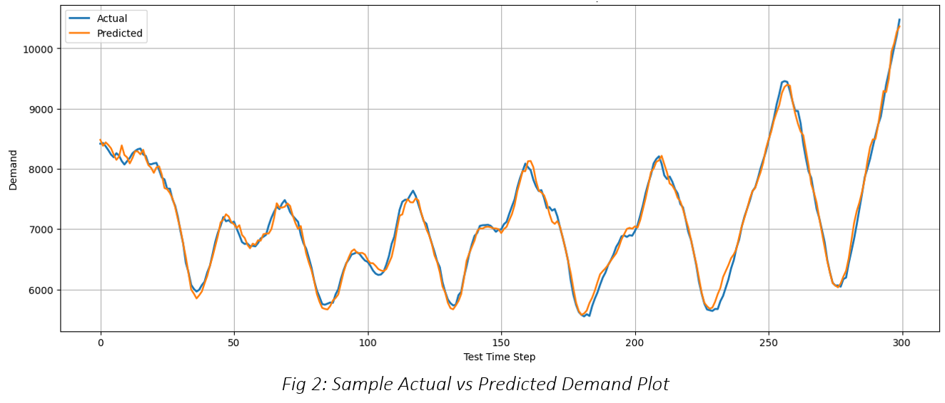
Key Learnings and Future Improvements
Critical success factors included clear role alignment, transparent communication, shared tools, and iterative integration. Future improvements include earlier standardisation of pipelines, stricter document ownership, and proactive timeline management. I contributed technical depth in feature engineering and LSTM modelling while supporting integration. This experience reinforces that high-performing teams depend on cohesive integration rather than individual effort.
Further Improvement and Future Steps
Future work will prioritise enhanced modelling sophistication. A Temporal Convolutional Network (TCN) will be introduced to capture long-range dependencies, followed by LSTM with Attention or ARIMA–LSTM hybrids to model nonlinear and linear dynamics. A Temporal Fusion Transformer (TFT) may be explored as an advanced extension, subject to time constraints.

References
- Peng, R.D. (2011) ‘Reproducible research in computational science’, Science, 334(6060), pp. 1226–1227.
- Schwaber, K. and Sutherland, J. (2020) The Scrum Guide.
- Wickham, H. and Grolemund, G. (2017) R for Data Science. O’Reilly.

1.
2. Model Comparison
Model | RMSE | MAE | R²
ARIMA | XXXX | XXXX | XXXX
XGBoost | XXXX | XXXX | XXXX
LSTM | XXXX | XXXX | XXXX
3. Team Contribution
Member | Contribution
Cathy | Project Lead, EDA, Report
Nader | ARIMA/SARIMA
Andrew | XGBoost
You | LSTM, Feature Engineering, Integration

