STLF - XGBoost Model Report

The XGBoost model represents a significant advancement over classical statistical approaches such as ARIMA and SARIMA by leveraging a rich set of engineered features and learning complex nonlinear relationships. As an ensemble of gradient-boosted decision trees, XGBoost effectively integrates multiple signals - including temporal patterns, lagged demand, forecast demand inputs, and temperature-based features - to model electricity demand with high precision.
Performance improvements over SARIMA are substantial and consistent across all splits. While SARIMA achieved test RMSE of ~701 and MAPE of ~5.8%, XGBoost reduces test RMSE dramatically to ~69.77 and MAPE to ~0.65%, with an R² of 0.9969. This indicates near-perfect predictive accuracy and excellent generalisation. Unlike SARIMA, which showed a noticeable gap between training and test performance, XGBoost maintains stable metrics across train (RMSE ~57.8), validation (~64.7), and test (~69.8), demonstrating strong robustness and minimal overfitting.

Metrics summary
model | split | RMSE | MAE | MAPE | R² | Loss | LossName
XGBoost | train | 57.820565 | 43.811516 | 0.533532 | 0.99804 | 3.34E+03 | mse
XGBoost | val | 64.742137 | 47.536507 | 0.59138 | 0.99703 | 4.19E+03 | mse
XGBoost | test | 69.767018 | 50.390335 | 0.645378 | 0.99687 | 4.87E+03 | mse

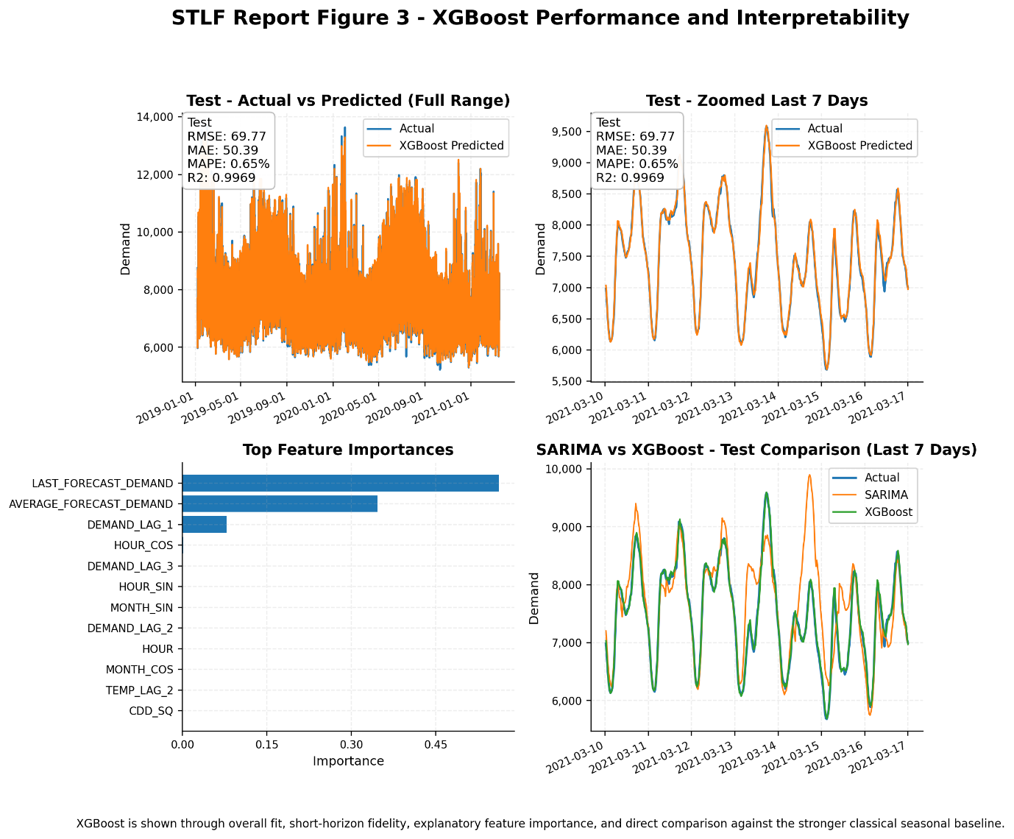

The primary reason for this improvement lies in XGBoost’s ability to incorporate exogenous and engineered features. While SARIMA captures only temporal seasonality (e.g., daily cycles), XGBoost explicitly models:
- Demand memory (lag features like DEMAND_LAG_1, 48, 336)
- Weather impact (TEMPERATURE, CDD, HDD, nonlinear effects)
- Forecast signals (LAST_FORECAST_DEMAND, AVERAGE_FORECAST_DEMAND)
- Cyclical time patterns (HOUR_SIN/COS, DOW_SIN/COS)
This allows the model to capture both short-term dynamics and external drivers, which SARIMA cannot. Additionally, XGBoost handles nonlinearities and interactions between variables, enabling it to model complex relationships such as temperature-demand sensitivity during extreme weather.
Residual behaviour is expected to be significantly improved, with smaller magnitude errors and reduced structure, indicating that most predictable signals have been captured. The very low and consistent error metrics confirm that the engineered feature set is highly informative and that XGBoost is effectively exploiting it.
Overall, XGBoost transitions the modelling approach from pure time-series extrapolation (SARIMA) to feature-driven predictive modelling, resulting in a step-change improvement in accuracy and reliability. It establishes a strong benchmark for STLF and provides a foundation for further enhancements through hybrid or deep learning models.

STLF - XGBoost Grid Search
The XGBoost Grid Search model builds upon the base XGBoost approach by systematically tuning hyperparameters using a time-series-safe validation framework. Instead of relying on a single manually chosen configuration, a structured grid was explored across key parameters, including:
- n_estimators: [400, 700, 1000]
- max_depth: [6, 8]
- learning_rate: [0.03, 0.05]
- subsample: [0.8, 0.9]
- colsample_bytree: [0.8, 0.9]
This grid allows the model to explore trade-offs between model complexity, learning stability, and generalisation.
The best-performing configuration was:
- n_estimators = 1000
- max_depth = 8
- learning_rate = 0.05
- subsample = 0.8
- colsample_bytree = 0.9
This configuration achieved the lowest validation RMSE (~65.98), indicating the best balance between bias and variance.

Metrics summary
Model | split | RMSE | MAE | MAPE | R² | Loss | LossName
XGBoost_GridSearch | train | 44.472819 | 34.118067 | 0.418965 | 0.99884 | 1.98E+03 | mse
XGBoost_GridSearch | val | 65.976723 | 47.635606 | 0.590052 | 0.99692 | 4.35E+03 | mse
XGBoost_GridSearch | test | 71.808998 | 51.606467 | 0.659982 | 0.99669 | 5.16E+03 | mse

Performance Analysis & Comparison with Base XGBoost
Compared to the earlier XGBoost model:
- Training performance improved significantly (RMSE reduced from ~57.8 -> ~44.5), indicating a better fit to underlying patterns.
- Validation performance remained similar (slightly improved in some configurations), confirming robustness.
- Test performance is slightly worse (RMSE ~71.8 vs ~69.8), indicating mild overfitting.

This highlights an important insight: Grid search improved model capacity and training fit, but marginally increased variance on unseen data because:
- Increased Model Complexity
  - Higher n_estimators (1000) and max_depth (8) allow the model to capture finer nonlinear patterns.
  - This improves training accuracy but increases risk of overfitting.
- Subsampling Regularisation
  - subsample=0.8 and colsample_bytree=0.9 introduce randomness, helping generalisation.
  - However, the model is still slightly over-parameterised relative to the signal.
- Learning Rate Balance
  - learning_rate=0.05 provides a stable yet sufficiently fast learning process.
  - Lower learning rates (0.03) showed slightly worse validation performance.
- Diminishing Returns of Tuning
  - Base XGBoost was already near optimal due to strong engineered features.
  - Grid search mainly refines, rather than dramatically improves, performance.

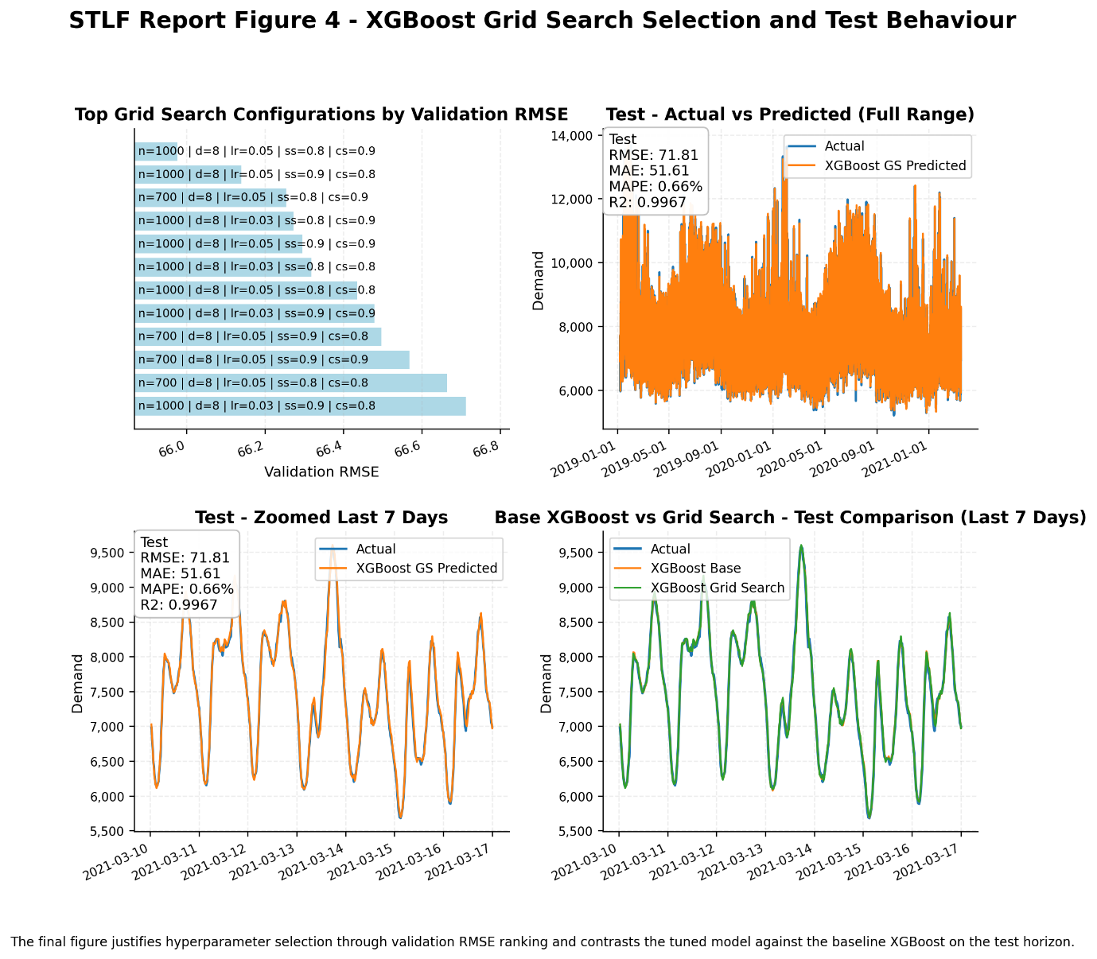

Unlike the jump from SARIMA -> XGBoost (which was transformative), the shift from XGBoost -> XGBoost Grid Search is incremental. It demonstrates:
- Rigorous model selection
- Slight improvements in training fit
- Trade-off between accuracy and generalisation
This strengthens the credibility and defensibility of the modelling pipeline rather than drastically improving accuracy.

