Ethical Evaluation, Risk Assessment & Recommendations for AI-Based Electricity Demand Forecasting System

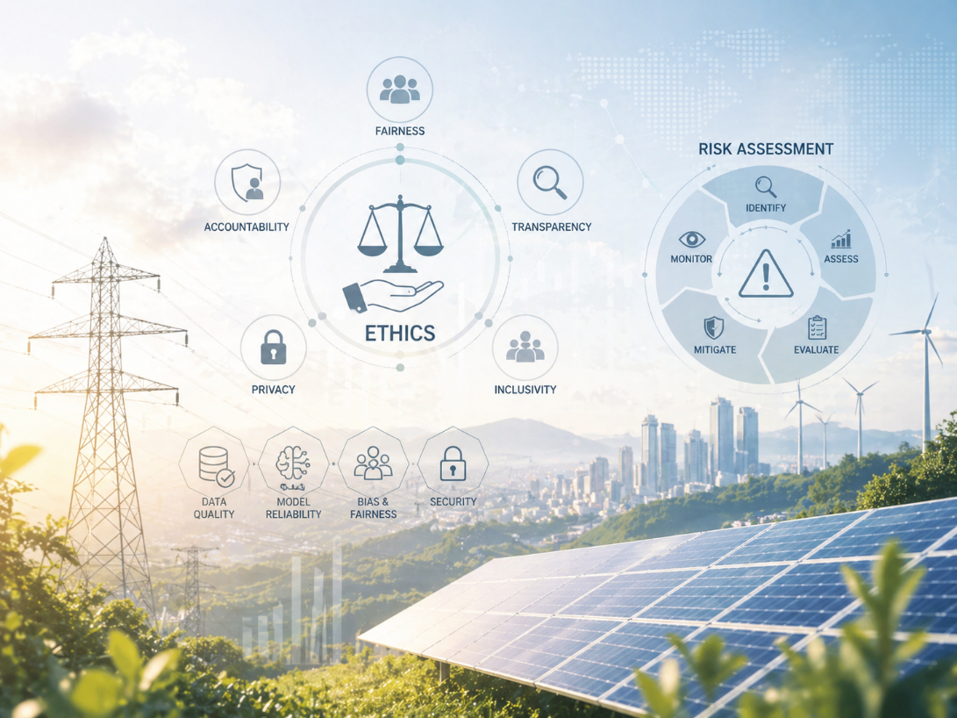

Author | Anirban Chakrabarty
zlD | z5626947
Course | ZZBU6505-Data and Ethics (H226 Online)
Tutorial Time | March - April 2026
Teaching Team | Dr. Tracy Wilcox, Dr. Burcin Hatipoglu, Nidal Danoun
Date | 27/April/2026

Contents
1. Introduction and Application of Ethical Frameworks 3
2. Legal and Regulatory Considerations 4
3. Risk Assessment 5
4. Recommendations 7
4.1. Implement fairness and bias auditing throughout the model lifecycle 7
4.2. Strengthen data governance and privacy protection mechanisms 7
4.3. Establish independent oversight and stakeholder participation 7
4.4. Develop operational resilience through continuous monitoring & contingency planning 7
References and AI Use Acknowledgement 8
References 8
Use of Artificial Intelligence (AI) and Its Limitations 8

1. Introduction and Application of Ethical Frameworks

The AI-based Electricity Demand Forecasting System for New South Wales predicts short-term electricity demand using operational, environmental, and economic datasets to support grid stability, generation planning, and electricity market pricing (Australian Energy Market Operator, 2023). As established in Part A, although the system primarily relies on aggregated and non-personal data, it indirectly reflects household and business consumption patterns, making electricity consumers the primary data subjects. Key stakeholders include electricity consumers, vulnerable populations, grid operators, energy providers, regulators, and data scientists, each with differing levels of power, agency, and exposure to the system’s outcomes.

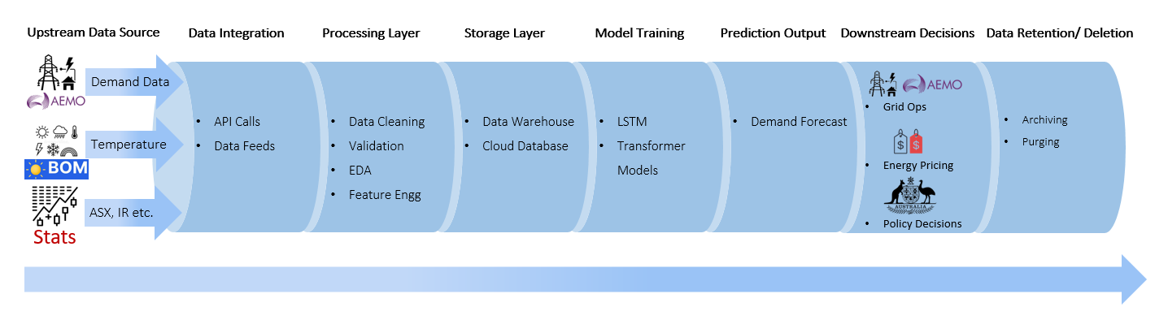
Fig 1: Electricity Demand Forecasting Data Pipeline Diagram

To evaluate the ethical dimensions of this forecasting system, this report applies two ethical frameworks drawn from Weeks 2 and 3 of the course (UNSW, 2026): utilitarianism and care ethics. These frameworks offer contrasting but complementary ways of evaluating data-driven decisions, particularly around efficiency, fairness, and vulnerability.

From a utilitarian perspective (Bentham, 1789), the ethical value of the system depends on whether it maximises overall social welfare. Accurate electricity forecasting improves load balancing, reduces generation waste, minimises blackouts, and supports stable electricity pricing. These benefits improve system efficiency and reliability, creating broad advantages for consumers, providers, and the wider economy. From this perspective, the system can be justified because it delivers the greatest good for the greatest number (Bentham, 1789). However, utilitarianism also exposes an ethical weakness. Aggregate benefits can conceal unequal burdens. Vulnerable groups, particularly low-income households and rural communities, may face higher electricity costs through forecast-driven pricing or reduced infrastructure investment where demand is lower. This raises concerns about unequal distribution of benefits and harms.

A care ethics perspective (Gilligan, 1982) shifts focus from outcomes to relationships, dependency, and vulnerability. Rather than asking what benefits the majority, care ethics asks whether the system adequately protects those most affected and least empowered. Electricity consumers, especially vulnerable groups (Gilligan, 1982), have minimal agency over how their consumption patterns are modelled or how decisions based on forecasts affect pricing and supply reliability. Care ethics highlights the responsibility of data scientists, grid operators, and regulators to act with attentiveness and responsibility toward these groups. This includes transparent communication, fairness-aware model design, and inclusive governance practices.

Together, utilitarianism and care ethics reveal a central ethical tension: while the system produces broad societal benefits through efficiency and reliability, it risks reinforcing inequality if vulnerable stakeholders are overlooked. Ethical legitimacy therefore requires balancing collective efficiency with relational responsibility, fairness, and protection of those with the least power.

2. Legal and Regulatory Considerations

Although the AI-based Electricity Demand Forecasting System primarily uses aggregated operational and environmental data, several legal and regulatory frameworks remain relevant because the system directly influences public infrastructure, electricity market pricing, and consumer welfare. In Australia, the most relevant framework is the Privacy Act 1988 (Cth) and its Australian Privacy Principles (APPs) (Federal Register of Legislation, 1988). Under Australian privacy law, “personal information” includes information that can reasonably identify an individual, either directly or indirectly. While the current forecasting model uses aggregated demand data, future integration with smart meter data could introduce identifiable household consumption profiles, bringing the system directly under privacy obligations such as data minimisation, purpose limitation, secure storage, transparency, and responsible disposal, consistent with Week 5 course content on privacy law (UNSW, 2026).

Beyond privacy law, data governance and stewardship principles from Week 4 are highly relevant. Forecasting systems depend on continuous upstream and downstream data flows, requiring accountability over data quality, storage, access permissions, and lifecycle management. Strong governance policies are necessary to ensure that data remains accurate, responsibly managed, and protected against misuse or unauthorised alteration. Privacy Impact Assessments (PIAs), introduced in Week 4 (UNSW, 2026), are particularly relevant as a governance mechanism to identify risks before introducing finer-grained consumer data into the system. In addition, governance frameworks establish clear responsibilities for data custodians, helping improve accountability and oversight.

From a public interest perspective, electricity forecasting affects a critical public utility essential to social and economic stability (Australian Energy Market Operator, 2023). Errors in forecasting can result in blackouts, inefficient generation allocation, and volatile electricity prices, directly affecting households, businesses, and government planning. Public interest concerns therefore include fairness in electricity pricing, transparency in automated decision-making, and equitable energy access. There is also concern that forecast-driven market decisions may disproportionately disadvantage low-income or regional communities, reinforcing existing structural inequalities and limiting equitable distribution of energy resources.

The major threats and vulnerabilities in this system fall into four key areas. First, unauthorised access or data breaches could expose sensitive operational or consumer-level data if data granularity increases. Second, data corruption or loss may compromise model accuracy, creating unreliable forecasts and operational failures. Third, misuse or misinterpretation of forecasts by energy providers could distort pricing strategies or infrastructure planning. Fourth, algorithmic bias and opacity remain significant risks, as historical demand data may reinforce regional inequalities while black-box models reduce explainability and accountability. Together, these legal, governance, and ethical concerns show that effective regulation must extend beyond technical compliance toward broader public accountability, fairness, and long-term trust in data-driven systems.

3. Risk Assessment

Building on the ethical and regulatory analysis above, this risk assessment identifies the most significant inherent risks within the AI-based Electricity Demand Forecasting System. In line with the Ada Lovelace Institute’s approach (Ada Lovelace Institute, 2023), risk assessment involves identifying potential harms, prioritising their significance, implementing mitigation strategies, and monitoring risks over time. Similarly, the NIST AI Risk Management Framework (NIST, 2023) emphasises that AI risks must be continuously governed, mapped, measured, and managed throughout the system lifecycle. These frameworks highlight that risks in AI systems are not limited to data collection and storage but also emerge through downstream decision-making and broader societal impacts.

Inherent Risk | Reason for Selection | Likelihood of Harm | Impact | Overall Risk | Mitigation Strategy
Unauthorised access to data systems | Centralised storage creates exposure to misuse or intrusion, especially if smart meter data is introduced | Medium – vulnerable without strong controls | Significant – may expose sensitive operational or consumer data | High | Role-based access, encryption, multi-factor authentication, access audits
Data breach or leakage | Aggregated data may become re-identifiable when linked with third-party datasets | Medium – integration increases exposure risk | Severe – privacy breaches may create legal and reputational harm | High | Data anonymization, minimisation, secure APIs, Privacy Impact Assessments
Loss or corruption of forecasting data | Forecasting depends on accurate historical and live data | High – pipelines are vulnerable to failure | Significant – inaccurate forecasts can disrupt grid stability | High | Backups, validation checks, integrity testing, lifecycle management
Misuse or misinterpretation of forecasts | Providers may use forecasts for aggressive pricing or unequal infrastructure prioritisation | Medium – commercial incentives increase misuse risk | Significant – unfair pricing or unequal service delivery may occur | High | Governance policies, usage restrictions, oversight, documentation
Algorithmic bias and model opacity | Historical data may embed inequalities and reduce explainability | High – bias is persistent and difficult to detect | Severe – may reinforce inequality and reduce public trust | Very High | Fairness testing, explainability tools, audits, stakeholder review

Table 1: Five most significant inherent risks and corresponding mitigation strategies.

Based on the stakeholder vulnerabilities, operational reliance on accurate forecasting, and public interest considerations identified in Part A and Part B, the above table outlines the five most significant inherent risks and corresponding mitigation strategies.

Among these risks, algorithmic bias and model opacity represent the most significant ethical concern because they directly affect vulnerable stakeholders with the least agency. Unlike technical failures, bias can operate invisibly while influencing electricity pricing, infrastructure planning, and resource allocation, potentially reinforcing existing social and regional inequalities. This reflects the justice concerns identified in Part-A (Rawls, 1971), where vulnerable communities may bear disproportionate burdens despite overall efficiency gains. Model opacity further reduces accountability (Doshi-Velez, 2017) by making it difficult for stakeholders to understand, question, or challenge decisions derived from complex forecasting models.

Loss or corruption of forecasting data presents a major operational risk. Electricity forecasting depends on continuous access to accurate historical and real-time data, and corrupted inputs can distort predictions, leading to inefficient generation scheduling, price volatility, or supply disruptions. In critical infrastructure systems, such failures can affect millions of users and undermine trust in operational decision-making.

The NIST AI Risk Management Framework highlights (NIST, 2023) that risk management must be continuous and embedded throughout the AI lifecycle, including data collection, model development, deployment, and review. This means mitigation strategies should be integrated into system design rather than introduced after harm occurs. Similarly, the Ada Lovelace framework stresses participatory risk assessment (Ada Lovelace Institute, 2023), recognising that affected communities can identify social harms that technical teams may overlook.

Therefore, this assessment demonstrates that the forecasting system’s most serious vulnerabilities exist at the intersection of technical reliability, privacy protection, and ethical fairness. Effective mitigation therefore requires both technical safeguards and governance mechanisms, including auditing, regular model evaluation, and transparent decision-making, to maintain public trust and ensure equitable outcomes across the energy sector.

4. Recommendations

Based on the ethical analysis, legal considerations, and risk assessment, four key recommendations are proposed to address the most significant risks within the AI-based Electricity Demand Forecasting System. These recommendations aim to strengthen fairness, accountability, and operational resilience while maintaining the system’s public value.

Implement fairness and bias auditing throughout the model lifecycle

Given the high risk of algorithmic bias, forecasting models should undergo regular fairness testing before and after deployment. Historical demand data may embed regional or socio-economic inequalities, which can be reproduced in pricing and infrastructure decisions. Regular audits should evaluate whether model outcomes disproportionately disadvantage low-income or rural communities. Explainability tools should also be integrated to improve transparency and support accountability. This aligns with Week 6 principles of algorithmic fairness (UNSW, 2026) and promotes more equitable outcomes.

Strengthen data governance and privacy protection mechanisms

As the system may expand to include smart meter data, stronger privacy protections are essential. Data minimisation, anonymization, encryption, and strict access controls should be embedded into the system’s architecture. Privacy Impact Assessments should be conducted before introducing new consumer-level datasets to identify privacy risks early. Governance policies should clearly define data ownership, retention periods, and disposal protocols. These measures align with Australian privacy law (Federal Register of Legislation, 1988) and Week 4 data stewardship principles (UNSW, 2026).

Establish independent oversight and stakeholder participation

To improve accountability and public trust, an independent governance body should oversee forecasting practices, risk reviews, and policy compliance. This body should include regulators, consumer representatives, and technical experts. Involving affected stakeholders, particularly vulnerable communities, ensures that social harms are identified alongside technical risks. Participatory governance improves transparency and reflects care ethics (Gilligan, 1982) by recognising stakeholder vulnerability and agency.

Develop operational resilience through continuous monitoring & contingency planning

Forecasting systems supporting critical infrastructure must maintain high reliability. Continuous data integrity monitoring, automated backup systems, and model performance testing should be mandatory. Contingency planning should also be developed to manage forecasting failures, including fall back operational procedures during system disruptions. This reduces operational risk and strengthens grid stability.

Together, these recommendations address the system’s most significant ethical, legal, and operational risks. By improving fairness, privacy, accountability, and resilience, the forecasting system can deliver public benefit while maintaining trust, protecting vulnerable stakeholders, and supporting responsible data-driven decision-making in the energy sector.

References and AI Use Acknowledgement

References

- Ada Lovelace Institute. (2023). Methods for AI risk assessment: A review of the current landscape of AI risk assessment and related methods. Retrieved from A review of the current landscape of AI risk assessment and related methods.
- Australian Energy Market Operator. (2023). Retrieved from Electricity demand and forecasting in the National Electricity Market.: https://www.aemo.com.au
- Bentham, J. (1789). An introduction to the principles of morals and legislation. Clarendon Press.
- Doshi-Velez, F. &. (2017). Towards a rigorous science of interpretable machine learning. arXiv, https://arxiv.org/abs/1702.08608.
- Federal Register of Legislation. (1988). Retrieved from Privacy Act 1988 (Cth). Government, Australian: https://www.legislation.gov.au
- Gilligan, C. (1982). In a different voice: Psychological theory and women’s development. Harvard University Press.
- NIST, A. R. (2023). Artificial intelligence risk management framework (AI RMF 1.0) (NIST AI 100-1). Retrieved from Commerce, U.S. Dept of: https://doi.org/10.6028/NIST.AI.100-1
- OpenAI. (2026). [Large language model]. Retrieved from ChatGPT: https://chat.openai.com
- Rawls, J. (1971). A theory of justice. Harvard University Press.
- UNSW. (2026). ZZBU6505 Data and Ethics course materials. Retrieved from University of New South Wales.

Use of Artificial Intelligence (AI) and Its Limitations

Limited use of generative AI (ChatGPT) was made during the preparation of this report, primarily for language refinement and structural clarity. Specifically, AI was used to assist in improving sentence flow, enhancing academic tone, and organising content in line with the assessment requirements.

Example prompts included:

- “Refine this paragraph for clarity and academic tone.”
- “Improve the structure of this section while maintaining original meaning.”

The substantive content, analysis, and interpretation were developed independently by the author, based on course materials and project work. All AI-assisted outputs were carefully reviewed, edited, and verified to ensure accuracy, relevance, and alignment with the electricity demand forecasting context.

AI use in this report has several limitations. First, AI does not have access to the full project context or underlying dataset and may generate generic or imprecise suggestions, requiring manual correction. Second, AI can sometimes oversimplify complex ethical concepts, necessitating further refinement to ensure appropriate depth and rigor. Third, there is a risk of inaccuracies, and therefore all content was cross-checked against course materials.

Overall, AI was used sparingly as an editing aid, and all final judgments, analysis, and conclusions remain the sole responsibility of the author.

