RAG: Retrieval Augmented Generation:

RAG Definition:
RAGs is a method where we combine LLMs with a retrieval system.
This retrieval system can search through vast sources of external information - like documents, databases, or knowledge bases whenever the LLM needs additional knowledge to give you better answers.
At the same time, it also makes sure the LLM is not overloaded with bigger prompts.
Real-world example:
Let’s say you’re working at a company with 100s of internal documents (like policy guidelines, technical specs, customer support documents, etc.)
Now, if you have a question that could be answered by one of these documents, it would be unrealistic to dump all 100 files into the LLM and ask that question
It is unrealistic because LLMs have a “context window”, meaning, a limited number of information it can process at a given time.
But with LLM + RAGs, this process can be streamlined.
So the next time when you have a question, you can just ask the RAG system in simple English and it retrieves the most relevant info from those documents and uses it to give you an accurate answer

Context window size:
GPT – 4.1/ Gemini 2.5 Pro: 1M
GPT – 5: 400K
Claude 4/ o3/ o4: 200K
Enterprise Data centers: 1.3 Quadrillion Tokens
Small, medium or large size companies: Giga bites to 100s of Tera bites of data

What are tokens?
In the context of language models, a token is a unit of text that the LLM model processes.
Tokens can be as short as one character or as long as one word, depending on the language and structure of the text
For example, the word “hello” is one token, while the phrase “I’m” is typically broken down into two tokens: “I” and “m.”
Understanding tokens are crucial because LLMs have a limit on how many tokens they can handle at once, referred to as the “context window.”
This means that if we have a PDF that’s 10 million tokens long, we can’t feed it to the model in one go.

Ingestion Pipeline:
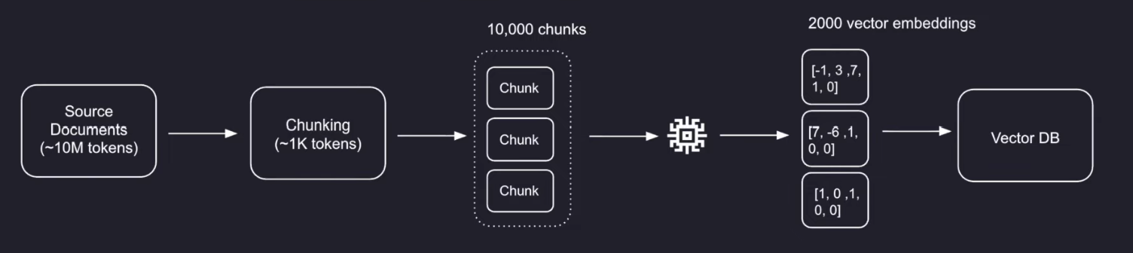

Embeddings and Vector DBs

What are embeddings?
A vector embedding is a mathematical representation of words, sentences or even images.
For example, the word “cat” can have a vector embedding that can look something like this:
[34, 21, 7.5]
So this is the computer’s way of making sense of the word “cat”
Basically each of these numbers can represent a certain aspect of the word “cat”, like “small”, “furry”, etc.
Examples:
Cat - [34, 8, 7.5]
Kitten - [33, 8, 2]
Elephant - [2, 62, 2]
Dog - [47, 8, 2]
Each number in the vector embedding is called a dimension.
Words with similar semantic meaning tend to have dimensions that are closer to each other.
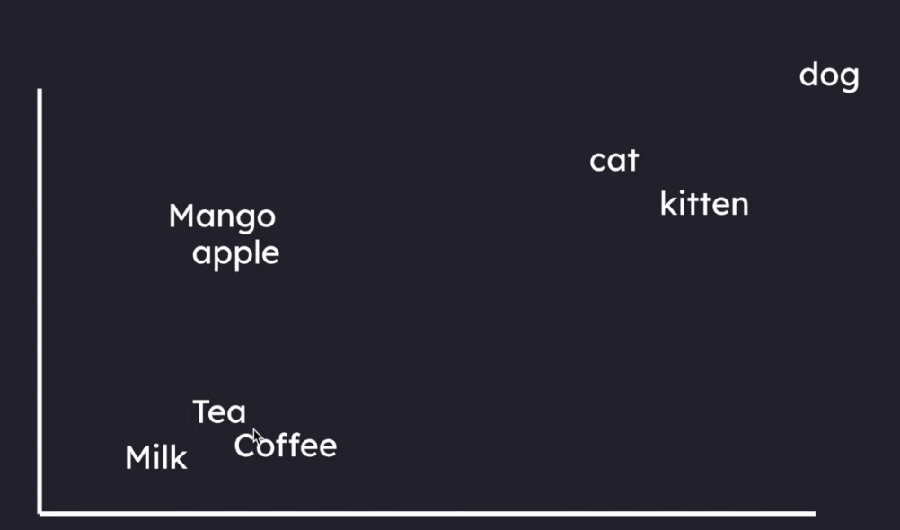

Even though we only see 3 dimensions in each vector embedding, in reality, popular embedding models like OpenAI’s “text-embedding-3-large” transform text to upto 3,072 dimensions in each vector embedding
Note that if we embed a small word like “cat” or a large paragraph, we always get one vector embedding output that has 3072 dimensions.
Advantage of using higher dimensional embedding models is, it captures more semantic information about the text passage. Downside is, it is slightly more expensive to embed as well as store.

Popular Embedding Models
There are many embedding model providers out there, but let’s focus on the most popular ones you’ll encounter:
OpenAI (Most Popular Choice):
- text-embedding-3-small: 1536 dimensions (default) - Great for most use cases (Can reduce to: 512, 1024, or any size ≤1536)
- text-embedding-3-large: 3072 dimensions (default) - Best performance, but costs more (Can reduce to: 256, 512, 1024, 1536, or any size ≤3072)
- Both models let you reduce dimensions to save storage costs without losing much quality
Other Notable Players:
- Cohere: Strong multilingual support, good for international applications
- Voyage AI: Often performs well in benchmarks
- Mistral: Open-source option that’s been showing impressive results

Embeddings and Vector DBs
A database built to store all the vector embeddings is considered a vector database.
To store the vectors, we can use:
- Specialised Vector Databases - Pinecone, Weaviate, ChromaDB, FAISS (Meta)
- Regular SQL Database - offers structured data storage and retrieval

Retrieval Pipeline
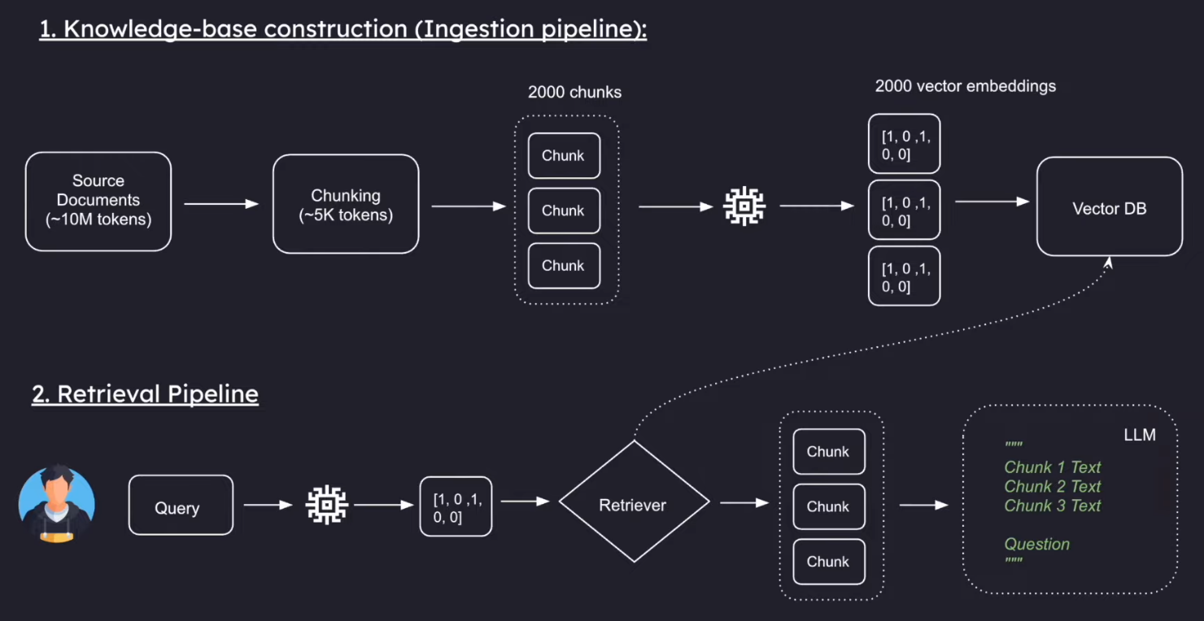

Consistency is key:
You MUST use the same embedding model for both your documents AND your user queries.
Think of embeddings like different languages. If you embed your documents using text-embedding-3-small but embed user queries using text-embedding-3-large, they literally can’t understand each other
Even within the same model, you must use the exact same dimensions everywhere.
For example: If you embed your documents using text-embedding-3-large with 1536 dimensions, you MUST also embed user queries with text-embedding-3-large at exactly 1536 dimensions.
Choose your embedding model at the start and stick with it throughout your entire RAG pipeline. If you want to switch later, you’ll need to re-embed ALL your documents.

D:\> cd RAG_experiments
D:\RAG_experiments> python -m venv venv
PS D:\RAG_experiments> .\venv\Scripts\Activate.ps1
(venv) PS D:\RAG_experiments> pip install langchain langchain-community langchain-text-splitters langchain-openai langchain-chroma python-dotenv

