Agentic AI System
- GenAI: LLM generates output as a response to one query as per as it’s training.
- AI agent typically (single agent) performs a specific, goal-oriented task using tools, memory, or reasoning. It can perceive, reason (decide) and act.
  - Example - Access internet, gets the content & context then generates a marketing message
  - Example: Recommendation System
    - Step-1 perceive: Understand user's behaviour
    - Step-2 reason: Decides what to recommend
    - Step-3 act: taking action
  - Robot Vacuum Cleaner: AI Agent without LLM. It perceives, reasons and acts.
- LLM Agents: Agents that rely on LLMs. Conversation like humans:
  - Example 1
    - Step-1: Perceive - user's query. Example: Query: "Tell me the weather of Delhi today." intent : Get weather data , entity: Delhi
    - Step-2: Reason - what needs to be done to answer the user's query. E.g.: Agent decides to use weather API to fetch the weather details.
    - Step-3: Act – E.g.: Agent will get the weather data from weather API in raw format. Then LLM will be used to get user friendly reply.
    - Output: The weather in Delhi today is cloudy, Temperature of 19°C.
  - Example 2
    - Step-1: Understand user's query. Example: User: How many units of Product A are in stock?
    - Step-2: Reason - Decides what needs to be done to answer the user's query (Agent: I need to query the database to retrieve this information)
    - Step-3: Action - SELECT stock_quantity FROM inventory WHERE product_name = 'Product A'; The database returns the result: 150 units.
    - Conversational Output: There are 150 units of Product A in stock.
- Agentic AI involves multiple specialized AI agents (or components) working together collaboratively or sequentially to achieve a complex, multi-step goal — with planning, decision-making, tool use, and self-reflection.
  - Example - Researches target audience → Writes copy → Designs image → Schedules → Posts → social media → Monitors results
An agentic AI system is more than a plain LLM chatbot. It has:
- Autonomy – it can decide what actions to take without step-by-step human prompting.
- Tools / APIs – it can use external functions like search, code execution, or databases.
- Reasoning + Planning – it can break down tasks into smaller steps and sequence them.
- Memory / Context – often it keeps short- or long-term state for multi-turn tasks.
So, the "agentic" part is about the system behaving like an agent — taking initiative, choosing actions, and orchestrating tools.
Example 1: Advertising and Marketing: Agentic AI chooses the target audience, while Generative AI designs the ad content for them.
Agentic AI: Analyzes customer data to decide which ads to show to which customer.
Generative AI: Creates personalized ad content (text, images, videos) based on customer preferences.
Example 2: Customer Support Chatbots: If a customer asks a tricky question, Agentic AI determines the next step, while Generative AI generates an appropriate, personalized response.
Agentic AI: Decides the best action to take in customer support.
Generative AI: Creates personalized responses based on the conversation.

1. Simple Reflex Agent
No memory. Just Check, Decide, Action and update the environment accordingly in an If Else logic.
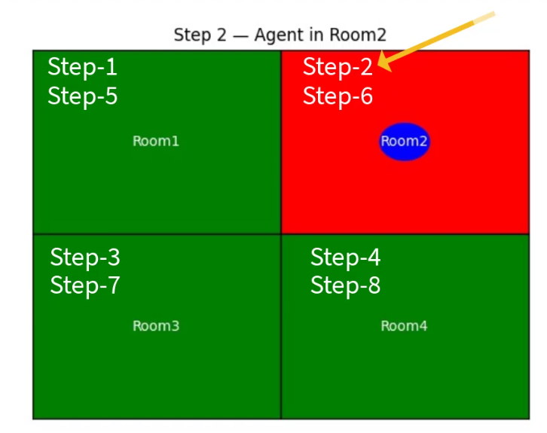

2. Model based agent
User memory or the model of the world to answer.

3. Goal Based Agent
Plans before acting
Use Case: Job Application Assistant
GOAL:
- Full Name
- Email Address
- Skills
User: My name is Aarohi Singla.
Agent: Thanks, Aarohi! Now I just need your email and skills.
Thanks! You're all set to apply. We've noted your name, email, and skills.

4. Utility Based Agent
Goal based agent + Smart optimization. Best possible way to plan and action.
Uses utility function (how good or useful each option is?) to assign a score to each action and then picks the best one.
Best for uncertain situation with incomplete information.

5. Learning Agent
This is an agent that gets better over time. (Feedback based)
It learns from its own experiences — just like we do!
