PLATFORM ARCHITECTURE
STEPS 19 C & D— LOCAL
REDDUST REST API FOUNDATION
Implementation runbook for core mobile app, gateway & same-Wi-Fi echo, Rest API microservices

Project RedDust


From Anodiam


Version | Publisher | Date | Reviewer | Date
1.0.0 | Anirban Chakrabarty | 17/10/2026 |  | 17/10/2026

Contents
19C–19D — LOCAL IDENTITY, DATA & UNIFIED ANDROID CLIENT 3
Step 19C — Build the Local RedDust Identity, Session and Audit Microservice 3
Step 19D — Merge Google-Authenticated Frontend and Proven WebRTC Call Client 13
Appendix 16
Appendix G – Install and Secure PostgreSQL on Windows 16
Appendix H — Create RedDust Application Role, Database and pgcrypto Extension 19
APPENDIX I – RedDust Database Schema Creation through Alembic 23
Appendix J — Google Identity Verification and Atomic User Linking 37
Appendix K — RedDust Signing Keys, JWT Access Tokens and Refresh Sessions 39
Appendix L — Versioned FastAPI Contracts and Local Integration Verification 42
Appendix M — Authentication Security Tests, Referential Integrity and Audit Evidence 44

19C–19D — LOCAL IDENTITY, DATA & UNIFIED ANDROID (Mobile) CLIENT
Till now, we developed RedDust on how to listen and communicate audio. Here, we are developing how RedDust will recognize (and protect) its users, along with their privacy and security. Next, we will teach it how to understand, remember context and act intelligently on the users’ behalf.
Where we stand: Proven WebRTC audio communication and completed local database foundation.
What Steps 19C–19D achieve: Secure Google-backed identity (OAuth2), RedDust-controlled sessions, authorized calls and one unified mobile application spanning across WebRTC audio communication and user identity and session.
Where we go next: Context-aware conversational AI, specialized agents and scalable cloud-native deployment.

Introduction — From a Working Voice Connection to an Intelligent, Identity-Aware RedDust Platform
Until now, our journey with RedDust has been about solving a fundamental challenge: can a mobile phone communicate with our own Python backend and carry a real-time voice conversation across the network? Starting with a React Native mobile application, we gradually established microphone access, WebRTC signalling, secure audio transport, and communication with a Python FastAPI/aiortc Gateway. Our local echo experiment demonstrated the essential communication pathway: a person speaks into the phone, the audio reaches the Gateway, and the Gateway returns the audio to the phone. Separately, we developed the foundations of Google Sign-In and built our local PostgreSQL 18.6 database. Through SQLAlchemy and Alembic, we have also established and verified a seven-table relational schema for storing RedDust users, external identities, devices, authentication sessions, calls, preferences, and audit events. We have therefore built the foundations of communication and data storage—but we have not yet completed the secure connection between a person's Google identity, their RedDust account, and their voice conversations.
Steps 19C and 19D bring these separate achievements together into the beginnings of a real, secure application. First, we will teach RedDust to recognize who is signing in: independently verify Google's authentication evidence, find or create the correct internal user, issue RedDust's own access and refresh tokens, and manage authorized sessions without exposing credentials or allowing one user to access another user's information. We will implement and test these capabilities in a dedicated FastAPI authentication microservice, using PostgreSQL as its trusted data store. Next, we will bring the Google-authenticated frontend and the proven WebRTC calling client together into one unified mobile application, connecting authentication, user navigation, call authorization, real-time audio, and secure logout into a coherent user experience. By the end of these steps, our target is no longer simply a phone that can exchange audio with a server, but a phone application through which a verified RedDust user can securely sign in, establish an authorized voice session, and interact with our backend while their identity, sessions, and data remain protected. This will provide the foundation for the next stage of RedDust: incorporating contextual intelligence, AI agents, personalized conversational experiences, and eventually deploying the platform through Google Cloud, Cloud SQL, Kubernetes, and a controlled DevSecOps pipeline.
DIAGRAM — 19CD-00: From the RedDust WebRTC Proof of Concept to an Identity-Aware Conversational Platform
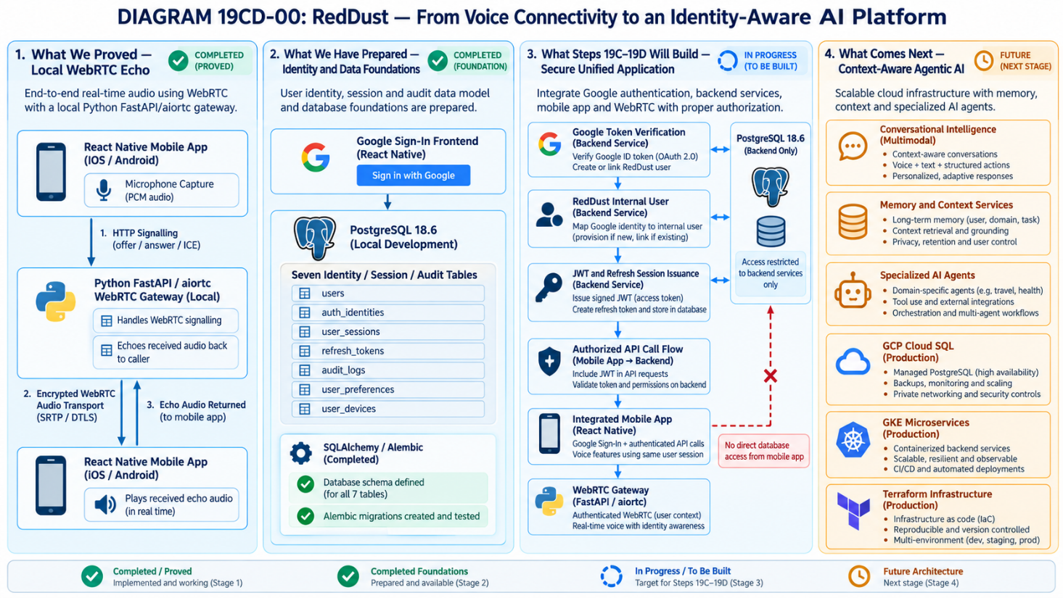

Source-code audit and design boundaries
Uploaded artifact | Observed, not assumed
reddust-mobile.zip | Expo ~56.0.21, React Native 0.85.3, react-native-webrtc ^124.0.7, config plugin 15.0.2, InCallManager 4.2.2. The primary real-time call screen is src/app/index.tsx; POST /offer uses EXPO_PUBLIC_GATEWAY_URL.
reddust-frontend.zip | Expo ~57.0.12, React Native 0.86.2, Google sign-in ^16.1.4, react-native-webrtc ^124.0.8, Zustand with AsyncStorage; splash/sign-in/drawer tabs and a placeholder Soulmate screen exist.
Frontend authentication code | GoogleSignInButton saves Google userInfo in Zustand and redirects; useAuthStore persists isAuthenticated + userInfo. There is no demonstrated backend verification, issued RedDust access token, or server authoritative login session.
Steps 0–19 DOCX | Local milestone is mic → HTTP SDP /offer → ICE/DTLS/SRTP → aiortc EchoAudioTrack → phone audio. The runbook explicitly postpones cloud/TURN and cautions against disturbing the working echo baseline.
CAUTION / STOP POINT: The two archives reddust-mobile.zip and reddust-frontend.zip are not drop-in-compatible merely by copying files. Do NOT combine Expo 56 and Expo 57 package manifests, merge node_modules, or claim Google ID tokens are validated simply because the mobile SDK reports sign-in. Pin one tested Expo/native dependency matrix and rebuild the EAS development APK after native-module changes.

Step 19C — Build the Local RedDust Identity, Session and Audit Microservice
What this step does and why it matters: Add a separate Python/FastAPI service that verifies Google ID tokens, provisions users, issues and revokes short-lived RedDust sessions, persists normalized relational identities in local PostgreSQL, and produces privacy-safe audit events. It will later point to Cloud SQL without coupling authentication to WebRTC media transport.
New technical concepts introduced in this step (in absolute beginner terms): An identity provider (Google) proves who signed in; the RedDust backend verifies that proof and decides which internal user it represents. A relational database gives stable user IDs. An access token authorizes API calls; a refresh token renews access. A call session ID is different from an authentication session ID.
Who does what: Backend developer owns auth-api, migrations and tests. Mobile developer provides one Google ID token only after successful native sign-in. Gateway developer gates signalling against verified backend identity. Lead approves token lifetime, retention, Google OAuth client IDs and schema changes.

19C.1 — Establish boundaries and invariants
What this section does and why it matters: Keep the identity service separate from the existing Gateway process so local echo can still be debugged independently.
New technical concepts introduced in this section (in absolute beginner terms): A trust boundary marks where client-supplied data must be verified by a server.
• Google OAuth/OIDC: Google ID token is presented to auth-api; verify its signature, issuer, audience and expiry. Never trust user email or profile fields supplied directly by the mobile client.
• RedDust identity: users.id is an internal UUID; Google subject (“sub”) is stored as an external identity key. Email is an attribute, not the primary identifier.
• RedDust auth_session_id: tracks device/account login. RedDust call_session_id: tracks one WebRTC conversation. WebRTC PeerConnection instance: transport object; not an identity.
• Gateway /offer must reject anonymous or invalid sessions and derive user_id server-side. Existing unauthenticated /offer remains available only under explicit local test mode until migrated.
- UDP — User Datagram Protocol: A connectionless transport protocol that WebRTC commonly uses to transmit real-time audio and video packets with low latency.
- SRTP — Secure Real-time Transport Protocol: A protocol that encrypts and protects real-time audio and video packets during transmission.
DIAGRAM — 19C-A: Identity and media trust boundaries
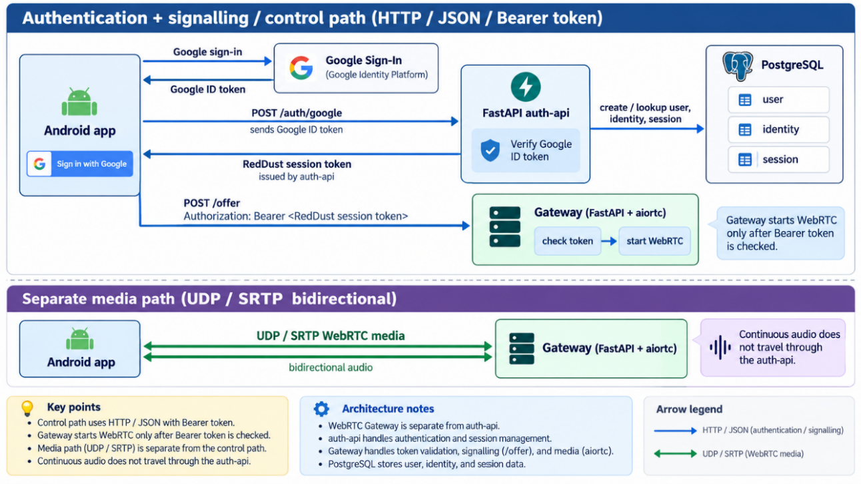

19C.2 — Create a third local project
What this section does and why it matters: Prepare a separately runnable Python service without changing the known-good Gateway virtual environment.
New technical concepts introduced in this section (in absolute beginner terms): Each microservice has its own source, dependencies, configuration and deployable lifecycle.
D:\RedDust\
reddust-mobile/ # current WebRTC proof; preserve as reference
reddust-frontend/ # UI + Google sign-in source to be merged
reddust-auth-api/ # NEW FastAPI application
app/{main.py,settings.py,db.py,models.py,schemas.py,security.py,routes/}
alembic/versions/
alembic.ini
tests/
requirements.txt
.env.example
reddust-unified/ # NEW target Android application (Step 19D)

cd D:\RedDust
mkdir reddust-auth-api
cd reddust-auth-api
py -3.12 -m venv .venv
.venv\Scripts\Activate.ps1
python -m pip install --upgrade pip
python -m pip install fastapi "uvicorn[standard]" sqlalchemy "psycopg[binary]" alembic pydantic-settings google-auth pyjwt cryptography pytest httpx
python -m pip freeze > requirements.txt
python -c "import fastapi, sqlalchemy, psycopg, google.auth; print('Auth stack imports OK')"
CAUTION / STOP POINT: Do not use the Gateway’s venv as the auth-api environment. Pin and review exact package versions after the first verified local build. For production, evaluate dependency updates and vulnerability scans rather than treating this illustrative requirements generation as a final supply-chain lock.

19C.3 — Install and configure local PostgreSQL
What this section does and why it matters: Create a non-superuser database login and database dedicated to RedDust development.
New technical concepts introduced in this section (in absolute beginner terms): A database role is an account inside PostgreSQL, not a Google user or an operating-system human account.
Install a supported PostgreSQL release from the official Windows installer or approved team package manager, selecting localhost-only listening. Record the installed major version as an explicit team baseline; this runbook does not claim an exact installed version from either source archive.
Details below in Appendix G – Install and Secure PostgreSQL on Windows. Follow Appendix G, step by step, to finish this.
Next, we will set up the PostgreSQL database that reddust-auth-api microservice will use for local development. Since we are new to PostgreSQL, I recommend using pgAdmin 4's graphical interface for most operations. Afterwards, we will verify everything using Windows PowerShell. Configure a dedicated local PostgreSQL login for the RedDust FastAPI authentication service, create its development database, enable pgcrypto, and prove the application account can connect.
Details below in Appendix H — Create RedDust Application Role, Database and pgcrypto Extension. Follow Appendix H, step by step, to finish this.

19C.4 — Define the normalized relational schema
What this section does and why it matters: Creates normalized RDBMS schema for RedDust database for – model identity, login sessions, device records, voice calls and limited audit metadata without duplicating Google accounts.
New technical concepts introduced in this section (in absolute beginner terms): RDBMS Database Normalization reduces duplicate facts. Foreign keys make relationships explicit; unique constraints prevent multiple accounts for one provider subject.
Table | Key columns / relations | Purpose
app_users | id UUID PK; display_name; status; created_at; updated_at | Internal durable RedDust user, independent of Google email changes
external_identities | id UUID PK; user_id FK; provider; provider_subject; email_at_verification; verified_at; UNIQUE(provider,provider_subject) | Account-to-Google identity mapping
client_devices | id UUID PK; user_id FK; installation_id; platform; created_at; last_seen_at; revoked_at | Device-scoped attribution; installation_id is not a secure proof by itself
auth_sessions | id UUID PK; user_id FK; device_id FK; refresh_token_hash; expires_at; revoked_at; created_at | Revocable per-device login sessions (never store plaintext refresh token)
call_sessions | id UUID PK; user_id FK; auth_session_id FK; started_at; ended_at; end_reason; status | Tracks voice-session lifecycle, distinct from login
audit_events | id UUID PK; actor_user_id FK nullable; auth_session_id FK nullable; event_type; occurred_at; request_id; metadata_json | Minimal redacted security/operational audit
user_preferences | user_id PK/FK; preferred_persona; speaker_default; updated_at | Small durable user preferences; separate from third-party identity
DIAGRAM — 19C-4: Entity Relationship diagram of BCNF Normalized RedDust application’s user authentication database
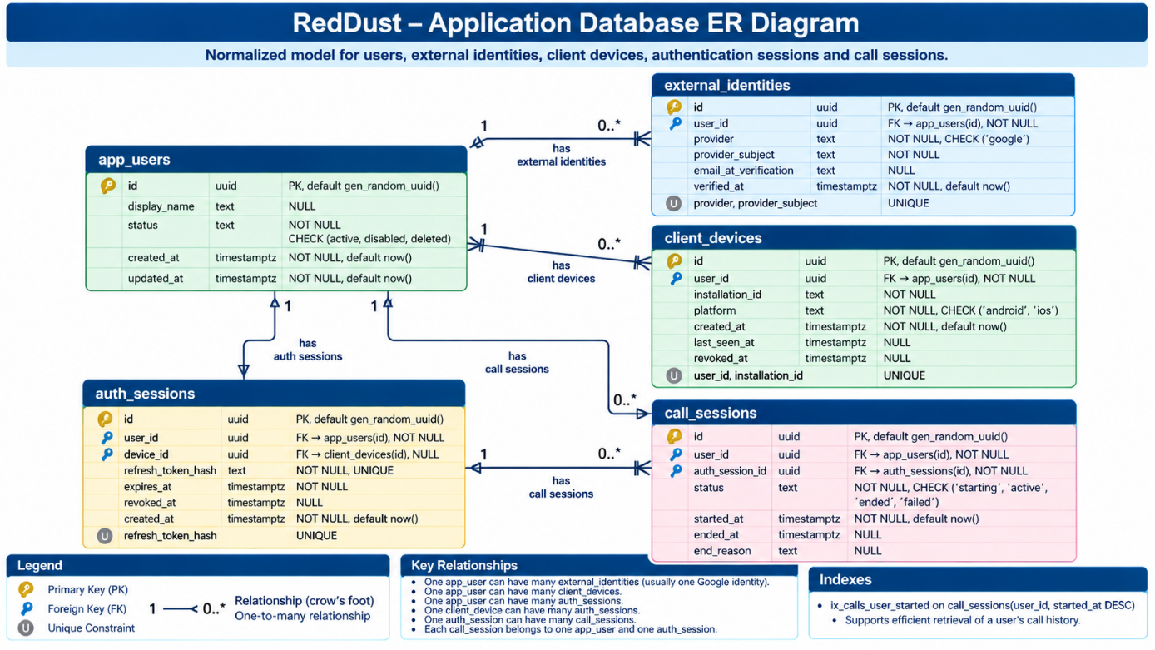
The PostgreSQL DDL script below is not supposed to be run directly anywhere. It is just for reference. The actual schema creation/ upgrade is supposed to be done by a Python Alembic migration file, explained in detail in APPENDIX I – RedDust Database Schema Creation through Alembic. Follow it step by step for database schema creation and migration through alembic.
-- Baseline DDL model: apply with versioned Alembic migrations, NOT ad hoc production edits.
CREATE TABLE app_users (
id uuid PRIMARY KEY DEFAULT gen_random_uuid(),
display_name text, status text NOT NULL DEFAULT 'active'
CHECK (status IN ('active','disabled','deleted')),
created_at timestamptz NOT NULL DEFAULT now(),
updated_at timestamptz NOT NULL DEFAULT now()
);
CREATE TABLE external_identities (
id uuid PRIMARY KEY DEFAULT gen_random_uuid(),
user_id uuid NOT NULL REFERENCES app_users(id),
provider text NOT NULL CHECK (provider IN ('google')),
provider_subject text NOT NULL,
email_at_verification text,
verified_at timestamptz NOT NULL DEFAULT now(),
UNIQUE(provider,provider_subject)
);
CREATE TABLE client_devices (
id uuid PRIMARY KEY DEFAULT gen_random_uuid(),
user_id uuid NOT NULL REFERENCES app_users(id),
installation_id text NOT NULL,
platform text NOT NULL CHECK (platform IN ('android','ios')),
created_at timestamptz NOT NULL DEFAULT now(),
last_seen_at timestamptz,
revoked_at timestamptz,
UNIQUE(user_id,installation_id)
);
CREATE TABLE auth_sessions (
id uuid PRIMARY KEY DEFAULT gen_random_uuid(),
user_id uuid NOT NULL REFERENCES app_users(id),
device_id uuid REFERENCES client_devices(id),
refresh_token_hash text NOT NULL UNIQUE,
expires_at timestamptz NOT NULL,
revoked_at timestamptz,
created_at timestamptz NOT NULL DEFAULT now()
);
CREATE TABLE call_sessions (
id uuid PRIMARY KEY DEFAULT gen_random_uuid(),
user_id uuid NOT NULL REFERENCES app_users(id),
auth_session_id uuid NOT NULL REFERENCES auth_sessions(id),
status text NOT NULL CHECK (status IN ('starting','active','ended','failed')),
started_at timestamptz NOT NULL DEFAULT now(),
ended_at timestamptz, end_reason text
);
CREATE INDEX ix_calls_user_started ON call_sessions(user_id,started_at DESC);
Complete the migration with audit_events, user_preferences, indexes and explicit delete/retention behavior. Use PostgreSQL timestamptz (UTC at API boundaries); use transactional upsert of external_identities to prevent duplicate Google sign-ins. Treat metadata_json as an allowlisted, bounded field, not an unrestricted event dump.

19C.5 — Configure verification and secrets
What this section does and why it matters: Keeps public configuration and private credentials out of Python source code. The RedDust backend must know its PostgreSQL address, allowed Google OAuth client identifiers, token issuer/audience, and signing-key locations. Private passwords and private keys must stay on the development machine, not in Git or the mobile application.

19C.5.1 — What to do and where
- Open VS Code → File → Open Folder → D:\RedDust\reddust-auth-api. In Explorer locate .env.example, .env.local, .gitignore and app/settings.py.
- Retain the working RD_DB_HOST / RD_DB_PORT / RD_DB_NAME / RD_DB_USER / RD_DB_PASSWORD settings proven during Appendix I (APPENDIX I – RedDust Database Schema Creation through Alembic). Keep RD_DB_HOST=127.0.0.1 because FastAPI and PostgreSQL share the same Windows laptop.
- Put example non-secret placeholders in .env.example. Put real development-only values in the git-ignored .env.local. Do not create a competing DATABASE_URL unless your application settings module is deliberately designed to use it.
- Add Google OAuth client allowlist, JWT issuer/audience, local signing-key paths, and token time-to-live settings. Match all environment-variable names in app/settings.py.
- Confirm .env.local and the local secrets directory are ignored; verify the Python settings loader will read the chosen file.
WHERE: VS CODE FILE .env.example — NOT A TERMINAL COMMAND
# VS CODE FILE: .env.example — placeholder values, safe to commit
RD_DB_HOST=127.0.0.1
RD_DB_PORT=5432
RD_DB_NAME=reddust_dev
RD_DB_USER=reddust_app
RD_DB_PASSWORD=REPLACE_LOCALLY
GOOGLE_ALLOWED_CLIENT_IDS=REPLACE_WITH_APPROVED_GOOGLE_CLIENT_ID
REDDUST_JWT_ISSUER=reddust-auth-local
REDDUST_JWT_AUDIENCE=reddust-api
REDDUST_PRIVATE_KEY_FILE=./secrets/jwt-private.pem
REDDUST_PUBLIC_KEY_FILE=./secrets/jwt-public.pem
ACCESS_TOKEN_TTL_SECONDS=900
REFRESH_TOKEN_TTL_DAYS=30
WHERE: VS CODE FILE .gitignore — NOT A TERMINAL COMMAND
# .gitignore — merge with the existing file
.env
.env.local
.env.*
!.env.example
.venv/
__pycache__/
*.pyc
secrets/
WHERE: VS CODE INTEGRATED POWERSHELL
Set-Location "D:\RedDust\reddust-auth-api"
git check-ignore -v .env.local
git check-ignore -v secrets/jwt-private.pem
git status –short
Follow Appendix J — Google Identity Verification and Atomic User Linking to finish this step in detail.
Verification: The first two commands must identify matching .gitignore rules. Review git status and confirm no secret-containing file is staged. A file already tracked by Git is not protected merely by adding .gitignore.
IMPLEMENTATION DETAIL: The earlier Step 19C used DATABASE_URL; Appendix I used RD_DB_* environment values. Choose one authoritative configuration path and reuse it. Never accidentally print the database password while verifying configuration.
Appendix reference: See Appendix K for private/public signing-key generation, RS256 access-token issuance, refresh-token hashing, rotation, revocation, key identifiers (kid) and secure Gateway validation.
ACCEPTANCE / EVIDENCE: Existing Appendix I database settings still work; local secrets are ignored; placeholder configuration is safe; intended variable names are documented.
STOP / DO NOT PROCEED IF: Secrets are tracked in Git, two contradictory connection configurations exist, or app/settings.py ignores the chosen .env.local mechanism.
DIAGRAM 19C-05 — Secrets and Configuration Trust Boundary
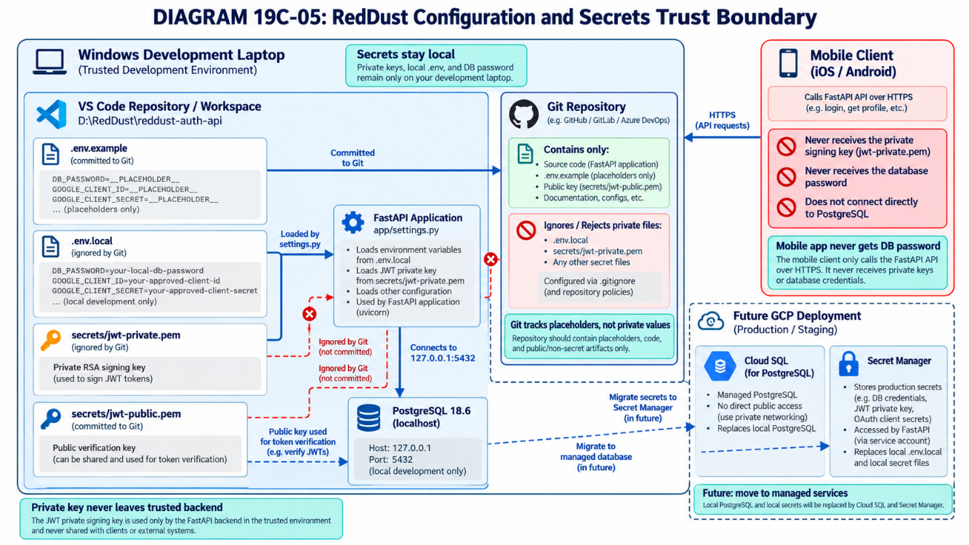

19C.6 — Implement Google ID-token verification
What this section does and why it matters: A successful Google sign-in supplies an ID token; RedDust must independently verify that token before creating or retrieving the internal RedDust account. Google authentication is distinct from RedDust authorization. The Section 19C.6 remains a short map. The Appendix J — Google Identity Verification and Atomic User Linking implements backend Google-token validation and account linking; it does not claim that the mobile Google sign-in flow or FastAPI route code already exists.

19C.6.1 — Required development actions
- In VS Code PowerShell activate D:\RedDust\reddust-auth-api\.venv and install google-auth and requests using the project dependency workflow.
- In app/security.py implement a verifier that checks the Google signature, expiration, issuer, approved audience and nonempty subject. Catch failures at the API route and respond without logging the supplied token.
- Read GOOGLE_ALLOWED_CLIENT_IDS from the approved server configuration; use the configured client ID(s), not an arbitrary value supplied in the HTTP request.
- In the /v1/auth/google endpoint, use provider="google" and the verified sub to look up external_identities. In one database transaction either reuse the linked user or create app_users plus external_identities, then record the authorized device/session.
- Handle concurrent first-time sign-ins using the database UNIQUE(provider, provider_subject) constraint and a controlled retry/lookup policy.
- Test positive and negative Google-token cases before connecting the mobile app.
WHERE: VS CODE INTEGRATED POWERSHELL
Set-Location "D:\RedDust\reddust-auth-api"
.\.venv\Scripts\Activate.ps1
python -m pip install google-auth requests
python -c "from google.oauth2 import id_token; from google.auth.transport import requests; print('Google verification imports OK')"
Google claim | What it means | Required RedDust check
Iss | Who issued the token | Trusted Google issuer
Aud | Which OAuth client it targets | Member of approved RedDust client-ID allowlist
Exp | Expiry timestamp | Not expired
Sub | Stable Google identity identifier | Present; use for external identity lookup
email/email_verified | Email and verification status | Useful metadata, not the stable account key
IMPORTANT: The attached material describes a verification core, not a complete OAuth authorization-code implementation and not a finished FastAPI route. Google API permissions require their own scopes and consent. Never join accounts automatically only because their email strings match.
Appendix reference: See Appendix J for the practical Google verifier, transaction lifecycle, mock testing, permitted OAuth audiences and rejection matrix.
ACCEPTANCE / EVIDENCE: A valid token is accepted; wrong signature, issuer, audience, expiry and missing sub are rejected; repeat logins reuse the same internal account.
STOP / DO NOT PROCEED IF: The frontend-provided email or user_id is trusted as identity without token verification, or token material appears in logs.
DIAGRAM 19C-06 — Google ID Token to RedDust Account
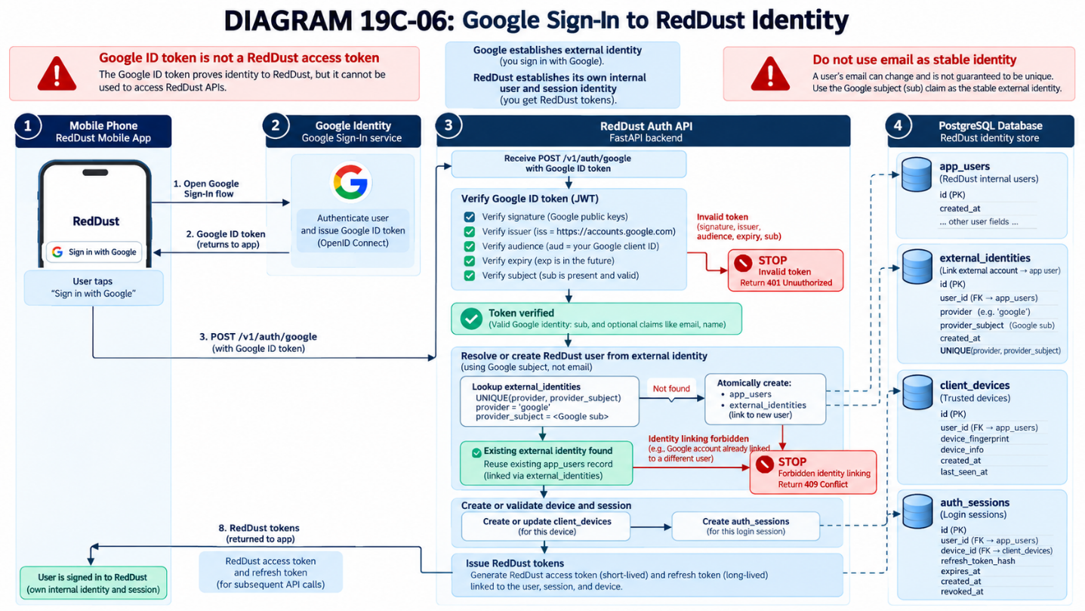

19C.7 — Publish minimal versioned API contracts
What this section does and why it matters: The phone and WebRTC Gateway need fixed request/response rules. Implement the interfaces in app/routes and record the contracts in docs/API_CONTRACT.md; FastAPI /docs will show the actual deployed interface.
Method and endpoint | Purpose | Acceptance / security
GET /healthz | Basic process status | No private data; no token required
POST /v1/auth/google | Exchange verified Google identity for RedDust session | Token verified server-side; atomic identity link; rate limit
POST /v1/auth/refresh | Rotate refresh credentials | Only token hash stored; reuse/replay policy
POST /v1/auth/logout | Revoke current session | Authorization required; revocation verified
GET /v1/users/me | Read current account and preferences | User derived from signed Bearer token
POST /v1/calls | Open authorized call session | Valid active auth session and matching user
POST /v1/calls/{id}/end | End owned call | Other users are rejected
POST /offer — Gateway | Exchange authorized WebRTC SDP | Validate token + call id; do not trust client user_id
- Create docs/API_CONTRACT.md in VS Code if it does not exist. Document method, path, request fields, response fields and expected status codes for each route.
- Implement one endpoint at a time in app/routes, exposing routers from app/main.py. Start with /healthz and /v1/users/me before the more complex refresh/call lifecycle.
- Use Pydantic request/response schemas, avoid returning refresh-token hashes, and require Bearer authorization on private endpoints.
- Start FastAPI; use http://127.0.0.1:8100/docs on the Windows browser to check the actual OpenAPI contract; compare it with docs/API_CONTRACT.md.
- Never accept a user_id from request body or query string as proof of identity. The token and server-owned session lookup determine authorization.
- Swagger: Swagger is an interactive interface for exploring and testing REST APIs, automatically generated by FastAPI from its OpenAPI specification. In RedDust, developers can access it at http://127.0.0.1:8100/docs to inspect endpoints, request/response schemas and test API calls.
- Scaffold: A scaffold is the basic, preliminary structure of an application, containing placeholder code or routes without their complete functionality. In RedDust, a FastAPI scaffold might display an endpoint in Swagger but not yet implement its actual authentication, database operations or authorization logic.
INTEGRATION BOUNDARY: The seven application routes belong to reddust-auth-api. POST /offer belongs to the separately running WebRTC Gateway. Documentation and code must not accidentally point phone traffic straight to PostgreSQL.
Appendix reference: See Appendix L — Versioned FastAPI Contracts and Local Integration Verification for endpoint build order, minimal health-route example, Swagger verification, PowerShell HTTP tests and the Gateway authorization contract.
ACCEPTANCE / EVIDENCE: Swagger UI lists every implemented endpoint with expected methods/schema; unauthorized calls are rejected; only authenticated owners may operate on their sessions/calls.
STOP / DO NOT PROCEED IF: Docs display only a scaffold yet the runbook marks routes “implemented”, or a user-supplied identifier is trusted for authorization.
DIAGRAM 19C-07 — Mobile/Auth API/Gateway Contract Map
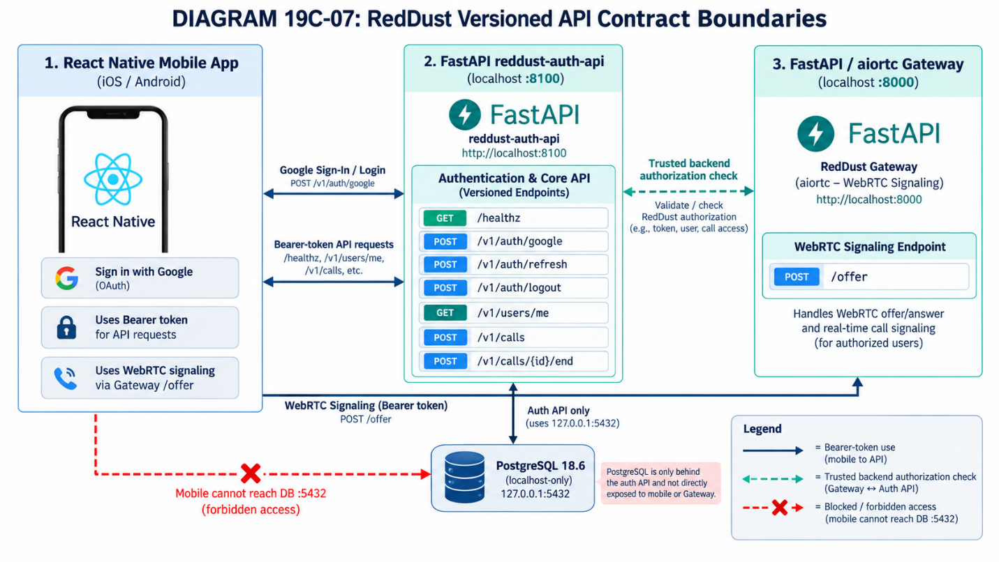

19C.8 — Start locally and verify API/database boundaries
What this section does and why it matters: Prove the existing schema and the developing authentication API work independently of the Gateway before phone integration. Do not redo Appendix I initialization.

19C.8.1 — Read-only Alembic verification
WHERE: VS CODE INTEGRATED POWERSHELL
Set-Location "D:\RedDust\reddust-auth-api"
.\.venv\Scripts\Activate.ps1
python -m alembic current
python -m alembic heads
python -m alembic check
Expected: current/head revision identifiers match for a single-head project; alembic check reports no new upgrade operations. These checks do not replace the constraint, index and pgcrypto verification already completed in Appendix I.
NEVER REPEAT BLINDLY: Do not run alembic init, generate a second initial identity schema, or reapply hand-written CREATE TABLE statements. Existing migrations are the authoritative history.

19C.8.2 — Validate the app entry point and start FastAPI
- Open app/main.py and confirm an actual FastAPI app object and route registrations exist. If it is still an empty scaffold, implement the minimal health route first (Appendix L).
- Open an activated PowerShell terminal in the project root; start Uvicorn bound to loopback on port 8100.
- Use a Windows browser (not the VS Code terminal) to open http://127.0.0.1:8100/docs.
- Open a SECOND PowerShell terminal for a health check while Uvicorn continues running in the first terminal.
- Verify database-backed endpoints only after the DB session dependency and routes have been implemented.
WHERE: VS CODE INTEGRATED POWERSHELL, TERMINAL 1
python -m uvicorn app.main:app --reload --host 127.0.0.1 --port 8100
WHERE: VS CODE INTEGRATED POWERSHELL, TERMINAL 2
Invoke-RestMethod "http://127.0.0.1:8100/healthz"
Expected: the first terminal prints an Uvicorn startup message; /docs loads; /healthz returns the intentional safe health response if the route exists. A 404 on /healthz means that route is not yet implemented.

19C.8.3 — Physical-phone boundary
Uvicorn --host 127.0.0.1 accepts only laptop-local connections. For deliberate phone-to-laptop reachability testing, the auth API must bind to an appropriate laptop interface and Windows Firewall must permit the test port. With your previously observed Wi-Fi IP 192.168.1.4, the phone might use 192.168.1.4:8100 if that address remains unchanged. Recheck ipconfig whenever the network changes. Real bearer/refresh credentials must not travel over unencrypted LAN HTTP; use an approved HTTPS development path.
PostgreSQL remains bound to 127.0.0.1:5432. The mobile application never uses RD_DB_HOST or RD_DB_PASSWORD.
ACCEPTANCE / EVIDENCE: Alembic current, heads and check are clean; FastAPI starts; /docs renders; implemented /healthz responds; the database is not network-exposed.
STOP / DO NOT PROCEED IF: A migration mismatch appears, the FastAPI import path fails, health is being mistaken for an implemented login flow, or tokens would cross plaintext Wi-Fi.
DIAGRAM 19C-08 — Local FastAPI and PostgreSQL Validation
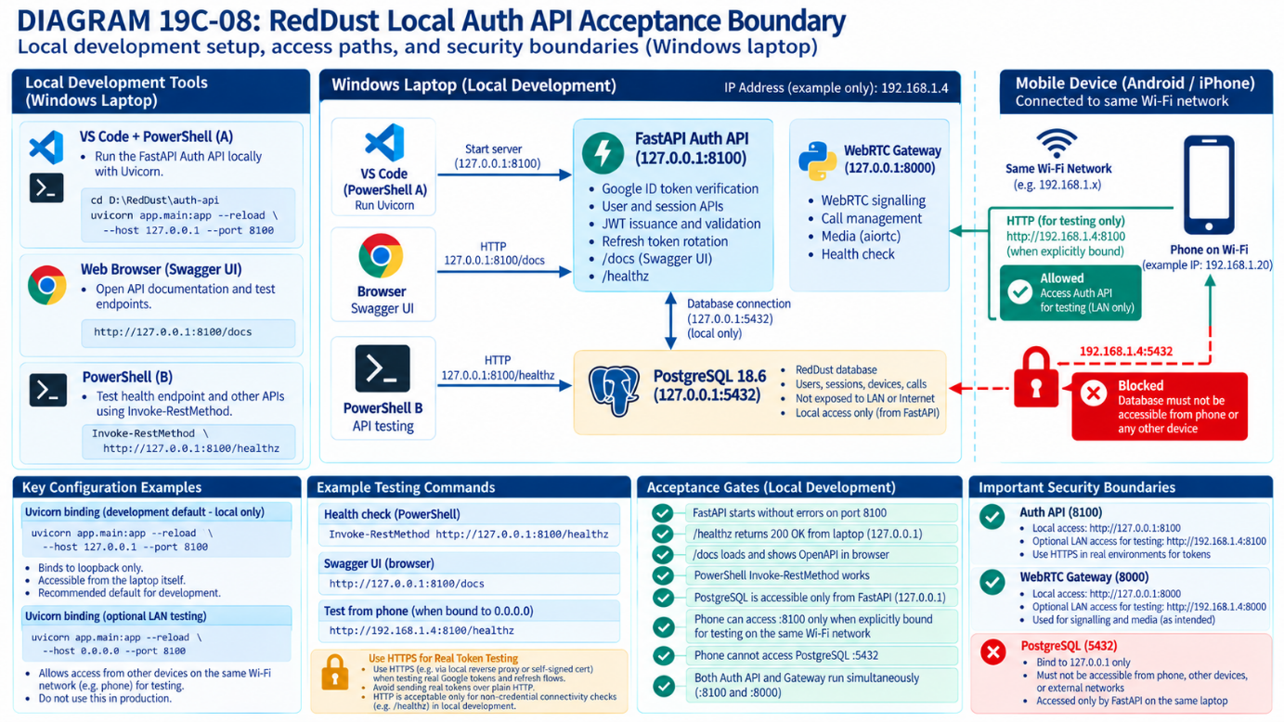

19C.9 — Test negative cases and logging policy
What this section does and why it matters: Authentication is incomplete unless it rejects malicious and accidental invalid requests. Use controlled pytest test data to prove forged tokens, expired sessions and cross-user access fail, while audit records never expose sensitive credentials or audio.
Test family | Required examples | Expected result
Google tokens | Bad signature, wrong audience/issuer, expiry, missing sub | Rejected; no raw token logged
Auth sessions | Refresh rotation, replay, logout, expiry, device revocation | Correct grant/revocation response
Authorization | Unauthenticated /users/me, cross-user call end, unauthorized /offer | 401 or 403/404 by documented policy
Database integrity | Wrong-user device/session or call/session pairing | Composite foreign key rejects mismatch
Audit and privacy | Success/failure and request IDs; metadata caps | Useful structured logs without secrets/audio/SDP/transcripts
- Create focused tests under tests/ using pytest; use a separate test database or rollback-controlled fixtures for all write tests.
- Run a valid path first and record its evidence; follow with failing/negative cases and check the exact response code.
- Inspect audit_events and structured logs, looking for correct event types and the absence of raw secret fields.
- Run tests with python -m pytest -v. “No tests ran” is not a passing security result.
- Do not test with another real person’s credentials or live production records.
WHERE: VS CODE INTEGRATED POWERSHELL
Set-Location "D:\RedDust\reddust-auth-api"
.\.venv\Scripts\Activate.ps1
python -m pytest –v
Appendix reference: See Appendix M for the test matrix, reversible relational-integrity checks, audit-event read-only queries, response expectations and release acceptance evidence.
ACCEPTANCE / EVIDENCE: Positive tests and negative tests pass, expected access denials are enforced, and logs/audits omit tokens, passwords, raw SDP, PCM, transcripts and private payloads.
STOP / DO NOT PROCEED IF: Only successful login is tested, an empty test suite is treated as proof, or other-user call operations succeed.
DIAGRAM 19C-09 — Security Negative-Test Decision Grid
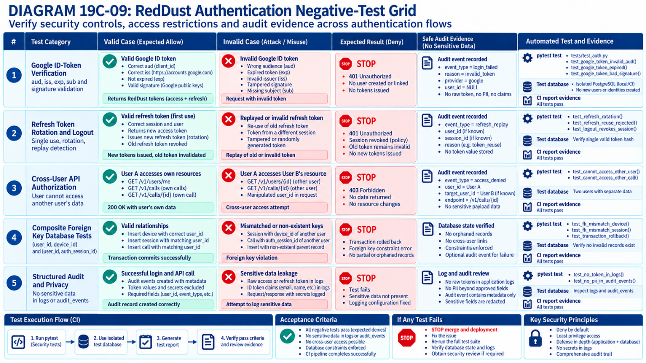

19C.10 — Future migration contract (Steps 20, 21 and production)
What this section does and why it matters: Preserve an architecture that can move from the Windows laptop to Cloud SQL and containerized services without rebuilding RedDust identity logic. This is a design contract now, not permission to deploy infrastructure prematurely.
Stage | Expected design choice | When to act
Now — local | Keep config external, Alembic revisions in Git, database loopback-only, FastAPI separately testable | Current Step 19C
GCP development VM / Cloud SQL | Use managed secrets, narrow DB connectivity, vetted migration run and backup verification | Future cloud milestone
Terraform / CI-CD | Provision infrastructure, IAM/network/secrets; run Alembic as a reviewed release task | Future DevSecOps milestone
GKE staging and production | Stateless service deployments, appropriate workload identity, connection and health policies | After local API/security acceptance
Operations | Backup/restore tests, incident response, retention/consent, key rotation, access audit | Before real-user production
BOUNDARY THAT MUST NOT BE CONFUSED: Terraform provisions database infrastructure; Alembic version-controls application schema changes; FastAPI handles app behavior; Google OAuth authenticates external identity; RedDust JWT/DB policies authorize RedDust actions. Each is a separate responsibility.
- Keep source-controlled Alembic migration files immutable after promotion; create a new reviewed revision for later schema changes.
- Plan separate migration and runtime database identities: schema DDL for the release identity, limited DML for normal application use. Current local reddust_app permissions may be broader because it owns the baseline; do not falsely describe them as production least privilege.
- For future destructive schema changes, use reviewed expand/contract releases with rollout compatibility, backups and recovery testing.
- Do not expose Cloud SQL or local PostgreSQL directly to a phone. The phone speaks to APIs only.
ACCEPTANCE / EVIDENCE: The future deployment plan explicitly distinguishes schema migration, application runtime, infrastructure provisioning and secrets management; current local work remains reproducible.
STOP / DO NOT PROCEED IF: Terraform is expected to generate Alembic revisions, production runtime identities have unrestricted DDL by default, or the mobile app is given database credentials.
DIAGRAM 19C-10 — From Local Auth Service to Cloud SQL and GKE
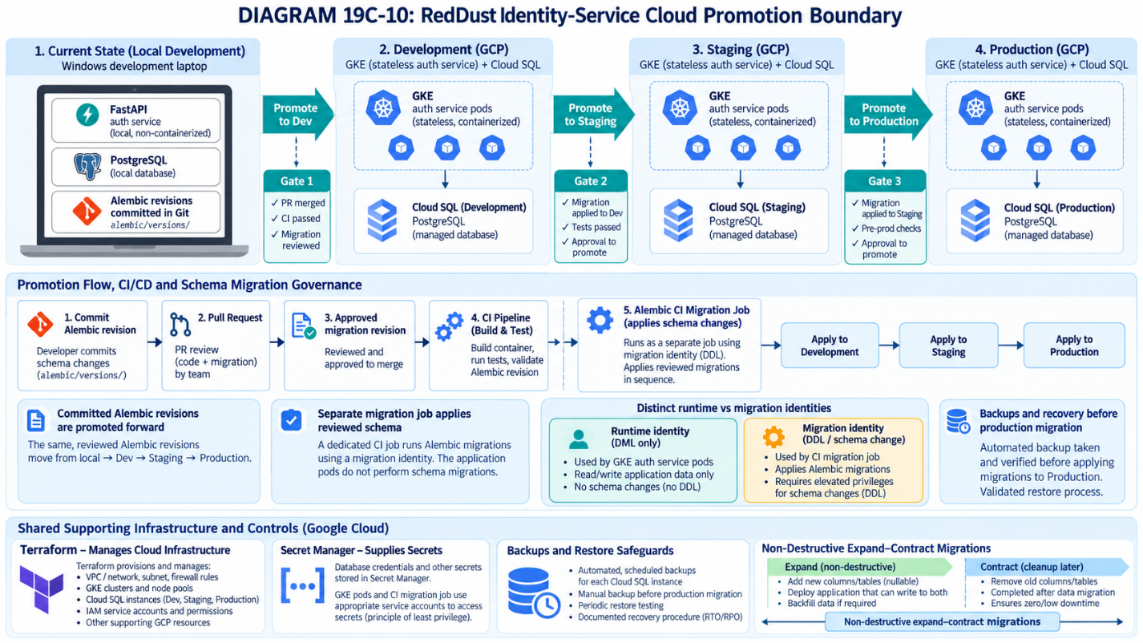

19C.5–19C.10 — Consolidated go/no-go checklist
Acceptance item | Evidence to capture
Secrets are not in Git | git check-ignore -v output; reviewed git status
Allowed Google IDs configured | Reviewed server allowlist values; no token or credential printed
Google verification works | Positive/negative pytest report; same internal ID on repeat login
API contract is real | /docs screenshot or documented endpoint list and schema comparison
Local service starts | Uvicorn startup log and health response
Appendix I remains current | alembic current=heads; alembic check no outstanding autogenerated ops
Security and audits pass | pytest and audit queries with sensitive fields redacted
Cloud responsibility separated | Approved architecture review of Terraform/Alembic/Secret Manager boundaries
End-state in plain English: A user signs in with Google. RedDust checks the proof, recognizes the correct internal account, manages its own secure sessions, lets that account operate only on its own data/calls, and keeps private secrets out of phones, logs and Git. The verified database and migration foundation from Appendix I supports—but does not itself implement—those behaviors.

Step 19D — Merge Google-Authenticated Frontend and Proven WebRTC Call Client
What this step does and why it matters: Make ONE distributable Android app: preserve reddust-frontend’s branding/navigation/Google sign-in, transplant reddust-mobile’s proven call lifecycle into an isolated feature, and require a server-verified RedDust session before starting a phone-like call to the aiortc Gateway.
New technical concepts introduced in this step (in absolute beginner terms): Merging code is not the same as merging native dependencies. Authentication state determines whether navigation is allowed; an authenticated Gateway request attaches an access token to HTTP signalling but never to raw WebRTC audio packets.
Who does what: Mobile developer owns unified Expo app and call hook; identity developer supplies /v1/auth/* contracts; Gateway developer enforces authenticated /offer; test engineer validates the whole session lifecycle and audio routing.

19D.1 — Choose one canonical Expo/native compatibility baseline
What this section does and why it matters: Resolve the SDK 56 versus 57 mismatch before transplanting code.
New technical concepts introduced in this section (in absolute beginner terms): Expo SDK fixes the supported React Native/native module matrix, so independent package upgrades may break Android builds.
Recommended implementation route: create reddust-unified from a version-controlled copy of reddust-frontend (preserve its UI/navigation/auth components), then reconcile native versions using Expo Doctor and a cloud Android development build. This is a recommendation, not a claim that Expo 57 supports every native combination here. If react-native-incall-manager/WebRTC/config plugin or Skia/TrackPlayer proves incompatible, switch to a tested Expo 56 target or update dependencies together in a dedicated compatibility branch. Keep the original reddust-mobile untouched as a rollback/acceptance reference.
cd D:\RedDust
# Start from a clean, source-only COPY of reddust-frontend (not node_modules/.expo)
# Name target reddust-unified and commit the unmodified baseline to Git.
cd reddust-unified
npm ci
npx expo-doctor
npm ls expo react-native react-native-webrtc react-native-incall-manager @react-native-google-signin/google-signin
# Preserve app.json android.package / scheme / EAS project identity deliberately;
# do NOT accidentally publish a second app under the same package ID.
CAUTION / STOP POINT: The frontend app.json currently lacks the WebRTC config plugin; it has @react-native-google-signin/google-signin configured. The WebRTC project uses a different SDK baseline and has InCallManager. Reconcile native plugins and Android RECORD_AUDIO permission, then make a NEW EAS development build. Expo Go and a JavaScript-only Metro reload cannot install missing native modules.

19D.2 — Map source files to destination modules
What this section does and why it matters: Migrate functionality by component boundary rather than replacing the entire app router.
New technical concepts introduced in this section (in absolute beginner terms): A feature module owns one responsibility, making sign-in, media and navigation separately testable.
Original source | Destination / rule
frontend/src/app/signin.tsx + GoogleSignInButton.tsx | Keep screen/UI; alter success handler to call auth-api after Google sign-in, then redirect only after verified RedDust login
frontend/src/store/useAuthStore.ts | Replace optimistic persisted isAuthenticated with hydrated, verified RedDust session state; secure token storage
frontend/src/app/(app)/_layout.tsx | Keep protected drawer; gate on auth bootstrap; avoid an incorrect redirect while hydration/refresh in progress
frontend/src/app/(app)/(tabs)/index.tsx | Replace Soulmate placeholder with a navigation entry / call launch control
mobile/src/app/index.tsx | Extract WebRTC code into src/features/call/useWebRTCCall.ts + CallScreen.tsx; keep start/stop/ICE/state/audio routing
mobile app config | Port STUN/WebRTC plugin and required Android permissions after compatibility review
frontend useAppStore | Keep non-sensitive UI/persona state; reset on logout; do not mix audio PeerConnection refs with global persisted state
reddust-unified/src/
app/signin.tsx
app/(app)/_layout.tsx
app/(app)/(tabs)/index.tsx
app/(app)/call.tsx
components/GoogleSignInButton.tsx
features/auth/{authApi.ts,authSession.ts}
features/call/{CallScreen.tsx,useWebRTCCall.ts,callApi.ts}
store/{useAuthStore.ts,useAppStore.ts}
config/env.ts

19D.3 — Reconcile Android permissions and native plugins
What this section does and why it matters: Ensure a single APK includes Google sign-in, WebRTC, routing and microphone permissions.
New technical concepts introduced in this section (in absolute beginner terms): An EAS build compiles native code; Metro only refreshes JavaScript.
// app.json — MERGE with existing settings; illustrative plugin fragment only
"plugins": [
"expo-router",
"@react-native-google-signin/google-signin",
"@config-plugins/react-native-webrtc",
"expo-font"
],
"android": {
"package": "com.app.reddust",
"permissions": ["android.permission.INTERNET",
"android.permission.RECORD_AUDIO",
"android.permission.MODIFY_AUDIO_SETTINGS",
"android.permission.ACCESS_NETWORK_STATE"]
}
// Preserve existing splash-screen plugin, icons, EAS projectId and other
// required settings; add InCallManager native dependency as tested.
Google OAuth Android client registration requires the FINAL package name and signing certificate SHA-1/SHA-256 for the appropriate development/release keys. Configure the webClientId actually accepted by the auth-api audience allowlist. Public OAuth client IDs are not secrets; Google client secrets and private signing keys never belong in React Native. Local HTTP cleartext may need explicit Android development-only network security configuration; production signalling must use HTTPS.

19D.4 — Replace optimistic Google-only state with backend-verified login
What this section does and why it matters: Convert Google sign-in success into a RedDust user/session accepted by the server.
New technical concepts introduced in this section (in absolute beginner terms): A local isAuthenticated Boolean is a UI convenience; it is not proof the backend authorized the user.
// Pseudocode within GoogleSignInButton.handleGoogleSignIn()
const response = await GoogleSignin.signIn();
if (response.type !== 'success') return;
const googleIdToken = response.data.idToken;
if (!googleIdToken) throw new Error('Google ID token is unavailable');
const rd = await authApi.exchangeGoogleIdToken({
id_token: googleIdToken,
installation_id: await getOrCreateInstallationId(),
platform: 'android',
});
await saveTokensToSecureStorage(rd.access_token, rd.refresh_token);
useAuthStore.getState().setVerifiedSession({
user: rd.user, authSessionId: rd.auth_session_id,
accessToken: rd.access_token, expiresIn: rd.expires_in,
});
router.replace('/(app)/(tabs)');
Implement getOrCreateInstallationId with stable local storage but do not rely on it for authentication. Use expo-secure-store (or an audited equivalent) for tokens, not the existing Zustand AsyncStorage persistence. Do not persist Google userInfo or access/refresh tokens in the current reddust-auth-storage object. Persist only non-sensitive UI state; on cold start securely recover the refresh token and revalidate via auth-api before showing a protected screen.

19D.5 — Design the authenticated navigation and call lifecycle
What this section does and why it matters: Make login, call initiation and teardown explicit application states.
New technical concepts introduced in this section (in absolute beginner terms): A state machine prevents double-start, stranded microphones and phantom logged-in sessions.
App launch → auth bootstrap → SIGNED_OUT or SIGNED_IN
SIGNED_OUT → Google sign-in → auth-api /v1/auth/google → SIGNED_IN
SIGNED_IN → CallScreen → POST /v1/calls → STARTING
STARTING → getUserMedia() → pc.addTrack() → createOffer()
→ ICE gathering complete → POST Gateway /offer
Authorization: Bearer <RedDust access token>
body: {call_session_id, sdp, type}
→ setRemoteDescription() → ICE connected → IN_CALL
IN_CALL → End → close pc / stop tracks / InCallManager.stop()
→ POST /v1/calls/{id}/end → SIGNED_IN
SIGN_OUT → revoke auth session, clear secure tokens and UI state,
immediately close any active call → SIGNED_OUT

19D.6 — Move the proven WebRTC implementation without rewriting its signal path
What this section does and why it matters: Retain the verified media path from Steps 16–19B while changing only ownership and authorization around signalling.
New technical concepts introduced in this section (in absolute beginner terms): Codec and RTP encryption happen in WebRTC; the React Native app does not manually transport PCM packets over HTTP.
• Extract mediaDevices.getUserMedia, RTCPeerConnection creation, STUN, track attachment, offer/answer, ICE wait, remote-track listener, speaker toggle and cleanup from mobile/src/app/index.tsx into one call feature.
• Use peerConnectionRef and remoteStreamRef inside the feature; guard concurrent Starts, enforce ICE gather timeout, handle errors and stop tracks on every exit path.
• Keep EXPO_PUBLIC_GATEWAY_URL and EXPO_PUBLIC_AUTH_API_URL as nonsecret environment variables. Validate they are configured; do not interpolate undefined into a URL.
• Preserve the exact 19B prompt → silence → echo acceptance test. Adding Google authentication must not change audio timing/echo behavior.
// callApi.ts — contract sketch only
const res = await fetch(`${gatewayBase}/offer`, {
method: 'POST',
headers: {
'Content-Type': 'application/json',
Authorization: `Bearer ${accessToken}`,
},
body: JSON.stringify({call_session_id: callSessionId,
sdp: pc.localDescription?.sdp, type: pc.localDescription?.type}),
});
if (res.status === 401) throw new Error('RedDust session expired');
if (!res.ok) throw new Error(`Gateway signalling failed: ${res.status}`);
await pc.setRemoteDescription(new RTCSessionDescription(await res.json()));
Security-critical backend dependency: Do not merely add an Authorization header on the phone. Implement Gateway validation and call ownership checks before enabling authenticated calls. A mobile-supplied user_id, email or call_session_id alone cannot authorize an offer.

19D.7 — Connect Gateway to the identity/call service
What this section does and why it matters: Gate new SDP negotiations on a verified RedDust session and an owned active call.
New technical concepts introduced in this section (in absolute beginner terms): Service-to-service trust verifies the phone’s token without trusting self-declared user details.
Recommended Gateway middleware/helper: verify JWT signature against the auth service public key/JWKS; check issuer, audience, expiration, subject, auth_session_id and call-session ownership/status through a trusted DB/service lookup or short-lived signed call authorization. Avoid sending JWT in SDP, ICE candidates, audio metadata or log messages. The existing /offer {sdp,type} schema must be extended intentionally and tests updated; return 401 for missing/invalid token, 403 for mismatched call, 422 for malformed offer.

19D.8 — Run the three-terminal local integrated test
What this section does and why it matters: Test auth-api, Gateway and Metro as distinct processes against the same physical Android phone.
New technical concepts introduced in this section (in absolute beginner terms): A green HTTP result from sign-in does not imply media connectivity, and a media connection does not imply authorized identity.
# Terminal A: PostgreSQL Windows service is running; auth-api:
cd D:\RedDust\reddust-auth-api
.venv\Scripts\Activate.ps1
python -m alembic upgrade head
python -m uvicorn app.main:app --reload --host 0.0.0.0 --port 8100
# Terminal B: Gateway (once authenticated /offer integration passes unit tests):
cd D:\RedDust\reddust-gateway
.venv\Scripts\Activate.ps1
python -m uvicorn app.main:app --reload --host 0.0.0.0 --port 8000
# Terminal C: unified app:
cd D:\RedDust\reddust-unified
npx expo-doctor
npx expo start
# EAS development APK must already contain ALL approved native plugins.
For first local tests, set EXPO_PUBLIC_AUTH_API_URL=http://LAPTOP_WIFI_IP:8100 and EXPO_PUBLIC_GATEWAY_URL=http://LAPTOP_WIFI_IP:8000 in ignored .env.local. This is an explicitly temporary same-LAN development exception; never expose ID tokens or Bearer credentials on cleartext networks outside an approved controlled environment. Prefer HTTPS even in development when practical.

19D.9 — Acceptance checklist, fault injection and rollback
What this section does and why it matters: Require one user journey to pass plus negative authorization and device cleanup tests.
New technical concepts introduced in this section (in absolute beginner terms): Acceptance evidence ensures a secure feature integration does not undo a known-good media proof.
Test | Pass criterion
A. Fresh install and sign-in | Google UI → verified /v1/auth/google → stable RedDust user UUID + auth session ID
B. Invalid Google token | Server rejects; protected UI and Gateway are not opened
C. Start call | Created call_session_id; Gateway authenticated /offer; ICE connected; remote track arrives
D. Audio regression | Audible Hello RedDust Echo → ~2 s silence → echoed speech; speaker/earpiece toggle works
E. Unauthorized call | Anonymous/mismatched/expired token and foreign call ID denied with no PeerConnection allocation
F. Logout during call | Stop mic/pc/routing, revoke backend auth session, clear secure tokens + UI state, redirect to signin
G. App restart/session expiry | Secure bootstrap refreshes valid session or sends user to sign-in; no stale persisted auth Boolean
H. No secrets in logs | No JWT, ID token, refresh token, Google profile JSON, raw SDP, PCM or transcripts
I. Data integrity | One Google sub resolves to same user; audit/call records attach correct UUIDs
J. Rollback | Unmodified reddust-mobile still reproduces Step 19B echo independently
DIAGRAM — 19D-A: One Android client, two control-plane services, one media path
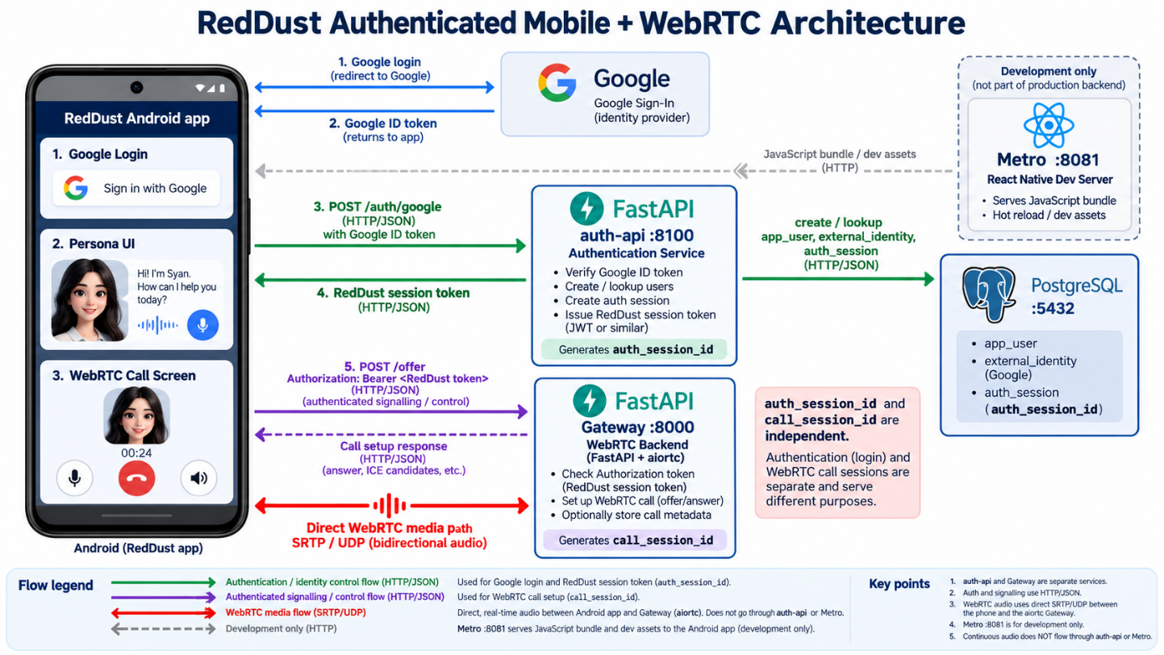

Appendix

Appendix G – Install and Secure PostgreSQL on Windows
RedDust local development runbook | PostgreSQL 18.6 | Windows x86-64 | October 2026
What this appendix does and why it matters: Standardizes the local PostgreSQL installation, prevents unintended network exposure, and establishes reproducible evidence that RedDust developers can use a functioning localhost-only database.

G.1 — Recommended version and baseline
Setting | Team baseline
PostgreSQL | 18.6 (major version 18; maintenance release dated 13 August 2026)
Operating system | Windows 64-bit (x86-64)
Installation path | C:\Program Files\PostgreSQL\18
Database listener | localhost only — 127.0.0.1 and, if available, ::1
TCP port | 5432
Authentication | Password-based local access; SCRAM-SHA-256 in pg_hba.conf
GUI tool | pgAdmin 4 (optional but recommended for beginners)
Compatibility decision: If the existing RedDust Cloud SQL database is on another major PostgreSQL version, match its major version locally until the team formally approves an upgrade. Always document the actual installed server version and patch number.

G.2 — Download from official sources
1. Visit the official PostgreSQL Windows installers’ page: https://www.postgresql.org/download/windows/
2. Select “Download the installer” to open the EDB installer download page: https://www.enterprisedb.com/downloads/postgres-postgresql-downloads
3. Choose PostgreSQL 18.6 for Windows x86-64, if listed. Obtain the .exe from the linked official vendor download page; do not download installers from unknown mirrors.
4. Right-click the downloaded installer and select “Run as administrator”.

G.3 — Follow the Windows installation wizard
Wizard screen | Value / action
Welcome | Next
Installation directory | C:\Program Files\PostgreSQL\18 (default)
Components | PostgreSQL Server + Command Line Tools + pgAdmin 4; Stack Builder optional
Data directory | Accept default unless team policy requires another drive
Password | Enter strong, unique postgres superuser password; store securely (abcd1234#$)
Port | 5432
Locale | Default locale
Summary / Install | Review values, select Next / Install; finish
Stack Builder prompt | Uncheck / skip unless extra drivers or extensions are needed
Important: The wizard does not have a separate “localhost-only” selector. Verify and enforce localhost binding AFTER installation (G.6–G.9). Keep the installer password out of source code, shared chats, screenshots and committed .env files.

G.4 — Check the PostgreSQL client version
Open a new PowerShell window and run:
& "C:\Program Files\PostgreSQL\18\bin\psql.exe" –version
Expected for the recommended installer:
psql (PostgreSQL) 18.6
This checks the psql client executable; the installed database server version must also be verified later with SHOW server version.

G.5 — Connect to the local server
& "C:\Program Files\PostgreSQL\18\bin\psql.exe" `
-h 127.0.0.1 `
-p 5432 `
-U postgres `
-d postgres
Enter the password supplied during installation. Expected interactive prompt:
postgres=#
If authentication fails, confirm the selected database role, password and server status before changing any configuration.

G.6 — Enforce localhost-only listening
While connected in psql as postgres, run:
ALTER SYSTEM SET listen_addresses = 'localhost';
Exit psql:
\q
A server restart is required for a change to listen addresses. Do not assume that ALTER SYSTEM alone has changed the active listener.

G.7 — Restart the Windows service
Open PowerShell as Administrator. Discover the actual PostgreSQL service name:
Get-Service postgresql*
For a standard PostgreSQL 18 installer service:
Restart-Service -Name postgresql-x64-18
Use the service name displayed by Get-Service if different. Verify the service is running:
Get-Service postgresql* | Select-Object Name, Status

G.8 — Verify configuration from PostgreSQL
Reconnect with the command from G.5. Then execute:
SHOW server_version;
SHOW listen_addresses;
SHOW port;
SHOW hba_file;
Parameter | Expected result
server_version | 18.6 for selected installer (record actual value)
listen_addresses | Localhost
Port | 5432
hba_file | Full path to the active pg_hba.conf file
If listen_addresses is not localhost, confirm you restarted the correct Windows service and connected to the intended PostgreSQL instance.

G.9 — Review authentication and network isolation
Open the path returned by SHOW hba_file. Review the active local TCP/IP authentication rules. Typical restrictive local entries are:
host all all 127.0.0.1/32 scram-sha-256
host all all ::1/128 scram-sha-256
Inspect existing entries rather than blindly replacing the file. Ensure there are no unneeded broad host rules. Optional SQL for investigating parsed rule errors:
SELECT line_number, error FROM pg_hba_file_rules WHERE error IS NOT NULL;
In PowerShell, confirm port 5432 is bound only to loopback addresses:
Get-NetTCPConnection -LocalPort 5432 -State Listen |
Select-Object LocalAddress, LocalPort
Expected LocalAddress values: 127.0.0.1 and optionally ::1. STOP if you see 0.0.0.0, :: or a LAN address; investigate the binding before using the database.
Security boundary: PostgreSQL does not need to be reachable from Android, iOS, the Wi-Fi LAN or the public Internet for these local exercises. Only the local Gateway process should connect to it. Avoid opening inbound Windows Firewall rules for TCP 5432.

G.10 — Verify with pgAdmin 4
1. Start pgAdmin 4 from the Windows Start menu.
2. Register/connect to a server using Host = 127.0.0.1, Port = 5432, Maintenance Database = postgres, Username = postgres.
3. Enter the saved password. Open Tools → Query Tool.
4. Run these read-only verification queries:
SELECT version();
SELECT current_database();
SELECT current_user;
Expected: PostgreSQL 18.6 release details; current database postgres; connected role postgres.

G.11 — Troubleshooting quick reference
Symptom | Likely cause / immediate check
psql.exe not found | Confirm installation path; use the full executable path shown above.
Connection refused | Check service running; TCP 5432; localhost listener; correct instance.
Password authentication failed | Check user/password; verify pg_hba.conf; do not disable auth.
Port 5432 already in use | Find conflicting service/process; avoid starting competing clusters.
listen_addresses still not localhost | Restart correct PostgreSQL service; inspect active config file.
pgAdmin cannot connect | Confirm host 127.0.0.1, port 5432, postgres role and stored password.
External interface listening | Stop and correct listener configuration; do not expose to LAN.

G.12 — Final RedDust acceptance checklist
☐ PostgreSQL 18.6 Windows x86-64 installer completed successfully.
☐ psql --version reports the installed client version.
☐ PostgreSQL Windows service is running.
☐ psql can authenticate to 127.0.0.1:5432.
☐ SHOW server_version reports the expected server version.
☐ SHOW listen_addresses returns 'localhost'.
☐ pg_hba.conf reviewed for restrictive local password authentication.
☐ Get-NetTCPConnection shows only loopback listeners on 5432.
☐ pgAdmin 4 executes verification queries successfully.
☐ Version, service name and command outputs are recorded in team onboarding evidence.
Completion gate: Installation is complete only when the server version, authentication, local TCP binding and basic SQL connectivity have been independently verified. Do not treat a successful installer wizard as sufficient proof.

G.13 — Optional architecture illustrations
DIAGRAM — G-01: PostgreSQL Windows installation and verification sequence
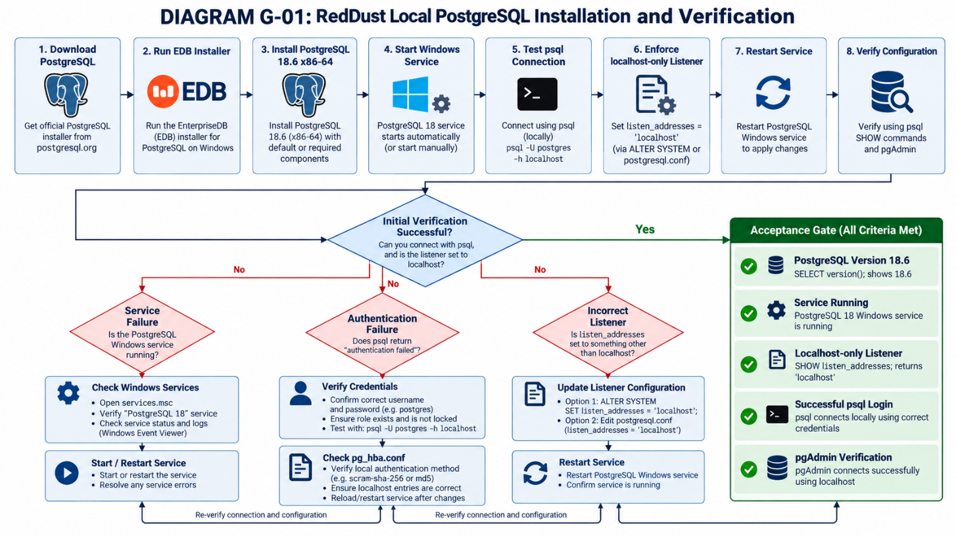
DIAGRAM — G-02: Localhost-only database trust boundary
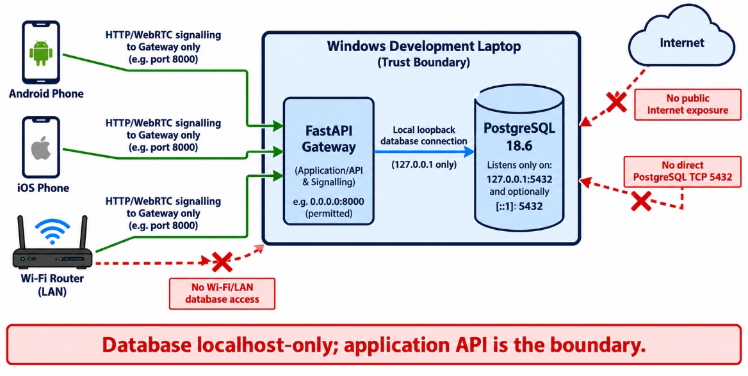

G.14 — Authoritative references
PostgreSQL Windows installers: https://www.postgresql.org/download/windows/
EDB PostgreSQL downloads: https://www.enterprisedb.com/downloads/postgres-postgresql-downloads
EDB Installing PostgreSQL on Windows: https://www.enterprisedb.com/docs/supported-open-source/postgresql/installing/windows/
PostgreSQL 18.6 release notes: https://www.postgresql.org/docs/release/18.6/
PostgreSQL listen_addresses documentation: https://www.postgresql.org/docs/18/runtime-config-connection.html
PostgreSQL pg_hba.conf documentation: https://www.postgresql.org/docs/18/auth-pg-hba-conf.html

Appendix H — Create RedDust Application Role, Database and pgcrypto Extension
What this section does and why it matters: Configure a dedicated local PostgreSQL login for the RedDust FastAPI authentication service, create its development database, enable pgcrypto, and prove the application account can connect. Instructions assume PostgreSQL 18.6 is installed, its Windows service is running, and you know the postgres administrator password.

H.1 — Understand the four objects being configured
Object | Name | What it means
Database server | PostgreSQL 18.6 | The Windows database service, normally listening on 127.0.0.1:5432.
Administrator | postgres | Privileged role used to perform setup operations.
Application role | reddust_app | Separate LOGIN role used by reddust-auth-api, rather than using the postgres administrator.
Application database | reddust_dev | The local development database, owned by reddust_app.
Extension | pgcrypto | A PostgreSQL extension enabled in the target database.

pgcrypto (PostgreSQL Cryptographic Functions) is a PostgreSQL extension that provides cryptographic capabilities such as hashing, encryption, decryption and secure random-number generation. In RedDust, it can support authentication, data integrity verification, secure token generation and protection of sensitive business information. It is enabled within a specific database using CREATE EXTENSION IF NOT EXISTS pgcrypto; However, enabling pgcrypto does not automatically encrypt the database or secure its connections; appropriate authentication, access controls, TLS and encryption-key management are still required.
Security rule. Only the FastAPI backend should use database credentials. The Android/iOS application must call the backend API, not connect to port 5432 directly.
DIAGRAM — H-01: Local role, database and application trust boundary
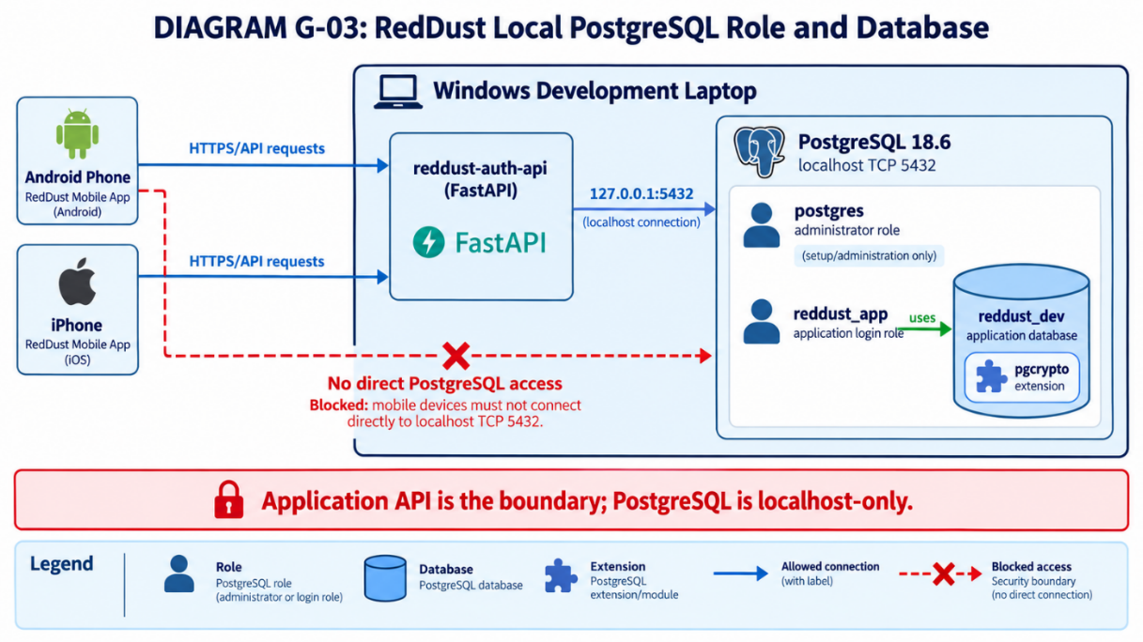

H.2 — Open pgAdmin 4 and inspect existing objects
1. Click Windows Start, search for “pgAdmin 4”, and open the application.
2. If prompted for the pgAdmin master password, enter it. This is separate from the PostgreSQL postgres account password.
3. In the left Explorer panel, expand Servers → PostgreSQL 18. Supply the database password if asked to connect.
4. Expand Login/Group Roles and check whether reddust_app already exists.
5. Right-click Databases → Refresh; expand Databases and check whether reddust_dev already exists.
Avoid duplicate creation. An earlier “database reddust_dev already exists” error (SQLSTATE 42P04) means you must verify the existing database, not repeat CREATE DATABASE. The same applies to an existing role.
Servers (1)
└── PostgreSQL 18
├── Databases
│ ├── postgres
│ └── reddust_dev ← check if already present
└── Login/Group Roles
├── postgres
└── reddust_app ← check if already present
DIAGRAM — H-02: pgAdmin Explorer navigation and initial checks
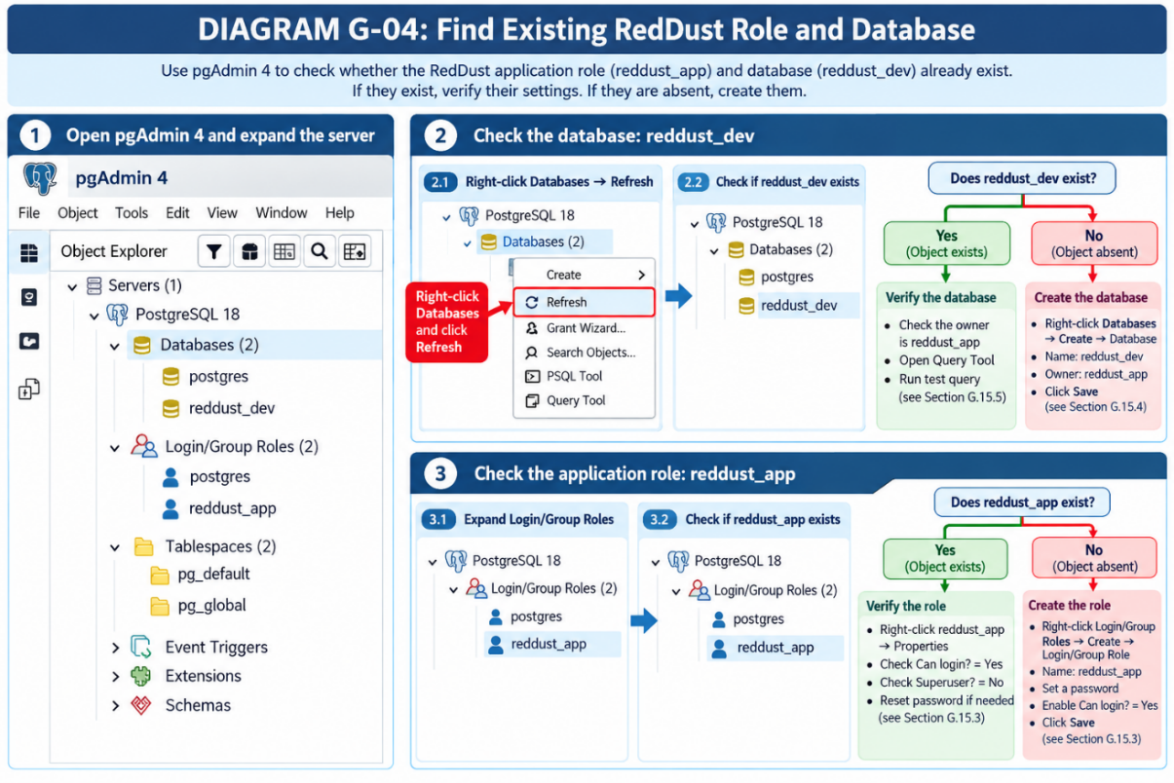

H.3 — Create reddust_app using pgAdmin 4 (only if absent)
1. In the left Explorer, expand Servers → PostgreSQL 18.
2. Right-click Login/Group Roles → Create → Login/Group Role.
3. On General, set Name to reddust_app and optionally set Comments to “RedDust local development application role”.
4. Open Definition, set a unique strong password (abcd1234#$) and confirm it if the field is provided. Store it securely; do not use the example password from the original runbook.
5. Open Privileges. Set Can login = Yes; Superuser = No; Create roles = No; Create databases = No; Replication = No; Bypass RLS = No; keep Inherit at its normal default.
6. Click Save. Right-click Login/Group Roles → Refresh; confirm reddust_app now appears.
Underlying SQL concept (do not run again if the role was created using pgAdmin):
CREATE ROLE reddust_app LOGIN PASSWORD 'YOUR_PRIVATE_PASSWORD';
Existing role? Right-click reddust_app → Properties to inspect LOGIN and privileges. You may change its password through the Definition tab if you own the installation. Do not attempt CREATE ROLE again.

H.4 — Create reddust_dev using pgAdmin 4 (only if absent)
1. Under PostgreSQL 18, right-click Databases → Create → Database.
2. On General, set Database = reddust_dev.
3. In Owner, select reddust_app, not postgres.
4. Optionally enter Comment = “RedDust local development database”. Keep normal defaults elsewhere (UTF-8 is recommended for a new database).
5. Click Save; right-click Databases → Refresh. Confirm reddust_dev appears.
Underlying SQL concept (do not run again if the database is already present):
CREATE DATABASE reddust_dev OWNER reddust_app;
If reddust_dev already exists, verify ownership rather than recreating it. Right-click postgres → Query Tool (or Tools → Query Tool with postgres selected). Enter the SQL below and press F5:
SELECT datname AS database_name,
pg_get_userbyid(datdba) AS database_owner
FROM pg_database
WHERE datname = 'reddust_dev';
Expected: one row with database_name = reddust_dev and database_owner = reddust_app. If the existing owner is postgres and this really is the intended RedDust database, the administrator may run:
ALTER DATABASE reddust_dev OWNER TO reddust_app;
Do not alter unrelated databases. Change ownership only after confirming the intended development database; ownership changes can affect permissions and operational responsibility.

H.5 — Open Query Tool against the correct database
1. In pgAdmin Explorer expand PostgreSQL 18 → Databases.
2. Right-click reddust_dev → Query Tool.
3. Confirm the new editor tab indicates reddust_dev (for example, reddust_dev/postgres@PostgreSQL 18).
4. Type the following SQL and click the Execute (play) button or press F5.
SELECT current_database(), current_user;
Expected field | Typical result
current_database | reddust_dev
current_user | postgres (when connected with administrator role)
Two command environments. pgAdmin Query Tool accepts SQL statements. The psql backslash command “\c reddust_dev” belongs only in the psql console, not in the pgAdmin SQL editor.

H.6 — Enable pgcrypto inside reddust_dev
DIAGRAM — H-03: pgAdmin create role, create database and enable extension sequence
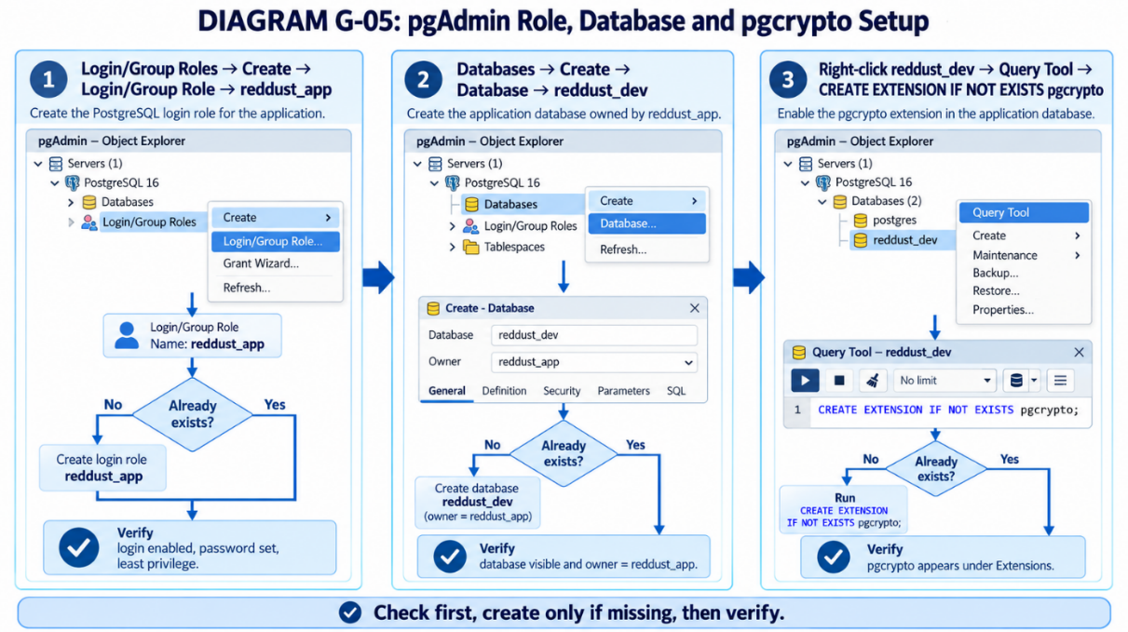
1. Keep the Query Tool connected to reddust_dev (not postgres).
2. Replace the previous SQL with CREATE EXTENSION IF NOT EXISTS pgcrypto; and run with F5.
3. In the Messages panel, look for CREATE EXTENSION or a notice that the extension already exists.
4. Run the verification query shown below.
5. In Explorer expand reddust_dev → Extensions; right-click Extensions → Refresh and locate pgcrypto.
CREATE EXTENSION IF NOT EXISTS pgcrypto;
SELECT extname, extversion
FROM pg_extension
WHERE extname = 'pgcrypto';
Expected: a row for pgcrypto with its installed extension version. That extension version (=1.4) need not be “18.6”.

H.7 — Verify application login from Windows PowerShell
1. Click Start, search “Windows PowerShell” and open it. An administrator PowerShell window is not necessary for the database connection test.
2. Ensure the prompt begins with PS C:\...> rather than postgres=# or reddust_dev=#.
3. Copy the command below into PowerShell as written; paste multi-line PowerShell commands together.
4. Enter the password assigned to reddust_app when prompted.
5. Confirm the output shows database reddust_dev and user reddust_app.
& "C:\Program Files\PostgreSQL\18\bin\psql.exe" `
-h 127.0.0.1 `
-p 5432 `
-U reddust_app `
-d reddust_dev `
-W `
-c "SELECT current_database(), current_user;"
Argument | Explanation
psql.exe | PostgreSQL command-line program
-h 127.0.0.1 | Connect to this laptop only
-p 5432 | PostgreSQL TCP port
-U reddust_app | Use the application role
-d reddust_dev | Use the application database
-W | Prompt for password
-c "SELECT ..." | Execute one SQL command and exit
Expected output (spacing may differ):
current_database | current_user
------------------+--------------
reddust_dev | reddust_app
(1 row)

H.8 — Confirm development database and schema privileges
While still in PowerShell, run the following command with reddust_app credentials. It checks whether the role can create database objects and has CREATE privilege on the public schema:
& "C:\Program Files\PostgreSQL\18\bin\psql.exe" `
-h 127.0.0.1 `
-p 5432 `
-U reddust_app `
-d reddust_dev `
-W `
-c "SELECT has_database_privilege(current_user, current_database(), 'CREATE') AS database_create, has_schema_privilege(current_user, 'public', 'CREATE') AS public_schema_create;"
Expected for this simple local setup: both returned flags are true (t). If public_schema_create = f, inspect schema ownership and permissions before running migrations; do not grant broad or unrelated privileges as a shortcut.

H.9 — Alternative terminal-only procedure (psql)
Alternative, not an additional setup. Use this method instead of the pgAdmin creation process, not after it. Repeating CREATE ROLE or CREATE DATABASE will raise “already exists” errors.
Step A — In PowerShell, open psql as postgres administrator:
& "C:\Program Files\PostgreSQL\18\bin\psql.exe" `
-h 127.0.0.1 -p 5432 -U postgres -d postgres
When you see postgres=#, you are inside psql. Enter SQL directly without the psql.exe prefix.
Step B — If the role is absent, create it and set its password using the interactive prompt:
CREATE ROLE reddust_app LOGIN;
\password reddust_app
Step C — If the database is absent, create it:
CREATE DATABASE reddust_dev OWNER reddust_app;
Step D — Switch database inside psql, then enable and inspect pgcrypto:
\c reddust_dev
CREATE EXTENSION IF NOT EXISTS pgcrypto;
SELECT extname FROM pg_extension WHERE extname = 'pgcrypto';
Step E — Exit psql and return to PowerShell:
\q
Then use the PowerShell connection test in G.15.7 to log in as reddust_app.
DIAGRAM — H-04: PowerShell vs psql vs pgAdmin SQL entry points
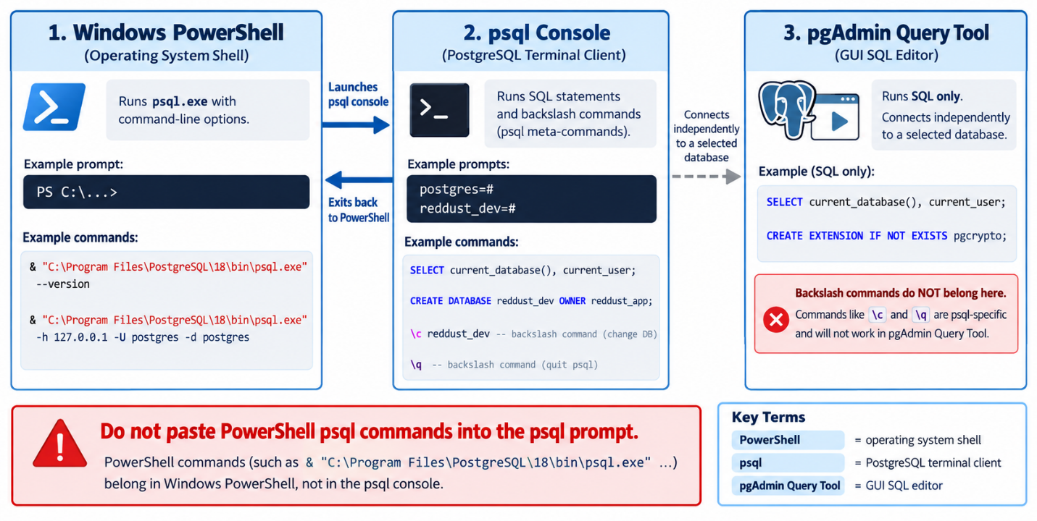

H.10 — Common mistakes and quick recovery
Observed error | Meaning | What to do
role reddust_app already exists | The role is already present | Inspect Login/Group Roles; do not recreate.
database reddust_dev already exists | Database was created previously | Refresh Databases and verify owner.
password authentication failed | Wrong password or role | Confirm username; reset role password if authorized.
syntax error at or near \ | A psql backslash command was run as SQL | Use \c and \q only inside psql.
reddust_dev"# prompt | psql is waiting for a closing quote | Press Ctrl+C once to cancel unfinished input.
permission denied for schema public | Role lacks needed schema CREATE permission | Review schema ownership and grants.
psql is not recognized | Executable directory is not on PATH | Use full C:\Program Files\PostgreSQL\18\bin\psql.exe path.

H.11 — Objective acceptance evidence and handoff
Completion gate — A believable response or a successful pgAdmin click is not sufficient on its own. Capture the exact SQL output, command results and (where appropriate) safe screenshots without exposing passwords.
Check | Evidence / pass condition
PostgreSQL service | postgresql-x64-18 is Running
Role | reddust_app is listed, LOGIN enabled, not superuser
Database | reddust_dev exists and its owner is reddust_app
Extension | pgcrypto listed in reddust_dev → Extensions and SQL query
Connection | PowerShell psql prints reddust_dev / reddust_app
Permissions | Database CREATE and public schema CREATE checked
Security | No actual password recorded in Git, screenshots or runbook
Final checklist for the developer:
☐ pgAdmin 4 connects to PostgreSQL 18.6
☐ reddust_app exists and has LOGIN enabled, without superuser privileges
☐ reddust_dev exists and is owned by reddust_app
☐ pgcrypto is installed in reddust_dev
☐ PowerShell client login succeeds as reddust_app
☐ Database/schema privileges are validated
☐ Credentials are stored only in approved local uncommitted configuration

H.12 — Next RedDust integration step
After all checks pass, configure the reddust-auth-api database connection as part of the above Steps 19C.4 onwards, using reddust_app and reddust_dev, install or verify the Python database driver and SQLAlchemy/Alembic dependencies, and run the initial migrations. Keep the database localhost-only and ensure the mobile app communicates through the FastAPI API rather than connecting to PostgreSQL directly.
Important credential rule. Do not include a real PostgreSQL password in .py files, committed .env files, Word documents, Git, logs or screenshots. Use a local uncommitted secrets file for development and a managed secret mechanism in deployed environments.

APPENDIX I – RedDust Database Schema Creation through Alembic
  - Windows • VS Code • PostgreSQL 18.6 • pgAdmin 4 • Python 3.12 • SQLAlchemy 2.x • Alembic
What this appendix does and why it matters. Takes the currently blank reddust-auth-api files and turns them into a version-controlled, reproducible seven-table PostgreSQL authentication schema. It explains exactly which application/window to use, the commands to execute, evidence to collect, and when to stop rather than overwrite existing database objects.
Your actual starting point. VS Code shows D:\RedDust\reddust-auth-api with .venv, app/db.py, app/models.py, an empty alembic.ini, and a compact alembic\versions directory. These are placeholders, not a functioning Alembic environment. Do not run alembic upgrade head until env.py, script.py.mako, models and migration revisions exist.

At-a-glance implementation sequence
1. Check PostgreSQL and verify the target database is empty of application tables.
2. Install Python packages and scaffold Alembic safely without deleting the existing folders.
3. Create non-committed database configuration and executable SQLAlchemy metadata.
4. Wire Alembic to the RedDust database and autogenerate a reviewed baseline revision.
5. Add the pgcrypto extension step, apply the migration, inspect pgAdmin and test security constraints.
6. Record commands, generated revision identifier and acceptance evidence.
DIAGRAM — I-01: Tools and execution surfaces
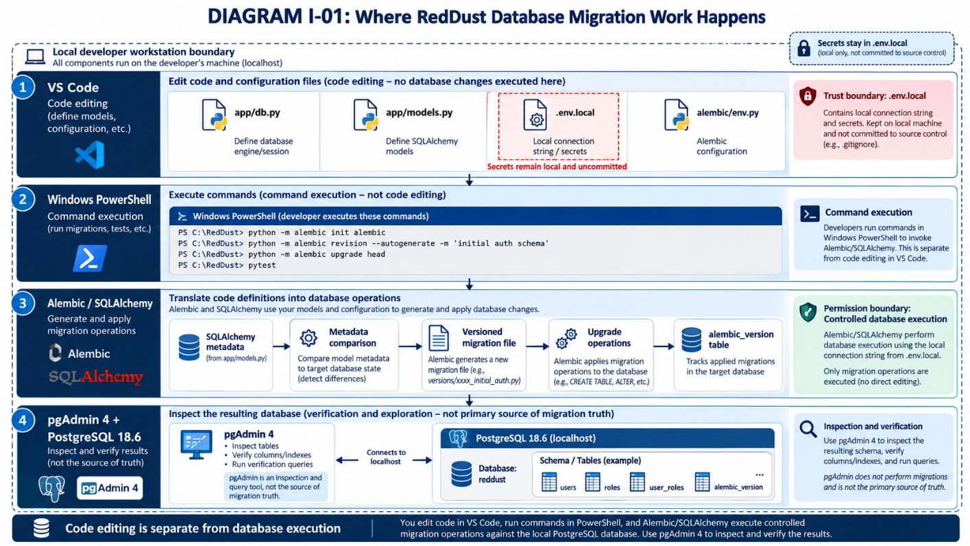

I.1 — Scope, non-goals and safety gates
The database is reddust_dev on 127.0.0.1:5432. Schema owner for these local learning exercises is reddust_app. The database must remain localhost-only; mobile applications never connect directly to PostgreSQL. This appendix is not a production database deployment procedure.
In scope | Not in scope
Seven normalized application tables, keys, checks and indexes | Production data migration or direct Cloud SQL changes
A reviewable SQLAlchemy schema and Alembic revision | Designing the final OAuth and refresh-token implementation
Local test, inspection, evidence and rollback discussion | Deleting or stamping pre-existing application schema
Development user with adequate CREATE permission | Using the postgres superuser as the API runtime identity
Stop condition. If the target database already contains any of the seven application tables or an alembic_version table, do not autogenerate or apply the baseline. Inspect the existing schema and reconcile it first. Do not drop existing tables or use alembic stamp to hide differences.

I.2 — Understand the final workspace layout
REFERENCE: VS CODE EXPLORER (FILES, NOT A TERMINAL COMMAND)
D:\RedDust\reddust-auth-api\
├── .venv\
├── .gitignore
├── .env.local # local only; NEVER commit
├── .env.example # placeholders, no secrets
├── alembic.ini # generated real configuration
├── alembic\
│ ├── env.py # migration connection logic
│ ├── script.py.mako # revision file template
│ ├── README
│ └── versions\
├── app\
│ ├── __init__.py
│ ├── db.py # SQLAlchemy URL from environment
│ ├── models.py # seven-table schema metadata
│ └── ... existing files
└── tests\
└── test_schema_metadata.py
In VS Code, alembic\ versions is a compact display of nested folders; it is not one folder with a backslash in its name. No second alembic/versions directory should be created.
DIAGRAM — I-02: Current placeholder folders versus initialized migration environment
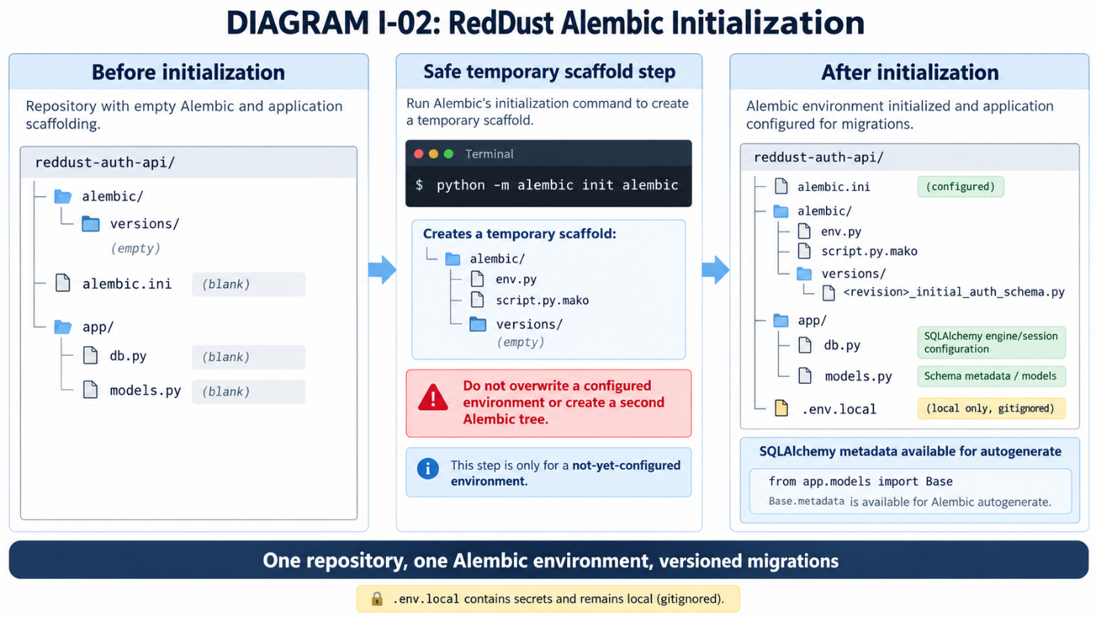

I.3 — Preflight: verify tools, roles and an empty target database

I.3.1 — Windows PowerShell: activate the existing virtual environment
1. In VS Code, choose Terminal → New Terminal.
2. Confirm the prompt begins with PS (PowerShell), not postgres=#.
3. Run the following commands from the project root.
WHERE: VS CODE INTEGRATED POWERSHELL
Set-Location "D:\RedDust\reddust-auth-api"
.\.venv\Scripts\Activate.ps1
python --version
python -m pip --version
python -m pip install --upgrade pip
python -m pip install "SQLAlchemy>=2,<3" "alembic>=1.17,<2" "psycopg[binary]>=3,<4" "python-dotenv>=1,<2" pytest
The selected Python and package versions should be recorded in the RedDust team dependency baseline; broad version ranges above are installation examples, not a reproducible deployment lockfile. Use pip freeze or an approved lock mechanism after validation.
python -m pip freeze > requirements.txt

I.3.2 — PostgreSQL: prove application login and target database
WHERE: WINDOWS POWERSHELL — ENTER THE APPLICATION PASSWORD WHEN PROMPTED
& "C:\Program Files\PostgreSQL\18\bin\psql.exe" `
-h 127.0.0.1 -p 5432 -U reddust_app -d reddust_dev -W `
-c "SELECT current_database(), current_user, version();"
Expected: current_database = reddust_dev, current_user = reddust_app, PostgreSQL 18.6. If authentication fails, fix the role/password; do not run Alembic as postgres merely to bypass the failure.

I.3.3 — pgAdmin Query Tool: check for pre-existing objects
1. Open pgAdmin 4 → Servers → PostgreSQL 18 → Databases.
2. Right-click reddust_dev → Query Tool. Confirm its tab is connected to reddust_dev.
3. Paste the SQL below and click Execute (F5).
WHERE: PGADMIN 4 QUERY TOOL — SQL ONLY
SELECT tablename
FROM pg_tables
WHERE schemaname = 'public'
ORDER BY tablename;
SELECT extname FROM pg_extension
WHERE extname = 'pgcrypto';
SELECT has_schema_privilege('reddust_app', 'public', 'CREATE')
AS can_create_in_public;
Expected on a clean target: no application tables; pgcrypto may already exist; can_create_in_public = true. The extension existing by itself is not an obstacle. If can_create_in_public is false, correct the local role/schema privileges using the administrator before continuing.

I.4 — Initialize Alembic when the folders already exist
Running python -m alembic init alembic directly in the existing project may fail because alembic/ and alembic.ini already exist. Instead, generate the official scaffolding in an isolated temporary folder and copy only the missing pieces into RedDust.

I.4.1 — Confirm the existing files are truly placeholders
WHERE: POWERSHELL; INSPECT BEFORE COPYING
Set-Location "D:\RedDust\reddust-auth-api"
(Get-Item .\alembic.ini).Length
Get-ChildItem .\alembic -Force
Get-ChildItem .\alembic\versions -Force
# STOP if alembic.ini is non-empty, env.py exists,
# or versions already contains any revision file.

I.4.2 — Generate a temporary official Alembic scaffold
WHERE: POWERSHELL; KEEP VIRTUAL ENVIRONMENT ACTIVATED
$project = "D:\RedDust\reddust-auth-api"
$scratch = Join-Path $env:TEMP `
("reddust_alembic_" + [guid]::NewGuid().ToString("N"))
New-Item -ItemType Directory -Path $scratch | Out-Null
Push-Location $scratch
python -m alembic init alembic
Pop-Location
# Only when the existing files passed the blank checks:
Copy-Item "$scratch\alembic.ini" "$project\alembic.ini"
Copy-Item "$scratch\alembic\env.py" "$project\alembic\env.py"
Copy-Item "$scratch\alembic\script.py.mako" `
"$project\alembic\script.py.mako"
Copy-Item "$scratch\alembic\README" "$project\alembic\README"
Remove-Item -LiteralPath $scratch -Recurse -Force
Acceptance gate. Open VS Code Explorer. You must now see alembic/env.py, alembic/script.py.mako, alembic/versions and a non-empty alembic.ini. Keep the existing single alembic tree. The initializer does not create tables in PostgreSQL.

I.4.3 — Check the generated configuration
Open alembic.ini in VS Code. In the [alembic] section, confirm that script_location points to the alembic folder; the generated file usually contains script_location = %(here)s/alembic (or an equivalent valid path). Do not put a real database password in alembic.ini. The custom env.py in Section I.7 will obtain the connection from local environment variables.

I.5 — Configure local secrets without putting passwords in code
1. In VS Code Explorer, right-click reddust-auth-api → New File → .env.local
2. Paste the values below. Replace the password placeholder with the existing reddust_app password.
3. Create or update .gitignore with .env.local, .venv and Python cache exclusions.
4. Use git check-ignore -v .env.local to confirm Git exclusion (if the repository is initialized).
Note: 127.0.0.1 => Localhost — Windows laptop communicating with itself: FastAPI → PostgreSQL
While 192.168.1.x may be the laptop's IP address on the home Wi-Fi network: Android/iPhone → FastAPI Gateway and 192.168.1.1 is Wi-Fi router's local IP address, this is about the Network gateway, not the database. Therefore, 127.0.0.1 is perfectly valid as localhost here.
WHERE: VS CODE FILE .ENV.LOCAL (NOT A TERMINAL COMMAND)
RD_DB_HOST=127.0.0.1
RD_DB_PORT=5432
RD_DB_NAME=reddust_dev
RD_DB_USER=reddust_app
RD_DB_PASSWORD="REPLACE_WITH_PRIVATE_LOCAL_SECRET"
WHERE: VS CODE FILE .GITIGNORE (MERGE, DO NOT OVERWRITE OTHER RULES)
.env.local
.venv/
__pycache__/
*.pyc
.pytest_cache/
The .env.example file can contain the same names with empty/example values, but never a real password. Avoid printing connection URLs or credentials into console logs or screenshots.

I.6 — Populate app/db.py: a safe SQLAlchemy connection configuration
In VS Code, click app → db.py, select the empty contents, and paste the complete Python code below. It assembles a database URL using SQLAlchemy URL.create(), so special characters in the password do not need manual URL encoding.
WHERE: VS CODE FILE APP/DB.PY — ENTIRE FILE
"""Local connection configuration; never commit .env.local."""
import os
from pathlib import Path
from dotenv import load_dotenv
from sqlalchemy.engine import URL
ROOT = Path(__file__).resolve().parents[1]
load_dotenv(ROOT / ".env.local", override=False)
def database_url() -> URL:
names = ("RD_DB_HOST", "RD_DB_PORT", "RD_DB_NAME",
"RD_DB_USER", "RD_DB_PASSWORD")
missing = [name for name in names if not os.getenv(name)]
if missing:
raise RuntimeError("Missing database settings: " + ", ".join(missing))
return URL.create(
drivername="postgresql+psycopg",
username=os.environ["RD_DB_USER"],
password=os.environ["RD_DB_PASSWORD"],
host=os.environ["RD_DB_HOST"],
port=int(os.environ["RD_DB_PORT"]),
database=os.environ["RD_DB_NAME"],
)
Why this matters: the migration connects to your local database using reddust_app; secrets are not embedded in Github source control. The helper returns a URL object; it does not connect merely by being imported.

I.7 — Populate app/models.py: the complete seven-table baseline
This subsection defines the structure, relationships, integrity rules and indexes of RedDust's seven-table authentication database in Python so that Alembic can create and maintain the corresponding PostgreSQL schema consistently.
In VS Code, open app/models.py. Paste the following eight code blocks into the SAME file, in order, without repeating the imports. This uses SQLAlchemy Core Table metadata. It is valid input for Alembic autogeneration and can later be integrated with ORM (Object-Relational Mapping) mappings as the authentication API grows. ORM is a programming technique that allows developers to interact with relational databases, such as PostgreSQL, using programming-language objects instead of writing SQL queries manually. In RedDust: SQLAlchemy is the Python ORM that maps Python classes to PostgreSQL tables, while Alembic manages versioned database schema migrations.
Source alignment and design choice. The five tables from Step 19C.4 are preserved, and audit_events plus user_preferences are added. This appendix strengthens integrity using composite foreign keys to prevent a session/device or call/session from being associated with different users. A normalized design is not automatically proven BCNF; a formal BCNF claim requires a separate functional-dependency review.

I.7.1 — Imports, naming conventions and app_users
This table stores each RedDust user's unique internal identity, name, account status and creation/update timestamps.
WHERE: APPEND TO VS CODE FILE APP/MODELS.PY
"""RedDust 19C baseline: SQLAlchemy Core schema for Alembic."""
from sqlalchemy import (
CheckConstraint, Column, DateTime, ForeignKey,
ForeignKeyConstraint, Index, MetaData, Table, Text,
UniqueConstraint, func, text,
)
from sqlalchemy.dialects.postgresql import JSONB, UUID
metadata = MetaData(naming_convention={
"pk": "pk_%(table_name)s",
"fk": "fk_%(table_name)s_%(column_0_name)s_%(referred_table_name)s",
"uq": "uq_%(table_name)s_%(column_0_name)s",
"ck": "ck_%(table_name)s_%(constraint_name)s",
"ix": "ix_%(column_0_label)s",
})
app_users = Table(
"app_users", metadata,
Column("id", UUID(as_uuid=True), primary_key=True,
server_default=text("gen_random_uuid()")),
Column("display_name", Text),
Column("status", Text, nullable=False, server_default="active"),
Column("created_at", DateTime(timezone=True), nullable=False,
server_default=func.now()),
Column("updated_at", DateTime(timezone=True), nullable=False,
server_default=func.now(), onupdate=func.now()),
CheckConstraint("status IN ('active','disabled','deleted')",
name="valid_status"),
)

I.7.2 — external_identities: Google-subject mapping
This table links a user's verified Google identity to their internal RedDust account using Google's unique subject identifier.
WHERE: APPEND TO VS CODE FILE APP/MODELS.PY
external_identities = Table(
"external_identities", metadata,
Column("id", UUID(as_uuid=True), primary_key=True,
server_default=text("gen_random_uuid()")),
Column("user_id", UUID(as_uuid=True),
ForeignKey("app_users.id", ondelete="RESTRICT"), nullable=False),
Column("provider", Text, nullable=False),
Column("provider_subject", Text, nullable=False),
Column("email_at_verification", Text),
Column("verified_at", DateTime(timezone=True), nullable=False,
server_default=func.now()),
CheckConstraint("provider IN ('google')", name="valid_provider"),
UniqueConstraint("provider", "provider_subject",
name="uq_external_identity_provider_subject"),
)

I.7.3 — client_devices: device-scoped records
This table records the Android or iPhone devices associated with each RedDust user.
WHERE: APPEND TO VS CODE FILE APP/MODELS.PY
client_devices = Table(
"client_devices", metadata,
Column("id", UUID(as_uuid=True), primary_key=True,
server_default=text("gen_random_uuid()")),
Column("user_id", UUID(as_uuid=True),
ForeignKey("app_users.id", ondelete="RESTRICT"), nullable=False),
Column("installation_id", Text, nullable=False),
Column("platform", Text, nullable=False),
Column("created_at", DateTime(timezone=True), nullable=False,
server_default=func.now()),
Column("last_seen_at", DateTime(timezone=True)),
Column("revoked_at", DateTime(timezone=True)),
CheckConstraint("platform IN ('android','ios')", name="valid_platform"),
UniqueConstraint("user_id", "installation_id",
name="uq_device_user_installation"),
UniqueConstraint("id", "user_id", name="uq_device_id_user"),
)

I.7.4 — auth_sessions: revocable refresh-token sessions
This table tracks users' login sessions, refresh-token hashes, expiry and revocation while ensuring device ownership matches the user.
WHERE: APPEND TO VS CODE FILE APP/MODELS.PY
auth_sessions = Table(
"auth_sessions", metadata,
Column("id", UUID(as_uuid=True), primary_key=True,
server_default=text("gen_random_uuid()")),
Column("user_id", UUID(as_uuid=True),
ForeignKey("app_users.id", ondelete="RESTRICT"), nullable=False),
Column("device_id", UUID(as_uuid=True)),
Column("refresh_token_hash", Text, nullable=False, unique=True),
Column("expires_at", DateTime(timezone=True), nullable=False),
Column("revoked_at", DateTime(timezone=True)),
Column("created_at", DateTime(timezone=True), nullable=False,
server_default=func.now()),
UniqueConstraint("id", "user_id", name="uq_auth_session_id_user"),
ForeignKeyConstraint(
["device_id", "user_id"],
["client_devices.id", "client_devices.user_id"],
name="fk_auth_device_same_user", ondelete="RESTRICT",
),
)
A nullable device_id is allowed. When present, the composite foreign key forces the device to belong to the same user as the authentication session.

I.7.5 — call_sessions: voice session lifecycle
This table records each user's voice-call sessions, their status and duration, and the authentication session that authorized them.
WHERE: APPEND TO VS CODE FILE APP/MODELS.PY
call_sessions = Table(
"call_sessions", metadata,
Column("id", UUID(as_uuid=True), primary_key=True,
server_default=text("gen_random_uuid()")),
Column("user_id", UUID(as_uuid=True),
ForeignKey("app_users.id", ondelete="RESTRICT"), nullable=False),
Column("auth_session_id", UUID(as_uuid=True), nullable=False),
Column("status", Text, nullable=False),
Column("started_at", DateTime(timezone=True), nullable=False,
server_default=func.now()),
Column("ended_at", DateTime(timezone=True)),
Column("end_reason", Text),
CheckConstraint("status IN ('starting','active','ended','failed')",
name="valid_status"),
ForeignKeyConstraint(
["auth_session_id", "user_id"],
["auth_sessions.id", "auth_sessions.user_id"],
name="fk_call_auth_same_user", ondelete="RESTRICT",
),
)
The composite foreign key ensures that call_sessions.user_id matches the associated auth_sessions.user_id; independent FKs would not guarantee this.

I.7.6 — audit_events: bounded operational evidence
This table maintains privacy-conscious records of important authentication, security and application events for monitoring and investigation.
WHERE: APPEND TO VS CODE FILE APP/MODELS.PY
audit_events = Table(
"audit_events", metadata,
Column("id", UUID(as_uuid=True), primary_key=True,
server_default=text("gen_random_uuid()")),
Column("actor_user_id", UUID(as_uuid=True),
ForeignKey("app_users.id", ondelete="SET NULL")),
Column("auth_session_id", UUID(as_uuid=True),
ForeignKey("auth_sessions.id", ondelete="SET NULL")),
Column("event_type", Text, nullable=False),
Column("occurred_at", DateTime(timezone=True), nullable=False,
server_default=func.now()),
Column("request_id", Text),
Column("metadata_json", JSONB, nullable=False,
server_default=text("'{}'::jsonb")),
CheckConstraint("jsonb_typeof(metadata_json) = 'object'",
name="metadata_is_object"),
CheckConstraint("octet_length(metadata_json::text) <= 4096",
name="metadata_size_limit"),
)
metadata_json is JSONB, must be an object, and is limited to 4096 bytes in its textual database representation. The API must additionally allowlist fields and redact PII and secrets before storage; this database limit is not a complete privacy control.

I.7.7 — user_preferences: one record per user
This table stores each user's personalized RedDust settings, such as their preferred AI persona and default speaker preference.
WHERE: APPEND TO VS CODE FILE APP/MODELS.PY
user_preferences = Table(
"user_preferences", metadata,
Column("user_id", UUID(as_uuid=True),
ForeignKey("app_users.id", ondelete="CASCADE"),
primary_key=True),
Column("preferred_persona", Text),
Column("speaker_default", Text),
Column("updated_at", DateTime(timezone=True), nullable=False,
server_default=func.now(), onupdate=func.now()),
)

I.7.8 — Indexes for expected access patterns
This table creates database lookup structures that help PostgreSQL find frequently requested user, session, call and audit records efficiently.
WHERE: APPEND TO VS CODE FILE APP/MODELS.PY
Index("ix_external_identities_user", external_identities.c.user_id)
Index("ix_client_devices_user", client_devices.c.user_id)
Index("ix_auth_sessions_user_created",
auth_sessions.c.user_id, auth_sessions.c.created_at.desc())
Index("ix_calls_user_started",
call_sessions.c.user_id, call_sessions.c.started_at.desc())
Index("ix_audit_events_occurred", audit_events.c.occurred_at.desc())
Index("ix_audit_events_actor_occurred",
audit_events.c.actor_user_id, audit_events.c.occurred_at.desc())
Index("ix_audit_events_request_id", audit_events.c.request_id)

I.7.9 — Compile-check metadata before making any database changes
This table confirms that the Python schema definitions compile successfully and that SQLAlchemy recognizes all seven required tables before migration.
WHERE: POWERSHELL; RUN FROM REDDUST-AUTH-API
python -m compileall -q app\db.py app\models.py
python -c "from app.models import metadata; print(sorted(metadata.tables))"
Expected: seven names: app_users, audit_events, auth_sessions, call_sessions, client_devices, external_identities, user_preferences. A Python import or syntax error must be corrected before generating a revision.
DIAGRAM — I-03: Seven-table logical ER model and enforced user consistency of RedDust Authentication (baseline) database
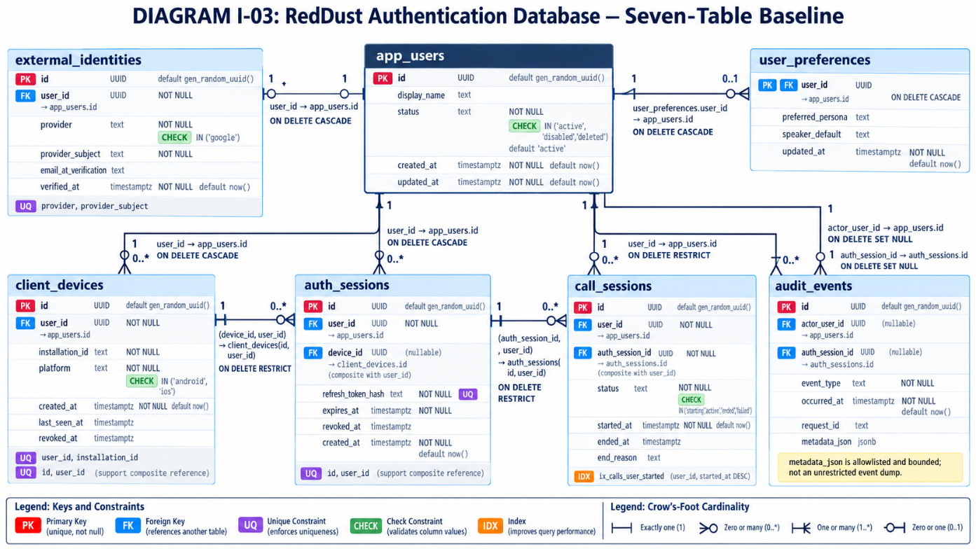

I.8 — Connect Alembic to models and the local database
In VS Code Explorer, open alembic/env.py generated in Section I.4. Replace its contents with the COMPLETE code below. This configuration imports your schema metadata, creates a local database connection only when Alembic runs, and enables reviewable type/default comparisons.
WHERE: VS CODE FILE ALEMBIC/ENV.PY — REPLACE ENTIRE FILE
"""Alembic runtime - online migrations only for this local runbook."""
from alembic import context
from sqlalchemy import create_engine, pool
from app.db import database_url
from app.models import metadata
config = context.config
target_metadata = metadata
def run_migrations_online() -> None:
engine = create_engine(database_url(), poolclass=pool.NullPool)
try:
with engine.connect() as connection:
context.configure(
connection=connection,
target_metadata=target_metadata,
compare_type=True,
compare_server_default=True,
include_schemas=False,
)
with context.begin_transaction():
context.run_migrations()
finally:
engine.dispose()
if context.is_offline_mode():
raise RuntimeError("Offline mode is disabled in this learning runbook")
else:
run_migrations_online()
This beginner baseline intentionally disallows offline SQL-script generation, reducing the chance of accidentally generating a script that contains a connection secret. A later DevSecOps version can add a carefully reviewed offline migration path.

I.8.1 — Confirm Alembic can see the revision environment
WHERE: POWERSHELL
Set-Location "D:\RedDust\reddust-auth-api"
python -m alembic heads
python -m alembic history
Expected before the first revision: no heads and no revision history. If Alembic cannot locate env.py or script.py.mako, fix scaffolding before moving on.
DIAGRAM — I-04: Metadata, migration revision, database and version table
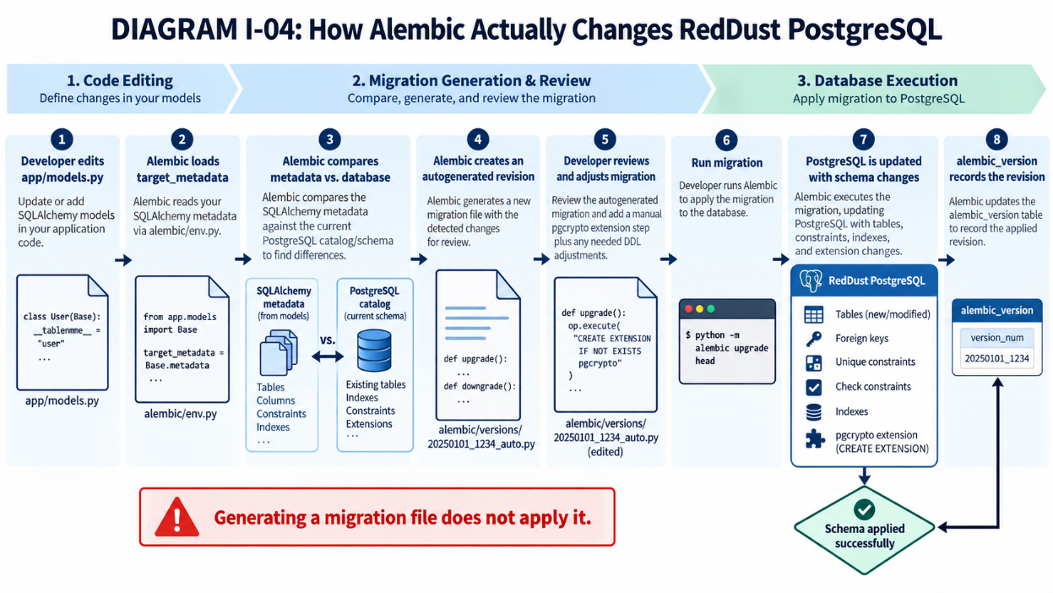

I.9 — Generate and review the first migration

I.9.1 — Verify the database is eligible for baseline creation
Return to pgAdmin and execute the table-list query in I.3.3 again.
1. Open pgAdmin 4 → Servers → PostgreSQL 18 → Databases.
2. Right-click reddust_dev → Query Tool. Confirm its tab is connected to reddust_dev.
3. Paste the SQL below and click Execute (F5).
WHERE: PGADMIN 4 QUERY TOOL — SQL ONLY
SELECT tablename
FROM pg_tables
WHERE schemaname = 'public'
ORDER BY tablename;
SELECT extname FROM pg_extension
WHERE extname = 'pgcrypto';
SELECT has_schema_privilege('reddust_app', 'public', 'CREATE')
AS can_create_in_public;
Expected on a clean target: no application tables; pgcrypto may already exist; can_create_in_public = true. The extension existing by itself is not an obstacle. If can_create_in_public is false, correct the local role/schema privileges using the administrator before continuing. Do not proceed if any of the seven application tables or alembic_version exists. pgcrypto may already be installed.

I.9.2 — Generate an Alembic revision from SQLAlchemy metadata
WHERE: POWERSHELL
python -m alembic revision --autogenerate `
-m "19C baseline auth and audit schema"
Expected: one newly generated Python revision in alembic/versions. Record its actual generated revision ID; do not hardcode examples into command lines.

I.9.3 — Review the generated revision BEFORE applying it
1. In VS Code, expand alembic → versions and open the new revision file.
2. In upgrade(), confirm seven op.create_table() calls and all intended indexes and FK/CHECK/UNIQUE constraints.
3. Confirm down_revision is None for the first-ever migration, and verify downgrade() drops child tables before parent tables.
4. If the revision unexpectedly drops objects, renames tables or omits a constraint, STOP and correct the model/revision.
5. Do not assume the word “autogenerate” means the produced migration has been tested.
Some indexes/constraints may appear in separate op.create_index() or op.create_foreign_key() statements. Their exact ordering can differ by Alembic and SQLAlchemy release.

I.9.4 — Make pgcrypto part of the versioned baseline
At the TOP of the generated upgrade() function, before its first table creation, insert this statement:
WHERE: VS CODE MIGRATION FILE — ADD INSIDE upgrade()
op.execute("CREATE EXTENSION IF NOT EXISTS pgcrypto")
If pgcrypto already exists in reddust_dev, the IF NOT EXISTS clause makes the operation idempotent. The database role running the migration still needs sufficient permissions. gen_random_uuid() in PostgreSQL 18 is built in and does not require pgcrypto, but Step 19C.4 also requests the extension for later cryptographic functions.
For the training baseline, do NOT automatically DROP EXTENSION pgcrypto in downgrade(): another database component may use it. Extension removal should be a separate explicitly reviewed change. This makes downgrade intentionally non-symmetric for the extension.

I.9.5 — Check that the revision can be imported
WHERE: POWERSHELL
python -m compileall -q alembic\versions
python -m alembic heads
python -m alembic history –verbose

I.10 — Apply the migration to local PostgreSQL 18.6
Only after Steps I.3–I.9 pass, return to PowerShell (not the psql prompt) and execute:
WHERE: POWERSHELL — CREATES ACTUAL TABLES AND INDEXES
python -m alembic upgrade head
python -m alembic current
python -m alembic heads
Expected: upgrade exits successfully; current revision matches the one reported by heads. PostgreSQL now contains the seven application tables plus the Alembic tracking table (alembic_version).
When errors occur. Stop and copy the full terminal error. Do not rerun an edited CREATE TABLE script in pgAdmin, DROP the database, or use alembic stamp head as a shortcut. PostgreSQL transactional DDL usually rolls back a failed migration, but verify actual state before retrying.

I.11 — Validate from pgAdmin, PowerShell and Python

I.11.1 — pgAdmin: refresh the schema tree
1. Open pgAdmin 4 → Servers → PostgreSQL 18 → Databases → reddust_dev.
2. Expand Schemas → public → Tables. Right-click Tables → Refresh.
3. Confirm the seven application tables and alembic_version appear.
4. Expand reddust_dev → Extensions and verify pgcrypto.

I.11.2 — Run read-only verification SQL
WHERE: PGADMIN QUERY TOOL, CONNECTED TO REDDUST_DEV
SELECT tablename FROM pg_tables
WHERE schemaname = 'public'
ORDER BY tablename;
SELECT version_num FROM alembic_version;
SELECT extname FROM pg_extension
WHERE extname = 'pgcrypto';
SELECT conrelid::regclass AS on_table,
conname, contype
FROM pg_constraint
WHERE connamespace = 'public'::regnamespace
ORDER BY 1, 2;
Expect eight tables including alembic_version, one matching revision ID, pgcrypto, and named primary/foreign/unique/check constraints. The query proves that database objects exist, not that all application behavior is correct.

I.11.3 — Alembic schema drift check
WHERE: POWERSHELL
python -m alembic check
Expected: Alembic reports no pending upgrade operations or schema differences. This is a useful additional gate, not a substitute for application tests or migration review.

I.11.4 — Add a small automated metadata test
Create tests/test_schema_metadata.py (ensure tests is a folder). Paste:
WHERE: VS CODE FILE TESTS/TEST_SCHEMA_METADATA.PY
from app.models import metadata
def test_required_tables_present():
expected = {
"app_users", "external_identities", "client_devices",
"auth_sessions", "call_sessions", "audit_events",
"user_preferences",
}
assert set(metadata.tables) == expected
def test_sensitive_uniqueness_constraints():
external = metadata.tables["external_identities"]
identity_keys = {tuple(c.name for c in u.columns)
for u in external.constraints
if u.__class__.__name__ == "UniqueConstraint"}
assert ("provider", "provider_subject") in identity_keys
WHERE: POWERSHELL
python -m pytest tests\test_schema_metadata.py -q
This checks your Python schema declarations only. The pgAdmin and Alembic checks are still required to verify the real PostgreSQL database.

I.11.5 — Smoke-test insert inside a rollback-only transaction
WHERE: PGADMIN QUERY TOOL, CONNECTED AS REDDUST_APP WHERE POSSIBLE
BEGIN;
INSERT INTO app_users (display_name)
VALUES ('Temporary schema smoke test')
RETURNING id, status, created_at;
ROLLBACK;
Expected: the insert succeeds and returns a UUID/status, but ROLLBACK leaves no persistent test user. If a check or foreign-key test fails inside a transaction, ROLLBACK is required before reusing that connection.
DIAGRAM — I-05: Foreign-key and tenant-consistency validation
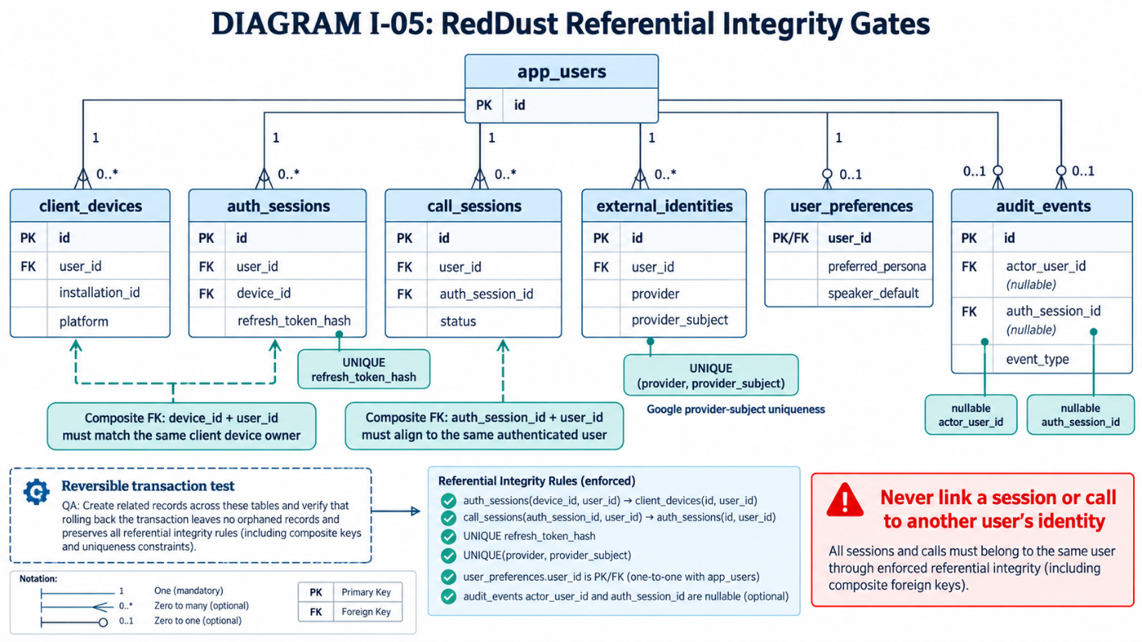

I.12 — Deletion, audit, timestamps and data-protection rules
Rule | Implementation / operational meaning
Soft-delete users | Use app_users.status = deleted; do not hard-delete users by default.
Revoke rather than delete | Set revoked_at on devices and auth sessions; end call sessions with status / ended_at.
Protect identity links | RESTRICT prevents deleting users while identities/sessions depend on them.
Audit deletion behavior | Audit actor/session foreign keys use SET NULL if referenced records are explicitly deleted.
Preferences cleanup | user_preferences uses CASCADE if a user is explicitly deleted after dependencies are resolved.
Timestamp semantics | timestamptz stores instants; emit UTC timestamps at API boundaries.
updated_at maintenance | SQLAlchemy onupdate is client-side, not a DB trigger; ensure all write paths update the field.
Bounded audit metadata | App must allowlist fields and redact PII/secrets; CHECK also limits JSONB size/type.
Retention is a policy decision, not a property of this baseline DDL. Before production, approve retention periods, legal hold rules, access to audit logs, and scheduled purging or archival. Do not add automatic deletions until those requirements are documented.

I.13 — Safe iteration: every later schema change is another revision
After baseline creation, do not modify the first revision once shared/applied. For example, adding a future audit index means changing SQLAlchemy metadata, creating a new revision, reviewing it and applying it to a disposable/test database first.
WHERE: POWERSHELL — EXAMPLE FUTURE MIGRATION WORKFLOW
# First edit and review app/models.py.
python -m alembic revision --autogenerate `
-m "add future audit index"
# Review generated file BEFORE proceeding.
python -m alembic upgrade head
python -m alembic check
python -m pytest –q
This appendix intentionally does not recommend running alembic downgrade against a production database. Destructive revisions need a reviewed rollback/recovery plan, database backup and operational approval.

I.14 — Production and Cloud SQL roadmap (future, not executed now)
- Maintain distinct development, staging and production databases, service identities, credentials and approval gates.
- Use CI to lint/test schema metadata and migrations, build a clean temporary database, run alembic upgrade head, and exercise negative constraints.
- Run migration execution under a dedicated migration identity; normal API runtime identities should not have permanent schema ALTER/CREATE authority.
- Cloud SQL extensions, migration privileges and PostgreSQL major versions must be verified per target instance before applying changes.
- Prefer expand–migrate–contract sequences for zero-/low-downtime schema evolution. Review long locks, transaction duration and backward compatibility.
- No autonomous or AI agent should apply production database migrations without approved change controls and evidence.
DIAGRAM — I-06: Local database trust boundary and migration identity
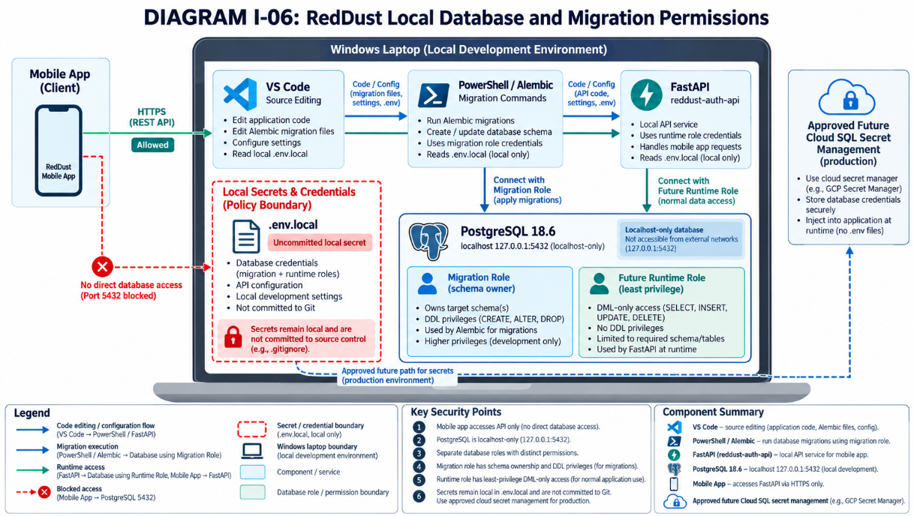
DIAGRAM — I-07: Future DevSecOps migration pipeline
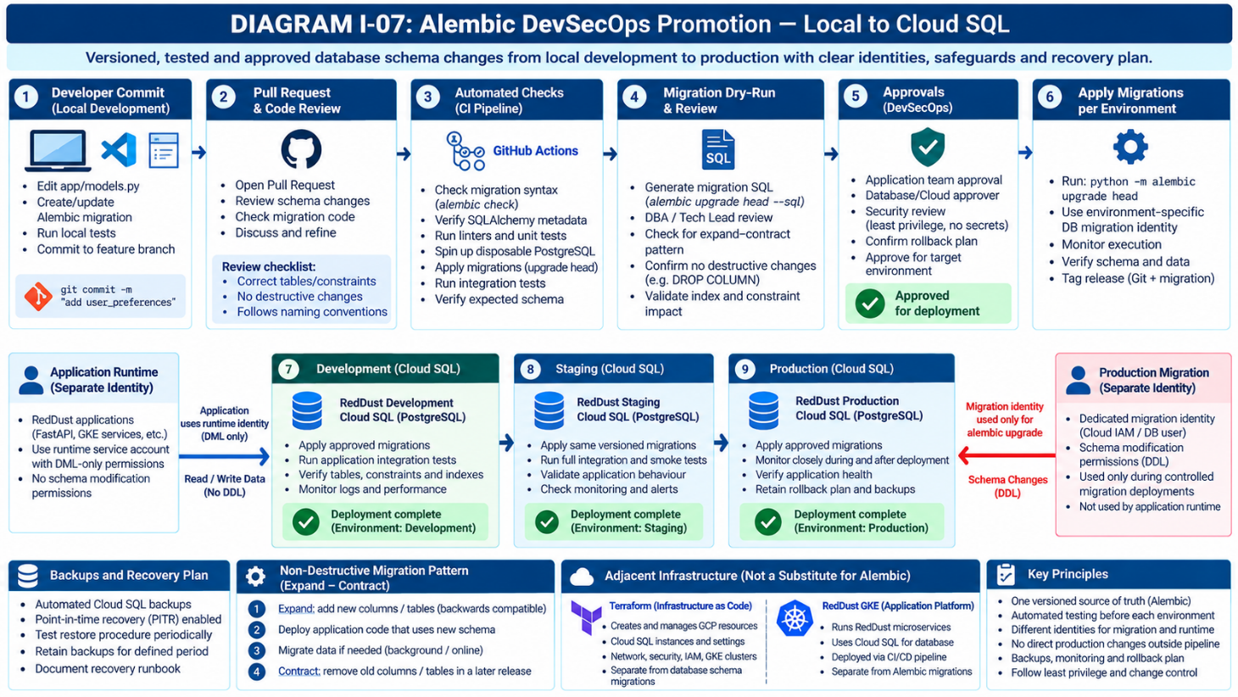

I.15 — Troubleshooting by symptom
Symptom | Cause / next action
alembic.ini exists / directory exists | You have placeholders. Use temporary scaffold I.4, not a second init in project root.
No module named alembic / sqlalchemy / psycopg | Activate .venv and install packages in that interpreter.
No config file or script_location | Confirm alembic.ini and the [alembic] script_location setting.
ModuleNotFoundError: app | Run from D:\RedDust\reddust-auth-api; confirm app/__init__.py if needed.
Missing database settings | Create .env.local at project root with all five RD_DB_* variables.
password authentication failed | Check reddust_app credential via psql; do not switch to postgres as shortcut.
permission denied for schema public | Verify reddust_app owns the dev DB or has schema CREATE permissions.
Target database is not up to date | Stop and inspect alembic current/history and existing alembic_version.
CREATE TABLE already exists | A previous script/migration changed the DB. Inspect; never blindly rerun baseline.
cannot create extension pgcrypto | Check CREATE privilege and extension availability; consult database admin.
alembic check finds differences | Inspect model versus catalog; correct in a new revision, do not stamp.
Error in autogenerate revision | Verify metadata import, target_database, model naming and DB grants.

I.16 — Objective evidence and final acceptance gate
Save the following artifacts outside public repositories as appropriate. Remove passwords and sensitive values before sharing screenshots or logs.
Required evidence | How obtained | Pass condition
Server/role/database confirmation | psql SELECT current_database(), current_user, version() | reddust_dev / reddust_app / PostgreSQL 18.6
Empty-database preflight | pgAdmin pg_tables query before migration | No pre-existing app schema
Model compilation and table list | compileall and Python metadata import | Seven application tables
Versioned migration file | alembic/versions/<revision>...py in Git | Reviewed upgrade/downgrade; pgcrypto entry
Applied revision | python -m alembic current and heads | Revision identifiers match
Database objects | pgAdmin tables and pg_constraint queries | Seven application tables + alembic_version and FKs
Extension | pg_extension query | pgcrypto exists
Schema drift | python -m alembic check | No pending operations
Tests | python -m pytest -q | All required tests pass
Security boundary | listen_addresses and network listener inspection | localhost-only DB; API is boundary

I.17 — Instructor / developer completion checklist
☐ I verified all installation prerequisites and reddust_app authentication.
☐ I checked reddust_dev has no existing application tables or Alembic tracking table.
☐ I initialized Alembic in the existing project using a temporary scaffold.
☐ I configured .env.local securely and verified it is excluded from Git.
☐ I populated db.py, all seven SQLAlchemy tables, indexes and constraints.
☐ I populated alembic/env.py and confirmed the migration environment loads.
☐ I generated and personally reviewed the first versioned revision.
☐ I ensured pgcrypto setup is part of the reviewed migration.
☐ I ran alembic upgrade head once against the intended local database.
☐ I confirmed tables, constraints, revision, pgcrypto and local database permissions.
☐ I ran tests, schema drift check and a rollback-only SQL smoke test.
☐ I attached objective evidence and kept passwords out of all deliverables.
DIAGRAM — I-08: Step 19C.4 migration acceptance ladder
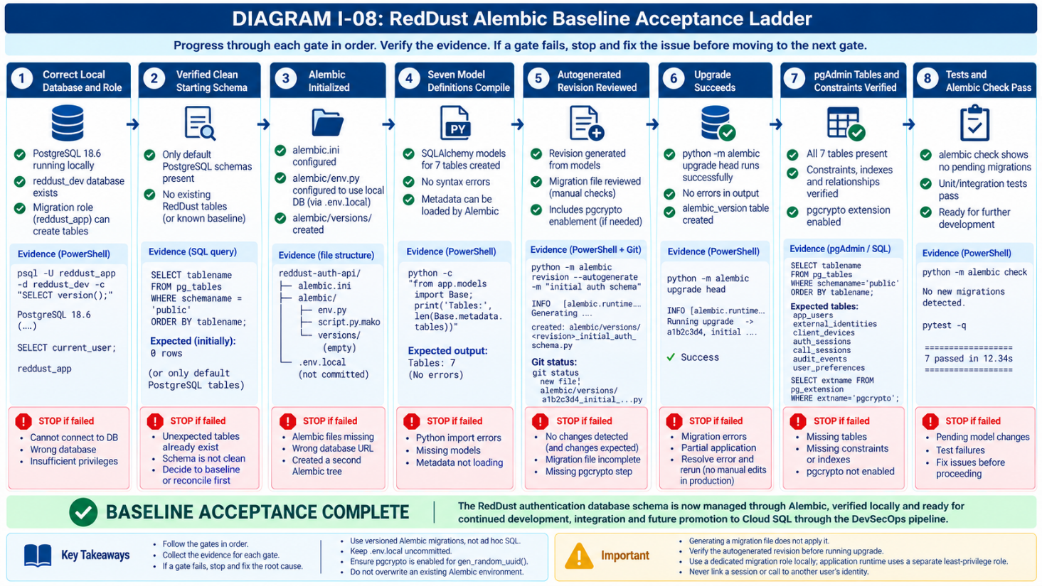

I.18 — Authoritative technical references
- Alembic official tutorial: https://alembic.sqlalchemy.org/en/latest/tutorial.html
- Alembic autogenerate: https://alembic.sqlalchemy.org/en/latest/autogenerate.html
- SQLAlchemy constraints and composite foreign keys: https://docs.sqlalchemy.org/en/20/core/constraints.html
- SQLAlchemy PostgreSQL dialect: https://docs.sqlalchemy.org/en/20/dialects/postgresql.html
- PostgreSQL 18 CREATE EXTENSION: https://www.postgresql.org/docs/18/sql-createextension.html
- PostgreSQL 18 pgcrypto: https://www.postgresql.org/docs/18/pgcrypto.html
- PostgreSQL 18 data definition: https://www.postgresql.org/docs/18/ddl.html
Completion gate — do not treat plausible output as evidence. Appendix I is complete only when an actual database revision is applied, all required schema objects and constraints are verified in PostgreSQL, and the corresponding test and migration evidence is recorded. This Word guide and its sample source listings are instructions; they do not prove that commands were executed on any developer machine.

Appendix J — Google Identity Verification and Atomic User Linking

J.1 — End-to-end objective in beginner terms
Google issues proof that someone signed in to a particular Google OAuth client. The RedDust backend independently checks the proof. Only then does it use the Google subject (sub) to find or create a RedDust account. The email address is profile data and must not serve as the permanent identity key. The server then decides whether that account may receive a RedDust session.

J.2 — First inspect the existing project
- In VS Code open D:\RedDust\reddust-auth-api; inspect app/security.py, app/settings.py, app/models.py, app/db.py, app/main.py and app/routes.
- Identify existing Pydantic settings conventions and the actual class names representing app_users and external_identities. Reuse them: this guide does not invent aliases that are guaranteed to match your code.
- Verify Appendix I already created the UNIQUE(provider,provider_subject) constraint and application tables. Do not recreate them.
- Confirm the mobile team has an approved Google OAuth client ID for the chosen sign-in flow; backend must validate aud (audience) against that ID or a deliberate allowlist.
When Google issues an ID token, its payload json object might contain:
{
"iss": "https://accounts.google.com",
"sub": "109876543210123456789",
"aud": "123456789012-abcdefg.apps.googleusercontent.com",
"exp": 1793000000,
"email": "example@gmail.com"
}
Claim | Full form | Meaning
iss | Issuer | Who issued the token? (Google)
sub | Subject | Which Google user is authenticated?
aud | Audience | Which application is this token intended for?
exp | Expiration Time | When does the token expire?
iat | Issued At | When was the token issued?
WHERE: VS CODE INTEGRATED POWERSHELL
Set-Location "D:\RedDust\reddust-auth-api"
.\.venv\Scripts\Activate.ps1
python -m pip install google-auth requests
python -c "from google.oauth2 import id_token; from google.auth.transport import requests; print('Google verifier imports OK')"
python -m pip check
Capture the exact versions in your existing dependency baseline after tests pass; do not accidentally overwrite a curated requirements file with a raw pip freeze unless that is the approved workflow.

J.3 — Implement a verification core
Paste the following in the empty app/security.py file. This is a self-contained verification-core example. It is not an entire FastAPI endpoint. It deliberately passes audience=None to the Google helper and performs an explicit allowlist check afterward, supporting multiple approved client IDs.
WHERE: VS CODE FILE app/security.py — ADAPT/TEST WITH CURRENT DEPENDENCIES
# app/security.py — illustrative implementation core
from google.oauth2 import id_token
from google.auth.transport import requests as google_requests
_GOOGLE_ISSUERS = {"accounts.google.com", "https://accounts.google.com"}

def verify_google_id_token(raw_token: str, allowed_audiences: set[str]) -> dict:
if not raw_token or not allowed_audiences:
raise ValueError("Missing token or approved audience")
claims = id_token.verify_oauth2_token(
raw_token,
google_requests.Request(),
audience=None, # aud is checked explicitly below
)
if claims.get("iss") not in _GOOGLE_ISSUERS:
raise ValueError("Invalid Google issuer")
if claims.get("aud") not in allowed_audiences:
raise ValueError("Token audience not approved")
subject = claims.get("sub")
if not isinstance(subject, str) or not subject:
raise ValueError("Missing Google subject")
return {
"provider_subject": subject,
"email": claims.get("email"),
"email_verified": claims.get("email_verified") is True,
"display_name": claims.get("name"),
}
SECURE BEHAVIOR: Google verification fetches or uses cached Google public keys, checks token signature/expiry/issuer according to library behavior, and the explicit checks above restrict the accepted audience and sub. Do not suppress exceptions or skip cryptographic checks to make development easier. In production review transport, timeouts, network behavior and key caching.

J.3.1 — Create tests/test_security.py
WHERE: In VS Code Explorer navigate to:
D:\RedDust\reddust-auth-api
Your project should have this structure:
reddust-auth-api/
├── app/
│ ├── security.py
│ ├── models.py
│ ├── db.py
│ └── ...
├── tests/
│ └── test_schema_metadata.py
│ └── test_security.py ← Create this new file
├── alembic/
├── .env.local
└── requirements.txt
If tests folder already exists, use the existing folder. Right-click tests → New File → enter: test_security.py
Paste the following complete code into the new file.
# tests/test_security.py
# RedDust — Google ID Token Verification Unit Tests
# These tests mock Google's verification helper.
# They do not require live Google tokens or network access.

import pytest
from app.security import verify_google_id_token

APPROVED_CLIENT_ID = ("reddust-test-client.apps.googleusercontent.com")

def mock_google_verification(monkeypatch, claims):
"""Replace Google's token verifier with a local mock."""
def fake_verify(raw_token, request, audience=None):
assert raw_token == "mock-google-token"
assert audience is None
return claims

monkeypatch.setattr("app.security.id_token.verify_oauth2_token", fake_verify,)

def valid_claims():
return {
"iss": "https://accounts.google.com",
"aud": APPROVED_CLIENT_ID,
"sub": "google-test-subject-123",
"email": "test@example.com",
"email_verified": True,
"name": "RedDust Test User",
}

def test_valid_google_token(monkeypatch):
"""A token with acceptable claims should be accepted."""
mock_google_verification(monkeypatch, valid_claims(),)
result = verify_google_id_token("mock-google-token", {APPROVED_CLIENT_ID},)
assert result["provider_subject"] == ("google-test-subject-123")
assert result["email"] == "test@example.com"
assert result["email_verified"] is True
assert result["display_name"] == "RedDust Test User"

def test_wrong_audience_rejected(monkeypatch):
"""A token for another application must be rejected."""
claims = valid_claims()
claims["aud"] = ("unapproved-client.apps.googleusercontent.com")
mock_google_verification(monkeypatch, claims)
with pytest.raises(ValueError, match="Token audience not approved",):
verify_google_id_token("mock-google-token", {APPROVED_CLIENT_ID},)

def test_wrong_issuer_rejected(monkeypatch):
"""An unapproved issuer must be rejected."""
claims = valid_claims()
claims["iss"] = "https://untrusted.example.com"
mock_google_verification(monkeypatch, claims)
with pytest.raises( ValueError, match="Invalid Google issuer",):
verify_google_id_token("mock-google-token", {APPROVED_CLIENT_ID},)

def test_missing_subject_rejected(monkeypatch):
"""A missing Google subject must be rejected."""
claims = valid_claims()
claims["sub"] = ""
mock_google_verification(monkeypatch, claims)
with pytest.raises(ValueError, match="Missing Google subject",):
verify_google_id_token("mock-google-token", {APPROVED_CLIENT_ID},)

def test_missing_token_rejected():
"""An empty token must be rejected."""
with pytest.raises(ValueError, match="Missing token or approved audience",):
verify_google_id_token("", {APPROVED_CLIENT_ID},)

def test_missing_allowed_audiences_rejected():
"""Verification must not run without approved audiences."""
with pytest.raises(ValueError, match="Missing token or approved audience",):
verify_google_id_token("mock-google-token", set(),)

def test_unverified_email_not_trusted(monkeypatch):
"""The email_verified field must be strictly boolean."""
claims = valid_claims()
claims["email_verified"] = False
mock_google_verification(monkeypatch, claims)
result = verify_google_id_token( "mock-google-token", {APPROVED_CLIENT_ID},)
assert result["email_verified"] is False
Important: The OAuth client ID above is a fictional test identifier, not an actual RedDust credential. These tests do not contact Google or validate a real cryptographic signature. They test the logic in your app/security.py function using controlled mock verification results.

J.3.2 — Run the unit tests
WHERE: VS Code integrated PowerShell
First save the above test_security.py file with Ctrl + S. Then run:
Set-Location "D:\RedDust\reddust-auth-api"
.\.venv\Scripts\Activate.ps1
python -m pytest tests\test_security.py -v
Expected results, assuming the file contains the code above:
tests/test_security.py::test_valid_google_token PASSED
tests/test_security.py::test_wrong_audience_rejected PASSED
tests/test_security.py::test_wrong_issuer_rejected PASSED
tests/test_security.py::test_missing_subject_rejected PASSED
tests/test_security.py::test_missing_token_rejected PASSED
tests/test_security.py::test_missing_allowed_audiences_rejected PASSED
tests/test_security.py::test_unverified_email_not_trusted PASSED

================== 7 passed ==================
Once those tests pass, run the full project test suite:
python -m pytest -v
Any existing additional tests will also run.

J.3.3 — Save evidence for your runbook
You can save the unit-test output in a text file.
WHERE: PowerShell
New-Item -ItemType Directory -Path ".\docs\evidence" -Force | Out-Null

python -m pytest tests\test_security.py -v `
| Tee-Object -FilePath ".\docs\evidence\J03_google_verification_unit_tests.txt"
This creates:
D:\RedDust\reddust-auth-api\
└── docs\
└── evidence\
└── J03_google_verification_unit_tests.txt
Review the evidence file before sharing or committing it, and ensure test output contains no credentials or sensitive values.
These seven tests are the first acceptance gate, not the complete set of Google authentication security tests. In particular, you must subsequently test the real verifier's rejection of invalid signatures and expired tokens.
Further Sequence: J.3 proves Google token verification → J.4 connects verified Google identity to one RedDust account → J.5 survives overlapping first-time sign-ins → J.6 assembles evidence and hands off remaining API work to Appendices K and L.

J.4 — Link a Verified Google Identity to the Correct RedDust Account
WHAT THIS SECTION DOES AND WHY IT MATTERS: After J.3 verifies Google’s ID token, RedDust must find or create its own internal user account using Google’s stable subject (sub). It must not identify a user by an unverified email or a client-provided user_id. Account, identity, device and authentication-session changes must be consistent and transactional.

J.4.1 — In plain English: Google identity is not a RedDust user account
Google proves that somebody authenticated as a particular Google subject. RedDust keeps its own user register so that devices, login sessions, calls, preferences, audit records and future AI experiences all refer to one stable app_users.id.
Identifier | Example (fictional) | Where it belongs
Google provider | Google | external_identities.provider
Google subject (sub) | google-sub-example-123 | external_identities.provider_subject
RedDust UUID | 550e8400-e29b-41d4-a716-446655440000 | app_users.id / external_identities.user_id
Email address | example@gmail.com | Profile/verification metadata, never the permanent account key
SECURITY RULE: Lookup key = (provider="google", verified provider_subject=sub). Never auto-link an existing RedDust account solely because its email matches an email in the Google token.

J.4.2 — Know what the four tables do
PostgreSQL table | Everyday meaning | Important relationship
app_users | Master register of RedDust users | Owns internal user UUID and status
external_identities | Address book linking Google accounts to RedDust users | UNIQUE(provider, provider_subject); user_id → app_users
client_devices | Register of mobile installations | Device belongs to a specific user
auth_sessions | Register of authorized login sessions | Same-user composite FK validates device + user
The composite foreign key in Appendix I means that an auth session cannot point to a device owned by some other user. The application must still check user and device status and enforce authorization; relational constraints do not replace business rules.
DIAGRAM — J-01: Google Identity to RedDust Account Resolution
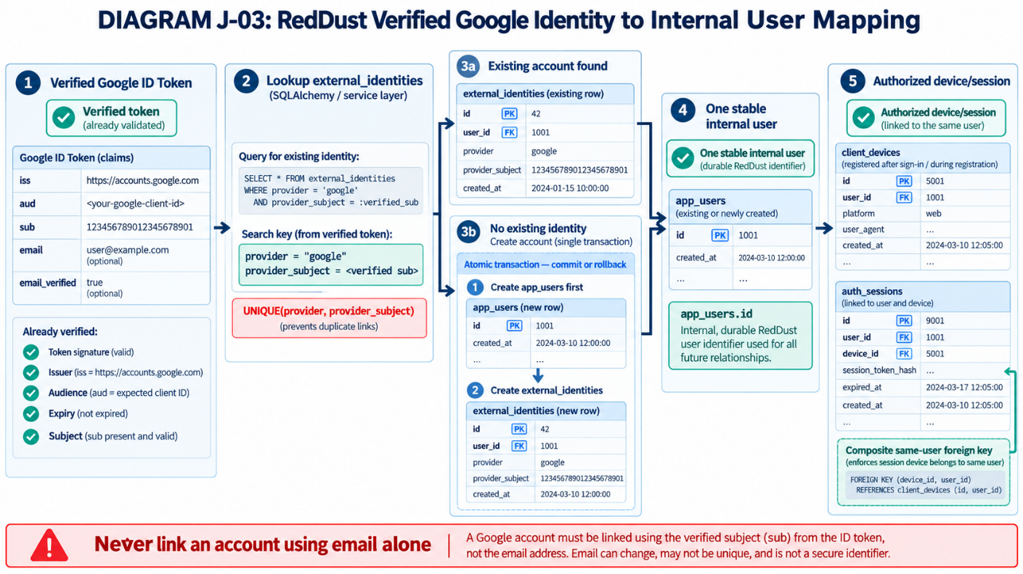

J.4.3 — Existing user versus first-time user
- Case A — Existing identity: Find external_identities using (provider, sub); follow user_id to app_users; confirm account is active; validate or register the device; create a permitted session.
- Case B — First-time identity: Create app_users and external_identities linked to the new UUID; validate/register the device; create a permitted session; commit the consistent set of records.
- If token verification fails, stop before accessing the account-linking write flow. Never accept a user_id or Google email supplied by the mobile app as proof of ownership.

J.4.4 — Atomic transactions: all-or-nothing database changes
A transaction behaves like a single, sealed package: either the whole package is saved (COMMIT), or its incomplete changes are discarded (ROLLBACK). This prevents an app_users row being left behind when external_identities cannot be linked.
BEGIN database transaction
Find external identity by ("google", verified sub)
IF found: reuse linked user; check status
ELSE: create app_users; create external_identities link
Find/register device under that user; check revocation policy
Create authorized auth_sessions row with refresh-token HASH
COMMIT if all required operations succeed
ROLLBACK if anything in the transaction fails
IMPORTANT IMPLEMENTATION BOUNDARY: The sequence above is pseudocode—not executable Python. JWT signing, secure refresh-token generation, replay handling and token response formatting are covered by Appendix K. Link the resulting token/ session component to this transaction without storing raw refresh tokens in PostgreSQL.

J.4.5 — Exactly where you work in VS Code
Open D:\RedDust\reddust-auth-api in VS Code. First inspect existing names and source files. Keep the Google token verification function in app/security.py; implement database-linking behavior as a separate service using the project’s established conventions.
File / location | What to inspect or implement
app/security.py | Existing J.3 Google ID-token verification function (do not replace it).
app/models.py | Actual SQLAlchemy class names, fields and relationship definitions.
app/db.py | Actual engine, session factory and session/transaction lifecycle.
app/settings.py | Approved OAuth audience configuration and local environment loading.
app/services/identity.py (proposed) | Identity lookup, first-time creation, status/device checks and transactional linking.
app/routes/auth.py (future) | HTTP POST /v1/auth/google integrates verifier, identity service and tokens in Appendix L.
tests/test_identity_linking.py (proposed) | Repeat-login, rollback and new-user tests using isolated PostgreSQL fixtures.

J.4.6 — Inspect existing models before writing account-linking code between Google OAuth and RedDust
WHERE: VS CODE INTEGRATED POWERSHELL (READ-ONLY SOURCE INSPECTION): Activate D:\RedDust\reddust-auth-api\.venv. The following commands display Python source and directory contents; check output before sharing, because configuration files may contain connection details.
Set-Location "D:\RedDust\reddust-auth-api"
.\.venv\Scripts\Activate.ps1
Get-Content .\app\models.py
Get-Content .\app\db.py
Get-ChildItem .\app\routes –Force
Determine the actual app_users and external_identities model class names, how SQLAlchemy Session objects are opened and closed, and whether a service directory already exists. Do not copy speculative class names into production code.

J.4.7 — Verify the current database structure without changing it
WHERE: PGADMIN 4 → SERVERS → POSTGRESQL 18 → DATABASES → REDDUST_DEV → QUERY TOOL: Run the read-only query below. It confirms actual columns, types and nullable fields in the four relevant tables; no table is recreated.
SELECT table_name, column_name, data_type, is_nullable
FROM information_schema.columns
WHERE table_schema = 'public'
AND table_name IN (
'app_users', 'external_identities',
'client_devices', 'auth_sessions'
)
ORDER BY table_name, ordinal_position;
Expected: a list of columns belonging to all four tables. Compare this output against app/models.py and your J.4 account-linking design. The result is inventory evidence, not a completed login test.

J.4.8 — Acceptance tests and evidence
Test case | Expected outcome | Evidence to retain
First valid sign-in | New internal user and one external identity link | Isolated test DB rows + pytest
Repeat sign-in, same provider/sub | Same app_users.id; new authorized session as needed | Test assertion of identical UUID
Email changes, sub stays fixed | Same RedDust account | Mock claims + test assertion
Disabled/deleted app user | Deny login/session issuance | Negative pytest result
Link creation fails | Entire create/link transaction rolls back | Rollback test; no orphaned row
Session references another user’s device | Rejected by API/DB ownership checks | Foreign-key negative integration test
J.4 ACCEPTANCE GATE: A verified Google (provider, sub) resolves to the right active RedDust account, repeated logins reuse its app_users.id, and all related records obey transaction and same-user database rules.

J.5 — Prevent Duplicate Accounts During Concurrent Sign-In
WHAT THIS SECTION DOES AND WHY IT MATTERS: Two authentic Google login requests can arrive at almost the same instant. Both may initially see “identity not found.” PostgreSQL must allow at most one committed identity link, and the losing request must recover cleanly rather than leaving a stray account or a raw database error.

J.5.1 — Race condition, explained using two receptionists
Imagine two receptionists checking whether a customer is already registered. Both search before either saves. Both see “not found” and both try to register the same customer. This overlapping timing is a race condition even when both requests are genuine.
Moment | Request A | Request B
T1 | Lookup (google, sub) → not found | Lookup same key → not found
T2 | Try creating user + identity | Try creating user + identity
T3 | Wins uniqueness race and commits | Specific uniqueness conflict; must rollback
T4 | Returns user A | Rereads winner; returns same app_users.id

J.5.2 — The existing PostgreSQL UNIQUE constraint is the safety lock
Appendix I already created uq_external_identity_provider_subject. This is the database’s non-negotiable rule: the same pair (provider, provider_subject) cannot exist twice as committed rows. Your application must catch and handle that specific collision correctly.
WHERE: PGADMIN QUERY TOOL (READ-ONLY): Check that the expected uniqueness constraint still exists.
SELECT conname, pg_get_constraintdef(oid) AS definition
FROM pg_constraint
WHERE conname = 'uq_external_identity_provider_subject';
Expected: one row showing UNIQUE (provider, provider_subject). Do not create a second uniqueness constraint if the existing one is present.
DIAGRAM — J-02: Concurrent Google Sign-In: One Winning Commit
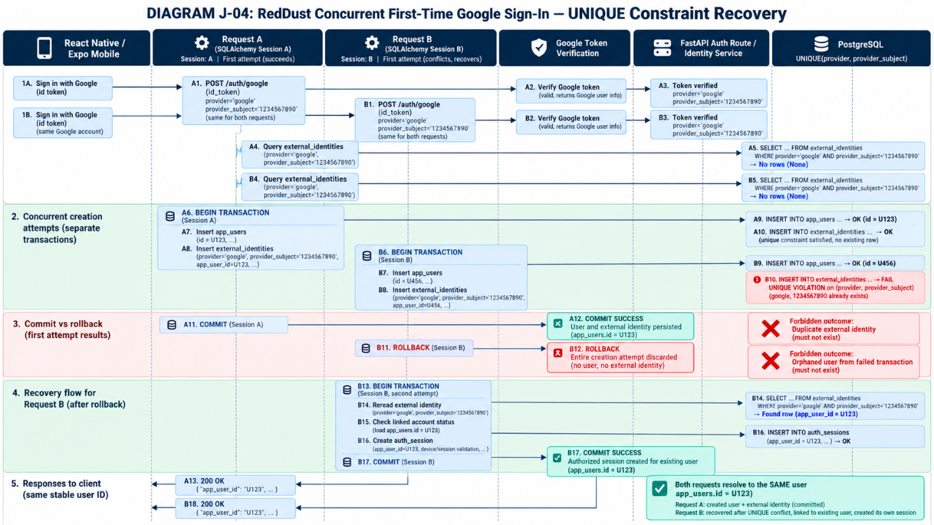

J.5.3 — How the losing request must behave
- Try the normal verified-identity lookup and transaction. Use a separate SQLAlchemy session per concurrent request.
- If an INSERT fails because of the specific provider+subject UNIQUE constraint, stop and roll back that failed transaction. A failed flush leaves the session unusable until rollback.
- With a fresh clean transaction, reread the identity committed by the winning request. Do not reuse a stale snapshot.
- Verify that the linked app user is permitted to sign in and that the requested device is legitimate.
- Create the losing request’s own valid auth session through the Appendix K session/token workflow. It may have a different session ID while still sharing the same user ID.
- Return a normal successful login result only if all authorization/session steps succeed. Any unrelated integrity or connectivity error must be handled separately, not silently treated as a race.

J.5.4 — Exception handling is not the same as hiding errors
A PostgreSQL duplicate-key violation is expected only for the narrow identity-creation race. Handle SQLAlchemy IntegrityError carefully and confirm the violated constraint before doing a targeted reread. Do not catch every database exception and return “existing user,” because that can conceal a broken schema or lost connection.
PSEUDOCODE — NOT A COPY-PASTE PYTHON MODULE
try:
with independent_database_transaction():
find_or_create_identity_for_verified_sub()
register_authorized_device_and_session()
except UNIQUE_CONFLICT_ON_PROVIDER_SUBJECT:
rollback_failed_transaction()
with fresh_database_transaction():
identity = reread_committed_identity()
verify_account_and_device_status(identity)
register_authorized_session_for_same_user()
except OTHER_DATABASE_FAILURE:
fail_safely_and_report_nonsecret_diagnostic()
IMPLEMENTATION CAUTION: The winning transaction may still be in progress when the other insert collides; database behavior may involve waiting or a retry. Recovery should be bounded and tested against your actual PostgreSQL isolation level. All retries must be deliberate; never loop indefinitely or generate duplicate refresh tokens.

J.5.5 — Why rollback prevents orphan users
If the losing request creates app_users first, then cannot create external_identities because Request A already won, rolling back the whole transaction also discards that losing request’s tentative app_users row. That is the difference between catching an error and preserving database integrity.

J.5.6 — Write tests in an isolated database, not against real accounts
Automated test | Pass evidence
First login creates link | One app_users row and one matching external_identities row
Repeated login | Both requests resolve to identical app_users.id
Two concurrent first-time login attempts | Exactly one identity link; no abandoned duplicate user; both requests handled according to policy
Conflict after tentative user creation | Failed transaction’s records absent after rollback
Invalid non-unique database exception | Not misclassified as normal existing-identity login
Disabled user on reread | Access denied even after race recovery

J.5.7 — Implement and Execute the Complete Identity-Linking and Concurrency Test Suite
WHAT THIS SECTION DOES: Creates SQLAlchemy Core identity-linking service, a dedicated migrated PostgreSQL test database, and the complete executable tests/test_identity_linking.py. Verifies success, rejection, atomic rollback and real two-connection concurrency race.
STARTING POINT: Appendix I is already complete in reddust_dev. J.3 Google-token verification core exists. These tests do NOT require a real Google ID token or implemented HTTP endpoint; full OAuth/JWT/API acceptance remains in Appendices K/L.
SAFETY / DESTRUCTIVE TEST WARNING: The test fixture deliberately TRUNCATES all seven application tables before and after every test. It is permitted ONLY in a dedicated, disposable database named reddust_test; never run it against reddust_dev, staging, Cloud SQL or real user data.

J.5.7.1 — Understand the three layers that must exist
The identity service for account-linking has not yet been implemented in the reddust-auth-api project. A pytest file cannot independently test non-existent account-linking code. This section supplies both. The missing application service as well as the tests. Think of it as testing a bank clerk: the database is the official customer register, identity.py is the clerk, and test_identity_linking.py asks the clerk to handle ordinary and simultaneous registrations correctly.
Layer | Location | Responsibility
Verified Google claims | app/security.py (already created in J.3) | Proves the Google token and extracts its trusted sub; not reimplemented here.
Account-linking transaction | app/services/identity.py (new) | Find/create RedDust user; link Google sub; device/session writes; recover targeted race.
Database integration and concurrency tests | tests/test_identity_linking.py (new) | Exercise actual PostgreSQL writes, UNIQUE conflicts, rollback, cross-user FK rules and safe audits.
Future API and token wiring | Appendix K and Appendix L | Create secure refresh credential/JWT and POST /v1/auth/google; not falsely declared implemented here.

J.5.7.2 — Verify the intended project layout
WHERE: VS Code Explorer — D:\RedDust\reddust-auth-api: Project file map — create missing service & test files, not a new Alembic tree
D:\RedDust\reddust-auth-api\
├── app\
│ ├── db.py # Existing Appendix I connection helper
│ ├── models.py # Existing seven SQLAlchemy Core Tables
│ ├── security.py # Existing J.3 verified Google token helper
│ └── services\ # NEW package
│ ├── __init__.py # NEW empty marker
│ └── identity.py # NEW implementation in J.5.7.5
├── tests\
│ ├── test_schema_metadata.py
│ ├── test_security.py
│ └── test_identity_linking.py # NEW integration tests
├── alembic\
├── .env.local # Existing PRIVATE dev DB configuration
└── requirements.txt
This runbook uses the actual Appendix I SQLAlchemy Core Table objects (app_users, external_identities, client_devices, auth_sessions, call_sessions, audit_events and metadata). Do not change app/models.py into invented ORM classes or recreate the baseline tables.

J.5.7.3 — Create an isolated PostgreSQL database for write tests
WHERE: pgAdmin 4 — Servers → PostgreSQL 18 → Databases
- Confirm there is no pre-existing database named reddust_test. If it exists, determine who uses it and do NOT erase it; the automated tests will empty its application tables.
- If absent, connect to the PostgreSQL 18 server as the authorized postgres administrator. Right-click Databases → Create → Database.
- General tab: Database = reddust_test; Owner = reddust_app; click Save.
- Refresh Databases and confirm both reddust_dev (the completed development database) and reddust_test (the new disposable test database) appear.
- Right-click reddust_test → Query Tool and run the read-only confirmation below.
SQL — pgAdmin Query Tool connected to reddust_test
SELECT current_database(), current_user;
SELECT pg_get_userbyid(datdba) AS database_owner FROM pg_database WHERE datname = 'reddust_test';
EXPECTED: current_database = reddust_test; the database owner is reddust_app. The connected current_user may be postgres if you used the administrator; the automated tests will connect as reddust_app.
NEVER DO: Do not rename, recreate, truncate or migrate your existing reddust_dev database for this exercise.

J.5.7.4 — Apply the EXISTING Alembic baseline to reddust_test only
This is NOT a new schema design and NOT another Alembic revision. A fresh database needs the already-approved baseline migration so the tests can exercise real constraints. Use a temporary environment override; the local .env.local remains unchanged.
WHERE: VS Code → Terminal → New Terminal → PowerShell (activated .venv): PowerShell — migrated test database only; process environment restored afterward
Set-Location "D:\RedDust\reddust-auth-api"
.\.venv\Scripts\Activate.ps1

$priorName = [Environment]::GetEnvironmentVariable('RD_DB_NAME', 'Process')
try {
$env:RD_DB_NAME = 'reddust_test'
python -m alembic upgrade head
if ($LASTEXITCODE -ne 0) { throw 'Test DB migration failed' }
python -m alembic current
if ($LASTEXITCODE -ne 0) { throw 'Test DB version check failed' }
}
finally {
if ($null -eq $priorName) {
Remove-Item Env:RD_DB_NAME -ErrorAction SilentlyContinue
} else {
$env:RD_DB_NAME = $priorName
}
}
How this works: the existing app/db.py calls load_dotenv(..., override=False). While RD_DB_NAME is temporarily set in this PowerShell process, the Alembic child process uses reddust_test. The finally block restores the previous variable even if migration fails.
WHERE: pgAdmin 4 → Databases → reddust_test → Query Tool: Read-only test DB verification — expected count is 7
SELECT current_database(), current_user;
SELECT version_num FROM public.alembic_version;
SELECT extname FROM pg_extension WHERE extname = 'pgcrypto';
SELECT count(*) AS application_tables
FROM pg_tables WHERE schemaname = 'public'
AND tablename IN ('app_users','external_identities','client_devices',
'auth_sessions','call_sessions','audit_events','user_preferences');
ACCEPTANCE: Seven application tables + alembic_version exist in reddust_test; version matches approved baseline; pgcrypto present. The test database is empty of real accounts. No migration changes were applied to reddust_dev.

J.5.7.5 — Create the identity-linking service used by the tests
WHERE: VS Code Explorer → app → New Folder → services; then New File → __init__.py and identity.py
- Inspect the existing app folder. Create services only if missing; add an empty __init__.py in services.
- Create app/services/identity.py. If it already contains real code, STOP and merge deliberately rather than overwriting it.
- Paste the COMPLETE implementation shown below into identity.py; save with Ctrl+S.
- Read the important boundaries: this function accepts claims that have ALREADY passed J.3; it accepts a refresh-token HASH supplied by the future Appendix K credential service; it does not issue JWTs.
- Use one PostgreSQL connection/transaction per call. The engine is safe to share across threads; a SQLAlchemy Connection or Session must not be shared between them.
Implementation details: The winning first-time login creates app_users and external_identities in a single transaction. The losing request is recognized only by PostgreSQL SQLSTATE 23505 on the specifically named Google identity UNIQUE constraint, rolls back automatically, and rereads under a fresh transaction. Device insertion uses a separate narrowly targeted ON CONFLICT rule to handle two requests using the same installation ID.
COMPLETE FILE — app/services/identity.py — paste as one Python module
"""J.5.7 teaching implementation: verified Google claims -> one RedDust user.

Only call with claims returned by app.security.verify_google_id_token.
The caller (Appendix K) supplies a cryptographically derived refresh_token_hash.
This module does NOT issue JWTs or verify Google's signature itself.
"""
from dataclasses import dataclass
from datetime import datetime, timezone
from typing import Mapping, Any
from uuid import UUID

from sqlalchemy import Engine, Connection, insert, select
from sqlalchemy.dialects.postgresql import insert as pg_insert
from sqlalchemy.exc import IntegrityError

from app.models import (
app_users, external_identities, client_devices, auth_sessions, audit_events,
)

class LoginDenied(Exception):
"""The verified identity is not authorized to start a RedDust session."""

class IdentityRaceRecoveryError(Exception):
"""A specific identity race occurred but the winning link was not found."""

@dataclass(frozen=True)
class LoginResult:
user_id: UUID
device_id: UUID
auth_session_id: UUID
created_user: bool
recovered_identity_race: bool

def _lookup_identity(connection: Connection, subject: str):
return connection.execute(
select(external_identities.c["user_id"], app_users.c["status"])
.join(app_users, external_identities.c["user_id"] == app_users.c["id"])
.where(
external_identities.c["provider"] == "google",
external_identities.c["provider_subject"] == subject,
)
).mappings().one_or_none()

def _is_identity_unique_conflict(error: IntegrityError) -> bool:
original = error.orig
return (
getattr(original, "sqlstate", None) == "23505"
and getattr(getattr(original, "diag", None), "constraint_name", None)
== "uq_external_identity_provider_subject"
)

def _register_device_session_and_audit(
connection: Connection, user_id: UUID, installation_id: str,
platform: str, refresh_token_hash: str, expires_at: datetime,
request_id: str | None, outcome: str,
) -> tuple[UUID, UUID]:
# The ON CONFLICT target is deliberately narrow: only same-user installation.
candidate = pg_insert(client_devices).values(
user_id=user_id, installation_id=installation_id, platform=platform
).on_conflict_do_nothing(
constraint="uq_device_user_installation"
).returning(client_devices.c["id"])
connection.execute(candidate).scalar_one_or_none()

device = connection.execute(
select(client_devices.c["id"], client_devices.c["platform"],
client_devices.c["revoked_at"])
.where(client_devices.c["user_id"] == user_id,
client_devices.c["installation_id"] == installation_id)
).mappings().one()
if device["revoked_at"] is not None:
raise LoginDenied("Device is revoked")
if device["platform"] != platform:
raise LoginDenied("Installation platform mismatch")

session_id = connection.execute(
insert(auth_sessions).values(
user_id=user_id, device_id=device["id"],
refresh_token_hash=refresh_token_hash, expires_at=expires_at,
).returning(auth_sessions.c["id"])
).scalar_one()
# Auditable metadata is strictly allowlisted. Do not persist token/claims.
connection.execute(insert(audit_events).values(
actor_user_id=user_id,
auth_session_id=session_id,
event_type="auth.google.login",
request_id=request_id,
metadata_json={"result": outcome},
))
return device["id"], session_id

def link_verified_google_identity(
engine: Engine, verified_claims: Mapping[str, Any], *,
installation_id: str, platform: str, refresh_token_hash: str,
expires_at: datetime, request_id: str | None = None,
) -> LoginResult:
"""Create/reuse a user atomically and recover the specific Google-sub race.

Each engine.begin() block owns a separate transaction/connection. The
initial failed transaction fully rolls back before recovery starts.
"""
subject = verified_claims.get("provider_subject")
if not isinstance(subject, str) or not subject.strip():
raise ValueError("Expected a verified non-empty Google subject")
if not isinstance(installation_id, str) or not installation_id.strip():
raise ValueError("installation_id is required")
if platform not in {"android", "ios"}:
raise ValueError("platform must be android or ios")
if not isinstance(refresh_token_hash, str) or not refresh_token_hash:
raise ValueError("Appendix K must supply a refresh-token hash")
if expires_at.tzinfo is None or expires_at <= datetime.now(timezone.utc):
raise ValueError("expires_at must be future and timezone-aware")
if request_id is not None and (not isinstance(request_id, str)
or len(request_id) > 128):
raise ValueError("request_id must be a short non-secret identifier")

try:
with engine.begin() as connection:
found = _lookup_identity(connection, subject)
created_user = found is None
if found is None:
user_id = connection.execute(
insert(app_users).values(
display_name=verified_claims.get("display_name"),
).returning(app_users.c["id"])
).scalar_one()
# Only store Google email if Google actually verified it.
email = (verified_claims.get("email")
if verified_claims.get("email_verified") is True
else None)
connection.execute(insert(external_identities).values(
user_id=user_id, provider="google",
provider_subject=subject,
email_at_verification=email,
))
else:
user_id = found["user_id"]
if found["status"] != "active":
raise LoginDenied("RedDust account is not active")

device_id, session_id = _register_device_session_and_audit(
connection, user_id, installation_id, platform,
refresh_token_hash, expires_at, request_id,
"created" if created_user else "existing",
)
return LoginResult(user_id, device_id, session_id, created_user, False)
except IntegrityError as exc:
if not _is_identity_unique_conflict(exc):
raise # Never disguise unrelated DB errors as normal sign-in.

# The context manager already rolled back any tentative new app_users row.
# A fresh READ COMMITTED transaction sees the winning committed identity.
with engine.begin() as connection:
found = _lookup_identity(connection, subject)
if found is None:
raise IdentityRaceRecoveryError(
"The winning Google identity is not visible after conflict"
)
if found["status"] != "active":
raise LoginDenied("RedDust account is not active")
user_id = found["user_id"]
device_id, session_id = _register_device_session_and_audit(
connection, user_id, installation_id, platform,
refresh_token_hash, expires_at, request_id, "race_recovered",
)
return LoginResult(user_id, device_id, session_id, False, True)
SECURITY BOUNDARY: This teaching implementation does not prove that its caller used Google verification, a strong refresh-token generator or the final account-rate-limit policy. Those boundaries MUST be enforced by J.3, Appendix K and Appendix L respectively; do not expose this service as a public endpoint on its own.

J.5.7.6 — Compile-check and import the new service before testing
WHERE VS Code integrated PowerShell, from project root
Set-Location "D:\RedDust\reddust-auth-api"
python -m compileall -q app\services\identity.py
python -c "from app.services.identity import link_verified_google_identity; print('Identity service imports OK')"
EXPECTED: The compilation command emits no error, and the import command prints Identity service imports OK. A compilation success is not a passed integration test.

J.5.7.7 — Create the full PostgreSQL-backed tests/test_identity_linking.py
WHERE: VS Code Explorer → tests → New File → test_identity_linking.py
If the earlier four-test preflight version of this file already exists, first save a copy outside the source directory; then replace its contents with the COMPLETE test module below. Do not paste this code into app/security.py, app/models.py or pgAdmin Query Tool.
The fixture is intentionally conservative: it constructs a new SQLAlchemy Engine using the existing local RD_DB_* settings but explicitly switches the database name to reddust_test. Before any TRUNCATE it confirms the actual database name, the reddust_app role, all eight tables and exactly one applied Alembic revision. Every test then clears the seven application tables both before and after execution, so it requires sole ownership of the disposable test database.
COMPLETE FILE — tests/test_identity_linking.py — paste in one file; 16 executable pytest tests
"""J.5.7 real PostgreSQL integration tests. DESTRUCTIVE TO reddust_test ONLY.

Prerequisites: create reddust_test owned by reddust_app and run Alembic
baseline on that database. Never point this test module at reddust_dev.
"""
from concurrent.futures import ThreadPoolExecutor
from datetime import datetime, timedelta, timezone
from hashlib import sha256
from threading import Barrier

import pytest
from sqlalchemy import create_engine, insert, select, text, update
from sqlalchemy.exc import IntegrityError

from app.db import database_url
from app.models import (
metadata, app_users, external_identities, client_devices,
auth_sessions, call_sessions, audit_events,
)
from app.services import identity as identity_service
from app.services.identity import LoginDenied, link_verified_google_identity

TEST_DB = "reddust_test"
REQUIRED_TABLES = {
"app_users", "external_identities", "client_devices", "auth_sessions",
"call_sessions", "audit_events", "user_preferences", "alembic_version",
}

@pytest.fixture(scope="session")
def engine():
# Explicitly target a separate disposable database. Do not use the dev DB.
url = database_url()
assert url.host in {"127.0.0.1", "localhost"}, "Local PostgreSQL required"
assert url.database == "reddust_dev", (
"Use normal RD_DB_* settings; this fixture selects reddust_test explicitly"
)
test_engine = create_engine(
url.set(database=TEST_DB),
isolation_level="READ COMMITTED",
pool_size=5,
max_overflow=5,
connect_args={"connect_timeout": 5},
)
try:
with test_engine.connect() as connection:
actual = connection.execute(text("SELECT current_database()"))
assert actual.scalar_one() == TEST_DB
actual_user = connection.execute(text("SELECT current_user"))
assert actual_user.scalar_one() == "reddust_app"
existing = set(connection.execute(text("""
SELECT tablename FROM pg_tables WHERE schemaname = 'public'
""")).scalars())
assert REQUIRED_TABLES <= existing, (
"Missing migrated test tables: " + repr(REQUIRED_TABLES - existing)
)
head_rows = connection.execute(
text("SELECT version_num FROM public.alembic_version")
).scalars().all()
assert len(head_rows) == 1, "Run reviewed Alembic upgrade on reddust_test"
yield test_engine
finally:
test_engine.dispose()

@pytest.fixture(autouse=True)
def clean_disposable_test_database(engine):
"""Erase ONLY application tables in reddust_test before/after each test.

The Alembic version table and schema objects remain intact.
Requires an EXCLUSIVELY dedicated disposable test database.
"""
def wipe():
with engine.begin() as connection:
assert connection.execute(
text("SELECT current_database()")
).scalar_one() == TEST_DB
connection.execute(text("""
TRUNCATE TABLE
public.audit_events, public.call_sessions,
public.auth_sessions, public.client_devices,
public.external_identities, public.user_preferences,
public.app_users
RESTART IDENTITY CASCADE
"""))

wipe()
yield
wipe()

def claims(sub="google-sub-A", email="a@example.test", verified=True):
# This dict represents the *output of J.3 verification*, not a raw ID token.
return {
"provider_subject": sub, "email": email,
"email_verified": verified, "display_name": "Test User",
}

def token_hash(label):
# Deterministic fake hashes are ONLY for this isolated test database.
# Real raw refresh tokens and cryptographic policy come from Appendix K.
return sha256(("reddust-j57-test-" + label).encode("utf-8")).hexdigest()

def login(engine, *, sub="google-sub-A", install="installation-A",
platform="android", hash_label="token-A", email="a@example.test",
verified=True):
return link_verified_google_identity(
engine, claims(sub=sub, email=email, verified=verified),
installation_id=install, platform=platform,
refresh_token_hash=token_hash(hash_label),
expires_at=datetime.now(timezone.utc) + timedelta(days=1),
request_id="j57-test-request",
)

def count_rows(engine, table):
with engine.connect() as connection:
return connection.execute(
select(text("count(*)")).select_from(table)
).scalar_one()

def violated_constraint(error: IntegrityError) -> str | None:
"""Read PostgreSQL's constraint name without dynamic .diag warnings."""
diagnostics = getattr(error.orig, "diag", None)
return getattr(diagnostics, "constraint_name", None)

def test_schema_has_unique_identity_constraint(engine):
assert "external_identities" in metadata.tables
with engine.connect() as connection:
constraint = connection.execute(text("""
SELECT pg_get_constraintdef(oid)
FROM pg_constraint
WHERE conrelid = 'public.external_identities'::regclass
AND conname = 'uq_external_identity_provider_subject'
AND contype = 'u' AND convalidated
""")).scalar_one()
assert "UNIQUE (provider, provider_subject)" in constraint

def test_first_login_creates_user_identity_device_session_and_audit(engine):
result = login(engine)
assert result.created_user is True
assert result.recovered_identity_race is False
for table in (app_users, external_identities, client_devices,
auth_sessions, audit_events):
assert count_rows(engine, table) == 1
with engine.connect() as connection:
identity = connection.execute(select(external_identities)).mappings().one()
device = connection.execute(select(client_devices)).mappings().one()
session = connection.execute(select(auth_sessions)).mappings().one()
audit = connection.execute(select(audit_events)).mappings().one()
assert identity["user_id"] == device["user_id"] == session["user_id"] == result.user_id
assert session["device_id"] == result.device_id
assert session["id"] == result.auth_session_id
assert session["refresh_token_hash"] == token_hash("token-A")
assert audit["metadata_json"] == {"result": "created"}
assert audit["actor_user_id"] == result.user_id
assert audit["auth_session_id"] == result.auth_session_id

def test_repeat_login_reuses_same_user_and_device(engine):
first = login(engine, hash_label="first")
second = login(engine, hash_label="second")
assert first.user_id == second.user_id
assert first.device_id == second.device_id
assert first.auth_session_id != second.auth_session_id
assert second.created_user is False
assert count_rows(engine, app_users) == 1
assert count_rows(engine, external_identities) == 1
assert count_rows(engine, client_devices) == 1
assert count_rows(engine, auth_sessions) == 2

def test_changed_email_does_not_change_stable_google_subject_mapping(engine):
first = login(engine, email="old@example.test", hash_label="first")
second = login(engine, email="new@example.test", hash_label="second")
assert first.user_id == second.user_id
assert count_rows(engine, external_identities) == 1

def test_unverified_email_is_not_stored_as_verified_identity_metadata(engine):
login(engine, email="unverified@example.test", verified=False)
with engine.connect() as connection:
stored = connection.execute(
select(external_identities.c["email_at_verification"])
)
assert stored.scalar_one() is None

def test_distinct_google_subjects_with_same_email_stay_separate(engine):
a = login(engine, sub="sub-A", install="install-A", hash_label="A")
b = login(engine, sub="sub-B", install="install-B", hash_label="B")
assert a.user_id != b.user_id
assert count_rows(engine, app_users) == 2
assert count_rows(engine, external_identities) == 2

def test_missing_subject_fails_without_database_changes(engine):
with pytest.raises(ValueError, match="non-empty Google subject"):
link_verified_google_identity(
engine, claims(sub=""), installation_id="x", platform="android",
refresh_token_hash=token_hash("invalid"),
expires_at=datetime.now(timezone.utc) + timedelta(days=1),
)
assert count_rows(engine, app_users) == 0

def test_unsupported_platform_rejected_before_writes(engine):
with pytest.raises(ValueError, match="platform must be"):
login(engine, platform="windows")
assert count_rows(engine, app_users) == 0

def test_disabled_account_does_not_get_new_session(engine):
first = login(engine)
with engine.begin() as connection:
connection.execute(
update(app_users)
.where(app_users.c["id"] == first.user_id)
.values(status="disabled")
)
with pytest.raises(LoginDenied, match="not active"):
login(engine, hash_label="second")
assert count_rows(engine, auth_sessions) == 1

def test_revoked_device_does_not_get_new_session(engine):
first = login(engine)
with engine.begin() as connection:
connection.execute(
update(client_devices)
.where(client_devices.c["id"] == first.device_id)
.values(revoked_at=datetime.now(timezone.utc))
)
with pytest.raises(LoginDenied, match="revoked"):
login(engine, hash_label="second")
assert count_rows(engine, auth_sessions) == 1

def test_duplicate_refresh_hash_is_not_misclassified_as_identity_race(engine):
login(engine, install="first", hash_label="same")
with pytest.raises(IntegrityError) as error:
login(engine, install="second", hash_label="same")
assert getattr(error.value.orig, "sqlstate", None) == "23505"
assert violated_constraint(error.value) == (
"uq_auth_sessions_refresh_token_hash"
)
# Both the tentative second device and session roll back.
assert count_rows(engine, client_devices) == 1
assert count_rows(engine, auth_sessions) == 1

def test_composite_device_foreign_key_rejects_another_users_device(engine):
a = login(engine, sub="sub-A", install="A", hash_label="A")
b = login(engine, sub="sub-B", install="B", hash_label="B")
with pytest.raises(IntegrityError) as error:
with engine.begin() as connection:
connection.execute(insert(auth_sessions).values(
user_id=a.user_id, device_id=b.device_id,
refresh_token_hash=token_hash("cross-device"),
expires_at=datetime.now(timezone.utc) + timedelta(days=1),
))
assert getattr(error.value.orig, "sqlstate", None) == "23503"
assert violated_constraint(error.value) == "fk_auth_device_same_user"
assert count_rows(engine, auth_sessions) == 2

def test_composite_call_foreign_key_rejects_another_users_session(engine):
a = login(engine, sub="sub-A", install="A", hash_label="A")
b = login(engine, sub="sub-B", install="B", hash_label="B")
with pytest.raises(IntegrityError) as error:
with engine.begin() as connection:
connection.execute(insert(call_sessions).values(
user_id=a.user_id, auth_session_id=b.auth_session_id,
status="starting",
))
assert getattr(error.value.orig, "sqlstate", None) == "23503"
assert violated_constraint(error.value) == "fk_call_auth_same_user"
assert count_rows(engine, call_sessions) == 0

def test_simultaneous_first_signins_recover_with_one_user(engine, monkeypatch):
# Force both real PostgreSQL transactions to read "not found" before
# either is allowed to insert. This is a true two-connection race test.
subject = "same-google-sub-for-two-threads"
barrier = Barrier(2)
original = identity_service._lookup_identity

def synchronized_lookup(connection, query_subject):
found = original(connection, query_subject)
if query_subject == subject and found is None:
barrier.wait(timeout=15)
return found

monkeypatch.setattr(identity_service, "_lookup_identity", synchronized_lookup)

def run_login(number):
return login(engine, sub=subject,
install=f"installation-{number}",
hash_label=f"concurrent-{number}")

with ThreadPoolExecutor(max_workers=2) as executor:
futures = [executor.submit(run_login, n) for n in (1, 2)]
results = [future.result(timeout=30) for future in futures]

assert results[0].user_id == results[1].user_id
assert results[0].auth_session_id != results[1].auth_session_id
assert sorted(r.recovered_identity_race for r in results) == [False, True]
assert count_rows(engine, app_users) == 1 # No orphaned losing user.
assert count_rows(engine, external_identities) == 1
assert count_rows(engine, client_devices) == 2
assert count_rows(engine, auth_sessions) == 2
assert count_rows(engine, audit_events) == 2
with engine.connect() as connection:
outcomes = connection.execute(
select(audit_events.c["metadata_json"])
).scalars().all()
assert {row["result"] for row in outcomes} == {"created", "race_recovered"}

def test_two_sessions_on_same_installation_do_not_duplicate_device(engine):
login(engine, hash_label="first")
with ThreadPoolExecutor(max_workers=2) as executor:
futures = [executor.submit(
login, engine, hash_label=f"parallel-{n}"
) for n in (1, 2)]
results = [future.result(timeout=30) for future in futures]
assert results[0].user_id == results[1].user_id
assert count_rows(engine, client_devices) == 1
assert count_rows(engine, auth_sessions) == 3

def test_audit_evidence_contains_no_raw_credential_or_google_email(engine):
login(engine, email="private@example.test")
with engine.connect() as connection:
audit = connection.execute(select(audit_events)).mappings().one()
rendered = repr(dict(audit))
assert "private@example.test" not in rendered
assert "mock-google-token" not in rendered
assert "Bearer " not in rendered
assert audit["metadata_json"] == {"result": "created"}

J.5.7.8 — Understand what the 16 tests actually cover
Coverage area | Tests / proof | Expected evidence
Migration and uniqueness | Schema constraint present | Actual PG UNIQUE(provider,provider_subject), not metadata-only
First-time login | Creates user, Google identity, device, auth session and safe audit event | One coordinated committed user/identity chain
Returning users | Repeat login and changed Google email | Stable app_users.id; fresh session ID
Identity hygiene | Unverified email; two subjects with same email | No email-only linking; different subjects remain different users
Input rejection | Empty subject; unsupported platform | Rejected before any writes
Access policy | Disabled user; revoked device | New session denied
Error discrimination | Duplicate refresh hash | Specific unrelated error propagated, transaction rolled back
Cross-user integrity | Foreign device; foreign call session | PostgreSQL rejects mismatched composite FK
True concurrency | Two threads forced to read missing subject together | Only one user/identity committed; loser rolls back/rereads
Device race | Two sessions from same app installation | One device record, multiple authorized sessions
Audit privacy | Allowlisted audit metadata | No raw tokens or Google email in audit record
The deterministic concurrency test uses a thread Barrier to ensure both independent PostgreSQL transactions initially see “identity not found.” The tests then allow the actual unique constraint to choose a winner and assert that the losing provisional user is not committed. Thread scheduling may determine which request wins; the invariant is one stable user ID.

J.5.7.9 — Execute only the new integration test module
WHERE VS Code integrated PowerShell — .venv activated, RD_DB_NAME restored to reddust_dev: PowerShell — use a NORMAL ASCII hyphen before v, not Word en-dash
Set-Location "D:\RedDust\reddust-auth-api"
.\.venv\Scripts\Activate.ps1
python -m pip check
python -m pytest tests\test_identity_linking.py -v
EXPECTED pytest collects 16 named test functions and each reports PASSED, ending with “16 passed” (runtime varies). These are anticipated results, NOT results verified on your Windows machine.
STOP / DIAGNOSE If the test DB is absent, migration incomplete, a check fails, or a test hangs, STOP. Do not change the fixture to point at reddust_dev. Never drop constraints or force tests to pass by mocking PostgreSQL.

J.5.7.10 — Preserve safe pytest evidence and validate cleanup
WHERE: VS Code PowerShell - after 16 tests pass: PowerShell - save unit/integration evidence; final 3 commands verify normal dev DB
New-Item -ItemType Directory -Path .\docs\evidence -Force | Out-Null
python -m pytest tests\test_identity_linking.py -v 2>&1 |
Tee-Object -FilePath .\docs\evidence\J057_identity_linking_tests.txt
if ($LASTEXITCODE -ne 0) { throw 'Identity-linking tests failed' }

python -m pytest -v
if ($LASTEXITCODE -ne 0) { throw 'Full project suite failed' }

python -m alembic current
python -m alembic heads
python -m alembic check
Do not publish logs or screenshots without inspecting them first. The pytest report should contain only test names, pass/fail results and redacted technical diagnostics. If running the whole suite introduces legacy tests that write to reddust_dev, correct those tests before treating the full-suite result as safe.
WHERE: pgAdmin 4 - reddust_test → Query Tool (READ-ONLY): Expected after pytest teardown: all listed row counts 0; version still present
SELECT current_database();
SELECT (SELECT COUNT(*) FROM app_users) AS users_remaining,
(SELECT COUNT(*) FROM external_identities) AS identities_remaining,
(SELECT COUNT(*) FROM client_devices) AS devices_remaining,
(SELECT COUNT(*) FROM auth_sessions) AS sessions_remaining,
(SELECT COUNT(*) FROM audit_events) AS audit_events_remaining;
SELECT version_num FROM alembic_version;
EVIDENCE: Store the pytest report, reviewed Git diff containing only the service/tests, the isolated-test database name, successful migrations and read-only cleanup query. Do not put connection passwords, real Google ID tokens, JWTs or raw refresh tokens in evidence.

J.5.7.11 — Troubleshooting by symptom
Symptom | Likely cause | What to do safely
File not found: tests\test_identity_linking.py | File not created/saved in tests folder | Create/save correct .py path; run Get-ChildItem .\tests
No module named app.services | Missing services/__init__.py, identity.py or wrong project root | Create missing files; run from reddust-auth-api
database reddust_test does not exist | Dedicated DB not created | Create via pgAdmin as authorized administrator
Missing migrated test tables | Alembic baseline not applied to test DB | Use temporary RD_DB_NAME override; verify version
Assertion expected reddust_dev | Shell RD_DB_NAME override not restored | Close test terminal, open fresh terminal; inspect environment safely
psycopg timeout / connection refused | PostgreSQL not running or local credentials wrong | Check PostgreSQL Windows service and localhost:5432
TRUNCATE permission denied | Owner/role not as expected | Verify reddust_test owner and reddust_app; never run as superuser casually
Barrier timeout / thread test hangs | One concurrency worker failed before reaching barrier | Inspect first traceback; do not remove real concurrency test
Unexpected UNIQUE constraint name | Model/migration differs from Appendix I | Read pg_constraint; do not guess or rename production constraints
Full suite fails while J.5.7 passes | Another test/module or unsafe fixture fails | Investigate separately; retain passing J.5.7 evidence

J.5.7.12 — Known limitations and later implementation duties
- J.5.7 tests verified account claims and PostgreSQL behavior; the J.3 Google verifier tests must separately cover Google signature, issuer, audience and expiration. These are not real Google OAuth integration tests.
- The identity-linking service receives a refresh-token hash; Appendix K must generate a sufficiently random opaque refresh token, hash it according to the approved policy and securely deliver the raw token only to its intended client.
- Appendix L must create the HTTP login route, catch LoginDenied and verification exceptions, return the documented 401/403 response, rate-limit requests, and never print raw token material.
- The service writes a minimal successful-login audit event. Rejected-login audit policy, redaction, monitoring and retention are part of Appendix M and later security review.
- The fixture uses TRUNCATE to isolate an exclusively disposable local test database. It is unsuitable for a shared test database without a different fixture isolation design.
- Identity race recovery is deliberately bounded to one specific 23505 constraint; it must not retry infinitely. The deployment team must review connection pools, timeouts, isolation levels and parallel CI workers.

J.5.7.13 — Optional diagram placeholders for training
DIAGRAM J-06: Identity-Linking Test Database Isolation and Boundaries
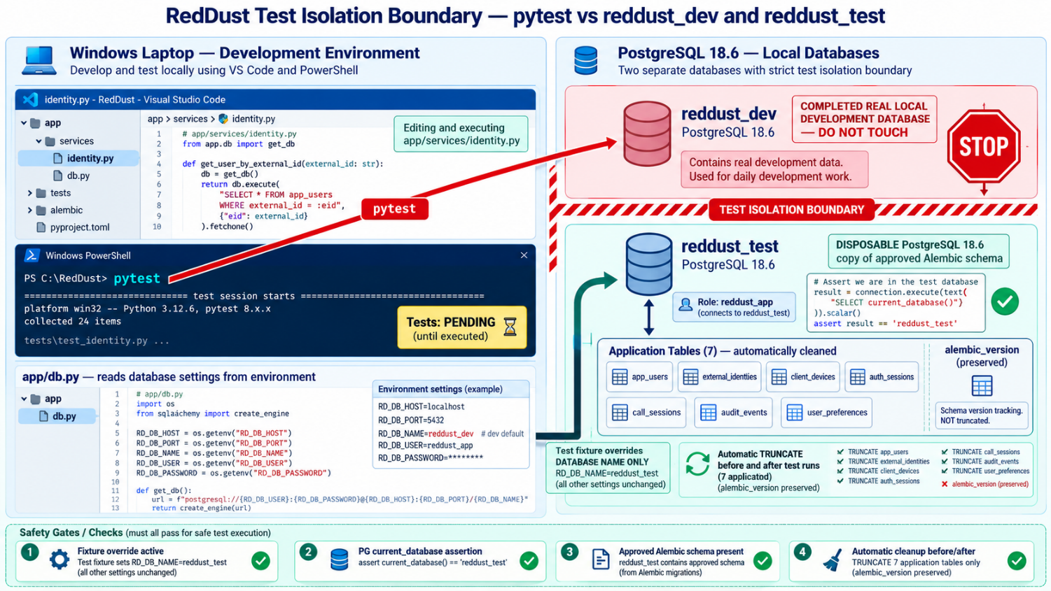
DIAGRAM J-07: Deterministic Two-Request SQLAlchemy Concurrency Test
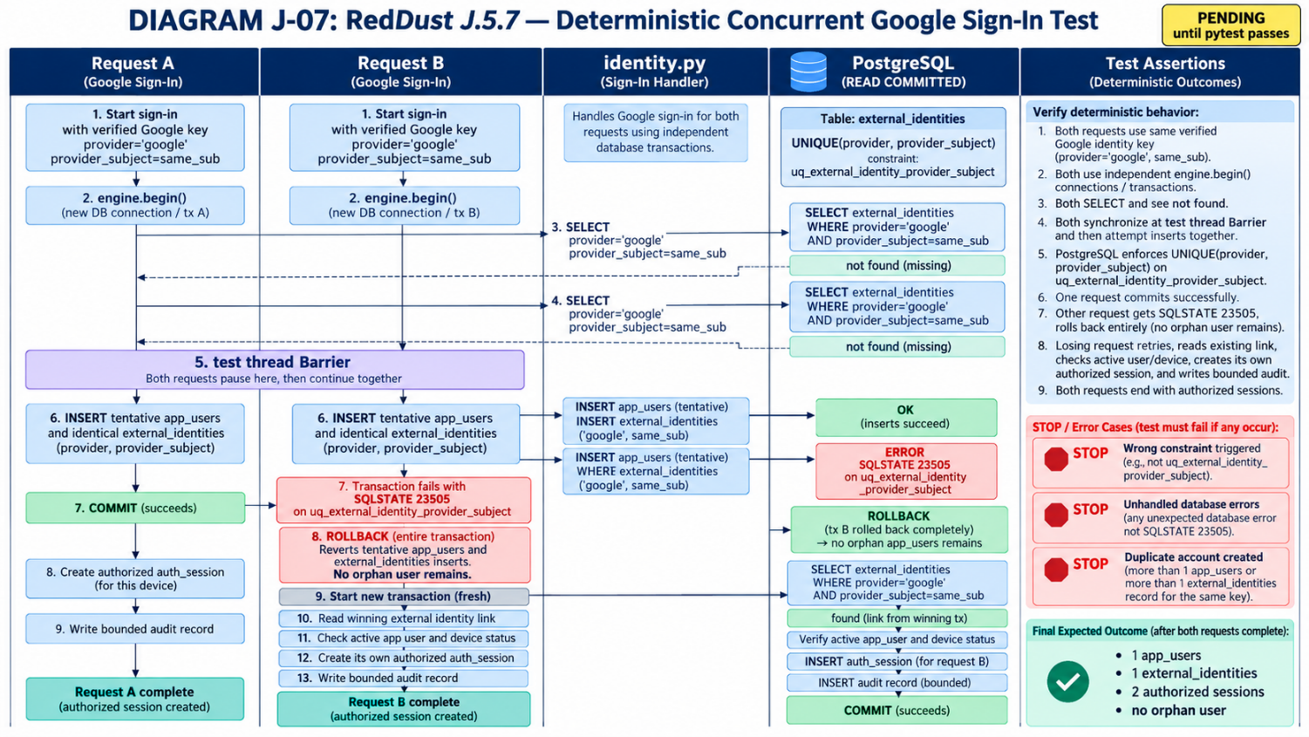

J.5.7.14 — Completion gate and hand-off
Acceptance requirement | How developer proves it
Dedicated writable test database exists | pgAdmin shows reddust_test, not reddust_dev; owner reddust_app
Existing migration applied to test database | alembic_version and all seven application tables present
Identity service compiles/imports | PowerShell compileall and import check
Full 16-test suite passes | pytest -v report includes 16 tests and zero failures
Real concurrency rollback verified | Two-connection barrier test proves one user/identity + two distinct auth sessions
Same-user composite FKs enforced | Cross-user device and call tests return SQLSTATE 23503
No stale test data | Read-only query shows zero application rows after fixture teardown
No token material in output | Review safe audit, pytest output and Git staged files
Dev database unchanged | RD_DB_NAME restored; alembic current/heads/check still agree
J.5.7 ACCEPTANCE STATEMENT: Record PASS only after all required checks actually succeed. Keep the next existing “Additional read-only diagnostics in your test database” section for your manual renumbering to J.5.8. After J.5.7, proceed with Appendix K refresh-token/JWT implementation and Appendix L HTTP integration; J.6 remains pending until complete end-to-end evidence exists.
Authoritative engineering references: SQLAlchemy PostgreSQL ON CONFLICT and INSERT RETURNING: https://docs.sqlalchemy.org/en/20/dialects/postgresql.html
SQLAlchemy transaction management: https://docs.sqlalchemy.org/en/20/core/connections.html
PostgreSQL READ COMMITTED isolation: https://www.postgresql.org/docs/18/transaction-iso.html
pytest fixtures: https://docs.pytest.org/en/stable/how-to/fixtures.html

J.5.8 — Additional read-only diagnostics in your test database
WHERE: PGADMIN QUERY TOOL CONNECTED TO AN ISOLATED REDDUST TEST DATABASE: Run only against the designated test database after the tests have finished. This does not itself test concurrency, but can reveal unexpected persisted records.
SELECT provider, provider_subject, COUNT(*) AS identity_count
FROM external_identities
GROUP BY provider, provider_subject
HAVING COUNT(*) > 1;
Expected: no rows. The unique constraint already prevents committed duplicate keys, so this query is supporting evidence rather than proof of race recovery.
SELECT COUNT(*) AS users_without_external_identity
FROM app_users u
WHERE NOT EXISTS (
SELECT 1 FROM external_identities e
WHERE e.user_id = u.id
);
For a test fixture containing only Google-provisioned users, zero is expected. Real systems may deliberately allow users without a Google identity, so do not treat every such row as corruption.
J.5 ACCEPTANCE GATE: Concurrent first-time Google sign-ins cannot create duplicate provider/sub identity links. The losing operation rolls back cleanly, rereads the winner and resolves to the same RedDust user ID, without suppressing unrelated database failures.

J.6 — Evidence Hand-off to Step 19C.7 and Appendix L
WHAT THIS SECTION DOES AND WHY IT MATTERS: Collect objective proof that the verifier, identity link and concurrency logic work before marking Google login complete. J.6 bridges Appendix J with Appendix K (token/session implementation) and Appendix L (FastAPI endpoints and real HTTP response evidence). Do not substitute example output for captured test results.

J.6.1 — Two-phase acceptance: what can be completed now?
Evidence item | When to collect | Acceptable proof
J.3 Google verifier unit tests | Now, after J.3 tests exist | pytest report including negative mocked-claims tests
OAuth aud allowlist review | When mobile sign-in configuration is approved | Recorded client-ID configuration / review, no secret keys
J.4 stable user linking | After J.4 service + test DB tests | Assertions for first/repeat login and user ID stability
J.5 uniqueness + rollback | After concurrency implementation | Automated race/rollback test report
Redacted HTTP 200 login | After Appendix K + Appendix L route integration | Successful /v1/auth/google response minus credentials
Redacted HTTP 401 failures | After Appendix L route and negative HTTP tests | Wrong aud/iss/exp/signature examples; no token leakage
Repeat login same UUID over HTTP | After real route integration | Two redacted responses or DB assertions using same app_users.id

J.6.2 — Store evidence in a predictable folder
WHERE: VS CODE INTEGRATED POWERSHELL: The commands below create a folder and capture test output. They do not automatically sanitize secrets. Review every file before it is shared or committed.
Set-Location "D:\RedDust\reddust-auth-api"
New-Item -ItemType Directory -Path ".\docs\evidence" -Force | Out-Null
python -m pytest tests\test_security.py -v `
| Tee-Object -FilePath ".\docs\evidence\J03_google_verification_unit_tests.txt"
# After J.4/J.5 tests exist:
python -m pytest tests\test_identity_linking.py -v `
| Tee-Object -FilePath ".\docs\evidence\J057_identity_linking_tests.txt"
The above filenames are suggestions. Preserve the test run date, Python version, dependency baseline, sanitized run result and Git revision or commit so another team member can reproduce the evidence.

J.6.3 — Approved OAuth audience evidence
Ask the mobile team which Google OAuth client IDs the selected React Native/Expo sign-in library causes Google to write into ID-token aud. Some native flows produce an ID token intended for a configured Web/server client ID. Confirm actual tokens against documentation/configuration; do not guess based only on the device platform.
- Record the approved OAuth client ID(s) in the non-secret configuration baseline; set GOOGLE_ALLOWED_CLIENT_IDS in server configuration according to its documented parser.
- Verify the backend does not read an allowed audience supplied by the HTTP caller as an authorization decision.
- Include a wrong-audience negative test: a genuine Google token meant for another client must be refused.
- Do not attach raw ID tokens to the evidence report.

J.6.4 — Redacted HTTP evidence: capture only after route implementation
When Appendix L has implemented POST /v1/auth/google and Appendix K has integrated token issuance, record sanitized success/failure responses. These illustrations show the expected redaction format only; they are NOT proof that your endpoint already works.
ILLUSTRATIVE REDACTED 200 SUCCESS — NOT LIVE EVIDENCE
HTTP/1.1 200 OK
{
"user": {"id": "<SAME_INTERNAL_UUID_ON_REPEAT_LOGIN>"},
"auth_session_id": "<REDACTED_SESSION_ID>",
"access_token": "<REDACTED>",
"refresh_token": "<REDACTED>",
"expires_in": 900
}
ILLUSTRATIVE REDACTED 401 DENIAL — NOT LIVE EVIDENCE
HTTP/1.1 401 Unauthorized
{ "detail": "Invalid authentication credentials" }
# Do not include the supplied Google ID token in request captures/logs.
Capture at least one successful login, an invalid Google-token denial, a wrong-audience denial and repeat-login ID consistency. Confirm failed requests do not leave unintended rows in PostgreSQL.

J.6.5 — Hand-off checklist
Gate | Status to record | Pass condition
J.3 verifier | PASS / NOT YET TESTED / FAIL | Unit tests pass; real verification failure modes covered by later integration tests
J.4 account linking | PASS / PENDING / FAIL | Correct mapping; same user on repeat; atomic rollback
J.5 concurrent sign-in | PASS / PENDING / FAIL | One identity link and controlled losing-request recovery
OAuth audience | APPROVED / PENDING | Backend uses agreed allowlist; wrong audience is denied
K + L integration | PASS / PENDING / FAIL | Token handling and real HTTP success/denial evidence
Privacy | PASS / FAIL | No real tokens, passwords or private keys in evidence/logs
STOP / DO NOT HAND OFF AS COMPLETE: Do not mark J.6 fully complete based only on app/security.py compilation or seven mocked unit tests. The final hand-off requires implemented and tested account linking, race handling, token/session management and real HTTP behavior. Use PENDING for items depending on Appendices K and L.
DIAGRAM — J-03: Appendix J Evidence Hand-off and Acceptance Gates
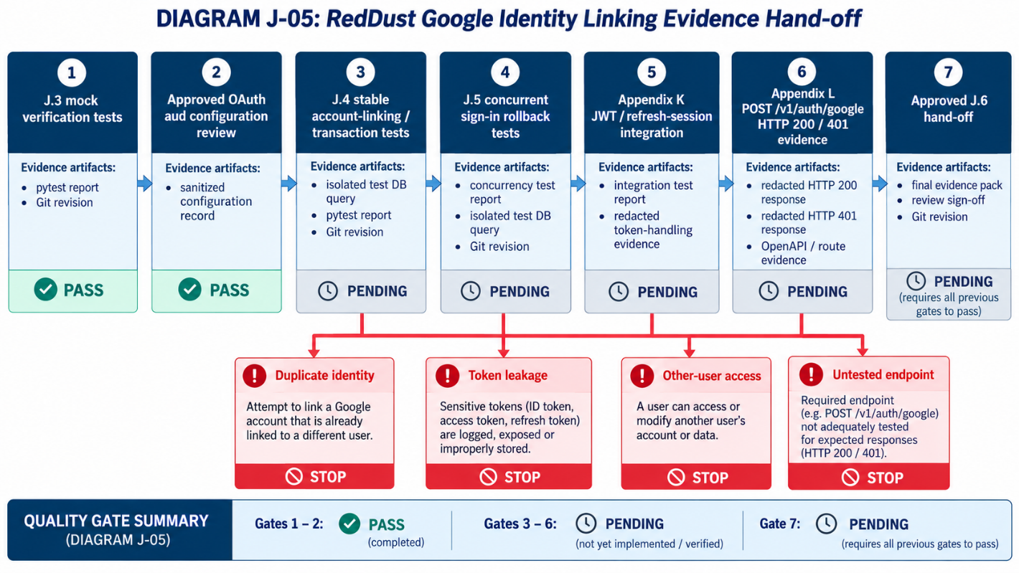

J.6.6 — Final review in plain English
J.3 checks the Google passport. J.4 finds or opens the correct RedDust account. J.5 ensures two simultaneous registration requests do not create duplicate people. J.6 is the signed inspection report proving that those operations—and later the real login endpoint—were tested safely.
Proceed to Appendix K for RedDust-issued JWT and refresh-token/session behavior, and Appendix L for API route integration. Preserve existing Appendix I migrations and database schema; introduce a new Alembic revision only for a deliberate, reviewed schema change.

Notes and authoritative technical references
- SQLAlchemy ORM session/transaction guidance: https://docs.sqlalchemy.org/en/20/orm/session_transaction.html
- SQLAlchemy session FAQ (one Session per concurrent unit of work): https://docs.sqlalchemy.org/en/20/orm/session_basics.html
- Google ID-token verification guidance: https://developers.google.com/identity/gsi/web/guides/verify-google-id-token
- PostgreSQL unique constraints: https://www.postgresql.org/docs/current/ddl-constraints.html
- All examples use fictional IDs and sanitized output. Adapt to the actual RedDust project source; never place live credentials in runbooks.

Appendix K — RedDust Signing Keys, JWT Access Tokens and Refresh Sessions
APPENDIX ROLE: This appendix is application security work. Source Step 19C recommends asymmetric signing (RS256/ES256), kid-based rotation and a hash-only refresh-token database design.
In systems and apps like RedDust, credentials are digital proofs of identity or authorization, much like identity cards, access passes, or keys used to enter a secured building. Different credentials serve different purposes: some prove who the user is, some allow the user to access RedDust services, and others enable the backend to create or verify those permissions securely. Together, they ensure that only verified users can access authorized RedDust resources, while sensitive information remains protected.

K.1 — Why RedDust needs its own tokens
Google’s ID token credential establishes that a user authenticated with Google. A RedDust access JWT token is a separate, short-lived authorization credential consumed by RedDust API and Gateway components. A RedDust refresh token renews access without requiring a full Google sign-in each time. Do not use the Google ID token as a general Gateway access token.
Credential | Who issues it | Used for | Protection
Google ID token | Google | Server verifies login evidence | Transport securely; never log
RedDust access JWT | RedDust auth API | Bearer authorization to RedDust APIs and Gateway | Asymmetric signature; short TTL; validate claims
RedDust refresh token | RedDust auth API | Secure refresh / rotation | Store opaque secret only on client; DB stores hash
Private signing key | RedDust deployment | Signing JWTs | Never commit, distribute to phone or put in logs
Public verification key | RedDust deployment | Verify JWT signatures | Distribute through controlled key/JWKS policy

K.2 — Create local signing-key material safely

Explanation in layman's terms
Think of RedDust Auth API as an office that issues digitally signed access passes. The private signing key is the office's confidential stamp, used to issue genuine RedDust access tokens. The public verification key lets the Gateway check whether a pass carries a valid signature, without giving the Gateway the confidential stamp.
This section K.2 creates that stamp and makes sure it stays private. Step 19C.5 — Configure verification and secrets established where to store it and how to keep it out of Git. Subsequent Appendix K steps here, will teach RedDust how to use it to sign and verify access tokens.
Once the file-generation, Git protection and Windows permission checks pass, you can mark K.2 complete and proceed to JWT implementation.

Exactly where to create the JWT signing-key generator, how to run it, and how to keep the private key out of Git
You need to create and run the Python generator once, unless the two JWT key files have already been generated through an earlier step.
Your earlier Step 19C.5 — Configure verification and secrets introduced the secrets/ directory and the .gitignore rules intended to protect it. However, configuring the key file paths does not create the actual keys, and .gitignore does not automatically prevent files from being committed under every circumstance. We will verify the protection first, then generate the keys.

1. Understand which files you need
I recommend keeping the one-time generator inside the already-ignored secrets directory, rather than creating another script in the main source-code directory. Your target structure will be:
D:\RedDust\reddust-auth-api\
├── .gitignore
├── .env.local
├── app\
│ ├── security.py
│ ├── settings.py
│ └── ...
├── secrets\ ← IGNORE ENTIRE FOLDER
│ ├── generate_local_jwt_keys.py ← Create and run once
│ ├── jwt-private.pem ← Generated automatically
│ └── jwt-public.pem ← Generated automatically
├── tests\
├── alembic\
└── requirements.txt
File | What it does | Do you create it manually?
secrets/generate_local_jwt_keys.py | Generates the RSA signing-key pair | Yes, paste the Python generator code
secrets/jwt-private.pem | Private key used by RedDust Auth API to sign JWTs | No, generated by the script
secrets/jwt-public.pem | Public key used to verify RedDust JWT signatures | No, generated by the script
.gitignore | Instructs Git to ignore local private files | Verify or update it
Even though a public key is not secret, keeping both key files together in the ignored local directory is a simple and consistent arrangement for this development stage. A production-ready public-key distribution mechanism can be introduced later.

2. Step K.2.1 — First, check whether the keys already exist
WHERE: VS Code → Terminal → New Terminal → PowerShell
Set-Location "D:\RedDust\reddust-auth-api"
.\.venv\Scripts\Activate.ps1
Test-Path .\secrets\jwt-private.pem
Test-Path .\secrets\jwt-public.pem
Interpret the result:
Private key | Public key | Action
False | False | Proceed with generating the pair
True | True | Do not regenerate; verify the existing pair
True | False | Stop and inspect the existing private key
False | True | Stop and investigate the existing public key
Your Appendix K assumes that you are generating the pair for the first time. Do not overwrite existing signing keys, because tokens signed with an old key may no longer verify after replacement.

3. Step K.2.2 — Verify .gitignore before generating anything
WHERE: VS Code Explorer → D:\RedDust\reddust-auth-api\.gitignore
Open the existing file. Confirm these lines are present:
# RedDust local environment and cryptographic secrets
.env.local
/secrets/
# Python local environment and cache
.venv/
__pycache__/
*.pyc
.pytest_cache/
If some lines are already present, do not duplicate them unnecessarily. Add missing rules and save with Ctrl + S.
The important line for Appendix K is:
/secrets/
This tells Git to ignore everything inside the project's root-level secrets directory, including the generator script and both PEM files.

Verify the ignore rule
Return to the PowerShell terminal:
git check-ignore -v secrets/jwt-private.pem
git check-ignore -v secrets/jwt-public.pem
git check-ignore -v secrets/generate_local_jwt_keys.py
Expected output will resemble:
.gitignore:3:/secrets/ secrets/jwt-private.pem
.gitignore:3:/secrets/ secrets/jwt-public.pem
.gitignore:3:/secrets/ secrets/generate_local_jwt_keys.py
The line numbers may be different.
If any file is not reported as ignored, STOP and correct .gitignore first.

A second, equally important check
Run:
git ls-files -- secrets/
For your intended new local secret directory, expected output is nothing.
Why is this additional check necessary?
- git check-ignore checks whether Git's ignore rules apply.
- git ls-files checks whether any secret-directory files are already tracked by Git.
A previously tracked file does not become untracked merely because you add it to .gitignore.
If git ls-files lists a private key, do not proceed as though it is protected. That key may already have been committed and must be treated as potentially exposed.

4. Step K.2.3 — Install the required Python packages
WHERE: VS Code integrated PowerShell
Set-Location "D:\RedDust\reddust-auth-api"
.\.venv\Scripts\Activate.ps1
python -m pip install "PyJWT[crypto]" cryptography
python -m pip check
Expected from the last command:
No broken requirements found.
This installs the libraries required for RSA key generation, JWT signing and verification. The package installation itself does not generate signing keys.

5. Step K.2.4 — Create the generator file in VS Code
Follow these exact instructions.
- In VS Code Explorer, expand D:\RedDust\reddust-auth-api.
- Find the secrets folder. If it does not exist, right-click the project root → New Folder → enter secrets.
- Right-click secrets → New File.
- Name the file exactly: generate_local_jwt_keys.py
- Paste the following Python code into the new file.
WHERE: VS Code file secrets/generate_local_jwt_keys.py — NOT the PowerShell terminal
"""Generate one local RSA key pair for RedDust JWT signing."""
# RedDust: one-time local RS256 JWT key generator.
# Keep this helper and its generated keys out of Git

from pathlib import Path
from cryptography.hazmat.primitives.asymmetric import rsa
from cryptography.hazmat.primitives import serialization

folder = Path("secrets")
folder.mkdir(exist_ok=True)

private_path = folder / "jwt-private.pem"
public_path = folder / "jwt-public.pem"

# Never overwrite existing signing keys.
if private_path.exists() or public_path.exists():
raise SystemExit(
"Refusing to overwrite existing signing key material"
)

# Generate a 3072-bit RSA private key.
key = rsa.generate_private_key(
public_exponent=65537,
key_size=3072,
)

# Write the PRIVATE signing key.
private_path.write_bytes(
key.private_bytes(
encoding=serialization.Encoding.PEM,
format=serialization.PrivateFormat.PKCS8,
encryption_algorithm=serialization.NoEncryption(),
)
)

# Write the matching PUBLIC verification key.
public_path.write_bytes(
key.public_key().public_bytes(
encoding=serialization.Encoding.PEM,
format=serialization.PublicFormat.SubjectPublicKeyInfo,
)
)

print("Generated local JWT key files (contents not displayed)")
Press Ctrl + S.
Notice that the script contains:
folder = Path("secrets")
This path is relative to the current working directory. That is why you must run the script from the project root, not from inside the secrets directory.

6. Step K.2.5 — Run the generator once
WHERE: VS Code integrated PowerShell
Set-Location "D:\RedDust\reddust-auth-api"
python .\secrets\generate_local_jwt_keys.py
Expected:
Generated local JWT key files (contents not displayed)
The generator now creates:
D:\RedDust\reddust-auth-api\secrets\jwt-private.pem
D:\RedDust\reddust-auth-api\secrets\jwt-public.pem
Do not manually create the .pem files or paste key contents into them. The cryptography library generates the matching mathematical key pair. We need to run generator only once for this local development key pair. Subsequent executions should refuse to overwrite it.

7. Step K.2.6 — Verify the files without exposing key contents
WHERE: VS Code integrated PowerShell
Get-ChildItem .\secrets |
Select-Object Name, Length
Expected three files:
generate_local_jwt_keys.py
jwt-private.pem
jwt-public.pem
Both PEM files should have nonzero lengths.
Next, confirm that the private and public keys mathematically match:
python -c "
from pathlib import Path
from cryptography.hazmat.primitives import serialization

p = Path('secrets')

private = serialization.load_pem_private_key(
(p / 'jwt-private.pem').read_bytes(),
password=None
)

public = serialization.load_pem_public_key(
(p / 'jwt-public.pem').read_bytes()
)

assert (
private.public_key().public_numbers()
== public.public_numbers()
), 'FAILED: RSA keys do not match'

print('SUCCESS: RSA private and public keys match')
"
Expected:
SUCCESS: RSA private and public keys match
This test checks the key pair without displaying any private-key material.

Check Windows file permissions
Because your local private PEM file is unencrypted, also inspect its Windows permissions:
icacls .\secrets\jwt-private.pem
Review which Windows accounts or groups have read access. The file should be restricted to the authorized development identity and necessary administrative or system accounts. If broad groups such as Everyone or ordinary unrelated users can read it, tighten the ACLs before using the key; do not blindly remove inherited permissions that might be required by your Windows environment.
A correctly configured .gitignore does not replace Windows file permissions. They protect against different risks.

8. Step K.2.7 — Finally, verify that Git is excluding your keys
After generating the files, run:
Set-Location "D:\RedDust\reddust-auth-api"
git check-ignore -v secrets/jwt-private.pem
git check-ignore -v secrets/jwt-public.pem
git ls-files -- secrets/
git status --short
The acceptance criteria are:
Check | Expected outcome
Private key ignore rule | .gitignore rule displayed
Public key ignore rule | .gitignore rule displayed
Already tracked secret files | git ls-files -- secrets/ returns nothing
Git working-tree status | No generated secret files listed for addition or commit
Existing key material | Both PEM files exist and match
If the repository has not yet been initialized with git init, the Git commands may report that it is not a repository. In that case, the .gitignore rules can still be prepared, but Git protection has not yet been verified; repeat these checks when the repository is initialized.

Will Git automatically commit these files?
No. Git does not automatically commit new files merely because you created or ran them in VS Code.
Normally a file enters Git history through a deliberate staging and commit operation, such as:
git add .
git commit -m "Some change"
However, automation, Git extensions or developer actions can perform staging and commits, so you should not rely on the absence of a manual command alone.
Once /secrets/ is correctly ignored, ordinary git add . will skip those untracked files.
If a private key was already committed at any point, adding .gitignore afterward is insufficient. It would need to be removed from tracking and the exposed key pair rotated; removing the current file does not erase its copies from Git history.

9. How does this relate to your previous RedDust steps?
Step | What it accomplishes
Appendix I | Builds the PostgreSQL database foundation — already completed
Step 19C.5 | Defines secret-file locations and .gitignore protection
Appendix J | Verifies Google login evidence and links Google identities to internal users
Appendix K.2 | Generates the actual RSA private/public signing keys
Appendix K.3 onward | Uses the keys to create and validate RedDust JWT access tokens
Appendix L | Integrates authentication and session handling into FastAPI endpoints
Step 19D | Allows the unified mobile app to use RedDust-issued credentials
Your .env.local may already contain:
REDDUST_PRIVATE_KEY_FILE=./secrets/jwt-private.pem
REDDUST_PUBLIC_KEY_FILE=./secrets/jwt-public.pem
Those settings are addresses pointing to files, not the key files themselves. Appendix K.2 creates the files those settings refer to.
The RedDust authentication service will also need Python code to read the keys and use them securely; merely generating the files does not enable JWT authentication.

10. Final K.2 acceptance checklist
- The project-root .gitignore contains /secrets/
- Both PEM files were absent before first generation, or existing keys were preserved
- PyJWT and cryptography are installed in the auth-api virtual environment
- The generator runs successfully from the project root
- The private and public RSA keys match
- Windows permissions on the private key have been reviewed
- git check-ignore confirms private-file exclusion
- git ls-files confirms no secrets directory files are already tracked
- No private-key material has been printed, copied to the mobile app or committed
- In VS Code verify the secrets/ directory is covered by .gitignore and no private key has been committed.
- Install cryptography and PyJWT in the activated .venv. Use an approved organization baseline for versions after validation.
- Create an ignored one-time Python helper under a temporary local path or enter a guarded script to generate an RSA private key and corresponding PEM public key.
- Ensure the private key is readable only by the necessary Windows development identity and authorized processes; never copy it into the React Native repository.
- Verify the two PEM files exist locally and their directory remains ignored.
WHERE: VS CODE INTEGRATED POWERSHELL
Set-Location "D:\RedDust\reddust-auth-api"
.\.venv\Scripts\Activate.ps1
python -m pip install "PyJWT[crypto]" cryptography
New-Item -ItemType Directory -Path .\secrets -Force | Out-Null
git check-ignore -v secrets/jwt-private.pem
Example one-time generator. Run it locally as a scratch script outside tracked sources; never paste generated key bytes into a bug report.
WHERE: LOCAL SCRATCH PYTHON FILE; DO NOT COMMIT
# Example: generate_local_jwt_keys.py — local one-time helper
from pathlib import Path
from cryptography.hazmat.primitives.asymmetric import rsa
from cryptography.hazmat.primitives import serialization

folder = Path("secrets")
folder.mkdir(exist_ok=True)
private_path = folder / "jwt-private.pem"
public_path = folder / "jwt-public.pem"
if private_path.exists() or public_path.exists():
raise SystemExit("Refusing to overwrite existing signing key material")
key = rsa.generate_private_key(public_exponent=65537, key_size=3072)
private_path.write_bytes(key.private_bytes(
encoding=serialization.Encoding.PEM,
format=serialization.PrivateFormat.PKCS8,
encryption_algorithm=serialization.NoEncryption(),
))
public_path.write_bytes(key.public_key().public_bytes(
encoding=serialization.Encoding.PEM,
format=serialization.PublicFormat.SubjectPublicKeyInfo,
))
print("Generated local JWT key files (contents not displayed)")
DEPLOYMENT CAUTION: Unencrypted local PEM private keys require filesystem permission controls. For managed deployment prefer Secret Manager and an approved key-management/rotation approach; avoid distributing raw keys across machines. The illustrative local helper is not a production key-lifecycle policy.

K.3 — Issue narrow short-lived access tokens
Use an asymmetric algorithm such as RS256, an explicit key identifier (kid), and issuer/audience and time claims. The signing service determines user_id and session_id from trusted server-side data; the mobile app must not choose them.
WHERE: VS CODE PYTHON MODULE — SECURITY CORE EXAMPLE, NOT FINAL PRODUCTION IMPLEMENTATION
# Illustrative JWT creation core — adapt to application models
from datetime import datetime, timedelta, timezone
from pathlib import Path
import jwt

def issue_access_token(user_id: str, session_id: str) -> str:
now = datetime.now(timezone.utc)
private_key = Path("secrets/jwt-private.pem").read_bytes()
payload = {
"sub": user_id, "sid": session_id,
"iss": "reddust-auth-local", "aud": "reddust-api",
"iat": now, "nbf": now,
"exp": now + timedelta(seconds=900),
}
return jwt.encode(payload, private_key,
algorithm="RS256", headers={"kid": "local-dev-v1"})
Gateway validation must fix the allowed algorithm list independently of the token header; verify signature, kid, issuer, audience, exp and nbf. Then enforce current session revocation or equivalent policy for authorization-sensitive actions. Do not treat JWT signature validation alone as proof that a call is still active.

K.4 — Refresh-token hashing, rotation and revocation
The refresh token should be an unguessable random string; the client receives it securely and the database stores only its hash. On refresh the service checks the hash, expiry, revoked status and device/session ownership, then rotates or revokes according to policy. Never log or store the raw token.
WHERE: PYTHON DESIGN EXAMPLE
# Illustrative refresh-token generation and hashing
import secrets
import hashlib

def generate_refresh_token() -> tuple[str, str]:
raw = secrets.token_urlsafe(48)
digest = hashlib.sha256(raw.encode("utf-8")).hexdigest()
return raw, digest

# Store only digest in auth_sessions.refresh_token_hash.
# Deliver raw over authenticated HTTPS; do not print it.
Event | Database action | Expected user-visible effect
Initial sign-in | Create auth_sessions with hash and expires_at | Access/refresh credentials issued
Legitimate refresh | Atomically invalidate old token and record replacement | New token pair issued
Replayed old refresh token | Detect reuse and revoke affected session/family per policy | Refresh denied; reauthentication may be required
Logout | Set revoked_at; disallow further refresh | Current session cannot refresh
Expired/revoked device or user | Deny refresh and protected actions | Authentication or authorization failure
IMPLEMENTATION CONSTRAINT: The current seven-table schema includes auth_sessions but may not contain a full token-family or replay-history table. Pick a refresh-rotation design that works with the actual schema, or create a separate reviewed Alembic revision for additional fields/tables. Do not claim strong reuse detection merely because refresh_token_hash is UNIQUE.

K.5 — Verify the token and key boundaries
1. Run the package import and signing/verification unit tests; test a changed JWT body and signature to confirm rejection.
2. Verify tokens contain the approved issuer/audience and short expiration; inspect claims without printing actual credentials in persistent logs.
3. Test old and new signing keys through a controlled kid rotation procedure. Keep old public verification keys available during a planned overlap window where necessary.
4. Inspect .gitignore and git status to confirm that private key material is not staged or tracked.
5. Confirm the mobile application is not shipped a database password or signing private key.
ACCEPTANCE / EVIDENCE: Private material stays local/managed; JWT validates only with approved algorithms/keys/issuer/audience; refresh tokens are hashed, rotated and revoked; tests prove denial of replay/expired sessions.
STOP / DO NOT PROCEED IF Key bytes are committed or logged, the Gateway trusts token-specified algorithms, or refresh-token replay is not handled.
DIAGRAM K-01 — Asymmetric JWT Trust Boundary
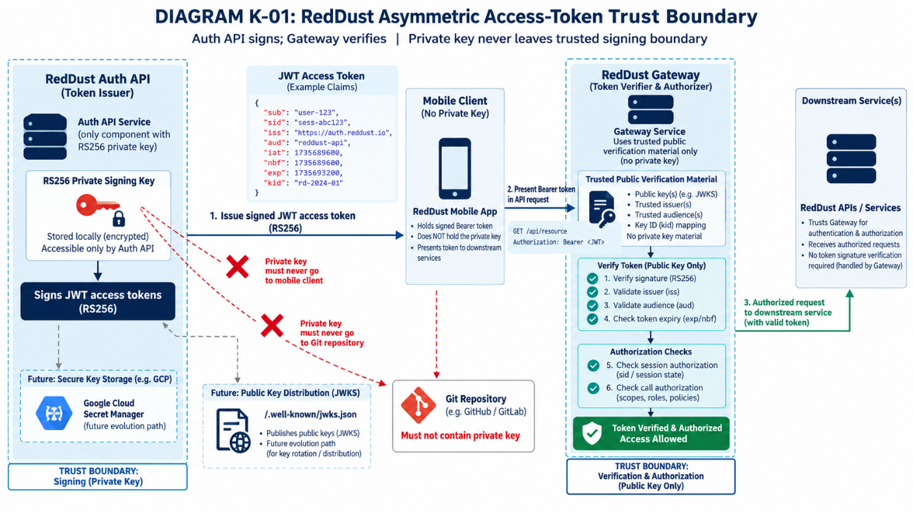
DIAGRAM K-02 — Refresh-Token Rotation and Replay Denial
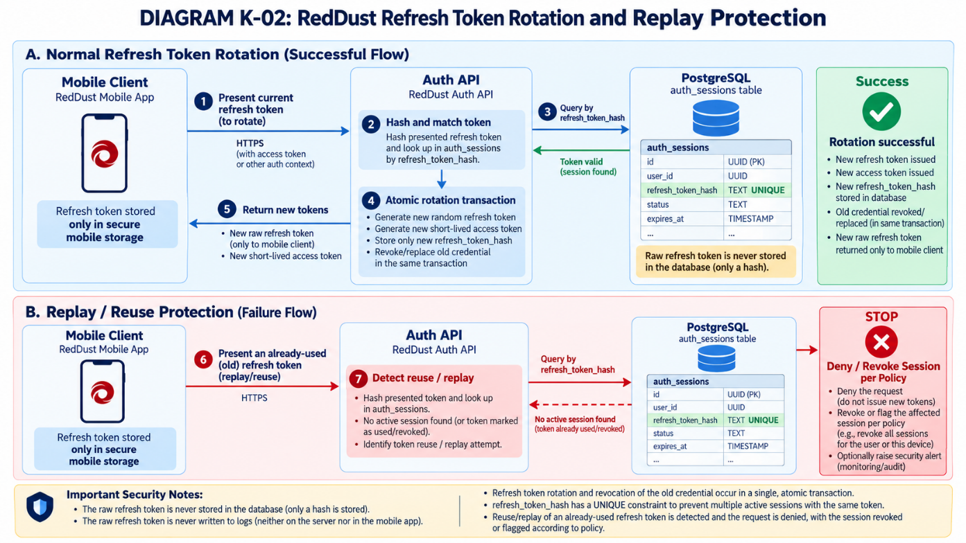

K.6 — Acceptance package
Preserve redacted evidence: key-files-excluded Git check, test names/results for signing and validation, issuer/audience validation evidence, refresh/logout/replay results, and approved rotation plan. Do not attach private keys, JWTs or raw refresh tokens.

Appendix L — Versioned FastAPI Contracts and Local Integration Verification
APPENDIX ROLE: Long-form expansion of 19C.7 and 19C.8. Distinguish the existing PostgreSQL/Alembic foundation (completed Appendix I) from routes that must still be coded and tested.

L.1 — Confirm files and responsibilities
Create these blank files and folders if they do not already exist. If they already exist as blank or non-blank files or folders, leave them as is.
Location | Responsibility | Evidence
app/main.py | FastAPI application object; router wiring | Import and /docs
app/routes/ | Auth, users, calls and health routes | OpenAPI endpoints
app/schemas.py or app/schemas/ | Typed request/response contracts | Validated 400/422 cases
app/security.py | Google verifier/JWT authorization helpers | Unit tests
app/db.py | SQLAlchemy session creation | Connectivity test
docs/API_CONTRACT.md | Human-readable endpoint agreement | Matches OpenAPI

L.2 — Minimal first route: health
The following stand-alone example is appropriate only if app/main.py has not already been implemented. If a working FastAPI app already exists, add the health route to it rather than replacing existing code.
WHERE: VS CODE FILE app/main.py
# app/main.py — minimal example only when starting from empty scaffold
from fastapi import FastAPI

app = FastAPI(title="RedDust Auth API", version="0.1.0")

@app.get("/healthz")
def healthz():
return {"status": "ok", "service": "reddust-auth-api"}
WHERE: VS CODE INTEGRATED POWERSHELL — TERMINAL 1
Set-Location "D:\RedDust\reddust-auth-api"
.\.venv\Scripts\Activate.ps1
python -m uvicorn app.main:app --reload --host 127.0.0.1 --port 8100
WHERE: VS CODE INTEGRATED POWERSHELL — TERMINAL 2
Invoke-RestMethod "http://127.0.0.1:8100/healthz"
Invoke-WebRequest "http://127.0.0.1:8100/openapi.json"
Expected: status “ok”, a safe service label, HTTP 200 and valid OpenAPI JSON. /healthz is process availability, not proof of a successful authenticated database action; add a separate controlled readiness check if later needed.

L.3 — Route-by-route implementation order
Order | Endpoint | Implementation dependency | Acceptance
1 | GET /healthz | Minimal FastAPI startup | 200 safe response
2 | POST /v1/auth/google | Appendix J verifier, DB transaction, Appendix K token issuance | 200 only for accepted Google token
3 | GET /v1/users/me | Bearer-JWT verification and active user lookup | 401 without token; 200 for own account
4 | POST /v1/auth/refresh | Stored token hash, rotation and revocation | Old/replayed token denied
5 | POST /v1/auth/logout | Authorized current session update | Session cannot refresh afterward
6 | POST /v1/calls | Active session; user and composite FK checks | Creates call only for current user
7 | POST /v1/calls/{id}/end | Owned-call check and idempotent end policy | Other-user call denied
8 | POST /offer — Gateway | Trusted JWT verification + call authorization | Unauthorized SDP exchange denied

L.4 — Specify each request and response
What this section does and why it matters: Establish a single, versioned API contract between the RedDust mobile application, Authentication API and WebRTC Gateway. The file docs/API_CONTRACT.md documents exactly what each endpoint accepts, returns and requires for secure operation. FastAPI implementation and Swagger documentation must subsequently conform to this contract.

L.4.1. Create and review the API contract document
Create the docs folder if it does not exist. Create or open API_CONTRACT.md and paste the complete supplied contract below, preserving any previously approved content that still applies. The file covers all seven Auth API endpoints and the separate WebRTC Gateway endpoint. It defines field types, validation rules, expected HTTP errors, ownership restrictions, security protections and sample JSON request/response bodies. It specifies the following:
Endpoint | Request | Successful response
GET /healthz | No body | 200 — Process status
POST /v1/auth/google | Google ID token, installation UUID, platform | 200 — User, auth session, JWT and refresh token
POST /v1/auth/refresh | Current refresh token | 200 — Rotated refresh token and new JWT
POST /v1/auth/logout | Bearer JWT | 204 — Session revoked; no body
GET /v1/users/me | Bearer JWT | 200 — Current user and preferences
POST /v1/calls | Bearer JWT, empty JSON body | 201 — New call session
POST /v1/calls/{id}/end | Bearer JWT, optional end reason | 200 — Ended call details
Gateway POST /offer | Bearer JWT, call UUID, SDP offer | 200 — Authorized SDP answer
Connection to the file: Sections 1–9 define the eight endpoints, including HTTP methods, paths, request/response JSON, field types, status codes and authentication requirements. Review the proposed values, especially token lifetimes, before treating them as approved.
WHERE: VS Code Explorer → D:\RedDust\reddust-auth-api\docs\API_CONTRACT.md
# RedDust API Contract — Version 0.1.0 (Local Development)

**Document:** `D:\RedDust\reddust-auth-api\docs\API_CONTRACT.md`
**Source:** RedDust Step 19C.7 and Appendix L.4; depends on Appendices I (database), J (Google identity), K (tokens), and M (security tests).
**Status:** **PROPOSED IMPLEMENTATION CONTRACT — NOT PROOF THAT ROUTES EXIST OR PASS TESTS.** Approve decisions below before coding; revise this file and OpenAPI together if implementation requirements change.

## 1. Service boundaries, conventions and security

| Service | Local base URL | Owns | Does **not** own |
|---|---|---|---|
| RedDust Auth API | `http://127.0.0.1:8100` | Seven routes below, Google verification, user/session/call records | WebRTC SDP negotiation |
| RedDust WebRTC Gateway | `http://127.0.0.1:8000` | `POST /offer`, authorized WebRTC signalling/media | Google login, issuing refresh tokens |
| PostgreSQL 18.6 | Server-side only (`127.0.0.1:5432` locally) | Seven Appendix I application tables | Direct access from the phone |

- **API prefix:** `/v1` for application routes; `/healthz` is intentionally unversioned; existing Gateway `/offer` remains unversioned at this stage.
- **Content type:** JSON requests/responses use `Content-Type: application/json`; token-authenticated requests use `Authorization: Bearer <REDDUST_ACCESS_JWT>`. `GET /healthz` has no body.
- **All UUIDs** in JSON/path are canonical UUID strings. Timestamps are UTC RFC 3339 strings (e.g. `2026-10-28T00:00:00Z`). An absent optional object is `null`, not an omitted field, where explicitly shown.
- **Mobile installation ID:** randomly generated, persistently stored app-installation UUID (not a hardware identifier); platform is exactly `android` or `ios`.
- **Do not put** `user_id`, `auth_session_id`, `device_id`, `refresh_token_hash`, database credentials or signing keys in client-supplied identity/authorization fields. Account and session ownership come from verified credentials and server-side database lookups.
- **Production and real-token traffic must use HTTPS.** Loopback HTTP is for local development, with synthetic/test credentials wherever possible. Never transmit real Google/refresh tokens over an unencrypted LAN.
- **Local proposed token policy (to confirm in Appendix K):** RS256 JWT access TTL **900 seconds**, refresh TTL **2,592,000 seconds (30 days)**, JWT issuer `reddust-auth-api`, JWT audiences `reddust-auth-api` and `reddust-gateway`, `kid` identifies the active signing key. Set actual issuer/audiences/TTL in trusted server configuration, not from client input. A service validates its **own** expected audience.
- **Access JWT required claims:** `iss`, `aud`, `sub` (RedDust `app_users.id`), `sid` (`auth_sessions.id`), `iat`, `nbf`, `exp`; signed header contains `alg: RS256` and configured `kid`. Verify signature, algorithm allowlist, issuer, intended audience, time claims, account status and active session; **Google ID tokens are never Gateway bearer tokens**.
- **Refresh token:** cryptographically random opaque secret; return in successful login/refresh response body once; client holds it in secure device storage; `auth_sessions.refresh_token_hash` stores only its derived hash. Never return or log this hash.
- **Security/audit:** no full ID tokens, access JWTs, refresh tokens, SDP, private keys or DB passwords in logs, URLs, error responses or `audit_events.metadata_json`. Audit metadata is short and allowlisted as in Appendix I.
- **Route errors:** documented application errors use `{"detail":{"code":"MACHINE_CODE","message":"Safe public explanation"}}`; standard FastAPI/Pydantic 422 uses `{"detail":[{"loc":["body","field"],"msg":"...","type":"..."}]}` (exact validator message/type may vary). FastAPI's default missing-auth or exception handling may **not** match this proposed error format until explicitly configured. Never send raw database exceptions.
- **Status codes:** 401 = invalid/missing credential (include `WWW-Authenticate: Bearer` for bearer-protected routes); 403 = valid identity/session but forbidden; 404 = missing **or non-owned** call, without revealing ownership; 409 = conflicting state; 422 = request validation failure; 429 = rate limit; 503 = unavailable dependency. Return only codes actually implemented and tested.
- **No automatic completeness:** `/docs` and `/openapi.json` describe **implemented** FastAPI routes. This Markdown records the **target** contract. A route appearing only here is **not implemented**.

### Contract-wide authentication rules

| Route | Google ID token in body? | RedDust Bearer JWT? | Refresh token in body? |
|---|---|---|---|
| `GET /healthz` | No | No | No |
| `POST /v1/auth/google` | **Yes** | No | No |
| `POST /v1/auth/refresh` | No | No (access JWT may be expired) | **Yes** |
| `POST /v1/auth/logout` | No | **Yes** | No |
| `GET /v1/users/me` | No | **Yes** | No |
| `POST /v1/calls` | No | **Yes** | No |
| `POST /v1/calls/{id}/end` | No | **Yes** | No |
| Gateway `POST /offer` | No | **Yes** | No |

## 2. `GET /healthz` — Auth API process health

**Request:** No body, no authentication, no query parameters.
**Success:** `200 OK`, JSON:

```json
{"status":"ok","service":"reddust-auth-api"}
```

**Errors:** `503` if the application deliberately reports itself unavailable; a refused connection is **not** an HTTP response. Do not include database credentials, customer information or detailed infrastructure. **This is a liveness check, not proof that PostgreSQL or authentication works.**

## 3. `POST /v1/auth/google` — Verify Google and open RedDust session

**Authentication:** No RedDust Bearer JWT; Google ID token must be verified on the server with Appendix J.3 approved audience(s), issuer, signature and expiry. Identity mapping uses `(provider='google', provider_subject=verified_sub)`; never email-only linking. The J.4/J.5 transaction links the user/device atomically. The Appendix K service issues independent RedDust credentials.

**Request:** JSON object with **exactly** these required fields (reject extra fields):

| Field | Type | Rule |
|---|---|---|
| `id_token` | string | Nonempty Google ID token; maximum length 16,384 characters; secret, never log |
| `installation_id` | UUID string | Required persistent app-installation UUID; not a device hardware ID |
| `platform` | enum string | `android` or `ios` |

```json
{
"id_token":"<GOOGLE_ID_TOKEN_FROM_GOOGLE_SIGN_IN>",
"installation_id":"70e91b9b-a66a-4c5b-a7ec-14515b0a9028",
"platform":"android"
}
```

**Success:** `200 OK` for **both first-time and returning** users; `Cache-Control: no-store`:

```json
{
"user": {
"id": "0ba779fd-74d9-4d39-92e7-03229b6aa8ba",
"display_name": "Example User"
},
"auth_session_id": "78675bb4-97a6-45d2-a66f-7019bf073237",
"token_type": "Bearer",
"access_token": "<REDDUST_RS256_ACCESS_JWT>",
"expires_in": 900,
"refresh_token": "<NEW_OPAQUE_RANDOM_REFRESH_TOKEN>",
"refresh_expires_in": 2592000
}
```

`display_name` may be `null`. `expires_in`/`refresh_expires_in` are seconds, based on issued token/session expiration. Only the hashed refresh credential goes to PostgreSQL; never return `refresh_token_hash`, Google subject or Google raw claims.

| HTTP | Code | When |
|---|---|---|
| 200 | — | Google proof verified, account/device authorized, transaction committed, tokens issued |
| 401 | `INVALID_GOOGLE_TOKEN` | Missing, invalid, expired or wrong-audience Google token (missing body field may be 422) |
| 403 | `ACCOUNT_OR_DEVICE_NOT_ALLOWED` | Disabled account, revoked device or disallowed existing installation |
| 422 | `VALIDATION_ERROR` | Malformed JSON, invalid UUID/platform, missing fields, extra fields |
| 429 | `RATE_LIMITED` | Authentication request rate limit exceeded (once configured) |
| 503 | `AUTH_UNAVAILABLE` | Token-signing or database dependency unavailable |

**Do not mark implemented** until real route code performs all verification, account linking, token creation and failure handling. `app/services/identity.py` by itself does not provide this HTTP endpoint.

## 4. `POST /v1/auth/refresh` — Rotate one refresh credential

**Authentication:** No access JWT required; the submitted **opaque refresh secret** is the credential. Compare its secure hash against a single unrevoked, unexpired `auth_sessions` row; verify account/device status. Rotate **atomically** so two simultaneous requests cannot both consume the same current token.

**Request:** JSON object with exactly one required field:

```json
{"refresh_token":"<CURRENT_OPAQUE_REFRESH_TOKEN>"}
```

`refresh_token`: nonempty string, maximum 512 characters; not in URL/query or logs.

**Success:** `200 OK`, `Cache-Control: no-store`; same underlying auth session, **new** access token and **new** opaque refresh token:

```json
{
"auth_session_id": "78675bb4-97a6-45d2-a66f-7019bf073237",
"token_type": "Bearer",
"access_token": "<NEW_REDDUST_RS256_ACCESS_JWT>",
"expires_in": 900,
"refresh_token": "<NEW_OPAQUE_RANDOM_REFRESH_TOKEN>",
"refresh_expires_in": 2592000
}
```

The old refresh token must immediately stop working after successful rotation. Implement a guarded database update conditioned on the **previous hash and active-session status**; if zero rows update, reject safely.

| HTTP | Code | When |
|---|---|---|
| 200 | — | Current refresh credential consumed exactly once; updated hash committed |
| 401 | `INVALID_REFRESH_TOKEN` | Unknown, expired, revoked, already rotated, or otherwise invalid refresh token |
| 403 | `ACCOUNT_OR_DEVICE_NOT_ALLOWED` | Linked account or installation is disabled/revoked |
| 422 | `VALIDATION_ERROR` | Invalid/missing JSON fields |
| 429 | `RATE_LIMITED` | Rate limit exceeded (once configured) |
| 503 | `AUTH_UNAVAILABLE` | Database/signing unavailable |

**Replay limitation of existing Appendix I schema:** a table retaining **only the current** `refresh_token_hash` can reject an old token, but it cannot reliably *classify* that rejected token as a replay of this particular session after rotation. Implement explicit reuse detection/session-family revocation only after adopting a separately approved token-history/family design; do **not** claim it exists now.

## 5. `POST /v1/auth/logout` — Revoke current RedDust auth session

**Authentication:** RedDust access Bearer JWT required; `sid` and `sub` are verified server-side and must agree with `auth_sessions` ownership. No client-supplied session/user identifiers.

**Request:** Empty JSON object `{}` (or an empty body if explicitly supported by implementation); no other fields.

**Success:** `204 No Content`, empty response body. Server sets `auth_sessions.revoked_at` for the JWT's current active session; future refresh requests fail. If online session-status verification is enforced for every protected request, the revoked JWT also stops authorizing them despite its remaining cryptographic validity.

| HTTP | Code | When |
|---|---|---|
| 204 | — | Current session revoked |
| 401 | `INVALID_ACCESS_TOKEN` | JWT missing/invalid/expired or session already revoked |
| 403 | `ACCOUNT_NOT_ALLOWED` | Verified account is disabled |
| 422 | `VALIDATION_ERROR` | Unexpected request fields or malformed JSON |
| 503 | `AUTH_UNAVAILABLE` | Revocation transaction fails |

## 6. `GET /v1/users/me` — Current account and preferences

**Authentication:** Valid RedDust Bearer JWT, expected audience, active `auth_sessions` row and active `app_users` row; derive account ID from verified `sub`, not request input.

**Request:** No body, no query parameters, no `user_id` parameter.

**Success:** `200 OK`:

```json
{
"user": {
"id": "0ba779fd-74d9-4d39-92e7-03229b6aa8ba",
"display_name": "Example User"
},
"preferences": {
"preferred_persona": null,
"speaker_default": null
}
}
```

`preferences` is `null` if no `user_preferences` row exists; when present, each value can be a string or `null`. Never return Google tokens, refresh hashes or other users' data.

| HTTP | Code | When |
|---|---|---|
| 200 | — | Active caller receives own profile |
| 401 | `INVALID_ACCESS_TOKEN` | Missing, invalid or expired JWT, or revoked/expired auth session |
| 403 | `ACCOUNT_NOT_ALLOWED` | Disabled/deleted account |
| 503 | `AUTH_UNAVAILABLE` | Account/session lookup cannot be completed |

## 7. `POST /v1/calls` — Create call for current authorized user

**Authentication:** Valid RedDust Bearer JWT and active, owned auth session; derive `user_id` and `auth_session_id` from trusted JWT + database, never from a request field.

**Request:** Empty JSON object `{}`; reject extra fields such as `user_id`, `auth_session_id`, or `device_id`.

```json
{}
```

**Success:** `201 Created`, response:

```json
{
"id": "821b0eb5-37be-4e54-8058-075f9e8a9ce1",
"status": "starting",
"started_at": "2026-10-28T00:00:00Z",
"ended_at": null,
"end_reason": null
}
```

Create `call_sessions` referencing the authenticated user and auth session; rely on Appendix I's `fk_call_auth_same_user` as an additional database safeguard. Client must use the returned call `id` in Gateway `POST /offer`.

| HTTP | Code | When |
|---|---|---|
| 201 | — | Call row created for authenticated caller |
| 401 | `INVALID_ACCESS_TOKEN` | Missing, invalid JWT or inactive session |
| 403 | `ACCOUNT_NOT_ALLOWED` | Caller cannot create calls |
| 422 | `VALIDATION_ERROR` | Body contains prohibited fields |
| 503 | `CALL_SERVICE_UNAVAILABLE` | Database unavailable |

## 8. `POST /v1/calls/{id}/end` — End an owned call

**Authentication:** RedDust Bearer JWT required. `{id}` is a **call UUID**, not a user ID. Use authenticated `sub` and DB ownership to select the call. For a nonexistent **or other-user-owned** call, return the same `404` to avoid revealing another user's records.

**Request path:** `/v1/calls/821b0eb5-37be-4e54-8058-075f9e8a9ce1/end`
**Request body:** Optional `reason`, one of `user_hangup`, `completed`, `connection_lost`, `error`; defaults to `user_hangup` if omitted. No additional keys.

```json
{"reason":"user_hangup"}
```

**Success:** `200 OK`:

```json
{
"id": "821b0eb5-37be-4e54-8058-075f9e8a9ce1",
"status": "ended",
"started_at": "2026-10-28T00:00:00Z",
"ended_at": "2026-10-28T00:04:10Z",
"end_reason": "user_hangup"
}
```

**Idempotency decision:** A repeat request by the **same owner** to end an already-ended call returns `200` with the **existing** persisted end time/reason, without overwriting them. Never mutate an unowned call.

| HTTP | Code | When |
|---|---|---|
| 200 | — | Owned call transitioned to ended, or was already ended |
| 401 | `INVALID_ACCESS_TOKEN` | Missing, invalid JWT or inactive session |
| 403 | `ACCOUNT_NOT_ALLOWED` | Authenticated account is not permitted |
| 404 | `CALL_NOT_FOUND` | UUID not found **or** call belongs to someone else |
| 422 | `VALIDATION_ERROR` | Invalid UUID, unsupported reason, extra body field |
| 503 | `CALL_SERVICE_UNAVAILABLE` | Database unavailable |

## 9. Gateway-only: `POST /offer` — Authorized WebRTC SDP exchange

**Different process:** This is hosted by the **WebRTC Gateway on port 8000**, not in `reddust-auth-api` on port 8100. This is the **target secured contract**; the existing echo Gateway may currently implement only `{sdp, type}` and must be explicitly updated before it is marked compliant.

**Authentication:** `Authorization: Bearer <REDDUST_ACCESS_JWT>`; Gateway verifies RedDust public-key signature/`kid`, issuer, **Gateway audience**, expiry and active session. It must also verify that `call_id` is an eligible active call owned by the authenticated `sub` using a trustworthy server-side authorization path. **Never accept caller-provided `user_id` as evidence**; never treat a Google ID token as a Gateway access token.

**Request:**

```json
{
"call_id": "821b0eb5-37be-4e54-8058-075f9e8a9ce1",
"type": "offer",
"sdp": "<VALID_WEBRTC_SDP_OFFER>"
}
```

- `call_id`: required UUID from `POST /v1/calls`.
- `type`: exactly `offer`.
- `sdp`: nonempty SDP string; apply a documented upper bound (proposed maximum **131,072 UTF-8 bytes**) and validation appropriate to WebRTC signalling. SDP may contain private network information: do not log raw SDP.

**Success:** `200 OK`:

```json
{
"call_id": "821b0eb5-37be-4e54-8058-075f9e8a9ce1",
"type": "answer",
"sdp": "<VALID_WEBRTC_SDP_ANSWER>"
}
```

| HTTP | Code | When |
|---|---|---|
| 200 | — | Authorized caller and eligible call; valid SDP answer generated |
| 401 | `INVALID_ACCESS_TOKEN` | Missing/invalid RedDust Bearer JWT or revoked session |
| 403 | `CALL_NOT_ALLOWED` | Caller lacks authorization to negotiate this call |
| 404 | `CALL_NOT_FOUND` | Unknown or non-owned call where ownership is concealed |
| 409 | `CALL_NOT_ACTIVE` | Owned call is already ended/not eligible for offer |
| 422 | `VALIDATION_ERROR` | Malformed payload/SDP, missing or invalid call UUID |
| 503 | `GATEWAY_UNAVAILABLE` | Negotiation or trusted authorization service unavailable |

The Gateway must **fail closed** if it cannot verify call ownership or current session status; a valid JWT signature alone does not establish that an arbitrary `call_id` is allowed.

## 10. OpenAPI / Swagger and acceptance checklist

**Compare the running services to this target contract; do not mark boxes complete on documentation alone.**

- [ ] Auth API process starts: `python -m uvicorn app.main:app --reload --host 127.0.0.1 --port 8100`.
- [ ] `GET http://127.0.0.1:8100/healthz` responds `200` and **exactly** the safe process-status payload.
- [ ] `http://127.0.0.1:8100/docs` and `/openapi.json` show **only real registered routes**; each matches its documented method, path, schema, Bearer protection and responses.
- [ ] All seven Auth API routes are implemented and exercised against approved local development/test data. **No unimplemented route is described as passing.**
- [ ] Protected routes deny missing/bad/expired Bearer JWTs with `401` (a missing route's `404` does **not** count as proof of authorization).
- [ ] Google ID tokens are verified against approved audiences and mapped by Google `sub`; unique collisions recover without extra users; disabled/revoked identities are denied.
- [ ] Refresh credential is hash-only in DB; rotation is atomic; old token fails; token replay classification is **not** claimed without a history/family design.
- [ ] Logout revokes session; `/users/me` and call actions obtain user identity from JWT + active database session, not from client-supplied `user_id`.
- [ ] Owner can create/end their call; different user cannot access/end it; FK ownership constraints hold.
- [ ] WebRTC Gateway (port 8000) actually implements Bearer and call ownership checks before accepting SDP; Gateway verification is tested separately from Auth API `/docs`.
- [ ] Pydantic **422** shape, error codes, `Cache-Control: no-store` on token responses, status codes and timestamp serialization match this file.
- [ ] Logs/audit/Swagger screenshots are redacted; **no raw credentials or SDP** stored in evidence.
- [ ] Hand over sanitized `GET /healthz` `200`, missing-Bearer `401`, successful login, refresh/logout, owned/unowned calls, Swagger inventory and Gateway evidence to Appendix M.

**Integration boundary:** The React Native phone calls API/Gateway HTTP(S) services; it never talks to PostgreSQL directly. Loopback URLs in this document work only on the Windows development laptop, not from a physical phone.

L.4.2 — Implement Pydantic Request and Response Schemas
WHAT THIS SECTION DOES AND WHY IT MATTERS: Translate the approved docs/API_CONTRACT.md into importable Pydantic v2 models before building FastAPI routes. These models enforce field shape and document the eventual HTTP interfaces; they do not sign tokens, authenticate users or touch PostgreSQL.
WHERE: VS Code project D:\RedDust\reddust-auth-api. Use the existing Python 3.12.10 virtual environment.
BOUNDARY: The seven Auth API routes belong to reddust-auth-api (port 8100); Gateway POST /offer belongs to the separate WebRTC Gateway (port 8000). This step creates models only, not endpoints.

L.4.2.1 — Understand the models and their API mapping
Pydantic is the gatekeeper for JSON shape. For example, GoogleLoginRequest accepts an ID token string, a canonical installation UUID and an android/ios platform; it rejects unexpected user_id fields. FastAPI later uses these models to produce request validation (normally 422) and OpenAPI schemas.
HTTP interface | Request model | Success response model
GET /healthz | No body | HealthResponse
POST /v1/auth/google | GoogleLoginRequest | GoogleLoginResponse
POST /v1/auth/refresh | RefreshRequest | RefreshResponse
POST /v1/auth/logout | LogoutRequest ({} if body supplied) | None — HTTP 204
GET /v1/users/me | No body | MeResponse
POST /v1/calls | CreateCallRequest ({}) | CallSessionResponse
POST /v1/calls/{id}/end | EndCallRequest | CallSessionResponse
Gateway POST /offer | GatewayOfferRequest | GatewayOfferResponse
SECURITY REMINDER: Schema validation is not authorization. The bearer JWT, server-owned session, user ownership, refresh rotation and Google cryptographic verification belong to Appendices J/K and the later route/service implementation.

L.4.2.2 — Prepare exactly these files
In VS Code Explorer, inspect existing app/schemas.py and app/schemas/ before creating anything. If an existing nonblank implementation is present, merge deliberately; do not overwrite it or leave two conflicting modules.
TARGET STRUCTURE — relative to D:\RedDust\reddust-auth-api
app/
__init__.py
db.py
models.py
security.py
schemas/
__init__.py
contracts.py
services/
identity.py
docs/
API_CONTRACT.md
tests/
test_api_schemas.py
Create app/schemas/ as a folder, create contracts.py and __init__.py inside it, and create tests/test_api_schemas.py in the existing tests folder. Save each using Ctrl+S.

L.4.2.3 — Implement app/schemas/contracts.py
This is the complete Pydantic v2 schema module. It rejects unexpected fields, enforces canonical UUIDs and timezone-aware timestamps, and validates token presence/length and documents mobile and Gateway JSON shapes.
COMPLETE FILE — app/schemas/contracts.py (paste without line numbers)
"""RedDust Step 19C.7 / Appendix L.4 — Pydantic v2 HTTP contracts.

Schema only: no FastAPI routes, authentication, database access or token issuance.
The Gateway models describe its separate /offer service (port 8000).
"""

from datetime import datetime, timezone
from typing import Annotated, Literal
from uuid import UUID

from pydantic import (
AfterValidator,
BaseModel,
BeforeValidator,
ConfigDict,
Field,
field_validator,
)

class ContractModel(BaseModel):
"""Reject fields that do not belong to a documented JSON object."""

model_config = ConfigDict(extra="forbid")

def _canonical_uuid(value: object) -> object:
"""Accept canonical UUID strings on the wire and UUIDs inside Python."""
if isinstance(value, str):
try:
parsed = UUID(value)
except (ValueError, AttributeError) as exc:
raise ValueError("Expected a valid canonical UUID") from exc
if value != str(parsed):
raise ValueError("UUID must use canonical lowercase hyphenated format")
return value

def _utc_datetime(value: datetime) -> datetime:
"""Require a timezone-aware timestamp; normalize it to UTC."""
if value.tzinfo is None or value.utcoffset() is None:
raise ValueError("Timestamp must contain a timezone")
return value.astimezone(timezone.utc)

CanonicalUUID = Annotated[UUID, BeforeValidator(_canonical_uuid)]
UtcDateTime = Annotated[datetime, AfterValidator(_utc_datetime)]

def _nonblank_token(value: str) -> str:
if not value or any(char.isspace() for char in value):
raise ValueError("Credential must be nonempty and contain no whitespace")
return value

class HealthResponse(ContractModel):
status: Literal["ok"] = "ok"
service: Literal["reddust-auth-api"] = "reddust-auth-api"

class UserSummary(ContractModel):
id: CanonicalUUID
display_name: str | None

class GoogleLoginRequest(ContractModel):
id_token: str = Field(min_length=1, max_length=16384, repr=False)
installation_id: CanonicalUUID
platform: Literal["android", "ios"]

_validate_id_token = field_validator("id_token")(_nonblank_token)

class GoogleLoginResponse(ContractModel):
user: UserSummary
auth_session_id: CanonicalUUID
token_type: Literal["Bearer"]
access_token: str = Field(min_length=1, max_length=16384, repr=False)
expires_in: int = Field(gt=0)
refresh_token: str = Field(min_length=1, max_length=512, repr=False)
refresh_expires_in: int = Field(gt=0)

class RefreshRequest(ContractModel):
refresh_token: str = Field(min_length=1, max_length=512, repr=False)

_validate_refresh_token = field_validator("refresh_token")(_nonblank_token)

class RefreshResponse(ContractModel):
auth_session_id: CanonicalUUID
token_type: Literal["Bearer"]
access_token: str = Field(min_length=1, max_length=16384, repr=False)
expires_in: int = Field(gt=0)
refresh_token: str = Field(min_length=1, max_length=512, repr=False)
refresh_expires_in: int = Field(gt=0)

class LogoutRequest(ContractModel):
"""If a body is supplied, it must be exactly {}. 204 has no response model."""

class UserPreferences(ContractModel):
preferred_persona: str | None
speaker_default: str | None

class MeResponse(ContractModel):
user: UserSummary
preferences: UserPreferences | None

class CreateCallRequest(ContractModel):
"""Client supplies {}, never user_id or auth_session_id."""

class CallSessionResponse(ContractModel):
id: CanonicalUUID
status: str = Field(min_length=1)
started_at: UtcDateTime
ended_at: UtcDateTime | None
end_reason: str | None

class EndCallRequest(ContractModel):
reason: Literal[
"user_hangup", "completed", "connection_lost", "error"
] = "user_hangup"

class ErrorDetail(ContractModel):
code: str = Field(min_length=1)
message: str = Field(min_length=1)

class ErrorResponse(ContractModel):
detail: ErrorDetail

def _validate_sdp(value: str) -> str:
if not value.strip():
raise ValueError("SDP must not be empty")
if len(value.encode("utf-8")) > 131072:
raise ValueError("SDP exceeds 131072 UTF-8 bytes")
return value

class GatewayOfferRequest(ContractModel):
"""Target contract for separate Gateway service; not an Auth API route."""

call_id: CanonicalUUID
type: Literal["offer"]
sdp: str = Field(min_length=1, repr=False)

_check_sdp = field_validator("sdp")(_validate_sdp)

class GatewayOfferResponse(ContractModel):
call_id: CanonicalUUID
type: Literal["answer"]
sdp: str = Field(min_length=1, repr=False)

_check_sdp = field_validator("sdp")(_validate_sdp)
Design notes: ConfigDict(extra="forbid") rejects undocumented fields; Literal limits platform and call-end values; UtcDateTime normalizes timestamp data; repr=False reduces accidental repr exposure but does not replace secret-safe logging and validation-error handling. The SDP validator imposes basic length/nonblank limits, not comprehensive WebRTC SDP parsing.

L.4.2.4 — Expose public imports in app/schemas/__init__.py
The package initializer exposes names such as from app.schemas import GoogleLoginRequest and keeps route imports consistent as the codebase grows.
COMPLETE FILE — app/schemas/__init__.py
"""Public Pydantic contracts for the RedDust Auth API and separate Gateway."""

from .contracts import (
CallSessionResponse,
CreateCallRequest,
EndCallRequest,
ErrorDetail,
ErrorResponse,
GatewayOfferRequest,
GatewayOfferResponse,
GoogleLoginRequest,
GoogleLoginResponse,
HealthResponse,
LogoutRequest,
MeResponse,
RefreshRequest,
RefreshResponse,
UserPreferences,
UserSummary,
)

__all__ = [
"CallSessionResponse", "CreateCallRequest", "EndCallRequest",
"ErrorDetail", "ErrorResponse", "GatewayOfferRequest",
"GatewayOfferResponse", "GoogleLoginRequest", "GoogleLoginResponse",
"HealthResponse", "LogoutRequest", "MeResponse", "RefreshRequest",
"RefreshResponse", "UserPreferences", "UserSummary",
]

L.4.2.5 — Check the required dependencies
WHERE: VS Code → Terminal → New Terminal → PowerShell: Activate the existing project virtual environment. Do not install packages globally or alter Appendix I database settings.
RUN — existing virtual environment
Set-Location "D:\RedDust\reddust-auth-api"
.\.venv\Scripts\Activate.ps1
python --version
python -m pip show pydantic fastapi pytest
python -m pip check
Requirement: Pydantic v2 (not v1). If pydantic or pytest is missing, install only what is needed using the command below; otherwise skip installation.
ONLY IF REQUIRED
python -m pip install "pydantic>=2,<3" pytest
python -m pip check
EXPECTED: python -m pip check reports “No broken requirements found.” Correct version/conflict errors before continuing.

L.4.2.6 — Compile and import the schemas
RUN — integrated PowerShell, from project root
Set-Location "D:\RedDust\reddust-auth-api"
python -m compileall -q app\schemas
python -c "
from app.schemas import (
GoogleLoginRequest,
GoogleLoginResponse,
RefreshRequest,
RefreshResponse,
CallSessionResponse,
GatewayOfferRequest,
)
print('SUCCESS: RedDust Pydantic schemas import correctly')
"
EXPECTED: compileall emits no errors and the import command prints “SUCCESS: RedDust Pydantic schemas import correctly”. Import success does not prove validation behaviour.

L.4.2.7 — Create tests/test_api_schemas.py and run all schema tests
These are the complete 22 collected schema tests. All credentials, timestamps and UUIDs are synthetic. No test in this file connects to PostgreSQL, opens a network socket, alters reddust_dev or alters reddust_test.
COMPLETE FILE — tests/test_api_schemas.py
"""Appendix L.4 schema-only checks: no database, network or real credentials."""

from datetime import datetime, timezone
from uuid import UUID

import pytest
from pydantic import ValidationError

from app.schemas import (
CallSessionResponse, CreateCallRequest, EndCallRequest,
GatewayOfferRequest, GatewayOfferResponse, GoogleLoginRequest,
GoogleLoginResponse, HealthResponse, LogoutRequest, MeResponse,
RefreshRequest, RefreshResponse,
)

USER_ID = "0ba779fd-74d9-4d39-92e7-03229b6aa8ba"
SESSION_ID = "78675bb4-97a6-45d2-a66f-7019bf073237"
CALL_ID = "821b0eb5-37be-4e54-8058-075f9e8a9ce1"
INSTALL_ID = "70e91b9b-a66a-4c5b-a7ec-14515b0a9028"

def login_request(**changes):
payload = {
"id_token": "synthetic.jwt.value",
"installation_id": INSTALL_ID,
"platform": "android",
}
payload.update(changes)
return payload

def login_response():
return {
"user": {"id": USER_ID, "display_name": "Test User"},
"auth_session_id": SESSION_ID,
"token_type": "Bearer",
"access_token": "synthetic.access.jwt",
"expires_in": 900,
"refresh_token": "synthetic-random-refresh",
"refresh_expires_in": 2592000,
}

def test_health_schema_exact():
assert HealthResponse().model_dump() == {
"status": "ok", "service": "reddust-auth-api"
}
with pytest.raises(ValidationError):
HealthResponse.model_validate({"status": "ok", "secret": "oops"})

def test_google_request_valid():
result = GoogleLoginRequest.model_validate(login_request())
assert result.installation_id == UUID(INSTALL_ID)
assert result.platform == "android"
assert result.model_dump(mode="json")["installation_id"] == INSTALL_ID

@pytest.mark.parametrize("changes", [
{"platform": "windows"},
{"installation_id": "not-a-uuid"},
{"installation_id": INSTALL_ID.replace("-", "")},
{"installation_id": INSTALL_ID.upper()},
{"id_token": ""},
{"id_token": " "},
{"id_token": "abc def"},
{"id_token": "x" * 16385},
{"user_id": USER_ID},
])
def test_google_request_rejects_bad_fields(changes):
with pytest.raises(ValidationError):
GoogleLoginRequest.model_validate(login_request(**changes))

def test_google_request_rejects_missing_fields():
for field in ("id_token", "installation_id", "platform"):
payload = login_request()
del payload[field]
with pytest.raises(ValidationError):
GoogleLoginRequest.model_validate(payload)

def test_login_response_contains_exact_safe_fields():
result = GoogleLoginResponse.model_validate(login_response())
output = result.model_dump(mode="json")
assert output == login_response()
assert "refresh_token_hash" not in output
assert "id_token" not in output
assert "synthetic.access.jwt" not in repr(result)
assert "synthetic-random-refresh" not in repr(result)

def test_login_response_requires_token_fields():
for field in ("access_token", "refresh_token", "expires_in"):
bad = login_response()
bad.pop(field)
with pytest.raises(ValidationError):
GoogleLoginResponse.model_validate(bad)

def test_refresh_contract_and_rejects_extra_fields():
assert RefreshRequest.model_validate({"refresh_token": "synthetic"}).refresh_token == "synthetic"
with pytest.raises(ValidationError):
RefreshRequest.model_validate({"refresh_token": "synthetic", "user_id": USER_ID})
with pytest.raises(ValidationError):
RefreshRequest.model_validate({"refresh_token": "synthetic\n"})
body = login_response()
del body["user"]
assert RefreshResponse.model_validate(body).auth_session_id == UUID(SESSION_ID)

def test_empty_logout_and_create_call_reject_untrusted_identifiers():
assert LogoutRequest.model_validate({}).model_dump() == {}
assert CreateCallRequest.model_validate({}).model_dump() == {}
for cls in (LogoutRequest, CreateCallRequest):
with pytest.raises(ValidationError):
cls.model_validate({"user_id": USER_ID})

def test_me_response_requires_preferences_key_but_accepts_null():
p = {"user": {"id": USER_ID, "display_name": None}, "preferences": None}
assert MeResponse.model_validate(p).model_dump(mode="json") == p
p["preferences"] = {"preferred_persona": None, "speaker_default": "neutral"}
assert MeResponse.model_validate(p).preferences.speaker_default == "neutral"
del p["preferences"]
with pytest.raises(ValidationError):
MeResponse.model_validate(p)

def test_call_response_serializes_utc_timestamps_and_null_fields():
item = CallSessionResponse.model_validate({
"id": CALL_ID, "status": "starting",
"started_at": "2026-10-28T11:00:00+11:00",
"ended_at": None, "end_reason": None,
})
body = item.model_dump(mode="json")
assert body["started_at"] == "2026-10-28T00:00:00Z"
assert body["ended_at"] is None
assert body["end_reason"] is None

def test_naive_call_timestamp_rejected():
with pytest.raises(ValidationError):
CallSessionResponse.model_validate({
"id": CALL_ID, "status": "starting",
"started_at": datetime(2026, 10, 28),
"ended_at": None, "end_reason": None,
})

def test_end_call_reason_defaults_and_validates():
assert EndCallRequest.model_validate({}).reason == "user_hangup"
assert EndCallRequest.model_validate({"reason": "completed"}).reason == "completed"
with pytest.raises(ValidationError):
EndCallRequest.model_validate({"reason": "made_up_reason"})
with pytest.raises(ValidationError):
EndCallRequest.model_validate({"reason": "completed", "user_id": USER_ID})

def test_gateway_offer_contract_and_utf8_byte_bound():
request = {"call_id": CALL_ID, "type": "offer", "sdp": "v=0\r\n"}
assert GatewayOfferRequest.model_validate(request).type == "offer"
assert GatewayOfferResponse.model_validate({**request, "type": "answer"}).type == "answer"
with pytest.raises(ValidationError):
GatewayOfferRequest.model_validate({**request, "type": "answer"})
with pytest.raises(ValidationError):
GatewayOfferRequest.model_validate({**request, "sdp": "😀" * 32769})
with pytest.raises(ValidationError):
GatewayOfferRequest.model_validate({**request, "sdp": " \n "})
with pytest.raises(ValidationError):
GatewayOfferRequest.model_validate({**request, "user_id": USER_ID})

def test_contract_schema_json_is_available():
assert "properties" in GoogleLoginRequest.model_json_schema()
assert "properties" in CallSessionResponse.model_json_schema()
RUN — compile and execute only this schema test file
Set-Location "D:\RedDust\reddust-auth-api"
python -m compileall -q tests\test_api_schemas.py
python -m pytest tests\test_api_schemas.py -v
EXPECTED: 22 tests collected and 22 passed; zero failures or skips. These 22 tests were also executed successfully in the document-generation environment. The Windows run remains pending until you execute it.

L.4.2.8 — Connect schemas to future FastAPI routes
In the later app/routes implementation, import the schema classes and declare request models and response_model on each endpoint. For instance, POST /v1/auth/google accepts GoogleLoginRequest, calls Appendix J’s verifier/linker and Appendix K’s token service, and then returns GoogleLoginResponse. Register the router in app/main.py before inspecting Swagger at http://127.0.0.1:8100/docs.
Important: Creating Pydantic models alone does not add routes to Swagger. The route only appears after it is implemented and registered. The {id} in POST /v1/calls/{id}/end must be validated as a UUID path parameter, separate from EndCallRequest. A 204 logout success has no response body.

L.4.2.9 — Acceptance and stop conditions
Gate | Pass evidence
Package structure | contracts.py, __init__.py and test_api_schemas.py saved to correct paths
Python syntax/import | compileall succeeds; imports succeed
Validation | 22/22 pytest tests pass locally
Untrusted identity | Unexpected client user_id rejected by applicable request models
Input constraints | Invalid UUID/platform/token/SDP/call-end reason rejected
Database protection | No PostgreSQL calls from these schema-only tests
Integration readiness | API_CONTRACT.md reviewed; route wiring remains separate work
STOP / DO NOT PROCEED IF: Imports fail, tests fail or are skipped, the approved schemas were overwritten without review, actual user identity is taken from client fields, or the schema-only work is mislabelled “routes implemented”.
CONTRACT CHECK — Confirm docs/API_CONTRACT.md and Appendix I user_preferences agree on speaker_default type before implementing /v1/users/me. Resolve any mismatch in the written contract and schema deliberately; do not silently convert it.

L.4.3 — Implement the Auth API Endpoints and Register Their Routers
PURPOSE: Implement the seven RedDust Auth API routes on port 8100 using the L.4.2 Pydantic models, J.3 Google verifier, J.5.7 SQLAlchemy Core identity service and K.2 local RSA keys. Keep the WebRTC Gateway POST /offer on port 8000 in its separate project.
ACCEPTANCE STATUS — PENDING LOCAL EXECUTION: The supplied router code and offline smoke tests were syntax-checked; 11 offline tests passed in a separate verification harness with synthetic models and no PostgreSQL connection. Real Google login, reddust_dev data paths, refresh/logout/call ownership, real signing keys and Gateway authorization still require execution and independent security acceptance on your laptop.

L.4.3.1 — Understand the dependency chain
Each HTTP route is an entrance to business logic, not a replacement for it. The Pydantic model validates input; the router checks authentication and calls a trusted service; the service uses the existing PostgreSQL tables; the response_model constrains what returns to the caller.
Layer | RedDust file / responsibility | Must already exist?
Approved schema | app/models.py, app/db.py, Alembic; seven tables | YES — Appendix I; do not recreate
Google identity proof | app/security.py → verify_google_id_token | YES — Appendix J.3
Transactional linking | app/services/identity.py | YES — Appendix J.5.7
HTTP shapes | app/schemas/{contracts.py,__init__.py} | YES — Appendix L.4.2
JWT / refresh logic | app/services/tokens.py + route transaction | NEW local reference; reconcile with Appendix K
FastAPI routes | app/routes/*.py; app/main.py | NEW or carefully merged
WebRTC authorization | separate reddust-gateway /offer | SEPARATE work; do not declare complete
Source of truth: docs/API_CONTRACT.md Sections 1–9 define the target behaviours. Section 10 is the contract/Swagger test matrix. Implemented routes must be measured against the contract; a /docs entry alone does not prove security.

L.4.3.2 — Inspect existing files before editing
WHERE: VS Code → Terminal → New Terminal → PowerShell; use your existing .venv.
Set-Location "D:\RedDust\reddust-auth-api"
.\.venv\Scripts\Activate.ps1
Get-ChildItem .\app -Recurse -File | Select-Object FullName
Get-Content .\app\main.py -ErrorAction SilentlyContinue
python -m pip show fastapi pydantic SQLAlchemy PyJWT cryptography google-auth python-dotenv pytest httpx
python -m pip check
If a package is genuinely missing, install it in the activated virtual environment (for example: python -m pip install fastapi "uvicorn[standard]" "PyJWT[crypto]" google-auth python-dotenv httpx pytest). Keep the existing PostgreSQL driver and working versions unless a compatibility check requires changes.
DO NOT OVERWRITE APPROVED WORK: Keep app/db.py, app/models.py, app/security.py, app/services/identity.py, app/schemas/ and Alembic unchanged. For any existing app/main.py, routes or Appendix K token modules, compare and MERGE rather than blindly replacing files. The code below is a cohesive local reference implementation; do not install parallel JWT implementations.

L.4.3.3 — File tree and precise ownership
D:\RedDust\reddust-auth-api\
app\
main.py # FastAPI app, routers, safe exceptions
runtime.py # NEW: SQLAlchemy engine dependency
db.py # EXISTING: database_url(); DO NOT REPLACE
models.py # EXISTING: seven Core tables; DO NOT REPLACE
security.py # EXISTING: Google verifier; DO NOT REPLACE
dependencies\
__init__.py # NEW
auth.py # NEW: Bearer + active DB session
services\
identity.py # EXISTING J.5.7; DO NOT REPLACE
tokens.py # NEW local JWT/refresh helper, if absent
rate_limits.py # NEW local single-process limiter
routes\
__init__.py # NEW only if absent
health.py # GET /healthz
auth.py # Google, refresh, logout
users.py # GET /v1/users/me
calls.py # Create/end call
schemas\ # EXISTING L.4.2; DO NOT REPLACE
tests\
test_api_router_smoke.py # NEW: no DB writes
test_token_service_unit.py # NEW: ephemeral in-memory RSA key
In VS Code Explorer, create only the missing directories/files. An __init__.py is required in the new dependencies directory; the existing services package may already contain one. The ZIP companion mirrors only the NEW/merge-required files, never your completed models, migrations, secrets or database configuration.

L.4.3.4 — Set K.2 local configuration without exposing keys
Open the already-ignored project-root .env.local and retain all proven RD_DB_* values. Add missing nonsecret settings; verify the signing-key paths agree with the PEM pair generated in K.2. This reference reads the following exact names:
# Existing Appendix I settings — retain your actual values
RD_DB_HOST=127.0.0.1
RD_DB_PORT=5432
RD_DB_NAME=reddust_dev
RD_DB_USER=reddust_app
# RD_DB_PASSWORD remains the existing private value; NEVER paste into docs.
# Appendix L.4.3 local HTTP/JWT configuration
RD_RUNTIME_ENV=local
RD_JWT_PRIVATE_KEY_PATH=secrets/jwt-private.pem
RD_JWT_PUBLIC_KEY_PATH=secrets/jwt-public.pem
RD_JWT_KID=local-rsa-1
RD_GOOGLE_ALLOWED_AUDIENCES=PASTE_APPROVED_GOOGLE_OAUTH_CLIENT_ID_HERE
RD_GOOGLE_ALLOWED_AUDIENCES accepts comma-separated APPROVED Google OAuth client IDs (the audiences checked by J.3). A placeholder is NOT valid configuration; replace it with IDs already reviewed in Appendix J. Private PEM and .env.local must remain ignored/untracked by Git. The local code uses a single active kid/key; multi-key rotation and shared rate limiting remain later production-hardening gates.
Test-Path .\secrets\jwt-private.pem
Test-Path .\secrets\jwt-public.pem
git check-ignore -v secrets/jwt-private.pem
git check-ignore -v secrets/jwt-public.pem
git check-ignore -v .env.local
git ls-files -- secrets/ .env.local
Expected: both PEM files exist, Git ignore rules are reported, and git ls-files has no output for secrets/.env.local. Do not print PEM contents or token values. If files are tracked or missing, STOP and follow Appendix K.2 before running authenticated endpoints.

L.4.3.5 — Create the supporting modules (full copy-paste code)
These modules are the glue between the existing J/K building blocks and FastAPI routes. Their database queries use SQLAlchemy Core table.c["column"] syntax to avoid the dynamic-column editor warnings identified in Appendix J.
FILE — app/runtime.py
Uses the existing app.db.database_url() without changing the database model. Local safety guard rejects accidental reddust_test runtime configuration; tests in J.5.7 remain separate.
VS CODE → app\runtime.py
"""Local Auth API database engine; uses the existing app.db.database_url()."""
from functools import lru_cache
import os
from sqlalchemy import Engine, create_engine
from app.db import database_url
@lru_cache(maxsize=1)
def get_engine() -> Engine:
url = database_url()
if os.getenv("RD_RUNTIME_ENV", "local") == "local" and url.database != "reddust_dev":
raise RuntimeError("Local Auth API must use reddust_dev; not a test database")
return create_engine(url, pool_pre_ping=True)
FILE — app/services/tokens.py
Implements one local RS256 signing-key pair, short-lived JWTs, opaque 384-bit-random refresh credentials, hash-only storage and issuer/audience/kid checks. This is a minimal compatible Appendix K integration, not a complete multi-key rotation design.
VS CODE → app\services\tokens.py
"""RedDust local-development RS256 JWTs and opaque refresh credentials.
K.2 local PEM keys are read only by this server. No keys are sent to clients.
A future K rotation design will use a multi-key JWKS/key registry.
"""
from dataclasses import dataclass
from datetime import datetime, timedelta, timezone
from functools import lru_cache
from hashlib import sha256
from pathlib import Path
import os
import secrets
from uuid import UUID
import jwt
from cryptography.hazmat.primitives import serialization
from dotenv import load_dotenv
ROOT = Path(__file__).resolve().parents[2]
ACCESS_TTL_SECONDS = 900
REFRESH_TTL_SECONDS = 30 * 24 * 60 * 60
ISSUER = "reddust-auth-api"
AUTH_AUDIENCE = "reddust-auth-api"
GATEWAY_AUDIENCE = "reddust-gateway"
class TokenConfigurationError(RuntimeError):
"""Key/configuration not ready; fail closed without exposing key contents."""
@dataclass(frozen=True)
class SigningMaterial:
private_pem: bytes
public_pem: bytes
kid: str
@lru_cache(maxsize=1)
def signing_material() -> SigningMaterial:
load_dotenv(ROOT / ".env.local", override=False)
private_name = os.getenv("RD_JWT_PRIVATE_KEY_PATH", "secrets/jwt-private.pem")
public_name = os.getenv("RD_JWT_PUBLIC_KEY_PATH", "secrets/jwt-public.pem")
kid = os.getenv("RD_JWT_KID", "local-rsa-1")
if not kid or len(kid) > 64 or any(c.isspace() for c in kid):
raise TokenConfigurationError("Invalid RD_JWT_KID")
def path_of(name: str) -> Path:
p = Path(name)
return p if p.is_absolute() else ROOT / p
try:
private = path_of(private_name).read_bytes()
public = path_of(public_name).read_bytes()
private_key = serialization.load_pem_private_key(private, password=None)
public_key = serialization.load_pem_public_key(public)
if private_key.public_key().public_numbers() != public_key.public_numbers():
raise TokenConfigurationError("Signing/verification keys do not match")
except (OSError, ValueError, TypeError, AttributeError) as exc:
raise TokenConfigurationError("JWT signing keys unavailable or invalid") from exc
return SigningMaterial(private, public, kid)
def new_refresh_secret() -> str:
return secrets.token_urlsafe(48)
def refresh_hash(raw_secret: str) -> str:
# SHA-256 is suitable here because the raw credential contains 384 random bits.
return sha256(raw_secret.encode("utf-8")).hexdigest()
def refresh_expiry() -> datetime:
return datetime.now(timezone.utc) + timedelta(seconds=REFRESH_TTL_SECONDS)
def issue_access_token(user_id: UUID, session_id: UUID, *, audience: str = AUTH_AUDIENCE) -> str:
if audience not in {AUTH_AUDIENCE, GATEWAY_AUDIENCE}:
raise ValueError("Unexpected access-token audience")
m = signing_material()
now = datetime.now(timezone.utc)
claims = {
"iss": ISSUER, "aud": [AUTH_AUDIENCE, GATEWAY_AUDIENCE],
"sub": str(user_id), "sid": str(session_id),
"iat": now, "nbf": now, "exp": now + timedelta(seconds=ACCESS_TTL_SECONDS),
}
return jwt.encode(claims, m.private_pem, algorithm="RS256", headers={"kid": m.kid, "typ": "JWT"})
def verify_access_token(raw_token: str, *, audience: str = AUTH_AUDIENCE) -> tuple[UUID, UUID]:
if audience not in {AUTH_AUDIENCE, GATEWAY_AUDIENCE}:
raise ValueError("Unexpected access-token audience")
m = signing_material()
header = jwt.get_unverified_header(raw_token)
if header.get("alg") != "RS256" or header.get("kid") != m.kid:
raise jwt.InvalidTokenError("Unapproved JWT signing algorithm or key")
claims = jwt.decode(
raw_token, m.public_pem, algorithms=["RS256"], issuer=ISSUER,
audience=audience, leeway=5,
options={"require": ["iss", "aud", "sub", "sid", "iat", "nbf", "exp"]},
)
try:
return UUID(claims["sub"]), UUID(claims["sid"])
except (TypeError, ValueError, KeyError) as exc:
raise jwt.InvalidTokenError("Invalid principal identifiers") from exc
FILE — app/services/rate_limits.py
Protects local sign-in/refresh endpoints from simple rapid repeats. It stores counters only in the current Python process; it is NOT suitable as a production distributed or trusted-proxy rate limit.
VS CODE → app\services\rate_limits.py
"""Single-process local-development rate limiter; NOT a production substitute."""
from collections import defaultdict, deque
from threading import Lock
from time import monotonic
from fastapi import HTTPException, Request
_lock = Lock()
_events: dict[str, deque[float]] = defaultdict(deque)
def enforce_local_rate_limit(request: Request, *, category: str, limit: int = 10, seconds: int = 60) -> None:
# Do not trust caller-supplied X-Forwarded-For. Proxy policy is separate.
remote = request.client.host if request.client else "unknown"
key = f"{category}:{remote}"
now = monotonic()
with _lock:
entries = _events[key]
while entries and entries[0] <= now - seconds:
entries.popleft()
if len(entries) >= limit:
raise HTTPException(429, detail={"code": "RATE_LIMITED", "message": "Too many requests"})
entries.append(now)
FILE — app/dependencies/__init__.py
Empty/marker package file; create only if absent.
VS CODE → app\dependencies\__init__.py
"""Authentication and other FastAPI dependencies."""
FILE — app/dependencies/auth.py
Verifies the signed Bearer JWT and then checks that the RedDust auth_session, user and device remain active in PostgreSQL. JWT signature alone is not enough to grant access.
VS CODE → app\dependencies\auth.py
"""Bearer-JWT verification AND current PostgreSQL session/account checks."""
from dataclasses import dataclass
from datetime import datetime, timezone
from uuid import UUID
import jwt
from fastapi import Depends, HTTPException
from fastapi.security import HTTPAuthorizationCredentials, HTTPBearer
from sqlalchemy import select
from app.models import app_users, auth_sessions, client_devices
from app.runtime import get_engine
from app.services.tokens import TokenConfigurationError, verify_access_token
bearer = HTTPBearer(auto_error=False)
@dataclass(frozen=True)
class Principal:
user_id: UUID
auth_session_id: UUID
def fail(status: int, code: str, message: str) -> HTTPException:
headers = {"WWW-Authenticate": "Bearer"} if status == 401 else None
return HTTPException(status, detail={"code": code, "message": message}, headers=headers)
def get_current_principal(credentials: HTTPAuthorizationCredentials | None = Depends(bearer)) -> Principal:
if credentials is None or credentials.scheme.lower() != "bearer":
raise fail(401, "INVALID_ACCESS_TOKEN", "Bearer credential required")
try:
user_id, session_id = verify_access_token(credentials.credentials)
except TokenConfigurationError as exc:
raise fail(503, "AUTH_UNAVAILABLE", "Authorization unavailable") from exc
except (jwt.InvalidTokenError, ValueError, TypeError) as exc:
raise fail(401, "INVALID_ACCESS_TOKEN", "Invalid or expired credential") from exc
engine = get_engine()
with engine.connect() as connection:
session = connection.execute(
select(
auth_sessions.c["id"], auth_sessions.c["user_id"],
auth_sessions.c["device_id"], auth_sessions.c["expires_at"],
auth_sessions.c["revoked_at"],
).where(
auth_sessions.c["id"] == session_id,
auth_sessions.c["user_id"] == user_id,
)
).mappings().one_or_none()
if (session is None or session["revoked_at"] is not None
or session["expires_at"] <= datetime.now(timezone.utc)):
raise fail(401, "INVALID_ACCESS_TOKEN", "Session inactive")
user_status = connection.execute(
select(app_users.c["status"]).where(app_users.c["id"] == user_id)
).scalar_one_or_none()
if user_status != "active":
raise fail(403, "ACCOUNT_NOT_ALLOWED", "Account not active")
if session["device_id"] is not None:
device = connection.execute(
select(client_devices.c["user_id"], client_devices.c["revoked_at"])
.where(client_devices.c["id"] == session["device_id"])
).mappings().one_or_none()
if (device is None or device["user_id"] != user_id
or device["revoked_at"] is not None):
raise fail(401, "INVALID_ACCESS_TOKEN", "Device inactive")
return Principal(user_id=user_id, auth_session_id=session_id)

L.4.3.6 — Create one router per responsibility
The routes below use exactly the L.4.2 schema names and the J.5.7 link_verified_google_identity function. Only registered Auth API routers belong in port 8100. Keep each router in the documented path for straightforward code review and Swagger comparison.
FILE — app/routes/__init__.py
Creates the Python router package, if absent.
VS CODE → app\routes\__init__.py
"""RedDust Auth API routers. Gateway /offer belongs elsewhere."""
FILE — app/routes/health.py
Route 1: GET /healthz is a safe, unauthenticated process-liveness response. It does not assert PostgreSQL or Google credentials are usable.
VS CODE → app\routes\health.py
from fastapi import APIRouter
from app.schemas import HealthResponse
router = APIRouter(tags=["health"])
@router.get("/healthz", response_model=HealthResponse, status_code=200)
def healthz() -> HealthResponse:
return HealthResponse()
FILE — app/routes/auth.py
Routes 2, 4 and 5: Google login exchanges server-verified claims for a committed account/session and RedDust tokens; refresh uses a PostgreSQL row lock and guarded hash update; logout revokes only the authenticated caller session. Sign-in depends on real Google/DB/K configuration.
VS CODE → app\routes\auth.py
"""Google sign-in, atomic refresh rotation and current-session logout."""
from datetime import datetime, timezone
import os
from uuid import uuid4
from dotenv import load_dotenv
from fastapi import APIRouter, Body, Depends, HTTPException, Request, Response, status
from google.auth.exceptions import GoogleAuthError
from sqlalchemy import insert, select, update
from app.dependencies.auth import Principal, fail, get_current_principal
from app.models import app_users, auth_sessions, audit_events, client_devices
from app.runtime import get_engine
from app.schemas import (
GoogleLoginRequest, GoogleLoginResponse, LogoutRequest,
RefreshRequest, RefreshResponse,
)
from app.security import verify_google_id_token
from app.services.identity import LoginDenied, link_verified_google_identity
from app.services.rate_limits import enforce_local_rate_limit
from app.services.tokens import (
ACCESS_TTL_SECONDS, REFRESH_TTL_SECONDS, TokenConfigurationError,
issue_access_token, new_refresh_secret, refresh_expiry, refresh_hash,
signing_material,
)
from pathlib import Path
router = APIRouter(prefix="/v1/auth", tags=["authentication"])
def allowed_google_audiences() -> set[str]:
load_dotenv(Path(__file__).resolve().parents[2] / ".env.local", override=False)
value = os.getenv("RD_GOOGLE_ALLOWED_AUDIENCES", "")
audiences = {part.strip() for part in value.split(",") if part.strip()}
if not audiences:
raise fail(503, "AUTH_UNAVAILABLE", "Google verification not configured")
return audiences
@router.post("/google", response_model=GoogleLoginResponse, status_code=200,
responses={401: {"description": "Invalid Google token"},
403: {"description": "Account/device denied"},
429: {"description": "Rate limited"},
503: {"description": "Authorization unavailable"}})
def google_login(payload: GoogleLoginRequest, request: Request, response: Response) -> GoogleLoginResponse:
response.headers["Cache-Control"] = "no-store"
enforce_local_rate_limit(request, category="google", limit=10)
try:
verified = verify_google_id_token(payload.id_token, allowed_google_audiences())
except HTTPException:
raise
except ValueError as exc:
raise fail(401, "INVALID_GOOGLE_TOKEN", "Google credential invalid") from exc
except GoogleAuthError as exc:
raise fail(503, "AUTH_UNAVAILABLE", "Google verification unavailable") from exc
# Preflight signing keys BEFORE creating an auth_sessions row.
try:
signing_material()
except TokenConfigurationError as exc:
raise fail(503, "AUTH_UNAVAILABLE", "Token signing unavailable") from exc
refresh = new_refresh_secret()
engine = get_engine()
try:
linked = link_verified_google_identity(
engine, verified, installation_id=str(payload.installation_id),
platform=payload.platform, refresh_token_hash=refresh_hash(refresh),
expires_at=refresh_expiry(), request_id=str(uuid4()),
)
except LoginDenied as exc:
raise fail(403, "ACCOUNT_OR_DEVICE_NOT_ALLOWED", "Account or device not allowed") from exc
try:
access = issue_access_token(linked.user_id, linked.auth_session_id)
except Exception:
# Compensate for an extremely unlikely signing failure after J.5 commit.
with engine.begin() as connection:
connection.execute(update(auth_sessions).where(
auth_sessions.c["id"] == linked.auth_session_id,
).values(revoked_at=datetime.now(timezone.utc)))
raise fail(503, "AUTH_UNAVAILABLE", "Token signing unavailable") from None
with engine.connect() as connection:
name = connection.execute(
select(app_users.c["display_name"])
.where(app_users.c["id"] == linked.user_id)
).scalar_one()
return GoogleLoginResponse(
user={"id": linked.user_id, "display_name": name},
auth_session_id=linked.auth_session_id, token_type="Bearer",
access_token=access, expires_in=ACCESS_TTL_SECONDS,
refresh_token=refresh, refresh_expires_in=REFRESH_TTL_SECONDS,
)
@router.post("/refresh", response_model=RefreshResponse, status_code=200,
responses={401: {"description": "Invalid/rotated refresh token"},
403: {"description": "Account/device denied"},
429: {"description": "Rate limited"}})
def refresh_session(payload: RefreshRequest, request: Request, response: Response) -> RefreshResponse:
response.headers["Cache-Control"] = "no-store"
enforce_local_rate_limit(request, category="refresh", limit=30)
try:
signing_material()
except TokenConfigurationError as exc:
raise fail(503, "AUTH_UNAVAILABLE", "Token signing unavailable") from exc
old_hash = refresh_hash(payload.refresh_token)
new_secret = new_refresh_secret()
new_hash = refresh_hash(new_secret)
new_expires = refresh_expiry()
with get_engine().begin() as connection:
# Row lock serializes simultaneous refresh requests for the same token.
session = connection.execute(
select(auth_sessions).where(
auth_sessions.c["refresh_token_hash"] == old_hash,
auth_sessions.c["revoked_at"].is_(None),
auth_sessions.c["expires_at"] > datetime.now(timezone.utc),
).with_for_update(of=auth_sessions)
).mappings().one_or_none()
if session is None:
raise fail(401, "INVALID_REFRESH_TOKEN", "Refresh credential invalid")
uid = session["user_id"]
status_value = connection.execute(
select(app_users.c["status"]).where(app_users.c["id"] == uid)
).scalar_one_or_none()
if status_value != "active":
raise fail(403, "ACCOUNT_OR_DEVICE_NOT_ALLOWED", "Account not active")
if session["device_id"] is not None:
device = connection.execute(
select(client_devices.c["user_id"], client_devices.c["revoked_at"])
.where(client_devices.c["id"] == session["device_id"])
).mappings().one_or_none()
if (device is None or device["user_id"] != uid
or device["revoked_at"] is not None):
raise fail(403, "ACCOUNT_OR_DEVICE_NOT_ALLOWED", "Device not active")
updated = connection.execute(
update(auth_sessions).where(
auth_sessions.c["id"] == session["id"],
auth_sessions.c["refresh_token_hash"] == old_hash,
auth_sessions.c["revoked_at"].is_(None),
).values(refresh_token_hash=new_hash, expires_at=new_expires)
)
if updated.rowcount != 1:
raise fail(401, "INVALID_REFRESH_TOKEN", "Refresh credential invalid")
access = issue_access_token(uid, session["id"])
connection.execute(insert(audit_events).values(
actor_user_id=uid, auth_session_id=session["id"],
event_type="auth.refresh", metadata_json={"result": "rotated"},
))
return RefreshResponse(
auth_session_id=session["id"], token_type="Bearer",
access_token=access, expires_in=ACCESS_TTL_SECONDS,
refresh_token=new_secret, refresh_expires_in=REFRESH_TTL_SECONDS,
)
@router.post("/logout", status_code=204, response_class=Response,
responses={401: {"description": "Invalid or inactive access token"}})
def logout_session(
payload: LogoutRequest | None = Body(default=None),
principal: Principal = Depends(get_current_principal),
) -> Response:
with get_engine().begin() as connection:
outcome = connection.execute(
update(auth_sessions).where(
auth_sessions.c["id"] == principal.auth_session_id,
auth_sessions.c["user_id"] == principal.user_id,
auth_sessions.c["revoked_at"].is_(None),
).values(revoked_at=datetime.now(timezone.utc))
)
if outcome.rowcount != 1:
raise fail(401, "INVALID_ACCESS_TOKEN", "Session already inactive")
connection.execute(insert(audit_events).values(
actor_user_id=principal.user_id,
auth_session_id=principal.auth_session_id,
event_type="auth.logout", metadata_json={"result": "revoked"},
))
return Response(status_code=status.HTTP_204_NO_CONTENT)
FILE — app/routes/users.py
Route 3: GET /v1/users/me derives user_id exclusively from a verified access token plus active database session, and returns only that user and their preferences.
VS CODE → app\routes\users.py
"""Current caller's account and preferences, never user-selected IDs."""
from fastapi import APIRouter, Depends
from sqlalchemy import select
from app.dependencies.auth import Principal, get_current_principal
from app.models import app_users, user_preferences
from app.runtime import get_engine
from app.schemas import MeResponse
router = APIRouter(prefix="/v1/users", tags=["users"])
@router.get("/me", response_model=MeResponse, status_code=200)
def users_me(principal: Principal = Depends(get_current_principal)) -> MeResponse:
with get_engine().connect() as connection:
user = connection.execute(
select(app_users.c["id"], app_users.c["display_name"])
.where(app_users.c["id"] == principal.user_id)
).mappings().one()
preferences = connection.execute(
select(user_preferences.c["preferred_persona"],
user_preferences.c["speaker_default"])
.where(user_preferences.c["user_id"] == principal.user_id)
).mappings().one_or_none()
return MeResponse(user=dict(user), preferences=dict(preferences) if preferences else None)
FILE — app/routes/calls.py
Routes 6 and 7: POST /v1/calls creates a call owned by the authenticated principal; POST /v1/calls/{id}/end performs an atomic, idempotent owner-checked update and gives the same 404 for unknown and non-owned calls.
VS CODE → app\routes\calls.py
"""Call session lifecycle for verified/current session owner only."""
from datetime import datetime, timezone
from uuid import UUID
from fastapi import APIRouter, Body, Depends
from sqlalchemy import insert, select, update
from app.dependencies.auth import Principal, fail, get_current_principal
from app.models import call_sessions
from app.runtime import get_engine
from app.schemas import CallSessionResponse, CreateCallRequest, EndCallRequest
router = APIRouter(prefix="/v1/calls", tags=["calls"])
@router.post("", response_model=CallSessionResponse, status_code=201)
def create_call(
payload: CreateCallRequest,
principal: Principal = Depends(get_current_principal),
) -> CallSessionResponse:
with get_engine().begin() as connection:
row = connection.execute(
insert(call_sessions).values(
user_id=principal.user_id,
auth_session_id=principal.auth_session_id,
status="starting",
).returning(
call_sessions.c["id"], call_sessions.c["status"],
call_sessions.c["started_at"], call_sessions.c["ended_at"],
call_sessions.c["end_reason"],
)
).mappings().one()
return CallSessionResponse(**dict(row))
@router.post("/{id}/end", response_model=CallSessionResponse, status_code=200,
responses={404: {"description": "Call missing or not owned"}})
def end_call(
id: UUID,
payload: EndCallRequest = Body(default=EndCallRequest()),
principal: Principal = Depends(get_current_principal),
) -> CallSessionResponse:
with get_engine().begin() as connection:
# Atomic update: two end requests cannot overwrite each other's end time.
result = connection.execute(
update(call_sessions).where(
call_sessions.c["id"] == id,
call_sessions.c["user_id"] == principal.user_id,
call_sessions.c["status"] != "ended",
).values(
status="ended", ended_at=datetime.now(timezone.utc),
end_reason=payload.reason,
).returning(
call_sessions.c["id"], call_sessions.c["status"],
call_sessions.c["started_at"], call_sessions.c["ended_at"],
call_sessions.c["end_reason"],
)
).mappings().one_or_none()
if result is None:
# Deliberately hide whether a missing UUID belongs to another user.
result = connection.execute(
select(
call_sessions.c["id"], call_sessions.c["status"],
call_sessions.c["started_at"], call_sessions.c["ended_at"],
call_sessions.c["end_reason"],
).where(
call_sessions.c["id"] == id,
call_sessions.c["user_id"] == principal.user_id,
call_sessions.c["status"] == "ended",
)
).mappings().one_or_none()
if result is None:
raise fail(404, "CALL_NOT_FOUND", "Call not found")
return CallSessionResponse(**dict(result))

L.4.3.7 — Wire all Auth API routers in app/main.py
If app/main.py was created in L.2 and contains only /healthz, merge its existing logic into this explicit router layout. Do not replace a nontrivial working app without reviewing and preserving its startup, exception, observability and middleware behavior.
FILE — app/main.py
The application object registers the seven Auth API routes and installs safe handlers: validation responses omit raw input values, and SQLAlchemy errors do not leak SQL statements or secret parameters. The Gateway /offer router is intentionally absent.
VS CODE → app\main.py
"""RedDust Auth API only. The WebRTC Gateway runs as a separate app."""
from fastapi import FastAPI, Request
from fastapi.exceptions import RequestValidationError
from fastapi.responses import JSONResponse
from sqlalchemy.exc import SQLAlchemyError
from app.routes import auth, calls, health, users
app = FastAPI(title="RedDust Auth API", version="0.1.0")
app.include_router(health.router)
app.include_router(auth.router)
app.include_router(users.router)
app.include_router(calls.router)
@app.exception_handler(RequestValidationError)
async def safe_validation_error(request: Request, exc: RequestValidationError):
# FastAPI's default error may echo input credential values. Strip them.
errors = [
{"loc": list(err.get("loc", ())),
"msg": err.get("msg", "Invalid input"),
"type": err.get("type", "value_error")}
for err in exc.errors()
]
return JSONResponse(status_code=422, content={"detail": errors})
@app.exception_handler(SQLAlchemyError)
async def safe_database_error(request: Request, exc: SQLAlchemyError):
# Do not return SQL statements, bind parameters or secret material.
code = ("CALL_SERVICE_UNAVAILABLE" if request.url.path.startswith("/v1/calls")
else "AUTH_UNAVAILABLE")
return JSONResponse(status_code=503, content={
"detail": {"code": code, "message": "Service temporarily unavailable"}
})

L.4.3.8 — Compile-check, import and test without touching PostgreSQL
First inspect the files in VS Code and save all with Ctrl+S. Then run only these non-destructive commands. Importing app.main and requesting OpenAPI must not insert, update, truncate or delete PostgreSQL rows.
Set-Location "D:\RedDust\reddust-auth-api"
.\.venv\Scripts\Activate.ps1
python -m compileall -q app\runtime.py app\dependencies app\services\tokens.py app\services\rate_limits.py app\routes app\main.py
if ($LASTEXITCODE -ne 0) { throw "Compile failed" }
python -c "from app.main import app; print('Auth API imports OK')"
if ($LASTEXITCODE -ne 0) { throw "FastAPI import failed" }
The following tests have no database write fixture and never use real credentials. They inspect the router inventory, OpenAPI Bearer requirements, the safe health response, missing-Bearer denial and 422 input sanitization. The token tests generate an ephemeral RSA pair only in memory.
FILE — tests/test_api_router_smoke.py
Run these seven HTTP/OpenAPI tests before the database-dependent flows. A 404 on an intended private Auth route is a FAILURE, not proof of authorization.
VS CODE → tests\test_api_router_smoke.py
"""Safe smoke tests. No real credentials, PostgreSQL connection or mutations."""
from fastapi.testclient import TestClient
from app.main import app
client = TestClient(app)
def test_healthz_200_safe_body():
r = client.get("/healthz")
assert r.status_code == 200
assert r.json() == {"status": "ok", "service": "reddust-auth-api"}
def test_openapi_exact_auth_api_routes():
paths = client.get("/openapi.json").json()["paths"]
for path in (
"/healthz", "/v1/auth/google", "/v1/auth/refresh",
"/v1/auth/logout", "/v1/users/me", "/v1/calls",
"/v1/calls/{id}/end",
):
assert path in paths
assert "/offer" not in paths # Gateway owns /offer, not the Auth API.
def test_bearer_security_present_in_openapi():
spec = client.get("/openapi.json").json()
for path, method in (
("/v1/auth/logout", "post"),
("/v1/users/me", "get"),
("/v1/calls", "post"),
("/v1/calls/{id}/end", "post"),
):
assert spec["paths"][path][method].get("security")
def test_users_me_without_bearer_is_401_not_404():
r = client.get("/v1/users/me")
assert r.status_code == 401
assert r.headers["www-authenticate"] == "Bearer"
def test_google_payload_rejects_client_user_id_and_does_not_echo_secret():
value = "NOT_A_REAL_GOOGLE_TOKEN"
r = client.post("/v1/auth/google", json={
"id_token": value,
"installation_id": "70e91b9b-a66a-4c5b-a7ec-14515b0a9028",
"platform": "android",
"user_id": "forged-client-user",
})
assert r.status_code == 422
assert value not in r.text
def test_refresh_requires_a_body():
r = client.post("/v1/auth/refresh", json={})
assert r.status_code == 422
def test_gateway_offer_is_not_an_auth_api_endpoint():
r = client.post("/offer", json={"sdp": "fake", "type": "offer"})
assert r.status_code == 404
FILE — tests/test_token_service_unit.py
Run these four offline crypto tests; they verify valid JWT round-trip, unknown kid rejection, expiry rejection and uniqueness/hash-only properties of refresh credentials.
VS CODE → tests\test_token_service_unit.py
"""Offline token checks: ephemeral in-memory RSA key, no local PEM/DB used."""
from datetime import datetime, timedelta, timezone
from uuid import uuid4
import jwt
import pytest
from cryptography.hazmat.primitives import serialization
from cryptography.hazmat.primitives.asymmetric import rsa
from app.services import tokens
@pytest.fixture
def signing_key(monkeypatch):
key = rsa.generate_private_key(public_exponent=65537, key_size=2048)
private = key.private_bytes(
serialization.Encoding.PEM, serialization.PrivateFormat.PKCS8,
serialization.NoEncryption(),
)
public = key.public_key().public_bytes(
serialization.Encoding.PEM, serialization.PublicFormat.SubjectPublicKeyInfo,
)
material = tokens.SigningMaterial(private, public, "test-key")
monkeypatch.setattr(tokens, "signing_material", lambda: material)
return material
def test_valid_access_token_roundtrip(signing_key):
user, session = uuid4(), uuid4()
raw = tokens.issue_access_token(user, session)
assert tokens.verify_access_token(raw) == (user, session)
assert tokens.verify_access_token(raw, audience=tokens.GATEWAY_AUDIENCE) == (user, session)
def test_unknown_kid_denied(signing_key):
raw = tokens.issue_access_token(uuid4(), uuid4())
payload = jwt.decode(raw, signing_key.public_pem, algorithms=["RS256"], options={"verify_aud": False})
altered = jwt.encode(payload, signing_key.private_pem, algorithm="RS256", headers={"kid": "unapproved-key"})
with pytest.raises(jwt.InvalidTokenError):
tokens.verify_access_token(altered)
def test_expired_access_token_denied(signing_key):
now = datetime.now(timezone.utc)
raw = jwt.encode({"iss": tokens.ISSUER, "aud": [tokens.AUTH_AUDIENCE],
"sub": str(uuid4()), "sid": str(uuid4()),
"iat": now - timedelta(hours=2),
"nbf": now - timedelta(hours=2),
"exp": now - timedelta(hours=1)},
signing_key.private_pem, algorithm="RS256", headers={"kid": "test-key"})
with pytest.raises(jwt.ExpiredSignatureError):
tokens.verify_access_token(raw)
def test_refresh_secrets_are_random_and_only_hashes_match():
a = tokens.new_refresh_secret()
b = tokens.new_refresh_secret()
assert a != b
assert len(a) >= 40
assert tokens.refresh_hash(a) == tokens.refresh_hash(a)
assert tokens.refresh_hash(a) != tokens.refresh_hash(b)
assert a != tokens.refresh_hash(a)
python -m pytest tests\test_api_router_smoke.py tests\test_token_service_unit.py -v
if ($LASTEXITCODE -ne 0) { throw "L.4.3 offline smoke tests failed" }
Reference execution evidence (separate isolated test harness): 11 passed. Your own local Windows run remains PENDING until pytest reports passes; do not copy an illustrative success result into your actual acceptance record.

L.4.3.9 — Start Uvicorn; inspect Swagger and explicit HTTP failures
TERMINAL 1 — keep running: Launch FastAPI on loopback only. The phone cannot reach laptop 127.0.0.1 directly.
Set-Location "D:\RedDust\reddust-auth-api"
.\.venv\Scripts\Activate.ps1
python -m uvicorn app.main:app --reload --host 127.0.0.1 --port 8100
TERMINAL 2 — safe read-only/unauthenticated checks: Use a separate integrated PowerShell terminal.
Invoke-RestMethod "http://127.0.0.1:8100/healthz"
$spec = Invoke-RestMethod "http://127.0.0.1:8100/openapi.json"
$spec.paths.PSObject.Properties.Name | Sort-Object
try {
Invoke-WebRequest "http://127.0.0.1:8100/v1/users/me" -ErrorAction Stop
} catch {
[int]$_.Exception.Response.StatusCode
}
# Rejected extra client identity field; do NOT use real Google tokens here.
$bad = '{"id_token":"synthetic-invalid","installation_id":"70e91b9b-a66a-4c5b-a7ec-14515b0a9028","platform":"android","user_id":"forged"}'
try {
Invoke-WebRequest -Method Post -Uri "http://127.0.0.1:8100/v1/auth/google" `
-ContentType "application/json" -Body $bad -ErrorAction Stop
} catch {
[int]$_.Exception.Response.StatusCode
}
Expected: health returns status=ok/service=reddust-auth-api; OpenAPI lists seven Auth routes; GET /v1/users/me without JWT returns 401 (not 404); Google payload containing a forged user_id returns 422 without echoing the token value. In the Windows browser open http://127.0.0.1:8100/docs and verify the four protected Auth endpoints display Bearer security.
NEVER USE THE PLACEHOLDER AS A REAL LOGIN: An actual Google login requires an authentic short-lived Google ID token, configured approved OAuth audience(s), local signing PEMs and working reddust_dev database. Real credential tests must be performed locally in a controlled context and never recorded with full raw credentials, refresh token, JWT or SDP.

L.4.3.10 — Full authenticated database integration: acceptance sequence
After the safe smoke tests pass, exercise each real operation using controlled test accounts and the approved local development database. Do not import the destructive J.5.7 reddust_test fixture into this route smoke suite. Each row below is a required future test, NOT a claim that it has passed.
Order / contract section | Required positive behavior | Required negative / safety behavior
1 / §2 Health | /healthz returns exact safe 200 | No credentials, DB details or user data
2 / §3 Google login | Verified Google sub creates/reuses same user + auth session; token response no-store | Invalid ID token=401; disabled/revoked=403; extra user_id=422
3 / §6 Users/me | Own user/preferences=200 with valid JWT | No Bearer=401; revoked session denied; user_id cannot be selected
4 / §4 Refresh | Old opaque token atomically replaced; new JWT and refresh=200 | Old token=401; concurrent double-use has only one success
5 / §5 Logout | Current sid revoked, response is empty 204 | Refresh old token=401; revoked JWT fails active session check
6 / §7 Calls/create | 201 only for active session; correct composite FK | Forged IDs rejected; invalid account/session cannot create
7 / §8 Calls/end | Owner ends once, repeat returns original end metadata=200 | Other-user UUID returns same 404 as nonexistent UUID
8 / §9 Gateway offer | Separate Gateway validates JWT + owned/eligible call before SDP | No JWT/wrong call/ended call fail closed; not routed by Auth API
For /v1/auth/refresh, the baseline seven-table schema stores only the current refresh hash: it can reject old tokens but cannot identify every historical replay or revoke an entire token family. Do not claim that full replay-history detection exists until Appendix K approves a token-history/family schema. Likewise the included local rate limiter does not meet a distributed production control.

L.4.3.11 — Gateway implementation boundary (port 8000)
DO NOT copy POST /offer into app/routes. In the existing D:\RedDust\reddust-gateway project, modify the existing aiortc/FastAPI offer handler only after inspecting its current request model and WebRTC tests. Preserve the proven echo media path.
Before processing an SDP offer, Gateway must (1) extract Bearer JWT; (2) verify RS256 signature, the approved kid, issuer, Gateway audience, expiry, sub and sid; (3) check current session/account authorization using a trustworthy server-to-server path; (4) check call_id exists, belongs to the user and is still eligible; (5) accept only bounded SDP fields; (6) reject if authorization services are unreachable. Never trust a phone-supplied user_id, and never log full SDP.
Gateway authorization architecture (direct restricted DB check versus signed internal introspection/authorization API) has NOT been selected in the supplied earlier runbook. Record and approve that design first; this L.4.3 Auth API code does not by itself make Gateway POST /offer compliant.

L.4.3.12 — Change review, acceptance and STOP conditions
Complete only after: All new/merged files pass compileall and import checks; local smoke + token tests pass; /docs and /openapi.json list exactly the Auth API methods; each actual database-authenticated route passes the L.4.3.10 positive and negative checks; Appendix M validates cross-user denial; Gateway is tested separately.
Evidence to retain: Git commit ID (not tokens); sanitized pytest output; redacted OpenAPI route inventory; safe /healthz 200 and /users/me missing-Bearer 401; redacted verified Google login/refresh/logout result; owner/non-owner call tests; separate Gateway authorization report.
STOP / DO NOT MARK IMPLEMENTED: If JWT keys or approved Google audiences are missing; app/main.py overwrites real existing routers; a private route returns 404 and is miscounted as auth denial; a client-supplied user_id influences ownership; tests touch reddust_test accidentally; credentials are logged or sent over plaintext LAN; refresh reuse/family detection or production rate limiting is claimed without implementation; or the Gateway accepts unverified SDP.

L.4.3.13 — Source-of-truth cross-reference
Existing source | How the code above connects
docs/API_CONTRACT.md §1 | Bearer, JWT issuer/audience, UUID, SQL isolation, no secrets in logs
§2 /healthz | app/routes/health.py → HealthResponse
§3 /auth/google | app/routes/auth.py → J.3 verifier → J.5.7 identity → K tokens
§4 /auth/refresh | app/routes/auth.py → row-lock/hash-only refresh rotation
§5 /auth/logout | app/routes/auth.py → JWT sid → DB revocation → 204
§6 /users/me | app/routes/users.py → verified principal → own user/preferences
§7 /calls | app/routes/calls.py → session-owner FK → 201
§8 /calls/{id}/end | app/routes/calls.py → owner-checked idempotent end
§9 Gateway /offer | Separate Gateway implementation and test, NOT app/main.py
§10 acceptance | Smoke + API contract diff + real auth security tests + Appendix M

4. Verify the implementation against Swagger and OpenAPI
WHERE: VS Code integrated PowerShell and Windows browser
Start the Auth API:
Set-Location "D:\RedDust\reddust-auth-api"
.\.venv\Scripts\Activate.ps1
python -m uvicorn app.main:app --reload --host 127.0.0.1 --port 8100
Open http://127.0.0.1:8100/docs and http://127.0.0.1:8100/openapi.json. Compare the registered endpoints, schemas, Bearer security requirements and HTTP responses with docs/API_CONTRACT.md.
Connection to the file: Section 10 contains the verification checklist. The Markdown file represents the intended API contract; Swagger represents what FastAPI actually exposes. Record differences and resolve them before marking routes implemented.

5. Enforce authentication, ownership and service boundaries
WHERE: VS Code → Authentication routes, security dependencies, database services and Gateway implementation
Derive authenticated user and session identifiers from verified RedDust JWTs and server-side database records. Never trust client-supplied user_id for authorization. Keep PostgreSQL access server-side, restrict refresh tokens and signing keys, and verify call ownership before Gateway signalling.
Connection to the file: Section 1 establishes the system-wide security rules; Sections 3–9 define endpoint-specific safeguards; Section 10 lists the required acceptance evidence. Test both successful and unauthorized requests before declaring implementation complete.
ACCEPTANCE / EVIDENCE: API_CONTRACT.md, FastAPI /docs, /openapi.json and actual HTTP responses agree for every implemented route. Authenticated operations enforce account/session ownership, invalid requests return documented errors, and Gateway signalling is authorized separately.
STOP / DO NOT PROCEED IF: An endpoint exists only in the contract or Swagger scaffold but is marked complete; unauthorized requests succeed; client-provided identity controls authorization; or real credentials are sent over an insecure network.

Important implementation decisions
Token lifetimes: The contract proposes a 15-minute JWT lifetime and a 30-day refresh-token lifetime. These should be confirmed against Appendix K before implementing the token service.
Refresh-token reuse detection: Your existing Appendix I schema can reject a previously rotated refresh token, but it cannot reliably identify every historical replay without additional token-history or session-family information. The contract explicitly distinguishes what can be implemented with the current schema from that future enhancement.
Recommended sequence: Insert the rewritten L.4 steps into your runbook, save the supplied Markdown file in docs/, then use it as the definitive target specification when implementing each endpoint. It does not mean those routes are already implemented or tested.

L.5 — Verify HTTP boundaries and server responses
Use /docs to see actual methods. For private endpoints, start with unauthenticated requests: a well-configured private route should deny them. Only then exercise token-bearing paths in a secure test context.
WHERE: VS CODE INTEGRATED POWERSHELL — TERMINAL 2
# Uvicorn must remain running in Terminal 1
Invoke-RestMethod "http://127.0.0.1:8100/healthz"
# For private endpoints, a 401/403 (or documented 404) is expected
try {
Invoke-WebRequest "http://127.0.0.1:8100/v1/users/me"
} catch {
$_.Exception.Response.StatusCode.value__
}
If you receive 404 for a route that should exist, it may not have been registered yet. Do not count a missing route as a successful authorization test.

L.6 — Laptop and mobile network boundary
Local laptop browser: http://127.0.0.1:8100/docs. The phone cannot reach a 127.0.0.1-bound server on the laptop. A LAN test requires an appropriate bind address plus Windows Firewall control; laptop Wi-Fi IP may change with network/hotspot. Use HTTPS for real credentials. Never expose PostgreSQL 5432 to the phone.
ACCEPTANCE / EVIDENCE: /docs and /openapi.json agree with API_CONTRACT.md; implemented endpoints have appropriate authentication and validation; mobile speaks to APIs only; health tests are not confused with full login verification.
STOP / DO NOT PROCEED IF: A route shown only on paper is treated as implemented, real tokens are sent across plaintext LAN, or frontend request fields decide authenticated identity.
DIAGRAM L-01 — API Implementation Dependencies
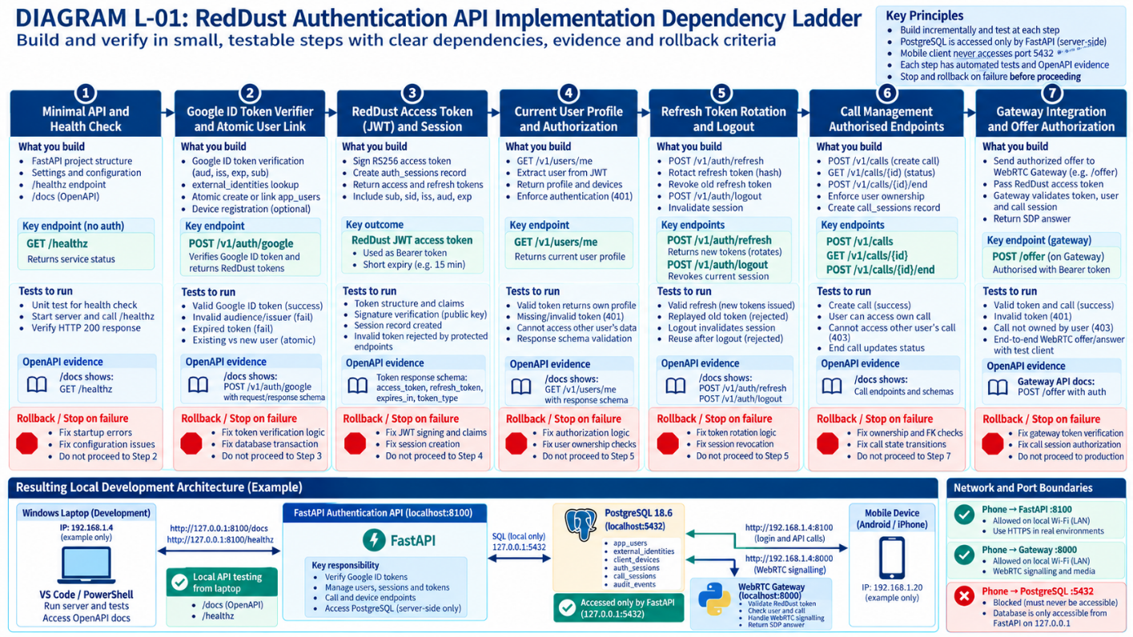
DIAGRAM L-02 — Laptop Phone Gateway Ports
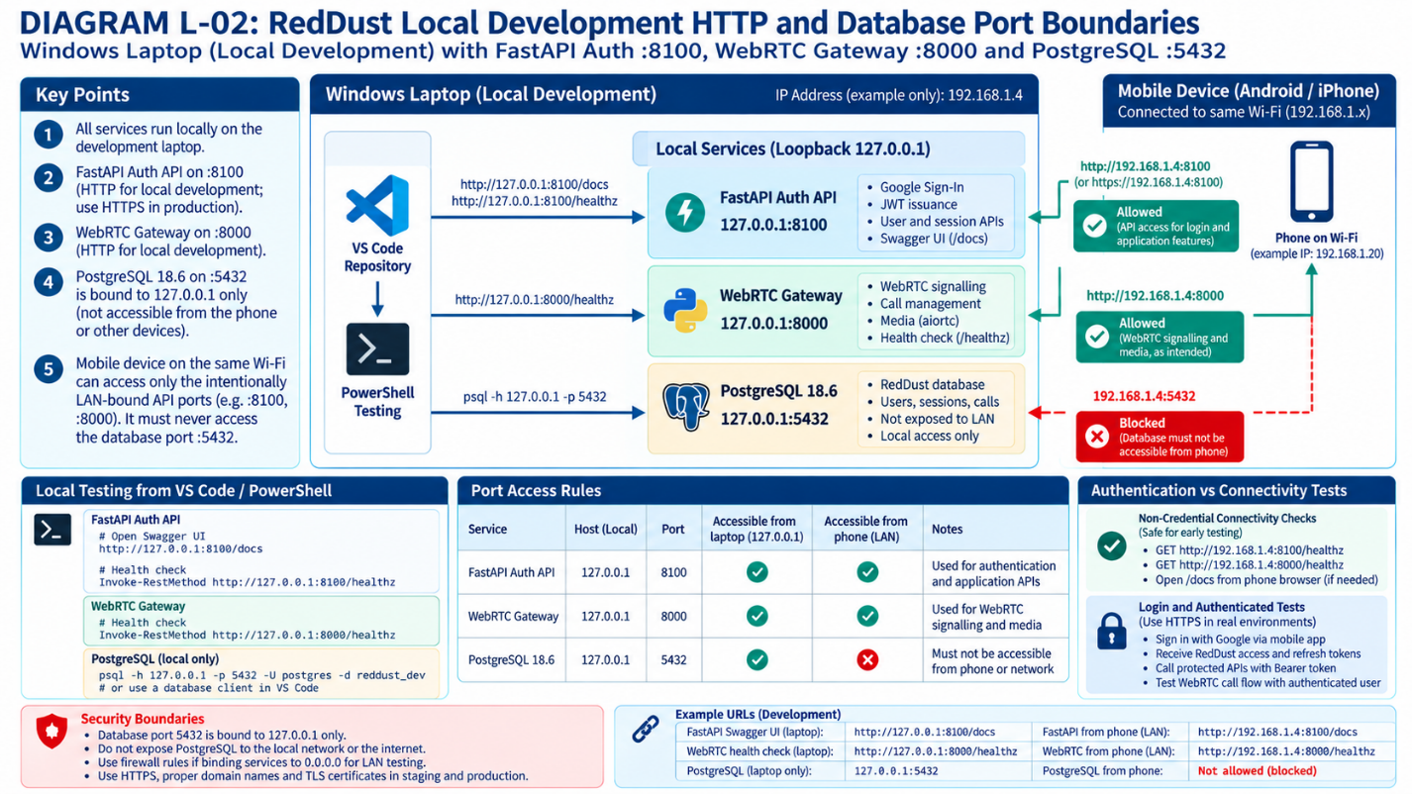

L.7 — Handoff to security testing
Deliver a redacted /docs verification record, OpenAPI inventory, API_CONTRACT.md, server startup evidence, a 200 /healthz check, unauthorized /users/me response, and one complete authenticated flow result when implemented. Hand these to Appendix M for negative/security testing.

Appendix M — Authentication Security Tests, Referential Integrity and Audit Evidence
APPENDIX ROLE: Long-form expansion of 19C.9. Do this only after the corresponding endpoints are implemented. The database schema from Appendix I may be checked read-only at any time, but API behavior tests require real route code. Use isolated test data.

M.1 — Decide where each kind of test runs
Type | Tool / location | Purpose
Unit tests | VS Code tests/ + pytest, mocked Google verifier | Claims, token utilities, deterministic error cases
API tests | FastAPI TestClient or controlled local HTTP | Status codes, auth, ownership and inputs
PostgreSQL integrity | Separate reddust_test database, SQLAlchemy/pytest or transaction-rollback SQL | Foreign keys, unique constraints and deletes
Operational evidence | PowerShell output, redacted logs, pgAdmin read-only SQL | Show acceptance and privacy
Later CI/CD | Disposable PostgreSQL and pipeline report | Repeat tests before promoting migration/code

M.2 — Prepare a separate test database
1. Prefer a dedicated local reddust_test database with explicitly scoped credentials rather than inserting synthetic security-test users into reddust_dev. Provision this through the approved local administrative workflow when tests require writes.
2. Apply the reviewed Alembic migration history to the test database, not ad hoc SQL; verify the test database name before any write test.
3. Load disposable test fixtures with distinct user A and user B, separate devices, sessions and calls. Store no real credentials.
4. Configure test code so it refuses to run destructive fixtures against reddust_dev, staging or production. Implement transaction-scoped cleanup or recreate the isolated test DB as appropriate.
SAFETY GATE: This appendix does not command you to create test data in reddust_dev. If reddust_test has not yet been approved, begin with mock/unit tests and read-only schema verification; do not run write tests against the validated baseline database.

M.3 — Authentication and token negative-test matrix
Scenario | Expected test observation
Forged signature / tampered Google ID token | 401; no user/session creation; no raw token in logs
Incorrect Google audience or issuer | 401; rejected even when email appears plausible
Expired Google ID token or missing sub | 401; no session created
Refresh with invalid/expired token | 401; no new active credentials
Reuse of rotated refresh token | Rejected; appropriate session/family revocation policy applied
Logout then refresh | Refresh refused
Missing Bearer header on /users/me | 401 with appropriate authentication challenge
User A tries to end User B call | 403 or privacy-preserving 404 by documented contract
User A sends another user’s device ID | Database/API denies cross-user association
Wrong-user auth_session_id used for a call | Composite foreign key / API policy rejects it
Too-large/unapproved audit metadata | Schema/application rejects or drops unsafe metadata

M.4 — Reversible referential-integrity acceptance
Your previously observed PostgreSQL constraints include fk_auth_device_same_user and fk_call_auth_same_user. Verify their actual definitions read-only in pgAdmin; then use isolated tests with a transaction rollback to prove mismatches are rejected, if the test design requires it.
WHERE: PGADMIN 4 → REDDUST_TEST OR REDDUST_DEV → QUERY TOOL; READ-ONLY
SELECT conname,
pg_get_constraintdef(oid) AS definition,
convalidated
FROM pg_constraint
WHERE conname IN (
'fk_auth_device_same_user',
'fk_call_auth_same_user'
)
ORDER BY conname;
Expected: FOREIGN KEY (device_id, user_id) references client_devices(id, user_id); FOREIGN KEY (auth_session_id, user_id) references auth_sessions(id, user_id). convalidated should be true. The names themselves are not proof of column pairing.
In a controlled write test, insert User A and User B with their own devices and sessions; try to create a session that says user A but points to user B’s device, and a call that says user A but points to user B’s auth session. Those writes should fail with foreign-key errors. Use SAVEPOINTs or isolated transaction-scoped fixtures because PostgreSQL marks a transaction failed after a constraint exception until it is rolled back to a savepoint.

M.5 — Inspect audit records without exposing secrets
The exact audit_events field names, JSON metadata format and event strings are application design decisions. The baseline showed event_type, metadata_json and occurred_at; query only fields known to exist.
WHERE: PGADMIN QUERY TOOL — READ-ONLY; USE AUTHORIZED TEST DB
SELECT event_type, occurred_at
FROM public.audit_events
ORDER BY occurred_at DESC
LIMIT 30;
Review event types and timestamps, then inspect safely redacted sample metadata using authorized tooling. Avoid exporting raw metadata blindly, as even non-token fields may contain personal information. Verify the schema constraints ck_audit_events_metadata_is_object and ck_audit_events_metadata_size_limit in the database as part of your evidence.

M.6 — Run, preserve and interpret pytest results
WHERE: VS CODE INTEGRATED POWERSHELL
Set-Location "D:\RedDust\reddust-auth-api"
.\.venv\Scripts\Activate.ps1
python -m pytest -v
python -m pip check
python -m alembic check
Expected: the intended test suite is actually collected and all required tests pass; pip check reports no broken requirements; Alembic detects no new autogenerate operations. Alembic check is an additional schema-alignment signal, not a substitute for security test coverage.

M.7 — Release acceptance evidence
Gate | Retained evidence | Failure response
Google trust boundary | Redacted positive/negative test report | STOP; fix verifier or allowed audiences
JWT and refresh security | Tampered-token, expiry, rotation, replay tests | STOP; fix session/key implementation
Cross-user isolation | API ownership and composite FK tests | STOP; treat as authorization defect
Audit privacy | Redacted events/log sample reviewed | STOP; remove secret-bearing fields
Schema alignment | alembic current/heads/check and constraint definitions | STOP; review drift/migration
Reproducible CI | Disposable test DB pipeline report when available | STOP; do not promote to next environment
DIAGRAM M-01 — Authentication Test Pyramid and STOP Gates
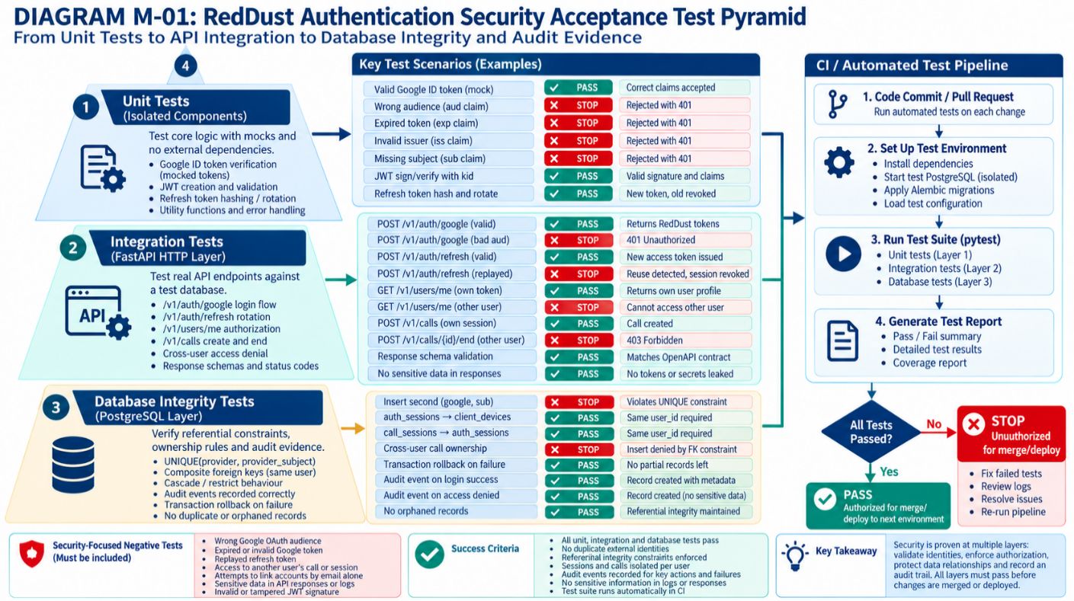
DIAGRAM M-02 — Cross-User Referential Integrity Failure
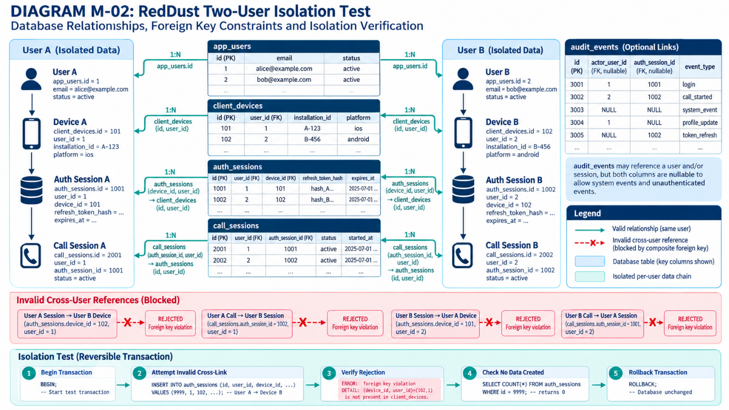

M.8 — End-of-phase decision
Only mark Step 19C security acceptance “PASSED” when there is test evidence for both success and intentional denial paths, and audit privacy has been reviewed. A finished Appendix I proves a database baseline; it does not replace these behavior

