GOOGLE CLOUD
ZERO TO HERO
A “GCP for Dummies” Style Foundation for Anodiam Interns
RedDust Edition


From cloud fundamentals to secure Compute Engine operations, containers, data, AI, observability and cost governance
Designed for absolute beginners
Assumes zero prior knowledge of cloud computing. Every important term is explained in plain English before it is used technically, and each chapter connects the theory back to the RedDust platform.

Document Control
Version | Audience | Purpose | Primary project context
1.0 | Anodiam interns and junior engineers | GCP fundamentals + RedDust platform onboarding | RedDust Development / Step 20 Compute Engine migration

This learning book is a conceptual and practical companion to the RedDust Step-20 implementation runbook. It teaches the cloud concepts that the implementation runbook assumes, while keeping hands-on exercises non-destructive by default. Product names, interfaces and service details can evolve; always re-check current Google Cloud documentation before making production changes.

Important training boundary
The examples in this book explain how Google Cloud works. They are not permission to modify a shared RedDust project. Interns should run write operations only in an approved sandbox or when explicitly assigned by a project Administrator.

How to Use This Book
Read Chapters 1, 2, 4 and 7 first if your immediate goal is to understand the RedDust Gateway migration. Chapters 3, 5, 6 and 8 broaden that foundation into storage, data, AI, operations and financial governance. Each chapter contains four recurring elements: beginner explanation, RedDust relevance, safe command-line examples, and diagram placeholders for future visual learning.
Reading path | Recommended chapters | Why
RedDust Gateway onboarding | 1 → 2 → 4 → 7 → 8 | Projects, Compute Engine, networking, IAM/IAP/OS Login, monitoring and cost are used directly in Step 20.
Future platform / microservices | 1 → 2 → 3 → 4 → 7 → 8 | Adds GKE, containers, storage, databases and DevOps foundations.
AI / data intern | 1 → 3 → 5 → 6 → 7 → 8 | Adds BigQuery, Pub/Sub, Dataflow, Vertex AI and governance.
Cloud certification foundation | All chapters | Broadly overlaps Digital Leader and Associate Cloud Engineer foundations; this is a learning companion, not an official exam guide.

Table of Contents
Document Control 2
How to Use This Book 2
Foundations of Cloud Computing & Google Cloud 4
Core Compute Services 11
Cloud Storage & Database Architecture 18
Cloud Networking Basics 24
Data Analytics & Big Data 30
Artificial Intelligence & Machine Learning 34
Security, Compliance & Governance 38
Cloud Operations & Financial Governance 43
Appendix 48
Final Intern Readiness Checklist 50
Closing Perspective 51
Reference Basis 51

CHAPTER 1

Foundations of Cloud Computing & Google Cloud
What this chapter does and why it matters
Build the mental model that makes every later GCP service understandable: what “the cloud” actually is, how public cloud differs from running a server yourself, why regions and zones matter, how Google organizes resources, and how identity and access are attached to those resources.

New technical concepts in absolute beginner terms
Cloud computing, elasticity, scalability, high availability, regions, zones, projects, IAM, principals, roles, permissions, service accounts, CapEx, OpEx and shared responsibility.

RedDust lens
RedDust Step 20 moves a working FastAPI + aiortc Gateway from a Windows laptop to an Ubuntu Compute Engine VM in the RedDust Development project. The cloud does not change the application’s purpose; it changes where it runs, how it is reached, how it is secured and how it is paid for.

1.1 — What Is Cloud Computing?
Cloud computing means renting computing capabilities—CPU, memory, storage, networking, databases, analytics and higher-level managed services—from a provider and consuming them on demand. Instead of buying a physical server, installing it in an office, wiring it to the Internet and maintaining the hardware yourself, you request a virtual or managed resource through an API or console.
A useful beginner analogy is electricity. A company usually does not build its own power station before turning on a laptop; it consumes power from a utility. Public cloud applies a similar consumption model to computing. You still design the application, choose capacity, secure identities and control data, but a cloud provider operates the underlying physical data-centre infrastructure.
Cloud does not mean “somebody else handles everything”
You still own application design, IAM, data access, network exposure, software vulnerabilities, backups appropriate to your architecture, and cost decisions. Cloud changes the boundary of responsibility; it does not remove responsibility.

Cloud is accessed programmatically
Most cloud resources can be created and managed through several interfaces: a web console, command-line tools, APIs, SDKs, or Infrastructure as Code. These are different ways of controlling the same underlying cloud platform rather than separate versions of Google Cloud.

1.2 — Agility, Scalability, Elasticity, Availability and Durability
Term | Plain-English meaning | Simple example
Agility | How quickly you can create or change infrastructure. | Create a VM in minutes instead of purchasing and racking a physical server.
Scalability | Ability to handle a larger workload by adding or enlarging resources. | Move from one VM to a managed group or a GKE deployment with more replicas.
Elasticity | Capacity can expand and shrink with demand. | Cloud Run can add instances when traffic rises and scale down when traffic falls.
High availability | Designing so a service keeps working despite individual failures. | Run redundant instances across zones behind a load balancer.
Durability | Probability that stored data survives over time. | Object storage keeps multiple copies according to service design.

Scalability and elasticity are related but not identical. A system can be scalable without being automatically elastic. For example, a manually resized VM can scale, but it does not automatically grow and shrink in response to traffic.
Availability asks whether a service can be used when needed; durability asks whether stored data remains intact over time. A highly durable storage system can still experience temporary unavailability, so the concepts should not be treated as interchangeable.

1.3 — Public, Private, Hybrid and Multi-cloud
Model | Where workloads run | Why organizations choose it
Public cloud | Provider-operated cloud such as Google Cloud. | Speed, global reach, managed services, pay-as-you-go consumption.
Private cloud | Dedicated infrastructure operated for one organization. | Special regulatory, legacy or control requirements.
Hybrid cloud | Combination of on-premises/private infrastructure and public cloud. | Gradual migration, data locality, legacy systems.
Multi-cloud | Use of services from more than one public cloud provider. | Risk management, specialized services, acquisition history or strategy.

RedDust currently uses a public-cloud model for the Gateway. A future architecture could still be multi-cloud or hybrid, but adding more clouds also adds operational complexity: identity, networking, observability, cost controls and deployment tooling must work across environments.

1.4 — IaaS, PaaS, SaaS and FaaS
Model | You manage more of… | Provider manages more of… | GCP example
IaaS | OS, runtime, application, patching choices | Physical servers, virtualization | Compute Engine
PaaS | Application and data | OS/runtime/platform scaling mechanics | App Engine
Container platform | Container image and workload configuration | Cluster control plane and/or runtime infrastructure | GKE / Cloud Run
FaaS | Function code and trigger logic | Runtime, scaling, servers | Cloud Run functions / Cloud Functions
SaaS | Configuration and usage | Application stack itself | Google Workspace is a familiar SaaS example

The key trade-off is control versus operational burden. Compute Engine gives RedDust full operating-system control, which is useful for learning and for the current WebRTC Gateway proof. A managed container platform can reduce server administration later, but it also changes deployment and networking design.
There is no universally "best" service model. The correct choice depends on how much infrastructure control the application requires versus how much infrastructure the team wants to operate.
For instance, RedDust currently chooses Compute Engine for the Gateway because direct control over Ubuntu, Python, native dependencies and WebRTC/network behaviour is valuable during the current platform stage. This does not imply that Compute Engine must remain the final production architecture.

1.5 — Cloud Economics: CapEx, OpEx and TCO
Capital expenditure (CapEx) is money spent up front to acquire long-lived assets such as servers, racks and networking hardware. Operational expenditure (OpEx) is ongoing spending for consumed services. Public cloud shifts much infrastructure spending toward OpEx: you pay for resources as you use them.
Total Cost of Ownership (TCO) is broader than the VM price. TCO includes engineering time, patching, monitoring, backups, incident response, network egress, software licenses, operational tooling, and the cost of idle resources. A cheap VM can become expensive if it is forgotten and left running; a managed service with a higher unit price may be cheaper overall if it removes large amounts of operational work.
RedDust cost lesson
The Step-20 e2-medium VM is billable. Budget alerts create visibility but do not automatically stop the VM. Cost control therefore combines budgets with operating discipline: run what you need, stop idle development compute, and review billing reports.

Note : Pay-as-you-go does not automatically mean cheaper. Cloud can reduce upfront infrastructure investment and improve flexibility, but poor resource management can still produce unnecessary cost.

1.6 — Google’s Global Infrastructure: Regions and Zones
A Google Cloud region is a geographic area containing multiple independent zones. A zone is a deployment area inside a region. You choose location because latency, availability design, legal requirements, service availability and price can all depend on it.
Concept | Beginner meaning | RedDust example
Region | Geographic area where cloud resources are placed. | australia-southeast1 (Sydney).
Zone | Failure domain / deployment location inside a region. | australia-southeast1-b.
Multi-region | Google-managed geography spanning multiple regions for specific services. | Useful for some storage/data products; not the Step-20 VM placement model.
Latency | Time for data to travel from source to destination. | Sydney is chosen to make Australian real-time voice testing representative.

Understanding Resource Scope: Global, Regional and Zonal
Not every Google Cloud resource belongs to a specific zone. Google Cloud resources can have different geographical scopes depending on how the service is designed.
Resource scope | What it means | Google Cloud example
Global | A resource is not restricted to one specific region or zone. | VPC networks
Regional | A resource belongs to a particular geographical region and may serve resources across its zones. | Subnets, regional persistent disks
Zonal | A resource belongs to one specific zone within a region. | Compute Engine virtual machines, zonal persistent disks

RedDust Example
The RedDust Gateway runs on a Compute Engine virtual machine deployed in a specific Google Cloud zone:
- Region: australia-southeast1 (Sydney)
- Zone: australia-southeast1-b
- VM: reddust-gateway-dev
The VM is a zonal resource, while the subnet it connects to is regional and the VPC network is global.
Why this matters
Understanding resource scope helps developers correctly configure cloud resources, select compatible locations, interpret gcloud commands and plan for availability.
For example, deploying one VM in australia-southeast1-b does not automatically make the application highly available across the entire Sydney region. If that zone becomes unavailable, the single VM may also become unavailable. Higher availability requires additional architectural decisions, such as deploying redundant instances across zones.
Key takeaway: A region contains zones, but cloud resources do not all operate at the same geographical scope. Always identify whether a resource is global, regional or zonal before configuring or deploying it.

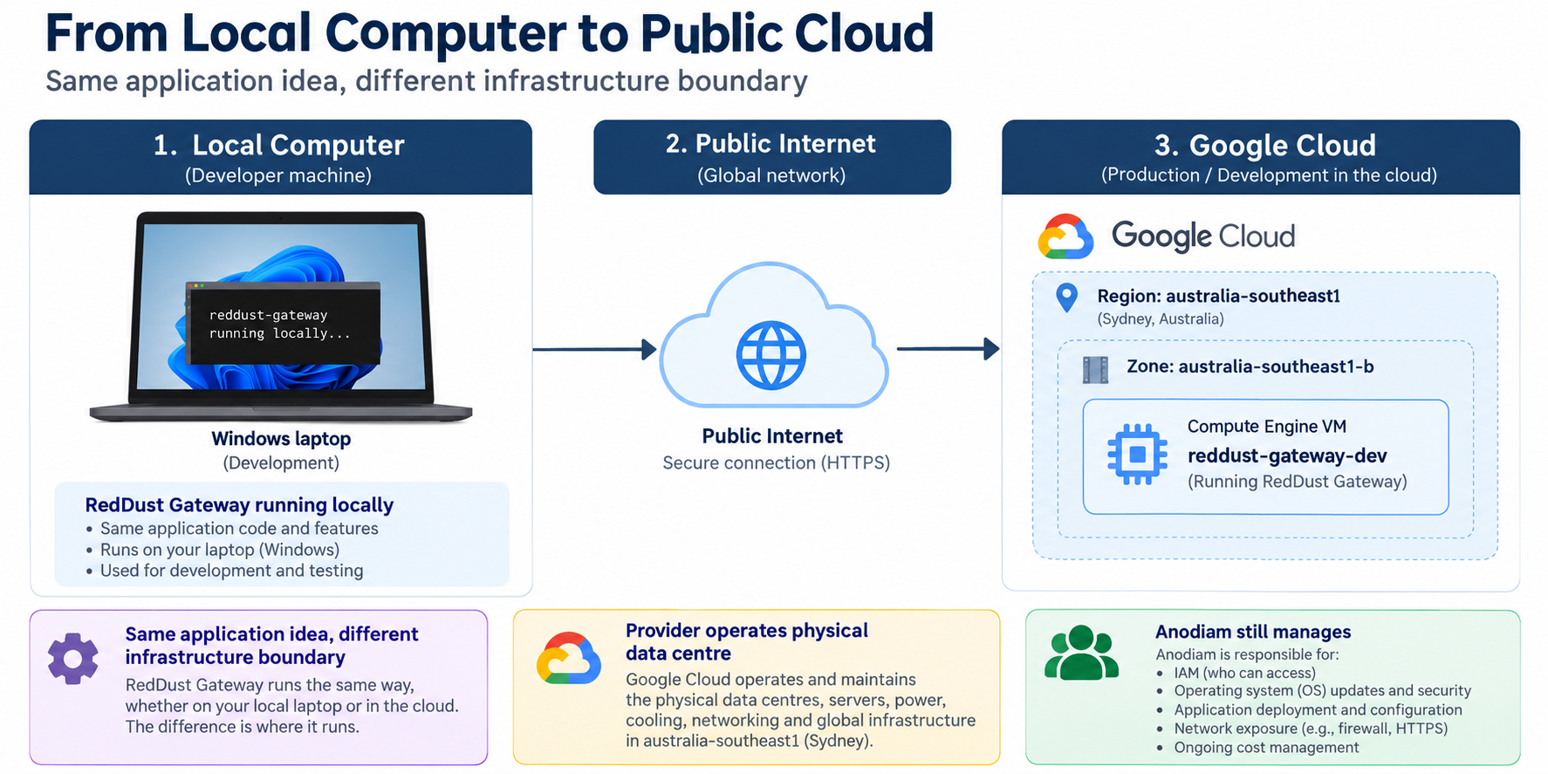
GCP-01: From Laptop to Public Cloud

1.7 — Google Cloud Resource Hierarchy
Google Cloud resources live in a hierarchy. At the top may be an Organization. Folders can group teams or environments. Projects are the main isolation and billing/IAM boundary used by most teams. Individual resources—VMs, buckets, databases, topics and so on—live inside projects or are associated with them.
Level | What it represents | Why it matters
Organization | Top-level company or Cloud Identity / Workspace boundary. | Central policy, organization-wide roles and governance.
Folder | Optional grouping layer. | Can separate business units, platforms or environments.
Project | Core working boundary for APIs, quotas, IAM, billing linkage and resources. | RedDust Development is the project for Step 20.
Resource | Concrete cloud object. | Examples: reddust-gateway-dev VM, firewall rule, service account.

IAM policies can be inherited downward. A role granted at a project may apply to resources in that project; a role granted only on one VM can be much narrower. This is why “where the role is granted” is as important as “which role is granted.”

Project name vs Project ID vs Project number
Identifier | Meaning
Project name | Human-readable display name, e.g. RedDust Development
Project ID | Globally unique identifier used by APIs/CLI, e.g. reddust-development
Project number | Google-assigned numeric identifier

1.8 — IAM: Principal + Role + Resource = Access
Identity and Access Management (IAM) answers: who can do what on which resource? A principal can be a human user, Google Group, service account or other supported identity. A role is a named bundle of permissions. The policy binding connects the principal and role at a specific scope.
IAM word | Plain English | Example
Principal | Who is asking? | A developer Google identity or a Gateway service account.
Permission | One low-level allowed operation. | compute.instances.get
Role | A curated bundle of permissions. | roles/compute.viewer
Binding | Role assigned to principal at a scope. | Developer → Compute Viewer on reddust-development
Least privilege | Give only what is required, at the narrowest useful scope. | Developer gets VM-scoped OS Admin Login instead of project-wide cloud admin.

Important Concept – Authentication vs Authorisation
Authentication asks "Who are you?"
Authorisation asks "What are you allowed to do?"
Successfully signing into Google Cloud proves identity; it does not mean that identity has permission to perform every operation in the RedDust project.

1.9 — Human Identity versus Workload Identity
A human identity represents a person. A workload identity represents software. In RedDust, humans authenticate as themselves through Google identity and OS Login, while the Gateway application can use a dedicated VM service account such as reddust-gateway-dev-runtime when it needs to call Google Cloud APIs.
Security boundary to remember
Do not turn a service account into a shared human login. Do not solve workload authentication by downloading and sharing long-lived JSON keys when a managed identity path is available. Human access and application access should remain separate and auditable.

1.10 — Google Cloud APIs: How Cloud Services Are Enabled
Google Cloud provides many services, such as Compute Engine, Cloud Storage, BigQuery and Vertex AI. Each service exposes an Application Programming Interface (API), which allows software and tools to communicate with Google Cloud and request operations.
An API acts as a defined communication interface between a user, application or tool and a cloud service.
For example, when a developer creates a virtual machine through the Google Cloud Console, the Console communicates with Google Cloud services through APIs to perform the requested operation.

Different Ways to Interact with Google Cloud
Developers can manage Google Cloud resources through several interfaces.
Interface | Beginner meaning | Example
Google Cloud Console | A graphical website for viewing and managing cloud resources. | Create a VM using the browser.
gcloud CLI | A command-line tool for interacting with Google Cloud services. | List Compute Engine instances from a terminal.
Client libraries / SDKs | Programming libraries that allow applications to interact with Google Cloud APIs. | A Python application accessing Cloud Storage.
Infrastructure as Code (IaC) | Tools that define and manage infrastructure through configuration files. | Terraform defining a Compute Engine VM.
These interfaces provide different ways to interact with the same underlying cloud platform.

Why Do Google Cloud APIs Need to Be Enabled?
Google Cloud projects do not automatically have every service API enabled.

Before using certain Google Cloud services within a project, the corresponding API must be enabled.
For example:
- Compute Engine API — required for managing Compute Engine resources.
- Cloud Storage API — provides programmatic access to Cloud Storage.
- BigQuery API — supports BigQuery operations.
- Vertex AI API — enables access to Vertex AI services.
Enabling an API makes the service available for use within the project, but it does not automatically grant users permission to access it.

Important distinction

API enabled = The project can use the service.
IAM permission granted = The identity is authorized to perform particular operations.
Both conditions must be satisfied for an authorized operation to succeed.

RedDust Example — Compute Engine API
During RedDust Step 20, the team deploys the FastAPI + aiortc Gateway on a Google Compute Engine virtual machine.
Before creating the VM, the Compute Engine API must be enabled in the RedDust Development project.
Once enabled, an authorized developer can use the Google Cloud Console or gcloud CLI to create, inspect and manage Compute Engine resources according to their assigned IAM permissions.

For example, the following command lists Compute Engine instances without modifying them:
gcloud compute instances list --project=reddust-development
This is a read-only operation, but it still requires appropriate permissions to view the instances.

Key Takeaway
Google Cloud APIs provide the underlying interfaces through which cloud services are accessed and managed. The Console, CLI, SDKs, and Infrastructure as Code tools are different ways to interact with those services.
Enabling a service API does not bypass IAM, remove security controls or make the service free to use.

Safe read-only orientation commands
gcloud auth list
gcloud config get-value project
gcloud projects describe reddust-development --format="yaml(projectId,name,parent)"

Simply said, a service account is not simply an "account without a person." It is an identity designed for software, allowing applications to receive only the permissions they require and to distinguish their actions from human activity.

Quick knowledge check
- In one sentence, what is the difference between scalability and elasticity?
- Why is a GCP project more than just a folder name?
- What three pieces make up an IAM decision: who, what role, and where?
- Why should the RedDust Gateway use a service account instead of a developer’s personal credentials?
- What is the difference between enabling a Google Cloud API and granting IAM permissions to a user?
- How do the Google Cloud Console, gcloud CLI and Terraform relate to Google Cloud APIs?

CHAPTER 2

Core Compute Services
What this chapter does and why it matters
Understand the major ways to run code on Google Cloud—from a virtual machine you administer yourself to managed containers, Kubernetes and serverless platforms—and learn how to choose among them.

New technical concepts in absolute beginner terms
Virtual machines, machine families, images, disks, Spot VMs, containers, Docker images, Kubernetes, pods, nodes, clusters, serverless, autoscaling and stateless services.

RedDust lens
RedDust Step 20 deliberately uses Compute Engine because it gives the team full control over Ubuntu, Python, aiortc, UDP/WebRTC behavior and systemd. The future roadmap moves toward containerization, Artifact Registry, CI/CD and eventually GKE microservices.

2.1 — Compute Engine: A Virtual Computer in Google’s Data Centre
Compute Engine provides virtual machines (VMs). To the operating system, a VM looks much like a normal computer: CPU, memory, disks, network interfaces and an OS. The hardware is virtualized and runs on Google’s physical infrastructure.
A VM is appropriate when you need operating-system control, custom networking behavior, background daemons, native packages, or a lift-and-shift path from an existing server. The trade-off is that you are responsible for more: OS updates, package management, process supervision, capacity choices and hardening.

Physical Servers, Virtual Machines and Local Computers
A physical server is a real computer with processors, memory, storage and networking hardware. Cloud providers operate large numbers of these servers inside data centres.
Virtualization allows physical computing hardware to support multiple isolated virtual machines (VMs). Each VM behaves like an independent computer with its own operating system and allocated computing resources.
For a developer, working with a cloud VM is similar to working with a remote Linux computer. You can install software, run applications, inspect logs and manage background services.
The main difference is that the cloud provider manages the underlying physical infrastructure, while the development team manages the guest operating system and application.

RedDust Example
During local development, the RedDust Gateway runs on a developer's computer. In Step 20, the same Gateway functionality is moved to an Ubuntu VM on Google Compute Engine.
The application's purpose remains unchanged. What changes is the execution environment, network accessibility, infrastructure management and operational responsibility.
Key takeaway: A cloud VM is a virtual computer running on cloud-provider infrastructure. It provides operating-system control without requiring the team to purchase and maintain a physical server.

2.2 — Machine Families and Machine Types
A machine family is a group of VM shapes optimized for broad purposes such as general-purpose, compute-intensive, memory-intensive or accelerator workloads. A machine type specifies a particular combination of virtual CPU and memory. Custom machine types let you select CPU/memory combinations where supported.
Choice | Good for | Trade-off
General purpose | Web apps, APIs, dev/test, balanced workloads. | Good default; not specialized for extreme CPU or memory.
Compute optimized | CPU-heavy computation. | Higher compute focus and cost profile.
Memory optimized | Large in-memory datasets. | More RAM; higher cost.
Accelerator/GPU | ML training/inference, rendering. | Expensive and operationally different.
Spot VM | Fault-tolerant batch or disposable workers. | Can be stopped by Google; not appropriate for an interactive baseline Gateway that must remain stable during testing.

Understanding vCPU, RAM and Machine Types
When creating a virtual machine, developers must choose how much computing capacity the VM requires.
- vCPU (virtual CPU): A unit of processing capacity presented to the virtual machine. The relationship between vCPUs and underlying physical CPU resources depends on the machine type.
- RAM (Random Access Memory): Temporary working memory used by the operating system and running applications.
- Machine family: A category of virtual machines designed for particular workload requirements.
- Machine type: A specific CPU and memory configuration within a machine family.
For example, e2-medium belongs to Google's general-purpose E2 family. It provides 4 GB of memory and exposes 2 vCPUs, using shared-core processing with a total fractional CPU allocation of 1.0 vCPU.
A machine with more vCPUs or RAM is not automatically the best choice. The appropriate configuration depends on application requirements, performance testing, availability and cost.

RedDust Example
The Step-20 Gateway uses e2-medium as its initial development baseline. This provides a defined environment for validating FastAPI, Uvicorn, aiortc and WebRTC behaviour before making more complex infrastructure decisions.
Key takeaway: Choose a machine type based on measured workload requirements rather than assuming that larger machines are always better.

RedDust Step-20 VM
Canonical baseline: reddust-gateway-dev in australia-southeast1-b, general-purpose E2, e2-medium, Ubuntu 24.04 LTS, 10 GB pd-standard. The runbook uses Standard/non-Spot provisioning because interruption would complicate baseline WebRTC testing.

2.3 — Images, Boot Disks and Persistent Disks
A VM image is a template used to create the boot disk. It typically contains an operating system such as Ubuntu. The boot disk stores the OS and local application files. Persistent Disk is network-backed block storage that can outlive a VM instance depending on deletion settings.
Think of the VM as the computer and the boot disk as its system drive. Deleting the VM and deleting the disk are separate lifecycle decisions. Snapshots and images are different tools for recovery and repeatable provisioning; production designs should make those choices explicitly.

Understanding Images, Disks and Snapshots
Although these concepts are related, they serve different purposes.
Concept | Simple Meaning | Example
VM image | A reusable template for creating a virtual machine's boot disk. | Ubuntu 24.04 LTS image
Boot disk | The storage device containing the VM's operating system and associated files. | RedDust's 10 GB boot disk
Persistent Disk | Network-backed block storage that can be attached to Compute Engine VMs. | pd-standard
Snapshot | A point-in-time backup of disk data that can be used for recovery or creating new disks. | Snapshot before a major system change

RedDust Example
When the RedDust Gateway VM is created, the Ubuntu 24.04 LTS image is used to initialize its 10 GB standard persistent boot disk.
After deployment, the boot disk contains the operating system, installed packages, application files and configuration changes made on the VM.
Deleting the VM does not always mean every attached disk is preserved or deleted. Disk lifecycle behaviour depends on the configured deletion settings.
Key takeaway: An image is a template, a disk stores the running system's data, and a snapshot captures disk state for recovery. These are separate resources with different purposes.

2.4 — VM Lifecycle: Create, Start, Stop, Reset, Delete
Action | What happens | Billing / data lesson
Stop | Guest stops running; VM is not serving. | Compute charges generally stop, but attached storage and some resources can still cost money.
Start | VM resumes using configured machine and disks. | Compute billing resumes.
Reset | Equivalent to a hard reboot. | Use only when needed; not a substitute for graceful shutdown.
Delete | Instance resource is removed. | Disk deletion depends on configuration; verify before destructive actions.

Stopping a VM Is Not the Same as Deleting It
Stopping a VM shuts down its execution while retaining the instance configuration and attached persistent disks, subject to their lifecycle settings.
Deleting a VM removes the instance itself. Depending on the configured deletion rules, attached disks may also be deleted.
This distinction matters for both cost control and data preservation.

RedDust Example
When developers finish testing the RedDust Gateway, stopping the development VM can reduce unnecessary compute costs without requiring the team to recreate the instance.
However, attached persistent disks and other allocated resources may continue generating charges even while the VM is stopped.
Before deleting a VM, developers must confirm whether important application files, configurations or data need to be preserved.
Key takeaway: Stop a VM when it is temporarily unnecessary. Delete resources only after verifying their dependencies, data-retention requirements and deletion settings.

Safe read-only Compute Engine inspection
gcloud compute instances list --project=reddust-development
gcloud compute instances describe reddust-gateway-dev \
--project=reddust-development \
--zone=australia-southeast1-b \
--format="yaml(name,status,machineType,disks,networkInterfaces,serviceAccounts)"

2.5 — Linux on a VM: Packages, Processes and systemd
Once you SSH into an Ubuntu VM, you are administering a Linux operating system. Processes are running programs. Services are long-running background processes. systemd is Ubuntu’s service manager: it starts services, restarts them when configured, launches them at boot and records status.
Typical non-destructive Linux checks on the RedDust VM
hostname
uname -a
free -h
df -h
systemctl status reddust-gateway --no-pager
journalctl -u reddust-gateway -n 50 --no-pager

For RedDust, systemd means Uvicorn/FastAPI can keep running after a developer closes an SSH session. This is a basic cloud-operations lesson: production-like workloads should not depend on somebody leaving a terminal window open.

Understanding Processes, Services and SSH Sessions
A process is an instance of a running program. For example, when Python starts the RedDust Gateway, the operating system creates one or more processes to execute the application.
An SSH session provides a remote terminal through which a developer can interact with the VM. However, programs launched directly from an interactive terminal may terminate when that session ends, depending on how they were started.
A systemd service allows a long-running application to be managed independently of an individual developer's terminal session.
systemd can be configured to start an application during system boot, restart it after certain failures and provide a consistent interface for checking its status.

RedDust Example
The RedDust Gateway runs through a systemd service named reddust-gateway.
An authorized developer can inspect its status using:
systemctl status reddust-gateway --no-pager
The service can continue running after the developer disconnects from SSH.
Key takeaway: SSH is a way to access the VM, a process is a running program, and systemd manages long-running services. These concepts serve different purposes.

2.6 — Containers: Package the Application, Not the Whole VM
A container packages an application with its user-space dependencies into a portable image. Containers share the host kernel, so they are lighter than full VMs. A Dockerfile describes how to build an image; a container registry stores built images; a runtime starts containers from those images.

Container Image vs Running Container
A container image is a packaged, reusable definition of an application and the user-space dependencies required to run it.
A container is a running or stopped instance created from that image.
A useful analogy is that an image is a reusable application package, while a container is an instance of that package being executed.
Multiple containers can be created from the same image, allowing applications to be deployed consistently across compatible environments.

RedDust Example
In a future containerized deployment, the RedDust team could build a container image containing the Gateway application, Python dependencies and startup configuration.
That image could then be stored in Artifact Registry and deployed as one or more running containers.
However, containerization alone does not guarantee that the Gateway will function correctly in every environment. Native dependencies, UDP networking, WebRTC connectivity, runtime permissions and resource requirements must still be tested.
Key takeaway: Images package applications; containers execute them. Containerization improves deployment consistency but does not eliminate infrastructure, networking or security responsibilities.
Illustrative container image for a future RedDust Gateway — example only
FROM python:3.12-slim
WORKDIR /app
COPY requirements.txt .
RUN pip install --no-cache-dir -r requirements.txt
COPY . .
CMD ["python", "-m", "uvicorn", "app.main:app", "--host", "0.0.0.0", "--port", "8000"]

Important
A container is not automatically “secure” or “serverless.” You still need vulnerability scanning, least-privilege runtime identity, network policy, secrets handling, logging and patching of base images.

2.7 — Kubernetes and GKE
Kubernetes is an orchestration system for containers. It decides where containers run, restarts failed replicas, performs rolling updates, exposes services, and helps manage desired state. Google Kubernetes Engine (GKE) is Google Cloud’s managed Kubernetes offering.
Kubernetes concept | Beginner meaning
Cluster | The overall Kubernetes environment.
Node | A worker machine that runs workloads.
Pod | Smallest deployable unit; usually one main application container plus helpers.
Deployment | Declares how many replicas should run and how updates happen.
Service | Stable network identity in front of one or more pods.
Ingress / Gateway | Routes incoming application traffic to services.
ConfigMap / Secret | Configuration objects; Secrets need careful security treatment.

GKE is powerful but introduces a new operational layer. You now manage Kubernetes concepts in addition to Google Cloud concepts. That is why the RedDust roadmap first proves the application and infrastructure boundary on a VM before adding container orchestration complexity.

2.8 — Cloud Run
Cloud Run runs containerized services in a fully managed environment. You provide a container image and service configuration; Google handles underlying server provisioning and automatic scaling. It is excellent for stateless HTTP services and event-driven workloads.
A real-time WebRTC Gateway may need careful evaluation because media traffic, UDP behavior, connection lifetimes and protocol requirements can differ from conventional HTTP APIs. The right compute choice depends on the workload, not on which product is newer or more fashionable.

2.9 — App Engine and Cloud Run Functions
App Engine is a platform-as-a-service option that abstracts much of the underlying infrastructure for web applications. Cloud Run functions (historically Cloud Functions in common usage) are event-driven functions where code runs in response to triggers such as HTTP requests, messages or storage events. These are useful for small, focused actions rather than a long-running, stateful server process.

2.10 — Compute Decision Matrix
Need | Compute Engine | GKE | Cloud Run | Functions / event runtime
Full OS control | Excellent | Indirect via nodes | No | No
Container orchestration | Manual | Excellent | Managed single-service model | Not primary use
Operational simplicity | Lowest | Lowest for beginners | High | Very high for small event logic
Long-running background daemon | Good | Good | Workload dependent | Usually not
Autoscaling | Manual/MIG design | Strong | Built-in | Built-in
RedDust Step 20 fit | Chosen baseline | Future | Potential for stateless services | Potential for event microservices

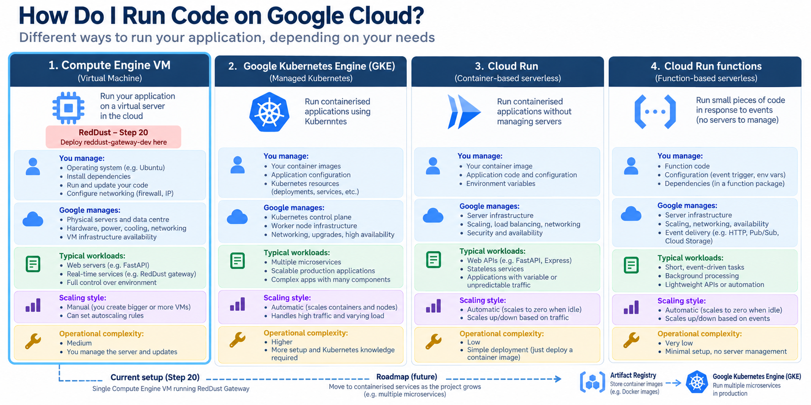
  - GCP-02: Compute Options: VM → Container → Kubernetes → Serverless

Quick knowledge check
- Why did Step 20 choose a VM instead of jumping straight to Kubernetes?
- What is the difference between a VM image and a container image?
- What problem does Kubernetes solve?
- Which compute option generally gives the highest OS-level control?
CHAPTER 3

Cloud Storage & Database Architecture
What this chapter does and why it matters
Learn the difference between object storage, block storage and databases, then understand when relational SQL, document NoSQL, wide-column stores and globally distributed relational systems are appropriate.

New technical concepts in absolute beginner terms
Buckets, objects, storage classes, lifecycle policies, block storage, relational databases, schemas, transactions, NoSQL, documents, wide columns, consistency and managed databases.

RedDust lens
RedDust already uses a VM boot disk and may later need Cloud Storage for artifacts or files, PostgreSQL via a managed database, Secret Manager for secrets, and data services for conversation/session analytics. Choosing storage based on access pattern prevents expensive redesign.

3.1 — Three Different Meanings of “Storage”
Storage type | Think of it as | Best for | GCP examples
Block storage | A disk attached to a computer. | Operating systems, filesystems, database disks. | Persistent Disk / Hyperdisk families.
Object storage | A giant API-accessed bucket of named objects. | Media, archives, backups, exports, static files. | Cloud Storage.
Database | Structured data engine with query/update semantics. | Application records, relationships, transactions, analytics. | Cloud SQL, Spanner, Firestore, Bigtable, BigQuery.

A common beginner error is to call every durable service “a database.” Cloud Storage does not behave like PostgreSQL, and a database is not a substitute for storing large binary objects just because it can technically hold them.

Choosing Storage Based on the Type of Data
Different types of application data have different storage requirements. The correct storage service depends on how the application needs to read, update, query and retain that data.
Consider three examples:
- Operating system and application files: A Compute Engine VM uses an attached boot disk to store its operating system, installed packages and local application files.
- Uploaded files and media: An application may use Cloud Storage to store files such as audio recordings, exported reports or backups.
- Structured application records: A relational database such as PostgreSQL may store user records, sessions, preferences and relationships between records.
These services are not interchangeable simply because they all store information.

RedDust Example
The current RedDust Gateway uses a Compute Engine boot disk for its operating system and application environment.
As RedDust develops, the team may introduce Cloud Storage for selected files and Cloud SQL for structured application data. These are potential architecture choices, not services that must be deployed immediately.

3.2 — Cloud Storage: Buckets and Objects
Cloud Storage is object storage. A bucket is the top-level container. Objects are stored under names inside a bucket. You interact with objects through APIs, command-line tools or application libraries rather than mounting the bucket as an ordinary local disk by default.
Storage class | Typical access pattern | Cost idea
Standard | Frequently accessed data. | Higher storage price, lower access penalties.
Nearline | Infrequent access. | Lower storage cost with minimum-duration/access considerations.
Coldline | Rare access. | Lower storage cost, higher retrieval considerations.
Archive | Very rare / long-term retention. | Lowest storage cost, intended for archival access patterns.

Lifecycle management lets a bucket automatically transition or delete objects based on age or other conditions. This is governance as code for data retention: instead of hoping someone remembers to clean old files, you declare a policy.
Safe Cloud Storage discovery commands
gcloud storage buckets list --project=reddust-development
gcloud storage ls --project=reddust-development

Understanding Buckets, Object Names and Access Control
A Cloud Storage bucket is a named container for objects. An object consists of stored data and associated metadata.
Each object has a name that identifies it within its bucket.
For example:
gs://reddust-example-files/session-exports/report-001.json
In this illustrative path:
- gs:// identifies a Google Cloud Storage URI.
- reddust-example-files is the bucket name.
- session-exports/report-001.json is the object name.
The slash-separated structure resembles folders, but in the common flat-namespace model, these are prefixes within object names rather than ordinary operating-system directories.
Bucket names must be globally unique across Google Cloud Storage.
Access Control
Cloud Storage access is controlled through mechanisms such as IAM. Permissions determine which identities can list, read, create or delete objects.
A bucket should not be made publicly accessible merely because an application needs to retrieve files from it.
For private RedDust data, access should be restricted to authorized users and workloads. Applications may use server-mediated access or appropriately restricted, time-limited access mechanisms where required.

RedDust Example
If RedDust eventually stores user-authorized session exports or media files, Cloud Storage could hold the file contents while an application database stores the associated metadata and ownership information.
The team would also need to define privacy requirements, retention periods, deletion behaviour and access controls.

3.3 — Cloud SQL: Managed Relational Databases
Cloud SQL is a managed relational database service for engines such as PostgreSQL, MySQL and SQL Server. You still design tables, indexes, queries and application transactions, but Google handles much of the underlying database infrastructure such as instance provisioning, managed backups features and maintenance workflows.
For RedDust, PostgreSQL is a natural fit for highly relational records such as users, sessions, conversations, summaries, scores and configuration where referential integrity and SQL queries matter. The application should use connection pooling and keep credentials out of source code.
Illustrative SQL — not a command to run against production
-- Example relational thinking for RedDust
SELECT session_id, started_at, ended_at
FROM sessions
WHERE user_id = $1
ORDER BY started_at DESC
LIMIT 20;

Understanding Tables, Schemas, Keys and Transactions
Relational databases organize information into tables containing rows and columns.
A database schema describes how data is structured, including tables, columns, data types, constraints and relationships.
Several important concepts are:
- Table: A collection of related records, such as users or sessions.
- Row: One record within a table.
- Column: A specific attribute of a record.
- Primary key: A value used to uniquely identify a row.
- Foreign key: A value that references a key in another table, helping maintain relationships between records.
- Transaction: A group of database operations treated as a single logical unit of work.
Transactions help preserve data consistency. For example, if several related updates must succeed together, a transaction can ensure that incomplete changes are rolled back when an operation fails.

RedDust Example
A possible future relational model could include:
Table | Example fields | Purpose
Users | user_id, created_at | Identify application users
Sessions | session_id, user_id, started_at | Associate sessions with users
Mood Entries | entry_id, user_id, mood_value, recorded_at | Store user-authorized mood records
Session Summaries | summary_id, session_id, created_at | Associate summaries with sessions
In this illustrative design, user_id could act as a primary key in the Users table and as a foreign key in Sessions.
This is an example of relational modelling, not a finalized RedDust database schema.
Managed Does Not Mean Maintenance-Free
Cloud SQL manages much of the database infrastructure, but developers remain responsible for schema design, access control, query performance, application-level data protection and appropriate backup and recovery configuration.

3.4 — Cloud Spanner
Cloud Spanner is a managed relational database designed for horizontal scale and strong consistency across large deployments. It solves a different class of problem from a small development PostgreSQL instance. Its value appears when an application needs very high scale, global distribution or availability while retaining relational semantics.
Do not choose enterprise-scale products by prestige
The best service is the simplest one that satisfies the workload’s functional, reliability, security and cost requirements. Early-stage systems often benefit from Cloud SQL before they ever need Spanner.

3.5 — Firestore
Firestore is a document-oriented NoSQL database. Instead of rows and joins, applications work with collections and documents. This can be convenient for mobile/web application state with flexible document structures and realtime-oriented access patterns.
NoSQL does not mean “no structure.” Good document design still requires careful thinking about keys, indexes, query patterns, duplication and consistency. The data model should be driven by how the application reads and writes data.

Understanding Collections and Documents
Firestore stores data using collections and documents rather than traditional relational tables.
A collection groups related documents. Each document contains fields and values describing an individual record.
For example, a collection named user_preferences might contain a document with the following structure:
{
"user_id": "example-user-001",
"preferred_language": "en",
"notifications_enabled": true,
"updated_at": "2026-10-01"
}

This is an illustrative document, not an existing RedDust database record.
Unlike relational databases, Firestore does not rely on traditional SQL joins to connect information across tables. Applications generally design documents around their expected reading and writing patterns.

RedDust Example
Firestore could be considered for certain application features requiring flexible document structures or real-time synchronization.
However, this does not mean Firestore is automatically preferable for a mobile application. RedDust must evaluate its data relationships, query requirements, consistency needs, privacy controls and operating costs before choosing a database.
Key takeaway: Firestore organizes information into collections and documents. It can simplify certain application data patterns, but choosing it requires careful consideration of how the application accesses its data.

3.6 — Bigtable
Bigtable is a wide-column NoSQL database designed for very high throughput and low-latency access to enormous datasets when access patterns can be modeled around row keys. Typical use cases include time-series, telemetry and large-scale operational analytics. It is not a general replacement for PostgreSQL.

3.7 — Database Selection Matrix
Question | Cloud SQL | Spanner | Firestore | Bigtable | Cloud Storage
Relational joins | Yes | Yes | No | No | No
Strong transactional relational model | Yes | Yes | Limited/different model | No relational tx | No
Massive horizontal/global relational scale | Limited vs Spanner | Core strength | Document scale | Core strength for key-based data | Object scale
Mobile/document data | Possible | Possible | Strong | Specialized | Files only
Files / audio / exports | Poor fit | Poor fit | Poor fit | Poor fit | Strong
Likely RedDust near-term role | PostgreSQL app data | Only if future scale demands | Selective mobile/document use | Telemetry at huge scale | Artifacts/files/backups

Applying the Database Selection Matrix to RedDust
When selecting a storage or database service, begin with the application's requirements rather than choosing a technology based on popularity.
Consider the following possible RedDust requirements:
Requirement | Potential GCP service | Reason
Store the Gateway operating system and local application files | Compute Engine Persistent Disk | Provides block storage for the VM
Store uploaded files, exports or backups | Cloud Storage | Designed for object storage
Store users, sessions and related application records | Cloud SQL for PostgreSQL | Supports relational structures, SQL queries and transactions
Store selected document-oriented application data | Firestore | Supports flexible documents and application-oriented access patterns
Process extremely large volumes of key-based telemetry | Bigtable | Designed for specialized, high-throughput workloads
Support globally distributed relational workloads at very large scale | Spanner | Provides scalable relational database capabilities
These are illustrative mappings, not confirmation that RedDust currently uses all these services.
A Practical Decision Process
Before choosing a storage solution, answer five questions:
- What type of data needs to be stored?
- How will the application read, update and query that data?
- Does the data require relationships, transactions or real-time synchronization?
- What are the privacy, security, retention and recovery requirements?
- Which solution meets those needs with acceptable operational complexity and cost?
For RedDust, sensitive wellbeing information also requires careful decisions about data minimization, user consent, access restrictions and deletion.
Architecture Principle
Use the simplest storage technology that meets the application's current requirements while allowing reasonable future growth.
Avoid introducing multiple database systems unless each has a clear and justified purpose.

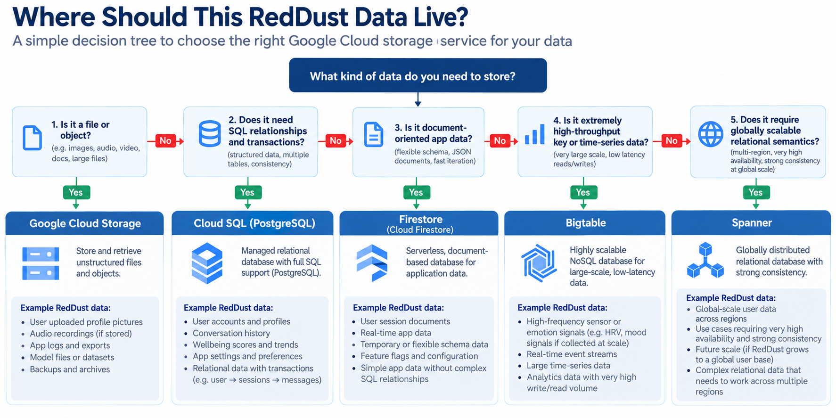
  - GCP-03: Choosing Storage and Databases

Quick knowledge check
- Why is a Cloud Storage bucket not the same thing as a VM disk?
- Why might PostgreSQL be a good fit for RedDust sessions and conversations?
- When would Firestore be preferable to a relational database?
- What problem is a lifecycle policy trying to solve?
- What is the difference between a primary key and a foreign key, and why are they useful when modelling RedDust users and sessions?
- If RedDust needs to store an uploaded audio file and information about who owns that file, why might Cloud Storage and a relational database be used together?

CHAPTER 4

Cloud Networking Basics
What this chapter does and why it matters
Build enough networking knowledge to understand why a VM can be running yet unreachable, why HTTP signaling and WebRTC media can succeed or fail independently, and how VPCs, subnets, IPs, firewalls, load balancers, VPNs and CDNs fit together.

New technical concepts in absolute beginner terms
VPC, subnet, CIDR, internal/external IP, route, firewall, ingress/egress, TCP, UDP, ports, NAT, DNS, load balancing, CDN, VPN and Interconnect.

RedDust lens
RedDust Step 20 depends heavily on networking: IAP-secured SSH on TCP 22, temporary HTTP signaling on TCP 8000, STUN-assisted WebRTC media over UDP, and a firewall model that must allow the correct sources and ports without opening everything to the Internet.

4.1 — VPC: Your Logical Cloud Network
A Virtual Private Cloud (VPC) is a logically isolated network in Google Cloud. Resources such as Compute Engine VMs attach network interfaces to VPC subnets. The VPC provides IP addressing, routes and firewall policy context.
A VPC is not a physical cable. It is software-defined networking: Google’s infrastructure implements the behavior described by your network configuration.

4.2 — Subnets and IP Addressing
A subnet is an IP address range associated with a region. VM network interfaces receive internal IP addresses from subnet ranges. An external IP, when configured, makes a resource reachable through Internet routing subject to firewall and service behavior.
Internal vs external IP
Internal IPs are for communication within the cloud network or connected private networks. External IPs are Internet-routable. “Has an external IP” does not mean “every port is open”; firewall rules and application listeners still matter.

4.3 — CIDR in Plain English
CIDR notation describes a block of IP addresses. The slash number tells you how many bits are fixed as the network prefix. For example, /32 describes one IPv4 address, while /24 describes 256 addresses. Smaller slash numbers describe larger ranges.
CIDR | Approximate interpretation
10.0.0.5/32 | Exactly one IPv4 address.
10.0.1.0/24 | 256-address block (network range).
35.235.240.0/20 | 4096-address block; used by Google for IAP TCP forwarding source traffic in the Step-20 security model.
0.0.0.0/0 | All IPv4 addresses — extremely broad and should be used only with deliberate justification.

4.4 — TCP, UDP and Ports
Concept | Plain English | RedDust example
TCP | Reliable ordered byte stream with connection state. | SSH TCP 22; temporary HTTP signaling TCP 8000.
UDP | Connectionless datagrams with low transport overhead. | WebRTC media commonly prefers UDP for low-latency audio.
Port | Number identifying a service endpoint on a host. | 22 = SSH convention; 8000 = RedDust dev FastAPI signaling.
Socket | IP + protocol + port endpoint used by an application. | Uvicorn listening on 0.0.0.0:8000.

A firewall rule can permit TCP 8000 while blocking UDP media, so successful HTTP signaling does not prove a WebRTC call will work. This separation is one of the most important troubleshooting lessons in the Step-20 runbook.

4.5 — Understanding Network Binding and Reachability

Understanding localhost, 0.0.0.0 and Network Reachability
When an application starts a network server, it listens on a particular IP address and port.
Three important concepts are:
- 127.0.0.1 (localhost): The application accepts connections through the local machine's loopback interface. Other devices cannot connect directly using that address.
- 0.0.0.0 (server listening address): The application listens on all available IPv4 network interfaces, subject to operating-system and network restrictions.
- External IP address: An Internet-routable address through which a cloud resource may be reached when routing, firewall rules and application configuration permit it.
For example, starting Uvicorn with:
--host 0.0.0.0 --port 8000
allows the application to listen on port 8000 across the VM's IPv4 interfaces.
However, this does not automatically make the application accessible from the Internet. The VM must also have an appropriate network path and firewall configuration.

RedDust Example
The RedDust Gateway may be running successfully on Ubuntu while a phone still cannot reach its /offer endpoint.
Possible causes include:
- Uvicorn listening only on localhost.
- An incorrect public IP address or port.
- A firewall rule blocking incoming TCP 8000.
- The Gateway process not running.
- A client-side network or transport restriction.

4.5 — Firewalls: Who May Reach Which Port?
Firewall rules evaluate network traffic against direction, sources/destinations, protocols, ports and target resources. A good firewall rule is narrowly scoped: only required traffic, only required targets, and only required sources.
RedDust path | Protocol / port | Security purpose
Administrator SSH through IAP | TCP 22 | Allow IAP’s forwarding range to reach SSH; do not expose direct public SSH unnecessarily.
Temporary signaling | TCP 8000 | Development-only HTTP signaling endpoint until HTTPS architecture is introduced.
WebRTC media | UDP ephemeral range | Media path; exact range is discovered from the VM and should be deliberately constrained.

Safe firewall inventory
gcloud compute firewall-rules list \
--project=reddust-development \
--format="table(name,direction,sourceRanges.list():label=SOURCE,allowed[].map().firewall_rule().list():label=ALLOW,targetTags.list():label=TARGETS)"

4.6 — Routes, NAT and Why “The Internet” Is Not One Thing
Routes tell packets where to go next. Network Address Translation (NAT) maps addresses across network boundaries. Home routers and mobile carriers often hide devices behind NAT. WebRTC must discover usable network paths through this reality, which is why ICE, STUN and TURN exist.
STUN helps a peer learn an address as seen from outside its NAT. TURN provides a relay when direct peer-to-peer style paths do not work. ICE is the overall connectivity process that gathers candidates and tests paths. RedDust Step 20 proves STUN-assisted direct connectivity before introducing TURN as the reliability layer.
4.6 How ICE, STUN and TURN Work Together
Real-time communication is more complicated than ordinary HTTP requests because devices may be behind home routers, mobile networks, firewalls or Network Address Translation (NAT).
WebRTC uses several mechanisms to establish connectivity.
- ICE (Interactive Connectivity Establishment): Collects possible network addresses and tests candidate paths between endpoints.
- STUN (Session Traversal Utilities for NAT): Helps an endpoint discover the public-facing address and port observed by a STUN server.
- TURN (Traversal Using Relays around NAT): Relays traffic when a suitable direct connection cannot be established.
A STUN server does not relay the actual conversation media. A TURN server can relay media when necessary.

RedDust Example
The RedDust mobile application exchanges WebRTC connection information with the FastAPI Gateway through /offer.
After signaling, ICE evaluates possible network paths. STUN may help discover usable addresses.
If the selected path cannot carry media because of network restrictions, a TURN relay may be required.
Key takeaway: Signaling exchanges connection information, ICE tests connectivity, STUN assists address discovery, and TURN provides a relay when needed. These mechanisms have different responsibilities.

4.7 — Signaling versus Media: Two Independent Paths
RedDust mental model
HTTP signaling path:
Phone → POST /offer (SDP) → FastAPI → aiortc → SDP answer → Phone
WebRTC media path:
Phone microphone → ICE/DTLS/SRTP/Opus over media path → aiortc → EchoAudioTrack → encrypted return audio → Phone speaker

Critical diagnostic rule
HTTP 200 from /offer proves only that signaling reached FastAPI and a response came back. It does not prove ICE connected, DTLS completed, SRTP media flows, audio tracks exist or the phone is playing returned audio.

4.8 - A Beginner's Network Troubleshooting Sequence

Troubleshooting RedDust Networking Layer by Layer
When a connection fails, diagnose each layer independently instead of assuming the entire cloud environment is broken.
Layer | Question to ask | Example symptom
VM | Is the instance running? | The server is unavailable
Application | Is FastAPI running and listening? | Connection refused
Firewall | Is the required protocol and port permitted? | Connection times out
Signaling | Does /offer exchange SDP correctly? | WebRTC negotiation fails
ICE | Has a working candidate pair been selected? | Connection remains disconnected
Media | Are audio packets and tracks functioning? | Connected call with no audible audio

RedDust Example
If /offer returns HTTP 200 but the phone cannot hear echoed audio, the problem may lie in ICE connectivity, encryption negotiation, audio-track handling, codec negotiation or device playback.
Changing the HTTP firewall rule without evidence may not solve the issue.
Key takeaway: Troubleshoot from infrastructure through application and signaling to media. Confirm which layer has failed before changing its configuration.

4.9 — IAP-Secured SSH
Identity-Aware Proxy (IAP) can forward TCP connections to a VM after evaluating the user’s Google identity and IAM authorization. In the RedDust design, IAP is the controlled entry path for SSH. The VPC firewall then allows the IAP TCP forwarding source range to TCP 22, and OS Login decides which Linux user the human becomes.
IAP SSH connection pattern
gcloud compute ssh reddust-gateway-dev \
--project=reddust-development \
--zone=australia-southeast1-b \
--tunnel-through-iap

4.10 — Load Balancing
A load balancer provides a stable frontend and distributes traffic to one or more backends. Depending on the Google Cloud product and configuration, load balancing can be external or internal, global or regional, and can operate at different protocol layers.
Load balancing becomes important when RedDust evolves from one development VM toward redundant services. It can separate a public frontend from changing backend instances, support health checks and improve resilience.

4.11 — Cloud CDN
A content delivery network caches suitable content closer to users at edge locations. Cloud CDN is useful for cacheable static or HTTP content such as web assets or downloadable media. It is not a generic acceleration switch for bidirectional real-time WebRTC media.

4.12 — Hybrid Connectivity: VPN and Interconnect
Cloud VPN creates encrypted IP connectivity over the public Internet between networks. Dedicated Interconnect and Partner Interconnect provide private connectivity options for higher-capacity or enterprise requirements. These are important for organizations connecting data centres to GCP, but they are not required for the Step-20 Internet Gateway proof.
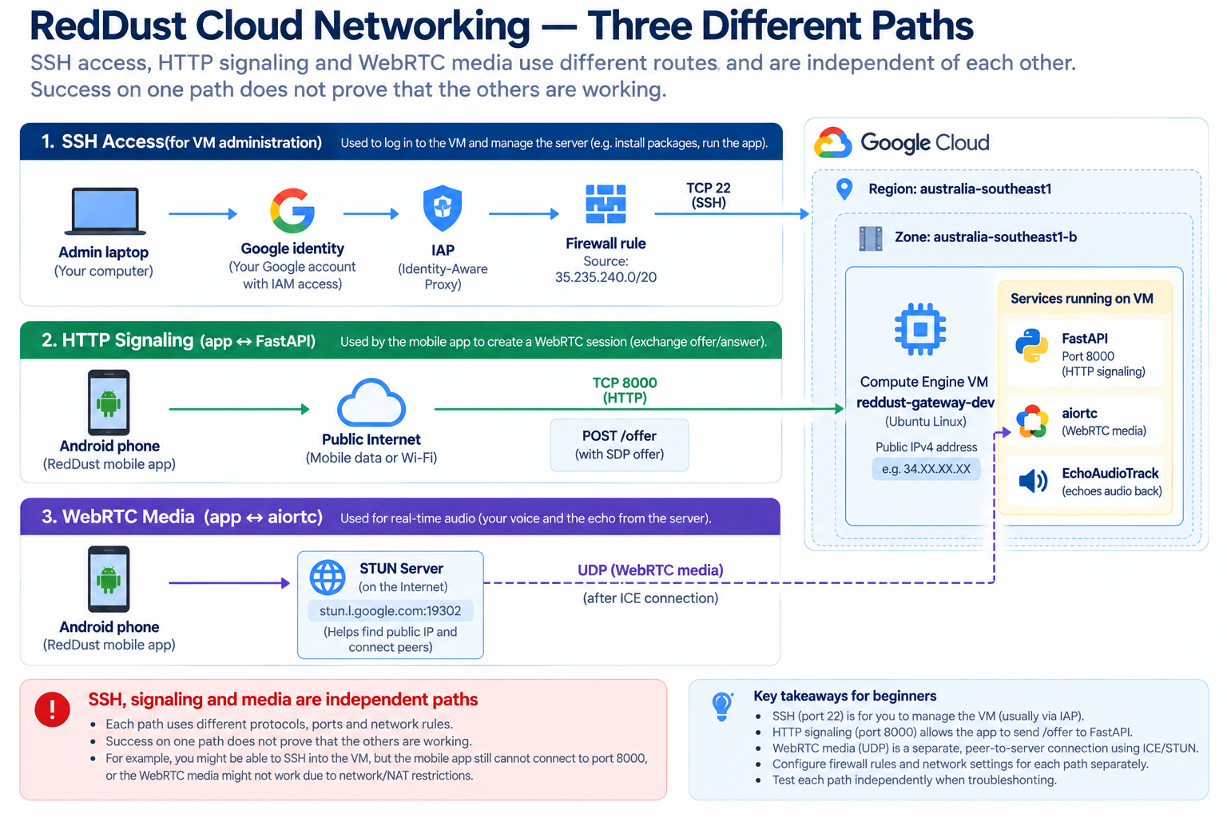
GCP-04: RedDust Networking: Signaling, Media and Admin Access

Quick knowledge check
- Why can /offer succeed while audio still fails?
- What is the difference between an internal IP and an external IP?
- Why is 0.0.0.0/0 risky as a firewall source?
- What separate jobs do IAP and OS Login perform?
CHAPTER 5

Data Analytics & Big Data
What this chapter does and why it matters
Introduce the services used to collect events, stream data, transform it, analyze it at scale and present it to humans. The goal is not to turn every intern into a data engineer, but to make the data platform vocabulary understandable.

New technical concepts in absolute beginner terms
Data warehouse, dataset, table, analytical SQL, event stream, message, topic, subscription, batch processing, stream processing, ETL/ELT, Dataflow, dashboards and BI.

RedDust lens
RedDust will generate operational and product data: sessions, conversation events, recommendation outcomes, wellbeing metrics, model telemetry and platform logs. Pub/Sub and BigQuery are natural building blocks for decoupled events and analytical reporting, while transactional application data can stay in an operational database.

5.1 — Operational Databases versus Analytical Warehouses
An operational database is optimized for application transactions: create a session, update a record, retrieve a user. A data warehouse is optimized for analytical questions across large volumes: trends by week, cohort behavior, model performance, cost per feature or aggregate wellbeing metrics.
Trying to run every analytical workload directly against the production application database can create performance and governance problems. A common architecture separates operational systems from analytical systems and moves curated data through controlled pipelines.

5.2 — BigQuery
BigQuery is Google Cloud’s serverless analytical data warehouse. You store data in datasets and tables and query it with SQL. “Serverless” here means you do not manage database servers; you still manage data design, permissions, query cost, retention and governance.
Example analytical SQL — illustrative
-- Illustrative BigQuery-style analytics
SELECT
DATE(session_started_at) AS day,
COUNT(*) AS sessions
FROM `reddust_analytics.sessions`
GROUP BY day
ORDER BY day DESC;

Cost principle
Serverless does not mean free. BigQuery cost can depend on storage and query processing. Partitioning, clustering, selecting only needed columns and setting governance controls matter.

5.3 — Pub/Sub: Decouple Producers from Consumers
Pub/Sub is a messaging service. A publisher sends messages to a topic. One or more subscriptions deliver those messages to consumers. The publisher does not need to know which consumers exist, which allows systems to evolve independently.
Concept | Plain English | RedDust example
Publisher | System that emits an event. | Gateway publishes session-ended event.
Topic | Named event channel. | reddust-session-events.
Subscription | Consumer’s delivery view of a topic. | Analytics pipeline subscription.
Consumer | Service processing messages. | Dataflow pipeline or microservice.

Understanding Event-Driven Architecture
An event is a record indicating that something meaningful has happened in a system.
Examples include:
- A user starts a session.
- A session ends.
- A music recommendation is delivered.
- A user submits a wellbeing check-in.
In an event-driven architecture, one service can publish an event without directly calling every other service that may need that information.
For example:
- The RedDust Gateway completes a session.
- The backend publishes a session.completed event.
- Pub/Sub makes the message available to subscriptions.
- Authorized consumers process the event for analytics or other approved purposes.
This separation is called decoupling.
Important Consideration
Pub/Sub messages may be delivered more than once depending on the delivery configuration. Consumers should be designed to handle duplicate events safely.
Key takeaway: Event-driven architecture helps services communicate without tightly depending on each other. Reliable event processing still requires careful handling of failures, retries and duplicate messages.

Safe Pub/Sub discovery
gcloud pubsub topics list --project=reddust-development
gcloud pubsub subscriptions list --project=reddust-development

5.4 — Dataflow and Apache Beam
Dataflow is Google Cloud’s managed service for Apache Beam pipelines. Beam lets engineers describe data transformations in a model that can run in batch or streaming modes. Dataflow handles much of the execution infrastructure.
A future RedDust pipeline could read events from Pub/Sub, validate and enrich them, remove or tokenize sensitive fields, and write analytical records to BigQuery. This should be designed with privacy and schema governance from the start.

5.5 — ETL versus ELT
Pattern | Sequence | When it appears
ETL | Extract → Transform → Load | Data is transformed before entering the final analytical store.
ELT | Extract → Load → Transform | Raw/landing data enters the warehouse first, then transformations run there.

Neither acronym is inherently better. The choice depends on source systems, governance, latency, tooling and how much raw data you are allowed to retain.

5.6 — Looker and Looker Studio
Business intelligence (BI) turns data into dashboards and reports. Looker provides governed semantic modeling and BI capabilities for enterprise analytics. Looker Studio provides accessible dashboarding and reporting workflows. The important architectural lesson is to define trusted metrics rather than letting every dashboard invent a different formula for the same business concept.

Designing Meaningful Analytics for RedDust
Collecting large amounts of data does not automatically produce useful product insights.
Before building dashboards, the team should define what each metric means, why it matters and how it will be calculated.
Possible RedDust metrics include:
Metric | Example definition | Purpose
Session completion rate | Completed sessions divided by eligible started sessions | Understand engagement
Recommendation acceptance rate | Accepted music recommendations divided by recommendations presented | Evaluate recommendation relevance
Self-reported mood change | Post-session mood rating minus pre-session rating on the same scale | Explore immediate perceived change
Session failure rate | Failed sessions divided by eligible started sessions | Monitor technical reliability
These are proposed metrics, not validated RedDust performance indicators.
A positive self-reported mood change does not, by itself, prove that RedDust caused the improvement. Outcome claims require appropriate research design, reliable measurement and consideration of alternative explanations.
Privacy Principle
Wellbeing analytics should use the minimum data required for the approved purpose. Identifiable conversation content should not automatically enter analytics pipelines.

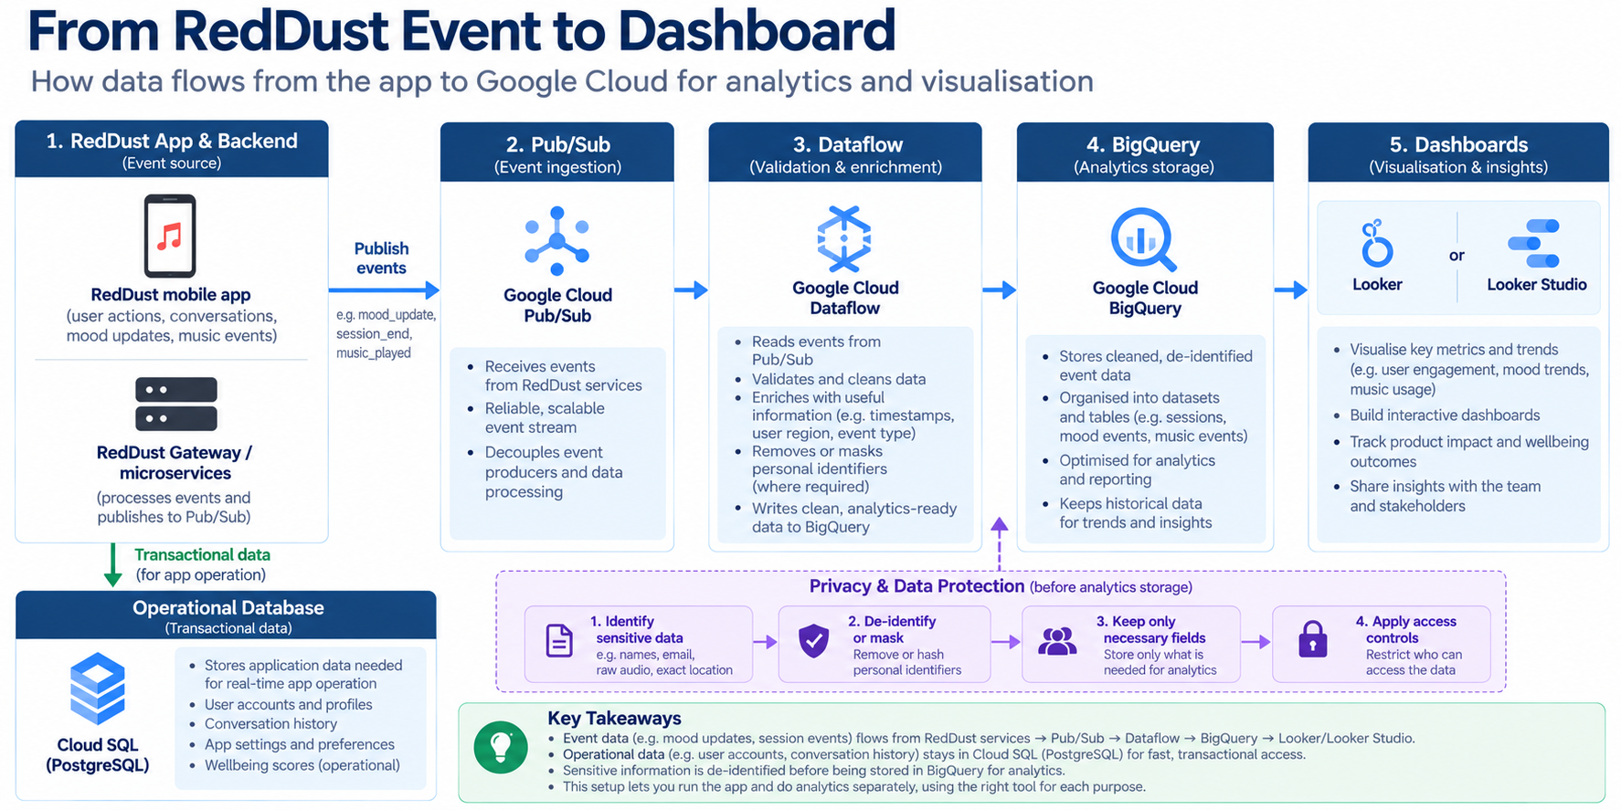
GCP-05: Event to Insight Pipeline

Quick knowledge check
- What problem does Pub/Sub solve between services?
- Why is BigQuery different from Cloud SQL?
- What is the difference between a topic and a subscription?
- Why should analytical metrics have agreed definitions?
CHAPTER 6

Artificial Intelligence & Machine Learning
What this chapter does and why it matters
Give interns a clean vocabulary for AI, ML, deep learning and generative AI, then introduce Google Cloud’s pre-trained APIs, Vertex AI, Gemini and responsible deployment considerations.

New technical concepts in absolute beginner terms
AI, machine learning, training, inference, model, feature, neural network, deep learning, foundation model, embedding, prompt, RAG, model endpoint, evaluation and responsible AI.

RedDust lens
RedDust is an AI-centric product, but the cloud architecture still needs deterministic infrastructure, identity, observability and data governance. Vertex AI can host models and Gemini capabilities; those services should be integrated through scoped workload identity rather than hard-coded secrets.

6.1 — AI, ML, Deep Learning and Generative AI
Term | Beginner definition
Artificial Intelligence | Broad field of building systems that perform tasks associated with intelligence.
Machine Learning | Systems learn patterns from data rather than using only hand-written rules.
Deep Learning | ML using multi-layer neural networks, often at large scale.
Generative AI | Models that generate new text, images, audio, code or other content.
Foundation model | Large general-purpose model that can be adapted or prompted for many tasks.

These terms overlap hierarchically: deep learning is a subset of machine learning; machine learning is one area within AI; modern generative AI often uses deep-learning foundation models.

6.2 — Training versus Inference
Training is the process of adjusting model parameters using data. Inference is using a trained model to produce an output for a new input. A product team often consumes inference services without training a model from scratch.
This distinction matters operationally because training and inference have different cost, hardware, latency and security profiles. A mobile voice assistant may need low-latency inference even if its models were trained elsewhere.

6.3 Understanding the AI Inference Workflow
How AI Inference Works in an Application
Inference is the process of providing new input to a trained model and receiving an output.
A typical AI-powered application follows these steps:
- The application receives input from a user or another authorized source.
- The backend prepares the input and any necessary context.
- The backend sends an inference request to a model or managed AI service.
- The model processes the request and produces an output.
- The application validates or interprets the output before using it.
- Relevant operational metrics and errors are recorded according to the application's logging and privacy policies.

RedDust Example
A future RedDust AI workflow might receive user-authorized emotional context, use a model to support a music recommendation decision and return an appropriate response through the application.
The model may help interpret context, but the backend remains responsible for permissions, external API calls, application rules and safe execution of actions.

6.4 — Pre-trained APIs
Google Cloud offers pre-trained APIs for tasks such as speech recognition, translation, vision analysis and natural-language processing. These services can reduce the amount of custom ML engineering required when their capabilities fit the product requirement.
Capability | Typical use
Speech-to-Text | Convert spoken audio into text.
Text-to-Speech | Generate spoken audio from text.
Translation | Translate text between languages.
Vision | Analyze images.
Natural Language | Analyze text using pre-built language capabilities.

6.5 — Vertex AI
Vertex AI is Google Cloud’s platform for building, evaluating, deploying and operating machine-learning and generative-AI workloads. It brings together model access, training, endpoints, pipelines, evaluation, feature/data integrations and governance capabilities.
For interns, the key mental model is that AI services are still cloud resources. They have APIs, IAM permissions, quotas, regions, logs, cost and data-handling implications just like other services.

6.6 — Gemini, Foundation Models and Model Garden
Gemini refers to Google’s family of multimodal foundation models. Model Garden is a way to discover and work with supported models in Vertex AI. A product can call a managed foundation model rather than hosting all model infrastructure itself.
Architecture rule
Do not put a model API key or long-lived service-account key inside the mobile app or source repository. Prefer server-side access with managed credentials and narrowly scoped IAM.

6.7 — Prompting, Context and Retrieval-Augmented Generation
A prompt is the input instruction and context given to a generative model. Retrieval-Augmented Generation (RAG) adds relevant external information—such as product knowledge or user-authorized context—before asking the model to produce an answer. RAG can improve grounding but does not magically make all outputs correct.
For RedDust, any personal or wellbeing-related context requires careful privacy design, explicit product decisions and appropriate access controls. The infrastructure must help enforce those boundaries through service identity, secrets management, logging policy and data minimization.

6.8 — Evaluation and Responsible AI
A model that produces fluent answers is not automatically safe or useful. Teams need evaluation criteria for quality, latency, cost, bias, safety, grounding and failure behavior. Evaluation should be repeatable and connected to product requirements.
Evaluation area | Example question
Quality | Does the output correctly satisfy the intended task?
Grounding | Can claims be tied to trusted context where required?
Latency | Is response time acceptable for a real-time conversation?
Safety | Does the system avoid disallowed or harmful behavior?
Privacy | Is personal data minimized and correctly protected?
Cost | What is the model cost per user/session/conversation?

6.9 - Responsible AI in a Wellbeing Application
Special Considerations for AI in Emotional Wellbeing
RedDust operates in a sensitive application domain because users may share information about their emotions, experiences and wellbeing.
This creates additional responsibilities beyond ordinary model performance.
1. Accuracy and uncertainty
AI-generated interpretations of emotion may be incomplete or incorrect. The application should avoid presenting uncertain inferences as established facts.
2. User control
Users should understand when AI is being used and retain appropriate control over personal information and recommendations.
3. Privacy and data minimization
The application should collect, transmit and retain only the information necessary for clearly defined purposes.
4. Safety boundaries
A wellbeing companion should not present itself as a substitute for qualified mental health professionals, emergency assistance or clinical diagnosis.
5. Evaluation
Model evaluation should consider response relevance, safety, user experience, latency, cost and the possibility of harmful or inappropriate recommendations.

RedDust Example
If RedDust recommends music based on a user's reported mood, the system should evaluate whether the recommendation is appropriate and helpful rather than assuming that a model-generated suggestion is automatically beneficial.

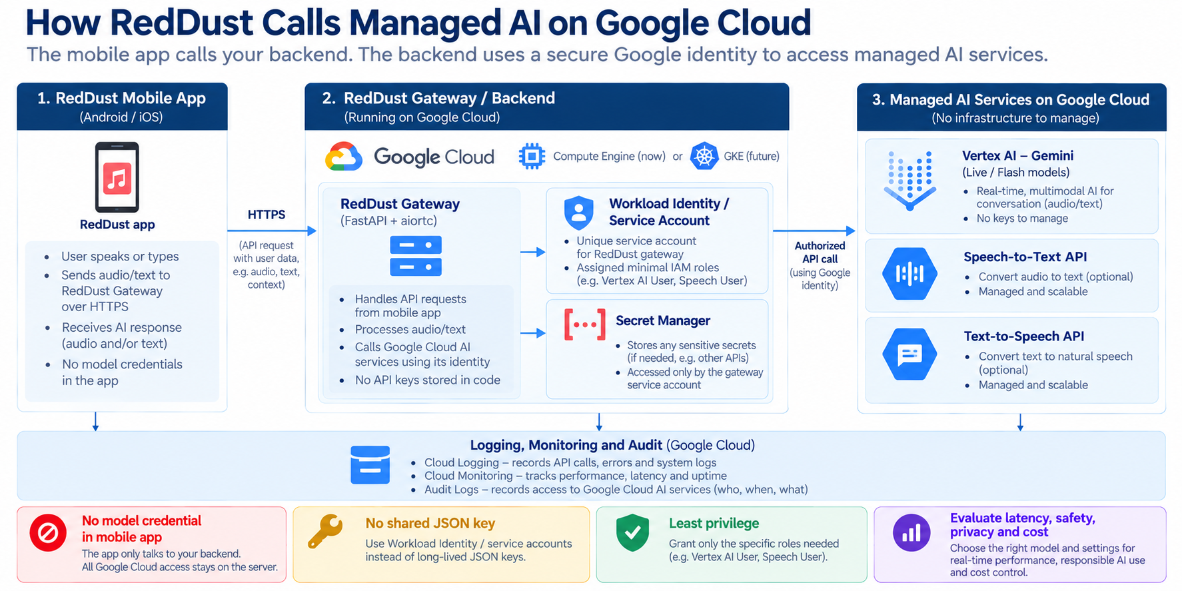

GCP-06: Secure AI Service Integration

Quick knowledge check
- What is the difference between training and inference?
- Why is Vertex AI still subject to IAM and cost governance?
- What does RAG add to a generative AI workflow?
- Why should model evaluation include latency and cost, not only answer quality?
CHAPTER 7

Security, Compliance & Governance
What this chapter does and why it matters
Learn the security model that protects cloud systems: shared responsibility, least privilege, encryption, Zero Trust, IAP, OS Login, service accounts, audit logs, DDoS protection and Security Command Center.

New technical concepts in absolute beginner terms
Shared responsibility, confidentiality/integrity/availability, encryption, TLS, CMEK, Zero Trust, least privilege, authentication, authorization, service account, OS Login, IAP, audit logs, security posture and defense in depth.

RedDust lens
RedDust Step 20 is intentionally identity-centric: individual Google identities, IAM, IAP to TCP 22, OS Login mapping to individual Linux users, 2-Step Verification, and a separate runtime service account. This is the most important chapter for interns who will touch shared cloud infrastructure.

7.1 — Shared Responsibility Model
Google secures the physical data centres, underlying hardware and many layers of managed service infrastructure. Customers secure what they configure and deploy: identities, IAM, application code, data access, network exposure, secrets, guest OS configuration where applicable, and workload behavior. The exact boundary depends on the service.
Layer | Mostly Google responsibility | Mostly customer responsibility
Physical facilities | Data centre access, hardware lifecycle | Choose appropriate locations and services.
Compute Engine virtualization | Hypervisor / infrastructure | Guest OS, packages, application, IAM, firewall design.
Managed services | Service platform operations | Data model, identities, permissions, configuration and application use.
Application | None of your business logic | Secure code, secrets, dependency management, validation and monitoring.

7.2 — Authentication versus Authorization
Authentication asks “Who are you?” Authorization asks “What are you allowed to do?” A user can authenticate successfully to Google but still be denied access to a project because IAM does not grant the required permission.
RedDust analogy
Google identity + 2-Step Verification proves the person. IAM, IAP and OS Login then decide what that person can do and whether they may reach the VM. Authentication success is not authorization success.

7.3 — Least Privilege and Scope
Least privilege means granting only the permissions required, at the narrowest scope that meets the task. It reduces blast radius if an account is compromised or a human makes a mistake.
RedDust developers may need sudo on the one development Gateway VM without needing permission to create arbitrary VMs, change project IAM or administer every service account. This is why the runbook separates project-level Compute Viewer from VM-scoped OS Admin Login and service-account-scoped Service Account User.

Why IAM Role Scope Matters
A user's effective permissions depend on more than the name of the role assigned to them.
An IAM decision considers:
- Principal: Which identity is requesting access?
- Role: Which permissions have been granted?
- Resource: Which resource is being accessed?
- Scope: Where was the role granted?
- Additional controls: Are other applicable policies or access restrictions preventing the action?
Permissions granted at a parent resource may be inherited by resources below it.
For example, granting a role at the project level may provide access to multiple resources, while granting an appropriate role on one supported resource can provide narrower access.

RedDust Example
A developer may need permission to inspect Compute Engine resources and administer the Linux environment of the development Gateway.
That does not mean the developer requires project-wide permission to modify IAM policies, delete arbitrary VMs or administer billing.
Key takeaway: Grant access according to the task and the narrowest practical scope. Being able to administer one VM does not imply permission to administer the entire Google Cloud project.w

7.4 — OS Login
OS Login uses Google identity and IAM to control SSH access to Linux VMs. Instead of maintaining a shared Linux account or manually distributing team SSH keys, each person signs in with their own Google identity and is mapped to an individual Linux account.
Question | Layer that answers it
Can the person see/operate the cloud resource? | Cloud IAM
May the person establish an IAP TCP tunnel? | IAP authorization
May traffic from the IAP proxy reach TCP 22? | VPC firewall
Which Linux account does the user become? | OS Login
May that Linux account use sudo? | Compute OS Admin Login role

7.5 — OS Login 2FA / Google 2-Step Verification
OS Login 2FA adds a second-factor requirement to human SSH login. The Google account must already have 2-Step Verification configured; enabling the project control does not enroll users automatically. Once the hardened path is proven, new users should be onboarded into the already-enabled 2FA model rather than temporarily disabling security.
Read-only check of project metadata
gcloud compute project-info describe \
--project=reddust-development \
--format="yaml(commonInstanceMetadata.items)"

7.6 — IAP and Zero Trust
Zero Trust replaces the old assumption “inside the network = trusted” with continuous identity- and context-based decisions. Identity-Aware Proxy is one Google Cloud mechanism that puts identity authorization in front of access paths. For RedDust administrative SSH, IAP means the VM does not need public port 22 open to the entire Internet.
Defense in depth means IAP is not the only control. IAM must allow the user, the firewall must allow IAP’s source range, OS Login must map the user, and the OS Login role must permit the requested Linux privilege. Every layer answers a different question, and all must pass.

7.7 — Service Accounts and Workload Identity
A service account is an identity for software. On a Compute Engine VM, an attached service account lets applications obtain short-lived credentials from the metadata service. IAM roles on that service account determine which Google Cloud APIs the workload can call.
Security consequence of sudo
A highly privileged VM user can potentially reach workload credentials available to the VM. Therefore the runtime service account must not have more cloud privilege than you are willing to trust to people who have root/sudo on that VM.

7.8 Understanding Service Account Impersonation and Runtime Identity

Human Credentials, Runtime Credentials and Service Account Impersonation
Human users and applications should authenticate through separate identity mechanisms.
A human developer typically authenticates using an individual Google identity.
A workload running on a Compute Engine VM may use an attached service account to obtain short-lived credentials for authorized Google Cloud API requests.
Service account impersonation is a controlled mechanism through which an authorized principal can obtain short-lived credentials to act as a service account. It requires specific permissions and should not be granted broadly.
These mechanisms should not be confused with sharing a service account JSON key.

RedDust Example
If the Gateway eventually needs to access a Google Cloud service, the team can attach an appropriately restricted runtime service account and grant only the required API permissions.
The application should not depend on a developer's personal Google Cloud credentials.
Important Security Principle
A developer with root access to a VM may be able to access credentials available to workloads on that VM. Therefore, the attached service account must have carefully limited permissions.

7.9 — Encryption at Rest, in Transit and CMEK
Encryption at rest protects stored data on media. Encryption in transit protects data moving over networks, commonly with TLS or workload-specific encrypted protocols. Customer-Managed Encryption Keys (CMEK) let organizations control encryption keys through Cloud KMS for supported services and use cases.
CMEK adds control but also adds operational responsibility: key IAM, rotation, availability and accidental key disablement can affect data access. Use it when requirements justify it rather than as a checkbox.

7.10 — Secrets Management
Secrets such as database passwords, API credentials and signing keys should not be committed to Git, embedded in mobile apps, pasted into documentation or stored in world-readable files. Secret Manager provides centralized secret storage with IAM-controlled access and versioning.
RedDust future pattern
Attach a dedicated workload identity to the Gateway; grant that service account access only to the specific Secret Manager secrets it needs. Avoid distributing long-lived service-account JSON keys to developers or servers.

Protecting Sensitive Application Data
Security is not limited to preventing unauthorized access to virtual machines.
Applications must also protect the information they collect, process, transmit and store.
For a wellbeing application, this may include mood entries, conversation content, session history and user preferences.
Important safeguards include:
- Data minimization: Collect only the information needed for an approved purpose.
- Access restrictions: Allow only authorized identities and services to access sensitive records.
- Encryption: Protect data in transit and at rest using appropriate mechanisms.
- Retention: Define how long information is stored.
- Deletion: Establish how user data can be deleted when required.
- Logging controls: Avoid exposing sensitive information through application logs and debugging output.
- Incident response: Define how suspected data exposure or unauthorized access will be investigated and handled.

RedDust Example
An application log may need to record that a session failed, but it does not necessarily need to store the user's private conversation to diagnose that failure.

7.11 — Cloud Audit Logs and Cloud Logging
Audit logs record important administrative and data-access events depending on service and log type. Application and system logs record what workloads are doing. Together they support troubleshooting, security investigations and accountability.
Example read-only log query
gcloud logging read \
'resource.type="gce_instance"' \
--project=reddust-development \
--limit=20 \
--format="table(timestamp,severity,logName,textPayload)"

7.12 — Cloud Armor and DDoS Protection
Cloud Armor provides web-application and DDoS protection capabilities for supported load-balanced applications. It can enforce IP-based rules and managed protections at the edge. It becomes relevant when RedDust exposes production HTTP(S) services behind supported Google Cloud load-balancing architecture.

7.13 — Security Command Center
Security Command Center centralizes security posture findings and asset/security signals. Depending on edition and configuration, it can help identify misconfigurations, vulnerabilities, threats and compliance issues. It is a governance layer—not a replacement for good IAM, patching, secure code or monitoring.

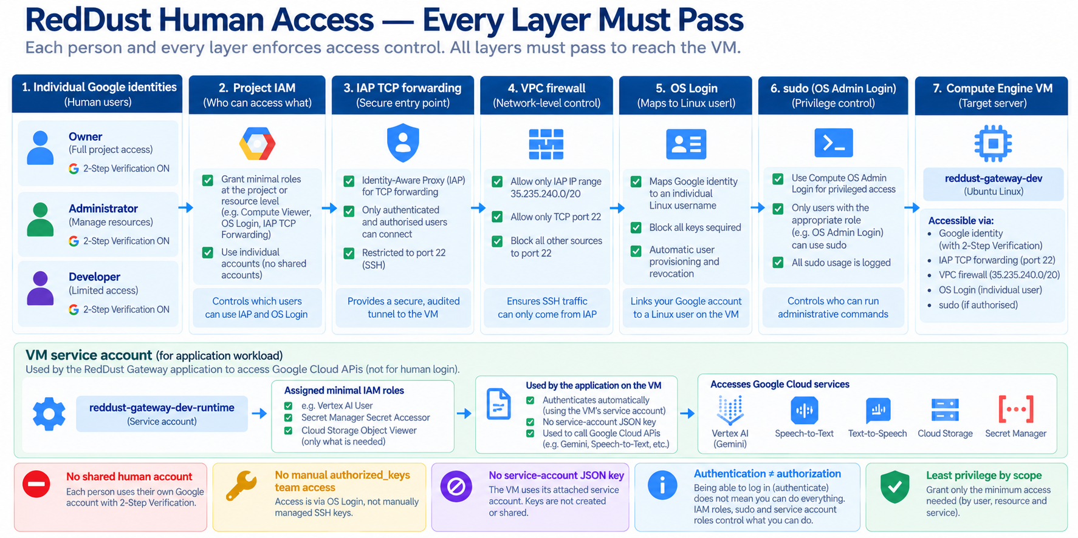
GCP-07: Layered RedDust Access Security

Quick knowledge check
- What is the difference between authentication and authorization?
- Why do IAP and OS Login both exist in the RedDust access path?
- Why can a service account be dangerous if it has broad roles on a VM where many people have sudo?
- Why should secrets not be placed in Git?
CHAPTER 8

Cloud Operations & Financial Governance
What this chapter does and why it matters
Learn how teams keep cloud systems healthy and affordable after deployment: logs, metrics, traces, alerts, SRE thinking, SLIs/SLOs/SLAs, error budgets, billing accounts, budgets and cost optimization.

New technical concepts in absolute beginner terms
Observability, metrics, logs, traces, alerting, APM, SLI, SLO, SLA, error budget, incident response, budget, forecast, cost allocation and FinOps.

RedDust lens
RedDust Step 20 is a development proof, but it still needs operational discipline: health checks, systemd, logs, network diagnostics, budget alerts and stopping the billable e2-medium when testing ends. Step 22 will expand this into CI/CD, DevSecOps, Artifact Registry and stronger observability.

8.1 — Monitoring, Logging and Tracing
Signal | Answers | Example
Metric | How much / how often / how fast? | CPU %, request latency, error count.
Log | What happened? | Gateway startup, exception stack, IAM denial.
Trace | Where did time go across services? | Request path through API → microservice → database.
Alert | When should a human or automation react? | Error rate above threshold for sustained period.

Observability is the ability to understand a system from its outputs. Collecting data is not enough; teams need meaningful dashboards, actionable alerts, retention rules and links from symptoms to root causes.

8.2 — Cloud Monitoring and Cloud Logging
Cloud Monitoring stores metrics and supports dashboards and alerts. Cloud Logging centralizes logs from cloud resources and applications. A Compute Engine workload can export system/application telemetry through Google Cloud agents and application integrations, depending on architecture.
A beginner should first learn the golden questions: Is the service up? Is it responding correctly? Is it fast enough? Are errors increasing? Are resources saturated? Did a deployment change behavior?

8.3 - Understanding Monitoring Versus Troubleshooting

Monitoring, Alerting and Troubleshooting
Although related, monitoring, alerting and troubleshooting serve different purposes.
- Monitoring: Continuously observing the condition and performance of a system.
- Alerting: Notifying an appropriate person or system when an important condition occurs.
- Troubleshooting: Investigating evidence to identify and resolve the cause of a problem.
For example, a monitoring system might record an increasing API error rate. An alert might notify the development team when the error rate exceeds an agreed threshold. Developers would then investigate logs, recent deployments and infrastructure metrics to identify the cause.

RedDust Example
Useful Gateway monitoring signals could include:
- Application availability.
- HTTP signaling success and failure rates.
- WebRTC connection success rates.
- Audio session failures.
- CPU and memory utilization.
- Application restart counts.
These are suggested monitoring signals rather than confirmation that they are currently implemented.

8.4 — Application Performance Management (APM)
APM combines telemetry such as traces, profiles, errors and metrics to understand application performance. In a microservices architecture, distributed tracing becomes especially useful because one user action can cross many services.

8.5 — SLI, SLO and SLA
Term | Meaning | Example
SLI — Service Level Indicator | The measured reliability signal. | 99.7% of API requests succeeded in the last 30 days.
SLO — Service Level Objective | Internal target for the SLI. | Target ≥ 99.9% successful requests.
SLA — Service Level Agreement | External/business commitment, often with consequences. | Contract promises a defined availability level.

Do not set an SLO because 99.99% “sounds professional.” Reliability has a cost. The target should reflect user expectations, business value and the architecture’s ability to deliver it.

8.6 — Error Budgets
An error budget is the amount of unreliability allowed by an SLO. If the SLO is 99.9% successful requests, the remaining 0.1% is the error budget. SRE uses error budgets to balance feature velocity against reliability work: when reliability is healthy, teams can take more change risk; when the budget is exhausted, stabilization becomes more urgent.

8.7 — Health Checks and Layered Troubleshooting
RedDust already uses a simple /healthz endpoint to prove that the FastAPI service is alive. But health should be layered. A VM can be running while the service is down; the service can return /healthz while WebRTC media fails; ICE can connect while audio processing fails.
Gate | Question
Infrastructure | Is the VM running and reachable through the intended admin path?
Application | Does /healthz respond?
Signaling | Does /offer exchange SDP successfully?
Connectivity | Does ICE reach connected/completed?
Media | Does encrypted audio travel and return audibly?

Why a Successful Health Check Does Not Guarantee a Working Application
A health check typically verifies a specific condition rather than every feature of an application.
For example, an HTTP endpoint may return a successful response while another part of the system is malfunctioning.

RedDust Example
Consider the following sequence:
- The Compute Engine VM is running.
- The FastAPI /healthz endpoint responds successfully.
- The mobile application successfully calls /offer.
- ICE establishes a WebRTC connection.
- Audio is transmitted and returned through the Gateway.
- The user hears the returned audio.
Each step validates a different part of the system.
Passing Step 2 does not guarantee that Steps 3–6 will succeed.
For a real-time voice application, functional testing should therefore include network connectivity and media behaviour, not just HTTP availability.

8.8 — Billing Accounts, Budgets and Alerts
A billing account pays for linked projects. Budgets compare spending to thresholds and send alerts. A budget is a visibility mechanism; it does not automatically stop a VM. If automatic shutdown is desired, that is a separate automation design with its own safety considerations.
RedDust operating discipline
Use one development Gateway VM unless an experiment requires more, stop it when not in use, avoid unnecessary static resources and quota increases, and review billing reports regularly. Promotional credits can hide the underlying architecture cost, so track gross consumption too.

8.9 — Cost Optimization Principles
Principle | Beginner action
Right-size | Do not run more CPU/RAM than the workload needs.
Stop idle compute | Development VMs should not run 24×7 unless necessary.
Use managed scaling where appropriate | Prefer services that scale down when the workload allows it.
Watch data transfer | Network egress can be material for media/data-heavy products.
Storage lifecycle | Move/delete data based on retention and access needs.
Tag/label resources | Make cost ownership and environment visible.
Review recurring waste | Old disks, IPs, snapshots and test resources can accumulate.

Cloud Cost Ownership and Development Discipline
Cloud services make it easy to create infrastructure, but resources may continue generating charges after an experiment has finished.
Every cloud resource should have a clear purpose and an identifiable owner or responsible team.
Useful development practices include:
- Create only the resources required for the current task.
- Apply consistent resource naming and labels where supported.
- Review running VMs, disks, snapshots and allocated network resources.
- Stop unnecessary development compute resources.
- Review billing reports and budget notifications.
- Remove obsolete resources only after verifying that they are no longer required.

RedDust Example
The reddust-gateway-dev VM is intended for development and testing.
The team should avoid leaving it running unnecessarily, while remembering that stopping a VM does not eliminate all associated storage and network charges.
A budget alert provides spending visibility but does not automatically shut down the VM.

8.10 — DevOps, CI/CD and DevSecOps
DevOps combines development and operations practices to make software changes repeatable, observable and safe. Continuous Integration (CI) automatically validates code changes. Continuous Delivery/Deployment (CD) moves tested artifacts through environments. DevSecOps integrates security controls—dependency scanning, secret scanning, image scanning, policy and provenance—into that delivery lifecycle.
For RedDust, the roadmap is: prove VM parity first; then add CI/CD, DevSecOps and Artifact Registry; later deploy microservices on GKE with dev/staging/prod, managed secrets, observability, TURN and HTTPS. The order matters because automation should encode a understood working system, not automate unknown failures.

8.11 — Infrastructure as Code
Infrastructure as Code (IaC) describes cloud infrastructure in version-controlled configuration. Terraform is a common tool. Instead of relying on manual console clicks, the desired resources and settings are reviewed as code, planned, applied and recorded in state.
Illustrative Terraform provider context used by the RedDust infrastructure roadmap
terraform {
required_version = "= 1.16.4"
}
provider "google" {
project = "reddust-development"
region = "australia-southeast1"
}

Brownfield rule
When infrastructure already exists, do not blindly “apply” new Terraform and hope it matches. Inventory existing resources, write matching code, import/adopt them, inspect the plan, reconcile drift and reach a no-op plan before controlled change.

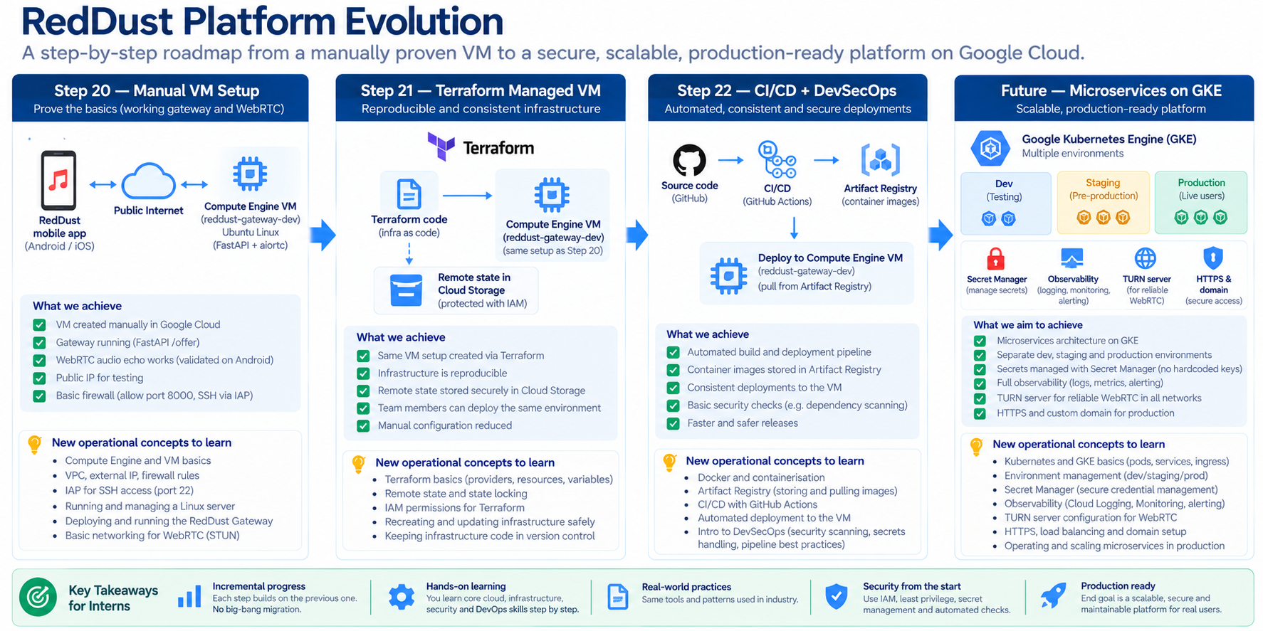
GCP-08: RedDust Platform Evolution Roadmap

Quick knowledge check
- Why is a budget alert not the same as an automatic shutdown?
- What is the difference between an SLI and an SLO?
- Why should CI/CD automate a known-good deployment pattern rather than a poorly understood one?
- What does Terraform state represent at a high level?
- What is the difference between monitoring, alerting and troubleshooting?
- Why can /healthz return a successful response while RedDust audio communication is still failing?

Appendix

Appendix A – RedDust-to-GCP Cheat Sheet
This appendix maps the abstract Google Cloud concepts in the book to the concrete names used in the Step-20 RedDust runbook. It is intentionally concise so interns can keep it beside the implementation guide.
Cloud concept | RedDust implementation / example
Organization | red-dust-proj-org (where applicable in the runbook)
Project | reddust-development / RedDust Development
Primary region | australia-southeast1 (Sydney)
Primary zone | australia-southeast1-b
Compute Engine VM | reddust-gateway-dev
Machine type | e2-medium
Guest OS | Ubuntu 24.04 LTS
Boot disk | 10 GB pd-standard
Application runtime | Python 3.12.10 + shared Linux virtual environment
Gateway stack | FastAPI + Uvicorn + aiortc + PyAV
Human SSH identity | Individual Google identity → IAP → OS Login → individual Linux user
Workload identity | reddust-gateway-dev-runtime service account
Admin SSH | IAP TCP forwarding → TCP 22 → OS Login
Temporary signaling | HTTP TCP 8000
WebRTC media | UDP ephemeral range + ICE/STUN; TURN later
Process manager | systemd
Cost control | Budget alerts + stop VM when not testing
Future IaC | Terraform
Future delivery | CI/CD + DevSecOps + Artifact Registry
Future runtime | GKE microservices with dev/staging/prod, secrets, observability, TURN, HTTPS

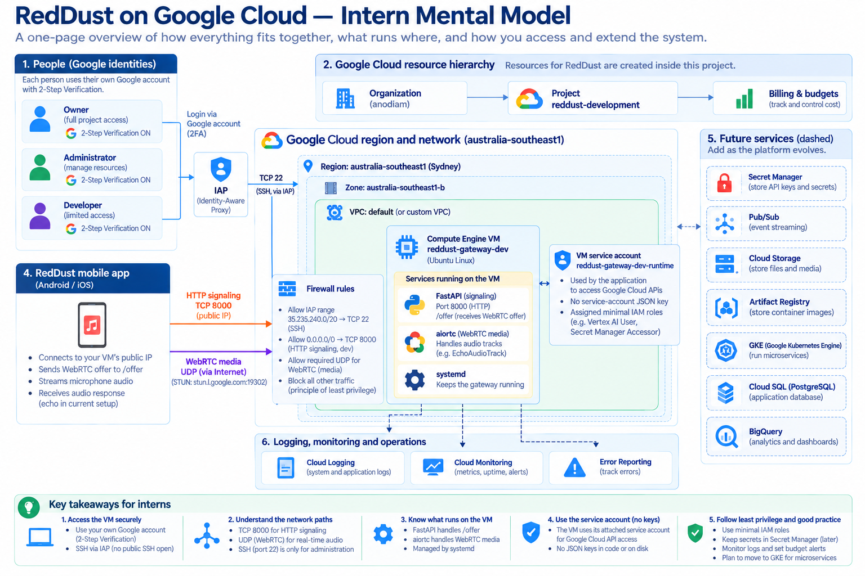
GCP-A1: Entire RedDust GCP Mental Model

Appendix B — gcloud & Cloud Shell Survival Guide
The Google Cloud CLI (gcloud) lets you inspect and manage Google Cloud from a terminal. Cloud Shell is a browser-based shell environment where gcloud is already installed. Interns should learn to verify identity and project context before every command batch.
The three pre-flight questions
1) Which Google identity is active? 2) Which project is active? 3) Is this command read-only or does it change cloud state?

Orientation
gcloud auth list
gcloud config get-value project
gcloud config list

Project and API discovery
gcloud projects describe reddust-development \
--format="yaml(projectId,name,projectNumber,parent)"
gcloud services list --enabled \
--project=reddust-development \
--format="table(NAME,TITLE)"

Compute and networking inventory
gcloud compute instances list --project=reddust-development
gcloud compute networks list --project=reddust-development
gcloud compute networks subnets list --project=reddust-development
gcloud compute firewall-rules list --project=reddust-development

Identity discovery — requires sufficient IAM permissions
gcloud iam service-accounts list --project=reddust-development
gcloud projects get-iam-policy reddust-development \
--format="table(bindings.role,bindings.members)"

Do not learn cloud by destructive experiments in the team project
Creating/deleting VMs, disabling APIs, changing other people’s IAM, deleting service accounts, modifying firewall rules or rotating credentials are write operations. Use an approved sandbox or an assigned runbook step.

Appendix C — Glossary for Absolute Beginners
Term | Plain-English definition
API | A defined interface software uses to request an operation from another system.
Availability zone | A deployment location/failure domain within a region.
Bucket | Top-level container for Cloud Storage objects.
CIDR | Notation for an IP address range, such as 10.0.0.0/24.
Cloud Shell | Browser-based command-line environment with Google Cloud tooling.
Container | Packaged application plus user-space dependencies that shares a host kernel.
DNS | System that maps names to IP addresses.
Egress | Traffic leaving a system/network.
Firewall | Rule set controlling allowed or denied network traffic.
IAM | Identity and Access Management: who can do what on which resource.
IAP | Identity-Aware Proxy; identity-aware access and TCP forwarding capability.
Ingress | Traffic entering a system/network.
Instance | A running or defined virtual machine resource.
Least privilege | Give only the access necessary for a task.
Load balancer | Frontend that distributes traffic to backend services.
Metadata server | Special endpoint through which a GCE workload can obtain instance information and short-lived credentials for an attached service account.
Object | Named data item stored in an object storage bucket.
OS Login | Google identity/IAM-based Linux SSH login for Compute Engine.
Principal | Identity making an access request.
Project | Core GCP boundary for resources, IAM, APIs, quotas and billing linkage.
Region | Geographic cloud location containing zones.
Role | Named bundle of IAM permissions.
Service account | Identity intended for software/workloads.
SLA | Service Level Agreement: formal external reliability commitment.
SLI | Service Level Indicator: measured reliability signal.
SLO | Service Level Objective: target for an SLI.
Subnet | Regional IP address range within a VPC.
Terraform state | Terraform’s record mapping configuration to managed real-world resources.
VPC | Virtual Private Cloud: logically isolated software-defined cloud network.
VM | Virtual machine: software-defined computer with CPU, memory, disks and OS.
Zone | Deployment area inside a region.

Appendix D — 30-Day Intern Learning Plan
Days | Focus | Practical outcome
1–3 | Chapter 1: cloud, regions/zones, projects, IAM | Can explain resource hierarchy and authentication vs authorization.
4–7 | Chapter 2: Compute Engine + Linux basics | Can safely inspect the RedDust VM and explain machine type, disk, image and systemd.
8–11 | Chapter 4: VPC, IPs, firewalls, TCP/UDP, IAP | Can draw the three RedDust network paths and troubleshoot which layer failed.
12–15 | Chapter 7: IAM, OS Login, service accounts, 2FA, audit | Can explain least privilege and human vs workload identity.
16–18 | Chapter 8: logs, monitoring, cost and SRE | Can inspect basic telemetry and explain budgets, SLI/SLO.
19–21 | Chapter 3: storage and databases | Can choose between Cloud Storage, Cloud SQL and NoSQL at a high level.
22–24 | Chapter 5: Pub/Sub, Dataflow, BigQuery | Can explain event-driven and analytical architecture.
25–27 | Chapter 6: Vertex AI / Gemini concepts | Can explain secure AI API integration and evaluation dimensions.
28–30 | Review + RedDust architecture walkthrough | Presents the Step-20 architecture and future roadmap to another intern without notes.

Final Intern Readiness Checklist
- ☐ I can explain why RedDust uses Sydney and what region/zone mean.
- ☐ I can distinguish project IAM from OS Login, IAP and Linux sudo.
- ☐ I can explain human identity versus workload/service-account identity.
- ☐ I can explain why /offer success does not prove WebRTC media success.
- ☐ I know the difference between TCP 22, TCP 8000 and UDP media in the Step-20 architecture.
- ☐ I can safely inspect a VM, VPC, firewall rules, service accounts and logs using read-only commands.
- ☐ I understand that budget alerts notify; they do not automatically stop resources.
- ☐ I can compare Compute Engine, GKE, Cloud Run and functions at a high level.
- ☐ I can distinguish Cloud Storage, Cloud SQL, Firestore, Bigtable and BigQuery by purpose.
- ☐ I can explain Pub/Sub, Dataflow and an event-to-analytics pipeline.
- ☐ I can explain Vertex AI/Gemini as governed cloud services with IAM, cost and data-handling implications.
- ☐ I know that production changes must follow reviewed runbooks/IaC, not ad hoc experiments in a shared project.

Closing Perspective
The most important skill in cloud engineering is not memorizing product names. It is learning to reason in layers: identity, resource hierarchy, network path, compute/runtime, data, observability, security and cost. When something fails, identify which layer is answering which question. When something works, verify that it works for the intended reason rather than because an overly broad permission or firewall rule accidentally made the test pass.
For RedDust, the immediate goal is modest and deliberate: prove a secure, observable, cost-conscious WebRTC Gateway on Compute Engine. Once that boundary is understood and repeatable, Terraform, CI/CD, DevSecOps, Artifact Registry and GKE become controlled engineering steps rather than a collection of unrelated cloud products.

Reference Basis
This book was prepared as an educational companion to the attached RedDust Step-20 “Move Gateway to Cloud” implementation runbook and expands its concrete Compute Engine, IAM, IAP, OS Login, networking, runtime and cost-control patterns into a broad GCP fundamentals curriculum. The chapters also follow the subject areas commonly encountered in Google Cloud Digital Leader and Associate Cloud Engineer foundational study. For production decisions, always validate service behavior and current product documentation before change approval.

