RedDust – WebRTC Connectivity Architecture using Mobile Hotspot
STUN & TURN Integration using Metered Relay Infrastructure

Technology Stack: React Native / Expo, Python / FastAPI, WebRTC
TURN Provider: Metered Relay Services
1. Overview
RedDust uses WebRTC to enable real-time audio and video communication between mobile application users.
To support reliable connectivity across different network environments, RedDust integrates STUN and TURN services through Metered Relay Infrastructure.
The architecture consists of three major components:
- RedDust Mobile: Handles media capture, WebRTC peer connections, and ICE negotiation.
- RedDust Gateway: Handles authentication, WebSocket signalling, SDP exchange, and ICE candidate exchange.
- Metered TURN Infrastructure: Provides STUN discovery and TURN media relay when direct peer-to-peer connectivity is unavailable.
2. Architecture Diagram
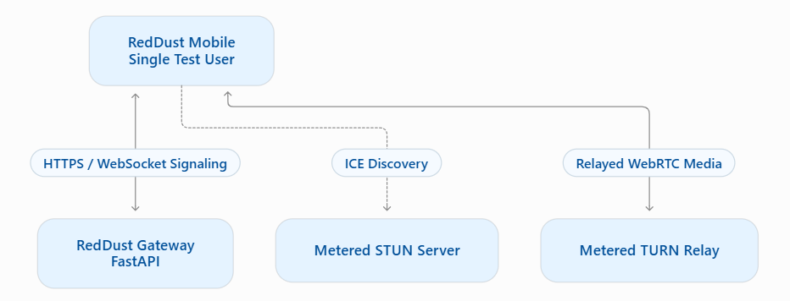
Note: The Gateway handles signaling, not media transmission. Media flows directly between users when possible or through TURN relay when required.
3. ICE Server Configuration
RedDust uses five ICE server endpoints:
Environment Variable | Endpoint
TURN_SERVER_URL_1 | stun:stun.relay.metered.ca:80
TURN_SERVER_URL_2 | turn:global.relay.metered.ca:80
TURN_SERVER_URL_3 | turn:global.relay.metered.ca:80?transport=tcp
TURN_SERVER_URL_4 | turn:global.relay.metered.ca:443
TURN_SERVER_URL_5 | turns:global.relay.metered.ca:443?transport=tcp
These endpoints support:
- STUN public address discovery.
- TURN over UDP.
- TURN over TCP.
- TURN over port 443.
- TURN over TLS.
4. Environment Configuration
Both RedDust Mobile and RedDust Gateway maintain the corresponding ICE server URLs in their environment configurations.
RedDust Mobile: Uses EXPO_PUBLIC_TURN_SERVER_URL_1 through EXPO_PUBLIC_TURN_SERVER_URL_5.
RedDust Gateway: Uses corresponding server-side environment variables if it creates its own WebRTC peer connections.
TURN credentials must be configured separately using the provider's authentication requirements.
Security: Expo public environment variables are accessible within the mobile application bundle. Production deployments should use short-lived TURN credentials rather than permanent credentials embedded in the application.
5. WebRTC Connection Flow (Single User)
- User initiates a call from RedDust Mobile.
- RedDust Gateway authenticates the user and creates a signaling session.
- RedDust Mobile creates an RTCPeerConnection and captures local media.
- Mobile sends an SDP offer through the Gateway.
- Gateway facilitates SDP offer/answer exchange with the remote endpoint.
- ICE candidates are exchanged through the Gateway.
- WebRTC establishes a direct P2P connection when possible; otherwise, TURN relay is used.
- Real-time audio/video communication begins.
6. Security and Reliability
Recommended practices:
- Use HTTPS and WSS for production communication.
- Authenticate and authorize signaling sessions.
- Use temporary TURN credentials.
- Protect backend TURN credentials.
- Monitor ICE connection states and selected candidate pairs.
- Support reconnection when network connectivity changes.
- Test UDP, TCP, and TLS connectivity across different networks.
WebRTC uses DTLS-SRTP to protect media communication.
7. Conclusion
The STUN/TURN integration improves RedDust's WebRTC connectivity across different network environments.
RedDust Mobile manages media and peer connections, RedDust Gateway manages signaling, and Metered provides network traversal and media relay services.
This architecture establishes a foundation for reliable and scalable real-time audio/video communication in RedDust

How to implement WebRTC Connectivity Architecture using Mobile Hotspot
Create user credential
Free WebRTC TURN Server - Open Relay Project | Open Relay Project - Free WebRTC TURN Server
- Press Login and do Signup if account is not there
- Then create a new credential by pressing +New Credential button
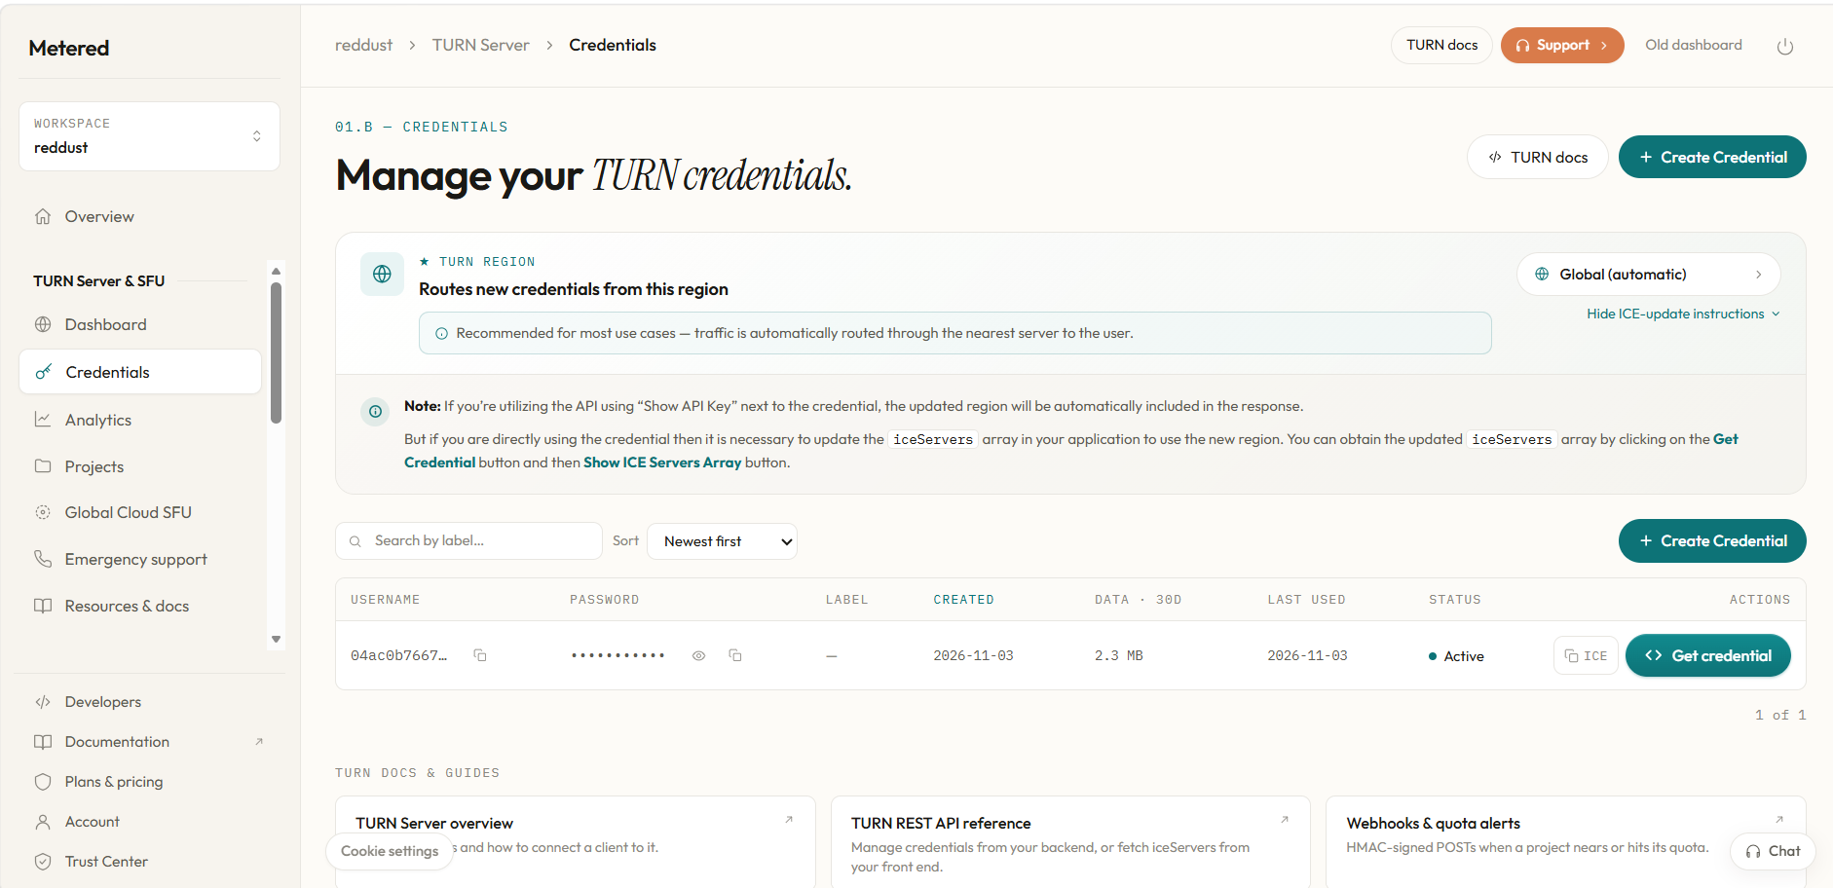

- After creating the credential, press Get credential button, the bottom screen appears
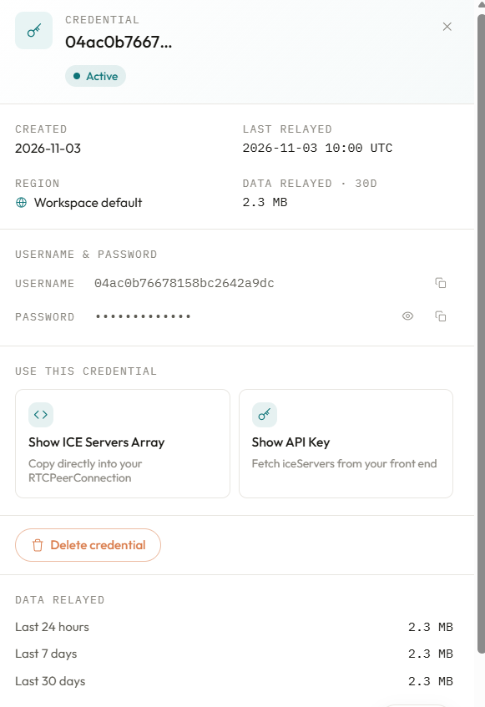

- Press button “Show ICE Servers Array”

- Add the ICE server urls in the file index.tsx of Reddust-mobile project.
const createPeerConnection = () => {
const turnUsername = process.env.EXPO_PUBLIC_TURN_USERNAME;
const turnCredential = process.env.EXPO_PUBLIC_TURN_CREDENTIAL;

const pc = new RTCPeerConnection({
iceServers: [
{
urls: process.env.EXPO_PUBLIC_TURN_SERVER_URL_1 as string,
},
{
urls: process.env.EXPO_PUBLIC_TURN_SERVER_URL_2 as string,
username: turnUsername,
credential: turnCredential,
},
{
urls: process.env.EXPO_PUBLIC_TURN_SERVER_URL_3 as string,
username: turnUsername,
credential: turnCredential,
},
{
urls: process.env.EXPO_PUBLIC_TURN_SERVER_URL_4 as string,
username: turnUsername,
credential: turnCredential,
},
{
urls: process.env.EXPO_PUBLIC_TURN_SERVER_URL_5 as string,
username: turnUsername,
credential: turnCredential,
},
],
});

- In your .env.local file Reddust-Mobile project add TURN Server Configuration properties
EXPO_PUBLIC_GATEWAY_URL= http://Laptop-ID:8000 This is already there
# TURN Server Configuration (This is for Metered OpenRelay users only)
EXPO_PUBLIC_TURN_SERVER_URL_1=stun:stun.relay.metered.ca:80
EXPO_PUBLIC_TURN_SERVER_URL_2=turn:global.relay.metered.ca:80
EXPO_PUBLIC_TURN_SERVER_URL_3=turn:global.relay.metered.ca:80?transport=tcp
EXPO_PUBLIC_TURN_SERVER_URL_4=turn:global.relay.metered.ca:443
EXPO_PUBLIC_TURN_SERVER_URL_5=turns:global.relay.metered.ca:443?transport=tcp
# Authentication credentials for the TURN server
EXPO_PUBLIC_TURN_USERNAME=YOUR_USER_NAME
EXPO_PUBLIC_TURN_CREDENTIAL=YOUR_PASSWORD.

- In your .env.local file of Reddust-Gateway project,

add TURN Server Configuration properties
# TURN Server Configuration (This is for Metered OpenRelay users only)
EXPO_PUBLIC_TURN_SERVER_URL_1=stun:stun.relay.metered.ca:80
EXPO_PUBLIC_TURN_SERVER_URL_2=turn:global.relay.metered.ca:80
EXPO_PUBLIC_TURN_SERVER_URL_3=turn:global.relay.metered.ca:80?transport=tcp
EXPO_PUBLIC_TURN_SERVER_URL_4=turn:global.relay.metered.ca:443
EXPO_PUBLIC_TURN_SERVER_URL_5=turns:global.relay.metered.ca:443?transport=tcp
# Authentication credentials for the TURN server
EXPO_PUBLIC_TURN_USERNAME=YOUR_USER_NAME
EXPO_PUBLIC_TURN_CREDENTIAL=YOUR_PASSWORD.

- Now start the Reddust-Gateway server
python -m uvicorn app.main:app --reload --host 0.0.0.0 --port 8000
- Start the Reddust-Mobile server
npx expo start

