PLATFORM
ARCHITECTURE
STEP 21 — MOVE REDDUST GATEWAY TO TERRAFORM IaC
Implementation runbook for converting the Step-20 Google Cloud VM into Infrastructure as Code
Project RedDust


From Anodiam


RedDust
Version | Publisher | Date | Reviewer | Date
1.0.0 | Anodiam | 25/09/2026

Document purpose
This runbook is the Step-21 continuation of the proven Step-20 GCP VM implementation. It moves the same RedDust Gateway echo-test environment into Terraform - Infrastructure as Code while preserving the working security, networking and runtime boundaries.

Contents
Introduction
21.0 — Terraform mental model
21.1 — Parity boundary
21.2 — Baseline inventory
21.3 — Windows Terraform toolchain
21.4 — Repository structure
21.5 — GCP authentication
21.6 — Remote Terraform state
21.7 — Root configuration
21.8 — Required GCP APIs
21.9 — OS Login and human IAM
21.10 — Runtime service account
21.11 — Networking
21.12 — IAP-only SSH
21.13 — TCP 8000 signalling
21.14 — WebRTC UDP
21.15 — Compute Engine VM
21.16 — Linux/Python bootstrap
21.17 — GitHub source delivery
21.18 — systemd
21.19 — Budget alerts
21.20 — Import existing Step-20 resources
21.21 — Reconcile to no-op plan
21.22 — First controlled apply
21.23 — Access validation
21.24 — Runtime health validation
21.25 — Wi-Fi and 4G/5G echo acceptance
21.26 — Ongoing Terraform workflow
21.27 — Stop/start, drift and break-glass
21.28 — DevSecOps guardrails
21.29 — Troubleshooting
21.30 — Completion checklist
21.31 — Condensed sequence
21.32 — Step-20 to Step-21 mapping
21.33 — Complete reference file set
21.34 — Glossary
21.35 — References
Next planned engineering step

Introduction
What this section does and why it matters
Step 20 proved the real Internet WebRTC echo path on reddust-gateway-dev. Step 21 changes the management method, not the working telephony architecture. The output of this step is reviewable Terraform code, protected Terraform state and a safe brownfield adoption of the existing resources.
New technical concepts in absolute beginner terms
Infrastructure as Code means the desired cloud environment is stored as text files in Git. Terraform compares those files with the real Google Cloud environment, produces a plan, and applies only reviewed changes.
Who does what
The Owner (owner@anodiam.com) retains ultimate authority. The Administrator (admin@anodiam.com) provisions and operates Terraform. The Developer (dev@anodiam.com) validates the Gateway and gets only the least privilege required to work on the development VM.

Role | Google identity | OS Login Linux user
Owner | owner@anodiam.com | owner_anodiam_com
Administrator | admin@anodiam.com | admin_anodiam_com
Developer | dev@anodiam.com | dev_anodiam_com

Central rule
Achieve Terraform parity before architecture improvement. Do not redesign the VM, VPC, HTTPS, TURN or Kubernetes while you are still proving that Terraform can safely describe the Step-20 environment.

DIAGRAM PLACEHOLDER — 21-A: Step 20 Manual GCP versus Step 21 Terraform
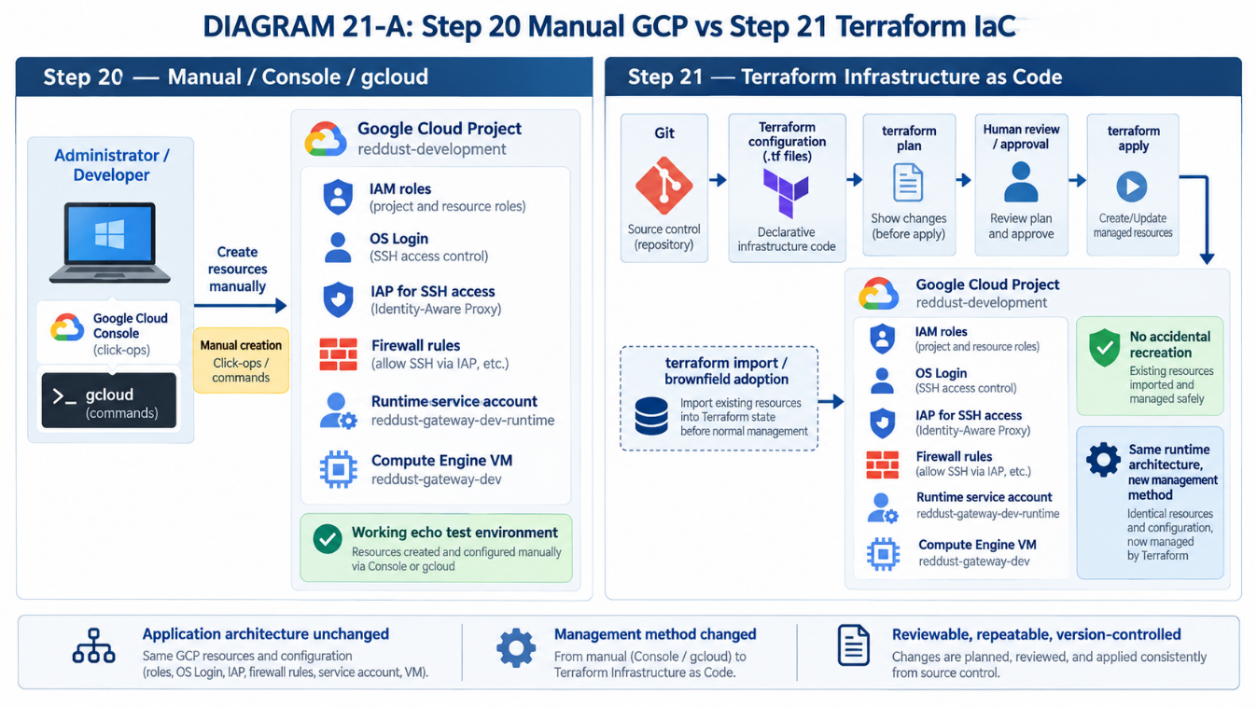

21.0 — What Changes in Step 21: From Click-Ops to Infrastructure as Code
What this section does and why it matters
Build the beginner mental model for configuration, state, plan and apply.
New technical concepts in absolute beginner terms
Declarative infrastructure describes the desired end state. Terraform state is the map between code and real cloud objects. Plan is a preview; apply is the change.
Who does what
Administrator drives Terraform. Owner reviews sensitive or destructive changes. Developer validates app-facing effects.

• Treat .tf files as the desired infrastructure recipe.
• Treat state as sensitive operational data.
• Never assume a successful apply proves the application works.
• Read create/update/destroy/replace actions before approval.
Reference command/configuration
resource "google_compute_instance" "gateway" {
name = "reddust-gateway-dev"
machine_type = "e2-medium"
zone = "australia-southeast1-b"
}

DIAGRAM PLACEHOLDER — 21-B: Terraform Mental Model
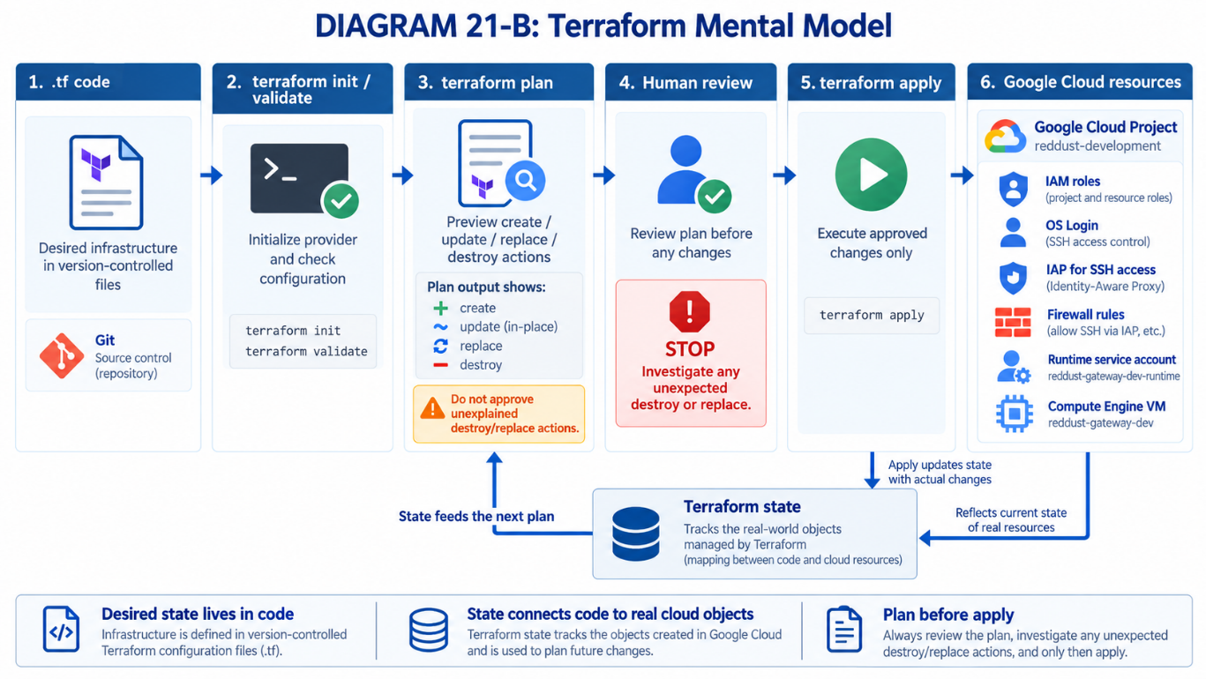

21.1 — Define the Terraform End State and Step-20 Parity Boundary
What this section does and why it matters
Freeze the exact Step-20 architecture that Terraform must first reproduce.
New technical concepts in absolute beginner terms
Parity means functionally the same infrastructure and behavior even though the provisioning mechanism changes.
Who does what
Owner approves the target. Administrator maps each resource. Developer confirms the echo-test behavior remains the same.

• Project in GCP stays reddust-development.
• VM stays reddust-gateway-dev / e2-medium / Sydney / Ubuntu 24.04 / 10 GB pd-standard.
• Runtime service account remains:
reddust-gateway-dev-runtime@reddust-development.iam.gserviceaccount.com
• IAP-only SSH, TCP 8000 signalling and the verified UDP range remain the initial network design.
• HTTPS, TURN, dedicated VPC, containers and Kubernetes are explicitly deferred.
DIAGRAM PLACEHOLDER — 21-C: Step-20 Resource-to-Terraform Mapping
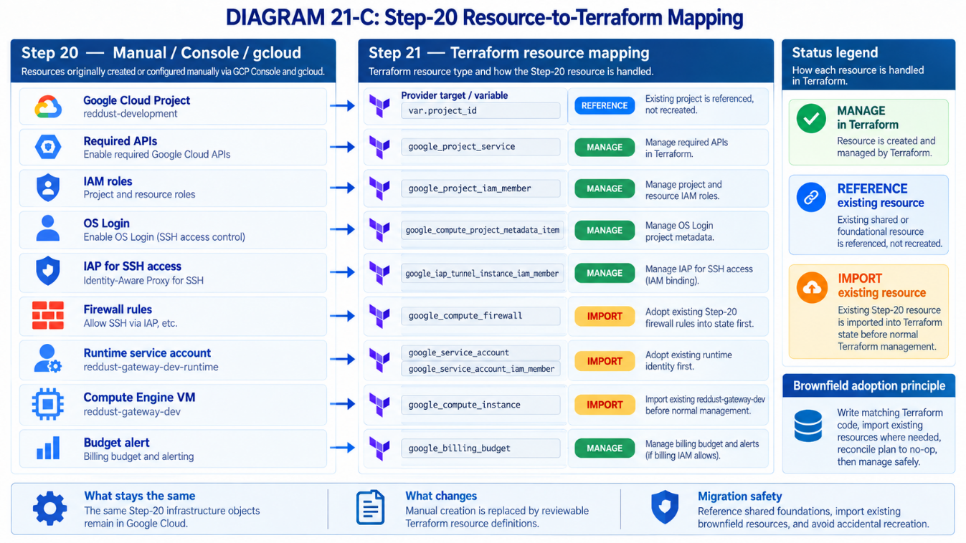

21.2 — Freeze and Inventory the Existing Step-20 Environment before Terraform Touches It
What this section does and why it matters
Capture read-only evidence of the existing working environment before any Terraform apply.
New technical concepts in absolute beginner terms
Brownfield means infrastructure already exists. Import associates an existing resource with a Terraform address instead of creating a duplicate.
Who does what
Administrator captures GCP data. Developer records Linux/runtime/WebRTC values. Owner confirms project and identity scope.

• Save project, VM, firewall, metadata, IAM and service-account JSON descriptions locally.
• Record the actual Linux UDP ephemeral range.
• Confirm current systemd status and /healthz.
• Record the current external IP and the known-good Git commit if available.
• Do not commit tokens, keys or .env secrets.
UDP (User Datagram Protocol) is a fast way for computers to send network data without waiting for confirmation that every packet arrived. WebRTC commonly uses UDP for real-time audio because low delay is more important than perfect delivery, so we record the Linux VM’s actual UDP ephemeral port range to make sure the GCP firewall and Terraform configuration allow the ports the Gateway may use for WebRTC media.
systemd is Linux’s standard service manager: it starts, stops, restarts, and monitors programs that should run in the background. For example, it can automatically start the RedDust Gateway when the VM boots, restart it if Uvicorn crashes, and keep it running even after a developer closes the SSH session. Common commands include systemctl start reddust-gateway, systemctl stop reddust-gateway, systemctl restart reddust-gateway, and systemctl status reddust-gateway.

Reference command/configuration
$PROJECT_ID="reddust-development"
$VM_NAME="reddust-gateway-dev"
$ZONE="australia-southeast1-b"
gcloud compute instances describe $VM_NAME --project=$PROJECT_ID --zone=$ZONE --format=json > vm.json
gcloud compute firewall-rules list --project=$PROJECT_ID --format=json > firewall-rules.json
gcloud projects get-iam-policy $PROJECT_ID --format=json > project-iam.json

DIAGRAM PLACEHOLDER — 21-D: Brownfield Adoption Safety Sequence
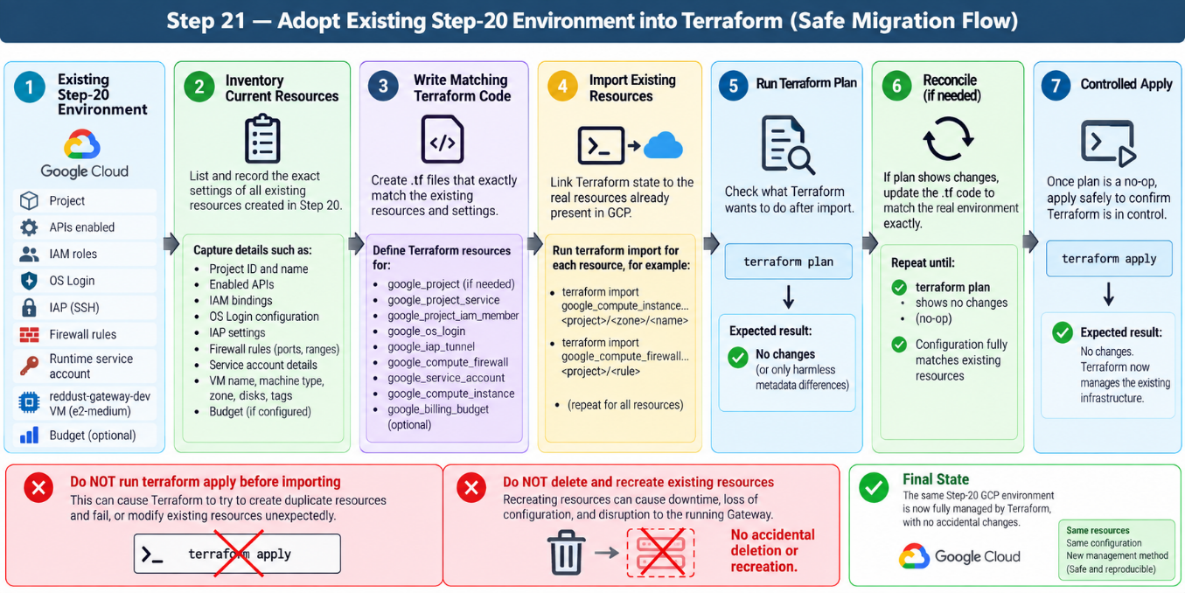

21.3 — Install and Verify the Local Terraform Toolchain on Windows
What this section does and why it matters
Prepare a repeatable Windows workstation for Terraform, Git and gcloud.
New technical concepts in absolute beginner terms
PATH lets PowerShell find executables. Terraform CLI parses configuration; Git tracks code; gcloud supplies authentication and independent verification.
Who does what
Administrator installs/verifies tools. Developer may install for validation/review. Apply permission remains controlled by IAM.

• Verify Terraform in a new PowerShell session.
• Verify Git and gcloud.
• Use VS Code Terraform support only as an editor aid.
• Run terraform fmt and terraform validate as the real local quality gate.
Reference command/configuration
terraform version
git --version
gcloud version
gcloud auth list

DIAGRAM PLACEHOLDER — 21-E: Windows Terraform Workstation
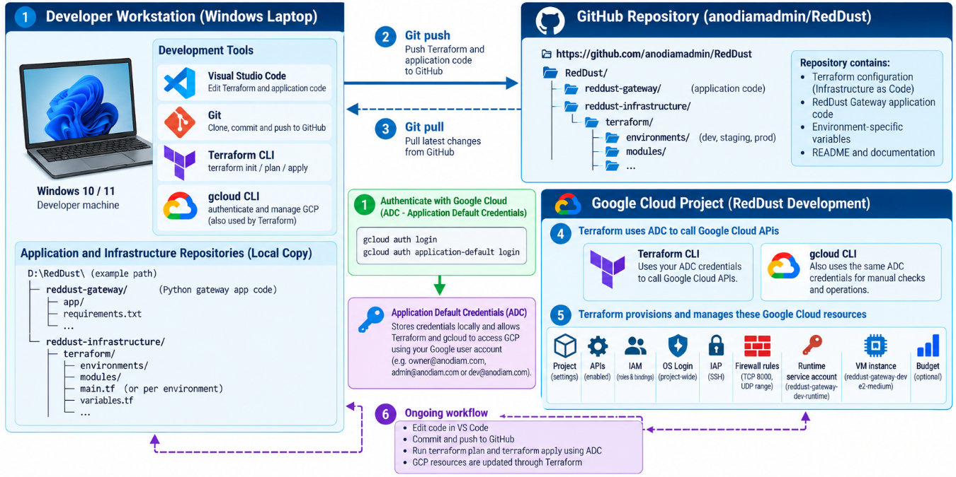

21.3 — Install and Verify the Local Terraform Toolchain on Windows
What this section does and why it matters
Prepare a repeatable Windows workstation for Terraform, Git and gcloud before any RedDust infrastructure is changed. The goal is to prove that every required local tool is installed, discoverable from PowerShell, and able to perform harmless local checks.
New technical concepts in absolute beginner terms
PATH is the list of folders Windows searches when you type a command. Terraform CLI reads and checks Terraform configuration, Git versions the code, and gcloud provides Google Cloud authentication and independent verification. VS Code is the editor; its extensions improve the editing experience but do not replace the underlying command-line tools.
Who does what
The Administrator installs and verifies the complete toolchain and will later be the primary Terraform operator. Developers may install the same tools for review, formatting, validation and troubleshooting. Whether anyone can actually change Google Cloud still depends on Google Cloud IAM permissions, not merely on having Terraform installed.

For Step 21.3, the minimum workstation components are:
Component | Required? | Purpose in Step 21
VS Code | Yes / already used | Primary editor for Terraform and RedDust source code.
Terraform CLI | YES | Runs Terraform commands such as fmt, validate, plan, apply and import.
Git for Windows | YES | Versions Terraform code and communicates with GitHub.
Git Bash | Optional | Convenient Bash shell installed with Git for Windows; this runbook standardizes on PowerShell.
Google Cloud CLI (gcloud) | YES | Later provides Google authentication and independent checks against real GCP resources.
HashiCorp Terraform VS Code extension | Strongly recommended | Adds Terraform syntax highlighting, language support, formatting and editor diagnostics.
Separate Git VS Code extension | No | VS Code already includes built-in Git source-control integration.
Google Cloud Code extension | Optional | Useful IDE integration but not required for Step 21.3.
Separate HCL extension | Not required | The HashiCorp Terraform extension already understands Terraform .tf files.

21.3.1 — Understand What We Are Installing
In Step 20, infrastructure could be created or inspected through the Google Cloud Console and gcloud commands. In Step 21, Terraform becomes the primary infrastructure-management tool, but it does not replace VS Code, Git or gcloud. Each tool has a different job.
Beginner mental model
VS Code
│
│ edit files
▼
Terraform .tf files
│
├──── Git ─────────► GitHub
│
└──── Terraform CLI ─────► Google Cloud
▲
│ authentication / verification
│
gcloud

Boundary for this subsection
For now, install and verify the tools only. Do not authenticate Terraform to Google Cloud, create Terraform-managed resources, import the Step-20 VM, or run terraform apply in this subsection.

21.3.2 — Use PowerShell as the Standard Step-21 Windows Shell
For consistency across the team, use PowerShell only as the normal Windows command shell for this Terraform runbook. Git Bash may remain installed and is useful for Bash-oriented work, but switching casually among PowerShell, Git Bash, Command Prompt and WSL can create confusing differences in quoting, path syntax and environment variables.
PowerShell variable syntax example
$PROJECT_ID="reddust-development"

Bash variable syntax example
PROJECT_ID="reddust-development"

Team convention
Unless a later subsection explicitly says otherwise, run Windows-side Terraform and gcloud commands from PowerShell only.

21.3.3 — Verify VS Code First
If VS Code is already installed, open a new PowerShell window and verify that Windows can find the VS Code command-line launcher.
code --version

Expected result: VS Code prints version information. If PowerShell reports that code is not recognized, repair or reinstall VS Code and ensure its command-line launcher is available on PATH.
Acceptance check
Do not continue until code --version succeeds from a fresh PowerShell session.

21.3.4 — Install Git for Windows
Git is required. Terraform files will be version-controlled just like application code, and Git will eventually be used to commit and push the infrastructure files to the RedDust GitHub repository.
Install Git for Windows using either the normal official installer or Windows Package Manager. If using winget:
winget install --id Git.Git -e --source winget

After installation, close PowerShell completely, open a brand-new PowerShell window, and verify Git:
git --version
where.exe git

Expected form: git prints a version such as git version 2.x.x.windows.x, and where.exe git returns the path to git.exe. The exact version and installation folder can vary.

21.3.5 — Decide How Git Bash Will Be Used
Git Bash is useful, but it is not a separate RedDust requirement. Git for Windows normally installs Git Bash automatically, so it can remain available for shell-script work.
Git for Windows REQUIRED
Git executable REQUIRED
Git Bash OPTIONAL / convenient

For this runbook, PowerShell remains the standard Windows shell. You also do not need a separate Git extension for VS Code because VS Code already provides built-in Git source-control support.

21.3.6 — Install Terraform CLI
Terraform CLI is the most important new tool in Step 21. It is the actual executable that reads Terraform configuration and runs Terraform commands. The VS Code extension does not replace it.
Examples of Terraform CLI commands used across Step 21
terraform fmt
terraform init
terraform validate
terraform plan
terraform apply
terraform import

Install the 64-bit Windows Terraform binary appropriate for the workstation. For a normal Intel/AMD Windows laptop this is the Windows AMD64 build. A simple team-friendly location is:
C:\HashiCorp\Terraform\
C:\HashiCorp\Terraform\terraform.exe

Important
Use an approved Terraform 1.x version for the project. The project configuration will later constrain compatible Terraform versions so that the team does not silently jump to an incompatible major release.

21.3.7 — Add Terraform to Windows PATH
PATH is simply the list of folders Windows searches when you type a command. Without PATH you would have to type the full path to terraform.exe every time; with PATH configured, the command terraform works from any normal terminal.
Add this folder to the Windows user PATH:
C:\HashiCorp\Terraform

Do not add the executable itself
PATH must contain the folder C:\HashiCorp\Terraform — not C:\HashiCorp\Terraform\terraform.exe.

1. Open Windows Search and search for “Edit environment variables for your account”.
2. Open Environment Variables.
3. Under User variables, select Path and choose Edit.
4. Choose New and enter C:\HashiCorp\Terraform.
5. Confirm all dialogs with OK.
6. Close existing terminals so new processes receive the updated PATH.

21.3.8 — Open a Completely New PowerShell Window and Verify Terraform
An already-open terminal may still be using the old PATH. Close PowerShell, Windows Terminal tabs and the VS Code integrated terminal, then reopen PowerShell.
terraform version
where.exe terraform

Expected result: Terraform prints its version and platform, and where.exe terraform identifies the terraform.exe location. For example, the platform should normally be windows_amd64 on a standard Intel/AMD laptop.
Acceptance check
Both terraform version and where.exe terraform must succeed before continuing.

21.3.9 — Install Google Cloud CLI
Google Cloud CLI is also required for the complete Step-21 workstation. Terraform will later use Google credentials, while gcloud remains valuable as an independent way to inspect and verify the real Google Cloud environment.
Examples of gcloud capabilities used later
gcloud auth list
gcloud config get-value project
gcloud compute instances list
gcloud auth application-default login

Run the normal Google Cloud CLI Windows installer. For a typical Windows workstation, allow the installer to install its bundled Python if required, add gcloud to PATH, and install the core CLI components.
Do not confuse the two Pythons
The Python used internally by gcloud is separate from the RedDust Gateway application Python 3.12.10. Installing or updating gcloud must not be treated as changing the Gateway runtime.

21.3.10 — Do Not Configure Terraform Authentication Yet
The Google Cloud CLI installer may offer to initialize or sign in. Step 21.3 only needs to prove that the gcloud command exists and starts correctly. The controlled Google identity and Application Default Credentials (ADC) procedure belongs to the later authentication section.
gcloud version
where.exe gcloud

Not yet
Do not run gcloud auth application-default login as part of Step 21.3. Authentication is deliberately separated from tool installation so we can verify the workstation before giving Terraform access to GCP.

21.3.11 — Install the Official HashiCorp Terraform VS Code Extension
Open VS Code, open Extensions (Ctrl+Shift+X), search for “HashiCorp Terraform”, and install the official extension published by HashiCorp. Its extension identifier is:
hashicorp.terraform

The extension improves editing with Terraform-aware syntax highlighting, completion, navigation, formatting and diagnostics. It is an editor aid; the actual terraform.exe must still be installed and available on PATH.
Use the stable extension
Install the standard HashiCorp Terraform extension. Do not standardize the project on a preview/testing Terraform extension.

21.3.12 — Do We Need the Separate HCL VS Code Extension?
No. Terraform files use HashiCorp Configuration Language (HCL), but the official HashiCorp Terraform extension already understands Terraform .tf files. A separate HCL extension is therefore not required for this project’s normal Terraform editing workflow.
HashiCorp Terraform extension YES
Separate HCL extension NOT REQUIRED

21.3.13 — Do We Need Google Cloud Code for VS Code?
No, not for this step. Google-oriented VS Code tooling can be added later if the team finds it useful, but it is not part of the minimum Terraform workstation. The required Google Cloud command-line tool for this runbook is gcloud CLI.
gcloud CLI REQUIRED
Google Cloud Code VS Code ext. OPTIONAL

21.3.14 — Restart VS Code and Verify All Commands Inside Its PowerShell Terminal
Close VS Code completely and reopen it so it inherits the updated Windows PATH. In VS Code, choose Terminal → New Terminal and confirm the shell is PowerShell.
Run all four tool checks from the VS Code PowerShell terminal:
terraform version
git --version
gcloud version
code --version

All four commands must work inside VS Code. This proves that the editor’s integrated PowerShell terminal sees the same tools as a normal Windows PowerShell session.

21.3.15 — Perform One Combined Workstation Verification
Run the following block from a fresh PowerShell terminal inside VS Code. The purpose is not to enforce one exact version number; it is to prove that each executable is found and starts correctly.
Write-Host "=== TERRAFORM ==="
terraform version
Write-Host "`n=== TERRAFORM PATH ==="
where.exe terraform
Write-Host "`n=== GIT ==="
git --version
Write-Host "`n=== GIT PATH ==="
where.exe git
Write-Host "`n=== GCLOUD ==="
gcloud version
Write-Host "`n=== GCLOUD PATH ==="
where.exe gcloud
Write-Host "`n=== VS CODE ==="
code --version

Expected result
Every command is found, each executable starts successfully, and there are no “command not found” or PATH errors.

21.3.16 — Perform a Harmless Local Terraform Formatting and Validation Test
Now prove that Terraform can process a local .tf file without authenticating to Google Cloud or changing any RedDust infrastructure.
Create a temporary folder and move into it:
mkdir D:\RedDust\terraform-tool-test
cd D:\RedDust\terraform-tool-test

Create a file named test.tf containing:
terraform {
required_version = ">= 1.6.0, < 2.0.0"
}

Then run:
terraform fmt
terraform validate

Expected result: Terraform reports that the configuration is valid.
Why this is safe
This test does not authenticate to Google, create a VM, modify RedDust, access the real Terraform state, or run terraform apply. It only proves that the local Terraform executable can parse, format and validate Terraform code.

21.3.17 — Test the VS Code Terraform Extension
Open the temporary test directory in VS Code so the Terraform extension can see the folder as a workspace:
code .

Open test.tf. VS Code should recognize it as Terraform and provide Terraform-aware syntax highlighting, language mode, formatting and diagnostics. Use Format Document (Shift+Alt+F) and confirm the file remains cleanly formatted.
Beginner note
Open the containing folder, not just a single isolated .tf file. Language tools generally work best when VS Code can see the whole Terraform working directory.

21.3.18 — Understand terraform fmt versus terraform validate
These commands are both local quality checks, but they answer different questions.
Command | Beginner meaning | What it checks
terraform fmt | “Make my Terraform files look like standard Terraform.” | Formatting, indentation and style consistency.
terraform validate | “Is this Terraform configuration structurally valid?” | Terraform syntax and configuration structure.

Quality-gate sequence
terraform fmt
↓
terraform validate
↓
terraform plan (later section)

Stop point for Step 21.3
In this subsection, stop after the local formatting and validation smoke test. Planning real RedDust infrastructure belongs later.

21.3.19 — Do Not Do These Things Yet
The workstation is now being verified, but it is not yet time to manage real GCP infrastructure.
Do not run terraform apply
Do not apply infrastructure changes in Step 21.3.

Do not run terraform import
Do not import reddust-gateway-dev, firewall rules, IAM bindings or the runtime service account yet.

Do not configure the remote state backend yet
Remote state setup is a separate later activity and should not be mixed into workstation installation.

Do not configure Terraform Google authentication yet
Do not run the ADC login procedure as part of Step 21.3.

21.3.20 — Final Step-21.3 Acceptance Checklist
Step 21.3 is complete only when the Windows workstation passes every applicable check below.
Done | Acceptance condition
☐ | VS Code installed: code --version succeeds.
☐ | Git for Windows installed: git --version succeeds.
☐ | Git available on PATH: where.exe git returns a valid path.
☐ | Terraform installed: terraform version succeeds.
☐ | Terraform available on PATH: where.exe terraform returns terraform.exe.
☐ | Google Cloud CLI installed: gcloud version succeeds.
☐ | gcloud available on PATH: where.exe gcloud returns a valid installation path.
☐ | PowerShell is the standard Windows shell for the runbook.
☐ | Official HashiCorp Terraform VS Code extension is installed and .tf files are recognized.
☐ | terraform fmt succeeds in the harmless local test folder.
☐ | terraform validate reports that the harmless test configuration is valid.
☐ | No terraform apply has been run against RedDust.
☐ | No Step-20 resource has been imported yet.
☐ | ADC/GCP Terraform authentication remains deliberately deferred to the later authentication section.

Completion criterion
A developer can open a fresh VS Code PowerShell terminal and successfully run terraform version, git --version, gcloud version and code --version. In the harmless local test directory, terraform fmt and terraform validate also succeed with no PATH, command-not-found or syntax errors. At that point Step 21.3 is complete, and nothing has yet been changed in Google Cloud.

DROP-IN NOTE: This standalone document contains the expanded replacement content for Section 21.3 only. It is designed to be inserted into the main Step21_RedDust_Gateway_Terraform_IaC_Runbook.docx in place of the shorter existing Section 21.3.

21.4 — Create the Terraform Repository Structure and Working Branch
What this section does and why it matters
Create a clean Git location for infrastructure code that can grow to staging and production.
New technical concepts in absolute beginner terms
A module is reusable Terraform configuration. An environment root is the folder where init/plan/apply are run.
Who does what
Administrator creates the branch/tree. Developer reviews application references. Owner requires pull-request review.

• Create branch step21/terraform-gateway-dev.
• Keep existing reddust-gateway application folder separate from infrastructure code.
• Use bootstrap for state-bucket creation.
• Use modules for future reuse and environments/dev for the actual dev state.
Reference command/configuration
RedDust/
├── reddust-gateway/
└── reddust-infrastructure/
└── terraform/
├── bootstrap/
├── modules/
│ ├── gateway-vm/
│ ├── iam/
│ └── firewall/
└── environments/
└── dev/

DIAGRAM PLACEHOLDER — 21-F: Repository and Environment Model
RESERVED SPACE FOR FUTURE ARCHITECTURE / ONBOARDING DIAGRAM
Diagram decision: NEW DIAGRAM REQUIRED.
Future ChatGPT image-generation prompt
Show RedDust monorepo with reddust-gateway and reddust-infrastructure/terraform; modules plus dev now and future staging/prod; Git PR → plan → review → apply.

21.5 — Authenticate Terraform to Google Cloud Safely
What this section does and why it matters
Allow Terraform to call GCP APIs as an authorized human without long-lived service-account keys.

New technical concepts in absolute beginner terms
Application Default Credentials (ADC) are local short-lived user credentials used by the Google provider. ADC is separate from the currently active gcloud CLI account.

Who does what
Administrator authenticates as admin@anodiam.com. Owner is used only when owner-only authority is needed. Developer never borrows the admin session.

• Confirm gcloud active account and project.
• Run ADC login for the intended administrator identity.
• Never copy ADC credential files between users.
• Never create a JSON key merely to run Terraform.
Reference command/configuration
gcloud auth list
gcloud config set project reddust-development
gcloud auth application-default login

DIAGRAM PLACEHOLDER — 21-G: Human Authentication to Terraform
RESERVED SPACE FOR FUTURE ARCHITECTURE / ONBOARDING DIAGRAM
Diagram decision: NEW DIAGRAM REQUIRED.
Future ChatGPT image-generation prompt
Show canonical identities, admin workstation, ADC, Terraform Google provider and GCP APIs. Red banners: no shared account, no JSON key.

21.6 — Bootstrap a Protected Remote Terraform State in Google Cloud Storage
What this section does and why it matters
Create a shared protected backend so state is not trapped on one laptop.

New technical concepts in absolute beginner terms
The backend stores Terraform state. GCS versioning provides recovery generations. The state bucket needs a one-time bootstrap because it cannot be its own backend before it exists.

Who does what
Administrator creates the bucket. Owner retains recovery authority. Developer does not need state access unless necessary.

• Use a globally unique bucket name.
• Use Sydney regional storage for this dev runbook.
• Enable uniform bucket-level access and versioning.
• Protect the bucket from accidental destroy.
• Never commit terraform.tfstate to Git.
Reference command/configuration
resource "google_storage_bucket" "terraform_state" {
name = "reddust-development-tfstate-CHANGE-ME-UNIQUE"
project = "reddust-development"
location = "AUSTRALIA-SOUTHEAST1"
uniform_bucket_level_access = true
versioning { enabled = true }
lifecycle { prevent_destroy = true }
}

DIAGRAM PLACEHOLDER — 21-H: Terraform State Architecture
RESERVED SPACE FOR FUTURE ARCHITECTURE / ONBOARDING DIAGRAM
Diagram decision: NEW DIAGRAM REQUIRED.
Future ChatGPT image-generation prompt
Show admin workstation → Terraform → protected versioned GCS backend; state is sensitive; no terraform.tfstate in Git; one shared state for dev.

21.7 — Create Versions, Provider, Variables, Locals and Backend Files
What this section does and why it matters
Create the root configuration every other resource depends on.

New technical concepts in absolute beginner terms
Providers are plugins; variables are inputs; locals are internal named values; outputs expose useful results; the lock file pins actual provider selections.

Who does what
Administrator authors the foundation. Owner reviews canonical identities. Developer confirms application-facing values.

• Pin Terraform 1.x and a reviewed Google provider series.
• Keep project, region, zone and UDP range as variables.
• Keep owner/admin/dev identities in locals.
• Use terraform.tfvars.example, not a real secret-filled committed tfvars.
Reference command/configuration
terraform {
required_version = ">= 1.6.0, < 2.0.0"
required_providers {
google = { source = "hashicorp/google", version = "~> 8.2" }
}
}
provider "google" {
project = var.project_id
region = var.region
zone = var.zone
}

DIAGRAM PLACEHOLDER — 21-I: Terraform Configuration Layers
RESERVED SPACE FOR FUTURE ARCHITECTURE / ONBOARDING DIAGRAM
Diagram decision: NEW DIAGRAM REQUIRED.
Future ChatGPT image-generation prompt
Show versions/provider, variables/tfvars, locals, resource files, outputs and GCS backend as connected layers.

21.8 — Codify Required Google Cloud APIs
What this section does and why it matters
Make service enablement explicit instead of relying on console history.

New technical concepts in absolute beginner terms
Most GCP products expose APIs that must be enabled. google_project_service can represent that requirement.

Who does what
Administrator manages the list. Owner understands core APIs are not casually disabled on destroy.

• Compute Engine, IAM, IAP, OS Login, Service Usage, Storage and Billing Budget APIs are candidates.
• Use disable_on_destroy=false for core project APIs in this development project.
• Reconcile already-enabled APIs before apply.
Reference command/configuration
resource "google_project_service" "required" {
for_each = local.required_apis
project = var.project_id
service = each.value
disable_on_destroy = false
}

DIAGRAM PLACEHOLDER — 21-J: API Enablement Dependency Graph
RESERVED SPACE FOR FUTURE ARCHITECTURE / ONBOARDING DIAGRAM
Diagram decision: NEW DIAGRAM REQUIRED.
Future ChatGPT image-generation prompt
Show Service Usage at foundation and Compute/IAM/IAP/OS Login/Storage/Billing APIs above it, with resource dependencies.

21.9 — Codify OS Login and Human Role-Based IAM
What this section does and why it matters
Move the Step-20 canonical Owner/Admin/Developer model into reviewable Terraform without broadening access.

New technical concepts in absolute beginner terms
IAM member resources add one member to one role without replacing unrelated members. Project scope and VM scope are intentionally different.

Who does what
Owner remains ultimate authority. Administrator receives the project admin baseline. Developer receives Compute Viewer at project level and OS Admin only on the Gateway VM.

• Manage enable-oslogin as a single project metadata item.
• Use google_project_iam_member for Administrator roles.
• Use google_project_iam_member for Developer Compute Viewer.
• Use google_compute_instance_iam_member for Developer OS Admin Login.
• Use instance-scoped IAP IAM for Developer tunnel access.
Reference command/configuration
resource "google_compute_project_metadata_item" "os_login" {
project = var.project_id
key = "enable-oslogin"
value = "TRUE"
}
resource "google_project_iam_member" "developer_compute_viewer" {
project = var.project_id
role = "roles/compute.viewer"
member = "user:${local.dev_email}"
}

DIAGRAM PLACEHOLDER — 21-K: Terraform-Managed Human Access Model
RESERVED SPACE FOR FUTURE ARCHITECTURE / ONBOARDING DIAGRAM
Diagram decision: NEW DIAGRAM REQUIRED.
Future ChatGPT image-generation prompt
Four layers: canonical Google identities → project IAM → IAP + OS Login → individual Linux users. Developer project viewer + VM-only sudo; Administrator project roles.

21.10 — Codify the Gateway Runtime Service Account and actAs Boundary
What this section does and why it matters
Represent the non-human workload identity separately from human access.

New technical concepts in absolute beginner terms
A service account is a workload identity. Service Account User provides iam.serviceAccounts.actAs; the runtime account’s own API roles are separate.

Who does what
Administrator manages the service account. Developer gets actAs only on this service account. Owner prevents broad runtime roles.

• Create/import reddust-gateway-dev-runtime.
• Attach it to reddust-gateway-dev.
• Grant Developer roles/iam.serviceAccountUser only on this service account.
• Do not create service-account JSON keys.
• Do not grant Owner/Editor/Compute Admin to the runtime account.
Reference command/configuration
resource "google_service_account" "gateway_runtime" {
project = var.project_id
account_id = "reddust-gateway-dev-runtime"
display_name = "RedDust Gateway Dev Runtime"
}
resource "google_service_account_iam_member" "developer_act_as" {
service_account_id = google_service_account.gateway_runtime.name
role = "roles/iam.serviceAccountUser"
member = "user:${local.dev_email}"
}

DIAGRAM PLACEHOLDER — 21-L: Human Identity versus Workload Identity
RESERVED SPACE FOR FUTURE ARCHITECTURE / ONBOARDING DIAGRAM
Diagram decision: NEW DIAGRAM REQUIRED.
Future ChatGPT image-generation prompt
Show humans through IAM/IAP/OS Login to VM; separate attached runtime service account to future Secret Manager/Logging/PubSub/Storage; no JSON keys.

21.11 — Codify Networking without Redesigning the Step-20 Architecture
What this section does and why it matters
Reference the existing default VPC while Terraform owns only the dedicated Gateway resources.

New technical concepts in absolute beginner terms
A data source reads an existing object without claiming lifecycle ownership. This is safer during brownfield parity migration.

Who does what
Administrator references default VPC/subnet. Owner approves any later dedicated-VPC redesign separately.

• Use data google_compute_network for default.
• Use a Sydney subnetwork data source.
• Do not import the entire default VPC just to achieve theoretical completeness.
• Keep the reddust-gateway network tag.
Reference command/configuration
data "google_compute_network" "default" {
project = var.project_id
name = "default"
}

DIAGRAM PLACEHOLDER — 21-M: Reference Existing vs Manage
RESERVED SPACE FOR FUTURE ARCHITECTURE / ONBOARDING DIAGRAM
Diagram decision: NEW DIAGRAM REQUIRED.
Future ChatGPT image-generation prompt
Show default VPC as data/reference while VM and dedicated firewall rules are managed Terraform resources.

21.12 — Codify IAP-Only SSH Firewall Access
What this section does and why it matters
Reproduce the Step-20 SSH security model: no public 0.0.0.0/0 SSH.

New technical concepts in absolute beginner terms
35.235.240.0/20 is Google’s IAP TCP-forwarding source range. Firewall, IAP IAM and OS Login are independent gates.

Who does what
Administrator owns the rule. Developer uses IAP. Owner verifies no parallel public-SSH rule remains.

• Rule name allow-iap-ssh.
• Ingress TCP 22 only.
• Source 35.235.240.0/20.
• Target only reddust-gateway tag.
• Still require IAP IAM and OS Login IAM.
Reference command/configuration
resource "google_compute_firewall" "iap_ssh" {
name = "allow-iap-ssh"
network = data.google_compute_network.default.name
source_ranges = ["35.235.240.0/20"]
target_tags = [local.gateway_network_tag]
allow { protocol = "tcp"; ports = ["22"] }
}

DIAGRAM PLACEHOLDER — 21-N: IAP SSH Three-Gate Model
RESERVED SPACE FOR FUTURE ARCHITECTURE / ONBOARDING DIAGRAM
Diagram decision: NEW DIAGRAM REQUIRED.
Future ChatGPT image-generation prompt
Developer identity → IAP IAM → IAP CIDR firewall TCP22 → OS Login → dev_anodiam_com → sudo; annotate Terraform resources.

21.13 — Codify Temporary TCP 8000 Signalling
What this section does and why it matters
Reproduce the temporary public signalling path required by the echo proof.

New technical concepts in absolute beginner terms
Signalling carries SDP offer/answer over HTTP and is separate from WebRTC media.

Who does what
Administrator manages firewall. Developer verifies Uvicorn/FastAPI and /healthz. Owner treats public 8000 as temporary dev exposure.

• Rule name allow-reddust-signaling-dev.
• Ingress TCP 8000.
• Target reddust-gateway tag.
• Keep a visible TODO for HTTPS/443 later.
• HTTP success never proves UDP media success.
Reference command/configuration
resource "google_compute_firewall" "gateway_signalling" {
name = "allow-reddust-signaling-dev"
network = data.google_compute_network.default.name
source_ranges = ["0.0.0.0/0"]
target_tags = [local.gateway_network_tag]
allow { protocol = "tcp"; ports = ["8000"] }
}

DIAGRAM PLACEHOLDER — 21-O: Temporary Signalling Path
RESERVED SPACE FOR FUTURE ARCHITECTURE / ONBOARDING DIAGRAM
Diagram decision: NEW DIAGRAM REQUIRED.
Future ChatGPT image-generation prompt
Phone → Internet → VM public IP → TCP8000 firewall → FastAPI /healthz and /offer; dashed future HTTPS/443; label signalling ≠ media.

21.14 — Codify the WebRTC UDP Media Firewall Rule
What this section does and why it matters
Convert the verified Step-20 UDP range into an explicit Terraform input and firewall rule.

New technical concepts in absolute beginner terms
WebRTC ICE discovers connectivity; DTLS/SRTP protects media. The media port range is distinct from HTTP signalling.

Who does what
Administrator sets the recorded range. Developer verifies ICE/audio. Owner accepts broad dev source range only as temporary parity.

• Read /proc/sys/net/ipv4/ip_local_port_range from the existing VM.
• Set webrtc_udp_port_range in local dev tfvars.
• Validate start-end syntax.
• Rule name allow-reddust-webrtc-udp.
• Revisit source/range design when TURN is introduced.
Reference command/configuration
resource "google_compute_firewall" "gateway_webrtc_udp" {
name = "allow-reddust-webrtc-udp"
network = data.google_compute_network.default.name
source_ranges = ["0.0.0.0/0"]
target_tags = [local.gateway_network_tag]
allow { protocol = "udp"; ports = [var.webrtc_udp_port_range] }
}

DIAGRAM PLACEHOLDER — 21-P: Signalling versus Media
RESERVED SPACE FOR FUTURE ARCHITECTURE / ONBOARDING DIAGRAM
Diagram decision: NEW DIAGRAM REQUIRED.
Future ChatGPT image-generation prompt
Two paths: TCP8000 SDP signalling and UDP ICE/DTLS/SRTP media through aiortc/EchoAudioTrack; each paired with its Terraform firewall.

21.15 — Codify the Compute Engine Gateway VM
What this section does and why it matters
Describe the existing VM as a managed resource while preventing accidental deletion.

New technical concepts in absolute beginner terms
Some Terraform argument changes update in place; others force replacement. lifecycle.prevent_destroy blocks accidental destroy but is not a backup.

Who does what
Administrator imports/manages VM. Developer reviews startup/application settings. Owner must approve intentional replacement.

• Name reddust-gateway-dev.
• Zone australia-southeast1-b.
• e2-medium, Ubuntu 24.04, 10 GB pd-standard.
• Attach runtime service account with cloud-platform scope and IAM least privilege.
• Ephemeral external IPv4 for Step-21 parity.
• Add prevent_destroy during migration.
Reference command/configuration
resource "google_compute_instance" "gateway" {
name = local.vm_name
zone = var.zone
machine_type = "e2-medium"
tags = [local.gateway_network_tag]
lifecycle { prevent_destroy = true }
}

DIAGRAM PLACEHOLDER — 21-Q: Compute Instance Anatomy
RESERVED SPACE FOR FUTURE ARCHITECTURE / ONBOARDING DIAGRAM
Diagram decision: NEW DIAGRAM REQUIRED.
Future ChatGPT image-generation prompt
Exploded VM: machine, Ubuntu disk, default Sydney subnet, ephemeral public IP, network tag, runtime SA, OS Login metadata, startup script, prevent_destroy.

21.16 — Bootstrap Ubuntu, Python 3.12.10 and the Shared RedDust Runtime
What this section does and why it matters
Convert manual Step-20 Linux setup into an idempotent startup script for reproducibility.

New technical concepts in absolute beginner terms
Idempotent means repeated execution converges to the same result. pyenv installs Python 3.12.10 separately from Ubuntu’s system Python.

Who does what
Administrator owns OS/bootstrap mechanics. Developer validates Python/packages. Owner reviews privilege/security changes only.

• Install build/media prerequisites.
• Create non-human service user reddust with nologin shell.
• Install pyenv under /opt/reddust/runtime/pyenv.
• Build exact Python 3.12.10.
• Create exactly one shared .venv under /opt/reddust/reddust-gateway.
• Never copy a Windows .venv.
Reference command/configuration
#!/usr/bin/env bash
set -euo pipefail
apt-get update
apt-get install -y build-essential git curl ffmpeg libssl-dev zlib1g-dev libffi-dev
id -u reddust >/dev/null 2>&1 || useradd --system --create-home --home-dir /opt/reddust --shell /usr/sbin/nologin reddust
mkdir -p /opt/reddust/runtime /opt/reddust/reddust-gateway
chown -R reddust:reddust /opt/reddust

DIAGRAM PLACEHOLDER — 21-R: Terraform Startup Bootstrap Sequence
RESERVED SPACE FOR FUTURE ARCHITECTURE / ONBOARDING DIAGRAM
Diagram decision: NEW DIAGRAM REQUIRED.
Future ChatGPT image-generation prompt
Terraform metadata → Ubuntu boot → apt → pyenv Python 3.12.10 → GitHub → shared .venv → pip → systemd → health.

21.17 — Retrieve the Gateway Source from GitHub Reproducibly
What this section does and why it matters
Replace the Step-20 ZIP upload with a repeatable Git checkout from the RedDust repository.

New technical concepts in absolute beginner terms
A Git ref can be a branch, tag or commit. A commit SHA is immutable and therefore best for a reproducible infrastructure rebuild.

Who does what
Developer identifies the known-good commit. Administrator passes it as gateway_git_ref. Owner does not manage application commits.

• Repository: https://github.com/anodiamadmin/RedDust.
• Gateway path: reddust-gateway.
• Prefer a tested commit SHA rather than moving main during migration.
• Exclude .venv, __pycache__, .git and secret files from the runtime copy.
• Future CI/CD should replace Terraform/startup-script application release delivery.
Reference command/configuration
REPO_DIR=/opt/reddust/source/RedDust
git clone https://github.com/anodiamadmin/RedDust.git "$REPO_DIR"
cd "$REPO_DIR"
git checkout "$GATEWAY_GIT_REF"
rsync -a --delete --exclude .venv --exclude __pycache__ reddust-gateway/ /opt/reddust/reddust-gateway/

DIAGRAM PLACEHOLDER — 21-S: GitHub Source to Runtime
RESERVED SPACE FOR FUTURE ARCHITECTURE / ONBOARDING DIAGRAM
Diagram decision: NEW DIAGRAM REQUIRED.
Future ChatGPT image-generation prompt
GitHub RedDust pinned commit → clone → reddust-gateway folder → /opt/reddust/reddust-gateway → shared .venv → systemd. Cross out ZIP and Windows .venv.

21.18 — Create the systemd Gateway Service through Terraform Bootstrap
What this section does and why it matters
Ensure Gateway runs independently of a human SSH session.

New technical concepts in absolute beginner terms
systemd starts, restarts and logs background services. WorkingDirectory and the ASGI import path must match the repository layout.

Who does what
Developer confirms app.main:app versus main:app. Administrator codifies the unit. Owner ensures service runs as reddust, not a human.

• Install requirements.txt into the shared Linux .venv.
• Run Uvicorn on 0.0.0.0:8000.
• Run as User=reddust and Group=reddust.
• Enable restart and boot activation.
• Validate journalctl output after bootstrap.
Reference command/configuration
[Service]
User=reddust
Group=reddust
WorkingDirectory=/opt/reddust/reddust-gateway
ExecStart=/opt/reddust/reddust-gateway/.venv/bin/python -m uvicorn app.main:app --host 0.0.0.0 --port 8000
Restart=always

DIAGRAM PLACEHOLDER — 21-T: Linux Runtime Ownership Model
RESERVED SPACE FOR FUTURE ARCHITECTURE / ONBOARDING DIAGRAM
Diagram decision: NEW DIAGRAM REQUIRED.
Future ChatGPT image-generation prompt
Canonical OS Login humans separate from service user reddust; /opt/reddust owned by reddust; one .venv; systemd/Uvicorn/FastAPI/aiortc.

21.19 — Codify Cost Visibility and Budget Alerts
What this section does and why it matters
Represent the Step-20 budget intent in Terraform where billing permissions allow it.

New technical concepts in absolute beginner terms
Billing budgets notify; they do not shut down Compute Engine. Budget API permissions live at billing-account scope.

Who does what
Owner controls billing authority and budget amount. Administrator manages Terraform if authorized. Developer gets no billing admin.

• Filter the budget to reddust-development.
• Keep actual thresholds 25/50/75/90/100% and a forecast threshold if supported.
• Exclude credits when the goal is to see gross architecture cost.
• If billing IAM is intentionally separate, document the budget as an explicit non-Terraform exception rather than over-granting.
Reference command/configuration
resource "google_billing_budget" "dev" {
billing_account = var.billing_account_id
display_name = "RedDust Development Monthly Budget"
# project filter, amount and threshold_rules here
}

DIAGRAM PLACEHOLDER — 21-U: Cost Visibility
RESERVED SPACE FOR FUTURE ARCHITECTURE / ONBOARDING DIAGRAM
Diagram decision: NEW DIAGRAM REQUIRED.
Future ChatGPT image-generation prompt
Billing account → project-filtered budget → alerts; separately show operational VM stop discipline. Banner: budget alert is not automatic shutdown.

21.20 — Adopt Existing Step-20 Resources into Terraform State
What this section does and why it matters
Import existing service account, VM, firewall and selected IAM/metadata rather than creating duplicates.

New technical concepts in absolute beginner terms
Import only creates the state mapping. The following plan reveals whether code matches reality.

Who does what
Administrator imports one resource at a time. Owner watches VM/IAM adoption. Developer confirms health remains unchanged.

• Run init/validate first but do not apply duplicate resource blocks.
• Import reddust-gateway-dev-runtime.
• Import reddust-gateway-dev.
• Import allow-iap-ssh, allow-reddust-signaling-dev and allow-reddust-webrtc-udp.
• Import metadata/IAM only with exact provider-documented IDs.
• Plan immediately after each major group.
Reference command/configuration
terraform import google_compute_instance.gateway projects/reddust-development/zones/australia-southeast1-b/instances/reddust-gateway-dev
terraform import google_compute_firewall.iap_ssh projects/reddust-development/global/firewalls/allow-iap-ssh
terraform import google_compute_firewall.gateway_signalling projects/reddust-development/global/firewalls/allow-reddust-signaling-dev
terraform import google_compute_firewall.gateway_webrtc_udp projects/reddust-development/global/firewalls/allow-reddust-webrtc-udp

DIAGRAM PLACEHOLDER — 21-V: Terraform Import Does Not Recreate
RESERVED SPACE FOR FUTURE ARCHITECTURE / ONBOARDING DIAGRAM
Diagram decision: NEW DIAGRAM REQUIRED.
Future ChatGPT image-generation prompt
Existing GCP object + empty state; import draws a mapping line to Terraform address; then plan compares .tf and reality. No delete/recreate arrow.

21.21 — Reconcile Configuration until terraform plan is a Safe No-Op
What this section does and why it matters
Make Terraform accurately describe the imported environment before allowing it to change anything.

New technical concepts in absolute beginner terms
Drift is a difference between desired configuration and real attributes. Replacement is much riskier than in-place update.

Who does what
Administrator explains every diff. Owner reviews IAM/destroy/replace. Developer reviews network/bootstrap/app-facing changes.

• No changes is the preferred migration checkpoint.
• A create action must be for a genuinely new resource.
• An update must have an understood field and impact.
• A VM replacement is a STOP condition during parity migration.
• Do not use ignore_changes simply to silence unexplained drift.
Reference command/configuration
terraform plan -out=step21-reconcile.tfplan
terraform show step21-reconcile.tfplan

DIAGRAM PLACEHOLDER — 21-W: Plan Review Decision Tree
RESERVED SPACE FOR FUTURE ARCHITECTURE / ONBOARDING DIAGRAM
Diagram decision: NEW DIAGRAM REQUIRED.
Future ChatGPT image-generation prompt
Branch on no-change, create, update, replace, destroy. Big STOP on replace/destroy, investigation loop, ending at safe no-op baseline.

21.22 — Perform the First Controlled Terraform Apply
What this section does and why it matters
Prove Terraform control with one understood, low-risk change after no-op reconciliation.

New technical concepts in absolute beginner terms
A saved plan ensures the exact reviewed proposal is the one applied.

Who does what
Administrator applies. Owner approves sensitive/high-impact plan. Developer performs immediate functional verification.

• Choose a reversible low-risk in-place change.
• Run fmt and validate.
• Save plan to a local .tfplan file.
• Review terraform show output.
• Apply the saved plan.
• Run a second plan and expect no unintended changes.
Reference command/configuration
terraform fmt -recursive
terraform validate
terraform plan -out=approved.tfplan
terraform show approved.tfplan
terraform apply approved.tfplan
terraform plan

DIAGRAM PLACEHOLDER — 21-X: Safe Terraform Apply Workflow
RESERVED SPACE FOR FUTURE ARCHITECTURE / ONBOARDING DIAGRAM
Diagram decision: NEW DIAGRAM REQUIRED.
Future ChatGPT image-generation prompt
Edit → fmt → validate → plan -out → review/approval → apply saved plan → no-op plan → app tests → evidence.

21.23 — Validate IAM, IAP, OS Login and Linux Identity after Terraform
What this section does and why it matters
Prove that infrastructure code preserved the Step-20 security model.

New technical concepts in absolute beginner terms
IAP, OS Login and sudo are different authorization layers. Successful Terraform apply does not automatically validate them.

Who does what
Developer tests dev path. Administrator tests admin path. Owner verifies Developer still lacks broad cloud roles.

• dev@anodiam.com should SSH through IAP and become dev_anodiam_com.
• admin@anodiam.com should become admin_anodiam_com.
• sudo whoami should return root for intended VM administrators.
• Developer must remain without Owner, Editor, Compute Admin and Project IAM Admin at project scope.
Reference command/configuration
gcloud compute ssh reddust-gateway-dev --zone=australia-southeast1-b --tunnel-through-iap
whoami
hostname
sudo whoami

DIAGRAM PLACEHOLDER — 21-Y: Post-Terraform Access Matrix
RESERVED SPACE FOR FUTURE ARCHITECTURE / ONBOARDING DIAGRAM
Diagram decision: NEW DIAGRAM REQUIRED.
Future ChatGPT image-generation prompt
Rows project visibility, VM list, IAP, OS Login, sudo, project IAM modify, VM create/delete; columns Owner/Admin/Developer with intended allow/deny.

21.24 — Validate the Gateway Runtime and /healthz
What this section does and why it matters
Prove Linux bootstrap and FastAPI health before debugging WebRTC.

New technical concepts in absolute beginner terms
Terraform can finish VM creation before a startup script finishes. journalctl shows bootstrap/systemd evidence.

Who does what
Developer checks Python/service/health. Administrator checks startup logs and outputs. Owner joins only for infrastructure policy issues.

• Check google-startup-scripts journal.
• Check reddust-gateway.service.
• Verify exact Python 3.12.10.
• Verify .venv executable/prefix/base prefix.
• Test localhost /healthz before the public URL.
• Use terraform output for current public endpoint.
Reference command/configuration
sudo journalctl -u google-startup-scripts.service -n 200 --no-pager
sudo systemctl status reddust-gateway --no-pager
/opt/reddust/reddust-gateway/.venv/bin/python --version
curl http://127.0.0.1:8000/healthz

DIAGRAM PLACEHOLDER — 21-Z: Validate from Inside Out
RESERVED SPACE FOR FUTURE ARCHITECTURE / ONBOARDING DIAGRAM
Diagram decision: NEW DIAGRAM REQUIRED.
Future ChatGPT image-generation prompt
Python/venv → systemd/Uvicorn → localhost health → firewall/public health → /offer → ICE/media; fix lowest failing layer first.

21.25 — Re-run the Wi-Fi and 4G/5G WebRTC Echo Tests
What this section does and why it matters
Make the original end-to-end telephony echo the Step-21 functional acceptance gate.

New technical concepts in absolute beginner terms
Signalling, SDP, ICE and actual audio are four independent gates. STUN assists direct connectivity; TURN remains a future reliability layer.

Who does what
Developer runs phone tests and captures logs. Administrator watches Gateway/network logs. Owner receives final pass/fail evidence.

• Read gateway_external_ip from Terraform output.
• Run Wi-Fi test first.
• Confirm /offer and SDP answer.
• Confirm ICE connected/completed.
• Confirm audible EchoAudioTrack return.
• Disable Wi-Fi and repeat on 4G/5G.
• Record failures by layer rather than only “call failed”.
Reference command/configuration
terraform output -raw gateway_external_ip
# mobile dev endpoint:
# http://CURRENT_IP:8000

DIAGRAM PLACEHOLDER — 21-AA: Terraform-Provisioned Echo Acceptance
RESERVED SPACE FOR FUTURE ARCHITECTURE / ONBOARDING DIAGRAM
Diagram decision: NEW DIAGRAM REQUIRED.
Future ChatGPT image-generation prompt
Phone Wi-Fi then 4G/5G → TCP signalling and separate UDP WebRTC path → Terraform-managed GCP VM → FastAPI/aiortc/EchoAudioTrack. Mark four gates.

21.26 — Establish the Day-to-Day Terraform Change Workflow
What this section does and why it matters
Turn the one-time migration into a repeatable engineering process.

New technical concepts in absolute beginner terms
Infrastructure pull requests should include code review and a reviewed plan, just like application changes include tests.

Who does what
Administrator authors/applies. Developer reviews app-facing effects. Owner reviews IAM/billing/destructive changes.

• Create a branch per infrastructure change.
• terraform fmt -check and validate locally.
• Generate a plan and summarize relevant changes in PR.
• Do not commit binary plan files or sensitive state.
• Apply only approved changes.
• Re-plan after apply and run relevant runtime/WebRTC tests.
Reference command/configuration
terraform fmt -recursive -check
terraform validate
terraform plan -out=review.tfplan
terraform show review.tfplan

DIAGRAM PLACEHOLDER — 21-AB: Git Pull Request to Apply
RESERVED SPACE FOR FUTURE ARCHITECTURE / ONBOARDING DIAGRAM
Diagram decision: NEW DIAGRAM REQUIRED.
Future ChatGPT image-generation prompt
Git branch → fmt/validate → plan → PR → Developer review → Owner gate for sensitive changes → Admin apply → no-op plan → functional validation.

21.27 — Handle VM Stop/Start, Drift and Emergency Console Changes
What this section does and why it matters
Preserve Step-20 cost discipline while keeping Terraform as infrastructure source of truth.

New technical concepts in absolute beginner terms
Stopping a VM is an operational action. Drift is a managed attribute changed outside Terraform. Break-glass is an emergency manual path followed by reconciliation.

Who does what
Authorized Admin/Developer may stop dev VM according to policy. Administrator reconciles drift. Owner approves emergency policy exceptions.

• Stop e2-medium when active testing ends.
• Use gcloud stop/start for operations rather than rewriting infrastructure each time.
• Run terraform plan before infrastructure work to discover drift.
• If emergency console changes are required, record them and immediately back-port the approved final state to Terraform.
Reference command/configuration
gcloud compute instances stop reddust-gateway-dev --zone=australia-southeast1-b
gcloud compute instances start reddust-gateway-dev --zone=australia-southeast1-b
terraform plan

DIAGRAM PLACEHOLDER — 21-AC: Drift and Break-Glass Loop
RESERVED SPACE FOR FUTURE ARCHITECTURE / ONBOARDING DIAGRAM
Diagram decision: NEW DIAGRAM REQUIRED.
Future ChatGPT image-generation prompt
Normal code=state=GCP; emergency console change creates drift; plan detects; keep→code it, reject→Terraform restores; return to no-op.

21.28 — Security and DevSecOps Guardrails for Terraform
What this section does and why it matters
Make security part of the IaC workflow rather than assuming repeatable means secure.

New technical concepts in absolute beginner terms
Sensitive variables can still end up in state. Static analysis checks code before apply. Policy-as-code can enforce rules automatically later.

Who does what
Owner defines guardrails. Administrator implements them. Developer participates in review and cannot bypass for convenience.

• No service-account JSON keys.
• No OAuth/ADC files, .env secrets or private SSH keys in Git.
• Protect remote state IAM.
• Prefer additive IAM member resources during brownfield migration.
• Pin providers and commit .terraform.lock.hcl.
• Future CI should run formatting, validation, IaC security scans and protected plan/apply.
DIAGRAM PLACEHOLDER — 21-AD: Terraform DevSecOps Guardrails
RESERVED SPACE FOR FUTURE ARCHITECTURE / ONBOARDING DIAGRAM
Diagram decision: NEW DIAGRAM REQUIRED.
Future ChatGPT image-generation prompt
Shield layers: branch protection, code review, fmt/validate, IaC scanning, plan review, approval, least-privilege apply, protected state, post-apply tests. Red exclusions: secrets, JSON keys, public SSH, unreviewed destroy.

21.29 — Troubleshooting Decision Tables
What this section does and why it matters
Separate Terraform/tooling problems from GCP runtime and WebRTC problems.

New technical concepts in absolute beginner terms
Layered diagnosis fixes the lowest failing layer before changing higher layers.

Who does what
Administrator leads Terraform/GCP issues. Developer leads app/WebRTC issues. Owner joins for organization/billing/high IAM authority.

• If terraform is not recognized, fix PATH before anything else.
• 403 during plan usually means wrong ADC or missing IAM.
• Already-exists errors during create usually mean import is missing.
• VM must-be-replaced is a STOP during parity migration.
• VM exists but health fails: inspect startup/systemd.
• Health works but ICE fails: inspect STUN/UDP/firewall, not Terraform state first.
DIAGRAM PLACEHOLDER — 21-AE: Troubleshooting Layer Stack
RESERVED SPACE FOR FUTURE ARCHITECTURE / ONBOARDING DIAGRAM
Diagram decision: NEW DIAGRAM REQUIRED.
Future ChatGPT image-generation prompt
Stack: local tool/auth/backend → provider/APIs → state/import/plan → GCP IAM/network/VM → bootstrap/systemd → health/signalling → ICE/STUN/UDP → audio.

21.30 — Step-21 Completion Checklist
What this section does and why it matters
Define done using infrastructure, security and functional evidence.

New technical concepts in absolute beginner terms
Acceptance criteria prevent a false success where Terraform exists but state is unsafe or the echo path is broken.

Who does what
Administrator owns IaC items; Developer owns functional test items; Owner signs off on IAM/state/billing governance.

Done | Acceptance condition
☐ | Canonical Owner/Admin/Developer identities are used throughout IaC.
☐ | Terraform code is stored in Git under reddust-infrastructure/terraform.
☐ | Remote versioned GCS state is protected and terraform.tfstate is not committed.
☐ | Provider versions are constrained and lock file is committed.
☐ | OS Login remains enabled.
☐ | Administrator has intended project roles and is not made Owner by this runbook.
☐ | Developer has project Compute Viewer, VM-specific OS Admin and VM-specific IAP access only.
☐ | Runtime service account is attached and Developer actAs is scoped to it only.
☐ | No service-account JSON key exists.
☐ | Default VPC is referenced rather than accidentally re-owned.
☐ | The three Step-20 firewall rules are represented/imported safely.
☐ | UDP range matches the value recorded from the Step-20 VM.
☐ | Gateway VM is imported and plan does not propose unintended replacement/destruction.
☐ | Python 3.12.10 and one shared Linux .venv are reproducible.
☐ | Gateway source comes from the GitHub repository at a known-good ref.
☐ | systemd runs as non-human reddust.
☐ | Developer IAP/OS Login/sudo test passes.
☐ | Administrator IAP/OS Login/sudo test passes.
☐ | Local and public /healthz pass.
☐ | Wi-Fi WebRTC echo passes all four gates.
☐ | 4G/5G test is repeated and recorded.
☐ | Post-apply terraform plan reports no unintended drift.
☐ | HTTPS/TURN/Kubernetes/CI-CD redesign remains deferred until Step 21 parity is stable.

DIAGRAM PLACEHOLDER — 21-AF: One-Page Completion View
RESERVED SPACE FOR FUTURE ARCHITECTURE / ONBOARDING DIAGRAM
Diagram decision: NEW DIAGRAM REQUIRED.
Future ChatGPT image-generation prompt
Create a checklist-style infographic summarizing state safety, imported resources, IAM, networking, VM/runtime, health and Wi-Fi/4G/5G WebRTC acceptance gates.

21.31 — Condensed Implementation Sequence
What this section does and why it matters
Provide a one-page operator order after the reader has studied the detailed runbook.

New technical concepts in absolute beginner terms
The sequence deliberately places import and no-op reconciliation before any normal apply.

Who does what
Administrator executes; Owner attends governance gates; Developer performs runtime and WebRTC gates.

1. Freeze Step-20 behavior and capture read-only baseline.
2. Install/verify Terraform, Git and gcloud.
3. Create step21/terraform-gateway-dev branch and Terraform folder tree.
4. Authenticate with ADC as authorized Administrator.
5. Bootstrap the versioned GCS state bucket.
6. Create backend/provider/version/variable/local files.
7. Create matching API, IAM, network, firewall, service-account and VM code.
8. Create idempotent Linux/Python/Git/systemd bootstrap.
9. Run fmt, init and validate.
10. Import existing Step-20 resources.
11. Reconcile plan until no unexpected differences remain.
12. Perform first reviewed low-risk apply.
13. Re-plan and expect convergence.
14. Validate Developer and Administrator IAP/OS Login.
15. Validate Python/systemd/local and public /healthz.
16. Re-run Wi-Fi then 4G/5G echo tests.
17. Merge IaC and enforce ongoing plan/review/apply workflow.
DIAGRAM PLACEHOLDER — 21-AG: Step-21 Roadmap
RESERVED SPACE FOR FUTURE ARCHITECTURE / ONBOARDING DIAGRAM
Diagram decision: NEW DIAGRAM REQUIRED.
Future ChatGPT image-generation prompt
Create a numbered 17-stage roadmap matching the condensed sequence, with green gates for no-op import baseline, first controlled apply and end-to-end echo.

21.32 — Step-20 to Step-21 Mapping
What this section does and why it matters
Cross-reference each manual Step-20 activity with its IaC replacement.

New technical concepts in absolute beginner terms
The mapping makes it clear which actions become resources, which stay operational, and which are only referenced as data.

Who does what
Administrator uses this for adoption; Developer uses it to understand the change in operating model.

Step-20 activity | Step-21 IaC equivalent | Source of truth
Enable APIs | google_project_service | Terraform
Enable OS Login | google_compute_project_metadata_item | Terraform
Admin roles | google_project_iam_member | Terraform
Developer Compute Viewer | google_project_iam_member | Terraform
Developer VM sudo | google_compute_instance_iam_member | Terraform
IAP access | google_iap_tunnel_instance_iam_member | Terraform
Runtime service account | google_service_account | Terraform
Developer actAs | google_service_account_iam_member | Terraform
Default VPC | google_compute_network data source | Existing GCP
IAP SSH firewall | google_compute_firewall.iap_ssh | Terraform
TCP 8000 firewall | google_compute_firewall.gateway_signalling | Terraform
Discover UDP range | read-only VM command → tfvars | Verified runtime input
UDP firewall | google_compute_firewall.gateway_webrtc_udp | Terraform
Create VM | google_compute_instance.gateway | Terraform
Install Python/venv | startup bootstrap script | Git
Upload ZIP | GitHub pinned checkout | GitHub
Create systemd | bootstrap script unit | Git
Budget | google_billing_budget if authorized | Terraform/explicit exception
Stop/start VM | gcloud operational command | Operations
Troubleshooting | terraform plan + logs + layer tests | Runbook

DIAGRAM PLACEHOLDER — 21-AH: Manual-to-IaC Crosswalk
RESERVED SPACE FOR FUTURE ARCHITECTURE / ONBOARDING DIAGRAM
Diagram decision: NEW DIAGRAM REQUIRED.
Future ChatGPT image-generation prompt
Create two lanes: Step-20 console/gcloud on left and Step-21 Terraform resource/data/import on right; arrows across IAM, OS Login, IAP, firewalls, service account, VM, bootstrap, GitHub and budget.

21.33 — Complete Reference Terraform File Set
What this section does and why it matters
Assemble the core files in one place for an absolute beginner.

New technical concepts in absolute beginner terms
Terraform loads all .tf files in the same environment directory together; filenames are human organization, dependencies come from references.

Who does what
Administrator reconciles this reference against imported reality. Developer reviews bootstrap/application assumptions. Owner reviews identity and security boundaries.

Important
This is a reference starting point, not a blind copy/paste deployment. Provider schemas evolve and imported attributes must be reconciled before apply.

versions.tf / backend
terraform {
required_version = ">= 1.6.0, < 2.0.0"
required_providers {
google = { source = "hashicorp/google", version = "~> 8.2" }
}
backend "gcs" {
bucket = "reddust-development-tfstate-CHANGE-ME-UNIQUE"
prefix = "step21/dev"
}
}

variables.tf / locals.tf
variable "project_id" { type = string }
variable "region" { type = string }
variable "zone" { type = string }
variable "gateway_git_ref" { type = string }
variable "webrtc_udp_port_range" { type = string }
locals {
owner_email = "owner@anodiam.com"
admin_email = "admin@anodiam.com"
dev_email = "dev@anodiam.com"
vm_name = "reddust-gateway-dev"
gateway_network_tag = "reddust-gateway"
runtime_sa_id = "reddust-gateway-dev-runtime"
}

providers.tf / core resources
provider "google" {
project = var.project_id
region = var.region
zone = var.zone
}
data "google_compute_network" "default" {
project = var.project_id
name = "default"
}
resource "google_compute_project_metadata_item" "os_login" {
project = var.project_id
key = "enable-oslogin"
value = "TRUE"
}
resource "google_service_account" "gateway_runtime" {
project = var.project_id
account_id = local.runtime_sa_id
display_name = "RedDust Gateway Dev Runtime"
}

compute.tf
resource "google_compute_instance" "gateway" {
project = var.project_id
name = local.vm_name
zone = var.zone
machine_type = "e2-medium"
tags = [local.gateway_network_tag]
boot_disk {
initialize_params {
image = "ubuntu-os-cloud/ubuntu-2404-lts-amd64"
size = 10
type = "pd-standard"
}
}
network_interface {
network = data.google_compute_network.default.id
access_config {}
}
service_account {
email = google_service_account.gateway_runtime.email
scopes = ["cloud-platform"]
}
lifecycle { prevent_destroy = true }
}

outputs.tf
output "gateway_external_ip" {
value = google_compute_instance.gateway.network_interface[0].access_config[0].nat_ip
}
output "gateway_health_url" {
value = "http://${google_compute_instance.gateway.network_interface[0].access_config[0].nat_ip}:8000/healthz"
}

DIAGRAM PLACEHOLDER — 21-AI: Complete Terraform Dependency Graph
RESERVED SPACE FOR FUTURE ARCHITECTURE / ONBOARDING DIAGRAM
Diagram decision: NEW DIAGRAM REQUIRED.
Future ChatGPT image-generation prompt
Show backend/provider/APIs/data sources/OS Login/service account/IAM/firewalls/VM/instance IAM/budget/outputs as a dependency graph, color-coded by state, identity, network, compute and cost.

21.34 — Technical Glossary for Absolute Beginners
What this section does and why it matters
Give new team members a plain-English vocabulary reference.

New technical concepts in absolute beginner terms
These definitions prioritize practical understanding in the RedDust context.

Who does what
Everyone can use this glossary; experienced engineers should use these terms consistently during onboarding.

Term | Beginner explanation
IaC | Infrastructure described in version-controlled files.
Terraform | Tool that compares desired .tf configuration with real infrastructure.
Provider | Plugin that talks to GCP APIs.
Resource | Cloud object Terraform manages.
Data source | Existing object Terraform reads without lifecycle ownership.
State | Terraform’s map from code addresses to real cloud IDs.
Backend | Where Terraform state is stored.
Plan | Preview of proposed infrastructure changes.
Apply | Execution of an approved plan.
Import | Associate an existing object with Terraform state.
Drift | Difference between Terraform desired state and real configuration.
Module | Reusable Terraform folder/building block.
Variable | Input to Terraform.
Local | Named internal Terraform value.
Output | Selected Terraform result exposed to users/tools.
ADC | Application Default Credentials used by Google provider locally.
OS Login | Google identity/IAM mapped to a Linux SSH account.
IAP | Google proxy used here for authenticated SSH tunneling.
Service account | Non-human workload identity.
actAs | Permission to use/attach a service account.
Idempotent | Safe to run repeatedly while converging to one end state.
systemd | Ubuntu service manager.
STUN | WebRTC helper for discovering public network mappings.
TURN | WebRTC relay for networks where direct media fails.
ICE | WebRTC connectivity-path discovery/testing.
SDP | Session description exchanged in signalling.
SRTP | Encrypted WebRTC media transport.

21.35 — Selected Authoritative References
What this section does and why it matters
Provide official references to verify evolving provider and GCP behavior.

New technical concepts in absolute beginner terms
Terraform provider schemas and cloud behavior evolve; stable architectural intent should be rechecked against current official syntax before material changes.

Who does what
Administrator checks provider docs before upgrades; Owner checks IAM/security guidance; Developer checks WebRTC/runtime docs as needed.

• Terraform Google Provider — https://registry.terraform.io/providers/hashicorp/google/latest/docs
• google_compute_instance — https://registry.terraform.io/providers/hashicorp/google/latest/docs/resources/compute_instance
• Compute instance IAM — https://registry.terraform.io/providers/hashicorp/google/latest/docs/resources/compute_instance_iam
• Project IAM — https://registry.terraform.io/providers/hashicorp/google/latest/docs/resources/google_project_iam
• IAP tunnel instance IAM — https://registry.terraform.io/providers/hashicorp/google/latest/docs/resources/iap_tunnel_instance_iam
• Project metadata item — https://registry.terraform.io/providers/hashicorp/google/latest/docs/resources/compute_project_metadata_item
• Billing budget — https://registry.terraform.io/providers/hashicorp/google/latest/docs/resources/billing_budget
• Google Cloud OS Login — https://cloud.google.com/compute/docs/oslogin
• Google Cloud OS Login setup — https://cloud.google.com/compute/docs/oslogin/set-up-oslogin
• Google Cloud IAP TCP forwarding — https://cloud.google.com/iap/docs/using-tcp-forwarding
• Terraform import — https://developer.hashicorp.com/terraform/language/import
• Terraform GCS backend — https://developer.hashicorp.com/terraform/language/backend/gcs
• RedDust Gateway source — https://github.com/anodiamadmin/RedDust/tree/main/reddust-gateway

Next Planned Engineering Step
What this section does and why it matters
Define the next move without contaminating Step 21 with future platform changes.

New technical concepts in absolute beginner terms
CI/CD automates delivery; DevSecOps adds security gates; Kubernetes/GKE changes the runtime model and therefore belongs after VM-based Terraform parity is stable.

Who does what
Owner approves roadmap/security. Administrator evolves Terraform/pipelines. Developer containerizes and adds automated application tests.

Recommended Step 22 direction: build CI/CD and DevSecOps around the Terraform-managed foundation, then progressively move the Gateway and new microservices toward containers and GKE/Kubernetes with separate dev, staging and production states.
• CI-generated Terraform fmt/validate/plan on pull requests.
• Protected Terraform apply with workload identity federation rather than stored cloud keys.
• Python application tests, dependency scans and SAST.
• Artifact Registry and immutable container image builds.
• Reusable Terraform modules for GKE and environment separation.
• HTTPS/TLS, TURN, Secret Manager, observability, SLOs and production network hardening.
DIAGRAM PLACEHOLDER — 21-AJ: Step 21 to Step 22 Platform Evolution
RESERVED SPACE FOR FUTURE ARCHITECTURE / ONBOARDING DIAGRAM
Diagram decision: NEW DIAGRAM REQUIRED.
Future ChatGPT image-generation prompt
Roadmap: Step 21 Terraform-managed VM parity and proven echo → Step 22 CI/CD + DevSecOps + Artifact Registry → later microservices on GKE with dev/staging/prod, secrets, observability, TURN and HTTPS.

