PLATFORM ARCHITECTURE
STEPS 0 - 19 — LOCAL REDDUST
WEBRTC VOICE
Implementation runbook for core mobile app, gateway & same-Wi-Fi echo, Rest API microservices

Project RedDust
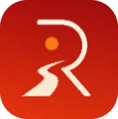

From Anodiam


Version | Publisher | Date | Reviewer | Date
1.0.0 | Anirban Chakrabarty | 17/10/2026 |  | 17/10/2026

Contents
Introduction to This Runbook 5
Background and Purpose 5
RedDust Beyond Syan — A Context-Aware Conversational AI Platform for Business Process Automation 6
Scope of Steps 0–19 6
Extending the Foundation with Authentication and PostgreSQL 7
Development Methodology and Intended Audience 7
The Road Ahead: From Local Development to Cloud-Native RedDust 7
Step 0 — Understand the Architecture and the Local Learning Boundary 8
0.1 — What RedDust is trying to feel like 8
0.2 — Full RedDust architecture diagram 8
0.3 — WebRTC in plain English 9
0.4 — Signalling is not the media stream 10
0.5 — Long-term Gemini/FastAPI architecture in future; not local echo implementation 10
Step 1 — Create Two-Project Workspace and Prepare the Mobile Toolchain 11
Understanding the RedDust Mobile Development Toolchain — A Beginner's Primer 11
How These Components Work Together 12
1.1 — Create the workspace boundary 12
1.2 — Install/verify Node.js, npm and npx for the mobile project 13
1.3 — Create the Expo SDK 56 TypeScript project 13
1.4 — Install expo-dev-client and react-native-webrtc 13
1.5 — Configure the WebRTC Expo plugin 13
1.6 — Prepare EAS without globally installing EAS CLI 14
Step 2 — Build the Python RedDust Gateway Environment 14
A Beginner's Introduction 14
The Main Technologies Used 15
How These Components Work Together 15
2.1 — Standardize Python on 3.12.10 15
2.2 — Create and activate the Gateway virtual environment 16
2.3 — Install FastAPI, Uvicorn, aiortc and PyAV 16
2.4 — Create the Gateway source structure 17
Step 3 — Understand the WebRTC Offer/Answer Handshake 17
Beginner's Introduction to WebRTC 17
Key Technical Concepts in Plain English 17
How the RedDust Handshake Works 18
Why RedDust Initially Uses Non-Trickle ICE 18
The Most Important Architectural Distinction 18
3.1 — Offer and answer in plain English 19
3.2 — Why the first implementation uses one-shot HTTP and non-trickle ICE 19
Step 4 — Add the FastAPI /offer Signalling Endpoint 19
4.1 — Start with a health/root endpoint 20
4.2 — Add the Offer model and POST /offer 20
Step 5 — Understand Incoming WebRTC Audio Tracks 21
5.1 — The aiortc track event 21
Step 6 — Implement the First EchoAudioTrack 21
6.1 — Create app/echo.py 21
Step 7 — Verify the Gateway Independently 22
7.1 — Recover from a broken Python virtual environment 22
7.2 — Start Uvicorn and inspect FastAPI docs 23
Step 8 — Build a Deliberately Simple Mobile Test Screen 23
8.1 — Keep the screen boring on purpose 23
Step 9 — Capture Microphone Audio with react-native-webrtc 24
9.1 — Import the WebRTC primitives 24
9.2 — Capture audio only 24
Step 10 — Configure Native Permissions, EAS Development Build and Metro 25
10.1 — Configure microphone permissions 25
10.2 — Make runtime microphone permission explicit on Android 26
10.3 — Create the EAS development build 26
10.4 — Install and open the development build on the physical Android phone 26
10.5 — Start Metro and connect the development build 27
10.6 — Prevent accidental duplicate microphone streams 28
Step 11 — Create RTCPeerConnection and Configure STUN 28
11.1 — Create the connection 28
Step 12 — Attach the Microphone Track to the PeerConnection 29
12.1 — Add all local tracks 29
Step 13 — Create and Adopt the SDP Offer 30
13.1 — Create the offer 30
13.2 — Set the local description 30
Step 14 — Send the Offer to FastAPI and Receive the Answer 30
14.1 — Determine the laptop’s active Wi-Fi IPv4 address 31
14.2 — Wait for ICE gathering to complete before posting 31
14.3 — POST the final local description to /offer 31
Step 15 — Apply the Gateway Answer on the Phone 32
15.1 — Convert and set the remote description 32
Step 16 — Prove ICE/DTLS Connectivity; Restart and Onboard Reproducibly 33
16.1 — Add ICE and PeerConnection state monitoring 33
16.2 — Use the source’s final TypeScript event-handler approach 33
16.3 — Daily restart routine after a reboot/login 34
16.4 — Team onboarding from Git: reproducibility boundary 34
16.5 — What Git should and should not contain 35
16.6 — New teammate setup sequence 35
16.7 — iPhone onboarding boundary on Windows 35
Step 17 — Receive the Echoed Remote Audio Track 35
17.1 — Attach EchoAudioTrack before the Gateway creates the answer 36
17.2 — Listen for the remote track on the phone 36
Step 18 — Perform the First Audible End-to-End Echo Test 37
18.1 — Run the end-to-end test 37
Step 19 — Stabilize the Same-Wi-Fi Test, Audio Routing and Backend Audio Sequencing 37
19.1 — Keep the first environment deliberately simple: same Wi-Fi 38
19.1A — Alternative Local Test Using an Android Mobile Hotspot 38
19A — Toggle Android audio between loudspeaker and earpiece 42
19B — Insert a pre-recorded prefix, two seconds of silence, then echo 42
19.2 — Final local success state before Step 20 44
Appendix 45
Appendix insertion notes — keep original appendices aligned 45
Appendix A — Canonical Local Project Structure and Daily Commands 45
Appendix B — Troubleshooting Decision Tree 46
Appendix C — Glossary for Absolute Beginners 47
Appendix D — Final Readiness Checklist before Step 19 47
Source and Consolidation Note 48
Appendix E — iOS / iPhone Development for RedDust Mobile 48
APPENDIX F – Preparing Physical Android Phones and iPhones for RedDust Development 55

Introduction to This Runbook

Background and Purpose
Imagine Kim, a 22 year old student from UNSW, and working on a part time job, returning home after a long, stressful day. Instead of opening a conventional music application, searching for a playlist or interacting with a text-based chatbot, Kim opens RedDust and starts a voice conversation with Syan, her personalized AI Radio Jockey, conversational companion and wellbeing assistant.
Syan greets Kim naturally, remembers relevant aspects of their previous conversations and begins interacting as a familiar companion rather than an unfamiliar automated system. As Kim talks about her day, Syan understands not only the words being spoken but also the conversational context, emotional cues and changes in her expressed mood.
Behind this seemingly simple conversation, RedDust is designed to operate as a context-aware, real-time conversational AI platform that progressively develops a personalized understanding of the user's personal wellbeing.
At the heart of this experience is the proposed RedDust Soul Score—a longitudinal, multidimensional representation of the user's wellbeing, derived from appropriately consented conversational observations, historical interactions, expressed emotions and other relevant contextual signals. Rather than treating every conversation independently, RedDust aims to maintain a short-term, medium-term and long-term understanding of Kim's wellbeing:
- Short-term wellbeing: Kim's immediate conversational state, such as feeling stressed, energetic, relaxed or emotionally overwhelmed during the current interaction.
- Medium-term wellbeing: Patterns observed over recent days or weeks, including recurring stressors, mood fluctuations, interests, lifestyle events and changes in expressed emotional needs.
- Long-term wellbeing: Broader trends and enduring personal context developed over months, including preferences, significant life events, recurring wellbeing patterns and the evolution of Kim's relationship with Syan.
For example, Syan might recognize that Kim appears unusually stressed today, that her recent conversations have repeatedly mentioned work pressure, and that she has historically preferred gentle acoustic music when unwinding in the evening.
Using this contextual understanding and Kim's preferences, RedDust could recommend music that is personally relevant rather than selecting songs solely by genre, popularity or a generic mood label.
The proposed music recommendation architecture would combine the Soul Score, short-, medium- and long-term wellbeing context, conversational intent, personal listening preferences and a verified music catalogue. Dedicated backend services would identify suitable tracks from YouTube or authorized RedDust music repositories, verify track identity and availability, and select an appropriate, legally permitted playback mechanism.
An important architectural and licensing boundary must be preserved: a verified YouTube track link confirms the identity or availability of a music resource; it does not automatically grant RedDust permission to download, extract, redistribute, independently stream or rebroadcast the underlying copyrighted audio. Any YouTube-based playback must follow the applicable platform terms and use permitted integrations. Where RedDust needs to process, store, mix, retransmit or independently stream music through its own infrastructure, it must use content for which the necessary rights and licences have been obtained, such as suitably licensed music repositories.
Syan could then say naturally:
"Kim, you've had quite a demanding week. Last time we spoke, you mentioned how much you enjoyed mellow acoustic music in the evenings. Would you like me to play something relaxing, or would you prefer something upbeat to change the mood?"
Kim could respond, interrupt, request another track, explain why she dislikes a recommendation or simply continue talking. RedDust would use this feedback, with appropriate consent and safeguards, to refine subsequent recommendations and the relevant aspects of her personalized context.
Importantly, Syan would not simply be a music recommendation engine with a voice interface. Music is one possible response within a broader ongoing conversation. Syan could listen, ask relevant questions, remember important preferences, offer supportive interaction and adapt the experience as the conversation develops. The Soul Score would be an indicative personalization signal, not a clinical diagnosis or definitive measure of mental health.
Technically, this experience requires multiple coordinated architectural layers: React Native and WebRTC for natural two-way voice interaction; Python FastAPI and aiortc for communication and media processing; Gemini Flash Live or similar Multimodal LLMs for future conversational reasoning; PostgreSQL for persistent user and session information; contextual memory and Retrieval-Augmented Generation (RAG) for relevant historical information; and dedicated wellbeing, recommendation and music-verification services.
Syan is the first illustrative use case of the RedDust platform, not its ultimate boundary. The same underlying context-aware conversational architecture can subsequently support enterprise AI voice agents for customer service, CRM operations and business-process automation, where personalized conversations are combined with secure access to customer records, business knowledge and authorized workflow execution.
The purpose of this runbook is to begin constructing that larger vision from its most fundamental engineering foundation: reliable, bidirectional, real-time voice communication between a mobile application and a Python backend, followed by user authentication, session management and relational data integration.
By implementing and validating each component incrementally, RedDust can evolve from a working local WebRTC echo experiment into a secure, personalized conversational AI platform capable of supporting Syan and a much broader range of consumer and enterprise applications.
Document purpose: This runbook turns the original working notes into one coherent implementation path. It teaches the architecture and terminology first, then guides an intern from an empty Windows workspace through the React Native/Expo mobile application, the Python/FastAPI/aiortc Gateway, local WebRTC signalling, transport verification, remote audio return, audible echo, phone audio routing, and backend-controlled audio sequencing.
CAUTION / STOP POINT: The versions and compatibility choices in this document are the baseline recorded in the source runbook: Python 3.12.10, Expo SDK 56, react-native-webrtc 124.0.7, @config-plugins/react-native-webrtc 15.0.2, and react-native-incall-manager 4.2.2. Do not casually upgrade one component in isolation while reproducing Steps 0–19.

RedDust Beyond Syan — A Context-Aware Conversational AI Platform for Business Process Automation
Although RedDust is initially demonstrated through Syan, a personalized AI Radio Jockey and conversational companion, its underlying architecture is intended to evolve into a much broader Context-Aware, Real-Time Conversational AI Platform capable of automating and augmenting voice-driven business processes.
Syan represents one application of the platform: an AI personality that can converse naturally, remember relevant user context, personalize interactions and deliver an engaging voice experience. However, the same foundational technologies—React Native, WebRTC, Python FastAPI, conversational AI, contextual retrieval, identity management and relational databases—can support numerous enterprise applications without requiring the underlying platform to be fundamentally redesigned.
A major target market for RedDust is AI-powered contact-centre automation and customer relationship management (CRM). Businesses across banking, insurance, telecommunications, healthcare, retail, travel, logistics and other service-intensive industries rely on human agents to conduct repetitive inbound and outbound telephone conversations.
RedDust is envisioned as a platform where AI voice agents can perform many of these interactions conversationally, securely and with access to relevant business context.
For example, a customer calling a bank could speak with a RedDust-powered AI agent that authenticates the customer using appropriate verification procedures, understands the inquiry, retrieves authorized account information, explains a transaction or initiates an approved service request. Similarly, an insurance AI agent could capture claim details, retrieve policy information, guide customers through required documentation and create structured follow-up tasks.
In CRM-driven outbound operations, AI agents could contact customers regarding appointment confirmations, service renewals, order updates, payment reminders, and customer satisfaction surveys or qualified sales follow-ups, subject to applicable consent, privacy, and identification and telemarketing requirements.
An important distinction exists between the current RedDust WebRTC application and conventional telephone-network integration. The implementation developed in Steps 0–19 establishes real-time voice communication between a React Native mobile application and a Python aiortc Gateway. It does not yet provide connectivity to ordinary telephone numbers, enterprise PBX systems or existing contact-centre telephony networks.
To automate conventional inbound and outbound telephone calls, RedDust will require additional SIP (Session Initiation Protocol) and PSTN (Public Switched Telephone Network) integration, potentially through telephony service providers, SIP trunks, hosted contact-centre platforms or suitable telephony gateways. These components will connect ordinary telephone calls to RedDust's conversational AI and media-processing infrastructure.
The future enterprise architecture must also support incoming-call handling, outbound-call initiation, call routing, queue management, call transfers, call-state management and escalation to human agents. For example, a customer calling an organization's published support number could be routed through its telephony infrastructure to a RedDust AI agent. If the inquiry requires human judgment or additional authorization, the conversation could be transferred to an appropriate customer-service representative, preserving relevant customer context where technically and legally permitted.
These telephony capabilities are planned extensions, not functionality already implemented within the current local WebRTC milestone.
The platform's intended distinguishing capability is context awareness. Rather than treating every call as an isolated conversation, an authorized RedDust agent could retrieve relevant customer history, CRM records, previous interactions, product information and business-process status through secure APIs and Retrieval-Augmented Generation (RAG). This context would allow the AI agent to provide more relevant responses and maintain continuity across interactions.
The longer-term architecture would combine real-time speech interaction, contextual reasoning and controlled business-process execution. Conversational AI would interpret customer intent, while FastAPI microservices would interact with CRM systems, databases, enterprise APIs and workflow engines to retrieve information or execute authorized actions. Sensitive operations would require appropriate identity verification, policy checks, audit trails and, where necessary, human approval.
RedDust is not intended exclusively to replace human agents. It can also augment contact-centre operations through real-time knowledge retrieval, agent assistance, conversation summarization, CRM updates, intelligent routing and seamless escalation to a human representative when a request is sensitive, complex or outside the AI agent's authority.
Ultimately, RedDust could support multiple specialized AI personas and business workflows on a common technological foundation—for example, Syan as a personalized Radio Jockey, a banking customer-service agent, an insurance claims assistant, a healthcare appointment coordinator or a retail customer-support representative.
By evolving from a single conversational companion into a configurable enterprise voice-automation platform, RedDust could address a substantially larger commercial market spanning customer service, contact centres, CRM operations, conversational commerce and voice-enabled enterprise workflow automation.
The strategic vision is therefore to build RedDust not merely as an AI companion application, but as reusable, context-aware conversational AI infrastructure capable of powering intelligent, secure and scalable voice interactions across consumer and enterprise use cases.
The local WebRTC, authentication, session-management and PostgreSQL foundations established in Steps 0–19 represent the first engineering building blocks toward that longer-term vision. SIP/PSTN integration, enterprise call routing and transfer, CRM connectors, AI orchestration, regulatory compliance and production-scale contact-centre functionality remain future development phases.

Scope of Steps 0–19
The runbook begins with the most fundamental technical challenge: establishing reliable, bidirectional, real-time audio communication between a physical Android phone and a Python backend running on a Windows development laptop.
The mobile application is developed using React Native, TypeScript, Expo and react-native-webrtc, while the backend Gateway uses Python 3.12.10, FastAPI, Uvicorn, aiortc and PyAV.
The initial implementation deliberately operates over the same Wi-Fi network to simplify connectivity and troubleshooting.
The first major milestone establishes the following communication path:
Kim's microphone → React Native WebRTC → secure WebRTC media transport → Python aiortc Gateway → EchoAudioTrack → WebRTC return audio → Kim's phone speaker.
The Gateway initially returns the user's own voice as an echo. This controlled experiment validates microphone capture, SDP offer/answer signalling, ICE connectivity, DTLS/SRTP transport, media-frame processing and remote audio playback.
Subsequent steps introduce loudspeaker/earpiece switching and backend-controlled audio sequencing, where the Gateway plays a pre-recorded greeting, inserts approximately two seconds of silence and then returns the caller's audio.
These experiments establish that the Gateway can not only transport audio but also control the content and timing of outgoing media.
An important architectural distinction is that FastAPI's HTTP endpoints handle signalling, while WebRTC handles continuous encrypted audio transport. The application does not manually implement low-level RTP packetization, Opus encoding/decoding or SRTP encryption.

Extending the Foundation with Authentication and PostgreSQL
After establishing the working WebRTC communication path, the runbook extends the local architecture through two additional implementation stages.
Step 19C — Build the Local RedDust Identity, Session and Audit Microservice introduces a separate Python FastAPI service and PostgreSQL relational database.
This service is designed to verify Google ID tokens, establish internal RedDust user identities, manage authentication sessions, issue short-lived access tokens, maintain device and voice-call session records, and support security-related audit logging.
The normalized database design distinguishes users, external Google identities, registered devices, authentication sessions, call sessions, preferences and audit events.
This separation is essential because a Google account, RedDust user identity, authenticated login session and WebRTC conversation represent different architectural concepts.
Step 19D — Merge Google-Authenticated Frontend and Proven WebRTC Call Client integrates the existing reddust-frontend and reddust-mobile capabilities into one Android application.
The intended integrated experience is straightforward: Kim opens RedDust, signs in using Google, receives a backend-verified RedDust session, and initiates a phone-like WebRTC conversation with Syan.
The integration must preserve the working WebRTC implementation while reconciling the projects' different Expo/native dependency versions.
Together, these two steps extend RedDust from a standalone audio communication experiment into the foundation of an authenticated, database-backed mobile application.
They represent implementation objectives with their own acceptance criteria, not functionality that should be assumed complete merely because the earlier echo test succeeds.

Development Methodology and Intended Audience
This runbook is designed for RedDust developers, engineering interns and technical team members who need a common understanding of the architecture and a reproducible implementation procedure.
It explains new technical concepts in beginner-friendly language before introducing the corresponding commands, configurations and code examples.
Each stage identifies the purpose of the implementation, the responsible components, relevant technical concepts and observable success criteria.
The implementation philosophy is based on four principles:
- Understand before implementing: Developers should understand the responsibilities of each component and the interfaces between them.
- Validate incrementally: Microphone capture, signalling, network connectivity, audio playback, authentication and database operations must be tested independently before end-to-end integration.
- Maintain reproducibility: Dependency versions, project structures, configuration conventions and startup procedures should be consistent across the development team.
- Preserve architectural boundaries: Mobile interaction, WebRTC media processing, authentication and persistent data management should remain logically separate and independently maintainable.
A successful HTTP response does not necessarily prove that WebRTC media is flowing, just as a successful Google sign-in does not establish backend authorization until the identity has been verified.
The runbook therefore uses explicit acceptance criteria to prevent one successfully functioning subsystem from being mistaken for an entirely operational application.

The Road Ahead: From Local Development to Cloud-Native RedDust
The local architecture developed in Steps 0–19 is intended to evolve into a scalable and secure cloud-based platform. The subsequent implementation roadmap proceeds through three major stages:
Step 20 — Google Cloud Deployment: Move the WebRTC Gateway and identity microservice to appropriate Google Compute Engine infrastructure, migrate PostgreSQL to Cloud SQL, and establish the networking, security and TURN capabilities required for Internet-based communication.
Step 21 — Infrastructure as Code: Introduce Terraform to define and manage cloud infrastructure through version-controlled, repeatable deployment configurations.
Future Cloud-Native Architecture: Containerize appropriate backend services, deploy them on Google Kubernetes Engine, and introduce CI/CD pipelines, DevSecOps controls, and observability and production operational practices.
The long-term platform will progressively incorporate Gemini-based conversational intelligence, contextual retrieval, persistent personalization, wellbeing functionality and other RedDust application services.
The expected outcome of this runbook is a verified, reproducible local foundation in which the mobile application, WebRTC Gateway, identity service and PostgreSQL database can operate together securely and consistently.
This foundation will allow the team to approach subsequent cloud deployment and AI integration from a position of architectural clarity, rather than adding infrastructure complexity to unresolved application-level problems.

Step 0 — Understand the Architecture and the Local Learning Boundary
What this section does and why it matters: Build a mental model of the complete RedDust voice architecture, then deliberately narrow the implementation goal to one small but critical proof: phone microphone → WebRTC → Python Gateway → echo → WebRTC → phone speaker.
New technical concepts introduced in this section (in absolute beginner terms): Architecture means the major parts of a system and how they communicate. A “boundary” is the point where one technology hands work to another. The key boundary in Steps 0–19 is between native mobile WebRTC and the Python aiortc Gateway.
Who does what: Every team member should understand this section before implementation. The lead/architect defines the long-term system; interns implement only the local Layer-1 proof described here.

0.1 — What RedDust is trying to feel like
What this section does and why it matters: Explain the product intent so technical choices are connected to the experience being built.
New technical concepts introduced in this section (in absolute beginner terms): Real-time voice interaction is a continuous two-way audio experience. It differs from a chatbot with a microphone button because audio, turn-taking and interruptions must behave like a live call.
The source describes RedDust as an emotionally aware companion called Syan, designed to feel like a real phone call rather than a text chatbot with occasional voice input. The long-term architecture includes live conversational AI, user-history retrieval, wellbeing updates, music recommendation and a control/feedback loop. Steps 0–19 do not implement that entire product; they prove the lowest-level real-time audio transport that the larger experience depends on.

0.2 — Full RedDust architecture diagram
What this section does and why it matters: Anchor this runbook in the project’s existing three-layer architecture and show exactly which part Steps 0–19 implement.
New technical concepts introduced in this section (in absolute beginner terms): The full architecture separates real-time voice, music recommendation and control/feedback. The green-outlined Layer 1 in the source diagram is the part that contains WebRTC signalling, connectivity, media transport and the conversational model boundary.
DIAGRAM — 0-A: RedDust three-layer communication architecture. For Steps 0–19, focus on mobile client and Layer 1 - WebRTC path
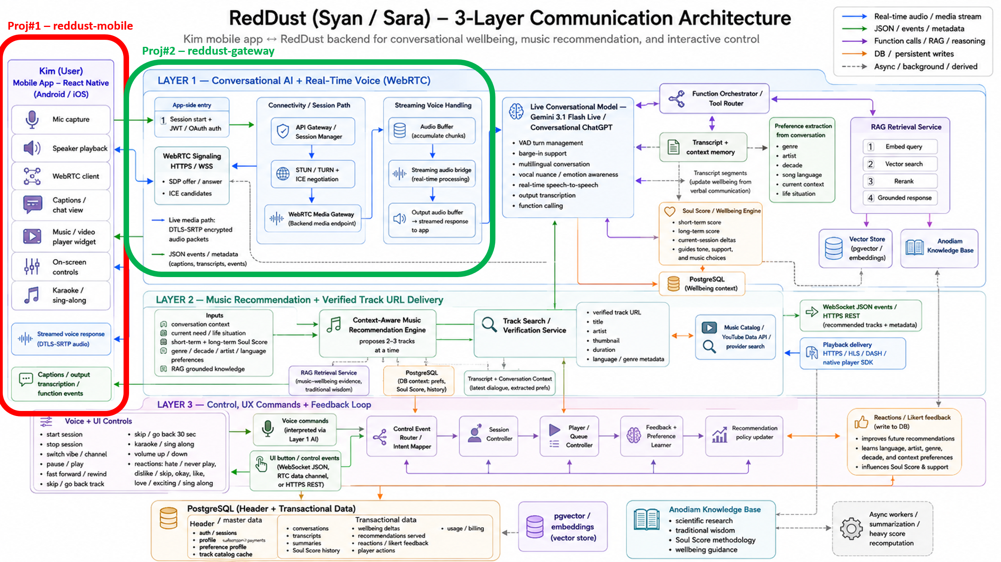

DIAGRAM — 0-B: Local Steps 0–19 Scope Zoom
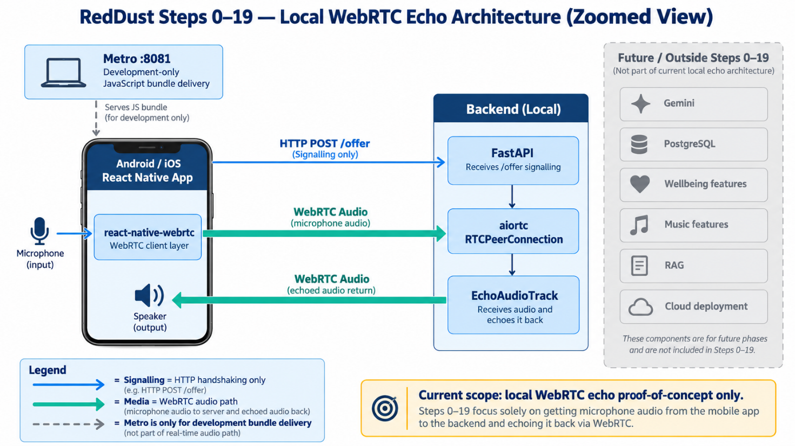

0.3 — WebRTC in plain English
DIAGRAM — 0-B: SDP Contract versus ICE Roadmap
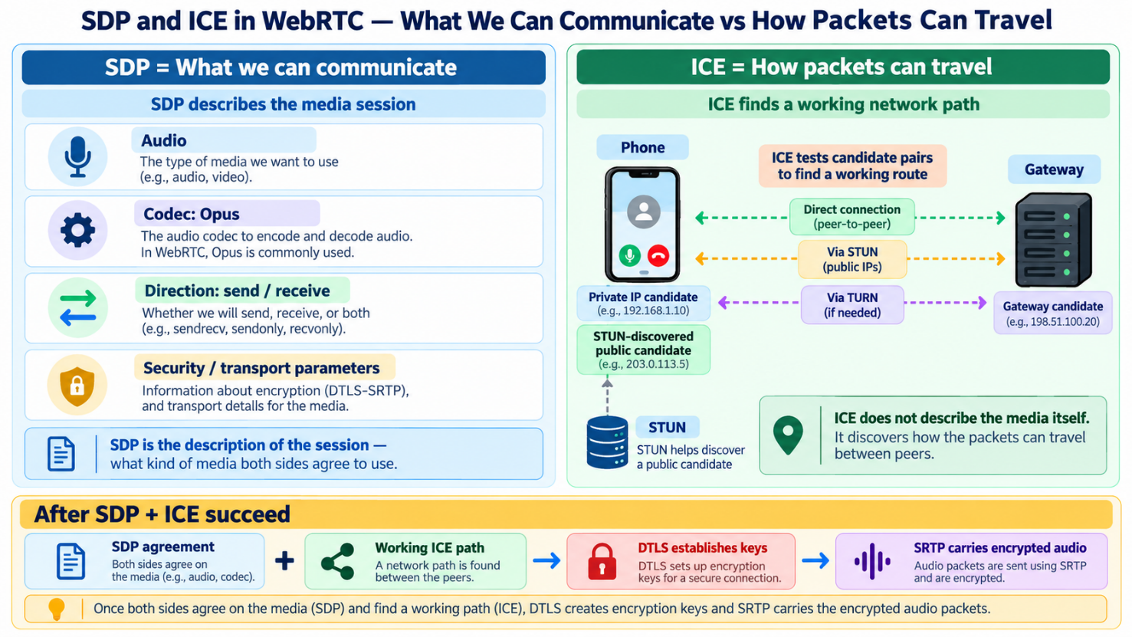
What this section does and why it matters: Explain what WebRTC contributes so interns do not confuse signalling, transport, codecs and application code.
New technical concepts introduced in this section (in absolute beginner terms): WebRTC means Web Real-Time Communication. It is a family of browser/mobile real-time communication technologies that negotiates media capabilities, discovers network paths, secures the connection and transports audio/video with very low delay.
In this runbook, React Native uses react-native-webrtc and Python uses aiortc. Those two libraries implement the WebRTC machinery on opposite sides of the connection. Your application code asks them to create a connection and attach media; you do not manually implement RTP packetization, encryption or audio codecs.

Concept | Absolute-beginner explanation | Role in RedDust Steps 0–19
SDP — Session Description Protocol | A text description of what a peer wants to send/receive and which media capabilities it supports. | The phone sends an SDP offer; aiortc returns an SDP answer.
ICE — Interactive Connectivity Establishment | The process WebRTC uses to discover and test possible network paths between two peers. | The phone and Gateway select a working path for media packets.
STUN — Session Traversal Utilities for NAT | A helper service that lets a device discover how it appears outside its local network/router. | Used by the mobile PeerConnection during development.
TURN — Traversal Using Relays around NAT | A relay used when direct peer-to-peer paths cannot work. | Deferred in Steps 0–19; becomes important for Internet deployment.
Opus | A low-latency audio codec widely used by WebRTC. | Appears in SDP; WebRTC libraries encode/decode it for us.
RTP | Real-time Transport Protocol, the packet format for live media. | Carries audio timing/media payloads.
DTLS | Datagram Transport Layer Security; performs secure key negotiation over UDP-style transport. | Establishes keys for secure WebRTC media.
SRTP | Secure Real-time Transport Protocol. | Encrypts the actual real-time media.
PCM | Pulse Code Modulation; uncompressed digital audio samples. | Useful conceptual form for backend media processing; application code normally receives frames through aiortc/PyAV rather than raw network packets.
UDP — User Datagram Protocol | A fast connectionless network transport that prioritizes low delay over guaranteed delivery. | WebRTC media commonly prefers UDP for real-time responsiveness.

0.4 — Signalling is not the media stream
What this section does and why it matters: Prevent one of the most common architectural misunderstandings: FastAPI’s HTTP endpoint negotiates the connection, but it does not carry the continuous audio stream.
New technical concepts introduced in this section (in absolute beginner terms): Signalling is the exchange of setup information such as SDP. Media transport is the separate real-time WebRTC flow that starts after negotiation.
Conceptual boundary
PHONE GATEWAY
createOffer() FastAPI POST /offer
| |
SDP offer -------- ordinary HTTP/JSON -----------> |
▼
aiortc setRemoteDescription()
aiortc createAnswer()
SDP answer <------- ordinary HTTP/JSON ----------- |
|
setRemoteDescription(answer)
|
ICE / DTLS / SRTP establish the REAL media path
|
Microphone audio ============================> aiortc
Echo audio <============================ aiortc
Important note: When Uvicorn logs POST /offer 200 OK, that proves signalling worked. It does not by itself prove that ICE connected or that audio packets are flowing.

0.5 — Long-term Gemini/FastAPI architecture in future; not local echo implementation
What this section does and why it matters: Preserve the full architecture concepts from the source while keeping interns focused on the current milestone.
New technical concepts introduced in this section (in absolute beginner terms): The source proposes Gemini Live handling turn detection/VAD and conversational reasoning, while FastAPI handles databases, tools, external APIs, wellbeing writes and audio relay. asyncio allows multiple backend tasks to make progress without a thread per task.
The original architecture summary describes a future session lifecycle in which FastAPI opens a live AI session, retrieves user history, relays audio, handles model-initiated function calls, and concurrently updates wellbeing data through an asyncio queue. It also separates responsibilities: the conversational model performs voice understanding/turn-taking decisions, while FastAPI owns PostgreSQL, external API calls, background work and persistence. This is important context, but none of those services are needed to prove the Steps 0–19 echo path.
Future responsibility | Model side in source architecture | FastAPI/backend side
VAD / turn detection | Yes | No
Acoustic nuance understanding | Yes | No
Decide when music/context is needed | Yes | No
Call YouTube / external APIs | No | Yes
Read/write PostgreSQL | No | Yes
Incremental/final wellbeing writes | No | Yes
Relay audio between mobile and model | No | Yes
CAUTION / STOP POINT: Do not introduce Gemini, PostgreSQL, RAG, wellbeing scoring or music recommendation into the local echo milestone. Each extra subsystem would make WebRTC failures harder to isolate.

Step 1 — Create Two-Project Workspace and Prepare the Mobile Toolchain

Understanding the RedDust Mobile Development Toolchain — A Beginner's Primer
Before setting up the RedDust mobile application, it is important to understand the tools, configuration files and software components that work together to build and run a React Native application. Although these technologies are frequently used together, each has a distinct responsibility.
Node.js: A JavaScript runtime installed on the developer's Windows laptop. It executes development tools such as Expo CLI, npm and Metro. Node.js is primarily required for building and developing the application; it is not the runtime executing RedDust's native Android application on the phone.
npm (Node Package Manager): The package manager distributed with Node.js. It downloads, installs and manages JavaScript/TypeScript dependencies declared in package.json. For example, npm install installs the project's dependencies, while npm ci performs a clean installation using the committed dependency lockfile.
npx: A command runner supplied with npm. It executes tools available in the project's dependencies or downloads an appropriate package when necessary. For example, npx expo-doctor runs Expo's diagnostic utility without requiring a separate global installation.
React Native: A framework for building mobile applications using JavaScript/TypeScript and React. It allows developers to create mobile interfaces while interacting with native Android and iOS functionality. RedDust uses React Native for its mobile application, including the voice-call interface and device interactions.
TypeScript: An extension of JavaScript that introduces static type checking. TypeScript helps developers identify many coding mistakes during development, such as passing an unexpected value to a function. RedDust uses TypeScript for clearer, more maintainable mobile application code.
Expo: A framework and development platform built around React Native. Expo simplifies application configuration, native dependency integration, development workflows and access to device functionality. It does not replace React Native; rather, it provides tools and services that make React Native development more manageable.
Expo SDK: A versioned collection of Expo libraries and compatible React Native dependencies. RedDust's recorded compatibility baseline is Expo SDK 56. Developers should not independently upgrade the SDK because native libraries such as react-native-webrtc must remain compatible with the project's React Native and Expo versions.
Expo CLI: The command-line interface used for common Expo development operations, such as starting the development server and inspecting project configuration. Commands such as npx expo start and npx expo config invoke this tooling.
Expo Router: A file-based navigation system for Expo and React Native applications. It uses files and folders inside the app/ directory to define application screens and navigation routes. RedDust can use it to organize login, persona selection and WebRTC call screens.
Metro Bundler: The JavaScript development server used by React Native. Metro reads the application's JavaScript/TypeScript source code and dependencies, transforms them into executable JavaScript, and serves the resulting bundle to the development application. In the RedDust local setup, Metro typically runs on TCP port 8081. Metro is not the Python FastAPI backend and does not carry WebRTC microphone audio.
EAS (Expo Application Services): Expo's cloud-based application development and delivery services. The most relevant capability for RedDust is EAS Build, which compiles the native Android application remotely. This allows developers working on Windows to build an Android development application without installing a full local Android Studio/Gradle build environment.
eas-cli: The command-line tool used to interact with EAS. Commands such as npx eas-cli@latest login, npx eas-cli@latest build:configure and npx eas-cli@latest build authenticate developers, configure builds and initiate cloud compilation.
Expo Go versus Expo Development Build: Expo Go is a general-purpose application containing a predefined set of native libraries. It cannot automatically include arbitrary project-specific native modules. RedDust uses react-native-webrtc, which requires native Android/iOS code; therefore, the project needs a custom Expo Development Build rather than ordinary Expo Go.
expo-dev-client: An Expo package that provides development-client functionality inside a custom native application. It enables the installed RedDust Development Build to connect to Metro, load development JavaScript, display development tools and support iterative testing.
react-native-webrtc: The native WebRTC library used by RedDust's mobile application. It provides interfaces such as RTCPeerConnection, mediaDevices.getUserMedia() and MediaStreamTrack for microphone capture, connection negotiation and secure real-time audio communication with the Python aiortc Gateway.
Expo Config Plugin: A package that modifies native Android/iOS project configuration when Expo prepares an application build. The @config-plugins/react-native-webrtc plugin integrates the WebRTC native dependency into Expo's build process. Installing the library with npm and declaring the plugin in the Expo configuration are separate, complementary steps.
app.json: The main static Expo application configuration file. It defines properties such as the application's name, slug, icon, Android package name, permissions, URL scheme and config plugins. RedDust's app.json must contain valid JSON and should preserve existing entries when adding the WebRTC plugin. Duplicate entries, missing commas or malformed JSON can prevent Expo Doctor and EAS Build from loading the configuration.
app.config.js / app.config.ts: Optional alternatives for defining Expo configuration dynamically using JavaScript or TypeScript. These are useful when configuration must depend on the development environment or build profile. The current runbook primarily uses app.json; interns should not introduce additional configuration files unnecessarily.
package.json: The main manifest of the Node.js project. It records the project name, scripts and dependencies, including Expo, React Native and WebRTC packages. npm reads this file to determine which software packages the application requires.
package-lock.json: The dependency lockfile generated by npm. It records the exact resolved dependency tree so other developers can reproduce the same installation. It should normally be committed to Git along with package.json. For an existing RedDust project, npm ci is generally preferable when the lockfile is valid and synchronized.
node_modules/: The local directory containing installed JavaScript packages and their dependencies. npm creates this folder automatically. It can be large and machine-specific, so developers should not manually edit its installed package files or commit the folder to Git. Instead, teammates recreate it using npm ci.
.env.local: A developer-specific configuration file containing local environment values, such as EXPO_PUBLIC_GATEWAY_URL, which points the Android application to the developer's laptop or cloud Gateway. The EXPO_PUBLIC_ prefix makes a variable accessible to mobile application code and means its value must be treated as public. Passwords, private keys, database credentials and other secrets must never be stored in EXPO_PUBLIC_ variables or embedded in the application.
.env.example: A safe configuration template showing which environment variables developers need to define. It can be committed to Git without real secrets, while each developer creates their own .env.local from the template.
eas.json: The EAS Build configuration file located in the project root. It defines build profiles, such as development, preview and production, and their build options. A development profile typically enables a development client so that the resulting native application can load JavaScript from Metro. This file should be version-controlled once the team agrees on its configuration.
Expo Doctor: A diagnostic utility that checks the Expo project for dependency compatibility, configuration problems and other common issues. Running npx expo-doctor helps developers identify problems before attempting an EAS build. A failing Expo Doctor check should be investigated rather than automatically resolved by upgrading all dependencies.
Git and .gitignore: Git tracks changes to source code and configuration files so developers can collaborate and reproduce project states. The .gitignore file identifies local/generated files that must not be committed, including node_modules/, Python .venv/ directories and developer-specific environment configuration such as .env.local.
Python FastAPI Gateway: The separate backend application stored in reddust-gateway/. Unlike Metro, it runs on Python and handles HTTP signalling through endpoints such as /offer. The aiortc component establishes the WebRTC connection and handles real-time media. During local development, the Gateway typically runs on TCP port 8000, independently of Metro on port 8081.

How These Components Work Together
A developer writes the RedDust mobile application using React Native and TypeScript. The project dependencies are defined in package.json, installed into node_modules/ using npm, and maintained reproducibly through package-lock.json. Expo reads app.json and its configured plugins, while EAS Build compiles the native Android application containing the WebRTC library.
Once the development build is installed on a physical Android phone, Metro serves the JavaScript application during development. The phone then communicates separately with the Python FastAPI Gateway for HTTP signalling and uses WebRTC to exchange secure real-time audio.
The most important distinction for new developers is that Expo and EAS prepare and build the mobile application, Metro delivers development JavaScript, FastAPI handles backend HTTP requests, and WebRTC/aiortc handle real-time audio communication. Understanding these responsibilities prevents confusion when diagnosing build, configuration, networking and audio problems.

— Create the workspace boundary
- DIAGRAM — 1-A: Two-Project Local Workspace
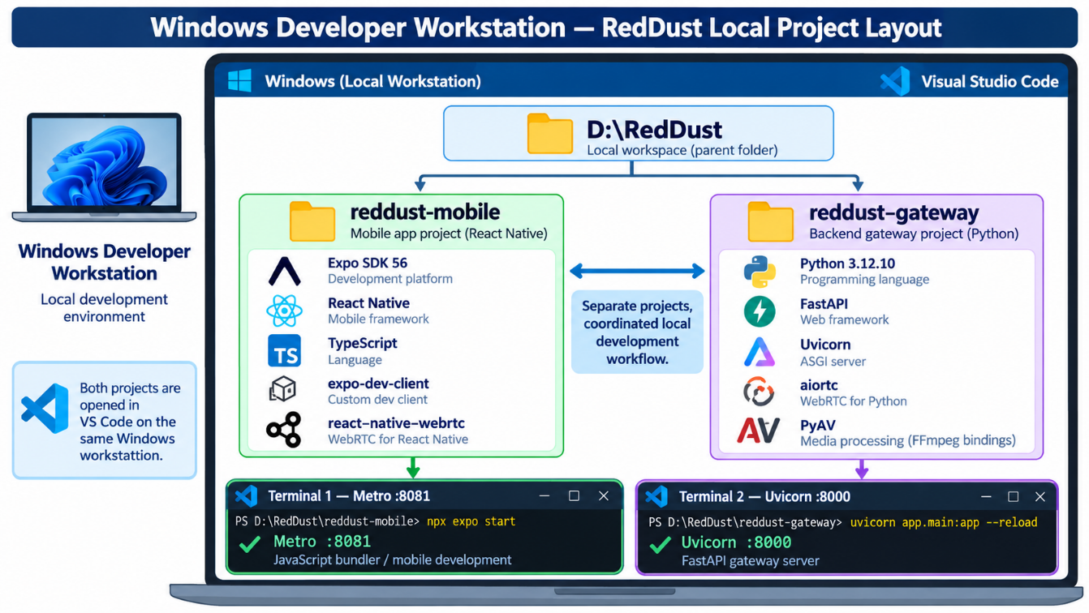
What this section does and why it matters: Create a clean RedDust workspace containing a mobile project and a Gateway project, then prepare the Expo/React Native mobile side with the exact source-runbook compatibility baseline.
New technical concepts introduced in this section (in absolute beginner terms): Expo manages React Native projects and cloud/native build configuration. TypeScript adds compile-time type checking. expo-dev-client produces a custom development application that can contain native libraries that ordinary Expo Go does not contain.
Who does what: Interns create their own local workspace. The team lead owns version policy; nobody upgrades the pinned compatibility set independently.
What this section does and why it matters: Separate mobile and Gateway code so each can be built, run and debugged independently.
New technical concepts introduced in this section (in absolute beginner terms)
A repository/folder boundary helps isolate dependencies. The mobile project is JavaScript/TypeScript + native modules; the Gateway is Python + native media libraries.
D:\RedDust\
├── reddust-mobile\
│ └── Expo / React Native / TypeScript
└── reddust-gateway\
└── Python / FastAPI / aiortc

1.2 — Install/verify Node.js, npm and npx for the mobile project
What this section does and why it matters: Make sure the JavaScript runtime/tooling required by Expo is available before creating the mobile application.
New technical concepts introduced in this section (in absolute beginner terms): Node.js executes JavaScript tooling on the laptop. npm installs packages. npx runs package-provided command-line tools without requiring every tool to be globally installed.
Verify
node --version
npm --version
npx –version
Important note: The source runbook records Node v24.19.0 and npm 11.17.0 during this proof of concept. For reproducibility, teammates should stay on the team-approved baseline rather than independently upgrading Node/npm while debugging WebRTC.

1.3 — Create the Expo SDK 56 TypeScript project
What this section does and why it matters: Create the mobile application using the Expo template and verify the project is internally consistent before adding native WebRTC.
New technical concepts introduced in this section (in absolute beginner terms): Expo SDK is the set of Expo/React Native versions and native modules tested together. The default Expo template already includes TypeScript configuration.
1. Open PowerShell at D:\RedDust.
2. Create the project with the source-runbook SDK baseline.
3. Enter the project directory and install dependencies.
4. Run Expo Doctor before adding WebRTC so you have a clean baseline.
cd D:\RedDust
npx create-expo-app@latest reddust-mobile --template default@sdk-56
cd reddust-mobile
npm install
npx expo --version
npx expo-doctor
CAUTION / STOP POINT: For this source-runbook baseline, do not run an automatic Expo 57 upgrade. The WebRTC package/plugin combination was intentionally pinned around Expo SDK 56.

1.4 — Install expo-dev-client and react-native-webrtc
What this section does and why it matters: Add the native WebRTC capability that the generic Expo Go application does not include.
New technical concepts introduced in this section (in absolute beginner terms): react-native-webrtc contains JavaScript/TypeScript APIs plus native Android/iOS WebRTC code. The Expo config plugin tells Expo how to integrate that native code when the custom development build is compiled.
npx expo install expo-dev-client
npm install react-native-webrtc@124.0.7
npm install @config-plugins/react-native-webrtc@15.0.2 --save-exact
Verify
Test-Path .\node_modules\@config-plugins\react-native-webrtc\build\withWebRTC.js
node .\node_modules\expo\bin\cli config --json --full
npx expo-doctor
Success criterion: The plugin file exists, Expo configuration resolves, and Expo Doctor shows no unexpected critical version mismatch. The source accepted the known WebRTC/New-Architecture warning during this experiment.

1.5 — Configure the WebRTC Expo plugin
What this section does and why it matters: Tell Expo that the native project must include react-native-webrtc whenever a development build is generated.
New technical concepts introduced in this section (in absolute beginner terms): An Expo config plugin modifies generated native Android/iOS project configuration during prebuild/cloud build.
app.json — preserve existing Expo-generated entries; add the plugin rather than replacing the whole file
{
"expo": {
"name": "reddust-mobile",
"slug": "reddust-mobile",
"plugins": [
"expo-router",
"@config-plugins/react-native-webrtc"
]
}
}
CAUTION / STOP POINT: Do not manually run npx expo prebuild or npx expo run:android for this lightweight Windows workflow. The source deliberately uses EAS cloud builds so Android Studio, the Android SDK and local Gradle compilation are not required.

1.6 — Prepare EAS without globally installing EAS CLI

Understanding EAS, Expo Login and Team Access
EAS (Expo Application Services) is Expo's cloud-based platform for building, signing and distributing React Native/Expo mobile applications. For RedDust, EAS Build compiles the native Android application—including react-native-webrtc and other native libraries—on Expo-managed cloud infrastructure. This allows developers using Windows laptops to create Android APKs without installing Android Studio or configuring a local Gradle build environment.
Expo Account and EAS Login: Every developer should create their own Expo account at https://expo.dev. The eas-cli command-line tool connects the developer's local project to Expo's cloud services. Developers authenticate using:
npx eas-cli@latest login
npx eas-cli@latest whoami
The login command authenticates the developer, while whoami verifies which Expo account is currently signed in. These credentials are separate from Google Cloud IAM and Google OAuth authentication used by the RedDust application.
Expo Organization and Project Access: RedDust should use a single Anodiam-owned Expo Organization containing the shared reddust-mobile EAS project. The Organization administrator invites developers individually through the Expo dashboard and assigns appropriate roles. Developers requiring cloud-build access should normally receive the Developer role rather than Owner or Admin. Developers must accept their invitations using their own Expo accounts; sharing a common Expo login is discouraged.
EAS Project Configuration: The app.json file identifies the Expo application and its owning Organization through the owner property, while extra.eas.projectId identifies the linked EAS project. The eas.json file defines build profiles such as development, preview and production. These files should be maintained consistently in Git.
Creating a RedDust Development Build: An authorized developer can initiate the Android cloud build using:
npx eas-cli@latest build --profile development --platform android
EAS uploads the required project files, prepares the native Android application, compiles the application and makes the resulting build available for installation. The RedDust Development Build contains the native WebRTC functionality required for microphone capture and real-time communication.
Do All Developers Need EAS Access? Not necessarily. Developers who only modify JavaScript/TypeScript or test an existing development APK can generally work without initiating their own EAS builds. Developers responsible for native dependency changes, Android permissions or generating new development builds require appropriate access. A new APK is generally necessary when native modules or build-time native configuration changes; ordinary JavaScript changes can usually be tested through Metro without rebuilding.
Important Architectural Distinction: EAS builds the Android application; Metro (typically port 8081) serves JavaScript during development; and the Python FastAPI/aiortc Gateway (port 8000) handles WebRTC signalling and real-time audio communication. EAS does not host the RedDust backend or replace the Gateway.
RedDust Team Policy: Maintain one centrally owned Expo Organization and EAS project, use individual developer logins, grant access according to responsibility, preserve build configurations in Git, and avoid unnecessary native rebuilds.
What this section does and why it matters: Authenticate to Expo and prepare the project for cloud development builds.
New technical concepts introduced in this section (in absolute beginner terms): EAS means Expo Application Services. EAS Build compiles the native Android/iOS application in Expo’s cloud. A development build is a custom app binary that includes your project’s native modules and can load JavaScript from Metro.
npx eas-cli@latest login
npx eas-cli@latest whoami
npx eas-cli@latest build:configure
Important note: The source recommends using npx eas-cli@latest rather than installing eas-cli globally. eas.json becomes project configuration and should be committed once the team has settled it.

Step 2 — Build the Python RedDust Gateway Environment

A Beginner's Introduction
The RedDust Gateway is the backend application responsible for establishing and managing real-time voice communication between the RedDust mobile application and the Python server. While the React Native mobile application captures the user's microphone audio and provides the user interface, the Gateway receives the incoming WebRTC audio, processes it and sends the resulting audio back to the phone.
In the initial RedDust implementation, the Gateway performs a simple audio echo: Kim speaks into her Android phone, the audio travels securely to the Python Gateway, and the Gateway returns the same audio to Kim's speaker. Later, this Gateway will form part of the infrastructure connecting the mobile application to conversational AI services such as Gemini, enabling real-time voice conversations with Syan.

The Main Technologies Used
Python 3.12.10: The programming language and exact interpreter version selected for the RedDust Gateway. Using the same Python version across all developers' laptops helps prevent compatibility problems and ensures reproducible execution.
Python Virtual Environment (.venv): An isolated Python environment created specifically for the Gateway project. It contains the project's installed Python packages without interfering with other Python applications on the same computer. Every developer creates their own .venv; this directory must not be copied between computers or committed to Git.
pip: Python's package installer. It downloads and installs the libraries required by the Gateway. The requirements.txt file records the project's dependencies so they can be installed consistently across different development environments.
FastAPI: A Python web framework used to build backend HTTP APIs. In RedDust, FastAPI exposes endpoints such as /offer, which receives the mobile application's WebRTC SDP offer and returns the Gateway's SDP answer. FastAPI handles signalling and application requests, not the continuous WebRTC audio stream itself.
Uvicorn: The application server that runs FastAPI and makes its HTTP endpoints accessible over the network. During local development, Uvicorn normally listens on TCP port 8000.
ASGI (Asynchronous Server Gateway Interface): The interface through which an asynchronous Python web application, such as FastAPI, communicates with an application server such as Uvicorn. It enables efficient handling of concurrent network requests.
aiortc: A Python implementation of WebRTC. It creates and manages RTCPeerConnection objects, negotiates connections, performs ICE/DTLS/SRTP operations and receives or transmits real-time audio tracks. It forms the core communication bridge between the mobile application's native WebRTC implementation and Python backend code.
PyAV (av): A Python library that provides access to multimedia frames and FFmpeg-based processing capabilities. RedDust uses PyAV to work with audio frames, resampling, timestamps and backend-controlled media sequences.
EchoAudioTrack: A custom Python class developed within the RedDust Gateway. It receives audio frames from the incoming WebRTC track and returns them as an outgoing track. Later implementations extend this behavior to insert pre-recorded audio, silence and other controlled audio processing.

How These Components Work Together
The RedDust Gateway follows this basic processing flow:
FastAPI receives an SDP offer → aiortc negotiates the WebRTC connection → incoming microphone audio becomes an aiortc audio track → EchoAudioTrack processes or returns the audio frames → aiortc transmits the outgoing audio → the mobile application plays the audio through the phone speaker.
FastAPI and Uvicorn establish the HTTP signalling interface, while aiortc handles the independent real-time media transport. PyAV supports media-frame processing when required.
During Steps 0–19, these components run locally on each developer's Windows laptop. In Step 20, the proven Gateway is migrated to a Google Cloud Compute Engine VM running Ubuntu Linux, where the Python environment and application dependencies are recreated rather than copied from Windows.
The objective of Step 2 is therefore to establish a clean, compatible and reproducible Python backend environment before implementing WebRTC signalling and audio-processing functionality. Understanding the responsibilities of Python, FastAPI, Uvicorn, aiortc and PyAV will help developers troubleshoot the Gateway systematically and prepare for its later integration with the wider RedDust conversational AI platform.
What this section does and why it matters: Create a reproducible Python Gateway environment that can host an HTTP signalling endpoint and a real aiortc WebRTC PeerConnection.
New technical concepts introduced in this section (in absolute beginner terms): A Python virtual environment isolates project packages. FastAPI defines web endpoints; Uvicorn runs the ASGI application; aiortc implements WebRTC; PyAV (av) handles media frames and FFmpeg-backed processing.
Who does what: Each developer creates their own .venv locally. Never copy someone else’s virtual environment or commit it to Git.

2.1 — Standardize Python on 3.12.10
What this section does and why it matters: Avoid the broken/mixed environment described in the source and give all team members the same Python baseline.
New technical concepts introduced in this section (in absolute beginner terms): Compiled Python packages contain native binary components that must match the Python interpreter version. A virtual environment remembers the interpreter that created it.
py -0p
py -3.12 –version
Success criterion: The project baseline is Python 3.12.10.
Every RedDust developer should install Python 3.12.10 if that exact version is not already available on their development laptop.
The RedDust Gateway uses native dependencies such as aiortc, PyAV and pydantic-core. Standardizing on Python 3.12.10 reduces compatibility problems and makes the development environment reproducible across the team.

Step 2.1.1 — Check Whether Python 3.12.10 Is Installed
Open PowerShell and execute:
py -0p
This lists the Python interpreters registered with the Windows Python Launcher.
Then run:
py -3.12 --version
Important: This command selects a Python 3.12 installation but does not necessarily guarantee patch version 3.12.10.
The expected output is:
Python 3.12.10

Step 2.1.2 — Install Python 3.12.10 If Missing
- Visit the official Python 3.12.10 release page.
- Download the Windows installer (64-bit).
- Run the installer and select Add Python to PATH if offered.
- Complete the installation without uninstalling other Python versions unnecessarily.
- Close and reopen PowerShell.
Verify again:
py -3.12 --version
Expected:
Python 3.12.10
If multiple Python 3.12 patch versions are installed, use py -0p to identify the interpreter paths and select the exact 3.12.10 executable when creating the environment.

Step 2.1.3 — Create the Gateway Virtual Environment
From the Gateway project directory:
cd D:\RedDust\reddust-gateway
py -3.12 -m venv .venv
.\.venv\Scripts\Activate.ps1
python --version
Expected result: The active virtual environment reports Python 3.12.10.
If py -3.12 selects a different patch version, recreate .venv using the full path to the Python 3.12.10 executable instead.

Important Note for Interns
Installing Python 3.12.10 does not require removing Python 3.13, 3.14 or other installed versions. Multiple versions can coexist on Windows. However, every RedDust Gateway virtual environment must be created using Python 3.12.10, regardless of which Python version is the system default. Once created, .venv contains the project-specific Python environment and dependencies. Developers must create it independently on their own computers and must never copy or commit it to Git.
DIAGRAM — 1-B: Expo Development Build versus Expo Go
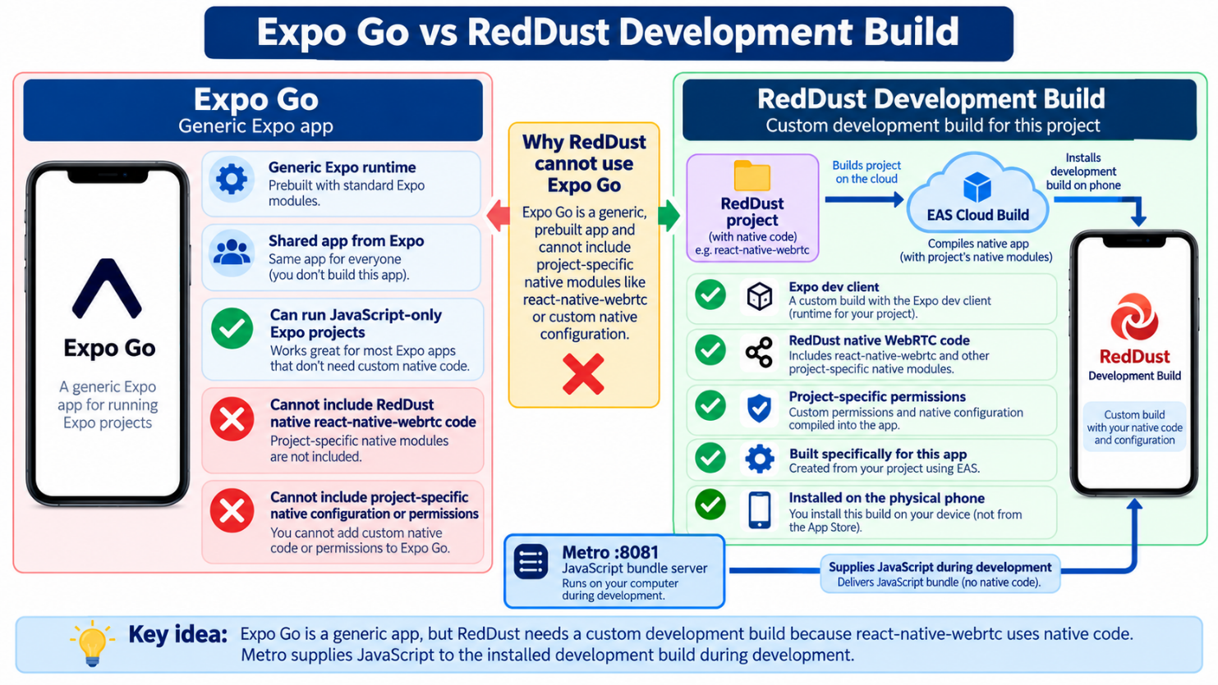

2.2 — Create and activate the Gateway virtual environment
What this section does and why it matters: Create an isolated dependency environment inside reddust-gateway and prove the active interpreter is the expected version.
New technical concepts introduced in this section (in absolute beginner terms): A .venv is a project-local environment containing its own Python executable and installed packages.
cd D:\RedDust\reddust-gateway
py -3.12 -m venv .venv
.venv\Scripts\Activate.ps1
python --version
python -m pip install --upgrade pip

2.3 — Install FastAPI, Uvicorn, aiortc and PyAV
What this section does and why it matters: Install the minimum Gateway stack needed for the local echo proof and record the dependency set.
New technical concepts introduced in this section (in absolute beginner terms): ASGI is the asynchronous server interface used by FastAPI. aiortc is built for asyncio-style WebRTC. PyAV exposes media frames and codec/media utilities to Python.
python -m pip install fastapi uvicorn aiortc av
python -c "import fastapi, pydantic_core, aiortc, av; print('All gateway imports OK')"
pip freeze > requirements.txt
Component | Role
FastAPI | Defines HTTP routes such as GET / and POST /offer.
Uvicorn | Runs the FastAPI ASGI application and listens on TCP port 8000.
Aiortc | Creates the server-side RTCPeerConnection and handles WebRTC negotiation/media.
av / PyAV | Represents/manipulates audio/video frames and uses FFmpeg capabilities underneath.
Pydantic Core | The high-performance validation engine underlying Pydantic, used by FastAPI to validate and process API request/response data efficiently, including JSON payloads such as WebRTC SDP offers.

2.4 — Create the Gateway source structure
What this section does and why it matters: Give the backend a small predictable file structure that interns can navigate.
New technical concepts introduced in this section (in absolute beginner terms): A Python package directory contains __init__.py. main.py holds the FastAPI application; echo.py holds the media-track transformation.
reddust-gateway/
├── app/
│ ├── __init__.py
│ ├── main.py
│ └── echo.py
├── requirements.txt
└── README.md
DIAGRAM — 2-A: Gateway Software Stack
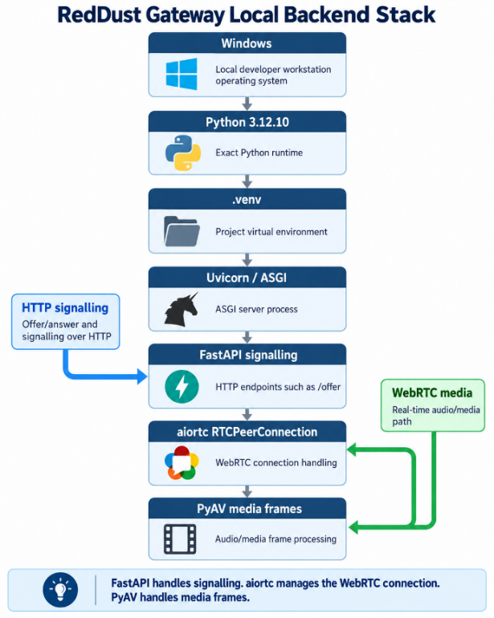

Step 3 — Understand the WebRTC Offer/Answer Handshake

Beginner's Introduction to WebRTC
The WebRTC Offer/Answer Handshake is the process through which two devices agree on how to establish a secure, real-time audio or video connection. In RedDust, the two communicating parties are the React Native mobile application (the phone) and the Python aiortc Gateway (the server).
Unlike an ordinary HTTP request, where a mobile application sends data to a server and receives a response, WebRTC establishes a persistent, bidirectional media connection. Once this connection is established, microphone audio can travel continuously from the phone to the Gateway, while the Gateway can simultaneously transmit audio back to the phone.
Before any audio can flow, both sides must negotiate their media capabilities, discover usable network paths and establish secure communication. This negotiation process is called the WebRTC handshake.

Key Technical Concepts in Plain English
WebRTC (Web Real-Time Communication): A technology that enables applications to exchange audio, video and other data in real time. RedDust uses WebRTC to transmit microphone audio between the mobile application and the Python Gateway with low latency.
RTCPeerConnection: The central WebRTC object responsible for negotiating and managing a connection between two peers. In RedDust, the mobile application creates an RTCPeerConnection using react-native-webrtc, while the Gateway creates its corresponding connection using Python's aiortc library.
Peer: One endpoint participating in a WebRTC connection. Although WebRTC is often described as peer-to-peer technology, a peer can also be a backend server. In RedDust, the phone and the Python Gateway are the two peers.
Signalling: The process of exchanging connection setup information between peers. WebRTC does not prescribe a particular signalling protocol. In the initial RedDust implementation, FastAPI provides an HTTP endpoint called POST /offer, allowing the phone to send its connection proposal and receive the Gateway's response.
SDP (Session Description Protocol): A structured text format used to describe a proposed or negotiated communication session. SDP contains information such as audio codecs, media directions, security parameters and network connection candidates. It describes how the peers intend to communicate; it does not carry the actual microphone audio.
SDP Offer: The session proposal created by the phone using createOffer(). It describes the media capabilities and connection parameters the phone wants to negotiate with the Gateway.
SDP Answer: The compatible response generated by the Python Gateway using createAnswer (). It establishes the negotiated media parameters that both sides can support.
setLocalDescription(): A WebRTC method that registers a peer's own SDP offer or answer. It also initiates the relevant ICE candidate-gathering process.
setRemoteDescription(): A WebRTC method that registers the SDP received from the other peer. The Gateway uses it to accept the phone's offer, while the phone uses it to accept the Gateway's answer.
ICE (Interactive Connectivity Establishment): The mechanism WebRTC uses to discover and test possible network paths between the phone and Gateway. This is necessary because devices may be behind routers, NAT systems, mobile networks or firewalls.
ICE Candidate: A possible network address and transport combination through which a peer may be reachable. WebRTC collects candidates and tests candidate pairs to identify a working path for communication.
STUN (Session Traversal Utilities for NAT): A supporting protocol that helps a WebRTC peer discover its public-facing network address and port as observed by a STUN server. STUN can help establish connectivity through NAT, although it cannot guarantee that every network configuration will permit a direct connection.
TURN (Traversal Using Relays around NAT): A relay mechanism used when direct connectivity is unavailable or blocked. TURN forwards encrypted WebRTC media between peers through a relay server. It becomes especially important when RedDust communicates across different mobile networks, restrictive firewalls and the public Internet.
DTLS (Datagram Transport Layer Security): A security protocol used by WebRTC to authenticate the connection endpoints and establish cryptographic keying material. These keys are used to protect real-time media through SRTP.
SRTP (Secure Real-time Transport Protocol): The protocol used to securely transport audio and video packets. In RedDust, microphone audio is encoded and transmitted as encrypted SRTP media packets, rather than ordinary HTTP messages.
Codec: A method for encoding and decoding media. WebRTC commonly uses the Opus codec for audio. The mobile and Gateway WebRTC implementations negotiate a mutually supported codec so audio can be transmitted and played correctly.

How the RedDust Handshake Works
The process begins when the user initiates a voice session from the RedDust mobile application.
Step 1 — Create the mobile PeerConnection: The application creates an RTCPeerConnection and prepares its microphone audio for transmission.
Step 2 — Generate the SDP offer: The phone calls createOffer() and setLocalDescription() to prepare its proposed session configuration.
Step 3 — Gather ICE candidates: In RedDust's initial non-trickle ICE implementation, the application waits for ICE candidate gathering to finish before sending its complete local SDP.
Step 4 — Send the offer to the Gateway: The application sends the SDP offer as an HTTP JSON request to FastAPI's POST /offer endpoint, usually on port 8000 during local development.
Step 5 — Process the offer: The Python Gateway creates its own RTCPeerConnection, calls setRemoteDescription() to register the received offer, and prepares the appropriate incoming and outgoing audio tracks.
Step 6 — Generate the SDP answer: The Gateway calls createAnswer() and setLocalDescription(). For the initial non-trickle implementation, it also waits for its own ICE gathering to complete before returning the final SDP answer.
Step 7 — Complete the negotiation: The mobile application receives the answer and calls setRemoteDescription(answer). Both peers now have the negotiated session descriptions needed to continue connection establishment.
Step 8 — Establish secure media transport: ICE tests possible network paths and selects a working candidate pair. DTLS establishes the required security context, enabling encrypted SRTP media transmission.
Step 9 — Exchange real-time audio: Once the necessary media transport is established, the phone can transmit microphone audio to aiortc, and the Gateway can return audio through its outgoing WebRTC track.

Why RedDust Initially Uses Non-Trickle ICE
WebRTC supports two general approaches to exchanging ICE candidates.
In Trickle ICE, candidates are exchanged progressively as they are discovered. This can reduce connection setup time but requires a signalling mechanism capable of carrying additional candidate messages after the initial offer and answer.
In Non-Trickle ICE, each peer waits until ICE candidate gathering is complete before transmitting its SDP containing the gathered candidates. This allows RedDust's initial implementation to use a straightforward HTTP request/response instead of adding WebSocket-based signalling immediately.
The trade-off is that the initial handshake may take longer because candidate gathering must finish before the SDP messages are exchanged. For the first local WebRTC echo proof of concept, the simplicity makes the handshake easier for new developers to understand, implement and debug.

The Most Important Architectural Distinction
HTTP signalling and WebRTC audio transport are two separate communication paths.
The HTTP connection to FastAPI's POST /offer endpoint exchanges SDP information needed to establish the session. It does not continuously transport the user's microphone audio.
After successful negotiation and connection establishment, WebRTC carries real-time encrypted audio over its negotiated media transport, typically using UDP. The application does not need to repeatedly call POST /offer to send individual audio packets.
This distinction becomes especially important when RedDust moves from local Windows development to Google Cloud, because HTTP signalling connectivity and WebRTC media connectivity must be configured, tested and secured separately.
The objective of Step 3 is for every RedDust developer to understand the complete sequence: SDP offer → HTTP signalling → SDP answer → ICE connectivity checks → DTLS security negotiation → SRTP audio exchange. This foundational knowledge is essential before implementing the actual mobile and Gateway WebRTC code in subsequent steps.
DIAGRAM — 3-A: WebRTC Offer/Answer Handshake
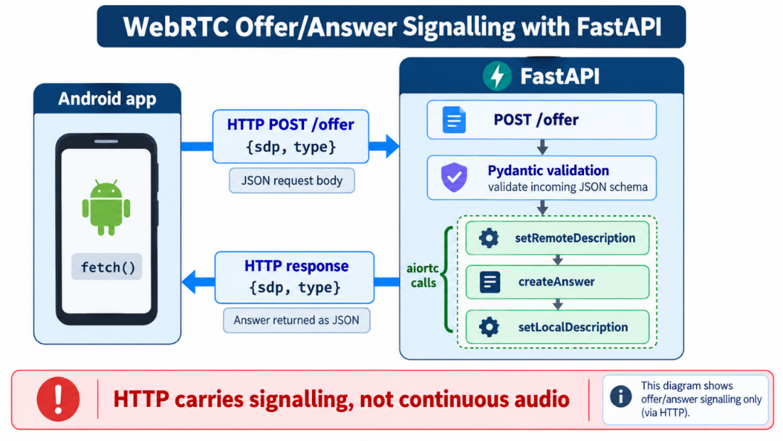
What this section does and why it matters: Learn the negotiation sequence before coding it so every subsequent line has a clear purpose.
New technical concepts introduced in this section (in absolute beginner terms): A PeerConnection cannot simply connect to a server address. Each side creates/accepts a session description, exchanges network candidates, establishes secure transport and only then moves media.
Who does what: Every developer should be able to explain the handshake without looking at code before implementing Steps 4–16.

3.1 — Offer and answer in plain English
What this section does and why it matters: Explain how the phone proposes a session and how the Gateway accepts it.
New technical concepts introduced in this section (in absolute beginner terms): An offer is the caller’s proposed session description. An answer is the remote peer’s compatible response. Both are SDP objects.
PHONE GATEWAY
RTCPeerConnection
|
createOffer()
▼
SDP OFFER -------- HTTP POST /offer --------> RTCPeerConnection
setRemoteDescription()
createAnswer()
setLocalDescription()
SDP ANSWER <--------- HTTP JSON response -------
|
setRemoteDescription(answer)
▼
ICE candidate checks → DTLS → SRTP media transport

3.2 — Why the first implementation uses one-shot HTTP and non-trickle ICE
What this section does and why it matters: Keep the signalling mechanism intentionally simple for the learning milestone.
New technical concepts introduced in this section (in absolute beginner terms): Trickle ICE sends candidates as they are discovered. Non-trickle ICE waits until gathering is complete and then sends one SDP containing the candidates. This is simpler for a first HTTP-only proof.
The source deliberately waits for ICE gathering to finish before posting the final local description. Later architectures can replace this with WebSocket/trickle-ICE signalling, but that change is outside Steps 0–19.

Step 4 — Add the FastAPI /offer Signalling Endpoint
What this section does and why it matters: Create the Gateway endpoint that accepts the phone’s SDP offer, asks aiortc to build an answer, and returns that answer as JSON.
New technical concepts introduced in this section (in absolute beginner terms): Pydantic validates incoming JSON. RTCSessionDescription is aiortc’s representation of an SDP offer/answer. A set of PeerConnections keeps live objects referenced by the application.
Who does what: Gateway developer edits app/main.py. Mobile code does not change yet.

4.1 — Start with a health/root endpoint
What this section does and why it matters: Provide the simplest possible proof that FastAPI itself can start before WebRTC code is blamed for server failures.
New technical concepts introduced in this section (in absolute beginner terms): An HTTP GET route is a small request/response endpoint. FastAPI automatically exposes OpenAPI/Swagger documentation at /docs.
from fastapi import FastAPI
app = FastAPI()
@app.get("/")
async def root():
return {"status": "RedDust Gateway running"}

4.2 — Add the Offer model and POST /offer
What this section does and why it matters: Accept exactly the two signalling fields the phone sends and return the Gateway’s local answer.
New technical concepts introduced in this section (in absolute beginner terms): JSON is a text format for structured data. The Offer Pydantic model requires sdp and type so malformed requests fail visibly rather than being silently misinterpreted.
from fastapi import FastAPI
from pydantic import BaseModel
from aiortc import RTCPeerConnection, RTCSessionDescription
app = FastAPI()
peer_connections = set()
class Offer(BaseModel):
sdp: str
type: str
@app.post("/offer")
async def offer(offer: Offer):
pc = RTCPeerConnection()
peer_connections.add(pc)
remote_offer = RTCSessionDescription(
sdp=offer.sdp,
type=offer.type,
)
await pc.setRemoteDescription(remote_offer)
answer = await pc.createAnswer()
await pc.setLocalDescription(answer)
return {
"sdp": pc.localDescription.sdp,
"type": pc.localDescription.type,
}
Important note: At this stage the Gateway can negotiate a receive-only audio session, but it does not yet add an outgoing echo track. That is intentional; we prove signalling before return media.
DIAGRAM — 4-A: FastAPI Signalling Boundary
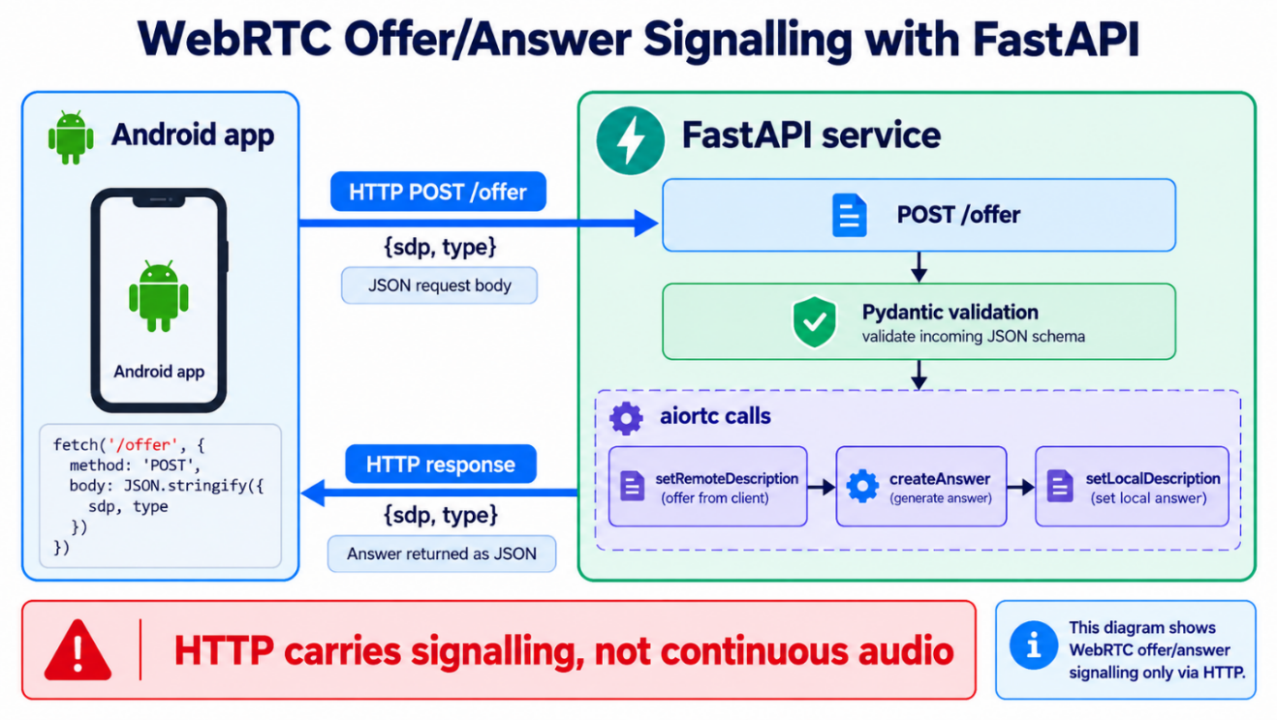

Step 5 — Understand Incoming WebRTC Audio Tracks
DIAGRAM — 5-A: From Encrypted WebRTC Packets to an aiortc Audio Track
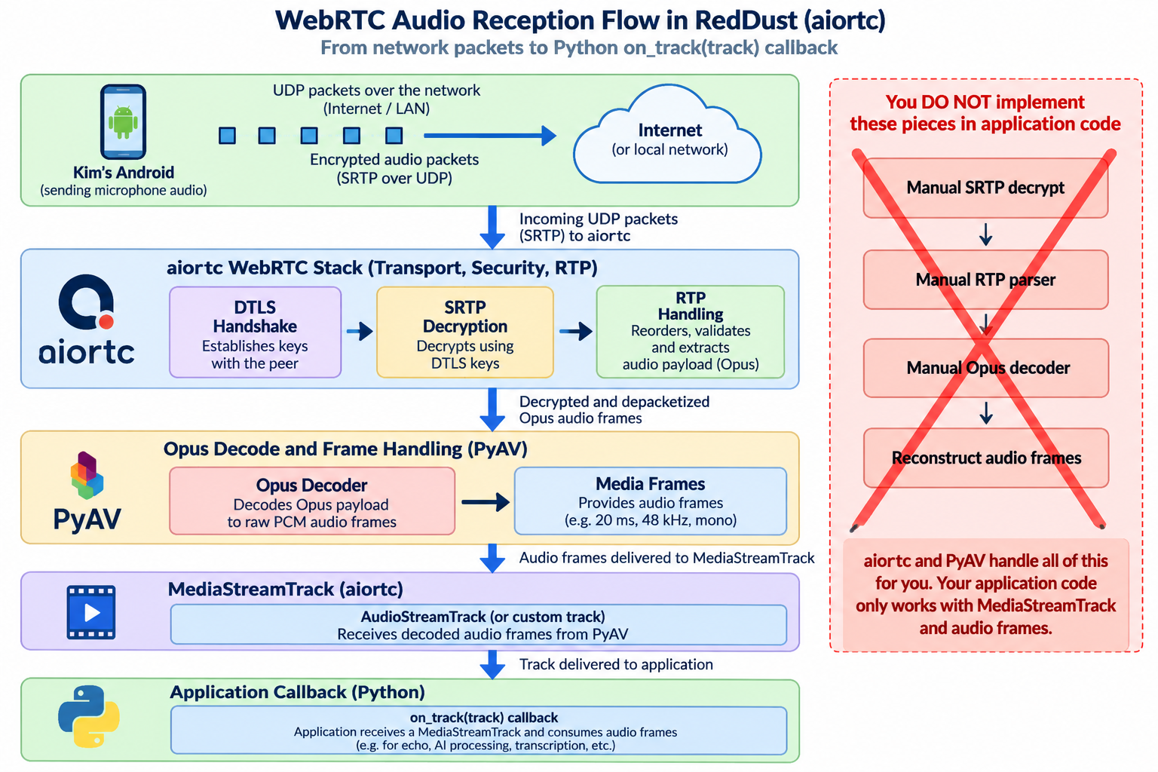
What this section does and why it matters: Teach what aiortc receives when the phone sends microphone media and establish the extension point for echo processing.
New technical concepts introduced in this section (in absolute beginner terms): A MediaStreamTrack is a logical stream of timed media frames. The aiortc track event fires when a remote track is discovered from the phone’s offer.
Who does what: Gateway developer learns the track event before implementing EchoAudioTrack.

5.1 — The aiortc track event
What this section does and why it matters: Show where incoming audio enters Python application code.
New technical concepts introduced in this section (in absolute beginner terms): An event handler is a function called when something happens. @pc.on("track") registers a function that receives the remote MediaStreamTrack.
@pc.on("track")
def on_track(track):
print("Gateway received track:", track.kind)
if track.kind == "audio":
# Step 6 will attach an outgoing echo track here.
pass
The application does not receive encrypted SRTP packets directly. aiortc handles transport, decryption, RTP and codec processing. The Python layer works with media-track frames.

Step 6 — Implement the First EchoAudioTrack
What this section does and why it matters: Create the smallest possible media transformation: receive an audio frame from the incoming track and return that same frame as the outgoing track.
New technical concepts introduced in this section (in absolute beginner terms): Subclassing means creating a specialized class based on an existing class. recv() is aiortc’s asynchronous method for obtaining the next media frame.
Who does what: Gateway developer creates app/echo.py and later attaches the track to the PeerConnection.

6.1 — Create app/echo.py

DIAGRAM — 6-A: EchoAudioTrack Frame Loop
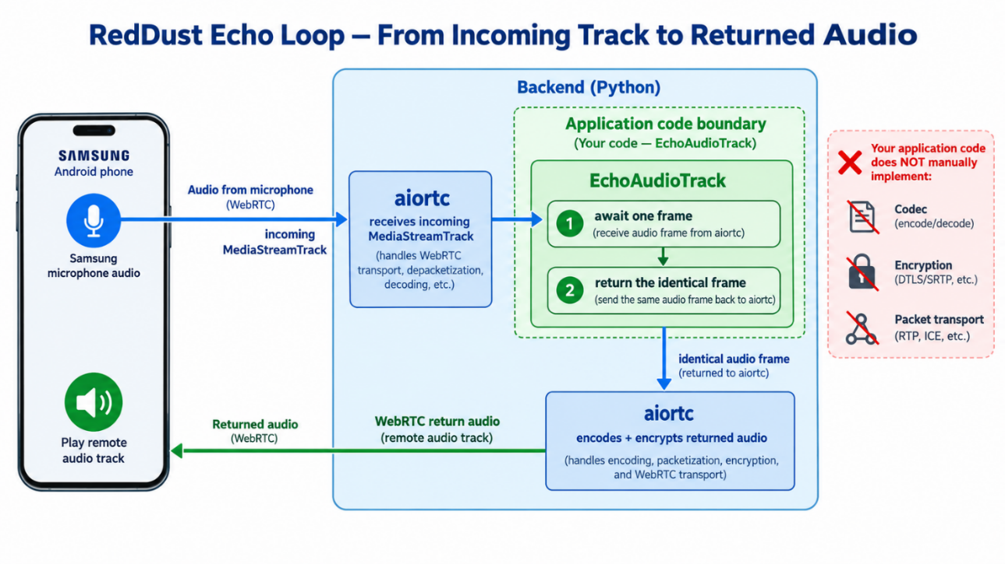
What this section does and why it matters: Implement an outgoing aiortc audio track whose source is the phone’s incoming audio track.
New technical concepts introduced in this section (in absolute beginner terms): async/await allows the function to wait for the next audio frame without blocking the entire server event loop.
from aiortc import MediaStreamTrack
class EchoAudioTrack(MediaStreamTrack):
kind = "audio"
def __init__(self, incoming_track):
super().__init__()
self.incoming_track = incoming_track
async def recv(self):
frame = await self.incoming_track.recv()
return frame
Conceptually, the first implementation performs no signal processing. It simply makes the incoming phone frame become the next outgoing frame.
phone audio frame
↓
incoming_track.recv()
↓
same frame
↓
EchoAudioTrack.recv() returns it
↓
aiortc sends it back through WebRTC

Step 7 — Verify the Gateway Independently
What this section does and why it matters: Prove Python, FastAPI, Uvicorn, aiortc and PyAV are healthy before introducing mobile networking.
New technical concepts introduced in this section (in absolute beginner terms): A native-module import failure can occur before main.py executes. Uvicorn’s reloader process can start even if the actual application worker crashes.
Who does what: Gateway developer performs these checks first; mobile developer waits until /docs and imports are healthy.

7.1 — Recover from a broken Python virtual environment
What this section does and why it matters: Consolidate the source’s pydantic_core failure into a clean recovery procedure.
New technical concepts introduced in this section (in absolute beginner terms): pydantic_core contains compiled native code. If the virtual environment was created with the wrong Python version or became inconsistent, the safest fix is often to recreate .venv rather than patch individual files.
CAUTION / STOP POINT: The source encountered a Python 3.14-created .venv and a missing pydantic_core native module. The consolidated baseline is Python 3.12.10.
# Stop Uvicorn first with Ctrl+C
Deactivate # if your shell provides the command; otherwise close the terminal
Remove-Item -Recurse -Force .venv
py -3.12 -m venv .venv
.venv\Scripts\Activate.ps1
python --version
python -m pip install --upgrade pip
python -m pip install -r requirements.txt
python -c "import fastapi, pydantic_core, aiortc, av; print('All gateway imports OK')"

7.2 — Start Uvicorn and inspect FastAPI docs
DIAGRAM — 7-A: Gateway Validation Ladder
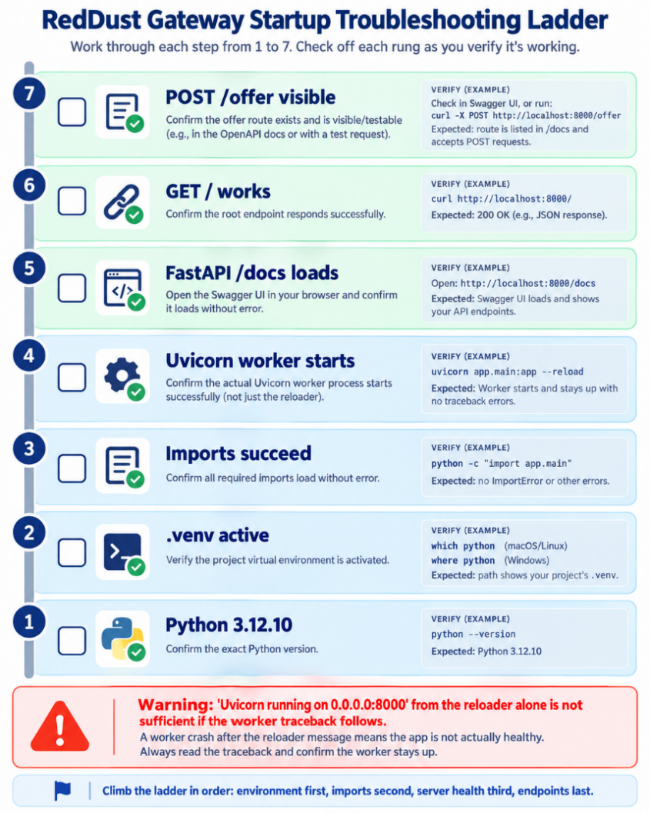
What this section does and why it matters: Prove the actual ASGI worker started and the expected routes are loaded.
New technical concepts introduced in this section (in absolute beginner terms): 0.0.0.0 means “listen on all local network interfaces”; it is not the URL a phone should literally use. /docs is FastAPI’s generated interactive API documentation.
cd D:\RedDust\reddust-gateway
.venv\Scripts\Activate.ps1
python -m uvicorn app.main:app --reload --host 0.0.0.0 --port 8000
Open on a browser in the laptop: http://localhost:8000/docs
Try: http://localhost:8000 and http://localhost:8000/garbage
Success criterion: Uvicorn reports application startup complete, /docs loads, and the expected GET / and POST /offer routes are visible.

Step 8 — Build a Deliberately Simple Mobile Test Screen
What this section does and why it matters: Create a minimal UI so WebRTC behavior is visible without mixing it with the final Syan experience.
New technical concepts introduced in this section (in absolute beginner terms): A proof-of-concept screen minimizes UI complexity and exposes status messages and Start/Stop controls that directly correspond to the connection lifecycle.
Who does what: Mobile developer builds only the test harness. Product UI integration is deferred until the transport works.

8.1 — Keep the screen boring on purpose
What this section does and why it matters: Make debugging observable by showing explicit status and only the controls required for the experiment.
New technical concepts introduced in this section (in absolute beginner terms): React state values cause the screen to re-render when they change. This makes status text a simple visual trace of connection progress.
┌──────────────────────────────┐
│ RedDust WebRTC Test │
│ │
│ Status: Disconnected │
│ │
│ [ Start Microphone ] │
│ [ Stop Microphone ] │
└──────────────────────────────┘
DIAGRAM — 8-A: Minimal WebRTC Test Screen
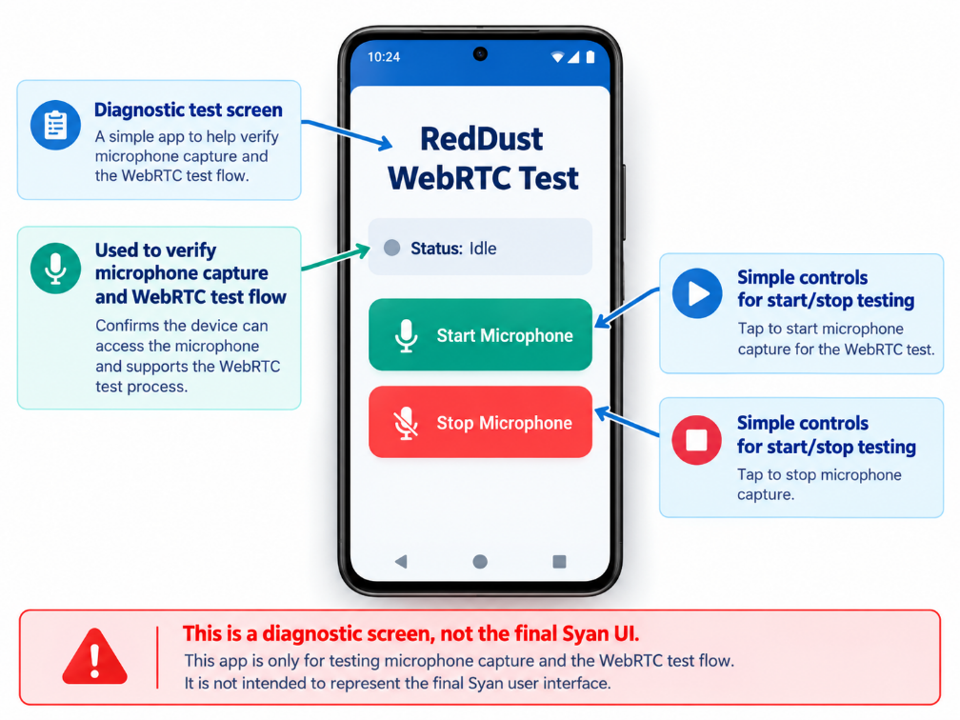

Step 9 — Capture Microphone Audio with react-native-webrtc
What this section does and why it matters: Prove that the physical phone microphone can be captured by the custom RedDust development build and represented as a live WebRTC MediaStream.
New technical concepts introduced in this section (in absolute beginner terms): getUserMedia() asks the native WebRTC layer for audio/video sources. A MediaStream groups tracks; a MediaStreamTrack is one specific source such as the microphone.
Who does what: Mobile developer works on index.tsx. Gateway can remain untouched while microphone capture is validated.

9.1 — Import the WebRTC primitives
What this section does and why it matters: Bring the native WebRTC APIs into the TypeScript screen.
New technical concepts introduced in this section (in absolute beginner terms): mediaDevices provides getUserMedia; RTCPeerConnection represents the connection; RTCSessionDescription represents SDP; MediaStream is the local/remote media stream type.
import {
mediaDevices,
MediaStream,
RTCPeerConnection,
RTCSessionDescription,
} from "react-native-webrtc";

9.2 — Capture audio only
What this section does and why it matters: Ask the physical phone for its microphone and verify that one live audio track exists.
New technical concepts introduced in this section (in absolute beginner terms): video:false prevents camera capture. The returned stream remains local until a track is explicitly added to a PeerConnection in Step 12.
const localStream = await mediaDevices.getUserMedia({
audio: true,
video: false,
});
const audioTracks = localStream.getAudioTracks();
console.log("Audio tracks:", audioTracks);
Success criterion: The log shows an audio track with kind="audio", enabled=true and readyState="live". remote=false indicates that this is the phone’s own local track.
DIAGRAM — 9-A: Microphone Capture Boundary
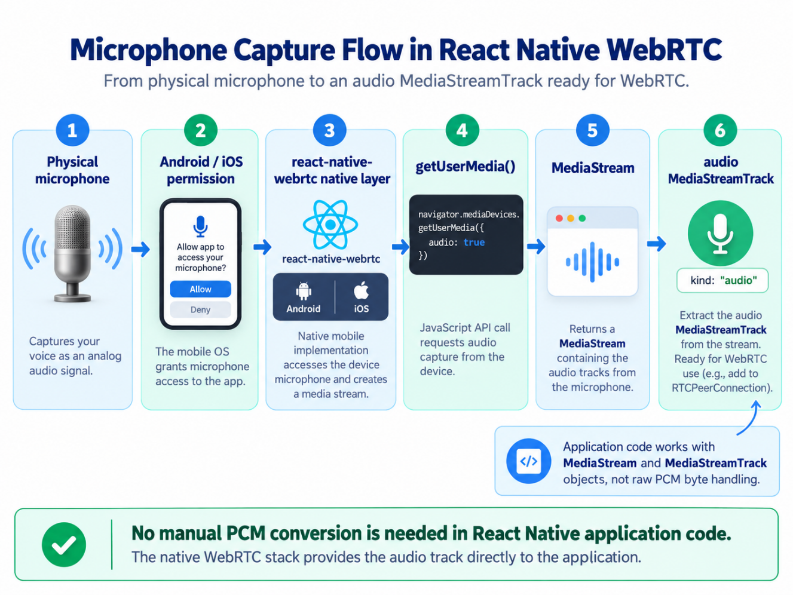

Step 10 — Configure Native Permissions, EAS Development Build and Metro
This section describes the Android development side of the mobile phone app. An elaborate description for the iOS development is in Appendix E — iOS / iPhone Development for RedDust Mobile towards the end of this document.
To prepare your physical mobile phones to install, run, diagnose and validate the native RedDust Development Build, follow the section Appendix F – Preparing Physical Android Phones and iPhones for RedDust Development towards the end of this document.
What this section does and why it matters: Give the native mobile application permission to record audio, build a custom development binary containing WebRTC, install it on a physical phone, and connect that binary to Metro for JavaScript development.
New technical concepts introduced in this section (in absolute beginner terms): Native permissions are compiled into the mobile application. APK is an installable Android application package. Metro is the React Native JavaScript bundler; it is not the WebRTC backend.
Who does what: Mobile developer changes app.json and creates/installs the development build. Gateway developer does not need to change Python for this step.

10.1 — Configure microphone permissions
What this section does and why it matters: Declare why the application needs microphone access on iOS and which Android capabilities the native binary should contain.
New technical concepts introduced in this section (in absolute beginner terms): iOS Info.plist and AndroidManifest permissions are native configuration. Runtime permission is the user’s later approval on the device.
iOS concept
"ios": {
"infoPlist": {
"NSMicrophoneUsageDescription":
"RedDust uses your microphone for real-time voice conversations."
}
}
Android concept — preserve other existing Expo-generated android settings
"android": {
"permissions": [
"android.permission.ACCESS_NETWORK_STATE",
"android.permission.INTERNET",
"android.permission.MODIFY_AUDIO_SETTINGS",
"android.permission.RECORD_AUDIO",
"android.permission.WAKE_LOCK"
]
}
Important note: The source also retained CAMERA, SYSTEM_ALERT_WINDOW and BLUETOOTH in its existing configuration. CAMERA is not required for the current audio-only test; preserve existing project settings unless intentionally reviewed.

10.2 — Make runtime microphone permission explicit on Android
What this section does and why it matters: Separate “the binary contains permission” from “the user granted permission at runtime”.
New technical concepts introduced in this section (in absolute beginner terms): PermissionsAndroid.request() displays Android’s permission dialog and returns the user’s decision.
const requestMicrophonePermission = async () => {
if (Platform.OS !== "android") {
return true;
}
const result = await PermissionsAndroid.request(
PermissionsAndroid.PERMISSIONS.RECORD_AUDIO,
{
title: "Microphone Permission",
message: "RedDust needs microphone access for real-time voice conversations.",
buttonPositive: "Allow",
buttonNegative: "Cancel",
},
);
return result === PermissionsAndroid.RESULTS.GRANTED;
};

10.3 — Create the EAS development build
What this section does and why it matters Compile the native RedDust app in the cloud so react-native-webrtc and permissions are physically present in the installed APK.
New technical concepts introduced in this section (in absolute beginner terms): A developmentClient build is a custom debug/development binary. An APK can be installed directly on Android; an AAB is normally intended for Play distribution.
eas.json — relevant development profile
{
"build": {
"development": {
"developmentClient": true,
"distribution": "internal"
}
}
}
cd D:\RedDust\reddust-mobile
npx eas-cli@latest build --profile development --platform android
Need to install the following packages:
eas-cli@25.0.0
Ok to proceed? (y) y
CAUTION / STOP POINT: If native permissions, Expo plugins or native libraries change, Metro cannot retrofit those changes into an already-compiled APK. A new development build is required.

10.4 — Install and open the development build on the physical Android phone
What this section does and why it matters: Put the compiled custom RedDust binary on the real device so microphone and native WebRTC can be tested.
New technical concepts introduced in this section (in absolute beginner terms): Android may require permission for the browser/file manager to install an APK from that source. This is a source-specific install permission, not a global disabling of device security.
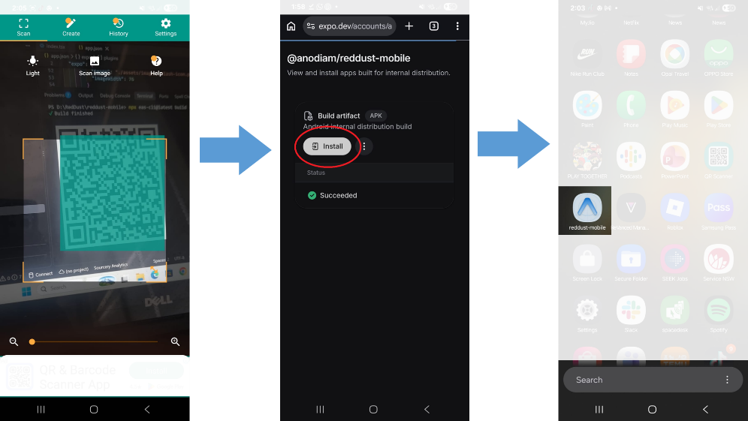
1. Open the completed EAS build page or scan its install QR code.
2. Download the development APK on the phone.
3. If Android asks, temporarily enable “Allow from this source” for the browser/file manager performing the install.
4. Install and open the RedDust development build.
5. Optionally disable “Allow from this source” afterward.

10.5 — Start Metro and connect the development build
What this section does and why it matters: Load the current TypeScript/JavaScript bundle from the Windows laptop into the already-installed native development application.
New technical concepts introduced in this section (in absolute beginner terms): Metro listens during development (commonly around port 8081) and serves the JavaScript bundle. It does not carry WebRTC media and it does not replace FastAPI.
cd D:\RedDust\reddust-mobile
npx expo start
1. Put laptop and phone on the same normal Wi-Fi network.
2. Open the installed RedDust development build, not Expo Go.
3. Choose the discovered development server or scan Metro’s QR code.
4. Wait for the RedDust WebRTC Test screen to load.
5. Tap Start Microphone and grant permission if asked.
6. Confirm one live audio track.
Once you start the expo mobile app with npx, your app will automatically start in your mobile phone.
If you receive an error like:
ERROR Microphone/WebRTC error: [Error: fetch failed: java.net.NoRouteToHostException: Host unreachable]
Check your laptop’s IP address:
ipconfig
And look for:
IPv4 Address. . . . . . . . . . . : 192.168.1.x
Paste the value in your mobile app’s root’s .env.local file. Save, your mobile app will refresh itself.
Rerun the test
Do Not Update/ Upgrade Expo or other packages: Ignore if you see warnings like this asking you to update Expo or other packages
An update for expo is available: 56.0.21 → ~56.0.23
5 other packages may need updating. Run npx expo install --check for details.
DIAGRAM — 10-A: Screenshot of Expo Development Client launcher.
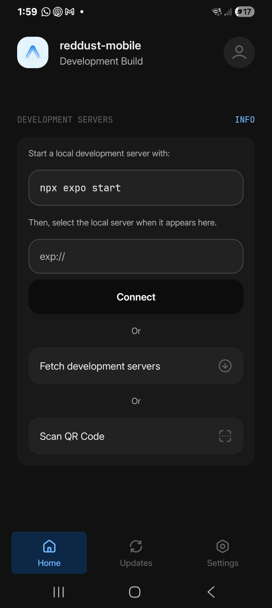
DIAGRAM — 10-B: Development-Only Metro versus WebRTC Gateway
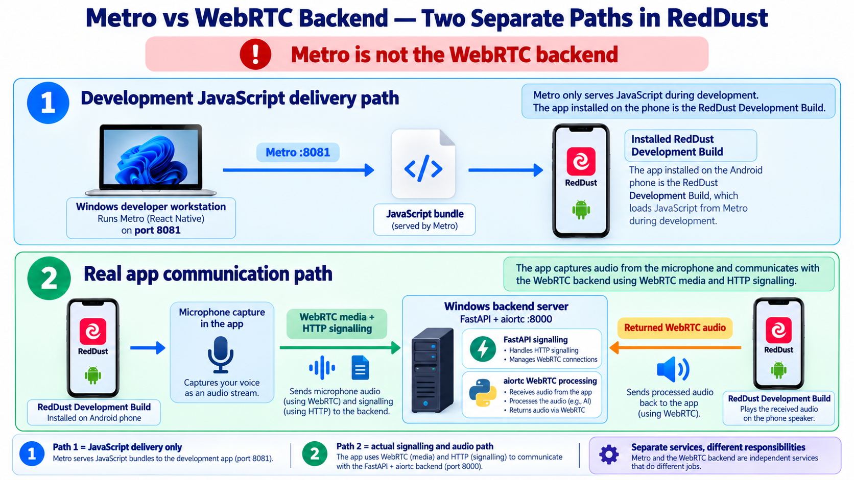

10.6 — Prevent accidental duplicate microphone streams
What this section does and why it matters: Keep the test harness deterministic when an intern taps Start repeatedly.
New technical concepts introduced in this section (in absolute beginner terms): A guard clause exits early if the local stream already exists; disabled buttons reinforce the same rule in the UI.
if (stream) {
setStatus("Microphone is already running");
return;
}
<Button
title="Start Microphone"
onPress={startMicrophone}
disabled={stream !== null}
/>
<Button
title="Stop Microphone"
onPress={stopMicrophone}
disabled={stream === null}
/>

Step 11 — Create RTCPeerConnection and Configure STUN
What this section does and why it matters: Create the phone-side WebRTC connection object and configure the ICE helper used to discover candidate network addresses.
New technical concepts introduced in this section (in absolute beginner terms): RTCPeerConnection is the central WebRTC object. NAT translates private local addresses to public addresses. STUN helps a peer discover a server-reflexive candidate; TURN would relay media when direct paths fail.
Who does what: Mobile developer creates one PeerConnection per test session. TURN is deliberately deferred.

11.1 — Create the connection
What this section does and why it matters: Construct the native WebRTC connection object before attaching media or creating an offer.
New technical concepts introduced in this section (in absolute beginner terms): iceServers tells WebRTC which STUN/TURN services may help candidate discovery.
const pc = new RTCPeerConnection({
iceServers: [
{
urls: "stun:stun.l.google.com:19302",
},
],
});
Important note: The Google STUN server is used here as a development helper. The source explicitly defers TURN until later Internet/production reliability work.
DIAGRAM — 11-A: STUN, NAT and ICE Candidates
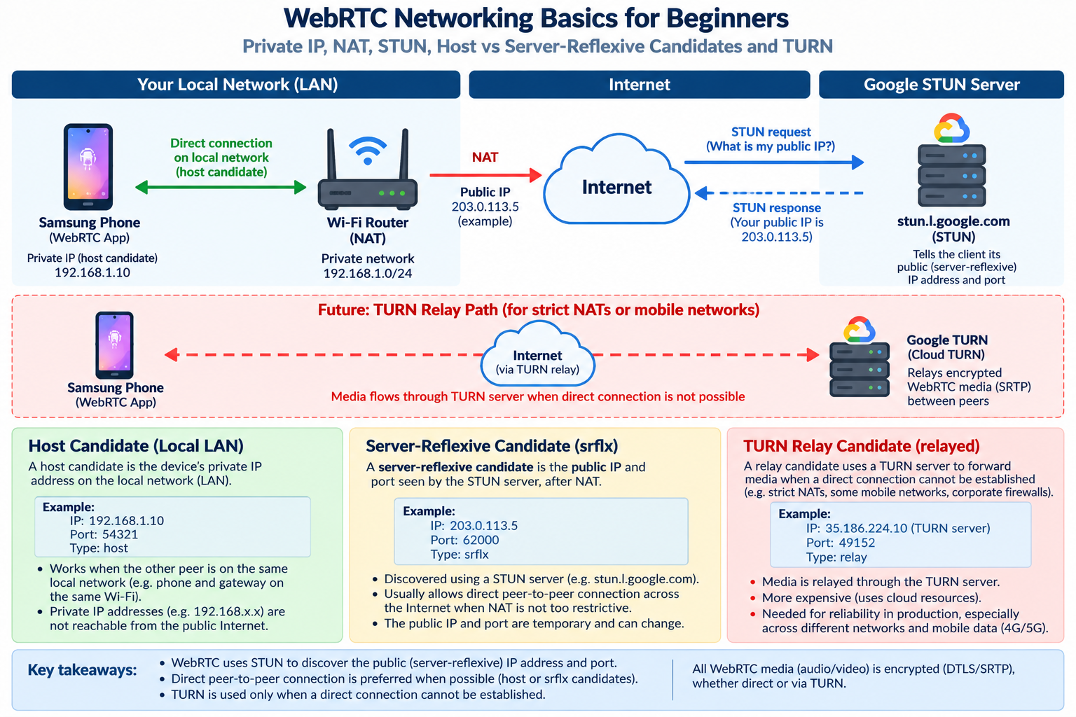

Step 12 — Attach the Microphone Track to the PeerConnection
DIAGRAM — 12-A: Microphone to PeerConnection
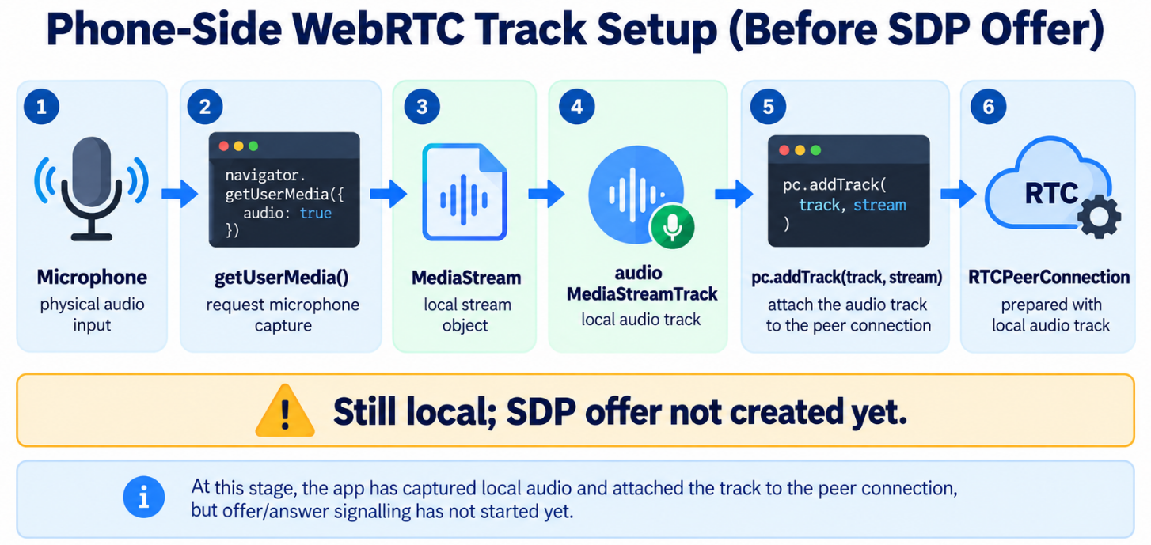
What this section does and why it matters: Move the microphone from “captured locally” to “declared as media this PeerConnection intends to send”.
New technical concepts introduced in this section (in absolute beginner terms): addTrack() attaches a MediaStreamTrack to RTCPeerConnection. Nothing necessarily leaves the phone at the instant addTrack is called; it changes what the later SDP offer describes.
Who does what: Mobile developer performs this after getUserMedia and before createOffer.

12.1 — Add all local tracks
What this section does and why it matters: Attach the current microphone audio track to the connection using the MediaStream it came from.
New technical concepts introduced in this section (in absolute beginner terms): A MediaStream can contain multiple tracks. getTracks().forEach() makes the code ready to attach all tracks in the stream.
localStream.getTracks().forEach((track) => {
pc.addTrack(track, localStream);
});
console.log("Microphone track added to RTCPeerConnection");
Milestone
Microphone
↓
MediaStream
↓
audio MediaStreamTrack
↓
RTCPeerConnection

Step 13 — Create and Adopt the SDP Offer
What this section does and why it matters: Ask the phone’s PeerConnection to generate its proposed WebRTC session description and set that proposal as the local description.
New technical concepts introduced in this section (in absolute beginner terms): createOffer() creates SDP based on attached tracks/capabilities. setLocalDescription() adopts the offer and starts ICE candidate gathering.
Who does what: Mobile developer adds these lines immediately after Step 12.

13.1 — Create the offer
What this section does and why it matters: Generate the phone’s proposal for the audio session.
New technical concepts introduced in this section (in absolute beginner terms): The SDP includes media sections, codecs such as Opus, security fingerprints, ICE credentials and other WebRTC negotiation parameters.
const offer = await pc.createOffer();
console.log("WebRTC offer created");
console.log("Offer type:", offer.type);
console.log("Initial Offer SDP:", offer.sdp);

13.2 — Set the local description
What this section does and why it matters: Tell the PeerConnection that this offer is now its official local session description.
New technical concepts introduced in this section (in absolute beginner terms): setLocalDescription() is also the trigger for ICE candidate gathering in this flow.
await pc.setLocalDescription(offer);
console.log("Local description set");
CAUTION / STOP POINT: Do not manually parse or hand-edit the SDP. WebRTC owns SDP construction. Logs are useful for learning/debugging, but full SDP may expose local/public IP information and temporary credentials, so do not treat production SDP logs as harmless.
DIAGRAM — 13-A: Offer Lifecycle on the Phone
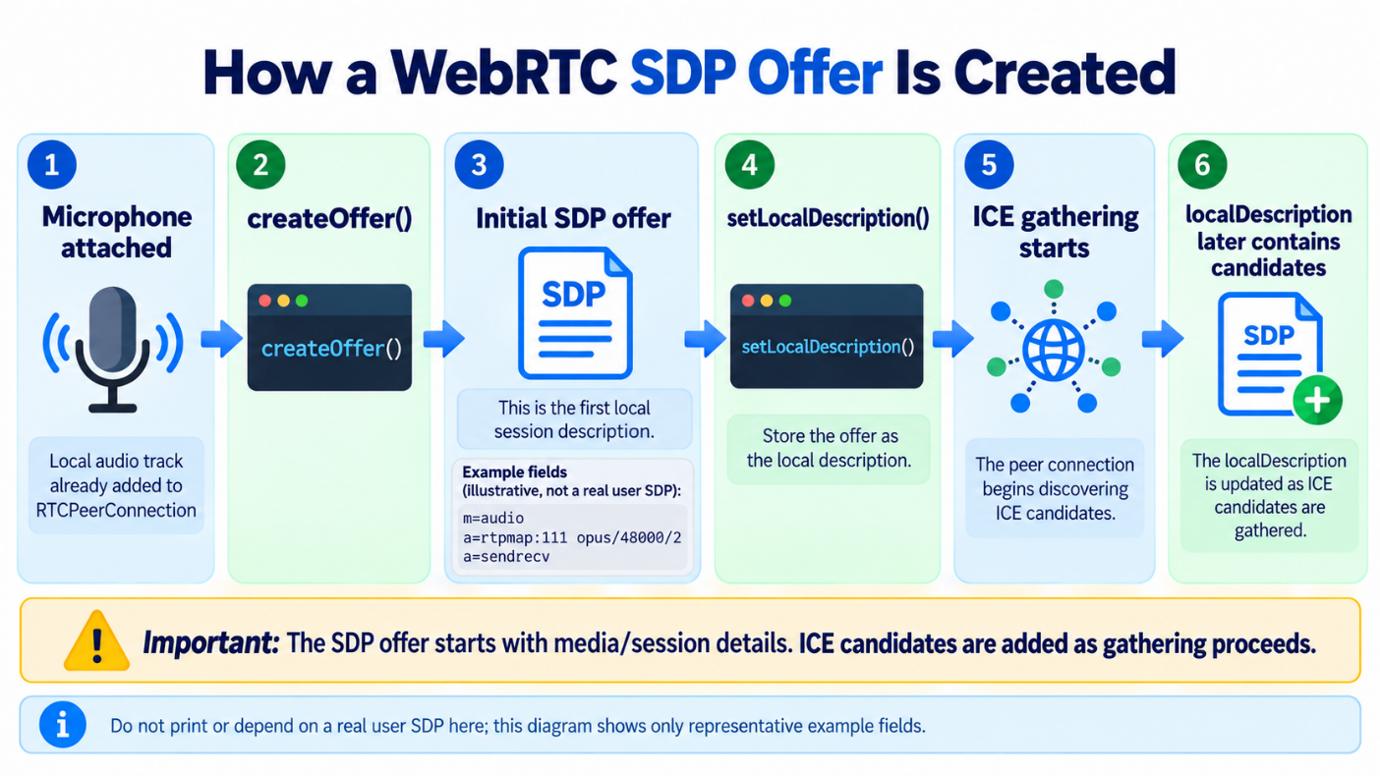

Step 14 — Send the Offer to FastAPI and Receive the Answer
What this section does and why it matters: Complete the HTTP signalling round-trip between the physical phone and the laptop Gateway.
New technical concepts introduced in this section (in absolute beginner terms): localhost is device-relative: on the phone, localhost means the phone. The phone must call the laptop’s Wi-Fi IPv4 address. fetch() sends JSON over HTTP; FastAPI/aiortc returns the SDP answer.
Who does what: Mobile developer determines their own LAN address; Gateway developer keeps Uvicorn listening on 0.0.0.0:8000.

14.1 — Determine the laptop’s active Wi-Fi IPv4 address
What this section does and why it matters: Give the phone an address it can actually reach on the same LAN.
New technical concepts introduced in this section (in absolute beginner terms): IPv4 private LAN addresses often look like 192.168.x.x. DHCP can change the address after reconnect/reboot.
ipconfig
Look under the active Wi-Fi adapter for IPv4 Address.
If the laptop is 192.168.1.8, the phone calls: http://192.168.1.8:8000/offer.
CAUTION / STOP POINT: Do not use http://localhost:8000/offer from the phone. On the phone, localhost means the phone itself.

14.2 — Wait for ICE gathering to complete before posting
What this section does and why it matters: Send one complete offer containing the discovered ICE candidates, matching the source’s non-trickle-ICE learning design.
New technical concepts introduced in this section (in absolute beginner terms): iceGatheringState progresses through new → gathering → complete. We wait for complete before reading pc.localDescription.
const waitForIceGatheringComplete = async (pc: RTCPeerConnection) => {
if (pc.iceGatheringState === "complete") {
return;
}
await new Promise<void>((resolve) => {
pc.onicegatheringstatechange = () => {
console.log("ICE gathering state:", pc.iceGatheringState);
if (pc.iceGatheringState === "complete") {
pc.onicegatheringstatechange = null;
resolve();
}
};
});
};

14.3 — POST the final local description to /offer
DIAGRAM — 14-A: Local HTTP Signalling Round Trip
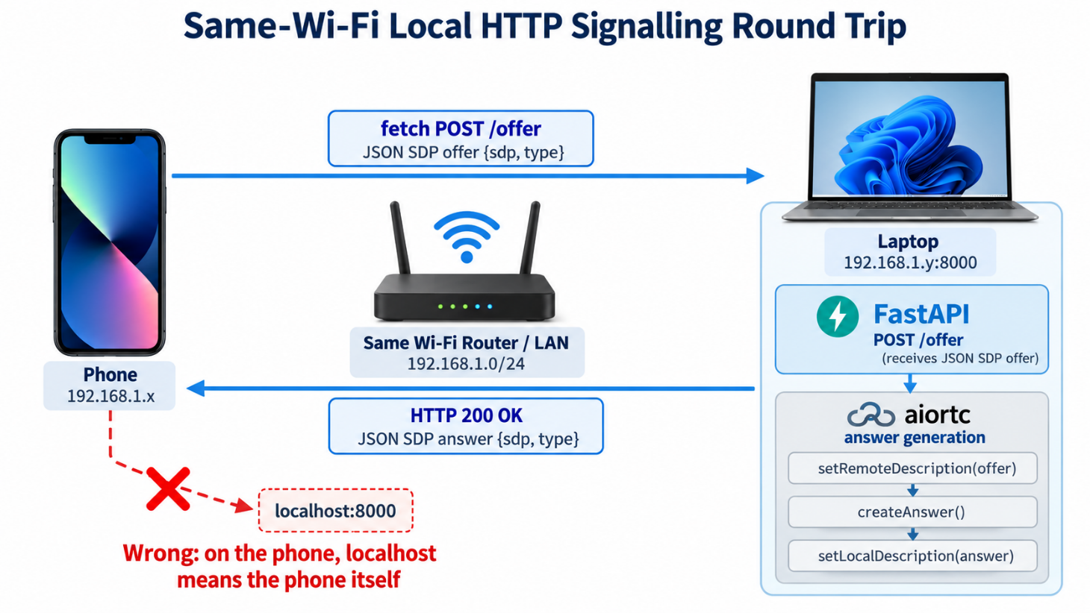
What this section does and why it matters: Send the complete offer as JSON and read the JSON answer returned by FastAPI.
New technical concepts introduced in this section (in absolute beginner terms): HTTP status response.ok is true for successful 2xx responses. JSON.stringify converts a JavaScript object into request text; response.json() converts the returned JSON text back into an object.
await waitForIceGatheringComplete(pc);
const localDescription = pc.localDescription;
if (!localDescription) {
throw new Error("PeerConnection has no local description");
}
const response = await fetch(
"http://YOUR_LAPTOP_IP:8000/offer",
{
method: "POST",
headers: {
"Content-Type": "application/json",
},
body: JSON.stringify({
sdp: localDescription.sdp,
type: localDescription.type,
}),
},
);
if (!response.ok) {
throw new Error(`Gateway returned HTTP ${response.status}`);
}
const answer = await response.json();
console.log("Gateway answer received");
console.log("Answer type:", answer.type);
Success criterion: Metro reports “Gateway answer received” with answer.type = answer, and Uvicorn reports POST /offer ... 200 OK.

Step 15 — Apply the Gateway Answer on the Phone
What this section does and why it matters: Finish SDP negotiation by giving the phone’s PeerConnection the answer returned by aiortc.
New technical concepts introduced in this section (in absolute beginner terms): The phone already knows its local offer; setRemoteDescription(answer) gives it the remote peer’s negotiated answer. Only after both local and remote descriptions exist can WebRTC fully proceed through connectivity/security setup.
Who does what: Mobile developer applies the answer. No Gateway change is required.

15.1 — Convert and set the remote description
What this section does and why it matters: Adopt the Gateway’s answer inside the same RTCPeerConnection that created the offer.
New technical concepts introduced in this section (in absolute beginner terms): RTCSessionDescription wraps the {type,sdp} answer as a WebRTC session-description object.
setStatus("Applying gateway WebRTC answer...");
await pc.setRemoteDescription(
new RTCSessionDescription(answer),
);
console.log("Remote description set");
Success criterion: Offer created, offer sent, Gateway answer received, and setRemoteDescription() completes successfully. This proves signalling through Step 15, but not yet live media connectivity.
DIAGRAM — 15-A: Phone State Before and After setRemoteDescription
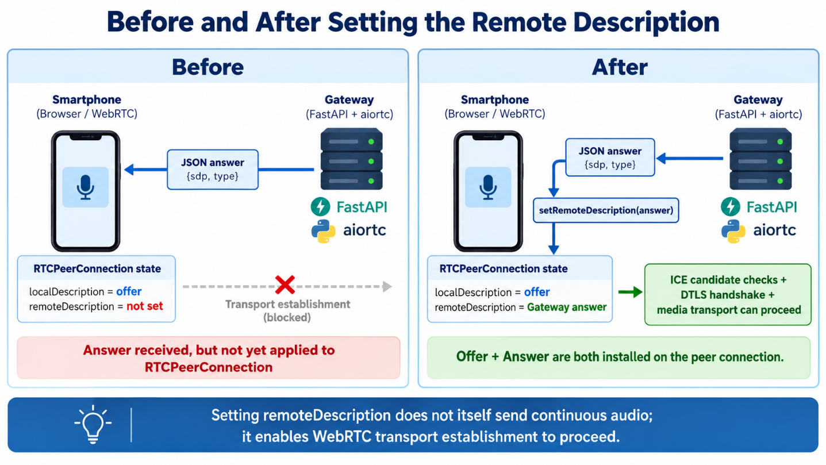

Step 16 — Prove ICE/DTLS Connectivity; Restart and Onboard Reproducibly
What this section does and why it matters: Move beyond “signalling succeeded” and prove that WebRTC establishes an actual transport. Then turn the working local setup into a repeatable restart and teammate-onboarding procedure.
New technical concepts introduced in this section (in absolute beginner terms): ICE gathering discovers addresses; ICE connection checks test whether those addresses actually communicate. PeerConnection connectionState is the higher-level transport state. A compatibility shim is a small localized workaround for library type definitions.
Who does what: Mobile developer monitors connection state. Gateway developer watches signalling. The team lead uses Step 16C as the onboarding baseline.

16.1 — Add ICE and PeerConnection state monitoring
What this section does and why it matters: Observe the live transport state so interns can distinguish SDP success from real network success.
New technical concepts introduced in this section (in absolute beginner terms): iceConnectionState typically moves new → checking → connected/completed. connectionState typically moves new → connecting → connected.
console.log("Initial ICE connection state:", pc.iceConnectionState);
console.log("Initial PeerConnection state:", pc.connectionState);
pc.oniceconnectionstatechange = () => {
console.log("ICE:", pc.iceConnectionState);
};
pc.onconnectionstatechange = () => {
console.log("Connection:", pc.connectionState);
};
State family | Healthy progression | Meaning
ICE gathering | new → gathering → complete | Possible addresses/candidates have been discovered.
ICE connection | new → checking → connected or completed | A candidate pair has actually been proven to carry traffic.
PeerConnection | new → connecting → connected | The overall WebRTC transport is established.
CAUTION / STOP POINT: Do not confuse “ICE gathering complete” with “ICE connected”. Gathering means addresses were found; connected means an address pair actually works.
Success criterion: ICE reaches connected or completed AND connectionState reaches connected.
DIAGRAM — 16-A: WebRTC State Machine for the Local Test
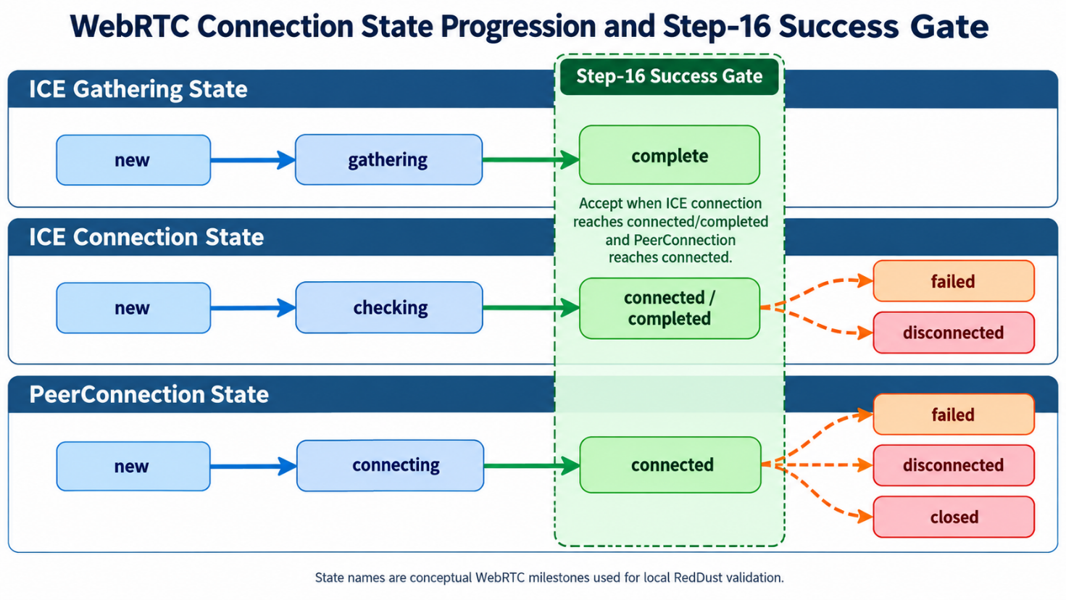

16.2 — Use the source’s final TypeScript event-handler approach
What this section does and why it matters: Consolidate the source’s experimentation around addEventListener typings into a stable, limited approach.
New technical concepts introduced in this section (in absolute beginner terms): TypeScript declarations describe APIs to the compiler. A library can work at runtime while its resolved typings omit a method. Property handlers avoid the addEventListener typing issue for the state-change events in this baseline.
For ICE gathering/ICE connection/PeerConnection state changes, use the onicegatheringstatechange, oniceconnectionstatechange and onconnectionstatechange properties as shown in the source’s corrected Step 16A. If a narrow compatibility cast is still needed later for the remote “track” event, keep it isolated and clearly documented rather than spreading casts throughout the application.
Important note: A TypeScript cast does not insert a runtime audio-processing layer. The source correctly treats this as a type-safety/maintainability compromise, not a media-latency cost.

16.3 — Daily restart routine after a reboot/login
What this section does and why it matters: Restore the known-good local test without reinstalling dependencies or rebuilding the native app.
New technical concepts introduced in this section (in absolute beginner terms): DHCP can assign a new laptop IP. Metro and Uvicorn are development processes that must be restarted after reboot, while the development APK remains installed.
1. Put laptop and phone on the same Wi-Fi.
2. Run ipconfig and re-check the laptop IPv4 address.
3. If the Gateway URL is still hard-coded during this stage, update it if the IP changed. Step 16C replaces this with .env.local.
4. Gateway terminal: activate .venv and start Uvicorn on 0.0.0.0:8000.
5. Mobile terminal: run npx expo start.
6. Open the installed RedDust Development Build; connect it to Metro.
7. Tap Stop first if an old connection is present, then Start Microphone.
8. Verify POST /offer 200 OK, ICE connected/completed and Connection connected.
# Terminal 1 — Gateway
cd D:\RedDust\reddust-gateway
.venv\Scripts\Activate.ps1
python -m uvicorn app.main:app --reload --host 0.0.0.0 --port 8000
# Terminal 2 — Mobile
cd D:\RedDust\reddust-mobile
npx expo start
CAUTION / STOP POINT: Do not rerun npm install, pip install, EAS build, expo prebuild or venv creation as part of the normal daily restart unless a dependency/native configuration actually changed.
DIAGRAM — 16-B: Daily Local Development Startup
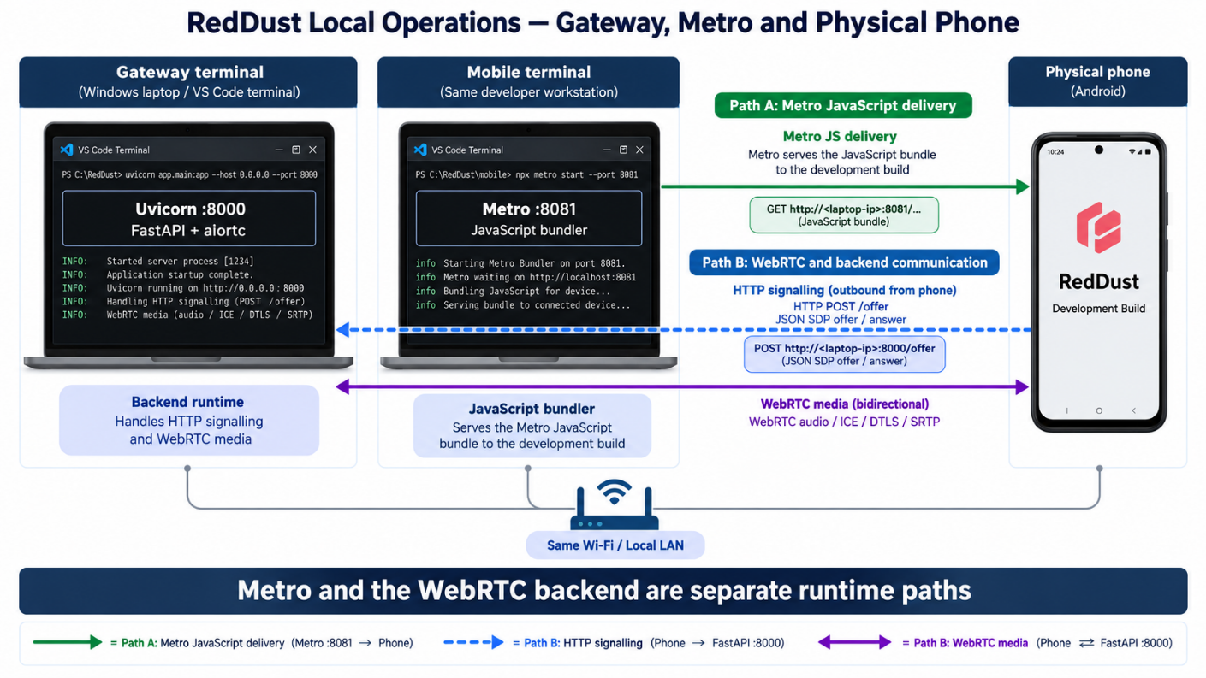

16.4 — Team onboarding from Git: reproducibility boundary
What this section does and why it matters: Turn the working environment into a process another intern can clone and reproduce rather than manually reconstructing the original workstation.
New technical concepts introduced in this section (in absolute beginner terms): Dependency manifests describe what to install; virtual environments and node_modules are machine-local build products and should not be committed. .env.local stores machine-specific values.
The source’s most important onboarding improvement is to remove the hard-coded laptop IP from TypeScript. Each developer should keep their own Gateway URL in an Expo public environment variable.
const gatewayUrl = process.env.EXPO_PUBLIC_GATEWAY_URL;
if (!gatewayUrl) {
throw new Error("EXPO_PUBLIC_GATEWAY_URL is not configured");
}
const response = await fetch(`${gatewayUrl}/offer`, { /* ... */ });
# reddust-mobile/.env.example
EXPO_PUBLIC_GATEWAY_URL=http://YOUR_LAPTOP_IP:8000
# each developer's uncommitted reddust-mobile/.env.local
EXPO_PUBLIC_GATEWAY_URL=http://192.168.x.x:8000

16.5 — What Git should and should not contain
What this section does and why it matters: Ensure the source repository contains everything needed to recreate dependencies but not machine-specific generated folders.
New technical concepts introduced in this section (in absolute beginner terms): Lock files and requirements files make dependency installation reproducible. node_modules and .venv are regenerated locally.
Project | Commit | Do not commit
reddust-gateway | app/, requirements.txt, .gitignore, README.md | .venv/, __pycache__/, *.pyc
reddust-mobile | source, assets, package.json, package-lock.json, app.json, eas.json, tsconfig.json, .env.example | node_modules/, .env.local, .expo/

16.6 — New teammate setup sequence
What this section does and why it matters: Give a newly joined intern a deterministic way to reconstruct both sides of the local proof.
New technical concepts introduced in this section (in absolute beginner terms): npm ci installs from package-lock.json; pip install -r installs from requirements.txt. A development build can be reused until native dependencies/configuration change.
1. Install/verify Git, VS Code, Python 3.12.10 and the team-approved Node/npm baseline.
2. Clone the RedDust repository into a local workspace.
3. Gateway: create a fresh .venv with Python 3.12.10, activate it, pip install -r requirements.txt, run the import test, start Uvicorn and verify /docs.
4. Mobile: run npm ci, verify pinned Expo/WebRTC packages and run npx expo-doctor.
5. Create .env.local with that developer laptop’s current Wi-Fi IPv4 address.
6. Install/reuse a compatible RedDust Development Build on the physical device; never use Expo Go for react-native-webrtc.
7. Start Metro and the Gateway in separate terminals.
8. Run the Step-16 connection test until ICE connected/completed and Connection connected.
DIAGRAM — 16-C: Teammate Onboarding Reproducibility Flow
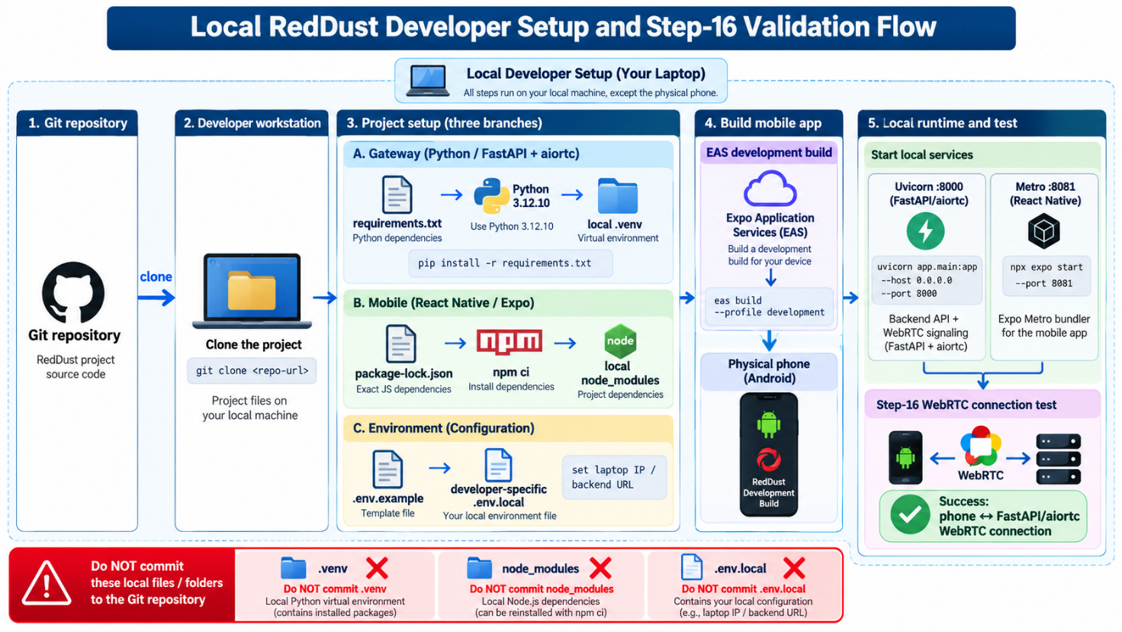

16.7 — iPhone onboarding boundary on Windows
What this section does and why it matters: Preserve the source’s platform caveat for interns who use iPhone while developing on Windows.
New technical concepts introduced in this section (in absolute beginner terms): Windows cannot locally compile iOS with Xcode. EAS can build in the cloud, but physical-device iOS development builds require Apple provisioning/device registration and Developer Mode.
The source describes using EAS cloud build for iOS from Windows, registering the physical iPhone, enabling Developer Mode on iOS 16+, and adding NSLocalNetworkUsageDescription when the app connects directly to a 192.168.x.x Gateway during development. This is a native Info.plist change and therefore requires a new iOS development build.
"NSLocalNetworkUsageDescription":
"RedDust connects to the local RedDust development gateway during development."

Step 17 — Receive the Echoed Remote Audio Track
What this section does and why it matters: Upgrade the Gateway from receive-only audio to two-way audio and prove that the phone receives a remote audio MediaStreamTrack.
New technical concepts introduced in this section (in absolute beginner terms): When aiortc adds EchoAudioTrack before createAnswer(), the answer can negotiate sending audio back. The phone’s track event represents the returned remote media after native WebRTC processing.
Who does what: Gateway developer adds the outgoing echo track; mobile developer registers the remote-track listener before applying the answer.

17.1 — Attach EchoAudioTrack before the Gateway creates the answer
What this section does and why it matters: Ensure the Gateway advertises an outgoing audio direction in its SDP answer.
New technical concepts introduced in this section (in absolute beginner terms): The order matters because createAnswer() describes the transceivers/tracks currently attached to the PeerConnection.
from app.echo import EchoAudioTrack
@pc.on("track")
def on_track(track):
print("Gateway received track:", track.kind)
if track.kind == "audio":
echo_track = EchoAudioTrack(track)
pc.addTrack(echo_track)
print("Gateway echo audio track added")
await pc.setRemoteDescription(remote_offer)
answer = await pc.createAnswer()
await pc.setLocalDescription(answer)
Important note: Register the track handler before setRemoteDescription(), because processing the remote offer is what reveals the incoming track.

17.2 — Listen for the remote track on the phone
What this section does and why it matters: Capture evidence that the return media path exists even before troubleshooting speaker routing.
New technical concepts introduced in this section (in absolute beginner terms): The remote track has already passed through SRTP decryption, RTP processing and codec decode in the native WebRTC layer. TypeScript receives a MediaStream/MediaStreamTrack, not encrypted packets.
const remoteStreamRef = useRef<MediaStream | null>(null);
// If your resolved react-native-webrtc typings require a narrow
// compatibility adapter for the track event, keep it isolated here.
eventPc.addEventListener("track", (event) => {
const remoteStream = event.streams[0];
if (!remoteStream) {
return;
}
remoteStreamRef.current = remoteStream;
const remoteAudioTracks = remoteStream.getAudioTracks();
console.log("Remote track kind:", event.track?.kind);
console.log("Remote audio track count:", remoteAudioTracks.length);
setStatus(`Remote audio received. Tracks: ${remoteAudioTracks.length}`);
});
Success criterion: Gateway logs “Gateway received track: audio” and “Gateway echo audio track added”; phone logs Remote track kind: audio and Remote audio track count: 1.
CAUTION / STOP POINT: Do not use “I hear myself” as the Step-17 success test. Step 17 proves the return media track exists. Speaker/earpiece routing is a separate layer handled by Step 18/19A.
DIAGRAM — 17-A: Return Audio Track Architecture
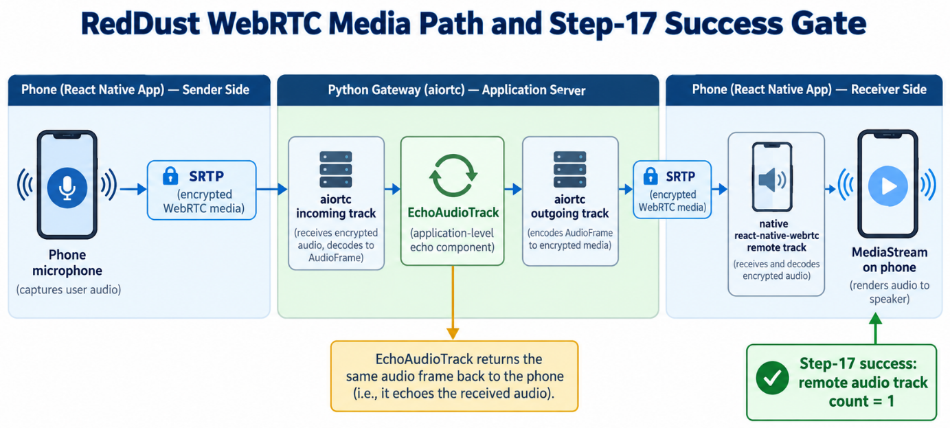

Step 18 — Perform the First Audible End-to-End Echo Test
What this section does and why it matters: Prove the complete bidirectional audio boundary by speaking into the phone and hearing the same speech return from the Python Gateway.
New technical concepts introduced in this section (in absolute beginner terms): This is the first test that combines microphone capture, signalling, ICE/DTLS/SRTP transport, aiortc media handling, EchoAudioTrack and device playback into one observable outcome.
Who does what: One person speaks/listens on the phone while another may watch Gateway/Metro logs. Stop and record the result before adding more features.

18.1 — Run the end-to-end test
What this section does and why it matters: Use a predictable phrase so the returned audio is easy to identify.
New technical concepts introduced in this section (in absolute beginner terms): An echo test is a controlled loopback: the backend returns the caller’s own media instead of generating new content.
Kim
| "one two three four five"
▼
Phone microphone
▼
react-native-webrtc
▼
WebRTC / SRTP
▼
FastAPI + aiortc Gateway
▼
EchoAudioTrack
▼
WebRTC / SRTP
▼
Phone speaker
▼
Kim hears "one two three four five"
Success criterion: You can speak a short phrase into the physical phone and hear that phrase returned over the Gateway-created WebRTC audio track. This proves the hardest local application/backend media boundary before cloud deployment.
DIAGRAM — 18-A: First End-to-End Local Echo Proof
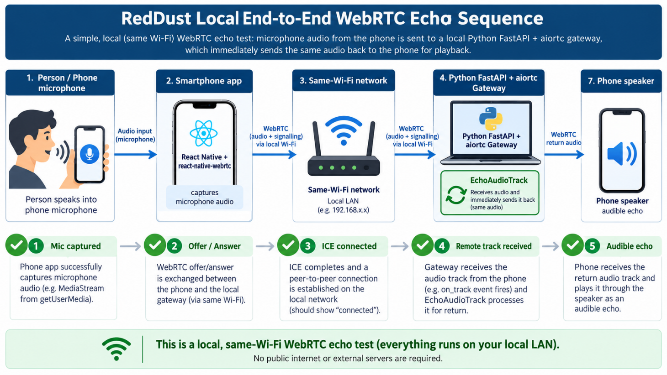

Step 19 — Stabilize the Same-Wi-Fi Test, Audio Routing and Backend Audio Sequencing
What this section does and why it matters: Turn the raw echo proof into a stronger local engineering baseline by fixing the intended network context, proving phone output routing, and proving the Gateway can insert its own audio and timing before echoing the caller.
New technical concepts introduced in this section (in absolute beginner terms): Audio routing chooses earpiece versus loudspeaker. A backend media transform can generate/resample/timestamp frames instead of simply returning the incoming frame. PTS and time_base place frames correctly on the media timeline.
Who does what: Mobile developer handles phone routing; Gateway developer handles backend media sequencing. Both preserve the already-working WebRTC connection.

19.1 — Keep the first environment deliberately simple: same Wi-Fi
What this section does and why it matters: Ensure cloud/NAT complexity is not mixed into the local audio milestone.
New technical concepts introduced in this section (in absolute beginner terms): LAN means Local Area Network. When phone and laptop are on the same normal Wi-Fi, direct host candidates are often available and debugging is simpler.
Laptop — RedDust Gateway
|
| same Wi-Fi
|
Android phone — RedDust app
Phone calls: http://<LAPTOP_WIFI_IP>:8000/offer
NOT: http://localhost:8000/offer
DIAGRAM — 19-A: Same-Wi-Fi Local Test Topology
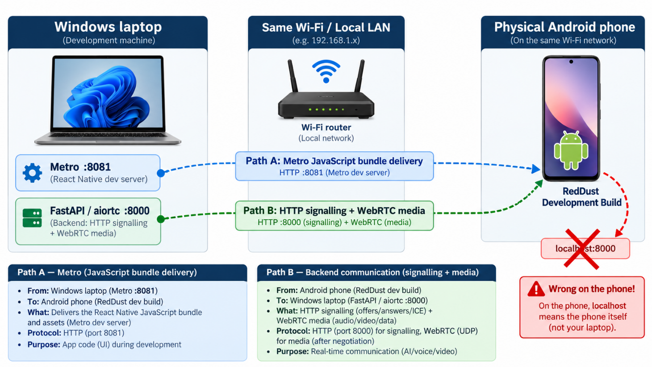

19.1A — Alternative Local Test Using an Android Mobile Hotspot
Placement in existing runbook: Insert immediately after Section 19.1 — “Keep the first environment deliberately simple: same Wi-Fi” and before Step 19A. This is an optional connectivity variant of the established local test; it does not replace Steps 14–18.
What this section does and why it matters: Run the proven local RedDust audio-echo test when the Android test phone supplies the hotspot, the Windows laptop joins that hotspot, and the same phone runs the RedDust mobile development build. The local HTTP and WebRTC paths must each be verified independently.
Who does what: The developer running the laptop checks its Wi-Fi IPv4 address, FastAPI listener and Windows Firewall. The tester running the phone checks browser reachability, Expo development build connectivity and ICE/media states.

19.1A.1 — Understand the changed network topology
A conventional router and an Android hotspot both create a local network, but the hotspot phone also acts as the router. The phone must call the laptop’s hotspot-assigned Wi-Fi IPv4 address—not localhost, not the phone’s hotspot/gateway address and not the public cellular IP.
Example only (verify with ipconfig):
Android phone / hotspot gateway 192.168.43.1
Windows laptop / Wi-Fi address 192.168.43.100
Mobile Gateway URL http://192.168.43.100:8000
STOP POINT: Some phones or carrier-customized hotspot implementations restrict traffic from the hotspot-hosting phone back to a connected laptop. A correct URL cannot bypass such a restriction. Verify browser reachability before changing WebRTC code.
DIAGRAM — 19-HS-A: Two local network topologies
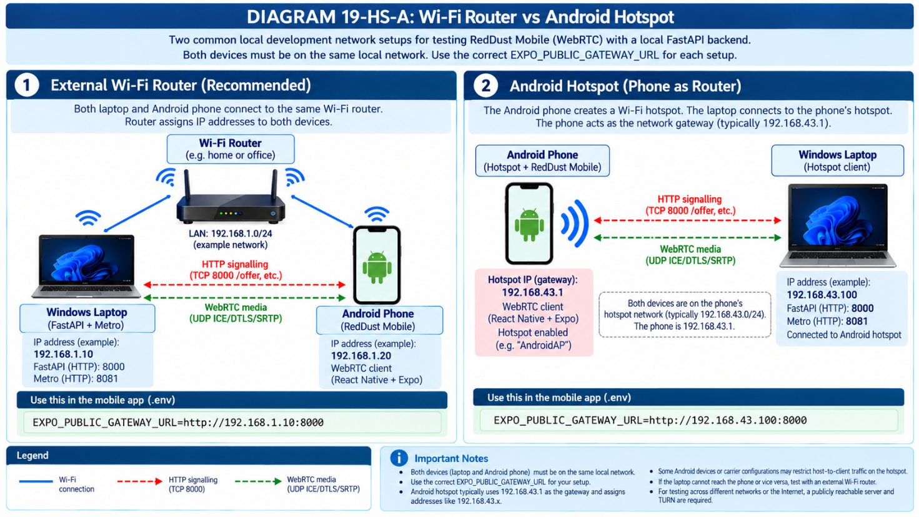
Figure 19-HS-A — Insert generated figure here when the onboarding manual is illustrated.

19.1A.2 — Find the laptop IP and start the Gateway
Step 1. Connect the Windows laptop to the Android phone’s hotspot. On the laptop open PowerShell and inspect the active Wi-Fi adapter:
Ipconfig
Get-NetConnectionProfile
Record the adapter’s IPv4 Address (LAPTOP_IP). Do not copy the Default Gateway. On hotspot reconnect, the assigned laptop IP may change.
Step 2. Start the existing Gateway with its established project import path:
cd D:\RedDust\reddust-gateway
.\.venv\Scripts\Activate.ps1
python -m uvicorn app.main:app --reload --host 0.0.0.0 --port 8000
Step 3. On the laptop, verify both the loopback and Wi-Fi paths (replace LAPTOP_IP):
Invoke-WebRequest http://127.0.0.1:8000/docs
Invoke-WebRequest http://LAPTOP_IP:8000/docs
Expected: successful responses. The bind address 0.0.0.0 is for listening; it is not the address placed in the mobile .env.local file.

19.1A.3 — Prove phone-to-laptop HTTP reachability
Step 4. On the same Android phone that hosts the hotspot, open Chrome and navigate to:
http://LAPTOP_IP:8000/docs
If Swagger UI opens, the local TCP 8000 path works; continue to the Expo/mobile checks. If Chrome cannot connect, do not debug SDP or ICE yet. First inspect Windows Firewall, the Gateway listener, VPN/network adapters and possible Android hotspot isolation.
Step 5 (only if firewall inspection identifies a block). On the Windows laptop, in an Administrator PowerShell session, allow inbound TCP 8000 from the local subnet on the Public profile:
New-NetFirewallRule `
-DisplayName "RedDust Local FastAPI 8000" `
-Direction Inbound -Action Allow -Protocol TCP `
-LocalPort 8000 -RemoteAddress LocalSubnet -Profile Public
This is a temporary development rule for a trusted hotspot. Prefer further scoping to the correct adapter/local address where feasible; never disable the firewall globally. Remove the rule after testing if no longer required:
Remove-NetFirewallRule -DisplayName "RedDust Local FastAPI 8000"
If the phone still cannot open /docs, try a different Wi-Fi router or a second phone hosting the hotspot while the test phone joins as a client. This distinguishes topology restrictions from application defects.
DIAGRAM — 19-HS-B: Gateway reachability and decision gate
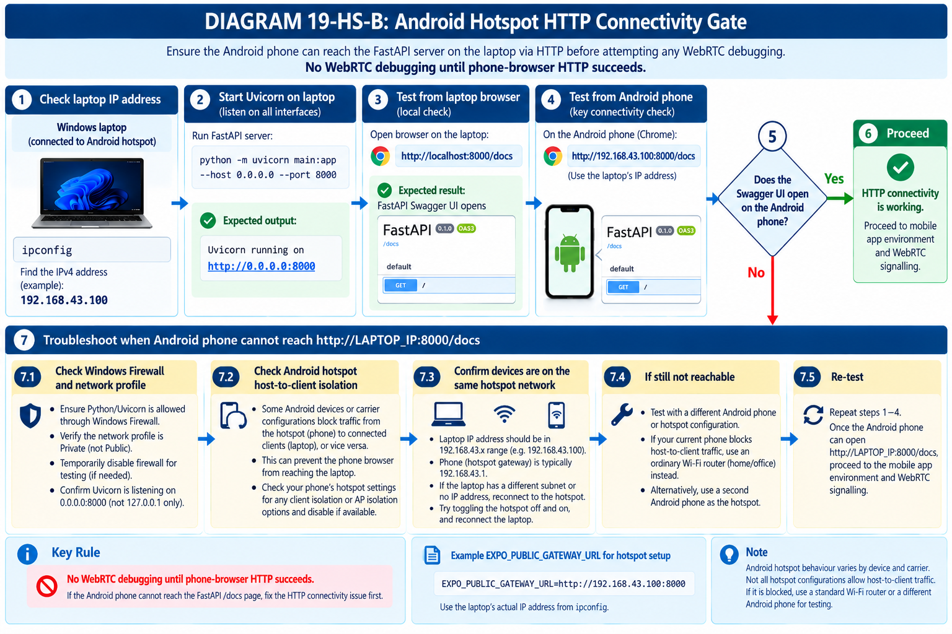
Figure 19-HS-B — Insert generated figure here when the onboarding manual is illustrated.

19.1A.4 — Configure Expo/React Native and reload
Step 6. In reddust-mobile/.env.local, set the exact laptop IPv4 address:
EXPO_PUBLIC_GATEWAY_URL=http://LAPTOP_IP:8000
Step 7. Confirm that the actual fetch code uses the variable rather than a hard-coded URL from earlier instructional examples:
const gatewayUrl = process.env.EXPO_PUBLIC_GATEWAY_URL;
if (!gatewayUrl) throw new Error("Gateway URL missing");
console.log("Gateway URL:", gatewayUrl);
const response = await fetch(`${gatewayUrl.replace(/\/$/, "")}/offer`, {
method: "POST",
headers: { "Content-Type": "application/json" },
body: JSON.stringify({
sdp: localDescription.sdp,
type: localDescription.type,
}),
});
Step 8. Run Metro for the existing native development build; reload the app after changing .env.local:
cd D:\RedDust\reddust-mobile
npx expo start --dev-client –clear
The JavaScript bundle must show the current laptop URL in the console. Keep machine-specific .env.local outside Git. Expo public variables are embedded in client JavaScript: never place credentials in them.
If Metro cannot reach the phone, npx expo start --dev-client --tunnel can be used for the development bundle. This does NOT tunnel the separate FastAPI TCP 8000 service and does NOT relay WebRTC UDP media.
If phone Chrome reaches /docs but the app reports a cleartext/HTTP security error, inspect Android network security configuration or the existing Expo development-build plugin settings. Enabling HTTP for local development may require a new native build; JavaScript-only IP changes generally do not.

19.1A.5 — Separate HTTP signalling from WebRTC media
Step 9. Start a RedDust call. In the Gateway terminal, confirm a successful POST /offer (HTTP 200). In the mobile logs, confirm the answer was received and setRemoteDescription completed. These signals prove SDP signalling only.
Step 10. Inspect ICE and PeerConnection state logs already introduced in Step 16:
pc.oniceconnectionstatechange = () =>
console.log("ICE:", pc.iceConnectionState);
pc.onconnectionstatechange = () =>
console.log("PeerConnection:", pc.connectionState);
Required for transport success: ICE becomes connected/completed and PeerConnection becomes connected. For the final Step 18/19 echo acceptance, audible remote audio must also work. If signalling succeeds but ICE fails, investigate hotspot routing/UDP reachability and ICE candidates; do not assume that STUN or Expo tunnel repairs every hotspot limitation.
DIAGRAM — 19-HS-C: Signalling vs WebRTC media
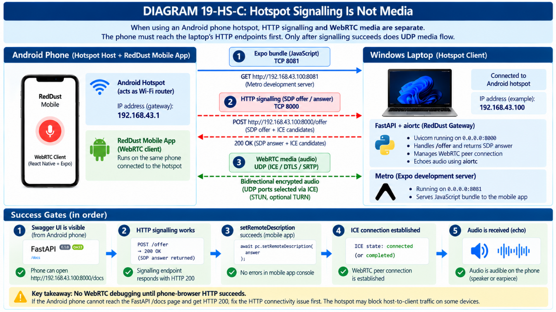
Figure 19-HS-C — Insert generated figure here when the onboarding manual is illustrated.

19.1A.6 — Rapid fault-isolation and acceptance checklist
Observation | Likely layer | Action
Laptop cannot open local /docs | Gateway process/bind | Check Uvicorn, import path and port 8000.
Laptop opens /docs; phone Chrome fails | Firewall or hotspot routing | Inspect Public profile, TCP 8000 rule, hotspot isolation.
Phone Chrome succeeds; app fetch fails | Mobile configuration | Check source uses EXPO_PUBLIC_GATEWAY_URL, full reload, Android HTTP policy.
Expo app cannot load | Metro connectivity | Check Metro TCP 8081; optionally use Expo tunnel for Metro only.
POST /offer is 200; ICE fails | WebRTC/UDP transport | Inspect candidate addresses, ICE logs and hotspot UDP routing.
ICE connected; no audible echo | Audio path | Return to Steps 17–19: remote track, permissions and output routing.
Completion gate: Record the laptop Wi-Fi IPv4, phone-browser /docs result, active Gateway URL logged by the mobile app, /offer HTTP status, ICE and PeerConnection states, and audible echo result. Do not mark the hotspot variant passed solely because an SDP answer was received.
DIAGRAM — 19-HS-D: Mobile hotspot acceptance ladder
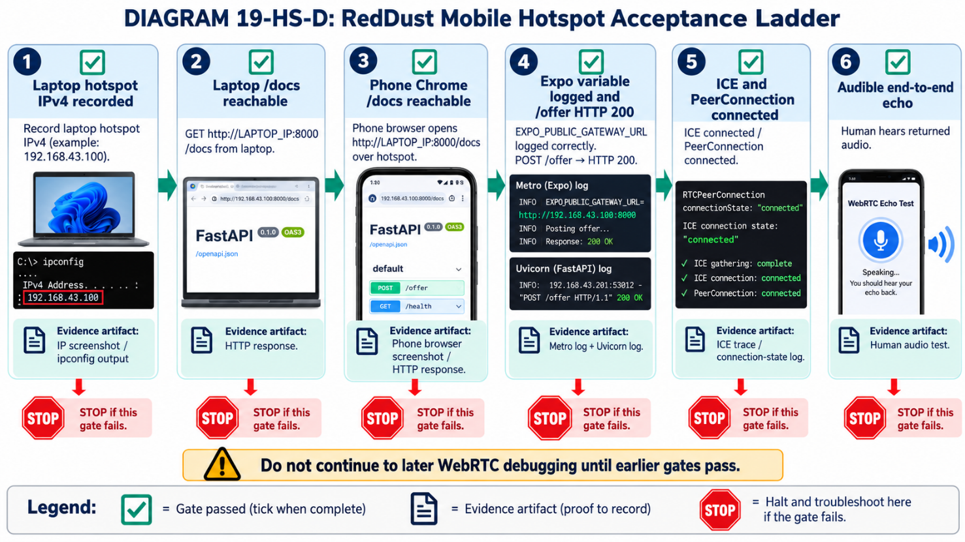
Figure 19-HS-D — Insert generated figure here when the onboarding manual is illustrated.

19.1A.7 — Authoritative references
Expo, “Environment variables”: https://docs.expo.dev/guides/environment-variables/
Expo, “Start developing” / tunnel mode: https://docs.expo.dev/get-started/start-developing/
Expo, “BuildProperties”: https://docs.expo.dev/versions/latest/sdk/build-properties/
Android Developers, “Network security configuration”: https://developer.android.com/privacy-and-security/security-config
Applicability note: This section describes the local Android/Windows development test only; production authentication, TLS, internet-facing signalling and TURN are separate deployment considerations.

19A — Toggle Android audio between loudspeaker and earpiece
What this section does and why it matters: Prove that a successfully received remote WebRTC track can be routed to the intended phone output device.
New technical concepts introduced in this section (in absolute beginner terms): react-native-incall-manager is a native call-audio routing library. Because it contains native code, adding it requires a new EAS development build.
cd D:\RedDust\reddust-mobile
npm install react-native-incall-manager@4.2.2 --save-exact
npm list react-native-incall-manager
import InCallManager from "react-native-incall-manager";
const [speakerOn, setSpeakerOn] = useState(true);
const toggleSpeakerRoute = () => {
const nextSpeakerOn = !speakerOn;
InCallManager.setForceSpeakerphoneOn(nextSpeakerOn);
setSpeakerOn(nextSpeakerOn);
};
// when the session starts
InCallManager.start({ media: "audio" });
InCallManager.setForceSpeakerphoneOn(true);
setSpeakerOn(true);
// when the session stops
InCallManager.stop();
CAUTION / STOP POINT: Because react-native-incall-manager is a native dependency, run a new EAS development build and install the new APK before testing this step.
npx eas-cli@latest build --profile development --platform android
Success criterion: Remote WebRTC audio plays through loudspeaker by default; toggle moves it to earpiece; toggle again returns it to loudspeaker.
DIAGRAM — 19-B: Phone Audio Routing Toggle
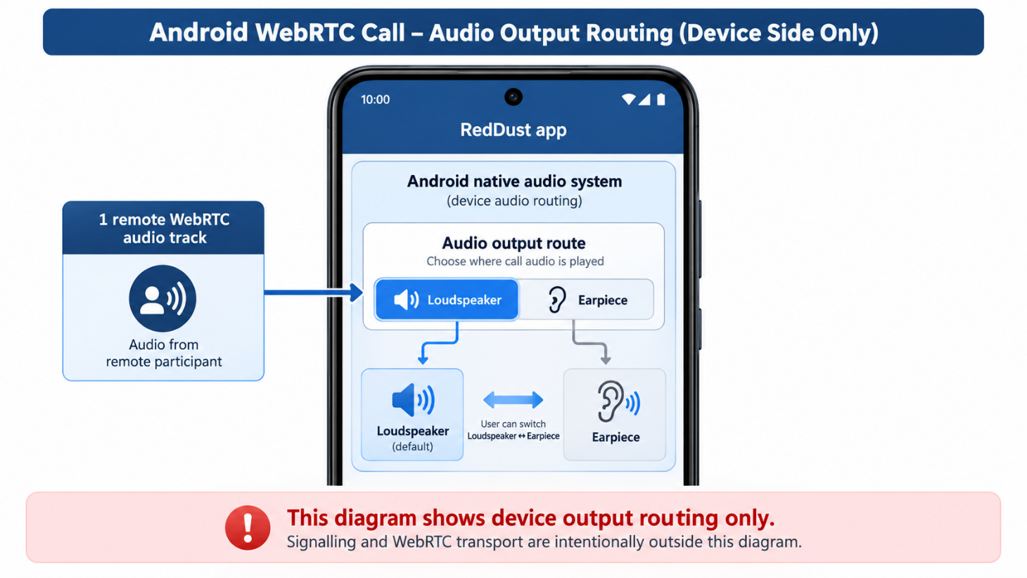

19B — Insert a pre-recorded prefix, two seconds of silence, then echo
What this section does and why it matters: Prove the Gateway can do more than immediate loopback: it can insert backend-generated media, control timing and then continue with microphone audio on the same outgoing WebRTC track.
New technical concepts introduced in this section (in absolute beginner terms): MediaPlayer reads a pre-recorded audio asset. AudioResampler converts frames to a consistent format/sample rate. PTS (presentation timestamp) and time_base define when each frame belongs on the media timeline. Timed silence keeps the outgoing track alive without bursting queued frames.
The source uses the fixed phrase “Hello RedDust Echo!”, approximately two seconds of silence, and then the caller’s incoming audio. This is an engineering sequencing test, not yet a production-grade continuously delayed echo.

19B.1 — Create the backend audio asset
What this section does and why it matters: Create one fixed WAV file that can be reused on every session.
New technical concepts introduced in this section (in absolute beginner terms): A WAV file is a common uncompressed/PCM audio container. The source generates it once with Windows System.Speech and then treats it as a normal project asset.
cd D:\RedDust\reddust-gateway
New-Item -ItemType Directory -Force .\app\audio
Add-Type -AssemblyName System.Speech
$synth = New-Object System.Speech.Synthesis.SpeechSynthesizer
$synth.Rate = 0
$synth.Volume = 100
$wav = Join-Path (Resolve-Path .\app\audio) "hello_reddust_echo.wav"
$synth.SetOutputToWaveFile($wav)
$synth.Speak("Hello RedDust Echo!")
$synth.Dispose()
Get-Item .\app\audio\hello_reddust_echo.wav

19B.2 — Replace the immediate echo with a three-stage processed track
What this section does and why it matters: Implement prompt → silence → echo as one continuous outgoing media source.
New technical concepts introduced in this section (in absolute beginner terms): A state machine stores the current stage. A deque buffers converted frames. _emit() assigns a continuous 48-kHz timeline so frames are paced instead of emitted as a burst.
Output sequence inside EchoAudioTrack.recv():
stage = "prompt"
→ read prerecorded prompt frames through MediaPlayer
→ resample to mono 48 kHz
stage = "delay"
→ emit timed silence frames for ~2 seconds
stage = "echo"
→ read caller frames
→ resample to mono 48 kHz
→ emit them on the same outgoing track
Important note: The complete implementation in the source uses AudioFrame, AudioResampler, Fraction(1, 48000), frame.pts and a deadline clock. The important architectural lesson is that a real media transform must preserve a coherent timeline; simply sleeping and then dumping queued frames can produce incorrect pacing.

19B.3 — Verify the processed sequence
What this section does and why it matters: Prove both the code path and the audible order without rebuilding the mobile native app.
New technical concepts introduced in this section (in absolute beginner terms): This step changes Python source and a backend asset only, so the existing mobile Development Build remains valid.
cd D:\RedDust\reddust-gateway
.venv\Scripts\Activate.ps1
python -c "from app.echo import EchoAudioTrack; print('Processed echo import OK')"
Test-Path .\app\audio\hello_reddust_echo.wav
python -m uvicorn app.main:app --reload --host 0.0.0.0 --port 8000
Expected Gateway progression:
Gateway RTCPeerConnection created
Gateway received track: audio
Gateway echo audio track added
Gateway remote description set
Gateway answer created
EchoAudioTrack: playing 'Hello RedDust Echo!'
EchoAudioTrack: prefix finished; waiting 2 seconds
EchoAudioTrack: now echoing caller audio
Success criterion: The phone plays “Hello RedDust Echo!”, then approximately two seconds of silence, then returns the caller’s speech over the same remote WebRTC audio track.
DIAGRAM — 19-C: Backend Audio Processing Sequence
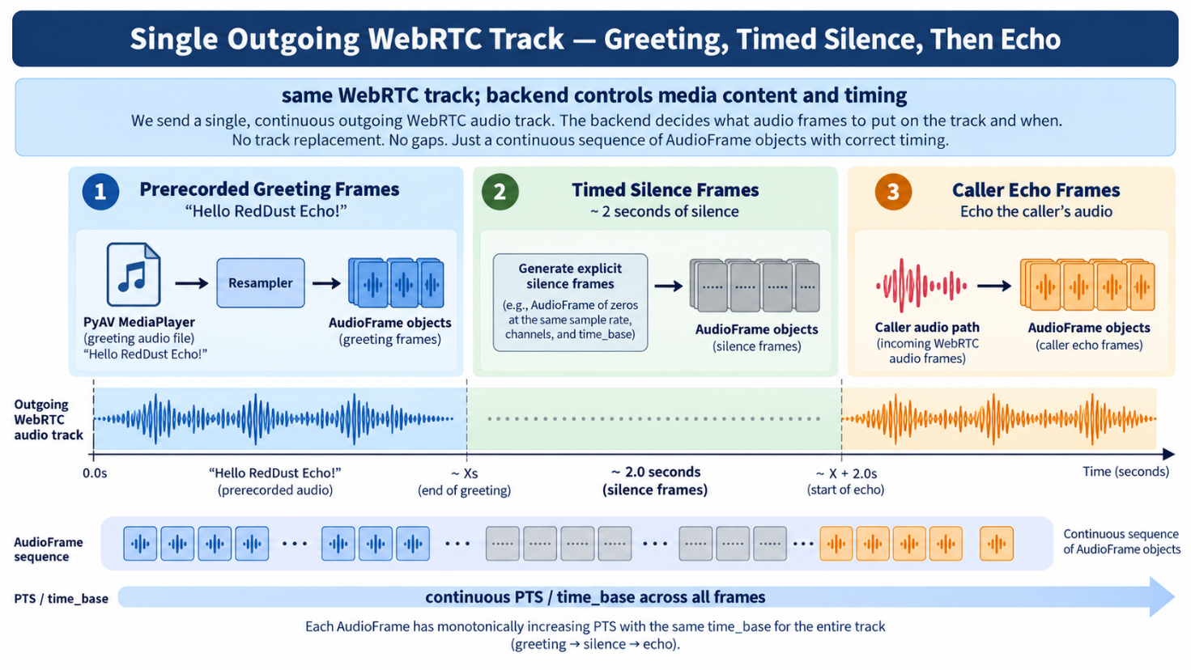

19.2 — Final local success state before Step 20
What this section does and why it matters: Define the exact evidence required before cloud/Internet deployment is allowed to introduce new networking variables.
New technical concepts introduced in this section (in absolute beginner terms): A layered acceptance gate means every lower layer has already been proven, so a later cloud failure can be isolated to deployment/networking rather than local microphone/media logic.
Milestone | Required evidence
Step 16 | ICE connected/completed and PeerConnection connected.
Step 17 | Gateway receives phone audio and phone receives one remote audio track.
Step 18 | Audible end-to-end echo works on the physical phone.
Step 19 same Wi-Fi | Phone reaches laptop by LAN IPv4, not localhost.
Step 19A | Loudspeaker → earpiece → loudspeaker routing works.
Step 19B | Gateway prefix plays, ~2-second silence occurs, then caller echo returns on the same track.
CAUTION / STOP POINT: Only after these local checks pass should Step 20 introduce Internet/cloud networking. A new failure can then be investigated as deployment, firewall, NAT, ICE/TURN or cloud configuration rather than as an unresolved local audio problem.
DIAGRAM — 19-D: Steps 0–19 Success Ladder
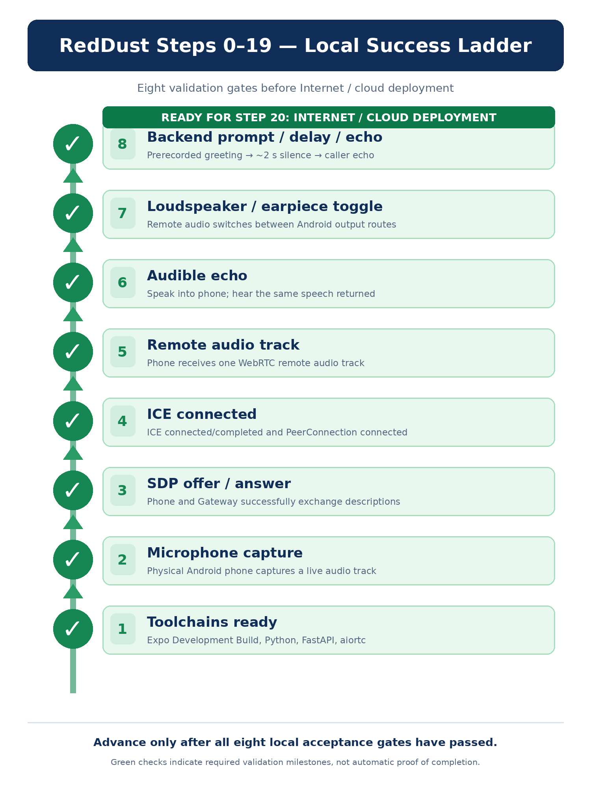

Appendix

Appendix insertion notes — keep original appendices aligned
Appendix A: Add reddust-auth-api and reddust-unified to canonical workspace. Add startup of PostgreSQL + auth-api :8100 to the daily commands table. Keep original mobile and Gateway reference directories intact until end-to-end migration passes.
Appendix B: Add troubleshooting rows for wrong Google OAuth audience/certificate, 401 auth-api, corrupt secure token state, Gateway 401/403, schema migration mismatch and Expo 56/57 native mismatch; debug authentication before ICE.
Appendix D: Add acceptance gates A–J from Step 19D. Step 20 readiness requires both local audio success AND secure identity/session integration. Change TOC to include Step 19C and Step 19D after Step 19.
Final sign-off / STOP POINT: Do not mark either new step complete on the basis of these designs or code snippets alone. Completion requires a working auth-api implementation, reviewed Alembic migrations, tested Google OAuth client configuration, an EAS APK with reconciled native dependencies, a Gateway-enforced authorization check and recorded phone tests.

Appendix A — Canonical Local Project Structure and Daily Commands
What this section does and why it matters: Give interns a one-page operational reference after initial setup is complete.
New technical concepts introduced in this section (in absolute beginner terms): Generated dependency folders are local; source/configuration files belong in version control. Daily startup uses existing installations rather than rebuilding the environment.
D:\RedDust\
├── reddust-mobile\
│ ├── source / app / assets
│ ├── app.json
│ ├── eas.json
│ ├── package.json
│ ├── package-lock.json
│ ├── tsconfig.json
│ ├── .env.example
│ ├── .env.local # local only
│ └── node_modules\ # local only
└── reddust-gateway\
├── app\
│ ├── __init__.py
│ ├── main.py
│ ├── echo.py
│ └── audio\
│ └── hello_reddust_echo.wav
├── requirements.txt
└── .venv\ # local only
Daily action | Command / check
Check laptop IP | Ipconfig
Start Gateway | cd D:\RedDust\reddust-gateway → activate .venv → python -m uvicorn app.main:app --reload --host 0.0.0.0 --port 8000
Start Metro | cd D:\RedDust\reddust-mobile → npx expo start
Phone | Same Wi-Fi → open RedDust Development Build → connect to Metro → Start Microphone
Success | POST /offer 200 OK → ICE connected/completed → Connection connected → remote track → audible echo

Appendix B — Troubleshooting Decision Tree
DIAGRAM — APP-B: Local Echo Troubleshooting Stack
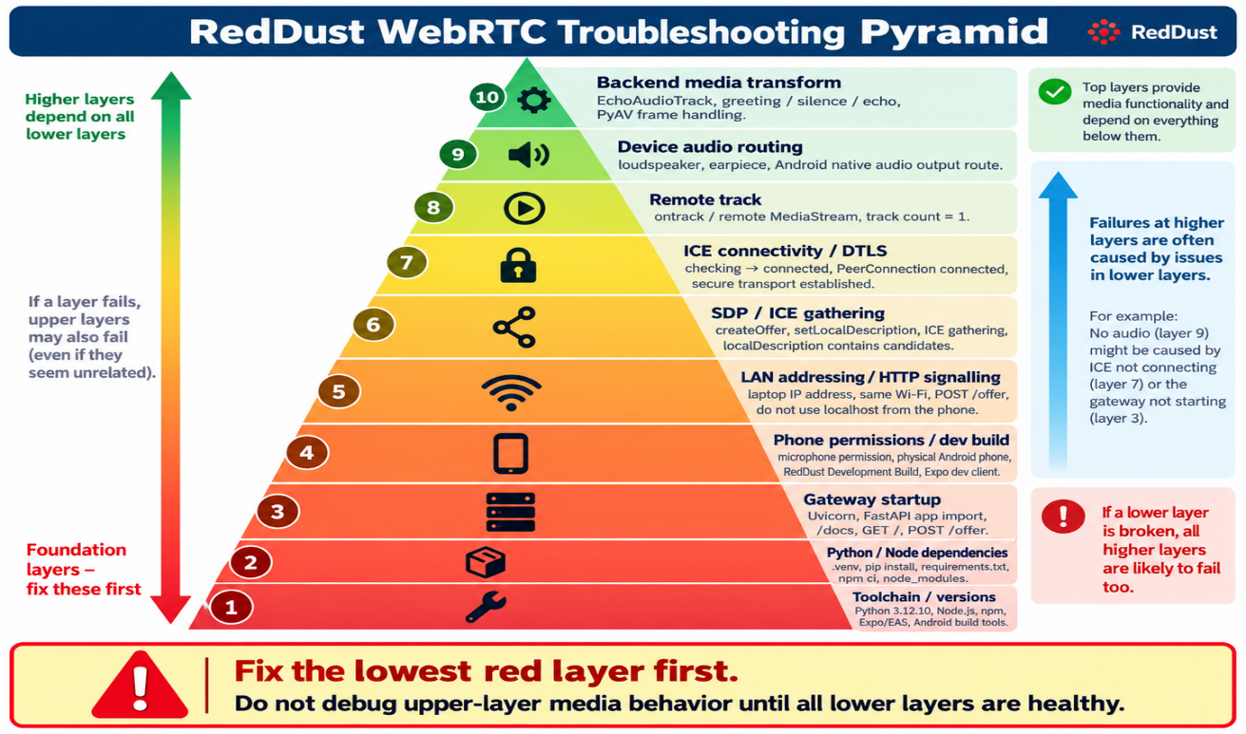
What this section does and why it matters: Help interns debug from the lowest failing layer instead of changing multiple subsystems at once.
New technical concepts introduced in this section (in absolute beginner terms): Layered troubleshooting means a higher layer cannot succeed if a required lower layer is already broken.
Symptom | Check first | Do not prematurely change
python/uvicorn import traceback | Python 3.12.10, .venv, imports, pydantic_core | React Native code
/docs does not load | Uvicorn worker startup, port 8000, app.main import | ICE/STUN
Phone cannot reach POST /offer | Laptop Wi-Fi IP, same Wi-Fi, Windows private-network firewall, URL not localhost | EchoAudioTrack
POST /offer returns 200 but no connection | ICE candidates, ICE state, network path | FastAPI route shape unless logs show errors
ICE gathering complete but ICE fails | Candidate connectivity/firewall/Wi-Fi/STUN path | Assume gathering complete means connected
Connection connected but no remote track | Gateway track handler, EchoAudioTrack added before createAnswer, answer direction | Phone speaker routing first
Remote audio track count is 1 but silent | Android/iOS audio routing / InCallManager | Rewrite signalling
Expo Go cannot load WebRTC | Use installed RedDust Development Build | Reinstall JS package only
Native dependency changed but app still behaves old | Create/install a new EAS Development Build | Metro cache only
After reboot phone cannot reach Gateway | Recheck laptop DHCP IPv4 / .env.local | Rebuild everything

Appendix C — Glossary for Absolute Beginners
What this section does and why it matters: Collect the vocabulary interns repeatedly encounter in Steps 0–19.
New technical concepts introduced in this section (in absolute beginner terms): Consistent terminology makes debugging conversations faster and prevents words such as “server”, “connection” or “stream” from being used ambiguously.
Term | Beginner explanation
React Native | Framework for building mobile apps with JavaScript/TypeScript and native components.
Expo | Tooling/platform around React Native development, configuration and cloud builds.
TypeScript | JavaScript plus static type checking.
EAS | Expo Application Services; cloud build/deployment services.
Development Build | Custom native RedDust app containing project-specific native modules, used with Metro during development.
Metro | React Native JavaScript bundler/development server; not the WebRTC backend.
APK | Installable Android application package.
FastAPI | Python web framework used here for HTTP signalling endpoints.
Uvicorn | ASGI server process that runs the FastAPI app.
ASGI | Asynchronous Server Gateway Interface for Python web applications.
Aiortc | Python implementation of WebRTC/ORTC used by the Gateway.
PyAV / av | Python media-frame/FFmpeg bindings used with aiortc.
Asyncio | Python’s asynchronous programming framework.
MediaStream | Container/group of one or more media tracks.
MediaStreamTrack | One timed media source, e.g. microphone audio or remote audio.
RTCPeerConnection | Object that negotiates and owns a WebRTC connection.
SDP | Session Description Protocol; text description of media/session capabilities.
Offer | Initiating SDP proposal from one WebRTC peer.
Answer | Responding SDP description from the remote peer.
ICE | Candidate discovery/testing framework that finds a working network path.
ICE candidate | One possible address/port/protocol path a peer can try.
STUN | Helper that discovers public/server-reflexive network identity.
TURN | Relay used when direct connectivity fails.
NAT | Router behavior that maps private addresses to external addresses.
UDP | User Datagram Protocol; low-overhead transport commonly preferred for real-time media.
RTP | Real-time Transport Protocol for timed media packets.
DTLS | Security handshake over datagram transport used by WebRTC.
SRTP | Encrypted real-time media transport.
Opus | Low-latency audio codec commonly negotiated by WebRTC.
PCM | Uncompressed digital audio samples.
VAD | Voice Activity Detection; detects speaking/turn boundaries in the future conversational architecture.
Localhost | The device itself. localhost on the phone is not the Windows laptop.
LAN | Local Area Network, such as the phone and laptop on the same Wi-Fi.
DHCP | Router service that can assign/change a device’s local IP address.
.venv | Local Python virtual environment.
node_modules | Local installed JavaScript package tree.
package-lock.json | Pinned npm dependency resolution used by npm ci.
requirements.txt | Recorded Python packages used to recreate the Gateway environment.
PTS | Presentation timestamp for a media frame.
time_base | Unit used to interpret media timestamps.
Resampling | Converting audio format/sample rate/layout to a consistent target.
system prompt / Gemini Live | Part of the future conversational AI architecture; not needed for the local echo proof.

Appendix D — Final Readiness Checklist before Step 19
What this section does and why it matters: Provide a single handoff gate between local engineering and Internet/cloud deployment.
New technical concepts introduced in this section (in absolute beginner terms): A checklist converts “it seems to work” into explicit evidence. Every unchecked local item is a future ambiguity if cloud testing fails.
Done | Acceptance condition
☐ | Workspace has separate reddust-mobile and reddust-gateway projects.
☐ | Gateway uses Python 3.12.10 in a local .venv.
☐ | FastAPI/Uvicorn/aiortc/av imports succeed.
☐ | FastAPI /docs loads and POST /offer exists.
☐ | Mobile project uses the source-runbook Expo SDK 56 / react-native-webrtc 124.0.7 / config-plugin 15.0.2 baseline.
☐ | RedDust Development Build is installed; Expo Go is not used for WebRTC.
☐ | Runtime microphone permission succeeds and one live local audio track exists.
☐ | RTCPeerConnection is created with STUN configured.
☐ | Microphone track is attached before createOffer().
☐ | ICE gathering completes before the one-shot HTTP offer is sent.
☐ | Phone sends /offer to laptop LAN IPv4, not localhost.
☐ | Gateway returns SDP answer and phone setRemoteDescription succeeds.
☐ | ICE reaches connected/completed and PeerConnection reaches connected.
☐ | Gateway receives the incoming audio track.
☐ | Gateway adds EchoAudioTrack before createAnswer().
☐ | Phone receives one remote audio track.
☐ | Audible same-Wi-Fi echo works end to end.
☐ | Audio can be routed loudspeaker → earpiece → loudspeaker.
☐ | Backend can play “Hello RedDust Echo!”, insert ~2 seconds of silence, then echo caller audio on the same outgoing track.
☐ | Gateway URL is externalized to developer-specific .env.local for team onboarding.
☐ | .venv, node_modules and .env.local are not committed; requirements/package-lock/.env.example are committed.
☐ | Daily restart routine has been reproduced after a reboot/login.
☐ | Only now is the team ready to move the already-proven local path to Step 20 cloud/Internet testing.
DIAGRAM — APP-D: Local-to-Cloud Handoff Gate
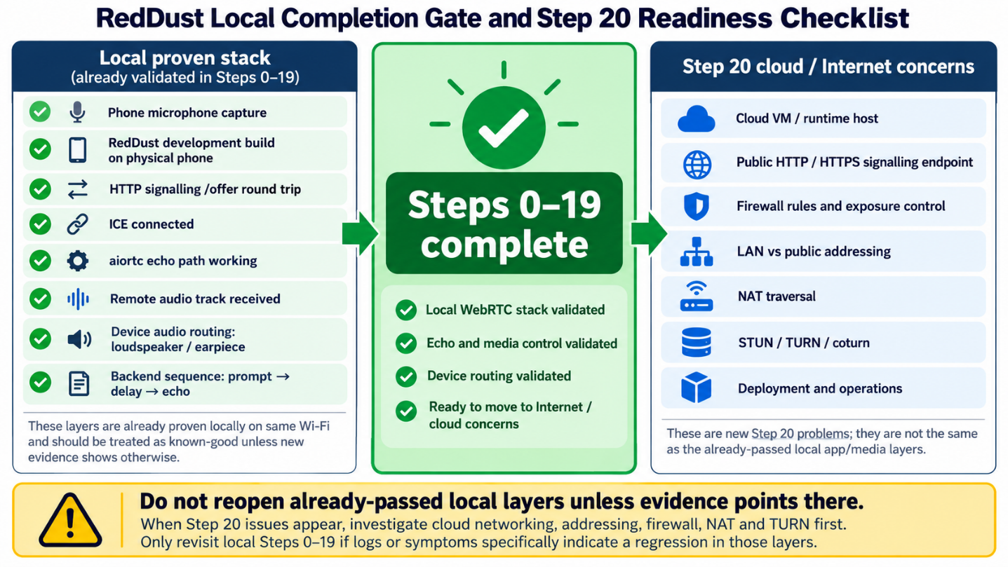

Source and Consolidation Note
What this section does and why it matters: Record what this document is and what it is not.
New technical concepts introduced in this section (in absolute beginner terms): Consolidation removes repeated trial-and-error narration while preserving the source’s final implementation decisions, concepts, warnings and success gates.
This runbook was rewritten and consolidated from the uploaded 158-page “Step0-19.docx” working document. The source contains iterative troubleshooting and repeated explanations; this version reorganizes those materials into a single learning sequence while retaining the project’s documented baseline choices and local WebRTC proof milestones.
CAUTION / STOP POINT: This document intentionally does not modernize package versions or redesign the architecture beyond what the source supports. Version upgrades, TURN/Internet hardening, cloud deployment, production signalling, CI/CD and Kubernetes belong to later steps.

Appendix E — iOS / iPhone Development for RedDust Mobile
Native Permissions • Apple Developer Program • EAS Cloud Builds • Physical iPhone Testing • Production Roadmap
Companion to Steps 0–19 | Extension of Step 10 (subsections 10.7–10.17)

Purpose: Provide iPhone-specific development guidance without replacing existing Android-focused Step 10. The goal is a secure, modern cross-platform RedDust app—not merely an audio echo demonstration.
Scope: Requirements and recommendations are framed around the existing Expo SDK 56 / react-native-webrtc baseline. Apple, Expo, and Xcode requirements evolve; verify current official documentation before procurement, provisioning or public release.
Reader: Interns, React Native mobile engineers, technical lead, iOS build administrator and future DevSecOps contributors.

Quick requirements overview
Item | Requirement / RedDust policy
Apple Developer Program | One company-controlled paid membership for physical-device EAS provisioning and App Store distribution; typically US$99/year or local equivalent.
Mac hardware | Not compulsory for Windows + EAS iPhone builds; recommended for Xcode, local simulator and native diagnosis. M3+ is a purchasing preference, not a strict minimum.
Mac specifications | Recommend Apple silicon, 16 GB RAM / 512 GB SSD minimum for a new team machine; 24–32 GB RAM and 1 TB preferable for advanced workflows.
Physical iPhone | Essential for microphone, WebRTC, routing, interruptions, Bluetooth and cellular validation.
iOS baseline | Expo SDK 56 baseline: minimum iOS 16.4; verify again when upgrading SDK / choosing production deployment target.
Windows iOS Simulator | No local official Xcode iOS Simulator on Windows; remote simulator or Mac is needed.
Build platform | EAS remote build supports Windows developers; iOS packages require correct Apple signing and provisioning.

10.7 — Understand the iOS Development Toolchain and Hardware Requirements
What this section does and why it matters: Explain the hardware, software and account requirements for iPhone development, including when EAS on Windows is sufficient and when a Mac is needed.
New concepts: Xcode (Apple IDE), iOS Simulator (virtual device), IPA (iOS application archive), code signing (app identity and installation authorization).
Who does what: Technical lead sets device policy; interns report device/laptop models; iOS lead owns native-debugging and device-test strategy.

10.7.1 — Supported development environments
Activity | Windows + EAS | Mac + Xcode
React Native / TypeScript | Yes | Yes
Run Metro | Yes | Yes
Trigger EAS iOS build | Yes | Yes
Install appropriately provisioned build on physical iPhone | Yes | Yes
Local Xcode iOS Simulator | No | Yes
Local native compile/debug with Xcode | No | Yes
Inspect Swift / Objective-C native issues | Limited | Full
Instruments performance profiling | No local Instruments | Yes
Submit via EAS Submit | Yes | Yes

10.7.2 — Do we need a MacBook M3 or newer?
No. An M3 processor is not an intrinsic minimum for Expo, React Native or EAS. Windows + EAS remains an efficient starting point. A Mac is important as native iOS complexity increases.
- Processor: Apple silicon M3 or newer is a reasonable new-purchase preference; an existing compatible M1 or M2 may suffice.
- RAM: 16 GB minimum recommended for a new workstation; 24–32 GB preferred.
- SSD: 512 GB minimum recommended; 1 TB preferred for Xcode and simulators.
- Form factor: MacBook Air/Pro or Mac mini depending on portability and team budget.
- Before purchasing: verify Mac model, macOS and the Xcode version required by the Expo SDK.

10.7.3 — iPhone models and iOS versions
Expo SDK 56 has a minimum deployment target of iOS 16.4. That is a compatibility floor, not the recommended production device standard. Use an iPhone 13 or newer as the primary test device where practical, while retaining an older supported device for coverage. A device must support the target iOS version.
Three distinct terms: Minimum deployment target = oldest runnable OS; tested OS versions = actual QA matrix; recommended device = useful hardware performance baseline.

10.7.4 — Can Windows run an iPhone emulator?
Apple does not provide its official local Xcode iOS Simulator for Windows. A remote simulator service or remote Mac may help with layout and basic flows, but cannot replace testing real microphones, Bluetooth, incoming calls and network handovers on physical iPhones.
Success criterion: Device/OS inventory and ownership of iOS testing are documented.

10.8 — Establish the Anodiam Apple Developer Account and Access Model
What this section does and why it matters: Ensure Apple signing and app identity belong to Anodiam rather than an intern or personal account.
New concepts: Apple Account, paid Developer Program, App Store Connect, Apple development team and provisioning roles.
Who does what: Authorized company representative enrolls and pays; iOS admin maintains signing; developers use individual accounts.

10.8.1 — Understand Apple accounts
Account / service | Purpose | Cost
Apple Account | Personal sign-in identity | Free
Free developer access | Xcode tools and limited personal-device workflows | Free
Apple Developer Program | Device signing, TestFlight, App Store distribution | Usually US$99/year or regional equivalent
App Store Connect | Apps, TestFlight, metadata and releases | Included in membership
Enterprise Program | Special-purpose private employee app distribution | Not required for public RedDust
The paid Developer Program is the appropriate path for RedDust’s public consumer application. Free Apple developer access is not a suitable substitute for a scalable Windows + EAS + physical iPhone team workflow.

10.8.2 — Enroll under company ownership
- Confirm Anodiam legal-entity eligibility and the authorized representative.
- Enroll at https://developer.apple.com/programs/enroll/ and complete required verification (potentially a D-U-N-S number).
- Secure the Account Holder with strong authentication and recovery.
- Invite team members using minimum necessary roles.
- Keep signing authority, billing and app identity under company control.
Important separation: Expo Organization membership does not automatically grant access to an Apple Developer team.

10.8.3 — RedDust ownership policy
- One Anodiam-controlled Apple Developer Program membership.
- One canonical production app identity, with separately managed development variants where needed.
- Individual accounts; no routine sharing of passwords or two-factor codes.
- Restricted certificate/provisioning management and distinct build/release responsibilities.
Success criterion: Paid membership and named signing/provisioning administrator are in place when physical iOS builds are required.

10.9 — Configure iOS Application Identity and Native Microphone Permissions
What this section does and why it matters: Declare app identity and microphone/local-network privacy purposes in the compiled iOS application.
New concepts: Bundle identifier, Info.plist, runtime permission prompt.
Who does what: Mobile engineer edits app.json; technical lead approves identifiers and user-facing privacy descriptions.

10.9.1 — iOS bundle identifiers
Bundle IDs identify the iOS application. A conceptual scheme is development “com.anodiam.reddustmobile.dev” and production “com.anodiam.reddustmobile”. These strings are recommendations, not an instruction to replace a registered existing app identifier; registration and migration require review.

10.9.2 — app.json iOS object
"ios": {
"bundleIdentifier": "com.anodiam.reddustmobile.dev",
"icon": "./assets/expo.icon",
"infoPlist": {
"NSMicrophoneUsageDescription": "RedDust uses your microphone for real-time voice conversations.",
"NSLocalNetworkUsageDescription": "RedDust connects to local development services and the RedDust Gateway during testing."
}
}
This is an illustrative fragment, not a complete replacement for app.json. Preserve existing plugins, settings and the configured EAS project ID. NSMicrophoneUsageDescription describes audio capture; NSLocalNetworkUsageDescription explains local networking during development where applicable.

10.9.3 — Runtime permission
Declaring the purpose string does not grant microphone access. iOS presents authorization when the application requests access, and the user can deny or later revoke it. Do not add speculative permissions for camera, speech recognition, photo library or background modes until the corresponding functionality exists.
CAUTION / STOP POINT: Keep privacy declarations accurate and avoid broad iOS entitlements merely for convenience.

10.10 — Implement iOS Runtime Microphone Permission Handling
What this section does and why it matters: Correctly separate Android permission handling from the native iOS getUserMedia authorization flow.
New concepts: Android PermissionsAndroid versus iOS microphone capture authorization; errors and cleanup.
Who does what: Mobile engineer maintains shared capture logic and tests both operating systems.

10.10.1 — Preserve Android-only pre-check
PermissionsAndroid.request(PermissionsAndroid.PERMISSIONS.RECORD_AUDIO) remains Android-only and should not run on iOS.

10.10.2 — Use the native WebRTC media API
import { Platform, PermissionsAndroid } from "react-native";
import { mediaDevices } from "react-native-webrtc";

async function requestMicrophonePermission(): Promise<boolean> {
if (Platform.OS !== "android") return true;
const result = await PermissionsAndroid.request(
PermissionsAndroid.PERMISSIONS.RECORD_AUDIO,
{
title: "Microphone Permission",
message: "RedDust needs microphone access for real-time voice conversations.",
buttonPositive: "Allow",
buttonNegative: "Cancel",
}
);
return result === PermissionsAndroid.RESULTS.GRANTED;
}

async function startMicrophone() {
const available = await requestMicrophonePermission();
if (!available) throw new Error("Microphone permission denied");
return await mediaDevices.getUserMedia({ audio: true, video: false });
}
On iOS, returning true from the Android-only permission helper does NOT indicate that iOS microphone access is granted. getUserMedia triggers the native authorization path when needed, and its promise may reject. Production code must catch errors, present recovery guidance and release tracks after use.

10.10.3 — Test permission lifecycle
- First use prompts for microphone access.
- Granting access produces exactly one live audio track.
- Denial is handled without crash and provides Settings guidance.
- Revocation in Settings is handled safely.
- Repeated Start does not produce duplicate streams.
- Stop ends all tracks and releases native resources.
Success criterion: One live audio track, clean stop and recoverable denial on a real iPhone.

10.11 — Register Physical iPhones for EAS Development Builds
What this section does and why it matters: Authorize specific iPhones for signed ad hoc development builds outside the App Store.
New concepts: Signing certificate, provisioning profile, registered device UDID.
Who does what: iOS admin manages signing; testers register their own trusted devices.

10.11.1 — Why iOS differs from Android
Android APK distribution can allow user-approved installation from a particular source. An iOS ad hoc development IPA must be signed and provisioned for each target device. Apple imposes device registration limits (including commonly 100 iPhones per membership year under ad hoc distribution).

10.11.2 — Register an iPhone
cd D:\RedDust\reddust-mobile
npx eas-cli@latest login
npx eas-cli@latest whoami
npx eas-cli@latest device:create
npx eas-cli@latest device:list
The EAS workflow may provide a URL or QR code to open on the iPhone and may ask the owner to install a temporary registration profile. Use only company-approved links. Confirm the device is incorporated into the provisioning profile used by the build.

10.11.3 — Provisioning delays
Apple device recognition and propagation may take time; first-time registrations sometimes need additional hours or days. Do not create unrelated projects or signing identities simply to bypass a delay.
Success criterion: Registered iPhone appears in the intended EAS/Apple provisioning configuration.

10.12 — Create the iOS EAS Development Build
What this section does and why it matters: Compile a signed native IPA containing the development client, microphone permissions and native WebRTC modules.
New concepts: IPA, remotely hosted Xcode build, development profile and native runtime.
Who does what: Authorized developer starts EAS build; administrator manages Apple signing prompts.

10.12.1 — eas.json development profile
{
"build": {
"development": {
"developmentClient": true,
"distribution": "internal",
"ios": { "simulator": false }
},
"preview": { "distribution": "internal" },
"production": {}
}
}
This is an example only. Merge with the existing eas.json rather than overwriting team configuration.

10.12.2 — Build from Windows PowerShell
cd D:\RedDust\reddust-mobile
npx eas-cli@latest whoami
npx expo-doctor
npx eas-cli@latest build --profile development --platform ios
EAS may request bundle identifier, Apple team selection, certificates, provisioning profiles or device registration. An authorized signing administrator should handle sensitive prompts.

10.12.3 — Know when native rebuilding is required
- Native dependencies and config plugins change.
- iOS entitlements, permissions, bundle ID or native configuration changes.
- Native audio session, push capability or runtime integration changes.
- Expo SDK or native runtime is upgraded.
Ordinary JavaScript/TypeScript edits typically reload via Metro without generating another IPA when the installed native runtime already contains the required modules.
CAUTION / STOP POINT: Metro cannot retrofit compiled native functionality or signed entitlements into an installed IPA.

10.13 — Install the Development Build on a Physical iPhone
What this section does and why it matters: Install RedDust’s custom development client on an authorized iPhone.
New concepts: Ad hoc installation and iOS Developer Mode.
Who does what: iPhone owner installs the IPA; iOS admin checks provisioning failures.

10.13.1 — Install from EAS
- Open the completed EAS build page on the registered iPhone.
- Follow the installation link, confirming system prompts.
- Wait for the RedDust app icon to appear.
- Open the app; investigate certificate/profile failures with the iOS build administrator.

10.13.2 — Enable Developer Mode if required
Settings → Privacy & Security → Developer Mode → Enable
iOS may require a restart and confirmation. Follow the device prompts; do not disable general platform security protections.

10.13.3 — Verify installation
- RedDust opens as the custom development client (not Expo Go).
- The device prompts for microphone access when needed.
- WebRTC can obtain a real audio track.
- The app can connect to Metro.
Success criterion: The test iPhone runs the correctly signed RedDust development application.

10.14 — Connect the iPhone to Metro and the Python Gateway
What this section does and why it matters: Independently verify JavaScript delivery and backend WebRTC signalling/media connectivity.
New concepts: LAN address, separate ports, App Transport Security (ATS), developer tunnels.
Who does what: Mobile engineer runs Metro; Gateway engineer exposes the relevant FastAPI listener and diagnoses media connectivity.

10.14.1 — Start Metro on Windows
cd D:\RedDust\reddust-mobile
npx expo start --dev-client
Connect laptop and iPhone to the same suitable Wi-Fi, open the installed development client and select or scan the Metro server. Approve the iOS local-network access request when appropriate.

10.14.2 — Use laptop LAN IP, not localhost
# Illustrative .env.local setting
EXPO_PUBLIC_GATEWAY_URL=http://192.168.1.20:8000
The address is an example only. On the iPhone, localhost means the phone itself; use the actual Windows laptop LAN IP or reachable cloud Gateway address. Windows Firewall and the Gateway binding must permit inbound traffic.

10.14.3 — iOS App Transport Security
iOS App Transport Security encourages secure network communication. For local testing, carefully assess any local-network exception (including NSAllowsLocalNetworking where relevant). Prefer HTTPS for deployed API/signalling endpoints and avoid broad unrestricted HTTP exceptions in production.

10.14.4 — Validate distinct paths
Path | Purpose | Typical development port
iPhone → Metro | JS bundle and development tooling | TCP 8081
iPhone → FastAPI Gateway | SDP offer/answer HTTP signalling | TCP 8000
iPhone ↔ aiortc | Encrypted WebRTC media | Negotiated transport / typically UDP
Metro connectivity does not prove signalling works; a successful /offer response does not prove ICE/DTLS/SRTP media connectivity.
Success criterion: Both Metro and Gateway are reachable, and an independent real-time WebRTC audio connection is established.

10.15 — Test iPhone Audio, Permissions and WebRTC Reliability
What this section does and why it matters: Evaluate genuine iOS audio, interruptions, routing and network behavior beyond the initial echo.
New concepts: iOS audio session, audio route, system interruption, reconnection and lifecycle.
Who does what: Mobile/iOS testers validate on devices; Gateway engineer correlates signalling and media logs.

10.15.1 — Basic echo acceptance
- Microphone permission and audio capture succeed.
- Exactly one local audio track exists.
- Gateway receives microphone audio.
- Returning track is audible through the intended route.
- Stop cleans up resources and repeat Start is safe.

10.15.2 — Extended iPhone test matrix
Scenario | Why it matters
Speaker / receiver | Correct privacy and output routing
USB-C / wired headphones | External route switching
Bluetooth earbuds | Latency, routing, wireless interruptions
Incoming call / Siri / alarm | Audio interruption and recovery
Background / foreground | App lifecycle and permitted activity
Wi-Fi ↔ cellular | ICE reconnection and network change
Weak network | Packet loss and recovery
Permission revoked | User-facing recoverability
Repeated Start/Stop | Race and resource-leak prevention

10.15.3 — Features required for final RedDust
- Low-latency conversational audio streaming and responsive playback.
- Barge-in: interrupt an AI response while the user starts speaking.
- Echo control to reduce recapturing the application’s output.
- Audio-focus handling for calls, Siri, alarms and Bluetooth transitions.
- Robust network reconnection and explicit session-state lifecycle.
- Background behavior designed to meet genuine product needs and Apple policies.
Success criterion: Echo works and a broader iOS quality test plan exists for real-time AI use cases.

10.16 — Plan TestFlight, Production Distribution and App Store Readiness
What this section does and why it matters: Separate developer builds, beta distribution and public release under Apple policies.
New concepts: TestFlight, App Store Connect, production signing, store review.
Who does what: Technical lead owns release policy; iOS lead coordinates signing/TestFlight; authorized release operator submits apps.

10.16.1 — Three build stages
Stage | Purpose | Distribution
Development | Native/WebRTC debugging | Registered-device EAS internal distribution
Preview / beta | Team and pilot testing | Internal distribution or TestFlight
Production | Public release | Apple App Store
TestFlight is useful for broader pilots because ad hoc device registration does not scale to a large tester population. Apple permits substantial external TestFlight testing subject to its current limits and review rules.

10.16.2 — Future production commands
npx eas-cli@latest build --profile production --platform ios
npx eas-cli@latest submit --platform ios
These commands are for authorized release personnel, not a current intern echo exercise. Configure certificates, store metadata and reviews before launching.

10.16.3 — Plan Sign in with Apple where applicable
RedDust currently uses Google authentication. For a public consumer iOS application, evaluate Apple’s applicable requirements for equivalent privacy-preserving login when third-party sign-in is used for the primary account. Plan Sign in with Apple and Google Sign-In as possible identity providers behind one canonical backend user model, subject to current App Review rules and exceptions.

10.16.4 — Other release considerations
Include privacy disclosures, account deletion, applicable digital-subscription/payment rules, audio consent, push-notification permissions, mobile security and music licensing in the release checklist.
Success criterion: The team can articulate development → TestFlight → production, with clear authorization and review gates.

10.17 — Long-Term RedDust Cross-Platform Development Strategy
What this section does and why it matters: Keep a single maintainable Android/iOS codebase while enabling modern native voice functionality and controlled releases.
New concepts: Shared code, platform adapters, CI/CD, DevSecOps, controlled SDK upgrades.
Who does what: Technical lead owns architecture; developers maintain platform adapters; DevOps team establishes build/test/release automation.

10.17.1 — One codebase, two native implementations
REDDUST MOBILE
React Native + TypeScript
|
Shared app logic
/ \
ANDROID iOS
Native WebRTC Native WebRTC
Permissions Audio session
Google auth Google / Apple auth
\ /
RedDust Gateway
FastAPI / aiortc
|
Conversational AI services
Share TypeScript business logic, interfaces, session state, identity orchestration, APIs and signalling. Encapsulate Android-only and iOS-only permissions/audio behavior behind well-defined platform boundaries.

10.17.2 — Evolution roadmap
- Stage 1 — Echo on both Android and iPhone with reproducible native builds.
- Stage 2 — Secure authentication, sessions, shared mobile UX and platform permission handling.
- Stage 3 — Streaming conversational AI, barge-in, network resilience and polished audio lifecycle.
- Stage 4 — CI/CD and DevSecOps with tests, dependency checks, controlled signing and beta distribution.
- Stage 5 — Public store launch, crash/performance telemetry, staged rollouts and regular upgrades.

10.17.3 — Expo version governance
The recorded Expo SDK 56 / pinned WebRTC dependency set is a reproducible baseline for the current experiment, not a permanent release target. Assess newer supported Expo/React Native versions, native WebRTC compatibility, Apple SDK submission requirements and iOS deployment targets before public launch. Upgrade through tested, reviewed changes rather than independent ad hoc upgrades.

10.17.4 — Team ownership
Responsibility | Owner
Expo Organization administration | Technical lead
Apple membership and billing | Authorized Anodiam representative
Apple signing / provisioning | Designated iOS lead
Shared TypeScript architecture | Mobile team
Android / iOS native integrations | Platform-capable mobile engineers
Gateway/WebRTC backend | Python backend team
Device and regression testing | Developers and QA
CI/CD and mobile security | DevOps / DevSecOps
Final success criterion: A defined path from cross-platform echo validation to a secure, continuously maintained Android and iOS conversational AI product.
DIAGRAM APP-E: RedDust Cross-Platform Development Toolchain
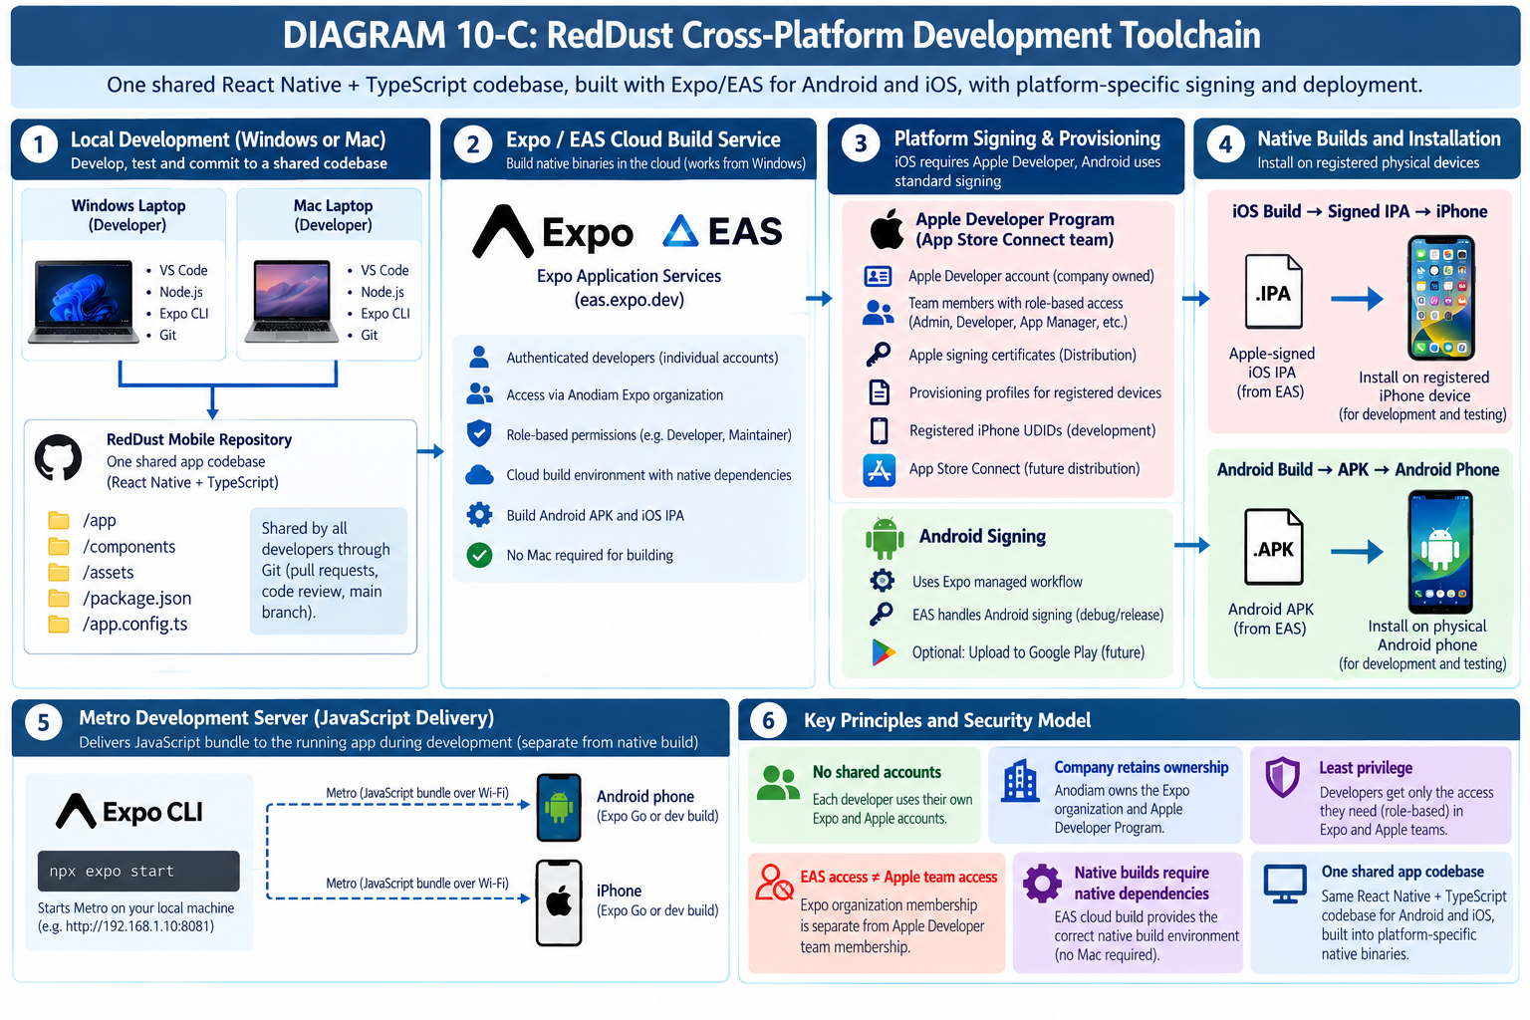
DIAGRAM APP-F: Apple Developer, Expo Organization and iPhone Provisioning
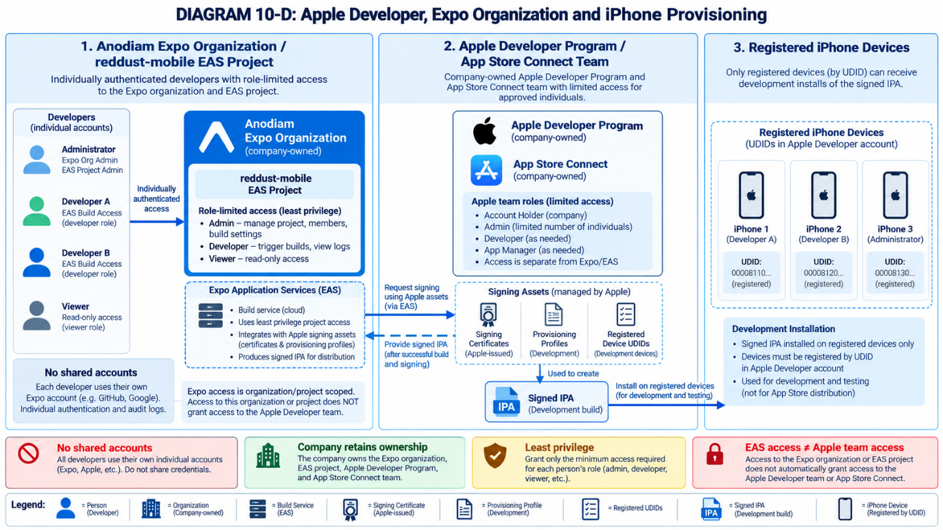
DIAGRAM APP-G: iPhone Microphone and WebRTC Audio Lifecycle
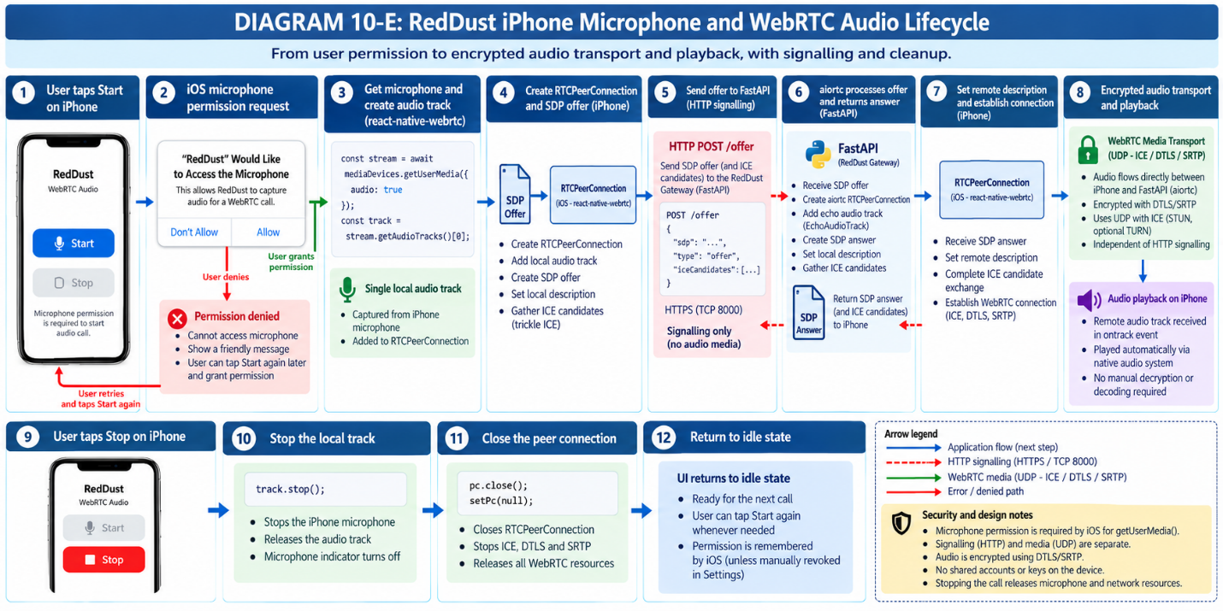
DIAGRAM APP-H: RedDust Mobile Evolution — Echo to Production AI
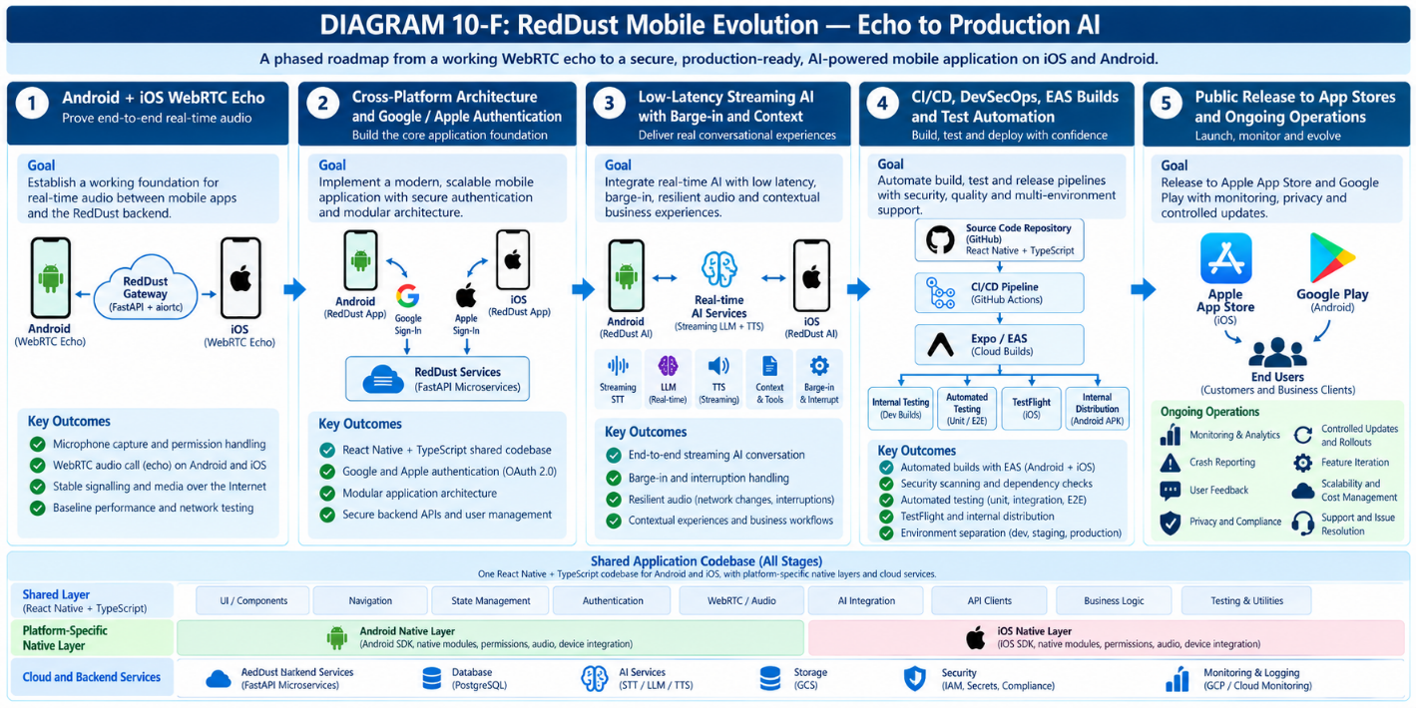

Authoritative Resources and Maintenance Notes
- Expo environment setup — https://docs.expo.dev/get-started/set-up-your-environment/
- Expo iOS device development builds — https://docs.expo.dev/tutorial/eas/ios-development-build-for-devices/
- Expo internal distribution — https://docs.expo.dev/build/internal-distribution/
- Expo iOS Developer Mode — https://docs.expo.dev/guides/ios-developer-mode/
- Apple Developer Program enrollment — https://developer.apple.com/programs/enroll/
- Apple Xcode requirements — https://developer.apple.com/xcode/system-requirements/
- Apple TestFlight — https://developer.apple.com/testflight/
- Apple App Review Guidelines — https://developer.apple.com/app-store/review/guidelines/
Maintenance note: Platform capabilities, required Xcode/iOS versions, prices, Apple review guidance and EAS free-plan limits can change. Check current official sources before any new iOS release, hardware procurement or team-wide build-profile change.
Recommended insertion: Append this entire chapter after Step 19 of the existing local WebRTC onboarding document as “Appendix — iOS / iPhone Development (Extension of Step 10)”. Keep original Android sections 10.1–10.6 unchanged.

APPENDIX F – Preparing Physical Android Phones and iPhones for RedDust Development
Device settings, secure installation, Expo/EAS development builds, Metro connectivity and physical-device WebRTC testing
Purpose: Prepare interns’ physical phones to install, run, diagnose and validate the native RedDust Development Build. This appendix complements Step 10 of the Steps 0–19 runbook.
Important distinction: Android provides Developer Options and optional USB Debugging. iPhone provides Developer Mode, plus Apple code-signing and device provisioning requirements for EAS development builds.

Quick comparison
Activity | Android | iPhone
Install development build | APK; approve install from source | Signed/provisioned IPA; Developer Mode
Developer setting | Developer Options optional for APK installation | Developer Mode for development-signed app
USB debugging | Optional; useful for ADB | Not applicable
USB connection to Windows | Optional | Not required for EAS build workflow
Physical microphone/WebRTC testing | Recommended | Recommended

SECTION A — CONFIGURE AN ANDROID PHONE FOR REDDUST DEVELOPMENT

A.1 — Understand Android Developer Options
What this section does and why it matters: Prepare the phone for app installation, diagnostics and optional direct debugging.
New concepts: Developer Options is an advanced Android settings menu. USB Debugging allows a trusted computer to communicate through Android Debug Bridge (ADB).
Who does what: Each Android developer configures their own device. A Google Play developer account is not needed to install a local EAS development APK.

A.2 — Enable Developer Options
- Unlock the Android phone and open Settings.
- Go to About phone (or the manufacturer-specific equivalent).
- Locate Build number; tap it seven times.
- Enter the device PIN or password if requested.
- Confirm the “You are now a developer!” notification.
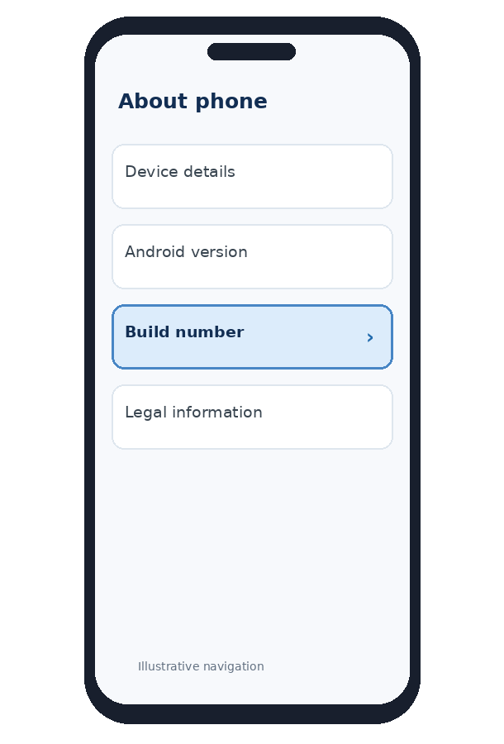
Illustrative Android settings navigation — actual screen varies by manufacturer.
Manufacturer | Typical path
Google Pixel | Settings → About phone → Build number
Samsung Galaxy | Settings → About phone → Software information → Build number
Other Android devices | About phone → Build number / OS version (varies)

A.3 — Locate Developer Options
Google Pixel:
Settings → System → Developer options
Samsung Galaxy:
Settings → Developer options
Verify that the main Developer Options switch is enabled. Do not change unrelated settings such as OEM unlocking, bootloader unlocking or system security controls.

A.4 — Enable USB Debugging (Optional)
- Open Settings → Developer options.
- Find the Debugging section and enable USB debugging.
- Confirm the device warning.
- Connect the phone to a trusted Windows laptop using a data-capable USB cable.
- Unlock the phone and approve the computer’s debugging authorization prompt.
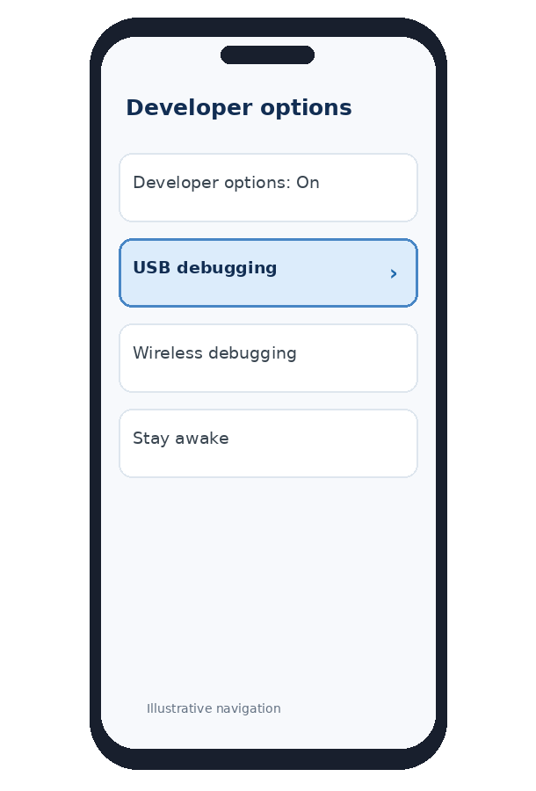
Illustrative USB Debugging setting; manufacturer wording varies.
Optional ADB verification: If Android SDK Platform Tools are installed on Windows, run:
adb devices
# Example output:
List of devices attached
R58N123456A device
If the status is “unauthorized”, unlock the phone and approve the on-device request. For the RedDust Windows + EAS cloud-build workflow, USB debugging and ADB are optional, not prerequisites.

A.5 — Install the RedDust Development APK
- Open the completed RedDust EAS build link on the phone.
- Download the development APK from the approved RedDust build.
- If blocked, open the prompt and enable “Allow from this source” for the specific browser/file manager.
- Install and open the RedDust Development Build (not Expo Go).
- Optionally disable “Allow from this source” once installation is complete.

A.6 — Prepare Microphone and WebRTC Permissions
Start microphone capture in the RedDust test screen. When Android prompts for access, choose “Allow while using the app” or the closest available choice.
Settings → Apps → RedDust → Permissions → Microphone
Confirm that microphone access is enabled and is not blocked by a device-wide privacy toggle. Camera permission is not required for the audio-only echo test.

A.7 — Connect Android to Metro and the Gateway
cd D:\RedDust\reddust-mobile
npx expo start --dev-client
- Connect the phone and laptop to the same suitable Wi-Fi network.
- Open the installed RedDust Development Build.
- Connect to Metro using the discovered server or QR code.
- Confirm that the RedDust test screen loads.
- Confirm that the FastAPI Gateway is independently reachable.
- Start microphone capture and run the WebRTC test.
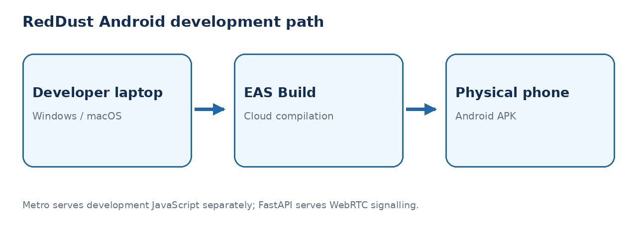
Android development-build path; Metro and FastAPI have separate responsibilities.
Networking distinction: Metro commonly uses TCP 8081 to serve JavaScript. FastAPI commonly uses TCP 8000 for HTTP signalling. WebRTC audio uses negotiated secure media transport.

A.8 — Android Developer Readiness Checklist
☐ Developer Options enabled (when needed)
☐ USB Debugging enabled only if ADB debugging is required
☐ Approved RedDust EAS development APK installed
☐ Microphone permission granted
☐ Development Build connects to Metro
☐ FastAPI Gateway reachable from phone
☐ WebRTC microphone/audio test successful

SECTION B — CONFIGURE AN IPHONE FOR REDDUST DEVELOPMENT

B.1 — Understand iPhone Developer Mode
What this section does and why it matters: Enable a physical iPhone to run appropriately signed RedDust development apps with native WebRTC.
New concepts: Developer Mode permits development workflows. Code signing authenticates the developer; provisioning profiles authorize app installation on registered devices for ad hoc distribution.
Who does what: The device owner enables Developer Mode; Anodiam’s designated Apple Developer/EAS administrator controls signing and provisioning.
Unlike Android, iPhone ad hoc development installation requires approved signing and provisioning. A Windows laptop can still trigger EAS iOS cloud builds; a Mac is not mandatory for this specific workflow.

B.2 — Record the iPhone Model and iOS Version
Settings → General → About
→ iOS Version
→ Model Name
Record the device model and installed iOS version. The Expo SDK 56 baseline identifies iOS 16.4 as its minimum supported iOS version; future RedDust SDK upgrades may change this requirement.

B.3 — Locate Developer Mode (and Understand Why It May Be Hidden)
Settings → Privacy & Security → Developer Mode
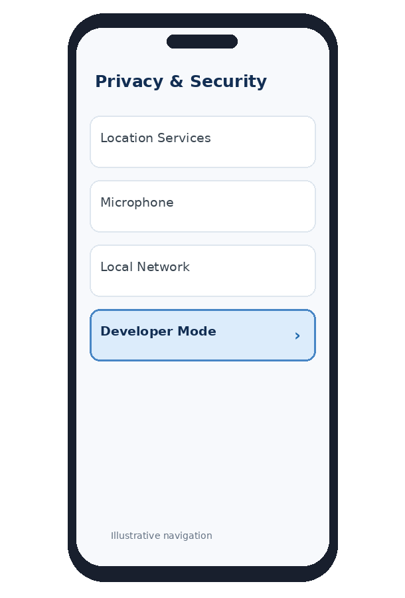
Illustrative iOS Privacy & Security navigation — appearance varies by iOS version.
Developer Mode may not initially be visible. It can become available after attempting to open a valid development build or after initiating a development workflow with Xcode on a Mac. Its absence does not automatically mean the iPhone is incompatible.

B.4 — Register the iPhone with RedDust EAS
cd D:\RedDust\reddust-mobile
npx eas-cli@latest login
npx eas-cli@latest device:create
Follow the EAS device-registration link/QR instructions on the iPhone. The process may request installation of a temporary registration profile. Only use links generated by the approved RedDust EAS workflow. An authorized Apple Developer administrator must ensure that the device is included in the signing/provisioning setup.
Important: Expo login access and Apple Developer team access are separate. Testers do not automatically require administrative rights in the Apple Developer team.

B.5 — Build and Install the iOS Development Application
cd D:\RedDust\reddust-mobile
npx eas-cli@latest build `
--profile development `
--platform ios
- Wait for the authorized EAS build to succeed.
- On the registered iPhone, open the EAS install link.
- Follow iOS installation instructions for the signed build.
- Confirm the RedDust app appears on the Home Screen.
- Attempt to open the installed RedDust Development Build.
Unlike an Android APK, a development IPA cannot generally be installed on an arbitrary iPhone. Apple signing and ad hoc provisioning must permit that specific device.

B.6 — Enable iPhone Developer Mode
- Open Settings → Privacy & Security → Developer Mode.
- Turn on the Developer Mode switch.
- Read the security message and select Restart when prompted.
- After restart, unlock the iPhone.
- Confirm Turn On (or equivalent wording).
- Enter the iPhone passcode if requested.
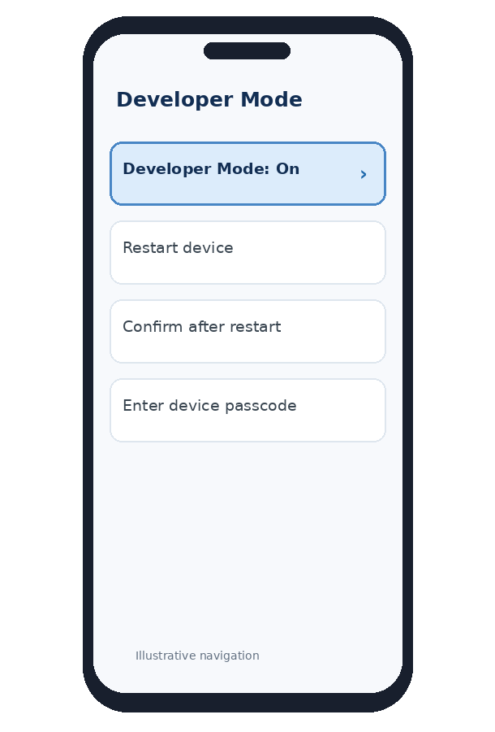
Illustrative Developer Mode activation sequence; follow actual on-device prompts.
Developer Mode normally remains enabled until it is deliberately changed or device policy/state requires reconfiguration.

B.7 — Alternative: Activate Developer Mode Using a Mac
- On a compatible Mac, install a suitable version of Xcode.
- Connect the iPhone using an appropriate cable and trust the computer when prompted.
- Open Xcode’s device management interface (menu wording depends on Xcode release).
- Follow Xcode’s device-preparation prompts.
- On the iPhone, enable Developer Mode in Privacy & Security and restart/confirm as instructed.
This Mac-based workflow is useful for local native debugging and simulator/device management. It is not a requirement for the initial Windows + EAS build workflow.

B.8 — Grant iPhone Microphone Permission
In the RedDust Development Build, trigger getUserMedia({ audio: true }). iOS should present the microphone permission request using the purpose text configured in NSMicrophoneUsageDescription.
Settings → Privacy & Security → Microphone → RedDust
Allow access and verify the live input audio track. If access is denied, RedDust should display recovery guidance rather than crashing.

B.9 — Grant Local Network Access
When the development app needs to find or reach devices/services on the local LAN, iOS may request local network permission. Allow it only for the trusted RedDust development network.
Settings → Privacy & Security → Local Network → RedDust
For a Gateway running on the Windows laptop, do not use localhost in the iPhone application: localhost refers to the phone. Use the laptop’s reachable LAN IP or an approved HTTPS Gateway URL.

B.10 — Connect the iPhone to Metro and FastAPI
cd D:\RedDust\reddust-mobile
npx expo start --dev-client
- Connect Windows laptop and iPhone to the same suitable Wi-Fi network.
- Open the RedDust Development Build.
- Choose the Metro development server or scan its QR code.
- Confirm that the TypeScript application loads.
- Start microphone capture and grant permission if asked.
- Verify separate connectivity to the FastAPI Gateway.
- Run the audio echo/WebRTC test.
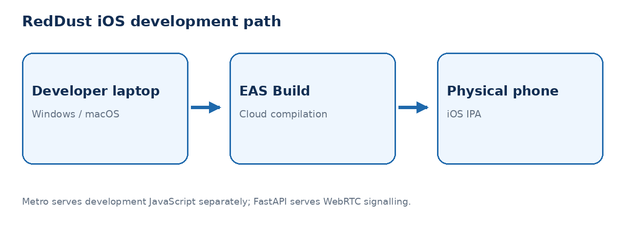
iPhone cloud-build path; Metro supplies development JavaScript, not WebRTC audio.

B.11 — iPhone Developer Readiness Checklist
☐ iPhone model and supported iOS version recorded
☐ Device registered in EAS for the intended ad hoc profile
☐ Correctly signed RedDust development build installed
☐ Developer Mode enabled after restart/confirmation
☐ Microphone access enabled
☐ Local Network access enabled when prompted
☐ Development Build connects to Metro
☐ FastAPI Gateway separately reachable
☐ WebRTC audio test successful

Final RedDust Device Readiness Comparison
Requirement | Android | iPhone
Development installation | APK from authorized EAS build | Signed/provisioned IPA from authorized EAS build
Key developer setting | Developer Options (optional for APK) | Developer Mode for development-signed builds
USB debugging | Optional for ADB | No Android-style USB debugging
Paid mobile-store membership | Not needed for direct APK testing | Apple Developer Program normally needed for team/EAS ad hoc signing
Windows + EAS | Supported | Supported
Mac/Xcode | Optional | Useful for native development; not required for EAS cloud build
Testing | Physical device strongly recommended | Physical device strongly recommended
RedDust should test on physical Android phones and iPhones, particularly for microphone capture, Bluetooth output, network transitions, interruption handling and real-time conversational AI behavior.
DIAGRAM — F-01: Android Developer Options and USB Debugging
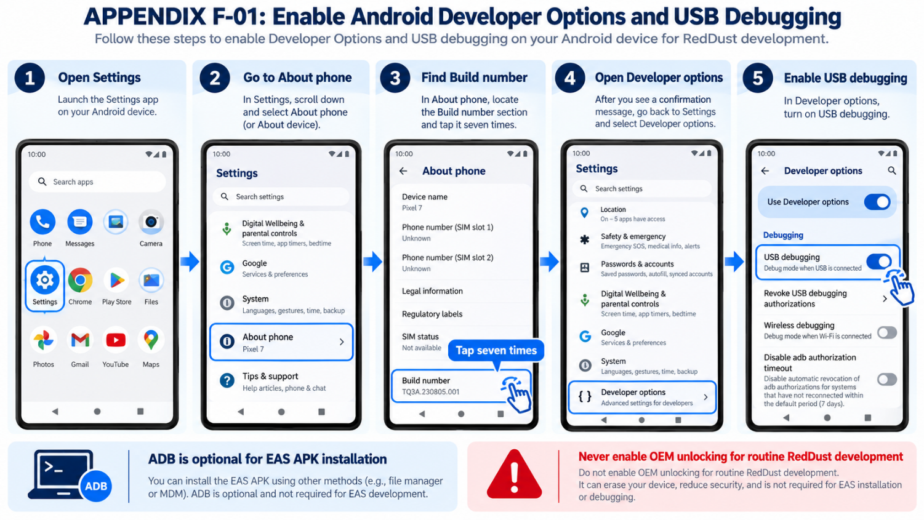
DIAGRAM — F-02: iPhone Developer Mode and EAS Ad Hoc Provisioning
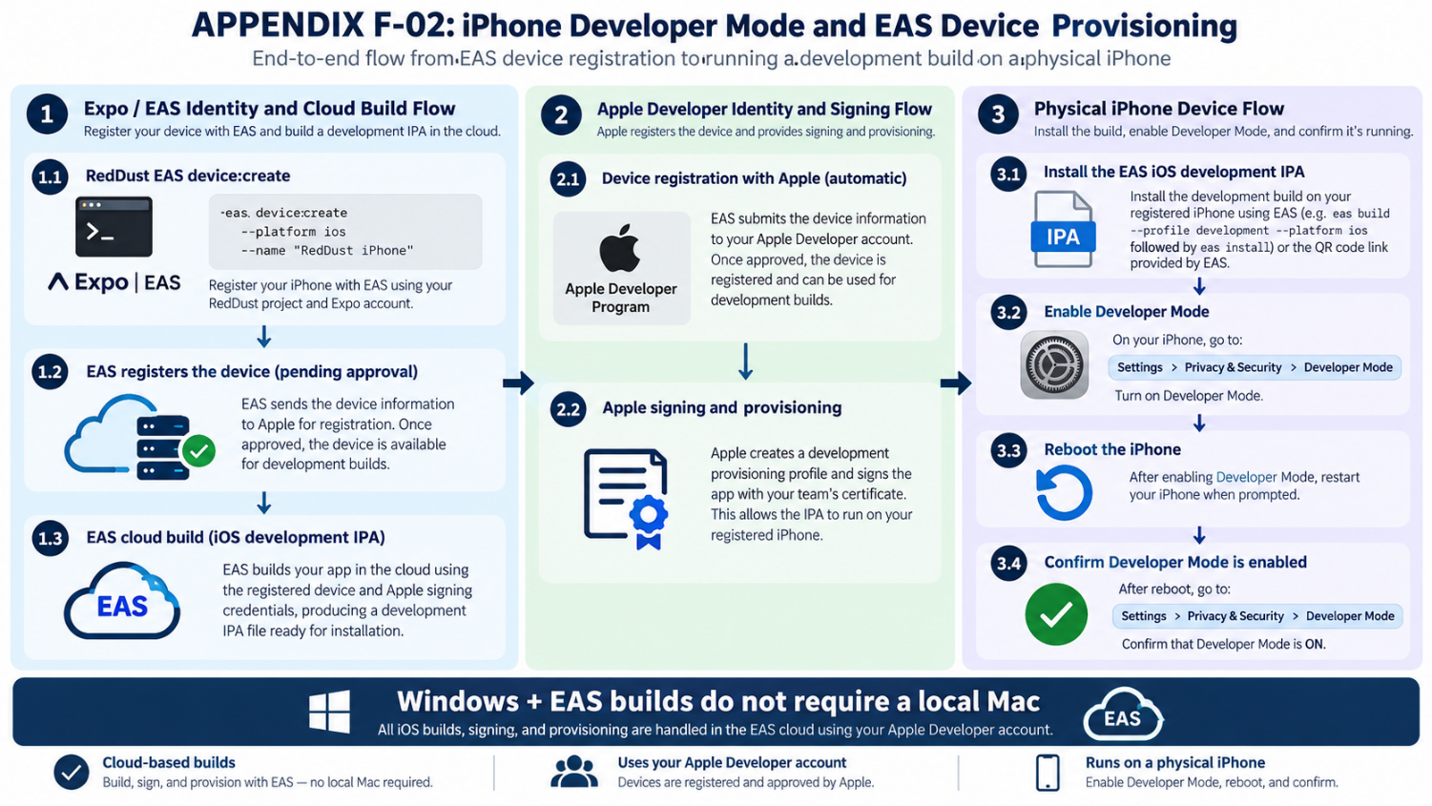DIAGRAM — F-03: Metro, FastAPI and WebRTC — Three Distinct Connections

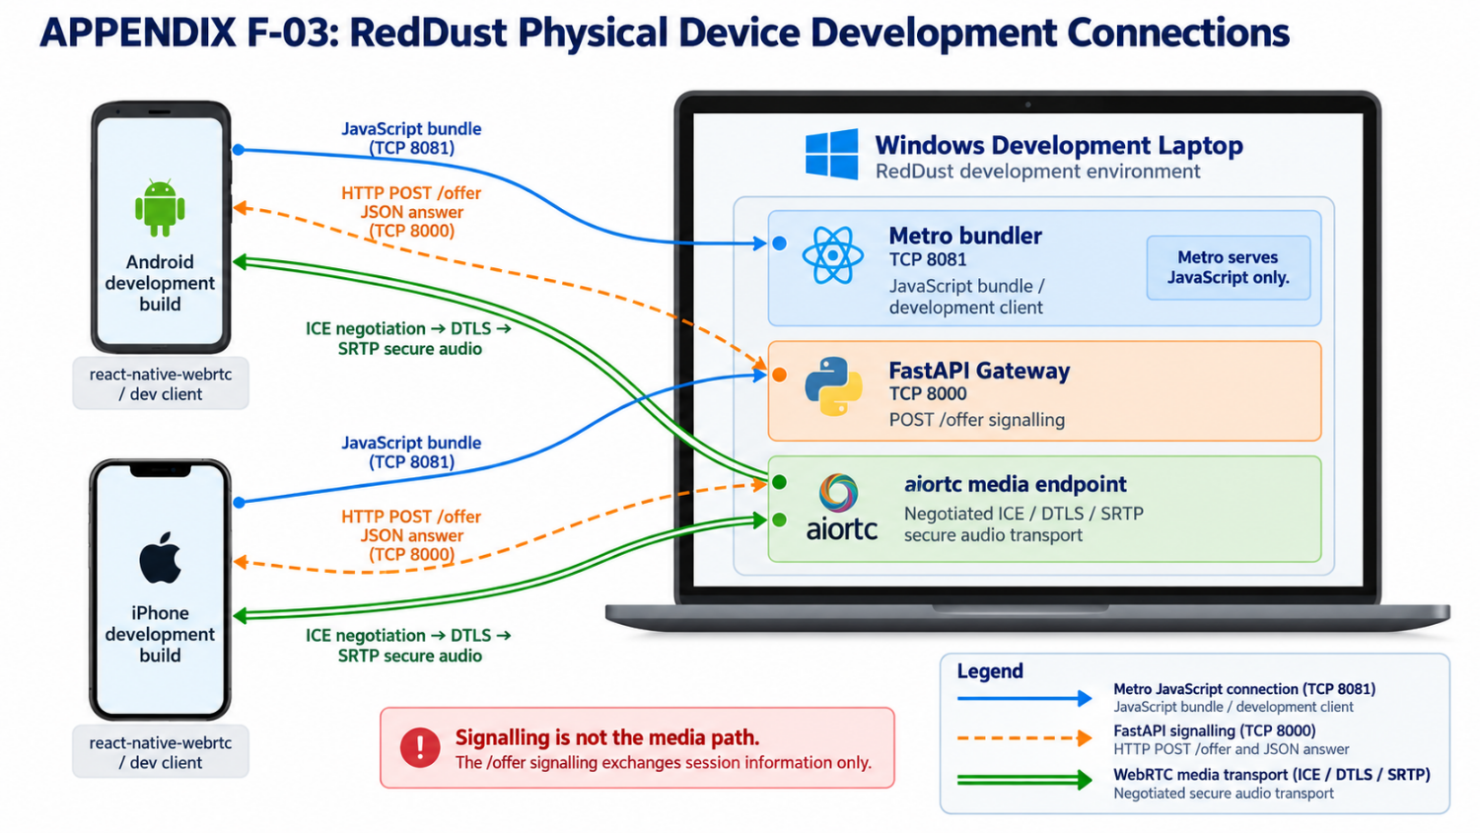Authoritative References
- Android Developer Options — https://developer.android.com/studio/debug/dev-options
- Expo iOS Developer Mode — https://docs.expo.dev/guides/ios-developer-mode/
- Expo iOS development builds for devices — https://docs.expo.dev/tutorial/eas/ios-development-build-for-devices/
- Expo internal distribution — https://docs.expo.dev/build/internal-distribution/
- Apple Developer Program — https://developer.apple.com/programs/

