PLATFORM
ARCHITECTURE
STEP 21 — MOVE REDDUST GATEWAY TO TERRAFORM IaC
Implementation runbook for converting the Step-20 Google Cloud VM into Infrastructure as Code
Project RedDust


From Anodiam


RedDust
Version | Publisher | Date | Reviewer | Date
1.0.0 | Anodiam | 25/09/2026

Document purpose
This runbook is the Step-21 continuation of the proven Step-20 GCP VM implementation. It moves the same RedDust Gateway echo-test environment into Terraform - Infrastructure as Code while preserving the working security, networking and runtime boundaries.

Contents
Introduction
21.0 — Terraform mental model
21.1 — Parity boundary
21.2 — Baseline inventory
21.3 — Windows Terraform toolchain
21.4 — Repository structure
21.5 — GCP authentication
21.6 — Remote Terraform state
21.7 — Root configuration
21.8 — Required GCP APIs
21.9 — OS Login and human IAM
21.10 — Runtime service account
21.11 — Networking
21.12 — IAP-only SSH
21.13 — TCP 8000 signalling
21.14 — WebRTC UDP
21.15 — Compute Engine VM
21.16 — Linux/Python bootstrap
21.17 — GitHub source delivery
21.18 — systemd
21.19 — Budget alerts
21.20 — Import existing Step-20 resources
21.21 — Reconcile to no-op plan
21.22 — First controlled apply
21.23 — Access validation
21.24 — Runtime health validation
21.25 — Wi-Fi and 4G/5G echo acceptance
21.26 — Ongoing Terraform workflow
21.27 — Stop/start, drift and break-glass
21.28 — DevSecOps guardrails
21.29 — Troubleshooting
21.30 — Completion checklist
21.31 — Condensed sequence
21.32 — Step-20 to Step-21 mapping
21.33 — Complete reference file set
21.34 — Glossary
21.35 — References
Next planned engineering step

Introduction
What this section does and why it matters
Step 20 proved the real Internet WebRTC echo path on reddust-gateway-dev. Step 21 changes the management method, not the working telephony architecture. The output of this step is reviewable Terraform code, protected Terraform state and a safe brownfield adoption of the existing resources.
New technical concepts in absolute beginner terms
Infrastructure as Code means the desired cloud environment is stored as text files in Git. Terraform compares those files with the real Google Cloud environment, produces a plan, and applies only reviewed changes.
Who does what
The Owner (owner@anodiam.com) retains ultimate authority. The Administrator (admin@anodiam.com) provisions and operates Terraform. The Developer (dev@anodiam.com) validates the Gateway and gets only the least privilege required to work on the development VM.

Role | Google identity | OS Login Linux user
Owner | owner@anodiam.com | owner_anodiam_com
Administrator | admin@anodiam.com | admin_anodiam_com
Developer | dev@anodiam.com | dev_anodiam_com

Central rule
Achieve Terraform parity before architecture improvement. Do not redesign the VM, VPC, HTTPS, TURN or Kubernetes while you are still proving that Terraform can safely describe the Step-20 environment.

DIAGRAM PLACEHOLDER — 21-A: Step 20 Manual GCP versus Step 21 Terraform
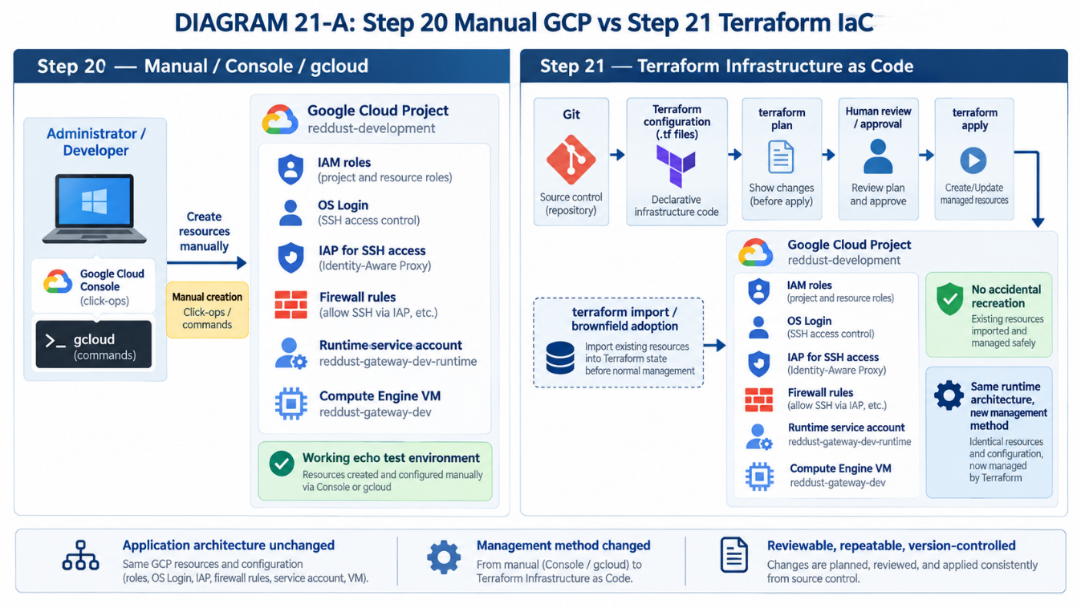

21.0 — What Changes in Step 21: From Click-Ops to Infrastructure as Code
What this section does and why it matters
Build the beginner mental model for configuration, state, plan and apply.
New technical concepts in absolute beginner terms
Declarative infrastructure describes the desired end state. Terraform state is the map between code and real cloud objects. Plan is a preview; apply is the change.
Who does what
Administrator drives Terraform. Owner reviews sensitive or destructive changes. Developer validates app-facing effects.

• Treat .tf files as the desired infrastructure recipe.
• Treat state as sensitive operational data.
• Never assume a successful apply proves the application works.
• Read create/update/destroy/replace actions before approval.
Reference command/configuration
resource "google_compute_instance" "gateway" {
name = "reddust-gateway-dev"
machine_type = "e2-medium"
zone = "australia-southeast1-b"
}

DIAGRAM PLACEHOLDER — 21-B: Terraform Mental Model
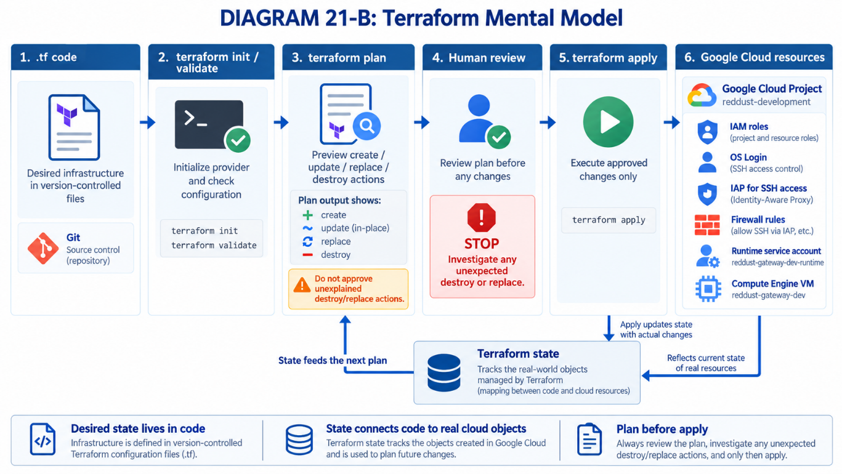

21.1 — Define the Terraform End State and Step-20 Parity Boundary
What this section does and why it matters
Freeze the exact Step-20 architecture that Terraform must first reproduce.
New technical concepts in absolute beginner terms
Parity means functionally the same infrastructure and behavior even though the provisioning mechanism changes.
Who does what
Owner approves the target. Administrator maps each resource. Developer confirms the echo-test behavior remains the same.

• Project in GCP stays reddust-development.
• VM stays reddust-gateway-dev / e2-medium / Sydney / Ubuntu 24.04 / 10 GB pd-standard.
• Runtime service account remains:
reddust-gateway-dev-runtime@reddust-development.iam.gserviceaccount.com
• IAP-only SSH, TCP 8000 signalling and the verified UDP range remain the initial network design.
• HTTPS, TURN, dedicated VPC, containers and Kubernetes are explicitly deferred.
DIAGRAM PLACEHOLDER — 21-C: Step-20 Resource-to-Terraform Mapping
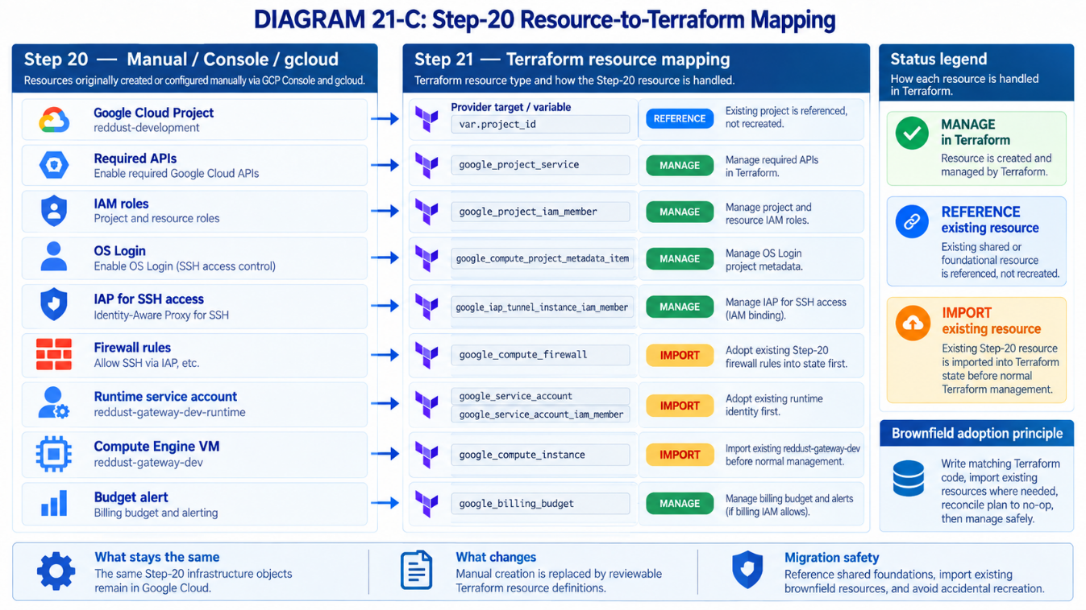

21.2 — Freeze and Inventory the Existing Step-20 Environment before Terraform Touches It
What this section does and why it matters
Capture read-only evidence of the existing working environment before any Terraform apply.
New technical concepts in absolute beginner terms
Brownfield means infrastructure already exists. Import associates an existing resource with a Terraform address instead of creating a duplicate.
Who does what
Administrator captures GCP data. Developer records Linux/runtime/WebRTC values. Owner confirms project and identity scope.

• Save project, VM, firewall, metadata, IAM and service-account JSON descriptions locally.
• Record the actual Linux UDP ephemeral range.
• Confirm current systemd status and /healthz.
• Record the current external IP and the known-good Git commit if available.
• Do not commit tokens, keys or .env secrets.
UDP (User Datagram Protocol) is a fast way for computers to send network data without waiting for confirmation that every packet arrived. WebRTC commonly uses UDP for real-time audio because low delay is more important than perfect delivery, so we record the Linux VM’s actual UDP ephemeral port range to make sure the GCP firewall and Terraform configuration allow the ports the Gateway may use for WebRTC media.
systemd is Linux’s standard service manager: it starts, stops, restarts, and monitors programs that should run in the background. For example, it can automatically start the RedDust Gateway when the VM boots, restart it if Uvicorn crashes, and keep it running even after a developer closes the SSH session. Common commands include systemctl start reddust-gateway, systemctl stop reddust-gateway, systemctl restart reddust-gateway, and systemctl status reddust-gateway.

Reference command/configuration
$PROJECT_ID="reddust-development"
$VM_NAME="reddust-gateway-dev"
$ZONE="australia-southeast1-b"
gcloud compute instances describe $VM_NAME --project=$PROJECT_ID --zone=$ZONE --format=json > vm.json
gcloud compute firewall-rules list --project=$PROJECT_ID --format=json > firewall-rules.json
gcloud projects get-iam-policy $PROJECT_ID --format=json > project-iam.json

DIAGRAM PLACEHOLDER — 21-D: Brownfield Adoption Safety Sequence
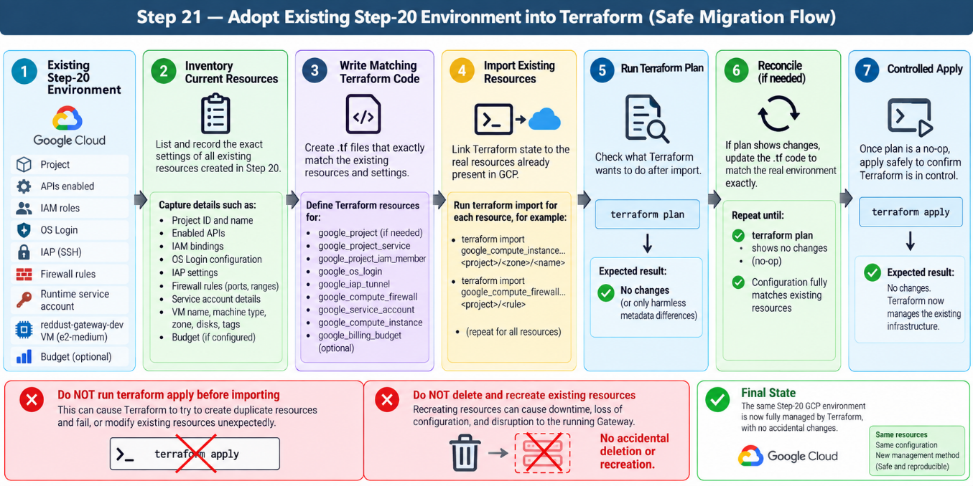

21.3 — Install and Verify the Local Terraform Toolchain on Windows
What this section does and why it matters
Prepare a repeatable Windows workstation for Terraform, Git and gcloud before any RedDust infrastructure is changed. The goal is to prove that every required local tool is installed, discoverable from PowerShell, and able to perform harmless local checks.
New technical concepts in absolute beginner terms
PATH is the list of folders Windows searches when you type a command. Terraform CLI reads and checks Terraform configuration, Git versions the code, and gcloud provides Google Cloud authentication and independent verification. VS Code is the editor; its extensions improve the editing experience but do not replace the underlying command-line tools.
Who does what
The Administrator installs and verifies the complete toolchain and will later be the primary Terraform operator. Developers may install the same tools for review, formatting, validation and troubleshooting. Whether anyone can actually change Google Cloud still depends on Google Cloud IAM permissions, not merely on having Terraform installed.

For Step 21.3, the minimum workstation components are:
Component | Required? | Purpose in Step 21
VS Code | Yes / already used | Primary editor for Terraform and RedDust source code.
Terraform CLI | YES | Runs Terraform commands such as fmt, validate, plan, apply and import.
Git for Windows | YES | Versions Terraform code and communicates with GitHub.
Git Bash | Optional | Convenient Bash shell installed with Git for Windows; this runbook standardizes on PowerShell.
Google Cloud CLI (gcloud) | YES | Later provides Google authentication and independent checks against real GCP resources.
HashiCorp Terraform VS Code extension | Strongly recommended | Adds Terraform syntax highlighting, language support, formatting and editor diagnostics.
Separate Git VS Code extension | No | VS Code already includes built-in Git source-control integration.
Google Cloud Code extension | Optional | Useful IDE integration but not required for Step 21.3.
Separate HCL extension | Not required | The HashiCorp Terraform extension already understands Terraform .tf files.
DIAGRAM PLACEHOLDER — 21-E: Windows Terraform Workstation
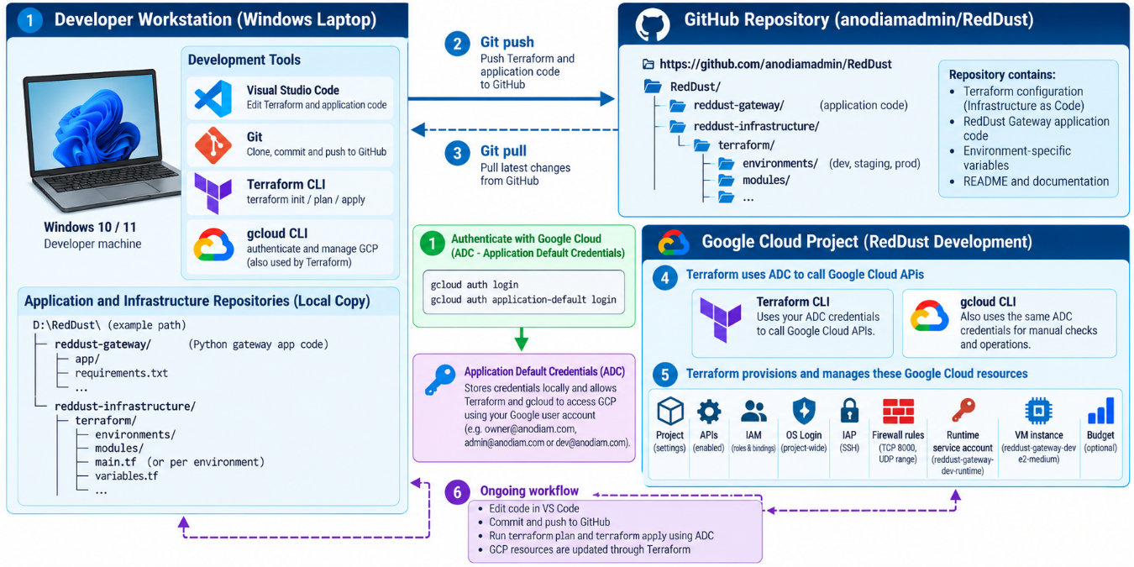

21.3.1 — Understand What We Are Installing
In Step 20, infrastructure could be created or inspected through the Google Cloud Console and gcloud commands. In Step 21, Terraform becomes the primary infrastructure-management tool, but it does not replace VS Code, Git or gcloud. Each tool has a different job.
Beginner mental model
VS Code
│
│ edit files
▼
Terraform .tf files
│
├──── Git ─────────► GitHub
│
└──── Terraform CLI ─────► Google Cloud
▲
│ authentication / verification
│
gcloud

Boundary for this subsection
For now, install and verify the tools only. Do not authenticate Terraform to Google Cloud, create Terraform-managed resources, import the Step-20 VM, or run terraform apply in this subsection.

21.3.2 — Use PowerShell as the Standard Step-21 Windows Shell
For consistency across the team, use PowerShell only as the normal Windows command shell for this Terraform runbook. Git Bash may remain installed and is useful for Bash-oriented work, but switching casually among PowerShell, Git Bash, Command Prompt and WSL can create confusing differences in quoting, path syntax and environment variables.
PowerShell variable syntax example
$PROJECT_ID="reddust-development"

Bash variable syntax example
PROJECT_ID="reddust-development"

Team convention
Unless a later subsection explicitly says otherwise, run Windows-side Terraform and gcloud commands from PowerShell only.

21.3.3 — Verify VS Code First
If VS Code is already installed, open a new PowerShell window and verify that Windows can find the VS Code command-line launcher.
code --version

Expected result: VS Code prints version information. If PowerShell reports that code is not recognized, repair or reinstall VS Code and ensure its command-line launcher is available on PATH.
Acceptance check
Do not continue until code --version succeeds from a fresh PowerShell session.

21.3.4 — Install Git for Windows
Git is required. Terraform files will be version-controlled just like application code, and Git will eventually be used to commit and push the infrastructure files to the RedDust GitHub repository.
Install Git for Windows using either the normal official installer or Windows Package Manager. If using winget:
winget install --id Git.Git -e --source winget

After installation, close PowerShell completely, open a brand-new PowerShell window, and verify Git:
git --version
where.exe git

Expected form: git prints a version such as git version 2.x.x.windows.x, and where.exe git returns the path to git.exe. The exact version and installation folder can vary.

21.3.5 — Decide How Git Bash Will Be Used
Git Bash is useful, but it is not a separate RedDust requirement. Git for Windows normally installs Git Bash automatically, so it can remain available for shell-script work.
Git for Windows REQUIRED
Git executable REQUIRED
Git Bash OPTIONAL / convenient

For this runbook, PowerShell remains the standard Windows shell. You also do not need a separate Git extension for VS Code because VS Code already provides built-in Git source-control support.
If you already use VS Code and GitHub Desktop, Git Bash is not required for this RedDust workflow. GitHub Desktop can handle the routine Git operations graphically, while PowerShell remains the standard command-line shell used throughout this runbook.
If someone does not have GitHub Desktop, they can use Git for Windows from PowerShell instead. In this runbook, that is completely acceptable and actually more universal. They would use commands such as:
git clone <repository-url>
git status
git pull
git add .
git commit -m "message"
git push

Though, GitHub Desktop is highly recommended for the graphical convenience, the actual requirement is Git for Windows; PowerShell can be used as the standard shell, and Git Bash is optional.

21.3.6 — Install the RedDust-Standard Terraform CLI Version (v1.16.4)
What this subsection does and why it matters
This subsection standardises every RedDust team member on one exact Terraform CLI version: Terraform v1.16.4. Using one version across Owner, Administrator and Developer workstations reduces avoidable differences in plans, lock files and command behaviour, and makes troubleshooting much easier.
New technical concepts in absolute beginner terms
Terraform is delivered on Windows as a small command-line executable named terraform.exe. Windows finds that executable through PATH, which is simply a list of folders that PowerShell searches when you type a command such as terraform version. Pinning a version means the project deliberately requires one exact Terraform release instead of silently accepting whatever version happens to be installed.
Who does what
All RedDust team members who will read, validate, plan or apply Terraform should install the same Terraform version. The Administrator normally performs infrastructure changes; the Owner retains governance authority; the Developer may validate and review. The installation procedure itself is the same for every team member.

RedDust Terraform CLI Standard
Use Terraform v1.16.4 exactly on Windows AMD64 for this Step-21 project. Do not automatically upgrade Terraform simply because a newer release appears. Any future version change should be deliberate, tested, reviewed and rolled out to the whole team together.

As of 25 September 2026, HashiCorp lists Terraform 1.16.4 as the current stable Terraform release, while Terraform 1.17 is still in prerelease/beta. For RedDust Step 21, the team therefore standardises on Terraform v1.16.4.

21.3.6.1 — Confirm the Windows Processor Architecture
Before downloading Terraform, confirm that the team member is using the normal 64-bit Intel/AMD Windows architecture expected by this runbook.
PowerShell
$env:PROCESSOR_ARCHITECTURE

For the standard Windows x64 case, expect:
AMD64

Stop condition
If the command does not return AMD64, do not use the Windows AMD64 download blindly. Confirm the actual machine architecture first.

21.3.6.2 — Download Terraform v1.16.4 from HashiCorp
Download the official Terraform 1.16.4 Windows AMD64 ZIP directly from HashiCorp. Terraform is distributed inside a ZIP archive rather than through a traditional Windows setup wizard.
Official direct download: https://releases.hashicorp.com/terraform/1.16.4/terraform_1.16.4_windows_amd64.zip
Official Terraform installation page: https://developer.hashicorp.com/terraform/install
After downloading, the file should be named similar to:
terraform_1.16.4_windows_amd64.zip

Important
Do not run Terraform directly from inside the ZIP archive. Extract terraform.exe into a permanent folder first.

21.3.6.3 — Create the Permanent Terraform Installation Folder
Use a version-specific folder so that the installed project version is obvious to every team member.
PowerShell
New-Item -ItemType Directory `
-Path "C:\HashiCorp\Terraform\1.16.4" `
-Force

The target folder is:
C:\HashiCorp\Terraform\1.16.4

21.3.6.4 — Extract terraform.exe into the Permanent Folder
Extract the downloaded ZIP into the folder created above. After extraction, the expected executable is:
C:\HashiCorp\Terraform\1.16.4\terraform.exe

Verify that the file exists:
PowerShell
Get-Item "C:\HashiCorp\Terraform\1.16.4\terraform.exe"

21.3.6.5 — Check for an Existing Terraform Installation
Before changing PATH, check whether another Terraform executable is already visible to Windows. Multiple versions on PATH can cause confusing behaviour because Windows will normally run the first matching executable it finds.
PowerShell
where.exe terraform

If Terraform has never been installed, a message similar to the following is acceptable:
INFO: Could not find files for the given pattern(s).

If one or more paths are displayed, record them. Do not continue until you understand which Terraform executable Windows will use.

21.3.6.6 — Add Terraform v1.16.4 to the Windows User PATH
Add the Terraform installation folder — not terraform.exe itself — to the Windows user PATH.
Add this folder to PATH
C:\HashiCorp\Terraform\1.16.4

Do not add this file as the PATH value
C:\HashiCorp\Terraform\1.16.4\terraform.exe

Use the following Windows navigation:
Start
→ Search: environment variables
→ Edit environment variables for your account
→ Environment Variables
→ User variables
→ Path
→ Edit
→ New

Enter:
C:\HashiCorp\Terraform\1.16.4

Click OK through all dialogs to save the change.

21.3.6.7 — Open a Completely New PowerShell Session
An already-open PowerShell or VS Code terminal may still be using the old PATH. Close existing PowerShell windows, Windows Terminal tabs and VS Code integrated terminals, then open a completely new PowerShell session.

21.3.6.8 — Verify Which Terraform Executable Windows Finds
PowerShell
where.exe terraform

The desired result is:
C:\HashiCorp\Terraform\1.16.4\terraform.exe

Stop condition
If several Terraform locations appear, or if the first result points to another version, do not continue until the PATH order is understood and corrected.

21.3.6.9 — Verify the Exact Terraform Version
PowerShell
terraform version

The important output must be:
Terraform v1.16.4
on windows_amd64

Acceptance rule
If the reported Terraform version is anything other than 1.16.4, the workstation is not yet Step-21-ready.

21.3.6.10 — Verify Terraform from the VS Code PowerShell Terminal
Completely restart VS Code so that it inherits the updated PATH. Open Terminal → New Terminal and make sure the terminal is PowerShell. Then run:
VS Code PowerShell terminal
terraform version
where.exe terraform

The same Terraform v1.16.4 version and the same version-specific executable path should be visible inside VS Code.

21.3.6.11 — Pin the RedDust Terraform Configuration to the Exact Version
The project should enforce the same version in Terraform code. This prevents a team member from accidentally running the project with a different CLI version. Replace a broad constraint such as:
Do not use this broad constraint for the final RedDust team standard
terraform {
required_version = ">= 1.6.0, < 2.0.0"
}

with the RedDust project standard:
Recommended versions.tf constraint
terraform {
required_version = "= 1.16.4"
}

If someone later tries to use an incompatible Terraform version, Terraform will stop and report that the configuration requires version 1.16.4 instead of silently allowing different team versions.

21.3.6.12 — Perform a Harmless Local Version Test
Create a temporary local test directory. This test does not access Google Cloud and does not create, modify or import any RedDust infrastructure.
PowerShell
New-Item -ItemType Directory `
-Path "D:\RedDust\terraform-version-test" `
-Force
Set-Location "D:\RedDust\terraform-version-test"

Create a file named versions.tf containing:
versions.tf
terraform {
required_version = "= 1.16.4"
}

Then run:
PowerShell
terraform fmt
terraform validate

Expected result:
Success! The configuration is valid.

Safety note
This local test does not authenticate to GCP, create a VM, change IAM, access Terraform state, or run terraform apply.

21.3.6.13 — Final Team Acceptance Checklist
Done | Acceptance condition
☐ | The workstation is Windows AMD64, or the architecture was separately confirmed.
☐ | Terraform v1.16.4 was downloaded from the official HashiCorp release source.
☐ | terraform.exe exists at C:\HashiCorp\Terraform\1.16.4\terraform.exe.
☐ | C:\HashiCorp\Terraform\1.16.4 is on the user PATH.
☐ | where.exe terraform resolves to the intended v1.16.4 executable.
☐ | terraform version reports Terraform v1.16.4.
☐ | The same version is visible in the VS Code PowerShell terminal.
☐ | The project required_version is pinned to = 1.16.4.
☐ | terraform fmt succeeds in the harmless local test folder.
☐ | terraform validate returns Success! The configuration is valid.
☐ | No terraform apply or terraform import has been run as part of this installation procedure.

Completion criterion
The Terraform installation portion of Step 21.3 is complete when every participating team member can open a fresh PowerShell or VS Code PowerShell terminal, run terraform version, see Terraform v1.16.4 on windows_amd64, and successfully run terraform fmt and terraform validate against the harmless local version-test configuration.

Official Sources for This Installation Procedure
• HashiCorp Terraform installation page: https://developer.hashicorp.com/terraform/install
• HashiCorp Terraform v1.16.4 Windows AMD64 binary: https://releases.hashicorp.com/terraform/1.16.4/terraform_1.16.4_windows_amd64.zip
• HashiCorp Terraform release index: https://releases.hashicorp.com/terraform/

21.3.9 — Install and Verify Google Cloud CLI on Windows
What this section does and why it matters
Install the official Google Cloud CLI (the gcloud command-line tool) on every Windows workstation that will participate in Step 21. The purpose of this subsection is only to make sure the tool is installed correctly, available from PowerShell and VS Code, and able to start successfully before Terraform authentication is configured later.
New technical concepts in absolute beginner terms
The Google Cloud CLI is a collection of command-line tools for Google Cloud. The main command is gcloud. PATH is the Windows list of folders searched when you type a command. Google Cloud CLI also needs Python internally, but its bundled Python is a tool dependency and is separate from the Python 3.12.10 used by the RedDust Gateway application.
Who does what
Administrators must install and verify gcloud because they will use it for Google Cloud checks and later Terraform authentication. Developers should install it as well if they need to validate cloud resources or run approved operational checks. The Owner may install it for administrative or recovery work, but no one should share another person’s Google login or credential files.
Step boundary — installation only
This subsection does not log Terraform into Google Cloud and does not change any RedDust GCP resource. We will verify that gcloud is installed, but commands such as gcloud auth login, gcloud auth application-default login, Terraform import and terraform apply are deliberately outside this subsection.

21.3.9.1 — Understand Why We Still Need gcloud When We Are Moving to Terraform
Terraform becomes the main Infrastructure-as-Code tool in Step 21, but gcloud remains extremely useful as an independent Google Cloud administration and verification tool. Terraform tells us what our configuration intends to manage; gcloud lets us ask Google Cloud directly what actually exists.
Later in the runbook, gcloud may be used for read-only checks such as identifying the active Google account, checking the selected project, listing Compute Engine VMs, checking IAM or networking information, or preparing Application Default Credentials (ADC) for the Terraform Google provider.
Examples of gcloud commands used later
gcloud auth list
gcloud config get-value project
gcloud compute instances list
gcloud auth application-default login

Important
The commands above are examples of capabilities used later. Do not run the authentication command merely because it appears here. The authentication procedure belongs to the dedicated Step-21 authentication section.

21.3.9.2 — Google Cloud CLI Version Policy for the RedDust Team
Unlike Terraform, which this project pins to an exact Terraform CLI version, gcloud is a supporting administration and verification tool and is released frequently. For this runbook, install the current stable Google Cloud CLI from Google’s official signed Windows installer and record the installed version during workstation verification.
At the time this documentation was prepared, Google’s versioned archive page listed Google Cloud CLI 586.0.0. The normal Windows installer, however, follows Google’s current stable release channel and may install a later stable version in the future. The team should not treat a routine gcloud update as an automatic Terraform or Gateway runtime upgrade.
Team rule
All users must install Google Cloud CLI from an official Google source. Do not download repackaged installers from third-party software sites.

21.3.9.3 — Check Whether gcloud Is Already Installed
Before installing anything, open a brand-new PowerShell window and ask Windows whether it already knows the gcloud command.
PowerShell pre-install check
gcloud version
where.exe gcloud
Get-Command gcloud -ErrorAction SilentlyContinue | Format-List Source

There are three common outcomes:
Result | Meaning | What to do
gcloud version succeeds and a path is shown | Google Cloud CLI is already installed | Record the path and version; continue with the verification steps below.
gcloud is not recognized / where.exe finds nothing | Google Cloud CLI is not installed or not on PATH | Install it using the official procedure below.
Multiple gcloud paths appear | More than one installation may exist | Do not ignore this. Identify which installation PowerShell resolves first and remove or intentionally standardize duplicates.

21.3.9.4 — Download the Official Google Cloud CLI Windows Installer
For the normal RedDust Windows workstation, use Google’s signed interactive installer. This is the simplest supported method because it installs the CLI, handles required dependencies, can install the bundled Python, and can add the CLI tools to Windows PATH.
Official direct Windows installer URL:
https://dl.google.com/dl/cloudsdk/channels/rapid/GoogleCloudSDKInstaller.exe
Official installation documentation:
https://cloud.google.com/sdk/docs/install-sdk
You can either click the official installer link in a browser or download it from PowerShell.
Optional PowerShell download
$Installer = "$env:TEMP\GoogleCloudSDKInstaller.exe"
Invoke-WebRequest `
-Uri "https://dl.google.com/dl/cloudsdk/channels/rapid/GoogleCloudSDKInstaller.exe" `
-OutFile $Installer
Get-Item $Installer

21.3.9.5 — Optionally Verify That the Installer Is Signed by Google
Windows normally verifies the installer signature when the program starts. For an additional explicit check, PowerShell can inspect the Authenticode signature before you run the installer.
Optional signature check
Get-AuthenticodeSignature "$env:TEMP\GoogleCloudSDKInstaller.exe" |
Format-List Status, StatusMessage, SignerCertificate

The signature status should be valid and the signer information should identify Google. If Windows reports an invalid or unknown signature, stop and download the installer again from the official Google URL.

21.3.9.6 — Run the Installer with the Recommended RedDust Choices
Start the downloaded installer. Google documents that the Windows installer is signed by Google LLC and can install the dependencies required by gcloud.
1. Launch GoogleCloudSDKInstaller.exe.
2. Choose the normal per-user installation unless the workstation is centrally managed and your IT policy specifically requires an all-users installation.
3. Allow the installer to add Google Cloud CLI to PATH. This is important because Step 21 expects the gcloud command to work from ordinary PowerShell and the VS Code integrated PowerShell terminal.
4. Keep “Install Bundled Python” selected unless there is a deliberate technical reason not to. Google Cloud CLI requires Python, and the Windows installer can manage a compatible Python installation for the CLI.
5. Install the normal core Google Cloud CLI components. Do not add unrelated optional components merely because they are available.
6. If the installer offers to start a Google Cloud CLI shell or immediately run configuration/authentication after installation, you may close or skip that configuration for this subsection. Authentication is intentionally handled later in Step 21.
Recommended choice for beginners
Keep the bundled Python option enabled. It reduces workstation differences and prevents the team from accidentally making gcloud depend on the RedDust application’s Python environment.

21.3.9.7 — Understand the Bundled Python versus RedDust Python 3.12.10
This distinction is important enough to state explicitly. Google Cloud CLI is itself software and needs Python internally. The Windows installer can bring its own supported Python runtime for that purpose. The RedDust Gateway, however, has its own application requirement: Python 3.12.10 and the project-specific virtual environment. These are separate technical layers.
Python use | Owned by | Purpose | Do not confuse it with
Google Cloud CLI bundled Python | Google Cloud CLI installation | Runs/supports gcloud itself | RedDust Gateway application runtime
RedDust Python 3.12.10 | RedDust project | Runs FastAPI, aiortc, Uvicorn and Gateway dependencies | The Python bundled with gcloud
RedDust .venv | RedDust Gateway project | Isolates Gateway Python packages | gcloud installation directory

Rule
Installing or updating Google Cloud CLI must not be treated as changing the Gateway Python 3.12.10 runtime. Likewise, rebuilding the RedDust .venv should not be used to “fix” a gcloud installation.

21.3.9.8 — Close Existing Terminals and Open a Fresh PowerShell Session
When an installer changes PATH, already-open terminals may still be using the old environment. Close existing PowerShell windows, Windows Terminal tabs, and VS Code integrated terminals. Then open a brand-new PowerShell window.
This small step prevents a common beginner problem where gcloud is installed correctly but the old terminal still reports that the command cannot be found.

21.3.9.9 — Verify the gcloud Command and PATH
Run from the new PowerShell window
gcloud version
where.exe gcloud
Get-Command gcloud | Format-List Source

The exact installation path can vary depending on whether the installer was run for one user or for all users. The important result is that PowerShell finds a Google Cloud SDK/CLI installation and starts gcloud without a command-not-found error.
Do not hard-code another team member’s path
A path under one user’s AppData folder is normal for a per-user installation. Each team member should verify their own workstation instead of copying another person’s absolute installation path.

21.3.9.10 — Inspect Basic Local gcloud Information without Changing GCP
The following commands are safe local inspection commands. They help prove that the CLI starts correctly without creating, deleting or modifying any Google Cloud resource.
Local inspection
gcloud version
gcloud info

The output should show Google Cloud CLI information and local installation details. If gcloud reports a Python problem, repair the Google Cloud CLI installation rather than changing the RedDust Gateway virtual environment.

21.3.9.11 — Verify gcloud inside the VS Code PowerShell Terminal
Step 21 uses VS Code as the normal editor and PowerShell as the normal Windows command shell. After the standalone PowerShell verification passes, completely restart VS Code so that it inherits the updated PATH.
1. Close all VS Code windows.
2. Reopen VS Code.
3. Choose Terminal → New Terminal.
4. Confirm the terminal profile is PowerShell.
5. Run the commands below.
VS Code integrated PowerShell verification
gcloud version
where.exe gcloud

If these work in standalone PowerShell but fail inside VS Code, fully restart VS Code again. The usual cause is that VS Code was opened before PATH changed.

21.3.9.12 — Do Not Configure ADC or Terraform Authentication Yet
Google Cloud has more than one authentication context, and mixing them is a common source of confusion. The normal gcloud login and Application Default Credentials (ADC) are related, but they are not the same local credential store.
Command | What it is for | Run now in 21.3.9?
gcloud auth login | Authenticates the gcloud CLI as a Google user | No — authentication is handled later.
gcloud auth list | Shows gcloud accounts already known to the CLI | Optional read-only check only; do not use it as proof that Terraform ADC is ready.
gcloud auth application-default login | Creates local Application Default Credentials used by client libraries and later by Terraform in this runbook | No — explicitly defer to the authentication section.
terraform apply | Changes infrastructure | Absolutely not in this installation subsection.

Critical beginner point
A successful gcloud auth list later does not automatically mean Terraform is using the same credential context. The Step-21 authentication section will deliberately verify both the active gcloud account and ADC before Terraform is allowed to touch GCP.

21.3.9.13 — Optional: Record the Installed Version for Team Support
When several team members are onboarding, recording the installed CLI version makes troubleshooting easier. From PowerShell run:
gcloud version

Copy the first part of the output into the onboarding checklist or support ticket if you encounter a problem. Exact gcloud versions do not need to match the RedDust Terraform version number; they are different products with different release cycles.

21.3.9.14 — Common Installation Problems and What They Mean
Symptom | Most likely explanation | Correct response
gcloud is not recognized | PATH was not updated in this terminal, or the install failed | Open a brand-new PowerShell; if still missing, verify/reinstall Google Cloud CLI.
where.exe gcloud shows multiple paths | Multiple Cloud SDK/CLI installs may exist | Identify the intended install and remove or deliberately standardize duplicates.
gcloud works in PowerShell but not VS Code | VS Code inherited the old PATH | Close every VS Code window and reopen it.
gcloud reports a Python error | Its internal/bundled Python or CLI installation is damaged/misconfigured | Repair/reinstall gcloud. Do not modify the RedDust .venv.
Installer asks about bundled Python | Normal Windows installation choice | For the RedDust beginner baseline, keep bundled Python selected.
Installer launches login/configuration | Normal installer convenience | Stop after tool installation for this subsection; authentication comes later.
User assumes GitHub or Terraform credentials automatically authenticate gcloud | Different tools have different credential contexts | Use the later authentication procedure; never share another user’s credentials.

21.3.9.15 — Commands That Must Not Be Used as Part of This Installation Step
Do not turn a simple tool installation into an infrastructure change. The following actions are deliberately outside the scope of 21.3.9:
# Do not authenticate Terraform yet:
gcloud auth application-default login
# Do not change cloud resources just to test gcloud:
gcloud compute instances create ...
gcloud compute firewall-rules create ...
# Do not begin Terraform adoption yet:
terraform import ...
terraform apply

The installation test is successful when the executable works. We do not need to create or change any real GCP resource to prove that.

21.3.9.16 — Final Google Cloud CLI Installation Acceptance Checklist
Done | Acceptance condition
☐ | Official Google Cloud CLI Windows installer was obtained from a Google-owned URL.
☐ | The installer signature was trusted/valid; optional explicit Authenticode verification passed if performed.
☐ | Bundled Python was kept for the standard RedDust workstation unless an approved exception exists.
☐ | Google Cloud CLI was added to PATH.
☐ | A fresh standalone PowerShell session runs gcloud version successfully.
☐ | where.exe gcloud resolves to the intended Google Cloud CLI installation.
☐ | gcloud info starts successfully.
☐ | A freshly restarted VS Code PowerShell terminal also runs gcloud version successfully.
☐ | The team understands that gcloud bundled Python is separate from RedDust Python 3.12.10 and the Gateway .venv.
☐ | No service-account JSON key was created.
☐ | gcloud auth application-default login has not been run merely as part of this installation subsection.
☐ | No Terraform import or apply has been run in this subsection.
☐ | No GCP resource was created, changed or deleted simply to test the installation.

Completion criterion
Section 21.3.9 is complete when a team member can open a fresh PowerShell terminal — including the VS Code integrated PowerShell terminal — and successfully run gcloud version, where.exe gcloud and gcloud info. At this point Google Cloud CLI is installed and ready, but Terraform authentication and any cloud-changing operation remain deliberately deferred.

21.3.9.17 — Authoritative Google Sources Used for This Installation Procedure
The following Google-owned sources should be used when the installation process or supported requirements change:
• Google Cloud CLI installation documentation: https://cloud.google.com/sdk/docs/install-sdk
• Google Cloud CLI interactive Windows installer documentation: https://cloud.google.com/sdk/docs/downloads-interactive
• Official Windows installer executable: https://dl.google.com/dl/cloudsdk/channels/rapid/GoogleCloudSDKInstaller.exe
• Versioned Google Cloud CLI archives: https://cloud.google.com/sdk/docs/downloads-versioned-archives
• Google Cloud CLI release notes: https://cloud.google.com/sdk/docs/release-notes

21.3.10 — Do Not Configure Terraform Authentication Yet
The Google Cloud CLI installer may offer to initialize or sign in. Step 21.3 only needs to prove that the gcloud command exists and starts correctly. The controlled Google identity and Application Default Credentials (ADC) procedure belongs to the later authentication section.
gcloud version
where.exe gcloud

Not yet
Do not run gcloud auth application-default login as part of Step 21.3. Authentication is deliberately separated from tool installation so we can verify the workstation before giving Terraform access to GCP.

21.3.11 — Install the Official HashiCorp Terraform VS Code Extension
Open VS Code, open Extensions (Ctrl+Shift+X), search for “HashiCorp Terraform”, and install the official extension published by HashiCorp. Its extension identifier is:
hashicorp.terraform

The extension improves editing with Terraform-aware syntax highlighting, completion, navigation, formatting and diagnostics. It is an editor aid; the actual terraform.exe must still be installed and available on PATH.
Use the stable extension
Install the standard HashiCorp Terraform extension. Do not standardize the project on a preview/testing Terraform extension.

21.3.12 — Do We Need the Separate HCL VS Code Extension?
No. Terraform files use HashiCorp Configuration Language (HCL), but the official HashiCorp Terraform extension already understands Terraform .tf files. A separate HCL extension is therefore not required for this project’s normal Terraform editing workflow.
HashiCorp Terraform extension YES
Separate HCL extension NOT REQUIRED

21.3.13 — Do We Need Google Cloud Code for VS Code?
No, not for this step. Google-oriented VS Code tooling can be added later if the team finds it useful, but it is not part of the minimum Terraform workstation. The required Google Cloud command-line tool for this runbook is gcloud CLI.
gcloud CLI REQUIRED
Google Cloud Code VS Code ext. OPTIONAL

21.3.14 — Restart VS Code and Verify All Commands Inside Its PowerShell Terminal
Close VS Code completely and reopen it so it inherits the updated Windows PATH. In VS Code, choose Terminal → New Terminal and confirm the shell is PowerShell.
Run all four tool checks from the VS Code PowerShell terminal:
terraform version
git --version
gcloud version
code --version

All four commands must work inside VS Code. This proves that the editor’s integrated PowerShell terminal sees the same tools as a normal Windows PowerShell session.

21.3.15 — Perform One Combined Workstation Verification
Run the following block from a fresh PowerShell terminal inside VS Code. The purpose is not to enforce one exact version number; it is to prove that each executable is found and starts correctly.
Write-Host "=== TERRAFORM ==="
terraform version
Write-Host "`n=== TERRAFORM PATH ==="
where.exe terraform
Write-Host "`n=== GIT ==="
git --version
Write-Host "`n=== GIT PATH ==="
where.exe git
Write-Host "`n=== GCLOUD ==="
gcloud version
Write-Host "`n=== GCLOUD PATH ==="
where.exe gcloud
Write-Host "`n=== VS CODE ==="
code –version

Expected result
Every command is found, each executable starts successfully, and there are no “command not found” or PATH errors.

21.3.16 — Perform a Harmless Local Terraform Formatting and Validation Test
Now prove that Terraform can process a local .tf file without authenticating to Google Cloud or changing any RedDust infrastructure.
Create a temporary folder and move into it:
mkdir D:\RedDust\terraform-tool-test
cd D:\RedDust\terraform-tool-test

Create a file named test.tf containing:
terraform {
required_version = ">= 1.6.0, < 2.0.0"
}

Then run:
terraform fmt
terraform validate

Expected result: Terraform reports that the configuration is valid.
Why this is safe
This test does not authenticate to Google, create a VM, modify RedDust, access the real Terraform state, or run terraform apply. It only proves that the local Terraform executable can parse, format and validate Terraform code.

21.3.17 — Test the VS Code Terraform Extension
Open the temporary test directory in VS Code so the Terraform extension can see the folder as a workspace:
code .

Open test.tf. VS Code should recognize it as Terraform and provide Terraform-aware syntax highlighting, language mode, formatting and diagnostics. Use Format Document (Shift+Alt+F) and confirm the file remains cleanly formatted.
Beginner note
Open the containing folder, not just a single isolated .tf file. Language tools generally work best when VS Code can see the whole Terraform working directory.

21.3.18 — Understand terraform fmt versus terraform validate
These commands are both local quality checks, but they answer different questions.
Command | Beginner meaning | What it checks
terraform fmt | “Make my Terraform files look like standard Terraform.” | Formatting, indentation and style consistency.
terraform validate | “Is this Terraform configuration structurally valid?” | Terraform syntax and configuration structure.

Quality-gate sequence
terraform fmt
↓
terraform validate
↓
terraform plan (later section)

Stop point for Step 21.3
In this subsection, stop after the local formatting and validation smoke test. Planning real RedDust infrastructure belongs later.

21.3.19 — Do Not Do These Things Yet
The workstation is now being verified, but it is not yet time to manage real GCP infrastructure.
Do not run terraform apply
Do not apply infrastructure changes in Step 21.3.
Do not run terraform import
Do not import reddust-gateway-dev, firewall rules, IAM bindings or the runtime service account yet.
Do not configure the remote state backend yet
Remote state setup is a separate later activity and should not be mixed into workstation installation.
Do not configure Terraform Google authentication yet
Do not run the ADC login procedure as part of Step 21.3.

21.3.20 — Final Step-21.3 Acceptance Checklist
Step 21.3 is complete only when the Windows workstation passes every applicable check below.
Done | Acceptance condition
☐ | VS Code installed: code --version succeeds.
☐ | Git for Windows installed: git --version succeeds.
☐ | Git available on PATH: where.exe git returns a valid path.
☐ | Terraform installed: terraform version succeeds.
☐ | Terraform available on PATH: where.exe terraform returns terraform.exe.
☐ | Google Cloud CLI installed: gcloud version succeeds.
☐ | gcloud available on PATH: where.exe gcloud returns a valid installation path.
☐ | PowerShell is the standard Windows shell for the runbook.
☐ | Official HashiCorp Terraform VS Code extension is installed and .tf files are recognized.
☐ | terraform fmt succeeds in the harmless local test folder.
☐ | terraform validate reports that the harmless test configuration is valid.
☐ | No terraform apply has been run against RedDust.
☐ | No Step-20 resource has been imported yet.
☐ | ADC/GCP Terraform authentication remains deliberately deferred to the later authentication section.

Completion criterion
A developer can open a fresh VS Code PowerShell terminal and successfully run terraform version, git --version, gcloud version and code --version. In the harmless local test directory, terraform fmt and terraform validate also succeed with no PATH, command-not-found or syntax errors. At that point Step 21.3 is complete, and nothing has yet been changed in Google Cloud.

21.4 — Create the Terraform Repository Structure and Working Branch
What this section does and why it matters
Create a clean Git location for infrastructure code that can grow to staging and production.
New technical concepts in absolute beginner terms
A module is reusable Terraform configuration. An environment root is the folder where init/plan/apply are run.
Who does what
Administrator creates the branch/tree. Developer reviews application references. Owner requires pull-request review.

• Create branch step21/terraform-gateway-dev.
• Keep existing reddust-gateway application folder separate from infrastructure code.
• Use bootstrap for state-bucket creation.
• Use modules for future reuse and environments/dev for the actual dev state.
Reference command/configuration
RedDust/
├── reddust-gateway/
└── reddust-infrastructure/
└── terraform/
├── bootstrap/
├── modules/
│ ├── gateway-vm/
│ ├── iam/
│ └── firewall/
└── environments/
└── dev/

Since D:\RedDust\reddust-gateway already exists, create only the new Terraform infrastructure tree now. Run this in PowerShell:
@(
"D:\RedDust\reddust-infrastructure\terraform\bootstrap",
"D:\RedDust\reddust-infrastructure\terraform\modules\gateway-vm",
"D:\RedDust\reddust-infrastructure\terraform\modules\iam",
"D:\RedDust\reddust-infrastructure\terraform\modules\firewall",
"D:\RedDust\reddust-infrastructure\terraform\environments\dev"
) | ForEach-Object { New-Item -ItemType Directory -Path $_ -Force }

You should see folders listed: terraform\bootstrap, terraform\modules\gateway-vm, terraform\modules\iam, terraform\modules\firewall, terraform\environments\dev
Get-ChildItem "D:\RedDust\reddust-infrastructure" -Recurse -Directory | Select-Object FullName

DIAGRAM PLACEHOLDER — 21-F: Repository and Environment Model
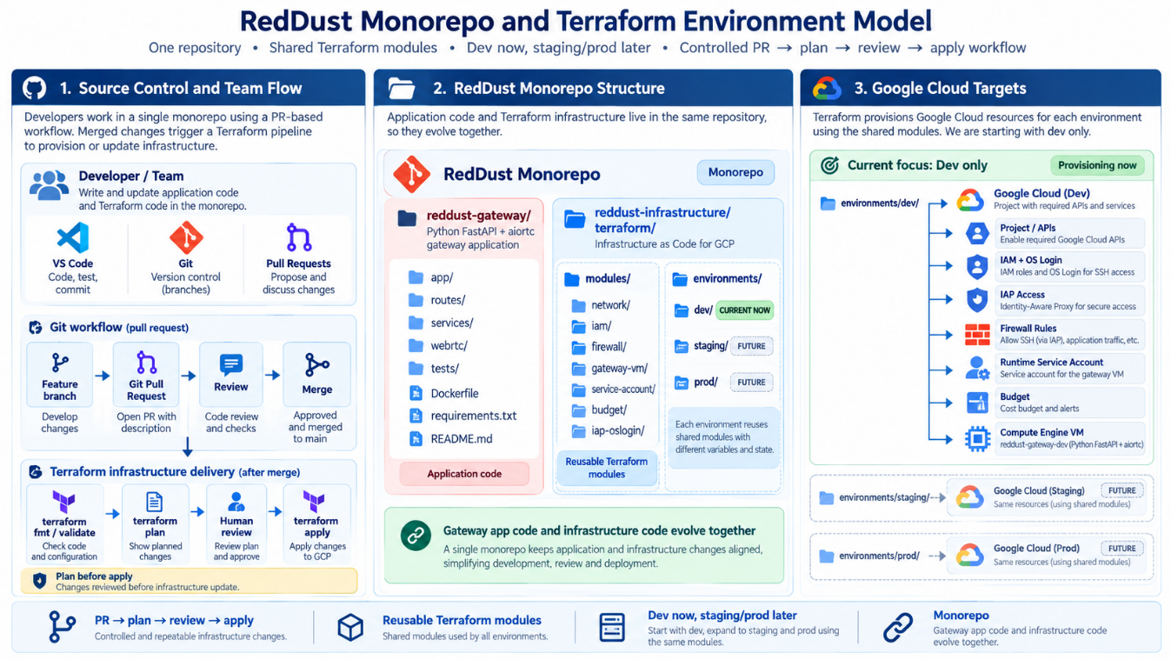

21.5 — Authenticate Terraform to Google Cloud Safely Using Application Default Credentials (ADC)
What this section does and why it matters
This section prepares the Windows Administrator workstation so Terraform can call Google Cloud APIs using the Administrator’s own Google identity. The goal is to authenticate Terraform without creating long-lived service-account JSON keys, without sharing another person’s login, and without changing any Google Cloud infrastructure yet.
New technical concepts introduced in this section (in absolute beginner terms)
Authentication answers “Who are you?” Authorization answers “What are you allowed to do?” The Google Cloud CLI (gcloud) has its own signed-in account, while Terraform normally discovers Application Default Credentials (ADC) separately. ADC is a standard local credential mechanism that Google client libraries and the Terraform Google provider can use automatically. For a detailed explanation of ADC follow this link.
Who does what
Administrator: perform the login as admin@anodiam.com and verify ADC. Owner: use owner@anodiam.com only when a later task genuinely requires Owner-only authority. Developer: authenticate with dev@anodiam.com for Developer work and never borrow the Administrator’s browser session, ADC file, access token, or Windows profile.
IMPORTANT
This section authenticates the workstation only. Do not run terraform apply, terraform import, delete cloud resources, create service-account keys, or make IAM changes while completing Section 21.5.
In plain English: the human authenticates into GCP through Google CLI, ADC securely represents that login locally, Terraform automatically uses ADC (authentication), and Google Cloud IAM decides whether each requested operation is allowed (authorization).
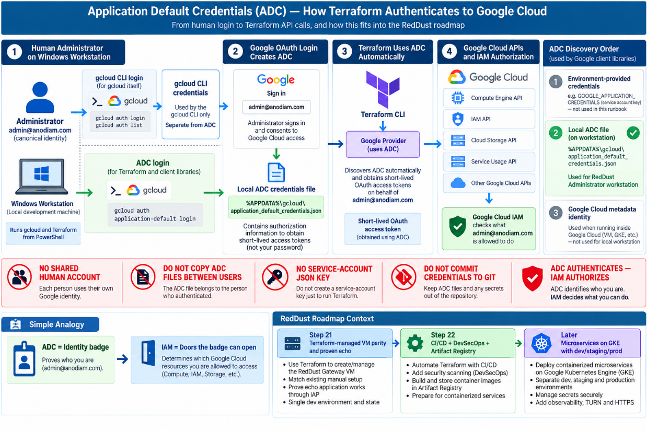

21.5.1 — Understand the Four Things That Are Easy to Confuse
What this subsection does
Build the mental model before running login commands. Most authentication mistakes happen because the active gcloud account, the selected project, ADC, and IAM permissions are treated as if they were the same thing.
Beginner concept
These four items are related but independent: the human identity signed into gcloud; the project gcloud is currently pointing at; the ADC credentials used by Terraform/client libraries; and IAM roles that authorize actions in Google Cloud.

Thing | Plain-English meaning | Example in RedDust
gcloud active account | The Google identity the gcloud CLI uses for its own commands. | admin@anodiam.com
gcloud project | The default Google Cloud project used when a command does not explicitly name one. | reddust-development
Application Default Credentials (ADC) | A separate local credential source discovered by Terraform and Google client libraries. | application_default_credentials.json in the Administrator Windows profile
IAM authorization | The roles and permissions granted to that identity in the target project/resource. | Administrator roles defined by the Step-20/21 role model

A successful Google login does not automatically mean the identity has permission to create or modify every resource. Likewise, setting the project does not grant access to that project.

21.5.2 — Verify the Google Cloud CLI before Authentication
What this subsection does
Confirm that the gcloud executable installed in Step 21.3 is visible in the current PowerShell and VS Code terminal.
Beginner concept
PATH is the list of folders Windows searches for commands. If gcloud is not found, fix the tool installation first rather than debugging authentication.

Run in a fresh PowerShell terminal
gcloud version
where.exe gcloud

SUCCESS CRITERION
Both commands must succeed. This proves only that gcloud is installed and discoverable; it does not prove that the correct account or ADC is configured.

21.5.3 — Confirm the Normal gcloud Account
What this subsection does
Check which Google identity the gcloud CLI is currently using. The role-based runbook expects infrastructure administration to be attributable to the canonical Administrator identity.
Beginner concept
A credentialed account is a Google identity for which gcloud already has login credentials. The ACTIVE marker shows which one gcloud will use by default.

Check the currently active gcloud identity
gcloud auth list

The desired role-based result for infrastructure administration is:
ACTIVE: *
ACCOUNT: admin@anodiam.com

IMPORTANT
If a named personal account or dev@anodiam.com is active, do not continue into Terraform administration merely because that account can log in. The purpose of the canonical accounts is to keep project actions role-based and auditable.

If admin@anodiam.com is already credentialed but not active, use:
gcloud config set account admin@anodiam.com

If it has not yet been authenticated on this workstation, sign in explicitly:
gcloud auth login admin@anodiam.com

Then run gcloud auth list again and verify the ACTIVE marker.

21.5.4 — Set and Verify the RedDust Development Project
What this subsection does
Point gcloud at the RedDust development project so later commands and the ADC quota project use the intended project context.
Beginner concept
The project setting is a convenience/default. It does not create the project and does not grant permissions. It simply tells gcloud which project to use when a command does not name another one.

Set and confirm the project
gcloud config set project reddust-development
gcloud config get-value project

SUCCESS CRITERION
The second command should print reddust-development.

About the environment-tag message
gcloud may print an informational message such as “[environment: untagged] Read more to tag...”. That is not an authentication failure and does not block this Step-21 workstation setup.

21.5.5 — Understand gcloud Login versus ADC Login
What this subsection does
Make the distinction explicit before creating ADC. This is the most important concept in this section.
Beginner concept
gcloud auth login authenticates the gcloud CLI. gcloud auth application-default login creates Application Default Credentials for software that asks Google for ADC, including Terraform’s Google provider. They are separate credential stores even if the same Google identity is used for both.

# gcloud CLI credentials
gcloud auth login admin@anodiam.com
# Application Default Credentials for Terraform/client libraries
gcloud auth application-default login

On Windows, a successful user ADC login normally creates:
%APPDATA%\gcloud\application_default_credentials.json

IMPORTANT
Never copy this ADC file to another developer, email it, put it in Teams/Slack/chat, attach it to a ticket, or commit it to Git. Each team member must create their own credentials under their own Windows profile and Google identity.

21.5.6 — Perform the Normal ADC Login
What this subsection does
Create the Administrator’s local ADC using the standard browser-assisted flow.
Beginner concept
OAuth is the browser-based authorization process. Google asks which account to use and which requested permissions/scopes the user consents to. The cloud-platform OAuth scope is required for the standard Google Cloud ADC flow used here.

1. Close unrelated Google sign-in tabs if that helps avoid choosing the wrong account.
2. From the same PowerShell session where the project is reddust-development, run the ADC login command.
3. When the browser opens, choose admin@anodiam.com.
4. Review and consent to the requested Google Cloud access. Do not deselect the required Google Cloud permission scopes.
5. Return to PowerShell and read the terminal result. The terminal result—not merely the browser success page—is the final indicator of whether ADC was created.
Standard ADC login command
gcloud auth application-default login

A successful terminal result should say that credentials were saved to application_default_credentials.json. It may also say that the quota project reddust-development was added to ADC.

21.5.7 — If the Browser Says “Success” but PowerShell Says “Error”
What this subsection does
Teach interns how to interpret a confusing but common OAuth outcome correctly.
Beginner concept
The browser can successfully finish its redirect page while the local gcloud process still rejects the authorization result—for example, if a required OAuth scope was not consented. The command-line process validates the final credentials it received.
IMPORTANT
If PowerShell prints an error such as “cloud-platform scope is required but not consented”, ADC is NOT ready—even if the browser page says “You are now authenticated with the gcloud CLI!”. Treat the terminal error as authoritative for this command.

Do not proceed to Terraform. Instead, use the controlled fallback in the next subsection.

21.5.8 — Use --no-launch-browser as the Preferred Fallback on Windows
What this subsection does
Complete the same ADC flow manually when automatic browser hand-off behaves incorrectly.
Beginner concept
--no-launch-browser tells gcloud to print a Google sign-in URL in the terminal. You open that URL yourself in a browser, complete sign-in/consent, then paste the verification code back into PowerShell. This is still a local human ADC login; it is not a service-account-key flow.

First clear any partial ADC attempt. If nothing was created, the command may simply say there is nothing to revoke, which is fine:
gcloud auth application-default revoke

Then start the manual-browser flow:
gcloud auth application-default login --no-launch-browser

1. Copy the entire https://accounts.google.com/... URL printed by gcloud.
2. Paste that URL into Chrome or Edge on the same workstation.
3. Select admin@anodiam.com.
4. Complete the consent prompts.
5. Copy the verification code shown by Google.
6. Return to PowerShell, paste the verification code at the prompt, and press Enter.
7. Wait for PowerShell to confirm that credentials were saved locally.
SUCCESS CRITERION
The successful terminal result should identify the ADC file location and normally confirm that reddust-development was added as the quota project.

21.5.9 — Understand Why --no-browser Is Different
What this subsection does
Prevent a specific mistake that can occur when the wrong fallback mode is chosen.
Beginner concept
--no-browser is designed for a machine that cannot use a browser locally. It prints a remote-bootstrap command that must be run on another machine that has both a browser and a compatible gcloud installation. The result from that second machine—not the bootstrap command itself—must be pasted back.

Remote-bootstrap mode (not the preferred RedDust Windows fallback)
gcloud auth application-default login --no-browser

IMPORTANT
If a prompt says “Enter the output of the above command”, do not paste the remote-bootstrap command itself. Doing so causes an error such as “The provided authorization response is invalid. Expect a url with query parameters of [state, code].” For the normal RedDust Windows workstation, prefer --no-launch-browser instead.

21.5.10 — Verify That the ADC File Exists
What this subsection does
Check the local credential file without opening or sharing it.
Beginner concept
Test-Path is a PowerShell command that returns True when the requested file exists. Existence confirms that gcloud wrote ADC, but we will also test that the credentials can actually obtain a token.

Verify the ADC file
Test-Path "$env:APPDATA\gcloud\application_default_credentials.json"

Expected result:
True

IMPORTANT
Do not open the file just to inspect its tokens, do not copy it into the RedDust repository, and do not send it to another team member.

21.5.11 — Verify ADC Can Obtain an Access Token without Displaying It
What this subsection does
Prove that ADC is operational while avoiding accidental credential disclosure.
Beginner concept
An access token is a short-lived secret that software presents to Google APIs. If ADC can obtain one, the local credential flow is functioning. The token itself must be treated like a password while it is valid.

Safe verification command
gcloud auth application-default print-access-token > $null
if ($LASTEXITCODE -eq 0) {
Write-Host "ADC access token test: SUCCESS"
}

Expected output:
ADC access token test: SUCCESS

IMPORTANT
Never paste an access token into ChatGPT, email, source code, GitHub, a ticket, a document, or a team chat. If a token is accidentally exposed, revoke the ADC credentials and log in again to create fresh credentials.

21.5.12 — Understand the ADC Quota Project
What this subsection does
Explain the “Quota project was added to ADC” success message so interns do not confuse it with changing infrastructure.
Beginner concept
A quota project tells Google which project should be used for quota and, for some APIs, related billing attribution when client libraries make requests. It does not move resources and does not mean every service will bill that project; resource-owning projects can still determine billing.

A successful login may print:
Quota project "reddust-development" was added to ADC which can be used by Google client libraries for billing and quota.

If ADC is valid but the quota project was not set and the Administrator has the required permission, it can be set explicitly:
gcloud auth application-default set-quota-project reddust-development

Do not overreact to quota-project permission errors
If setting the quota project fails because the identity lacks the required Service Usage permission, do not grant yourself broad roles merely to silence the message. Confirm the intended IAM model with the project Owner/Administrator design.

21.5.13 — Authentication Is Not the Same as IAM Authorization
What this subsection does
Stop interns from assuming “ADC works” means “Terraform may do anything”.

Beginner concept
Authentication proves identity. IAM authorization checks whether that identity has permission for a specific API action. Terraform will still receive 403/permission errors if admin@anodiam.com lacks a role required by a planned resource.

Question | Answered by | Example
Who is Terraform acting as? | ADC / Google OAuth authentication | admin@anodiam.com
Which project is the local default? | gcloud project configuration | reddust-development
May that identity create/update a VM or IAM binding? | Google Cloud IAM authorization | Depends on the roles intentionally granted
Does a working access token prove Owner-level access? | No | A token proves authentication, not unlimited authorization

IMPORTANT
Do not “fix” a permission error by adding Owner, Editor, or another broad role without reviewing the Step-20/21 access model. Least privilege still applies after authentication succeeds.

21.5.14 — Security Rules for ADC on Team Workstations
What this subsection does
Make the operational security rules explicit so the convenient local login does not become a credential-sharing mechanism.
Beginner concept
ADC is intentionally per-user and per-workstation. It is safer than long-lived service-account JSON keys for this local human workflow because credentials are created through the user’s Google login and can be revoked.

• Each person signs in with their own authorized Google identity. No shared human login.
• Administrator work uses admin@anodiam.com; Developer work uses dev@anodiam.com; Owner is reserved for Owner-only tasks.
• Never copy application_default_credentials.json between Windows profiles or computers.
• Never create a service-account JSON key merely because Terraform needs credentials.
• Never commit ADC files, OAuth files, access tokens, .env secrets, or credential exports to Git.
• Never paste access tokens into support chats, screenshots, documentation, tickets, or AI prompts.
• Lock the Windows workstation when unattended because the logged-in profile can access local credentials.
• Revoke and recreate credentials if a workstation is lost, transferred, or a token/credential is accidentally exposed.

21.5.15 — Revoke and Recreate ADC When Needed
What this subsection does
Provide a clean recovery procedure for the most common credential-security problem.
Beginner concept
Revoking ADC removes the local application-default login. It is separate from removing the normal gcloud account credential. Useful after accidental token exposure or when changing identity used by Terraform.

Remove local ADC
gcloud auth application-default revoke

Then create fresh ADC with the correct Administrator identity:
gcloud auth application-default login --no-launch-browser

Re-run the file and token tests from Sections 21.5.10 and 21.5.11.
Do not confuse the revoke commands
gcloud auth application-default revoke removes ADC. gcloud auth revoke <ACCOUNT> removes normal gcloud CLI credentials for that account. They are different operations.

21.5.16 — Recommended End-to-End Command Sequence for Admin
What this subsection does
Give interns one concise sequence to follow after understanding the concepts above.
Beginner concept
The sequence deliberately separates ordinary gcloud identity/project checks from ADC creation and verification.

# 1. Tool check
gcloud version
# 2. Normal gcloud identity
gcloud auth list
# 3. Use the canonical Administrator account if already credentialed
gcloud config set account admin@anodiam.com
# 4. Project context
gcloud config set project reddust-development
gcloud config get-value project
# 5. Create ADC
gcloud auth application-default login
# If normal browser hand-off fails, use:
# gcloud auth application-default revoke
# gcloud auth application-default login --no-launch-browser
# 6. Verify ADC file
Test-Path "$env:APPDATA\gcloud\application_default_credentials.json"
# 7. Verify token acquisition without printing the token
gcloud auth application-default print-access-token > $null
if ($LASTEXITCODE -eq 0) {
Write-Host "ADC access token test: SUCCESS"
}

IMPORTANT
Do not run terraform apply or terraform import simply because this sequence succeeds. Section 21.5 establishes credentials only.

21.5.17 — Troubleshooting Table
What this subsection does
Provide a first-response guide so interns can stop at the correct layer instead of changing unrelated Terraform or IAM settings.
Beginner concept
Authentication errors should be solved at the authentication layer. Do not modify cloud resources to fix a local browser/OAuth problem.

Symptom | What it usually means | Action
Browser says success, terminal says cloud-platform scope not consented | Browser redirect finished, but gcloud rejected the final OAuth scopes. | Treat login as failed. Revoke incomplete ADC and use --no-launch-browser; select the correct account and consent.
Application Default Credentials have not been set up, nothing to revoke | No usable ADC exists yet. | This is harmless. Continue with a fresh ADC login.
Invalid authorization response; expects state and code | Wrong text was pasted into a --no-browser remote-bootstrap prompt. | Cancel and use --no-launch-browser on the Windows workstation.
Test-Path returns False | ADC file was not written to this Windows profile. | Repeat ADC login and read the terminal result.
print-access-token fails | ADC exists incorrectly, expired/revoked, or login did not complete. | Revoke and recreate ADC.
gcloud auth list shows the wrong account | The gcloud CLI is operating as a different identity. | Set/login the canonical Administrator identity, then verify again.
Terraform later returns 403 | Identity is authenticated but lacks a required IAM permission. | Review the intended IAM role; do not grant broad roles blindly.

21.5.18 — Completion Checklist and Stop Point
What this subsection does
Define exactly what “Section 21.5 complete” means.
Beginner concept
A checklist prevents team from mistaking a partial browser login for a Terraform-ready credential setup.

Done | Acceptance condition
☐ | gcloud version succeeds in a fresh PowerShell/VS Code terminal.
☐ | gcloud auth list shows admin@anodiam.com as the intended active Administrator identity.
☐ | gcloud config get-value project returns reddust-development.
☐ | ADC login completed with no terminal error.
☐ | The ADC file exists under the current Windows user profile.
☐ | The safe access-token test prints ADC access token test: SUCCESS.
☐ | The ADC quota project is reddust-development, or any exception is intentionally documented.
☐ | No service-account JSON key was created.
☐ | No ADC file or token was copied/shared/committed.
☐ | No terraform apply, terraform import, resource deletion, or IAM broadening was performed in this section.

SUCCESS CRITERION
When every applicable checkbox is satisfied, the Administrator workstation is authenticated for later Terraform Google-provider use. Stop here. The next runbook section will handle the next infrastructure concern; this section must not silently advance into Terraform resource management.

21.5.19 — Diagram 21-G: Human Authentication to Terraform
What this subsection does
Retain the authentication architecture visual used by the Step-21 runbook.
Beginner concept
The diagram should make the identity boundary visually obvious: canonical human identity → local ADC → Terraform Google provider → Google Cloud APIs. It must also show what is deliberately absent: shared accounts and JSON keys.

DIAGRAM PLACEHOLDER — 21-G: Human Authentication to Terraform
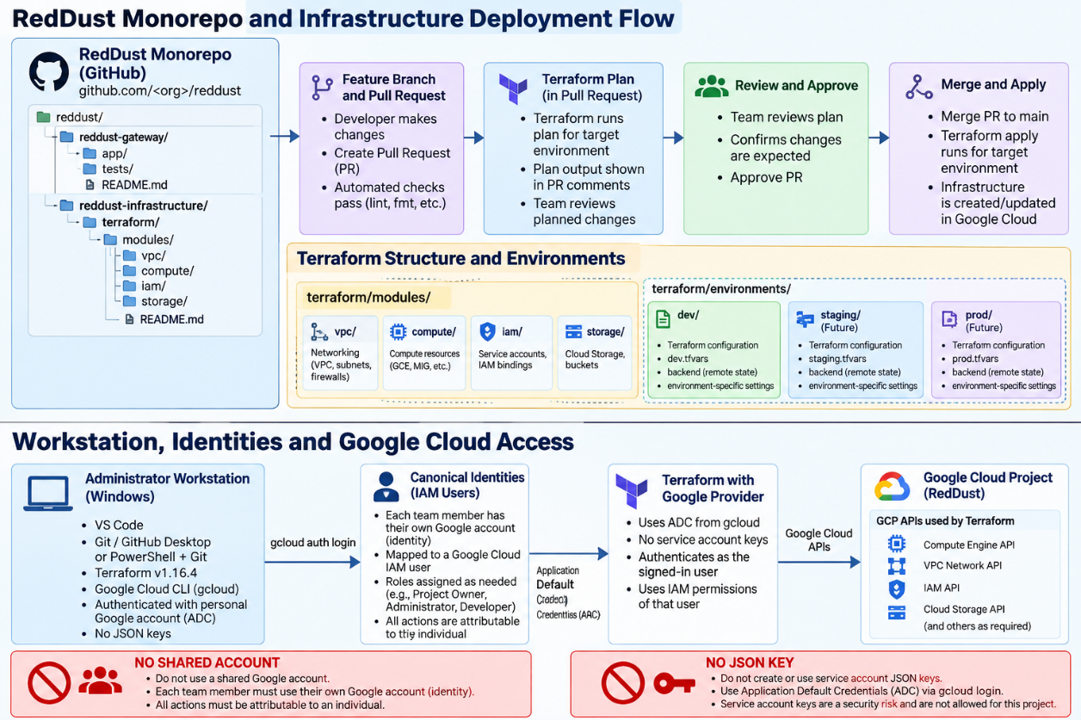

21.5.20 — Authoritative Reference Links
What this subsection does
Give interns the official source pages to consult if gcloud behavior changes.
Beginner concept
Command-line authentication screens and flags can evolve. The stable architectural rule remains: authenticate the intended human identity, use ADC for local Terraform/client-library access, and avoid long-lived service-account keys.

• GCP — How ADC work: https://cloud.google.com/docs/authentication/application-default-credentials
• gcloud CLI reference — application-default login: https://cloud.google.com/sdk/gcloud/reference/auth/application-default/login
• gcloud CLI reference — application-default revoke: https://cloud.google.com/sdk/gcloud/reference/auth/application-default/revoke
• GCP — Authenticate local dev: https://cloud.google.com/docs/authentication/provide-credentials-adc

21.6 — Bootstrap a Protected Remote Terraform State in Google Cloud Storage
What this section does and why it matters
Create a shared protected backend so state is not trapped on one laptop.
New technical concepts in absolute beginner terms
The backend stores Terraform state. GCS versioning provides recovery generations. The state bucket needs a one-time bootstrap because it cannot be its own backend before it exists.
Who does what
Administrator creates the bucket. Owner retains recovery authority. Developer does not need state access unless necessary.

• Use a globally unique bucket name.
• Use Sydney regional storage for this dev runbook.
• Enable uniform bucket-level access and versioning.
• Protect the bucket from accidental destroy.
• Never commit terraform.tfstate to Git.
Reference command/configuration
resource "google_storage_bucket" "terraform_state" {
name = "reddust-development-tfstate-CHANGE-ME-UNIQUE"
project = "reddust-development"
location = "AUSTRALIA-SOUTHEAST1"
uniform_bucket_level_access = true
versioning { enabled = true }
lifecycle { prevent_destroy = true }
}

DIAGRAM PLACEHOLDER — 21-H: Terraform State Architecture
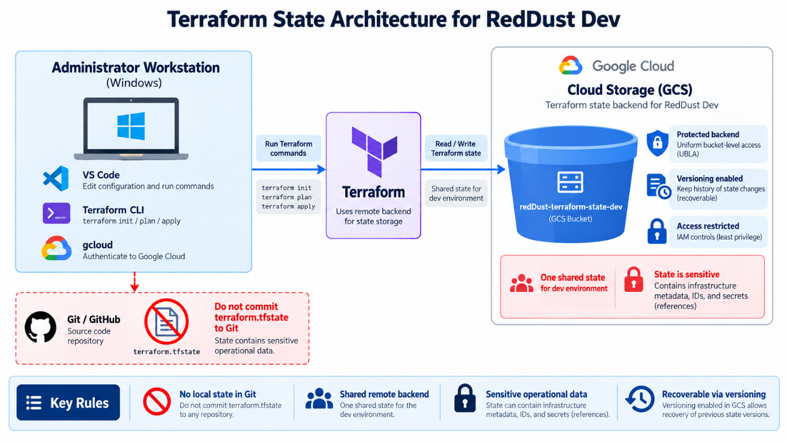

21.7 — Create Versions, Provider, Variables, Locals and Backend Files
What this section does and why it matters
Create the root configuration every other resource depends on.
New technical concepts in absolute beginner terms
Providers are plugins; variables are inputs; locals are internal named values; outputs expose useful results; the lock file pins actual provider selections.
Who does what
Administrator authors the foundation. Owner reviews canonical identities. Developer confirms application-facing values.

• Pin Terraform 1.x and a reviewed Google provider series.
• Keep project, region, zone and UDP range as variables.
• Keep owner/admin/dev identities in locals.
• Use terraform.tfvars.example, not a real secret-filled committed tfvars.
Reference command/configuration
terraform {
required_version = ">= 1.6.0, < 2.0.0"
required_providers {
google = { source = "hashicorp/google", version = "~> 8.2" }
}
}
provider "google" {
project = var.project_id
region = var.region
zone = var.zone
}

DIAGRAM PLACEHOLDER — 21-I: Terraform Configuration Layers
RESERVED SPACE FOR FUTURE ARCHITECTURE / ONBOARDING DIAGRAM
Diagram decision: NEW DIAGRAM REQUIRED.
Future ChatGPT image-generation prompt
Show versions/provider, variables/tfvars, locals, resource files, outputs and GCS backend as connected layers.

21.8 — Codify Required Google Cloud APIs
What this section does and why it matters
Make service enablement explicit instead of relying on console history.

New technical concepts in absolute beginner terms
Most GCP products expose APIs that must be enabled. google_project_service can represent that requirement.

Who does what
Administrator manages the list. Owner understands core APIs are not casually disabled on destroy.

• Compute Engine, IAM, IAP, OS Login, Service Usage, Storage and Billing Budget APIs are candidates.
• Use disable_on_destroy=false for core project APIs in this development project.
• Reconcile already-enabled APIs before apply.
Reference command/configuration
resource "google_project_service" "required" {
for_each = local.required_apis
project = var.project_id
service = each.value
disable_on_destroy = false
}

DIAGRAM PLACEHOLDER — 21-J: API Enablement Dependency Graph
RESERVED SPACE FOR FUTURE ARCHITECTURE / ONBOARDING DIAGRAM
Diagram decision: NEW DIAGRAM REQUIRED.
Future ChatGPT image-generation prompt
Show Service Usage at foundation and Compute/IAM/IAP/OS Login/Storage/Billing APIs above it, with resource dependencies.

21.9 — Codify OS Login and Human Role-Based IAM
What this section does and why it matters
Move the Step-20 canonical Owner/Admin/Developer model into reviewable Terraform without broadening access.

New technical concepts in absolute beginner terms
IAM member resources add one member to one role without replacing unrelated members. Project scope and VM scope are intentionally different.

Who does what
Owner remains ultimate authority. Administrator receives the project admin baseline. Developer receives Compute Viewer at project level and OS Admin only on the Gateway VM.

• Manage enable-oslogin as a single project metadata item.
• Use google_project_iam_member for Administrator roles.
• Use google_project_iam_member for Developer Compute Viewer.
• Use google_compute_instance_iam_member for Developer OS Admin Login.
• Use instance-scoped IAP IAM for Developer tunnel access.
Reference command/configuration
resource "google_compute_project_metadata_item" "os_login" {
project = var.project_id
key = "enable-oslogin"
value = "TRUE"
}
resource "google_project_iam_member" "developer_compute_viewer" {
project = var.project_id
role = "roles/compute.viewer"
member = "user:${local.dev_email}"
}

DIAGRAM PLACEHOLDER — 21-K: Terraform-Managed Human Access Model
RESERVED SPACE FOR FUTURE ARCHITECTURE / ONBOARDING DIAGRAM
Diagram decision: NEW DIAGRAM REQUIRED.
Future ChatGPT image-generation prompt
Four layers: canonical Google identities → project IAM → IAP + OS Login → individual Linux users. Developer project viewer + VM-only sudo; Administrator project roles.

21.10 — Codify the Gateway Runtime Service Account and actAs Boundary
What this section does and why it matters
Represent the non-human workload identity separately from human access.

New technical concepts in absolute beginner terms
A service account is a workload identity. Service Account User provides iam.serviceAccounts.actAs; the runtime account’s own API roles are separate.

Who does what
Administrator manages the service account. Developer gets actAs only on this service account. Owner prevents broad runtime roles.

• Create/import reddust-gateway-dev-runtime.
• Attach it to reddust-gateway-dev.
• Grant Developer roles/iam.serviceAccountUser only on this service account.
• Do not create service-account JSON keys.
• Do not grant Owner/Editor/Compute Admin to the runtime account.
Reference command/configuration
resource "google_service_account" "gateway_runtime" {
project = var.project_id
account_id = "reddust-gateway-dev-runtime"
display_name = "RedDust Gateway Dev Runtime"
}
resource "google_service_account_iam_member" "developer_act_as" {
service_account_id = google_service_account.gateway_runtime.name
role = "roles/iam.serviceAccountUser"
member = "user:${local.dev_email}"
}

DIAGRAM PLACEHOLDER — 21-L: Human Identity versus Workload Identity
RESERVED SPACE FOR FUTURE ARCHITECTURE / ONBOARDING DIAGRAM
Diagram decision: NEW DIAGRAM REQUIRED.
Future ChatGPT image-generation prompt
Show humans through IAM/IAP/OS Login to VM; separate attached runtime service account to future Secret Manager/Logging/PubSub/Storage; no JSON keys.

21.11 — Codify Networking without Redesigning the Step-20 Architecture
What this section does and why it matters
Reference the existing default VPC while Terraform owns only the dedicated Gateway resources.

New technical concepts in absolute beginner terms
A data source reads an existing object without claiming lifecycle ownership. This is safer during brownfield parity migration.

Who does what
Administrator references default VPC/subnet. Owner approves any later dedicated-VPC redesign separately.

• Use data google_compute_network for default.
• Use a Sydney subnetwork data source.
• Do not import the entire default VPC just to achieve theoretical completeness.
• Keep the reddust-gateway network tag.
Reference command/configuration
data "google_compute_network" "default" {
project = var.project_id
name = "default"
}

DIAGRAM PLACEHOLDER — 21-M: Reference Existing vs Manage
RESERVED SPACE FOR FUTURE ARCHITECTURE / ONBOARDING DIAGRAM
Diagram decision: NEW DIAGRAM REQUIRED.
Future ChatGPT image-generation prompt
Show default VPC as data/reference while VM and dedicated firewall rules are managed Terraform resources.

21.12 — Codify IAP-Only SSH Firewall Access
What this section does and why it matters
Reproduce the Step-20 SSH security model: no public 0.0.0.0/0 SSH.

New technical concepts in absolute beginner terms
35.235.240.0/20 is Google’s IAP TCP-forwarding source range. Firewall, IAP IAM and OS Login are independent gates.

Who does what
Administrator owns the rule. Developer uses IAP. Owner verifies no parallel public-SSH rule remains.

• Rule name allow-iap-ssh.
• Ingress TCP 22 only.
• Source 35.235.240.0/20.
• Target only reddust-gateway tag.
• Still require IAP IAM and OS Login IAM.
Reference command/configuration
resource "google_compute_firewall" "iap_ssh" {
name = "allow-iap-ssh"
network = data.google_compute_network.default.name
source_ranges = ["35.235.240.0/20"]
target_tags = [local.gateway_network_tag]
allow { protocol = "tcp"; ports = ["22"] }
}

DIAGRAM PLACEHOLDER — 21-N: IAP SSH Three-Gate Model
RESERVED SPACE FOR FUTURE ARCHITECTURE / ONBOARDING DIAGRAM
Diagram decision: NEW DIAGRAM REQUIRED.
Future ChatGPT image-generation prompt
Developer identity → IAP IAM → IAP CIDR firewall TCP22 → OS Login → dev_anodiam_com → sudo; annotate Terraform resources.

21.13 — Codify Temporary TCP 8000 Signalling
What this section does and why it matters
Reproduce the temporary public signalling path required by the echo proof.

New technical concepts in absolute beginner terms
Signalling carries SDP offer/answer over HTTP and is separate from WebRTC media.

Who does what
Administrator manages firewall. Developer verifies Uvicorn/FastAPI and /healthz. Owner treats public 8000 as temporary dev exposure.

• Rule name allow-reddust-signaling-dev.
• Ingress TCP 8000.
• Target reddust-gateway tag.
• Keep a visible TODO for HTTPS/443 later.
• HTTP success never proves UDP media success.
Reference command/configuration
resource "google_compute_firewall" "gateway_signalling" {
name = "allow-reddust-signaling-dev"
network = data.google_compute_network.default.name
source_ranges = ["0.0.0.0/0"]
target_tags = [local.gateway_network_tag]
allow { protocol = "tcp"; ports = ["8000"] }
}

DIAGRAM PLACEHOLDER — 21-O: Temporary Signalling Path
RESERVED SPACE FOR FUTURE ARCHITECTURE / ONBOARDING DIAGRAM
Diagram decision: NEW DIAGRAM REQUIRED.
Future ChatGPT image-generation prompt
Phone → Internet → VM public IP → TCP8000 firewall → FastAPI /healthz and /offer; dashed future HTTPS/443; label signalling ≠ media.

21.14 — Codify the WebRTC UDP Media Firewall Rule
What this section does and why it matters
Convert the verified Step-20 UDP range into an explicit Terraform input and firewall rule.

New technical concepts in absolute beginner terms
WebRTC ICE discovers connectivity; DTLS/SRTP protects media. The media port range is distinct from HTTP signalling.

Who does what
Administrator sets the recorded range. Developer verifies ICE/audio. Owner accepts broad dev source range only as temporary parity.

• Read /proc/sys/net/ipv4/ip_local_port_range from the existing VM.
• Set webrtc_udp_port_range in local dev tfvars.
• Validate start-end syntax.
• Rule name allow-reddust-webrtc-udp.
• Revisit source/range design when TURN is introduced.
Reference command/configuration
resource "google_compute_firewall" "gateway_webrtc_udp" {
name = "allow-reddust-webrtc-udp"
network = data.google_compute_network.default.name
source_ranges = ["0.0.0.0/0"]
target_tags = [local.gateway_network_tag]
allow { protocol = "udp"; ports = [var.webrtc_udp_port_range] }
}

DIAGRAM PLACEHOLDER — 21-P: Signalling versus Media
RESERVED SPACE FOR FUTURE ARCHITECTURE / ONBOARDING DIAGRAM
Diagram decision: NEW DIAGRAM REQUIRED.
Future ChatGPT image-generation prompt
Two paths: TCP8000 SDP signalling and UDP ICE/DTLS/SRTP media through aiortc/EchoAudioTrack; each paired with its Terraform firewall.

21.15 — Codify the Compute Engine Gateway VM
What this section does and why it matters
Describe the existing VM as a managed resource while preventing accidental deletion.

New technical concepts in absolute beginner terms
Some Terraform argument changes update in place; others force replacement. lifecycle.prevent_destroy blocks accidental destroy but is not a backup.

Who does what
Administrator imports/manages VM. Developer reviews startup/application settings. Owner must approve intentional replacement.

• Name reddust-gateway-dev.
• Zone australia-southeast1-b.
• e2-medium, Ubuntu 24.04, 10 GB pd-standard.
• Attach runtime service account with cloud-platform scope and IAM least privilege.
• Ephemeral external IPv4 for Step-21 parity.
• Add prevent_destroy during migration.
Reference command/configuration
resource "google_compute_instance" "gateway" {
name = local.vm_name
zone = var.zone
machine_type = "e2-medium"
tags = [local.gateway_network_tag]
lifecycle { prevent_destroy = true }
}

DIAGRAM PLACEHOLDER — 21-Q: Compute Instance Anatomy
RESERVED SPACE FOR FUTURE ARCHITECTURE / ONBOARDING DIAGRAM
Diagram decision: NEW DIAGRAM REQUIRED.
Future ChatGPT image-generation prompt
Exploded VM: machine, Ubuntu disk, default Sydney subnet, ephemeral public IP, network tag, runtime SA, OS Login metadata, startup script, prevent_destroy.

21.16 — Bootstrap Ubuntu, Python 3.12.10 and the Shared RedDust Runtime
What this section does and why it matters
Convert manual Step-20 Linux setup into an idempotent startup script for reproducibility.

New technical concepts in absolute beginner terms
Idempotent means repeated execution converges to the same result. pyenv installs Python 3.12.10 separately from Ubuntu’s system Python.

Who does what
Administrator owns OS/bootstrap mechanics. Developer validates Python/packages. Owner reviews privilege/security changes only.

• Install build/media prerequisites.
• Create non-human service user reddust with nologin shell.
• Install pyenv under /opt/reddust/runtime/pyenv.
• Build exact Python 3.12.10.
• Create exactly one shared .venv under /opt/reddust/reddust-gateway.
• Never copy a Windows .venv.
Reference command/configuration
#!/usr/bin/env bash
set -euo pipefail
apt-get update
apt-get install -y build-essential git curl ffmpeg libssl-dev zlib1g-dev libffi-dev
id -u reddust >/dev/null 2>&1 || useradd --system --create-home --home-dir /opt/reddust --shell /usr/sbin/nologin reddust
mkdir -p /opt/reddust/runtime /opt/reddust/reddust-gateway
chown -R reddust:reddust /opt/reddust

DIAGRAM PLACEHOLDER — 21-R: Terraform Startup Bootstrap Sequence
RESERVED SPACE FOR FUTURE ARCHITECTURE / ONBOARDING DIAGRAM
Diagram decision: NEW DIAGRAM REQUIRED.
Future ChatGPT image-generation prompt
Terraform metadata → Ubuntu boot → apt → pyenv Python 3.12.10 → GitHub → shared .venv → pip → systemd → health.

21.17 — Retrieve the Gateway Source from GitHub Reproducibly
What this section does and why it matters
Replace the Step-20 ZIP upload with a repeatable Git checkout from the RedDust repository.

New technical concepts in absolute beginner terms
A Git ref can be a branch, tag or commit. A commit SHA is immutable and therefore best for a reproducible infrastructure rebuild.

Who does what
Developer identifies the known-good commit. Administrator passes it as gateway_git_ref. Owner does not manage application commits.

• Repository: https://github.com/anodiamadmin/RedDust.
• Gateway path: reddust-gateway.
• Prefer a tested commit SHA rather than moving main during migration.
• Exclude .venv, __pycache__, .git and secret files from the runtime copy.
• Future CI/CD should replace Terraform/startup-script application release delivery.
Reference command/configuration
REPO_DIR=/opt/reddust/source/RedDust
git clone https://github.com/anodiamadmin/RedDust.git "$REPO_DIR"
cd "$REPO_DIR"
git checkout "$GATEWAY_GIT_REF"
rsync -a --delete --exclude .venv --exclude __pycache__ reddust-gateway/ /opt/reddust/reddust-gateway/

DIAGRAM PLACEHOLDER — 21-S: GitHub Source to Runtime
RESERVED SPACE FOR FUTURE ARCHITECTURE / ONBOARDING DIAGRAM
Diagram decision: NEW DIAGRAM REQUIRED.
Future ChatGPT image-generation prompt
GitHub RedDust pinned commit → clone → reddust-gateway folder → /opt/reddust/reddust-gateway → shared .venv → systemd. Cross out ZIP and Windows .venv.

21.18 — Create the systemd Gateway Service through Terraform Bootstrap
What this section does and why it matters
Ensure Gateway runs independently of a human SSH session.

New technical concepts in absolute beginner terms
systemd starts, restarts and logs background services. WorkingDirectory and the ASGI import path must match the repository layout.

Who does what
Developer confirms app.main:app versus main:app. Administrator codifies the unit. Owner ensures service runs as reddust, not a human.

• Install requirements.txt into the shared Linux .venv.
• Run Uvicorn on 0.0.0.0:8000.
• Run as User=reddust and Group=reddust.
• Enable restart and boot activation.
• Validate journalctl output after bootstrap.
Reference command/configuration
[Service]
User=reddust
Group=reddust
WorkingDirectory=/opt/reddust/reddust-gateway
ExecStart=/opt/reddust/reddust-gateway/.venv/bin/python -m uvicorn app.main:app --host 0.0.0.0 --port 8000
Restart=always

DIAGRAM PLACEHOLDER — 21-T: Linux Runtime Ownership Model
RESERVED SPACE FOR FUTURE ARCHITECTURE / ONBOARDING DIAGRAM
Diagram decision: NEW DIAGRAM REQUIRED.
Future ChatGPT image-generation prompt
Canonical OS Login humans separate from service user reddust; /opt/reddust owned by reddust; one .venv; systemd/Uvicorn/FastAPI/aiortc.

21.19 — Codify Cost Visibility and Budget Alerts
What this section does and why it matters
Represent the Step-20 budget intent in Terraform where billing permissions allow it.

New technical concepts in absolute beginner terms
Billing budgets notify; they do not shut down Compute Engine. Budget API permissions live at billing-account scope.

Who does what
Owner controls billing authority and budget amount. Administrator manages Terraform if authorized. Developer gets no billing admin.

• Filter the budget to reddust-development.
• Keep actual thresholds 25/50/75/90/100% and a forecast threshold if supported.
• Exclude credits when the goal is to see gross architecture cost.
• If billing IAM is intentionally separate, document the budget as an explicit non-Terraform exception rather than over-granting.
Reference command/configuration
resource "google_billing_budget" "dev" {
billing_account = var.billing_account_id
display_name = "RedDust Development Monthly Budget"
# project filter, amount and threshold_rules here
}

DIAGRAM PLACEHOLDER — 21-U: Cost Visibility
RESERVED SPACE FOR FUTURE ARCHITECTURE / ONBOARDING DIAGRAM
Diagram decision: NEW DIAGRAM REQUIRED.
Future ChatGPT image-generation prompt
Billing account → project-filtered budget → alerts; separately show operational VM stop discipline. Banner: budget alert is not automatic shutdown.

21.20 — Adopt Existing Step-20 Resources into Terraform State
What this section does and why it matters
Import existing service account, VM, firewall and selected IAM/metadata rather than creating duplicates.

New technical concepts in absolute beginner terms
Import only creates the state mapping. The following plan reveals whether code matches reality.

Who does what
Administrator imports one resource at a time. Owner watches VM/IAM adoption. Developer confirms health remains unchanged.

• Run init/validate first but do not apply duplicate resource blocks.
• Import reddust-gateway-dev-runtime.
• Import reddust-gateway-dev.
• Import allow-iap-ssh, allow-reddust-signaling-dev and allow-reddust-webrtc-udp.
• Import metadata/IAM only with exact provider-documented IDs.
• Plan immediately after each major group.
Reference command/configuration
terraform import google_compute_instance.gateway projects/reddust-development/zones/australia-southeast1-b/instances/reddust-gateway-dev
terraform import google_compute_firewall.iap_ssh projects/reddust-development/global/firewalls/allow-iap-ssh
terraform import google_compute_firewall.gateway_signalling projects/reddust-development/global/firewalls/allow-reddust-signaling-dev
terraform import google_compute_firewall.gateway_webrtc_udp projects/reddust-development/global/firewalls/allow-reddust-webrtc-udp

DIAGRAM PLACEHOLDER — 21-V: Terraform Import Does Not Recreate
RESERVED SPACE FOR FUTURE ARCHITECTURE / ONBOARDING DIAGRAM
Diagram decision: NEW DIAGRAM REQUIRED.
Future ChatGPT image-generation prompt
Existing GCP object + empty state; import draws a mapping line to Terraform address; then plan compares .tf and reality. No delete/recreate arrow.

21.21 — Reconcile Configuration until terraform plan is a Safe No-Op
What this section does and why it matters
Make Terraform accurately describe the imported environment before allowing it to change anything.

New technical concepts in absolute beginner terms
Drift is a difference between desired configuration and real attributes. Replacement is much riskier than in-place update.

Who does what
Administrator explains every diff. Owner reviews IAM/destroy/replace. Developer reviews network/bootstrap/app-facing changes.

• No changes is the preferred migration checkpoint.
• A create action must be for a genuinely new resource.
• An update must have an understood field and impact.
• A VM replacement is a STOP condition during parity migration.
• Do not use ignore_changes simply to silence unexplained drift.
Reference command/configuration
terraform plan -out=step21-reconcile.tfplan
terraform show step21-reconcile.tfplan

DIAGRAM PLACEHOLDER — 21-W: Plan Review Decision Tree
RESERVED SPACE FOR FUTURE ARCHITECTURE / ONBOARDING DIAGRAM
Diagram decision: NEW DIAGRAM REQUIRED.
Future ChatGPT image-generation prompt
Branch on no-change, create, update, replace, destroy. Big STOP on replace/destroy, investigation loop, ending at safe no-op baseline.

21.22 — Perform the First Controlled Terraform Apply
What this section does and why it matters
Prove Terraform control with one understood, low-risk change after no-op reconciliation.

New technical concepts in absolute beginner terms
A saved plan ensures the exact reviewed proposal is the one applied.

Who does what
Administrator applies. Owner approves sensitive/high-impact plan. Developer performs immediate functional verification.

• Choose a reversible low-risk in-place change.
• Run fmt and validate.
• Save plan to a local .tfplan file.
• Review terraform show output.
• Apply the saved plan.
• Run a second plan and expect no unintended changes.
Reference command/configuration
terraform fmt -recursive
terraform validate
terraform plan -out=approved.tfplan
terraform show approved.tfplan
terraform apply approved.tfplan
terraform plan

DIAGRAM PLACEHOLDER — 21-X: Safe Terraform Apply Workflow
RESERVED SPACE FOR FUTURE ARCHITECTURE / ONBOARDING DIAGRAM
Diagram decision: NEW DIAGRAM REQUIRED.
Future ChatGPT image-generation prompt
Edit → fmt → validate → plan -out → review/approval → apply saved plan → no-op plan → app tests → evidence.

21.23 — Validate IAM, IAP, OS Login and Linux Identity after Terraform
What this section does and why it matters
Prove that infrastructure code preserved the Step-20 security model.

New technical concepts in absolute beginner terms
IAP, OS Login and sudo are different authorization layers. Successful Terraform apply does not automatically validate them.

Who does what
Developer tests dev path. Administrator tests admin path. Owner verifies Developer still lacks broad cloud roles.

• dev@anodiam.com should SSH through IAP and become dev_anodiam_com.
• admin@anodiam.com should become admin_anodiam_com.
• sudo whoami should return root for intended VM administrators.
• Developer must remain without Owner, Editor, Compute Admin and Project IAM Admin at project scope.
Reference command/configuration
gcloud compute ssh reddust-gateway-dev --zone=australia-southeast1-b --tunnel-through-iap
whoami
hostname
sudo whoami

DIAGRAM PLACEHOLDER — 21-Y: Post-Terraform Access Matrix
RESERVED SPACE FOR FUTURE ARCHITECTURE / ONBOARDING DIAGRAM
Diagram decision: NEW DIAGRAM REQUIRED.
Future ChatGPT image-generation prompt
Rows project visibility, VM list, IAP, OS Login, sudo, project IAM modify, VM create/delete; columns Owner/Admin/Developer with intended allow/deny.

21.24 — Validate the Gateway Runtime and /healthz
What this section does and why it matters
Prove Linux bootstrap and FastAPI health before debugging WebRTC.

New technical concepts in absolute beginner terms
Terraform can finish VM creation before a startup script finishes. journalctl shows bootstrap/systemd evidence.

Who does what
Developer checks Python/service/health. Administrator checks startup logs and outputs. Owner joins only for infrastructure policy issues.

• Check google-startup-scripts journal.
• Check reddust-gateway.service.
• Verify exact Python 3.12.10.
• Verify .venv executable/prefix/base prefix.
• Test localhost /healthz before the public URL.
• Use terraform output for current public endpoint.
Reference command/configuration
sudo journalctl -u google-startup-scripts.service -n 200 --no-pager
sudo systemctl status reddust-gateway --no-pager
/opt/reddust/reddust-gateway/.venv/bin/python --version
curl http://127.0.0.1:8000/healthz

DIAGRAM PLACEHOLDER — 21-Z: Validate from Inside Out
RESERVED SPACE FOR FUTURE ARCHITECTURE / ONBOARDING DIAGRAM
Diagram decision: NEW DIAGRAM REQUIRED.
Future ChatGPT image-generation prompt
Python/venv → systemd/Uvicorn → localhost health → firewall/public health → /offer → ICE/media; fix lowest failing layer first.

21.25 — Re-run the Wi-Fi and 4G/5G WebRTC Echo Tests
What this section does and why it matters
Make the original end-to-end telephony echo the Step-21 functional acceptance gate.

New technical concepts in absolute beginner terms
Signalling, SDP, ICE and actual audio are four independent gates. STUN assists direct connectivity; TURN remains a future reliability layer.

Who does what
Developer runs phone tests and captures logs. Administrator watches Gateway/network logs. Owner receives final pass/fail evidence.

• Read gateway_external_ip from Terraform output.
• Run Wi-Fi test first.
• Confirm /offer and SDP answer.
• Confirm ICE connected/completed.
• Confirm audible EchoAudioTrack return.
• Disable Wi-Fi and repeat on 4G/5G.
• Record failures by layer rather than only “call failed”.
Reference command/configuration
terraform output -raw gateway_external_ip
# mobile dev endpoint:
# http://CURRENT_IP:8000

DIAGRAM PLACEHOLDER — 21-AA: Terraform-Provisioned Echo Acceptance
RESERVED SPACE FOR FUTURE ARCHITECTURE / ONBOARDING DIAGRAM
Diagram decision: NEW DIAGRAM REQUIRED.
Future ChatGPT image-generation prompt
Phone Wi-Fi then 4G/5G → TCP signalling and separate UDP WebRTC path → Terraform-managed GCP VM → FastAPI/aiortc/EchoAudioTrack. Mark four gates.

21.26 — Establish the Day-to-Day Terraform Change Workflow
What this section does and why it matters
Turn the one-time migration into a repeatable engineering process.

New technical concepts in absolute beginner terms
Infrastructure pull requests should include code review and a reviewed plan, just like application changes include tests.

Who does what
Administrator authors/applies. Developer reviews app-facing effects. Owner reviews IAM/billing/destructive changes.

• Create a branch per infrastructure change.
• terraform fmt -check and validate locally.
• Generate a plan and summarize relevant changes in PR.
• Do not commit binary plan files or sensitive state.
• Apply only approved changes.
• Re-plan after apply and run relevant runtime/WebRTC tests.
Reference command/configuration
terraform fmt -recursive -check
terraform validate
terraform plan -out=review.tfplan
terraform show review.tfplan

DIAGRAM PLACEHOLDER — 21-AB: Git Pull Request to Apply
RESERVED SPACE FOR FUTURE ARCHITECTURE / ONBOARDING DIAGRAM
Diagram decision: NEW DIAGRAM REQUIRED.
Future ChatGPT image-generation prompt
Git branch → fmt/validate → plan → PR → Developer review → Owner gate for sensitive changes → Admin apply → no-op plan → functional validation.

21.27 — Handle VM Stop/Start, Drift and Emergency Console Changes
What this section does and why it matters
Preserve Step-20 cost discipline while keeping Terraform as infrastructure source of truth.

New technical concepts in absolute beginner terms
Stopping a VM is an operational action. Drift is a managed attribute changed outside Terraform. Break-glass is an emergency manual path followed by reconciliation.

Who does what
Authorized Admin/Developer may stop dev VM according to policy. Administrator reconciles drift. Owner approves emergency policy exceptions.

• Stop e2-medium when active testing ends.
• Use gcloud stop/start for operations rather than rewriting infrastructure each time.
• Run terraform plan before infrastructure work to discover drift.
• If emergency console changes are required, record them and immediately back-port the approved final state to Terraform.
Reference command/configuration
gcloud compute instances stop reddust-gateway-dev --zone=australia-southeast1-b
gcloud compute instances start reddust-gateway-dev --zone=australia-southeast1-b
terraform plan

DIAGRAM PLACEHOLDER — 21-AC: Drift and Break-Glass Loop
RESERVED SPACE FOR FUTURE ARCHITECTURE / ONBOARDING DIAGRAM
Diagram decision: NEW DIAGRAM REQUIRED.
Future ChatGPT image-generation prompt
Normal code=state=GCP; emergency console change creates drift; plan detects; keep→code it, reject→Terraform restores; return to no-op.

21.28 — Security and DevSecOps Guardrails for Terraform
What this section does and why it matters
Make security part of the IaC workflow rather than assuming repeatable means secure.

New technical concepts in absolute beginner terms
Sensitive variables can still end up in state. Static analysis checks code before apply. Policy-as-code can enforce rules automatically later.

Who does what
Owner defines guardrails. Administrator implements them. Developer participates in review and cannot bypass for convenience.

• No service-account JSON keys.
• No OAuth/ADC files, .env secrets or private SSH keys in Git.
• Protect remote state IAM.
• Prefer additive IAM member resources during brownfield migration.
• Pin providers and commit .terraform.lock.hcl.
• Future CI should run formatting, validation, IaC security scans and protected plan/apply.
DIAGRAM PLACEHOLDER — 21-AD: Terraform DevSecOps Guardrails
RESERVED SPACE FOR FUTURE ARCHITECTURE / ONBOARDING DIAGRAM
Diagram decision: NEW DIAGRAM REQUIRED.
Future ChatGPT image-generation prompt
Shield layers: branch protection, code review, fmt/validate, IaC scanning, plan review, approval, least-privilege apply, protected state, post-apply tests. Red exclusions: secrets, JSON keys, public SSH, unreviewed destroy.

21.29 — Troubleshooting Decision Tables
What this section does and why it matters
Separate Terraform/tooling problems from GCP runtime and WebRTC problems.

New technical concepts in absolute beginner terms
Layered diagnosis fixes the lowest failing layer before changing higher layers.

Who does what
Administrator leads Terraform/GCP issues. Developer leads app/WebRTC issues. Owner joins for organization/billing/high IAM authority.

• If terraform is not recognized, fix PATH before anything else.
• 403 during plan usually means wrong ADC or missing IAM.
• Already-exists errors during create usually mean import is missing.
• VM must-be-replaced is a STOP during parity migration.
• VM exists but health fails: inspect startup/systemd.
• Health works but ICE fails: inspect STUN/UDP/firewall, not Terraform state first.
DIAGRAM PLACEHOLDER — 21-AE: Troubleshooting Layer Stack
RESERVED SPACE FOR FUTURE ARCHITECTURE / ONBOARDING DIAGRAM
Diagram decision: NEW DIAGRAM REQUIRED.
Future ChatGPT image-generation prompt
Stack: local tool/auth/backend → provider/APIs → state/import/plan → GCP IAM/network/VM → bootstrap/systemd → health/signalling → ICE/STUN/UDP → audio.

21.30 — Step-21 Completion Checklist
What this section does and why it matters
Define done using infrastructure, security and functional evidence.

New technical concepts in absolute beginner terms
Acceptance criteria prevent a false success where Terraform exists but state is unsafe or the echo path is broken.

Who does what
Administrator owns IaC items; Developer owns functional test items; Owner signs off on IAM/state/billing governance.

Done | Acceptance condition
☐ | Canonical Owner/Admin/Developer identities are used throughout IaC.
☐ | Terraform code is stored in Git under reddust-infrastructure/terraform.
☐ | Remote versioned GCS state is protected and terraform.tfstate is not committed.
☐ | Provider versions are constrained and lock file is committed.
☐ | OS Login remains enabled.
☐ | Administrator has intended project roles and is not made Owner by this runbook.
☐ | Developer has project Compute Viewer, VM-specific OS Admin and VM-specific IAP access only.
☐ | Runtime service account is attached and Developer actAs is scoped to it only.
☐ | No service-account JSON key exists.
☐ | Default VPC is referenced rather than accidentally re-owned.
☐ | The three Step-20 firewall rules are represented/imported safely.
☐ | UDP range matches the value recorded from the Step-20 VM.
☐ | Gateway VM is imported and plan does not propose unintended replacement/destruction.
☐ | Python 3.12.10 and one shared Linux .venv are reproducible.
☐ | Gateway source comes from the GitHub repository at a known-good ref.
☐ | systemd runs as non-human reddust.
☐ | Developer IAP/OS Login/sudo test passes.
☐ | Administrator IAP/OS Login/sudo test passes.
☐ | Local and public /healthz pass.
☐ | Wi-Fi WebRTC echo passes all four gates.
☐ | 4G/5G test is repeated and recorded.
☐ | Post-apply terraform plan reports no unintended drift.
☐ | HTTPS/TURN/Kubernetes/CI-CD redesign remains deferred until Step 21 parity is stable.

DIAGRAM PLACEHOLDER — 21-AF: One-Page Completion View
RESERVED SPACE FOR FUTURE ARCHITECTURE / ONBOARDING DIAGRAM
Diagram decision: NEW DIAGRAM REQUIRED.
Future ChatGPT image-generation prompt
Create a checklist-style infographic summarizing state safety, imported resources, IAM, networking, VM/runtime, health and Wi-Fi/4G/5G WebRTC acceptance gates.

21.31 — Condensed Implementation Sequence
What this section does and why it matters
Provide a one-page operator order after the reader has studied the detailed runbook.

New technical concepts in absolute beginner terms
The sequence deliberately places import and no-op reconciliation before any normal apply.

Who does what
Administrator executes; Owner attends governance gates; Developer performs runtime and WebRTC gates.

1. Freeze Step-20 behavior and capture read-only baseline.
2. Install/verify Terraform, Git and gcloud.
3. Create step21/terraform-gateway-dev branch and Terraform folder tree.
4. Authenticate with ADC as authorized Administrator.
5. Bootstrap the versioned GCS state bucket.
6. Create backend/provider/version/variable/local files.
7. Create matching API, IAM, network, firewall, service-account and VM code.
8. Create idempotent Linux/Python/Git/systemd bootstrap.
9. Run fmt, init and validate.
10. Import existing Step-20 resources.
11. Reconcile plan until no unexpected differences remain.
12. Perform first reviewed low-risk apply.
13. Re-plan and expect convergence.
14. Validate Developer and Administrator IAP/OS Login.
15. Validate Python/systemd/local and public /healthz.
16. Re-run Wi-Fi then 4G/5G echo tests.
17. Merge IaC and enforce ongoing plan/review/apply workflow.
DIAGRAM PLACEHOLDER — 21-AG: Step-21 Roadmap
RESERVED SPACE FOR FUTURE ARCHITECTURE / ONBOARDING DIAGRAM
Diagram decision: NEW DIAGRAM REQUIRED.
Future ChatGPT image-generation prompt
Create a numbered 17-stage roadmap matching the condensed sequence, with green gates for no-op import baseline, first controlled apply and end-to-end echo.

21.32 — Step-20 to Step-21 Mapping
What this section does and why it matters
Cross-reference each manual Step-20 activity with its IaC replacement.

New technical concepts in absolute beginner terms
The mapping makes it clear which actions become resources, which stay operational, and which are only referenced as data.

Who does what
Administrator uses this for adoption; Developer uses it to understand the change in operating model.

Step-20 activity | Step-21 IaC equivalent | Source of truth
Enable APIs | google_project_service | Terraform
Enable OS Login | google_compute_project_metadata_item | Terraform
Admin roles | google_project_iam_member | Terraform
Developer Compute Viewer | google_project_iam_member | Terraform
Developer VM sudo | google_compute_instance_iam_member | Terraform
IAP access | google_iap_tunnel_instance_iam_member | Terraform
Runtime service account | google_service_account | Terraform
Developer actAs | google_service_account_iam_member | Terraform
Default VPC | google_compute_network data source | Existing GCP
IAP SSH firewall | google_compute_firewall.iap_ssh | Terraform
TCP 8000 firewall | google_compute_firewall.gateway_signalling | Terraform
Discover UDP range | read-only VM command → tfvars | Verified runtime input
UDP firewall | google_compute_firewall.gateway_webrtc_udp | Terraform
Create VM | google_compute_instance.gateway | Terraform
Install Python/venv | startup bootstrap script | Git
Upload ZIP | GitHub pinned checkout | GitHub
Create systemd | bootstrap script unit | Git
Budget | google_billing_budget if authorized | Terraform/explicit exception
Stop/start VM | gcloud operational command | Operations
Troubleshooting | terraform plan + logs + layer tests | Runbook

DIAGRAM PLACEHOLDER — 21-AH: Manual-to-IaC Crosswalk
RESERVED SPACE FOR FUTURE ARCHITECTURE / ONBOARDING DIAGRAM
Diagram decision: NEW DIAGRAM REQUIRED.
Future ChatGPT image-generation prompt
Create two lanes: Step-20 console/gcloud on left and Step-21 Terraform resource/data/import on right; arrows across IAM, OS Login, IAP, firewalls, service account, VM, bootstrap, GitHub and budget.

21.33 — Complete Reference Terraform File Set
What this section does and why it matters
Assemble the core files in one place for an absolute beginner.

New technical concepts in absolute beginner terms
Terraform loads all .tf files in the same environment directory together; filenames are human organization, dependencies come from references.

Who does what
Administrator reconciles this reference against imported reality. Developer reviews bootstrap/application assumptions. Owner reviews identity and security boundaries.

Important
This is a reference starting point, not a blind copy/paste deployment. Provider schemas evolve and imported attributes must be reconciled before apply.

versions.tf / backend
terraform {
required_version = ">= 1.6.0, < 2.0.0"
required_providers {
google = { source = "hashicorp/google", version = "~> 8.2" }
}
backend "gcs" {
bucket = "reddust-development-tfstate-CHANGE-ME-UNIQUE"
prefix = "step21/dev"
}
}

variables.tf / locals.tf
variable "project_id" { type = string }
variable "region" { type = string }
variable "zone" { type = string }
variable "gateway_git_ref" { type = string }
variable "webrtc_udp_port_range" { type = string }
locals {
owner_email = "owner@anodiam.com"
admin_email = "admin@anodiam.com"
dev_email = "dev@anodiam.com"
vm_name = "reddust-gateway-dev"
gateway_network_tag = "reddust-gateway"
runtime_sa_id = "reddust-gateway-dev-runtime"
}

providers.tf / core resources
provider "google" {
project = var.project_id
region = var.region
zone = var.zone
}
data "google_compute_network" "default" {
project = var.project_id
name = "default"
}
resource "google_compute_project_metadata_item" "os_login" {
project = var.project_id
key = "enable-oslogin"
value = "TRUE"
}
resource "google_service_account" "gateway_runtime" {
project = var.project_id
account_id = local.runtime_sa_id
display_name = "RedDust Gateway Dev Runtime"
}

compute.tf
resource "google_compute_instance" "gateway" {
project = var.project_id
name = local.vm_name
zone = var.zone
machine_type = "e2-medium"
tags = [local.gateway_network_tag]
boot_disk {
initialize_params {
image = "ubuntu-os-cloud/ubuntu-2404-lts-amd64"
size = 10
type = "pd-standard"
}
}
network_interface {
network = data.google_compute_network.default.id
access_config {}
}
service_account {
email = google_service_account.gateway_runtime.email
scopes = ["cloud-platform"]
}
lifecycle { prevent_destroy = true }
}

outputs.tf
output "gateway_external_ip" {
value = google_compute_instance.gateway.network_interface[0].access_config[0].nat_ip
}
output "gateway_health_url" {
value = "http://${google_compute_instance.gateway.network_interface[0].access_config[0].nat_ip}:8000/healthz"
}

DIAGRAM PLACEHOLDER — 21-AI: Complete Terraform Dependency Graph
RESERVED SPACE FOR FUTURE ARCHITECTURE / ONBOARDING DIAGRAM
Diagram decision: NEW DIAGRAM REQUIRED.
Future ChatGPT image-generation prompt
Show backend/provider/APIs/data sources/OS Login/service account/IAM/firewalls/VM/instance IAM/budget/outputs as a dependency graph, color-coded by state, identity, network, compute and cost.

21.34 — Technical Glossary for Absolute Beginners
What this section does and why it matters
Give new team members a plain-English vocabulary reference.

New technical concepts in absolute beginner terms
These definitions prioritize practical understanding in the RedDust context.

Who does what
Everyone can use this glossary; experienced engineers should use these terms consistently during onboarding.

Term | Beginner explanation
IaC | Infrastructure described in version-controlled files.
Terraform | Tool that compares desired .tf configuration with real infrastructure.
Provider | Plugin that talks to GCP APIs.
Resource | Cloud object Terraform manages.
Data source | Existing object Terraform reads without lifecycle ownership.
State | Terraform’s map from code addresses to real cloud IDs.
Backend | Where Terraform state is stored.
Plan | Preview of proposed infrastructure changes.
Apply | Execution of an approved plan.
Import | Associate an existing object with Terraform state.
Drift | Difference between Terraform desired state and real configuration.
Module | Reusable Terraform folder/building block.
Variable | Input to Terraform.
Local | Named internal Terraform value.
Output | Selected Terraform result exposed to users/tools.
ADC | Application Default Credentials used by Google provider locally.
OS Login | Google identity/IAM mapped to a Linux SSH account.
IAP | Google proxy used here for authenticated SSH tunneling.
Service account | Non-human workload identity.
actAs | Permission to use/attach a service account.
Idempotent | Safe to run repeatedly while converging to one end state.
systemd | Ubuntu service manager.
STUN | WebRTC helper for discovering public network mappings.
TURN | WebRTC relay for networks where direct media fails.
ICE | WebRTC connectivity-path discovery/testing.
SDP | Session description exchanged in signalling.
SRTP | Encrypted WebRTC media transport.

21.35 — Selected Authoritative References
What this section does and why it matters
Provide official references to verify evolving provider and GCP behavior.

New technical concepts in absolute beginner terms
Terraform provider schemas and cloud behavior evolve; stable architectural intent should be rechecked against current official syntax before material changes.

Who does what
Administrator checks provider docs before upgrades; Owner checks IAM/security guidance; Developer checks WebRTC/runtime docs as needed.

• Terraform Google Provider — https://registry.terraform.io/providers/hashicorp/google/latest/docs
• google_compute_instance — https://registry.terraform.io/providers/hashicorp/google/latest/docs/resources/compute_instance
• Compute instance IAM — https://registry.terraform.io/providers/hashicorp/google/latest/docs/resources/compute_instance_iam
• Project IAM — https://registry.terraform.io/providers/hashicorp/google/latest/docs/resources/google_project_iam
• IAP tunnel instance IAM — https://registry.terraform.io/providers/hashicorp/google/latest/docs/resources/iap_tunnel_instance_iam
• Project metadata item — https://registry.terraform.io/providers/hashicorp/google/latest/docs/resources/compute_project_metadata_item
• Billing budget — https://registry.terraform.io/providers/hashicorp/google/latest/docs/resources/billing_budget
• Google Cloud OS Login — https://cloud.google.com/compute/docs/oslogin
• Google Cloud OS Login setup — https://cloud.google.com/compute/docs/oslogin/set-up-oslogin
• Google Cloud IAP TCP forwarding — https://cloud.google.com/iap/docs/using-tcp-forwarding
• Terraform import — https://developer.hashicorp.com/terraform/language/import
• Terraform GCS backend — https://developer.hashicorp.com/terraform/language/backend/gcs
• RedDust Gateway source — https://github.com/anodiamadmin/RedDust/tree/main/reddust-gateway

21.36 — Next Planned Engineering Step
What this section does and why it matters
Define the next move without contaminating Step 21 with future platform changes.
New technical concepts in absolute beginner terms
CI/CD automates delivery; DevSecOps adds security gates; Kubernetes/GKE changes the runtime model and therefore belongs after VM-based Terraform parity is stable.
Who does what
Owner approves roadmap/security. Administrator evolves Terraform/pipelines. Developer containerizes and adds automated application tests.

Recommended Step 22 direction: build CI/CD and DevSecOps around the Terraform-managed foundation, then progressively move the Gateway and new microservices toward containers and GKE/Kubernetes with separate dev, staging and production states.
• CI-generated Terraform fmt/validate/plan on pull requests.
• Protected Terraform apply with workload identity federation rather than stored cloud keys.
• Python application tests, dependency scans and SAST.
• Artifact Registry and immutable container image builds.
• Reusable Terraform modules for GKE and environment separation.
• HTTPS/TLS, TURN, Secret Manager, observability, SLOs and production network hardening.
DIAGRAM — 21-AJ: Step 21 to Step 22 Platform Evolution
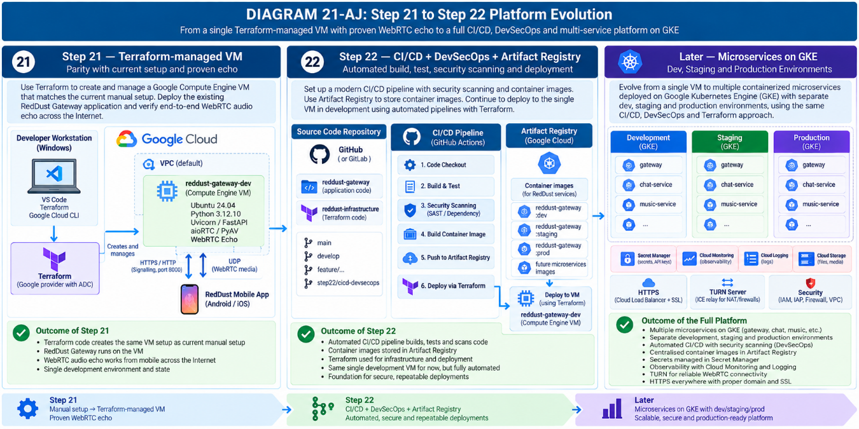

APPENDIX - A — APPLICATION DEFAULT CREDENTIALS (ADC)
Purpose of this appendix
This appendix explains “How Terraform Authenticates to Google Cloud on a RedDust Administrator Workstation” through Application Default Credentials (ADC), in absolute beginner terms, so that interns can understand how a human Google identity, the local workstation, Terraform, the Google provider and Google Cloud IAM fit together. It is intended to be appended directly to the Step-21 RedDust Gateway Terraform runbook.
Important security principle
ADC is credential material. Each human uses their own Google identity and their own local ADC. Do not share ADC files, do not commit them to Git, and do not create a long-lived service-account JSON key merely to make Terraform work.

A.1 — What Application Default Credentials (ADC) Are
What this section does and why it matters
ADC answers a simple question for Google-aware software: “Which Google identity should I use when I call a Google Cloud API?” Terraform needs this answer before it can inspect or manage RedDust cloud resources. ADCs are short lived OAuth access token stored as files in the human user’s designated local folder. These are used by Terraform to get authenticated to the GCP cloud resources and services to work on behalf of the human user.
New technical concepts introduced in this section
ADC is Google’s standard credential-discovery mechanism for applications and client libraries. It lets software obtain usable Google Cloud credentials without hard-coding usernames, passwords or private keys inside Terraform files.

In the RedDust Step-21 workflow, Terraform needs to call Google Cloud APIs to inspect or manage resources such as Compute Engine VMs, IAM bindings, firewall rules, service accounts and Cloud Storage. Instead of putting credentials inside Terraform code, the Terraform Google provider can automatically discover the locally configured ADC credentials.
A useful beginner definition is: ADC is the standard local “credential hand-off” that lets Terraform and other Google client libraries know which authenticated identity they should use when talking to Google Cloud.

A.2 — gcloud Login and ADC Are Two Different Credential Paths
What this section does and why it matters
This section prevents one of the most common onboarding mistakes: assuming that because gcloud works, Terraform must already be authenticated.
New technical concepts introduced in this section
The gcloud CLI maintains its own active account. ADC is a separate credential source used by Google client libraries and the Terraform Google provider.

When you run the following command, you are checking the account used by the gcloud CLI:
gcloud auth list

When you run the following command, you create or refresh Application Default Credentials for ADC-aware software:
gcloud auth application-default login

Conceptually, keep these two paths separate:
gcloud auth login / gcloud auth list
│
└── credentials mainly for the gcloud CLI
gcloud auth application-default login
│
└── Application Default Credentials (ADC)
│
├── Terraform Google provider
├── Google client libraries
└── other ADC-aware tools

Key point
It is possible for `gcloud auth list` to work while ADC has not yet been configured. Step 21 deliberately verifies both.

A.3 — What Happens When the Administrator Creates ADC
What this section does and why it matters
Explain the actual login sequence so interns understand that ADC is created through a normal Google OAuth consent flow, not through a service-account key download.
New technical concepts introduced in this section
OAuth is the web-based authorization flow Google uses to let a human identity approve access without giving Terraform the person’s Google password.

The Administrator runs:
gcloud auth application-default login

Google opens a browser sign-in and consent flow. The Administrator signs in using the intended Google identity, for example `admin@anodiam.com`, and consents to the requested Google Cloud access. After the flow succeeds, gcloud writes the local ADC credentials file.
On Windows, the standard location is:
%APPDATA%\gcloud\application_default_credentials.json

which normally resolves to a path similar to:
C:\Users\<WindowsUser>\AppData\Roaming\gcloud\application_default_credentials.json

Do not copy this file
The ADC file belongs to the human who authenticated. It must stay on that user’s workstation and must never be copied to another teammate.

A.4 — ADC Does Not Store Your Google Password
What this section does and why it matters
Clarify what the local credential file represents and why the security model is safer than embedding passwords or long-lived private keys in code.
New technical concepts introduced in this section
An OAuth access token is a short-lived credential used for API calls. ADC can use locally stored authorization information to obtain fresh access tokens when required.

ADC does not store your Google account password for Terraform. With a human-user ADC login, the local credential material allows Google’s authentication system to obtain short-lived OAuth access tokens on behalf of the authenticated human identity.
Administrator Google identity
│
│ OAuth login / consent
▼
Local ADC credentials
│
│ obtains short-lived access token
▼
Terraform Google provider
│
▼
Google Cloud APIs

This means credentials do not need to be embedded inside `main.tf`, `terraform.tfvars`, PowerShell scripts or the Git repository.

A.5 — How Terraform Uses ADC
What this section does and why it matters
Show how Terraform can authenticate without any username, password or key being written into the provider configuration.
New technical concepts introduced in this section
A Terraform provider is the plugin that knows how to talk to a particular platform. The Google provider uses Google authentication libraries and can discover ADC automatically.

A normal RedDust provider configuration can look like this:
provider "google" {
project = "reddust-development"
region = "australia-southeast1"
}

Notice what is deliberately absent:
username = "..."
password = "..."
private_key = "..."
credentials = "some-service-account-key.json"

For the local Administrator workstation, the desired flow is:
Terraform CLI
│
▼
Terraform Google Provider
│
│ "Find ADC"
▼
Application Default Credentials
│
▼
Short-lived OAuth access token
for admin@anodiam.com
│
▼
Google Cloud APIs

A.6 — ADC Authenticates; IAM Authorizes
What this section does and why it matters
Separate identity from permission. This makes 403 errors much easier to understand and prevents teams from trying to “fix” authorization problems by creating new credentials.
New technical concepts introduced in this section
Authentication proves who the caller is. Authorization decides what that caller is allowed to do. Google Cloud IAM is the authorization layer.

ADC answers: “Who is Terraform acting as?” IAM answers: “What is that identity allowed to do?” These are separate questions.
ADC identity:
admin@anodiam.com
│
▼
Google Cloud IAM
│
├── Compute permissions
├── IAM permissions
├── Service Account permissions
└── Storage permissions

A successful ADC login does not grant unlimited access. Terraform can authenticate successfully and still receive a `403 Permission Denied` response if the identity lacks the required IAM permission.
Intern analogy
ADC is your identity badge. IAM is the set of doors that badge is allowed to open.

A.7 — Project Selection, Quota Project and Terraform Target Are Related but Different
What this section does and why it matters
Prevent confusion between the currently selected gcloud project, the ADC quota project and the project referenced in Terraform configuration.
New technical concepts introduced in this section
A quota project helps Google associate some API usage and quota with a project. It is not an IAM permission grant.

The command below sets the default project used by gcloud:
gcloud config set project reddust-development

During successful ADC setup, gcloud may also report that `reddust-development` was added as the ADC quota project. That helps associate API quota and some usage accounting with the project, but it does not authorize Terraform to do anything by itself.
Terraform still uses its own provider configuration and resource definitions to decide which project and resources it intends to manage, while IAM decides whether the authenticated human identity is permitted to perform those operations.

A.8 — How ADC Is Discovered
What this section does and why it matters
Explain why Terraform can “just find” credentials after ADC has been configured and why the team does not need to point Terraform at the ADC file manually in the normal workstation flow.
New technical concepts introduced in this section
Credential discovery is an ordered search for a usable credential source. Different environments can supply ADC in different ways.

In simplified terms, Google authentication libraries can discover credentials from several places. The most important ones to understand are:
Priority / Source | Beginner explanation
1. Explicit environment-provided credentials | For example, an explicitly configured credential source. This is not the normal RedDust local-workstation method.
2. Local ADC file | The file created by `gcloud auth application-default login`. This is the method used for the Step-21 Administrator workstation.
3. Google Cloud metadata identity | When software runs inside Google Cloud, it can obtain credentials from the identity attached to that workload rather than from a local human ADC file.

RedDust Step-21 choice
For the Administrator’s Windows workstation, use the local human ADC created by `gcloud auth application-default login`. Do not introduce service-account JSON keys.

A.9 — Team Security Rules for ADC
What this section does and why it matters
Turn the authentication design into clear team rules that interns can follow without improvising.
New technical concepts introduced in this section
Credential accountability means every cloud action can be attributed to the individual human identity that performed it.

• Each human uses their own Google identity.
• Each human creates their own local ADC on their own workstation.
• Never copy `application_default_credentials.json` from one user to another.
• Never commit the ADC file, access tokens or OAuth material to Git/GitHub.
• Never put access tokens into documentation, tickets, chat messages or screenshots.
• Do not create a service-account JSON key merely to make Terraform authenticate.
• If a credential is accidentally exposed, revoke it and create a fresh credential set.
• Owner credentials are used only when owner-level authority is genuinely required; routine Terraform work uses the Administrator identity.
Canonical rule
One human → one Google identity → one local credential context → attributable cloud actions.

A.10 — ADC versus a Service-Account JSON Key
What this section does and why it matters
Explain why the RedDust workstation design deliberately avoids long-lived private-key files.
New technical concepts introduced in this section
A service-account key file can contain a long-lived private key. If copied or leaked, it may remain usable until explicitly revoked.

Approach | RedDust local Terraform workstation
Human ADC via OAuth | Preferred. Human signs in, ADC obtains short-lived access tokens, and actions remain attributable to the human identity.
Service-account JSON key | Not used merely for local Terraform. Creates portable long-lived key material and increases leakage risk.

The Step-21 rule is simple: do not create a service-account JSON key merely so Terraform can authenticate from a developer or administrator laptop.

A.11 — Verify ADC Safely
What this section does and why it matters
Provide a verification procedure that proves ADC works without unnecessarily displaying a live access token.
New technical concepts introduced in this section
A verification test should prove credentials are usable while minimizing exposure of sensitive output.

First verify that the ADC file exists:
Test-Path "$env:APPDATA\gcloud\application_default_credentials.json"

Expected result:
True

Then test whether ADC can obtain an access token without printing the token to the terminal:
gcloud auth application-default print-access-token > $null
if ($LASTEXITCODE -eq 0) {
Write-Host "ADC access token test: SUCCESS"
}

Expected result:
ADC access token test: SUCCESS

Security caution
Do not paste the actual access token into chat, email, tickets, documentation or screenshots. If a token is accidentally exposed, revoke the credential set and create a new one.

A.12 — A Four-Layer Mental Model for Interns
What this section does and why it matters
Provide a compact model that can be remembered even after the detailed explanation is forgotten.
New technical concepts introduced in this section
The authentication path can be understood as four layers: human identity, ADC, Terraform provider and Google Cloud IAM.

1. HUMAN
admin@anodiam.com
↓ authenticates
2. ADC
local Google authentication credentials
↓ supplies temporary token
3. TERRAFORM GOOGLE PROVIDER
makes Google API requests
↓ API request
4. GOOGLE CLOUD IAM
checks what admin@anodiam.com
is actually permitted to do

In plain English: the human signs in, ADC securely represents that login locally, Terraform automatically uses ADC (authentication), and Google Cloud IAM decides whether each requested operation is allowed (authorization).

A.13 — Keep Authentication, Authorization & Proj Selection Separate
What this section does and why it matters
Give interns a troubleshooting vocabulary so that every error is not treated as “authentication is broken.”
New technical concepts introduced in this section
Authentication, authorization and project targeting are independent controls and can fail independently.

Concept | Beginner question it answers
`gcloud auth login` / `gcloud auth list` | Who is using the gcloud CLI?
Application Default Credentials (ADC) | Which credentials can Terraform and Google client libraries automatically use?
IAM | What is that authenticated identity permitted to do?
gcloud project configuration | Which GCP project is gcloud currently targeting by default?
Terraform provider / variables | Which GCP project and infrastructure does Terraform intend to manage?

This distinction makes troubleshooting much clearer:
Terraform cannot authenticate
≠
Terraform authenticated but received 403
≠
Terraform authenticated successfully but targets the wrong project

A.14 — Appendix Completion Checklist
What this section does and why it matters
Summarize the knowledge and operational checks that should be understood before an intern is considered ready to work with Terraform authentication.
New technical concepts introduced in this section
A completion checklist converts conceptual learning into a repeatable onboarding gate.

Done | Acceptance condition
☐ | Intern can explain the difference between gcloud login and ADC.
☐ | Intern understands that ADC authenticates while IAM authorizes.
☐ | Intern knows the Windows ADC file location.
☐ | Intern knows ADC must never be copied between teammates.
☐ | Intern knows credentials and access tokens must never be committed to Git.
☐ | Intern understands why service-account JSON keys are not used for routine local Terraform authentication.
☐ | Intern can verify that the ADC file exists.
☐ | Intern can perform a safe token test without printing the token.
☐ | Intern understands that a 403 normally indicates authorization, not failed authentication.
☐ | Intern understands the difference between gcloud project selection, ADC quota project and Terraform target configuration.

A.15 — Future Diagram Placeholder: ADC Explained
What this section does and why it matters
Visual explanation that can later be inserted into this appendix without changing the surrounding text.
New technical concepts introduced in this section
The diagram visually separates gcloud CLI credentials, ADC, Terraform credential discovery and IAM authorization.

DIAGRAM — APPENDIX ADC-1: Application Default Credentials — From Human Login to Terraform API Call
