GOOGLE CLOUD
ZERO TO HERO
A “GCP for Dummies” Style Foundation for Anodiam Interns
RedDust Edition


From cloud fundamentals to secure Compute Engine operations, containers, data, AI, observability and cost governance
Designed for absolute beginners
Assumes zero prior knowledge of cloud computing. Every important term is explained in plain English before it is used technically, and each chapter connects the theory back to the RedDust platform.

Document Control
Version | Audience | Purpose | Primary project context
1.0 | Anodiam interns and junior engineers | GCP fundamentals + RedDust platform onboarding | RedDust Development / Step 20 Compute Engine migration

This learning book is a conceptual and practical companion to the RedDust Step-20 implementation runbook. It teaches the cloud concepts that the implementation runbook assumes, while keeping hands-on exercises non-destructive by default. Product names, interfaces and service details can evolve; always re-check current Google Cloud documentation before making production changes.

Important training boundary
The examples in this book explain how Google Cloud works. They are not permission to modify a shared RedDust project. Interns should run write operations only in an approved sandbox or when explicitly assigned by a project Administrator.

How to Use This Book
Read Chapters 1, 2, 4 and 7 first if your immediate goal is to understand the RedDust Gateway migration. Chapters 3, 5, 6 and 8 broaden that foundation into storage, data, AI, operations and financial governance. Each chapter contains four recurring elements: beginner explanation, RedDust relevance, safe command-line examples, and diagram placeholders for future visual learning.
Reading path | Recommended chapters | Why
RedDust Gateway onboarding | 1 → 2 → 4 → 7 → 8 | Projects, Compute Engine, networking, IAM/IAP/OS Login, monitoring and cost are used directly in Step 20.
Future platform / microservices | 1 → 2 → 3 → 4 → 7 → 8 | Adds GKE, containers, storage, databases and DevOps foundations.
AI / data intern | 1 → 3 → 5 → 6 → 7 → 8 | Adds BigQuery, Pub/Sub, Dataflow, Vertex AI and governance.
Cloud certification foundation | All chapters | Broadly overlaps Digital Leader and Associate Cloud Engineer foundations; this is a learning companion, not an official exam guide.

Table of Contents
Document Control 2
How to Use This Book 2
Foundations of Cloud Computing & Google Cloud 4
Core Compute Services 8
Cloud Storage & Database Architecture 12
Cloud Networking Basics 15
Data Analytics & Big Data 19
Artificial Intelligence & Machine Learning 22
Security, Compliance & Governance 25
Cloud Operations & Financial Governance 29
Appendix 32
Final Intern Readiness Checklist 34
Closing Perspective 35
Reference Basis 35

CHAPTER 1

Foundations of Cloud Computing & Google Cloud
What this chapter does and why it matters
Build the mental model that makes every later GCP service understandable: what “the cloud” actually is, how public cloud differs from running a server yourself, why regions and zones matter, how Google organizes resources, and how identity and access are attached to those resources.

New technical concepts in absolute beginner terms
Cloud computing, elasticity, scalability, high availability, regions, zones, projects, IAM, principals, roles, permissions, service accounts, CapEx, OpEx and shared responsibility.

RedDust lens
RedDust Step 20 moves a working FastAPI + aiortc Gateway from a Windows laptop to an Ubuntu Compute Engine VM in the RedDust Development project. The cloud does not change the application’s purpose; it changes where it runs, how it is reached, how it is secured and how it is paid for.

1.1 — What Is Cloud Computing?
Cloud computing means renting computing capabilities—CPU, memory, storage, networking, databases, analytics and higher-level managed services—from a provider and consuming them on demand. Instead of buying a physical server, installing it in an office, wiring it to the Internet and maintaining the hardware yourself, you request a virtual or managed resource through an API or console.
A useful beginner analogy is electricity. A company usually does not build its own power station before turning on a laptop; it consumes power from a utility. Public cloud applies a similar consumption model to computing. You still design the application, choose capacity, secure identities and control data, but a cloud provider operates the underlying physical data-centre infrastructure.
Cloud does not mean “somebody else handles everything”
You still own application design, IAM, data access, network exposure, software vulnerabilities, backups appropriate to your architecture, and cost decisions. Cloud changes the boundary of responsibility; it does not remove responsibility.

1.2 — Agility, Scalability, Elasticity and High Availability
Term | Plain-English meaning | Simple example
Agility | How quickly you can create or change infrastructure. | Create a VM in minutes instead of purchasing and racking a physical server.
Scalability | Ability to handle a larger workload by adding or enlarging resources. | Move from one VM to a managed group or a GKE deployment with more replicas.
Elasticity | Capacity can expand and shrink with demand. | Cloud Run can add instances when traffic rises and scale down when traffic falls.
High availability | Designing so a service keeps working despite individual failures. | Run redundant instances across zones behind a load balancer.
Durability | Probability that stored data survives over time. | Object storage keeps multiple copies according to service design.

Scalability and elasticity are related but not identical. A system can be scalable without being automatically elastic. For example, a manually resized VM can scale, but it does not automatically grow and shrink in response to traffic.

1.3 — Public, Private, Hybrid and Multi-cloud
Model | Where workloads run | Why organizations choose it
Public cloud | Provider-operated cloud such as Google Cloud. | Speed, global reach, managed services, pay-as-you-go consumption.
Private cloud | Dedicated infrastructure operated for one organization. | Special regulatory, legacy or control requirements.
Hybrid cloud | Combination of on-premises/private infrastructure and public cloud. | Gradual migration, data locality, legacy systems.
Multi-cloud | Use of services from more than one public cloud provider. | Risk management, specialized services, acquisition history or strategy.

RedDust currently uses a public-cloud model for the Gateway. A future architecture could still be multi-cloud or hybrid, but adding more clouds also adds operational complexity: identity, networking, observability, cost controls and deployment tooling must work across environments.

1.4 — IaaS, PaaS, SaaS and FaaS
Model | You manage more of… | Provider manages more of… | GCP example
IaaS | OS, runtime, application, patching choices | Physical servers, virtualization | Compute Engine
PaaS | Application and data | OS/runtime/platform scaling mechanics | App Engine
Container platform | Container image and workload configuration | Cluster control plane and/or runtime infrastructure | GKE / Cloud Run
FaaS | Function code and trigger logic | Runtime, scaling, servers | Cloud Run functions / Cloud Functions
SaaS | Configuration and usage | Application stack itself | Google Workspace is a familiar SaaS example

The key trade-off is control versus operational burden. Compute Engine gives RedDust full operating-system control, which is useful for learning and for the current WebRTC Gateway proof. A managed container platform can reduce server administration later, but it also changes deployment and networking design.

1.5 — Cloud Economics: CapEx, OpEx and TCO
Capital expenditure (CapEx) is money spent up front to acquire long-lived assets such as servers, racks and networking hardware. Operational expenditure (OpEx) is ongoing spending for consumed services. Public cloud shifts much infrastructure spending toward OpEx: you pay for resources as you use them.
Total Cost of Ownership (TCO) is broader than the VM price. TCO includes engineering time, patching, monitoring, backups, incident response, network egress, software licenses, operational tooling, and the cost of idle resources. A cheap VM can become expensive if it is forgotten and left running; a managed service with a higher unit price may be cheaper overall if it removes large amounts of operational work.
RedDust cost lesson
The Step-20 e2-medium VM is billable. Budget alerts create visibility but do not automatically stop the VM. Cost control therefore combines budgets with operating discipline: run what you need, stop idle development compute, and review billing reports.

1.6 — Google’s Global Infrastructure: Regions and Zones
A Google Cloud region is a geographic area containing multiple independent zones. A zone is a deployment area inside a region. You choose location because latency, availability design, legal requirements, service availability and price can all depend on it.
Concept | Beginner meaning | RedDust example
Region | Geographic area where cloud resources are placed. | australia-southeast1 (Sydney).
Zone | Failure domain / deployment location inside a region. | australia-southeast1-b.
Multi-region | Google-managed geography spanning multiple regions for specific services. | Useful for some storage/data products; not the Step-20 VM placement model.
Latency | Time for data to travel from source to destination. | Sydney is chosen to make Australian real-time voice testing representative.

The practical lesson is that location is an architecture decision, not a cosmetic setting. For WebRTC, network distance can materially affect call setup, jitter and perceived audio delay.

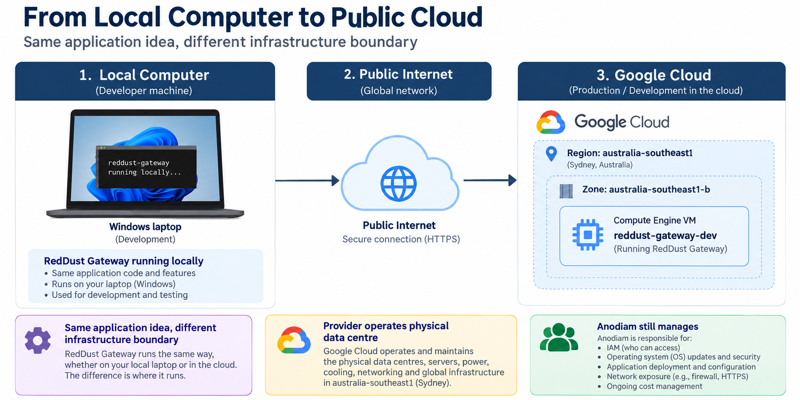
GCP-01: From Laptop to Public Cloud

1.7 — Google Cloud Resource Hierarchy
Google Cloud resources live in a hierarchy. At the top may be an Organization. Folders can group teams or environments. Projects are the main isolation and billing/IAM boundary used by most teams. Individual resources—VMs, buckets, databases, topics and so on—live inside projects or are associated with them.
Level | What it represents | Why it matters
Organization | Top-level company or Cloud Identity / Workspace boundary. | Central policy, organization-wide roles and governance.
Folder | Optional grouping layer. | Can separate business units, platforms or environments.
Project | Core working boundary for APIs, quotas, IAM, billing linkage and resources. | RedDust Development is the project for Step 20.
Resource | Concrete cloud object. | Examples: reddust-gateway-dev VM, firewall rule, service account.

IAM policies can be inherited downward. A role granted at a project may apply to resources in that project; a role granted only on one VM can be much narrower. This is why “where the role is granted” is as important as “which role is granted.”

1.8 — IAM: Principal + Role + Resource = Access
Identity and Access Management (IAM) answers: who can do what on which resource? A principal can be a human user, Google Group, service account or other supported identity. A role is a named bundle of permissions. The policy binding connects the principal and role at a specific scope.
IAM word | Plain English | Example
Principal | Who is asking? | A developer Google identity or a Gateway service account.
Permission | One low-level allowed operation. | compute.instances.get
Role | A curated bundle of permissions. | roles/compute.viewer
Binding | Role assigned to principal at a scope. | Developer → Compute Viewer on reddust-development
Least privilege | Give only what is required, at the narrowest useful scope. | Developer gets VM-scoped OS Admin Login instead of project-wide cloud admin.

1.9 — Human Identity versus Workload Identity
A human identity represents a person. A workload identity represents software. In RedDust, humans authenticate as themselves through Google identity and OS Login, while the Gateway application can use a dedicated VM service account such as reddust-gateway-dev-runtime when it needs to call Google Cloud APIs.
Security boundary to remember
Do not turn a service account into a shared human login. Do not solve workload authentication by downloading and sharing long-lived JSON keys when a managed identity path is available. Human access and application access should remain separate and auditable.

Safe read-only orientation commands
gcloud auth list
gcloud config get-value project
gcloud projects describe reddust-development --format="yaml(projectId,name,parent)"

Quick knowledge check
- In one sentence, what is the difference between scalability and elasticity?
- Why is a GCP project more than just a folder name?
- What three pieces make up an IAM decision: who, what role, and where?
- Why should the RedDust Gateway use a service account instead of a developer’s personal credentials?
CHAPTER 2

Core Compute Services
What this chapter does and why it matters
Understand the major ways to run code on Google Cloud—from a virtual machine you administer yourself to managed containers, Kubernetes and serverless platforms—and learn how to choose among them.

New technical concepts in absolute beginner terms
Virtual machines, machine families, images, disks, Spot VMs, containers, Docker images, Kubernetes, pods, nodes, clusters, serverless, autoscaling and stateless services.

RedDust lens
RedDust Step 20 deliberately uses Compute Engine because it gives the team full control over Ubuntu, Python, aiortc, UDP/WebRTC behavior and systemd. The future roadmap moves toward containerization, Artifact Registry, CI/CD and eventually GKE microservices.

2.1 — Compute Engine: A Virtual Computer in Google’s Data Centre
Compute Engine provides virtual machines (VMs). To the operating system, a VM looks much like a normal computer: CPU, memory, disks, network interfaces and an OS. The hardware is virtualized and runs on Google’s physical infrastructure.
A VM is appropriate when you need operating-system control, custom networking behavior, background daemons, native packages, or a lift-and-shift path from an existing server. The trade-off is that you are responsible for more: OS updates, package management, process supervision, capacity choices and hardening.

2.2 — Machine Families and Machine Types
A machine family is a group of VM shapes optimized for broad purposes such as general-purpose, compute-intensive, memory-intensive or accelerator workloads. A machine type specifies a particular combination of virtual CPU and memory. Custom machine types let you select CPU/memory combinations where supported.
Choice | Good for | Trade-off
General purpose | Web apps, APIs, dev/test, balanced workloads. | Good default; not specialized for extreme CPU or memory.
Compute optimized | CPU-heavy computation. | Higher compute focus and cost profile.
Memory optimized | Large in-memory datasets. | More RAM; higher cost.
Accelerator/GPU | ML training/inference, rendering. | Expensive and operationally different.
Spot VM | Fault-tolerant batch or disposable workers. | Can be stopped by Google; not appropriate for an interactive baseline Gateway that must remain stable during testing.

RedDust Step-20 VM
Canonical baseline: reddust-gateway-dev in australia-southeast1-b, general-purpose E2, e2-medium, Ubuntu 24.04 LTS, 10 GB pd-standard. The runbook uses Standard/non-Spot provisioning because interruption would complicate baseline WebRTC testing.

2.3 — Images, Boot Disks and Persistent Disks
A VM image is a template used to create the boot disk. It typically contains an operating system such as Ubuntu. The boot disk stores the OS and local application files. Persistent Disk is network-backed block storage that can outlive a VM instance depending on deletion settings.
Think of the VM as the computer and the boot disk as its system drive. Deleting the VM and deleting the disk are separate lifecycle decisions. Snapshots and images are different tools for recovery and repeatable provisioning; production designs should make those choices explicitly.

2.4 — VM Lifecycle: Create, Start, Stop, Reset, Delete
Action | What happens | Billing / data lesson
Stop | Guest stops running; VM is not serving. | Compute charges generally stop, but attached storage and some resources can still cost money.
Start | VM resumes using configured machine and disks. | Compute billing resumes.
Reset | Equivalent to a hard reboot. | Use only when needed; not a substitute for graceful shutdown.
Delete | Instance resource is removed. | Disk deletion depends on configuration; verify before destructive actions.

Safe read-only Compute Engine inspection
gcloud compute instances list --project=reddust-development
gcloud compute instances describe reddust-gateway-dev \
--project=reddust-development \
--zone=australia-southeast1-b \
--format="yaml(name,status,machineType,disks,networkInterfaces,serviceAccounts)"

2.5 — Linux on a VM: Packages, Processes and systemd
Once you SSH into an Ubuntu VM, you are administering a Linux operating system. Processes are running programs. Services are long-running background processes. systemd is Ubuntu’s service manager: it starts services, restarts them when configured, launches them at boot and records status.
Typical non-destructive Linux checks on the RedDust VM
hostname
uname -a
free -h
df -h
systemctl status reddust-gateway --no-pager
journalctl -u reddust-gateway -n 50 --no-pager

For RedDust, systemd means Uvicorn/FastAPI can keep running after a developer closes an SSH session. This is a basic cloud-operations lesson: production-like workloads should not depend on somebody leaving a terminal window open.

2.6 — Containers: Package the Application, Not the Whole VM
A container packages an application with its user-space dependencies into a portable image. Containers share the host kernel, so they are lighter than full VMs. A Dockerfile describes how to build an image; a container registry stores built images; a runtime starts containers from those images.
Illustrative container image for a future RedDust Gateway — example only
FROM python:3.12-slim
WORKDIR /app
COPY requirements.txt .
RUN pip install --no-cache-dir -r requirements.txt
COPY . .
CMD ["python", "-m", "uvicorn", "app.main:app", "--host", "0.0.0.0", "--port", "8000"]

Important
A container is not automatically “secure” or “serverless.” You still need vulnerability scanning, least-privilege runtime identity, network policy, secrets handling, logging and patching of base images.

2.7 — Kubernetes and GKE
Kubernetes is an orchestration system for containers. It decides where containers run, restarts failed replicas, performs rolling updates, exposes services, and helps manage desired state. Google Kubernetes Engine (GKE) is Google Cloud’s managed Kubernetes offering.
Kubernetes concept | Beginner meaning
Cluster | The overall Kubernetes environment.
Node | A worker machine that runs workloads.
Pod | Smallest deployable unit; usually one main application container plus helpers.
Deployment | Declares how many replicas should run and how updates happen.
Service | Stable network identity in front of one or more pods.
Ingress / Gateway | Routes incoming application traffic to services.
ConfigMap / Secret | Configuration objects; Secrets need careful security treatment.

GKE is powerful but introduces a new operational layer. You now manage Kubernetes concepts in addition to Google Cloud concepts. That is why the RedDust roadmap first proves the application and infrastructure boundary on a VM before adding container orchestration complexity.

2.8 — Cloud Run
Cloud Run runs containerized services in a fully managed environment. You provide a container image and service configuration; Google handles underlying server provisioning and automatic scaling. It is excellent for stateless HTTP services and event-driven workloads.
A real-time WebRTC Gateway may need careful evaluation because media traffic, UDP behavior, connection lifetimes and protocol requirements can differ from conventional HTTP APIs. The right compute choice depends on the workload, not on which product is newer or more fashionable.

2.9 — App Engine and Cloud Run Functions
App Engine is a platform-as-a-service option that abstracts much of the underlying infrastructure for web applications. Cloud Run functions (historically Cloud Functions in common usage) are event-driven functions where code runs in response to triggers such as HTTP requests, messages or storage events. These are useful for small, focused actions rather than a long-running, stateful server process.

2.10 — Compute Decision Matrix
Need | Compute Engine | GKE | Cloud Run | Functions / event runtime
Full OS control | Excellent | Indirect via nodes | No | No
Container orchestration | Manual | Excellent | Managed single-service model | Not primary use
Operational simplicity | Lowest | Lowest for beginners | High | Very high for small event logic
Long-running background daemon | Good | Good | Workload dependent | Usually not
Autoscaling | Manual/MIG design | Strong | Built-in | Built-in
RedDust Step 20 fit | Chosen baseline | Future | Potential for stateless services | Potential for event microservices

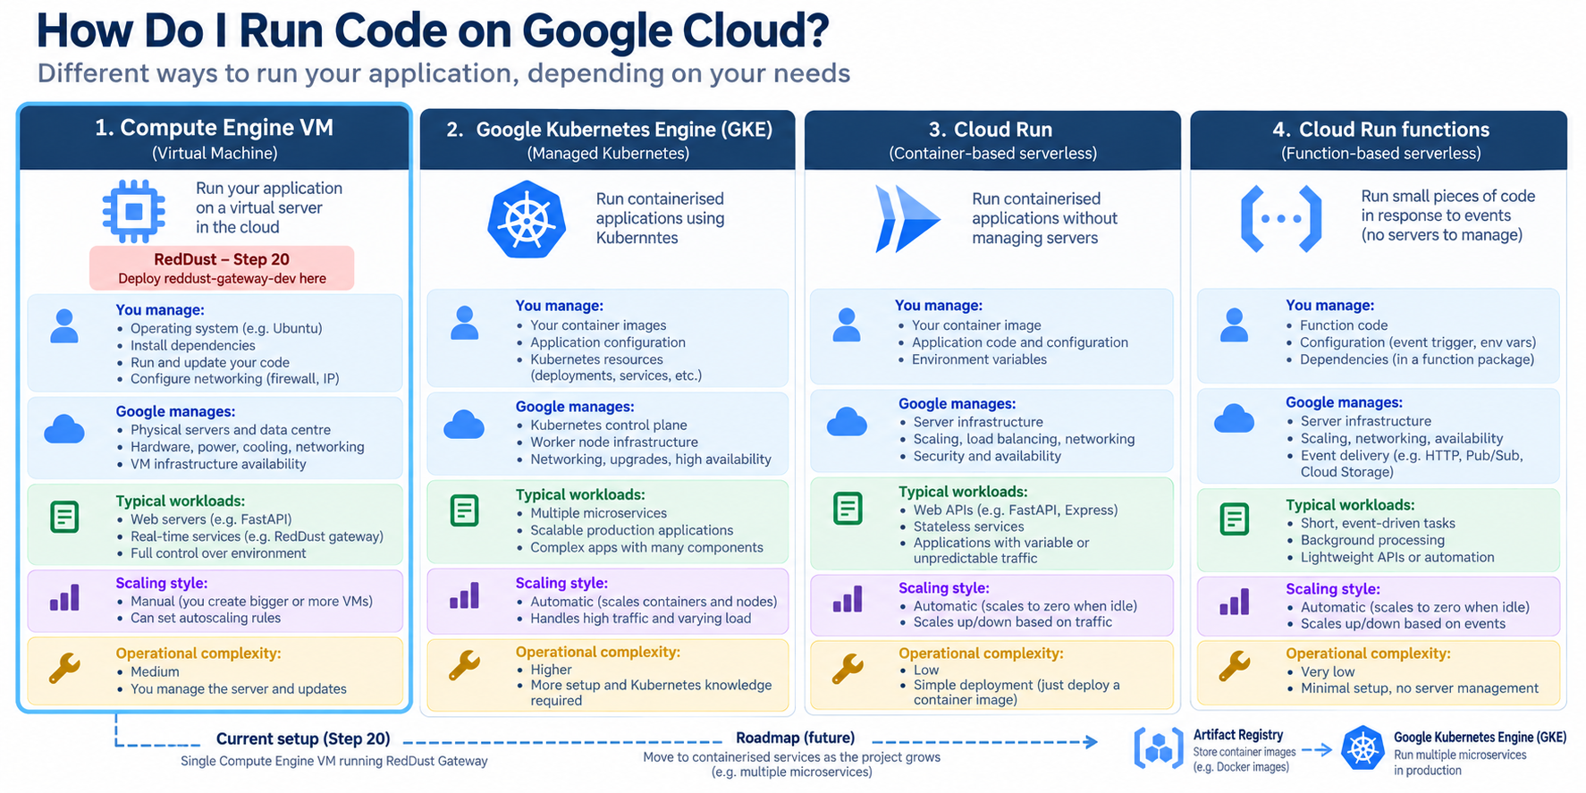
  - GCP-02: Compute Options: VM → Container → Kubernetes → Serverless

Quick knowledge check
- Why did Step 20 choose a VM instead of jumping straight to Kubernetes?
- What is the difference between a VM image and a container image?
- What problem does Kubernetes solve?
- Which compute option generally gives the highest OS-level control?
CHAPTER 3

Cloud Storage & Database Architecture
What this chapter does and why it matters
Learn the difference between object storage, block storage and databases, then understand when relational SQL, document NoSQL, wide-column stores and globally distributed relational systems are appropriate.

New technical concepts in absolute beginner terms
Buckets, objects, storage classes, lifecycle policies, block storage, relational databases, schemas, transactions, NoSQL, documents, wide columns, consistency and managed databases.

RedDust lens
RedDust already uses a VM boot disk and may later need Cloud Storage for artifacts or files, PostgreSQL via a managed database, Secret Manager for secrets, and data services for conversation/session analytics. Choosing storage based on access pattern prevents expensive redesign.

3.1 — Three Different Meanings of “Storage”
Storage type | Think of it as | Best for | GCP examples
Block storage | A disk attached to a computer. | Operating systems, filesystems, database disks. | Persistent Disk / Hyperdisk families.
Object storage | A giant API-accessed bucket of named objects. | Media, archives, backups, exports, static files. | Cloud Storage.
Database | Structured data engine with query/update semantics. | Application records, relationships, transactions, analytics. | Cloud SQL, Spanner, Firestore, Bigtable, BigQuery.

A common beginner error is to call every durable service “a database.” Cloud Storage does not behave like PostgreSQL, and a database is not a substitute for storing large binary objects just because it can technically hold them.

3.2 — Cloud Storage: Buckets and Objects
Cloud Storage is object storage. A bucket is the top-level container. Objects are stored under names inside a bucket. You interact with objects through APIs, command-line tools or application libraries rather than mounting the bucket as an ordinary local disk by default.
Storage class | Typical access pattern | Cost idea
Standard | Frequently accessed data. | Higher storage price, lower access penalties.
Nearline | Infrequent access. | Lower storage cost with minimum-duration/access considerations.
Coldline | Rare access. | Lower storage cost, higher retrieval considerations.
Archive | Very rare / long-term retention. | Lowest storage cost, intended for archival access patterns.

Lifecycle management lets a bucket automatically transition or delete objects based on age or other conditions. This is governance as code for data retention: instead of hoping someone remembers to clean old files, you declare a policy.
Safe Cloud Storage discovery commands
gcloud storage buckets list --project=reddust-development
gcloud storage ls --project=reddust-development

3.3 — Cloud SQL: Managed Relational Databases
Cloud SQL is a managed relational database service for engines such as PostgreSQL, MySQL and SQL Server. You still design tables, indexes, queries and application transactions, but Google handles much of the underlying database infrastructure such as instance provisioning, managed backups features and maintenance workflows.
For RedDust, PostgreSQL is a natural fit for highly relational records such as users, sessions, conversations, summaries, scores and configuration where referential integrity and SQL queries matter. The application should use connection pooling and keep credentials out of source code.
Illustrative SQL — not a command to run against production
-- Example relational thinking for RedDust
SELECT session_id, started_at, ended_at
FROM sessions
WHERE user_id = $1
ORDER BY started_at DESC
LIMIT 20;

3.4 — Cloud Spanner
Cloud Spanner is a managed relational database designed for horizontal scale and strong consistency across large deployments. It solves a different class of problem from a small development PostgreSQL instance. Its value appears when an application needs very high scale, global distribution or availability while retaining relational semantics.
Do not choose enterprise-scale products by prestige
The best service is the simplest one that satisfies the workload’s functional, reliability, security and cost requirements. Early-stage systems often benefit from Cloud SQL before they ever need Spanner.

3.5 — Firestore
Firestore is a document-oriented NoSQL database. Instead of rows and joins, applications work with collections and documents. This can be convenient for mobile/web application state with flexible document structures and realtime-oriented access patterns.
NoSQL does not mean “no structure.” Good document design still requires careful thinking about keys, indexes, query patterns, duplication and consistency. The data model should be driven by how the application reads and writes data.

3.6 — Bigtable
Bigtable is a wide-column NoSQL database designed for very high throughput and low-latency access to enormous datasets when access patterns can be modeled around row keys. Typical use cases include time-series, telemetry and large-scale operational analytics. It is not a general replacement for PostgreSQL.

3.7 — Database Selection Matrix
Question | Cloud SQL | Spanner | Firestore | Bigtable | Cloud Storage
Relational joins | Yes | Yes | No | No | No
Strong transactional relational model | Yes | Yes | Limited/different model | No relational tx | No
Massive horizontal/global relational scale | Limited vs Spanner | Core strength | Document scale | Core strength for key-based data | Object scale
Mobile/document data | Possible | Possible | Strong | Specialized | Files only
Files / audio / exports | Poor fit | Poor fit | Poor fit | Poor fit | Strong
Likely RedDust near-term role | PostgreSQL app data | Only if future scale demands | Selective mobile/document use | Telemetry at huge scale | Artifacts/files/backups

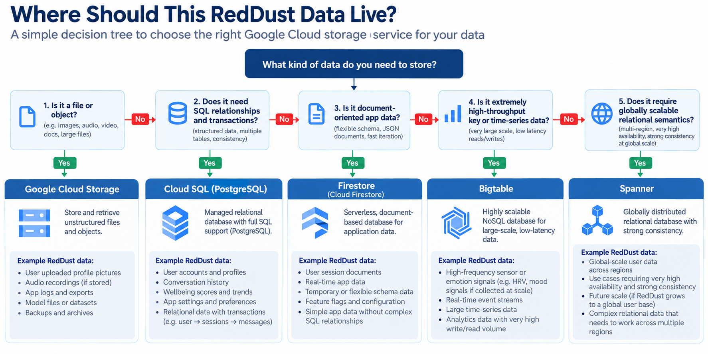
  - GCP-03: Choosing Storage and Databases

Quick knowledge check
- Why is a Cloud Storage bucket not the same thing as a VM disk?
- Why might PostgreSQL be a good fit for RedDust sessions and conversations?
- When would Firestore be preferable to a relational database?
- What problem is a lifecycle policy trying to solve?
CHAPTER 4

Cloud Networking Basics
What this chapter does and why it matters
Build enough networking knowledge to understand why a VM can be running yet unreachable, why HTTP signaling and WebRTC media can succeed or fail independently, and how VPCs, subnets, IPs, firewalls, load balancers, VPNs and CDNs fit together.

New technical concepts in absolute beginner terms
VPC, subnet, CIDR, internal/external IP, route, firewall, ingress/egress, TCP, UDP, ports, NAT, DNS, load balancing, CDN, VPN and Interconnect.

RedDust lens
RedDust Step 20 depends heavily on networking: IAP-secured SSH on TCP 22, temporary HTTP signaling on TCP 8000, STUN-assisted WebRTC media over UDP, and a firewall model that must allow the correct sources and ports without opening everything to the Internet.

4.1 — VPC: Your Logical Cloud Network
A Virtual Private Cloud (VPC) is a logically isolated network in Google Cloud. Resources such as Compute Engine VMs attach network interfaces to VPC subnets. The VPC provides IP addressing, routes and firewall policy context.
A VPC is not a physical cable. It is software-defined networking: Google’s infrastructure implements the behavior described by your network configuration.

4.2 — Subnets and IP Addressing
A subnet is an IP address range associated with a region. VM network interfaces receive internal IP addresses from subnet ranges. An external IP, when configured, makes a resource reachable through Internet routing subject to firewall and service behavior.
Internal vs external IP
Internal IPs are for communication within the cloud network or connected private networks. External IPs are Internet-routable. “Has an external IP” does not mean “every port is open”; firewall rules and application listeners still matter.

4.3 — CIDR in Plain English
CIDR notation describes a block of IP addresses. The slash number tells you how many bits are fixed as the network prefix. For example, /32 describes one IPv4 address, while /24 describes 256 addresses. Smaller slash numbers describe larger ranges.
CIDR | Approximate interpretation
10.0.0.5/32 | Exactly one IPv4 address.
10.0.1.0/24 | 256-address block (network range).
35.235.240.0/20 | 4096-address block; used by Google for IAP TCP forwarding source traffic in the Step-20 security model.
0.0.0.0/0 | All IPv4 addresses — extremely broad and should be used only with deliberate justification.

4.4 — TCP, UDP and Ports
Concept | Plain English | RedDust example
TCP | Reliable ordered byte stream with connection state. | SSH TCP 22; temporary HTTP signaling TCP 8000.
UDP | Connectionless datagrams with low transport overhead. | WebRTC media commonly prefers UDP for low-latency audio.
Port | Number identifying a service endpoint on a host. | 22 = SSH convention; 8000 = RedDust dev FastAPI signaling.
Socket | IP + protocol + port endpoint used by an application. | Uvicorn listening on 0.0.0.0:8000.

A firewall rule can permit TCP 8000 while blocking UDP media, so successful HTTP signaling does not prove a WebRTC call will work. This separation is one of the most important troubleshooting lessons in the Step-20 runbook.

4.5 — Firewalls: Who May Reach Which Port?
Firewall rules evaluate network traffic against direction, sources/destinations, protocols, ports and target resources. A good firewall rule is narrowly scoped: only required traffic, only required targets, and only required sources.
RedDust path | Protocol / port | Security purpose
Administrator SSH through IAP | TCP 22 | Allow IAP’s forwarding range to reach SSH; do not expose direct public SSH unnecessarily.
Temporary signaling | TCP 8000 | Development-only HTTP signaling endpoint until HTTPS architecture is introduced.
WebRTC media | UDP ephemeral range | Media path; exact range is discovered from the VM and should be deliberately constrained.

Safe firewall inventory
gcloud compute firewall-rules list \
--project=reddust-development \
--format="table(name,direction,sourceRanges.list():label=SOURCE,allowed[].map().firewall_rule().list():label=ALLOW,targetTags.list():label=TARGETS)"

4.6 — Routes, NAT and Why “The Internet” Is Not One Thing
Routes tell packets where to go next. Network Address Translation (NAT) maps addresses across network boundaries. Home routers and mobile carriers often hide devices behind NAT. WebRTC must discover usable network paths through this reality, which is why ICE, STUN and TURN exist.
STUN helps a peer learn an address as seen from outside its NAT. TURN provides a relay when direct peer-to-peer style paths do not work. ICE is the overall connectivity process that gathers candidates and tests paths. RedDust Step 20 proves STUN-assisted direct connectivity before introducing TURN as the reliability layer.

4.7 — Signaling versus Media: Two Independent Paths
RedDust mental model
HTTP signaling path:
Phone → POST /offer (SDP) → FastAPI → aiortc → SDP answer → Phone
WebRTC media path:
Phone microphone → ICE/DTLS/SRTP/Opus over media path → aiortc → EchoAudioTrack → encrypted return audio → Phone speaker

Critical diagnostic rule
HTTP 200 from /offer proves only that signaling reached FastAPI and a response came back. It does not prove ICE connected, DTLS completed, SRTP media flows, audio tracks exist or the phone is playing returned audio.

4.8 — IAP-Secured SSH
Identity-Aware Proxy (IAP) can forward TCP connections to a VM after evaluating the user’s Google identity and IAM authorization. In the RedDust design, IAP is the controlled entry path for SSH. The VPC firewall then allows the IAP TCP forwarding source range to TCP 22, and OS Login decides which Linux user the human becomes.
IAP SSH connection pattern
gcloud compute ssh reddust-gateway-dev \
--project=reddust-development \
--zone=australia-southeast1-b \
--tunnel-through-iap

4.9 — Load Balancing
A load balancer provides a stable frontend and distributes traffic to one or more backends. Depending on the Google Cloud product and configuration, load balancing can be external or internal, global or regional, and can operate at different protocol layers.
Load balancing becomes important when RedDust evolves from one development VM toward redundant services. It can separate a public frontend from changing backend instances, support health checks and improve resilience.

4.10 — Cloud CDN
A content delivery network caches suitable content closer to users at edge locations. Cloud CDN is useful for cacheable static or HTTP content such as web assets or downloadable media. It is not a generic acceleration switch for bidirectional real-time WebRTC media.

4.11 — Hybrid Connectivity: VPN and Interconnect
Cloud VPN creates encrypted IP connectivity over the public Internet between networks. Dedicated Interconnect and Partner Interconnect provide private connectivity options for higher-capacity or enterprise requirements. These are important for organizations connecting data centres to GCP, but they are not required for the Step-20 Internet Gateway proof.
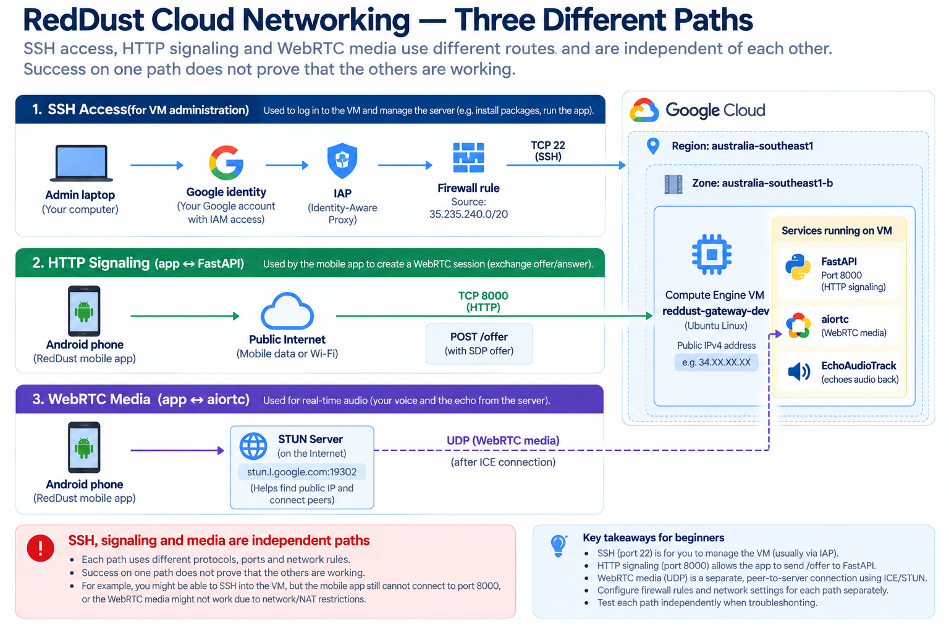
GCP-04: RedDust Networking: Signaling, Media and Admin Access

Quick knowledge check
- Why can /offer succeed while audio still fails?
- What is the difference between an internal IP and an external IP?
- Why is 0.0.0.0/0 risky as a firewall source?
- What separate jobs do IAP and OS Login perform?
CHAPTER 5

Data Analytics & Big Data
What this chapter does and why it matters
Introduce the services used to collect events, stream data, transform it, analyze it at scale and present it to humans. The goal is not to turn every intern into a data engineer, but to make the data platform vocabulary understandable.

New technical concepts in absolute beginner terms
Data warehouse, dataset, table, analytical SQL, event stream, message, topic, subscription, batch processing, stream processing, ETL/ELT, Dataflow, dashboards and BI.

RedDust lens
RedDust will generate operational and product data: sessions, conversation events, recommendation outcomes, wellbeing metrics, model telemetry and platform logs. Pub/Sub and BigQuery are natural building blocks for decoupled events and analytical reporting, while transactional application data can stay in an operational database.

5.1 — Operational Databases versus Analytical Warehouses
An operational database is optimized for application transactions: create a session, update a record, retrieve a user. A data warehouse is optimized for analytical questions across large volumes: trends by week, cohort behavior, model performance, cost per feature or aggregate wellbeing metrics.
Trying to run every analytical workload directly against the production application database can create performance and governance problems. A common architecture separates operational systems from analytical systems and moves curated data through controlled pipelines.

5.2 — BigQuery
BigQuery is Google Cloud’s serverless analytical data warehouse. You store data in datasets and tables and query it with SQL. “Serverless” here means you do not manage database servers; you still manage data design, permissions, query cost, retention and governance.
Example analytical SQL — illustrative
-- Illustrative BigQuery-style analytics
SELECT
DATE(session_started_at) AS day,
COUNT(*) AS sessions
FROM `reddust_analytics.sessions`
GROUP BY day
ORDER BY day DESC;

Cost principle
Serverless does not mean free. BigQuery cost can depend on storage and query processing. Partitioning, clustering, selecting only needed columns and setting governance controls matter.

5.3 — Pub/Sub: Decouple Producers from Consumers
Pub/Sub is a messaging service. A publisher sends messages to a topic. One or more subscriptions deliver those messages to consumers. The publisher does not need to know which consumers exist, which allows systems to evolve independently.
Concept | Plain English | RedDust example
Publisher | System that emits an event. | Gateway publishes session-ended event.
Topic | Named event channel. | reddust-session-events.
Subscription | Consumer’s delivery view of a topic. | Analytics pipeline subscription.
Consumer | Service processing messages. | Dataflow pipeline or microservice.

Safe Pub/Sub discovery
gcloud pubsub topics list --project=reddust-development
gcloud pubsub subscriptions list --project=reddust-development

5.4 — Dataflow and Apache Beam
Dataflow is Google Cloud’s managed service for Apache Beam pipelines. Beam lets engineers describe data transformations in a model that can run in batch or streaming modes. Dataflow handles much of the execution infrastructure.
A future RedDust pipeline could read events from Pub/Sub, validate and enrich them, remove or tokenize sensitive fields, and write analytical records to BigQuery. This should be designed with privacy and schema governance from the start.

5.5 — ETL versus ELT
Pattern | Sequence | When it appears
ETL | Extract → Transform → Load | Data is transformed before entering the final analytical store.
ELT | Extract → Load → Transform | Raw/landing data enters the warehouse first, then transformations run there.

Neither acronym is inherently better. The choice depends on source systems, governance, latency, tooling and how much raw data you are allowed to retain.

5.6 — Looker and Looker Studio
Business intelligence (BI) turns data into dashboards and reports. Looker provides governed semantic modeling and BI capabilities for enterprise analytics. Looker Studio provides accessible dashboarding and reporting workflows. The important architectural lesson is to define trusted metrics rather than letting every dashboard invent a different formula for the same business concept.

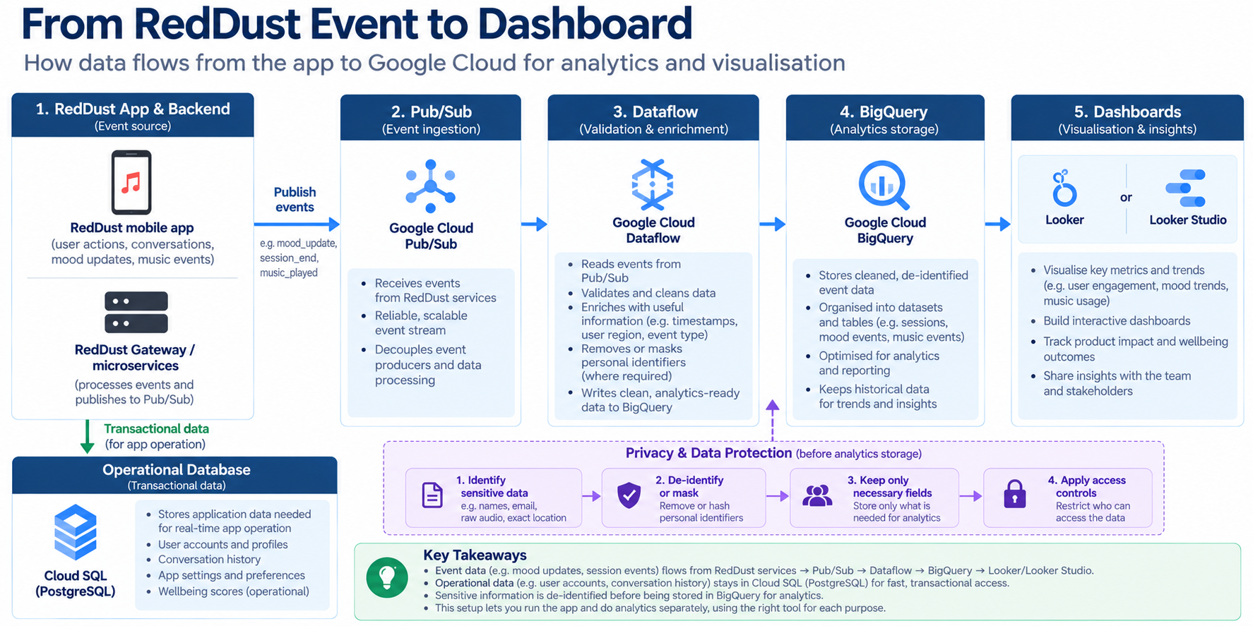
GCP-05: Event to Insight Pipeline

Quick knowledge check
- What problem does Pub/Sub solve between services?
- Why is BigQuery different from Cloud SQL?
- What is the difference between a topic and a subscription?
- Why should analytical metrics have agreed definitions?
CHAPTER 6

Artificial Intelligence & Machine Learning
What this chapter does and why it matters
Give interns a clean vocabulary for AI, ML, deep learning and generative AI, then introduce Google Cloud’s pre-trained APIs, Vertex AI, Gemini and responsible deployment considerations.

New technical concepts in absolute beginner terms
AI, machine learning, training, inference, model, feature, neural network, deep learning, foundation model, embedding, prompt, RAG, model endpoint, evaluation and responsible AI.

RedDust lens
RedDust is an AI-centric product, but the cloud architecture still needs deterministic infrastructure, identity, observability and data governance. Vertex AI can host models and Gemini capabilities; those services should be integrated through scoped workload identity rather than hard-coded secrets.

6.1 — AI, ML, Deep Learning and Generative AI
Term | Beginner definition
Artificial Intelligence | Broad field of building systems that perform tasks associated with intelligence.
Machine Learning | Systems learn patterns from data rather than using only hand-written rules.
Deep Learning | ML using multi-layer neural networks, often at large scale.
Generative AI | Models that generate new text, images, audio, code or other content.
Foundation model | Large general-purpose model that can be adapted or prompted for many tasks.

These terms overlap hierarchically: deep learning is a subset of machine learning; machine learning is one area within AI; modern generative AI often uses deep-learning foundation models.

6.2 — Training versus Inference
Training is the process of adjusting model parameters using data. Inference is using a trained model to produce an output for a new input. A product team often consumes inference services without training a model from scratch.
This distinction matters operationally because training and inference have different cost, hardware, latency and security profiles. A mobile voice assistant may need low-latency inference even if its models were trained elsewhere.

6.3 — Pre-trained APIs
Google Cloud offers pre-trained APIs for tasks such as speech recognition, translation, vision analysis and natural-language processing. These services can reduce the amount of custom ML engineering required when their capabilities fit the product requirement.
Capability | Typical use
Speech-to-Text | Convert spoken audio into text.
Text-to-Speech | Generate spoken audio from text.
Translation | Translate text between languages.
Vision | Analyze images.
Natural Language | Analyze text using pre-built language capabilities.

6.4 — Vertex AI
Vertex AI is Google Cloud’s platform for building, evaluating, deploying and operating machine-learning and generative-AI workloads. It brings together model access, training, endpoints, pipelines, evaluation, feature/data integrations and governance capabilities.
For interns, the key mental model is that AI services are still cloud resources. They have APIs, IAM permissions, quotas, regions, logs, cost and data-handling implications just like other services.

6.5 — Gemini, Foundation Models and Model Garden
Gemini refers to Google’s family of multimodal foundation models. Model Garden is a way to discover and work with supported models in Vertex AI. A product can call a managed foundation model rather than hosting all model infrastructure itself.
Architecture rule
Do not put a model API key or long-lived service-account key inside the mobile app or source repository. Prefer server-side access with managed credentials and narrowly scoped IAM.

6.6 — Prompting, Context and Retrieval-Augmented Generation
A prompt is the input instruction and context given to a generative model. Retrieval-Augmented Generation (RAG) adds relevant external information—such as product knowledge or user-authorized context—before asking the model to produce an answer. RAG can improve grounding but does not magically make all outputs correct.
For RedDust, any personal or wellbeing-related context requires careful privacy design, explicit product decisions and appropriate access controls. The infrastructure must help enforce those boundaries through service identity, secrets management, logging policy and data minimization.

6.7 — Evaluation and Responsible AI
A model that produces fluent answers is not automatically safe or useful. Teams need evaluation criteria for quality, latency, cost, bias, safety, grounding and failure behavior. Evaluation should be repeatable and connected to product requirements.
Evaluation area | Example question
Quality | Does the output correctly satisfy the intended task?
Grounding | Can claims be tied to trusted context where required?
Latency | Is response time acceptable for a real-time conversation?
Safety | Does the system avoid disallowed or harmful behavior?
Privacy | Is personal data minimized and correctly protected?
Cost | What is the model cost per user/session/conversation?
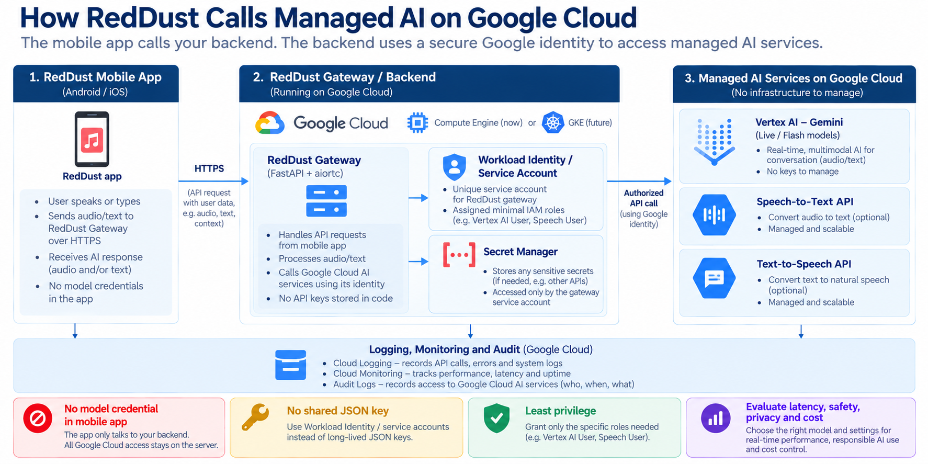
GCP-06: Secure AI Service Integration

Quick knowledge check
- What is the difference between training and inference?
- Why is Vertex AI still subject to IAM and cost governance?
- What does RAG add to a generative AI workflow?
- Why should model evaluation include latency and cost, not only answer quality?
CHAPTER 7

Security, Compliance & Governance
What this chapter does and why it matters
Learn the security model that protects cloud systems: shared responsibility, least privilege, encryption, Zero Trust, IAP, OS Login, service accounts, audit logs, DDoS protection and Security Command Center.

New technical concepts in absolute beginner terms
Shared responsibility, confidentiality/integrity/availability, encryption, TLS, CMEK, Zero Trust, least privilege, authentication, authorization, service account, OS Login, IAP, audit logs, security posture and defense in depth.

RedDust lens
RedDust Step 20 is intentionally identity-centric: individual Google identities, IAM, IAP to TCP 22, OS Login mapping to individual Linux users, 2-Step Verification, and a separate runtime service account. This is the most important chapter for interns who will touch shared cloud infrastructure.

7.1 — Shared Responsibility Model
Google secures the physical data centres, underlying hardware and many layers of managed service infrastructure. Customers secure what they configure and deploy: identities, IAM, application code, data access, network exposure, secrets, guest OS configuration where applicable, and workload behavior. The exact boundary depends on the service.
Layer | Mostly Google responsibility | Mostly customer responsibility
Physical facilities | Data centre access, hardware lifecycle | Choose appropriate locations and services.
Compute Engine virtualization | Hypervisor / infrastructure | Guest OS, packages, application, IAM, firewall design.
Managed services | Service platform operations | Data model, identities, permissions, configuration and application use.
Application | None of your business logic | Secure code, secrets, dependency management, validation and monitoring.

7.2 — Authentication versus Authorization
Authentication asks “Who are you?” Authorization asks “What are you allowed to do?” A user can authenticate successfully to Google but still be denied access to a project because IAM does not grant the required permission.
RedDust analogy
Google identity + 2-Step Verification proves the person. IAM, IAP and OS Login then decide what that person can do and whether they may reach the VM. Authentication success is not authorization success.

7.3 — Least Privilege and Scope
Least privilege means granting only the permissions required, at the narrowest scope that meets the task. It reduces blast radius if an account is compromised or a human makes a mistake.
RedDust developers may need sudo on the one development Gateway VM without needing permission to create arbitrary VMs, change project IAM or administer every service account. This is why the runbook separates project-level Compute Viewer from VM-scoped OS Admin Login and service-account-scoped Service Account User.

7.4 — OS Login
OS Login uses Google identity and IAM to control SSH access to Linux VMs. Instead of maintaining a shared Linux account or manually distributing team SSH keys, each person signs in with their own Google identity and is mapped to an individual Linux account.
Question | Layer that answers it
Can the person see/operate the cloud resource? | Cloud IAM
May the person establish an IAP TCP tunnel? | IAP authorization
May traffic from the IAP proxy reach TCP 22? | VPC firewall
Which Linux account does the user become? | OS Login
May that Linux account use sudo? | Compute OS Admin Login role

7.5 — OS Login 2FA / Google 2-Step Verification
OS Login 2FA adds a second-factor requirement to human SSH login. The Google account must already have 2-Step Verification configured; enabling the project control does not enroll users automatically. Once the hardened path is proven, new users should be onboarded into the already-enabled 2FA model rather than temporarily disabling security.
Read-only check of project metadata
gcloud compute project-info describe \
--project=reddust-development \
--format="yaml(commonInstanceMetadata.items)"

7.6 — IAP and Zero Trust
Zero Trust replaces the old assumption “inside the network = trusted” with continuous identity- and context-based decisions. Identity-Aware Proxy is one Google Cloud mechanism that puts identity authorization in front of access paths. For RedDust administrative SSH, IAP means the VM does not need public port 22 open to the entire Internet.
Defense in depth means IAP is not the only control. IAM must allow the user, the firewall must allow IAP’s source range, OS Login must map the user, and the OS Login role must permit the requested Linux privilege. Every layer answers a different question, and all must pass.

7.7 — Service Accounts and Workload Identity
A service account is an identity for software. On a Compute Engine VM, an attached service account lets applications obtain short-lived credentials from the metadata service. IAM roles on that service account determine which Google Cloud APIs the workload can call.
Security consequence of sudo
A highly privileged VM user can potentially reach workload credentials available to the VM. Therefore the runtime service account must not have more cloud privilege than you are willing to trust to people who have root/sudo on that VM.

7.8 — Encryption at Rest, in Transit and CMEK
Encryption at rest protects stored data on media. Encryption in transit protects data moving over networks, commonly with TLS or workload-specific encrypted protocols. Customer-Managed Encryption Keys (CMEK) let organizations control encryption keys through Cloud KMS for supported services and use cases.
CMEK adds control but also adds operational responsibility: key IAM, rotation, availability and accidental key disablement can affect data access. Use it when requirements justify it rather than as a checkbox.

7.9 — Secrets Management
Secrets such as database passwords, API credentials and signing keys should not be committed to Git, embedded in mobile apps, pasted into documentation or stored in world-readable files. Secret Manager provides centralized secret storage with IAM-controlled access and versioning.
RedDust future pattern
Attach a dedicated workload identity to the Gateway; grant that service account access only to the specific Secret Manager secrets it needs. Avoid distributing long-lived service-account JSON keys to developers or servers.

7.10 — Cloud Audit Logs and Cloud Logging
Audit logs record important administrative and data-access events depending on service and log type. Application and system logs record what workloads are doing. Together they support troubleshooting, security investigations and accountability.
Example read-only log query
gcloud logging read \
'resource.type="gce_instance"' \
--project=reddust-development \
--limit=20 \
--format="table(timestamp,severity,logName,textPayload)"

7.11 — Cloud Armor and DDoS Protection
Cloud Armor provides web-application and DDoS protection capabilities for supported load-balanced applications. It can enforce IP-based rules and managed protections at the edge. It becomes relevant when RedDust exposes production HTTP(S) services behind supported Google Cloud load-balancing architecture.

7.12 — Security Command Center
Security Command Center centralizes security posture findings and asset/security signals. Depending on edition and configuration, it can help identify misconfigurations, vulnerabilities, threats and compliance issues. It is a governance layer—not a replacement for good IAM, patching, secure code or monitoring.

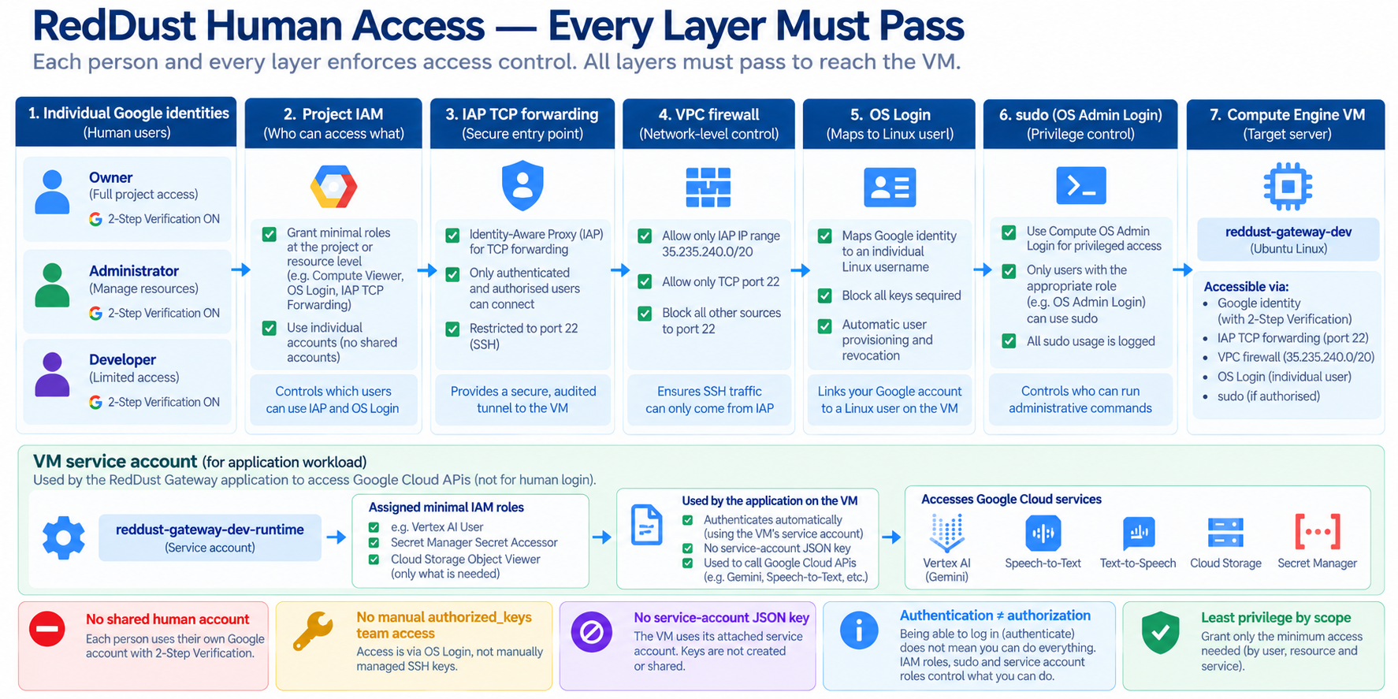
GCP-07: Layered RedDust Access Security

Quick knowledge check
- What is the difference between authentication and authorization?
- Why do IAP and OS Login both exist in the RedDust access path?
- Why can a service account be dangerous if it has broad roles on a VM where many people have sudo?
- Why should secrets not be placed in Git?
CHAPTER 8

Cloud Operations & Financial Governance
What this chapter does and why it matters
Learn how teams keep cloud systems healthy and affordable after deployment: logs, metrics, traces, alerts, SRE thinking, SLIs/SLOs/SLAs, error budgets, billing accounts, budgets and cost optimization.

New technical concepts in absolute beginner terms
Observability, metrics, logs, traces, alerting, APM, SLI, SLO, SLA, error budget, incident response, budget, forecast, cost allocation and FinOps.

RedDust lens
RedDust Step 20 is a development proof, but it still needs operational discipline: health checks, systemd, logs, network diagnostics, budget alerts and stopping the billable e2-medium when testing ends. Step 22 will expand this into CI/CD, DevSecOps, Artifact Registry and stronger observability.

8.1 — Monitoring, Logging and Tracing
Signal | Answers | Example
Metric | How much / how often / how fast? | CPU %, request latency, error count.
Log | What happened? | Gateway startup, exception stack, IAM denial.
Trace | Where did time go across services? | Request path through API → microservice → database.
Alert | When should a human or automation react? | Error rate above threshold for sustained period.

Observability is the ability to understand a system from its outputs. Collecting data is not enough; teams need meaningful dashboards, actionable alerts, retention rules and links from symptoms to root causes.

8.2 — Cloud Monitoring and Cloud Logging
Cloud Monitoring stores metrics and supports dashboards and alerts. Cloud Logging centralizes logs from cloud resources and applications. A Compute Engine workload can export system/application telemetry through Google Cloud agents and application integrations, depending on architecture.
A beginner should first learn the golden questions: Is the service up? Is it responding correctly? Is it fast enough? Are errors increasing? Are resources saturated? Did a deployment change behavior?

8.3 — Application Performance Management (APM)
APM combines telemetry such as traces, profiles, errors and metrics to understand application performance. In a microservices architecture, distributed tracing becomes especially useful because one user action can cross many services.

8.4 — SLI, SLO and SLA
Term | Meaning | Example
SLI — Service Level Indicator | The measured reliability signal. | 99.7% of API requests succeeded in the last 30 days.
SLO — Service Level Objective | Internal target for the SLI. | Target ≥ 99.9% successful requests.
SLA — Service Level Agreement | External/business commitment, often with consequences. | Contract promises a defined availability level.

Do not set an SLO because 99.99% “sounds professional.” Reliability has a cost. The target should reflect user expectations, business value and the architecture’s ability to deliver it.

8.5 — Error Budgets
An error budget is the amount of unreliability allowed by an SLO. If the SLO is 99.9% successful requests, the remaining 0.1% is the error budget. SRE uses error budgets to balance feature velocity against reliability work: when reliability is healthy, teams can take more change risk; when the budget is exhausted, stabilization becomes more urgent.

8.6 — Health Checks and Layered Troubleshooting
RedDust already uses a simple /healthz endpoint to prove that the FastAPI service is alive. But health should be layered. A VM can be running while the service is down; the service can return /healthz while WebRTC media fails; ICE can connect while audio processing fails.
Gate | Question
Infrastructure | Is the VM running and reachable through the intended admin path?
Application | Does /healthz respond?
Signaling | Does /offer exchange SDP successfully?
Connectivity | Does ICE reach connected/completed?
Media | Does encrypted audio travel and return audibly?

8.7 — Billing Accounts, Budgets and Alerts
A billing account pays for linked projects. Budgets compare spending to thresholds and send alerts. A budget is a visibility mechanism; it does not automatically stop a VM. If automatic shutdown is desired, that is a separate automation design with its own safety considerations.
RedDust operating discipline
Use one development Gateway VM unless an experiment requires more, stop it when not in use, avoid unnecessary static resources and quota increases, and review billing reports regularly. Promotional credits can hide the underlying architecture cost, so track gross consumption too.

8.8 — Cost Optimization Principles
Principle | Beginner action
Right-size | Do not run more CPU/RAM than the workload needs.
Stop idle compute | Development VMs should not run 24×7 unless necessary.
Use managed scaling where appropriate | Prefer services that scale down when the workload allows it.
Watch data transfer | Network egress can be material for media/data-heavy products.
Storage lifecycle | Move/delete data based on retention and access needs.
Tag/label resources | Make cost ownership and environment visible.
Review recurring waste | Old disks, IPs, snapshots and test resources can accumulate.

8.9 — DevOps, CI/CD and DevSecOps
DevOps combines development and operations practices to make software changes repeatable, observable and safe. Continuous Integration (CI) automatically validates code changes. Continuous Delivery/Deployment (CD) moves tested artifacts through environments. DevSecOps integrates security controls—dependency scanning, secret scanning, image scanning, policy and provenance—into that delivery lifecycle.
For RedDust, the roadmap is: prove VM parity first; then add CI/CD, DevSecOps and Artifact Registry; later deploy microservices on GKE with dev/staging/prod, managed secrets, observability, TURN and HTTPS. The order matters because automation should encode a understood working system, not automate unknown failures.

8.10 — Infrastructure as Code
Infrastructure as Code (IaC) describes cloud infrastructure in version-controlled configuration. Terraform is a common tool. Instead of relying on manual console clicks, the desired resources and settings are reviewed as code, planned, applied and recorded in state.
Illustrative Terraform provider context used by the RedDust infrastructure roadmap
terraform {
required_version = "= 1.16.4"
}
provider "google" {
project = "reddust-development"
region = "australia-southeast1"
}

Brownfield rule
When infrastructure already exists, do not blindly “apply” new Terraform and hope it matches. Inventory existing resources, write matching code, import/adopt them, inspect the plan, reconcile drift and reach a no-op plan before controlled change.

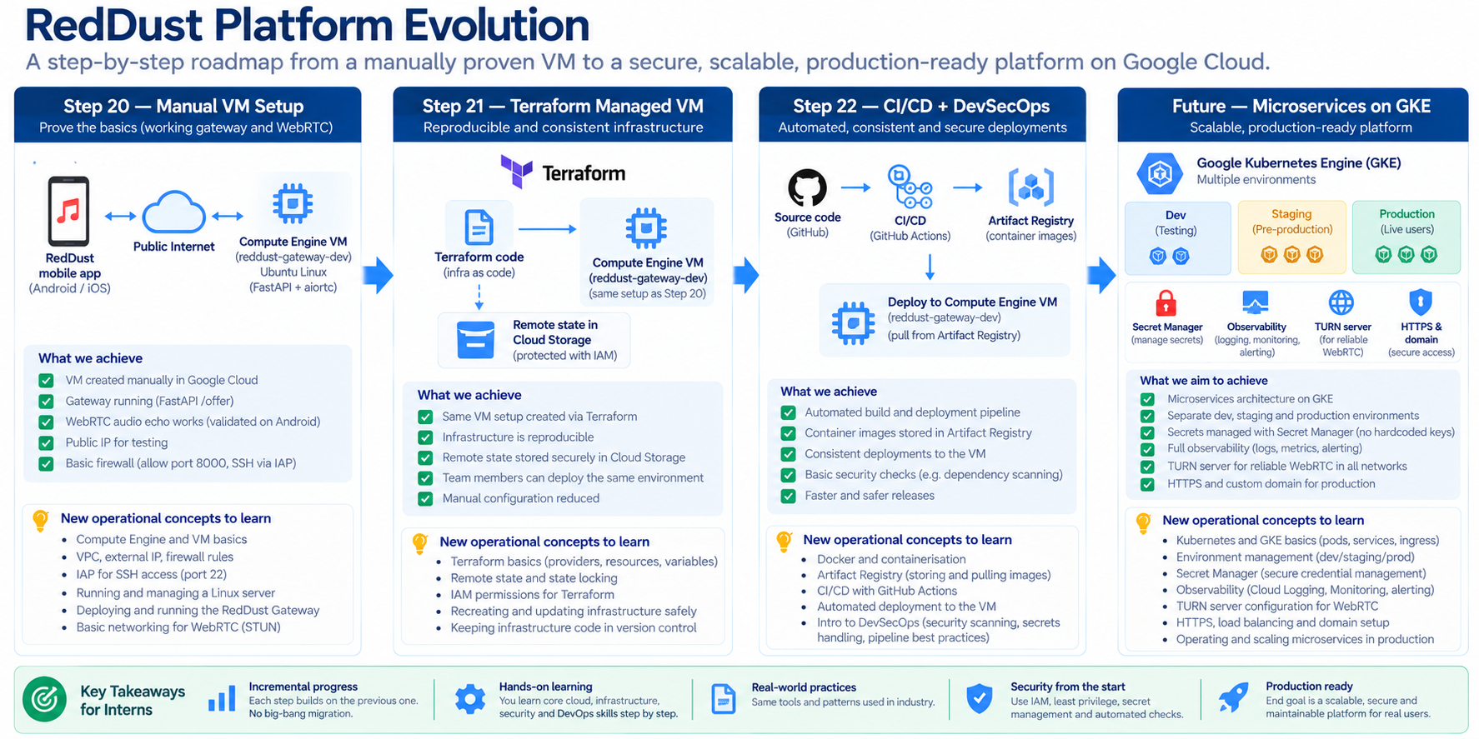
GCP-08: RedDust Platform Evolution Roadmap

Quick knowledge check
- Why is a budget alert not the same as an automatic shutdown?
- What is the difference between an SLI and an SLO?
- Why should CI/CD automate a known-good deployment pattern rather than a poorly understood one?
- What does Terraform state represent at a high level?

Appendix

Appendix A – RedDust-to-GCP Cheat Sheet
This appendix maps the abstract Google Cloud concepts in the book to the concrete names used in the Step-20 RedDust runbook. It is intentionally concise so interns can keep it beside the implementation guide.
Cloud concept | RedDust implementation / example
Organization | red-dust-proj-org (where applicable in the runbook)
Project | reddust-development / RedDust Development
Primary region | australia-southeast1 (Sydney)
Primary zone | australia-southeast1-b
Compute Engine VM | reddust-gateway-dev
Machine type | e2-medium
Guest OS | Ubuntu 24.04 LTS
Boot disk | 10 GB pd-standard
Application runtime | Python 3.12.10 + shared Linux virtual environment
Gateway stack | FastAPI + Uvicorn + aiortc + PyAV
Human SSH identity | Individual Google identity → IAP → OS Login → individual Linux user
Workload identity | reddust-gateway-dev-runtime service account
Admin SSH | IAP TCP forwarding → TCP 22 → OS Login
Temporary signaling | HTTP TCP 8000
WebRTC media | UDP ephemeral range + ICE/STUN; TURN later
Process manager | systemd
Cost control | Budget alerts + stop VM when not testing
Future IaC | Terraform
Future delivery | CI/CD + DevSecOps + Artifact Registry
Future runtime | GKE microservices with dev/staging/prod, secrets, observability, TURN, HTTPS

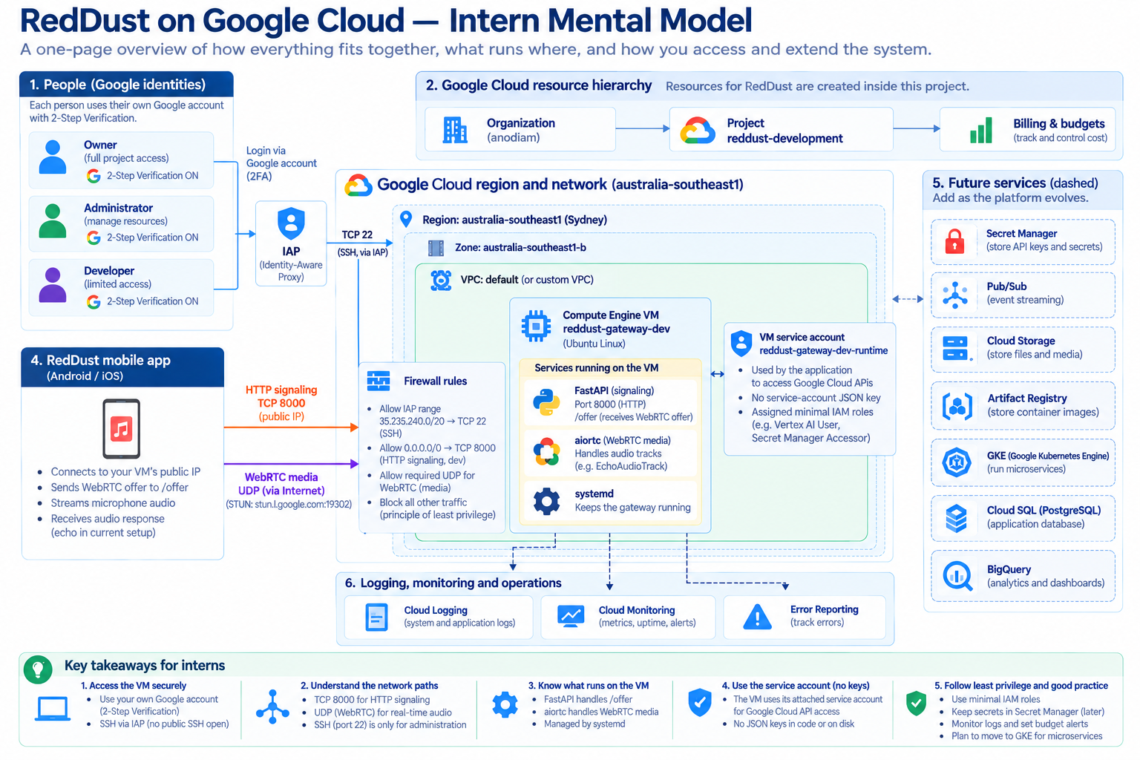
GCP-A1: Entire RedDust GCP Mental Model

Appendix B — gcloud & Cloud Shell Survival Guide
The Google Cloud CLI (gcloud) lets you inspect and manage Google Cloud from a terminal. Cloud Shell is a browser-based shell environment where gcloud is already installed. Interns should learn to verify identity and project context before every command batch.
The three pre-flight questions
1) Which Google identity is active? 2) Which project is active? 3) Is this command read-only or does it change cloud state?

Orientation
gcloud auth list
gcloud config get-value project
gcloud config list

Project and API discovery
gcloud projects describe reddust-development \
--format="yaml(projectId,name,projectNumber,parent)"
gcloud services list --enabled \
--project=reddust-development \
--format="table(NAME,TITLE)"

Compute and networking inventory
gcloud compute instances list --project=reddust-development
gcloud compute networks list --project=reddust-development
gcloud compute networks subnets list --project=reddust-development
gcloud compute firewall-rules list --project=reddust-development

Identity discovery — requires sufficient IAM permissions
gcloud iam service-accounts list --project=reddust-development
gcloud projects get-iam-policy reddust-development \
--format="table(bindings.role,bindings.members)"

Do not learn cloud by destructive experiments in the team project
Creating/deleting VMs, disabling APIs, changing other people’s IAM, deleting service accounts, modifying firewall rules or rotating credentials are write operations. Use an approved sandbox or an assigned runbook step.

Appendix C — Glossary for Absolute Beginners
Term | Plain-English definition
API | A defined interface software uses to request an operation from another system.
Availability zone | A deployment location/failure domain within a region.
Bucket | Top-level container for Cloud Storage objects.
CIDR | Notation for an IP address range, such as 10.0.0.0/24.
Cloud Shell | Browser-based command-line environment with Google Cloud tooling.
Container | Packaged application plus user-space dependencies that shares a host kernel.
DNS | System that maps names to IP addresses.
Egress | Traffic leaving a system/network.
Firewall | Rule set controlling allowed or denied network traffic.
IAM | Identity and Access Management: who can do what on which resource.
IAP | Identity-Aware Proxy; identity-aware access and TCP forwarding capability.
Ingress | Traffic entering a system/network.
Instance | A running or defined virtual machine resource.
Least privilege | Give only the access necessary for a task.
Load balancer | Frontend that distributes traffic to backend services.
Metadata server | Special endpoint through which a GCE workload can obtain instance information and short-lived credentials for an attached service account.
Object | Named data item stored in an object storage bucket.
OS Login | Google identity/IAM-based Linux SSH login for Compute Engine.
Principal | Identity making an access request.
Project | Core GCP boundary for resources, IAM, APIs, quotas and billing linkage.
Region | Geographic cloud location containing zones.
Role | Named bundle of IAM permissions.
Service account | Identity intended for software/workloads.
SLA | Service Level Agreement: formal external reliability commitment.
SLI | Service Level Indicator: measured reliability signal.
SLO | Service Level Objective: target for an SLI.
Subnet | Regional IP address range within a VPC.
Terraform state | Terraform’s record mapping configuration to managed real-world resources.
VPC | Virtual Private Cloud: logically isolated software-defined cloud network.
VM | Virtual machine: software-defined computer with CPU, memory, disks and OS.
Zone | Deployment area inside a region.

Appendix D — 30-Day Intern Learning Plan
Days | Focus | Practical outcome
1–3 | Chapter 1: cloud, regions/zones, projects, IAM | Can explain resource hierarchy and authentication vs authorization.
4–7 | Chapter 2: Compute Engine + Linux basics | Can safely inspect the RedDust VM and explain machine type, disk, image and systemd.
8–11 | Chapter 4: VPC, IPs, firewalls, TCP/UDP, IAP | Can draw the three RedDust network paths and troubleshoot which layer failed.
12–15 | Chapter 7: IAM, OS Login, service accounts, 2FA, audit | Can explain least privilege and human vs workload identity.
16–18 | Chapter 8: logs, monitoring, cost and SRE | Can inspect basic telemetry and explain budgets, SLI/SLO.
19–21 | Chapter 3: storage and databases | Can choose between Cloud Storage, Cloud SQL and NoSQL at a high level.
22–24 | Chapter 5: Pub/Sub, Dataflow, BigQuery | Can explain event-driven and analytical architecture.
25–27 | Chapter 6: Vertex AI / Gemini concepts | Can explain secure AI API integration and evaluation dimensions.
28–30 | Review + RedDust architecture walkthrough | Presents the Step-20 architecture and future roadmap to another intern without notes.

Final Intern Readiness Checklist
- ☐ I can explain why RedDust uses Sydney and what region/zone mean.
- ☐ I can distinguish project IAM from OS Login, IAP and Linux sudo.
- ☐ I can explain human identity versus workload/service-account identity.
- ☐ I can explain why /offer success does not prove WebRTC media success.
- ☐ I know the difference between TCP 22, TCP 8000 and UDP media in the Step-20 architecture.
- ☐ I can safely inspect a VM, VPC, firewall rules, service accounts and logs using read-only commands.
- ☐ I understand that budget alerts notify; they do not automatically stop resources.
- ☐ I can compare Compute Engine, GKE, Cloud Run and functions at a high level.
- ☐ I can distinguish Cloud Storage, Cloud SQL, Firestore, Bigtable and BigQuery by purpose.
- ☐ I can explain Pub/Sub, Dataflow and an event-to-analytics pipeline.
- ☐ I can explain Vertex AI/Gemini as governed cloud services with IAM, cost and data-handling implications.
- ☐ I know that production changes must follow reviewed runbooks/IaC, not ad hoc experiments in a shared project.

Closing Perspective
The most important skill in cloud engineering is not memorizing product names. It is learning to reason in layers: identity, resource hierarchy, network path, compute/runtime, data, observability, security and cost. When something fails, identify which layer is answering which question. When something works, verify that it works for the intended reason rather than because an overly broad permission or firewall rule accidentally made the test pass.
For RedDust, the immediate goal is modest and deliberate: prove a secure, observable, cost-conscious WebRTC Gateway on Compute Engine. Once that boundary is understood and repeatable, Terraform, CI/CD, DevSecOps, Artifact Registry and GKE become controlled engineering steps rather than a collection of unrelated cloud products.

Reference Basis
This book was prepared as an educational companion to the attached RedDust Step-20 “Move Gateway to Cloud” implementation runbook and expands its concrete Compute Engine, IAM, IAP, OS Login, networking, runtime and cost-control patterns into a broad GCP fundamentals curriculum. The chapters also follow the subject areas commonly encountered in Google Cloud Digital Leader and Associate Cloud Engineer foundational study. For production decisions, always validate service behavior and current product documentation before change approval.

