Platform Architecture
Step 20 — Move Gateway to Cloud
Implementation runbook for Google Cloud Compute Engine (e2-medium)

Project RedDust


From Anodiam


Version | Publisher | Date | Reviewer | Date
1.0.0 | Anirban Chakrabarty | 17/10/2026 |  | 17/10/2026

Contents
Introduction to Step 20 5
20.0 — What Is Moving? Understand That Exactly 6
20.0.1 — Path 1: HTTP signalling 6
20.0.2 — Path 2: WebRTC media 7
20.1 — Freeze Baseline Code – Known-Good Local Baseline before GCP 7
20.1.1 — Open the Windows Gateway project 7
20.1.2 — Re-run the local echo 7
20.1.3 — Add or verify a health endpoint 7
20.1.4 — Prepare a portable dependency definition 7
20.1.5 — Never copy the Windows .venv 7
20.2 — Create RedDust GCP Project from Scratch 8
20.2.1 — Sign in to the intended RedDust Google account 8
20.2.2 — Create the project 8
20.2.3 — Enable Compute Engine when prompted 9
20.2.4 — Link billing before creating resources 9
20.3 — Create Cost Visibility before the First VM 9
20.3.1 — Create the budget 9
20.3.2 — Free-trial credits and gross cost visibility 9
20.3.3 — Operating discipline for e2-medium 9
20.4 — Choose Region: Sydney for the e2-medium Design 10
20.4.1 — Optional US cost/latency comparison later 10
20.5 — Configure IAM and OS Login before Creating the VM — setting up just enough access to the required resources for each team member 11
20.5.1 — Objectives and completion criteria 11
20.5.2 — Identity Register and Target Tiers 11
20.5.3 — Least-Privilege Target IAM Model 12
20.5.4 — Understand Two Authorization Layers 12
20.5.5 — Owner Pre-flight: Establish Correct Project Context 13
20.5.6 — Enable Required APIs before delegating administration 14
20.5.7 — Audit the human-access starting state 14
20.5.8 — Enable OS Login project-wide before any VM is created 14
20.5.9 — Grant the Administrator tier from scratch 15
20.5.10 — Grant the Developer tier from scratch (pre-VM phase) 15
20.5.11 — Organization/ external-user check for OS Login 16
20.5.12 — Verify the complete project-level IAM before VM creation 16
20.5.13 — Test the Developer path before onboarding other developers 17
20.5.14 — Test the Administrator path before onboarding other admins 17
20.5.15 — Optional: Policy Troubleshooter – verify permissions non-destructively 18
20.6 — Create the Compute Engine VM 18
20.6.1 — Basic machine configuration 18
20.6.2 — Open Create instance 19
20.6.3 — Select Ubuntu 24.04 LTS standard image 19
20.6.4 — Configure the boot disk 19
20.6.5 — Service account 19
20.6.6 — OS Login during creation 20
20.6.7 — Immediately after GCP Compute VM ‘reddust-gateway-dev’ creation 20
20.6.8 — Test the developer identity after the VM exists 26
20.6.9 — Test the administrator identity after the VM exists 27
20.6.10 — Harden OS Login with 2-Step Verification and Direct 2FA Onboarding 28
20.6.11 — Troubleshooting decision table 33
20.6.12 — Offboarding and access revocation pattern 34
20.6.13 — Final acceptance checklist 39
20.6.14 — Resulting RedDust access model 39
20.6.15 — Authoritative Google Cloud references 40
20.7 — Configure Networking in the Create VM Screen 40
20.7.1 — Open Networking 40
20.7.2 — VPC and subnet 40
20.7.3 — Internal and external addresses 40
20.7.4 — Network tag 40
20.7.5 — Generic HTTP/HTTPS checkboxes 41
20.7.6 — Final review before Create 41
20.8 — Add IAP-Secured SSH to the RedDust Access Model 41
20.8.1 — CIDR Primer: Understanding 35.235.240.0/20 42
20.8.2 — Access Path and Security Model 43
20.8.3 — Enable the IAP API 43
20.8.4 — Grant IAP-Secured Tunnel User to the Team Members 43
20.8.5 — Verify the IAP IAM Bindings 44
20.8.6 — Discover the VM Zone and VPC Network 44
20.8.7 — Allow the IAP Source Range through the Firewall 44
20.8.8 — Keep the Existing OS Login Model 44
20.8.9 — Start the VM and Test SSH Through IAP 44
20.8.10 — Only After IAP Works, Close Direct Internet SSH 45
20.8.11 — Acceptance Checklist 45
20.8.12 — Final RedDust Access Model 46
Reference Notes 46
20.9 — First Boot: Verify OS, Resources, OS Login and Sudo before Installing Anything 46
20.9.1 — Verify operating system 46
20.9.2 — Verify e2-medium resources 46
20.9.3 — Verify OS Login metadata 46
20.9.4 — Verify sudo immediately 47
20.9.5 — Verify sudo remains valid after five minutes 47
20.10 — Install System Dependencies and Shared Python Environment 47
20.10.1 — Fully Update Ubuntu 24.04 47
20.10.2 — Install Build Tools, Media Utilities and Diagnostics 47
20.11 — Install Shared Python 3.12.10 and Create the Shared RedDust Virtual Environment without Modifying Ubuntu System Python 48
Team .venv 48
Single user .venv 62
20.12 — Upload Existing Gateway Source and Install Dependencies 63
20.12.1 — Build a clean archive on Windows 64
20.12.2 — Upload through SSH-in-browser 66
20.12.3 — Activate the Linux environment and install requirements 67
20.12.4 — Verify critical packages 67
20.13 — Start FastAPI Manually on VM before Opening Firewall 67
20.13.1 — Test from another SSH tab or terminal 67
20.14 — Create the Temporary TCP 8000 Signalling Firewall Rule 67
20.15 — Test FastAPI across the Public Internet 68
20.16 — Configure STUN Explicitly on Both Peers 69
20.16.1 — React Native RTCPeerConnection 69
20.16.2 — aiortc RTCPeerConnection 69
20.17 — Determine the VM UDP Ephemeral Port Range 70
20.18 — Create the WebRTC UDP Firewall Rule 70
20.19 — Add WebRTC Diagnostic Log before Pointing the App at GCP 71
20.19.1 — React Native logging 71
20.19.2 — aiortc logging 71
20.20 — Point the Mobile App at the GCP Gateway 71
20.20.1 — Important Android cleartext note 72
20.21 — First Cloud WebRTC Test: Phone on Wi-Fi 72
20.22 — Second Cloud WebRTC Test: Disable Wi-Fi and Use 4G/5G 73
20.23 — Remove Metro as a Variable during the 4G/5G Test 73
20.24 — Define Success as Four Independent Gates 74
20.25 — Troubleshooting by Layer 74
20.25.1 — External /healthz fails 74
20.25.2 — /healthz works but /offer fails 74
20.25.3 — /offer and SDP succeed but ICE fails 74
20.25.4 — ICE connects but no audio returns 74
20.25.5 — Wi-Fi passes but 5G repeatedly fails 75
20.26 — Put the Proven Gateway under systemd 75
20.26.1 — Record the OS Login Linux username 75
20.26.2 — Create the service unit 75
20.26.3 — Enable and start 76
20.26.4 — Follow logs 76
20.27 — Stop the Billable VM when Development Ends 76
20.27.1 — Optional scheduled stop 76
20.28 — Stabilise the Address only after the Architecture Works 76
20.29 — HTTPS Hardening Comes after the WebRTC Proof 76
20.30 — TURN/coturn Is Next Reliability Layer, Not the First Cloud Step 77
20.31 — Final Step-20 Architecture 78
Step 20 Completion Checklist 78
Condensed Implementation Sequence 80
Architectural Boundary to Preserve 80
Selected Technical References 81
Next Planned Engineering Step 81
20.32 — Complete TURN/coturn Implementation for Reliable Internet WebRTC 81
20.32.1 — Understand the role of TURN in the RedDust media path 81
20.32.2 — Reserve a stable external IPv4 address before configuring coturn 82
20.32.3 — Add a TURN DNS name 82
20.32.4 — Install coturn on Ubuntu and inspect the packaged service 82
20.32.5 — Create narrowly scoped GCP firewall rules for TURN 82
20.32.6 — Generate a strong TURN REST shared secret 83
20.32.7 — Configure /etc/turnserver.conf 83
20.32.8 — Enable and start coturn under systemd 84
20.32.9 — Add a Gateway endpoint that mints short-lived TURN credentials 84
20.32.10 — Configure React Native WebRTC to use STUN plus authenticated TURN 85
20.32.11 — Give the aiortc peer the same TURN capability 85
20.32.12 — Validate coturn locally before testing WebRTC 85
20.32.13 — Run three WebRTC acceptance tests 85
20.32.14 — Prove which candidate pair was selected 86
20.32.15 — Add TURN over TLS on TCP 5349 86
20.32.16 — Harden the TURN service before pilot use 86
20.32.17 — Troubleshoot TURN by layer 87
20.32.18 — Add operational logging and monitoring 87
20.32.19 — Production evolution path 87
20.32.20 — TURN/coturn completion checklist 88
20.32.21 — Final Step-20 networking architecture after TURN 88
Technical references for this section 88
20.33 — Provision RedDust Dev Cloud SQL PostgreSQL Infrastructure 89
20.33.1 — RedDust target configuration and precise completion boundary 89
20.33.2 — Concepts: instance, database, edition, region, network and identity 90
20.33.3 — Owner pre-flight: billing, credit, IAM and APIs (console-only execution) 90
20.33.4 — Estimate ongoing costs BEFORE provisioning 90
20.33.5 — Create or verify Private Services Access before Cloud SQL creation 91
20.33.6 — Console procedure: create the PostgreSQL Enterprise instance 92
20.33.7 — Create logical reddust_dev database; no application users or schema 93
20.33.8 — Inspect instance infrastructure, patching and maintenance without touching applications 93
20.33.9 — Maintenance/patching deep dive: what happens automatically, what we schedule 94
20.33.10 — Backups & high availability: infrastructure visibility (exercises later) 95
20.33.11 — Security baseline and explicit non-goals 95
20.33.12 — Acceptance checklist and evidence inventory 95
20.33.13 — Troubleshooting by layer (non-destructive) 96
20.33.14 — Future architectural handoff: how RedDust evolves AFTER Step 20.33 96
20.33.15 — Authoritative references and console links 97
20.33.16 — Cloud SQL Scaling Model, Cost Controls & RedDust Recommendation 97

Introduction to Step 20
This Step 20 assumes the team has completed the local LAN echo milestone in Step 19 but has not yet created any RedDust Google Cloud project, IAM configuration, VM, firewall rule, Linux environment, or public endpoint. It therefore starts from zero and builds the entire Internet-facing development environment in a controlled order.
In Step 20, we will move the existing RedDust WebRTC Gateway — FastAPI, aiortc and EchoAudioTrack — from the developer’s Windows laptop on the local LAN to an Ubuntu Compute Engine VM in Google Cloud, while the React Native mobile app remains on the user’s Android phone and begins communicating with the Gateway across the public Internet. To make that possible, we will create the required GCP project, IAM/OS Login and IAP access model, Compute Engine VM, Linux/Python runtime, firewall rules, public signalling path and WebRTC media path, and we will configure the WebRTC ICE process, including ICE candidate gathering, STUN-based server-reflexive candidate discovery, ICE connectivity checks and UDP media establishment; TURN/relay candidates are deliberately deferred to the next reliability step once direct STUN-assisted Internet connectivity has been proven.
The goal is not to build the final production platform. The goal is to prove that the existing React Native + react-native-webrtc client can establish a real Internet WebRTC connection to a Python FastAPI + aiortc Gateway running on Google Cloud, and that microphone audio can travel to EchoAudioTrack and return audibly to the phone.
We will be using a shared runtime (Python virtual environment) for the entire team under the GCP VM’s /opt/reddust folder. All subsequent upload, package-install, manual-run and systemd instructions are aligned to that shared runtime model. Unrelated WebRTC, GCP networking, STUN, firewall and Terraform concepts retain the same architectural intent.
Canonical clean-slate Step-20 baseline
GCP project: RedDust Development
Recommended region: australia-southeast1 (Sydney)
Preferred zone: australia-southeast1-b
VM: reddust-gateway-dev
Machine: e2-medium — 2 vCPUs exposed, 1.0 fractional vCPU allocation, 4 GB RAM
Provisioning: Standard / non-Spot
OS: Ubuntu 24.04 LTS standard image, x86-64 / amd64, codename noble
Boot disk: 10 GB Standard Persistent Disk (pd-standard)
Human SSH access: OS Login controlled through IAM
Administrator role: Compute OS Admin Login (roles/compute.osAdminLogin)
VM service account: None for Step 20, if the console permits it
RedDust Python: exact Python 3.12.10 via pyenv and a Linux .venv
Temporary signalling: HTTP TCP 8000
WebRTC media: UDP ephemeral port range discovered from the VM
ICE: STUN enabled; TURN/coturn deliberately deferred to the next reliability step.
Why Sydney region? e2-medium is billable in any region, so for a real-time voice experiment whose intended users and demos are in Australia, Sydney (australia-southeast1) is the default choice because it reduces network distance and makes the WebRTC latency test more representative. If the team later wants a cheaper US-region comparison, the same runbook can be repeated in us-west1 without changing the application architecture.
Cost warning: e2-medium is not the Compute Engine Always Free e2-micro instance. It is a billable VM and will consume free-trial credit or paid usage. Create budget alerts before the VM, stop the VM when it is not being actively tested, and review the estimated monthly cost shown by the GCP Create VM screen before clicking Create.
systemd: It is Ubuntu’s standard system and service manager: it starts, stops, monitors, and restarts background services, and can automatically launch them when the VM boots. In RedDust, systemd will eventually run the Gateway as the dedicated reddust Linux service account using the shared virtual environment directly, so the application keeps running independently of any developer’s SSH session and does not rely on someone manually activating .venv or starting Uvicorn from a terminal.
DIAGRAM 20-A: Step 19 LAN Prototype versus Step 20 Internet Gateway
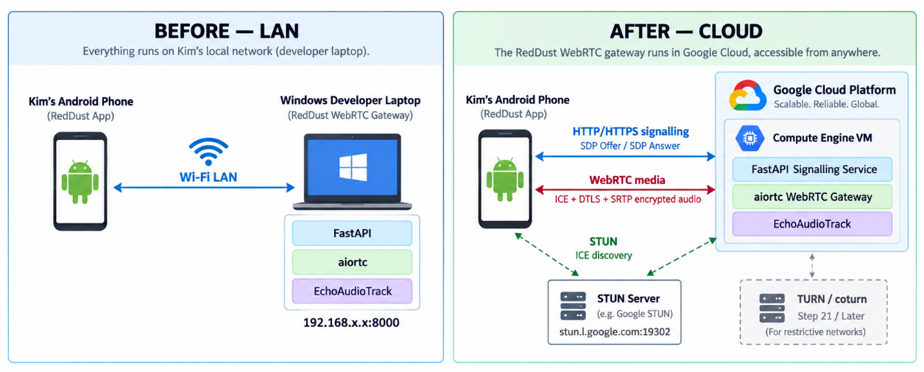

20.0 — What Is Moving? Understand That Exactly
The most important troubleshooting rule is that signalling and WebRTC media are separate network paths. Moving the Gateway to GCP changes both paths, but success on one path does not prove success on the other.

20.0.1 — Path 1: HTTP signalling
React Native App
│ HTTP POST /offer
│ SDP Offer
▼
FastAPI on GCP
│
▼
aiortc RTCPeerConnection
│ SDP Answer
▼
FastAPI response
│
▼
React Native App
DIAGRAM 20-B: Signalling is Handshaking. It is not Media Transmission
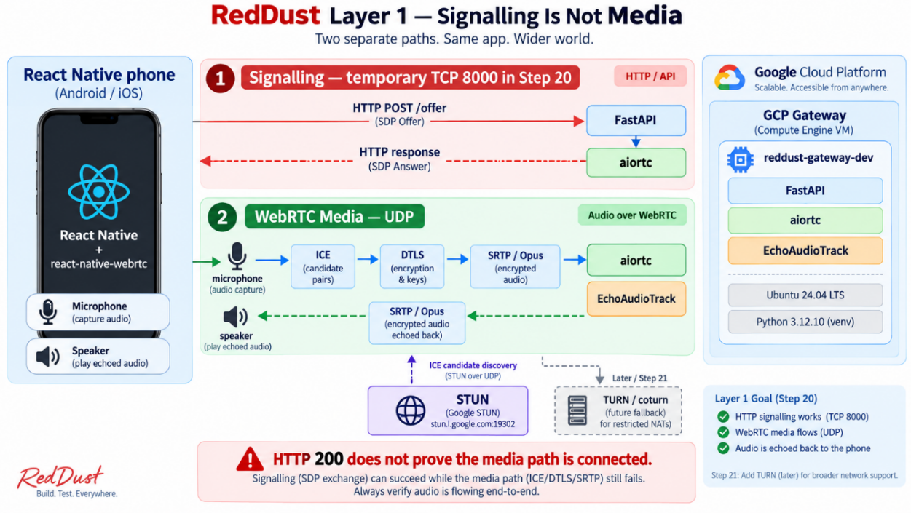

20.0.2 — Path 2: WebRTC media
Phone microphone
│ ICE connectivity checks
│ DTLS key negotiation
│ SRTP encrypted Opus audio
▼
aiortc on GCP
│
▼
EchoAudioTrack
│ SRTP encrypted return audio
▼
Phone speaker
Critical diagnostic rule: HTTP 200 from /offer means signalling works. It does not mean WebRTC audio works. Always inspect ICE state, peer-connection state and track events separately.

20.1 — Freeze Baseline Code – Known-Good Local Baseline before GCP
The cloud migration should change infrastructure, not application behaviour. First prove that the Windows Gateway still works exactly as it did at the end of Step 19.

20.1.1 — Open the Windows Gateway project
cd D:\RedDust\reddust-gateway
.venv\Scripts\Activate.ps1
python –version
Expected application Python version:
Python 3.12.10

20.1.2 — Re-run the local echo
1. Start the existing FastAPI/aiortc Gateway on the Windows laptop.
2. Run the existing React Native WebRTC echo flow over the local LAN.
3. Confirm the phone microphone reaches aiortc.
4. Confirm EchoAudioTrack returns audio and the phone speaker plays it.

20.1.3 — Add or verify a health endpoint
@app.get("/healthz")
async def healthz():
return {
"status": "ok",
"service": "reddust-gateway"
}
Start Uvicorn locally:
uvicorn main:app --host 0.0.0.0 --port 8000
Test:
http://127.0.0.1:8000/healthz
Expected:
{"status":"ok","service":"reddust-gateway"}

20.1.4 — Prepare a portable dependency definition
If the project already has a curated requirements.txt, keep it. If not, create one from the known-good Windows environment and review it for Windows-only packages before installing on Linux.
python -m pip freeze > requirements.txt
Get-Content requirements.txt

20.1.5 — Never copy the Windows .venv
Do not upload these to GCP
.venv/
__pycache__/
*.pyc
large logs
temporary build outputs
Cross-platform rule: Match Python 3.12.10, source code and application dependencies. Recreate the virtual environment on Linux. A Windows .venv contains Windows-specific paths and binaries and must not be copied to Ubuntu.
DIAGRAM 20-C: Windows-to-Linux Deployment Boundary
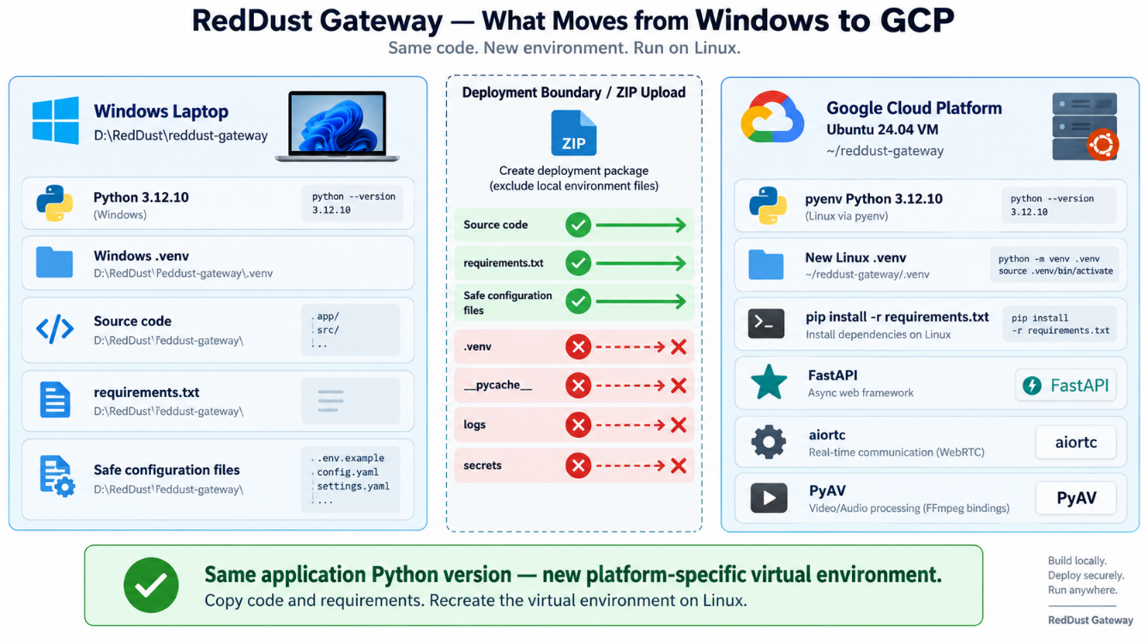

20.2 — Create RedDust GCP Project from Scratch
Log in as the owner (red.dust.proj@gmail.com). As described in detail in section 20.2.2 below, we will create a New Project named "RedDust Development" (Project ID = "reddust-development") Inside the organization: “red-dust-proj-org” (ID=173416320671), and link the project with a billing account.
We will use this dedicated development project for all dev work in RedDust platform, so that billing, IAM, firewall rules and experiments remain isolated from unrelated cloud development. Do not create staging or production projects in this step.

20.2.1 — Sign in to the intended RedDust Google account
1. Open the Google Cloud Console from owner account (red.dust.proj@gmail.com)
2. Confirm the intended RedDust Google identity (red.dust.proj@gmail.com) in the profile menu.
3. Avoid creating the project under a personal or unrelated Google account.

20.2.2 — Create the project
1. Open project selector in top bar. Choose New Project, or navigate to IAM & Admin → Manage Resources → Create Project.
2. Project name: RedDust Development.
3. Choose a globally unique Project ID such as reddust-development-xxxxx.
4. If the account is not part of a Workspace organization, No organization is acceptable for this MVP/dev stage.
5. Create the project and then explicitly select RedDust Development in the project selector.
Project field | Example | Purpose
Project name | RedDust Development | Human-readable console name
Project ID | reddust-development-xxxxx | Technical identifier used by APIs, CLI, IAM and logs
Project number | Generated by Google | Internal numeric resource identifier

20.2.3 — Enable Compute Engine when prompted
The first visit to Compute Engine may prompt you to enable its API. Enable it and wait for initialization before creating the VM.

20.2.4 — Link billing before creating resources
1. With RedDust Development selected, open Billing.
2. Confirm the project is linked to the active Cloud Billing account.
3. If the project has no billing account, use Link a billing account and attach the intended active account.
4. Do not proceed to VM creation until project + billing relationship is confirmed.
DIAGRAM 20-D: Project, Billing, IAM and Resource Hierarchy
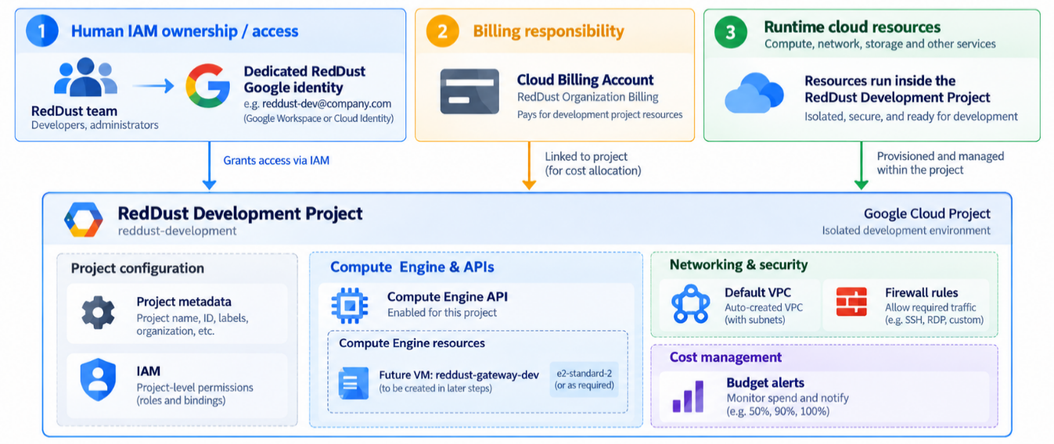

20.3 — Create Cost Visibility before the First VM
Because e2-medium is billable, set the budget before the VM exists. Use an alerts-only budget. A budget is an alerting mechanism; it does not automatically stop a Compute Engine VM.

20.3.1 — Create the budget
1. Open Billing → Budgets & alerts → Create Budget.
2. Choose Alerts only.
3. Name: RedDust Development Monthly Budget.
4. Time range: Monthly.
5. Scope the budget to the RedDust Development project.
6. Services: All services.
7. Budget amount: a fixed monthly amount appropriate for the team's development allowance.
8. Configure Actual thresholds at 25%, 50%, 75%, 90% and 100%.
9. Add a 100% Forecasted threshold.
10. Enable email notifications to the relevant billing administrators/users and project owners.
11. Do not add Pub/Sub budget automation yet.

20.3.2 — Free-trial credits and gross cost visibility
If the budget screen allows you to include or exclude promotional/free-trial credits, choose the setting that best matches your management goal. For startup economics, it is useful to see the approximate underlying resource consumption rather than letting promotional credits hide the cost of the architecture.

20.3.3 — Operating discipline for e2-medium
- Run only one development Gateway VM unless a specific experiment requires more.
- Stop the VM after each active test session.
- Do not request unnecessary quota increases.
- Do not reserve unused static public IPs.
- Review Billing → Reports / Cost table regularly.
- Consider an automatic evening stop schedule after the VM is proven.
Important: A 100% budget alert means "notify us" — not "shut the VM down". Compute Engine cost control still depends on operational discipline and optional scheduling/automation.
DIAGRAM 20-E: Three-Layer Development Cost Control
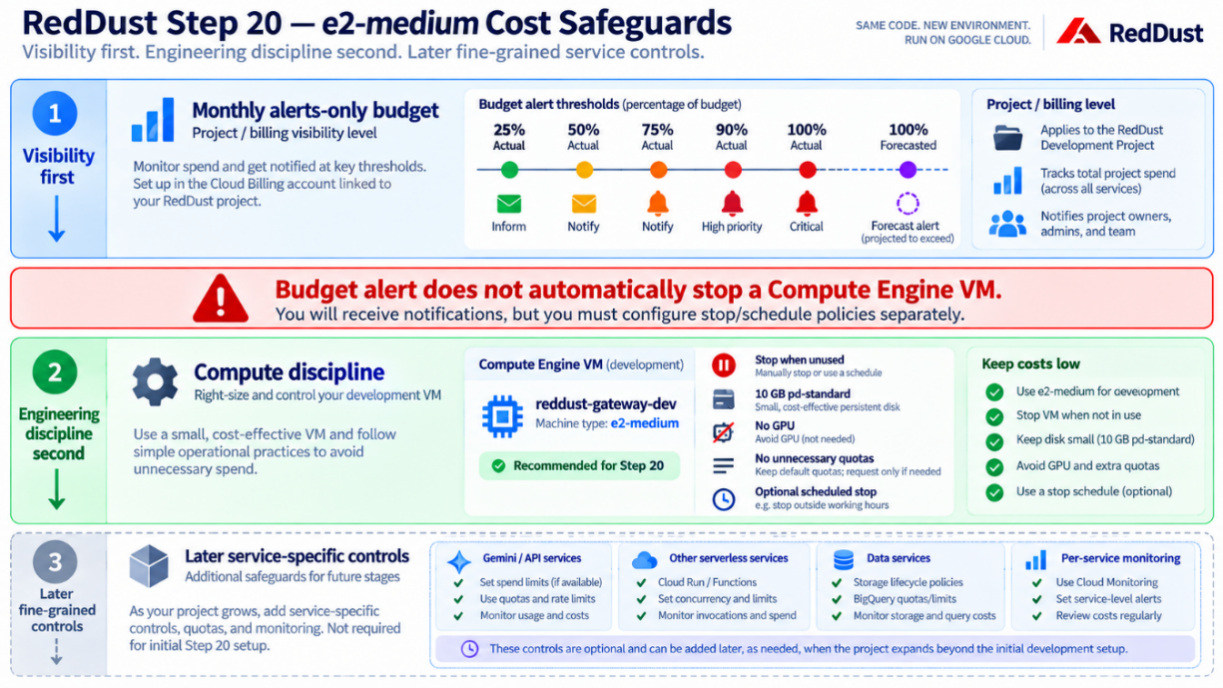

20.4 — Choose Region: Sydney for the e2-medium Design
For this clean-slate version, use Sydney because e2-medium is paid regardless of region and RedDust is testing real-time voice interactions for Australian users. The benefit of shorter network distance is more valuable than preserving the earlier Oregon/free-tier rationale that applied only to e2-micro.
Region: australia-southeast1
Location: Sydney, Australia
Preferred zone: australia-southeast1-b
Alternative zones: australia-southeast1-a / australia-southeast1-c
Google currently lists E2 machines as available in all three australia-southeast1 zones.

20.4.1 — Optional US cost/latency comparison later
If the team later wants a cost or latency A/B test, deploy the same immutable Gateway in us-west1 and compare ICE connection time, round-trip audio latency, and jitter and packet loss. Do not mix that experiment into the first clean-slate setup.
DIAGRAM 20-F: Australian User to Sydney GCP Region
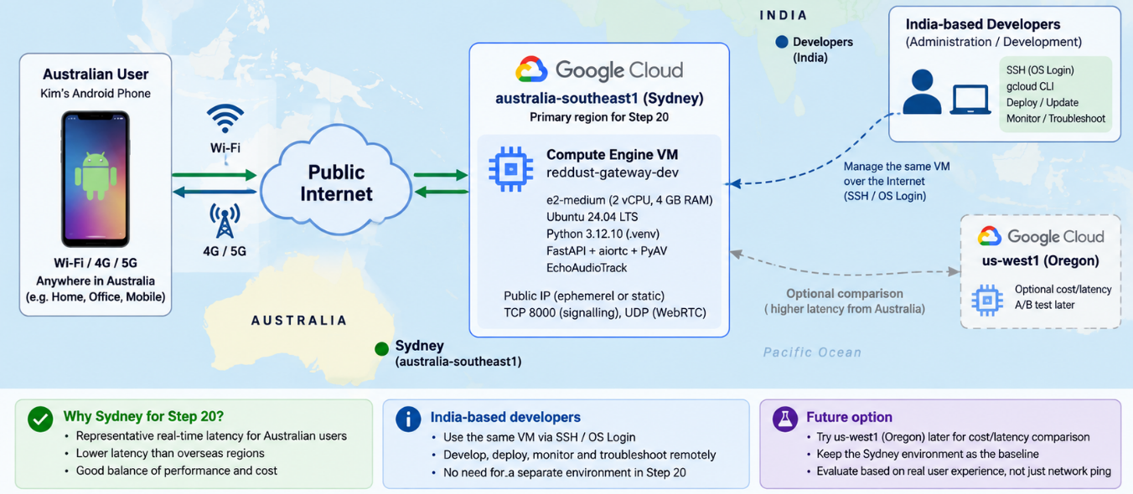

20.5 — Configure IAM and OS Login before Creating the VM — setting up just enough access to the required resources for each team member
Clean-slate starting point: This section assumes that red.dust.proj@gmail.com is the only human identity with access to the Google Cloud project reddust-development. A billing account already exists and is attached to the project. No other team member has any IAM role, OS Login permission, SSH permission, service-account permission, or administrator permission before these steps begin.
Single source of truth: Follow this section as a standalone procedure. Do not depend on manual Linux users, shared SSH keys, previous IAM bindings, or undocumented access. Human access is established through Google Cloud IAM and OS Login.
The purpose of this section is to create a repeatable, auditable and least-privilege access model before the first RedDust development VM is used by the team. It also defines the small set of deferred checks that must be completed immediately after the gateway VM exists, because instance-level IAM cannot be assigned to a VM that has not yet been created.

20.5.1 — Objectives and completion criteria
At the end of this section, the RedDust project will have a clearly separated Owner, Administrator and Developer model. OS Login will be enabled at project level before the VM is created. Administrators will be able to operate the development project. Developers will be able to discover and inspect Compute Engine resources but will not receive broad cloud administration rights. After the gateway VM is created, developers will receive sudo-capable OS Login only on that VM.
- The project owner remains RedDustProj (red.dust.proj@gmail.com) and retains Owner.
- anirban@anodiam.com receives the defined development-project administrator baseline, but not Owner.
- 1120anirban@gmail.com receive project-level Compute Viewer only before the VM exists.
- OS Login is enabled project-wide before the VM is created.
- No shared Linux account and no manually distributed project/instance SSH key is used for human access.
- After the VM reddust-gateway-dev exists, developer OS Admin Login is assigned only to that VM.
- If the VM has a service account, each developer receives Service Account User only on that attached service account.
- The two test identities (anirban@anodiam.com and 1120anirban@gmail.com) prove the Developer and Administrator paths before the wider team is asked to test.
DIAGRAM 20-G: RedDust Human Access Model
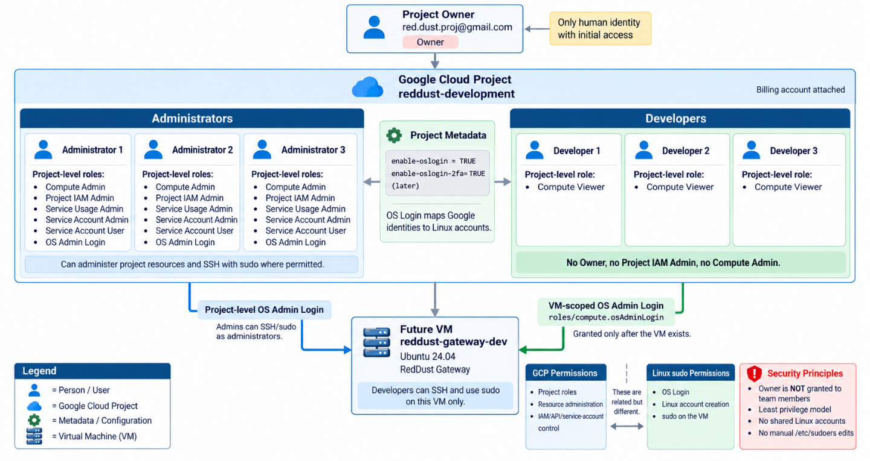

20.5.2 — Identity Register and Target Tiers
Use the following identities exactly when granting access. The owner should verify spelling before executing any IAM command, because IAM bindings attach to the exact Google identity string.
Google identity | GCP Linux whoami Username | Tier | Purpose | Target access
red.dust.proj@gmail.com | red_dust_proj_gmail_com | Project Owner | Owner / root cloud admin | Retain existing Owner; no additional team role
anirban@anodiam.com | anirban_anodiam_com | Administrator test ID | Validates admin access before team rollout | Administrator baseline
1120anirban@gmail.com | usr_1120anirban_gmail_com | Developer test ID | Validates developer access before team rollout | Developer baseline
Test Identities: This guide uses 1120anirban@gmail.com for Developer testing and anirban@anodiam.com for Administrator testing. Replace them consistently if different test identities are used.

20.5.3 — Least-Privilege Target IAM Model
The IAM design intentionally separates cloud-resource administration from Linux administration. Having sudo on a development VM does not require Editor, Compute Admin or Owner on the Google Cloud project.
Tier | Role ID | Grant scope | Principals | Why
Owner | roles/owner | Project | red.dust.proj@gmail.com only | Ultimate project control.
Administrator | roles/compute.admin | Project | Admin test ID only: anirban@anodiam.com | Manage Compute Engine resources.
Administrator | roles/resourcemanager.projectIamAdmin | Project | Admin test ID only: anirban@anodiam.com | Manage project IAM policy. High privilege; still narrower than Owner.
Administrator | roles/serviceusage.serviceUsageAdmin | Project | Admin test ID only: anirban@anodiam.com | Enable/disable and inspect APIs/services.
Administrator | roles/iam.serviceAccountAdmin | Project | Admin test ID only: anirban@anodiam.com | Create and manage service accounts.
Administrator | roles/iam.serviceAccountUser | Project | Admin test ID only: anirban@anodiam.com | Act as/attach project service accounts where required.
Administrator | roles/compute.osAdminLogin | Project | Admin test ID only: anirban@anodiam.com | OS Login with sudo on OS Login-enabled VMs in the project.
Developer | roles/compute.viewer | Project | Dev test ID only: 1120anirban@gmail.com | See project in selector; inspect Compute resources; no infrastructure modification.
Developer | roles/compute.osAdminLogin | Specific gateway VM | Dev test ID only: 1120anirban@gmail.com | Deferred until VM exists; SSH + sudo only on the gateway VM.
Developer | roles/iam.serviceAccountUser | Attached VM service account only | Dev test ID only: 1120anirban@gmail.com | Conditional: required only if the gateway VM has a service account attached.
Why developers do not need the Browser role: Compute Viewer already allows project discovery and read-only access to Compute Engine resources, so Browser would be redundant.
Why developers do not get project-level OS Admin Login: Project-level access would allow sudo on every OS Login-enabled VM. Instead, developers receive OS Admin Login only on reddust-gateway-dev after it is created.

20.5.4 — Understand Two Authorization Layers
RedDust uses two related but different authorization layers. Cloud IAM controls what a person can do to Google Cloud resources. OS Login uses Google identity and IAM to decide whether that person may become a Linux user on a VM and whether that Linux user may elevate with sudo.
Question | Controlled by | Example
Can this person see the project and VM? | Project IAM | Compute Viewer or Compute Admin
Can this person create/delete VMs? | Project IAM | Compute Admin
Can this person change project IAM? | Project IAM | Project IAM Admin
Can this person SSH into a Linux VM? | OS Login + IAM | Compute OS Login / OS Admin Login
Can this person run sudo? | OS Login + IAM | Compute OS Admin Login
Can this SSH user act as the VM service account? | Service-account IAM | Service Account User when a service account is attached
DIAGRAM 20-H: GCP IAM vs OS Login
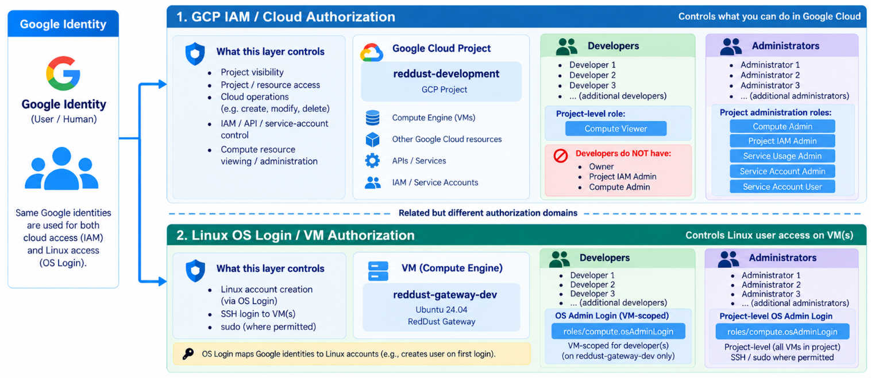

20.5.5 — Owner Pre-flight: Establish Correct Project Context
Perform all initial provisioning from Cloud Shell while signed in as red.dust.proj@gmail.com. Cloud Shell already includes the Google Cloud CLI, which avoids local installation differences during the access setup.
1. Open Google Cloud Console and select the owner identity. Confirm the account is red.dust.proj@gmail.com.
2. Open Cloud Shell. Use the terminal icon in the Google Cloud Console.
3. Create the project variables. From Owner GCP account’s Cloud Shell — core variables
PROJECT_ID="reddust-development"
OWNER_EMAIL="red.dust.proj@gmail.com"
ADMIN_TEST_EMAIL="anirban@anodiam.com"
DEV_TEST_EMAIL="1120anirban@gmail.com"
4. Confirm which Google account Cloud Shell is using. Expected active account: red.dust.proj@gmail.com
gcloud auth list
Stop condition: If active account is not red.dust.proj@gmail.com, do not grant any roles. Switch/authenticate to correct owner identity first.
5. Set and verify the project context.
gcloud config set project "$PROJECT_ID"
gcloud config get-value project
Expected value:
reddust-development
6. Verify the project and inspect whether it belongs to an organization.
gcloud projects describe "$PROJECT_ID" --format="yaml(projectId,name,projectNumber,parent)"
Record the project number and inspect the parent field (below). If parent is empty or absent, the project is not under a GCP organization. If the parent is an organization, the external-user check in Section 20.5.10 becomes important.
name: RedDust Development
parent:
id: '173416320671'
type: organization
projectId: reddust-development
projectNumber: '1095997693007'
7. Confirm billing is attached; do not change it.
gcloud billing projects describe "$PROJECT_ID"
Billing scope: This access procedure does not grant team members Billing Account Administrator, Billing Account User or Billing Project Manager. Billing is already attached and is outside the purpose of Section 20.5.

20.5.6 — Enable Required APIs before delegating administration
The project owner should enable the APIs needed for Compute Engine, IAM/OS Login and optional IAM troubleshooting, preventing access tests from failing because a required API is not enabled.
gcloud services enable compute.googleapis.com oslogin.googleapis.com am.googleapis.com \
serviceusage.googleapis.com policytroubleshooter.googleapis.com --project="$PROJECT_ID"
Verify the core services:
gcloud services list --enabled --project="$PROJECT_ID" \
--filter="NAME:(compute.googleapis.com OR oslogin.googleapis.com OR iam.googleapis.com OR \
serviceusage.googleapis.com OR policytroubleshooter.googleapis.com)" \
--format="table(NAME,TITLE)"

20.5.7 — Audit the human-access starting state
Before adding anyone, capture the human-user bindings currently present. Google-managed service agents and service accounts can exist even in a clean project and should not be mistaken for team-member access.
gcloud projects get-iam-policy "$PROJECT_ID" --flatten="bindings[].members" \
--filter="bindings.members:user:*" --format="table(bindings.role,bindings.members)"
Expected clean-slate human state: Before these grants, only the project Owner should have human access. Existing service accounts or Google-managed service agents may remain and should not be removed merely because they are not human users.
If team members already have project-level IAM roles: Remove those existing grants, then re-run the audit until only the Owner retains human project-level access.

20.5.8 — Enable OS Login project-wide before any VM is created
DIAGRAM 20-I: OS Login Provisioning Sequence before First VM
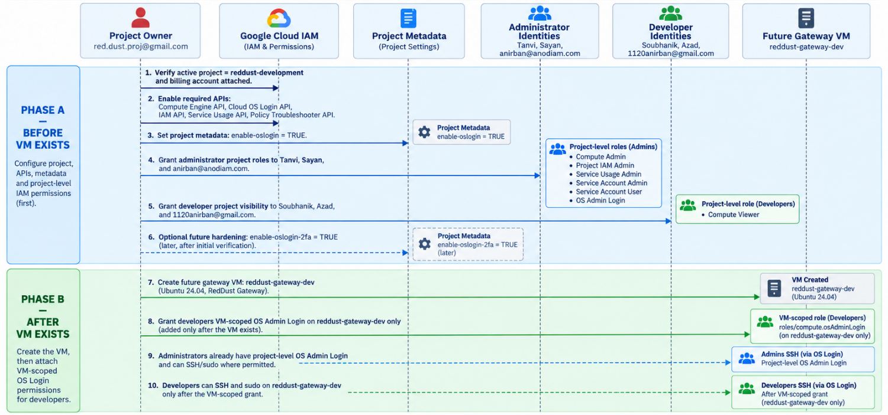
Enable OS Login at project level so new Linux VMs use IAM-based SSH access instead of manually managed team SSH keys.
gcloud compute project-info add-metadata --project="$PROJECT_ID" --metadata=enable-oslogin=TRUE
Verify the metadata value:
gcloud compute project-info describe --project="$PROJECT_ID" \
--format="yaml(commonInstanceMetadata.items)"
Confirm the output contains a metadata item equivalent to:
key: enable-oslogin
value: 'TRUE'
Do not create a shared Linux account: Use individual OS Login identities instead of shared users, manual /etc/sudoers entries, or team SSH keys. IAM + OS Login remains the source of truth for human access.
Metadata precedence: An instance-level enable-oslogin value can override project metadata. When the gateway VM is created, do not set enable-oslogin=FALSE on the instance.

20.5.9 — Grant the Administrator tier from scratch
The three Administrator identities receive the same development-project baseline. This intentionally gives them operational control over Compute Engine, project IAM, API enablement and service accounts, plus OS Login sudo. They do not receive Owner. Grant the administrator baseline to all three administrators
ADMINS=(
"anirban@anodiam.com"
)
ADMIN_ROLES=(
"roles/compute.admin"
"roles/resourcemanager.projectIamAdmin"
"roles/serviceusage.serviceUsageAdmin"
"roles/iam.serviceAccountAdmin"
"roles/iam.serviceAccountUser"
"roles/compute.osAdminLogin"
)
for member in "${ADMINS[@]}"; do
for role in "${ADMIN_ROLES[@]}"; do
gcloud projects add-iam-policy-binding "$PROJECT_ID" --member="user:${member}" \
--role="$role" --condition=None --quiet
done
done
High-privilege role: Project IAM Admin can change project IAM policy. Grant it only because these identities are explicitly designated as RedDust development administrators. Do not copy this administrator role set to developers.
Verify the admin test identity specifically:
gcloud projects get-iam-policy "$PROJECT_ID" --flatten="bindings[].members" \
--filter="bindings.members:user:${ADMIN_TEST_EMAIL}" --format="table(bindings.role,bindings.members)"

20.5.10 — Grant the Developer tier from scratch (pre-VM phase)
Before the gateway VM exists, developers receive only read-only Compute visibility at project level. This lets them find the project in the project selector and inspect Compute resources without being able to create, delete or reconfigure infrastructure. Pre-VM developer grant
DEVELOPERS=(
"1120anirban@gmail.com"
)
for member in "${DEVELOPERS[@]}"; do
gcloud projects add-iam-policy-binding "$PROJECT_ID" \
--member="user:${member}" \
--role="roles/compute.viewer" \
--condition=None \
--quiet
done
Verify the developer test identity specifically:
gcloud projects get-iam-policy "$PROJECT_ID" \
--flatten="bindings[].members" \
--filter="bindings.members:user:${DEV_TEST_EMAIL}" \
--format="table(bindings.role,bindings.members)"
Expected pre-VM result for the developer test ID: The developer test identity should have only Compute Viewer at project scope, with no Owner, Editor, Compute Admin, Project IAM Admin, Service Account Admin/User, or project-level OS Admin Login.

20.5.11 — Organization/ external-user check for OS Login
OS Login has an additional requirement when a person belongs to a different Google Workspace/Cloud Identity organization than the VM’s project. Google documents the Compute OS Login External User role for this case, and it is granted at organization scope by an organization administrator.
1. Re-check the project parent.
gcloud projects describe "$PROJECT_ID" --format="yaml(parent)"
2. If there is no organization parent, skip this subsection. No organization-scoped external-user role can or needs to be granted.
3. If there is an organization parent, identify which team identities are outside that organization. Consumer Gmail accounts are commonly outside a Workspace organization.
4. Have an Organization Administrator grant Compute OS Login External User to each required external identity at the organization level. Run only when the project has an organization and the user is external
ORG_ID="173416320671"
EXTERNAL_OSLOGIN_USERS=(
"1120anirban@gmail.com"
"anirban@anodiam.com"
)
for member in "${EXTERNAL_OSLOGIN_USERS[@]}"; do
echo "Granting OS Login External User to: ${member}"
gcloud organizations add-iam-policy-binding "$ORG_ID" \
--member="user:${member}" --role="roles/compute.osLoginExternalUser" --condition=None --quiet
done
Then verify all external OS Login users with:
gcloud organizations get-iam-policy "$ORG_ID" --flatten="bindings[].members" \
--filter="bindings.role:roles/compute.osLoginExternalUser" \
--format="table(bindings.role,bindings.members)"
You should see all seven users:
1120anirban@gmail.com
anirban@anodiam.com
Important authority boundary: Being Owner of reddust-development does not automatically make red.dust.proj@gmail.com an Organization Administrator. If this role is required and the owner lacks organization-level IAM authority, the organization administrator must perform this specific grant.
Check whether the identity red.dust.proj@gmail.com is an Organization Administrator, i.e. has roles/resourcemanager.organizationAdmin access.
gcloud organizations get-iam-policy "$ORG_ID" --flatten="bindings[].members" \
--filter="bindings.members:user:red.dust.proj@gmail.com" \
--format="table(bindings.role,bindings.members)"

20.5.12 — Verify the complete project-level IAM before VM creation
Run the following report from the owner account. It should show the owner, the three administrator identities with their administrator roles, and the three developer identities with Compute Viewer.
gcloud projects get-iam-policy "$PROJECT_ID" \
--flatten="bindings[].members" \
--filter="bindings.members:user:*" \
--sort-by="bindings.members,bindings.role" \
--format="table(bindings.members,bindings.role)"
Identity tier | Must have before VM creation | Must NOT receive merely for this step
Owner | Owner | N/A
Administrators | Compute Admin; Project IAM Admin; Service Usage Admin; Service Account Admin; Service Account User; OS Admin Login | Owner unless explicitly promoted later
Developers | Compute Viewer | Owner; Editor; Compute Admin; Project IAM Admin; Service Account Admin; project-level OS Admin Login

20.5.13 — Test the Developer path before onboarding other developers
Use 1120anirban@gmail.com as the developer test identity before involving the wider developer team. Use a separate browser profile or incognito session to avoid accidentally using the Owner account.
1. Sign in to Google Cloud Console as 1120anirban@gmail.com.
2. Open the project selector and search for reddust-development. The project should be visible because Compute Viewer includes project discovery permissions.
3. Open Cloud Shell under the developer test identity and confirm the active account.
gcloud auth list
4. Set the RedDust project and read its metadata.
gcloud config set project reddust-development
gcloud projects describe reddust-development \
--format="table(projectId,name,projectNumber)"
5. Verify read-only Compute access.
gcloud compute instances list --project=reddust-development
Before the gateway VM exists, a successful command may simply show no instances. The important result is that it does not fail with a project-access permission error.
6. Verify that this identity was not accidentally given broad project roles. Return to the owner Cloud Shell and run the binding report below.
PROJECT_ID="reddust-development"
DEV_TEST_EMAIL="1120anirban@gmail.com"
gcloud projects get-iam-policy "$PROJECT_ID" \
--flatten="bindings[].members" \
--filter="bindings.members:user:${DEV_TEST_EMAIL}" \
--format="table(bindings.role)"
Expected result is actually this error depicting consistent depicting that the developer account is actually restricted.
ERROR: (gcloud.projects.get-iam-policy) [1120anirban@gmail.com] does not have permission to access projects instance [reddust-development:getIamPolicy] (or it may not exist): The caller does not have permission. This command is authenticated as 1120anirban@gmail.com which is …
Developer pre-VM acceptance: The developer test identity can view reddust-development and list Compute resources, but has only the intended read-only project role. SSH is tested later, after the VM exists and VM-specific OS Login is granted.

20.5.14 — Test the Administrator path before onboarding other admins
Use anirban@anodiam.com as the controlled administrator test identity. Again, use a separate browser profile/incognito session to prevent account crossover.
1. Sign in to Google Cloud Console as anirban@anodiam.com and select reddust-development.
2. Open Cloud Shell and confirm the active account.
gcloud auth list
gcloud config set project reddust-development
3. Verify Compute administration visibility.
gcloud compute instances list --project=reddust-development
4. Verify service account administration visibility.
gcloud iam service-accounts list --project=reddust-development
5. Verify API/service administration visibility.
gcloud services list --enabled --project=reddust-development --format="table(NAME,TITLE)"
6. Verify project IAM can be inspected.
gcloud projects get-iam-policy reddust-development --format="table(bindings.role,bindings.members)"
Do not perform destructive tests: Do not create/delete resources, disable APIs, or alter others’ IAM just to prove admin access. Predefined roles plus non-destructive read checks are sufficient.

20.5.15 — Optional: Policy Troubleshooter – verify permissions non-destructively
Policy Troubleshooter is a safe, read-only way to check whether a Google identity would be allowed to perform a specific action without actually doing it. Here, it verifies whether the Developer or Administrator could change the project IAM policy.
The check should be run by the Owner or an authorized Administrator. Preferably, the Owner should run it because the Owner is more likely to have enough visibility into project- and organization-level policies. The Developer should not run this as a self-test. Run the commands from Google Cloud Shell while signed in as the intended Owner or Administrator account. Cloud Shell is recommended because gcloud is already installed and authenticated.
Expected result:
- Developer: not granted resourcemanager.projects.setIamPolicy
- Administrator: granted that permission
If the result is Unknown, it may simply mean the caller cannot inspect every higher-level policy. In that case, rely on IAM binding reports and other non-destructive access checks rather than granting extra permissions just to make the result conclusive.
PROJECT_ID="reddust-development"
DEV_TEST_EMAIL="1120anirban@gmail.com"
ADMIN_TEST_EMAIL="anirban@anodiam.com"
PROJECT_RESOURCE="//cloudresourcemanager.googleapis.com/projects/${PROJECT_ID}"
# Developer should NOT be granted project IAM modification.
gcloud policy-intelligence troubleshoot-policy iam "$PROJECT_RESOURCE" \
--principal-email="$DEV_TEST_EMAIL" --permission="resourcemanager.projects.setIamPolicy"
# Administrator should be granted project IAM modification.
gcloud policy-intelligence troubleshoot-policy iam "$PROJECT_RESOURCE" \
--principal-email="$ADMIN_TEST_EMAIL" --permission="resourcemanager.projects.setIamPolicy"
Interpretation: For the developer, look for a not-granted result for resourcemanager.projects.setIamPolicy. For the administrator, look for a granted result. If Policy Troubleshooter reports Unknown because organization policies cannot be inspected, use the IAM binding reports and actual non-destructive access tests instead of weakening IAM merely to make the troubleshooter conclusive.
DIAGRAM 20-J: Pre-VM Access Test Matrix
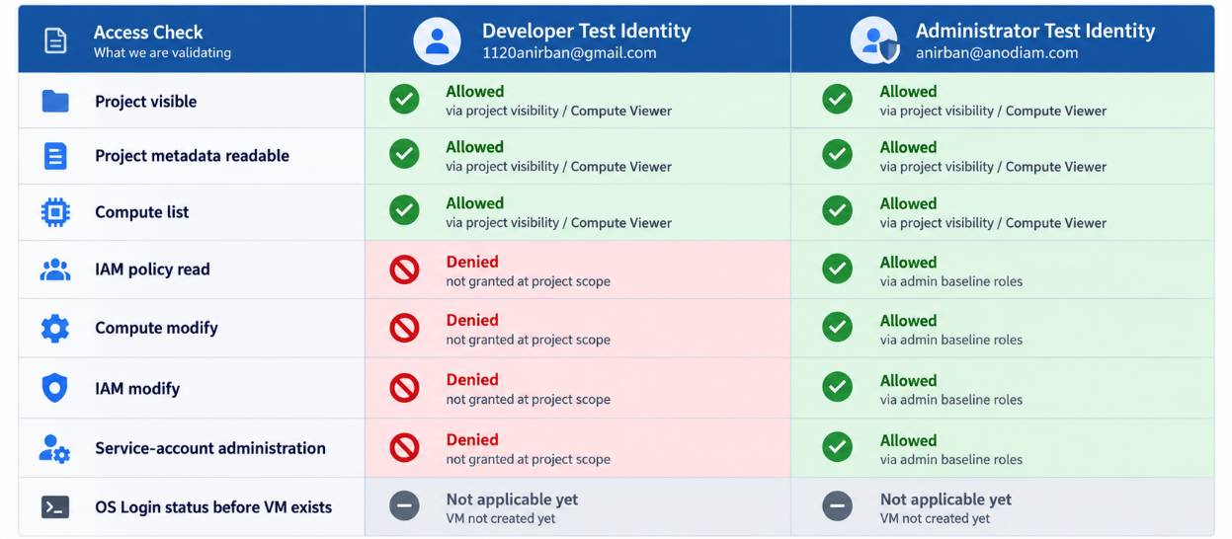

20.6 — Create the Compute Engine VM

20.6.1 — Basic machine configuration
Setting | Canonical value | Notes
Name | reddust-gateway-dev | Stable team-wide resource name
Region | australia-southeast1 | Sydney
Zone | australia-southeast1-b | Use a/c only if needed
Machine family | General purpose / E2 | Cost-efficient development family
Machine type | e2-medium | 2 exposed vCPUs, 1.0 fractional vCPU allocation, 4 GB RAM
Provisioning model | Standard | Not Spot / not pre-emptible
GPU | None | Not needed for Step 20
DIAGRAM 20-K: Canonical e2-medium VM Configuration
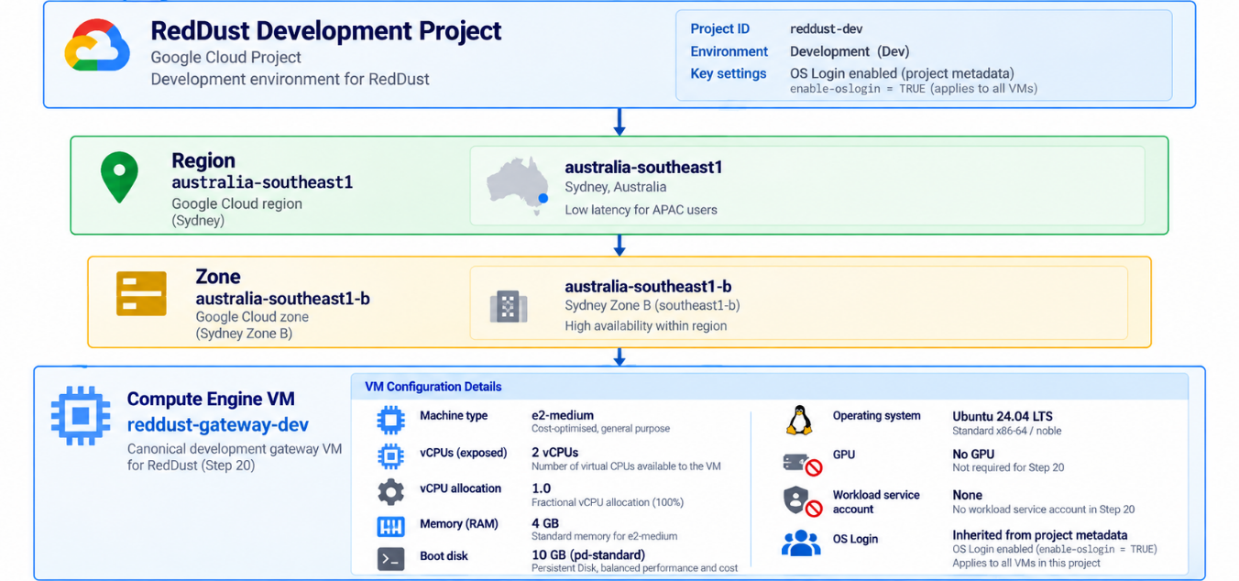
Now create the VM only after project, billing, budget, IAM and project-wide OS Login are in place.

20.6.2 — Open Create instance
1. Open Compute Engine → VM instances.
2. Click Create instance.
3. If Compute Engine is still initializing, wait until the form becomes available.
e2-medium: 2 vCPUs exposed to the guest / 1.0 fractional vCPU allocation / 4 GB RAM. It is an E2 shared-core VM, not a dedicated single-core machine.

20.6.3 — Select Ubuntu 24.04 LTS standard image
1. Open OS and storage.
2. Click Change on the boot disk.
3. Choose Public images.
4. Operating system: Ubuntu.
5. Version: Ubuntu 24.04 LTS.
6. Architecture: x86/64 or amd64.
7. Choose the standard Ubuntu image, not Ubuntu 24.04 LTS Minimal and not Ubuntu Pro 24.04 LTS.
8. Confirm the selection and return to the Create instance screen.
Expected OS target:
Ubuntu 24.04 LTS
Codename: noble
Image project: ubuntu-os-cloud
Image family: ubuntu-2404-lts-amd64

20.6.4 — Configure the boot disk
Boot disk type:
Standard Persistent Disk (pd-standard)
Size: 10 GB
Ten GB is intentionally lean but adequate for this Gateway if logs and caches are kept controlled. The disk can be expanded later. Do not choose a larger disk merely because it is the UI default.

20.6.5 — Service account
1. Open the Security section in the Create instance form.
2. Find Service account.
3. Choose No service account if the console permits it.
4. Don’t just create custom service account for FastAPI/aiortc; Step-20 Gateway does not need authenticated GCP API access.
Human OS Login is separate from VM workload service account. Choosing No service account does not disable IAM-based SSH.

20.6.6 — OS Login during creation
Because project metadata already contains enable-oslogin=TRUE, the VM will inherit OS Login. If the Create VM UI exposes Advanced options → Security → Manage access → Control VM access through IAM permissions, keep it enabled. Do not add an instance-level enable-oslogin=FALSE override.

20.6.7 — Immediately after GCP Compute VM ‘reddust-gateway-dev’ creation
This section is intentionally completed only after the Compute Engine VM reddust-gateway-dev has been created. Earlier in Step 20.5, project-level IAM roles could be configured, but permissions tied to the specific VM and its workload identity could not yet be applied.
The workload is the RedDust Gateway code running on the VM. Its workload identity is the VM-attached service account (reddust-gateway-dev-runtime@reddust-development.iam.gserviceaccount.com), which the Gateway uses to access Google Cloud services such as Secret Manager, Pub/Sub, Logging, and Cloud Storage.
Section 20.6.7 now connects three deliberately separate security layers:
- Human identity — who the Administrators and Developers are.
- VM access — which VM each human identity may administer.
- Workload identity — which service account the Gateway application uses to access Google Cloud services.
The governing principle is least privilege: Developers receive OS administrative access only to reddust-gateway-dev, while the Gateway uses its own dedicated service account with only the permissions it requires.
By the end of Section 20.6.7, you will have granted Developers VM-specific OS administrative access, verified or attached the dedicated runtime service account, scoped Developer actAs permission to that service account, verified the resulting IAM bindings, restarted the VM, and confirmed that Developer and Administrator test identities can connect securely through IAP and OS Login with the expected Linux privileges.
The intended end state is:
Human Google Identity
↓
IAM + IAP
↓
OS Login
↓
Individual Linux User
↓
VM: reddust-gateway-dev
↓
Service Account: reddust-gateway-dev-runtime
↓
Only the Google Cloud services and permissions that the Gateway genuinely requires
This separation is important. Human users authenticate as themselves; the VM application authenticates as its own workload identity. No shared human Linux account, shared SSH-key mechanism, or long-lived service-account JSON key is required.
This subsection is deferred: because instance-level IAM requires the VM to exist first. Do not substitute this with project-wide developer OS Admin Login. Execute this step immediately after creating reddust-gateway-dev.
Return to the owner or an authorized Administrator Cloud Shell and set the VM variables:
PROJECT_ID="reddust-development"
VM_NAME="reddust-gateway-dev"
ZONE=$(gcloud compute instances list --project="$PROJECT_ID" --filter="name=$VM_NAME" \
--format="value(zone.basename())")
echo "VM_NAME=$VM_NAME"
echo "ZONE=$ZONE"
Expected: ZONE must be exactly reddust-gateway-dev VM’s zone. If it is blank, stop & verify VM name/project rather than guessing a zone.

20.6.7.1 — Grant developers OS Admin Login only on the gateway VM
DEVELOPERS=("1120anirban@gmail.com")
for member in "${DEVELOPERS[@]}"; do
gcloud compute instances add-iam-policy-binding "$VM_NAME" --project="$PROJECT_ID" --zone="$ZONE" \
--member="user:${member}" --role="roles/compute.osAdminLogin" --condition=None --quiet
done
Verify the VM-specific policy:
gcloud compute instances get-iam-policy "$VM_NAME" --project="$PROJECT_ID" --zone="$ZONE"

20.6.7.2 — Check whether the VM has a service account
OS Login checks iam.serviceAccounts.actAs when a VM has an attached service account, because an SSH user on that VM can potentially obtain credentials for the attached service account. First detect whether a service account is actually attached.
VM_SA=$(gcloud compute instances describe "$VM_NAME" \
--project="$PROJECT_ID" --zone="$ZONE" --format="value(serviceAccounts[0].email)")
echo "VM_SA=[$VM_SA]"
If VM_SA is blank: no service account is attached to this VM (assuming the VM lookup succeeded). The VM being stopped does not cause the configured service-account field to disappear. If no service account is attached, skip the developer Service Account User grant below.

20.6.7.3 — If a VM service account is attached, grant developers actAs only on that account
if [[ -n "$VM_SA" ]]; then
for member in "${DEVELOPERS[@]}"; do
gcloud iam service-accounts add-iam-policy-binding "$VM_SA" --project="$PROJECT_ID" \
--member="user:${member}" --role="roles/iam.serviceAccountUser" --condition=None --quiet
done
else
echo "No VM service account is attached; no developer actAs grant is required."
fi
Least privilege: Do not grant developers roles/iam.serviceAccountUser across the project merely to make SSH work. If the gateway VM has a service account, grant this role on that one service account only.

20.6.7.4 — Establish a dedicated Gateway runtime service account when VM_SA is blank
If VM_SA is blank, the VM currently has no workload service account attached. For RedDust development, create a dedicated user-managed service account for the Gateway runtime instead of relying on the default Compute Engine service account.
Recommended service-account ID: reddust-gateway-dev-runtime
Resulting service-account email: reddust-gateway-dev-runtime@reddust-development.iam.gserviceaccount.com
Service account belongs to Gateway workload. It is not human developer account. It must not be used as a shared login identity.
The intended relationship is:
Human Developer / Administrator
| OS Login + appropriate actAs permission
▼
reddust-gateway-dev
| attached workload identity
▼
reddust-gateway-dev-runtime
| least-privilege Google Cloud API permissions
▼
Secret Manager / Logging / Storage / Pub/Sub / other required APIs
DIAGRAM 20-L: Human Access vs Gateway Workload Identity
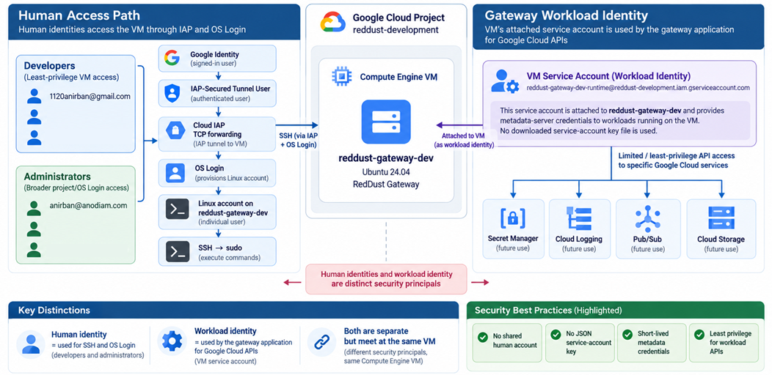

20.6.7.4.1 — Define the required variables
Run from the project owner or Administrator Cloud Shell:
PROJECT_ID="reddust-development"
VM_NAME="reddust-gateway-dev"
VM_SA_NAME="reddust-gateway-dev-runtime"
VM_SA="${VM_SA_NAME}@${PROJECT_ID}.iam.gserviceaccount.com"
ZONE=$(gcloud compute instances list --project="$PROJECT_ID" --filter="name=$VM_NAME" \
--format="value(zone.basename())")
echo "PROJECT_ID=$PROJECT_ID"
echo "VM_NAME=$VM_NAME"
echo "ZONE=$ZONE"
echo "VM_SA=$VM_SA"
Expected service-account value:
VM_SA=reddust-gateway-dev-runtime@reddust-development.iam.gserviceaccount.com

20.6.7.5 — Create the dedicated service account if it does not already exist
First check whether the intended service account already exists:
gcloud iam service-accounts describe "$VM_SA" --project="$PROJECT_ID"
If the command returns NOT_FOUND, create the service account:
gcloud iam service-accounts create "$VM_SA_NAME" --project="$PROJECT_ID" \
--display-name="RedDust Gateway Dev Runtime" \
--description="Runtime identity for the reddust-gateway-dev development VM"
Verify the resulting identity:
gcloud iam service-accounts describe "$VM_SA" \
--project="$PROJECT_ID" --format="yaml(email,displayName,disabled)"
Expected state:
email: reddust-gateway-dev-runtime@reddust-development.iam.gserviceaccount.com
disabled: false
Do not create a JSON key: Do not create, download, or distribute a long-lived JSON service-account key for this VM. The VM should obtain short-lived credentials through the Google Cloud metadata server.

20.6.7.6 — Attach the dedicated service account to reddust-gateway-dev
DIAGRAM 20-M: Attach the dedicated service account to reddust-gateway-dev
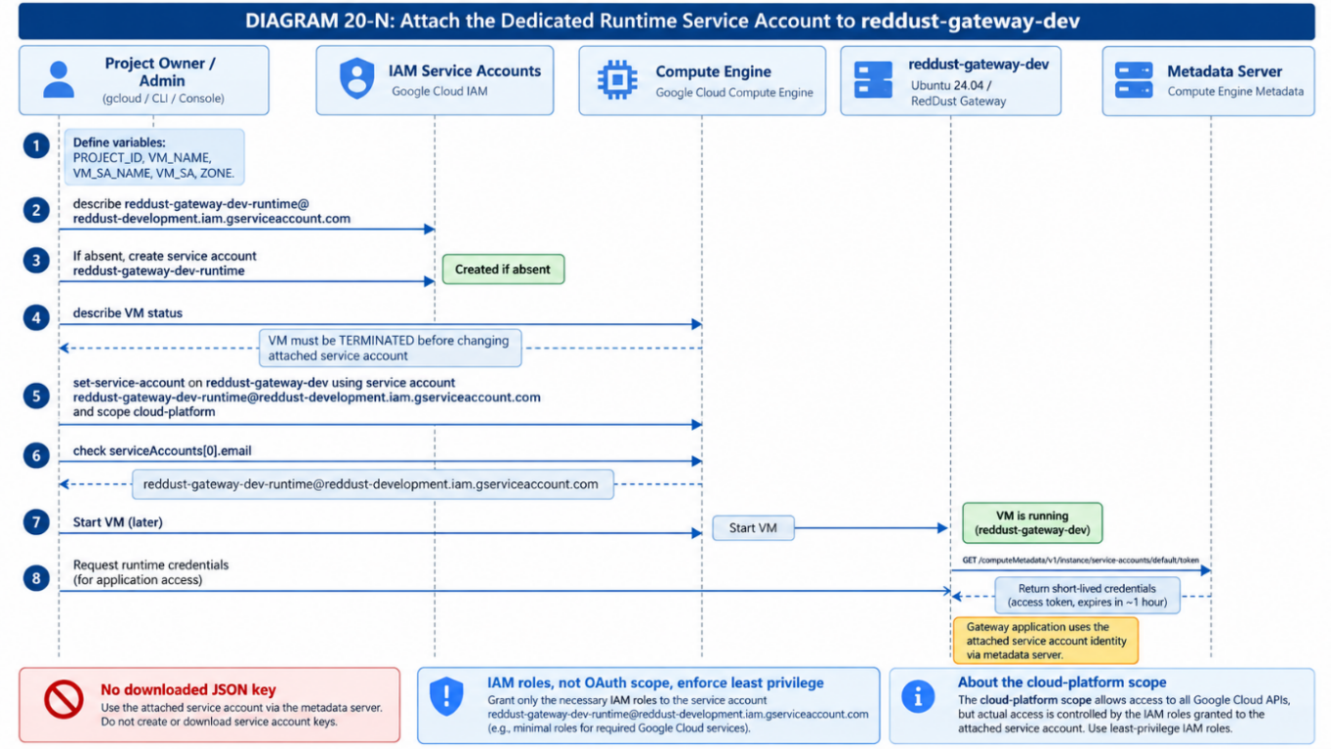
Changing the service account attached to an existing Compute Engine VM is performed while the VM is stopped. Verify the VM state rather than assuming it.
VM_STATUS=$(gcloud compute instances describe "$VM_NAME" \
--project="$PROJECT_ID" --zone="$ZONE" --format="value(status)")
echo "VM_STATUS=$VM_STATUS"
For a stopped VM, expect:
VM_STATUS=TERMINATED
If the VM is not stopped, stop it:
gcloud compute instances stop "$VM_NAME" --project="$PROJECT_ID" --zone="$ZONE"
Attach the dedicated runtime service account with the cloud-platform scope:
gcloud compute instances set-service-account "$VM_NAME" \
--project="$PROJECT_ID" --zone="$ZONE" --service-account="$VM_SA" --scopes=cloud-platform
Why use cloud-platform scope? Use the broad OAuth access scope and enforce actual authorization with IAM roles granted to the service account. Access scopes are not a substitute for IAM least privilege.

20.6.7.6.1 — Verify the attachment
VM_SA=$(gcloud compute instances describe "$VM_NAME" \
--project="$PROJECT_ID" --zone="$ZONE" --format="value(serviceAccounts[0].email)")
echo "VM_SA=[$VM_SA]"
Expected:
VM_SA=[reddust-gateway-dev-runtime@reddust-development.iam.gserviceaccount.com]
For a fuller configuration check:
gcloud compute instances describe "$VM_NAME" --project="$PROJECT_ID" --zone="$ZONE" \
--format="yaml(name,status,serviceAccounts)"

20.6.7.7 — Do not give the runtime service account broad permissions yet
Attaching the service account gives the VM a workload identity. It does not justify granting that identity broad Google Cloud permissions. Do not grant the runtime service account any of the following simply for convenience:
roles/owner
roles/editor
roles/compute.admin
roles/resourcemanager.projectIamAdmin
Instead, add service-specific permissions only when the Gateway has a concrete requirement. Examples of future least-privilege grants might include:
- Read only the specific Secret Manager secrets required by the Gateway.
- Write application logs and metrics through the chosen observability path.
- Publish only to required Pub/Sub topics.
- Read or write only explicitly required Cloud Storage buckets or objects.
Security consequence of sudo: Sudo access allows privileged users to extract short-lived service account credentials from the metadata server. Therefore, a runtime service account must never possess more permissions than you trust the VM administrators with.

20.6.7.8 — Grant developers actAs only on this Gateway service account
Once the service account is attached, OS Login developers need the iam.serviceAccounts.actAs permission for the attached service account. The predefined Service Account User role contains this permission. Define the Developer identities:
DEVELOPERS=( "1120anirban@gmail.com")
Grant Service Account User on this service account only:
for member in "${DEVELOPERS[@]}"; do
echo "Granting Service Account User on ${VM_SA} to ${member}"
gcloud iam service-accounts add-iam-policy-binding "$VM_SA" --project="$PROJECT_ID" \
--member="user:${member}" --role="roles/iam.serviceAccountUser" --condition=None --quiet
done
Least privilege: Do not grant developers roles/iam.serviceAccountUser across the entire project merely to make SSH work. The developer grant should be attached directly to reddust-gateway-dev-runtime only.

20.6.7.9 — Administrator actAs access
The Administrator baseline already includes project-level roles/iam.serviceAccountUser for the three RedDust development administrator:
anirban@anodiam.com
Therefore, these administrators already have effective iam.serviceAccounts.actAs across service accounts in reddust-development. A second service-account-specific binding is not required for them.
Tier | Scope of Service Account User | Principals
Administrator | Project-level | anirban@anodiam.com
Developer | Only reddust-gateway-dev-runtime | 1120anirban@gmail.com
Intentional difference: Administrators are responsible for service-account lifecycle and infrastructure operations. Developers receive actAs only on the one runtime identity attached to their development VM.

20.6.7.10 — Verify the developer Service Account User bindings
Inspect direct Service Account User bindings on the runtime service account:
gcloud iam service-accounts get-iam-policy "$VM_SA" --project="$PROJECT_ID" \
--flatten="bindings[].members" --filter="bindings.role:roles/iam.serviceAccountUser" \
--format="table(bindings.role,bindings.members)"
Expected direct bindings should include the three Developers:
roles/iam.serviceAccountUser
1120anirban@gmail.com
Why administrators may not appear here: This command reports bindings attached directly to the service account. Administrators inherit Service Account User from the project-level IAM policy, so they may not appear in this direct service-account report.

20.6.7.11 — Verify the administrator project-level actAs grants
gcloud projects get-iam-policy "$PROJECT_ID" --flatten="bindings[].members" \
--filter="bindings.role:roles/iam.serviceAccountUser" \
--format="table(bindings.role,bindings.members)"
Expected Administrator principals:
user:anirban@anodiam.com
These entries should be associated with:
roles/iam.serviceAccountUser

20.6.7.12 — Final access architecture after attaching the service account
After runtime identity is attached & actAs permissions are correctly scoped, the RedDust development access model becomes:
reddust-development
↓
+---------------------------------------------+
↓ ↓
Administrators Developers
Service-Account-User < Project-level access > Compute-Viewer
| +-- VM-scoped OS Admin Login
| +-- IAP-Secured Tunnel User
| +-- Service Account User on ONE service account
+-----------------------+---------------------+
▼
VM: reddust-gateway-dev
| attached identity
▼
SA: reddust-gateway-dev-runtime
| workload-specific IAM permissions only
▼
Google Cloud APIs
Important security boundary: Attaching a service account allows privileged VM users to extract its short-lived credentials. Therefore, Developer VM privileges must never be weaker than the permissions assigned to the runtime service account
DIAGRAM 20-N: Final Gateway Human + Workload Least-Privilege Boundary
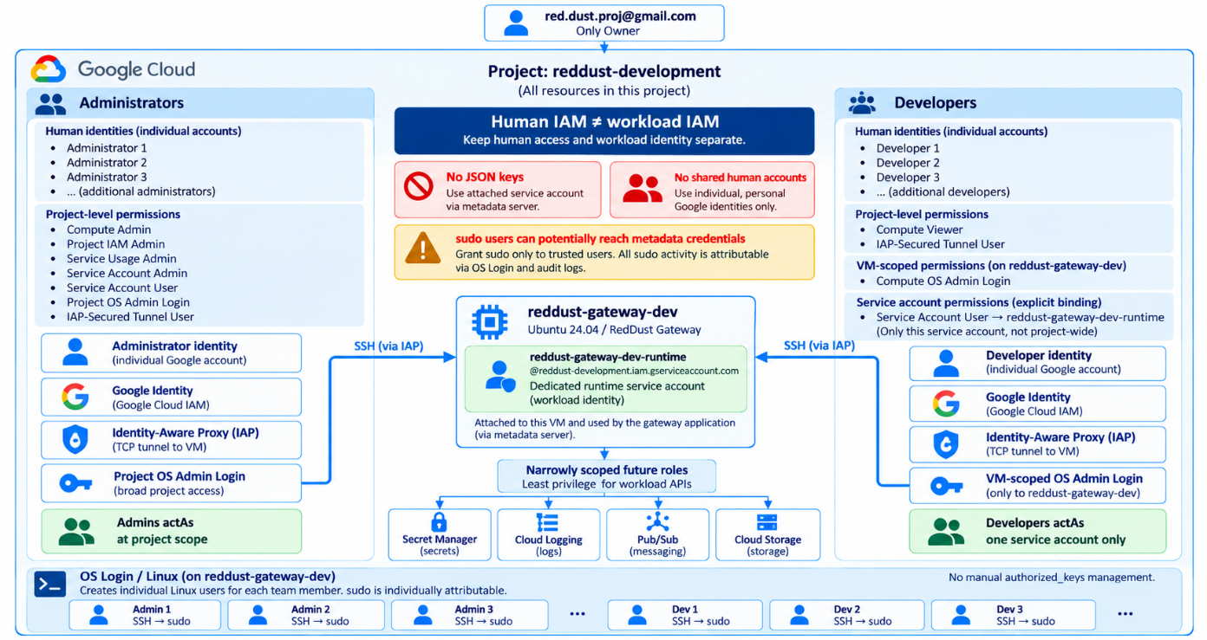

20.6.7.13 — Restart and validate through IAP (Identity Aware Proxy)
Once the runtime identity and actAs policies are in place, start the VM:
gcloud compute instances start "$VM_NAME" --project="$PROJECT_ID" --zone="$ZONE"
Validate separately using the two designated test identities:
Test tier | Identity
Developer test | 1120anirban@gmail.com
Administrator test | anirban@anodiam.com
From each identity, connect through IAP:
gcloud compute ssh "$VM_NAME" --project="$PROJECT_ID" --zone="$ZONE" --tunnel-through-iap
After login, validate the Linux identity and sudo path:
whoami
hostname
sudo whoami
Expected key results:
hostname -> reddust-gateway-dev; sudo whoami -> root
DIAGRAM 20-O: Post-Attachment Validation Sequence
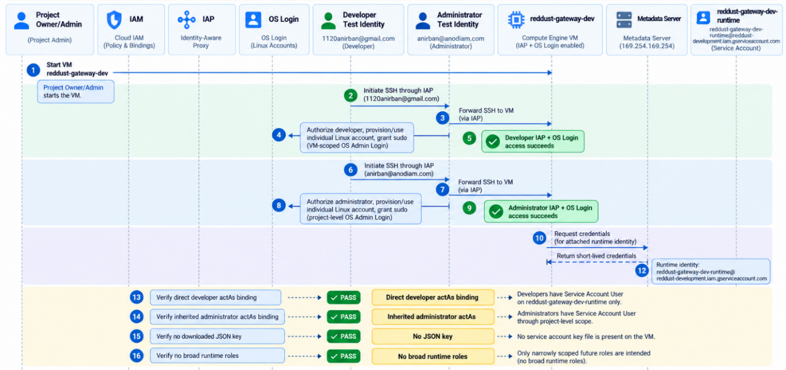

20.6.7.13.0 — If Warning Received while SSH through IAP
If the following warning is received while trying to SSH through IAP:
WARNING: To increase the performance of the tunnel, consider installing NumPy. For instructions,
please see https://cloud.google.com/iap/docs/using-tcp-forwarding#increasing_the_tcp_upload_bandwidth …
Then for every user profile, exit the VM and return to Cloud Shell: anirban@cloudshell:~ (reddust-development)$
$(gcloud info --format="value(basic.python_location)") -m pip install --user numpy
After it finishes, run the following so that the CLOUDSDK_PYTHON_SITEPACKAGES=1 setting persists across future Cloud Shell sessions. We need to add it to the Cloud Shell’s .bashrc file:
echo 'export CLOUDSDK_PYTHON_SITEPACKAGES=1' >> ~/.bashrc
source ~/.bashrc
Then reconnect:
gcloud compute ssh "$VM_NAME" --project="$PROJECT_ID" --zone="$ZONE" --tunnel-through-iap
Your flow is therefore:
Cloud Shell
├── gcloud CLI
├── NumPy ← install HERE
└── IAP tunnel
↓
reddust-gateway-dev VM
├── RedDust
├── FastAPI
├── aiortc
└── application Python environment
Installing NumPy inside reddust-gateway-dev would not remove that particular IAP warning, because the tunnel process is running from Cloud Shell. Also, this NumPy is completely separate from Python/NumPy dependencies of RedDust application.

20.6.7.13.1 — Acceptance checklist
Check | Expected result
Dedicated runtime service account exists | reddust-gateway-dev-runtime@reddust-development.iam.gserviceaccount.com
Gateway VM has one attached service account | The dedicated runtime identity is shown in serviceAccounts[0].email
No service-account JSON key | No downloaded/shared long-lived key is used
Developer actAs scope | Service Account User is bound directly to the one Gateway runtime service account
Administrator actAs scope | Service Account User remains project-level for the Administrator tier
Developer IAP + OS Login | Developer test identity reaches the VM through IAP and sudo succeeds
Administrator IAP + OS Login | Administrator test identity reaches the VM through IAP and sudo succeeds
Runtime permissions | No broad Owner/Editor/Compute Admin role is granted to the runtime identity

20.6.7.14 — Final RedDust recommendation
Attach the dedicated runtime service account now because the Gateway is becoming a real workload and will increasingly need controlled access to GCP services Like Secret Manager, Pub/Sub, storage, CI/CD-related components, platform services etc.
Recommended principle: Attach the workload identity now; add runtime permissions only when each concrete requirement appears. Do not pre-grant a long list of permissions because the Gateway may need them someday.
The resulting policy is intentionally asymmetric:
- Human access is controlled through Google identity, IAP, OS Login, and scoped IAM roles
- Devs get proj visibility, VM-specific OS admin access & actAs only on the one attached Gateway runtime Service Account
- Admins retain broader development-project administration baseline, including project-level Service Account User
- Gateway workload itself receives dedicated identity whose GCP API permissions are added only as needed by application
- No shared Linux account, manually managed authorized_keys team-access path, or long-lived service-account JSON key.
Completion criterion: This section is complete when the dedicated runtime identity is attached, Dev and Admin actAs scopes verified, both test identities can reach VM through IAP using OS Login, sudo works, and runtime service account still has no unnecessary broad permissions.
DIAGRAM 20-P: End-State RedDust Gateway Identity Model
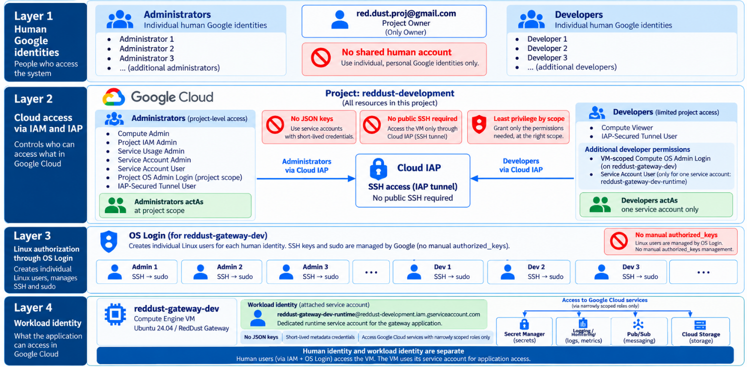

20.6.8 — Test the developer identity after the VM exists
Use the developer test identity before asking Soubhanik, Jazzy and Azad to test. Confirm that OS Login creates an individual Linux identity and that sudo works without elevating the identity to cloud administrator.
1. Sign in as 1120anirban@gmail.com to GCP Cloud Shell and set the project.
gcloud auth list
gcloud config set project reddust-development
2. List the VM and note its zone.
gcloud compute instances list --project=reddust-development
3. Connect with OS Login. Make sure the VM reddust-gateway-dev is turned on. Then
gcloud compute ssh reddust-gateway-dev --project=reddust-development --zone=YOUR_ACTUAL_ZONE
4. Verify the Linux identity and host.
whoami
id
hostname
pwd
Expected hostname:
reddust-gateway-dev
5. Verify sudo capability.
sudo whoami
Expected:
root
6. Exit the VM and re-check the project-level role report from the owner account. The developer must still have no broad cloud administration role.
Developer acceptance: Successful SSH + sudo proves Linux administration on the intended development VM. It does not mean the developer can modify project IAM, create arbitrary VMs, change networking, enable APIs or administer service accounts.
DIAGRAM 20-Q: Final OS Login Authentication Path for reddust-gateway-dev VM
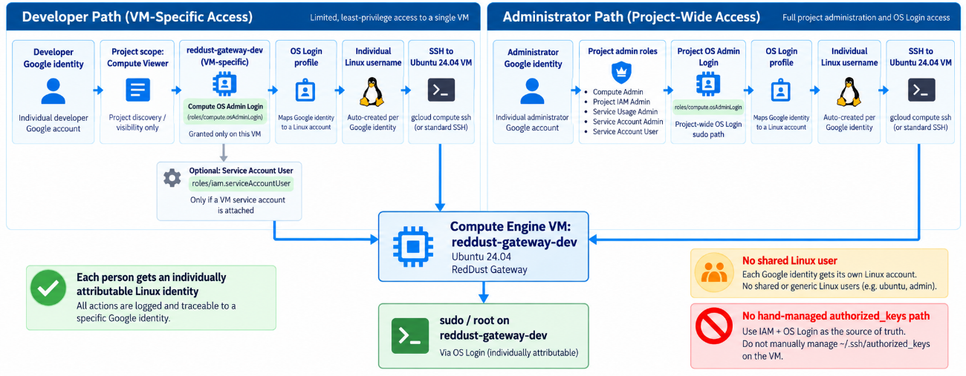

20.6.9 — Test the administrator identity after the VM exists
Use anirban@anodiam.com to validate the administrator path. Administrators already have project-level Compute OS Admin Login and therefore should not need a VM-specific OS Admin Login binding.
gcloud auth list
gcloud config set project reddust-development
gcloud compute instances list
gcloud compute ssh reddust-gateway-dev \
--zone=YOUR_ACTUAL_ZONE
Inside the VM:
whoami
id
hostname
sudo whoami
Expected sudo result:
root
If the VM has a service account: Administrator baseline already includes project-level roles/iam.serviceAccountUser, so admin has actAs permission required for OS Login to VM with a project service account. Devs use narrower service-account-level binding described earlier.

20.6.10 — Harden OS Login with 2-Step Verification and Direct 2FA Onboarding

20.6.10.0 – Google Account 2-Step Verification (2SV)
Purpose of this step: Prepare and verify 2-Step Verification for every active human Google identity before RedDust enables OS Login 2FA. This step changes Google-account authentication readiness only. It does not change Compute Engine metadata, IAM roles, OS Login authorization, Linux users, or SSH configuration.

Scope and acceptance target
At this checkpoint RedDust is intentionally continuing with only three baseline human identities. The five deferred users have already been removed from the audited access paths and are outside the scope of this 2SV step.
Role | Google identity | Known Linux OS Login username | 2SV target
Owner | red.dust.proj@gmail.com | red_dust_proj_gmail_com | Enabled + tested
Administrator | anirban@anodiam.com | anirban_anodiam_com | Enabled + tested
Developer | 1120anirban@gmail.com | usr_1120anirban_gmail_com | Enabled + tested
Acceptance criterion: Do not proceed to the OS Login 2FA enablement step until all three active identities can successfully complete Google sign-in using appropriate second factor, and a recovery/backup method has been deliberately considered.

Why 2SV is a separate prerequisite
Google Account 2-Step Verification (2SV) and Compute Engine OS Login 2FA are related controls, but they are not same
- 2SV belongs to the human Google identity. It establishes that the account can prove identity with an additional authentication factor.
- OS Login controls whether an IAM-authorized Google identity can map to a Linux identity and log in to a Compute Engine VM.
- OS Login 2FA is the Compute Engine enforcement layer that requires an OS Login user to satisfy the configured second-factor challenge during SSH access.

Google identity + 2SV readiness
↓
IAM authorization
↓
OS Login identity mapping
↓
OS Login 2FA enforcement
↓
SSH session to reddust-gateway-dev

Google requirement: Google's Compute Engine documentation states that users must configure 2-Step Verification on their accounts before OS Login 2FA is enabled. If OS Login 2FA is enabled and the user's Google Account or domain is not set up for 2-Step Verification, connection attempts are denied.

Safety rules for this step
- Do not set enable-oslogin-2fa yet. That belongs to the later OS Login 2FA phase.
- Do not remove or alter the existing IAM roles of the three baseline identities while performing 2SV setup.
- Do not share passwords, authenticator secrets, QR codes, SMS codes, security-key data, passkeys, or backup codes in the RedDust runbook, tickets, source repository, screenshots, chat, or team channels.
- Perform each identity's setup in a separate browser profile/incognito context so that the Owner account is not accidentally reused for another identity.
- For a managed work/domain account, follow the organization's Google Workspace or identity-provider policy. If the 2-Step Verification option is unavailable, stop and involve the domain administrator rather than changing unrelated Google Cloud settings.

Pre-check: identify the account type
Treat the three identities as two account categories:
Identity | Likely category | Operational note
red.dust.proj@gmail.com | Personal Google Account | User can normally manage 2SV from Google Account Security settings.
1120anirban@gmail.com | Personal Google Account | User can normally manage 2SV from Google Account Security settings.
anirban@anodiam.com | Domain/work identity | 2SV availability and enforcement can depend on Google Workspace / Cloud Identity / SSO administration.

Procedure for each active identity
Repeat the following procedure separately for Owner, Administrator, and Developer. Do not treat one user's successful setup as evidence for another user.

5.1 Open the correct Google Account security context
- Open a fresh browser profile or incognito/private window for the identity being tested.
- Sign in explicitly as the intended identity.
- Open the Google Account Security & sign-in page. https://myaccount.google.com/general-light?pli=1
- Under “How you sign in to Google,” locate “2-Step Verification.”
- Confirm the email address shown in the account UI before making any change.
Official Google Account entry point: Google Account – Security

5.2 Determine whether 2SV is already enabled
If 2-Step Verification is already enabled, do not disable and recreate it merely for this runbook. Record the status as enabled and continue to the validation and recovery-readiness checks.
Do not record secrets: Record only status information such as “2SV enabled” and the broad factor category used for testing. Never record the actual code, authenticator seed, QR code, backup code, passkey material, or security-key credential.

5.3 Enable 2-Step Verification when it is not already enabled
- Select the option to turn on 2-Step Verification.
- Follow Google's on-screen identity verification flow.
- Configure an allowed second-step method appropriate for the account and organizational policy.
- Complete the enrolment flow until Google reports that 2-Step Verification is enabled.
- Return to the Security page and verify that 2-Step Verification remains shown as enabled.
Google can support several authentication methods depending on the account and policy, including Google prompts, authenticator applications, security keys, SMS/phone verification, backup codes, and passkeys. The exact options shown can vary. For RedDust, prefer strong, phishing-resistant methods where practical; do not weaken an existing organizational policy merely to make the test easier.

5.4 Establish recovery resilience
A second factor improves security but also introduces an account-recovery dependency. Before relying on 2SV for administrative access, make sure the user has a deliberate recovery path.
- Review the account's recovery phone/email configuration where appropriate.
- Where Google makes backup codes available and organizational policy permits them, generate them and store them securely outside the VM and outside the source repository.
- If a hardware security key is used, consider a separately stored backup key or another approved second factor.
- Do not store recovery material in /opt/reddust, Git, Terraform state, Cloud Shell history, shared chat, or the user's VM home directory.

5.5 Perform an independent 2SV sign-in test
The objective is to prove that the user can actually satisfy the second step before OS Login 2FA is enforced.
- Sign out of the Google Account in the test browser context, or use a fresh private/incognito context.
- Sign in again as the same identity.
- If signing in with a password, complete the second-factor challenge presented by Google.
- Confirm that sign-in succeeds and that the user reaches the intended Google Account.
- Record PASS for the identity. Do not capture the challenge response or secret.
Passkey note: Google states that signing in with a passkey can satisfy possession of the device and can bypass a separate second-step prompt. Important readiness criterion is that 2-Step Verification is enabled on the account and the user has a working, policy-compliant authentication path. Later OS Login testing must still validate the actual SSH challenge behavior.

Identity-by-identity execution
As Owner (red.dust.proj@gmail.com), Admin (anirban@anodiam.com) and Developer (1120anirban@gmail.com) do this:
- Open an isolated browser context and verify the account email.
- Confirm 2-Step Verification is enabled; enable it if required.
- Confirm at least one usable second-factor method.
- Confirm an appropriate recovery/backup path.
- Perform an independent sign-in test.
- Record the result in the acceptance table below.
Domain-account checkpoint: If the 2-Step Verification control is unavailable or indicates that the administrator manages the setting, stop for this identity. Do not attempt to work around the domain policy. Resolve the Google Workspace / Cloud Identity / SSO configuration first.

2SV acceptance record
Complete this table before moving to the separate OS Login regression-test and OS Login 2FA enablement steps. Record only non-secret status information.
Role | Identity | 2SV enabled | Second factor tested | Recovery ready | Result
Owner | red.dust.proj@gmail.com | ☐ Yes | ☐ Yes | ☐ Yes | ☐ PASS
Administrator | anirban@anodiam.com | ☐ Yes | ☐ Yes | ☐ Yes | ☐ PASS
Developer | 1120anirban@gmail.com | ☐ Yes | ☐ Yes | ☐ Yes | ☐ PASS

Stop conditions
Do not proceed to OS Login 2FA if any of the following is true:
- Any one of the three baseline identities does not have 2SV enabled.
- A user cannot complete an independent Google sign-in with the configured authentication method.
- The domain-managed administrator identity cannot enroll because of Google Workspace, Cloud Identity, or SSO policy.
- The only working second factor is unavailable, lost, or dependent on an unverified recovery path.
- The team cannot positively identify which Google account is being configured.

Completion criteria and handoff to OS Login 2FA
This discrete step is complete only when all of the following are true:
- Owner: 2SV enabled and tested — PASS.
- Administrator: 2SV enabled and tested — PASS.
- Developer: 2SV enabled and tested — PASS.
- Recovery readiness has been reviewed for all three identities.
- No 2SV secrets or recovery codes have been stored in RedDust infrastructure, source control, documentation, or shared communications.
- No Compute Engine OS Login 2FA metadata has been changed as part of this step.

2SV READINESS COMPLETE
↓
Pre-OS-Login-2FA SSH regression test
↓
Capture OS Login metadata baseline
↓
Enable enable-oslogin-2fa=TRUE
↓
Validate Owner → Administrator → Developer

Handoff: Only after this document's acceptance criteria pass should the RedDust runbook proceed to the separate Compute Engine OS Login 2FA phase.

Troubleshooting guidance
Situation | Action
2-Step Verification option is missing | For a work/school/domain account, contact the identity administrator. Do not change Google Cloud IAM to compensate.
User lost the enrolled phone/security key | Use another configured second step or Google's account-recovery process. Do not enable OS Login 2FA for that user until access is stable.
User can sign in but sees no separate second prompt | A passkey or trusted authentication flow may satisfy the sign-in. Verify that 2SV is shown as enabled; actual OS Login SSH challenge behavior is tested later.
Backup codes are generated | Store them securely and privately. Do not paste them into the runbook or any shared system.
2SV works for two users but not the third | Stop. The OS Login 2FA phase is blocked until the third baseline identity passes.

Official references
- Google Cloud — Set up OS Login (including OS Login 2FA)
- Google Cloud — 2-step verification requirement
- Google Account Help — Turn on 2-Step Verification
- Google Account Help — Sign in with backup codes
- Google Account Help — Fix common issues with 2-Step Verification
Reference note: Google product behavior and available authentication methods can change. Use the official Google documentation above as the authoritative source when executing this step.

Runbook record
Environment | reddust-development
Target VM for later OS Login 2FA phase | reddust-gateway-dev
Prepared as | Discrete prerequisite before OS Login 2FA
Execution date | ____________________________
Executed/reviewed by | ____________________________

20.6.10.1 — Enable OS Login 2FA after the Admin & Dev test IDs have proven baseline OS Login
After the intended baseline test users—Owner: red.dust.proj@gmail.com, Administrator: anirban@anodiam.com, and Developer: 1120anirban@gmail.com—have successfully completed OS Login testing and confirmed Google 2-Step Verification, enable project-level OS Login 2FA.
What this section does: This hardens RedDust SSH access only after the baseline has been proven. Once enabled, every future human user must first configure Google 2-Step Verification, then receive the required IAM/IAP/OS Login access, and connect through the existing 2FA-protected path. Do not disable 2FA for future onboarding, because users without 2-Step Verification will be denied SSH.
New technical concepts introduced in this section (in absolute beginner terms): OS Login decides which Google identity becomes which Linux user. OS Login 2FA adds a second identity check when that person opens a new SSH session. Google calls the account-side feature “2-Step Verification (2SV)”; Compute Engine calls the SSH enforcement feature “OS Login 2FA”. For enforcement, both project metadata values enable-oslogin=TRUE and enable-oslogin-2fa=TRUE must be active.
Who does what: Owner: enable the project-level metadata and retain recovery authority. Administrator: verify the setting and continue normal administration after the control is enabled. Existing tested users: prove that fresh SSH sessions still work with the second factor. Future Administrators and Developers: configure their own Google 2-Step Verification before their first SSH attempt, then receive only the role-based access defined elsewhere in Step 20.
IMPORTANT — account 2-Step Verification is a prerequisite: OS Login 2FA does not enroll a user into Google 2-Step Verification. Before enabling the project control, confirm that 3 already-tested human identities have 2-Step Verification configured. After project control is enabled, any future human user without 2-Step Verification will be denied a new OS Login SSH connection until they configure it.
What this subsection does and why it matters: The baseline access path is already known to work. This subsection adds the second-factor requirement at project level without changing the established IAM, IAP, firewall or Linux authorization model.
Known-good baseline before the 2FA change
Identity type |  | Google identity | Baseline OS Login status | Required before enabling 2FA
Owner |  | red.dust.proj@gmail.com | Working | Confirm Google 2-Step Verification is enabled
Administrator test |  | anirban@anodiam.com | Working | Confirm Google 2-Step Verification is enabled
Developer test |  | 1120anirban@gmail.com | Working | Confirm Google 2-Step Verification is enabled
 | STOP CHECK: Do not run the metadata change until all three known-good identities above have their own Google 2-Step Verification configured. Their ability to SSH prove OS Login, but it does not by itself prove that their Google accounts are ready for OS Login 2FA.
Where and who should run the change: Run the following commands in Google Cloud Shell while signed in as the RedDust Owner, red.dust.proj@gmail.com. Using the Owner for this one-time security-control change keeps the runbook deterministic and preserves the Administrator account for ordinary administration. An Administrator should not be given extra permissions merely to perform this step.
- Set project context: Point gcloud at reddust-development and confirm the active account before making the metadata change. Run in Google Cloud Shell:
PROJECT_ID="reddust-development"
gcloud config set project "$PROJECT_ID"
gcloud auth list
gcloud config get-value project
Expected pre-change check: The active account should be the intended Owner and the project should be reddust-development. If a different Google identity or project is active, stop and correct the Cloud Shell session before continuing.
- Inspect the current project metadata first: Record the current common instance metadata before changing it. This gives you a before/after checkpoint and helps confirm that OS Login was already enabled.
gcloud compute project-info describe --project="$PROJECT_ID" \
--format="yaml(commonInstanceMetadata.items)"
- Enable OS Login & OS Login 2FA: Update 2 metadata keys. Keeps OS Login enabled & adds second-factor requirement.
gcloud compute project-info add-metadata --project="$PROJECT_ID" \
--metadata=enable-oslogin=TRUE,enable-oslogin-2fa=TRUE
What this command changes: enable-oslogin=TRUE keeps Google identity-based Linux login active. enable-oslogin-2fa=TRUE tells Compute Engine to require a second factor for human OS Login connections. This does not create shared Linux accounts, does not add SSH keys manually, and does not replace IAM/IAP authorization.
- Verify both project metadata values: Read the project metadata back from Google Cloud. Do not assume the update succeeded merely because the command returned without an obvious error.
gcloud compute project-info describe --project="$PROJECT_ID" \
--format="yaml(commonInstanceMetadata.items)"
Expected metadata result
commonInstanceMetadata:
items:
- key: enable-oslogin
value: "TRUE"
- key: enable-oslogin-2fa
value: "TRUE"
Other metadata items may also appear. Important acceptance condition is - both OS Login keys are present with TRUE values.
- Check the Gateway VM for an instance-level override: Project metadata can be overridden by instance metadata. Verify that reddust-gateway-dev does not contain a conflicting instance-level value such as enable-oslogin-2fa=FALSE.
gcloud compute instances describe reddust-gateway-dev --project="$PROJECT_ID" \
--zone="australia-southeast1-b" --format="yaml(metadata.items)"
Interpretation: If the VM does not define the OS Login keys at instance level, the project-level TRUE values apply. If the VM explicitly defines a conflicting value, stop and investigate that override before treating 2FA as enforced.
- Prove 2FA with fresh SSH sessions: Close or ignore any already-open SSH terminals and start new IAP SSH connections. An existing session does not prove that a new login is being challenged by the 2FA policy.
Run separately while authenticated as each test identity
gcloud compute ssh reddust-gateway-dev --project="$PROJECT_ID" \
--zone="australia-southeast1-b" --tunnel-through-iap
Repeat the fresh-login test for all three known-good identities
Identity | Expected result after 2FA is enabled
red.dust.proj@gmail.com | Fresh IAP + OS Login SSH succeeds after the required second-factor challenge.
anirban@anodiam.com | Fresh IAP + OS Login SSH succeeds after the required second-factor challenge.
1120anirban@gmail.com | Fresh IAP + OS Login SSH succeeds after the required second-factor challenge.
Inside the VM: non-destructive confirmation
whoami
id
sudo –l
Record the exact Linux username returned by whoami. Do not assume the Linux username from the email address. sudo -l is a non-destructive way to inspect whether the intended OS Admin Login privilege is available.
ACCEPTANCE CRITERION: Project metadata shows enable-oslogin=TRUE and enable-oslogin-2fa=TRUE; no conflicting instance override defeats the project setting; and the Owner, Administrator test identity and Developer test identity can each establish a new IAP + OS Login SSH session using their own second factor.
Do not weaken the control after it is proven: Once the three known-good users have successfully reconnected under 2FA, keep project-level OS Login 2FA enabled. Future team members should be prepared for the hardened path rather than temporarily lowering the project security setting for onboarding.

20.6.10.2 — Onboard all new Administrators and Developers directly with OS Login 2FA enabled
What this subsection does and why it matters: This becomes the permanent onboarding model after 20.5.19.1 succeeds. New team members do not receive a temporary non-2FA SSH path. They prepare their Google account for 2-Step Verification first, receive the correct role-based access, and then perform their first SSH login through the already-enforced OS Login 2FA path.
New beginner concept: project-level 2FA is not configured per user: You do not toggle enable-oslogin-2fa for each person. The project control remains TRUE. Each new human identity either satisfies the requirement and can proceed through the remaining IAM/IAP/OS Login layers, or fails the login until its own Google 2-Step Verification is correctly configured.
Planned users to onboard later
Role tier | Google identity | Onboarding path
Administrator | tanvimultani.work@gmail.com | 2SV first → Administrator IAM/IAP/OS Login grants → fresh 2FA SSH test
Administrator | sayan@anodiam.com | 2SV first → Administrator IAM/IAP/OS Login grants → fresh 2FA SSH test
Developer | soubhanikpatra@gmail.com | 2SV first → Developer-scoped grants → fresh 2FA SSH test
Developer | mdazadansari0210@gmail.com | 2SV first → Developer-scoped grants → fresh 2FA SSH test
Developer | jehanzaib.f@gmail.com | 2SV first → Developer-scoped grants → fresh 2FA SSH test
Permanent onboarding sequence for every future human user
- Create or confirm the individual Google identity: Use the person’s own Google identity. Do not create a shared “reddust”, “developer”, “team” or “ubuntu” login for human SSH access.
- Require Google 2-Step Verification before SSH access: New user must configure Google 2-Step Verification on that account before attempting OS Login to the Gateway. This is now an onboarding prerequisite, not a post-login hardening task.
- Grant only the role tier defined by Step 20: Apply same Administrator or Developer IAM/IAP/OS Login role model already established earlier in the runbook. Do not grant Owner, Editor or broad Compute/IAM roles to make onboarding easier.
- Apply the external-user prerequisite when applicable: If the identity is outside the Google Cloud organization that owns reddust-development, follow Section 20.3.6 and ensure the required organization-level OS Login External User access is in place before troubleshooting the VM.
- Keep the project 2FA metadata unchanged: Do not set enable-oslogin-2fa=FALSE for the new user. Verify that the project still has enable-oslogin=TRUE and enable-oslogin-2fa=TRUE. Owner or Administrator verification:
PROJECT_ID="reddust-development"
gcloud compute project-info describe --project="$PROJECT_ID" \
--format="yaml(commonInstanceMetadata.items)"
- Have the new user make the first IAP SSH connection: The new team member signs in with their own Google identity and connects through IAP. The second-factor challenge is part of the first hardened login path.
gcloud compute ssh reddust-gateway-dev --project="reddust-development" \
--zone="australia-southeast1-b" --tunnel-through-iap
- Verify the Linux identity and intended privilege level: Inside the VM, capture the exact OS Login username and inspect the authorization level. The result becomes part of the onboarding record for that person.
whoami
id
sudo –l
- Record success without creating shared credentials: Record the Google identity, role tier, exact Linux username, date of successful 2FA SSH test and whether sudo is expected. Never copy another user’s SSH key, ADC file, browser session or Linux home directory.
If the first 2FA SSH attempt fails: Do not disable project-level 2FA as the first troubleshooting step. Check, in order: the user’s Google 2-Step Verification enrolment; project IAM role; IAP TCP forwarding permission; IAP firewall path to TCP 22; OS Login role; organization-level OS Login External User requirement where applicable; and only then the VM/guest OS. This preserves the proven security baseline while isolating the missing layer.
Planned onboarding acceptance tracker
User Level |  | 2SV confirmed | Role grants complete | Fresh 2FA SSH works | whoami recorded
Owner |  | ☐ | ☐ | ☐ | ☐
Administrator |  | ☐ | ☐ | ☐ | ☐
Developer |  | ☐ | ☐ | ☐ | ☐
 | ACCEPTANCE CRITERION: Each new Administrator or Developer is onboarded through an individual Google identity with Google 2-Step Verification already configured, receives only the intended RedDust role tier, establishes a fresh IAP + OS Login SSH connection while project-level 2FA remains enabled, and is mapped to an individual Linux account. No shared human account, manual authorized_keys workflow or temporary 2FA bypass is introduced.
Operational rule to carry forward: Existing team: prove baseline OS Login → enable project-level OS Login 2FA → re-test fresh SSH sessions. Future team member: configure personal Google 2-Step Verification → grant least-privilege access → connect directly through the already-enabled 2FA path. Do not disable 2FA for routine onboarding.
Google Cloud reference basis: This subsection follows the current Compute Engine OS Login guidance: OS Login 2FA is enforced when both enable-oslogin and enable-oslogin-2fa are TRUE; human users must have 2-Step Verification configured to connect; and instance metadata can override project metadata. See GCP documentation: “Set up OS Login” and “About OS Login”.

20.6.11 — Troubleshooting decision table
Symptom | Most likely cause | Corrective check
Project does not appear in a member’s selector | Wrong Google account, misspelled identity, or missing project discovery role | Confirm browser account; owner checks exact IAM member; verify developer has roles/compute.viewer.
gcloud says project access denied | Active gcloud account is wrong or required project permission is missing | Run gcloud auth list; set project; inspect owner-side IAM report.
Developer can see project but cannot SSH after VM exists | VM-specific OS Admin Login missing, external-user org role missing, OS Login disabled/overridden, or service-account actAs missing | Check project metadata, VM IAM, organization rule, then VM service account.
SSH error mentions iam.serviceAccounts.actAs | VM has an attached service account and user lacks Service Account User | Grant roles/iam.serviceAccountUser on that service account only.
VM_SA variable is blank | No service account attached, or VM/project/zone lookup is wrong | First confirm instance describe succeeds and zone is correct. If serviceAccounts is absent, skip actAs grant.
VM is stopped and service account output is blank | Stopping a VM is not the cause | A stopped VM retains its configured service account. Inspect the VM configuration and lookup variables.
External Gmail user receives OS Login denial in an organization-owned project | Compute OS Login External User may be missing at organization scope | Organization administrator grants roles/compute.osLoginExternalUser when applicable.
Developer unexpectedly has broad control | Over-broad project role was granted | Remove unintended Owner/Editor/Compute Admin/Project IAM Admin; re-run role report.
Administrator cannot manage IAM | Project IAM Admin missing or account mismatch | Verify exact identity and roles/resourcemanager.projectIamAdmin binding.
OS Login appears enabled project-wide but a VM ignores it | Instance metadata may override project metadata | Inspect instance metadata for enable-oslogin=FALSE and remove/fix the override.

20.6.12 — Offboarding and access revocation pattern
When a person leaves the RedDust project, remove their IAM bindings rather than deleting a shared Linux password or editing authorized_keys. For a developer, remove the project-level Compute Viewer binding, the VM-level OS Admin Login binding, and (if present) the service-account-level Service Account User binding. For an administrator, remove each project-level administrator role.
Audit principle: One Google identity per person makes onboarding and offboarding attributable. Do not reuse another person’s Google account, Cloud Shell session or Linux identity.
What this section does and why it matters: This section defines the RedDust process for removing access when someone leaves the project, changes roles, or no longer requires Gateway VM access. Because RedDust uses individual Google identities with IAM, IAP, and OS Login, offboarding removes cloud authorization rather than managing shared passwords, authorized_keys, or shared Linux accounts.
Core objective: Remove the person’s Google Cloud authorization at every layer where it was granted, then verify—non-destructively—that new access is no longer possible.
Who performs offboarding: The Owner or an authorized Administrator who is not the person being removed performs the change. For privileged Administrator offboarding, the Owner should preferably perform or approve the revocation.

20.6.12.1 — Understand what must be revoked
A person’s ability to reach reddust-gateway-dev can depend on several independent permissions. Removing one role does not necessarily remove every access path.
For a typical Developer, review and remove any applicable bindings for:
- Compute Viewer at project level.
- IAP-secured Tunnel User if granted directly.
- Compute OS Admin Login or Compute OS Login at VM or project level.
- Service Account User on reddust-gateway-dev-runtime, if previously granted.
- Any other RedDust-specific role granted individually.
For an Administrator, review and remove every administrator role granted to that identity, including Compute, IAM, service-account, IAP, OS Login, Storage, Logging/Monitoring, Terraform/infrastructure, or other administrative roles.
⚠ Important: IAM bindings may exist at project, instance, service-account, folder or organization scope. Do not assume that removing a single project role fully offboards the person.

20.6.12.2 — Record the identity being removed
Before changing IAM, record the exact Google identity and target project/VM. Use the Google identity as the authoritative identifier; do not rely only on the Linux username because OS Login derives the Linux identity from the Google identity.
OFFBOARD_EMAIL="user@example.com"
PROJECT_ID="reddust-development"
VM_NAME="reddust-gateway-dev"
ZONE="australia-southeast1-b"

20.6.12.3 — Capture the current access state before removal
Before removing anything, inspect the current IAM state so the offboarding record shows what the person had immediately before revocation. Project-level bindings:
gcloud projects get-iam-policy "$PROJECT_ID" --flatten="bindings[].members" \
--filter="bindings.members:user:$OFFBOARD_EMAIL" --format="table(bindings.role)"
Instance-level IAM:
gcloud compute instances get-iam-policy "$VM_NAME"
--zone="$ZONE" --project="$PROJECT_ID"
Look for the departing identity in the returned members list. If the person had permission to act as the Gateway runtime service account, inspect that policy separately:
gcloud iam service-accounts get-iam-policy \
reddust-gateway-dev-runtime@reddust-development.iam.gserviceaccount.com \
--project="$PROJECT_ID"
Audit note: Save or record the relevant before-state as part of the project offboarding evidence. Do not store passwords, OAuth tokens, private keys or other credentials in the record.

20.6.12.4 — Remove project-level IAM roles
Remove each direct project role assigned to the departing identity. For a Developer, Compute Viewer is a common example:
gcloud projects remove-iam-policy-binding "$PROJECT_ID" \
--member="user:$OFFBOARD_EMAIL" \
--role="roles/compute.viewer"
For any other project role that must be removed, repeat the command with the exact role name:
gcloud projects remove-iam-policy-binding "$PROJECT_ID" \
--member="user:$OFFBOARD_EMAIL" \
--role="ROLE_TO_REMOVE"
Least-change rule: Remove only the intended principal from the intended role. Do not replace the whole IAM policy or delete a shared role binding that other users still require.

20.6.12.5 — Remove IAP access
If the person’s IAP TCP forwarding permission was granted directly, remove that binding at the scope where it was assigned. The relevant security question is:
IAP question: Can this Google identity still create an IAP TCP tunnel to the VM?
If IAP access is inherited through a Google Group, remove the person from that group instead of deleting the group’s IAM binding. Other authorized members must remain unaffected.

20.6.12.6 — Remove OS Login / OS Admin Login access
If the person’s OS Login role was granted directly on reddust-gateway-dev, remove the corresponding instance-level IAM binding. Typical roles include roles/compute.osLogin and roles/compute.osAdminLogin.
OS Login question: Even if this person can still see the project, are they still authorized to become a Linux user on this VM?
After the binding is removed, future OS Login authentication must no longer grant access through that permission.
⛔ Do not edit Linux SSH keys: Do not manually edit ~/.ssh/authorized_keys and do not create/delete shared Linux passwords as part of normal OS Login offboarding. IAM and OS Login remain the authoritative access controls.

20.6.12.7 — Remove Service Account User access
If the departing person was allowed to act as the Gateway runtime service account, remove the roles/iam.serviceAccountUser binding on:
reddust-gateway-dev-runtime@reddust-development.iam.gserviceaccount.com
This matters because service-account actAs capability is a separate authorization path from SSH. A user who no longer needs RedDust access should not retain the ability to attach or act as the Gateway runtime identity.

20.6.12.8 — Check permissions inherited through groups
Direct IAM removal is not sufficient when access is inherited through a group. Check whether the departing identity belongs to any group used for Developers, Administrators, IAP users, OS Login users, Terraform administrators, CI/CD operators, or other RedDust access.
If access is inherited through a group, remove the person from the group. Do not delete the group-level IAM binding while other team members still require it.

20.6.12.9 — Do not manually delete the OS Login Linux identity
With OS Login, the Linux username is derived from the person’s Google identity. Normal offboarding therefore happens through IAM and OS Login authorization rather than by deleting the Linux account.
Google identity
↓
OS Login
↓
Individual Linux username
Authoritative boundary: The security decision is whether the Google identity is still authorized. Avoid manually deleting the Linux user merely to revoke ordinary OS Login access.

20.6.12.10 — Consider already-open SSH sessions
Removing IAM prevents future authorized access, but an SSH session that was established before the IAM change may remain active until that session closes.
For routine offboarding, perform IAM revocation promptly at the agreed offboarding time. For security-sensitive or immediate termination, an Administrator should additionally check for active Linux sessions:
who
w
If necessary, terminate only the specific departing user’s active session under the organization’s approved offboarding or incident procedure. Do not terminate unrelated users’ sessions.
Important distinction: IAM revocation protects new connections. Active-session handling is a separate operational step when immediate termination is required.

20.6.12.11 — Verify project IAM after removal
Repeat the project IAM query after revocation:
gcloud projects get-iam-policy "$PROJECT_ID" \
--flatten="bindings[].members" \
--filter="bindings.members:user:$OFFBOARD_EMAIL" \
--format="table(bindings.role)"
For a fully offboarded user with no remaining project access, the result should contain no unintended direct project-level roles. Then re-check VM-level IAM, IAP access, service-account IAM and relevant groups.

20.6.12.12 — Perform a non-destructive access verification
Do not create, delete or modify resources merely to prove that offboarding worked. Instead, verify that the removed identity can no longer establish a new IAP/OS Login SSH session to reddust-gateway-dev.
✓ Expected result: A new SSH connection for the offboarded identity is denied, while authorized Owner, Administrator and Developer accounts continue to work normally.
Where appropriate, Policy Troubleshooter and read-only IAM reports may also be used to verify that sensitive permissions are no longer granted. Do not weaken IAM merely to obtain a more convenient test result.

20.6.12.13 — Preserve audit evidence
Record the offboarding event in the project access register. At minimum capture the following information:
Item | Record
Person | Name
Google identity | Exact email address
Role | Developer / Administrator
Offboarding date/time | Timestamp
Project roles removed | List
VM roles removed | List
IAP access removed | Yes / N/A
Service Account User removed | Yes / N/A
Group memberships removed | List / N/A
Active sessions reviewed | Yes / N/A
Access verification completed | Yes
Performed by | Owner / Administrator
Reviewed by | Owner / authorized reviewer
Do not record secrets: The offboarding record must not contain passwords, OAuth access tokens, SSH private keys, ADC files or other credentials.

20.6.12.14 — Developer offboarding pattern
For the current RedDust model, Developer offboarding normally follows this sequence:
Developer Google identity
├── Remove Compute Viewer
├── Remove direct IAP access, if granted
├── Remove VM-level OS Login / OS Admin Login
├── Remove Service Account User, if granted
├── Remove relevant group membership
↓
Verify no unintended authorization remains
↓
New SSH attempt must fail

20.6.12.15 — Administrator offboarding pattern
Administrators may have several independent authorization paths, so offboarding begins with a complete inventory rather than assuming that one broad role is sufficient.
Administrator Google identity
├── Remove Compute administration roles
├── Remove IAM administration roles
├── Remove Service Account roles
├── Remove IAP permissions
├── Remove OS Login / OS Admin Login
├── Remove Terraform / infrastructure access
├── Remove relevant group memberships
└── Remove any other project-specific roles
↓
Verify all authorization paths
↓
Confirm new administrative and SSH access is denied
Do not assume one role is enough: Removing roles/compute.admin alone does not necessarily offboard an Administrator. Review every direct and inherited authorization path.

20.6.12.16 — Do not remove shared infrastructure
Offboarding a person removes the person’s authorization; it does not delete the RedDust platform. Unless a separate infrastructure change explicitly requires it, do not delete or alter shared platform resources such as:
- reddust-gateway-dev
- reddust-gateway-dev-runtime
- VPC/firewall rules
- IAP configuration
- OS Login project metadata
- Terraform state or state bucket
- Artifact Registry repositories
- shared service accounts or shared infrastructure policies

20.6.12.17 — Completion checklist
# | Offboarding control | Done
1 | Exact Google identity confirmed | □
2 | Before-state IAM evidence captured | □
3 | Direct project IAM roles removed | □
4 | IAP access removed or group membership revoked | □
5 | OS Login / OS Admin Login access removed | □
6 | Service Account User removed, if applicable | □
7 | Relevant group memberships removed | □
8 | Active SSH sessions checked when required | □
9 | Post-removal IAM reports reviewed | □
10 | New IAP/OS Login SSH access verified denied | □
11 | Authorized team members verified unaffected | □
12 | Offboarding record completed and reviewed | □

20.6.12.18 — Audit principle and permanent RedDust pattern
Audit principle: One Google identity per person keeps access attributable & revocable. Never offboard by changing shared passwords, editing authorized_keys, reusing Google accounts, sharing Cloud Shell sessions, or transferring ADC credentials.
The permanent RedDust model is:
JOIN
Individual Google identity
↓
Least-privilege IAM
↓
IAP
↓
OS Login + 2FA
↓
Authorized VM access

LEAVE
Individual Google identity
↓
Remove IAM / IAP / OS Login authorization
↓
Remove service-account and group access where applicable
↓
Verify new access is denied
↓
Preserve audit evidence
✓ Security outcome: Offboarding revokes the person, not the platform. The result should be attributable, least-privilege, auditable and reversible only through a deliberate new authorization decision.
DIAGRAM 20-R: RedDust User Offboarding and Access Revocation Flow
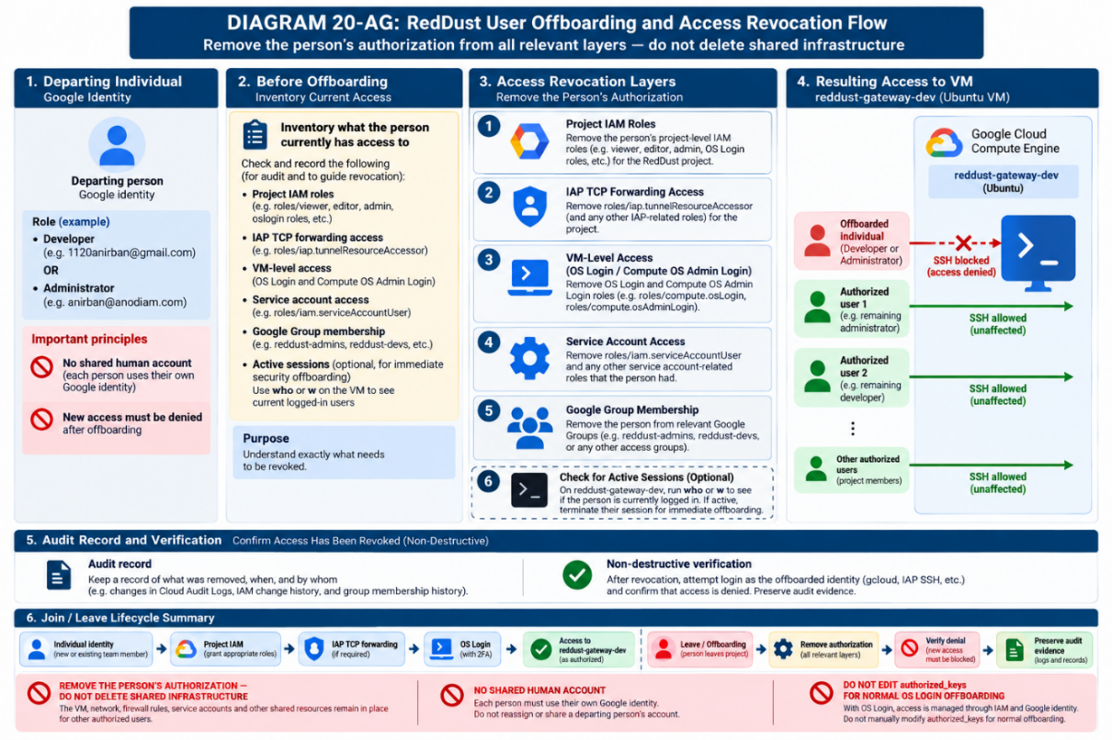

20.6.12.19 — Section acceptance criteria
- The exact departing Google identity is documented.
- All direct and inherited RedDust authorization paths have been reviewed.
- Unneeded project-, VM-, IAP-, service-account- and group-level access has been revoked.
- Any immediate active-session requirement has been handled without disrupting unrelated users.
- A new IAP/OS Login SSH connection for the offboarded identity is denied.
- Authorized team members and shared RedDust infrastructure remain unaffected.
- The before-state, changes, verification and reviewer are recorded for audit.
STOP/ ESCALATE: If access persists after removing IAM bindings, do not weaken security or delete shared infra. Investigate inherited IAM, Google Groups, organization/folder policies, SA permissions, & active sessions before proceeding.

20.6.13 — Final acceptance checklist
Done | Acceptance condition
☐ | Owner account red.dust.proj@gmail.com remains Owner.
☐ | Billing remains attached to reddust-development; no team billing-admin role was added by this section.
☐ | Compute Engine, OS Login and IAM-related APIs required by this procedure are enabled.
☐ | Project metadata contains enable-oslogin=TRUE.
☐ | anirban@anodiam.com passes the controlled Administrator test.
☐ | 1120anirban@gmail.com passes the controlled Developer pre-VM test.
☐ | If the project is organization-owned, external-user OS Login requirements are handled at organization scope where applicable.
☐ | No shared Linux account is used for human team access.
☐ | No manually distributed team SSH keys are stored as the access-control model.
☐ | After reddust-gateway-dev exists, developers receive OS Admin Login on that VM only.
☐ | If the VM has a service account, developers receive Service Account User on that service account only.
☐ | Developer test SSH succeeds and sudo whoami returns root.
☐ | Administrator test SSH succeeds and sudo whoami returns root.
☐ | Developers still do not have project Owner, Editor, Compute Admin or Project IAM Admin.
☐ | After first-login validation, all human users enable Google 2-Step Verification before project-wide OS Login 2FA is enforced.
DIAGRAM 20-S: Final RedDust IAM & OS Login Least Privilege Architecture
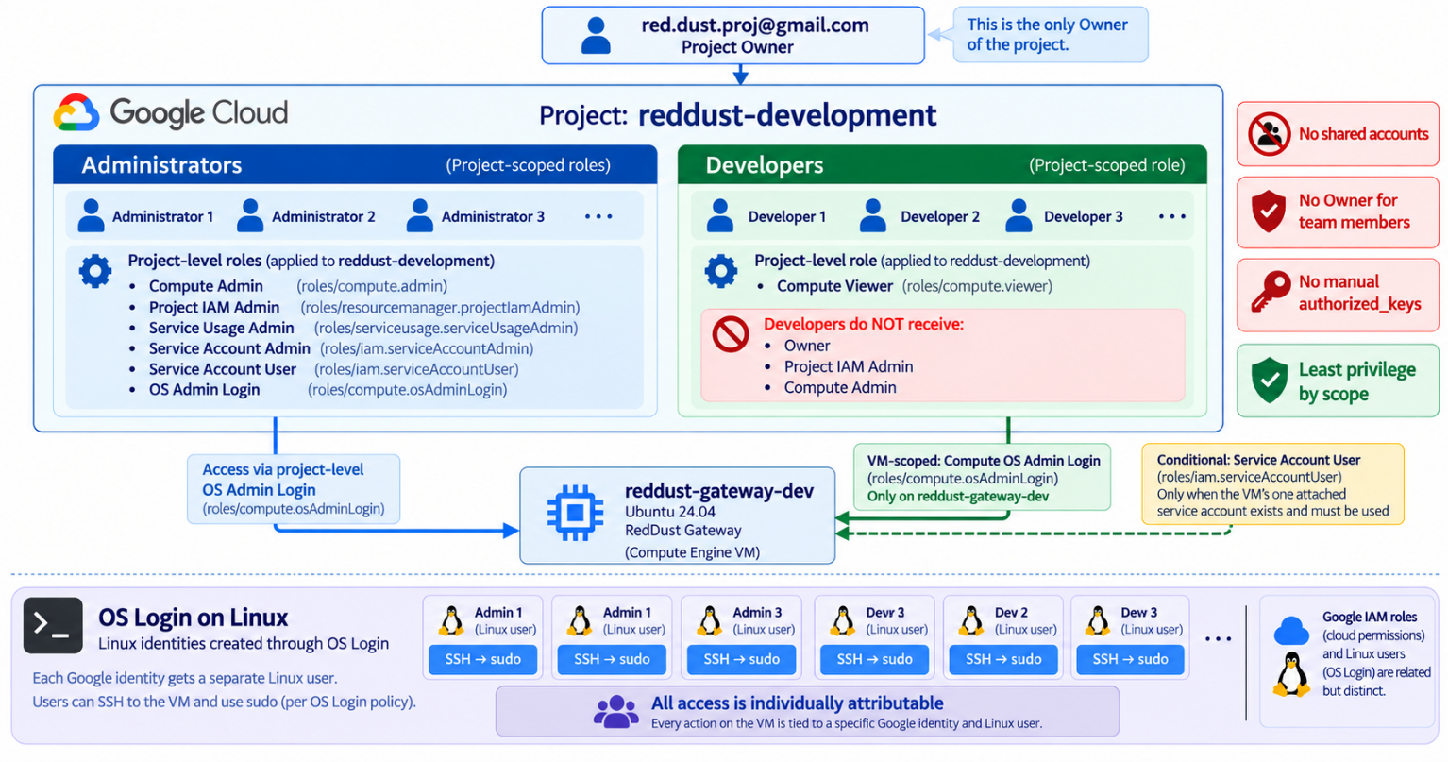

20.6.14 — Resulting RedDust access model
When all acceptance checks pass, the project has an intentional split between infrastructure authority and VM operating-system authority. Administrators can operate the development project; developers can inspect the project and administer the one gateway VM through their own OS Login identities. The project owner remains the ultimate authority without distributing Owner to the team.
reddust-development
├── red.dust.proj@gmail.com
│ └── Owner
├── Administrators
│ └── anirban@anodiam.com [administrator test]
│ ├── Compute Admin
│ ├── Project IAM Admin
│ ├── Service Usage Admin
│ ├── Service Account Admin + User
│ └── OS Admin Login (project scope)
└── Developers
└── 1120anirban@gmail.com [developer test]
├── Compute Viewer (project scope)
├── OS Admin Login (reddust-gateway-dev only, after creation)
└── Service Account User (attached VM SA only, if one exists)

20.6.15 — Authoritative Google Cloud references
This implementation pattern is based on current Google Cloud IAM and Compute Engine OS Login guidance. Google Cloud roles and product behavior can evolve; re-check these references before materially changing the security model.
• Set up OS Login
• Best practices for controlling SSH login access
• Manage OS Login in an organization
• Compute Engine roles and permissions
• IAM roles and permissions (Service Account User/Admin)
• Resource Manager roles and permissions (Project IAM Admin)
• Service Usage roles and permissions
• Compute Engine service accounts
• Troubleshoot IAM permissions
Documentation status: Prepared as a clean-slate Section 20.5 implementation guide for reddust-development. The access model assumes no pre-existing team-member permissions and should be applied deliberately from the owner account.

20.7 — Configure Networking in the Create VM Screen
The Step-20 Gateway needs a public IPv4 address for temporary signalling and direct WebRTC testing. Keep networking intentionally simple: one NIC, default VPC, IPv4 only.

20.7.1 — Open Networking
1. In Create instance, open Networking.
2. Locate Network interfaces.
3. Open the default interface, usually nic0.

20.7.2 — VPC and subnet
Network: default
Subnetwork: default subnet in australia-southeast1
Network interfaces: 1 (nic0 only)

20.7.3 — Internal and external addresses
Internal IPv4: Automatic / ephemeral
External IPv4: Ephemeral
IP stack: IPv4 only
Do not reserve a static external IP yet. The first objective is connectivity. A static IP is a later stabilisation step after the WebRTC path works.

20.7.4 — Network tag
reddust-gateway
This tag will be used by the dedicated TCP 8000 and UDP WebRTC firewall rules.

20.7.5 — Generic HTTP/HTTPS checkboxes
Allow HTTP traffic: OFF
Allow HTTPS traffic: OFF
Do not use the generic HTTP/HTTPS shortcuts. Step 20 creates explicit development firewall rules. Later production signalling will use HTTPS on TCP 443 through a reverse proxy.

20.7.6 — Final review before Create
Area | Required value
Project | RedDust Development
VM | reddust-gateway-dev
Region / zone | australia-southeast1 / australia-southeast1-b
Machine | E2 / e2-medium
Provisioning | Standard
OS | Ubuntu 24.04 LTS standard, amd64
Boot disk | 10 GB pd-standard
Service account | No service account, if available
OS Login | Project-wide enable-oslogin=TRUE / IAM access
VPC | Default
External IPv4 | Ephemeral
IP stack | IPv4 only
Network tag | reddust-gateway
HTTP/HTTPS shortcuts | Off / Off
After reviewing the estimated cost shown by GCP, click Create.
DIAGRAM 20-T: VPC, NIC, Public IP and Network Tag
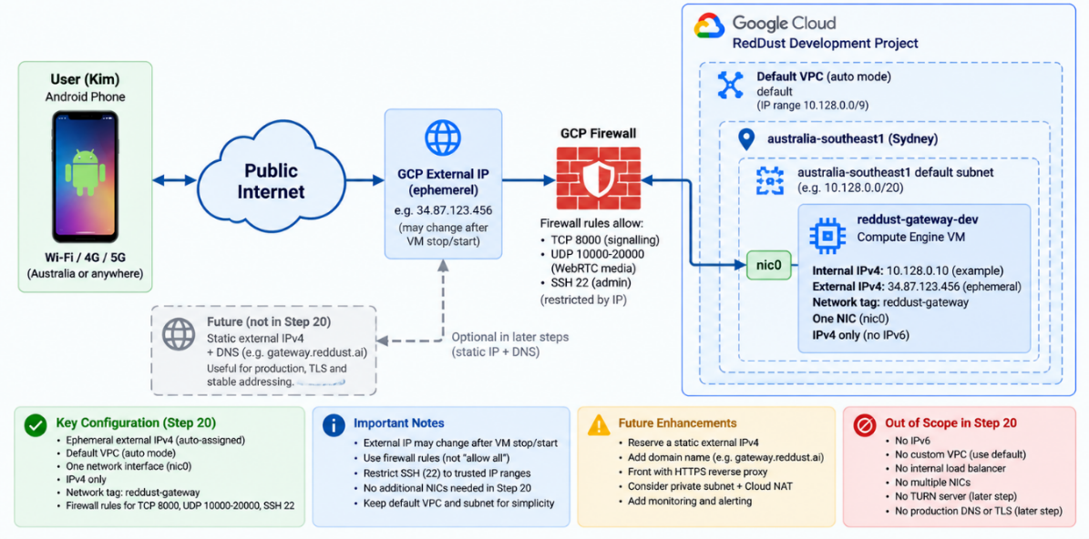

20.8 — Add IAP-Secured SSH to the RedDust Access Model
IAP stands for Identity-Aware Proxy, and SSH stands for Secure Shell. In this RedDust design, IAP becomes the controlled entry path for administrative SSH access to reddust-gateway-dev VM. Instead of exposing TCP port 22 broadly to the public Internet, an authenticated and authorized user establishes an encrypted tunnel through Google Cloud IAP, and the VM firewall accepts SSH traffic, only from Google's IAP TCP-forwarding address range.
This does not replace OS Login. IAP answers “May this Google identity establish a tunnel to this VM?”, while OS Login answers “Once the connection reaches the VM, which Linux identity is this user, and what Linux privileges should that identity have?”. The two controls are intentionally layered. The security payoff is that direct Internet SSH can be removed after IAP access has been tested successfully.
Target security outcome:
Google identity → IAP authorization → firewall allows IAP source range on TCP/22 → OS Login maps the human to an individual Linux account → sudo is controlled by the OS Login role. No shared SSH account is required.

20.8.1 — CIDR Primer: Understanding 35.235.240.0/20
CIDR (Classless Inter-Domain Routing) notation is a compact way to describe a block of IP addresses. An IPv4 address contains 32 binary bits (8bits.8bits.8bits.8bits)/ (0to255.0to255.0to255.0to255), written for humans as four decimal numbers separated by dots. The number after the slash tells us how many of those 32 bits are fixed as the network prefix.
In 35.235.240.0/20, the /20 does not mean “20 IP addresses.” It means first 20 bits are fixed & remaining 12 bits vary.
Item | Meaning
IPv4 address size | 32 bits total
CIDR prefix /20 | First 20 bits are fixed as the network prefix
Remaining bits | 32 − 20 = 12 variable bits
Number of available addresses | 2^12 = 4,096 addresses
Subnet mask | 255.255.240.0
First address | 35.235.240.0
Last address | 35.235.255.255

Why the third octet runs from 240 to 255
Each IPv4 octet contains 8 bits. The address can be shown in binary as:
35 . 235 . 240 . 0
00100011 . 11101011 . 11110000 . 00000000
A /20 prefix fixes 8 bits from the first octet, 8 bits from the second octet, and the first 4 bits of the third octet:
00100011 . 11101011 . 1111 | 0000 . 00000000
<------- 20 fixed bits --->|<- 12 variable bits ->
The final four bits of the third octet can therefore vary from 0000 to 1111, which makes the third decimal octet range from 240 through 255. All eight bits of the fourth octet can vary from 0 through 255.
35.235.240.0 first address
35.235.240.255
35.235.241.0
...
35.235.254.255
35.235.255.0
35.235.255.255 last address
There are 16 possible values for the third octet (240–255), and each has 256 possible fourth-octet values. Therefore: 16 × 256 = 4,096 addresses.
Conceptual shortcut: Read CIDR as “IP address / number of fixed bits.” A larger slash number fixes more bits and therefore describes a smaller address block. A smaller slash number fixes fewer bits and describes a larger block.
Important: 35.235.240.0/20 means 35.235.240.0 through 35.235.255.255 inclusive. It does not mean 35.235.240.0 through 35.235.240.20. For the firewall rule, treat the whole /20 as the permitted IAP source block.
Google identifies 35.235.240.0/20 as the IPv4 source range used by IAP TCP forwarding. In this section, the firewall permits TCP port 22 from this specific range rather than from 0.0.0.0/0, which represents all IPv4 source addresses.
DIAGRAM 20-U: Cloud IAP (Identity Aware Proxy) TCP Forwarding - Secured SSH Tunnel Access Path
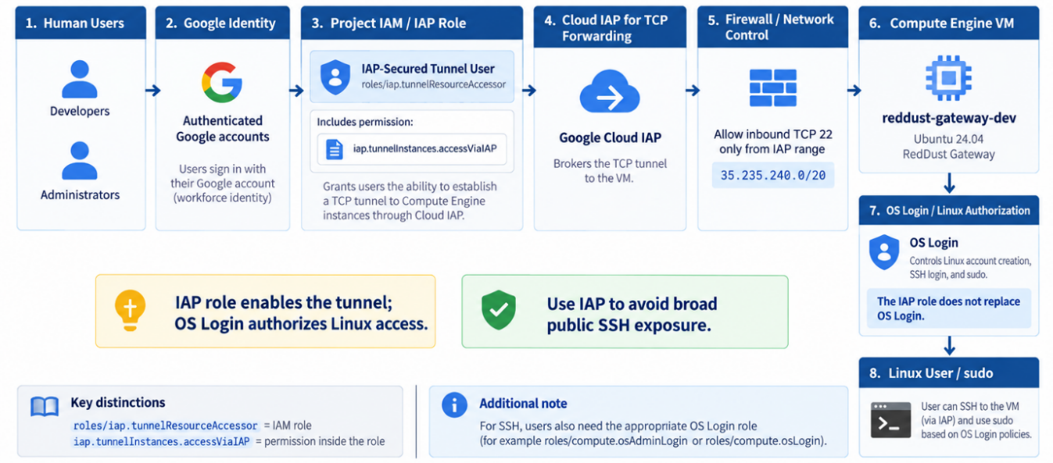

20.8.2 — Access Path and Security Model
Developer / Administrator laptop
↓ Google authentication + IAM authorization
Google Cloud IAP
↓ TCP 22 through IAP
VPC firewall: source = 35.235.240.0/20 port = tcp:22
↓
reddust-gateway-dev
↓
OS Login
↓
Individual Linux identity
↓
sudo according to assigned OS Login role

20.8.3 — Enable the IAP API
Run from Cloud Shell as the project owner or an authorized Administrator, for example red.dust.proj@gmail.com:
PROJECT_ID="reddust-development"
gcloud services enable iap.googleapis.com --project="$PROJECT_ID"
Verify that the API is enabled:
gcloud services list --enabled --project="$PROJECT_ID" \
--filter="NAME:iap.googleapis.com" --format="table(NAME,TITLE)"
Expected output:
NAME: iap.googleapis.com
TITLE: Cloud Identity-Aware Proxy API

20.8.4 — Grant IAP-Secured Tunnel User to the Team Members
The predefined role is roles/iap.tunnelResourceAccessor. It contains the permission required to establish an IAP TCP tunnel. For RedDust, restrict the grant with an IAM condition so that the tunnel permission applies only to SSH port 22.
IAP_USERS=(
"1120anirban@gmail.com"
"anirban@anodiam.com"
)
for member in "${IAP_USERS[@]}"; do
echo "Granting IAP SSH tunnel access to: ${member}"
gcloud projects add-iam-policy-binding "$PROJECT_ID" \
--member="user:${member}" --role="roles/iap.tunnelResourceAccessor" \
--condition='expression=destination.port == 22,title=iap-ssh-only,description=Allow IAP TCP forwarding only to SSH port 22' --quiet
done
Why port-22 condition: Without this, IAP-Secured Tunnel User role can authorize TCP forwarding to other destination ports where the remaining controls also permit it. The condition destination.port == 22 narrows this IAM grant to SSH only.

20.8.5 — Verify the IAP IAM Bindings
gcloud projects get-iam-policy "$PROJECT_ID" --flatten="bindings[]" \
--filter="bindings.role:roles/iap.tunnelResourceAccessor" --format="yaml(bindings)"
Verify that all six identities are represented in the IAP-Secured Tunnel User binding and that the condition includes:
destination.port == 22

20.8.6 — Discover the VM Zone and VPC Network
Do not guess the VM zone or network. Rediscover them from Google Cloud before creating the firewall rule.
PROJECT_ID="reddust-development"
VM_NAME="reddust-gateway-dev"
ZONE=$(gcloud compute instances list --project="$PROJECT_ID" \
--filter="name=$VM_NAME" --format="value(zone.basename())")
NETWORK=$(gcloud compute instances describe "$VM_NAME" --project="$PROJECT_ID" \
--zone="$ZONE" --format="value(networkInterfaces[0].network.basename())")
echo "ZONE=[$ZONE]"
echo "NETWORK=[$NETWORK]"
Expected result:
NETWORK=[default]
Stop condition: If ZONE or NETWORK is blank, stop and verify the project and VM name. Do not guess either value.

20.8.7 — Allow the IAP Source Range through the Firewall
First inspect the existing rules so that you do not create an unnecessary duplicate:
gcloud compute firewall-rules list --project="$PROJECT_ID" \
--format="table(name,network,direction,sourceRanges,allowed)"
If an equivalent rule does not already exist, create the IAP SSH ingress rule:
gcloud compute firewall-rules create allow-iap-ssh --project="$PROJECT_ID" \
--network="$NETWORK" --direction=INGRESS --action=ALLOW --rules=tcp:22 \
--source-ranges=35.235.240.0/20
This rule says: allow inbound TCP/22 when the connection source is within 35.235.240.0/20. It does not itself decide which human is authorized; the IAP IAM role and OS Login handle those identity checks.
Future hardening note: This command targets the VPC network. If that network later contains additional VMs that should not accept IAP SSH, narrow the firewall target with an appropriate VM-specific mechanism such as a dedicated target tag or service-account target.

20.8.8 — Keep the Existing OS Login Model
IAP does not replace OS Login. These controls perform different jobs and both remain required in the RedDust access model.
Control | Question it answers | RedDust role
Google identity | Who is the human? | Individual Google account; no shared identity
IAP IAM | May this principal establish an IAP tunnel? | roles/iap.tunnelResourceAccessor, restricted to destination.port == 22
VPC firewall | May IAP-originated network traffic reach TCP/22? | Allow source 35.235.240.0/20 to tcp:22
OS Login IAM | May this principal log in, and with what Linux admin level? | Developers: VM-scoped roles/compute.osAdminLogin; Administrators: project-level roles/compute.osAdminLogin
Linux identity | Which Unix account is used? | Per-user OS Login POSIX username; sudo according to authorization
Where an identity is treated as external to the Google Cloud organization, the organization-level roles/compute.osLoginExternalUser requirement from the earlier access-model steps also remains applicable.

20.8.9 — Start the VM and Test SSH Through IAP
If the VM is stopped, start it first:
gcloud compute instances start "$VM_NAME" --project="$PROJECT_ID" --zone="$ZONE"
From each test identity, establish SSH specifically through IAP:
PROJECT_ID="reddust-development"
VM_NAME="reddust-gateway-dev"
ZONE=$(gcloud compute instances list --project="$PROJECT_ID" --filter="name=$VM_NAME" \
--format="value(zone.basename())")
gcloud compute ssh "$VM_NAME" --project="$PROJECT_ID" --zone="$ZONE" \
--tunnel-through-iap
Perform the first validation with these two identities:
Test tier | Identity | Expected Linux username
Developer | 1120anirban@gmail.com | usr_1120anirban_gmail_com
Administrator | anirban@anodiam.com | anirban_anodiam_com
After login, run:
whoami
hostname
sudo whoami
Command | Expected result
Whoami | usr_1120anirban_gmail_com for the developer test; anirban_anodiam_com for the administrator test
Hostname | reddust-gateway-dev
sudo whoami | Root

20.8.10 — Only After IAP Works, Close Direct Internet SSH
This is the most important security transition in this section. Do not remove an existing direct SSH rule until IAP has been tested successfully from both the Developer and Administrator test identities. Inspect the current SSH-related firewall rules:
gcloud compute firewall-rules list --project="$PROJECT_ID" \
--format="table(name,direction,sourceRanges,allowed)"
Look for any rule that effectively allows tcp:22 from 0.0.0.0/0. Source 0.0.0.0/0 means all IPv4 sources, including public Internet. Once IAP access is proven, disable or remove the broad rule according to the RedDust firewall procedure.
BEFORE: Internet (0.0.0.0/0)
↓ tcp:22 may be reachable directly
reddust-gateway-dev
AFTER: Authorized human
↓
Google Cloud IAP
↓ source range 35.235.240.0/20, tcp:22
reddust-gateway-dev
↓
OS Login → individual Linux identity
Do not lock yourself out: Keep the existing direct-SSH path until both test identities have successfully connected with --tunnel-through-iap, confirmed whoami, confirmed the correct hostname, and confirmed the intended sudo behavior.

20.8.11 — Acceptance Checklist
Check | Expected result
IAP API | iap.googleapis.com is enabled in reddust-development
IAP IAM | All six team identities have roles/iap.tunnelResourceAccessor with destination.port == 22
Firewall | TCP/22 is allowed from 35.235.240.0/20
CIDR understanding | 35.235.240.0/20 is understood as 4,096 addresses from 35.235.240.0 through 35.235.255.255
OS Login | Existing Developer/Admin OS Login roles remain in force
Developer test | 1120anirban@gmail.com reaches the VM through IAP and resolves to usr_1120anirban_gmail_com
Administrator test | anirban@anodiam.com reaches the VM through IAP and resolves to anirban_anodiam_com
Host verification | hostname returns reddust-gateway-dev
Sudo verification | sudo whoami returns root for the intended OS Admin Login users
Direct Internet SSH | Broad 0.0.0.0/0 SSH rule is removed or disabled only after IAP validation succeeds

20.8.12 — Final RedDust Access Model
When this section is complete, Gateway SSH administration no longer requires broadly exposing Internet port 22. Google verifies human identities, IAP IAM authorizes tunnels, firewall rules restrict access to Google’s IAP source range, and OS Login provides individual Linux accounts.
The resulting layered model is intentionally defense-in-depth: IAP controls the tunnel, the firewall controls the network path, and OS Login controls the Linux identity and privilege. A failure or misconfiguration in one layer should not be treated as a reason to weaken the others.
Completion criterion: Section 20.5.25 is complete when the IAP API is enabled, IAM tunnel access is restricted to TCP/22, the firewall allows 35.235.240.0/20 to TCP/22, both test identities can connect through IAP with the expected OS Login identities and sudo behavior, and broad Internet SSH has been removed or disabled only after that validation.

Reference Notes
Current Google Cloud documentation confirms that IAP TCP forwarding uses the IPv4 source range 35.235.240.0/20, supports the IAM condition destination.port == 22, and recommends considering removal/disablement of broad default SSH rules when direct Internet SSH should be prevented.
Google Cloud: Use IAP for TCP forwarding — https://cloud.google.com/iap/docs/using-tcp-forwarding
Google Cloud: Use VPC firewall rules — https://cloud.google.com/firewall/docs/using-firewalls

20.9 — First Boot: Verify OS, Resources, OS Login and Sudo before Installing Anything
Wait until the VM shows Running, then open SSH in browser.

20.9.1 — Verify operating system
cat /etc/os-release
Required indicators:
VERSION_ID="24.04"
VERSION_CODENAME=noble

20.9.2 — Verify e2-medium resources
nproc
free -h
df -h /
nproc should report 2 logical processors. free -h should show approximately 4 GB of RAM before system overhead. The root filesystem should reflect the 10 GB boot disk.

20.9.3 — Verify OS Login metadata
curl -s -H "Metadata-Flavor: Google" http://metadata.google.internal/computeMetadata/v1/project/attributes/enable-oslogin
Expected:
TRUE
Optionally inspect instance-level metadata:
curl -s -H "Metadata-Flavor: Google" http://metadata.google.internal/computeMetadata/v1/instance/attributes/enable-oslogin
An instance-level TRUE or true is fine. A 404 is also fine if the project-level query returns TRUE, because the VM is inheriting the project value. FALSE is not acceptable because instance metadata overrides project metadata.

20.9.4 — Verify sudo immediately
whoami
sudo whoami
Required output from sudo whoami:
root

20.9.5 — Verify sudo remains valid after five minutes
sleep 300 && sudo whoami
Expected after five minutes:
Root
Gate before package installation: Do not proceed if sudo fails after the initial SSH session. The intended baseline is stable IAM/OS Login authorization, not a temporary metadata-key workaround.
DIAGRAM 20-V: First-Boot Verification Gate
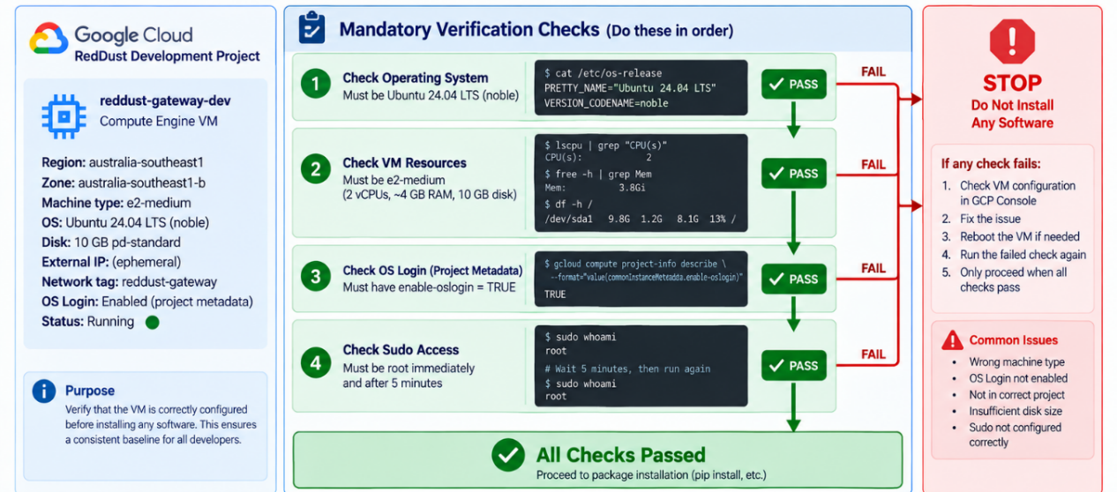

20.10 — Install System Dependencies and Shared Python Environment

20.10.1 — Fully Update Ubuntu 24.04
sudo apt update
sudo apt upgrade –y
Check whether a reboot is required:
test -f /var/run/reboot-required && echo "REBOOT REQUIRED" || echo "NO REBOOT REQUIRED"
If required:
sudo reboot
Reconnect, then verify:
sudo whoami
Expected:
Root

20.10.2 — Install Build Tools, Media Utilities and Diagnostics
Install the packages needed to build exact Python 3.12.10 and to debug the WebRTC/media stack.
sudo apt install -y build-essential git curl unzip ffmpeg make gcc libssl-dev zlib1g-dev libbz2-dev libreadline-dev libsqlite3-dev libncurses-dev xz-utils tk-dev libffi-dev liblzma-dev libgdbm-dev libnss3-dev libxml2-dev libxmlsec1-dev uuid-dev
Optional but useful during diagnosis:
sudo apt install -y htop
Verify:
git --version
curl --version
ffmpeg -version

20.11 — Install Shared Python 3.12.10 and Create the Shared RedDust Virtual Environment without Modifying Ubuntu System Python
We should focus on the team .venv rather than individual .venv approach below to deploy the echo-test backend on GCP VM.

Team .venv
While ~/.pyenv is the default home-directory location for the normal single-user setup for pyenv, it explicitly permits PYENV_ROOT to point somewhere other than ~/.pyenv for multi-user setup.
Anirban (red.dust.proj@gmail.com) will set this up once for all the team members. Individual team members do not need to set up the .venv for the team. The correct target should be:
Ubuntu system Python (/usr/bin/python3)
│ untouched
└───────────────────────────────────────────
Shared RedDust Python (/opt/reddust/pyenv/versions/3.12.10/bin/python)
↓
Shared RedDust virtual environment (/opt/reddust/reddust-gateway/.venv)
├── Owner (red.dust.proj@gmail.com)
├── 1120anirban@gmail.com
├── anirban@anodiam.com
├── …
└── Other Admins and Developers (all activate the SAME .venv)
DIAGRAM 20-W: Shared Python Runtime Model on GCP VM
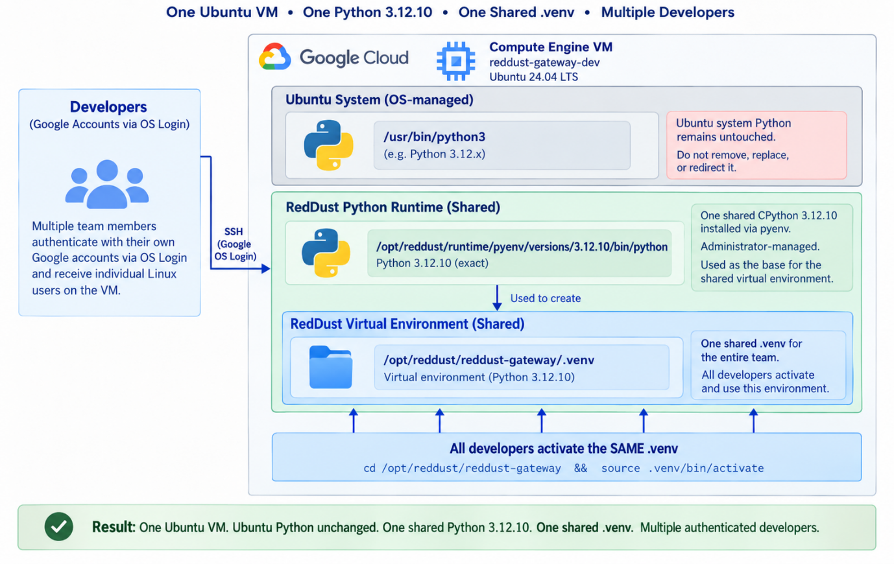

20.11.1 — Leave Ubuntu Python completely alone
Keep your existing instruction:
python3 –version
Do not remove it, replace /usr/bin/python3, or repoint the operating system to RedDust Python.

20.11.2 — Do not use your personal ~/.pyenv as the team Python
If you have already done:
~/.pyenv
and built:
~/.pyenv/versions/3.12.10
That is not a disaster. You can leave it there temporarily. But do not create the final shared .venv from it. A Python virtual environment records the location of the Python installation from which it was created. Python also considers virtual environments disposable/non-portable rather than something that should be moved between locations later. So we will compile Python 3.12.10 one more time into a permanent shared location.

20.11.3 — Create the permanent RedDust server hierarchy
DIAGRAM 20-X: RedDust Gateway – Permanent Linux Directory Structure
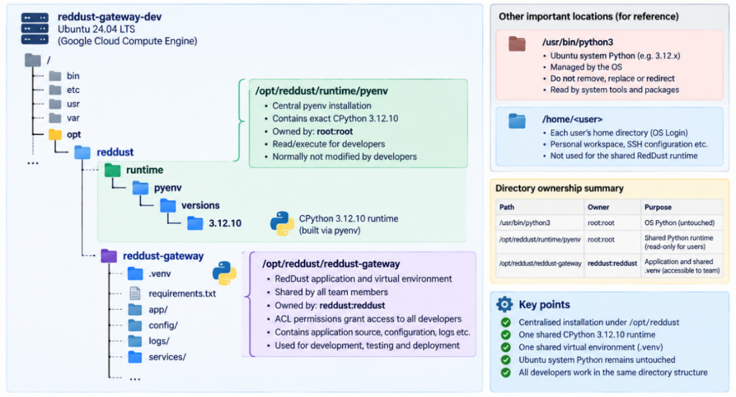
Do this as red.dust.proj@gmail.com from your VM SSH session:
sudo mkdir -p /opt/reddust
sudo mkdir -p /opt/reddust/runtime
sudo mkdir -p /opt/reddust/reddust-gateway
Verify:
ls -ld /opt/reddust \
/opt/reddust/runtime \
/opt/reddust/reddust-gateway
Going forward /opt/reddust/ will represent the server-side RedDust installation. Recommended directory structure:
/opt/reddust/
├── runtime/
│ └── pyenv/
│ └── versions/
│ └── 3.12.10/
└── reddust-gateway/
├── .venv/
├── requirements.txt
├── application source...
└── configuration...

20.11.4 — Install Python build dependencies once
Run:
sudo apt update
Then:
sudo apt install -y git make build-essential libssl-dev zlib1g-dev libbz2-dev \
libreadline-dev libsqlite3-dev curl libncursesw5-dev xz-utils tk-dev libxml2-dev \
libxmlsec1-dev libffi-dev liblzma-dev acl
These are consistent with pyenv's current Ubuntu build environment for CPython 3.12. The acl (access control list) package is important for our multi-user design.

20.11.5 — Install one central pyenv
Run the following instead of ~/.pyenv use /opt/reddust/runtime/pyenv
sudo git clone https://github.com/pyenv/pyenv.git /opt/reddust/runtime/pyenv
Verify:
sudo env PYENV_ROOT=/opt/reddust/runtime/pyenv /opt/reddust/runtime/pyenv/bin/pyenv --version
You should get something similar to: pyenv 2.x.x. We are deliberately not adding this pyenv installation to everyone's .bashrc. Why? Because the team does not need to manipulate Python versions. Pyenv is simply the installation mechanism by which the server administrator creates the exact RedDust CPython runtime.

20.11.6 — Verify that 3.12.10 is available
Run:
sudo env PYENV_ROOT=/opt/reddust/runtime/pyenv \
/opt/reddust/runtime/pyenv/bin/pyenv install --list | grep ' 3.12.10$'
You should see: 3.12.10

20.11.7 — Build one central Python 3.12.10
Now run:
sudo bash -c '
export PYENV_ROOT=/opt/reddust/runtime/pyenv
export PATH="$PYENV_ROOT/bin:$PATH"
export MAKE_OPTS="-j2"
pyenv install 3.12.10
'
This will create: /opt/reddust/runtime/pyenv/versions/3.12.10/
Verify directly:
/opt/reddust/runtime/pyenv/versions/3.12.10/bin/python --version
Required: Python 3.12.10
Also:
/opt/reddust/runtime/pyenv/versions/3.12.10/bin/python \
-c "import sys; print(sys.executable); print(sys.version)"
You should see the interpreter under: /opt/reddust/runtime/pyenv/versions/3.12.10/bin/python

20.11.8 — Make the Base Python Runtime Shared but Immutable
Human developers should be able to execute the shared Python installation, but they should not normally modify it. The canonical CPython 3.12.10 installation remains under /opt/reddust/runtime/pyenv and is protected by root ownership. Run:
sudo chown -R root:root /opt/reddust/runtime/pyenv
sudo chmod -R a+rX /opt/reddust/runtime/pyenv
sudo chmod -R go-w /opt/reddust/runtime/pyenv
The resulting permission model is: root can modify the shared Python runtime; RedDust users can read and execute it. This is preferable to maintaining separate CPython installations for each developer.

20.11.9 — Create a Dedicated RedDust Runtime Account
Create a non-human Linux service identity for the Gateway runtime. This account is not a Google/OS Login human identity and is not intended for SSH.
sudo useradd --system --home-dir /opt/reddust --shell /usr/sbin/nologin \
reddust 2>/dev/null || true
Verify:
getent passwd reddust
Expected: The account exists and its shell is /usr/sbin/nologin.
Eventually systemd will run the RedDust Gateway as reddust rather than as root or as any developer’s personal Google/OS Login identity.
DIAGRAM 20-Y: Human OL Login Identities vs. the Non-Human RedDust Runtime Account
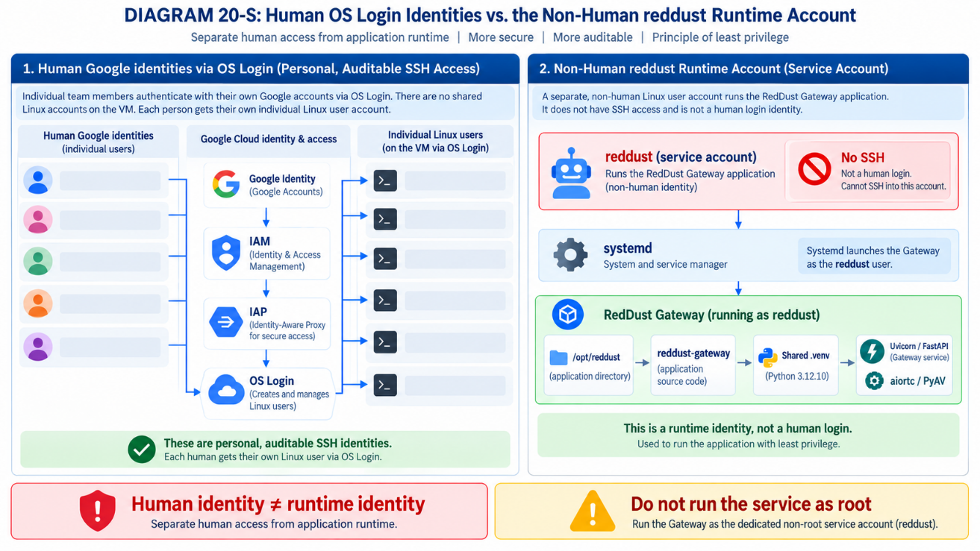
DIAGRAM 20-Z: Shared, Immutable Python 3.12.10 Runtime
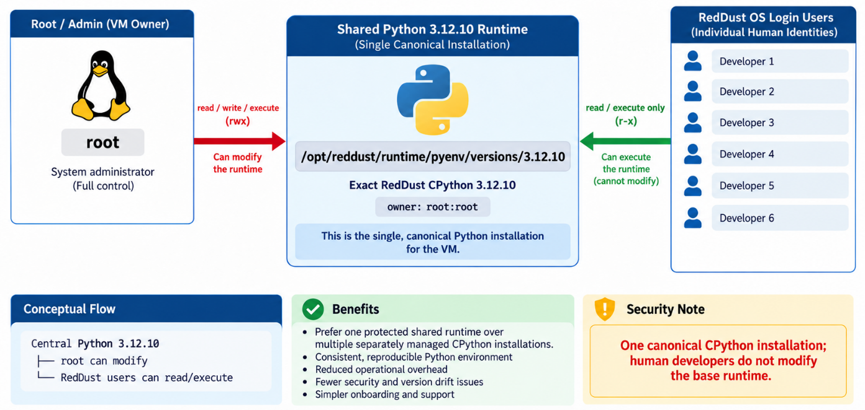

20.11.10 — Create Exactly One Shared Virtual Environment
Critical change: Do not create a per-user virtual environment such as ~/reddust-gateway/.venv. Create one shared environment under /opt/reddust/reddust-gateway/.venv.
Do not run:
python -m venv ~/reddust-gateway/.venv
Instead run:
sudo -u reddust /opt/reddust/runtime/pyenv/versions/3.12.10/bin/python \
-m venv /opt/reddust/reddust-gateway/.venv
If you receive Permission denied while creating .venv
If the command returns Error:
Errno 13] Permission denied: '/opt/reddust/reddust-gateway/.venv', the reddust service account exists but does not yet have write permission inside /opt/reddust/reddust-gateway. This is expected if the directory was originally created with sudo mkdir and is still owned by root.
Inspect the directory and the service account:
ls -ld /opt/reddust/reddust-gateway
id reddust
If the directory is owned by root, make reddust the canonical owner of the shared Gateway directory:
sudo chown -R reddust:$(id -gn reddust) /opt/reddust/reddust-gateway
Verify ownership:
ls -ld /opt/reddust/reddust-gateway
Expected: The owner is reddust.
Retry creation of the shared virtual environment:
sudo -u reddust /opt/reddust/runtime/pyenv/versions/3.12.10/bin/python \
-m venv /opt/reddust/reddust-gateway/.venv
Verify the Python version:
/opt/reddust/reddust-gateway/.venv/bin/python --version
Expected: Python 3.12.10
DIAGRAM 20-AA: Python Runtime -> Shared venv -> Gateway Ownership Chain
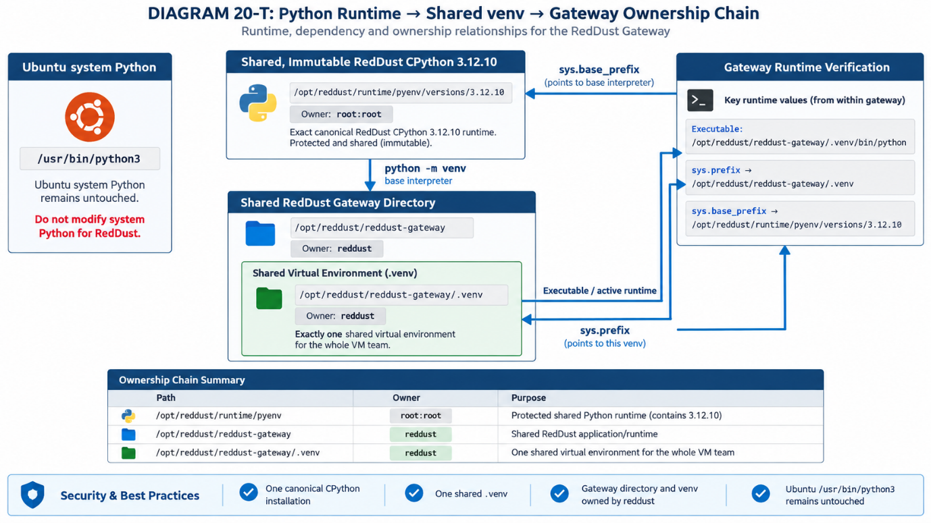
Verify the interpreter, virtual-environment prefix, and base Python prefix:
/opt/reddust/reddust-gateway/.venv/bin/python -c "import sys; print('Executable:', sys.executable); print('Prefix:', sys.prefix); print('Base:', sys.base_prefix)"
Expected: Executable: /opt/reddust/reddust-gateway/.venv/bin/python
Prefix: /opt/reddust/reddust-gateway/.venv
Base: /opt/reddust/runtime/pyenv/versions/3.12.10
The ownership model should now be:
Path | Owner | Purpose
/opt/reddust/runtime/pyenv | Root | Protected shared Python runtime
/opt/reddust/reddust-gateway | reddust | Shared RedDust application/runtime
/opt/reddust/reddust-gateway/.venv | reddust | One shared virtual environment
Now, with the exact OS Login usernames, Linux ACLs will grant individual human users access to /opt/reddust/reddust-gateway without changing the canonical reddust ownership.

20.11.10-A — Grant Named Linux ACL Access without Changing Canonical Ownership
ACL in Linux stands for Access Control List. It is a mechanism that lets you define more fine-grained file and directory permissions than the basic owner / group / others model. Currently, shared Gateway directory and shared virtual environment already have the correct canonical ownership: the non-human Linux service account reddust owns /opt/reddust/reddust-gateway, while the protected base CPython 3.12.10 runtime remains root-owned. Next task is to let verified human OS Login identities work in the shared Gateway tree without transferring ownership away from reddust.
Key ownership rule: Ownership remains with reddust. Human developers and administrators receive additional read/write/search access through named Linux ACLs. ACLs extend access; they do not replace the canonical owner.

Verified OS Login identities
Google Identity | GCP Linux whoami Username | Tier
red.dust.proj@gmail.com | red_dust_proj_gmail_com | Project Owner
1120anirban@gmail.com | usr_1120anirban_gmail_com | Developer test ID
anirban@anodiam.com | anirban_anodiam_com | Administrator test ID

1. Define the authoritative Linux usernames
Use the exact POSIX usernames already verified through OS Login. Do not derive or guess alternative names at this stage.
RED_DUST_PROJ="red_dust_proj_gmail_com"
ANIRBAN1120="usr_1120anirban_gmail_com"
ANIRBAN="anirban_anodiam_com"
Group them into one array so the same validated user set is reused consistently:
REDDUST_USERS=(
"$RED_DUST_PROJ"
"$ANIRBAN1120"
"$ANIRBAN")

2. Verify that OS Login/NSS can resolve every identity
Before modifying filesystem permissions, confirm that Linux can resolve every username through NSS. A successful getent lookup proves that the OS Login identity is visible to the VM as a POSIX user.
for U in "${REDDUST_USERS[@]}"; do
echo "=== $U ==="
getent passwd "$U"
done
Stop condition: If any username produces no output, do not add an ACL entry for that username yet. Resolve the OS Login identity first.

3. Confirm that ACL tooling is available
command -v setfacl
Expected:
/usr/bin/setfacl
If the command is missing:
sudo apt update
sudo apt install -y acl

4. Back up the current ACL state
Before making recursive permission changes, save the current ACL state to secure a readable before-state for troubleshooting.
sudo getfacl -R /opt/reddust/reddust-gateway > ~/reddust-gateway-acl-before.txt

5. Grant named ACL access to the existing Gateway tree
Apply rwX to every verified RedDust OS Login user on the existing files and directories.
for U in "${REDDUST_USERS[@]}"; do
echo "Granting existing-tree ACL to: $U"
sudo setfacl -R -m "u:${U}:rwX" /opt/reddust/reddust-gateway
done
Why rwX uses an uppercase X: r = read, w = write, and X grants execute/search on directories and execute on files that are already executable. This avoids unnecessarily making ordinary source files such as .py, .txt or .json executable.

6. Make the access inheritable with default ACLs
Named ACLs above fix access to the existing tree. Default ACLs are also required so files and directories created later inherit the same team access.
for U in "${REDDUST_USERS[@]}"; do
echo "Granting inheritable/default ACL to: $U"
sudo find /opt/reddust/reddust-gateway -type d -exec setfacl -m "d:u:${U}:rwx" {} +
done
Inheritance matters particularly inside the shared virtual environment, because future package installation creates new files and directories under:
/opt/reddust/reddust-gateway/.venv/lib/python3.12/site-packages

7. Make the ACL masks explicit
The ACL mask limits the maximum effective permissions available to named users and groups. Set rwx on the current and default masks so the named ACL entries can take effect as intended.
sudo setfacl -R -m m::rwx /opt/reddust/reddust-gateway
sudo find /opt/reddust/reddust-gateway -type d -exec setfacl -m d:m::rwx {} +

8. Verify the top-level ACL
getfacl /opt/reddust/reddust-gateway
You should see named entries for all seven verified identities, conceptually like:
# file: opt/reddust/reddust-gateway
# owner: reddust
# group: reddust
user::rwx
user:red_dust_proj_gmail_com:rwx
user:usr_1120anirban_gmail_com:rwx
user:anirban_anodiam_com:rwx
group::r-x
mask::rwx
other::r-x
default:user::rwx
default:user:red_dust_proj_gmail_com:rwx
default:user:usr_1120anirban_gmail_com:rwx
default:user:anirban_anodiam_com:rwx
default:group::r-x
default:mask::rwx
default:other::r-x
The order of named users may differ. That is not a problem.

9. Confirm that canonical ownership has not changed
ls -ld /opt/reddust/reddust-gateway
The important result is still:
owner = reddust; group = reddust
Expected model: The human identities have access because of ACLs. They do not become the owner of the shared application directory.

10. Verify important nested paths
Check both the shared virtual environment and site-packages to confirm that the recursive and default ACL strategy reached the important nested runtime paths.
getfacl /opt/reddust/reddust-gateway/.venv
getfacl /opt/reddust/reddust-gateway/.venv/lib/python3.12/site-packages

11. Perform a real write test using individual OS Login identities
Permission reports are useful, but a practical test confirms that the user can actually work in the shared tree without sudo.
Example using the Developer test identity 1120anirban@gmail.com:
whoami
# Expected: usr_1120anirban_gmail_com
cd /opt/reddust/reddust-gateway
touch acl-test-1120anirban.txt
ls -l acl-test-1120anirban.txt
rm acl-test-1120anirban.txt
Repeat the same test from at least one additional identity, for example: anirban@anodiam.com
whoami
cd /opt/reddust/reddust-gateway
touch acl-test-anirban.txt
rm acl-test-anirban.txt
Both tests should succeed without sudo.

Resulting RedDust filesystem access model
Canonical owner
↓
reddust
↓
/opt/reddust/reddust-gateway
↓
↓------------------↓-----------------↓
source .venv requirements.txt
↓
site-packages
↑
Default ACL inheritance
↓
↓------------------↓-----------------↓
OS Login user (rwX) OS Login user (rwX) OS Login user (rwX)
Governing rule: reddust remains the canonical owner of /opt/reddust/reddust-gateway and its shared runtime. Individual human users receive access through named and default Linux ACLs based on their verified OS Login POSIX usernames. Ownership must not be transferred to individual developers merely to enable collaborative access.

Operational note — the shared venv is intentionally mutable by the team
Because the verified users receive write access to the shared .venv, they can modify the shared Python environment. That is intentional for the current development-integration VM, but dependency changes must follow the team governance rule: perform one controlled pip change at a time, record the change in requirements.txt (and later a lockfile), and avoid simultaneous or ad-hoc package mutation.

Acceptance checklist
Check | Expected
All seven OS Login usernames resolve with getent. | Pass
setfacl is available on the VM. | Pass
Named rwX ACL entries exist for all seven verified users. | Pass
Default ACL entries exist on the shared Gateway directory tree. | Pass
The ACL mask permits the intended named-user access. | Pass
The directory owner remains reddust and the group remains reddust. | Pass
Nested .venv and site-packages paths show the expected ACLs. | Pass
At least one Developer and one Administrator can create and remove a test file without sudo. | Pass
No individual human user becomes the canonical owner of the Gateway tree. | Pass

20.11.11 — Upgrade pip Once for Everybody
Upgrade pip inside the one shared virtual environment as the reddust runtime account:
sudo -u reddust /opt/reddust/reddust-gateway/.venv/bin/python -m pip install --upgrade pip
Verify:
/opt/reddust/reddust-gateway/.venv/bin/python -m pip –version
Expected: The reported pip path is inside /opt/reddust/reddust-gateway/.venv/. There is one pip installation and one site-packages tree for the VM team.

20.11.12 — Do Not Use the Old .python-version Mechanism Here
The previous single-user approach used pyenv local 3.12.10 inside a developer workspace:
cd ~/reddust-gateway
pyenv local 3.12.10
DIAGRAM 20-AB: Explicit Interpreter Selection without .python-version
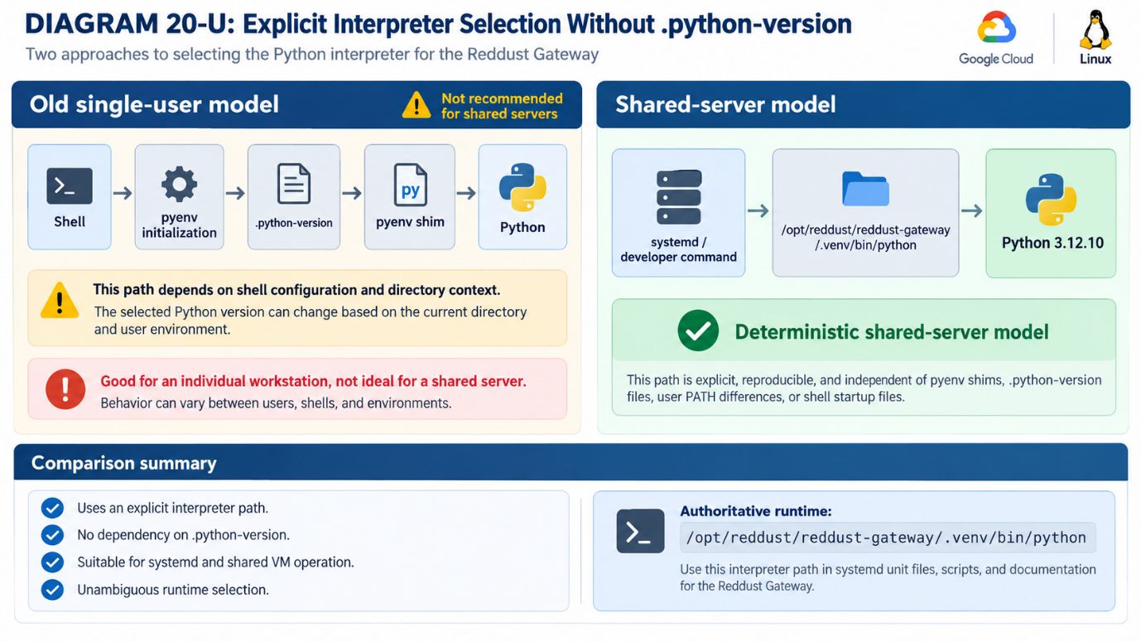
That model is useful for a single-user development directory because pyenv local creates a .python-version file and lets pyenv choose an interpreter based on the current directory. For the shared RedDust server model, do not use this mechanism. The VM now has an explicitly installed Python 3.12.10 runtime and one shared RedDust virtual environment. Server processes should invoke that environment directly rather than depending on a developer’s shell, PATH, pyenv initialization, or .python-version file.
Authoritative runtime /opt/reddust/reddust-gateway/.venv/bin/python

20.11.13 — Obtain Each Person's Actual OS Login Linux Username
Important: Do not guess a team member’s Linux username. Record the exact POSIX username supplied by OS Login.
Have each team member SSH into the VM once, then run:
whoami
id
Record the exact whoami value for each identity:
Google / team identity | Recorded OS Login Linux username
red.dust.proj@gmail.com | red_dust_proj_gmail_com
1120anirban@gmail.com | usr_1120anirban_gmail_com
anirban@anodiam.com | anirban_anodiam_com
Do not guess unresolved usernames; verify them before applying filesystem permissions.
DIAGRAM 20-AC: Google Identity -> OS Login -> POSIX Username -> Linux ACL
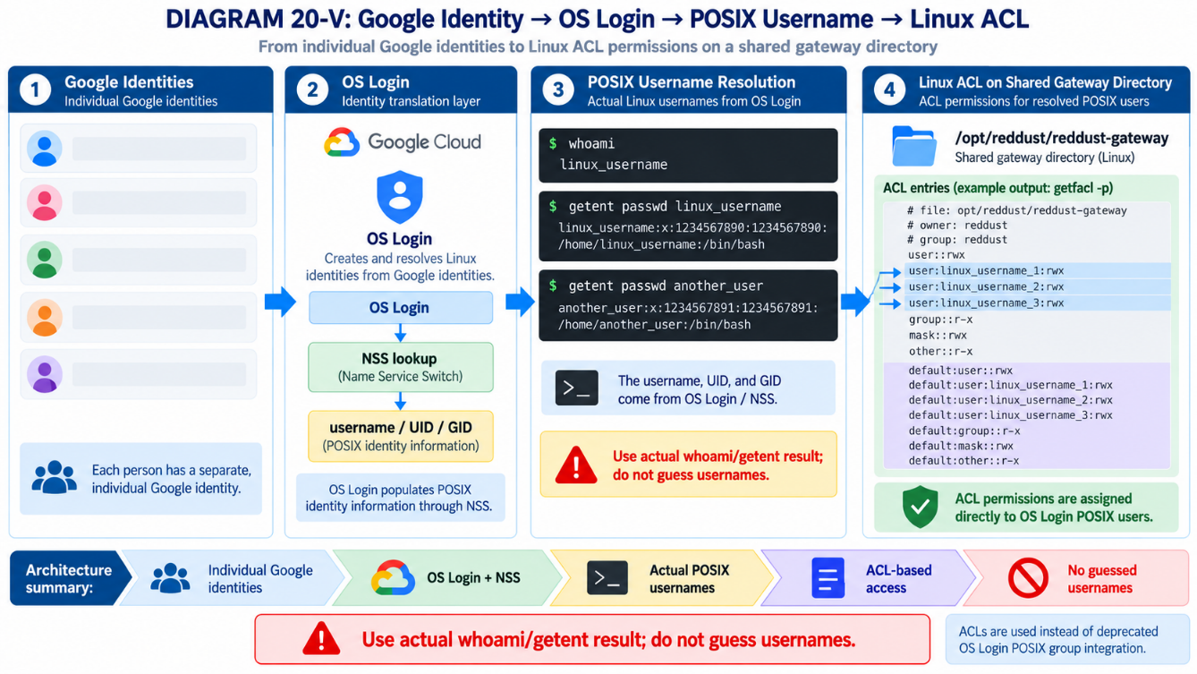

20.11.14 — Why We Will Use ACLs Rather Than an OS Login Linux Group
The shared directory still needs a way to grant multiple individual OS Login users read/write access without changing its canonical reddust ownership. In this procedure, that mechanism is Linux filesystem ACLs rather than a shared OS Login POSIX group. The supplied design notes that OS Login POSIX group integration is no longer the basis for this 2026 VM design. OS Login still supplies individual POSIX usernames and UIDs through NSS, and those identities can be referenced directly by Linux ACLs.
Design choice: Keep reddust as the owner; add named ACL entries for individual OS Login users.

20.11.15 — Grant Every RedDust Developer Access to the Shared Directory
After the exact OS Login usernames have been recorded, log in to reddust-gateway-dev using the authorized administrator/owner identity and define shell variables. Example:
RED_DUST_PROJ="red_dust_proj_gmail_com"
ANIRBAN1120="usr_1120anirban_gmail_com"
ANIRBAN="anirban_anodiam_com"
First verify that Linux can resolve each identity:
getent passwd "$RED_DUST_PROJ"
getent passwd "$ANIRBAN1120"
getent passwd "$ANIRBAN"
Stop condition: Do not proceed for any username that getent cannot resolve. Resolve the OS Login identity first.
Apply recursive named-user ACL permissions to the identities that have been verified. The following block preserves the current staged rollout in which unresolved users remain commented out:
for U in "$RED_DUST_PROJ" "$ANIRBAN1120" "$ANIRBAN"do
sudo setfacl -R -m "u:${U}:rwX" /opt/reddust/reddust-gateway
done
# Add other individual developers and admins after their usernames resolve with getent.
The capital X is intentional: it grants execute/search where appropriate — notably on directories and already-executable files — without unnecessarily marking every ordinary source file as executable.

20.11.16 — Make the Access Inheritable
DIAGRAM 20-AD: Canonical Ownerships Plus Named and Default ACLs
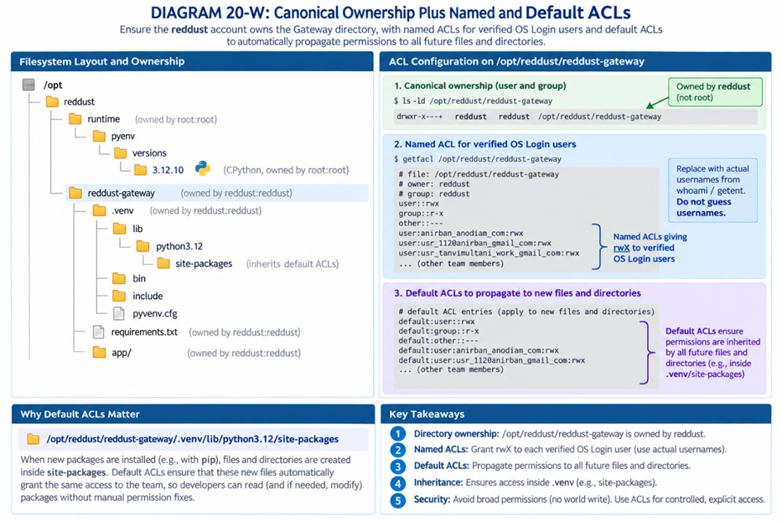
Named ACLs on existing content are not enough. New files and directories created later should inherit team access, especially under .venv/lib/python3.12/site-packages/ when pip installs additional packages.
for U in "$RED_DUST_PROJ" "$ANIRBAN1120" "$ANIRBAN" do
sudo find /opt/reddust/reddust-gateway -type d -exec setfacl -m "d:u:${U}:rwx" {} +
done
# Add other individual developers and admins after their usernames are verified.
Verify the top-level ACL:
getfacl /opt/reddust/reddust-gateway
Expected: Named user entries and corresponding default: user entries appear for every user that has been added.

20.11.17 — Every Developer Activates Exactly the Same venv
Every developer uses the same project directory and activates the same shared virtual environment in their own shell session:
cd /opt/reddust/reddust-gateway
source .venv/bin/activate
Activation is local to the current terminal shell. If one developer activates the environment, another developer’s terminal is not automatically activated; each person runs the same activation command independently.
Key concept: There are not multiple virtual environments. Multiple shells point to the same /opt/reddust/reddust-gateway/.venv. Activation only adjusts that shell’s environment variables, such as PATH.

20.11.18 — Every User Performs the Same Verification
After activation, every developer should prove that the shell resolves to the exact same shared runtime:
Command | Required result
python –version | Python 3.12.10
which python | /opt/reddust/reddust-gateway/.venv/bin/python
python -c "import sys; print(sys.executable)" | /opt/reddust/reddust-gateway/.venv/bin/python
python -c "import sys; print(sys.version)" | Output begins with 3.12.10
python -m pip –version | The path references /opt/reddust/reddust-gateway/.venv
DIAGRAM 20-AE: Many Developer Shells, One Shared Virtual Environment
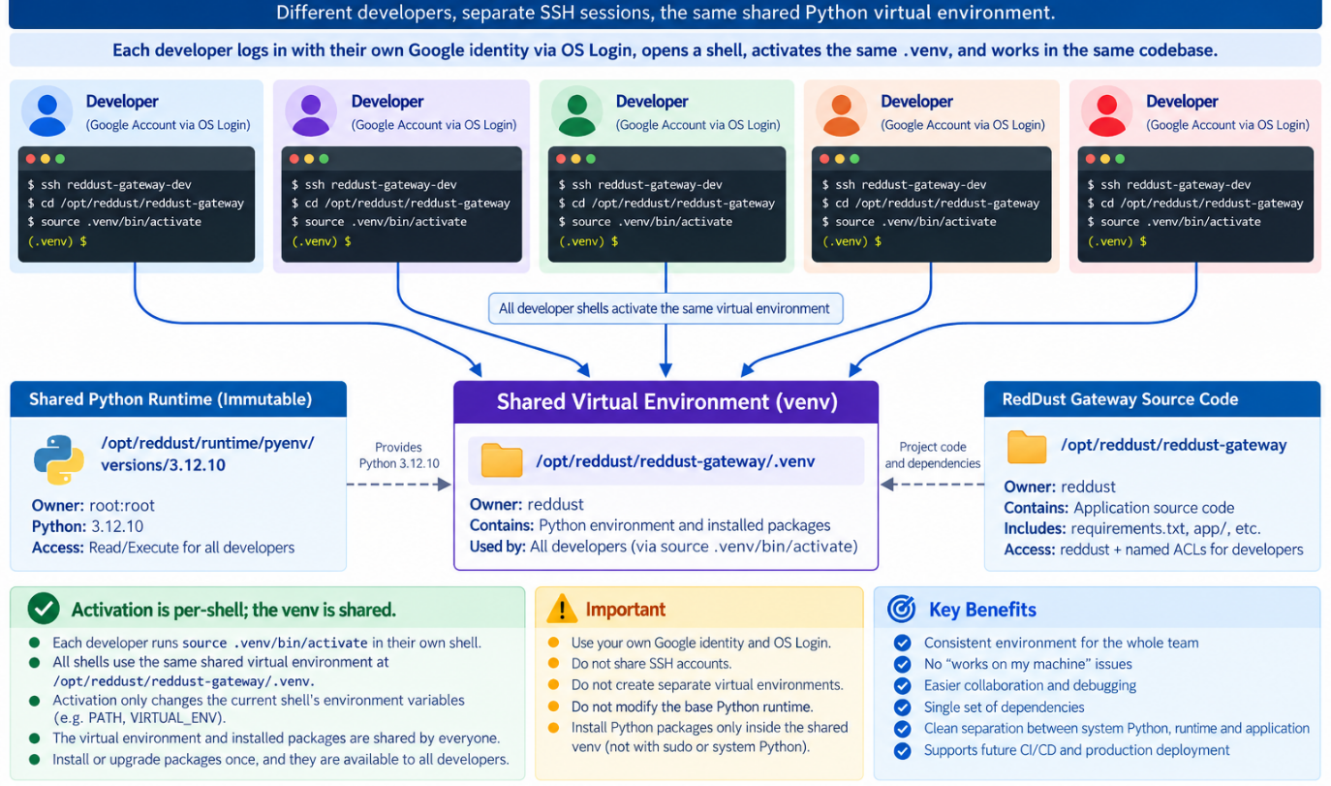

20.11.19 — Prove That Packages Are Actually Shared
DIAGRAM 20-AF: One Site-packages Tree Shared by the Team
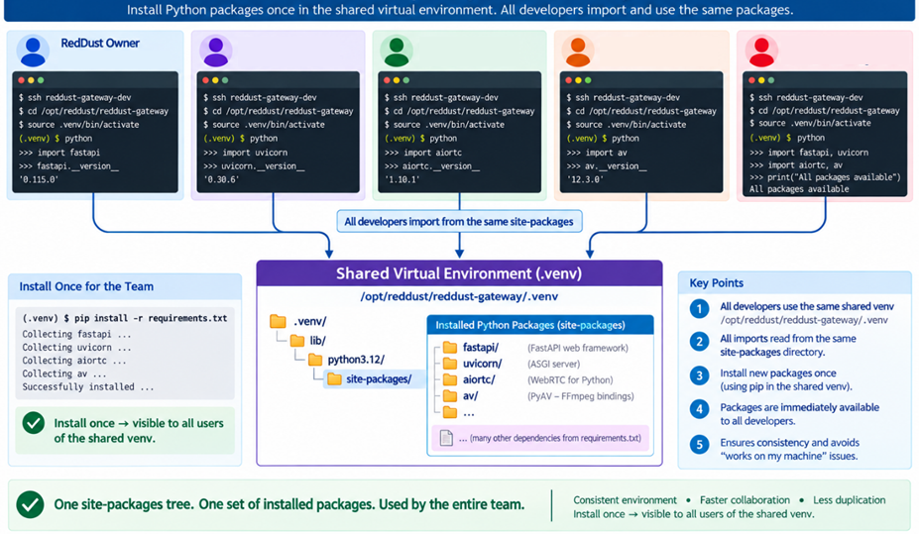
Install a package once in the shared environment, then verify that another developer can import it after activating the same venv. For example:
python -m pip install fastapi
A different developer then logs in and runs:
cd /opt/reddust/reddust-gateway
source .venv/bin/activate
python -c "import fastapi; print(fastapi.__version__)"
That developer should be able to import FastAPI without installing it again. The same shared-package behavior applies to uvicorn, aiortc, av, FastAPI, and every other dependency installed into the shared venv.

20.11.20 — Team Rule: Nobody Creates another Server .venv
Team convention: On reddust-gateway-dev, use only /opt/reddust/reddust-gateway/.venv. Do not create personal server-side RedDust virtual environments in home directories.
Do not use server-side copies such as:
~/reddust-gateway/.venv
/home/anirban/.../.venv
/home/anirban1120/.../.venv
Use only:
/opt/reddust/reddust-gateway/.venv
Personal home directories still exist for normal Linux purposes, but the shared RedDust Gateway runtime belongs under /opt/reddust/reddust-gateway.

20.11.21 — A Shared venv Also Means Shared Consequences
DIAGRAM 20-AG: Dependency Governance for the Shared Environment
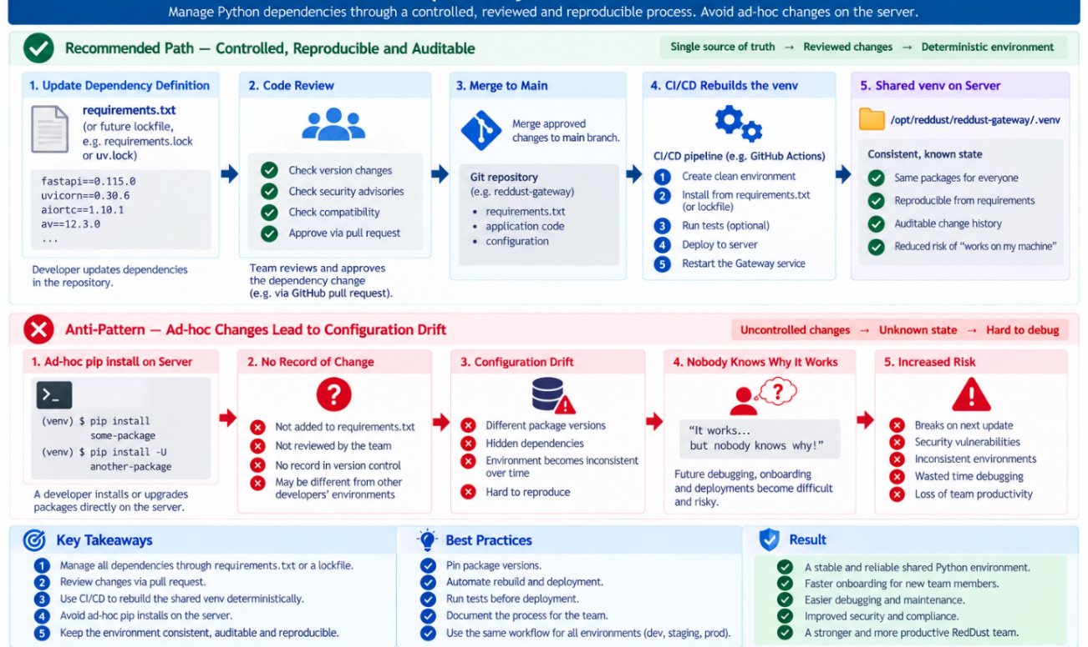
Because every developer is using the same environment, dependency changes affect everyone. If one developer installs a package, everyone sees it; if another uninstalls a required package, the shared environment can break for the entire team. The permanent dependency source of truth should therefore be requirements.txt and, later if adopted, a lockfile. Dependency changes should be deliberate and reflected in the canonical specification.
requirements.txt
↓
approved dependency change
↓
shared .venv
Avoid the opposite pattern:
developer randomly installs packages
↓
nobody knows why the VM works
python -m pip freeze can help capture the environment, but it should be used deliberately rather than as an uncontrolled daily workflow. Later, CI/CD should rebuild the runtime deterministically from source control.

20.11.22 — Do Not Have Multiple Developers Run pip simultaneously
All developers may activate the shared venv and run Python applications or tests at the same time. They should not perform simultaneous installation, removal, or upgrade operations against that same environment. Safe concurrent activity:
Developer 1 → python application/test
Developer 2 → pytest
Developer 3 → inspect application
…
Developer n → run gateway
Avoid concurrent dependency mutation:
Developer 1 → pip install X
at the same time
Developer 2 → pip uninstall Y
Operational rule: Dependency mutation should be serialized.
DIAGRAM 20-AH: Concurrent Runtime Used vs Serialized pip Mutation
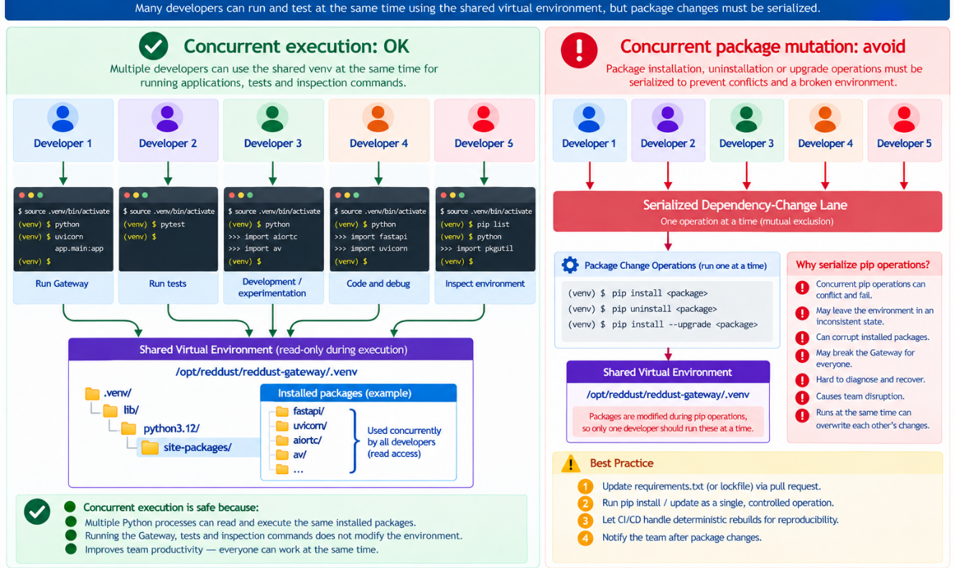

20.11.23 — The Shared Source Checkout Needs Similar Discipline
Use /opt/reddust/reddust-gateway as the single integration/deployment working directory on this development integration VM. However, do not treat that shared directory as every developer’s primary Git development workspace; one person changing branches, resetting files, or altering the working tree would affect everyone.
The eventual workflow should be:
Developer Windows laptops
├── individual Git branches
↓
Git repository
↓
PR / CI
↓
reddust-gateway-dev
↓
ONE integration checkout
ONE shared/runtime environment
This distinction becomes increasingly important when RedDust introduces CI/CD: developers work independently in source control, while the VM represents one shared integration/deployment state.
DIAGRAM 20-AI: Developer Workspaces -> Git/ PR/ CI -> One Integration VM Checkout
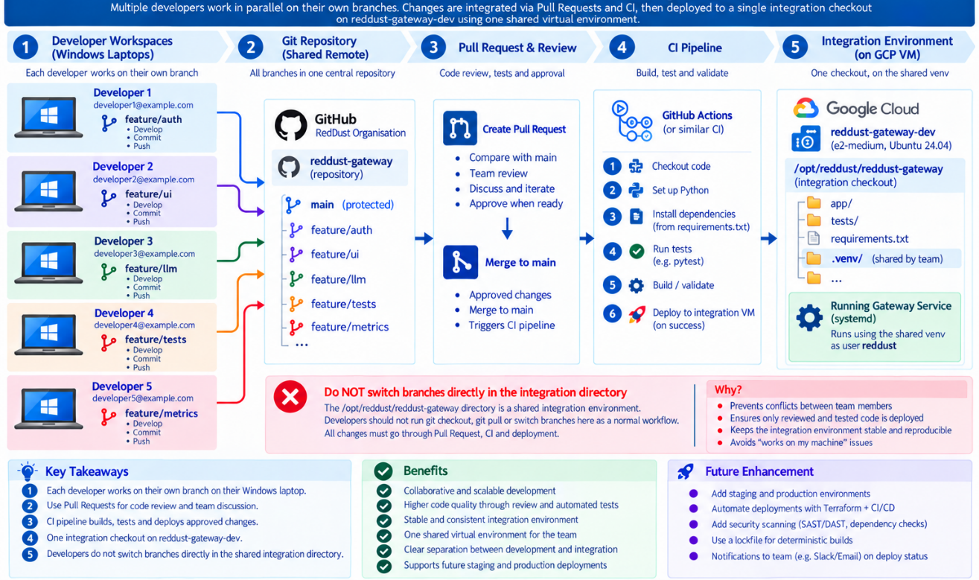

20.11.24 — systemd should Eventually Use the venv directly
When the Gateway becomes a Linux service, systemd should not depend on shell activation. Use the virtual environment executable directly so the runtime is unambiguous. Do not depend on:
source .venv/bin/activate
Use the shared executable directly, for example:
/opt/reddust/reddust-gateway/.venv/bin/python
# or
/opt/reddust/reddust-gateway/.venv/bin/uvicorn
A future systemd unit will conceptually contain:
User=reddust
WorkingDirectory=/opt/reddust/reddust-gateway
ExecStart=/opt/reddust/reddust-gateway/.venv/bin/python -m uvicorn ...
This makes the service independent of any developer’s interactive shell and ensures that the Gateway always uses the intended shared Python environment.

The Resulting RedDust Model
Component | Location / mechanism | Copies / model
Ubuntu system Python | /usr/bin/python3 | 1
Exact RedDust CPython 3.12.10 | /opt/reddust/runtime/pyenv/versions/3.12.10 | 1
RedDust Gateway project | /opt/reddust/reddust-gateway | 1 shared integration copy
RedDust virtual environment | /opt/reddust/reddust-gateway/.venv | 1
Human Linux identities | OS Login | One identity per person
Application service user | Reddust | 1 non-human account
Python dependencies | Shared .venv | 1 shared set
The intended end state is that each team member connects using an individual, auditable Google/OS Login identity while the VM uses one exact Python 3.12.10 installation, one shared virtual environment, one shared Gateway integration checkout, and one non-human reddust service account for the application runtime.

DIAGRAM 20-AJ: systemd Launches the Gateway directly from the Shared venv
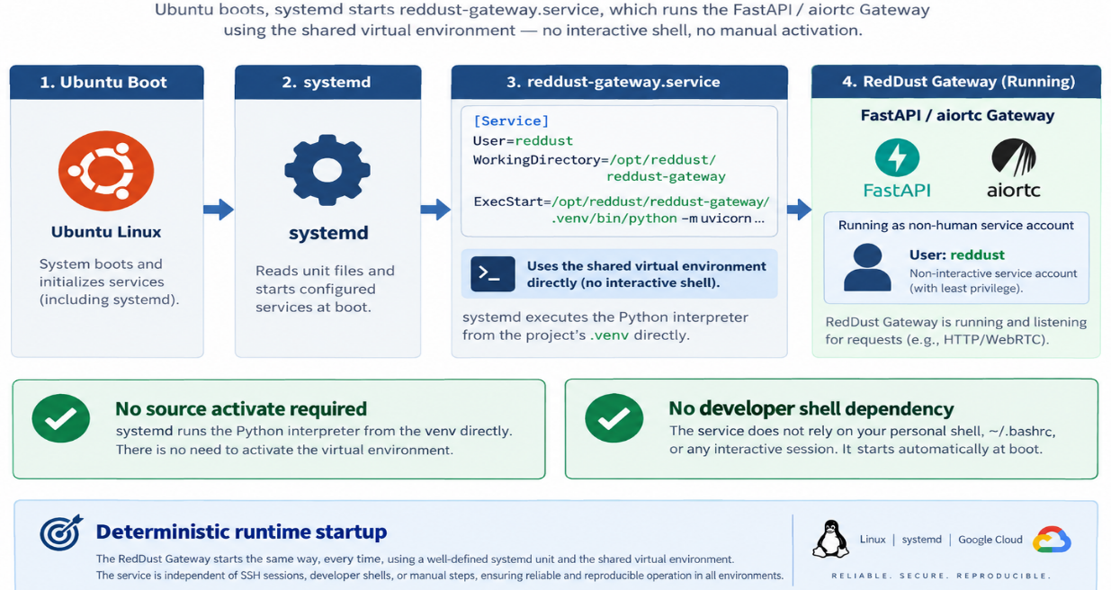
DIAGRAM 20-AK: End-State Shared Python and Gateway Runtime Model
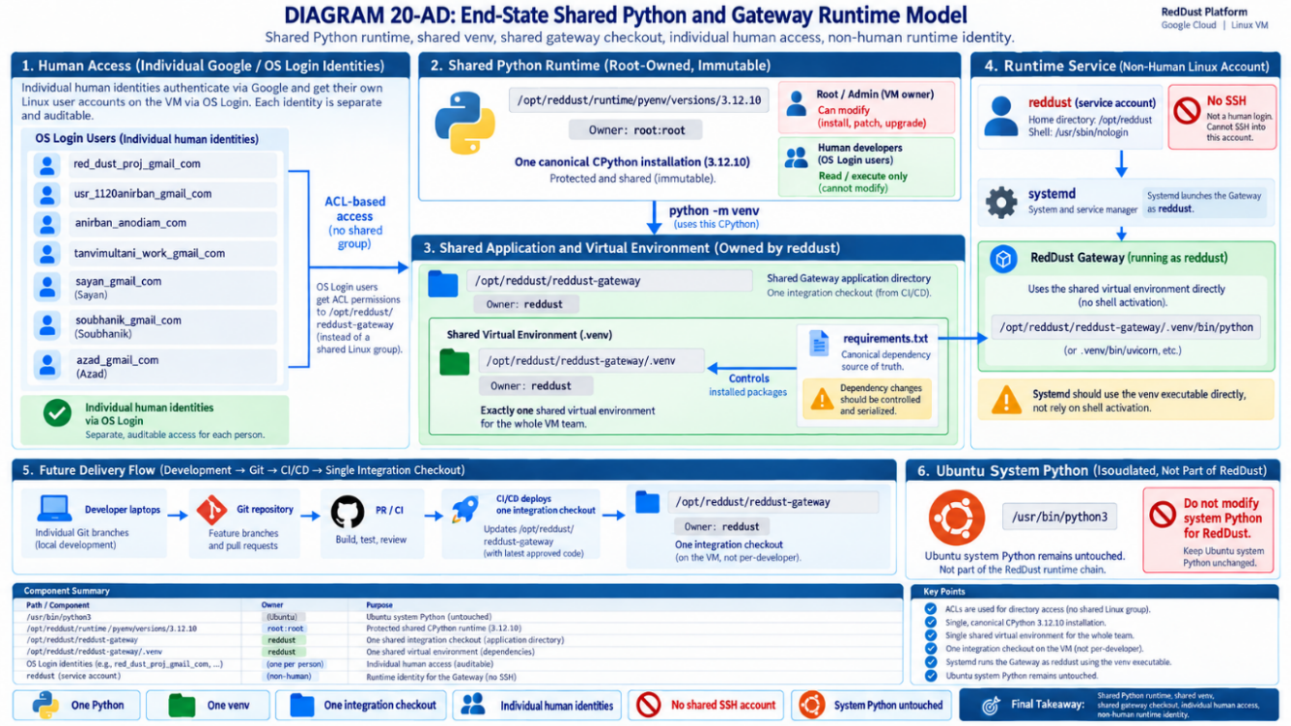

Single user .venv
For RedDust setup we will ignore signle user .venv. Ubuntu 24.04 includes own OS-managed Python 3.12.x. Don’t replace or remove the operating-system Python. RedDust will install exact Python 3.12.10 side-by-side and use it only inside project.

20.11.1 — Inspect the system Python but leave it alone
python3 –version
Do not do this: Do not run sudo apt remove python3. Do not delete /usr/bin/python3. Do not redirect the operating system globally to the RedDust Python. Ubuntu packages and administration tools may depend on the system Python.

20.11.2 — Install pyenv as the normal OS Login user
git clone https://github.com/pyenv/pyenv.git ~/.pyenv
echo 'export PYENV_ROOT="$HOME/.pyenv"' >> ~/.bashrc
echo '[[ -d $PYENV_ROOT/bin ]] && export PATH="$PYENV_ROOT/bin:$PATH"' >> ~/.bashrc
echo 'eval "$(pyenv init - bash)"' >> ~/.bashrc
source ~/.bashrc
pyenv –version

20.11.3 — Confirm Python 3.12.10 is available
pyenv install --list | grep 3.12.10

20.11.4 — Build Python 3.12.10 on e2-medium
MAKE_OPTS="-j2" pyenv install 3.12.10
Using two compilation jobs is reasonable because e2-medium exposes two vCPUs and has 4 GB RAM. Unlike the e2-micro strategy, a temporary 2 GB swap file should not normally be necessary. Verify:
pyenv versions

20.11.5 — Bind Python 3.12.10 to the RedDust project directory
mkdir -p ~/reddust-gateway
cd ~/reddust-gateway
pyenv local 3.12.10
python --version
cat .python-version
Required output: Python 3.12.10 and .python-version containing 3.12.10.

20.11.6 — Create the Linux virtual environment
python -m venv .venv
source .venv/bin/activate
python --version
python -c "import sys; print(sys.executable)"
python -c "import sys; print(sys.version)"
The executable path must point inside ~/reddust-gateway/.venv and the version must begin with 3.12.10.

20.11.7 — Upgrade pip
python -m pip install --upgrade pip
python -m pip –version
DIAGRAM 20-AL: Ubuntu System Python versus RedDust Python 3.12.10
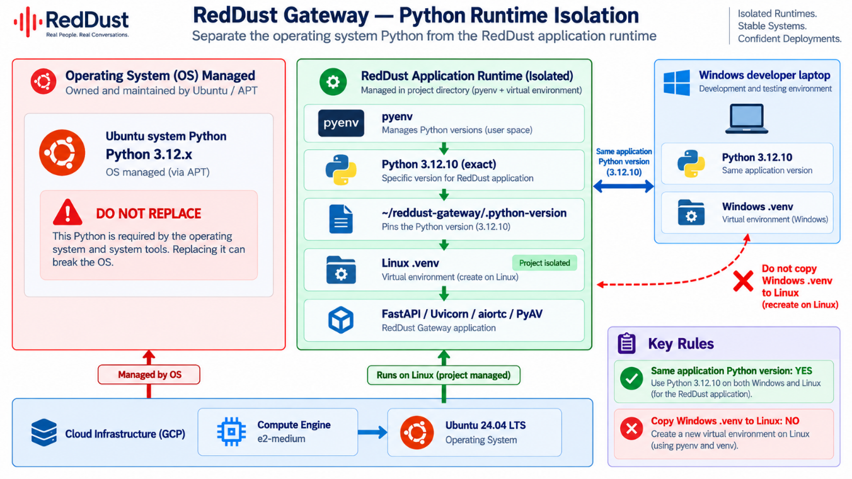

20.12 — Upload Existing Gateway Source and Install Dependencies
At this stage, the basic Linux development environment already exists on the GCP Gateway VM. The target structure should eventually look approximately like this:
/home/<OS_LOGIN_USER>/
├── reddust-gateway/
├── .python-version
├── .venv/
├── requirements.txt
├── main.py
├── ...
└── other RedDust Gateway modules
└── reddust-gateway.zip
The important rule in this step is:
Windows source code
↓
Upload
↓
GCP temporary extraction directory
↓
Copy source files only
↓
Existing ~/reddust-gateway
↓
KEEP existing Linux .venv
KEEP existing .python-version
Do not upload the Windows .venv and do not replace the Linux .venv.
A Python virtual environment created on Windows cannot simply be copied to Linux and used there. The VM must maintain its own Linux virtual environment.

20.12.1 — Build a clean archive on Windows

Step 1 — Open VSCode
On the Windows development laptop, open local RedDust Gateway project in VS Code. You may see its contents similar to:
.venv
.git (This may be in one directory above, in /reddust if that is the Git repository directory.)
__pycache__
main.py
requirements.txt
...

Step 2 — Confirm requirements.txt Exists
Run:
Test-Path .\requirements.txt
Expected output: True
Inspect the file requirements.txt. For the current RedDust WebRTC Gateway, it should contain the Python dependencies required by the application. For example, depending on the exact codebase:
fastapi
uvicorn
aiortc
av
There may be additional dependencies. Do not automatically assume that every package installed in the Windows virtual environment belongs in the Linux application. In particular, inspect requirements.txt for Windows-specific dependencies or local filesystem references. Look for entries such as:
pywin32 or some-package @ file:///C:/...
These should normally not be present in a portable Linux deployment requirements file. Fortunately no such entries exist as of now.

Step 3 — Make Sure Secrets Are Not Being Uploaded
Do not include any file containing:
passwords
API keys
OAuth client secrets
service-account private keys
production credentials
database passwords
private certificates
private SSH keys

In particular, be very careful with files such as:
.env
credentials.json
client_secret.json
service-account.json
*.pem
*.key

A file such as .env.example is acceptable if it contains only placeholders, for example:
GOOGLE_CLIENT_ID=YOUR_CLIENT_ID_HERE
DATABASE_URL=YOUR_DATABASE_URL_HERE

It must not contain actual credentials. Fortunately no such entries exist as of now.

Step 4 — Create a Clean Staging Directory
Rather than ZIPing the complete development directory, first create a temporary clean copy. From:
D:\RedDust\reddust-gateway

run:
$stage = "..\reddust-gateway-upload"

Delete an old staging directory if one exists:
Remove-Item $stage -Recurse -Force -ErrorAction SilentlyContinue

Create a fresh staging directory:
New-Item -ItemType Directory -Path $stage

Step 5 — Copy the Project While Excluding Development Artifacts
A convenient way to do this on Windows is robocopy. Run:
robocopy . $stage /E `
/XD .venv .git __pycache__ .pytest_cache .mypy_cache build dist `
/XF *.pyc *.pyo *.log .env *.pem *.key

This copies the useful project files while excluding common unwanted material. The archive should normally include things such as:
main.py
requirements.txt
Python packages/modules
configuration templates
application source files
README files
other required project resources

It should exclude:
.venv/
.git/
__pycache__/
*.pyc
*.log
build/
dist/
.env
private keys
credentials

Step 6 — Inspect the Staging Directory
Run:
Get-ChildItem $stage -Recurse -Force

Check carefully that your actual Python source files are present. For example:
reddust-gateway-upload
├── main.py
├── requirements.txt
├── ...
└── project modules

Also confirm that .venv is not there:
Test-Path "$stage\.venv"

Expected: False
Confirm .git is absent:
Test-Path "$stage\.git"

Expected: False

Confirm .env is absent:
Test-Path "$stage\.env"

Expected: False

Step 7 — Perform a Basic Secret Check
As an additional precaution, search filenames for obvious credential-related names:

Get-ChildItem $stage -Recurse -Force |
Where-Object {
$_.Name -match "secret|credential|password|private|\.pem$|\.key$"
}

Review anything returned. This is not a complete security scanner, but it provides a useful final manual check.

Step 8 — Create the ZIP File
Delete an older archive if necessary:

Remove-Item ..\reddust-gateway.zip -Force -ErrorAction SilentlyContinue
Create the archive:
Compress-Archive `
-Path "$stage\*" `
-DestinationPath ..\reddust-gateway.zip `
-Force

Confirm it exists:
Get-Item ..\reddust-gateway.zip

You should see something similar to:
reddust-gateway.zip

with a non-zero file size.

Step 9 — Optionally Inspect the ZIP before Uploading
Windows includes tar.exe on modern installations, which can normally list ZIP contents. Run:
tar -tf ..\reddust-gateway.zip

Look through the list. You should see:
main.py
requirements.txt
...

You should not see:
.venv/
.git/
__pycache__/
.env

At this point:
reddust-gateway.zip

is the archive to upload to the GCP VM.

20.12.2 — Upload through SSH-in-browser
Use the browser SSH upload command/menu. The upload normally lands in the OS Login user home directory.
ls -la ~
Unzip to a temporary location:
unzip reddust-gateway.zip -d ~/reddust-gateway-upload
Copy or move the project source into ~/reddust-gateway without overwriting .venv or .python-version.

20.12.3 — Activate the Linux environment and install requirements
cd ~/reddust-gateway
source .venv/bin/activate
python --version
python -m pip install -r requirements.txt

20.12.4 — Verify critical packages
pip show fastapi
pip show uvicorn
pip show aiortc
pip show av
If pip installation fails: Do not immediately switch Python versions. First inspect whether requirements.txt contains Windows-only packages, pinned wheels unavailable on Linux, or a package version that is incompatible with Python 3.12.10.
DIAGRAM 20-AM: Source Upload and Environment Rebuild
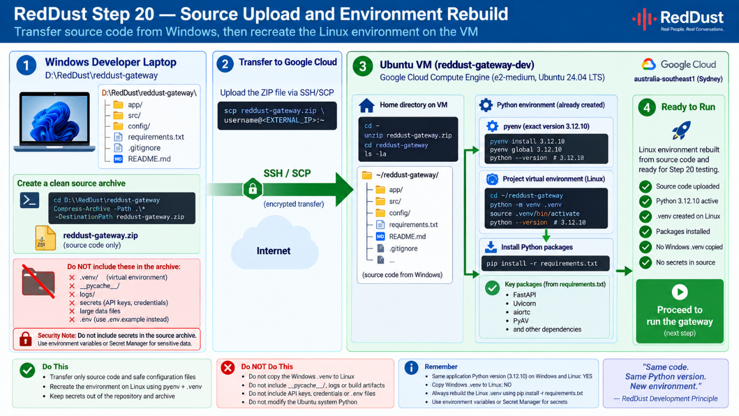

20.13 — Start FastAPI Manually on VM before Opening Firewall
Prove the application inside the VM first. Do not introduce systemd, Nginx, TLS or TURN yet.
cd ~/reddust-gateway
source .venv/bin/activate
uvicorn main:app --host 0.0.0.0 --port 8000
If the FastAPI object is not main:app, substitute the actual module/object name.

20.13.1 — Test from another SSH tab or terminal
curl http://127.0.0.1:8000/healthz
Expected:
{"status":"ok","service":"reddust-gateway"}
Checkpoint: FastAPI now works on the VM. The public Internet path is still unproven.

20.14 — Create the Temporary TCP 8000 Signalling Firewall Rule
Create an explicit development ingress rule targeted only at VMs carrying the reddust-gateway network tag.
1. Open VPC network → Firewall (or Firewall policies/rules page exposed by the current console).
2. Create a firewall rule.
3. Network: default.
4. Direction of traffic: Ingress.
5. Action on match: Allow.
6. Targets: Specified target tags.
7. Target tag: reddust-gateway.
8. Source IPv4 ranges: 0.0.0.0/0 for this temporary mobile development test.
9. Protocols and ports: Specified protocols and ports → TCP → 8000.
10. Create the rule.
Field | Value
Name | allow-reddust-signaling-dev
Network | Default
Direction | Ingress
Action | Allow
Target | Specified target tags
Target tag | reddust-gateway
Source IPv4 ranges | 0.0.0.0/0
Protocol | TCP
Port | 8000
Temporary development exposure: TCP 8000 is intentionally public only for Step 20. The production direction is HTTPS on TCP 443 through a reverse proxy, with FastAPI no longer directly exposed on public TCP 8000.

20.15 — Test FastAPI across the Public Internet
DIAGRAM 20-AN: Public FastAPI Reachability Test
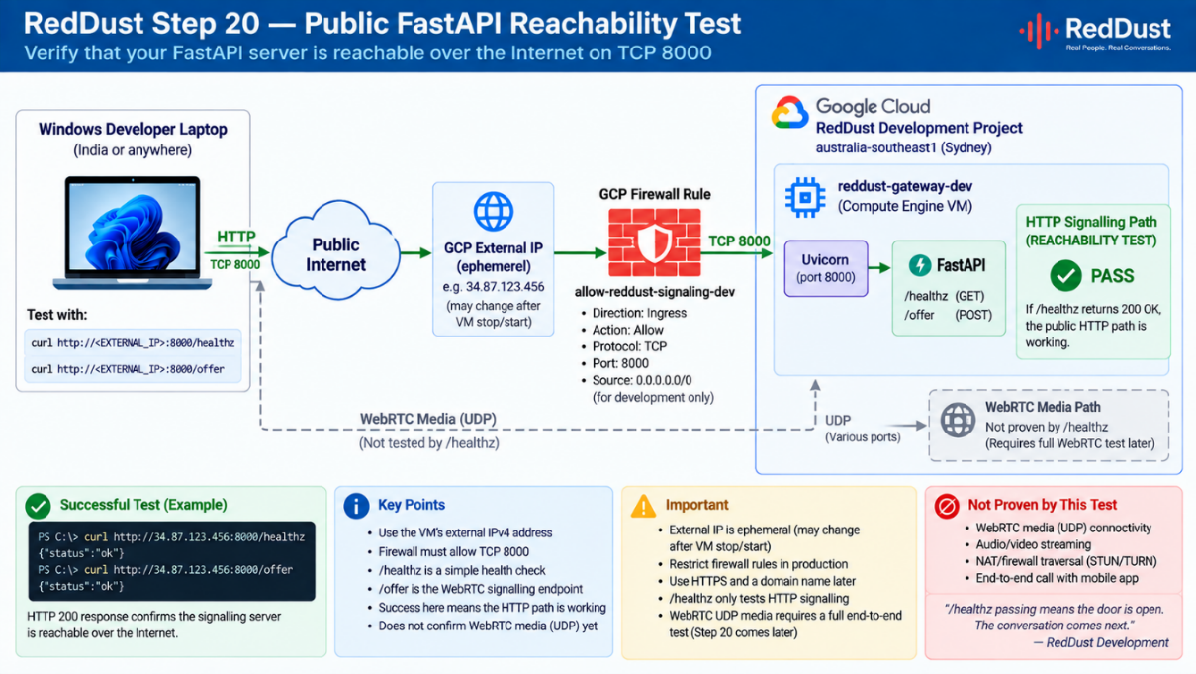
1. Open Compute Engine → VM instances.
2. Record the current external IPv4 address of reddust-gateway-dev.
3. From the Windows laptop, browse to or curl http://GCP_EXTERNAL_IP:8000/healthz.
4. Confirm the health JSON is returned.
http://GCP_EXTERNAL_IP:8000/healthz
Expected:
{"status":"ok","service":"reddust-gateway"}
This proves:
Developer laptop
↓
Public Internet
↓
Ephemeral GCP public IPv4
↓
GCP firewall / TCP 8000
↓
Uvicorn
↓
FastAPI
Do not over-interpret this test: A successful external /healthz proves only the HTTP signalling route and TCP firewall. It does not prove ICE, UDP, DTLS, SRTP or audio.

20.16 — Configure STUN Explicitly on Both Peers
STUN lets ICE discover Internet-reachable server-reflexive addresses. Use STUN in Step 20; do not deploy coturn/TURN yet.

20.16.1 — React Native RTCPeerConnection
const pc = new RTCPeerConnection({
iceServers: [
{
urls: 'stun:stun.l.google.com:19302',
},
],
});

20.16.2 — aiortc RTCPeerConnection
from aiortc import (
RTCPeerConnection,
RTCConfiguration,
RTCIceServer,
)
configuration = RTCConfiguration(
iceServers=[
RTCIceServer(
urls="stun:stun.l.google.com:19302"
)
]
)
pc = RTCPeerConnection(configuration)
DIAGRAM 20-AO: ICE and STUN Connectivity Architecture
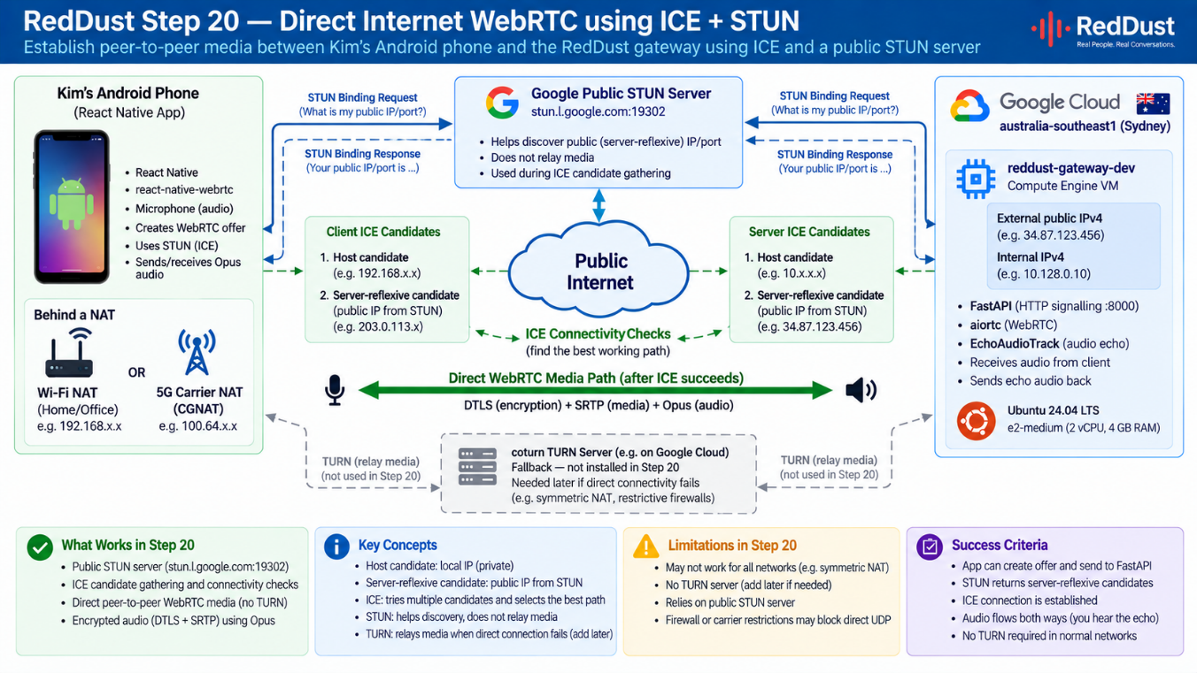
STEP 20
ICE
└── STUN
LATER / STEP 21
ICE
├── STUN
└── TURN
└── coturn

20.17 — Determine the VM UDP Ephemeral Port Range
aiortc/ICE needs UDP ports on the server side. For the first controlled experiment, inspect the VM rather than assuming a range copied from another host.
cat /proc/sys/net/ipv4/ip_local_port_range
A common result may look like:
32768 60999
Record the actual range returned by your VM. Use that value in the firewall rule below.

20.18 — Create the WebRTC UDP Firewall Rule
DIAGRAM 20-AP: GCP Firewall Rules
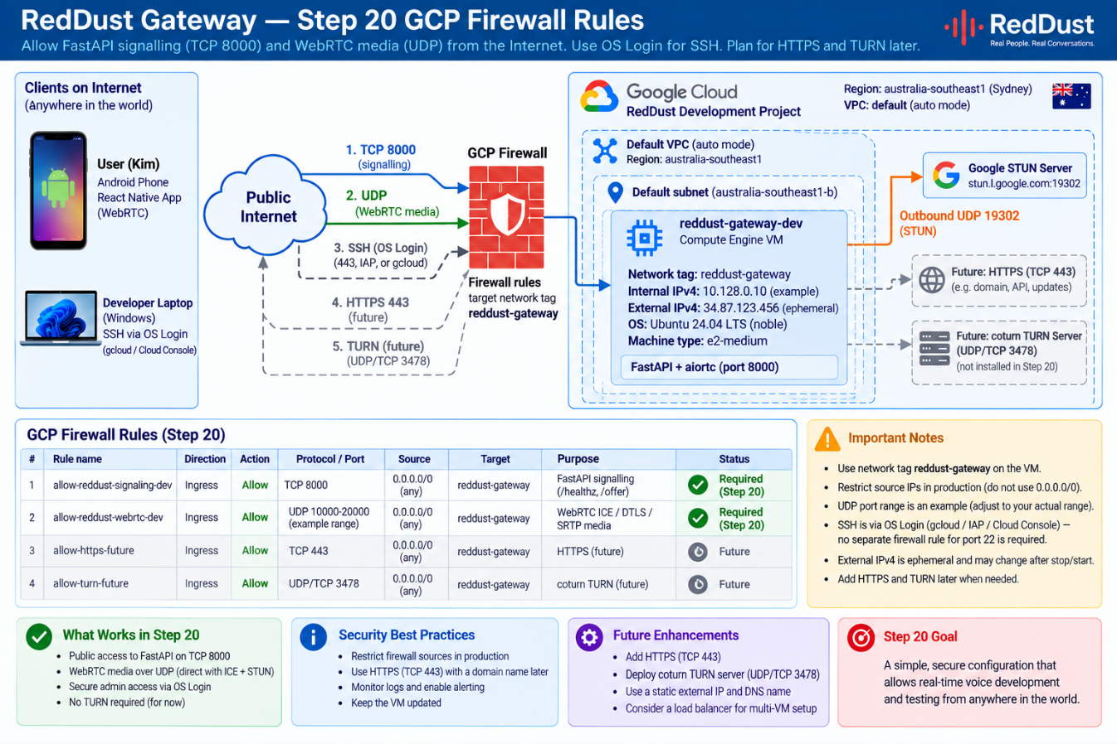
1. Open the GCP firewall rules page.
2. Create a second ingress rule.
3. Network: default.
4. Action: Allow.
5. Targets: Specified target tags.
6. Target tag: reddust-gateway.
7. Source IPv4 ranges: 0.0.0.0/0 because mobile clients can come from changing public IP addresses.
8. Protocol: UDP.
9. Ports: the actual Linux ephemeral port range from Step 20.17.
10. Create the rule.
Field | Value
Name | allow-reddust-webrtc-udp
Network | Default
Direction | Ingress
Action | Allow
Target | Specified target tags
Target tag | reddust-gateway
Source IPv4 ranges | 0.0.0.0/0
Protocol | UDP
Ports | <actual Linux ephemeral range>
The rule is broad by source address but remains constrained by protocol, port range and the reddust-gateway target tag.

20.19 — Add WebRTC Diagnostic Log before Pointing the App at GCP

20.19.1 — React Native logging
pc.addEventListener('icegatheringstatechange', () => {
console.log('ICE gathering:', pc.iceGatheringState);
});
pc.addEventListener('iceconnectionstatechange', () => {
console.log('ICE connection:', pc.iceConnectionState);
});
pc.addEventListener('connectionstatechange', () => {
console.log('Peer connection:', pc.connectionState);
});
pc.addEventListener('icecandidate', event => {
console.log('ICE candidate:', event.candidate);
});
pc.addEventListener('track', event => {
console.log('REMOTE TRACK RECEIVED:', event.track.kind);
});

20.19.2 — aiortc logging
@pc.on("iceconnectionstatechange")
async def on_iceconnectionstatechange():
print("ICE connection state:", pc.iceConnectionState)
@pc.on("connectionstatechange")
async def on_connectionstatechange():
print("Peer connection state:", pc.connectionState)
@pc.on("track")
def on_track(track):
print("Track received:", track.kind)
Useful progression:
ICE gathering: new → gathering → complete
ICE connection: checking → connected / completed
Peer connection: connected

20.20 — Point the Mobile App at the GCP Gateway
Replace the LAN Gateway URL only after the public /healthz test succeeds.
// Step 19 LAN URL
http://192.168.x.x:8000/offer
// Step 20 temporary GCP URL
http://GCP_EXTERNAL_IP:8000/offer

const GATEWAY_URL = 'http://34.xx.xx.xx:8000';
const response = await fetch(
`${GATEWAY_URL}/offer`,
{
method: 'POST',
headers: {
'Content-Type': 'application/json',
},
body: JSON.stringify({
sdp: offer.sdp,
type: offer.type,
}),
}
);
Use the actual current external IP from the VM list. The sample address above is only illustrative.

20.20.1 — Important Android cleartext note
Step 20 intentionally uses temporary HTTP on port 8000. If Android blocks cleartext HTTP in the build, use the same development-only cleartext configuration that allowed the LAN HTTP endpoint in Step 19, or move directly to HTTPS. Do not treat an Android cleartext policy error as a WebRTC ICE failure.
DIAGRAM 20-AQ: SDP Offer/ Answer through GCP
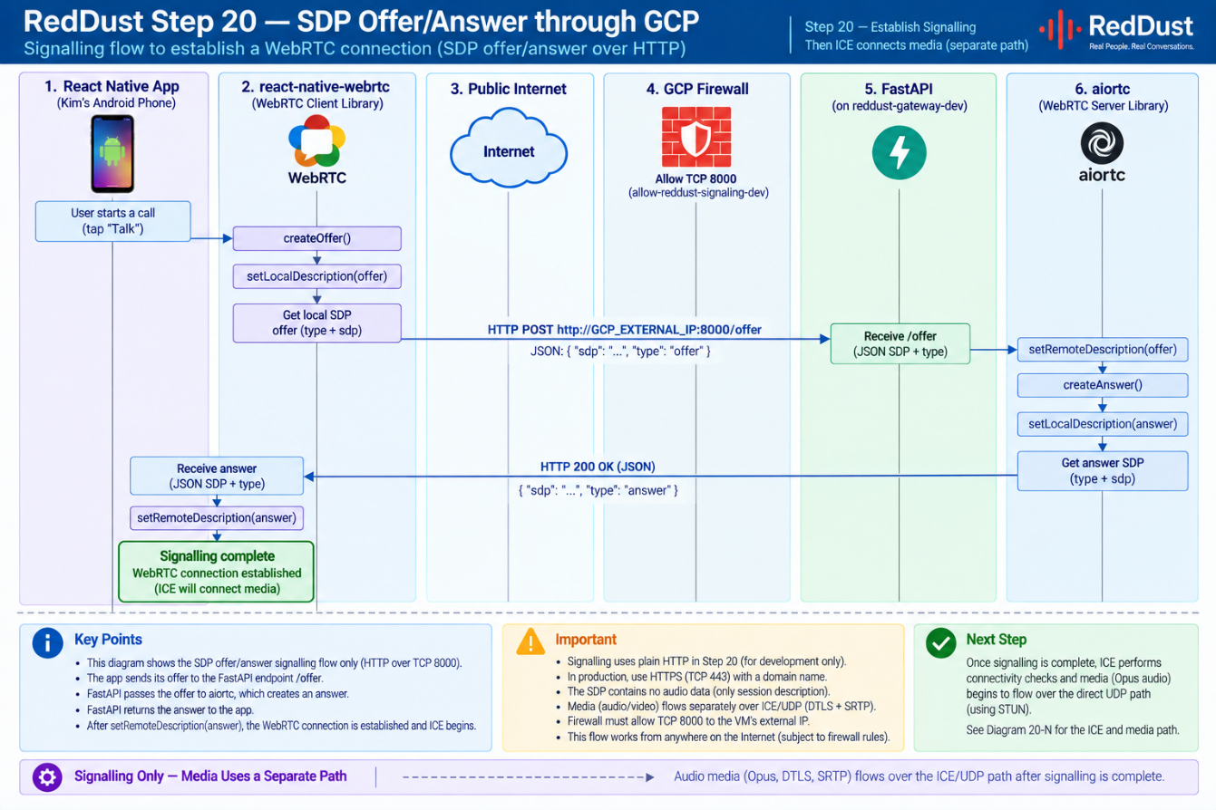

20.21 — First Cloud WebRTC Test: Phone on Wi-Fi
Keep the phone on normal Wi-Fi for the first cloud test. The Gateway is already Internet-separated because it is now in Sydney GCP rather than on the local LAN.
Android phone
↓
Wi-Fi router / NAT
↓
Public Internet
↓
GCP australia-southeast1
↓
reddust-gateway-dev
1. Start the Gateway manually on the VM.
2. Open the React Native app.
3. Start the same echo flow that passed Step 19.
4. Watch the backend for POST /offer.
5. Confirm the SDP answer is returned.
6. Confirm aiortc logs an incoming audio track.
7. Confirm ICE reaches connected or completed.
8. Speak into the phone.
9. Confirm EchoAudioTrack returns audible audio to the speaker.
Milestone 1: Phone on Wi-Fi → public Internet → GCP → aiortc → echo → public Internet → phone speaker.

20.22 — Second Cloud WebRTC Test: Disable Wi-Fi and Use 4G/5G
This is the decisive Step-20 test because the phone now sits behind the mobile carrier network and likely NAT/CGNAT.
1. Disable Wi-Fi on the Android phone.
2. Confirm the phone displays 4G, 5G or LTE.
3. Start the same echo workflow.
4. Observe POST /offer, SDP answer, ICE state, aiortc track logs and returned audio.
5. Speak and confirm audible round-trip echo.
Kim's phone
↓ 4G / 5G
Mobile carrier
↓ NAT / CGNAT
Public Internet
↓
GCP Sydney public IPv4
↓
reddust-gateway-dev
├── FastAPI
├── aiortc
└── EchoAudioTrack
Decisive Step-20 success criterion: The user hears round-trip echo with Wi-Fi disabled and mobile data enabled while the Gateway runs on GCP. At that moment the Layer-1 echo path is no longer a LAN-only prototype.
DIAGRAM 20-AR: Wi-Fi versus 4G/5G Internet Validation
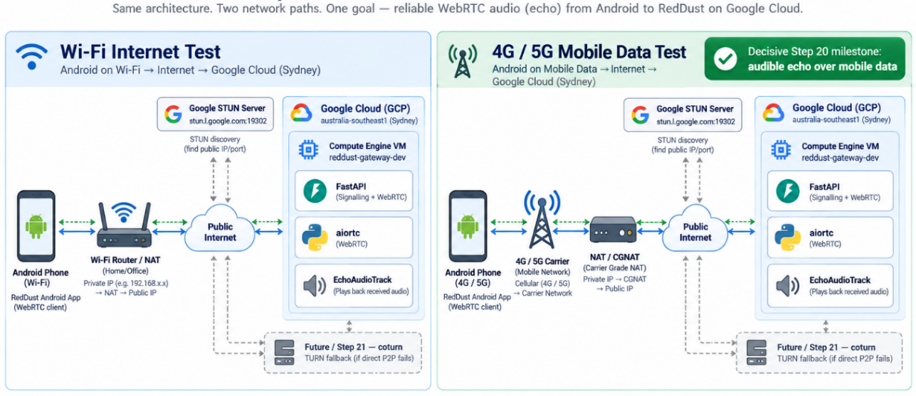

20.23 — Remove Metro as a Variable during the 4G/5G Test
A React Native development build can still depend on Metro running on the Windows laptop. When the phone leaves the local Wi-Fi, the app can lose Metro even though the GCP Gateway is perfectly reachable. Use an internal preview build for the cleanest independent mobile-data test.
{
"build": {
"preview": {
"distribution": "internal"
}
}
}
eas build --platform android --profile preview
- Install the resulting APK and repeat the mobile-data test without relying on the developer laptop at runtime.

20.24 — Define Success as Four Independent Gates
Gate | Pass condition | What it proves
1 — Public signalling reachability | POST /offer reaches GCP | External IP, TCP 8000 and FastAPI route work
2 — SDP negotiation | Offer accepted; answer returned and applied | Both peers have compatible session descriptions
3 — ICE connectivity | ICE reaches connected/completed | A viable WebRTC network path exists
4 — Bidirectional audio echo | Microphone reaches aiortc and EchoAudioTrack is audible on phone | Step 20 Layer-1 Internet milestone is complete
DIAGRAM 20-AS: Complete Successful Message and Media Sequence
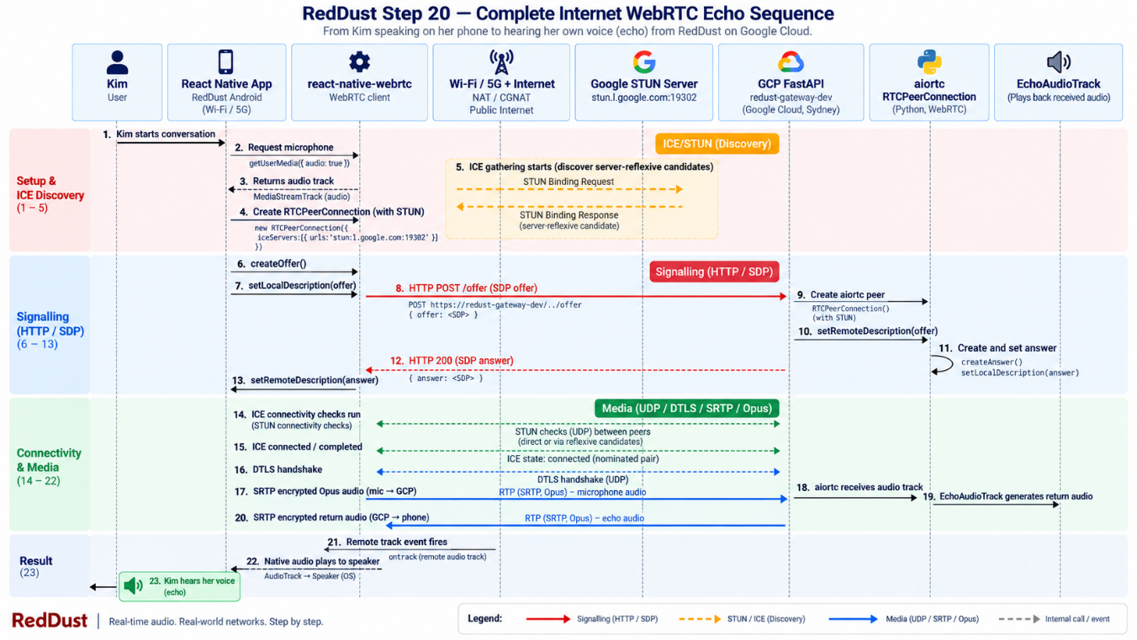

20.25 — Troubleshooting by Layer

20.25.1 — External /healthz fails
- Confirm Uvicorn is running.
- Confirm it is bound to 0.0.0.0:8000, not only 127.0.0.1.
- Confirm the VM current external IPv4.
- Confirm allow-reddust-signaling-dev exists.
- Confirm the VM carries the reddust-gateway network tag.

20.25.2 — /healthz works but /offer fails
- Check the FastAPI /offer route and request schema.
- Inspect backend validation errors and exceptions.
- Check whether the Android build is blocking cleartext HTTP.

20.25.3 — /offer and SDP succeed but ICE fails
- Confirm STUN is configured on the client and server peers.
- Inspect gathered ICE candidates.
- Confirm the UDP ingress rule exists.
- Confirm the rule targets reddust-gateway.
- Confirm the rule uses the actual VM ephemeral UDP range.
- Compare Wi-Fi and 4G/5G behaviour.

20.25.4 — ICE connects but no audio returns
- Confirm the client microphone track is added to the RTCPeerConnection.
- Confirm aiortc fires its track handler and reports kind=audio.
- Confirm EchoAudioTrack is added back to the peer.
- Confirm React Native fires its remote track event.
- Confirm the native audio output path is not muted or routed unexpectedly.

20.25.5 — Wi-Fi passes but 5G repeatedly fails
Treat restrictive NAT/CGNAT traversal as the leading hypothesis. That result justifies Step 21: add TURN/coturn fallback.
DIAGRAM 20-AT: Troubleshooting Decision Tree: Failure Isolation
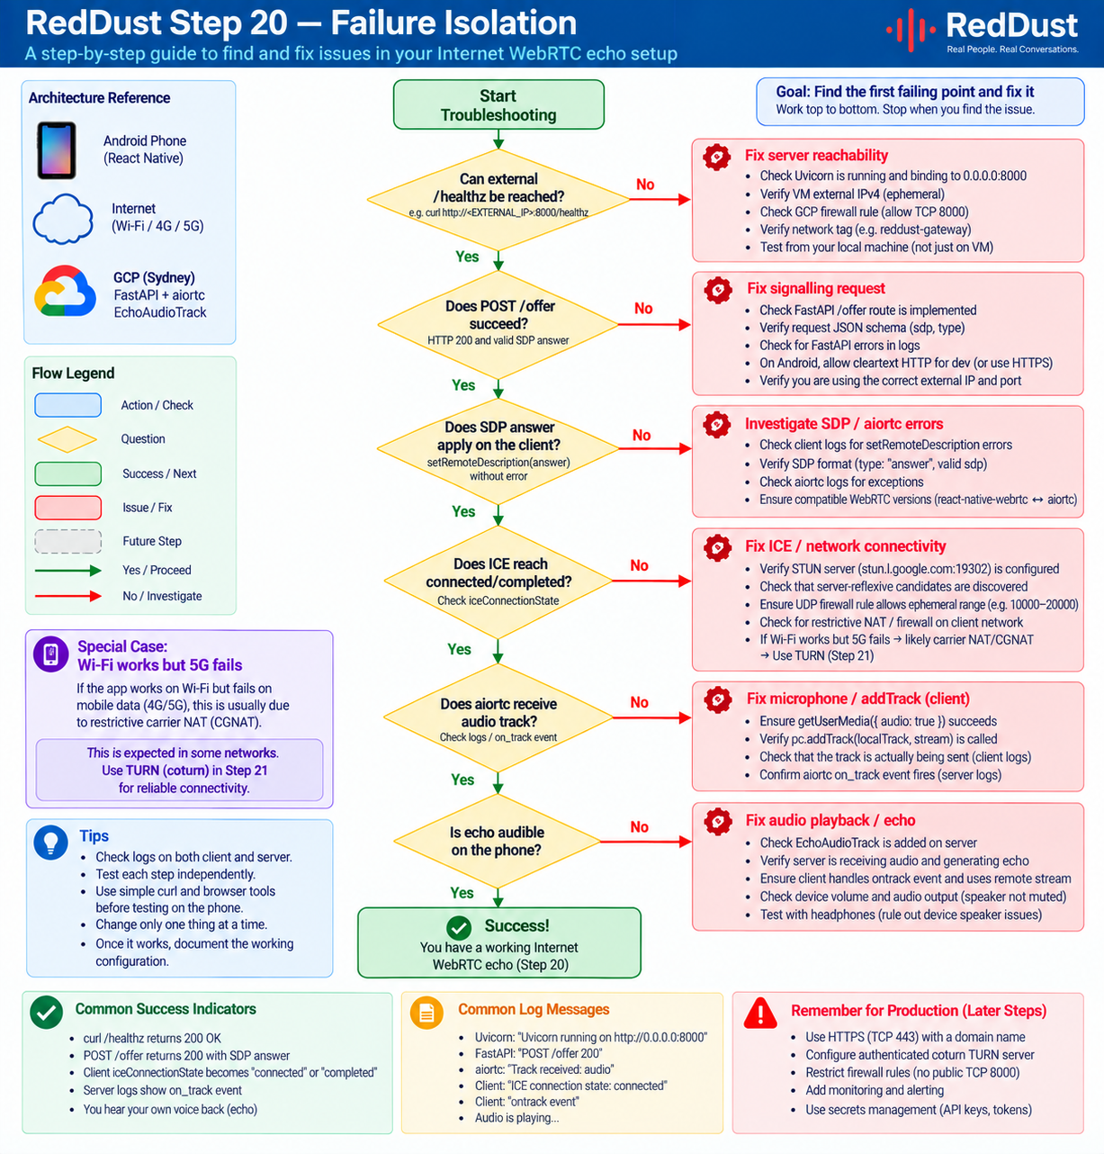

20.26 — Put the Proven Gateway under systemd
Only after manual Uvicorn testing succeeds should the Gateway stop depending on an open SSH session.

20.26.1 — Record the OS Login Linux username
whoami

20.26.2 — Create the service unit
sudo nano /etc/systemd/system/reddust-gateway.service
[Unit]
Description=RedDust WebRTC Gateway
After=network.target
[Service]
Type=simple
User=YOUR_LINUX_USERNAME
WorkingDirectory=/home/YOUR_LINUX_USERNAME/reddust-gateway
Environment="PYTHONUNBUFFERED=1"
ExecStart=/home/YOUR_LINUX_USERNAME/reddust-gateway/.venv/bin/uvicorn main:app --host 0.0.0.0 --port 8000
Restart=always
RestartSec=3
[Install]
WantedBy=multi-user.target
Replace YOUR_LINUX_USERNAME with the exact result of whoami and adjust main:app if necessary.

20.26.3 — Enable and start
sudo systemctl daemon-reload
sudo systemctl enable reddust-gateway
sudo systemctl start reddust-gateway
sudo systemctl status reddust-gateway

20.26.4 — Follow logs
sudo journalctl -u reddust-gateway –f
Close the SSH window and confirm the Gateway remains reachable. Reconnect and check systemctl status again.
DIAGRAM 20-AU: systemd-Managed Gateway Runtime
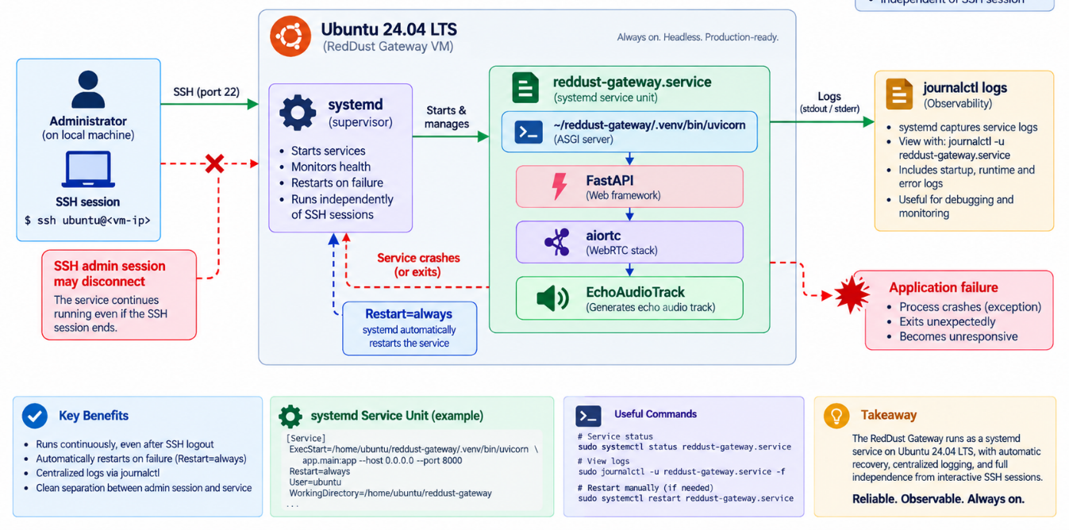

20.27 — Stop the Billable VM when Development Ends
Because e2-medium is billable, stopping the VM is part of the development procedure, not an optional housekeeping task.
Google Cloud Console
→ Compute Engine
→ VM instances
→ reddust-gateway-dev
→ Stop
Stopping ends active VM compute usage, but the persistent disk and certain networking resources may still be billable. When you start the VM again, re-check the ephemeral external IPv4 before testing.

20.27.1 — Optional scheduled stop
After the team understands its development hours, add an automatic evening stop schedule so a forgotten VM does not run overnight or through a weekend.

20.28 — Stabilise the Address only after the Architecture Works
Keep the public address ephemeral during the first proof. After the echo is stable, reserve/promote a static external IPv4 and then move the mobile app away from a hard-coded numeric address.
Step 20 temporary: React Native → ephemeral public IPv4 → Gateway
Later: React Native → DNS hostname → static public IPv4 → Gateway

20.29 — HTTPS Hardening Comes after the WebRTC Proof
React Native
↓ HTTPS / TCP 443
Gateway DNS hostname
↓
Caddy / Nginx
↓ localhost
FastAPI :8000
At that stage, close public TCP 8000 and keep FastAPI behind the reverse proxy.

20.30 — TURN/coturn Is Next Reliability Layer, Not the First Cloud Step
Can direct ICE connectivity succeed?
├── YES → direct WebRTC media
└── NO → TURN relay
↓
coturn
Step 20 establishes the direct STUN/ICE baseline. Towards the end, Step 20 should also introduce authenticated coturn TURN fallback and intentionally test restrictive networks.
DIAGRAM 20-AV: Evolution from Step 20 to Pilot-Ready Networking
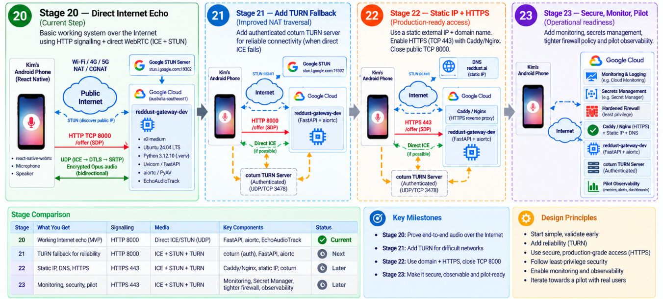
DIAGRAM 20-AW: Final Clean-Slate Step-20 Architecture
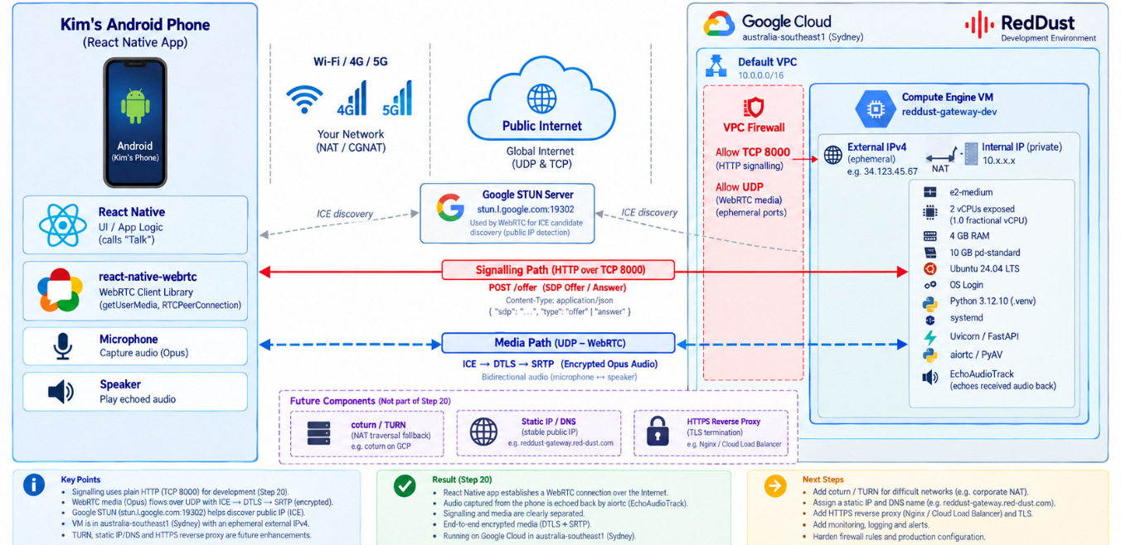

20.31 — Final Step-20 Architecture
Kim's Android phone
↓ Wi-Fi / 4G / 5G
Public Internet
├────────────── STUN discovery → stun.l.google.com:19302
↓
GCP australia-southeast1 — Sydney
↓
Ephemeral public IPv4
↓
GCP firewall
├── TCP 8000 → temporary FastAPI signalling
└── UDP range → ICE / DTLS / SRTP media
↓
reddust-gateway-dev
├── e2-medium
├── 2 vCPUs exposed
├── 1.0 fractional vCPU allocation
├── 4 GB RAM
├── 10 GB pd-standard
├── Ubuntu 24.04 LTS / noble / amd64
├── OS Login + IAM-controlled sudo
├── pyenv Python 3.12.10
├── Linux .venv Python 3.12.10
├── systemd
├── Uvicorn + FastAPI
├── aiortc + PyAV
└── EchoAudioTrack
FUTURE:
TURN/coturn
static public IPv4 + DNS
HTTPS :443 + reverse proxy
pilot observability

Step 20 Completion Checklist
Done | Validation item
☐ | Local Step-19 Windows echo still works before cloud changes.
☐ | Local /healthz works.
☐ | A dedicated RedDust Development GCP project exists.
☐ | The project is linked to the intended active billing account.
☐ | Monthly alerts-only budget is configured.
☐ | Compute Engine API is enabled.
☐ | Administrator has Compute OS Admin Login.
☐ | Project metadata contains enable-oslogin = TRUE.
☐ | reddust-gateway-dev exists in australia-southeast1 / australia-southeast1-b.
☐ | Machine type is e2-medium.
☐ | Guest OS sees 2 logical vCPUs and approximately 4 GB RAM.
☐ | Provisioning model is Standard, not Spot.
☐ | OS is Ubuntu 24.04 LTS standard x86-64 / noble.
☐ | Boot disk is 10 GB pd-standard.
☐ | No unnecessary workload service account is attached.
☐ | Network is the default VPC with one nic0.
☐ | External IPv4 is Ephemeral and IP stack is IPv4 only.
☐ | VM has network tag reddust-gateway.
☐ | Generic HTTP/HTTPS checkboxes were not used.
☐ | Project OS Login metadata query returns TRUE.
☐ | sudo whoami returns root immediately.
☐ | sudo whoami still returns root after at least five minutes.
☐ | Ubuntu packages are fully updated.
☐ | Build/media utilities are installed.
☐ | Exact pyenv Python 3.12.10 is installed.
☐ | RedDust Linux .venv uses exactly Python 3.12.10.
☐ | Windows .venv was not copied to Linux.
☐ | Gateway source and reviewed requirements.txt are uploaded.
☐ | FastAPI, Uvicorn, aiortc and av are installed in the Linux .venv.
☐ | /healthz works locally on the VM.
☐ | allow-reddust-signaling-dev permits TCP 8000 to target tag reddust-gateway.
☐ | /healthz works through the public external IPv4.
☐ | STUN is configured explicitly.
☐ | The actual Linux UDP ephemeral range is recorded.
☐ | allow-reddust-webrtc-udp permits the actual UDP range to target tag reddust-gateway.
☐ | React Native points to the current GCP Gateway address.
☐ | React Native ICE/connection/track logs are enabled.
☐ | aiortc ICE/connection/track logs are enabled.
☐ | POST /offer reaches GCP.
☐ | SDP offer/answer negotiation succeeds.
☐ | ICE reaches connected/completed.
☐ | aiortc receives the phone microphone track.
☐ | EchoAudioTrack returns audio.
☐ | React Native receives the remote audio track.
☐ | Audible echo works over Wi-Fi → Internet → GCP.
☐ | Audible echo works over 4G/5G → Internet → GCP.
☐ | The clean mobile-data test does not depend on Metro.
☐ | Gateway runs under systemd after manual validation.
☐ | VM is stopped when the development session ends.

Condensed Implementation Sequence
20.0 Separate signalling from media conceptually
↓
20.1 Re-verify local Windows echo + /healthz
↓
20.2 Create RedDust Development GCP project + billing
↓
20.3 Create monthly budget alerts
↓
20.4 Select Sydney: australia-southeast1
↓
20.5 Configure IAM + project-wide OS Login
↓
20.6 Create e2-medium / Ubuntu 24.04 / 10 GB pd-standard VM
↓
20.7 Configure default VPC + ephemeral IPv4 + network tag
↓
20.8 Verify OS / CPU / RAM / OS Login / persistent sudo
↓
20.9 Update Ubuntu
↓
20.10 Install build and media tooling
↓
20.11 Install exact Python 3.12.10 + Linux .venv
↓
20.12 Upload Gateway source + install requirements
↓
20.13 Start FastAPI manually and test locally
↓
20.14 Open temporary TCP 8000
↓
20.15 Verify /healthz across the Internet
↓
20.16 Configure STUN
↓
20.17 Discover actual UDP ephemeral range
↓
20.18 Open WebRTC UDP ingress range
↓
20.19 Add client/server ICE logging
↓
20.20 Point React Native to GCP public address
↓
20.21 Test Wi-Fi → Internet → GCP echo
↓
20.22 Test 4G/5G → Internet → GCP echo
↓
20.23 Remove Metro from mobile-data runtime dependency
↓
20.24 Pass signalling, SDP, ICE and audio gates
↓
20.25 Troubleshoot by layer if needed
↓
20.26 Put Gateway under systemd
↓
20.27 Stop e2-medium when not in use
↓
STEP 20 COMPLETE

Architectural Boundary to Preserve
FastAPI /offer = signalling only
WebRTC transport = real-time encrypted audio
React Native native WebRTC stack
= microphone / codec / packetisation / ICE / DTLS / SRTP / speaker path
aiortc = server-side RTCPeerConnection and media track handling
Do NOT manually:
decrypt SRTP in FastAPI
decode Opus in /offer
push PCM speaker bytes through the signalling endpoint
Core rule: Keep signalling and media responsibilities separate. This boundary remains valid when EchoAudioTrack is later replaced by the real RedDust conversation engine.

Selected Technical References
Google Compute Engine — E2 machine types — https://docs.cloud.google.com/compute/docs/general-purpose-machines
Google Compute Engine — Create a Linux VM — https://docs.cloud.google.com/compute/docs/create-linux-vm-instance
Google Compute Engine — Regions and zones — https://docs.cloud.google.com/compute/docs/regions-zones
Google Compute Engine — Ubuntu OS image details — https://docs.cloud.google.com/compute/docs/images/os-details
Google Compute Engine — Set up OS Login — https://docs.cloud.google.com/compute/docs/oslogin/set-up-oslogin
Google Compute Engine — Troubleshoot OS Login — https://docs.cloud.google.com/compute/docs/troubleshooting/troubleshoot-os-login
Google Compute Engine — VM service accounts — https://docs.cloud.google.com/compute/docs/access/create-enable-service-accounts-for-instances
Google Cloud Billing — Budgets and alerts — https://docs.cloud.google.com/billing/docs/how-to/budgets
Google Cloud — VPC firewall rules — https://docs.cloud.google.com/firewall/docs/firewalls
React Native WebRTC — improving call reliability — https://react-native-webrtc.github.io/handbook/guides/improving-call-reliability.html
React Native WebRTC — basic usage — https://react-native-webrtc.github.io/handbook/guides/basic-usage.html
aiortc API documentation — https://aiortc.readthedocs.io/en/latest/api.html
Expo EAS — internal distribution — https://docs.expo.dev/build/internal-distribution/

Next Planned Engineering Step
After Step 20 is complete, the next reliability milestone should be authenticated TURN/coturn fallback. Intentionally test restrictive mobile, hotel and corporate networks and record when ICE selects direct transport versus TURN relay. After TURN is proven, harden signalling with static addressing, DNS, HTTPS/TLS, reverse proxying, secrets management, tighter firewall exposure and pilot-ready monitoring.

20.32 — Complete TURN/coturn Implementation for Reliable Internet WebRTC
Final section for Step 20 — RedDust Gateway: Local Development to Google Cloud VM
What this final section does and why it matters
The earlier Step-20 tests prove signalling and direct ICE/STUN media across the Internet. This final reliability extension adds an authenticated TURN relay using coturn on Google Cloud so RedDust can still establish WebRTC audio when direct peer-to-peer paths fail behind carrier-grade NAT, restrictive Wi-Fi, enterprise firewalls or symmetric NAT. TURN is a fallback transport, not a replacement for STUN or direct ICE.
RedDust implementation decision
For the current development proof, run coturn on the existing reddust-gateway-dev VM to minimise cost and operational complexity. Give the VM a stable public IPv4 address, keep the Gateway and coturn as separate systemd services, and use short-lived TURN REST credentials generated by the trusted Gateway. For pilot/production, split TURN onto dedicated instances or a managed TURN service and scale it independently from the application tier.

20.32.1 — Understand the role of TURN in the RedDust media path
DIAGRAM 20-AX: Direct ICE versus TURN Fallback
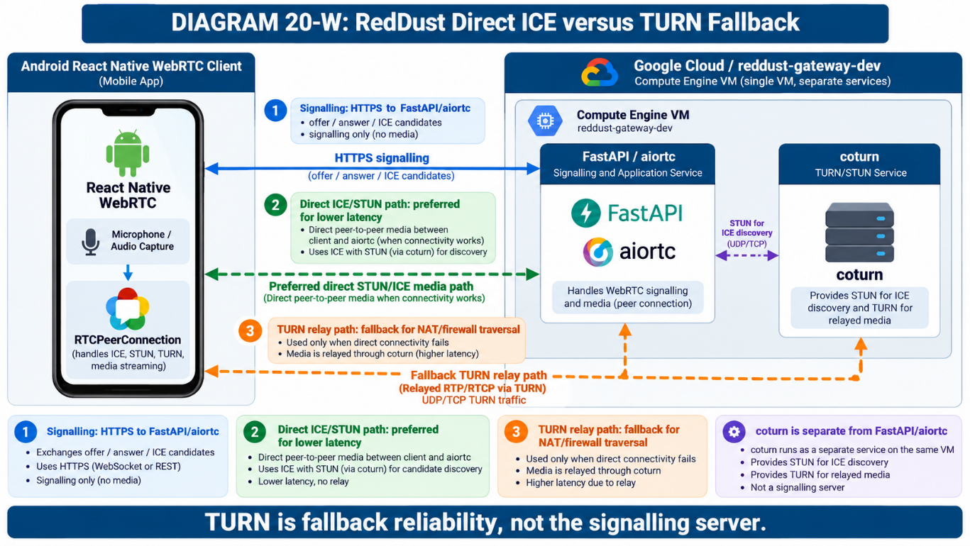
ICE tries candidate pairs in order of connectivity and priority. A typical RedDust call can use host/server-reflexive candidates when direct connectivity succeeds. A relay candidate is obtained from TURN and is selected only when the direct route cannot work or when testing deliberately forces relay-only transport.
- STUN discovers a public-facing server-reflexive candidate; it does not relay the audio.
- TURN allocates a relay address on the coturn server and forwards encrypted WebRTC packets between the phone and the aiortc peer.
- DTLS-SRTP remains the WebRTC media-security layer end-to-end between the two WebRTC peers; coturn forwards packets and does not become the application audio processor.
- Signalling (/offer, health endpoints and future authentication APIs) remains separate from TURN transport.

20.32.2 — Reserve a stable external IPv4 address before configuring coturn
TURN advertises relay addresses to clients. Do not build the final coturn configuration around an ephemeral VM address that can change after stop/start. Promote or reserve the current external address, then verify that the VM uses it.
PROJECT_ID="reddust-development"
VM="reddust-gateway-dev"
ZONE="australia-southeast1-b"
REGION="australia-southeast1"
gcloud config set project "$PROJECT_ID"
gcloud compute instances describe "$VM" --zone="$ZONE" \
--format="get(networkInterfaces[0].accessConfigs[0].natIP)"
If the current address is still ephemeral, reserve/promote it using the Google Cloud console or the appropriate gcloud address command for the current VM/network design. Record the resulting public IPv4 as TURN_PUBLIC_IP. Then obtain the VM internal IPv4:
TURN_PUBLIC_IP="<STATIC_EXTERNAL_IPV4>"
TURN_PRIVATE_IP=$(gcloud compute instances describe "$VM" --zone="$ZONE" \
--format="get(networkInterfaces[0].networkIP)")
echo "Public: $TURN_PUBLIC_IP"
echo "Private: $TURN_PRIVATE_IP"
Why both addresses matter on GCE
The VM guest normally owns its internal VPC address while Google Cloud maps the external IPv4 to it. coturn therefore needs the public/private mapping when advertising relay addresses: external-ip=<public>/<private>. Do not guess either value; inspect the VM.

20.32.3 — Add a TURN DNS name
Create a stable DNS record such as turn-dev.<your-domain> pointing to TURN_PUBLIC_IP. A DNS name is strongly preferred before enabling TURN over TLS because certificates are issued for names, not for an arbitrary changing development address.
TURN_HOST="turn-dev.<your-domain>"
# DNS: create an A record TURN_HOST -> TURN_PUBLIC_IP
# Verify after DNS propagation:
nslookup "$TURN_HOST"

20.32.4 — Install coturn on Ubuntu and inspect the packaged service
sudo apt update
sudo apt install -y coturn
turnserver --version
systemctl status coturn --no-pager || true
dpkg -L coturn | grep -E "turnserver.conf|systemd|default"
Do not assume the package defaults or service-enablement mechanism. Inspect the installed unit and configuration paths on the actual Ubuntu image before editing them:
systemctl cat coturn
sudo grep -vE "^\s*(#|$)" /etc/turnserver.conf || true

20.32.5 — Create narrowly scoped GCP firewall rules for TURN
TURN clients can arrive from arbitrary mobile and Wi-Fi networks, so the public TURN listener normally needs Internet ingress. Limit exposure by opening only the listener ports and a deliberately bounded relay range. For this development VM, use UDP/TCP 3478 and a small UDP relay range such as 49160–49200. Add 5349 only when TURN over TLS is actually configured.
NETWORK="default"
TAG="reddust-gateway"
gcloud compute firewall-rules create allow-reddust-turn-dev \
--network="$NETWORK" \
--direction=INGRESS \
--action=ALLOW \
--rules=udp:3478,tcp:3478,udp:49160-49200 \
--source-ranges=0.0.0.0/0 \
--target-tags="$TAG" \
--description="RedDust dev TURN listener and bounded UDP relay range"
Later, after TLS is configured:
gcloud compute firewall-rules update allow-reddust-turn-dev \
--rules=udp:3478,tcp:3478,tcp:5349,udp:49160-49200
Security boundary
Do not open all TCP/UDP ports. Do not enable anonymous TURN. Do not expose a Prometheus/administrative listener publicly. Keep the relay range in the coturn configuration exactly aligned with the GCP firewall range.
DIAGRAM 20-AY: TURN Ports and GCP Firewall Boundaries
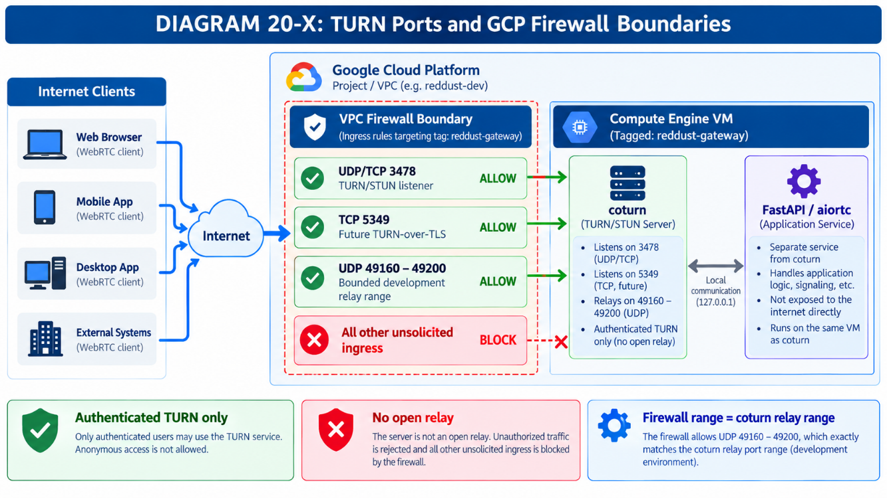

20.32.6 — Generate a strong TURN REST shared secret
For the final RedDust design, do not embed a permanent TURN username/password in the mobile application. coturn supports shared-secret authentication in which the trusted Gateway generates short-lived credentials and the client receives only a temporary username/password pair.
sudo install -d -m 0750 -o root -g root /etc/reddust
sudo sh -c 'umask 077; openssl rand -base64 48 > /etc/reddust/turn_shared_secret'
sudo chmod 600 /etc/reddust/turn_shared_secret
sudo ls -l /etc/reddust/turn_shared_secret
# Do NOT print or paste the secret into team documentation, Git, chat logs or screenshots.

20.32.7 — Configure /etc/turnserver.conf
Back up the package configuration, then create an explicit development configuration. Replace placeholders with the values discovered above. The example intentionally disables legacy/unused surfaces and bounds relay allocation.
sudo cp /etc/turnserver.conf /etc/turnserver.conf.before-reddust
TURN_SECRET=$(sudo cat /etc/reddust/turn_shared_secret)
sudo tee /etc/turnserver.conf >/dev/null <<EOF
listening-port=3478
fingerprint
# GCE public-to-private address mapping
external-ip=${TURN_PUBLIC_IP}/${TURN_PRIVATE_IP}
# TURN REST / time-limited credentials
use-auth-secret
static-auth-secret=${TURN_SECRET}
realm=${TURN_HOST}
server-name=${TURN_HOST}
# Development relay range - must match GCP firewall
min-port=49160
max-port=49200
# Hardening
no-multicast-peers
no-loopback-peers
stale-nonce
# Keep verbose logging off after initial diagnosis
# verbose
EOF
sudo chmod 600 /etc/turnserver.conf
sudo sed -E 's/^(static-auth-secret=).*/\1<REDACTED>/' /etc/turnserver.conf
Authentication choice
use-auth-secret and a static long-term user are alternative authentication designs. The RedDust target design uses use-auth-secret so the Gateway can mint expiring credentials. Do not configure no-auth. Do not combine the REST shared-secret flow with a hard-coded mobile credential and assume they are the same mechanism.

20.32.8 — Enable and start coturn under systemd
sudo systemctl enable coturn
sudo systemctl restart coturn
sudo systemctl status coturn --no-pager
sudo journalctl -u coturn -n 100 --no-pager
sudo ss -lntup | grep -E ":3478|:5349" || true
If the distribution package requires an explicit service-enable switch in a defaults file, follow the installed unit/package instructions discovered in 20.32.4, then restart and re-check systemd. Do not replace a working packaged unit with an ad-hoc background process.

20.32.9 — Add a Gateway endpoint that mints short-lived TURN credentials
DIAGRAM — 20-AZ: Short-Lived TURN Credential Flow
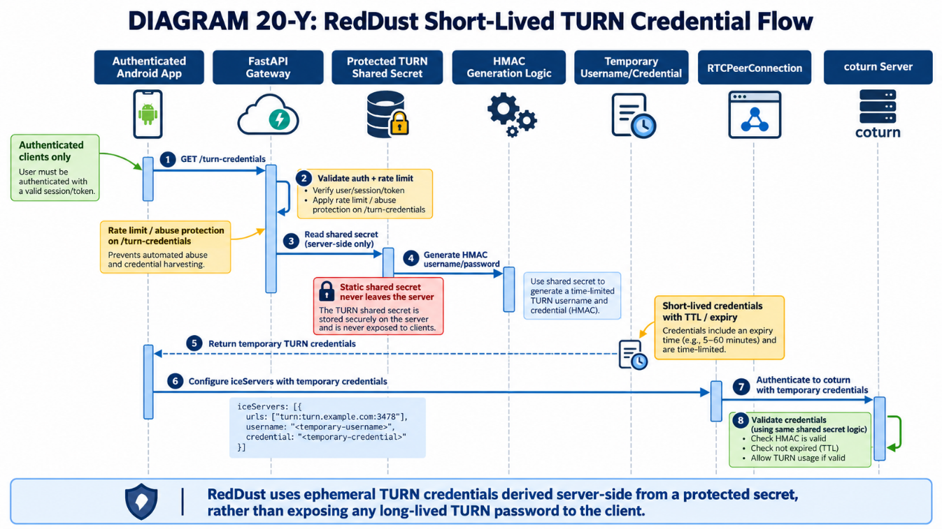
The trusted backend should read the shared secret from protected server-side configuration. The mobile app requests temporary ICE-server credentials after normal application authentication. A common TURN REST pattern uses an expiry timestamp in the username and HMAC-SHA1 over that username with the shared secret; the result is Base64-encoded as the temporary credential.
import base64
import hashlib
import hmac
import time
def make_turn_credentials(user_id: str, secret: str, ttl_seconds: int = 3600):
expires = int(time.time()) + ttl_seconds
username = f"{expires}:{user_id}"
digest = hmac.new(
secret.encode("utf-8"),
username.encode("utf-8"),
hashlib.sha1,
).digest()
credential = base64.b64encode(digest).decode("ascii")
return {
"username": username,
"credential": credential,
"ttl": ttl_seconds,
}
Return ICE-server data rather than the shared secret itself:
{
"iceServers": [
{ "urls": ["stun:turn-dev.<your-domain>:3478"] },
{
"urls": [
"turn:turn-dev.<your-domain>:3478?transport=udp",
"turn:turn-dev.<your-domain>:3478?transport=tcp"
],
"username": "<expiry>:<authenticated-user-id>",
"credential": "<short-lived-hmac-credential>"
}
],
"ttl": 3600
}
- Require normal RedDust user/session authentication before issuing TURN credentials.
- Use a short TTL appropriate to call/session duration and refresh before expiry when necessary.
- Rate-limit the credential endpoint and log issuance metadata without logging the credential or shared secret.
- Load the shared secret from a protected server-side secret source; move it to Google Secret Manager when the Step-22/DevSecOps platform work introduces central secret management.

20.32.10 — Configure React Native WebRTC to use STUN plus authenticated TURN
Fetch the temporary ICE-server configuration before constructing RTCPeerConnection. Preserve STUN and list TURN/UDP before TURN/TCP so direct/UDP paths remain preferred when available.
const turnConfig = await fetchTurnCredentials();
const pc = new RTCPeerConnection({
iceServers: turnConfig.iceServers,
});
pc.addEventListener("iceconnectionstatechange", () => {
console.log("ICE state:", pc.iceConnectionState);
});
pc.addEventListener("connectionstatechange", () => {
console.log("Peer state:", pc.connectionState);
});
Do not hard-code production TURN secrets in the app
Anything shipped inside an APK/IPA should be treated as recoverable by a client. The app may receive expiring TURN credentials; it must never contain the coturn shared secret used to generate them.

20.32.11 — Give the aiortc peer the same TURN capability
The server-side RTCPeerConnection also participates in ICE. Supply STUN/TURN servers when constructing the aiortc peer so either side can gather the required candidate types. Generate a temporary credential server-side using the same credential helper rather than exposing the shared secret.
from aiortc import RTCConfiguration, RTCIceServer, RTCPeerConnection
cred = make_turn_credentials("gateway", TURN_SHARED_SECRET, 3600)
configuration = RTCConfiguration(iceServers=[
RTCIceServer(urls=["stun:turn-dev.<your-domain>:3478"]),
RTCIceServer(
urls=[
"turn:turn-dev.<your-domain>:3478?transport=udp",
"turn:turn-dev.<your-domain>:3478?transport=tcp",
],
username=cred["username"],
credential=cred["credential"],
),
])
pc = RTCPeerConnection(configuration=configuration)
Adapt this to the Gateway’s existing peer-connection factory rather than creating a second competing construction path.

20.32.12 — Validate coturn locally before testing WebRTC
sudo systemctl is-active coturn
sudo journalctl -u coturn -f
Use coturn client utilities if installed to perform an allocation test with valid temporary credentials. Exact utility availability and flags can vary by package version; confirm with the local help output before running:
command -v turnutils_uclient || true
turnutils_uclient --help 2>&1 | head -80
At minimum, confirm that 3478 is reachable from outside GCP and that authenticated allocation succeeds while an unauthenticated allocation is rejected.

20.32.13 — Run three WebRTC acceptance tests
- Test A — Normal Wi-Fi/direct preference: run the echo call with STUN + TURN configured. Confirm ICE connects and observe whether a direct candidate pair wins. TURN being configured does not mean it must be used.
- Test B — Mobile 4G/5G: disable Wi-Fi and repeat. Confirm the call survives carrier NAT/CGNAT conditions. Record the selected candidate type and transport.
- Test C — Forced relay: temporarily set the client ICE transport policy to relay (only for controlled validation) or otherwise use a test configuration that prevents direct candidates. Confirm the selected pair contains a relay candidate and audio still echoes. Restore the normal policy after the test.
// Controlled diagnostic only; restore normal policy afterwards.
const pc = new RTCPeerConnection({
iceServers: turnConfig.iceServers,
iceTransportPolicy: "relay",
});
TURN acceptance criterion
The implementation is not complete merely because coturn is “running”. Completion requires a successful authenticated TURN allocation and an end-to-end WebRTC audio test in which ICE demonstrably selects a relay candidate.
DIAGRAM — 20-BA: Forced-Relay TURN Acceptance Test
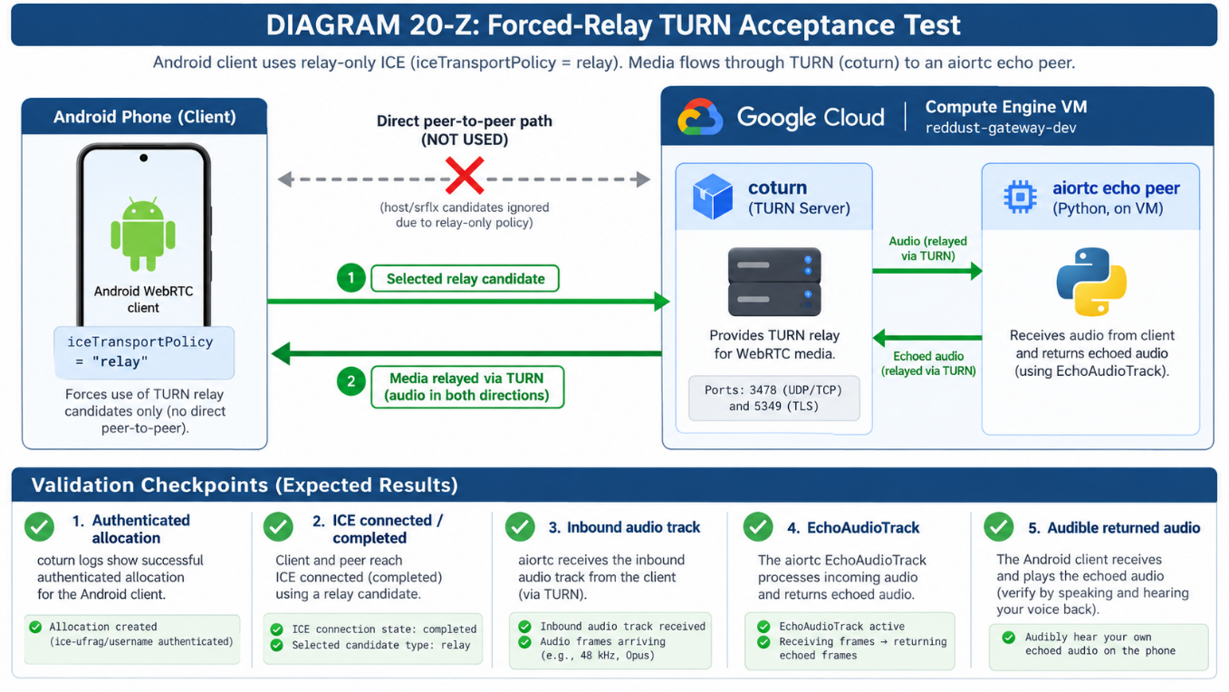

20.32.14 — Prove which candidate pair was selected
Do not infer TURN usage from network conditions alone. Capture WebRTC statistics/logs and identify the nominated/selected candidate pair. Record local/remote candidate types (host, srflx, relay), protocol (UDP/TCP), state and bytes sent/received. Keep this diagnostic evidence with the Step-20 acceptance notes.
- Normal Wi-Fi should preferably succeed without requiring relay.
- 4G/5G may use direct or relay depending on the carrier/NAT path.
- Forced-relay validation must show relay in the selected candidate path.

20.32.15 — Add TURN over TLS on TCP 5349
UDP TURN is usually the efficient first fallback. A second fallback over TLS/TCP can help on networks that block UDP. Configure this only after a DNS name resolves to the stable public IP and a valid certificate/private key are available.
# Illustrative additions to /etc/turnserver.conf after certificate provisioning:
tls-listening-port=5349
cert=/path/to/fullchain.pem
pkey=/path/to/privkey.pem
# Then validate configuration and restart:
sudo systemctl restart coturn
sudo systemctl status coturn --no-pager
sudo ss -lntp | grep :5349
Then add a TLS URL to the ICE-server list:
turns:turn-dev.<your-domain>:5349?transport=tcp
Certificate lifecycle
The certificate renewal mechanism must also preserve coturn access to the renewed key material and restart/reload coturn safely. Do not weaken private-key permissions merely to make the service start. Validate renewal before calling the TLS path production-ready.

20.32.16 — Harden the TURN service before pilot use
- Use authenticated TURN only; never operate an Internet-facing no-auth/open relay.
- Keep the shared secret out of source control, Terraform state, mobile binaries, logs and documentation.
- Use a dedicated TURN VM/service for pilot and production so relay bandwidth and failure domains are independent from FastAPI/aiortc.
- Constrain relay ports and mirror the same range in firewall rules.
- Apply OS patching, least-privilege service execution, log rotation and resource monitoring.
- Rate-limit temporary credential issuance and tie it to authenticated RedDust identities/sessions.
- Consider bandwidth/session quotas and abuse monitoring before public launch.
- Use TURN/TLS as a compatibility fallback, not as the only media path.
- When moving to GKE, keep TURN architecture separate from ordinary HTTP Ingress assumptions; TURN has UDP/TCP relay semantics and should be designed explicitly.

20.32.17 — Troubleshoot TURN by layer
Symptom | Primary checks
coturn will not start | Check systemctl status and journalctl; validate config paths, secret/certificate permissions and duplicate/invalid directives.
3478 unreachable | Check VM network tag, GCP firewall rule, listener binding and current static public IP/DNS.
401/438 or auth failures | Check clock skew, realm, shared secret, username expiry and HMAC generation. Ensure the app is not using expired credentials.
Allocation succeeds but media fails | Check relay UDP range in both coturn and GCP firewall; verify external-ip public/private mapping.
Wi-Fi works, forced relay fails | Inspect selected candidates and coturn allocation logs; prove that relay candidates are gathered and reachable.
UDP TURN fails on restrictive network | Test TURN/TCP and then TURN/TLS 5349 after it is configured.
High latency/cost | Confirm relay is fallback rather than forced globally; TURN carries media bandwidth through the server and adds network path/cost.
DIAGRAM — 20-BB: TURN Troubleshooting Decision Tree
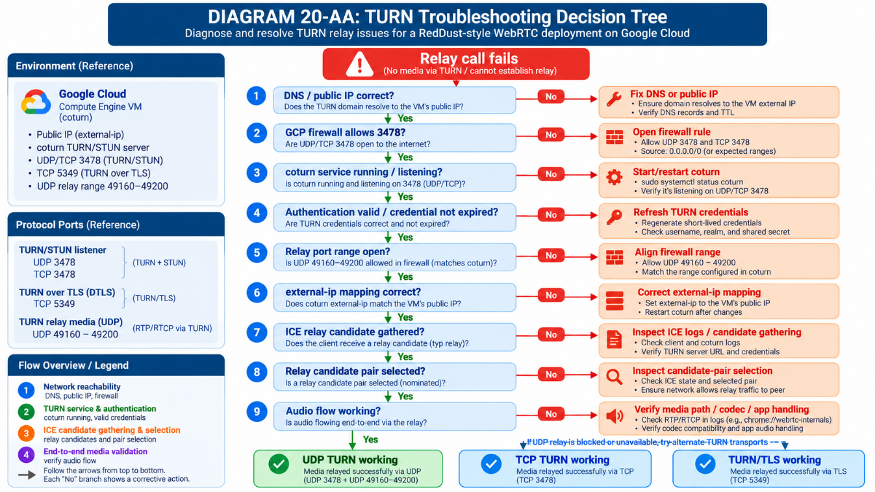

20.32.18 — Add operational logging and monitoring
For development, systemd journal logs are sufficient for initial diagnosis. For pilot/production, centralise service logs and create metrics/alerts for service availability, allocation failures, authentication failures, active sessions, bandwidth, packet loss and VM/network saturation. Avoid logging secrets or temporary passwords.
sudo journalctl -u coturn --since "30 minutes ago" --no-pager
sudo journalctl -u coturn -f

— Production evolution path
DIAGRAM — 20-BC: Development-to-Production TURN Evolution
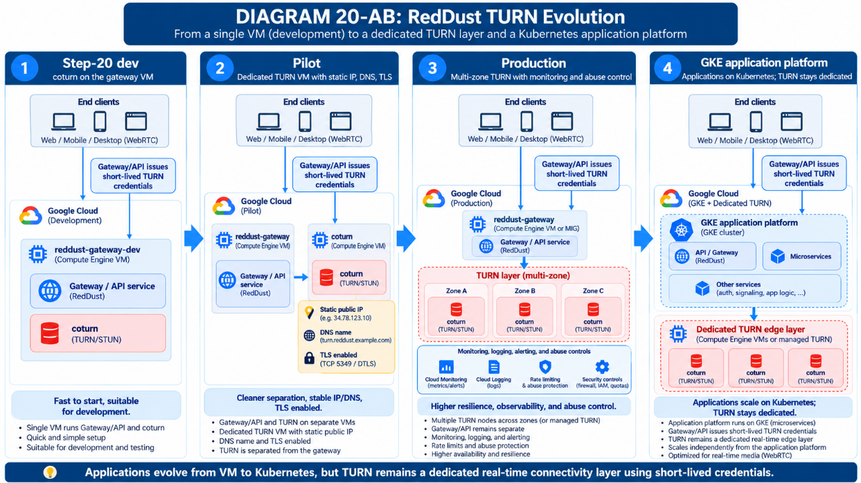
- Development: coturn colocated on reddust-gateway-dev, stable public IP, bounded relay range, REST shared-secret credentials.
- Pilot: dedicated TURN VM(s), dedicated static IP/DNS, TLS fallback, central secrets, logging/monitoring, quotas and abuse controls.
- Scale: multiple geographically placed TURN endpoints or a managed TURN provider; select nearby servers and monitor relay ratio/cost.
- Kubernetes era: application microservices move to GKE, while TURN remains an explicitly designed real-time edge service rather than being casually placed behind the same HTTP ingress path.

20.32.20 — TURN/coturn completion checklist
☐Stable external IPv4 assigned and verified.
☐TURN DNS A record resolves to the stable IPv4.
☐coturn installed from the Ubuntu package and managed by systemd.
☐GCP firewall permits only required TURN listener and bounded relay ports.
☐coturn external-ip public/private mapping matches the VM.
☐Anonymous TURN is not enabled.
☐Strong shared secret is protected server-side.
☐Gateway generates expiring TURN REST credentials for authenticated users.
☐React Native and aiortc both receive correct ICE-server configuration.
☐Authenticated allocation succeeds; unauthenticated allocation is rejected.
☐Normal Wi-Fi call succeeds.
☐4G/5G call succeeds.
☐Forced-relay call succeeds and statistics prove relay candidate selection.
☐TURN/TCP tested.
☐TURN/TLS 5349 configured and tested before pilot use.
☐Logs/monitoring do not expose secrets.
☐Documentation records exact final ports, DNS, IP mapping and acceptance evidence.

20.32.21 — Final Step-20 networking architecture after TURN
At the end of this section, RedDust has two independent Internet paths for WebRTC media: direct ICE where possible and authenticated TURN relay where necessary. FastAPI remains the signalling/control plane; aiortc remains the Python WebRTC peer; coturn is the relay edge. Human VM access remains governed by IAM/OS Login, while the runtime and future secret-management path remain separate from human identities.
DIAGRAM — 20-BD: Final Step-20 Gateway + TURN Architecture
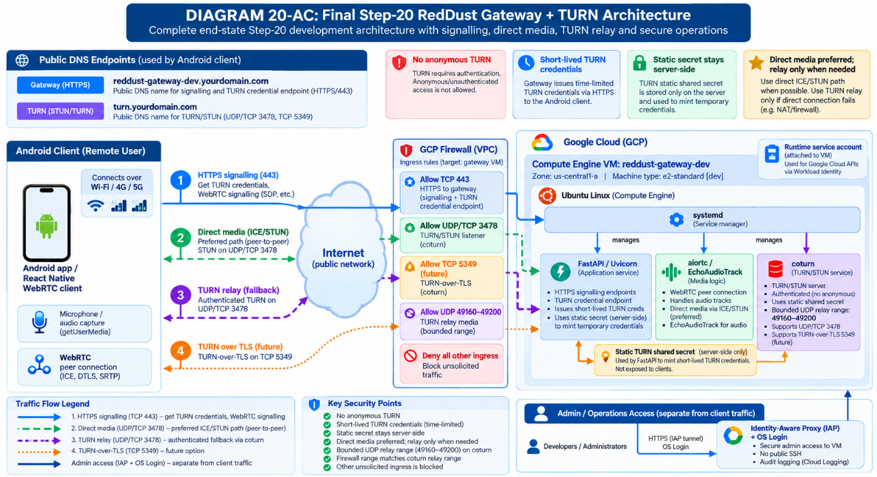

Technical references for this section
- coturn project configuration and turnserver documentation — GitHub: coturn/coturn (turnserver.conf examples and turnserver manual).
- Google Cloud documentation — VPC firewall rules and gcloud compute firewall-rules create/update.
- IETF TURN/STUN/ICE specifications should be treated as protocol authority; coturn configuration and deployed package version remain the operational source for supported options.

20.33 — Provision RedDust Dev Cloud SQL PostgreSQL Infrastructure
SCOPE OF THIS STEP: Provision and inspect one billable, long-running Cloud SQL for PostgreSQL Enterprise instance and its empty application database in the existing reddust-development project. Do not integrate FastAPI, deploy a microservice, create application tables, or perform restore/HA experiments here.
This section extends the Step-20 Google Cloud Gateway environment with a separately managed relational database foundation. The Android/WebRTC client, FastAPI/aiortc Gateway, coturn and Ubuntu VM remain unchanged. PostgreSQL runs as a Google-managed Cloud SQL service, not inside reddust-gateway-dev. The goal is a correctly named, privately addressed, observable database resource whose cost and maintenance settings the team can understand before any application connects.
This is a new infrastructure boundary: A Cloud SQL instance is a managed database server resource; a database (reddust_dev) is a logical named database inside it. Compute Engine OS Login users and the Linux reddust account are not PostgreSQL identities. Cloud IAM governs instance administration; PostgreSQL roles govern SQL data access once introduced later.
Provisioning decision: NORMAL paid-by-credits Cloud SQL in reddust-development. Do NOT select a 30-day promotional Cloud SQL trial/sandbox and do NOT create another GCP project. Promotional Google Cloud credits can offset eligible charges while available; credits are neither an unlimited free tier nor a guaranteed stop mechanism.

20.33.1 — RedDust target configuration and precise completion boundary
DIAGRAM — 20-BE: Gateway VM and Managed PostgreSQL: Separate Compute Boundaries
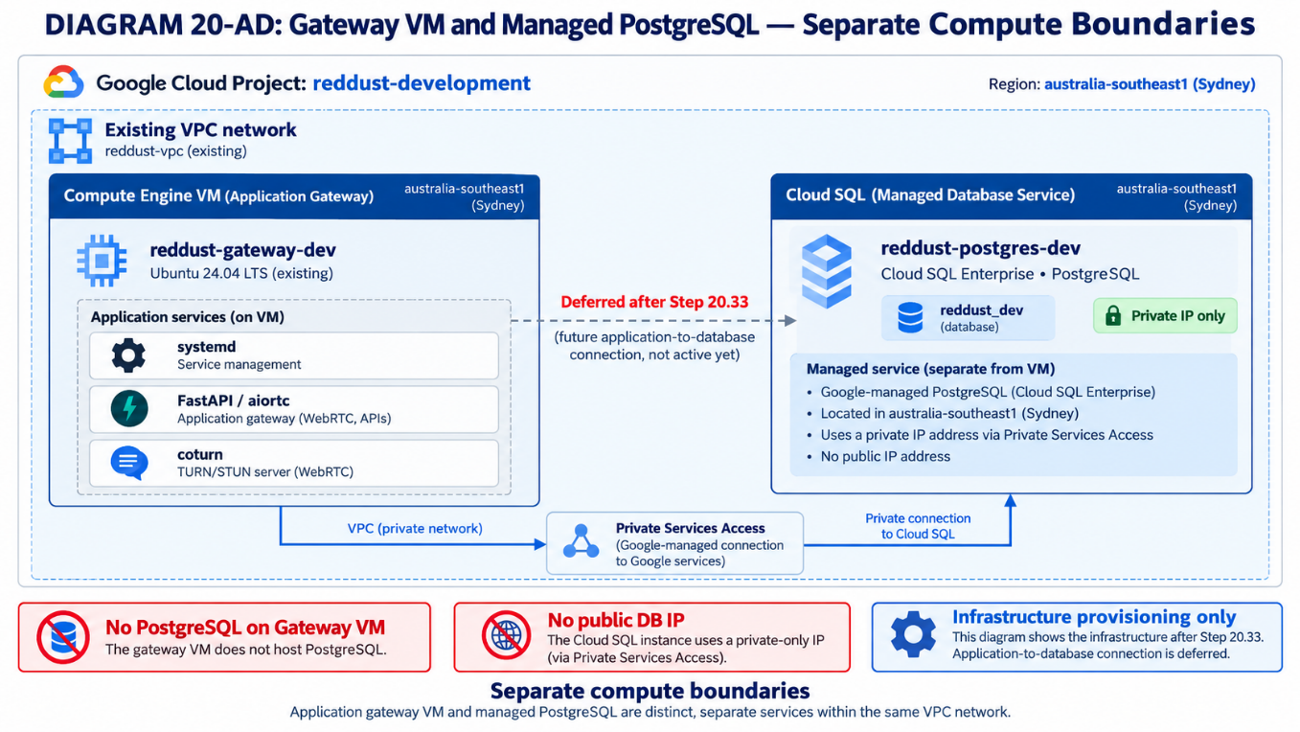
Configuration | RedDust value | Rationale / validation
Project | reddust-development | Existing development project; verify selector before every action
Managed service | Cloud SQL for PostgreSQL | Native GCP service, not Marketplace VM image
Edition | Cloud SQL Enterprise (not Enterprise Plus) | Lower-complexity development tier
Instance ID | reddust-postgres-dev | Unique project-wide managed-instance name
Database name | reddust_dev | Logical application database, created after instance exists
Region | australia-southeast1 — Sydney | Same region as Gateway VM
Availability | Zonal / single-zone | No HA replica at this stage
Machine | Smallest compatible Enterprise option that satisfies UI constraints | Compare shared-core versus dedicated-core; record precise tier and price
Storage | SSD, smallest supported practical size (typically 10 GiB where offered) | Verify editable default; do not assume UI permits every size
Connection | Private IP; Private Services Access on the existing Gateway VPC | No internet-reachable database public IP
Encryption | Google-managed encryption at rest | CMEK is deferred
Identity | Administrative Google IAM plus built-in postgres administration only | Do not create application database users yet
Backups | Inspect default standard backup and PITR options; record explicit choice | No restore experiment now
Observability | Instance overview, operations, monitoring, billing | Inspect metrics without app workloads
IaC | Console first; Terraform later | Capture configuration inventory for migration
STOP CONDITION: If your existing Gateway VM uses a VPC different from the one selected for Cloud SQL, do not proceed to create. Network alignment must be resolved first; region alone does not establish private reachability.

20.33.2 — Concepts: instance, database, edition, region, network and identity
Managed database: Google runs the underlying database service and infrastructure. Anodiam still owns data, configurations, access policies, schema changes, budgets and recovery decisions.
Instance versus database: reddust-postgres-dev is the provisioned PostgreSQL server; reddust_dev is a named logical database inside that instance.
Enterprise versus Enterprise Plus: Cloud SQL edition defines eligible features and price class. Select Enterprise explicitly rather than inheriting defaults for newer PostgreSQL versions.
Zonal versus regional availability: Single-zone runs in one zone; regional HA uses a standby/failover architecture and costs more. HA is intentionally postponed.
Private IP and PSA: Cloud SQL private services access joins the chosen VPC to Google-managed producer networking via a reserved internal range. The range must not overlap other networks.
Database IAM versus PostgreSQL roles: Google IAM grants cloud control-plane permissions. PostgreSQL users/roles control SQL authentication and privileges. Neither is the same as OS Login.
Maintenance versus backup: Maintenance patches and updates database software; backup provides recoverability. One does not replace the other.
Stopping versus deleting: Cloud SQL can support instance stop/start operations in some configurations, but storage/backups and other charges may continue; deletion is destructive. Do not plan cost control on an assumption that it becomes free when stopped.

20.33.3 — Owner pre-flight: billing, credit, IAM and APIs (console-only execution)
- Sign in as the authorized RedDust project Owner or a specifically authorized Cloud SQL infrastructure administrator; use a separate browser profile from ordinary developer sessions.
- Open https://console.cloud.google.com/ and verify project selector shows reddust-development. Open IAM & Admin → Settings or Dashboard; record project ID and billing association.
- Go to Billing → Overview and Credits (or equivalent Billing account screens). Record remaining applicable trial credits, remaining eligibility period and whether the billing account is trial or fully paid. Do not assume credit availability based on the project itself.
- Open Billing → Budgets & alerts. Reuse the existing Step-20 development budget; confirm Cloud SQL service charges are included. Configure project-scoped service budget alerts if desired. Budget alerts notify; they do not shut down Cloud SQL.
- Navigate to APIs & Services → Library. Enable Cloud SQL Admin API (sqladmin.googleapis.com). Private IP setup also requires Service Networking API (servicenetworking.googleapis.com) and appropriate Compute Engine/VPC APIs. Enable only when prompted/needed. An API being enabled is not proof that networking is configured.
- Verify that the provisioning identity can create Cloud SQL instances and configure the chosen VPC private service connection. The Cloud SQL Admin role (roles/cloudsql.admin) supports Cloud SQL administration; establishing PSA requires separate network privileges, typically appropriate Compute/network and Service Networking permissions. Use the Owner during this initial step rather than broadening developer IAM.
- In Compute Engine → VM instances → reddust-gateway-dev → Networking, record actual VPC network and subnet; record zone australia-southeast1-b if unchanged. Cloud SQL must be attached to this actual VPC, not automatically to “default” if the Gateway uses another network.
IAM design: Existing Compute Viewer or VM-scoped OS Admin Login does NOT imply authorization to create, administer or read the contents of Cloud SQL. Do not give all RedDust developers roles/cloudsql.admin or Editor just to observe this phase. Grant database viewer roles later only to intended reviewers.

20.33.4 — Estimate ongoing costs BEFORE provisioning
Cloud SQL is principally provisioned-capacity billing: instance compute, allocated disk, backups/PITR logs, network egress and optional services. An empty database can still incur nearly the same base server and storage charge as a lightly used database. Sydney prices, available tiers, taxes, currency and discounts can change; use the current official pricing page or Pricing Calculator as the source of truth on the day of creation.
Cost component | Driver | Cost control / note
Database CPU + memory | Selected Enterprise machine tier × running hours | Largest base driver; inspect exact tier/hour in console or calculator
Allocated SSD/HDD | Provisioned GiB × storage rate × time | Allocated capacity, not only SQL data stored
Backups | Stored backup GiB × backup tier/rate × retention | Standard vs enhanced pricing and retention differ
PITR / WAL logs | Transaction logs / retention / storage class where applicable | Inspect billing SKU and backup configuration; do not assume zero
Regional HA | Regional instance resources and HA storage | Not enabled in Step 20.33
Network egress | Bytes × route / destination rate | Same-region GCP paths may differ from internet or cross-region
Private networking | PSA network configuration / relevant service SKUs | Check current cost of ancillary connectivity, DNS, egress
Operations/logging/monitoring | Usage beyond service free allowances | Review retention and billable data volumes
CMEK / KMS | Key storage and cryptographic operations | Deferred; Google-managed at-rest encryption initially
Extended database support | Version lifecycle / support status | Pick supported PostgreSQL version, avoid extended-support fees
Planning formula (USD): Estimated monthly gross ≈ machine hourly rate × running hours + provisioned GiB × storage unit rate × hours + backup/transaction-log charges + network egress + other enabled services. Estimated out-of-pocket ≈ gross - eligible credits applied; never subtract credits to compute the actual resource consumption.
Example only — NOT a Sydney quote:
730 hours/month × $0.0105/hour = $7.67 compute
PLUS Sydney storage + backup/PITR + network + other SKU charges.
This example uses a published shared-core reference rate; your Sydney tier,
storage and final total MUST be verified in the live calculator.
- Open https://cloud.google.com/products/calculator (Google Cloud Pricing Calculator). Search for Cloud SQL, select PostgreSQL, region Sydney (australia-southeast1), Enterprise, zonal, the actual eligible machine tier and 730 hours/month for continuous use.
- Enter exact disk type/capacity, backup estimate and any extra applicable line items. Repeat with a slightly larger tier to see incremental cost. Record full MONTHLY gross estimate and estimate URL/screenshot, with the date and currency.
- Return to the Cloud SQL Create instance page and check any live estimated cost/summary before the final Create action. If no cost is shown, rely on the calculator and official pricing table; never treat missing UI estimate as zero.
- Open Billing → Reports, group by Service and SKU after creation. Check daily during the first week; budgets are notifications, not hard caps.
BUDGET GATE: Do not click Create until an authorized owner records machine tier, provisioned disk, regional monthly gross estimate, projected 90-day cost, remaining promotional credit and a monthly spending threshold.
DIAGRAM — 20-BF: Cloud SQL Cost Stack and $300 Credit Drawdown
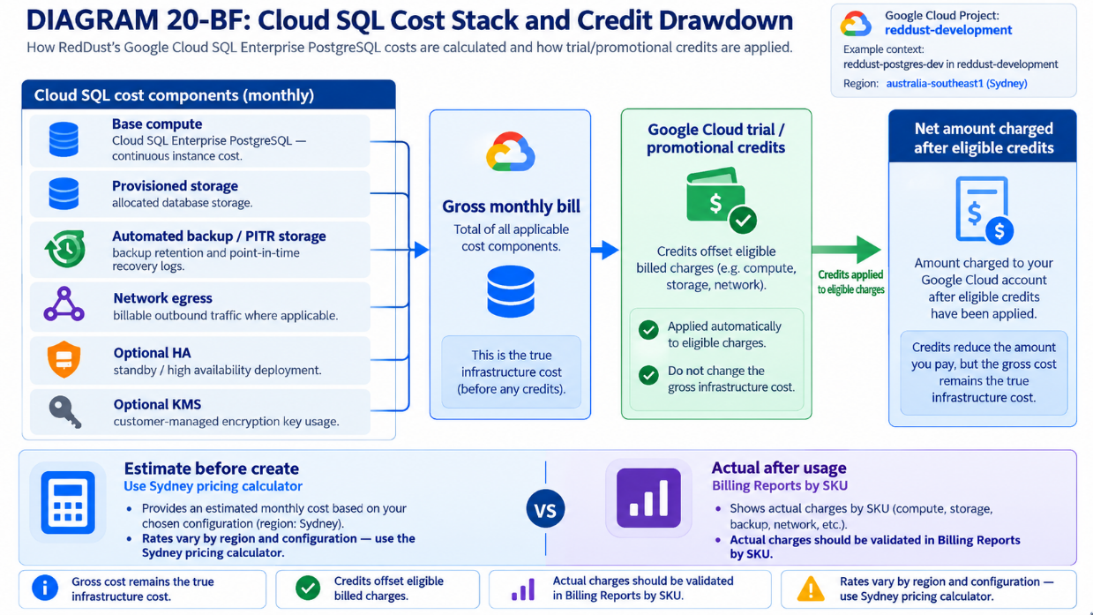

20.33.5 — Create or verify Private Services Access before Cloud SQL creation
This is the most easily overlooked prerequisite. Cloud SQL is managed outside the guest VM. Choosing Private IP requires a producer/private-service network allocation and connection for the selected consumer VPC. Allocate sufficient NON-OVERLAPPING RFC1918 addresses for current and future managed services. A /24 is the documented minimum block; plan capacity rather than taking random addresses. Google notes /16 as an ample general recommendation, but a smaller planned range may be appropriate for limited development when verified against all existing VPC/subnet/IP allocations.
- Open VPC network → VPC networks, select the exact VPC recorded from reddust-gateway-dev. Inspect existing subnet CIDRs, secondary ranges and peering. Record a proposed service range free of collisions.
- Open VPC network → Private service connection or Private services access (label varies). Locate allocated internal ranges for services and existing Service Networking connections. If an eligible allocated range and connection already exist, reuse them; do not create duplicates.
- If not set up, choose Allocate IP range / Allocate a new range. Prefer a documented, approved unused RFC1918 range, name e.g. reddust-managed-services-dev; use the console-provided automatic allocation if IP planning is not yet reliable and record the exact assigned range.
- Create the private connection to servicenetworking.googleapis.com, selecting the reserved range. Confirm the operation succeeds. Depending on UI, the Cloud SQL instance wizard can offer a “Set up connection” flow leading to the same PSA prerequisite.
- Verify the VPC name, reserved range and Service Networking connection; note the producer network allocation is NOT a host firewall rule or public address. It does not by itself authorize PostgreSQL users.
Do not expose port 5432 to the public Internet. For this private-only Cloud SQL deployment there is no need to create a public-ingress VPC firewall rule for PostgreSQL or grant broad 0.0.0.0/0 authorized networks.
DIAGRAM — 20-BG: Private Services Access: VPC to Managed Cloud SQL
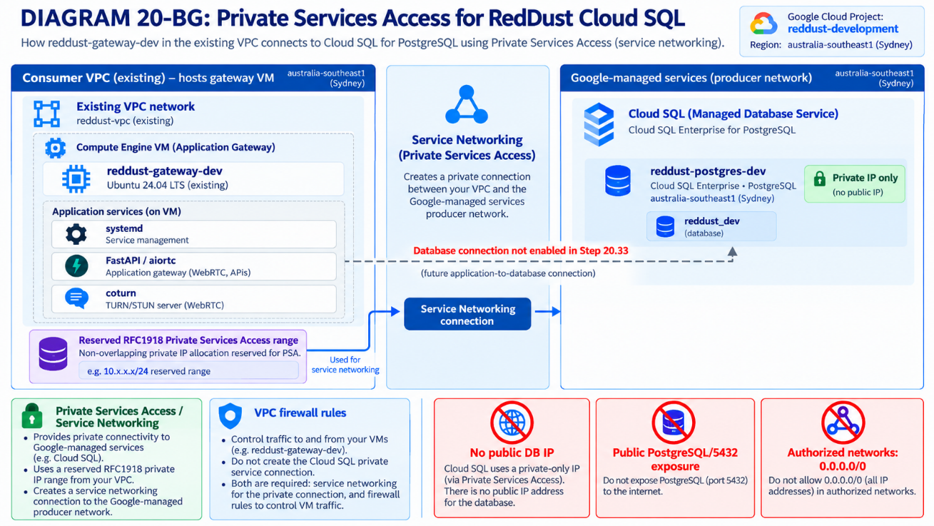

20.33.6 — Console procedure: create the PostgreSQL Enterprise instance
- Navigate to https://console.cloud.google.com/sql/instances and verify reddust-development is selected. Click CREATE INSTANCE; choose PostgreSQL (not MySQL or SQL Server).
- Choose a NORMAL Cloud SQL instance rather than 30-day free trial/sandbox. If the console presents templates or edition cards, explicitly select Cloud SQL Enterprise, not Enterprise Plus.
- Set Instance ID to reddust-postgres-dev. Enter a strong temporary administrative password for built-in postgres only if requested. Keep this secret in an approved password manager; do not include it in Word, screenshots, source code, Cloud Shell history or chat. Avoid creating a Secret Manager secret as part of this infrastructure-only step unless explicitly authorized later.
- Select a current, fully supported PostgreSQL major version (for example PostgreSQL 17 if offered and compatible with Cloud SQL Enterprise). Record the exact version shown; avoid extended support and do not let the version implicitly switch editions. No application-specific version compatibility is being asserted yet.
- Region: australia-southeast1 (Sydney). Availability: Single zone / Zonal; select australia-southeast1-b only if offered and desired for symmetry. Placement in the same zone as the VM is not necessary for private networking.
- Customize your instance → Machine configuration: select the smallest available Enterprise configuration that meets constraints and cost approval. For learning/empty infrastructure, consider db-f1-micro if offered under Enterprise; compare db-g1-small or small dedicated core where required. Shared-core has limitations and does not receive the Cloud SQL SLA; do not call it production-grade.
- Storage: select SSD initially where affordable, then smallest supported practical provisioned capacity (commonly 10 GiB where offered). Review automatic storage increases explicitly: enabling reduces risk of storage exhaustion but can permanently raise allocated storage and costs. Set sensible monitoring/limits if UI offers them.
- Connections → deselect Public IP and select Private IP → Private Services Access (PSA). Choose the SAME VPC as reddust-gateway-dev and the preconfigured PSA range/connection. Do not enable Public IP as a troubleshooting shortcut. Do not configure authorized public networks.
- Private Service Connect (PSC) is an alternative architecture; do not activate it in parallel without a design reason. If wizard requires PSC or presents a network mismatch, stop and review the GCP documentation instead of improvising connectivity.
- Security: retain Google-managed encryption at rest and the default server CA configuration. Do not enable customer-managed KMS keys in this phase. Review any Data API option and leave it DISABLED unless explicitly required; the Data API can create an additional SQL access surface independent of private IP.
- Data protection: review Standard backups and automated backup configuration (console normally enables automated backups by default). Review point-in-time recovery, which may be enabled by default for Enterprise in the console. Record whether both are on; choose cost and recoverability deliberately. Do not configure restore tests now.
- Maintenance: select an off-hours one-hour maintenance window suitable for the team; review timing option, for example Week 2 if offered. Record the time zone as rendered in console. Do not set an indefinite maintenance block; critical maintenance cannot be skipped forever.
- Labels: add environment=dev, application=reddust, component=postgresql, managed-by=console, cost-center=reddust-development (adjust label constraints). These aid Billing reports and later Terraform inventory.
- Review the final configuration for project, edition, DB version, zone, machine, cost, storage, private networking, Public IP=off, backup/PITR and maintenance. Obtain explicit owner sign-off before clicking CREATE INSTANCE. Expect creation to take several minutes.
FINAL CREATE GATE: Project reddust-development; PostgreSQL; Enterprise; reddust-postgres-dev; Sydney; single-zone; approved small machine; private IP+PSA; no public IP; Google-managed encryption; budget and cost recorded. If any differs, stop and correct BEFORE clicking Create.

20.33.7 — Create logical reddust_dev database; no application users or schema
- Once instance status is RUNNABLE (or the console shows a green ready state), click reddust-postgres-dev → Databases. Note that a PostgreSQL instance may already contain administrative/default databases such as postgres; do not delete these.
- Click CREATE DATABASE. Database name: reddust_dev. If encoding/collation options appear, leave supported defaults unless you have a documented application-specific requirement; document choices before selecting non-defaults.
- Click CREATE, wait for completion and verify reddust_dev appears in the Databases list. No tables, extensions, seed data, migration files or app schema are created here.
- Open Users and inspect built-in administrator entry without exposing passwords. Do NOT create a Gateway login or app service role; dedicated least-privilege database users are a later integration task.
The instance is not the application database: verify both resource names independently: Cloud SQL instance = reddust-postgres-dev; logical database = reddust_dev.

20.33.8 — Inspect instance infrastructure, patching and maintenance without touching applications
- Open Cloud SQL → Instances → reddust-postgres-dev → Overview. Record State, edition, version, connection name, private IP, region, zone, memory/CPU tier, storage, CPU chart and instance creation date.
- Open Configuration / Edit (read-only review; do not save inadvertent changes). Verify machine, storage autoscaling, networking, maintenance window, labels, backup and PITR settings.
- Open Maintenance. Record selected window, maintenance timing, current version, pending update if displayed, and historical events. Read schedule notices; the managed service performs maintenance, but a zonal instance can undergo a short interruption.
- Open Operations / Activity and inspect instance creation operation completion and any automatically scheduled background work. Do not interpret a blank operations list as a fault.
- Open Monitoring → Cloud SQL metrics (or instance Monitoring tab). Inspect CPU utilization, memory, disk used, bytes received/sent, open connections, restarts/availability metrics where exposed. At this stage no user workload means near-idle metrics are normal.
- Open Logs Explorer with resource type Cloud SQL Database (or cloudsql_database). Review administrative/operational records when present. Logging and SQL audit scope vary; do not assume every SQL query is automatically captured.
- Open Data protection / Backups for configuration and next scheduled backup. You may inspect status without creating an on-demand backup. Do not initiate restore, PITR or failover in Step 20.33.
- Navigate Billing → Reports → filter project reddust-development / service Cloud SQL; after billing data becomes available, compare billed SKUs with the estimate. Charges can lag behind provisioning.
Cloud SQL managed function | Google provides / operates | Anodiam still decides / verifies
Hosts / VM, OS, database engine | Underlying managed compute, storage and service lifecycle | Tier, region, edition, version support and cost
OS and engine patching | Maintenance rollout and platform updates | Schedule, notice review, client tolerance and version compatibility
Storage lifecycle | Provisioned storage, optional automatic increase | Initial capacity, alerts and cost consequences
At-rest encryption | Default managed encryption | Whether CMEK needed later and IAM controls
Private connectivity | Managed IP endpoint and PSA/PSC integration options | VPC address planning, select Private IP, connectivity design
Backups | Automated backup mechanisms when configured | Enablement, retention, cost, restore exercises and recovery objectives
PITR | WAL/point-in-time capability where enabled | Log retention, costs, recovery plan, test later
HA/failover | Regional standby and failover when purchased | Enablement decision, expense and acceptance testing later
Monitoring / logs | Managed telemetry, operations and audit surfaces | Alerts, review ownership, budget alerts and incident response
Access | Google IAM and PostgreSQL authentication capabilities | Least privilege, ownership, account lifecycle, password policies

DIAGRAM — 20-BH: Shared Responsibility: Google Cloud vs Anodiam
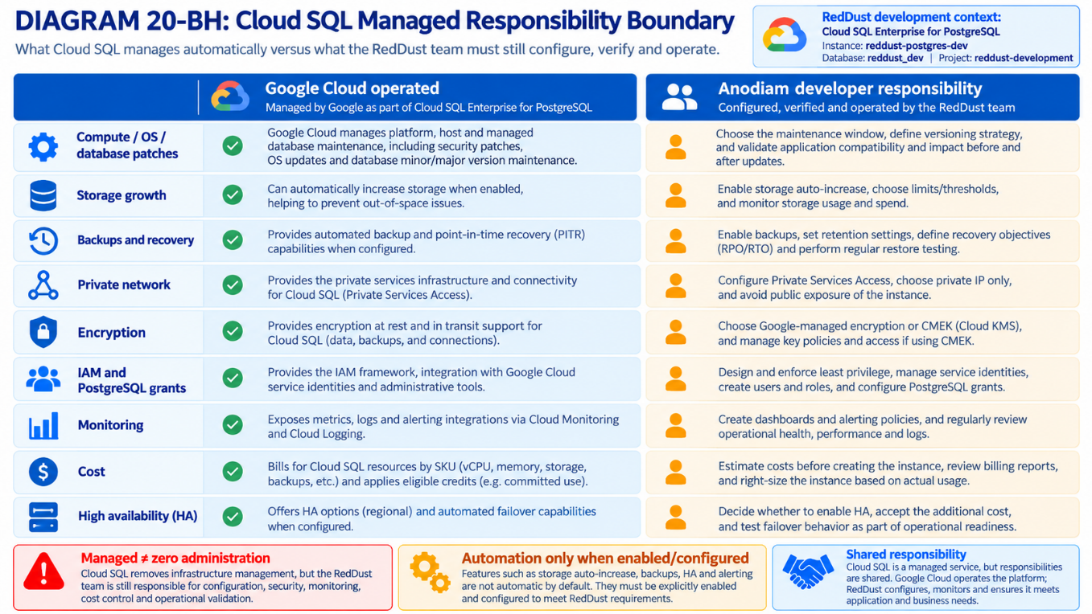

20.33.9 — Maintenance/patching deep dive: what happens automatically, what we schedule
Cloud SQL routinely handles platform updates, including supported database software updates. Some work occurs online; some scheduled maintenance causes brief interruption or restarts. Google offers a one-hour maintenance window and rollout timing selections. Anodiam does not sudo into Cloud SQL hosts, install apt upgrades, run systemctl on Cloud SQL or manually patch underlying operating system.
- Week options such as Any, Week 1, Week 2 or Week 5 may be displayed; availability and labels vary. A later rollout week allows a planned review window, not permanent avoidance.
- A deny-maintenance period is temporary and should be reserved for genuine high-risk events; it must not be chained to avoid security patches. Critical/out-of-policy releases can supersede normal scheduling expectations.
- Maintenance windows are service scheduling preferences, not guarantees of zero downtime. A single-zone development instance is expected to tolerate short restarts and to remain disconnected from the production serving path.
- A PostgreSQL major-version upgrade is a separate compatibility and migration decision; do not assume routine minor patching implies seamless major-version upgrade.
Recommended Step-20 setting: Set a low-traffic one-hour window and record the exact console timezone, with maintenance timing Week 2 when available. Do not trigger maintenance manually merely to test it today.
DIAGRAM — 20-BI: Backups, PITR and HA: Different Failure Scenarios
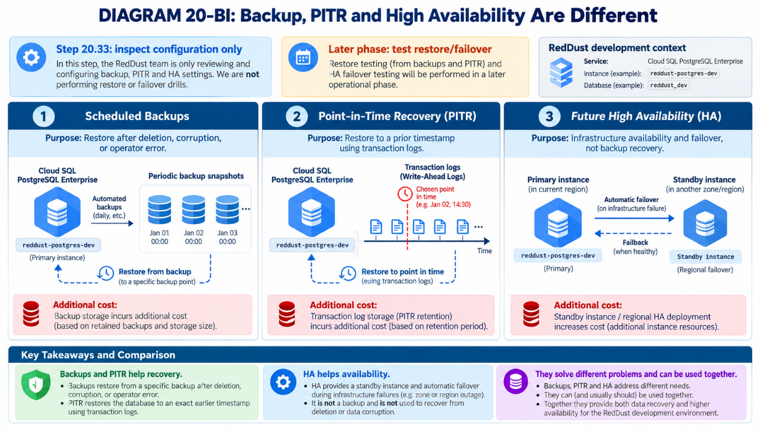

20.33.10 — Backups & high availability: infrastructure visibility (exercises later)
Backups address logical deletion and other data-loss scenarios when properly retained and restored. High availability addresses service continuity across eligible infrastructure failure domains. Neither replaces the other, and both are not proven merely because a console checkbox is enabled.
Feature | What to do NOW in 20.33 | DEFERRED practical experiment
Standard automatic backups | Inspect configuration, schedule and retention; record price impact | Create backup, restore to test instance, measure recovery
PITR | Inspect whether enabled and retained transaction-log interval | Recover to a chosen timestamp after controlled mutation
Regional HA | Leave disabled; record availability mode = ZONAL | Cost comparison, enable HA, deliberate failover test
Read replicas | Do not create | Replica lag, read routing and cross-region economics
Enhanced backup/Backup and DR | Do not enable unless chosen after pricing review | Backup vault governance, retention and restore drills
CMEK | Use Google-managed encryption | KMS keys, rotation, lockout risk and charges
Avoid treating “Backup enabled” as “Recovery proven”. Later acceptance must demonstrate successful restore, owner permissions, data integrity and actual recovery-time/recovery-point objectives.

20.33.11 — Security baseline and explicit non-goals
- Do not assign a public IPv4 address to Cloud SQL; do not open PostgreSQL TCP 5432 to all addresses.
- Leave Cloud SQL Data API disabled for now; private-only deployment does not imply every potential API access path is disabled.
- Use Google-managed at-rest encryption and managed TLS/server CA defaults. A future application client must separately validate database connection security.
- Do not create broad application database users, grant superuser-equivalent privileges, download credentials to developer laptops, or put database passwords into source/Word files.
- Do not bind the existing reddust-gateway-dev-runtime service account to Cloud SQL just because it exists. Later grant least-privilege Cloud SQL permissions only if the chosen connection/authentication architecture needs them.
- No direct phone-to-database connection. The future Android app talks only to authenticated APIs; microservices own data-access boundaries.
- Do not install PostgreSQL server packages on Ubuntu or alter FastAPI requirements.txt, .venv, WebRTC ICE, systemd Gateway or coturn configuration in this step.

20.33.12 — Acceptance checklist and evidence inventory
☐ Project verified as reddust-development; approved billing account and applicable credits checked.
☐ Cost estimate recorded with Sydney region, machine tier, monthly gross and 90-day projection.
☐ Cloud SQL Admin API and Service Networking prerequisites enabled and verified.
☐ Gateway VPC documented; PSA allocation and private service connection verified.
☐ Instance reddust-postgres-dev exists, status healthy/ready, Enterprise and supported PostgreSQL version recorded.
☐ Region australia-southeast1; zonal/single-zone deployment; specific zone recorded.
☐ Chosen small machine, SSD type/capacity and storage autoscaling setting documented.
☐ Private IP configured; Public IP disabled; no public authorized networks or 5432 ingress rule.
☐ Google-managed encryption selected and Data API status reviewed.
☐ Logical database reddust_dev created; no application tables or application users.
☐ Standard backup and PITR settings inspected; retention and cost implications noted.
☐ Maintenance window and patch/update strategy inspected; no manual patch run performed.
☐ Operations, monitoring, logs and actual Billing report reviewed when data available.
☐ No FastAPI/microservice integration, HA failover test, restore test, Vault/JWT configuration or Terraform apply executed.
Infrastructure record | Value / evidence to fill after console work
Execution date / operator | ________________________________________
Project / billing credit snapshot | ________________________________________
GCP console instance resource URL | ________________________________________
PostgreSQL version / edition | ________________________________________
Machine tier / memory / vCPU | ________________________________________
Zone / VPC network | ________________________________________
PSA allocated range / private IP | ________________________________________
Storage capacity / auto-growth | ________________________________________
Backup tier / backup schedule / PITR | ________________________________________
Maintenance timing / timezone | ________________________________________
Monthly gross estimate / source URL | ________________________________________
Actual billed SKU review date | ________________________________________
RedDust reviewer approval | ________________________________________

20.33.13 — Troubleshooting by layer (non-destructive)
Symptom | Most likely check | Safe resolution / stop boundary
Create button unavailable | Correct project, billing, Cloud SQL API, IAM | Enable appropriate API or ask project Owner; do not grant Editor broadly
Enterprise Plus selected unexpectedly | Edition default linked to PostgreSQL version/template | Explicitly change to Enterprise; revalidate price
Private network selection empty | Gateway VPC identification, PSA prerequisite | Return to VPC / Private service connection setup
SERVICE_NETWORKING_NOT_ENABLED | Service Networking API missing | Enable approved API; retry only after confirmation
NETWORK_NOT_PEERED or range conflict | PSA connection / overlap / allocation | Fix producer connection; no random CIDR choices
Cannot choose small machine | Version/edition/region / tier constraints | Compare supported Enterprise alternatives and re-price
Public IP appears on review | Connection selection default | Disable before Create; do not trust private-only assumption
Backup charges higher than estimate | Retention, PITR WAL, backup volume | Compare Billing SKU and configured retention
Maintenance window unexpected | Timezone or chosen timing misread | Inspect Maintenance details; do not trigger manual update
Metrics near zero | No application traffic in this phase | Normal; record baseline idle state
Unexpected daily costs | Always-on compute and provisioned disk | Review SKU-level Billing and budget immediately

20.33.14 — Future architectural handoff: how RedDust evolves AFTER Step 20.33
At completion, RedDust possesses a managed relational persistence service that is independent of its WebRTC Gateway and independent of the eventual GKE microservice deployment. Only the infrastructure and an empty logical database exist. This deliberately leaves the development team free to design domain schemas, service boundaries and secure database connectivity later without coupling them prematurely to the current VM.
- Later phase — application integration: define microservice ownership, API contracts and schema boundaries; provision least-privilege PostgreSQL roles; evaluate IAM database authentication and Cloud SQL connectors; connect FastAPI REST services by private network without exposing database credentials or the database publicly.
- Later phase — data lifecycle: add migrations (e.g. Alembic), schema versioning, test fixtures, connection pooling, transactions, and migrations in CI/CD and database observability. Adopt separate databases/schemas or ownership boundaries deliberately rather than giving every microservice unrestricted access.
- Later phase — security research: compare Secret Manager and HashiCorp Vault, service identities/Workload Identity, dynamic database credentials with TTL/leases, key rotation, TLS, Google IAM auth, and JWTs for API authorization. JWT access tokens are not PostgreSQL passwords by default; each layer requires a distinct threat model.
- Later phase — resilience experiments: enable and test backup restore, PITR, deletion recovery, multi-zone/regional HA and failover; record costs, RTO/RPO, monitoring and alert routing before pilots.
- Later phase — Terraform and Kubernetes: codify Cloud SQL, PSA, IAM, networks, backups, maintenance and outputs in Terraform; adopt secured remote state and import existing console-created resources rather than destroying/recreating the database; move application microservices to GKE while keeping Cloud SQL managed externally.
ARCHITECTURAL BOUNDARY TO PRESERVE: Android/WebRTC ↔ FastAPI or future microservices ↔ managed PostgreSQL. The phone never accesses PostgreSQL directly. The database remains an independently administered cloud service, even when applications evolve from Compute Engine to GKE.
DIAGRAM — 20-BJ: RedDust Persistence Roadmap: Console to GKE and Terraform
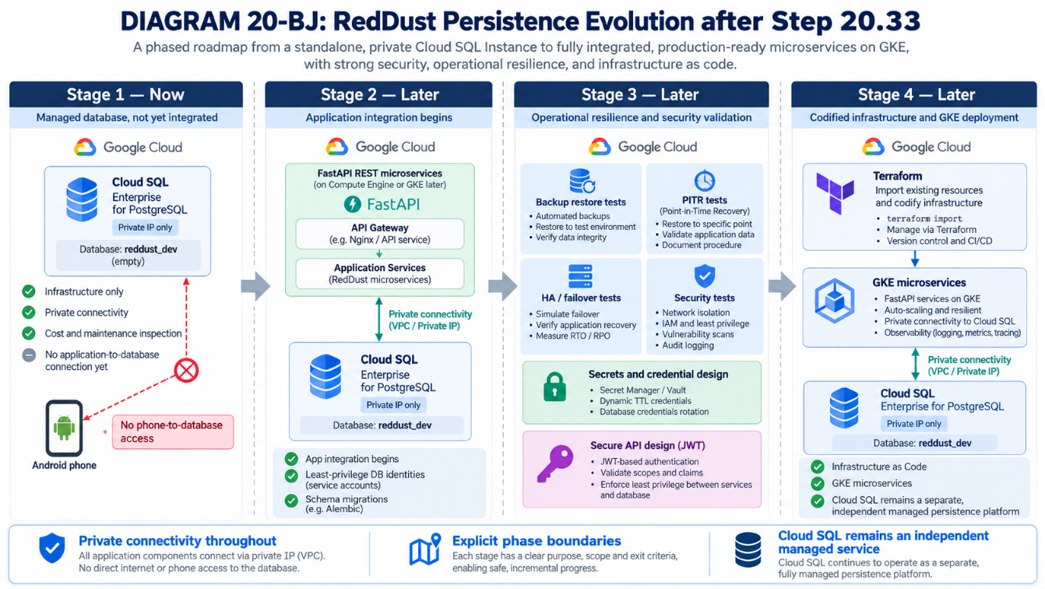

20.33.15 — Authoritative references and console links
- https://console.cloud.google.com/sql/instances
- https://docs.cloud.google.com/sql/docs/postgres/create-instance
- https://docs.cloud.google.com/sql/docs/postgres/configure-private-ip
- https://docs.cloud.google.com/sql/docs/postgres/private-ip
- https://docs.cloud.google.com/sql/docs/postgres/maintenance
- https://docs.cloud.google.com/sql/docs/postgres/instance-settings
- https://docs.cloud.google.com/sql/docs/postgres/backup-recovery/backups
- https://docs.cloud.google.com/sql/docs/postgres/backup-recovery/configure-pitr
- https://cloud.google.com/sql/pricing
- https://cloud.google.com/products/calculator
- https://cloud.google.com/free/docs/free-cloud-features
Reference note: Verified against Google Cloud documentation available in October 2026. Console labels, editions, supported versions, available machine tiers, prices and defaults can change. When the live console conflicts with an illustrative step, stop, verify the current official guide, and record the implemented configuration rather than guessing.

20.33.16 — Cloud SQL Scaling Model, Cost Controls & RedDust Recommendation
What this subsection does and why it matters: Distinguishes storage autoscaling, vertical compute resizing, replicas, high availability and future read-pool autoscaling. It provides console checks, cost methodology and a recommendation for reddust-postgres-dev without connecting FastAPI or creating application tables.
Setting | RedDust development target
Project / database | reddust-development / reddust_dev
Managed instance | reddust-postgres-dev
Product / edition | Cloud SQL for PostgreSQL / Enterprise
Location | australia-southeast1 (Sydney), single-zone
Connectivity | Private IP; no public database exposure
Application integration | Deferred; infrastructure inspection only

20.33.16.1 — Understand five different meanings of “scaling”
An application can scale while its database does not. In Cloud SQL, capacity growth, resilience and availability are distinct controls. Treat each separately before increasing cost.
Capability | Enterprise (target) | What happens automatically?
Primary CPU and memory | Machine tier chosen by administrator | No workload-based automatic scaling; resize manually when justified.
Disk capacity | Automatic storage increase supported | Yes, if enabled; size grows as thresholds are reached.
Storage decrease | Capacity planning / migration concern | No routine automatic scale-down; do not expect charges to fall after growth.
Read replicas | Optional separate billable instances | No automatic replica count based on traffic.
Regional HA | Optional standby in another zone | Automatic failover if HA configured; not extra write throughput.
Read pool autoscaling | Enterprise Plus only, not current edition | Read pool nodes can scale by configured CPU/connections targets.
Important distinction: Automatic failover is not autoscaling. A standby is for recovery, not a second writable primary. Similarly, creating more GKE Pods does not enlarge PostgreSQL compute capacity.
DIAGRAM — 20-BK: Five Scaling Dimensions in RedDust Cloud SQL
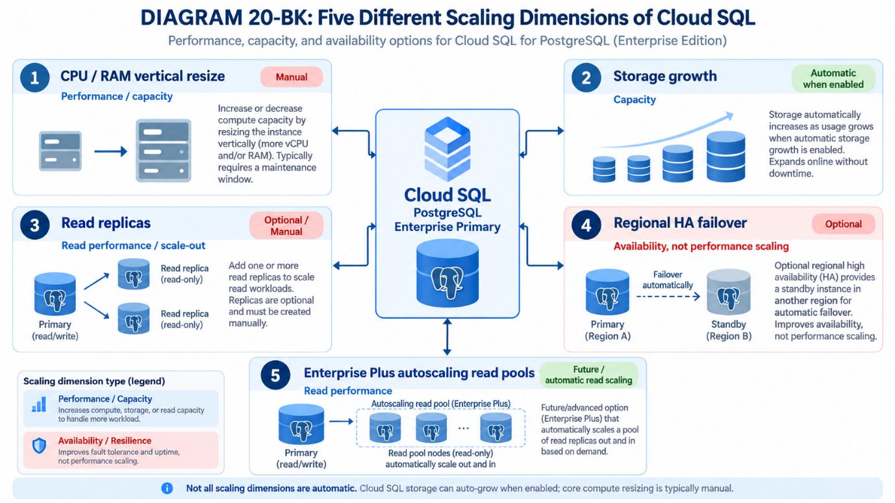

20.33.16.2 — Configure automatic storage increases in Cloud SQL console
- Open Google Cloud Console → Cloud SQL → Instances; select reddust-development and open reddust-postgres-dev. Confirm that you are editing the correct instance and that its edition is Enterprise.
- Open Overview / Configuration and inspect Storage settings. For a new instance, use the corresponding storage section of the creation wizard before clicking Create; for an existing instance, use Edit where supported.
- Select a conservative initial SSD provisioned capacity supported by the selected machine type. Record the actual console default and monthly price rather than assuming a particular minimum.
- Turn on “Enable automatic storage increases” (or the equivalent console label). Examine the optional “Automatic storage increase limit” field; enter an upper capacity ceiling appropriate to your cash budget, if supported for the chosen configuration.
- Review the resulting instance summary and estimated monthly charge, save the settings, then return to Configuration and verify the persisted capacity, automatic-growth flag and limit.
- Record a storage usage metric and set notification thresholds before the limit is approached. Never induce a disk-full condition on the long-running instance merely to prove autoscaling.
Storage safety: The growth limit is a cost guardrail, not a guarantee of continuity: if the database needs more space than the cap permits, writes/connections may fail. A sudden growth event can increase recurring charges; storage does not automatically shrink afterward.

20.33.16.3 — CPU/RAM: measure first, then resize deliberately
The Enterprise primary does not provide an autoscaling group for vCPU or memory. Choose a small, supported machine configuration now. Later, review CPU load, memory use, disk pressure, query performance and connection demand before manually changing the machine tier.
- In Cloud SQL → Instances → reddust-postgres-dev, inspect Overview, Monitoring and Configuration. Write down current machine configuration, region, storage and availability before making changes.
- Open Edit → Machine configuration (labels may vary). Compare the current tier with the next supported tier and inspect the updated cost estimate.
- Plan a maintenance window, ensure suitable recovery provisions, and understand that an instance resize can interrupt connectivity. Do not apply a resize merely as an experiment during 20.33.
- If a later workload justifies resizing, perform the authorized change, confirm READY status, inspect operation history and validate metrics after it completes.

20.33.16.4 — Monitoring and alert thresholds (beginner-friendly starting policy)
DIAGRAM — 20-BL: Capacity Monitoring and Scaling Decision Loop
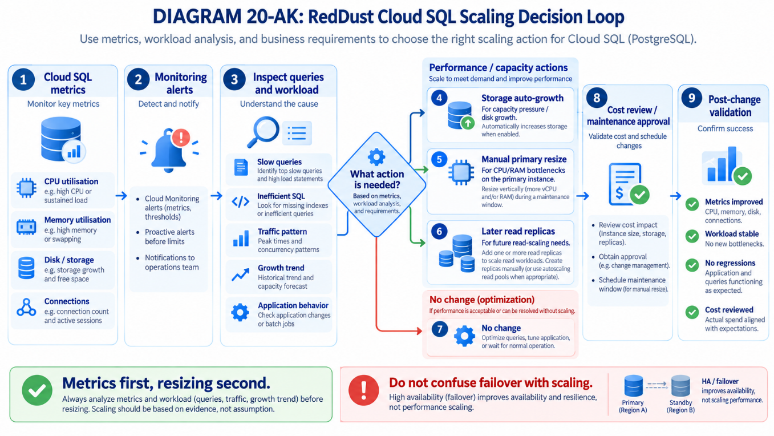
Cloud Monitoring provides the evidence for an informed scaling decision. The suggestions below are initial investigation thresholds, not universal PostgreSQL sizing rules; tune them after a representative RedDust workload exists.
Signal / starting trigger | Developer / operator response
CPU sustained >70% for 15–30 minutes | Inspect query behavior and concurrent workload; consider tier review if recurring.
Memory pressure / swap / OOM indications | Inspect active connections and workload; consider tier change only with evidence.
Disk usage >70% and >85% | Review growth rate, autoscale limit, logs and expected cost.
Connections near configured max | Investigate connection leaks / pool sizing after application integration.
Replication lag (future replica/read pool) | Check freshness requirements; read replicas are asynchronous.
Instance unavailable or unexpected restart | Inspect operations, database logs, and maintenance and incident status.
- From Monitoring → Metrics Explorer or Cloud SQL → Instance → Monitoring, select the Cloud SQL database resource and inspect CPU, memory, disk utilization and connections (where available).
- Use Monitoring → Alerting → Create policy; select the relevant Cloud SQL metric and project/instance filter. Choose a duration and a notification channel, review and save.
- Create at least one storage-capacity alert and an instance availability alert. Add CPU and connection alerts when application workload testing begins.
- Review Alerting policy charges, monitoring ingestion and retention pricing separately, because observability is not automatically unlimited or always free.

20.33.16.5 — Cost estimation: include the full database footprint
Cloud SQL capacity is billed for provisioned resources, not only executed queries. Compute/storage charges continue while the database instance remains running or provisioned under applicable billing rules. Use the official Google Cloud Pricing Calculator with Australia (Sydney), the precise edition/machine series, storage and any separately billed features.
Cost component | Estimation / control
Primary instance compute | Hourly rate × expected chargeable hours; use Sydney Enterprise tier pricing.
Provisioned storage | GB provisioned × regional GB-month price; include expected autoscale growth.
Backup / PITR / retained logs | Add the applicable backup and log storage charges based on configuration/retention.
Network and private connectivity | Check egress, region boundaries and Private Services Access or chosen network architecture charges.
Monitoring / logs | Estimate ingestion, retention and alerting as applicable.
Replica or HA later | Treat additional nodes/standby as added billable capacity, not free failover.
Promotional credits | Compare gross forecast and remaining eligible trial credits; do not assume infinite free service.
Estimated monthly gross ≈ primary compute + provisioned storage + backup/PITR
+ network + monitoring/logging + optional replicas/HA
Estimated trial-credit burn ≈ eligible billed usage − applied promotional credits
Run-rate after credits ≈ gross monthly estimate (subject to discounts/taxes)
- Open https://cloud.google.com/products/calculator and select Cloud SQL; enter PostgreSQL, Enterprise, Sydney, single-zone and the intended machine and disk values.
- Model at least two scenarios: (A) initial storage and (B) storage expanded to the proposed automatic-growth ceiling. Add backups/other chargeable features explicitly.
- Copy the calculator link or export estimate; record currency, date, exact configuration and assumptions. Console estimates are indicative and can change with pricing and resource selection.
- In Billing → Reports, filter project reddust-development and Cloud SQL. Compare gross usage, credits and net charges over time; remember there are other running RedDust services consuming the same credits.
- Set/update a Cloud Billing budget and email alerts. Budgets warn; they do not shut Cloud SQL down.
No fabricated fixed price: The document intentionally does not claim a definitive AUD/month amount: prices depend on the actual tier, capacity, current regional pricing, usage period, backups, traffic and credit eligibility. Record a live estimate immediately before saving the Cloud SQL settings.

20.33.16.6 — Enterprise versus Enterprise Plus versus AlloyDB
DIAGRAM — 20-BM: RedDust Database Scaling Evolution
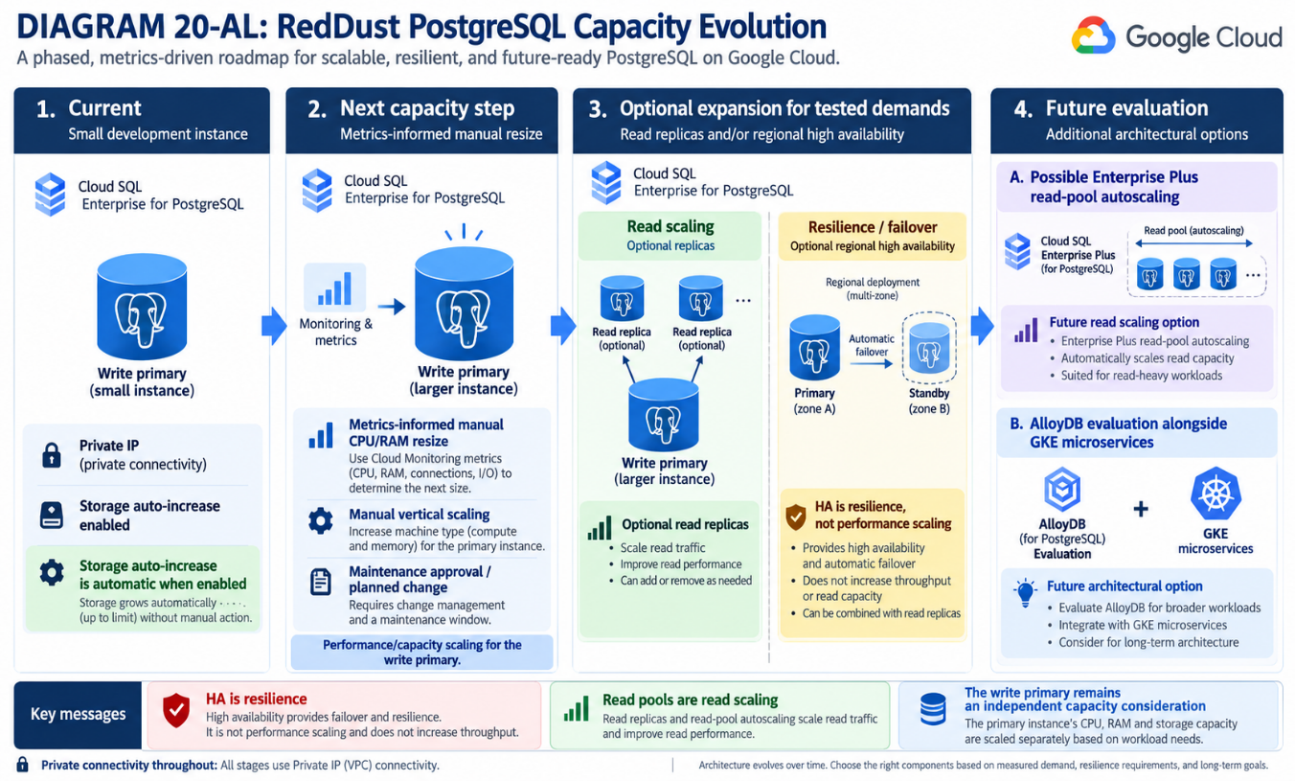
Option | Useful scaling characteristic | Decision for RedDust
Cloud SQL Enterprise | Storage autogrowth; primary compute resized manually; optional replicas/HA | Choose now for an inexpensive, simple, persistent development database.
Cloud SQL Enterprise Plus | Read pools with node-count autoscaling using average CPU and/or connection targets; primary still not an elastic automatically resizing write node | Evaluate later for sustained read-heavy workloads; additional fees and complexity.
AlloyDB for PostgreSQL | Different managed PostgreSQL-compatible architecture; scaling behavior depends on chosen instance/read-pool configuration | Only benchmark after workload, performance targets and cost budget exist.
Enterprise Plus read-pool autoscaling requires eligible Enterprise Plus primary and read-pool architecture; setting minimum/maximum node count and CPU/connections targets is a future operation. It is not a checkbox that makes an existing Enterprise primary autoscale its RAM.

20.33.16.7 — Final Step-20.33 decision and explicit stopping point
- KEEP: reddust-development → reddust-postgres-dev → PostgreSQL Enterprise → Sydney → single-zone → private connectivity.
- ENABLE/VERIFY: automatic storage increases with a recorded ceiling appropriate to the cost budget; set storage-capacity monitoring and billing alerts.
- DO NOT ENABLE NOW: paid read replicas, Enterprise Plus read pools, regional HA, or a larger primary machine purely in anticipation of future scale.
- DO NOT PERFORM NOW: FastAPI/SQLAlchemy integration, application login, schema migrations, workload load testing, Terraform apply, failover exercises or backup restore drills.
- DOCUMENT: selected edition/machine, storage size/limit, instance status, monthly gross cost estimate, remaining credit balance and monitoring acceptance evidence.
RedDust recommendation: Create and retain a modest single-zone Cloud SQL Enterprise PostgreSQL development instance, with controlled automatic storage growth and alerts. Revisit CPU/RAM when application metrics exist, then compare read replicas/Enterprise Plus/AlloyDB & HA against measured requirements rather than assuming automatic primary autoscaling.

20.33.16.8 — Verification checklist and official references
☐ Current Enterprise edition and single-zone location documented.
☐ Primary CPU/RAM recognized as manually resized resources.
☐ Automatic storage increase configured and limit recorded.
☐ Monthly baseline and expanded-storage gross cost scenarios recorded.
☐ Monitoring and budget warning policies reviewed.
☐ No new application/database connection or extra replica created.
☐ Future read-pool autoscaling explicitly treated as Enterprise Plus-only.
- https://docs.cloud.google.com/sql/docs/postgres/instance-settings
- https://docs.cloud.google.com/sql/docs/postgres/create-instance
- https://docs.cloud.google.com/sql/docs/postgres/read-pool-autoscaling
- https://docs.cloud.google.com/sql/docs/postgres/about-read-pools
- https://cloud.google.com/sql/pricing
- https://cloud.google.com/products/calculator
Reference note: Product specifications and console labels change. Verify the selected edition, regional price and operations through current Google Cloud documentation and the live console before provisioning or editing resources.

STEP 20 — CLOUD IDENTITY, POSTGRESQL MIGRATION & SECURITY
This supplement assumes that the updated local Steps 19C–19D have produced an identity/session FastAPI microservice, PostgreSQL schema and unified mobile Google sign-in + WebRTC application. It also assumes Step 20.33 has provisioned the dev Cloud SQL infrastructure. The actual schema, Alembic revision names, repository module names, and OAuth client IDs MUST be confirmed from the local implementation before execution; no undocumented application endpoint or table name is treated as established.
Insert | New content | Prerequisite
20.34 | Cloud security foundation and gate | 20.5–20.8 human IAM/IAP/OS Login; 20.33 Cloud SQL provisioned
20.35 | Dedicated identity-service Compute VM and application deployment | 20.34 minimum safeguards accepted
20.36 | Local PostgreSQL → Cloud SQL migration and cutover | 20.34 security gate + 20.35 connectivity
Existing-runbook compatibility: Keep reddust-gateway-dev and its WebRTC UDP/TURN networking unchanged. The identity service is not deployed inside the media Gateway VM. Existing 20.33 creates logical reddust_dev only; this supplement creates schema and application privileges.

20.34 — Secure the RedDust Cloud Data and Application Foundation
What this section does and why it matters: Establish the minimum safe boundary for cloud user identity, session data and the new API before importing local PostgreSQL or exposing an authenticated mobile endpoint.
New technical concepts introduced in this section (in absolute beginner terms): Identity federation proves a Google account; application authorization controls what Kim may do. Cloud IAM is for workloads/operators, PostgreSQL privileges are database-specific, and TLS protects network data.
Who does what: Owner/security lead approves policy; infrastructure administrator configures GCP; backend developer implements token/session controls; an independent reviewer validates access-denied tests.

20.34.1 — Security scope, assumptions and stop conditions
Asset / traffic | Protection target | Dev choice
Kim’s Google sign-in | Validate identity server-side | Google ID token verification; strict audience, issuer and expiration
RedDust access tokens | Prevent replay and overlong access | Short-lived signed application token; 5–15 min initial TTL
Refresh/session state | Support revocation | Opaque rotating refresh credential; salted hash in PostgreSQL, not plaintext
Cloud SQL rows/backups | Confidentiality and recoverability | Cloud SQL encryption at rest, backup/restore and least privilege
Identity API traffic | Authenticated HTTPS | Trusted public certificate at edge; no open direct Uvicorn
VM-to-database | Private and authenticated TLS | Private IP + Cloud SQL Auth Proxy on loopback
Cloud secrets | No credentials in Git/VM keys | Secret Manager + attached VM service account
Operations | Detect misuse and restore quickly | Cloud Logging/Monitoring, audit trails and restore drill
STOP / HIGH-RISK: Do not import real personal data or accept real login traffic while the identity API is reachable over plain HTTP, Cloud SQL has public exposure, PostgreSQL credentials exist in Git, access controls are untested, or a restore test is missing. Use synthetic user records until these gates pass.

20.34.2 — Preflight project, instance and trusted identity inventory
# Owner/administrator Cloud Shell; do not paste access tokens or passwords.
PROJECT_ID="reddust-development"
REGION="australia-southeast1"
DB_INSTANCE="reddust-postgres-dev" # Confirm actual name from 20.33
DB_NAME="reddust_dev"
gcloud config set project "$PROJECT_ID"
gcloud auth list
gcloud sql instances list --project "$PROJECT_ID"
gcloud sql instances describe "$DB_INSTANCE" --project "$PROJECT_ID" \
--format="yaml(name,region,connectionName,ipAddresses,settings.ipConfiguration)"
gcloud compute networks list --project "$PROJECT_ID"
- Verify project and region are correct. Record actual Cloud SQL instance connection name, PostgreSQL major version, private IP, VPC, backups and deletion protection without putting secrets into the runbook.
- Confirm 20.33 private-services-access connectivity and that the database has no public IPv4 address unless a separately documented, approved exception exists.
- Enumerate current IAM bindings and human VM privilege model from Step 20.6; do not grant the new runtime service account Owner, Editor or broad Compute roles.
DIAGRAM — 20-BN: Cloud Identity Security Boundaries
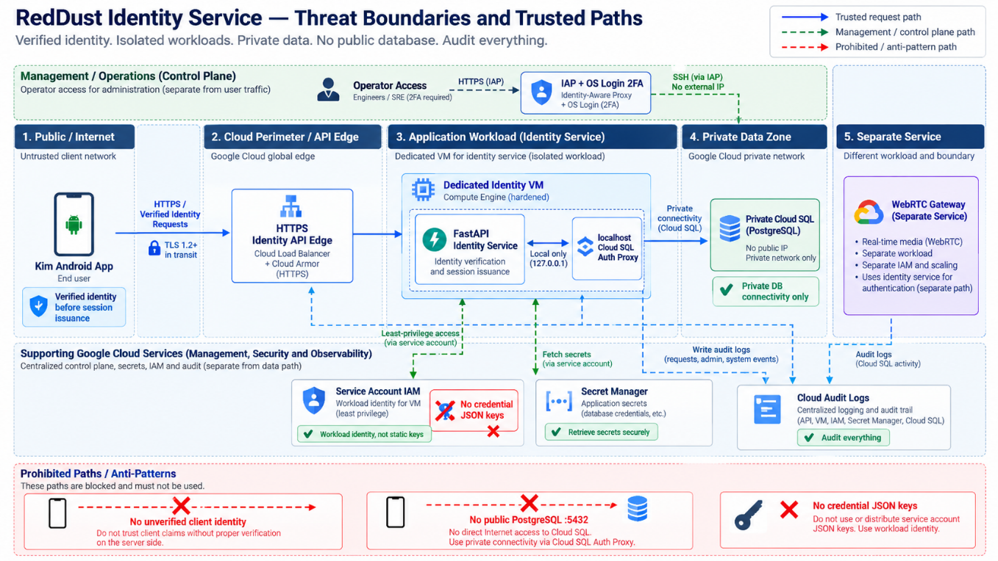

20.34.3 — GCP API and IAM permissions: least privilege by workload
gcloud services enable sqladmin.googleapis.com secretmanager.googleapis.com \
logging.googleapis.com monitoring.googleapis.com cloudkms.googleapis.com \
--project="$PROJECT_ID"
IDENTITY_SA="reddust-identity-dev-runtime@${PROJECT_ID}.iam.gserviceaccount.com"
gcloud iam service-accounts describe "$IDENTITY_SA" --project="$PROJECT_ID" || \
gcloud iam service-accounts create reddust-identity-dev-runtime \
--display-name="RedDust Identity Dev Runtime" --project="$PROJECT_ID"
gcloud projects add-iam-policy-binding "$PROJECT_ID" \
--member="serviceAccount:${IDENTITY_SA}" --role="roles/cloudsql.client"
The example project-scope Cloud SQL Client grant is a pragmatic development baseline; restrict its effective resource access further where supported and re-evaluate at production-project separation. Create secret-specific accessor grants rather than granting Secret Manager Secret Accessor on all secrets.
# Run only after each named secret has been created.
for SECRET in reddust-dev-db-password reddust-dev-jwt-signing-key; do
gcloud secrets add-iam-policy-binding "$SECRET" --project="$PROJECT_ID" \
--member="serviceAccount:${IDENTITY_SA}" --role="roles/secretmanager.secretAccessor"
done
Principal separation: reddust-gateway-dev-runtime remains the WebRTC workload identity. reddust-identity-dev-runtime is the authentication workload identity. Never reuse developer OAuth credentials or a downloaded service-account JSON key as a server identity.

20.34.4 — Choose database authentication: clear initial recommendation and evolution
Pattern | Use now? | Reason
Cloud SQL Auth Proxy + DB app role + Secret Manager password | YES — straightforward migration baseline | Private routing, IAM-authorized connector and TLS; native SQL privilege isolation
Cloud SQL automatic IAM database authentication | Recommended subsequent upgrade | Avoid fixed DB passwords where driver/connector and account naming are validated
HashiCorp Vault dynamic PostgreSQL credentials | NOT necessary for first dev deployment | Adds an HA/control plane, policies, lease management and operating cost
Direct public database IP + authorized networks | NO | Unnecessary attack surface for this architecture
Cloud SQL Auth Proxy authenticates the workload to the Cloud SQL instance; it does NOT automatically replace PostgreSQL database-user authentication unless IAM database authentication is separately configured. Its client-side listener on 127.0.0.1 is plaintext locally; only the proxy-to-Cloud-SQL leg has managed TLS. Preserve loopback-only access and filesystem/process isolation.

20.34.5 — Secret Manager: create secrets without command-history exposure
- Use Cloud Console → Security → Secret Manager to create two regional-policy-appropriate secrets: reddust-dev-db-password and reddust-dev-jwt-signing-key. Generate high-entropy distinct values using an approved password manager or secrets generator, then paste directly into the Secret Manager UI. Do not put values in source, shell history, environment files committed to Git, or the DOCX.
- Use a dedicated least-privilege runtime service account to fetch each required secret. Keep the secret name/version as non-secret configuration. Prefer numeric pinned versions for deliberate rotations and maintain a tested restart procedure.
- Enable Secret Manager data-access audit logs where required by the security policy; verify log volume and sensitivity before turning on broad logging.
# Verify metadata only — NEVER print secret payloads during evidence capture.
gcloud secrets describe reddust-dev-db-password --project="$PROJECT_ID" \
--format="yaml(name,replication,labels)"
gcloud secrets versions list reddust-dev-db-password --project="$PROJECT_ID"

20.34.6 — Token model: Google OAuth, internal JWT and revocable sessions
- Android completes Google OAuth/OpenID Connect using the correct Android OAuth client configuration; transmit the obtained Google ID token only to the identity-service login/exchange endpoint over HTTPS.
- FastAPI verifies Google-issued token signature against Google keys and checks iss, aud, exp, and stable sub; optionally check email_verified when email is used for product policy. The backend maps Google sub to the internal immutable user UUID, never uses email as a primary key.
- Mint a separate RedDust application access JWT containing iss, aud, sub (internal UUID), jti, iat, nbf and exp. Sign using an asymmetric key where practical; maintain an allowed-algorithms list and kid-based key rotation. Never accept alg=none or derive permissions from unverified claims.
- Set an initial access JWT TTL of 10 minutes. Store a rotating opaque refresh token only as a strong one-way hash in the backend, with expiry/revocation and device/session binding. Never store raw refresh tokens or Google ID tokens in application audit logs.
- Enforce revocation for refresh tokens immediately; for access JWTs, accept short residual TTL or check a server-side session version/jti deny-list for higher-risk operations. Document expected logout semantics.
# PSEUDOCODE — ADAPT to actual Step 19C identity package and schemas.
claims = verify_google_id_token(id_token, expected_android_client_ids)
assert claims["iss"] in VALID_GOOGLE_ISSUERS
assert claims["aud"] in ALLOWED_GOOGLE_CLIENT_IDS
user = upsert_identity(provider="google", provider_subject=claims["sub"])
session = issue_rotating_session(user.id, device_id, refresh_ttl_days=30)
access_jwt = sign_reddust_jwt(sub=str(user.id), sid=str(session.id),
audience="reddust-api", ttl_minutes=10)
return {"access_token": access_jwt, "expires_in": 600, "token_type": "Bearer"}
Critical distinction: The Google-issued ID token proves the Google identity; a RedDust-issued access token authorizes RedDust API requests; a TURN REST credential authorizes coturn relay use. These are three different credentials with different issuers, scopes and lifetimes.

20.34.7 — Application API authorization and WebRTC call-session protection
- Require RedDust bearer-token validation on the identity API and on Gateway signalling/control endpoints that create WebRTC sessions. A client-provided user_id or session_id must not override the identity derived from the validated token.
- Issue server-owned call_session_id values; store user_id, status, created_at, ended_at and a safe correlation ID; bind the /offer action to the authenticated user/session. Apply rate limits and concurrency caps per account/device/IP, including login, refresh, /offer and TURN credential minting.
- Do not expose full SDP payloads, ICE credentials, access tokens, microphone audio or personally identifying details in production logs. Allow diagnostic SDP capture only during a time-limited approved troubleshooting window with redaction.
- Apply Android secure storage for refresh credentials, with token clearance on logout. OAuth redirect/callback must be validated against the exact app package and signing keys for EAS build variants.

20.34.8 — HTTPS, certificate ownership and transport boundaries
Connection | Recommended TLS/certificate boundary | Required action
Kim Android → API | HTTPS with trusted certificate on public hostname | Use HTTPS LB with Google-managed certificate, or Caddy/Nginx + ACME for small dev VM; prohibit plain HTTP for real user data
Edge proxy → identity FastAPI | Loopback HTTP on same VM or authenticated internal TLS when remote | Bind Uvicorn 127.0.0.1:8100; do not expose 8100 inbound
Identity VM → Cloud SQL | Cloud SQL Auth Proxy managed TLS 1.3 | Proxy bound 127.0.0.1:5433 + --private-ip
Kim → Gateway signalling | HTTPS with validated app JWT | Retire temporary TCP 8000 public HTTP before real users
Kim → WebRTC media | ICE + DTLS-SRTP | Separate from HTTPS; TURN over TLS when needed
VM operators | IAP + OS Login 2FA | No public SSH port 22
Choose one public HTTPS option only after budget/domain readiness: (A) Google external Application Load Balancer with managed certificate, health check, backend ingress locked to load-balancer proxies; or (B) dedicated VM reverse proxy with ACME certificate and narrow TCP 80/443 firewall. For the initial dev migration, option B can reduce fixed costs but places patching/renewal responsibility on the team. Never claim a certificate exists until DNS, issuance, auto-renewal and remote verification pass.
# After HTTPS and DNS are active (on a trusted testing workstation):
curl -vI https://identity-dev.YOUR_DOMAIN.example/healthz
# Verify the correct certificate chain and hostname; do not use -k.
# Do NOT expose database port 5432 or internal Uvicorn port 8100.

20.34.9 — Cloud SQL at-rest encryption, network and backups
- Confirm Cloud SQL default Google-managed encryption at rest is enabled. CMEK is optional only when RedDust has a documented compliance/key-control need, key ownership, availability and recovery plan; introducing CMEK without rotation/deletion controls can cause data loss.
- Set Cloud SQL to private IP and confirm appropriate VPC/PSA routing. No ingress firewall opening on 5432 and no SQL instance public-IP address are required for the application VM.
- Enable automated backups and review point-in-time recovery settings, backup retention, deletion protection, maintenance window and storage-growth ceilings in the Console. Cloud SQL backups are not a substitute for testing restore.
- For sensitive user context, consider application-layer field encryption and data classification before storing conversation content. Do not store raw voice/audio as part of the auth database unless consent, retention, access and deletion policy exist.

20.34.10 — Host hardening, IAM reviews, logs and detection
- Use Ubuntu 24.04 LTS security updates, minimal installed packages, automatic security-patch policy and a documented reboot window. Avoid editing sudoers for team developers; retain IAM/OS Login/IAP.
- Keep Shielded VM Secure Boot/vTPM/integrity monitoring compatible with supported image. Disable project-wide legacy SSH keys; eliminate external SSH ingress; monitor service-account permissions and metadata access risk.
- Install Google Cloud Ops Agent or an approved collector; send structured app logs with user UUID redacted or hashed where suitable, request_id/call_session_id, service/version, outcome, and timing. Exclude secrets, request bodies with tokens and audio.
- Configure alerts for API auth failure spikes, token refresh anomalies, 5xx, latency, VM disk/full, Cloud SQL CPU/connections/storage, backup failure, unusual secret reads and privileged IAM changes. Define pager/email owner and escalation.
- Turn on Cloud Audit Logs for relevant admin activities and selective data access. Establish data retention and incident response plan: contain, revoke, rotate, investigate, recover, document.

20.34.11 — Security acceptance gate BEFORE data transfer
☐ Identity runtime service account exists and has no owner/editor permissions.
☐ Secret Manager secrets exist without credentials in Git or shared files.
☐ Cloud SQL has private connectivity and approved backups/restore strategy.
☐ HTTPS hostname/certificate valid (or migration is explicitly synthetic-only until finished).
☐ No 5432, 8100 or SSH 22 public firewall rule for identity VM.
☐ Session JWT verification, refresh rotation and logout/revocation have test cases.
☐ Logging is redacted and alert ownership recorded.
☐ Owner/security reviewer authorizes moving actual account data.
DIAGRAM — 20-BO: RedDust Secrets, Tokens and TLS Matrix
RESERVED SPACE FOR FUTURE ARCHITECTURE / ONBOARDING DIAGRAM Future ChatGPT image-generation prompt: Create landscape audit diagram with four vertical control planes: Google ID token exchange, RedDust 10-minute JWT + rotating refresh, Secret Manager DB/JWT material, Cloud SQL Auth Proxy TLS; side branch TURN REST credentials. Label every issuer, audience, TTL, validation boundary and storage rule. Add risk markers for public 5432, raw token logs and static service account keys.

20.35 — Deploy the RedDust Identity Microservice to a Dedicated Compute Engine VM
What this section does and why it matters: Move the local Step 19C FastAPI identity/session microservice to its own Ubuntu VM without changing the proven reddust-gateway-dev real-time audio processes.
New technical concepts introduced in this section (in absolute beginner terms): A separate Compute Engine VM is a failure/security boundary; a dedicated service account authenticates the workload; systemd makes the API restart automatically; reverse proxy terminates HTTPS.
Who does what: Owner approves cost/creation; infrastructure administrator configures VM/IAP; backend developer packages and deploys code; security reviewer verifies network isolation.

20.35.1 — Target architecture and capacity/cost checkpoint
Property | Recommended development baseline
Project / region / zone | reddust-development / australia-southeast1 / australia-southeast1-b
VM name | reddust-identity-dev
OS | Ubuntu 24.04 LTS standard
Type | e2-small initially if supported/adequate; e2-medium if measured RAM/CPU requires it
Network | Same VPC used by Cloud SQL private IP; reserve private address via DHCP
Human access | IAP SSH + OS Login + 2FA; no public port 22
Workload identity | reddust-identity-dev-runtime@reddust-development.iam.gserviceaccount.com
Runtime | Python 3.12.10 isolated venv, separate from Ubuntu system Python
Service | FastAPI/Uvicorn localhost:8100 under systemd
Database path | Cloud SQL Auth Proxy localhost:5433 → private-IP Cloud SQL
Internet entry | HTTPS identity-dev subdomain, reverse proxy or HTTPS LB
Gateway relation | Authenticated token-checked gateway integration over protected channels
Cost and architecture: An additional Compute Engine VM is billable even when the WebRTC Gateway is stopped; Cloud SQL continues billing. Recalculate VM, disk, external IP, certificate edge/LB, logging, egress, Secret Manager and database costs before creation. Kubernetes and Terraform remain future steps; do not silently use them here.

20.35.2 — Freeze the local microservice and its database contract
- On Windows, confirm Step 19C auth/session service exists, local Google login verification and session persistence work, and Alembic migrations are committed. Record the exact Python app import path and dependency lock/requirements.
- Capture a sanitized OpenAPI inventory: /healthz, login/exchange, refresh, logout, /me and call-session endpoints ONLY where present. Do not invent endpoint names; replace examples in this runbook with the actual local routes.
- Run automated unit/integration tests with synthetic identities; commit the known-good Git revision. Export package requirements and remove machine-local files, database password files, logs, virtual environments and secrets from the transfer archive.
# Windows PowerShell — adapt path to actual identity repository.
cd D:\RedDust\reddust-identity
python --version
python -m pytest -q
python -m pip freeze > requirements-validated.txt
# Record git commit, migrations and sanitized FastAPI /openapi.json.

20.35.3 — Create VM with guarded GCP CLI
# Project owner/authorized infra admin in Cloud Shell.
PROJECT_ID="reddust-development"
ZONE="australia-southeast1-b"
VM="reddust-identity-dev"
SA="reddust-identity-dev-runtime@${PROJECT_ID}.iam.gserviceaccount.com"
VPC="default" # REPLACE with the exact VPC used by Step 20.33 Cloud SQL PSA.
gcloud compute networks describe "$VPC" --project="$PROJECT_ID"
gcloud compute instances create "$VM" --project="$PROJECT_ID" \
--zone="$ZONE" --machine-type=e2-small \
--image-family=ubuntu-2404-lts-amd64 --image-project=ubuntu-os-cloud \
--boot-disk-size=20GB --boot-disk-type=pd-balanced \
--network="$VPC" --no-address \
--service-account="$SA" --scopes=cloud-platform \
--metadata=enable-oslogin=TRUE,enable-oslogin-2fa=TRUE \
--tags=reddust-identity-dev
Preflight: The example creates a VM WITHOUT an external address. If using direct Caddy/ACME ingress, plan a separate controlled HTTPS exposure path (e.g., load balancer with suitable backend connectivity) rather than blindly adding a public IP. Consult current Compute Engine CLI flags and OS Login organization policy before executing.
- If the VM creation command differs from the Console due to policy/image/available machine types, use the Console to create the same properties and capture the final configuration. Do not change the Gateway machine or Cloud SQL networking.
- Verify the actual zone, subnetwork, SA, no external NAT IP and the presence of Shielded VM settings. Check cloud cost estimate before accepting.
gcloud compute instances describe "$VM" --zone="$ZONE" --project="$PROJECT_ID" \
--format="yaml(name,status,networkInterfaces,serviceAccounts,shieldedInstanceConfig,metadata.items)"
DIAGRAM — 20-BP: Dedicated RedDust Identity VM
RESERVED SPACE FOR FUTURE ARCHITECTURE / ONBOARDING DIAGRAM Future ChatGPT image-generation prompt: Create landscape architecture with two separate Ubuntu 24.04 Compute Engine VMs: reddust-gateway-dev / aiortc and reddust-identity-dev / FastAPI. Show Android app HTTPS identity calls and protected /offer signalling, public WebRTC UDP media only to gateway, identity VM IAP SSH, dedicated service accounts and private Cloud SQL. Mark no direct public PostgreSQL and no shared service-account identity.

20.35.4 — IAP and VM-specific OS Login onboarding
- Reuse Step 20.8 IAP TCP 22 firewall rule scoped to the identity VM network tag and 35.235.240.0/20 source. Never open SSH TCP 22 to 0.0.0.0/0.
- Grant developer VM-specific OS Admin Login only when genuinely needed; apply the same individual-user account/2SV approach from Step 20.6.10. Give serviceAccountUser on the identity runtime SA only to the authorized VM administrators who need actAs.
# Example for the previously designated controlled dev test identity only.
DEV_EMAIL="1120anirban@gmail.com"
gcloud compute instances add-iam-policy-binding "$VM" \
--project="$PROJECT_ID" --zone="$ZONE" \
--member="user:${DEV_EMAIL}" --role="roles/compute.osAdminLogin"
gcloud iam service-accounts add-iam-policy-binding "$SA" --project="$PROJECT_ID" \
--member="user:${DEV_EMAIL}" --role="roles/iam.serviceAccountUser"
# SSH from an authorized Google identity:
gcloud compute ssh "$VM" --zone="$ZONE" --project="$PROJECT_ID" \
--tunnel-through-iap
Depending on organizational policy, IAP Tunnel Resource accessor may need a resource-scoped binding. Avoid granting service account Token Creator or VM sudo broadly just to bypass an authorization failure.

20.35.5 — Install Ubuntu dependencies and isolated Python runtime
# Inside reddust-identity-dev through IAP SSH.
sudo apt-get update && sudo apt-get -y upgrade
sudo apt-get install -y git curl ca-certificates build-essential \
libssl-dev zlib1g-dev libbz2-dev libreadline-dev libsqlite3-dev \
libffi-dev liblzma-dev postgresql-client
# Reuse the documented Step 20.11 Python 3.12.10 build approach; do not
# change /usr/bin/python3 or install system-wide application packages.
python3 --version
sudo install -d -m 0755 /opt/reddust/identity
# Run the documented shared runtime install or create service-owned .venv.
- For a separate microservice VM, use a single root-owned release directory and an application-owned venv, e.g. /opt/reddust/identity/.venv. Create an unprivileged Linux service user for systemd (not a shared human SSH identity). OS Login remains mandatory for people.
sudo useradd --system --home /var/lib/reddust-identity \
--create-home --shell /usr/sbin/nologin reddust_identity || true
sudo install -d -o reddust_identity -g reddust_identity -m 0750 \
/opt/reddust/identity /var/lib/reddust-identity
# Once a Python 3.12.10 interpreter exists at the documented install path:
# sudo -u reddust_identity /PATH/TO/PYTHON-3.12.10 -m venv /opt/reddust/identity/.venv

20.35.6 — Transfer a clean application release; install packages
- Create a sanitized source archive or signed Git checkout containing only Python application code, requirements and Alembic migrations. Do not upload the local PostgreSQL data directory or .env secrets with it.
- Transfer through IAP-backed SSH/scp or a private version-controlled deploy procedure. Verify checksum, commit ID and file ownership. Install pinned requirements using the service venv, then run import smoke test.
# Example on identity VM after transfer and Python venv creation:
sudo -u reddust_identity /opt/reddust/identity/.venv/bin/python -m pip \
install -r /opt/reddust/identity/requirements.txt
sudo -u reddust_identity /opt/reddust/identity/.venv/bin/python -c \
"import fastapi, sqlalchemy; print('identity imports OK')"
# Validate module path from actual local source before service startup.

20.35.7 — Install and supervise Cloud SQL Auth Proxy
- Download the current official linux.amd64 Cloud SQL Auth Proxy binary following Google’s maintained installation page; verify publisher checksum/version, install root-owned executable and pin a reviewed version in the operations record.
- Create a dedicated unprivileged systemd proxy service. Keep listener 127.0.0.1:5433; select --private-ip. Do not run proxy as root or expose listener on 0.0.0.0.
# Example systemd unit: /etc/systemd/system/reddust-sql-proxy.service
[Unit]
Description=RedDust Cloud SQL Auth Proxy (private)
After=network-online.target
Wants=network-online.target
[Service]
User=reddust_identity
Group=reddust_identity
ExecStart=/usr/local/bin/cloud-sql-proxy --private-ip \
--address 127.0.0.1 --port 5433 \
reddust-development:australia-southeast1:reddust-postgres-dev
Restart=on-failure
RestartSec=5
NoNewPrivileges=true
[Install]
WantedBy=multi-user.target

sudo systemctl daemon-reload
sudo systemctl enable --now reddust-sql-proxy
sudo systemctl --no-pager status reddust-sql-proxy
ss -ltn | grep 5433 # must be bound to 127.0.0.1 only
Networking check: Private-IP Cloud SQL Proxy requires the VM to have private network reachability to the Cloud SQL instance and IAM Cloud SQL Client permission. A proxy process running does not prove that a PostgreSQL login succeeds.

20.35.8 — Application settings, migrations and systemd
- Configure non-secret settings (DB host 127.0.0.1, DB port 5433, DB name reddust_dev, secret names, accepted Google audiences, RedDust JWT issuer/audience, log level) in a root-controlled settings file; do not store secret values there.
- At application startup, obtain the database password and signing material through the Secret Manager API using VM attached identity. Cache secrets in process memory only and implement safe refresh/restart on rotation; never log returned secret payloads.
- Do NOT run schema initialization on every API startup. Execute reviewed Alembic upgrades once as a separate operator-controlled migration step in 20.36.
# Adjust app.main:app and project directory to the actual Step 19C code.
# /etc/systemd/system/reddust-identity.service
[Unit]
Description=RedDust Identity FastAPI
Wants=network-online.target reddust-sql-proxy.service
After=network-online.target reddust-sql-proxy.service
[Service]
Type=simple
User=reddust_identity
Group=reddust_identity
WorkingDirectory=/opt/reddust/identity
Environment=PYTHONUNBUFFERED=1
EnvironmentFile=/etc/reddust/identity-nonsecret.conf
ExecStart=/opt/reddust/identity/.venv/bin/python -m uvicorn app.main:app \
--host 127.0.0.1 --port 8100 --workers 1
Restart=on-failure
RestartSec=5
NoNewPrivileges=true
PrivateTmp=true
ProtectSystem=strict
ProtectHome=true
ReadWritePaths=/var/lib/reddust-identity
[Install]
WantedBy=multi-user.target

sudo systemctl daemon-reload
sudo systemctl enable --now reddust-identity
sudo systemctl --no-pager status reddust-identity
curl --fail http://127.0.0.1:8100/healthz
journalctl -u reddust-identity -n 60 --no-pager
Startup dependency: Before migration (20.36), the service may legitimately fail its database readiness check because tables/users are not yet installed. Use the health endpoint to distinguish process health from database readiness and do not claim completion until both pass.

20.35.9 — HTTPS ingress decision and rollout
- Decide whether to use a managed external Application Load Balancer with a Google-managed TLS certificate or a protected VM-level reverse proxy + ACME certificate. Record expected ongoing cost and choose a stable development domain.
- For an external LB, explicitly configure backend health checks, appropriate backend ingress ranges and firewall rules, forwarding 443 to reverse proxy/API, not directly to port 8100. For direct VM reverse proxy, assign controlled public address and permit only TCP 80/443 as necessary; keep SSH IAP-only.
- Verify certificate CN/SAN, complete chain, expiry, automatic renewal, correct Host forwarding and HTTPS redirection. Do not turn off TLS validation in mobile code.
- Configure CORS only for applicable web origins (not a replacement for bearer authentication). Configure HTTP request-size/timeouts and basic rate limits. Use strict security headers where appropriate; avoid blindly enabling HSTS before the hostname is stable.

20.35.10 — Identity VM acceptance and handoff
☐ VM reddust-identity-dev is independent from reddust-gateway-dev.
☐ Dedicated runtime SA is attached and has narrow Cloud SQL/Secret permissions.
☐ IAP + individual OS Login/2FA passes; public SSH blocked.
☐ Python 3.12.10 runtime and requirements validated.
☐ Cloud SQL Auth Proxy listening only on 127.0.0.1:5433.
☐ FastAPI listening only on 127.0.0.1:8100 under systemd.
☐ HTTPS external endpoint is planned/tested, with no plaintext user login.
☐ No credentials in /opt/reddust releases, app logs or Git.
☐ VM and TLS/cost ownership assigned.
DIAGRAM — 20-BQ: Identity VM Boot and Private Data Path
RESERVED SPACE FOR FUTURE ARCHITECTURE / ONBOARDING DIAGRAM Future ChatGPT image-generation prompt: Create a step-by-step landscape sequence: boot identity VM → attached service account metadata credentials → Secret Manager read → start private Cloud SQL Auth Proxy → start FastAPI systemd on 127.0.0.1:8100 → HTTPS entry → Android Google login and JWT exchange. Show health/readiness and rollback branches; distinct dotted future GKE deployment.

20.36 — Migrate Local RedDust PostgreSQL to Cloud SQL and Cut Over Safely
What this section does and why it matters: Move the normalized identity/session database created during local Step 19C into the already provisioned reddust_dev Cloud SQL database, preserve referential integrity, and switch the cloud identity API from local PostgreSQL to private Cloud SQL.
New technical concepts introduced in this section (in absolute beginner terms): pg_dump makes a logical database archive; pg_restore restores tables and data; Alembic tracks schema versions; a cutover stops writes briefly so source and target do not diverge.
Who does what: DB owner approves migration; backend developer validates schema; cloud admin enables network/access; security reviewer approves data movement; test user validates the complete Google OAuth → RedDust API → WebRTC flow.

20.36.1 — Choose the migration route and downtime policy
Case | Recommended route | Why
Small local developer DB, no production traffic | pg_dump custom archive + pg_restore in a controlled window | Simple, auditable and inexpensive
Clean new cloud environment, no real user data yet | Run Alembic migrations + create synthetic seed records | Often safer than copying developer test data
Later large/live transactional migration | Assess Database Migration Service / replication | Low downtime, extra complexity and cost
This runbook assumes a small development dataset and a maintenance window with all local writes stopped. There is no live dual-write mechanism. If the database contains actual user data, approval, backup, legal basis, retention policy and encrypted file handling are prerequisites.

20.36.2 — Inventory actual local schema and versions; do not invent tables
# Windows PowerShell in the local PostgreSQL development environment.
psql --version
pg_dump --version
# Replace LOCAL_* placeholders with values retrieved securely, not embedded in Git.
psql -h localhost -U LOCAL_ADMIN -d LOCAL_REDDUST_DB \
-c "select version();"
psql -h localhost -U LOCAL_ADMIN -d LOCAL_REDDUST_DB \
-c "select schemaname,tablename from pg_tables where schemaname='public' order by tablename;"
psql -h localhost -U LOCAL_ADMIN -d LOCAL_REDDUST_DB \
-c "select extname from pg_extension order by extname;"
- Extract ERD and actual CREATE TABLE contracts; confirm users, external_identities, sessions, call_sessions and audit-related tables by inspection rather than assuming the local Step 19C proposal was implemented verbatim.
- Check PostgreSQL source major version against target Cloud SQL major version. Use pg_dump tools compatible with server versions; review unsupported extensions, superuser operations, ownership and collations.
- Record table row counts, foreign keys, unique indexes, audit trail size, schema migrations/Alembic version, test identities and record timestamps. Do not paste individual user email addresses or sensitive rows into the evidence pack.
# Safe generic inventory SQL — run on local source.
SELECT table_schema, table_name
FROM information_schema.tables
WHERE table_type='BASE TABLE' AND table_schema NOT IN ('pg_catalog','information_schema')
ORDER BY table_schema, table_name;
SELECT version_num FROM alembic_version; -- only if Alembic is present

20.36.3 — Back up the local source and establish rollback
- Announce maintenance window; disable new mobile login/call-session writes on the local service and stop scheduled background workers. Do not start a Cloud SQL import while writes are still occurring.
- Create a local custom-format logical dump, excluding ownership and ACL when appropriate for Cloud SQL. Include full schema and data, not a CSV-only subset, and keep archive encrypted and access-restricted at rest.
# PowerShell. Run interactively so credentials are requested securely.
$BackupDir = "D:\RedDust\private-migration"
New-Item -ItemType Directory -Force $BackupDir | Out-Null
pg_dump -h 127.0.0.1 -U LOCAL_ADMIN -d LOCAL_REDDUST_DB \
--format=custom --no-owner --no-acl \
--file "$BackupDir\reddust_dev_precloud.dump"
pg_restore --list "$BackupDir\reddust_dev_precloud.dump" | Select-Object -First 30
Get-FileHash "$BackupDir\reddust_dev_precloud.dump" -Algorithm SHA256
Windows syntax checkpoint: The command above is a multi-line illustration; in PowerShell, use one line or PowerShell backtick continuation, not Bash backslashes. Never upload the archive to an unprotected shared Cloud Storage bucket.
- Record archive checksum, source row counts and exact local Git revision. Keep the source local database read-only and retained until cloud post-cutover tests pass. Restore verification must happen on a separate scratch database, not by overwriting the original source.

20.36.4 — Create least-privilege Cloud SQL database roles
- On Cloud SQL, keep administrative bootstrap identity separate from application DML identity and schema-migration identity. Use a migration/owner role with DDL privileges and a runtime login with only SELECT/INSERT/UPDATE/DELETE on required tables/sequences.
- Choose explicit owner/privilege grants after inspecting the actual schema; do not use the Cloud SQL postgres user as the application runtime identity. Do not grant SUPERUSER or CREATEDB to the app.
-- Run through a trusted psql client as approved DB administrator.
-- Example template; review real schemas before execution.
CREATE ROLE reddust_identity_app LOGIN PASSWORD 'SET_SECURELY_OUTSIDE_RUNBOOK';
CREATE ROLE reddust_identity_migrator LOGIN PASSWORD 'SET_SECURELY_OUTSIDE_RUNBOOK';
REVOKE CREATE ON SCHEMA public FROM PUBLIC;
GRANT USAGE ON SCHEMA public TO reddust_identity_app;
GRANT CONNECT ON DATABASE reddust_dev TO reddust_identity_app;
-- After restored objects are owned by the migrator, grant only required DML:
GRANT SELECT, INSERT, UPDATE, DELETE ON ALL TABLES IN SCHEMA public
TO reddust_identity_app;
GRANT USAGE, SELECT ON ALL SEQUENCES IN SCHEMA public
TO reddust_identity_app;
ALTER DEFAULT PRIVILEGES FOR ROLE reddust_identity_migrator IN SCHEMA public
GRANT SELECT, INSERT, UPDATE, DELETE ON TABLES TO reddust_identity_app;
ALTER DEFAULT PRIVILEGES FOR ROLE reddust_identity_migrator IN SCHEMA public
GRANT USAGE, SELECT ON SEQUENCES TO reddust_identity_app;
Password safety: The SQL shown contains a PLACEHOLDER and must never be run with literal example credentials. Use an approved secure bootstrap procedure to supply generated secrets without storing the password in shell history, logs or document. Prefer dedicated IAM database authentication after it is validated end-to-end.

20.36.5 — Move the encrypted archive through an approved channel
- If using the identity VM as the restore client, connect to it by IAP and transfer the archive through IAP-backed SCP or an access-controlled, short-lived storage object. Use encryption, minimum retention and deletion afterward; record checksum at source and destination.
- Check the archive is readable only by a temporary authorized migration operator. Do not write dump files to a world-readable /tmp directory or application release tree.
# Cloud Shell / trusted operator: illustrate IAP transfer; adapt source location.
gcloud compute scp --tunnel-through-iap \
--project=reddust-development --zone=australia-southeast1-b \
./reddust_dev_precloud.dump reddust-identity-dev:~/reddust_dev_precloud.dump
# On target: sha256sum ~/reddust_dev_precloud.dump
# Compare hash to local SHA256; remove file after acceptance.

20.36.6 — Restore to Cloud SQL using loopback proxy
- Stop identity FastAPI background writes during restore. Confirm Cloud SQL database reddust_dev is empty, except any intended system objects, and an approved backup exists. Never restore destructively into a populated production/pilot database.
- Start Cloud SQL Auth Proxy (20.35.7) using the attached VM service account. Confirm database login with the dedicated approved migration identity. Proxy connectivity alone is not database authorization.
- Restore using pg_restore --exit-on-error --no-owner --no-acl, with validated extension/TOC handling. Avoid --clean/--create unless an explicitly approved disposable target is being used.
# On approved migration host / identity VM with proxy on 127.0.0.1:5433.
# Set PGPASSWORD through a secure ephemeral mechanism or use interactive prompt.
pg_restore --verbose --exit-on-error --no-owner --no-acl \
--host=127.0.0.1 --port=5433 --username=reddust_identity_migrator \
--dbname=reddust_dev ~/reddust_dev_precloud.dump
# Do not mask failures with || true. Review restore errors before continuing.
- If existing local roles/ACLs or unsupported extensions produce failures, stop and adapt the archive’s restore list or prepare target extension prerequisites. Re-run only after cleaning a disposable target; do not repeatedly partially restore into a production destination.

20.36.7 — Validate schema, rows, integrity and migration revision
psql -h 127.0.0.1 -p 5433 -U reddust_identity_migrator -d reddust_dev \
-c "SELECT table_name FROM information_schema.tables WHERE table_schema='public' ORDER BY table_name;"
psql -h 127.0.0.1 -p 5433 -U reddust_identity_migrator -d reddust_dev \
-c "SELECT version_num FROM alembic_version;"
- Compare source-vs-target counts for every auth/user/session/audit table, FK/unique indexes, constraints, database encoding and migration revision. An absence of import errors is not enough evidence.
- Run application migration status check (e.g. alembic current), but do not blindly run alembic upgrade head on an already restored matching schema. If migration level is behind, plan a reviewed incremental migration with a rollback/backup checkpoint.
- Verify runtime application database role can read/insert only allowed tables and cannot CREATE, DROP, ALTER or access unrelated schemas. Test rollback/restore separately with a scratch database.

20.36.8 — Cut over identity microservice and validate Kim’s app
- Update only non-secret DB host/port/instance settings in the identity service; retrieve the runtime DB secret from Secret Manager. Restart systemd identity service and test readiness connecting to Cloud SQL.
- Run Google sign-in on the unified Android app; exchange Google ID token for RedDust JWT; call /me using access JWT; refresh token; logout; verify server-side session revocation. Check internal user UUID continuity and no duplicate provider identity.
- Start an authenticated WebRTC call through the existing gateway: ensure Gateway verifies RedDust token on /offer; save/close the associated call session in Cloud SQL; confirm ICE connected and audible echo on Wi-Fi and mobile data.
- Simulate an expired/invalid JWT, mismatched user ID, duplicate replayed refresh token, revoked session and unauthenticated /offer; all must be denied without leaking account information. Inspect sanitized audit logs.
- Switch primary development configuration to Cloud SQL only after complete test pass. Keep local database frozen for rollback; never permit automatic dual-writes to two databases without an explicit consistency design.
DIAGRAM — 20-BR: Identity Database Migration and Cutover
RESERVED SPACE FOR FUTURE ARCHITECTURE / ONBOARDING DIAGRAM Future ChatGPT image-generation prompt: Create a three-lane landscape migration swimlane: Windows PostgreSQL source → encrypted pg_dump + checksum → IAP transfer → Cloud SQL Auth Proxy → private Cloud SQL reddust_dev. Parallel secure track: Google OAuth → JWT auth → new identity VM. Show write freeze, schema/row/FK/Alembic checks, go/no-go cutover, local database rollback and future Terraform/GKE handoff.

20.36.9 — Rollback, evidence, backup and decommissioning
- If Cloud SQL restore/integrity fails: do NOT point mobile users at target; keep local identity endpoint and local PostgreSQL as the approved source of truth during the window. Retain restore logs and repair a fresh/disposable target.
- If app flows fail after cutover: stop new cloud writes immediately, capture correlation IDs and sanitized logs, restore the previous app configuration and reopen local source only after confirming whether cloud accepted any writes; reconcile changes manually if needed.
- After acceptance, test Cloud SQL backup restore to a scratch instance/database, validate row counts, and record RPO/RTO observations and associated costs. Implement periodic restore exercises before pilot users.
- Securely delete temporary dump/secret artifacts from staging locations under the agreed retention policy, rotate any credentials exposed during debugging, and record execution identities and dates.

20.36.10 — Completion checklist and forward migration handoff
☐ Local schema, migration revision and extensions inventoried.
☐ Writes frozen and encrypted source dump checksum recorded.
☐ Cloud SQL private-only connectivity and proxy TLS proven.
☐ Cloud DB roles scoped and secrets reside in Secret Manager.
☐ pg_restore completed with no unreviewed errors.
☐ Source and target counts, keys, constraints and Alembic version agree.
☐ Authentication, refresh, logout, authorization failures and /me tested.
☐ Authenticated /offer and two-way WebRTC audio work.
☐ Logs/audits/alerts and Cloud SQL backup restore reviewed.
☐ Rollback plan validated and temporary artifacts removed.
☐ Owner signs off before calling cloud deployment complete.
Later step | Required handoff without rework
Step 21 — Terraform | Codify VPC/PSA, Cloud SQL settings, identity VM, SAs, IAM, firewall, DNS/TLS, Secret Manager metadata and monitoring; import existing manually created resources into state before apply; never recreate a data-bearing SQL instance.
Docker/GKE stage | Package identity FastAPI into independently deployed container; use GKE Workload Identity Federation, Secret Manager access, private Cloud SQL connector and Kubernetes probes; separate media gateway architecture as required.
Cloud SQL production | Separate project/environment, PostgreSQL migrations, PITR/backup restoration, retention/privacy, HA/replicas on measured need, audit controls and zero-public-DB policy.
DIAGRAM — 20-BS: RedDust Cloud Evolution after Step 20
RESERVED SPACE FOR FUTURE ARCHITECTURE / ONBOARDING DIAGRAM Future ChatGPT image-generation prompt: Create clean four-stage roadmap: local Windows auth/PostgreSQL → Step20 identity VM + private Cloud SQL → Step21 Terraform-managed GCP → GKE containerized identity microservice + Cloud SQL. Preserve application user UUID and Google subject mapping, schema migrations, JWT contract and audit correlation across all stages. Distinguish HA from read scaling and avoid any false implication that Terraform or Kubernetes has already been implemented.

20.36.11 — Troubleshooting by lowest failing layer
Symptom | First check | Do not change yet
VM cannot connect private Cloud SQL | VPC/subnetwork, PSA, instance private IP, proxy --private-ip, Cloud SQL Client IAM | Open PostgreSQL publicly
Proxy starts but PostgreSQL login rejected | DB role, password/secret version, DB grants, target DB name | Give service account Editor
Restore reports owner/extension failure | no-owner/no-acl, supported extensions and role ownership | Retry destructive --clean blindly
API returns 500 after restore | Alembic revision, missing tables, runtime privileges, secrets | Rewrite Google OAuth first
Google login 401 | ID token signature/issuer/audience/expiry, Android OAuth client | Disable JWT verification
Refresh/logout inconsistent | Session rotation/revocation DB transaction logic | Raise token TTL without analysis
WebRTC /offer 200 but no audio | Gateway ICE/DTLS/SRTP/track path; separate from identity API | Change PostgreSQL configuration
Costs exceed forecast | Cloud SQL continuous charges, VM, LB/IP, logs and backups | Disable backups or security controls

20.36.12 — Authoritative references and execution record
- https://docs.cloud.google.com/sql/docs/postgres/connect-compute-engine
- https://docs.cloud.google.com/sql/docs/postgres/sql-proxy
- https://docs.cloud.google.com/sql/docs/postgres/import-export/import-export-dmp
- https://docs.cloud.google.com/sql/docs/postgres/authentication
- https://docs.cloud.google.com/secret-manager/docs/overview
- https://docs.cloud.google.com/compute/docs/oslogin/set-up-oslogin
- https://docs.cloud.google.com/load-balancing/docs/ssl-certificates/google-managed-certs
- https://docs.cloud.google.com/sql/docs/postgres/backup-recovery/backups
- https://cloud.google.com/sql/pricing
Product names, console paths, service limits and pricing can change. Validate current Google Cloud documentation and organization policy before commands are executed. Security configuration described here is a recommended target baseline, not evidence that controls have been activated.
Execution record | Complete at implementation time
Project / VM / Cloud SQL | reddust-development / reddust-identity-dev / verify actual Cloud SQL name
Application git revision | _________________________
Database source + target major versions | _________________________
Alembic revision | _________________________
Source dump SHA-256 | _________________________
Private connection name | _________________________
HTTPS hostname / certificate issuer | _________________________
Migration timestamp and operator | _________________________
Security reviewer / go-no-go | _________________________
Rollback evidence / restore exercise | _________________________

