Step 19D — Merge Google-Auth Frontend & WebRTC Call

What we have achieved: In the previous steps, we built two independent foundations of RedDust:
- Steps 0–19A/B — Local RedDust WebRTC Voice: Established real-time, two-way audio communication between the React Native mobile app and Python aiortc Gateway, validated through a working voice echo.
- Step 19C — Local RedDust Identity, Session and Audit: Built Google authentication, FastAPI Auth API, JWT-based sessions and PostgreSQL-backed identity and audit management.
We can communicate. We can authenticate. Now we must connect the two.
Current Step 19D transforms two independent capabilities into one secure, voice-enabled RedDust application: We combine the existing frontend's branding, navigation and Google Sign-In with the proven WebRTC voice engine, creating reddust-unified for Android and iOS.
Intended user journey: Open RedDust → Google Sign-In → Verify RedDust Identity → Establish Session → Start Authenticated Voice Call. The Auth API establishes who the user is. The Gateway authorises the call. WebRTC securely carries the audio.

Key technical concepts:
- Integration: Combine proven components without breaking existing functionality.
- Native compatibility: Make Google Sign-In, WebRTC and audio permissions work within one mobile build.
- Authenticated calling: Only a user with a valid RedDust session can initiate an authorised call.

Team responsibilities:
- Mobile: Unified app and WebRTC integration.
- Identity: Authentication, tokens and sessions.
- Gateway: Authorised signalling and audio.
- Testing: End-to-end verification on physical devices.
- Success criterion: One Android/iOS application where a verified (Google logged in) RedDust user can successfully establish, use and end a secure WebRTC voice call (only echo as of now, by the end of Step 19D).

19D.1 — Establish a Unified Expo and Native Compatibility Baseline
What this section does and why it matters: Create reddust-unified from the existing Google-authenticated frontend, preserving its branding, navigation and working features. Keep both original projects unchanged while aligning Expo, React Native and native dependencies before integrating WebRTC.
Key technical concept — Native compatibility: Expo, React Native and native libraries must use compatible versions. A JavaScript package may install successfully but still fail when building the Android or iOS app.
Starting point: reddust-unified is created from reddust-frontend. Establish a clean, reproducible dependency baseline and investigate the Expo SDK 56/57 compatibility differences.
Success criterion: A validated unified frontend baseline, ready for controlled WebRTC integration. No WebRTC merge or authenticated voice call is expected yet.

19D.1.1 — Understand the baseline and STOP conditions
Project / path | Keep or create | Role
D:\RedDust\reddust-frontend | Preserve unchanged | Source of branding, navigation, Google sign-in and existing Expo configuration.
D:\RedDust\reddust-mobile | Preserve unchanged | Known-good WebRTC echo reference and regression/rollback baseline.
D:\RedDust\reddust-unified | Populate from frontend | Only this new project is modified during the merge.
D:\RedDust\reddust-auth-api | Keep separate | FastAPI authentication microservice; Python .venv is unrelated to npm.
STOP BEFORE COPYING: Confirm the destination really is empty. Do not overwrite a nonempty project. Do not initialize a fresh Expo app in reddust-unified, merge two package.json files, or copy node_modules, secrets or .git from either source.

19D.1.2 — Preflight: inspect the real source and target
WHERE: VS Code → Terminal → New Terminal → PowerShell
$Source = "D:\RedDust\reddust-frontend"
$Target = "D:\RedDust\reddust-unified"
if (-not (Test-Path -LiteralPath (Join-Path $Source 'package.json'))) {
throw "STOP: Frontend package.json missing. Check the source path."
}
if (-not (Test-Path -LiteralPath $Target)) {
New-Item -ItemType Directory -Path $Target | Out-Null
}
if (Get-ChildItem -LiteralPath $Target -Force | Select-Object -First 1) {
throw "STOP: reddust-unified is not empty. Inspect before copying."
}
Get-ChildItem -LiteralPath $Source -Name |
Where-Object { $_ -in @('package.json','package-lock.json',
'yarn.lock','pnpm-lock.yaml','app.json','app.config.js',
'app.config.ts','eas.json','src') }
Expected: package.json and the existing frontend configuration are discovered; the new target passes the empty-folder check. The lockfile determines the next dependency-install command.

19D.1.3 — Create a clean, source-only copy (no secrets)
WHERE: same PowerShell terminal. These commands do not delete or modify the original frontend. Excluded files must be reviewed separately if the app requires them.
robocopy "$Source" "$Target" /E /R:2 /W:2 `
/XD node_modules .git .expo .expo-shared dist build coverage .next .turbo secrets `
/XF .env .env.* .npmrc google-services.json GoogleService-Info.plist `
*.keystore *.jks *.p8 *.p12 *.pem *.key *.pfx *.mobileprovision
$copyExit = $LASTEXITCODE
if ($copyExit -ge 8) { throw "STOP: Robocopy failed ($copyExit)." }
Write-Host "Source copy completed; robocopy exit code: $copyExit"
WHY THESE EXCLUSIONS MATTER: node_modules and .expo are regenerated; .git belongs to the original source. Local .env files, .npmrc credentials, signing certificates, keys and service-configuration files require deliberate review—not blind copying. This command intentionally also excludes .env.example; copy it later only if inspected and placeholder-only.
Robocopy exit codes 0–7 normally indicate no fatal copy failure; 8 or more means at least one file-copy failure. Do not use /MIR because it can delete destination files. Confirm target contents rather than relying only on the exit code.

19D.1.4 — Verify the copied Expo application
Set-Location "D:\RedDust\reddust-unified"
Test-Path .\package.json
Test-Path .\package-lock.json
Test-Path .\src
Test-Path .\app.json
Test-Path .\app.config.js
Test-Path .\app.config.ts
Get-ChildItem -Force –Name
Expected: package.json = True; at least one app configuration source (app.json, app.config.js or app.config.ts) exists if used by the frontend. package-lock.json may be absent if a different package manager is used. src may differ for other project layouts.
VERIFY, DO NOT ASSUME: Open package.json, app.json/app.config.*, eas.json and .gitignore in VS Code. Check that assets, routes, native plugins, Android package name, URL scheme and EAS project identity were preserved. Do not invent or overwrite these values.

19D.1.5 — Install dependencies using the existing lockfile
Choose the command that matches the source project’s actual package manager. For npm, use the following only when package-lock.json (or npm-shrinkwrap.json) is present and consistent with package.json.
Set-Location "D:\RedDust\reddust-unified"
node --version
npm --version
if (Test-Path .\package-lock.json) {
npm ci
if ($LASTEXITCODE -ne 0) { throw "STOP: npm ci failed." }
} else {
Write-Host "STOP: No package-lock.json; inspect package manager first."
}
If yarn.lock or pnpm-lock.yaml exists instead, use the source project’s corresponding locked install workflow. If no lockfile exists, do not fabricate one without reviewing the project’s package manager and dependency policy. Avoid npm install --force, automatic upgrades and --legacy-peer-deps as unreviewed shortcuts.

19D.1.6 — Inventory compatibility; do not merge WebRTC yet
WHERE: PowerShell, still inside reddust-unified.
npx expo-doctor
npx expo install --check
npm ls --depth=0 expo react-native react-native-webrtc `
react-native-incall-manager `
"@react-native-google-signin/google-signin"
When asked for:
√ Fix dependencies?
Press N
Fix the invalid configuration first, investigate Track Player/WebRTC compatibility, and then perform a controlled Expo dependency update in reddust-unified. Do not mark 19D.1 complete until the chosen baseline passes the required checks and native tests.
Interpretation: Expo Doctor checks project and dependency health; expo install --check identifies possible mismatches. npm ls is an INVENTORY—WebRTC or InCallManager may legitimately be absent because they have not been merged yet. Do not interpret those missing packages alone as failure of the frontend baseline.
Check | Decision / evidence
Expo SDK and React Native versions | Record values from actual package.json and npm ls; do not assume SDK 56/57 compatibility.
Google Sign-In / navigation | Verify existing dependencies and configuration survived the copy.
WebRTC, InCallManager, config plugin | Compare the separate reddust-mobile project; propose a tested compatible native set in 19D.3.
Android package / signing identity | Keep intentional android.package and OAuth/EAS alignment; do not assume a fresh project identity.
Native build | After native changes, create a new EAS development build; Metro reload alone cannot add native modules.

19D.1.6-A — Expo Compatibility: Fix and Verify
Purpose: Correct the Expo config, review native dependencies and align SDK 57 packages without disturbing the existing app identities or working references.
CURRENT STATUS: 18/21 Expo Doctor checks passed; three categories failed. You correctly answered N to “Fix dependencies?”. Inventory complete; baseline NOT approved.

What failed — and what it means
Finding | Action
Invalid `newArchEnabled` in app.json | Remove only this property. SDK 57 uses the New Architecture.
Track Player unsupported; WebRTC untested | Review versions, patches and plugins. Directory warnings are not device-test results.
16 Expo/React Native version mismatches | Align later through Expo, after a backup and native-library review.
Confirmed installed: Expo 57.0.14; React Native 0.86.2; WebRTC 124.0.8; Google Sign-In 16.1.4. Track Player 4.1.2 was patched during npm ci. InCallManager was not listed in the top-level inventory. WebRTC installation ≠ working call integration.

1 — Back up the current configuration
Set-Location "D:\RedDust\reddust-unified"
$Backup = "D:\RedDust\_local-backups\19D1-6-$(Get-Date -Format yyyyMMdd-HHmmss)"
New-Item -ItemType Directory -Path $Backup -Force | Out-Null
Copy-Item .\app.json,.\package.json,.\package-lock.json,.\eas.json -Destination $Backup
Copy-Item .\patches -Destination $Backup -Recurse
STOP if a required source file is missing or the backup fails. Keep this backup outside reddust-unified; do not copy secrets.

2 — Fix the invalid app.json property only
code .\app.json
# Remove the "newArchEnabled" property; save. Keep valid JSON.
Get-Content .\app.json -Raw | ConvertFrom-Json -ErrorAction Stop | Out-Null
npx expo-doctor
Expected: the schema failure disappears (possibly 19/21), while library and version findings remain. Preserve plugins, Android package, URL scheme and EAS project ID; do not replace app.json.
If the issue still exists go and manually remove the line for:
"newArchEnabled": false, // or true

3 — Inspect native dependencies without installing anything
npm ls --depth=0 expo react-native react-native-webrtc `
react-native-incall-manager react-native-track-player `
"@config-plugins/react-native-webrtc" `
"@react-native-google-signin/google-signin"
npm explain react-native-webrtc
npm explain react-native-track-player
A nonzero npm ls exit may reflect an absent requested package. Inspect the old reddust-mobile echo project as a reference; do not copy its manifests or native plugin versions.

4 — Update Expo versions only after compatibility review
npx expo install --check # Choose N for inventory.
# After backup + library decision are approved, run once:
npx expo install --fix # Changes package.json / package-lock.json.
npx expo-doctor
npx expo install --check # Choose N if prompted during recheck.
Choosing Yes during the initial inventory changes dependencies too early. The later reviewed --fix operation targets the 16 version mismatches; it does not make Track Player/WebRTC automatically compatible. 20/21 checks passed after this step.

5 — Record security findings and acceptance
npm audit --omit=dev
npm explain uuid
npm ls --depth=0 "@shopify/react-native-skia"
Previous npm ci: 29 reported vulnerabilities; Skia install script awaiting review. Do not run npm audit fix --force or automatically approve scripts. Triage critical/high findings before release.
Acceptance: No schema error; no unexplained Expo version mismatches; native-library risks documented; security review recorded. A new EAS development build and physical-device Google Sign-In/microphone/WebRTC tests are required before native acceptance (iOS remains pending until configured).
STOP: Do not alter signing identities, copy secrets, and suppress warnings to fake a pass, or claim authenticated WebRTC from npm/Doctor output alone.

6 – Security Preview
Run the following:
# Identify which dependencies introduce vulnerable packages.
npm explain shell-quote
npm explain @xmldom/xmldom
npm explain decode-uri-component
npm explain deepmerge

# List install scripts awaiting review.
npm approve-scripts --allow-scripts-pending

# Preview non-forced security fixes without changing files.
npm audit fix --dry-run --ignore-scripts
The security-fix preview completed successfully, and it shows a promising way to reduce vulnerabilities without immediately upgrading RedDust to Expo SDK 58.
Your output confirms that npm audit fix --dry-run --ignore-scripts identified seven dependency updates. Because this was a dry run, those changes have not been applied.
What the preview found
Package | Current | Proposed
shell-quote | 1.10.0 | 1.12.0
@xmldom/xmldom | 0.8.14 | 0.8.15
brace-expansion | 5.0.9 | 5.0.12
source-map-js | 1.2.1 | 1.2.2
postcss-selector-parser | 6.1.4 | 6.1.5
@react-navigation/routers | 7.6.4 | 7.6.5
@react-navigation/core | 7.21.13 | 7.24.0
The most significant proposed update is shell-quote, which addresses the package associated with your critical-severity advisory.
The preview did not propose an Expo SDK 58 upgrade.
What remains unresolved
Your audit still reports 24 vulnerabilities, including one critical. That is expected after a dry run: the preview does not actually replace the installed vulnerable packages.
The output also confirms that the Skia installation script is still awaiting an allow/deny decision. Do not approve it without reviewing whether the RedDust application requires it.

19D.1.7 — Source control, evidence and hand-off
Before the WebRTC transplant, review the new project’s .gitignore, confirm that excluded secret-bearing files were not reintroduced, and commit the verified frontend-copy baseline to the team-approved Git repository. If D:\RedDust is already inside another Git repository, follow that repository’s agreed structure; do not blindly run git init inside a nested folder.
Set-Location "D:\RedDust\reddust-unified"
Get-ChildItem -Force -Name
Get-ChildItem . -Force -File | Where-Object {
$_.Name -like '.env*' -or $_.Name -eq '.npmrc'
} | Select-Object Name
# Inspect Git ownership/status before any commit:
git rev-parse --show-toplevel
git status –short
If Git reports "not a git repository," decide first whether the unified app belongs in a new repository or a parent monorepo. Review the intended remote, .gitignore and staged file list before making a commit.
ACCEPTANCE / GO: reddust-unified contains the frontend manifest, chosen lockfile, app config, screens and assets; dependencies install with the approved tool; actual Expo/RN versions are recorded; Doctor findings are reviewed; no secrets are copied; original projects remain unchanged. Only then proceed to 19D.2 (source mapping) and 19D.3 (native plugin/permissions reconciliation).
STOP / NO-GO: A missing or inconsistent lockfile, failed source copy, unreviewed EAS/app identity, leaked credentials, or incompatible native dependencies blocks advancement. Do not claim unified Google + WebRTC functionality until integration builds and device tests pass.

19D.1.8 — Quick troubleshooting
Symptom | Meaning / immediate fix
npm ci → EUSAGE | Target lacks package-lock.json or npm-shrinkwrap.json, or manifest/lock mismatch. Copy/inspect the project first.
deactivate not recognized | No Python .venv active. Expo/Node/npm does not require a Python deactivate command.
npm ls reports WebRTC missing | Expected if frontend baseline has not yet integrated the Gateway call feature.
Expo Doctor flags mismatches | Record exact messages and reconcile dependencies before native build; do not blindly upgrade.
app.json references absent file | An excluded environment/Google service file may need an approved, nonsecret or securely provisioned replacement.
DIAGRAM PLACEHOLDER — 19D-01: Clean Unified App Baseline and Native Compatibility Gate
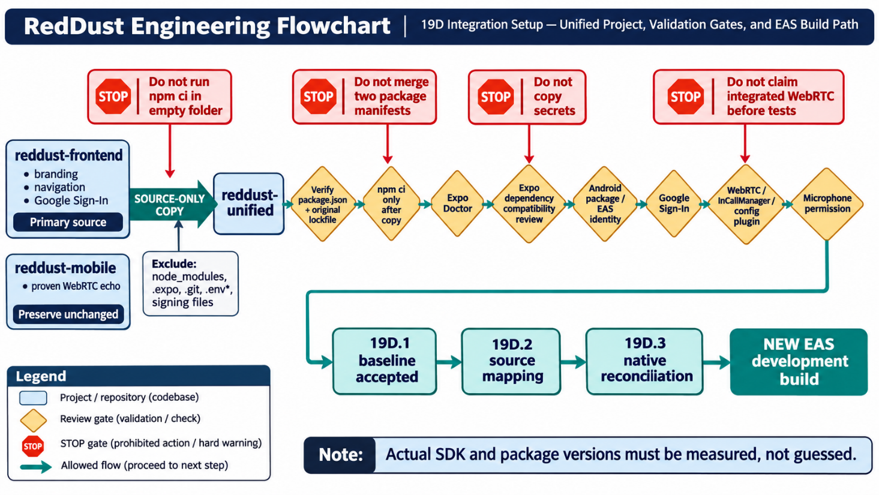

Authoritative references
- npm CLI — npm ci: https://docs.npmjs.com/cli/commands/npm-ci
- Expo — Development tools / Expo Doctor: https://docs.expo.dev/develop/tools/
- Expo — CLI package compatibility: https://docs.expo.dev/more/expo-cli/
- Microsoft — Robocopy parameters and exit codes: https://learn.microsoft.com/en-us/windows-server/administration/windows-commands/robocopy/

19D.2 — Map Source Files to Destination Modules
WHAT THIS SECTION DOES AND WHY IT MATTERS: Map the real, copied frontend files and the proven WebRTC source to separately testable authentication, navigation and call features—without overwriting working code or assuming planned files already exist.
BEGINNER CONCEPT: A feature module owns one responsibility. Expo Router files under src/app define navigation; services and hooks under src/features contain reusable authentication and calling logic.

19D.2.1 — Confirm what exists and what is only planned
Your VS Code screenshot confirms that reddust-unified now contains the copied frontend layout. It does not show the full contents of src/store, the exact filename of the truncated Google sign-in component, or the internal implementations. Mark those as “inspect” rather than assuming them.
Category |  | Evidence from your current project | Decision
Confirmed existing |  | src/app/signin.tsx; src/app/_layout.tsx; src/app/(app)/_layout.tsx | Keep; inspect before editing
Confirmed existing |  | src/app/(app)/(tabs)/{_layout.tsx, index.tsx, soul-space.tsx} | Keep all routes; map purpose
Confirmed existing |  | src/components/{Header.tsx, MusicPlayer.tsx}; src/store/; assets/; patches/ | Preserve; examine dependencies
Confirmed existing |  | src/components/GoogleSignInButton.tsx | Preserve; examine dependencies
Planned—not missing errors |  | src/features/auth/; src/features/call/; src/config/env.ts; src/app/(app)/call.tsx | Create later only when mapping approved
 | STOP / DO NOT DO: Do not rename existing tabs or delete soul-space.tsx/MusicPlayer.tsx merely to match an illustrative directory tree. Do not copy a second package.json from reddust-mobile.

19D.2.2 — Define the source of truth
reddust-frontend is the primary source for appearance, Google sign-in and navigation. reddust-mobile is the untouched reference for the working microphone → WebRTC echo path. reddust-unified is the only destination to be modified for integration.

19D.2.3 — Inspect actual files before creating anything
WHERE: VS Code → Terminal → New Terminal → PowerShell.
The commands below list or search files only; they do not install packages or alter project source.
Set-Location "D:\RedDust\reddust-unified"
# Current Expo Router pages and layouts
Get-ChildItem -LiteralPath ".\src\app" -Recurse -File |
Select-Object FullName
# Confirm the full Google button filename and state-store files
Get-ChildItem -LiteralPath ".\src\components" -File |
Select-Object Name
Get-ChildItem -LiteralPath ".\src\store" -Recurse -File |
Select-Object FullName
# Inspect the separate, proven WebRTC source (no copy yet)
Test-Path "D:\RedDust\reddust-mobile\src\app\index.tsx"
Get-ChildItem "D:\RedDust\reddust-mobile\src\app" -Recurse -File |
Select-Object FullName
For code ownership, inspect only selected matches instead of dumping confidential configuration or the entire repository:
# Locate sign-in, persistence, WebRTC, SDP and call-control functions
Get-ChildItem ".\src" -Recurse -File -Include *.ts,*.tsx |
Select-String -Pattern 'GoogleSignin|isAuthenticated|persist|AsyncStorage|SecureStore'
Select-String -Path "D:\RedDust\reddust-mobile\src\app\index.tsx" `
-Pattern 'RTCPeerConnection|getUserMedia|createOffer|/offer|ontrack|InCallManager' `
-ErrorAction SilentlyContinue
EXPECTED: A real inventory of existing screen, store and WebRTC files. A missing Select-String match is not proof that the capability does not exist; inspect imports and nearby modules. Do not run copies or edits yet.

19D.2.4 — Approved source-to-destination mapping
Existing source (inspect) | Destination in reddust-unified | Integration rule
frontend: src/app/signin.tsx and GoogleSignInButton.tsx | Existing src/app/signin.tsx and existing component | Preserve UI; after Google sign-in, call Auth API and enter app only on verified RedDust session
frontend: src/store/ (names to confirm) | Existing store + planned features/auth/ | Keep nonsecret UI state; securely store credentials outside persisted AsyncStorage
frontend: src/app/(app)/_layout.tsx | Same existing layout | Gate authenticated routes on session bootstrap; avoid redirect during refresh
frontend: src/app/(app)/(tabs)/index.tsx | Same existing tab + planned app/(app)/call.tsx | Add call entry; preserve tab layout and soul-space.tsx
mobile: inspect src/app/index.tsx | Planned features/call/{useWebRTCCall.ts, CallScreen.tsx, callApi.ts} | Extract tested tracks, offer/answer, ICE, remote audio, routing and cleanup—not the entire old router
frontend app.json/eas.json; mobile config | Existing app.json/eas.json only | Review plugins, permissions and package/EAS identity in Step 19D.3; do not replace manifests
frontend MusicPlayer.tsx / patches/ | Preserve existing component and patches | Review Track Player/New Architecture risk; do not remove to silence checks

19D.2.5 — Target tree: distinguish EXISTING from PLANNED
This is a design map, not a claim that the new feature files have already been created. Parentheses in Expo Router folder names are intentional route groups.
D:\RedDust\reddust-unified\src\
app\
_layout.tsx EXISTING
signin.tsx EXISTING
(app)\
_layout.tsx EXISTING
(tabs)\
_layout.tsx EXISTING
index.tsx EXISTING
soul-space.tsx EXISTING — PRESERVE
call.tsx PLANNED route
components\
GoogleSignInButton.tsx EXISTING
Header.tsx EXISTING
MusicPlayer.tsx EXISTING — PRESERVE
store\ EXISTING — INSPECT filenames
features\ PLANNED
auth\
authApi.ts PLANNED HTTPS client
authSession.ts PLANNED secure session lifecycle
call\
CallScreen.tsx PLANNED call UI
useWebRTCCall.ts PLANNED media/ICE lifecycle
callApi.ts PLANNED call + Gateway requests
config\
env.ts PLANNED nonsecret URL validation

19D.2.6 — Migration order and integration boundaries
- FIRST: Inventory current frontend route/store/component code and the exact WebRTC source. Capture an unchanged baseline in source control. No WebRTC edits yet.
- SECOND: Complete the 19D.1 Expo SDK/New Architecture decision and dependency/security review before moving native modules. Do not silently accept the 16 version mismatches or the previous 29 npm audit findings.
- THIRD: Add the small authentication API client and session bootstrap design; use POST /v1/auth/google, refresh/logout, user lookup, and secure mobile token storage. No client-supplied user_id establishes identity.
- FOURTH: Extract the proven WebRTC call lifecycle into a feature hook and screen, without changing media behaviour. Add POST /v1/calls and the Gateway POST /offer Bearer-JWT contract only after server-side authorization is implemented.
- FIFTH: Under 19D.3, reconcile required native plugins, Android RECORD_AUDIO, Google signing fingerprints, Android package name and EAS project identity; then build a new development APK and run the original echo regression.
SECURITY BOUNDARY: WebRTC signalling carries JSON/SDP and a Bearer JWT over protected HTTP; WebRTC media uses ICE/DTLS/SRTP. Never send JWTs in SDP or audio packets, use AsyncStorage for refresh tokens, or expose PostgreSQL/keys to the phone.

19D.2.7 — Evidence, hand-off and explicit STOP gates
Create a short inventory note in the project evidence directory after inspecting actual files. Record only paths, module responsibilities, detected SDK/native package versions and open issues—no OAuth ID tokens, JWTs, refresh tokens, certificates or private keys.
Set-Location "D:\RedDust\reddust-unified"
New-Item -ItemType Directory -Path ".\docs\evidence" -Force | Out-Null
# Save a read-only inventory with known filenames (UTF-8)
Get-ChildItem ".\src" -Recurse -File -Include *.ts,*.tsx |
Select-Object -ExpandProperty FullName |
Out-File ".\docs\evidence\19D_2_Source_File_Inventory.txt" -Encoding utf8
Acceptance check | Pass criterion
Source projects protected | reddust-frontend and reddust-mobile stay unchanged; integration occurs only in reddust-unified.
Real inventory captured | Actual route, component, store and WebRTC filenames recorded; truncated filenames confirmed.
Navigation preserved | signin, root/layout, tabs and soul-space routes retained unless explicitly reviewed.
Feature boundaries approved | auth API/session modules and call modules have clear ownership; planned files not reported as completed.
Expo/native review tracked | 19D.1 SDK/New Architecture warnings, package alignment, native packages and npm audit remain visible until resolved.
Authorization contract defined | Only verified RedDust sessions unlock calls; Gateway /offer needs its own server-side JWT/session/call checks.
No regression claim | Step 19D.2 is a mapping milestone; authenticated WebRTC is not “working” until EAS device tests pass.
STOP / DO NOT PROCEED TO NATIVE MERGE: If source file ownership is unclear, the native SDK baseline is unresolved, a signing/secret file would be copied, or Gateway authorization is assumed from a frontend Bearer header alone.

19D.2.8 — Reserved architecture diagram
DIAGRAM 19D-02 — Actual Source-to-Feature Mapping for RedDust Unified Mobile
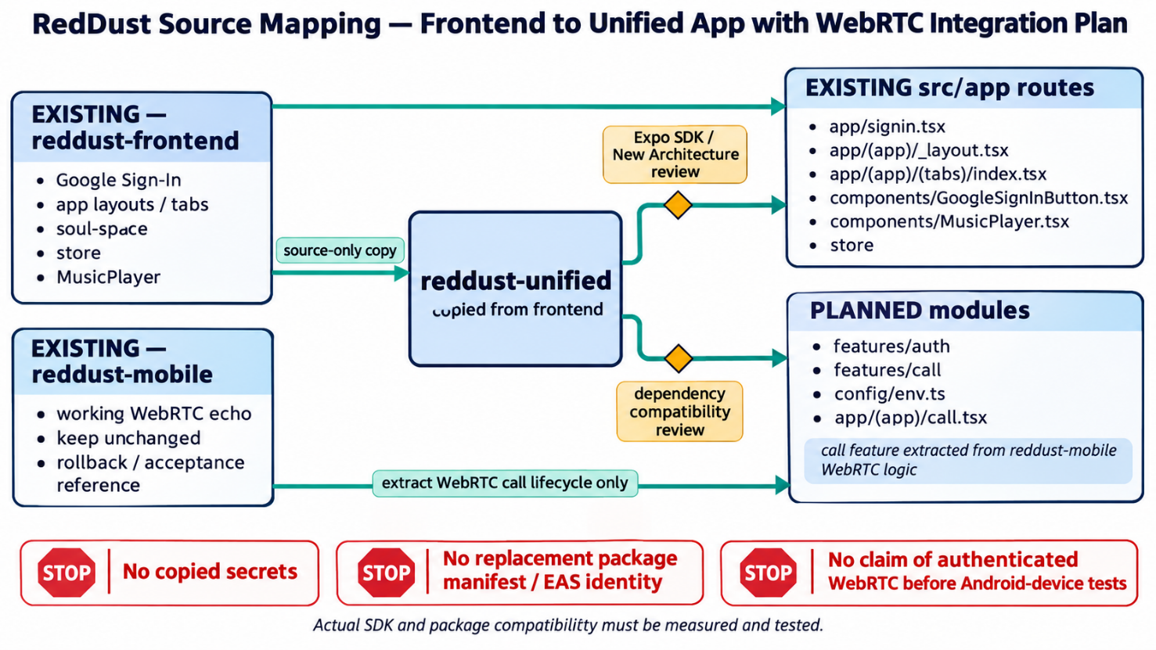

19D.3 — Reconcile Android and iOS Native Permissions and Plugins
PURPOSE: Produce one Expo native development application that can combine existing Google Sign-In/navigation with the proven aiortc/WebRTC echo flow—without losing credentials, identity configuration, microphone access or a working rollback.
CURRENT ACCEPTANCE STATUS: NOT YET ACCEPTED. The copied frontend runs Expo SDK 57-era packages; the latest local Expo Doctor output reported invalid newArchEnabled, New Architecture concerns for Track Player/WebRTC, 16 patch mismatches and prior npm audit findings. Those must be assessed before native integration is declared successful.

19D.3.1 — Boundaries, prerequisites and beginner concepts
A JavaScript change can reload through Metro; adding or changing a native module, Android manifest entry, iOS Info.plist/URL scheme, or config plugin requires a new development binary. Expo Go cannot stand in for a custom WebRTC/Google Sign-In native build.
Layer | Responsibility / source of truth
reddust-unified | Canonical NEW integration workspace. Preserve existing UI, routing and Google Sign-In; no automatic reset of app.json or eas.json.
reddust-frontend | Original signed-in UI source and rollback comparison; do not update native packages here.
reddust-mobile | Proven WebRTC echo source and rollback comparator; do not overwrite or reinitialize.
reddust-auth-api | Google ID-token verification and RedDust JWT issuance. Its RD_GOOGLE_ALLOWED_AUDIENCES remains server-side.
reddust-gateway | Separate /offer signalling service and aiortc media; Bearer/JWT + session/call checks are pending acceptance.
Vocabulary: A config plugin modifies generated native project settings during prebuild; a signing identity is an Android keystore or Apple certificate/profile; a native build compiles code that Metro cannot add later.
STOP: Do not copy keystores, .env.local, JWT private RSA PEMs or Google OAuth client secrets into the mobile repository. OAuth CLIENT IDs may appear in app configuration; private credentials must not.

19D.3.2 — Freeze and inspect the current local baseline before editing
Commands below are read-only until the explicit “edit” steps. Save the inspection result or a redacted screenshot in engineering evidence. Do not paste any secret-bearing configuration into a shared chat.
WHERE: VS Code > Terminal > PowerShell.
Set-Location 'D:\RedDust\reddust-unified'
node --version
npm --version
node -p "'expo='+require('./package.json').dependencies.expo"
node -p "'react-native='+require('./package.json').dependencies['react-native']"
npm ls --depth=0 expo react-native react-native-webrtc `
react-native-incall-manager '@react-native-google-signin/google-signin'
Get-Content .\app.json
Get-Content .\eas.json
Get-Content .\.gitignore
The npm ls command may exit nonzero for modules not installed yet; that is an inventory finding, not permission to install incompatible versions. Review the app configuration locally because other projects may include environment-specific values.
# Identify plugins and approved app identifiers without printing credentials.
node -e "const x=require('./app.json').expo; console.log(JSON.stringify({sdkPkg:require('./package.json').dependencies.expo,androidPackage:x.android?.package,iosBundle:x.ios?.bundleIdentifier,scheme:x.scheme,plugins:(x.plugins||[]).map(p=>Array.isArray(p)?p[0]:p),easProjectId:x.extra?.eas?.projectId},null,2))"
# Record baseline without mutating dependencies:
npx expo-doctor # authorize npx to obtain Expo Doctor diagnostic tool, not make changes to dependencies.
npx expo install --check

19D.3.3 — Make a deliberate Expo SDK / New Architecture decision
Use your actual Expo Doctor output as the decision record; avoid guessing a working pairing. On Expo SDK 57, the New Architecture is mandatory. The invalid app.json newArchEnabled field must be removed from its current location, not set to false. SDK 56 is also New-Architecture-only; changing to SDK 56 alone is not a fallback to the legacy architecture.
Observed item | Required engineering action
app.json: newArchEnabled invalid | Remove the unsupported property; validate JSON and run Expo Doctor again. Do not introduce an alternative false value.
react-native-track-player: unsupported | Check whether MusicPlayer is required for the native acceptance build; isolate/remove only through a reviewed change, test independently and preserve patch-package changes.
react-native-webrtc: untested | Treat as unknown, not proven broken or supported. Compare against reddust-mobile known-good native versions; validate on BOTH physical platforms.
16 Expo/RN version mismatches | After source-control checkpoint, plan the expected patch alignment together; inspect diff of package.json and lockfile. Do not use --force as an escape hatch.
29 audit findings (previous run) | Investigate npm audit and npm audit --omit=dev; prioritize critical/high findings and record accepted/blocked remediation, not just a count.
# After removing the invalid property in VS Code:
node -e "JSON.parse(require('fs').readFileSync('app.json','utf8')); console.log('app.json valid JSON')"
npx expo-doctor
# Review version choices before permitting automated fixes:
npx expo install --check
npm audit --omit=dev
COMPATIBILITY GATE: As of the referenced WebRTC config-plugin documentation, the published version matrix has examples through Expo SDK 56, not an approved SDK 57 combination. Do NOT invent a plugin version or bulk-install a random latest set; approve exact versions through source review, native compile and device evidence.

19D.3.4 — Merge config without overwriting the working frontend
Open app.json and eas.json in VS Code. Preserve name, slug, existing routing/splash/font/Google plugins, assets, scheme, Android package, any iOS bundle identifier, EAS projectId and build profiles. Add or modify only the reviewed entries. One plugins array and one android/ios object must remain—never paste a second duplicate object.
Illustrative SHAPE only: the placeholders below are NOT a replacement app.json and must never be pasted verbatim.
// Within the EXISTING expo object (illustration, not whole JSON):
"plugins": [
"expo-router",
["@react-native-google-signin/google-signin",
{ "iosUrlScheme": "<ACTUAL_REVERSED_iOS_CLIENT_ID>" }],
["@config-plugins/react-native-webrtc",
{ "microphonePermission": "RedDust uses the mic for voice calls." }],
"expo-font"
// Keep all existing applicable plugin entries.
],
"android": {
"package": "<PRESERVE_VERIFIED_EXISTING_PACKAGE>",
"permissions": ["RECORD_AUDIO", "MODIFY_AUDIO_SETTINGS"]
},
"ios": {
"bundleIdentifier": "<PRESERVE_OR_APPROVE_REAL_BUNDLE_ID>",
"infoPlist": {
"NSMicrophoneUsageDescription": "RedDust uses the microphone for voice calls."
}
}
The sample is deliberately not valid standalone JSON (comments and placeholders) and may omit existing permissions/plugins. Merge manually; do not erase required entries. expo config-plugin output is the authority for generated permissions, not the sample.
- Use the Google Sign-In configuration required by the package version actually installed. For NON-Firebase Expo Google Sign-In, its current guide documents iosUrlScheme; obtain that from the real iOS OAuth client. Do not invent it.
- The @config-plugins/react-native-webrtc plugin needs to match the chosen Expo and react-native-webrtc versions. It may add or change platform permissions and minimum OS settings; review its changelog / generated configuration.
- Do not add a second Google Sign-In plugin entry. If the existing entry is a string, replace it with the documented tuple only once the real iOS URL scheme is available and iOS configuration is approved.

19D.3.5 — Android — package identity, permissions and Google OAuth

19D.3.5.1 — Verify application/package and EAS ownership
WHERE: Windows PowerShell in reddust-unified
The actual package name must come from the copied frontend app.json; com.app.reddust shown in the old draft was only an illustration.
Set-Location 'D:\RedDust\reddust-unified'
node -p "require('./app.json').expo.android?.package || 'MISSING'"
node -p "require('./app.json').expo.extra?.eas?.projectId || 'MISSING'"
Get-Content .\eas.json
# If EAS CLI already installed, inspect the signed-in account/project:
eas whoami
eas project:info
If eas is not recognized, install or run a reviewed EAS CLI version; do not run an initialization that silently replaces the existing EAS project. Confirm which Expo account and project own the current frontend.

19D.3.5.2 — Verify Android OAuth client signing fingerprints
In Google Cloud Console > Google Auth Platform > Clients, inspect/create an ANDROID OAuth client for the real Android package and SHA-1 certificate fingerprint of the actual APK signing key. Your Web OAuth client is separately used as the approved ID-token audience for RedDust. An EAS development key, local debug key and Play App Signing key may have different SHA-1 values.
# Interactive credentials metadata review; do NOT print/commit keystore data.
eas credentials --platform android
- Obtain the actual keystore signing certificate SHA-1 via the EAS credentials flow or verified build-signing metadata. Record the fingerprint classification (development, release, Play), not a credential secret.
- In Google Auth Platform > Clients, match Android package + SHA-1 and verify the Web client remains in RD_GOOGLE_ALLOWED_AUDIENCES on the SERVER. Do not put RD_DB_PASSWORD or JWT signing PEM into the phone.
- Do not register /v1/auth/google, /offer or /healthz as OAuth redirect URIs. Those are RedDust API endpoints, not native Google callback URLs.

19D.3.5.3 — Permission manifest + runtime microphone approval
For foreground audio calls, Android RECORD_AUDIO must be declared in the generated app manifest and granted at runtime. MODIFY_AUDIO_SETTINGS may be needed for speaker/earpiece routing; existing native modules may already contribute INTERNET or ACCESS_NETWORK_STATE. Preserve union of required permissions—do not overwrite the list blindly.
// Illustrative React Native runtime gate before getUserMedia:
import { PermissionsAndroid, Platform } from 'react-native';
async function requireMicrophone(): Promise<boolean> {
if (Platform.OS !== 'android') return true;
const result = await PermissionsAndroid.request(
PermissionsAndroid.PERMISSIONS.RECORD_AUDIO
);
return result === PermissionsAndroid.RESULTS.GRANTED;
}
// Only open audio capture when the result is true.
Do not log microphone data, SDP or auth headers. Verify denied, granted and previously-denied flows on a real Android device. Phone-to-Auth/Gateway must use a reachable HTTPS endpoint; 127.0.0.1 on the phone is not the Windows laptop.

19D.3.5.4 — Audio route and network tests
- Check microphone capture and remote audio playback using the known-good reddust-mobile echo reference after the new native build. Test speaker/earpiece, Bluetooth where available, interruption, call end and permission denial.
- Confirm ICE/STUN/TURN configuration in the call feature; the media path uses WebRTC ICE/DTLS/SRTP—not JSON audio and not a JWT in media packets.
- Cleartext HTTP is not acceptable for real credentials over the LAN. Any local debugging exception must be strictly development-only and separately approved; production signalling requires HTTPS.

19D.3.6 — iOS — bundle identity, Google callback scheme and microphone

19D.3.6.1 — Confirm iOS application identity and constraints
Windows + EAS cloud build can produce the iOS native binary, but an installable development build for a physical iPhone needs Apple signing credentials through an Apple Developer membership/team and registered device. A free EAS tier does not remove Apple signing requirements. iOS Developer Mode must be enabled on the test phone.
Set-Location 'D:\RedDust\reddust-unified'
node -p "require('./app.json').expo.ios?.bundleIdentifier || 'NOT CONFIGURED'"
node -p "require('./app.json').expo.scheme || 'NO ROOT SCHEME'"
Get-Content .\eas.json
# Interactive review only:
eas credentials --platform ios
- Choose/confirm one genuine iOS bundle identifier, owned by your Apple developer team. Never silently reuse another app’s production identifier.
- Register an iOS OAuth client in the SAME approved Google Cloud project using the matching iOS bundle ID. Retrieve the actual iOS Client ID and reversed iOS URL scheme (com.googleusercontent.apps.…).

19D.3.6.2 — Configure Google Sign-In callback correctly
For a non-Firebase Expo setup using the existing Google Sign-In package, preserve the plugin and supply the real iosUrlScheme once available. This is a native Google callback URL scheme, NOT a web OAuth redirect URI and NOT an Auth API route.
// Illustrative plugin entry within EXISTING expo.plugins:
[
"@react-native-google-signin/google-signin",
{ "iosUrlScheme": "<REAL_GOOGLE_REVERSED_IOS_CLIENT_ID>" }
]
The phone obtains a Google ID token for the configured approved Web client; RedDust FastAPI verifies the signature/iss/aud/exp/sub; Google identity alone does not authorize RedDust calls. iOS client registration and webClientId audience serve different purposes.

19D.3.6.3 — Configure iOS microphone purpose string and audio session
For voice input, ensure the generated Info.plist contains NSMicrophoneUsageDescription with a clear user-facing purpose. The WebRTC config plugin can supply this string; alternatively reconcile ios.infoPlist without duplicating or conflicting. A camera permission is NOT required solely for audio-only calls; inspect any camera setting a plugin auto-generates before distribution.
// Within EXISTING expo.ios (illustrative only):
"infoPlist": {
"NSMicrophoneUsageDescription":
"RedDust uses the microphone during voice conversations."
}
- Audio session/route ownership must be decided between WebRTC, InCallManager and the existing Track Player. Test hands-free, speaker/earpiece, Bluetooth, interruptions, and cleanup on iPhone; do not assume Android audio routing applies to iOS.
- Do not add UIBackgroundModes/audio unless an explicitly designed, tested background calling capability needs it; background audio requirements introduce separate review and privacy obligations.
- For eventual App Store distribution, review Apple guideline 4.8 for third-party login equivalence; Google-only primary-account sign-in may require another privacy-preserving login option unless an exception applies.

19D.3.7 — Resolve WebRTC, InCallManager and Track Player native compatibility
This is the engineering STOP gate shared by Android and iOS. The successful echo in reddust-mobile proves that older build, not the proposed combined native binary. Do not combine manifests by copy/paste or transplant the original phone app’s entire navigation tree.
Component | Decision before native build
react-native-webrtc | Compare baseline versions with the proven source; select a tested package + matching config-plugin version for the actual Expo SDK; validate SDK 57 New Architecture behavior on device.
react-native-incall-manager | Only include if its exact native version is compatible with chosen React Native/iOS/Android build; verify how it manages audio session/route with WebRTC.
react-native-track-player + patch-package | Confirm patched native dependency still builds under the required New Architecture. If incompatible, isolate existing MusicPlayer only through an approved change.
Google Sign-In native module | Preserve current working package; verify actual plugin setting, Android SHA-1, iOS URL scheme and the chosen API version.
expo-router / existing plugins | Preserve route groups, fonts, splash, navigation scheme and EAS identity; rebuild only after configurations are reconciled.
STOP: Do not mark “WebRTC integrated” because npm installs or Expo Doctor changes to green. Require APK/IPA native compile, physical-device Google sign-in and real audio path validation. A test failure must preserve the original two projects.

19D.3.8 — Inspect the resolved Expo config and EAS build profile
Once plugin choices and package updates have been peer reviewed, inspect the final configuration. Introspection shows generated iOS/Android native metadata without intentionally producing a distributable binary; some dangerous native modifications are not fully visible here and still need build verification.
Set-Location 'D:\RedDust\reddust-unified'
node -e "JSON.parse(require('fs').readFileSync('app.json','utf8')); console.log('JSON OK')"
npx expo config --type public
npx expo config --type introspect
npx expo-doctor
npm ls expo react-native react-native-webrtc `
react-native-incall-manager '@react-native-google-signin/google-signin'
Review the generated Android microphone permission and the iOS Info.plist microphone purpose string, Google URL scheme, native plugin modifications and build profile. Introspection is not proof that compile or microphone permission succeeds on hardware.

19D.3.8.1 — EAS development profile
Verify the existing eas.json first. A development profile commonly has developmentClient=true and distribution=internal; merge without removing existing Android/iOS settings, release profiles or the established Expo project linkage.
// Shape ONLY — merge into EXISTING eas.json; do not replace the file.
"build": {
"development": {
"developmentClient": true,
"distribution": "internal"
}
}
Build tools may prompt to create or select signing credentials. Inspect who owns the Expo project and Apple team first. Do not commit or share keystore, certificate private keys, provisioning secrets or EAS access tokens.

19D.3.8.2 — Create native binaries only after gates are approved
# Use EAS CLI already configured for the correct account/project.
eas whoami
eas project:info
# Android development APK (after signing/OAuth and compatibility approval):
eas build --platform android --profile development
# iPhone device build (requires Apple Developer signing + registered device):
eas device:register
eas build --platform ios --profile development
Run iOS device registration only for the correct Apple team/device, and only when iOS is ready. On a physical device, enable Developer Mode, install the development build, and start Metro for the unified project. The phone must reach the approved HTTPS Auth API/Gateway addresses—not the laptop loopback host.
# Start the JavaScript bundler AFTER the matching native build is installed:
npx expo start --dev-client

19D.3.9 — Android and iOS acceptance matrix
Acceptance test | Android phone | iPhone
Native module loads | Google Sign-In + WebRTC + routing load; no missing-native-module crash | Same; iOS URL scheme and signed installation verified
Google identity | Correct Android SHA-1/package; ID token reaches approved Auth API | Correct iOS client/bundle/scheme; ID token reaches approved Auth API
Authorization | JWT Bearer on HTTPS /offer signalling; revoked/foreign call denied | Same after auth/call ownership controls are implemented
Microphone | Runtime grant, deny and reopen states | NSMicrophoneUsageDescription prompt; deny/retry
Media transport | Offer/answer ICE/DTLS/SRTP echo, speaker/earpiece and cleanup | Same, plus iOS audio-session/interruptions
Security boundary | No DB/password/private RSA key or raw bearer credentials in logs | Same
Evidence | Build ID, test date, sanitized logs, package & SHA-1 class | Build ID, test date, bundle & Apple team/device class
GATEWAY DEPENDENCY: Until Step 19C authentication/session validation and Gateway /offer ownership enforcement pass integration tests, label “Google-authenticated calling” as TARGET / PENDING—not complete. WebRTC echo alone does not prove authorization.

19D.3.10 — Evidence, rollback and change control
Keep a compact, non-secret evidence report under docs/evidence; record exact tested SDK/RN/native package versions, npx expo-doctor findings, approved plugin pairing, signing identities (names/fingerprints only), EAS build IDs and device test results. Mark the known 29 audit findings as investigated/accepted/remediated by owner and review date.
Set-Location 'D:\RedDust\reddust-unified'
New-Item -ItemType Directory -Force '.\docs\evidence' | Out-Null
$report = '.\docs\evidence\19D_3_Native_Config_Review.txt'
@(
'RedDust 19D.3 — native config review (no secrets)'
('Local date: ' + (Get-Date -Format 'yyyy-MM-dd HH:mm:ss zzz'))
('Node: ' + (node --version))
('npm: ' + (npm --version))
('Expo package: ' + (node -p "require('./package.json').dependencies.expo"))
('React Native package: ' + (node -p "require('./package.json').dependencies['react-native']"))
'Expo Doctor / native build acceptance: PENDING REVIEW'
) | Set-Content -Path $report -Encoding UTF8
Get-Content $report
Save detailed doctor output separately only after checking it contains no secret values; this template deliberately does not assert success. A new build changes the binary; preserve earlier known-good APK/IPA and Git commit to roll back safely.

19D.3.11 — Diagram placeholders for team onboarding
DIAGRAM 19D-03A — Android and iOS Native Build Reconciliation
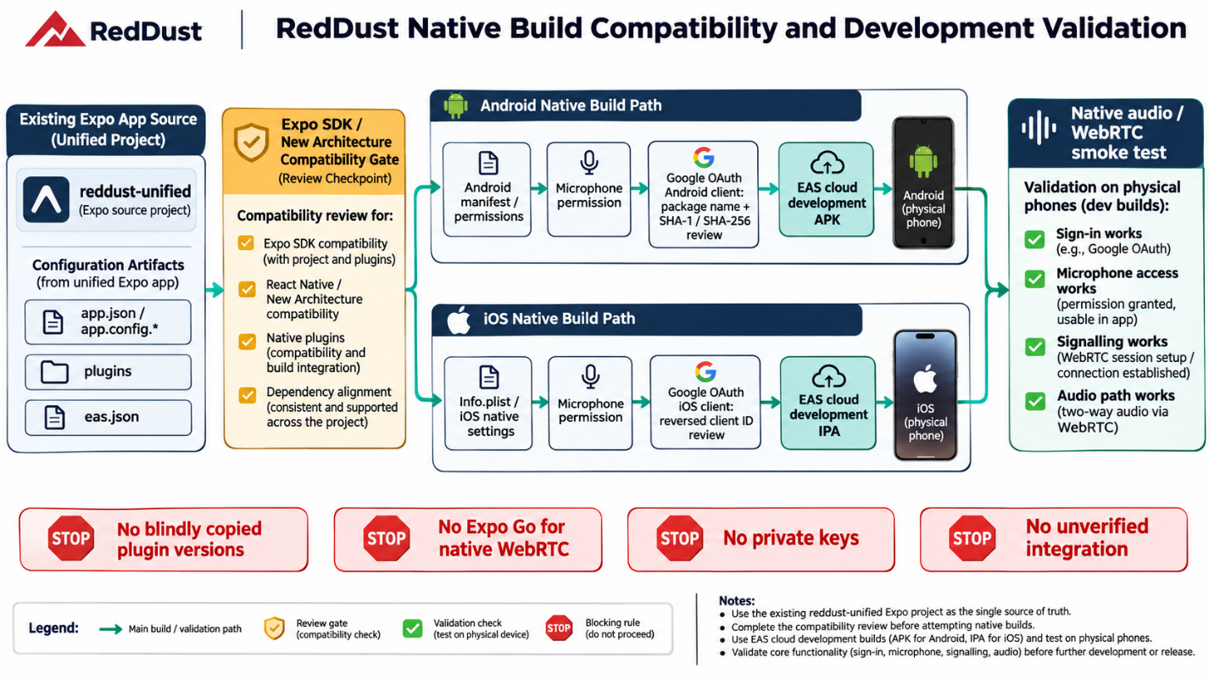
DIAGRAM 19D-03B — Three Google OAuth Clients and One RedDust Backend Audience
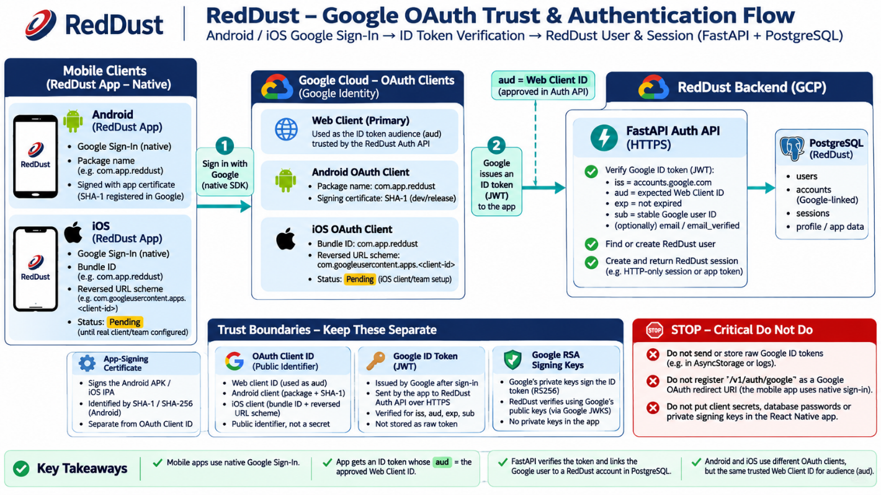

19D.3.12 — Final handoff / acceptance gate
Gate | Pass condition
Configuration | Actual package/bundle/scheme/EAS project preserved and reviewed; no duplicate plugin entries or unsupported newArchEnabled.
Dependencies | Approved Expo/React Native pairing and WebRTC plugin; Track Player/InCallManager compatibility disposition; high/critical audit triaged.
Native permissions | Android RECORD_AUDIO + runtime test; iOS NSMicrophoneUsageDescription and device permission test.
Identity / sessions | OAuth clients align with real signing/bundle IDs; Auth API approves aud; no credentials embedded.
Build / media | New physical-device Android and (when funded/signed) iOS dev builds; routing/ICE/DTLS/SRTP tested.
Ownership / evidence | Peer-reviewed diffs, build IDs, redacted results, rollback commit; Gateway auth remains pending until verified.
STOP / DO NOT PROCEED TO COMPLETED STATUS: If SDK/new-architecture incompatibility remains unresolved; a native permission or Google callback fails; an EAS project/Android package/iOS bundle changes unexpectedly; a secret is copied; or the Gateway accepts unverified SDP. Read-only mapping from 19D.2 may continue, but 19D.3 native acceptance cannot be claimed.

References — Official documentation and version authority
- Expo — New Architecture: https://docs.expo.dev/guides/new-architecture/
- Expo — Permissions: https://docs.expo.dev/guides/permissions/
- Expo — Introspection: https://docs.expo.dev/config-plugins/development-and-debugging/
- Expo — EAS profiles: https://docs.expo.dev/build/eas-json/
- Expo — iPhone development build: https://docs.expo.dev/tutorial/eas/ios-development-build-for-devices/
- Google Sign-In — Expo: https://react-native-google-signin.github.io/docs/setting-up/expo
- Google Sign-In — OAuth clients / SHA-1: https://react-native-google-signin.github.io/docs/setting-up/get-config-file
- WebRTC config-plugin compatibility: https://github.com/expo/config-plugins/blob/main/packages/react-native-webrtc/README.md
- Apple — App Review guidelines 4.8: https://developer.apple.com/app-store/review/guidelines/

19D.4 — Replace optimistic Google-only state with backend-verified login
What this section does and why it matters: Convert Google sign-in success into a RedDust user/session accepted by the server.
New technical concepts introduced in this section (in absolute beginner terms): A local isAuthenticated Boolean is a UI convenience; it is not proof the backend authorized the user.
// Pseudocode within GoogleSignInButton.handleGoogleSignIn()
const response = await GoogleSignin.signIn();
if (response.type !== 'success') return;
const googleIdToken = response.data.idToken;
if (!googleIdToken) throw new Error('Google ID token is unavailable');
const rd = await authApi.exchangeGoogleIdToken({
id_token: googleIdToken,
installation_id: await getOrCreateInstallationId(),
platform: 'android',
});
await saveTokensToSecureStorage(rd.access_token, rd.refresh_token);
useAuthStore.getState().setVerifiedSession({
user: rd.user, authSessionId: rd.auth_session_id,
accessToken: rd.access_token, expiresIn: rd.expires_in,
});
router.replace('/(app)/(tabs)');
Implement getOrCreateInstallationId with stable local storage but do not rely on it for authentication. Use expo-secure-store (or an audited equivalent) for tokens, not the existing Zustand AsyncStorage persistence. Do not persist Google userInfo or access/refresh tokens in the current reddust-auth-storage object. Persist only non-sensitive UI state; on cold start securely recover the refresh token and revalidate via auth-api before showing a protected screen.

19D.5 — Design the authenticated navigation and call lifecycle
What this section does and why it matters: Make login, call initiation and teardown explicit application states.
New technical concepts introduced in this section (in absolute beginner terms): A state machine prevents double-start, stranded microphones and phantom logged-in sessions.
App launch → auth bootstrap → SIGNED_OUT or SIGNED_IN
SIGNED_OUT → Google sign-in → auth-api /v1/auth/google → SIGNED_IN
SIGNED_IN → CallScreen → POST /v1/calls → STARTING
STARTING → getUserMedia() → pc.addTrack() → createOffer()
→ ICE gathering complete → POST Gateway /offer
Authorization: Bearer <RedDust access token>
body: {call_session_id, sdp, type}
→ setRemoteDescription() → ICE connected → IN_CALL
IN_CALL → End → close pc / stop tracks / InCallManager.stop()
→ POST /v1/calls/{id}/end → SIGNED_IN
SIGN_OUT → revoke auth session, clear secure tokens and UI state,
immediately close any active call → SIGNED_OUT

19D.6 — Move the proven WebRTC implementation without rewriting its signal path
What this section does and why it matters: Retain the verified media path from Steps 16–19B while changing only ownership and authorization around signalling.
New technical concepts introduced in this section (in absolute beginner terms): Codec and RTP encryption happen in WebRTC; the React Native app does not manually transport PCM packets over HTTP.
• Extract mediaDevices.getUserMedia, RTCPeerConnection creation, STUN, track attachment, offer/answer, ICE wait, remote-track listener, speaker toggle and cleanup from mobile/src/app/index.tsx into one call feature.
• Use peerConnectionRef and remoteStreamRef inside the feature; guard concurrent Starts, enforce ICE gather timeout, handle errors and stop tracks on every exit path.
• Keep EXPO_PUBLIC_GATEWAY_URL and EXPO_PUBLIC_AUTH_API_URL as nonsecret environment variables. Validate they are configured; do not interpolate undefined into a URL.
• Preserve the exact 19B prompt → silence → echo acceptance test. Adding Google authentication must not change audio timing/echo behavior.
// callApi.ts — contract sketch only
const res = await fetch(`${gatewayBase}/offer`, {
method: 'POST',
headers: {
'Content-Type': 'application/json',
Authorization: `Bearer ${accessToken}`,
},
body: JSON.stringify({call_session_id: callSessionId,
sdp: pc.localDescription?.sdp, type: pc.localDescription?.type}),
});
if (res.status === 401) throw new Error('RedDust session expired');
if (!res.ok) throw new Error(`Gateway signalling failed: ${res.status}`);
await pc.setRemoteDescription(new RTCSessionDescription(await res.json()));
Security-critical backend dependency: Do not merely add an Authorization header on the phone. Implement Gateway validation and call ownership checks before enabling authenticated calls. A mobile-supplied user_id, email or call_session_id alone cannot authorize an offer.

19D.7 — Connect Gateway to the identity/call service
What this section does and why it matters: Gate new SDP negotiations on a verified RedDust session and an owned active call.
New technical concepts introduced in this section (in absolute beginner terms): Service-to-service trust verifies the phone’s token without trusting self-declared user details.
Recommended Gateway middleware/helper: verify JWT signature against the auth service public key/JWKS; check issuer, audience, expiration, subject, auth_session_id and call-session ownership/status through a trusted DB/service lookup or short-lived signed call authorization. Avoid sending JWT in SDP, ICE candidates, audio metadata or log messages. The existing /offer {sdp,type} schema must be extended intentionally and tests updated; return 401 for missing/invalid token, 403 for mismatched call, 422 for malformed offer.

19D.8 — Run the three-terminal local integrated test
What this section does and why it matters: Test auth-api, Gateway and Metro as distinct processes against the same physical Android phone.
New technical concepts introduced in this section (in absolute beginner terms): A green HTTP result from sign-in does not imply media connectivity, and a media connection does not imply authorized identity.
# Terminal A: PostgreSQL Windows service is running; auth-api:
cd D:\RedDust\reddust-auth-api
.venv\Scripts\Activate.ps1
python -m alembic upgrade head
python -m uvicorn app.main:app --reload --host 0.0.0.0 --port 8100
# Terminal B: Gateway (once authenticated /offer integration passes unit tests):
cd D:\RedDust\reddust-gateway
.venv\Scripts\Activate.ps1
python -m uvicorn app.main:app --reload --host 0.0.0.0 --port 8000
# Terminal C: unified app:
cd D:\RedDust\reddust-unified
npx expo-doctor
npx expo start
# EAS development APK must already contain ALL approved native plugins.
For first local tests, set EXPO_PUBLIC_AUTH_API_URL=http://LAPTOP_WIFI_IP:8100 and EXPO_PUBLIC_GATEWAY_URL=http://LAPTOP_WIFI_IP:8000 in ignored .env.local. This is an explicitly temporary same-LAN development exception; never expose ID tokens or Bearer credentials on cleartext networks outside an approved controlled environment. Prefer HTTPS even in development when practical.

19D.9 — Acceptance checklist, fault injection and rollback
What this section does and why it matters: Require one user journey to pass plus negative authorization and device cleanup tests.
New technical concepts introduced in this section (in absolute beginner terms): Acceptance evidence ensures a secure feature integration does not undo a known-good media proof.
Test | Pass criterion
A. Fresh install and sign-in | Google UI → verified /v1/auth/google → stable RedDust user UUID + auth session ID
B. Invalid Google token | Server rejects; protected UI and Gateway are not opened
C. Start call | Created call_session_id; Gateway authenticated /offer; ICE connected; remote track arrives
D. Audio regression | Audible Hello RedDust Echo → ~2 s silence → echoed speech; speaker/earpiece toggle works
E. Unauthorized call | Anonymous/mismatched/expired token and foreign call ID denied with no PeerConnection allocation
F. Logout during call | Stop mic/pc/routing, revoke backend auth session, clear secure tokens + UI state, redirect to signin
G. App restart/session expiry | Secure bootstrap refreshes valid session or sends user to sign-in; no stale persisted auth Boolean
H. No secrets in logs | No JWT, ID token, refresh token, Google profile JSON, raw SDP, PCM or transcripts
I. Data integrity | One Google sub resolves to same user; audit/call records attach correct UUIDs
J. Rollback | Unmodified reddust-mobile still reproduces Step 19B echo independently
DIAGRAM — 19D-A: One Android client, two control-plane services, one media path


