
MVP WORKFLOW

1. User submits input
User uploads a selfie and answers the questionnaire on the Shopify frontend. This creates a customer_session row.
2. Image goes to a vision LLM
The image is preprocessed (quality/blur checks) and sent with a prompt asking it to return, in JSON, which of your ~32 skin concerns it detects .
3. Questionnaire answers go to a text LLM, separately
The questionnaire responses are sent in their own prompt, and the LLM returns its own JSON list of detected concerns.
We now have two independent JSON opinions about the same user: one from the face, one from the answers.
4. Concern fusion
We combine those two JSONs into one final concern list per user This combined result gets written into session_skin_concern_score (one row per concern per session).
concern_score = questionnaire_concern OR image_concern
5. Safety gate
Before anything touches the formulation LLM, we run a SQL filter: take the user's declared allergens/contraindications (from the questionnaire) and remove any active ingredient that's excluded for that user.
6. Build the candidate shortlist
For the user's confirmed concerns, we join concern_benefit (which benefits matter for each concern, and how — PRIMARY/SECONDARY/SUPPORTING, plus the rationale text) with active_benefit_score (the raw 0–20 efficacy scores) and base_active_compatibility. This gives us a filtered, structured JSON packet: "here are the concerns, here are the safe, relevant actives and bases, here's the supporting evidence" — nothing irrelevant or excluded is in there.
7. Formulation LLM call
That shortlist packet gets sent to the LLM with a prompt asking it to pick actives, a base, dosing (grams per 100g), and write an explanation — this is where the actual "which actives, how much, why" decision-making happens for MVP.
8. Store the result
Formulation gets written to formulation + formulation_active. Every LLM call along the way (image, questionnaire, formulation) gets logged to audit_log for traceability.

9. Response to frontend
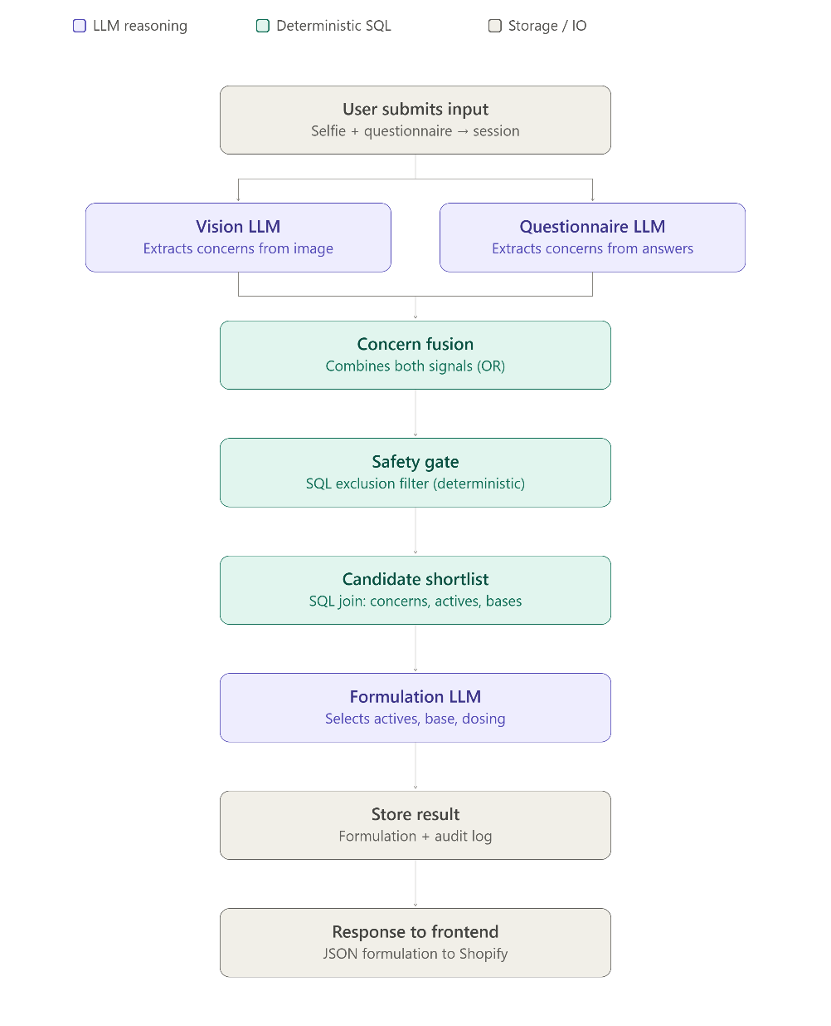
Final JSON — formulation, actives, explanation — goes back to Shopify to render for the user.

