 | Q.No. | Question | ExpectedTime  to complete
 | 1 | Lab 3: Prompt Engineering – Improving Prompts and Context Management  Lab Objectives:  - To understand how prompt structure and wording influence AI-generated code.  - To explore how context (like comments and function names) helps AI generate relevant output.  - To evaluate the quality and accuracy of code based on prompt clarity.  - To develop effective prompting strategies for AI-assisted programming.  Lab Outcomes (LOs):  After completing this lab, students will be able to:  - Generate Python code using Google Gemini in Google Colab.  - Analyze the effectiveness of code explanations and suggestions by Gemini.  - Set up and use Cursor AI for AI-powered coding assistance.  - Evaluate and refactor code using Cursor AI features.  - Compare AI tool behavior and code quality across different platforms.  Task Description#1  - Try 3 different prompts to generate a factorial function.  Expected Output#1  - Comparison of AI-generated code styles  Prompt1: Generate a python function to calculate factorial of 5.  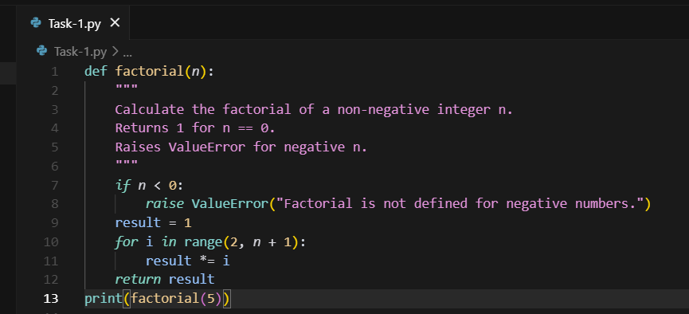  OUTPUT:  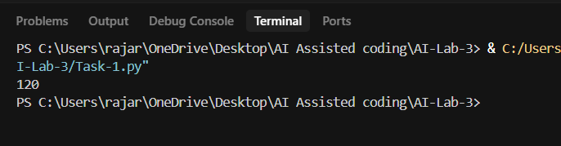  Prompt2: Write python function that take input from console and return factorial of the number user entered  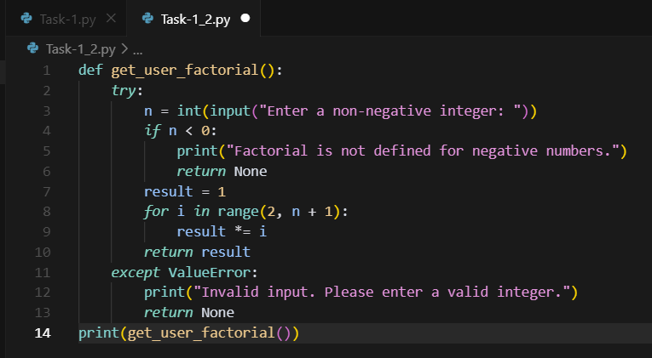  OUTPUT:  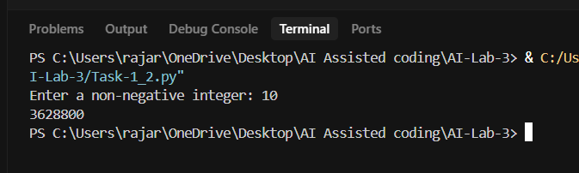  Prompt3: Create a Python program to compute the factorial of a number using recursion with proper function docstring.  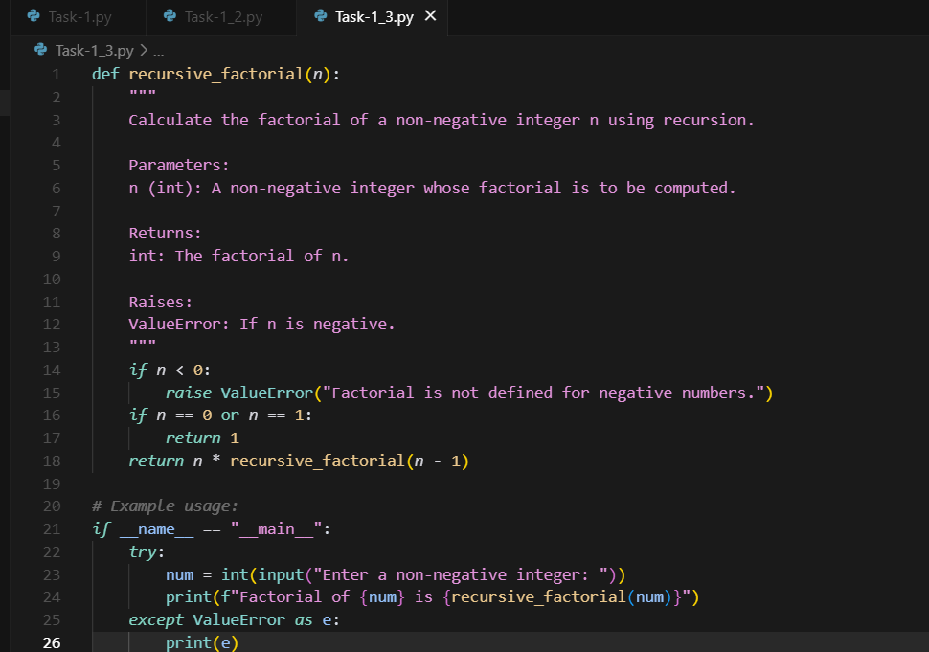  Output:  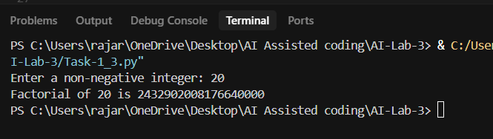  Report: These three codes all do the same job finding the factorial of a number but in different ways. The first one is simple and straight to the point, good if you just want to use it inside another program. The second one feels more user-friendly since it asks for input and handles errors, but it’s less flexible for reuse. The third one uses recursion, which looks neat and matches the mathematical definition, but it’s not the best for very large numbers. In short, each code has the same purpose but fits different situations depending on what you need.  Task Description#2  - Provide a clear example input-output prompt to generate a sorting function.  Expected Output#2  - Functional sorting code from AI  Prompt: Write a Python function that takes a list of integers as input and returns the list sorted in descending order  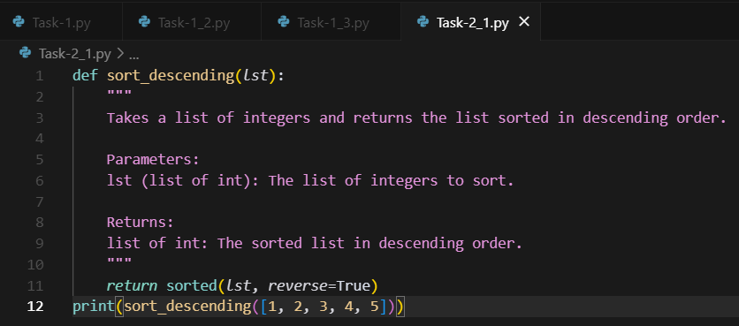  OUTPUT:  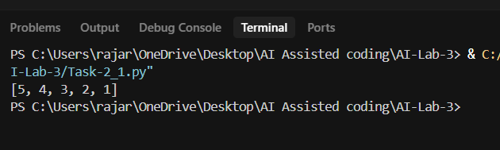  Task Description#3  - Start with the vague prompt “Generate python code to calculate power bill” and improve it step-by-step  Expected Output#3  - Enhanced AI output with clearer prompts  PROMPT: Generate python code to calculate power bill  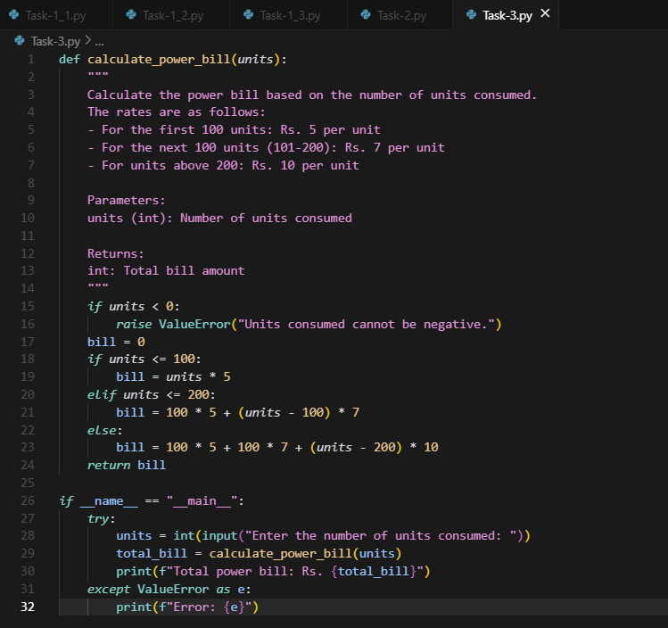  OUTPUT:  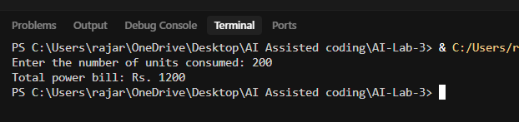  Prompt-2: Write a Python function `calculate_bill(units: float) -> float` to compute an electricity bill for domestic consumers using slab rates:  - 0–100 units @ ₹3.00/unit  - 101–200 units @ ₹4.50/unit  - 201–300 units @ ₹6.00/unit  - Above 300 units @ ₹8.00/unit  Add a fixed charge of ₹50 to every bill.  Validate that units ≥ 0, else raise ValueError.  Return the final amount rounded to 2 decimals.  Include a docstring and two example calls.  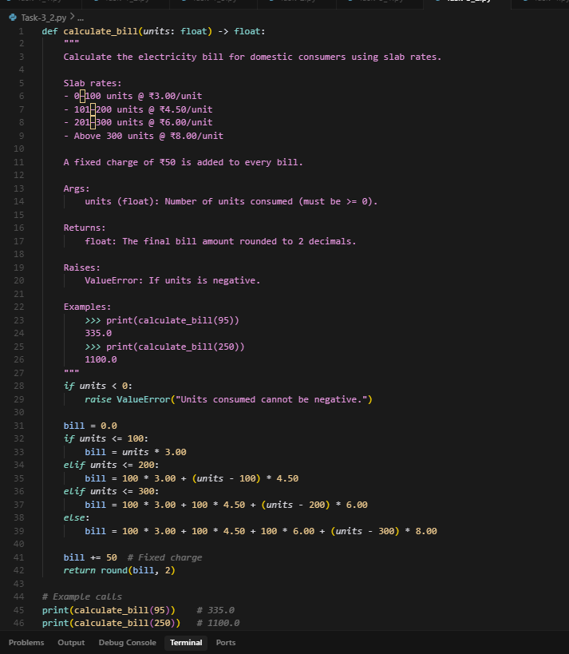  OUTPUT:  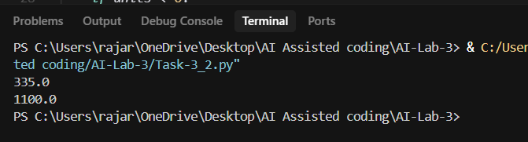  Report: I gave 2 prompts 1st prompt is very vague and the 2nd one is much clearer a structured specifying prompt (Slab rates, docstring etc)  1st: It takes units from user and multiplies by fixed rates and prints total bill. No fixed charge, no error Handling, no slab system it is a plain code. Maintainability is poor and realism is very low.  2nd: Function returns bill amount and more reusable and this works for only one category no taxes are involved we can be more specific about taxes. It is slab based, Documentation using Docstring and examples realism is much higher and fixed chargers and quality in terms of correctness.  Increasing prompt specificity directly improves AI output quality in terms of correctness, realism and maintainability.  Task Description#4  - Write structured comments to help AI generate two linked functions (e.g., login_user() and register_user()).  Expected Output#4  - Consistent functions with shared logic  Prompt: Generate two Linked functions Square and sum of squares.  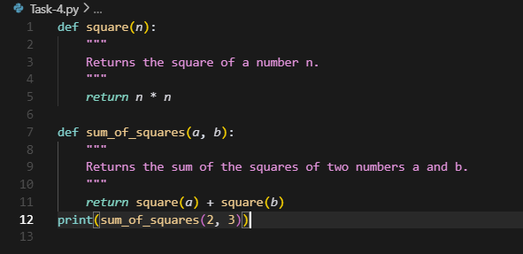  OUTPUT:  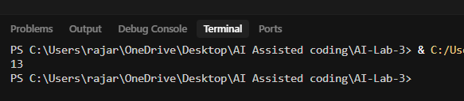  Task Description#5  - Analyzing Prompt Specificity: Improving Temperature Conversion Function with Clear Instructions  Expected Output#5  - Code quality difference analysis for various prompts  Prompt-1: Write a Python function to convert Celsius to Fahrenheit and Kelvin.  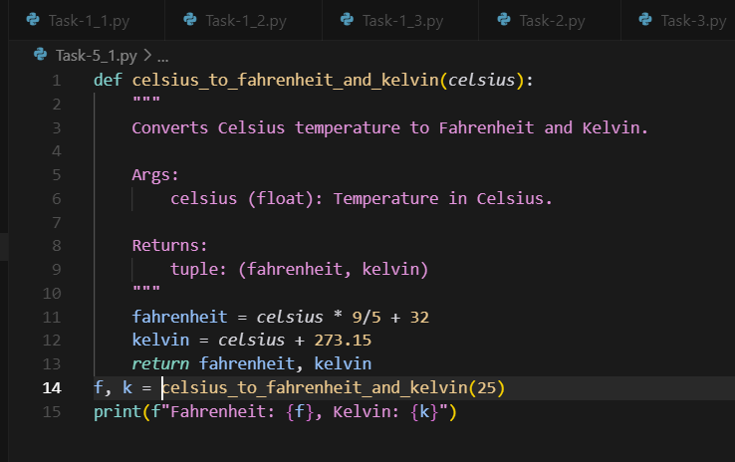  Output:  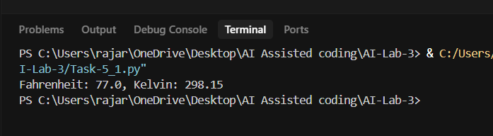  Prompt-2: Write a Python function convert_temp(value, from_unit, to_unit) that:  - Supports Celsius, Fahrenheit, Kelvin  - Raises ValueError for invalid units  - Disallows temperatures below absolute zero  - Includes docstrings and type hints  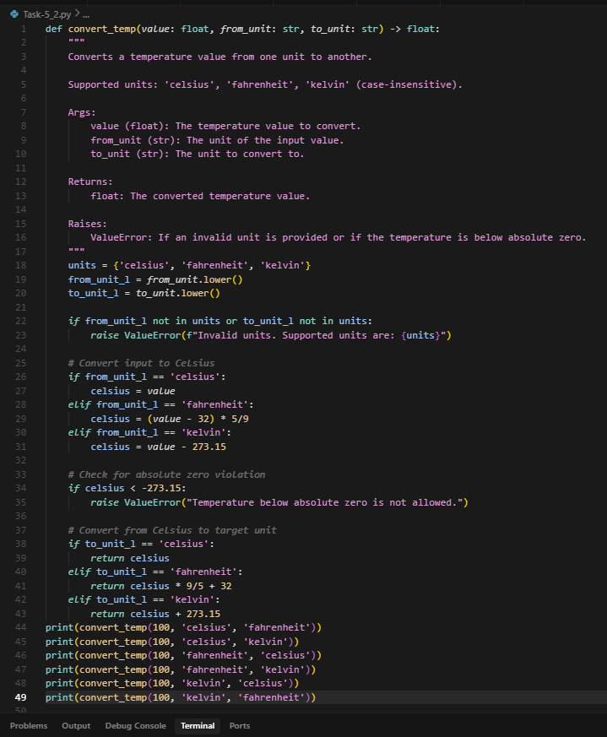  OUTPUT:  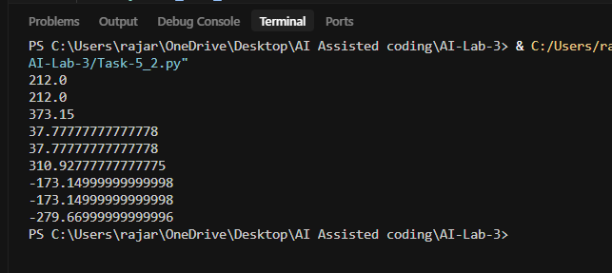  Report: I gave 2 prompts 1st prompt is very vague and the 2nd one is much clearer a structured specifying prompt  1st: It converts Celsius to Fahrenheit, kelvin it is simple and good for conversions, function is reusable. It cannot handle reverse conversions and does not use try and error block. Maintainability is medium, realism is low and function design is for single purpose.  2nd: Produced a robust and reusable utility with full conversions, input validation, docstrings, and type hints. No optional rounding or extra features. Error handling: raises ValueError for bad units. Docstring + type hints improve readability.  Specific prompts that mention requirements (validations, constraints, documentation) push the AI to generate production-quality code instead of bare-bones scripts.  Note: Report should be submitted a word document for all tasks in a single document with prompts, comments & code explanation, and output and if required, screenshots  Evaluation Criteria: | 03.08.2025 EOD
  Criteria | Max Marks
  Factorial Function (Task#1) | 0.5
  Sorting Function (Task#2) | 0.5
  Vogue Vs. Specific Prompting (Task #3) | 0.5
  Linked Functions (Task #4) | 0.5
  Temperature Conversion Function (Task #5) | 0.5
  Total | 2.5 Marks

