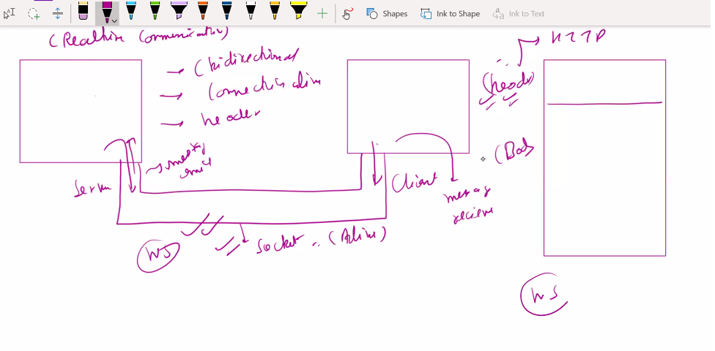

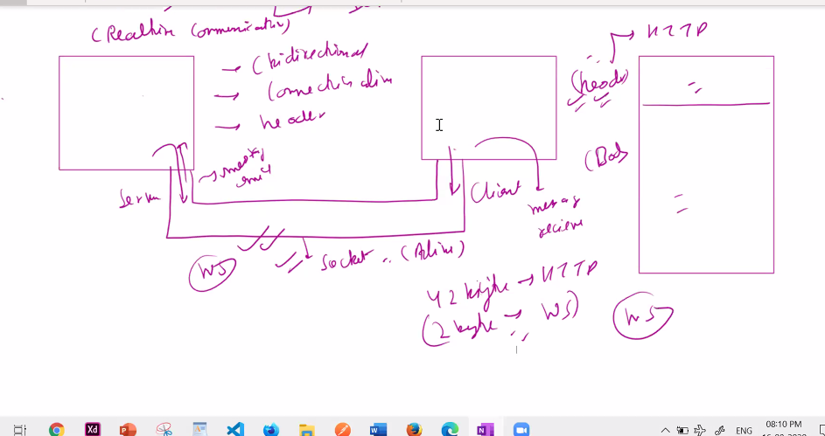

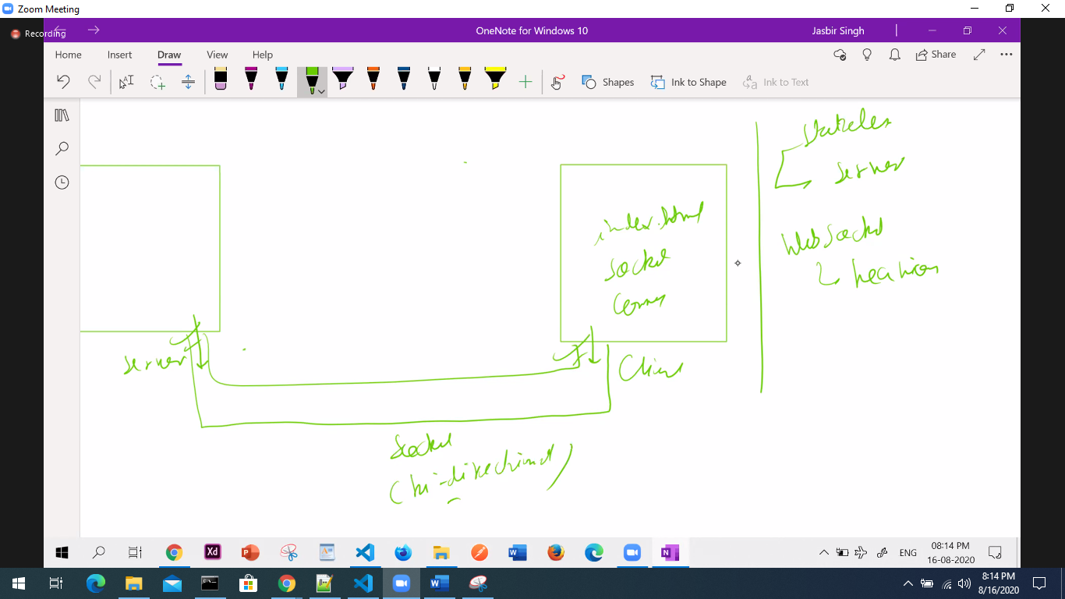

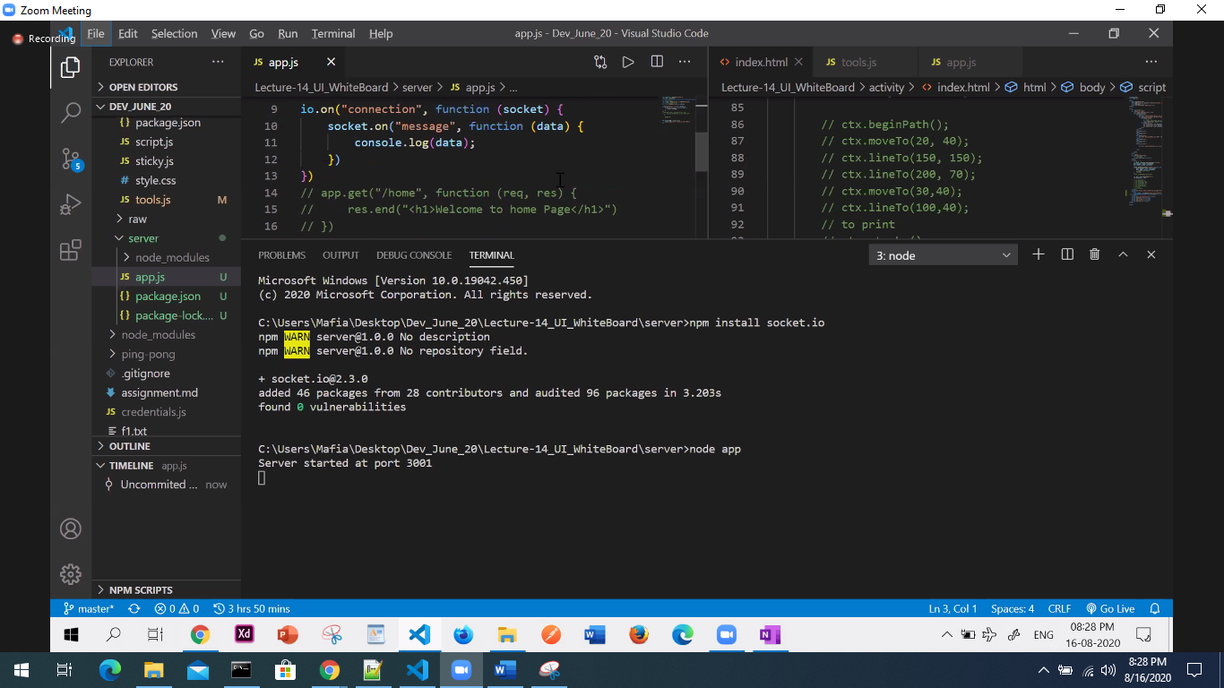

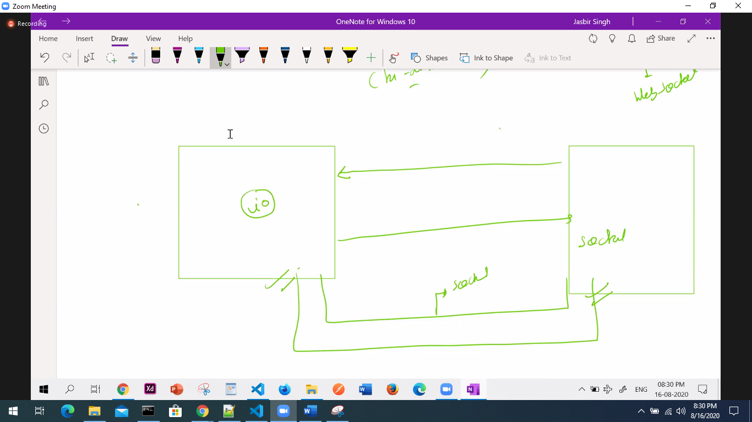

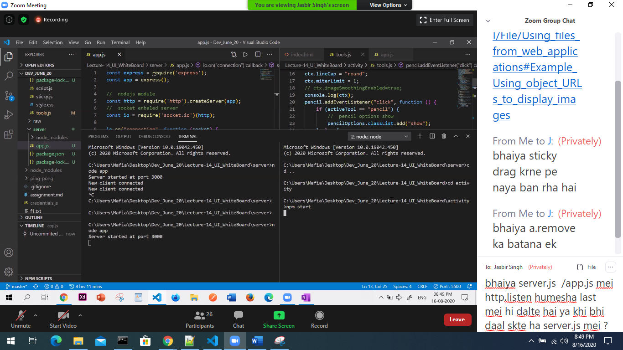

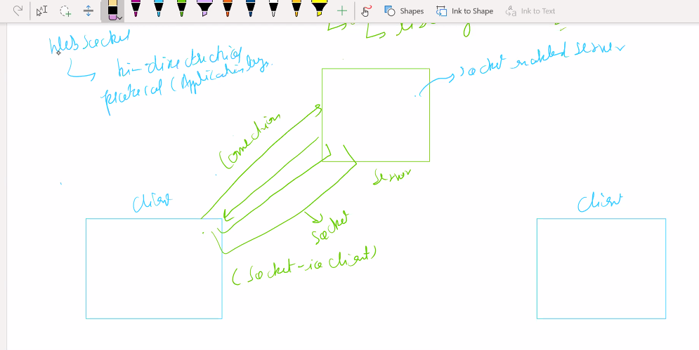

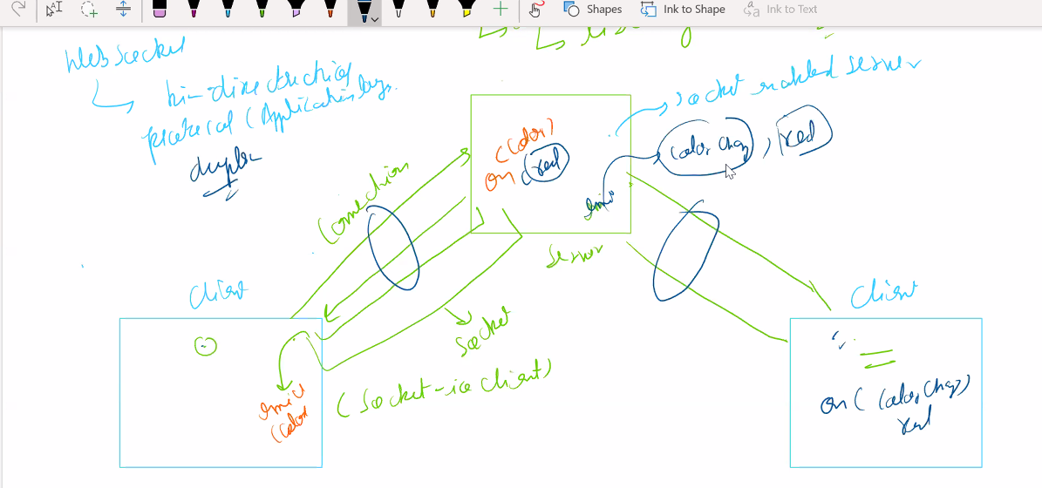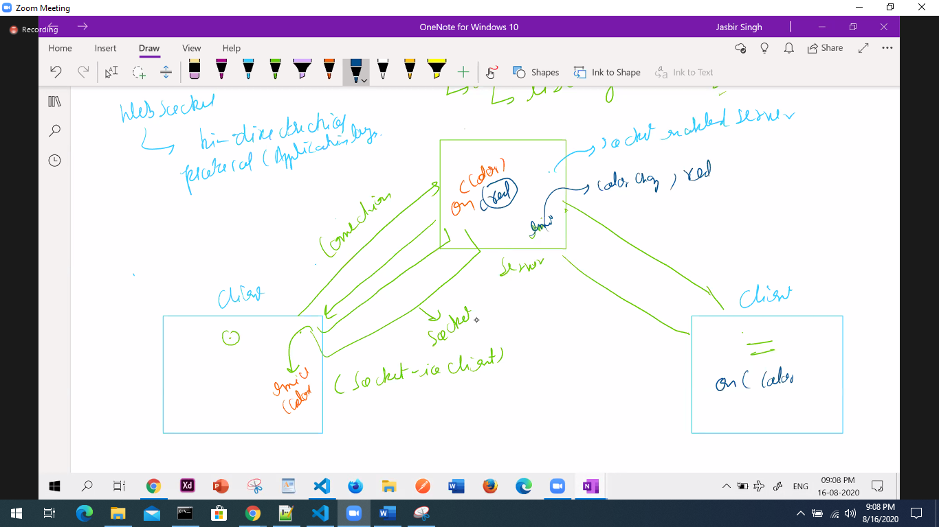

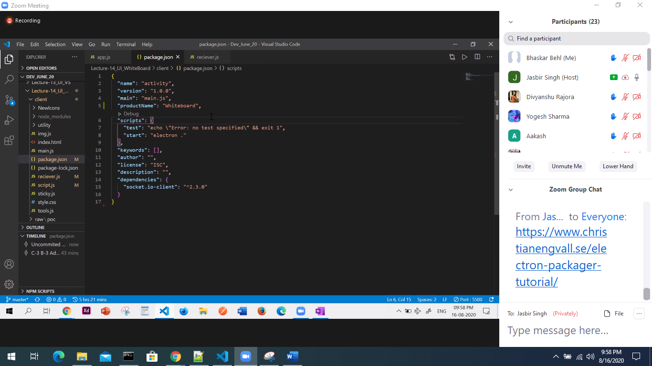

<https://www.christianengvall.se/electron-packager-tutorial/>

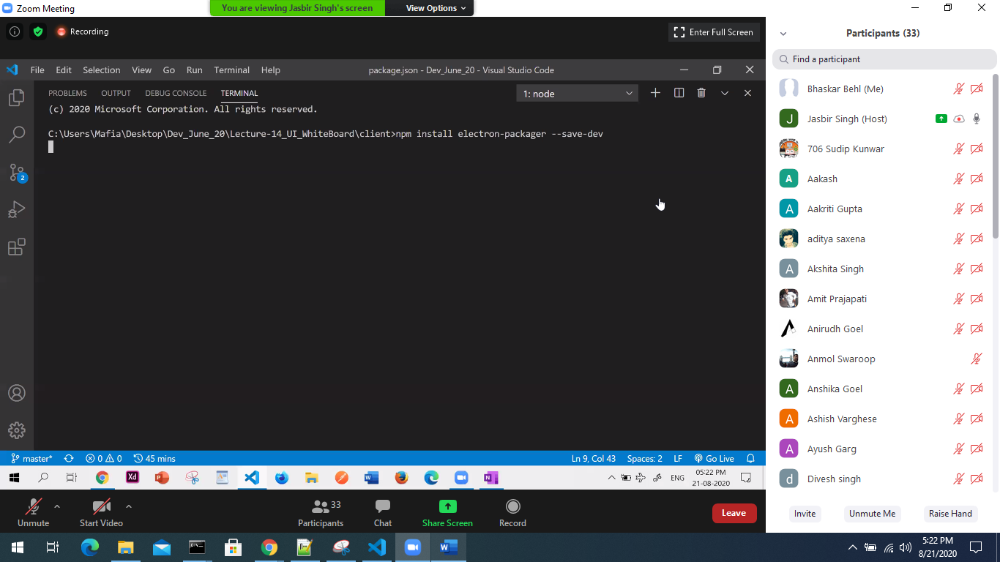

npm install electron-packager --save-dev

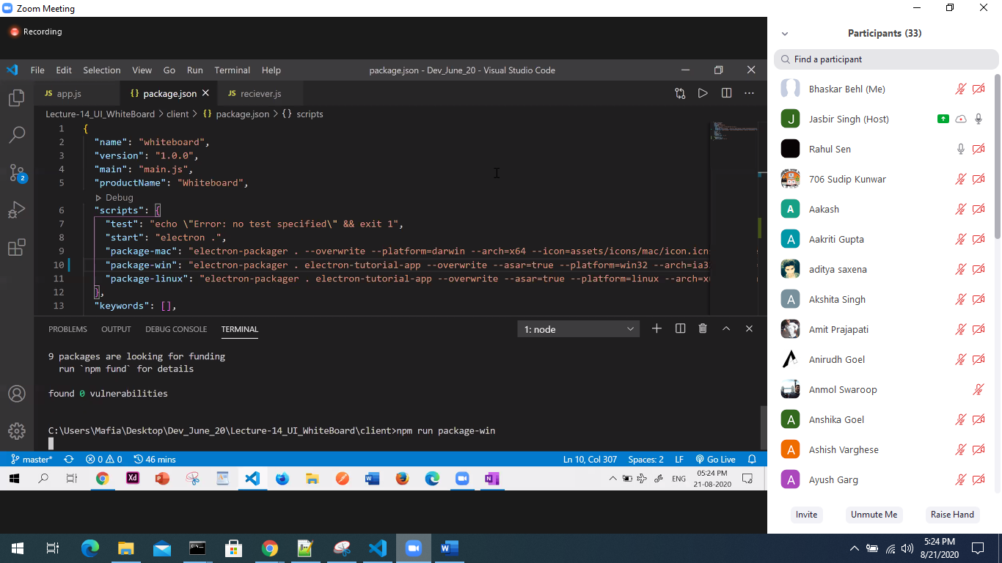

npm run package-win

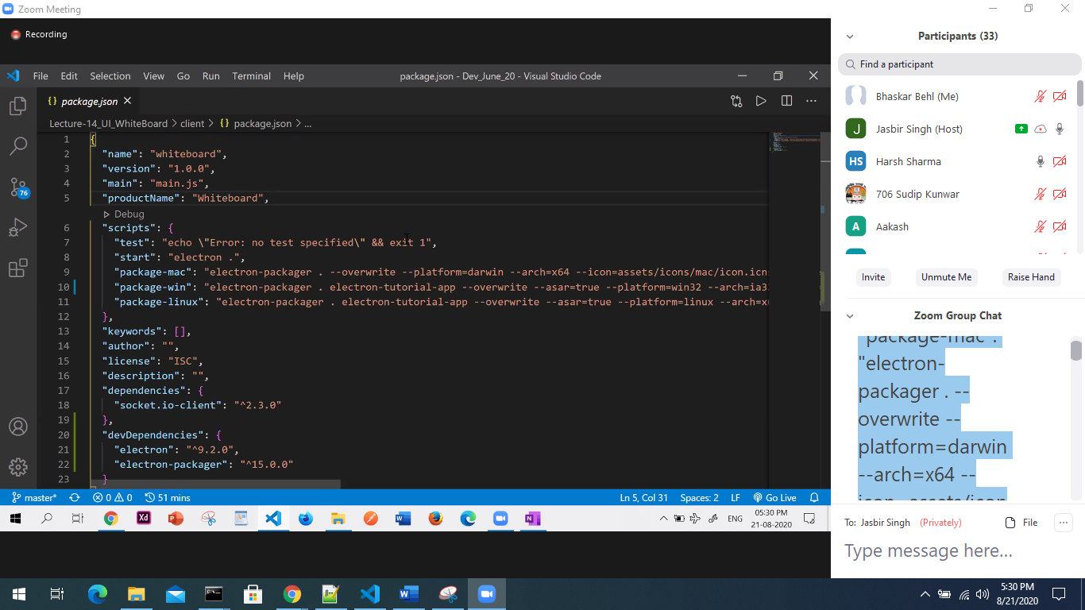

"package-mac": "electron-packager . --overwrite --platform=darwin --arch=x64 --icon=assets/icons/mac/icon.icns --prune=true --out=release-builds", "package-win": "electron-packager . electron-tutorial-app --overwrite --asar=true --platform=win32 --arch=ia32 --icon=assets/icons/win/icon.ico --prune=true --out=release-builds --version-string.CompanyName=CE --version-string.FileDescription=CE --version-string.ProductName=\"Electron Tutorial App\"", "package-linux": "electron-packager . electron-tutorial-app --overwrite --asar=true --platform=linux --arch=x64 --icon=assets/icons/png/1024x1024.png --prune=true --out=release-builds"

