Greenland Halibut (*Reinhardtius hippoglossoides*) in SA 2 + Divs. 3KLMNO

STACFIS  
Paul Regular & Bob Rogers

## Introduction

### Background

**Fishery and Catches:** TACs prior to 1995 were set autonomously by Canada; subsequent TACs have been established by NAFO Fisheries Commission (FC). Catches increased sharply in 1990 due to a developing fishery in the NAFO Regulatory Area in Div. 3LMNO and continued at high levels during 1991-94. The catch was only 15 000 to 20 000 t per year in 1995 to 1998. The catch increased after 1998 and by 2001 was estimated to be 38 000 t, the highest since 1994. The estimated catch for 2002 was 34 000 t. The 2003 catch could not be precisely estimated, but was believed to be within the range of 32 000 t to 38 500 t. In 2003, a fifteen year rebuilding plan was implemented by Fisheries Commission for this stock (FC Doc. 03/13). Though much lower than values of the early 2000s, estimated catch over 2004-2010 exceeded the TAC by considerable margins. TAC over-runs have ranged from 22%-64%, despite considerable reductions in effort. The STACFIS estimate of catch for 2010 was 26 170 t (64% over-run). In 2010, Fisheries Commission implemented a survey-based harvest control rule (FC Doc. 10/12) to generate annual TACs over at least 2011-2014. In 2013 Fisheries Commission extended this management approach to set the TACs for 2015 – 2017 (FC Doc. 13/23), but did not apply the HCR in 2017, rather setting the TAC equal to the 2016 TAC (FC Doc. 16/20). The TAC in 2018 is based on the HCR adopted in 2017 (Com Doc 17/17). Catch exceeded the TAC in every year from 2004 to 2014 but was similar to the TAC in 2015 through 2017.

Recent catches and TACs (’000 t) are as follows:

|  | **2011** | **2012** | **2013** | **2014** | **2015** | **2016** | **2017** | **2018** | **2019** |
| --- | --- | --- | --- | --- | --- | --- | --- | --- | --- |
| TAC | 17.21 | 16.31 | 15.51 | 15.41 | 15.61 | 14.81 | 14.82 | 16.53 | 16.53 |
| STATLANT 21 | 15.7 | 15.2 | 15.6 | 15.6 | 14.9 | 14.8 | 14.7 | 11.7 | -- |
| STACFIS | 25.0 | 23.0 | 20.0 | 21.4 | 15.3 | 14.9 | 14.8 | 16.6 | 16.5 |
| 1 TAC generated from HCR | | | | | | | | | |
| 2 TAC equal to 2016 | | | | | | | | | |
| 3 TAC generated from HCR adopted in 2017 | | | | | | | | | |

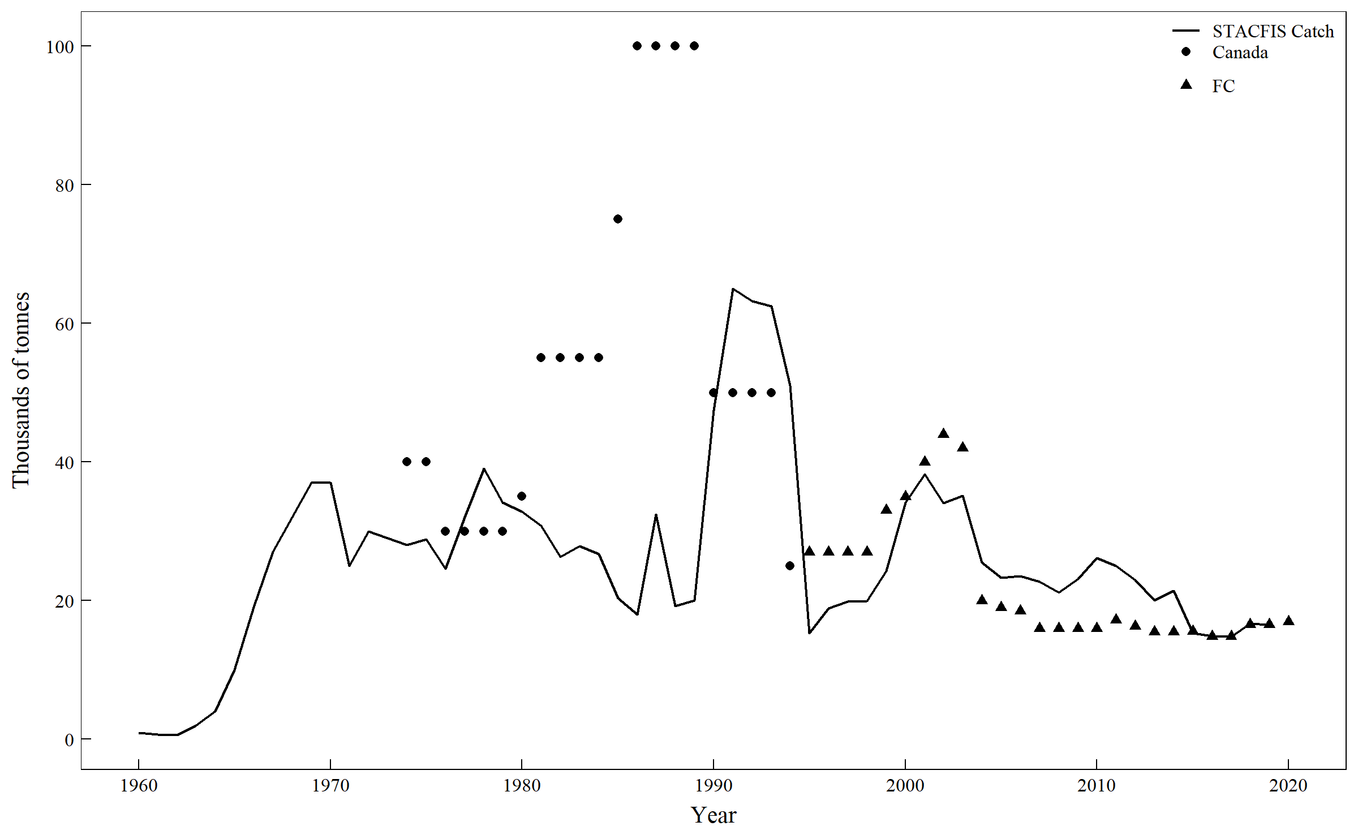

Figure 19.1: Greenland halibut in Subarea 2 + Div. 3KLMNO: TACs and STACFIS catches.

## Input Data

Standardized estimates of CPUE were available from fisheries conducted by EU- Spain, EU-Portugal and Canada. Abundance and biomass indices were available from research vessel surveys by Canada in Div. 2+3KLMNO (1978-2017), EU in Div. 3M (1988-2017), EU-Spain in Div. 3NO (1995-2017) and EU-Spain in Div. 3L (2003-2017). Different years are examined to represent population trends from the different surveys. For the Canadian fall survey in Divs. 2J3K the years are 1978-2017 (excluding 2008); from the Canadian spring survey in Divs. 3LNO 1996-2016 (excluding 2006 and 2015, 2017 not included due to survey coverage issues); for the Canadian fall survey to 730 m from 1996-2017 (excluding 2014 when the survey was incomplete); for the survey in Div. 3M to 700 m 1988-2017, and to 1400 m 2004-2017; for the survey by EU-Spain in Div. 3L 2006-2017; and for the survey by EU-Spain in Divs. 3NO 1997-2017. Commercial catch-at-age data were available from 1975-2016.

### Commercial fishery data

**Catch and effort.** **UPDATE IF REQUIRED** Analyses of otter trawl catch rates from Canadian vessels operating inside of the Canadian 200 mile limit indicated a general decline from the mid-1980s to the mid-1990s. The 2010 – 2012 estimates of standardized CPUE for Canadian otter-trawlers decreased substantially. Since then the CPUE has increased to a peak in 2016 before declining in 2017. Analyses of catch-rates of Portuguese otter trawlers fishing in the NRA of Div. 3LMNO over 1988-2019 show that the CPUE has been variable but at a high level since 2006, reaching a time series high in 2016 before declining in 2017. Analyses of data from the Spanish fishery show that the CPUE has been variable at a high level since 2006, reaching a time series high in 2016 and 2017. In general, for the Russian fishery, the catch rate ranged from 5.2 t to 33.9 t and averaged 18.2 t per fishing vessel day. These catch rates are higher than those in 2016 and 2015. A comparison of the available standardized CPUE estimates from the Canadian, Spanish and Portuguese fleets indicates consistency in the timing and relative magnitude of change over the 2004-2007 period (Fig 20.2). CPUE for all three countries is mainly higher from 2007-2017 than in the period of the 1990s to the mid 2000s. Commercial catch per unit effort for Greenland halibut in Subarea 2 and Div. 3KLMNO is a measure of fishery performance. STACFIS previously recognized that trends in CPUE should not be used as indices of the trends in the stock. It is possible that by concentration of effort and/or concentration of Greenland halibut, commercial catch rates may remain stable or even increase as the stock declines.

**Catch-at-age and mean weights-at-age.**  Length samples of the 2019 fishery were provided by EU-Spain, EU-Portugal, EU-Estonia, Russia and Japan. Ageing information was available for the Spanish and Russian fisheries. Weights were available from EU-Spain, EU-Portugal, and EU-Estonia.

### Research survey data

STACFIS reiterated that most research vessel survey series providing information on the abundance of Greenland halibut are deficient in various ways and to varying degrees. Variation in divisional and depth coverage creates problems in comparing results of different years (***SCR Doc. 12/19***). A single survey series which covers the entire stock area is not available. A subset of standardized (depth and area) stratified random survey indices have been used to monitor trends in resource status, and are described below.

**Canadian stratified-random autumn surveys in Div. 2J and 3K.**  The Canadian autumn Div. 2J3K survey index provides the longest time-series of abundance and biomass indices (Fig. 20.3) for this resource. Biomass declined from relatively high estimates of the early 1980s to reach an all-time low in 1992. The index increased substantially due to the abundant 1993-1995 year-classes, but this increase was not sustained, with declines over 1999-2002. The index increased substantially from 2010-2014 to levels near those of the early part of the time series. However, the index declined substantially from 2015 to 2017. The abundance index was stable through the 1980s, but increased substantially in the mid-1990s, again due to the presence of the 1993-1995 year-classes. After this, abundance declined to the late 1990s and had been relatively stable except for the decline in 2005. Following improved estimates of abundance in 2010 and 2011, the 2012 to 2017 indices are considerably lower.

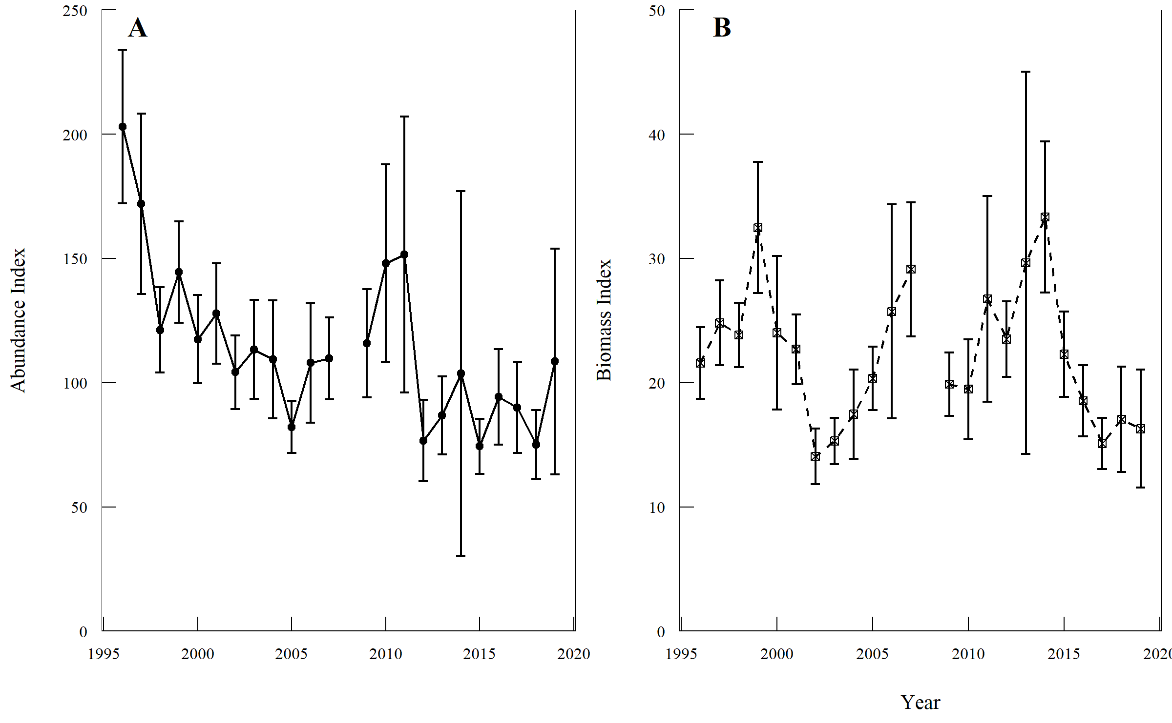

Figure 19.2: Greenland halibut in Subarea 2 + Div. 3KLMNO: abundance (A) and biomass (B) indices (with 95% CI) from Canadian autumn surveys in Div. 2J and 3K. The 2008 survey was not completed.

**Canadian stratified-random spring surveys in Div. 3LNO.**  Abundance and biomass indices from the Canadian spring surveys in Div. 3LNO (Fig. 20.4) declined from relatively high values in the late 1990s and has been relatively low in most years thereafter. In 2013, 2014, and 2016, both abundance and biomass were below the time-series average. The 2015 and 2017 surveys were incomplete and are not considered representative of the population.

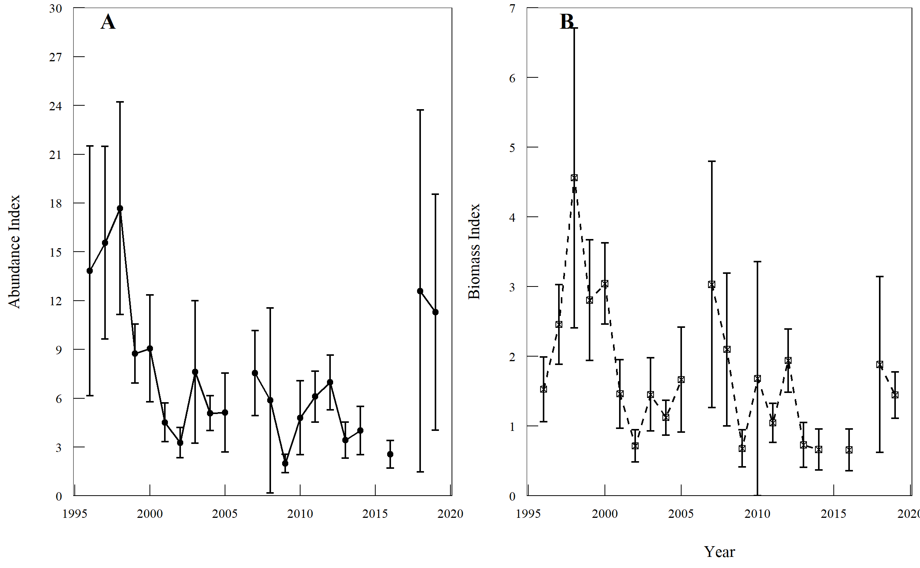

Figure 19.3: Greenland halibut in Subarea 2 + Div. 3KLMNO: abundance (A) and biomass (B) indices (with 95% CI) from Canadian spring surveys in Div. 3LNO.

**Canadian stratified-random autumn surveys in Div. 3LNO.** Time series of abundance and biomass were developed from the Canadian autumn surveys from 1995-2017 to a depth of 730 m. The abundance index from the Canadian autumn surveys in Div. 3LNO (Fig. 20.5) declined from relatively high values in the late 1990s and has been relatively low in most years thereafter. The biomass index declined from 1998 to 2002 and then increased to 2005, to a level near that of the beginning of the time series. From 2015-2017, biomass was lower than all other years in the time series. The 2014 survey was incomplete and is not considered compatible with the rest of the series.

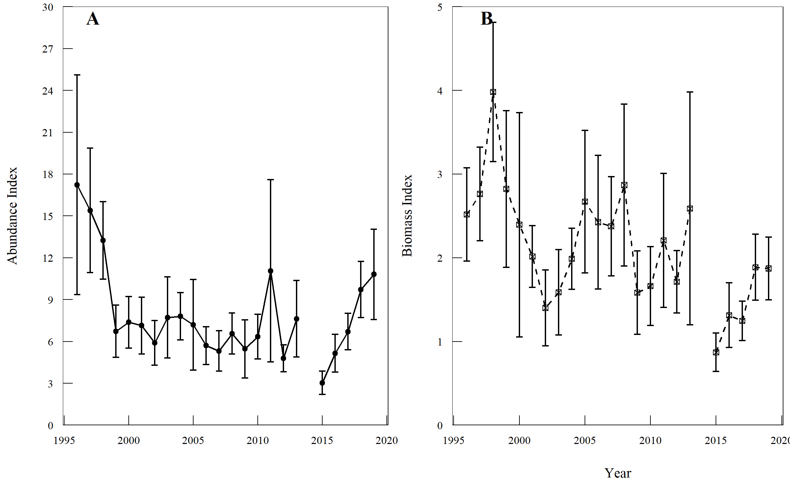

Figure 19.4: Greenland halibut in Subarea 2 + Div. 3KLMNO: abundance (A) and biomass (B) indices (with 95% CI) from Canadian autumn surveys in Div. 3LNO.

**EU stratified-random surveys in Div. 3M (Flemish Cap).** Surveys conducted by the EU in Div. 3M during summer indicate that the Greenland halibut biomass index in depths to 730 m, increased in the 1988 to 1998 period (Fig. 20.5) to a maximum value in 1998. This biomass index declined continually over 1998-2002. The 2002 - 2008 results were relatively stable, with the exception of an anomalously low value in 2003. From 2009 to 2013 the index decreased to its lowest observed value. From 2014 to 2017 the index remained well below the series average. The Flemish Cap survey was extended to cover depths down to 1460 m beginning in 2004. Biomass estimates over the full depth range doubled over 2005-2008 but then declined to below the timeseries average in 2012 and 2013. From 2015-2017 the index has been variable but above the average of the time series, with 2015 and 2017 being the highest in the series.

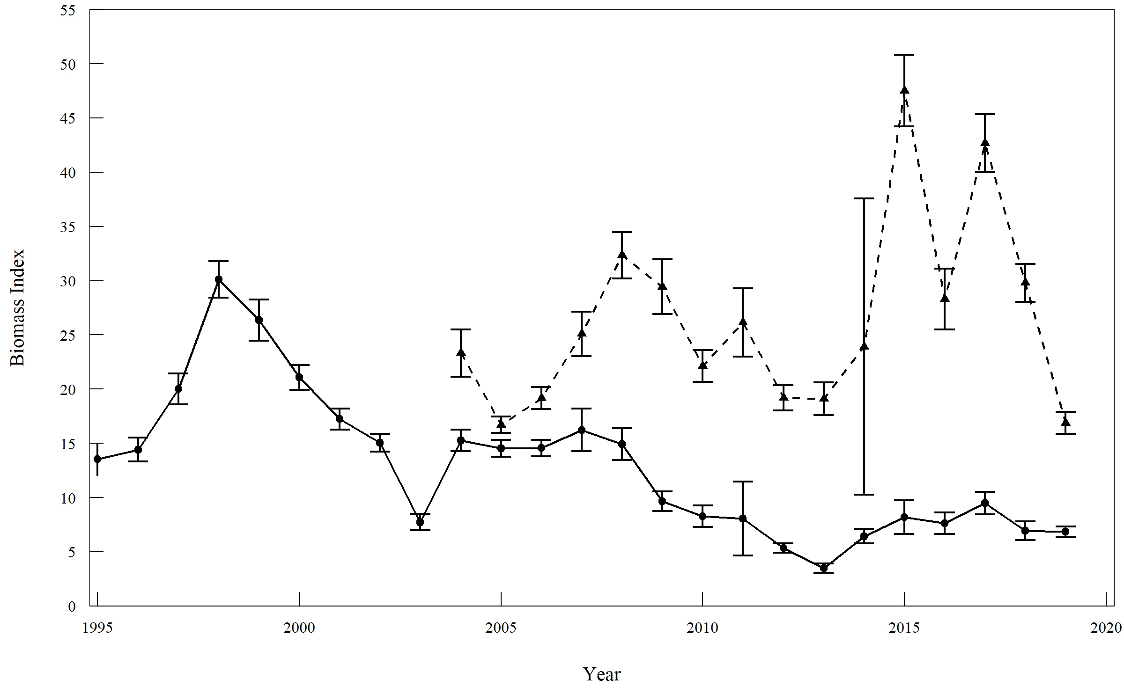

Figure 19.5: Greenland halibut in Subarea 2 + Div. 3KLMNO: Biomass index (± 1 S.E.) from EU Flemish Cap surveys in Div. 3M. Solid line: biomass index for depths <730 m. Dashed line: biomass index for all depths <1460 m.

**EU-Spain stratified-random surveys in NAFO Regulatory Area of Div. 3LNO.** The biomass index for the survey of the NRA in Div. 3NO generally declined over 1999 to 2006 (Fig. 20.6) but increased four-fold over 2006-2009. The survey index has increased since 2013 to a time series high in 2017. The biomass index for the survey of the NRA in Div. 3L increased from 2006 to 2008. After declining to lower levels in 2011 and 2012 it has increased to a time series high in 2017.

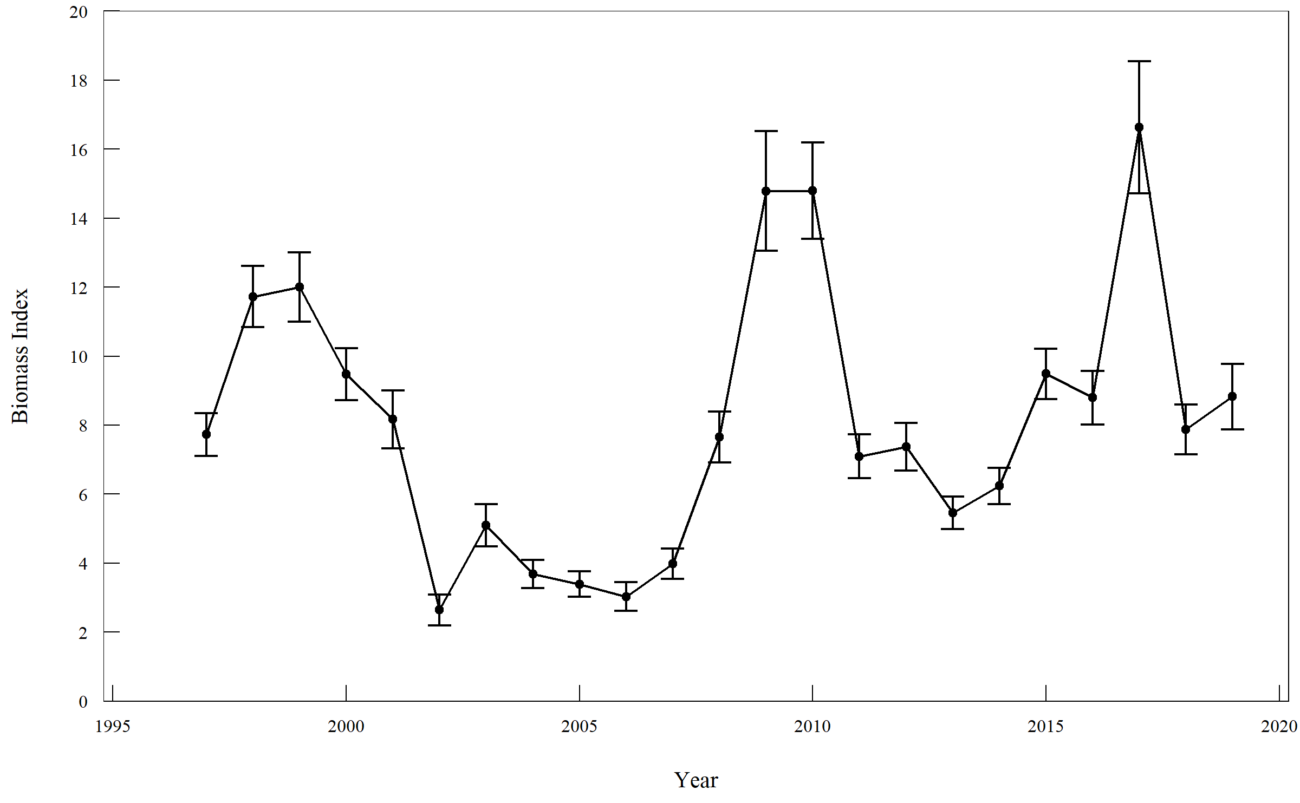

Figure 19.6: Greenland halibut in Subarea 2 + Div. 3KLMNO: biomass index (±1 SE) from EU-Spain spring surveys in the NRA of Div. 3NO and Div. 3L.

**Summary of research survey data trends.** These surveys provide coverage of the majority of the spatial distribution of the stock and the area from which the majority of catches are taken. Over 1995-2007, indices from the majority of the surveys generally provided a consistent signal in stock biomass (Fig. 20.7). Results since 2007 show greater divergence which complicates interpretation of overall status. Since 2014 there is a clear divergence with the surveys in the NRA (including 3M) increased to well above their time series averages while the Canadian surveys have been lower than their respective time series average. The overall trend since 2007 is unclear, but the 3 of 4 surveys that start in the mid 1990s, are only about 70% of their average in 2016.

#> survey year mwpt error mean_period rel_bio  
#> 1 Canada Fall 2J3K 1995 NA NA 22.729182 NA  
#> 2 Canada Fall 2J3K 1996 21.5819402 2.8808078 22.729182 0.9495256  
#> 3 Canada Fall 2J3K 1997 24.8029893 3.4131430 22.729182 1.0912398  
#> 4 Canada Fall 2J3K 1998 23.8309343 2.5971623 22.729182 1.0484730  
#> 5 Canada Fall 2J3K 1999 32.4809571 5.2718257 22.729182 1.4290420  
#> 6 Canada Fall 2J3K 2000 24.0072893 6.1667489 22.729182 1.0562320  
#> 7 Canada Fall 2J3K 2001 22.6866014 2.8115948 22.729182 0.9981266  
#> 8 Canada Fall 2J3K 2002 14.0659563 2.2258056 22.729182 0.6188501  
#> 9 Canada Fall 2J3K 2003 15.3060346 1.8698962 22.729182 0.6734089  
#> 10 Canada Fall 2J3K 2004 17.4548369 3.5854099 22.729182 0.7679483  
#> 11 Canada Fall 2J3K 2005 20.3372818 2.5608304 22.729182 0.8947652  
#> 12 Canada Fall 2J3K 2006 25.7324315 8.6187439 22.729182 1.1321319  
#> 13 Canada Fall 2J3K 2007 29.1234424 5.3974028 22.729182 1.2813238  
#> 14 Canada Fall 2J3K 2008 NA NA 22.729182 NA  
#> 15 Canada Fall 2J3K 2009 19.8826111 2.5436429 22.729182 0.8747614  
#> 16 Canada Fall 2J3K 2010 19.4675588 4.0306561 22.729182 0.8565006  
#> 17 Canada Fall 2J3K 2011 26.7358159 8.2828766 22.729182 1.1762771  
#> 18 Canada Fall 2J3K 2012 23.5043147 3.0272144 22.729182 1.0341030  
#> 19 Canada Fall 2J3K 2013 29.6450008 15.3834372 22.729182 1.3042704  
#> 20 Canada Fall 2J3K 2014 33.3361960 6.0973261 22.729182 1.4666694  
#> 21 Canada Fall 2J3K 2015 22.2900986 3.4322400 22.729182 0.9806819  
#> 22 Canada Fall 2J3K 2016 18.5413749 2.8536296 22.729182 0.8157520  
#> 23 Canada Fall 2J3K 2017 15.1038823 2.0622598 22.729182 0.6645150  
#> 24 Canada Fall 2J3K 2018 17.0537080 4.2393577 22.729182 0.7503001  
#> 25 Canada Fall 2J3K 2019 16.2849107 4.7465724 22.729182 0.7164759  
#> 26 Canada Fall 3LNO 1995 NA NA 1.956626 NA  
#> 27 Canada Fall 3LNO 1996 2.5164501 0.5572322 1.956626 1.2861172  
#> 28 Canada Fall 3LNO 1997 2.7617787 0.5594185 1.956626 1.4115007  
#> 29 Canada Fall 3LNO 1998 3.9799252 0.8314765 1.956626 2.0340758  
#> 30 Canada Fall 3LNO 1999 2.8218941 0.9356605 1.956626 1.4422247  
#> 31 Canada Fall 3LNO 2000 2.3947574 1.3400887 1.956626 1.2239220  
#> 32 Canada Fall 3LNO 2001 2.0142167 0.3691306 1.956626 1.0294338  
#> 33 Canada Fall 3LNO 2002 1.4009116 0.4534679 1.956626 0.7159834  
#> 34 Canada Fall 3LNO 2003 1.5878574 0.5101696 1.956626 0.8115284  
#> 35 Canada Fall 3LNO 2004 1.9861066 0.3648327 1.956626 1.0150672  
#> 36 Canada Fall 3LNO 2005 2.6709316 0.8507383 1.956626 1.3650702  
#> 37 Canada Fall 3LNO 2006 2.4242987 0.7993674 1.956626 1.2390201  
#> 38 Canada Fall 3LNO 2007 2.3761542 0.5913395 1.956626 1.2144142  
#> 39 Canada Fall 3LNO 2008 2.8678285 0.9658692 1.956626 1.4657011  
#> 40 Canada Fall 3LNO 2009 1.5824033 0.4985024 1.956626 0.8087409  
#> 41 Canada Fall 3LNO 2010 1.6627975 0.4706957 1.956626 0.8498291  
#> 42 Canada Fall 3LNO 2011 2.2062004 0.8015790 1.956626 1.1275536  
#> 43 Canada Fall 3LNO 2012 1.7121814 0.3713496 1.956626 0.8750684  
#> 44 Canada Fall 3LNO 2013 2.5888136 1.3922199 1.956626 1.3231010  
#> 45 Canada Fall 3LNO 2014 NA NA 1.956626 NA  
#> 46 Canada Fall 3LNO 2015 0.8691691 0.2293734 1.956626 0.4442184  
#> 47 Canada Fall 3LNO 2016 1.3136595 0.3859956 1.956626 0.6713903  
#> 48 Canada Fall 3LNO 2017 1.2456844 0.2347244 1.956626 0.6366493  
#> 49 Canada Fall 3LNO 2018 1.8865322 0.3943968 1.956626 0.9641763  
#> 50 Canada Fall 3LNO 2019 1.8718883 0.3737556 1.956626 0.9566920  
#> 51 Canada Spring 3LNO 1995 NA NA 1.433741 NA  
#> 52 Canada Spring 3LNO 1996 1.5278563 0.4627438 1.433741 1.0656431  
#> 53 Canada Spring 3LNO 1997 2.4567361 0.5714131 1.433741 1.7135144  
#> 54 Canada Spring 3LNO 1998 4.5611017 2.1499723 1.433741 3.1812589  
#> 55 Canada Spring 3LNO 1999 2.8064257 0.8634021 1.433741 1.9574145  
#> 56 Canada Spring 3LNO 2000 3.0439216 0.5822674 1.433741 2.1230622  
#> 57 Canada Spring 3LNO 2001 1.4618336 0.4912848 1.433741 1.0195938  
#> 58 Canada Spring 3LNO 2002 0.7155834 0.2297054 1.433741 0.4991022  
#> 59 Canada Spring 3LNO 2003 1.4538710 0.5247025 1.433741 1.0140401  
#> 60 Canada Spring 3LNO 2004 1.1215889 0.2492326 1.433741 0.7822813  
#> 61 Canada Spring 3LNO 2005 1.6652038 0.7523829 1.433741 1.1614396  
#> 62 Canada Spring 3LNO 2006 NA NA 1.433741 NA  
#> 63 Canada Spring 3LNO 2007 3.0325816 1.7656202 1.433741 2.1151529  
#> 64 Canada Spring 3LNO 2008 2.0999649 1.0949982 1.433741 1.4646751  
#> 65 Canada Spring 3LNO 2009 0.6791972 0.2655088 1.433741 0.4737237  
#> 66 Canada Spring 3LNO 2010 1.6827205 1.6788749 1.433741 1.1736571  
#> 67 Canada Spring 3LNO 2011 1.0458760 0.2779595 1.433741 0.7294734  
#> 68 Canada Spring 3LNO 2012 1.9406013 0.4536989 1.433741 1.3535228  
#> 69 Canada Spring 3LNO 2013 0.7300819 0.3238021 1.433741 0.5092146  
#> 70 Canada Spring 3LNO 2014 0.6643852 0.2917182 1.433741 0.4633927  
#> 71 Canada Spring 3LNO 2015 NA NA 1.433741 NA  
#> 72 Canada Spring 3LNO 2016 0.6584885 0.3005107 1.433741 0.4592799  
#> 73 Canada Spring 3LNO 2017 NA NA 1.433741 NA  
#> 74 Canada Spring 3LNO 2018 1.8842037 1.2611951 1.433741 1.3141868  
#> 75 Canada Spring 3LNO 2019 1.4455737 0.3336520 1.433741 1.0082529  
#> 76 EU 3M 0-1400m 1995 NA NA 26.992833 NA  
#> 77 EU 3M 0-1400m 1996 NA NA 26.992833 NA  
#> 78 EU 3M 0-1400m 1997 NA NA 26.992833 NA  
#> 79 EU 3M 0-1400m 1998 NA NA 26.992833 NA  
#> 80 EU 3M 0-1400m 1999 NA NA 26.992833 NA  
#> 81 EU 3M 0-1400m 2000 NA NA 26.992833 NA  
#> 82 EU 3M 0-1400m 2001 NA NA 26.992833 NA  
#> 83 EU 3M 0-1400m 2002 NA NA 26.992833 NA  
#> 84 EU 3M 0-1400m 2003 NA NA 26.992833 NA  
#> 85 EU 3M 0-1400m 2004 23.3300000 2.1800000 26.992833 0.8643035  
#> 86 EU 3M 0-1400m 2005 16.7100000 0.7500000 26.992833 0.6190532  
#> 87 EU 3M 0-1400m 2006 19.1700000 1.0100000 26.992833 0.7101885  
#> 88 EU 3M 0-1400m 2007 25.1000000 2.0500000 26.992833 0.9298765  
#> 89 EU 3M 0-1400m 2008 32.3500000 2.1400000 26.992833 1.1984663  
#> 90 EU 3M 0-1400m 2009 29.4400000 2.5100000 26.992833 1.0906599  
#> 91 EU 3M 0-1400m 2010 22.1300000 1.4600000 26.992833 0.8198473  
#> 92 EU 3M 0-1400m 2011 26.1515753 3.1500000 26.992833 0.9688341  
#> 93 EU 3M 0-1400m 2012 19.1980761 1.1550000 26.992833 0.7112287  
#> 94 EU 3M 0-1400m 2013 19.1100000 1.5050000 26.992833 0.7079657  
#> 95 EU 3M 0-1400m 2014 23.9206596 13.6689484 26.992833 0.8861856  
#> 96 EU 3M 0-1400m 2015 47.5171772 3.3000000 26.992833 1.7603628  
#> 97 EU 3M 0-1400m 2016 28.2975000 2.8175000 26.992833 1.0483338  
#> 98 EU 3M 0-1400m 2017 42.6650000 2.6600000 26.992833 1.5806048  
#> 99 EU 3M 0-1400m 2018 29.8025000 1.7500000 26.992833 1.1040894  
#> 100 EU 3M 0-1400m 2019 16.8875000 1.0325000 26.992833 0.6256290  
#> 101 EU 3M 0-700m 1995 13.5200000 1.5200000 9.932628 1.3611705  
#> 102 EU 3M 0-700m 1996 14.4200000 1.1000000 9.932628 1.4517810  
#> 103 EU 3M 0-700m 1997 20.0100000 1.4100000 9.932628 2.0145726  
#> 104 EU 3M 0-700m 1998 30.1300000 1.6800000 9.932628 3.0334370  
#> 105 EU 3M 0-700m 1999 26.3700000 1.8900000 9.932628 2.6548866  
#> 106 EU 3M 0-700m 2000 21.0800000 1.1500000 9.932628 2.1222984  
#> 107 EU 3M 0-700m 2001 17.2500000 0.9700000 9.932628 1.7367005  
#> 108 EU 3M 0-700m 2002 15.0500000 0.8200000 9.932628 1.5152083  
#> 109 EU 3M 0-700m 2003 7.7300000 0.7600000 9.932628 0.7782432  
#> 110 EU 3M 0-700m 2004 15.2800000 0.9900000 9.932628 1.5383643  
#> 111 EU 3M 0-700m 2005 14.5500000 0.7800000 9.932628 1.4648692  
#> 112 EU 3M 0-700m 2006 14.5600000 0.7600000 9.932628 1.4658759  
#> 113 EU 3M 0-700m 2007 16.2200000 1.9600000 9.932628 1.6330019  
#> 114 EU 3M 0-700m 2008 14.9100000 1.4700000 9.932628 1.5011133  
#> 115 EU 3M 0-700m 2009 9.6700000 0.9000000 9.932628 0.9735591  
#> 116 EU 3M 0-700m 2010 8.2800000 1.0100000 9.932628 0.8336163  
#> 117 EU 3M 0-700m 2011 8.0509550 3.4125000 9.932628 0.8105564  
#> 118 EU 3M 0-700m 2012 5.3361720 0.4200000 9.932628 0.5372367  
#> 119 EU 3M 0-700m 2013 3.4825000 0.4375000 9.932628 0.3506122  
#> 120 EU 3M 0-700m 2014 6.4263382 0.6739697 9.932628 0.6469928  
#> 121 EU 3M 0-700m 2015 8.1784505 1.5500000 9.932628 0.8233924  
#> 122 EU 3M 0-700m 2016 7.6300000 0.9975000 9.932628 0.7681754  
#> 123 EU 3M 0-700m 2017 9.4850000 1.0150000 9.932628 0.9549336  
#> 124 EU 3M 0-700m 2018 6.9300000 0.8575000 9.932628 0.6977006  
#> 125 EU 3M 0-700m 2019 6.8425000 0.4900000 9.932628 0.6888912  
#> 126 EU 3NO 1995 NA NA 8.018314 NA  
#> 127 EU 3NO 1996 NA NA 8.018314 NA  
#> 128 EU 3NO 1997 7.7255174 0.6190288 8.018314 0.9634840  
#> 129 EU 3NO 1998 11.7260544 0.8856165 8.018314 1.4624089  
#> 130 EU 3NO 1999 12.0020452 1.0039634 8.018314 1.4968290  
#> 131 EU 3NO 2000 9.4817792 0.7532572 8.018314 1.1825153  
#> 132 EU 3NO 2001 8.1663053 0.8362455 8.018314 1.0184566  
#> 133 EU 3NO 2002 2.6420369 0.4534220 8.018314 0.3295003  
#> 134 EU 3NO 2003 5.0952642 0.6106238 8.018314 0.6354533  
#> 135 EU 3NO 2004 3.6828768 0.4022114 8.018314 0.4593081  
#> 136 EU 3NO 2005 3.3922867 0.3635082 8.018314 0.4230673  
#> 137 EU 3NO 2006 3.0301596 0.4176775 8.018314 0.3779048  
#> 138 EU 3NO 2007 3.9797157 0.4419022 8.018314 0.4963282  
#> 139 EU 3NO 2008 7.6606780 0.7382318 8.018314 0.9553976  
#> 140 EU 3NO 2009 14.7815791 1.7346649 8.018314 1.8434772  
#> 141 EU 3NO 2010 14.7964515 1.3995551 8.018314 1.8453320  
#> 142 EU 3NO 2011 7.0926670 0.6337859 8.018314 0.8845584  
#> 143 EU 3NO 2012 7.3727771 0.6908484 8.018314 0.9194922  
#> 144 EU 3NO 2013 5.4631012 0.4726715 8.018314 0.6813279  
#> 145 EU 3NO 2014 6.2391547 0.5272237 8.018314 0.7781130  
#> 146 EU 3NO 2015 9.4857023 0.7279049 8.018314 1.1830046  
#> 147 EU 3NO 2016 8.7956226 0.7754484 8.018314 1.0969416  
#> 148 EU 3NO 2017 16.6265230 1.9176456 8.018314 2.0735684  
#> 149 EU 3NO 2018 7.8754172 0.7162996 8.018314 0.9821787  
#> 150 EU 3NO 2019 8.8242101 0.9486332 8.018314 1.1005069

### Recruitment

Abundance indices at age 4 from surveys were examined as a measure of recruitment. All the survey indices have low abundance at age 4 since the 2009 year class. Abundance at age 4 has been below average since the 2009 year class in the Canadian spring Divs. 3LNO survey and since the 2008 year class in the Canadian fall Divs. 2J3K survey. After 3 very large year classes of 2000-2002 in the EU survey of Div. 3M, abundance at age 4 has been below average. The abundance at age 4 in the EU Spain survey of Div. 3NO has been below average since the 2006 year class and in the Canadian Div. 3LNO fall survey since the 2008 year class.

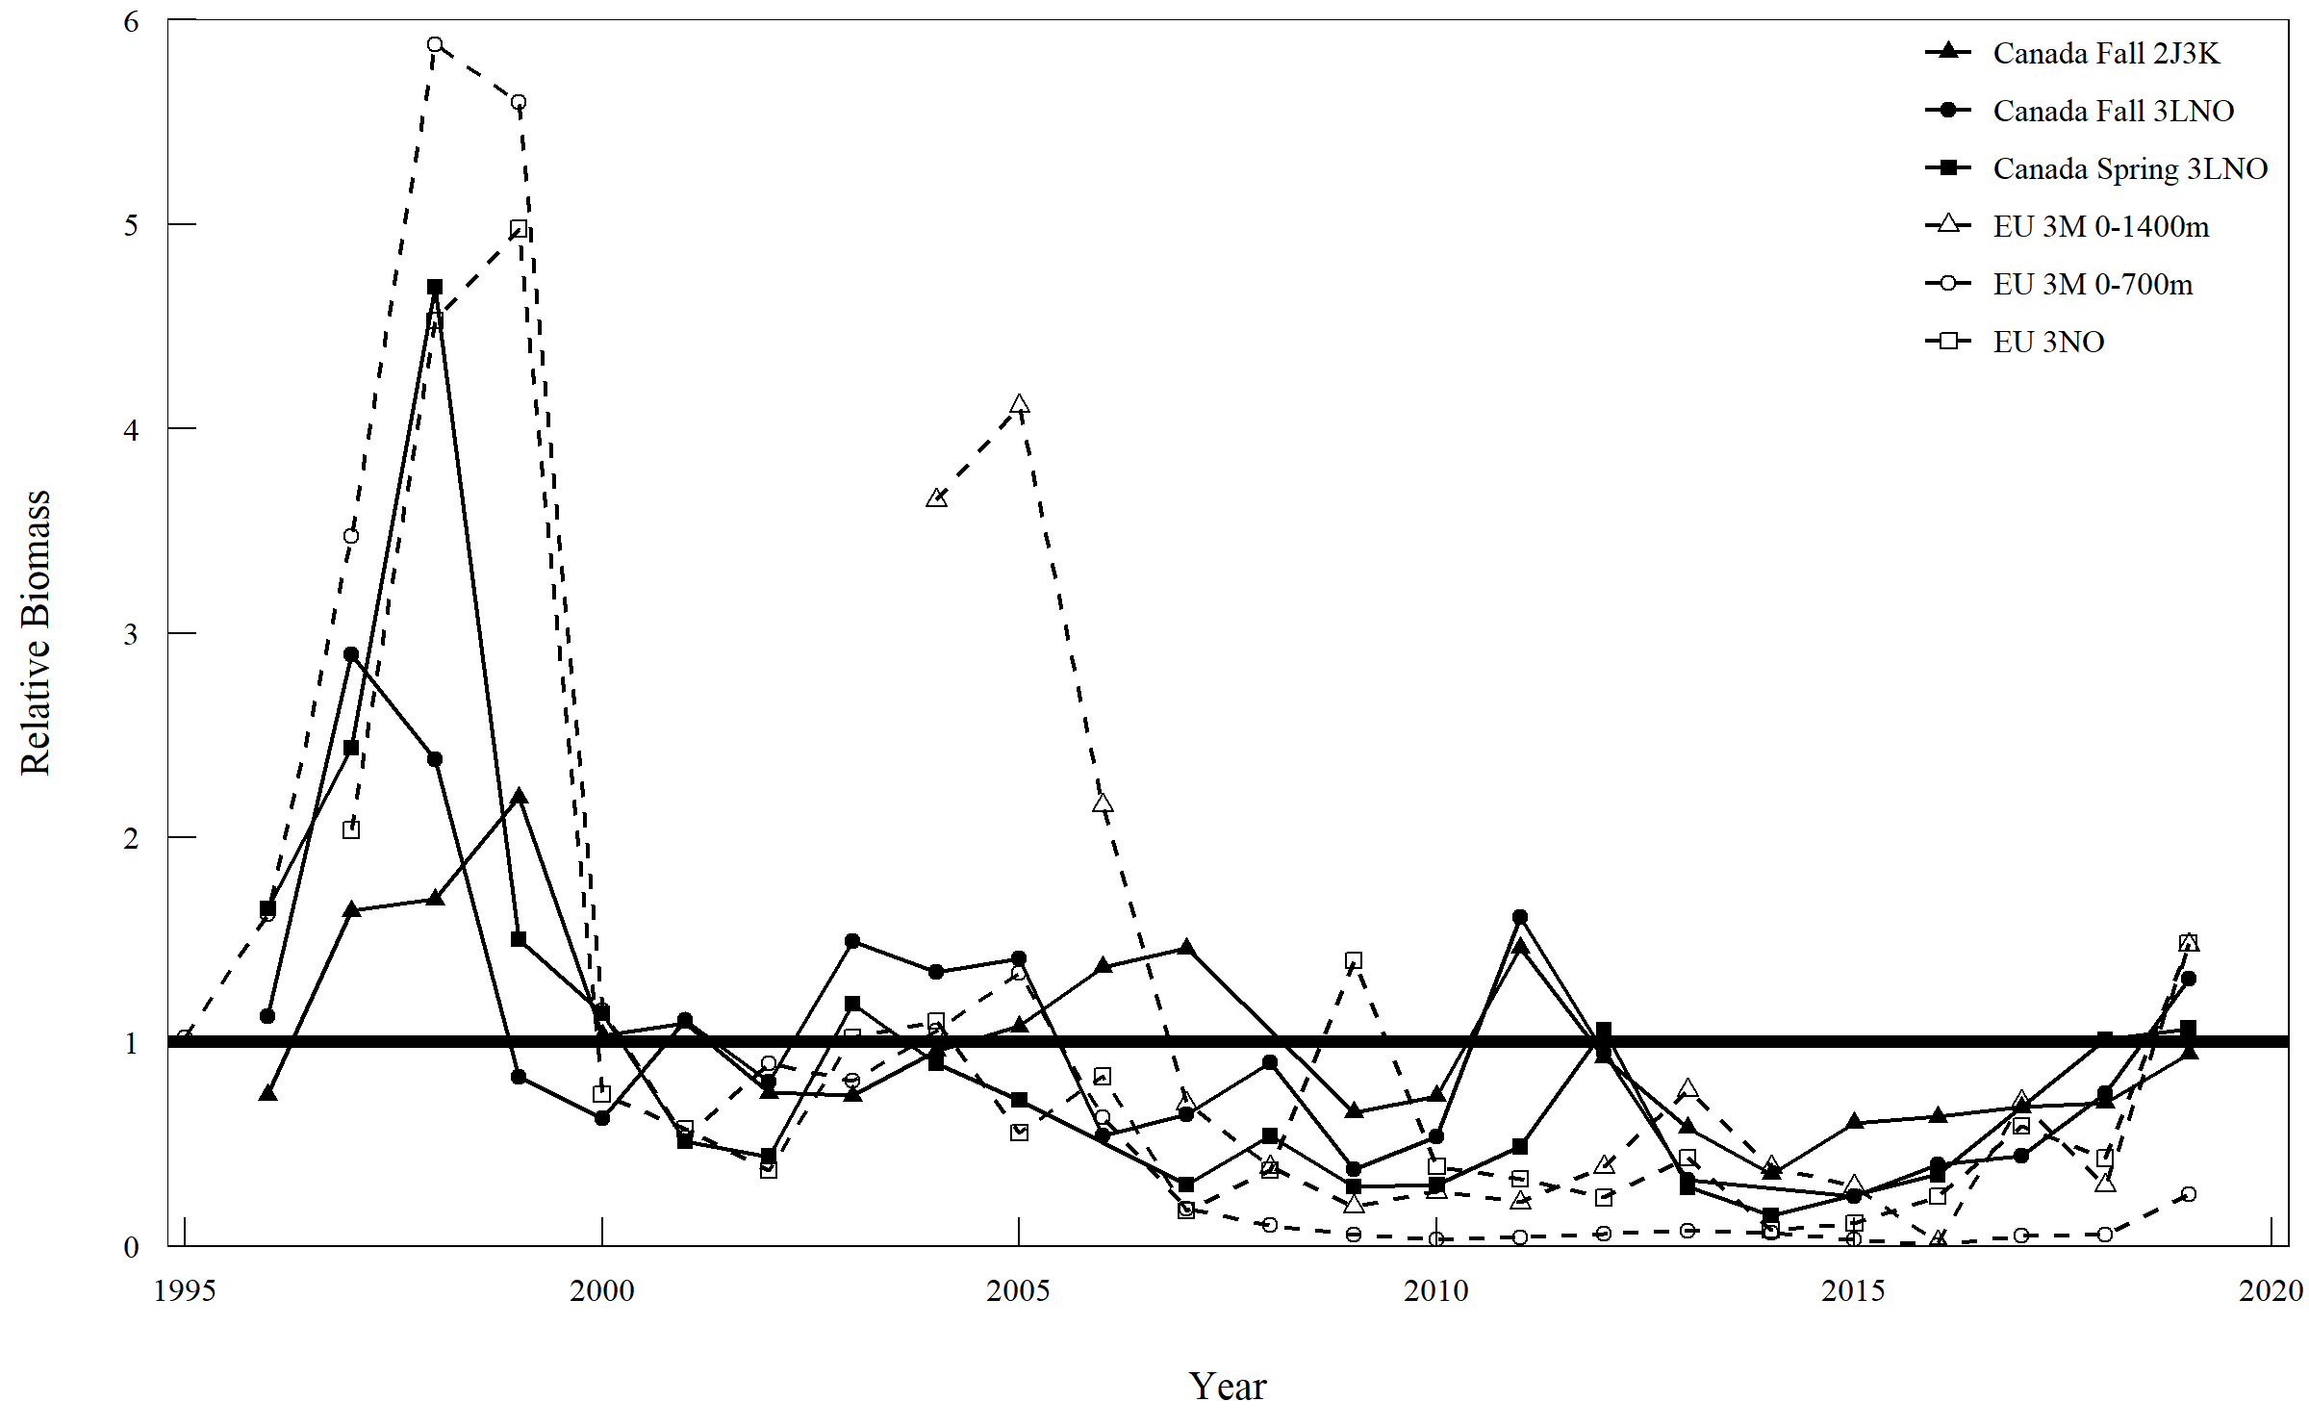

Figure 19.7: Greenland halibut in Subarea 2 + Div. 3KLMNO: Relative recruitment indices from Canadian autumn surveys in Div. 2J3K, Canadian spring surveys in Div. 3LNO, and EU survey of Flemish Cap. Each series is scaled to its average and the average line is shown as thick black line.

### Biological parameters

## Estimation of Parameters

## Assessment Results

*Biomass*: Survey data from 2011-2017 are variable which complicates the interpretation of overall status. The five surveys that are used in the HCR show differing trends over this period. Three of the surveys have declined and are low in 2017, while two have increased and are at a time series high in 2017. *Recruitment*: Results of all surveys indicate that recruitment (age 4) has been below average since 2009. *Fishing Mortality*: Unknown. Catch was equal to the TAC in 2017.

## Retrospective analysis

## State of the stock

Survey results in recent years show greater divergence which complicates interpretation of overall status. The slope for three of the five indices used in the HCR was negative while two were positive. Similarly 3 are below their 2011-2015 average and two are above.

## Reference Points

## Stock projections

## Research recommendations