**Trade Net Trade & Portfolio Management Software:**

**Software Architecture Description**

Srikar Devarakonda(sd1454)

Armand Nokbak Nyembe(an499)

Narendra Mallela(nkm111)

Vijyanth Kanwar(vk198)

**CSE 4233/6233**

**Fall 2015**

# **Table of Contents**

Table of Contents

1. Architectural Documentation (Document Control Information)

1.1 Date of issue and status

1.2 Issuing organization

1.3 Change history

1.4 Summary (System Overview)

1.5 Context

1.6 Glossary

1.7 References

1.8 Acknowledgements

2. Identification of Stakeholders and Concerns

2.1 Stakeholders

2.2 Concerns

3. Selection of Architectural Viewpoints (How a View is Documented – View Template)

3.1 Logical structure

3.2 Run-Time Structure and Dynamics

3.3 Allocation Structure

4. Architectural views

4.1 Logical views

4.2 Run-time Structure and Dynamic Views

4.3 Allocation Views

5. Consistency among Architectural Views (Mapping Between Views)

6. Architectural Rationale

# **Architectural Documentation (Document Control Information)**

## Date of issue and status

Saturday, 11/21/2015.

## Issuing organization

Trade Net Brokerage and Financial Services.

## Change history

|  |  |
| --- | --- |
| Date | Change Log |
| 11/20/2015 | Document started. |
|  |  |
|  |  |

## Summary (System Overview)

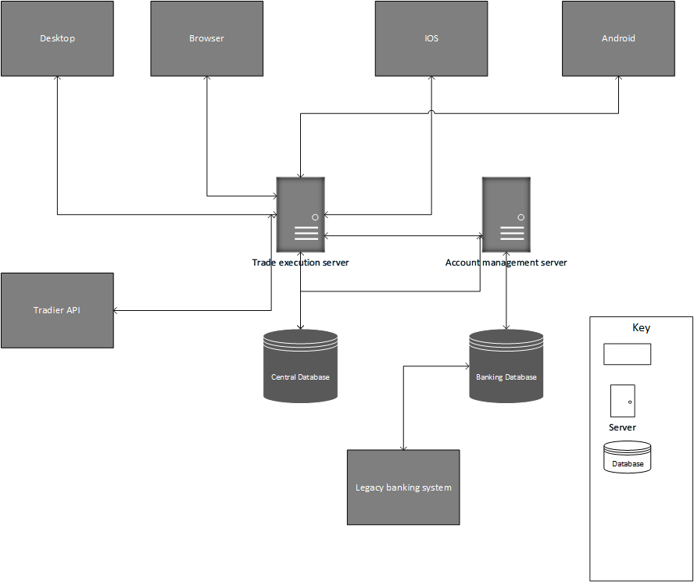

*Trade Net Brokerage system Context Diagram*

## Context

The Trade Net Brokerage system helps bank customers purchase stock shares from their bank accounts. The system offers four (04) different clients that let the customers see what shares are available, what they cost, but also let them purchase them using their bank account’s balance. The Trade Net Brokerage system is represented by the context diagram above.

## Glossary

* Clients: Computer program or hardware that accesses services provided by a server.
* Server: Computer program or hardware that services requests from other applications called clients.
* Database: “ A database is a collection of [information](http://searchsqlserver.techtarget.com/definition/information) that is organized so that it can easily be accessed, managed, and updated” [2].
* Libraries: “Collections of similar objects which are used occasionally” [4].
* Browser: “A browser is an application program that provides a way to look at and interact with accessible information on the world wide web” [3].
* Application : “It is a software program that runs on a computer” [1].
* AD: Architecture Document (this document).
* COTS: Commercial off-the-shelf software.

## References

[1] Christensson, Per. "Application Definition." *TechTerms*. Sharpened Productions, 12 October 2008. Web. 20 November 2015. <http://techterms.com/definition/application>>.

[2] Leake, Allan. "What Is Database? - Definition from WhatIs.com." *SearchSQLServer*. Techtarget, 1 Apr. 2006. Web. 20 Nov. 2015. <http://searchsqlserver.techtarget.com/definition/database>.

[3] "What Is Browser? - Definition from WhatIs.com." *Browser Definiton*. WhatIs.com, 1 Nov. 2007. Web. 20 Nov. 2015. <http://searchwindevelopment.techtarget.com/definition/browser>.

[4] "What Is Library? - Definition from WhatIs.com." *SearchSQLServer*. Web. 20 Nov. 2015.

## Acknowledgements

* Armand Nokbak
* Narendra Mallela
* Srikar Devarakonda
* Vijayant Kanwar

# **Identification of Stakeholders and Concerns**

## Stakeholders

In this document, the stakeholders are the parties that affect or are affected by the Trade Net Brokerage system. They are listed below by alphabetical order.

### 2.1.1 Developers (Software):

The software developers are the programmers responsible for coding the application.

They care about the architecture document (AD) because they need to know and understand the different components and modules of the system, their interactions, and the protocols used to communicate and transmit data.

### 2.1.2 Project Manager:

The Project Manager is the person responsible for making sure that all the functional and non-functional requirements of the software are met within schedule.

He is concerned about the architecture document (AD) as he wants to make sure that the system covers all the aspects and requirements.

*2.1.3* *Database Administrator:*

The Database Administrator is responsible for the maintenance of the database. From the AD, he gets the structure of the database models, the database size and performance, and the number of people interacting with the database to provide the stakeholders with the access specified in this document.

*2.1.4 Information Technology Manager:*

The Information Technology manager is the person in charge of the hardware and software infrastructures within the Trade Net Brokerage and Financial Services organization.

He cares about the AD because he needs to know where to deploy every software artifact and the properties needed by them, such as what ports should be available, what processor speed is needed, and what security and access measures should be implemented.

*2.1.5 Business Analyst:*

A business analyst is the person who bridges the gap between the business and the technical teams. He is responsible for gathering requirements from the business side of the company and change it into system specifications.

He is concerned about the AD to make sure that it addresses all the business requirements.

*2.1.6 Software Quality Assurance Analyst:*

The Software Quality Assurance Analyst is the person responsible for managing and executing all the activities for the end to end testing of the software. He should understand the possible causes of failure for each module and component in the architecture document so he.

*2.1.7 Maintenance:*

Once the software has been deployed, the software maintenance team is concerned about the quality of the product. They use the AD to know the exact module in the architecture where they can fix defects and add patches to make modifications.

## Concerns

## *Software developer (programmer):*

### Does the AD shows sufficient details to guide the design?

The programmer needs to find enough guidelines in the AD to design system artifacts.

### Does the AD give enough references for assembling components?

Since the Trade Net Brokerage system incorporates several components, the programmer needs to know how to assemble them.

* Is the system as described in the AD, compatible with existing systems?

The Trade Net Brokerage System must be compatible with the existing legacy banking system.

### 2.2.2 Project manager:

* Schedule estimation

Manager is responsible for estimation and scheduling of tasks

Manager can find the each module in the AD of Trade Net Brokerage system and can assign the tasks based on the dependencies and priority.

* Feasibility and risk assessment

Since all the views are expressed in the AD of Trade Net Brokerage system manager can access the possibility of risk from all perspectives and he can able to reduce the possibilities and consequences of risks.

* Requirements traceability

Each view in the AD of Trade Net Brokerage system has developed based on the requirements of the client which shows how we implements the system.

* Progress tracking

By details provided in the AD of Trade Net Brokerage system manager can know how to separate the individual independent task ,assess their duration and progress of the tasks.

*2.2.3* *Database Administrator:*

* Structure and the type of the database.

Based on the how many users will be accessing and what is the scope of the system admin can easily identify what kind of database suits the security level required by the project . Data model view of the AD of Trade Net Brokerage system can give a view of how many databases are involved in the project and what is the scope of each database in entire architecture.

* Establishing the needs of users and monitoring user access and security.

Uses style of the AD of Trade Net Brokerage system can give an idea how each database is used by the users . In this he can know each user security level through their accessibility.

* Developing, managing and testing back-up and recovery plans

By analyzing the risks through all the views in AD of Trade Net brokerage system Database administrator can take regular backups to avoid risk of losing the data.

*2.2.4 Information Technology Manager:*

Through the module view in the AD of Trade Net Brokerage system we can identify the components of software which can be used . for reused ,portable and inter operable.

*2.2.5 Business Analyst:*

Requirements gathering and functional aspects of supporting systems. This can cover the human actors involved in the system, the user processes involved in the system, the functions required to support the processes, and the information required to flow in support of the processes.

*2.2.6 Software Quality Assurance Analyst:*

He can know how each module is independent and how efficiently all the components are utilized to check whether any redundancy in the system which is addressed by each view in different perspective.

*2.2.7 Maintenance:*

* Maintain compatibility with existing systems

Compatibility can be maintained by seeing the module view of the AD of Trade Net Brokerage system based on how each module view is interconnected with each other.

* Guidance on software modification

Software can be written based on the functionality of each module which can be addressed by the AD of Trade Net Brokerage system through module view and uses view.

* Non-functional requirements (performance, reliability etc)
* It is a measure of how better the system performance can evaluated through this architecture and by showing how system behaves in the run time through several component & connector views in AD of Trade Net Brokerage System.

# **Architectural views**

## *Logical views :*

### Class Diagram:

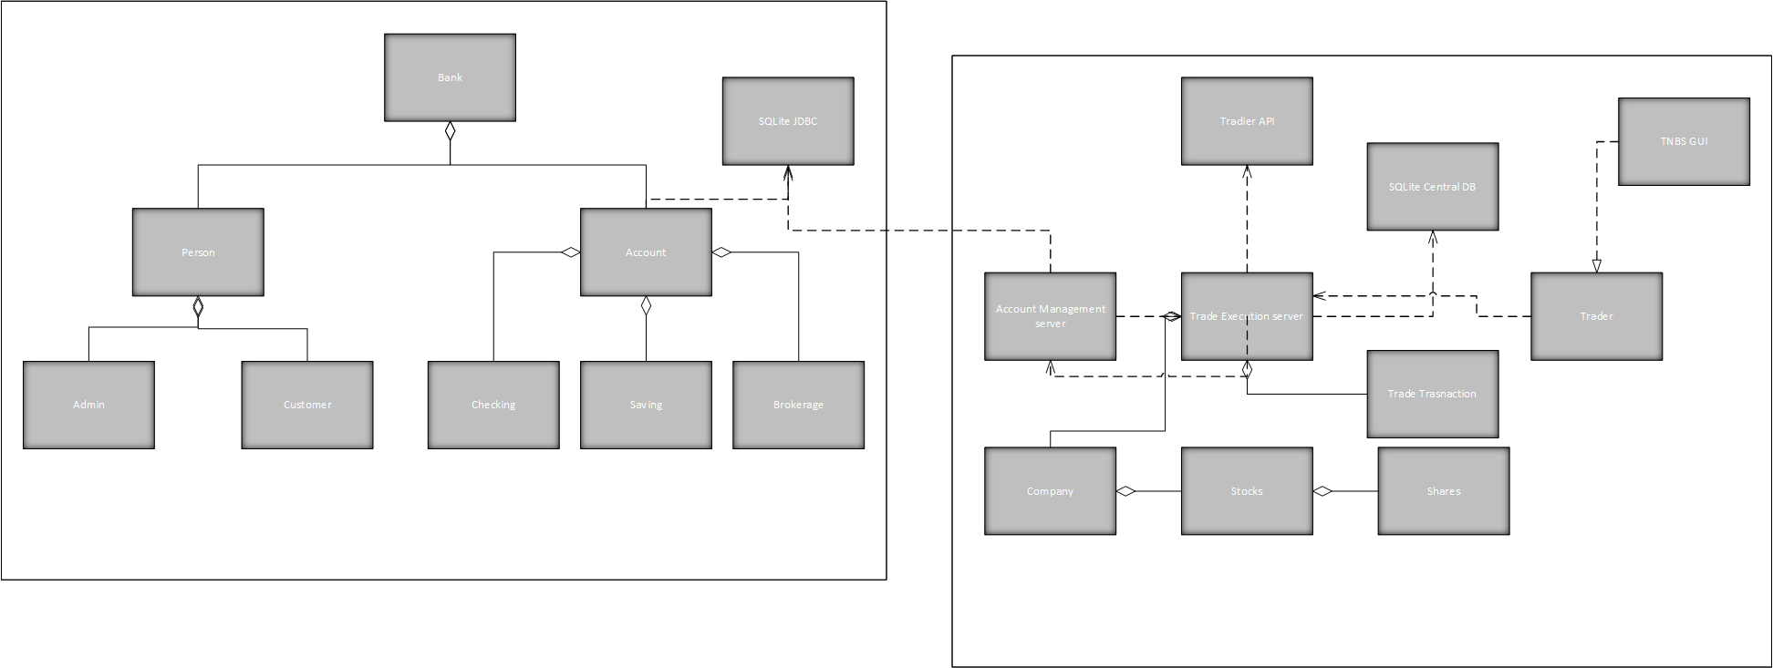

Element Catalogue :

|  |  |
| --- | --- |
| Element | Description/Function |
| Bank class : | The parent class of the legacy banking system responsible for banking transactions. |
| Person class: | Parent class for admin and customer responsible for the classification of the users of the system. |
| Admin class: | Admin is responsible for managing the user accounts of the bank. |
| Customer class : | Customer is user of the system who performs transactions. |
| Account class: | Account is responsible for the classification of the user accounts savings and checking. |
| Checking class : | The checking deals with all sorts of cash transactions made by the customer having a checking account. |
| Savings class : | The savings deals with all sorts of cash transactions made by the customer having a savings account. |
| Brokerage class: | Brokerage deals with the buying and selling of shares based on the account balance. |
| Transaction class: | Transaction deals with all money transactions and maintains a log for all the transactions. |
| SqlLite JDBC: | The database which stores all the details about the users and the transactions they made. |
| Account Management Server class: | Responsible for communicating with legacy banking system and aid in transactions. |
| Trade Net Execution Server class: | Authenticates the users and aids the users in buying and selling the shares. |
| Tradier API class: | Responsible for providing real time market data. |
| Company class: | Gives the list of companies and their share value. |
| Stocks class: | Contains the value of stocks of the companies. |
| Shares class: | Contains the individual share values of the companies. |
| Trader class: | Helps the user is buying and selling the shares by selecting the appropriate menu. |
| Trade transcation class: | Handles the trade transactions of the user |
| SqlLite_Central class: | Stores the buying and selling history of the user. |
| TNBS GUI class: | The user interface of the brokerage system. |

1. *Layered view*: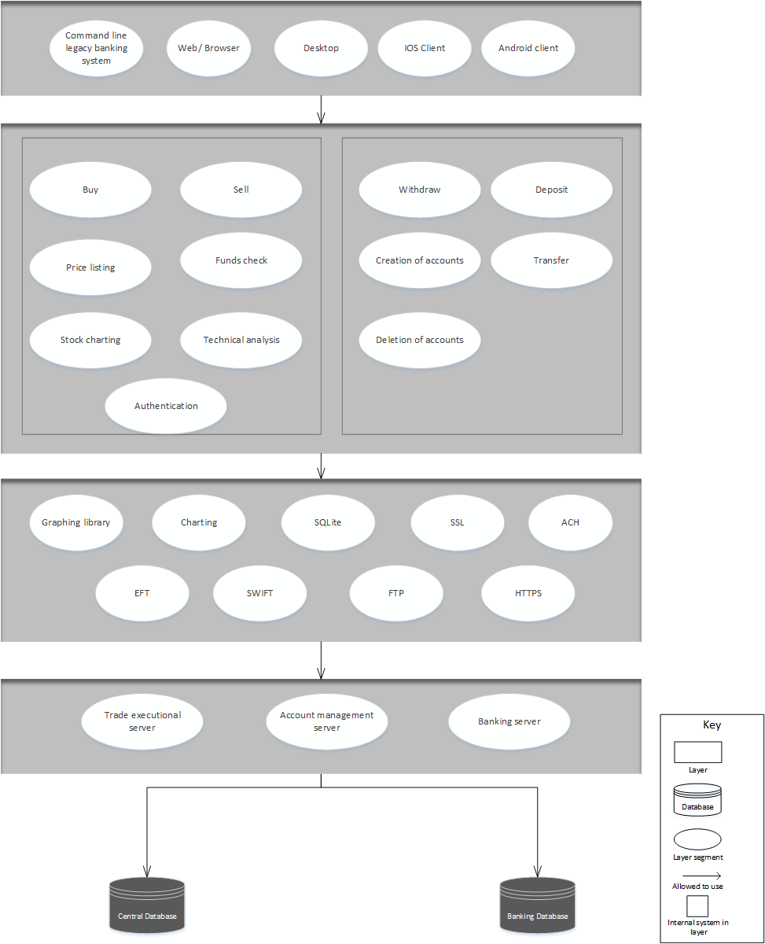

The software modules in the system are

* Command Line Banking System
* Web/Browser Client
* Desktop Client
* IOS Client
* Android Client
* Buy
* Sell
* Price listing
* Funds check
* Stock charting
* Technical Analysis
* Authentication
* Withdraw
* Deletion of Account
* Creation of Account
* Transfer
* Deposit
* Trade Execution Server
* Account Management Server
* Banking Server
* Central Database
* Banking Database
* Tradier API
* Graphing service
* Financial charting service

These layered style consists of the 5 layers which completely separates the software to provide the unidirectional relation with the layers below that.

The top most layer contains the set of services which contains interface used by the public.

Command line legacy banking system: This is the system which is used by end user through a command line which contains the command line user interface and database associated with this. Its logically structured in the top most layer of this views as it can be only used by the end users f the Trade Net Brokerage system.It allowed to use some of the functions in the next layer to operate on the bank account of the user which then uses the protocols to connect to the database which contains the details of the customers.

Web/Browser: It is generally used to represent the information from the resources which resides in the top most layer of the view.Through this users of the Trade Net Brokerage system are allowed to use the below services to do the transactions of the shares through the services and protocols of the below layers.

Desktop Client: Desktop Client is used to get give the user the real time financial news updates from Dow Jones.

IOS Client :It is an application which made to run on the IOS powered apple devices which generally used by the end users. Through this users of the Trade Net Brokerage system are allowed to use the below services to do the transactions of the shares through the services and protocols of the below layers.

Android Client :It is an application which made to run on the Android powered devices which generally used by the end users. It allows the users of the Trade Net Brokerage system to use the below services to do the transactions of the shares through the services and protocols of the below layers.

Trade Execution server :It is the server which is used to execute the trade for the shares.This is allowed to use by the modules in the above layer for providing services to the customer and it uses the central database to store the data of all the transactions, historical market data and logs. It also uses the banking database which contains the bank details of the customers for their transaction authentication.

Account management server: It is the server which facilitates the users to do the bank accounts management.This is allowed to use by the modules in the above layer for providing services to the customer for their bank transactions and it stores all its data to the central database and it provides customer authentication using the banking database.

Banking server: It provides the services to the customers of the bank to transact through their accounts and it contains all the details about the legacy system customers. It uses the central database to store the transactions of the system and banking database to authenticate the legacy customers

Central Database: It stores all the data about transactions ,historical market data , logs which are done by the services in the above layers.

Banking Database: This database contains all the details about the customer bank accounts. It will be used by the above layers to authenticate the users for the secured transactions.

Rationale:

Command Line Banking system is legacy banking system which allow to access and manage the customers of the Trade Net Brokerage system.

IOS Client: This provides the services to the customers using IOS to access and manage the customers of the Trade Net Brokerage system.

Android Client: This provides the services to the customers using Android devices to access and manage the customers of the Trade Net Brokerage system.

Desktop Client: It provides the real time market data through the tradier.

Trade Execution server: It provides the services to the customers to buy,sell or trade through their bank accounts. It provides the real time market data through communicating with the Tradier API. It uses the account management server for the accessing the customer information.

Account Management server: It provides the services to the trade execution server and access the customer account database which contains all the details about the customer.

Banking server: It provides the services to the legacy banking customers which is purchased to integrate in the Trade Net Brokerage system.

Central Database: It serves the purpose for storing all the transaction details and logs of the transactions which are done through the Trade Net Brokerage system.

Banking Database:It contains all the details of the customer to authenticate the details of the customer which can be used by the account management server.

http://www.webopedia.com/TERM/I/iphone_app.html

[Include (where needed) for each view:

Primary Presentation (graphical)(done)

Element catalog (elements and properties, relations and properties, interfaces, and behavior)

Architecture background (rationale, analysis results, assumptions)

Explanation of style using key

Related view packets)]

Element Catalog:

|  |  |
| --- | --- |
| Element | Description/Function |
| Command Line Banking System | Interface for the banking system. |
| Web/Browser Client | Helps in accessing the brokerage system via browser. |
| Desktop Client | Helps in accessing the brokerage system via desktop. |
| IOS Client | Helps in accessing the brokerage system via IOS device. |
| Android Client | Helps in accessing the brokerage system via Android device. |
| Buy | Helps in buying the shares. |
| Sell | Helps in selling the shares |
| Price listing | Displays the prices of the shares of the companies |
| Funds check | Helps in checking whether they have sufficient funds. |
| Stock charting | Helps in stock charting. |
| Technical Analysis | Helps in technical analysis. |
| Authentication | Helps in user log-in. |
| Withdraw | Helps in withdrawing the funds. |
| Deletion of Account | Helps in deletion of the user accounts |
| Creation of Account | Helps in creation of the user accounts. |
| Transfer | Helps in transfering the funds. |
| Deposit | Helps in depositing the funds. |
| Trade Execution Server | Helps in retrieving real-time market data |
| Account Management Server | Helps in checking the availability of the funds. |
| Banking Server | Helps in performing banking transactions. |
| Central Database | Stores the data of the TE server and AM server. |
| Banking Database | Stores the data of the banking server. |

3.1.3 Uses Style :

The software modules in the system are 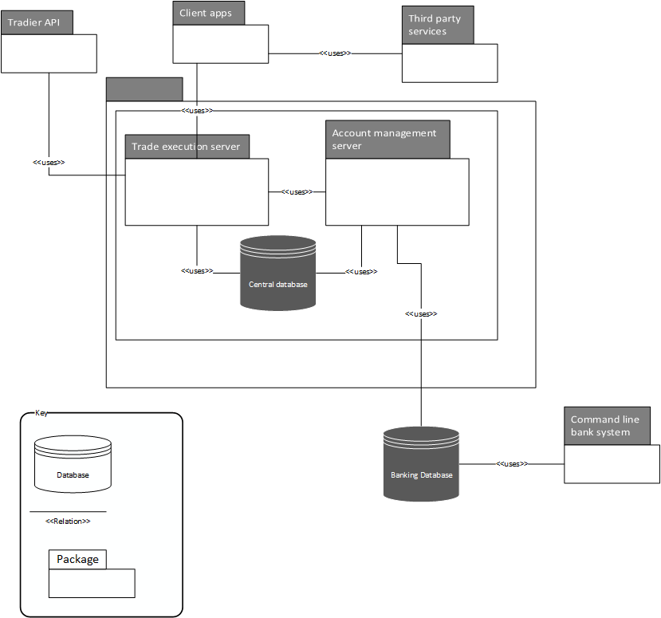

* Command Line Banking System
* Clients(Web/Browser Client, Desktop Client, IOS Client, Android Client)
* Trade Execution Server
* Account Management Server
* Banking Server
* Central Database
* Banking Database
* Tradier API
* Third Party Services (Graphing service & financial charting service)

Command line legacy banking system: This is the system which is used by end user through a command line which contains the command line user interface and database associated with this. It is uses the banking database to authenticate the users .

Clients: It provides the services to the customer by using the Trade execution server and it also uses the third party service to report the data.

Trade Execution server: It is used by the clients to provide the services to buy sell or trade. It uses the account management server to access the customer information from account management server.It also uses the central database to log all the transactions and also the tradier api for accessing the real time market data.

Account management server: It is used by the Trade execution server for customer information. It uses the central database to log all the information about the user transactions.

Central database: It is used by the Trade execution server and account management server .

Banking database: It is used by the account management server for authentication of the users .

Third Party services: They are used by the client apps for graphing and charting library.

Tradier API: It is used by the trade execution server for accessing the real time market data.

Rationale :

Command Line Banking system is legacy banking system which allow to access and manage the customers of the Trade Net Brokerage system.

Clients : These are used by the clients to access and manage the trade net customer account. It is used for stock charting, data access and perform the transactions

Account Management server: It provides the services to the trade execution server and access the customer account database which contains all the details about the customer.

Banking server: It provides the services to the legacy banking customers which is purchased to integrate in the Trade Net Brokerage system.

Central Database: It serves the purpose for storing all the transaction details and logs of the transactions which are done through the Trade Net Brokerage system.

Banking Database:It contains all the details of the customer to authenticate the details of the customer which can be used by the account management server.

Element Catalog :

|  |  |
| --- | --- |
| Element | Description/Function |
| Client Apps | Helps in accessing the Trade Net application. |
| Legacy Banking system | Helps in accessing the banking system via command line interface. |
| Trade Execution Server | Helps in retrieving real-time market data |
| Account Management Server | Helps in checking the availability of the  Cash. |
| Central Database | Stores the data of the TE server and AM server. |
| Banking Database | Stores the data of the banking server. |
| Third Party Services | Provides financial charting and Graphing functions for the customers. |
| Tradier | Provides real-time market data to the customers. |

## Run-time Structure and Dynamic Views:

A component and connector (C&C) view illustrates the union of all the possible execution traces, and combination of these items such as an execution trace. While designing an architecture for the system we tend to include all the functionalities of the system i.e. we are including all the components needed, these components need suitable interfaces to interact with each other so we include connectors for these components. If we take a particular component and want to analyze that particular execution trace, we can do that by selecting the particular components architecture. For example, consider a client-server architecture in which a client accessing the server of the banking system. This can provide the execution trace of a particular transaction from the entire system. If we want to analyze, how the entire system is working and responding in different execution traces we can do that for the component and connector style as it includes all the functionalities of the system. This can provide a execution trace of complete systems processes: A component and connector (C&C) view illustrates the union of all the possible execution traces, and combination of these items such as an execution trace. While designing an architecture for the system we tend to include all the functionalities of the system i.e. we are including all the components needed, these components need suitable interfaces to interact with each other so we include connectors for these components. If we take a particular component and want to analyze that particular execution trace, we can do that by selecting the particular components architecture. For example, consider a client-server architecture in which a client accessing the server of the banking system. This can provide the execution trace of a particular transaction from the entire system. If we want to analyze, how the entire system is working and responding in different execution traces we can do that for the component and connector style as it includes all the functionalities of the system. For example, consider a peer-to-peer architecture for distributed data storage for a company. This can provide a execution trace of complete systems processes.

### 3.2.1 Client-Server view:

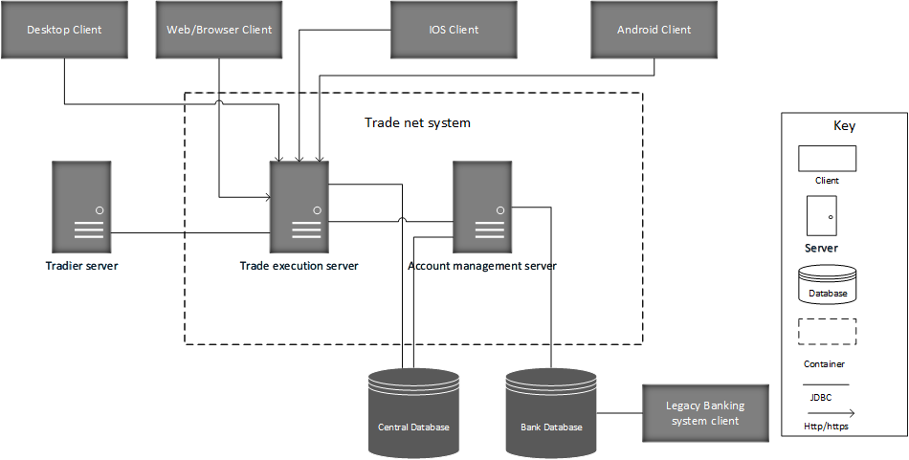

*Graphical representation of the client-server view*

The components in the system are Web/Browser, Desktop , IOS , Android, Trade Execution Server, Account Management Server, Banking Server, Central Database, Banking Database, Legacy Banking system. The Tradier API collects the real-time market data for the users to buy and sell the stocks.

### Element Catalog :

|  |  |  |
| --- | --- | --- |
| Module | Type | Description/Function |
| Web/Browser | Client | Helps in accessing the brokerage system via browser. |
| Desktop | Client | Helps in accessing the brokerage system via desktop. |
| IOS | Client | Helps in accessing the brokerage system via IOS device. |
| Android | Client | Helps in accessing the brokerage system via Android device. |
| Trade Execution Server | Server | Helps in retrieving real-time market data |
| Account Management Server | Server | Helps in checking the availability of the funds. |
| Banking Server | Server | Helps in performing banking transactions. |
| Central Database | Database | Stores the data of the TE server and AM server. |
| Banking Database | Database | Stores the data of the banking server. |
| Legacy Banking system | Client | Helps in accessing the banking system via command line interface. |

Process & their modules :

|  |  |
| --- | --- |
| Processes | Modules |
| Accessing the Trade Net Brokerage system. | Web/Browser Client, Desktop Client, IOS Client, Android Client. |
| Accessing the Banking System. | Command Line Banking System, Account Management Server , Banking Server, Banking Database. |
| Checking the real-time market values. | Clients, Tradier API, Trade Execution server. |
| Buying and Selling of shares. | Clients, Tradier API, Trade Execution server, Account Management Server. |
| Authenticating the user. | Clients, Trade Execution server. |
| Checking the availability of funds. | Account Management Server, Banking Database. |

Accessing the banking system will communicate with the buying and selling of shares process to to exchange the details about the sellers and buyers bank account details involves the and it also communicates with the authentication process for valid user authentication

Accessing the Trade Net Brokerage system.is the process which communicates with the user and the Trade Net Brokerage system. When user log-in it checks the validity through the authentication process.

If the user is valid it allows the user to buy sell shares and after the selecting user shares to buy/sell it checks with the real time market data for the value of their shares and gives the results to the trade execution server.

Banking system exchanges the information about the details of the customer with the other processes like buy/ sell shares.

Check the availability of the funds process gives the information about the details of the funds available in the bank account to the buy /Sell shares and access the banking system processes.

*3.2.2 Service Oriented architectural view:*

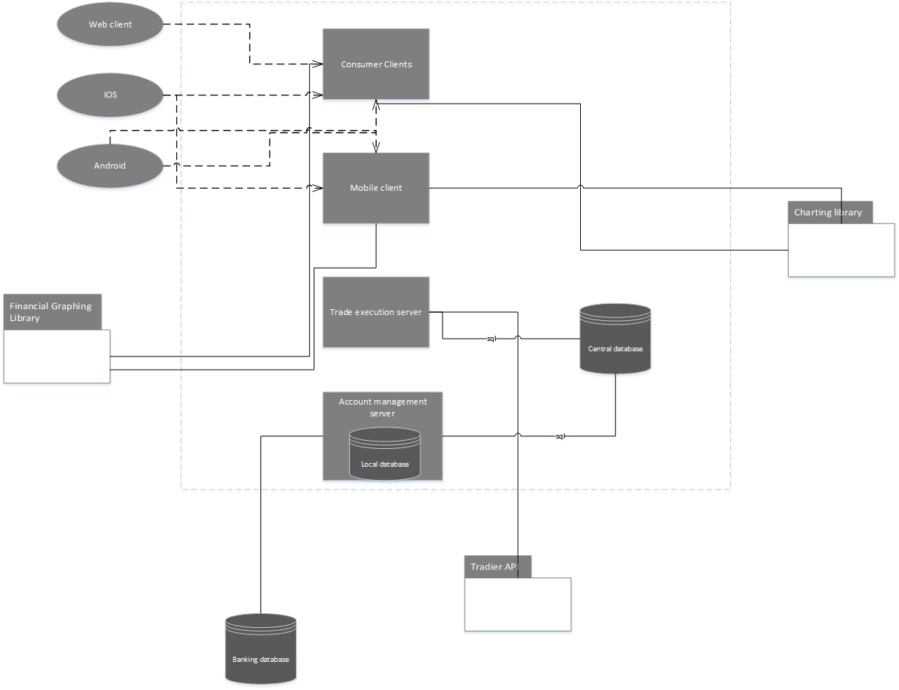

The components in the system are Web/Browser, Desktop , IOS , Android, Trade Execution Server, Account Management Server, Banking Server, Central Database, Banking Database, Legacy Banking system. The Tradier API(Service) collects the real-time market data for the users to buy and sell the stocks. Charting and Financial Graphing Library are the third party services offered for the clients via Trade Net System.

Element Catalog :

|  |  |  |
| --- | --- | --- |
| Module | Type | Description/Function |
| Web/Browser | Client | Helps in accessing the brokerage system via browser. |
| Desktop | Client | Helps in accessing the brokerage system via desktop. |
| IOS | Client | Helps in accessing the brokerage system via IOS device. |
| Android | Client | Helps in accessing the brokerage system via Android device. |
| Trade Execution | Server | Helps in retrieving real-time market data |
| Account Management Server | Server | Helps in checking the availability of the funds. |
| Banking Server | Server | Helps in performing banking transactions. |
| Central Database | Database | Stores the data of the TE server and AM server. |
| Banking Database | Database | Stores the data of the banking server. |
| Tradier | Server | Provides real-time market data. |
| Financial Graphing | Services(3rd party) | Provides financial graphing services for the users. |
| Charting | Services(3rd party) | Provides charting services for the users. |

Process & their modules :

|  |  |
| --- | --- |
| Processes | Modules |
| Accessing the Trade Net Brokerage system. | Web/Browser Client, Desktop Client, IOS Client, Android Client. |
| Accessing the Banking System. | Command Line Banking System, Account Management Server , Banking Server, Banking Database. |
| Checking the real-time market values. | Clients, Tradier API, Trade Execution server. |
| Buying and Selling of shares. | Clients, Tradier API, Trade Execution server, Account Management Server. |
| Authenticating the user. | Clients, Trade Execution server. |
| Checking the availability of funds. | Account Management Server, Banking Database. |
| Charting Service | Clients, Trade Execution server, 3rd party Service Provider. |
| Financial Graphing Service | Clients, Trade Execution server, 3rd party Service Provider. |
|  |  |

Accessing the banking system will communicate with the buying and selling of shares process to to exchange the details about the sellers and buyers bank account details involves the and it also communicates with the authentication process for valid user authentication.

Accessing the Trade Net Brokerage system.is the process which communicates with the user and the Trade Net Brokerage system. When user log-in it checks the validity through the authentication process.

If the user is valid it allows the user to buy sell shares and after the selecting user shares to buy/sell it checks with the real time market data for the value of their shares and gives the results to the trade execution server.

Banking system exchanges the information about the details of the customer with the other processes like buy/ sell shares.

Check the availability of the funds process gives the information about the details of the funds available in the bank account to the buy /Sell shares and access the banking system processes.

Charting service takes the data from the clients and use the charting libraries for preparing charts and the communicate or send the charts to the clients for displaying them.

Graphing service takes the data from the clients and use the graphing libraries for creating graphs and the communicate or send the graphs to the clients for displaying them.

3.2.3 Pipe & Filter :

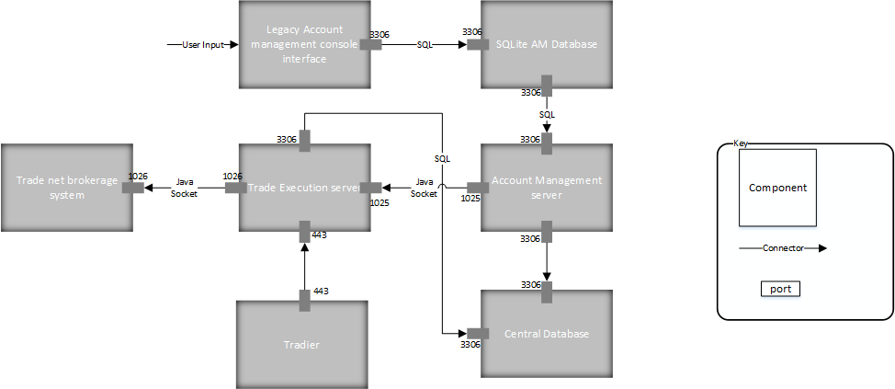

The components in the system are Trade Net Brokerage System, Trade Execution Server, Account Management Server, Central Database, Banking Database, Legacy Banking system. The Tradier API(Service) collects the real-time market data for the users to buy and sell the stocks.

Element Catalog :

|  |  |
| --- | --- |
| Element | Description/Function |
| Trade Net Brokerage System | Interface for the Trade Net Brokerage System. |
| Trade Execution | Helps in retrieving real-time market data. |
| Account Management Server | Helps in checking the availability of the funds. |
| Legacy Banking System | Helps in accessing the banking system via command line interface. |
| Central Database | Stores the data of the TE server and AM server. |
| Banking Database | Stores the data of the banking server. |
| Tradier | Provides real-time market data. |

Process & their modules :

|  |  |
| --- | --- |
| Processes | Modules |
| Accessing the Trade Net Brokerage system. | Trade Net Brokerage system Clients. |
| Accessing the Banking System. | Command Line Banking System, Account Management Server , Banking Server, Banking Database. |
| Checking the real-time market values. | Clients, Tradier API, Trade Execution server. |
| Buying and Selling of shares. | Clients, Tradier API, Trade Execution server, Account Management Server. |
| Authenticating the user. | Clients, Trade Execution server. |
| Checking the availability of funds. | Account Management Server, Banking Database. |

Accessing the banking system will communicate with the buying and selling of shares process to to exchange the details about the sellers and buyers bank account details involves the and it also communicates with the authentication process for valid user authentication

Accessing the Trade Net Brokerage system.is the process which communicates with the user and the Trade Net Brokerage system. When user log-in it checks the validity through the authentication process.

If the user is valid it allows the user to buy sell shares and after the selecting user shares to buy/sell it checks with the real time market data for the value of their shares and gives the results to the trade execution server.

Banking system exchanges the information about the details of the customer with the other processes like buy/ sell shares.

Check the availability of the funds process gives the information about the details of the funds available in the bank account to the buy /Sell shares and access the banking system processes.

## Allocation Views

Customers can initiate the request to access the Trade Net Brokerage system through the desktops and mobile apps. Then the all the requests from the clients are send to the web server. Then the web server accepts all the requests and redirects the requests to the respective servers. if the customer requests the buy/sell the trades the request is redirected to the trade execution server. When the customer selects the the shares to buy or sell it checks the real time market data with the tradier api . Checking of the funds which are sufficient for the sale is then checked and response from this is sent to the customer. If the customer requests are to check the bank balance of their accounts the requests are redirected to the account management server. Then the account management server checks the details of the customer through the banking database.Command line banking system also has the command line user interface through which customers can check the balance and transfer the amount to the other accounts.

3.3.2 Deployment View :

### 

Element Catalog :

|  |  |
| --- | --- |
| Element | Description/Function |
| Web/Browser | Helps in accessing the brokerage system via browser. |
| Desktop | Helps in accessing the brokerage system via desktop. |
| IOS | Helps in accessing the brokerage system via IOS device. |
| Android | Helps in accessing the brokerage system via Android device. |
| Trade Execution | Helps in retrieving real-time market data |
| Account Management Server | Helps in checking the availability of the funds. |
| Banking Server | Helps in performing banking transactions. |
| Central Database | Stores the data of the TE server and AM server. |
| Banking Database(SQLite) | Stores the data of the banking server. |
| Web Server | Connects the Trade Net requests from the client to Trade Net server. |

*Hardware components:*

Web Server

Trade execution server

Account management server

Desktop

Mobiles

*Location:*

Web server , Account management server , Trade execution server located at the remote location and locally which is made available through the ports and protocols.If one of the servers fails other server serves the purpose of the users.

Desktops can be of personal or shared desktops where personal computers are located in their residences and public computers can be in the labs,stock exchanges offices and brokerage firms.

Mobile is portable device which can be used to access the Trade Net Brokerage system with a proper Internet connection.

*Communication capabilities:*

Web server can accept the requests from the clients and redirect the requests to the trade execution server. When the trade execution server responds to the requests it will send the response to the respective clients.

The Trade execution server receives the requests of the clients and it performs buy/sell operation on the shares and communicates its response to the clients through the web server.It also access the customer details from the account management server.

Account management server contains the details of all customers. Trade execution server requests are served by the account management server and it communicates with the banking server for authentication of all customers.

Desktop can send the requests to the servers and it receives the responses which is displayed using xml code.

Mobile can send the requests through the applications of the IOS and android and the response is displayed through the xml code.

*Processes of hardware items:*

Web server are associated with the processes like the accessing the Trade Net Brokerage system and sending the responses to the clients.

Trade net execution server is associated with the process like buy/sell shares, checking the details of the customers and checking the real time data with the Tradier API.

Account management server is associated with the process like checking the funds and customer details of their accounts.

Mobile and Desktop can be used to access the Trade Net Brokerage system and display the charts and graphs.

# **Consistency among Architectural Views (Mapping Between Views)**

[Fill in your information]

# **Architectural Rationale**

[Fill in your information – include a mapping of requirements to modules]