Lab – 7

Anok Anil Thomas

23BDS1160

1.Creating a bouncing ball which changes its shape and color during its transition

Screenshots:



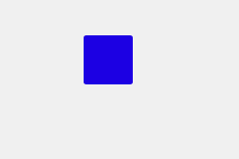

HTML code :

<!DOCTYPE html>

<html lang="en">

<head>

<meta charset="UTF-8">

<meta name="viewport" content="width=device-width, initial-scale=1.0">

<title>Bouncing Ball</title>

<link rel="stylesheet" href="styles.css">

</head>

<body>

<div class="ball"></div>

</body>

</html>

CSS Code:

body {

display: flex;

justify-content: center;

align-items: center;

height: 100vh;

background-color: #f0f0f0;

margin: 0;

}

.ball {

width: 50px;

height: 50px;

border-radius: 50%;

background-color: red;

position: absolute;

animation: bounce 2s infinite, changeColor 2s infinite, changeShape 2s infinite;

}

@keyframes bounce {

0%, 100% {

transform: translateY(0);

}

50% {

transform: translateY(-200px);

}

}

@keyframes changeColor {

0%, 100% {

background-color: red;

}

50% {

background-color: blue;

}

}

@keyframes changeShape {

0%, 100% {

border-radius: 50%;

}

50% {

border-radius: 0;

}

}

2.Create a HTML document that creates a blue square that rotates and changes colors as it moves back and forth horizontally. The animation repeats infinitely

ScreenShots :

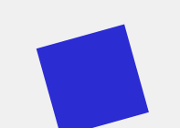 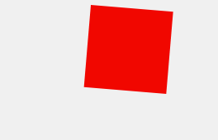

Code :

<!DOCTYPE html>

<html lang="en">

<head>

<meta charset="UTF-8">

<meta name="viewport" content="width=device-width, initial-scale=1.0">

<title>Animated Square</title>

<style>

body {

display: flex;

justify-content: center;

align-items: center;

height: 100vh;

margin: 0;

background-color: #f0f0f0;

}

#animated-square {

width: 100px;

height: 100px;

background-color: blue;

animation: moveAndRotate 5s linear infinite;

}

@keyframes moveAndRotate {

0% {

transform: translateX(-200px) rotate(0deg);

background-color: blue;

}

25% {

transform: translateX(200px) rotate(90deg);

background-color: red;

}

50% {

transform: translateX(-200px) rotate(180deg);

background-color: green;

}

75% {

transform: translateX(200px) rotate(270deg);

background-color: yellow;

}

100% {

transform: translateX(-200px) rotate(360deg);

background-color: blue;

}

}

</style>

</head>

<body>

<div id="animated-square"></div>

</body>

</html>