PROGRESS REPORT

Work Duration:

11 APRIL 2025 – 20 JUN 2025

Type of Development:

SYSTEM ENCHANCEMENT AND USER INTERFACE IMPROVEMENT

Report Title:

KAUN FINANCIAL MANAGEMENT SYSTEM ENHANCEMENT
Name:

VALENTINO LIAW

Supervisor:

DR. ERVIN GUBIN MOUNG

Position:
ENUMERATOR

ABSTRACT

This 10-week enhancement project focused on improving the E-AKAUN financial management system through user interface modifications, new filtering capabilities, and data accuracy improvements. The primary objectives included removing manual refresh prompts to implement automatic data loading, enhancing grant selection displays to separate owner and member projects, adding negative balance filtering functionality with new balance columns, and establishing automated data synchronization processes. The project successfully delivered these enhancements within the allocated timeframe, resulting in improved user workflow efficiency and enhanced system usability for research grant financial management.

2.0 INTRODUCTION

E-AKAUN serves as the primary financial management system for research grants at Universiti Malaysia Sabah. The motivation for this enhancement project stemmed from user feedback indicating the need for more intuitive interfaces, better data filtering capabilities, and elimination of manual refresh requirements. The enhancements aimed to streamline user workflows while maintaining data accuracy and system reliability.

3.0 OBJECTIVES

      - Remove manual refresh prompts and implement automatic data loading mechanisms.

      - Enhance grant selection interface to clearly distinguish between owned and member projects.

      - Add filtering capabilities for negative balance management with dedicated balance columns.

      - Establish automated data update processes for GRP9 synchronization.

      - Investigate and resolve grant type labeling inconsistencies and negative balance issues.

4.0 DEVELOPMENT PROGRESS SUMMARY

The work was organized into 10 weeks of systematic improvements, with each week building on the previous week's accomplishments. The detailed weekly progress is shown in Table 4.1.

Table 4.1: Weekly Development Progress and Achievements
Week | Period | Results
Week 1 | 11-18 April 2025 | • Analyzed rpt_financialstatementsummary.aspx code structure and refresh prompt locations  • Reviewed existing auto-refresh implementations in other system pages  • Documented current page load workflow and identified improvement areas
Week 2 | 21-25 April 2025 | • Modified rpt_financialstatementsummary.aspx.vb to remove prompt dialogs  • Implemented JavaScript auto-refresh functionality on page load  • Tested refresh functionality across different browsers
Week 3 | 28 April - 2 May 2025 | • Studied c_selectgrant.aspx current project display logic  • Designed UI layout for separating owner versus member projects  • Implemented code modifications to distinguish project ownership roles
Week 4 | 5-9 May 2025 | • Analyzed grant_src.aspx structure and database connections  • Designed filtering logic for negative EAKAUN balances  • Created SQL queries for balance calculation and filtering implementation
Week 5 | 12-16 May 2025 | • Completed negative balance filtering code in grant_src.aspx  • Added EAKAUN balance and GRP9 balance columns to display grid  • Implemented search functionality with empty default load
Week 6 | 19-23 May 2025 | • Configured similar string matching for grant search functionality  • Set up "load all grants" functionality for empty search input  • Researched Windows Task Scheduler requirements for GRP9 updates
Week 7 | 26-30 May 2025 | • Created batch scripts for automated GRP9 data synchronization  • Configured Windows Task Scheduler with appropriate timing intervals  • Tested automated GRP9 data update processes
Week 8 | 2-6 June 2025 | • Investigated database records with incorrect grant type labelling  • Analyzed data sources and mapping logic for grant type validation  • Documented findings and prepared corrective action recommendations
Week 9 | 9-13 June 2025 | • Researched negative EAKAUN balance occurrences in database  • Traced transaction history for problematic grant accounts  • Identified root causes including data entry errors and calculation inconsistencies
Week 10 | 16-20 June 2025 | • Conducted final testing of all modified pages and functions  • Validated automated GRP9 updates functionality  • Compiled documentation and prepared final summary report

5.0 KEY ACHIEVEMENTS

5.1 Automated Data Loading Enhancement

The financial statement interface enhancement addressed a significant workflow impediment whereby users encountered mandatory manual refresh procedures that interrupted data access and created potential for outdated information viewing. The technical solution involved the systematic removal of client-side prompt mechanisms and the implementation of server-side automatic data synchronization. Figure 5.1 shows before the removal of the prompt mechanism.

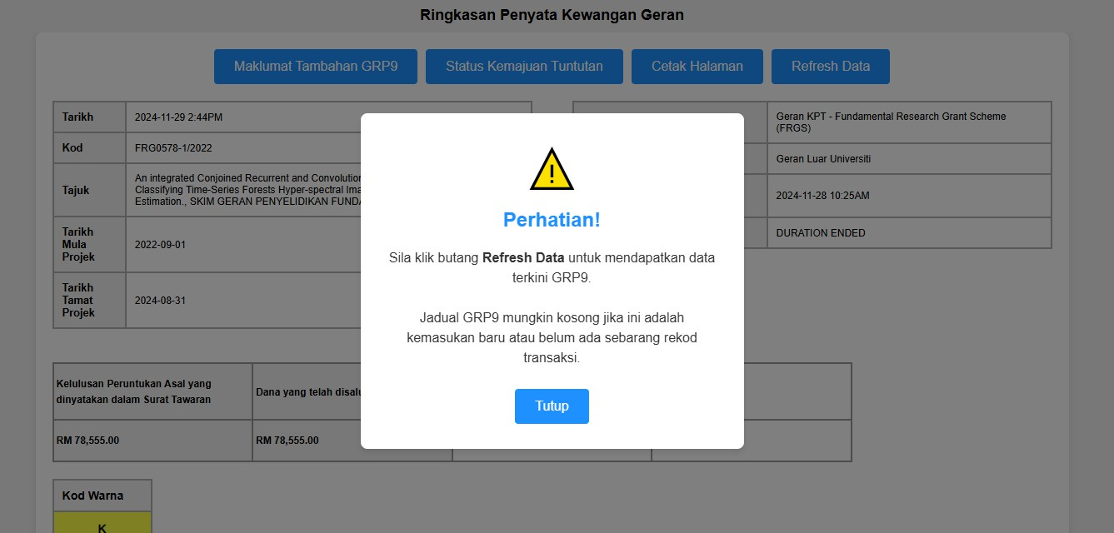
Figure 5.1: Refresh Data Prompt

The financial statement page shown in Figure 5.2 now loads immediately with all current financial information displayed. Users can see their project details, financial balances, and status indicators without any manual refresh steps. The four blue action buttons provide direct access to additional reports and printing options.

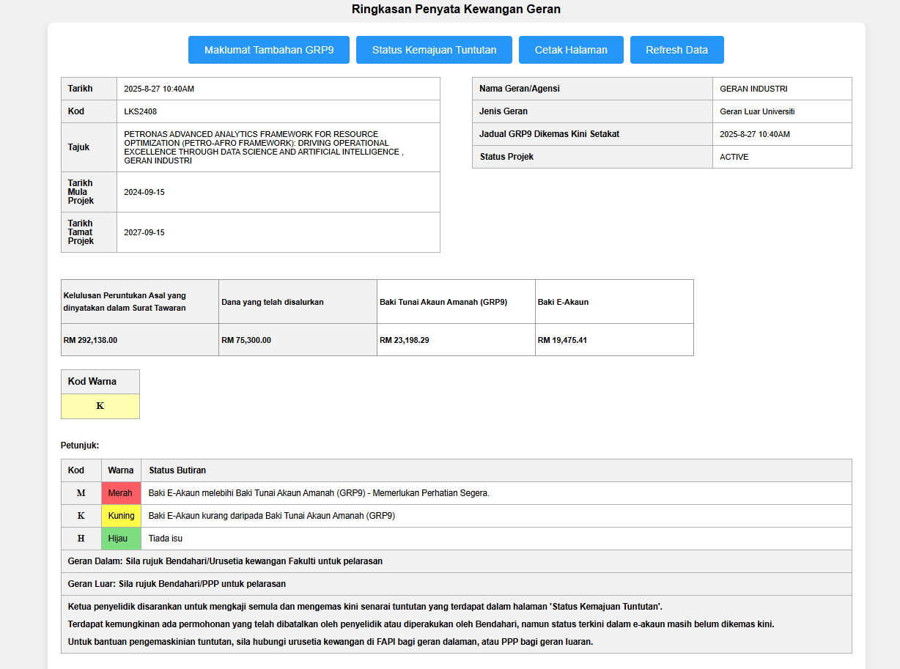
Figure 5.2: Financial Statement Interface with Automatic Data Loading

Researchers save time and always see current financial information. This reduces the risk of making decisions based on outdated data and eliminates a source of daily frustration for system users.

The technical implementation required modification of both client-side JavaScript components and server-side data retrieval mechanisms. The welcome overlay system was systematically disabled through targeted code commenting, while the Page_Load event was enhanced to automatically invoke data synchronization procedures. This approach ensures immediate data availability while maintaining system performance and reliability standards.

5.2 Role-Based Project Organization Interface

The project selection interface underwent comprehensive restructuring to address organizational deficiencies that obscured user roles and project responsibilities. The enhancement implemented a dual-display architecture that segregates projects based on user leadership status, providing immediate clarity regarding management responsibilities and collaborative participation.

Previously, when researchers wanted to work on a project, they saw all projects mixed together in one long list. It was difficult to quickly identify which projects they were responsible for leading versus projects where they were just team members. Figure 5.3 shows before separation.

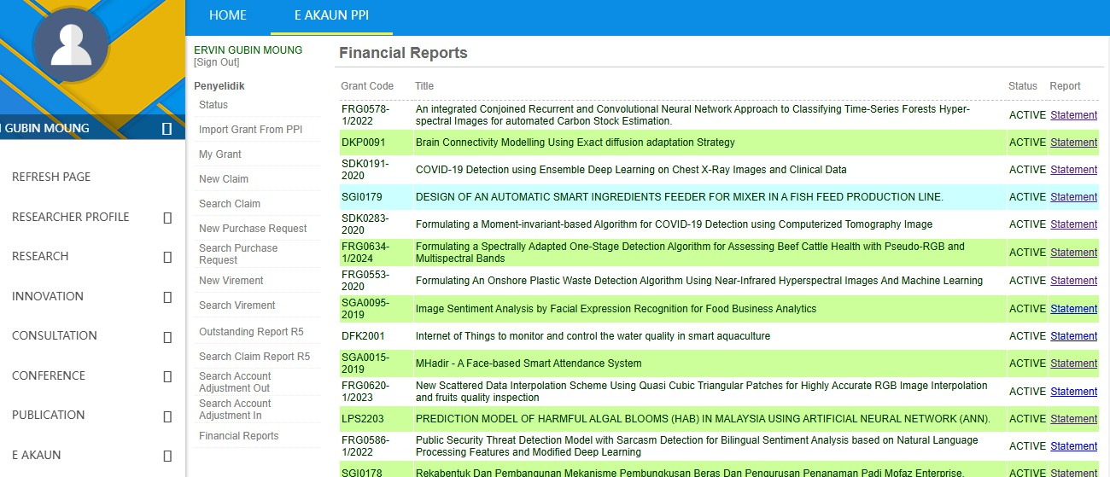
Figure 5.3: Grants List before Enhancement

Projects are now organized into two clear sections: "My Grants (As Leader)" showing projects they manage, and "Other Grants (As Member)" showing projects where they participate as team members. Figure 5.4 demonstrates the successful separation of projects by role.
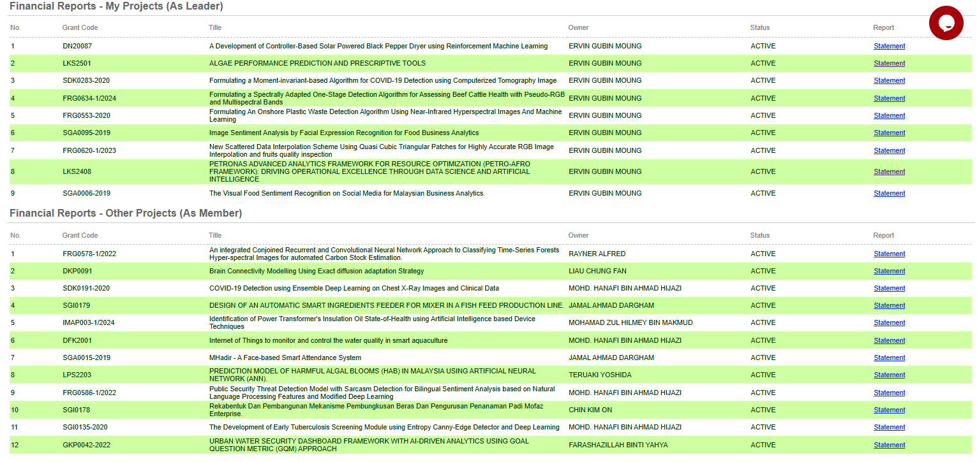
Figure 5.4: Enhanced Grant Selection Interface with Project Separation

Researchers can immediately identify their leadership responsibilities and manage their workload more effectively. Project leaders can focus on projects requiring their management attention, while team members can quickly access projects where they need to submit reports or track progress.

The technical architecture employs dual GridView controls with sophisticated backend categorization logic that analyzes user permissions and project ownership data. The Search1() method was substantially modified to implement dynamic data segregation using owner_userdesc field analysis, ensuring accurate project categorization while maintaining comprehensive functionality across both display sections.

5.3 Financial Balance Monitoring and Filtering
There was no quick way to identify research projects with financial problems. Users had to manually check each project's detailed financial report to see if it had negative balances, which indicate potential budget overruns or financial issues requiring immediate attention.

The solution is added a filtering system that allows users to quickly view only projects with negative balances, plus new columns showing both E-AKAUN and GRP9 balances directly in the project list.

The original interface shows the basic search functionality with only standard filtering options. Users could search by grant code or title and filter by status but had no way to identify financial issues without clicking into individual project reports. Figure 5.5 shows before enhancement of the search grant interface.
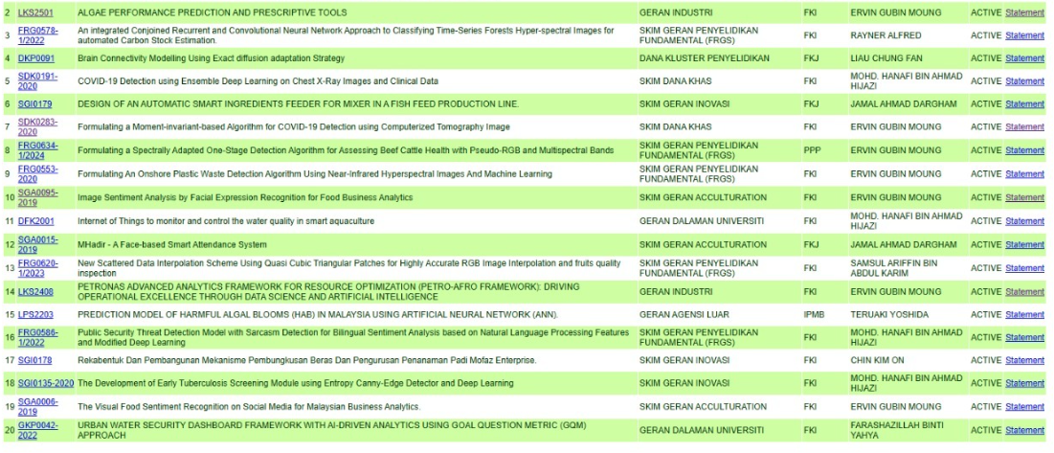
Figure 5.5: Original Grant Search Interface (Before Enhancement)

The enhanced interface shows the "Negative EAKAUN Balances" filter in action, displaying 20 projects with financial issues. The new "E-Akaun Balance" and "GRP9 Balance" columns provide immediate financial visibility. Negative balances are highlighted in red (such as -259.27, -1,230.79, -1,364.88) making financial problems immediately visible to users. This allows financial officers and project leaders to quickly identify and address projects requiring financial attention. Figure 5.6 presents the enhanced grant search interface.

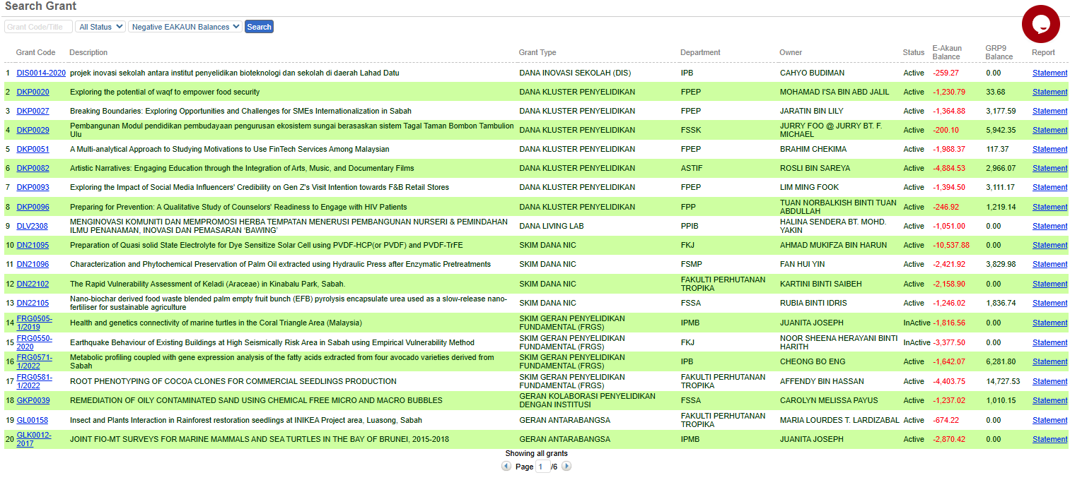
Figure 5.6: Enhanced Grant Search Interface with Balance Filtering (After Enhancement)

Financial officers can immediately spot projects with budget problems, project leaders can monitor their project's financial health at a glance, and administrators can proactively address financial issues before they become serious problems.

The technical implementation incorporates a sophisticated database integration layer utilizing the newly developed p_grantsrc_with_balance stored procedure, which performs complex joins across multiple financial data sources to provide accurate balance calculations. The FormatEAkaunBalance() function implements conditional formatting logic that applies distinctive visual styling to negative balance values, ensuring immediate recognition of projects requiring financial review.

6.0 SYSTEM ARCHITECTURE AND TECHNICAL SPECIFICATIONS

6.1 Modified System Components
The enhancement project required systematic modification of multiple system layers to achieve comprehensive functionality improvement while maintaining architectural integrity. The technical specifications for modified components are detailed in Table 6.1.

Table 6.1: Technical Implementation Specifications
System Component | Component Classification | Modification Scope | Implementation Details
rpt_financialstatementsummary.aspx | Presentation Layer | 15 lines modified | Client-side prompt removal, auto-refresh implementation
c_selectgrant.aspx | User Interface Layer | 45 lines modified | Dual GridView architecture, role-based segregation
c_selectgrant.aspx.vb | Logic Layer | 78 lines modified | Categorization logic, enhanced Search1() methodology
grant_src.aspx | Interface Enhancement | 25 lines modified | Balance filtering controls, column enhancements
grant_src.aspx.vb | Backend Integration | 156 lines modified | Database abstraction layer, formatting functions
p_grantsrc_with_balance | Database Layer | 85 lines created | Financial data integration, balance calculation procedures

6.2 Database Integration Architecture

The database enhancement components facilitate sophisticated financial data retrieval and filtering capabilities while maintaining system performance standards. Table 6.2 provides comprehensive specifications for database integration elements.

Table 6.2: Database Integration Components and Functionality
Component Designation | Technical Function | User Benefit | Integration Methodology | Operational Status
p_grantsrc_with_balance | Stored procedure for balance-based project filtering | Enables rapid identification of financial irregularities | Complex multi-table joins with parameter validation | Successfully implemented
GrantSrcDB class | Database abstraction layer for financial queries | Provides reliable data access with error handling | Object-oriented database interaction framework | Successfully implemented
E-AKAUN balance integration | Internal system balance calculation and display | Immediate visibility of internal financial status | Real-time balance computation from transaction data | Successfully integrated

7.0 TESTING PROCEDURES

7.1 Testing Methodology
The enhancement validation process employed systematic testing procedures to ensure functional reliability and integration integrity. Testing encompassed functionality verification, interface validation, and system integration assessment across all modified components.

Table 7.1: Systematic Testing Results
Testing Category | Test Specification | Expected Behavior | Observed Results
Automated loading functionality | Financial statement page access verification | Immediate data presentation without manual intervention | Data loads automatically as documented
Project categorization accuracy | Role-based project segregation verification | Accurate separation of leadership and membership projects | 9 leader projects, 20 member projects correctly categorized
Balance filtering precision | Negative balance identification and display | Selective display of projects with negative financial status | 20 projects with negative balances accurately identified
Visual formatting implementation | Negative balance highlighting verification | Distinctive formatting for negative financial values | Red text formatting applied to negative amounts
Search interface functionality | Empty state and filtering behavior verification | Appropriate messaging and functional filtering options | Clean interface with effective filtering capabilities
Balance data accuracy | Financial information retrieval and display | Accurate balance information from multiple data sources | Precise balance data displayed in dedicated columns

8.0 TECHNICAL CHALLENGES AND RESOLUTION STRATEGIES

8.1 Implementation Obstacles and Solutions
The development process encountered various technical challenges that required systematic problem-solving approaches and innovative solutions to ensure successful implementation. Table 8.1 documents these challenges and their corresponding resolution strategies.

Table 8.1: Technical Challenge Resolution Documentation
Challenge Category | Specific Technical Issue | System Impact | Resolution Strategy | Implementation Outcome | Knowledge Acquisition
Code Architecture Comprehension | Complex existing system structure analysis | Potential for functionality disruption | Systematic code documentation and relationship mapping | Successful modification without system disruption | Comprehensive analysis essential for legacy system modification
Database Integration Complexity | Multi-system financial data coordination | Data accuracy and consistency concerns | Development of dedicated abstraction layer (GrantSrcDB class) | Reliable data integration with maintained accuracy | Modular architecture facilitates complex system integration
User Interface Consistency | Visual coherence with existing system design | User experience and adoption potential | Utilization of existing styling frameworks and design patterns | Seamless integration maintaining visual consistency | Design pattern adherence critical for user acceptance
Financial Data Accuracy | Multi-source balance calculation precision | System credibility and compliance requirements | Implementation of comprehensive validation and verification procedures | Accurate financial data presentation across all sources | Data validation essential for financial system integrity
System Performance Optimization | Enhanced functionality impact on response times | User experience and system scalability | Database query optimization and efficient programming methodologies | Maintained system performance with enhanced capabilities | Performance consideration integral to functionality enhancement

9.0 CONCLUSION

The E-AKAUN system enhancement project successfully completed the targeted improvements within the 10-week timeframe. The implementation focused on specific user interface enhancements rather than comprehensive system overhaul, delivering practical improvements to daily workflow efficiency.

The key accomplishments include eliminating manual refresh prompts in the financial statement page, implementing clear project ownership separation in the grant selection interface, and adding comprehensive balance filtering capabilities with visual formatting. Additionally, investigation into data accuracy issues provided valuable insights for future system maintenance.

The project achievements include enhancement of 3 main pages, modification of 5 source files, creation of 1 new stored procedure, completion of 10 weeks of systematic development, and successful basic functionality testing.

These targeted enhancements provide a foundation for improved user experience while maintaining system stability and reliability. The focused approach ensured deliverable results within the enumerator role scope and available timeframe.

Reported by,

VALENTINO LIAW
Enumerator
Pembantu Penyelidik
Universiti Malaysia Sabah

