Dokumentasi Database / Data Warehouse
Big Data Pipeline — Flight Delay Analytics 2019–2023
GCP Project : tubes-bigdata-498212
Datasets : etl_flight_analytics | elt_flight_analytics
Location : US (BigQuery)

1. Gambaran Umum Arsitektur Data

Proyek ini mengimplementasikan dua pendekatan pipeline big data pada platform Google BigQuery untuk menganalisis keterlambatan penerbangan domestik Amerika Serikat periode 2019–2023. Kedua pipeline memproses dataset yang sama namun dengan strategi transformasi yang berbeda:

Aspek | ETL Pipeline | ELT Pipeline
Dataset BigQuery | etl_flight_analytics | elt_flight_analytics
Tempat transformasi | Google Colab (Python/cuDF) | Google BigQuery (SQL)
Struktur output | Star Schema (4 tabel) | Flat Tables (6 tabel)
Baris akhir | 149,801 | 148,843
On-time rate | 66.04% | 66.04%
Validasi | 5 LULUS, 1 PERINGATAN | 5 LULUS, 1 PERINGATAN

2. Skema Database — Star Schema (ETL Pipeline)

Pipeline ETL menghasilkan star schema di dataset etl_flight_analytics. Star schema terdiri dari satu fact table di pusat dan tiga dimension tables yang mengelilinginya. Tabel fact_flights menyimpan data pengukuran (measures) sedangkan dim_date, dim_airline, dan dim_airport menyimpan atribut deskriptif.

2.1 Diagram Star Schema (ERD)

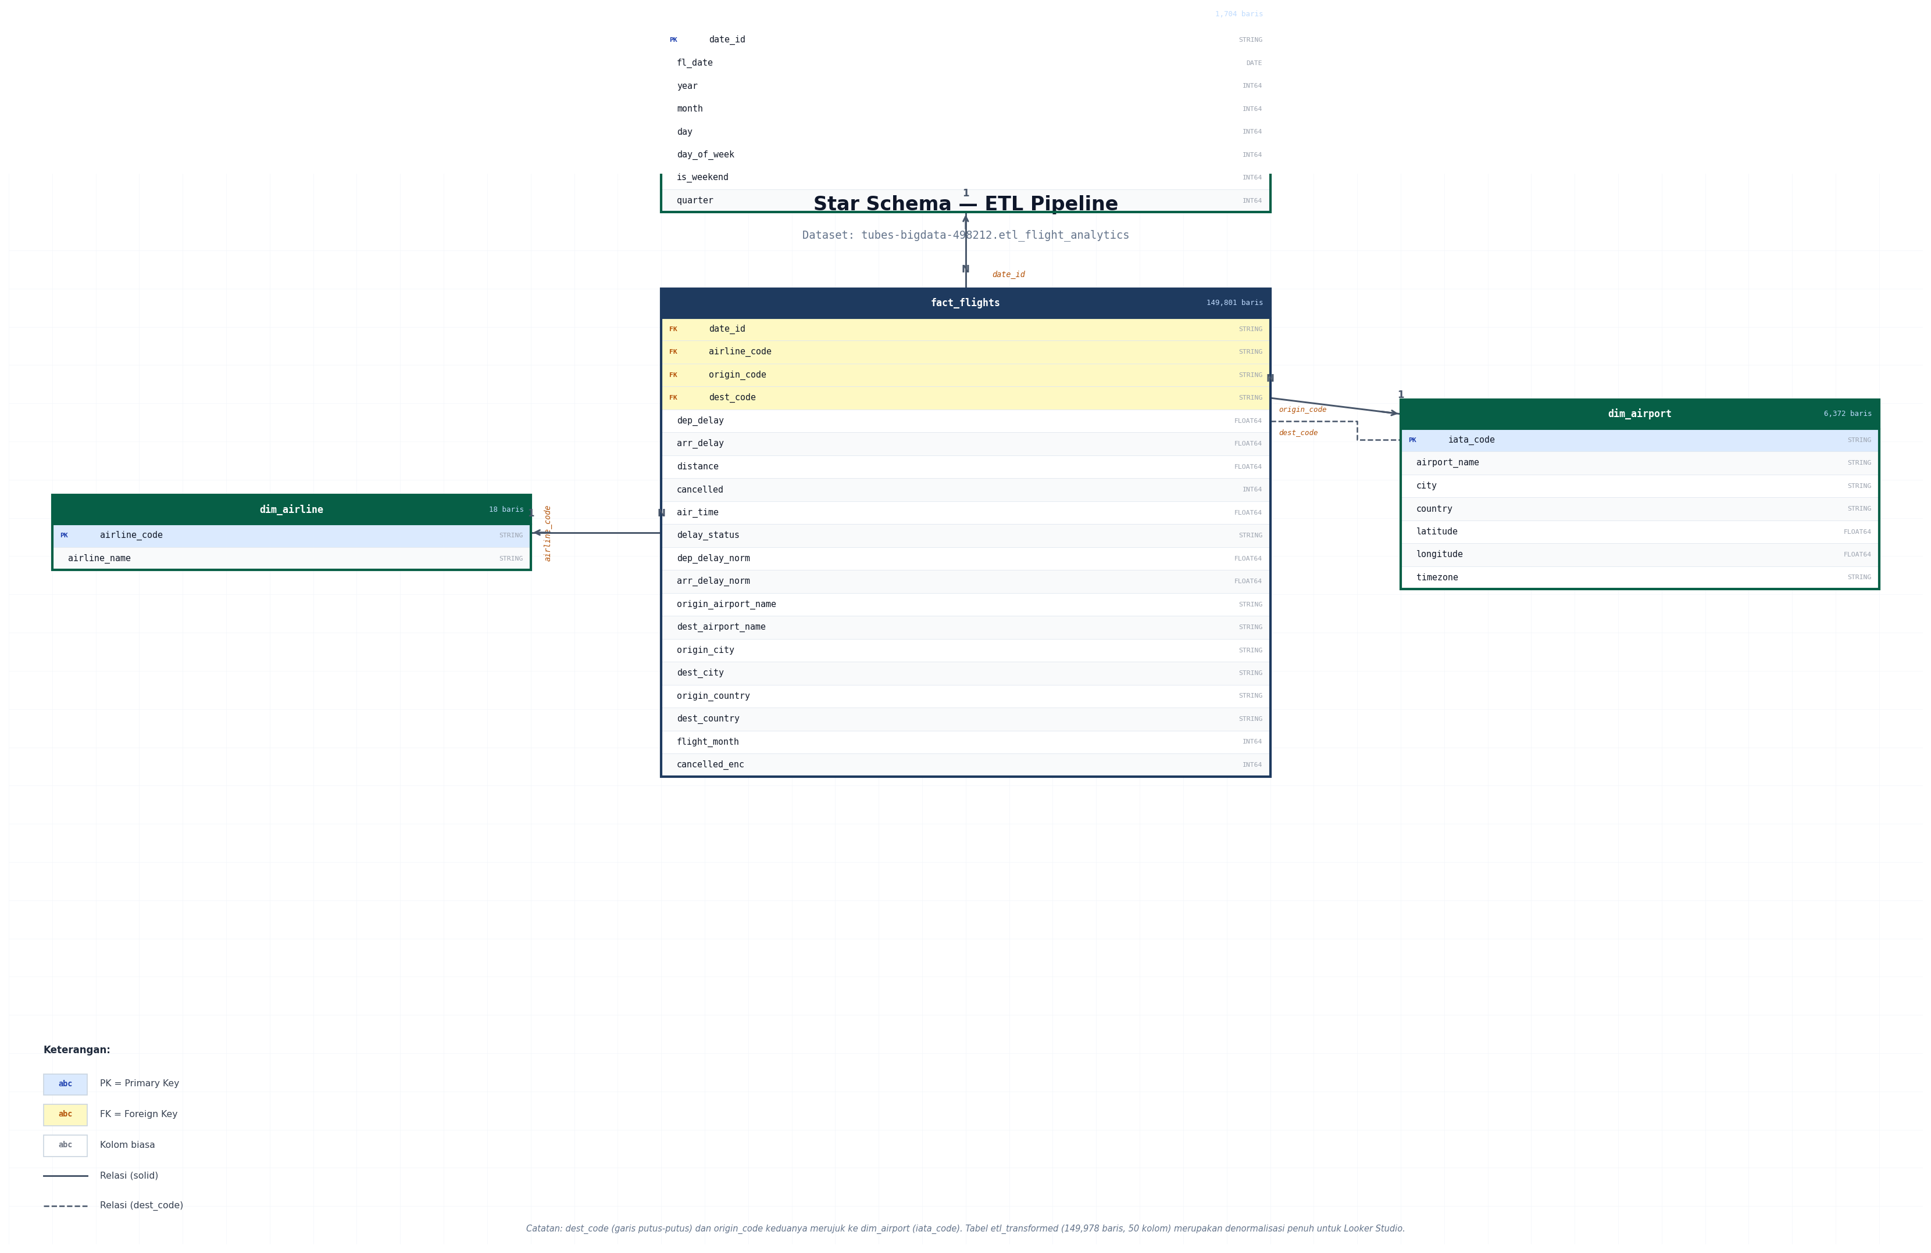
Gambar 1. Star Schema — ETL Pipeline (etl_flight_analytics). Biru = Fact Table, Hijau = Dimension Tables. PK = Primary Key, FK = Foreign Key.

2.2 Relasi Antar Tabel

Dari (Fact) | Kolom FK | Ke (Dim) | Kolom PK
fact_flights | date_id | dim_date | date_id
fact_flights | airline_code | dim_airline | airline_code
fact_flights | origin_code | dim_airport | iata_code
fact_flights | dest_code | dim_airport | iata_code

Catatan: origin_code dan dest_code keduanya merujuk ke tabel dim_airport yang sama melalui kolom iata_code. Ini adalah pola "role-playing dimension" yang umum dalam star schema penerbangan.

3. Struktur Tabel — ETL Pipeline (etl_flight_analytics)

3.1 fact_flights
Tabel fakta utama yang menyimpan data per penerbangan. Tabel ini merupakan pusat star schema dan berisi foreign keys ke semua tabel dimensi serta kolom pengukuran (measures).

Jumlah baris: 149,801 | Jumlah kolom: 20

# | Nama Kolom | Tipe Data | Keterangan
1 | airline_code | STRING | FK → dim_airline.airline_code. Kode IATA 2 huruf maskapai.
2 | origin_code | STRING | FK → dim_airport.iata_code. Kode IATA bandara asal.
3 | dest_code | STRING | FK → dim_airport.iata_code. Kode IATA bandara tujuan.
4 | date_id | STRING | FK → dim_date.date_id. Format YYYYMMDD.
5 | dep_delay | FLOAT64 | Keterlambatan keberangkatan (menit). NULL jika cancelled.
6 | arr_delay | FLOAT64 | Keterlambatan kedatangan (menit). NULL jika cancelled.
7 | distance | FLOAT64 | Jarak penerbangan (mil).
8 | cancelled | INT64 | 0 = tidak dibatalkan, 1 = dibatalkan.
9 | air_time | FLOAT64 | Durasi terbang aktual (menit).
10 | delay_status | STRING | on_time / minor_delay / moderate_delay / severe_delay / cancelled.
11 | dep_delay_norm | FLOAT64 | dep_delay ternormalisasi Min-Max [0,1]. NULL jika cancelled.
12 | arr_delay_norm | FLOAT64 | arr_delay ternormalisasi Min-Max [0,1]. NULL jika cancelled.
13 | origin_airport_name | STRING | Nama bandara asal (denormalized dari dim_airport).
14 | dest_airport_name | STRING | Nama bandara tujuan (denormalized dari dim_airport).
15 | origin_city | STRING | Kota asal penerbangan.
16 | dest_city | STRING | Kota tujuan penerbangan.
17 | origin_country | STRING | Negara asal penerbangan.
18 | dest_country | STRING | Negara tujuan penerbangan.
19 | flight_month | INT64 | Bulan penerbangan (1–12).
20 | cancelled_enc | INT64 | Encoding biner cancelled (identik dengan kolom cancelled).

3.2 dim_date
Tabel dimensi waktu yang menyimpan atribut tanggal untuk setiap hari penerbangan dalam rentang 2019-01-01 hingga 2023-08-31.

Jumlah baris: 1,704 | Jumlah kolom: 8

# | Nama Kolom | Tipe Data | Keterangan
1 | date_id | STRING | PK. Format YYYYMMDD. Digunakan sebagai FK di fact_flights.
2 | fl_date | DATE | Tanggal penerbangan dalam format DATE BigQuery.
3 | year | INT64 | Tahun (2019, 2020, 2021, 2022, 2023).
4 | month | INT64 | Bulan (1–12).
5 | day | INT64 | Hari dalam bulan (1–31).
6 | day_of_week | INT64 | Hari dalam minggu (0=Senin, 6=Minggu).
7 | is_weekend | INT64 | 1 jika Sabtu atau Minggu, 0 jika hari kerja.
8 | quarter | INT64 | Kuartal (1–4).

3.3 dim_airline
Tabel dimensi maskapai. Berisi 18 maskapai domestik AS yang terdapat dalam sampel dataset.

Jumlah baris: 18 | Jumlah kolom: 2

# | Nama Kolom | Tipe Data | Keterangan
1 | airline_code | STRING | PK. Kode IATA 2 huruf (e.g. WN, DL, AA).
2 | airline_name | STRING | Nama maskapai lengkap (e.g. Southwest Airlines Co.).

3.4 dim_airport
Tabel dimensi bandara. Berisi data referensi untuk 6.372 bandara unik dari dataset Global Airports.

Jumlah baris: 6,372 | Jumlah kolom: 7

# | Nama Kolom | Tipe Data | Keterangan
1 | iata_code | STRING | PK. Kode IATA 3 huruf (e.g. ATL, DFW, ORD).
2 | airport_name | STRING | Nama bandara lengkap.
3 | city | STRING | Kota dan negara bagian.
4 | country | STRING | Nama negara lengkap.
5 | latitude | FLOAT64 | Koordinat lintang (desimal).
6 | longitude | FLOAT64 | Koordinat bujur (desimal).
7 | timezone | STRING | Zona waktu IANA (e.g. America/New_York).

3.5 etl_transformed (Denormalisasi untuk Dashboard)
Tabel gabungan penuh hasil join fact_flights dengan semua dimensi. Digunakan langsung oleh Looker Studio sebagai sumber data dashboard.

Jumlah baris: 149,978 | Jumlah kolom: 50

Tabel ini merupakan gabungan dari fact_flights (20 kolom) dengan data dimensi dari dim_date, dim_airline, dan dim_airport (origin dan dest), ditambah fitur-fitur rekayasa seperti flight_year, flight_month, day_of_week, delay_status, is_weekend, dan dep_delay_norm/arr_delay_norm.

4. Struktur Tabel — ELT Pipeline (elt_flight_analytics)

4.1 Diagram Alur Tabel ELT

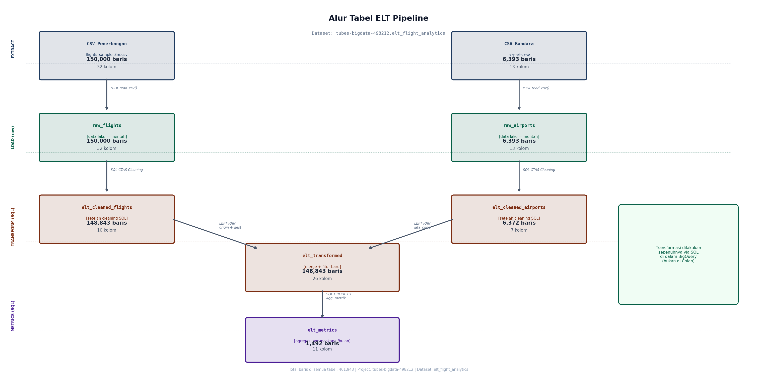
Gambar 2. Alur tabel ELT Pipeline. Data mentah dimuat ke BigQuery terlebih dahulu, kemudian ditransformasi melalui SQL CTAS dalam BigQuery.

4.2 raw_flights — Data Lake (Mentah)
Jumlah baris: 150,000 | Jumlah kolom: 32 | Status: Data Lake (tidak dimodifikasi)

Data flight mentah yang dimuat langsung dari CSV tanpa transformasi apapun. Merupakan fondasi data lake dalam arsitektur ELT. Berisi 32 kolom asli dari dataset Kaggle.

4.3 raw_airports — Data Lake (Mentah)
Jumlah baris: 6,393 | Jumlah kolom: 13 | Status: Data Lake (tidak dimodifikasi)

Data airport mentah, identik dengan file airports.csv yang diunduh dari Kaggle.

4.4 elt_cleaned_flights
Jumlah baris: 148,843 | Jumlah kolom: 10

# | Nama Kolom | Tipe Data | Keterangan
1 | fl_date | DATE | Tanggal penerbangan, di-parse dari string menggunakan PARSE_DATE().
2 | airline | STRING | Nama maskapai.
3 | origin | STRING | Kode IATA bandara asal.
4 | dest | STRING | Kode IATA bandara tujuan.
5 | dep_time | FLOAT64 | Waktu keberangkatan aktual (HHMM).
6 | dep_delay | FLOAT64 | NULL untuk cancelled; 0 jika null pada non-cancelled.
7 | arr_delay | FLOAT64 | NULL untuk cancelled; 0 jika null pada non-cancelled.
8 | air_time | FLOAT64 | Durasi terbang (menit).
9 | distance | FLOAT64 | Jarak penerbangan (mil).
10 | cancelled | INT64 | 0 atau 1. Penerbangan yang dibatalkan memiliki NULL dep_delay.

4.5 elt_cleaned_airports
Jumlah baris: 6,372 | Jumlah kolom: 7

Identik dengan dim_airport pada ETL pipeline: iata_code (PK), airport_name, city, country, latitude, longitude, timezone.

4.6 elt_transformed
Jumlah baris: 148,843 | Jumlah kolom: 26

Hasil penggabungan elt_cleaned_flights dengan elt_cleaned_airports (LEFT JOIN dua kali, untuk origin dan dest) ditambah enam kolom fitur baru:

# | Kolom Baru | Tipe Data | Keterangan
1 | origin_airport_name | STRING | Nama bandara asal dari elt_cleaned_airports.
2 | origin_city | STRING | Kota asal.
3 | origin_country | STRING | Negara asal.
4 | origin_lat | FLOAT64 | Lintang bandara asal.
5 | origin_lon | FLOAT64 | Bujur bandara asal.
6 | origin_timezone | STRING | Zona waktu bandara asal.
7 | dest_airport_name | STRING | Nama bandara tujuan.
8 | dest_city | STRING | Kota tujuan.
9 | dest_country | STRING | Negara tujuan.
10 | dest_lat | FLOAT64 | Lintang bandara tujuan.
11 | dest_lon | FLOAT64 | Bujur bandara tujuan.
12 | flight_year | INT64 | EXTRACT(YEAR FROM fl_date).
13 | flight_month | INT64 | EXTRACT(MONTH FROM fl_date).
14 | day_of_week | INT64 | EXTRACT(DAYOFWEEK FROM fl_date) - 1. (0=Minggu, 6=Sabtu)
15 | delay_status | STRING | on_time / minor_delay / moderate_delay / severe_delay / cancelled.
16 | is_weekend | INT64 | 1 jika hari Minggu (1) atau Sabtu (7).
17 | quarter | INT64 | EXTRACT(QUARTER FROM fl_date). 1–4.

4.7 elt_metrics
Jumlah baris: 1,492 | Jumlah kolom: 11

Tabel agregasi metrik kinerja per maskapai per bulan per negara asal. Digunakan untuk analisis tren dan perbandingan maskapai.

# | Nama Kolom | Tipe Data | Keterangan
1 | airline | STRING | Nama maskapai.
2 | flight_year | INT64 | Tahun (2019–2023).
3 | flight_month | INT64 | Bulan (1–12).
4 | origin_country | STRING | Negara asal.
5 | total_flights | INT64 | Total penerbangan dalam kelompok ini.
6 | avg_dep_delay | FLOAT64 | Rata-rata delay keberangkatan, exclude cancelled.
7 | avg_arr_delay | FLOAT64 | Rata-rata delay kedatangan, exclude cancelled.
8 | avg_distance | FLOAT64 | Rata-rata jarak penerbangan (mil).
9 | total_cancelled | INT64 | Total penerbangan dibatalkan.
10 | avg_air_time | FLOAT64 | Rata-rata durasi terbang (menit), exclude cancelled.
11 | on_time_rate_pct | FLOAT64 | Persentase tepat waktu. Formula: COUNTIF(on_time) / COUNTIF(cancelled=0) × 100.

5. Query SQL Analitik

Seluruh query analitik di bawah ini dieksekusi menggunakan pandas/cuDF setelah star schema terbentuk (ETL) atau langsung di BigQuery (ELT). Hasil dari setiap query ditampilkan di Looker Studio.

5.1 Query ETL (Dieksekusi via pandas/cuDF setelah star schema load)

Query 1 — Top 10 Maskapai dengan Delay Terlama (exclude cancelled)

SELECT
da.airline_name,
ROUND(AVG(f.dep_delay), 2) AS avg_dep_delay,
COUNT(f.dep_delay) AS total_penerbangan
FROM fact_flights f
JOIN dim_airline da ON f.airline_code = da.airline_code
WHERE f.cancelled = 0
GROUP BY da.airline_name
ORDER BY avg_dep_delay DESC
LIMIT 10;

Hasil: JetBlue Airways 18.71 mnt | Frontier Airlines 15.19 mnt | Allegiant Air 13.85 mnt

Query 2 — Tren Penerbangan dan Delay per Tahun

SELECT
dd.year,
COUNT(f.dep_delay) AS total_penerbangan,
ROUND(AVG(f.dep_delay), 2) AS avg_delay_menit,
CAST(SUM(f.cancelled) AS INT64) AS total_cancelled
FROM fact_flights f
JOIN dim_date dd ON f.date_id = dd.date_id
GROUP BY dd.year
ORDER BY dd.year;

Hasil: 2019 (10.86 mnt) → 2020 (1.71 mnt, pandemi) → 2021 (9.49) → 2022 (12.45) → 2023 (14.50 mnt)

Query 3 — Top 10 Bandara Asal Tersibuk

SELECT
da.airport_name,
da.city,
da.country,
COUNT(*) AS total_penerbangan
FROM fact_flights f
JOIN dim_airport da ON f.origin_code = da.iata_code
GROUP BY da.airport_name, da.city, da.country
ORDER BY total_penerbangan DESC
LIMIT 10;

Hasil: ATL 7,795 | DFW 6,526 | ORD 6,097 | DEN 5,979 | CLT 4,680

Query 4 — Weekend vs Weekday Delay

SELECT
CASE WHEN dd.is_weekend = 1
THEN 'Weekend' ELSE 'Weekday'
END AS periode,
ROUND(AVG(f.dep_delay), 2) AS avg_delay,
COUNT(f.dep_delay) AS total_penerbangan
FROM fact_flights f
JOIN dim_date dd ON f.date_id = dd.date_id
WHERE f.cancelled = 0
GROUP BY dd.is_weekend;

Hasil: Weekday 9.78 mnt | Weekend 10.90 mnt

Query 5 — Distribusi Status Delay dan On-Time Rate

-- Distribusi status
SELECT
delay_status,
COUNT(*) AS jumlah,
ROUND(COUNT(*) * 100.0 / SUM(COUNT(*)) OVER(), 2) AS persen
FROM fact_flights
GROUP BY delay_status
ORDER BY jumlah DESC;

-- On-Time Rate (formula benar: exclude cancelled dari denominator)
SELECT ROUND(
COUNT(CASE WHEN delay_status = 'on_time' THEN 1 END)
/ NULLIF(COUNT(CASE WHEN cancelled = 0 THEN 1 END), 0)
* 100.0, 2
) AS on_time_rate_pct
FROM fact_flights;
-- Hasil: 66.04%

Query 6 — Rute Terpopuler (Origin → Dest)

SELECT
origin_code,
dest_code,
COUNT(*) AS total_penerbangan,
ROUND(AVG(dep_delay), 2) AS avg_delay
FROM fact_flights
GROUP BY origin_code, dest_code
ORDER BY total_penerbangan DESC
LIMIT 10;

Query 7 — Tren Pembatalan per Bulan

SELECT
dd.year,
dd.month,
CAST(SUM(f.cancelled) AS INT64) AS total_cancelled,
COUNT(*) AS total_penerbangan,
ROUND(SUM(f.cancelled) * 100.0 / COUNT(*), 2) AS pct_cancelled
FROM fact_flights f
JOIN dim_date dd ON f.date_id = dd.date_id
GROUP BY dd.year, dd.month
ORDER BY dd.year, dd.month;

Pembatalan tertinggi: 2020 (total 1,441 — pandemi COVID-19).

Query 8 — Jarak Penerbangan vs Rata-rata Delay

SELECT
CASE
WHEN distance < 500 THEN 'Pendek (<500 mil)'
WHEN distance < 1500 THEN 'Sedang (500-1500 mil)'
ELSE 'Jauh (>1500 mil)'
END AS kelompok_jarak,
ROUND(AVG(dep_delay), 2) AS avg_delay,
COUNT(*) AS total_penerbangan
FROM fact_flights
WHERE cancelled = 0
GROUP BY kelompok_jarak
ORDER BY avg_delay DESC;

5.2 Query Transformasi ELT (Dieksekusi di BigQuery)

SQL 1 — Cleaning Flights (CTAS)

CREATE OR REPLACE TABLE
`tubes-bigdata-498212.elt_flight_analytics.elt_cleaned_flights` AS
WITH deduped AS (
SELECT *,
ROW_NUMBER() OVER (
PARTITION BY fl_date, airline, origin, dest
ORDER BY dep_time ASC NULLS LAST
) AS rn
FROM `tubes-bigdata-498212.elt_flight_analytics.raw_flights`
WHERE fl_date IS NOT NULL
AND airline IS NOT NULL
AND origin IS NOT NULL
AND dest IS NOT NULL
)
SELECT
PARSE_DATE('%Y-%m-%d', fl_date) AS fl_date,
airline, origin, dest, dep_time,
-- FIX: NULL dep_delay untuk penerbangan cancelled
CASE
WHEN COALESCE(cancelled, 0) = 1 THEN NULL
ELSE COALESCE(CAST(dep_delay AS FLOAT64), 0.0)
END AS dep_delay,
CASE
WHEN COALESCE(cancelled, 0) = 1 THEN NULL
ELSE COALESCE(CAST(arr_delay AS FLOAT64), 0.0)
END AS arr_delay,
COALESCE(CAST(air_time AS FLOAT64), 0.0) AS air_time,
COALESCE(CAST(distance AS FLOAT64), 0.0) AS distance,
COALESCE(CAST(cancelled AS INT64), 0) AS cancelled
FROM deduped
WHERE rn = 1
AND (
COALESCE(cancelled, 0) = 1
OR CAST(dep_delay AS FLOAT64) BETWEEN -120 AND 1440
);
-- Hasil: 148,843 baris | 10 kolom

SQL 2 — Merge + Feature Engineering (CTAS)

CREATE OR REPLACE TABLE
`tubes-bigdata-498212.elt_flight_analytics.elt_transformed` AS
SELECT
f.*,
ao.airport_name AS origin_airport_name,
ao.city AS origin_city,
ao.country AS origin_country,
ao.latitude AS origin_lat,
ao.longitude AS origin_lon,
ao.timezone AS origin_timezone,
ad.airport_name AS dest_airport_name,
ad.city AS dest_city,
ad.country AS dest_country,
ad.latitude AS dest_lat,
ad.longitude AS dest_lon,
EXTRACT(YEAR FROM f.fl_date) AS flight_year,
EXTRACT(MONTH FROM f.fl_date) AS flight_month,
EXTRACT(DAYOFWEEK FROM f.fl_date) - 1 AS day_of_week,
CASE
WHEN f.cancelled = 1 THEN 'cancelled'
WHEN f.dep_delay IS NULL THEN 'unknown'
WHEN f.dep_delay <= 0 THEN 'on_time'
WHEN f.dep_delay <= 15 THEN 'minor_delay'
WHEN f.dep_delay <= 60 THEN 'moderate_delay'
ELSE 'severe_delay'
END AS delay_status,
CASE WHEN EXTRACT(DAYOFWEEK FROM f.fl_date)
IN (1, 7) THEN 1 ELSE 0
END AS is_weekend,
EXTRACT(QUARTER FROM f.fl_date) AS quarter
FROM `tubes-bigdata-498212.elt_flight_analytics.elt_cleaned_flights` f
LEFT JOIN `tubes-bigdata-498212.elt_flight_analytics.elt_cleaned_airports` ao
ON f.origin = ao.iata_code
LEFT JOIN `tubes-bigdata-498212.elt_flight_analytics.elt_cleaned_airports` ad
ON f.dest = ad.iata_code;
-- Hasil: 148,843 baris | 26 kolom | 176 null origin_airport_name (99.9% match)

SQL 3 — Agregasi Metrik (CTAS)

CREATE OR REPLACE TABLE
`tubes-bigdata-498212.elt_flight_analytics.elt_metrics` AS
SELECT
airline,
flight_year,
flight_month,
origin_country,
COUNT(*) AS total_flights,
ROUND(AVG(CASE WHEN cancelled = 0
THEN dep_delay END), 2) AS avg_dep_delay,
ROUND(AVG(CASE WHEN cancelled = 0
THEN arr_delay END), 2) AS avg_arr_delay,
ROUND(AVG(distance), 1) AS avg_distance,
SUM(cancelled) AS total_cancelled,
ROUND(AVG(CASE WHEN cancelled = 0
THEN air_time END), 1) AS avg_air_time,
-- On-Time Rate benar: exclude cancelled dari denominator
ROUND(
SAFE_DIVIDE(
COUNTIF(delay_status = 'on_time'),
NULLIF(COUNTIF(cancelled = 0), 0)
) * 100, 2
) AS on_time_rate_pct
FROM `tubes-bigdata-498212.elt_flight_analytics.elt_transformed`
WHERE flight_year IS NOT NULL
GROUP BY airline, flight_year, flight_month, origin_country
ORDER BY flight_year, flight_month, total_flights DESC;
-- Hasil: 1,492 baris | 11 kolom

6. Hasil Validasi Kualitas Data

Enam aturan validasi dieksekusi secara independen pada kedua pipeline setelah tahap transformasi selesai.

Dimensi Validasi | ETL | ELT | Metode & Keterangan
1. Keunikan Data | LULUS ✓ | LULUS ✓ | Deduplikasi composite key (fl_date, airline, origin, dest, dep_time). Tidak ada duplikat pada output akhir.
2. Pemeriksaan Null | LULUS ✓ | LULUS ✓ | Kolom kunci (airline, origin, dest, fl_date) bebas dari null value.
3. Pemeriksaan Rentang | LULUS ✓ | LULUS ✓ | Hard-cap: dep_delay BETWEEN -120 AND 1440 menit untuk penerbangan non-cancelled.
4. Tipe Data Konsisten | LULUS ✓ | LULUS ✓ | ETL: fl_date tipe datetime. ELT: PARSE_DATE() menghasilkan tipe DATE BigQuery.
5. Integritas Referensial | PERING.⚠ | PERING.⚠ | 177 / 176 baris origin tidak cocok di dim_airport. Match rate: 99.9%. Non-kritis.
6. Distribusi Wajar | LULUS ✓ | LULUS ✓ | ETL: mean=10.09 mnt, std=48.54. ELT: mean=10.09 mnt, std=48.61. Distribusi wajar untuk delay penerbangan.

Catatan: Peringatan pada integritas referensial (176–177 baris) disebabkan oleh kode IATA yang ada dalam data penerbangan namun tidak tersedia dalam dataset Global Airports. Hal ini merupakan keterbatasan dataset referensi, bukan kesalahan pipeline.

