TASK 01
NETWORK SCANNING REPORT
Basic Network Scanning with Nmap

Name | Adeen Shahzad
Track | Cyber Security
Task | Task 01 of 10
Organization | OASIS Infobyte
Date | 26 June, 2026


OASIS INFOBYTE
CYBER SECURITY INTERNSHIP

TABLE OF CONTENTS

1. Summary 3
2. Scope 3
3. Environment Setup 3
4. Methodology 4
4.1. Step 1 - Basic Nmap Scan 4
4.2. Step 2 - Service Version Scan (-sV) 5
4.3. Step 3 - OS Detection Scan (-O) 6
5. Scan Results Documentation 9
6. Port Analysis & Security Assessment 9
7. Key Findings 11

1. SUMMARY
This report documents the network scanning activities carried out for Task 01 of the Oasis Infobyte Cyber Security Internship. The objective of this task was to perform a structured network reconnaissance of a local virtual machine using Nmap one of the most widely used open-source network scanning tools in the security industry.

The scan covered three core phases: a basic port discovery scan, a service version detection scan, and an operating system fingerprinting scan. All open ports discovered were identified, the services running on them were documented, and each port was assessed for its potential security implications. The findings are presented in a structured format suitable for both technical review and beginner learning.
2. SCOPE
Target | Local Virtual Machine (VirtualBox / VMware) - localhost or 192.168.x.x
Scope Type | Active scanning - local VM only (no external systems)
Tools Used | Nmap (Network Mapper)
OS Used | Kali Linux (attacking machine)
Out of Scope | Any external IP, production systems, or machines without explicit permission
Date | 26 June, 2026
3. ENVIRONMENT SETUP
Before running any scans, the environment was prepared. Nmap was installed on Kali Linux and a target virtual machine was configured on the local network. The steps below document the installation and initial target identification.

Installing Nmap on Kali Linux
Kali Linux ships with Nmap pre-installed. The following command is used to verify the installation and update to the latest version.

sudo apt update && sudo apt install nmap -y
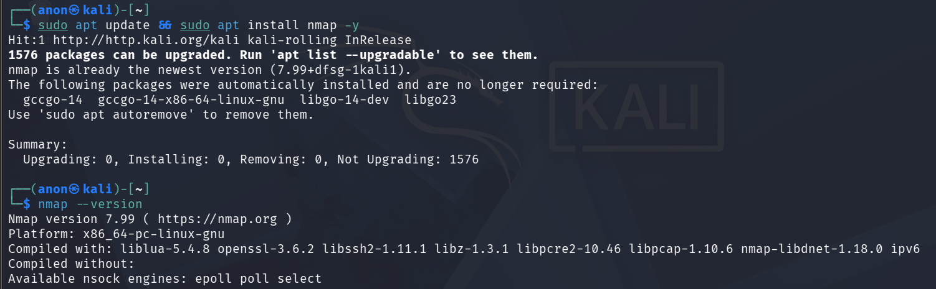

Identifying the Target IP Address
The IP address of the target virtual machine was identified using the following command on the target machine:

ip a
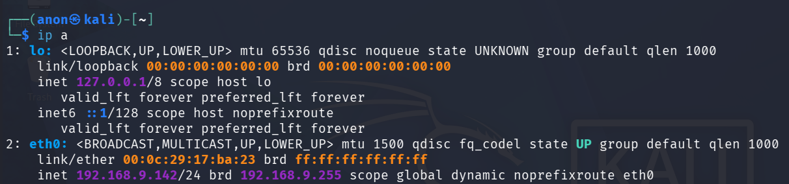
4. METHODOLOGY
The scanning was carried out in three progressive steps, each building on the previous. Starting with a basic port scan to identify which ports are open, followed by a service version scan to identify what is running on those ports, and finally an OS detection scan to fingerprint the operating system.
4.1 Step 1 - Basic Nmap Scan
The first scan is a basic TCP scan to discover all open ports on the target. This gives a high-level overview of the attack surface without triggering too many alerts.

nmap [target ip]
This runs a default SYN scan against the 1000 most common ports. For a more thorough scan covering all 65535 ports, the following variant was also run.

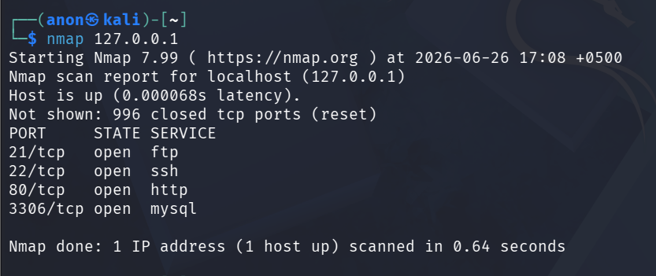

nmap -p- [target ip]
The results of this scan were saved to a text file for documentation.

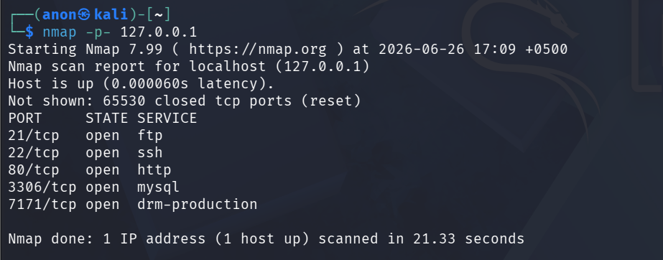

nmap [target ip] -oN basic_scan.txt
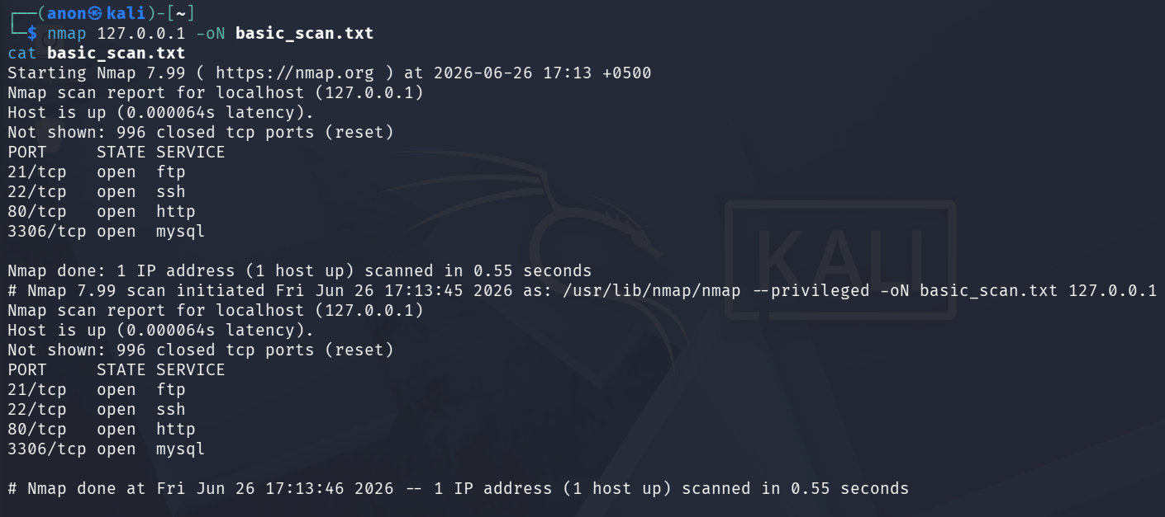

4.2 Step 2 - Service Version Scan (-sV)
The second scan uses the -sV flag to probe open ports and determine the exact service name and version number running on each. This is critical for identifying outdated or vulnerable software versions.

nmap -sV [target ip]
The -sV flag intensity can be controlled. For a more aggressive version detection (slower but more accurate):

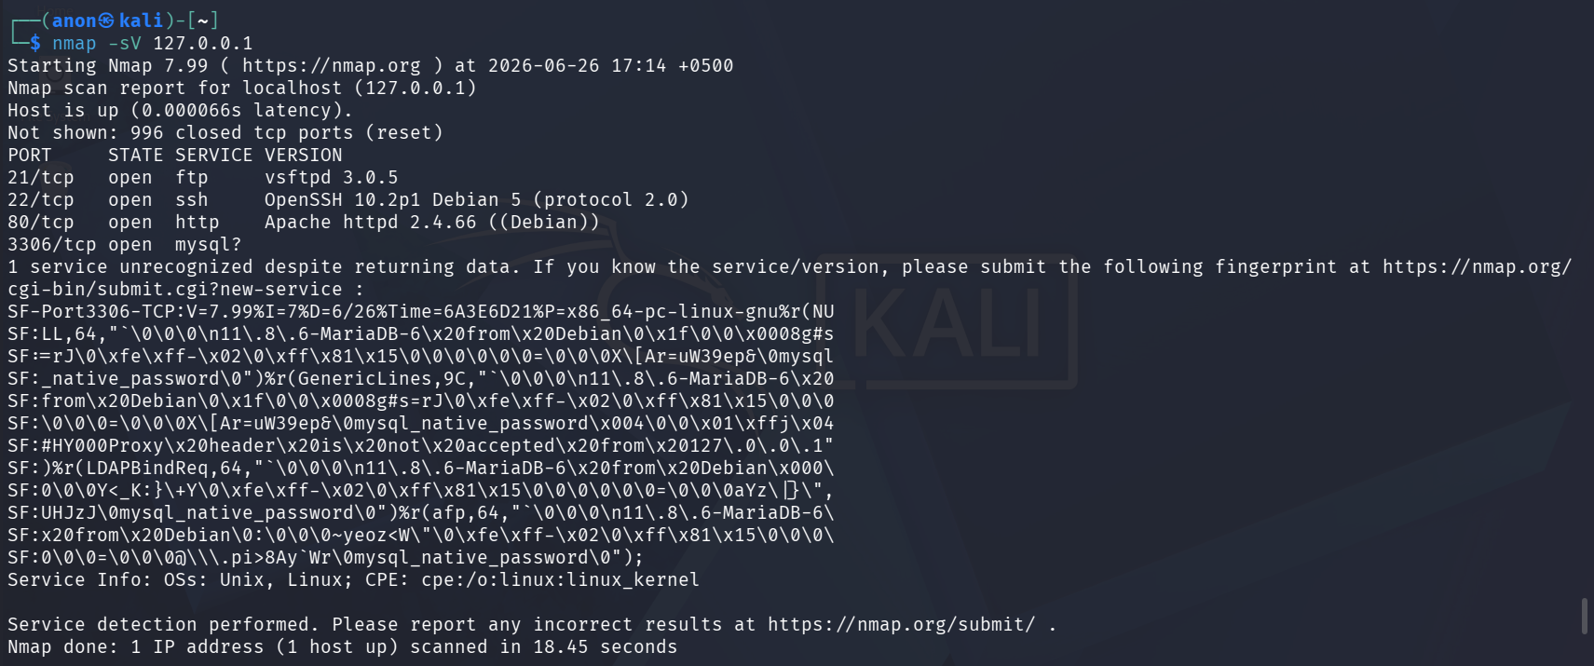

nmap -sV --version-intensity 9 [target ip]
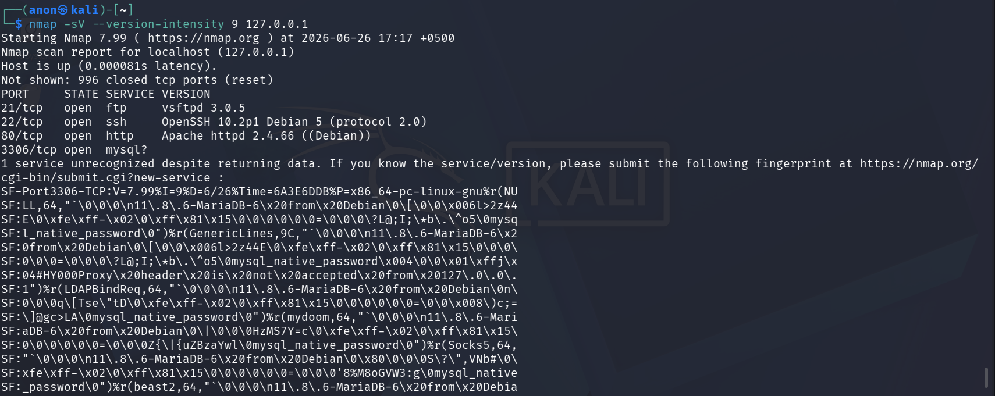
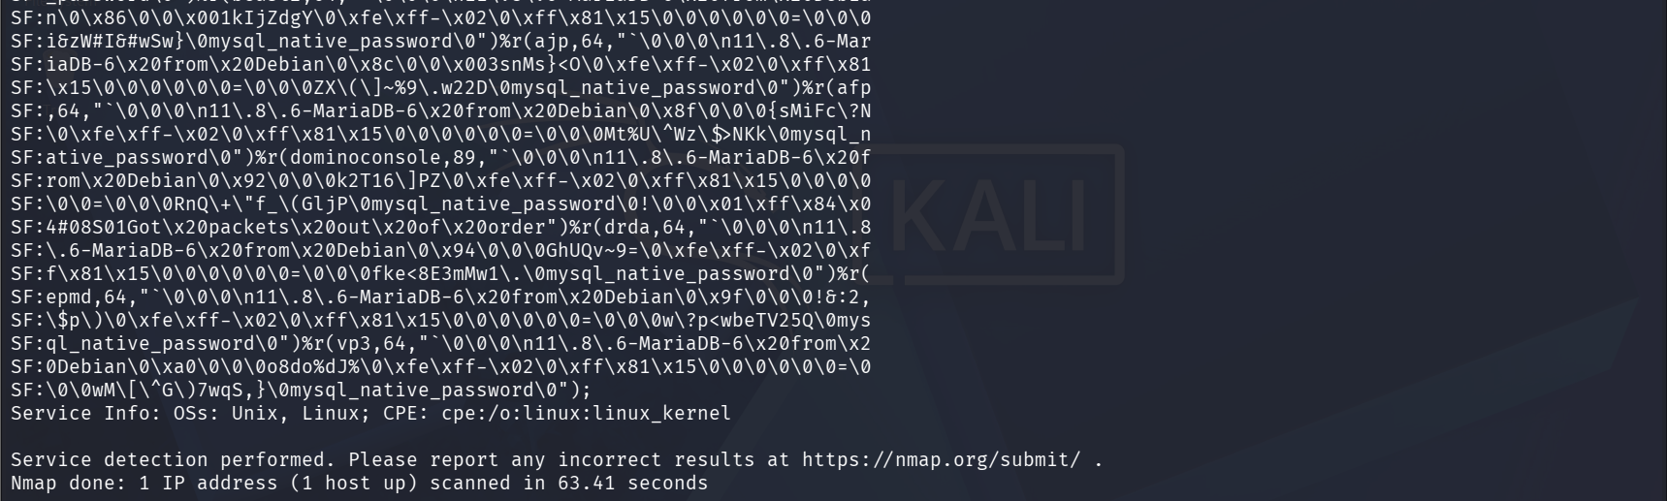
4.3 Step 3 - OS Detection Scan (-O)
The third scan attempts to fingerprint the operating system of the target machine. Nmap compares the responses from the target against its OS fingerprint database to make an educated guess.

sudo nmap -O [target ip]
An aggressive combined scan combining all three techniques was also performed for comprehensive results:

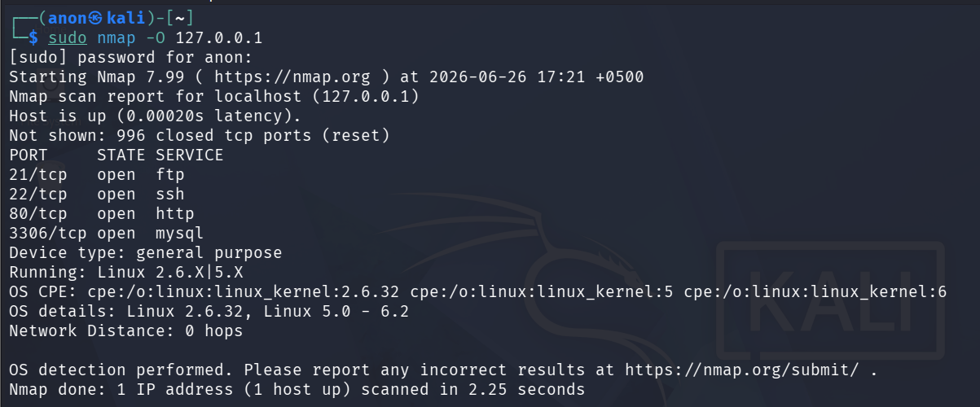

sudo nmap -sV -O -A [target ip]-oN full_scan.txt

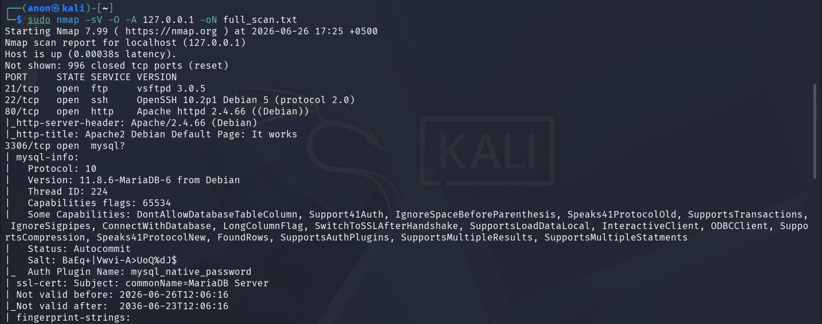
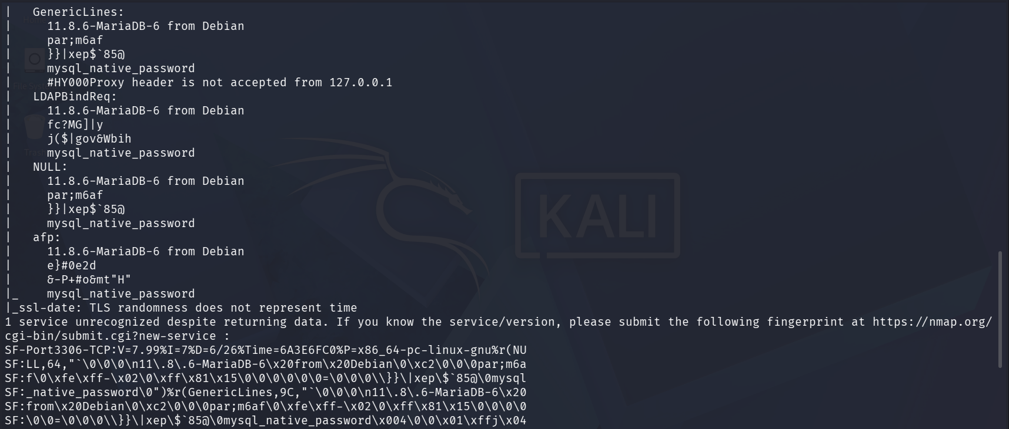
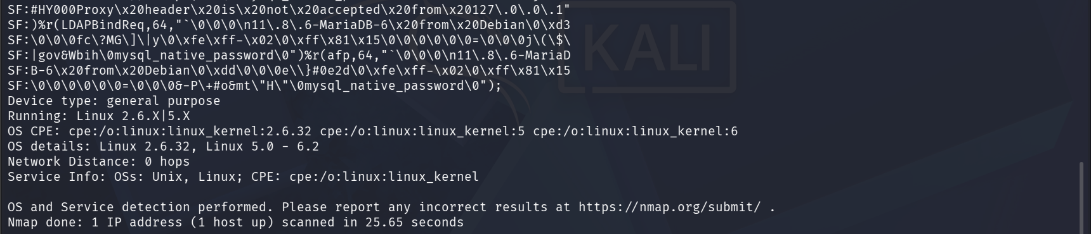

5. SCAN RESULTS DOCUMENTATION
The file nmap_scan_results.txt was created to consolidate all scan findings. Below is a structured summary of the open ports, identified services, and their version information as discovered by Nmap.

Port | State | Service | Details
21/tcp | open | FTP | vsftpd 3.0.5 - File Transfer Protocol (Plain text)
22/tcp | open | SSH | OpenSSH 10.2p1 Debian 5 - Remote access protocol
80/tcp | open | HTTP | Apache httpd 2.4.66 ((Debian)) - Web server
3306/tcp | open | MySQL | MariaDB 11.8.6-6 from Debian - Database service
6. PORT ANALYSIS & SECURITY ASSESSMENT
For each open port discovered, the following analysis documents what the service does, whether it poses a security risk, and what an attacker could potentially exploit.

Port 21 - FTP (File Transfer Protocol)
Aspect | Details
Service | vsftpd 3.0.5
Risk Level | CRITICAL
What it does | FTP allows files to be transferred between a client and server. It operates over plain text with no encryption.
Security Risk | FTP transmits credentials and data in plain text, making it vulnerable to packet sniffing and Man-in-the-Middle attacks. Anonymous FTP access may be enabled. vsftpd 3.0.5 may have undisclosed CVEs.
Mitigation | Disable FTP if not needed. Replace with SFTP or FTPS. Disable anonymous login. Never expose FTP to the internet. Use firewall rules to restrict access.

Port 22 - SSH (Secure Shell)
Aspect | Details
Service | OpenSSH 10.2p1 Debian 5
Risk Level | MEDIUM
What it does | SSH provides encrypted remote access to the machine. It is the standard protocol for remotely managing Linux/Unix systems.
Security Risk | If SSH is exposed with weak passwords or default credentials, it is susceptible to brute-force attacks. While OpenSSH 10.2p1 is recent, misconfigurations remain a risk.
Mitigation | Disable root login, enforce key-based authentication, use fail2ban, and keep OpenSSH updated. Change default SSH port (optional security through obscurity).

Port 80 - HTTP (Hypertext Transfer Protocol)
Aspect | Details
Service | OpenSSH 10.2p1 Debian 5
Risk Level | MEDIUM
What it does | SSH provides encrypted remote access to the machine. It is the standard protocol for remotely managing Linux/Unix systems.
Security Risk | If SSH is exposed with weak passwords or default credentials, it is susceptible to brute-force attacks. While OpenSSH 10.2p1 is recent, misconfigurations remain a risk.
Mitigation | Disable root login, enforce key-based authentication, use fail2ban, and keep OpenSSH updated. Change default SSH port (optional security through obscurity).

Port 3306 - MySQL (MariaDB Database)
Aspect | Details
Service | MariaDB 11.8.6-6 from Debian
Risk Level | HIGH
What it does | MySQL/MariaDB is a relational database management system. Port 3306 is its default listening port.
Security Risk | Exposing the database port directly allows external parties to attempt authentication. Default credentials (root with no password) are a common misconfiguration. The MariaDB version is recent but may have undisclosed vulnerabilities.
Mitigation | Bind MySQL to localhost (127.0.0.1) only. Set a strong root password. Disable remote root login. Use mysql_secure_installation script.

7. KEY FINDINGS
The table below summarises all key findings from the three Nmap scans. Each finding is rated by severity based on its potential impact if exploited.

Finding | Severity | Description
FTP on Port 21 | Critical | Plain-text file transfer with no encryption. vsftpd 3.0.5 exposed. Credentials and data transmitted in clear text.
HTTP on Port 80 | High | Unencrypted web traffic. Susceptible to MITM and web application attacks. Apache 2.4.66 exposed.
MySQL on Port 3306 | High | Database port exposed. Risk of brute-force and default credential attacks. MariaDB 11.8.6 accessible.
SSH on Port 22 | Medium | Remote access port open. Brute-force risk if password authentication is enabled. OpenSSH 10.2p1 running.
OS Fingerprinted | Info | Target OS identified as Linux (Kernel 5.0 - 6.2) via Nmap -O. Aids attacker reconnaissance.

