Online Supplementary Materials
Does online sharing drive attention to extreme viewpoints?
[Registered Report Stage 1]
Contents
S1. Stimulus Validation Study
An independent pretest in which 59 U.S. participants placed each of the 88 statements on a five-point left–right scale, verifying the intended ideological direction and extremity of each statement and providing its position on the left–right continuum used in the main analyses. Includes the political knowledge screen, the full statement list, and summary and item-level ratings (Tables S1–S4; Figures S1–S12).
Appendix S1. All 88 Stimuli as Presented to Participants
Every post reproduced exactly as shown in the validation study and the main study, grouped by topic and ordered by intended position.
S2. Development Studies
Two preregistered eye-tracking studies conducted before this registration, which informed the design and hypotheses of the main study. Covers their preregistrations and deviations, methods, results and summaries (Tables S5–S7; Figures S13–S15).

S1. Stimulus Validation Study
The ideological position of each of the 88 statements used in the main study was established in an independent pretest, in which participants who did not take part in the main study placed each statement on a five-point left–right scale. The pretest served two purposes. First, it verified that each statement expresses the ideological direction, and the degree of extremity, that it was written to express. Second, the median placement of each statement is used as its position on the left–right continuum (−2 to +2) in the main analyses (see Derived Variables in the main text).

Method

Participants
Participants were recruited through Prolific on September 7, 2026, who were fluent in English, currently resided in the United States, were of United States nationality, and took part on a desktop or laptop computer with a functioning webcam. Participants were compensated £4.05 (equivalent to £9 per hour). The study’s median time was approximately 17 minutes.
In total, 100 participants gave informed consent and completed the webcam setup and proceeded to the political knowledge questions. Participants were excluded if they failed any of the three attention checks or answered more than one of the five political knowledge questions incorrectly (Table S1). Twenty-four participants were excluded under the attention-check criterion (3 answered an attention check incorrectly and 21 left the study before reaching all three attention checks) and a further 17 under the political knowledge criterion. For one participant who submitted a rating for the same statement twice, the later rating was retained. The final sample comprised 59 participants (age: M = 43.51, SD = 13.29; 29 women, 30 men).

Procedure
The study was administered on the Inqeri platform. After giving informed consent and entering their Prolific ID, participants completed a webcam calibration. They then answered five questions on U.S. politics, which served as a political knowledge screen (Table S1).
Participants were next told that they would be presented with 88 different statements in the form of social media posts and that their task was to place each statement on the standard political spectrum. The 88 statements were then presented one at a time, in a new random order for each participant, as microblogging-style posts identical to those used in the main study (Figure S1; all posts are reproduced in Appendix S1). Beneath each post, participants completed the sentence “I believe this is where the statement fits on the political spectrum:” on a five-point scale labelled Far left, Left of centre, Centre, Right of centre, and Far right. Three attention checks were interspersed at random among the statements. Each was a post that instructed participants to select a specific response option: Far left, Centre, and Far right, respectively. Finally, participants were debriefed and redirected back to Prolific.
Table S1
Political Knowledge Questions
Question | Response options | Answer scored as correct
What job or political office is now held by JD Vance? | Open text | Any answer naming the Vice Presidency (e.g., “Vice President”, “VP”)
Whose responsibility is it to determine if a law is constitutional or not? | The President; The Congress; The Supreme Court; I don’t know | The Supreme Court
How much of a majority is required for the U.S. Senate and House to override a presidential veto? | 2/3; 3/4; 4/5; I don’t know | 2/3
Which party had the most members in the House of Representatives in Washington before the most recent election? | The Democratic Party; The Republican Party; I don’t know | The Republican Party
Would you say that one of the parties is more conservative than the other at the national level? Which party is more conservative? | The Democratic Party; The Republican Party; I don’t think that either one of them is more conservative than the other; I don’t know | The Republican Party
Note. Questions were presented in the order shown. Participants who answered more than one of the five questions incorrectly were excluded. Among the 100 participants who reached these questions, the proportions answering correctly were 96% (Vice President), 84% (constitutionality), 75% (veto), 63% (House majority), and 92% (more conservative party).
Figure S1
Example of a Statement as Presented to Participants

Note. The statement shown (CSV-032-A) takes an extreme right position on the topic “Should abortion be legal?”. In the pretest, the five-point response scale appeared beneath each post. The display name and handle are fictitious.

Materials
The construction of the stimulus set is described in the main text (Materials). The 88 statements address 11 topics, each represented by eight statements. Two were written to take an extreme left position, two a moderate left position, two a moderate right position, and two an extreme right position. The statements form 44 pairs. Each pair consists of a source statement adapted from Kialo and a counterpart written to take the same direction at the other level of extremity, matched on length to within one word in 42 of the 44 pairs (the two remaining pairs, WB-023 and TRN-001, differ by seven and six words). Table S2 lists every statement with its intended position, and Appendix S1 reproduces all 88 posts exactly as participants saw them.
Table S2
Stimulus Statements by Topic and Intended Position
ID | Statement | Intended position | Words
Will man-made climate change cause human extinction?
CSV-181-A | Climate change poses no urgency because humans can always adapt. | Extreme right | 10
CSV-181-S | Climate Change is slow. We can adapt within that timeframe | Right | 10
WB-001-A | Climate change poses serious long-term risks, so the United States should strengthen emissions reductions and climate adaptation policies. | Left | 18
WB-001-S | If climate-change tipping points are reached, collapsing ecosystems could lead to the eventual extinction of the human race. | Extreme left | 18
WB-018-A | Current climate measures suffice, so America should repeal regulations and make no further effort to cut emissions. | Extreme right | 17
WB-018-S | Evidences and statistics suggest that actions taken by us are enough to deal with major climate change | Right | 17
WB-066-A | Climate change is an existential threat, so America must rapidly eliminate fossil fuels despite economic costs. | Extreme left | 16
WB-066-S | The effects of global warming directly threaten the land and environment that humans need to live | Left | 16
Should religion be involved in politics?
CSV-228-A | Government should maintain independence from religion and avoid allowing religious doctrine to determine public policy. | Left | 15
CSV-228-S | Politics and religion should be put aside. Three aspects of life should NOT co-exist: religion-state-army | Extreme left | 15
WB-007-A | American laws should follow Christian teachings because secular morality cannot provide a foundation for government. | Extreme right | 15
WB-007-S | The involvement of religion in politics is necessary to ensure laws and policies are ethical | Right | 15
WB-058-A | American government should formally prioritize Christian moral values in lawmaking, and secular objections should never limit their legitimate political influence. | Extreme right | 20
WB-058-S | Almost all laws are based on moral beliefs, therefore it is appropriate for religious persons to be involved in politics | Right | 20
WB-084-A | Religious beliefs should have no influence on American laws, public policy, or governmental decisions. | Extreme left | 14
WB-084-S | Involving religion in politics is antithetical to the principles of a secular democratic society | Left | 14
Should abortion be considered murder?
CSV-034-A | Abortion ends developing human life and should therefore face substantial legal restrictions. | Right | 12
CSV-034-S | Abortions are self-serving, and killing another person for self-serving purposes is murder | Extreme right | 12
CSV-037-A | Abortion intentionally ends fetal life and should generally face legal restrictions. | Right | 11
CSV-037-S | Since abortion intentionally causes fetal death, it should be considered murder. | Extreme right | 11
WB-023-A | Abortion should remain legal throughout pregnancy without any government restrictions. | Extreme left | 10
WB-023-S | A fetus or embryo is not a person, which means abortion does not end a person's life. | Left | 17
WB-028-A | All abortion restrictions should be abolished because they force women toward dangerous procedures that threaten their lives. | Extreme left | 17
WB-028-S | Equating abortion with murder would cause women to use unsafe methods and put their lives at risk | Left | 17
Should abortion be legal?
CSV-032-A | Life begins at conception, so abortion must always be prohibited because it violates fetal rights. | Extreme right | 15
CSV-032-S | Life begins at conception. Abortion, therefore, violates the foetus' rights to life and bodily autonomy | Right | 15
CSV-033-A | Abortion is always immoral because faith establishes human life begins at conception. | Extreme right | 12
CSV-033-S | Some religious values and beliefs support the view that abortion is immoral | Right | 12
WB-074-A | Gender equality requires abortion to remain legal at every stage, for any reason, without restrictions. | Extreme left | 15
WB-074-S | The ability for people to control their own reproduction is fundamental to achieving gender equality | Left | 15
WB-083-A | Bodily autonomy is absolute, so abortion should be legal at every stage of pregnancy, for any reason and without government restrictions. | Extreme left | 21
WB-083-S | People have a right to bodily autonomy and should ultimately be able to decide whether to continue or terminate a pregnancy. | Left | 21
Does feminism strive for equality?
CSV-129-A | Feminism must completely dismantle gender hierarchies to liberate everyone equally. | Extreme left | 10
CSV-129-S | Feminism also improves society for all genders, not just women | Left | 10
CSV-130-A | Feminism must dismantle every remaining gender-based power hierarchy. | Extreme left | 8
CSV-130-S | Feminism is about equalising power relations within society | Left | 8
CSV-134-A | Feminism destroys genuine equality by demanding identical outcomes and unfairly punishing men solely for their sex. | Extreme right | 16
CSV-134-S | Feminism strives for absolute equality rather than equitable opportunity, which leads to less practical equality overall | Right | 16
CSV-139-A | Modern feminism sometimes prioritizes women's interests and should give greater attention to cases in which men face disadvantages. | Right | 18
CSV-139-S | Feminism strives for more rights, more advantages. Feminism hasn't advocated for male rights when it was the case | Extreme right | 18
Is gender a social construct?
GEN-001-A | Gender is entirely socially constructed, so institutions must dismantle every binary norm that reinforces traditional gender categories. | Extreme left | 17
GEN-001-S | Gender is a social construct because its features are fluid and change throughout time and across societies. | Left | 17
GEN-002-A | Gender roles often reflect social expectations that sustain inequalities between men and women. | Left | 13
GEN-002-S | Gender is constructed to uphold hierarchical social structures and would not exist otherwise. | Extreme left | 13
GEN-003-A | Gender equals biological sex, and no social identity can change it. | Extreme right | 11
GEN-003-S | Gender is determined by the biological features associated with one's sex. | Right | 11
GEN-004-A | Men and women have fixed biological roles that society must always preserve. | Extreme right | 12
GEN-004-S | There are clear sex-based differences in the behaviours of men and women. | Right | 12
Does mass legal immigration damage America?
IMM-001-A | Immigration inevitably causes crime. | Extreme right | 4
IMM-001-S | Mass immigration increases crime. | Right | 4
IMM-002-A | Immigration can weaken cohesion and America's shared national identity. | Right | 9
IMM-002-S | Mass immigration will cause America to lose it's identity. | Extreme right | 9
IMM-003-A | Economic prosperity requires unrestricted immigration. | Extreme left | 5
IMM-003-S | Mass immigration boosts the economy. | Left | 5
IMM-004-A | Immigration restrictions destroy diversity and tolerance in America. | Extreme left | 8
IMM-004-S | Mass legal immigration promotes diversity and tolerance. | Left | 7
Does transgenderism exist?
TRN-001-A | Because biological sex is male or female, public policy should preserve sex-based distinctions while allowing adults to identify differently in society. | Right | 21
TRN-001-S | The fact that humans are biologically either male or female nullifies the concept of transgenderism. | Extreme right | 15
TRN-002-A | Transgender identity may be shaped by culture, but adults should retain freedom in personal expression. | Right | 15
TRN-002-S | Transgenderism is an artificial product of cultural and linguistic evolution rather than a real concept. | Extreme right | 15
TRN-003-A | Historical transgender identities prove society must fully recognize every self-defined gender. | Extreme left | 11
TRN-003-S | Transgenderism is documented as having been around for hundreds of years. | Left | 11
TRN-004-A | Society must unconditionally affirm transgender identities to protect everyone who identifies that way. | Extreme left | 13
TRN-004-S | Accepting that transgenderism exists is important to protecting those who identify as such. | Left | 13
Do all or most White Americans experience privileges exclusive to White people?
RACE-001-A | American policing systematically protects White people while subjecting racial minorities to suspicion, violence, and unequal treatment. | Extreme left | 16
RACE-001-S | White Americans enjoy a more positive relationship with the police compared to people of other ethnicities. | Left | 16
RACE-002-A | Racial minorities remain underrepresented in powerful American institutions. | Left | 8
RACE-002-S | Non-whites are systemically excluded from power-holding institutions. | Extreme left | 7
RACE-003-A | Personal choices determine success; race never creates meaningful privilege or disadvantage in modern America. | Extreme right | 14
RACE-003-S | Privilege is complex; other factors can outweigh the effects of skin color on privilege. | Right | 14
RACE-004-A | White Americans may have advantages, but these often reflect individual circumstances more than systemic racial privilege. | Right | 16
RACE-004-S | In general, any advantages white Americans have are a result of their personal choices, not privilege. | Extreme right | 16
Should the U.S. adopt stricter gun control legislation?
GUN-001-A | America must ban most civilian firearms to eliminate gun injury, accidental death, murder, and suicide. | Extreme left | 15
GUN-001-S | Stricter gun control legislation may reduce instances of gun-related injury, accidental death, murder, and suicide. | Left | 15
GUN-002-A | America must prohibit civilian ownership of assault weapons and impose gun restrictions to end mass shootings. | Extreme left | 16
GUN-002-S | Gun control measures are an effective way to limit the incidence and impact of mass shootings. | Left | 16
GUN-003-A | Every gun restriction violates the Constitution, so Americans must have unrestricted access to firearms and government must never regulate their ownership or use. | Extreme right | 23
GUN-003-S | Gun control policies infringe on a number of rights that the US government was explicitly founded upon and has an obligation to uphold. | Right | 23
GUN-004-A | Every American should have unrestricted access to any firearm because gun ownership defines the nation's culture. | Extreme right | 16
GUN-004-S | Open access to guns is a cultural characteristic of the US and thus should be preserved. | Right | 16
Should we adapt to climate change rather than avert it?
WB-017-A | America should abandon emission cuts, relying entirely on climate adaptation. | Extreme right | 10
WB-017-S | Adapting to climate change would be faster than averting it | Right | 10
WB-020-A | America should reject adapting to climate change and eliminate fossil fuels, whatever the economic cost. | Extreme left | 15
WB-020-S | Adapting to climate change is a short-term solution, whereas averting climate change is a long-term solution | Left | 16
WB-069-A | America should spend nothing on climate adaptation and direct all available resources toward immediately eliminating carbon emissions. | Extreme left | 17
WB-069-S | If we decide to adapt to climate change, then we will lose the ability to avert it | Left | 17
WB-070-A | Humans can adapt to any climate, so emissions policies should end. | Extreme right | 11
WB-070-S | Humanity has a long history of successfully adapting to climate change | Right | 11
Note. IDs ending in -S denote source statements adapted from Kialo and IDs ending in -A their generated counterparts; the two members of a pair share the rest of the ID. The prefix records the source from which the candidate statement was drawn.

Results
Across the 5,192 ratings, 82.0% placed a statement on its intended side of the scale, and 50.6% placed it at exactly the intended scale point. Table S3 summarises the ratings by intended position, and Figure S2 shows the pooled distributions. The results were broadly consistent with what we expected. Statements written to take a left position were placed left of centre, and statements written to take a right position were placed right of centre. Statements written as extreme were placed further from the centre than the moderate statements on the same side (M = 1.68 vs. 1.96 on the left; M = 4.42 vs. 3.89 on the right). At the item level, the median placement fell on the intended political side for 85 of 88 statements and at the exact intended scale point for 61 of 88 statements (Table S4).
Item-level summaries are given in Table S4, and the full distribution of ratings for every statement is shown in Figures S3 to S12.
Table S3
Ratings by Intended Position
Intended position | k | M (SD) | FL | L | C | R | FR | Intended side (%)
Extreme left | 22 | 1.68 (0.98) | 55.7 | 29.8 | 8.6 | 2.4 | 3.5 | 85.5
Left | 22 | 1.96 (0.80) | 29.0 | 50.1 | 17.7 | 2.2 | 1.0 | 79.0
Right | 22 | 3.89 (0.98) | 2.9 | 5.9 | 19.6 | 43.0 | 28.7 | 71.6
Extreme right | 22 | 4.42 (0.77) | 1.2 | 1.6 | 5.3 | 38.1 | 53.8 | 91.8
Note. k = number of statements. Ratings were coded 1 (Far left) to 5 (Far right). FL, L, C, R, and FR give the percentage of ratings at Far left, Left of centre, Centre, Right of centre, and Far right. Intended side (%) = percentage of ratings on the intended side of the scale (left of or right of Centre). Each statement was rated by all 59 participants.
Figure S2
Distribution of Ratings Pooled Across All Statements and by Statement Version
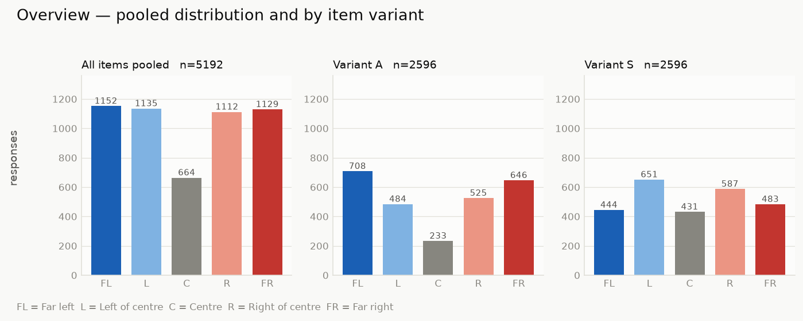
Note. Variant A = generated counterparts; Variant S = source statements. FL = Far left; L = Left of centre; C = Centre; R = Right of centre; FR = Far right. Attention checks are excluded.
Table S4
Item-Level Ratings
ID | Intended position | M | SD | Mdn | FL | L | C | R | FR | Intended side
Will man-made climate change cause human extinction?
CSV-181-A | Extreme right | 4.32 | 0.60 | 4 | 0.0 | 1.7 | 1.7 | 59.3 | 37.3 | 96.6
CSV-181-S | Right | 3.93 | 0.69 | 4 | 0.0 | 1.7 | 22.0 | 57.6 | 18.6 | 76.3
WB-001-A | Left | 2.05 | 0.84 | 2 | 25.4 | 49.2 | 22.0 | 1.7 | 1.7 | 74.6
WB-001-S | Extreme left | 1.78 | 0.79 | 2 | 44.1 | 33.9 | 22.0 | 0.0 | 0.0 | 78.0
WB-018-A | Extreme right | 4.29 | 0.62 | 4 | 0.0 | 0.0 | 8.5 | 54.2 | 37.3 | 91.5
WB-018-S | Right | 3.46 | 0.99 | 4 | 3.4 | 11.9 | 33.9 | 37.3 | 13.6 | 50.8
WB-066-A | Extreme left | 1.54 | 0.70 | 1 | 55.9 | 35.6 | 6.8 | 1.7 | 0.0 | 91.5
WB-066-S | Left | 2.08 | 0.75 | 2 | 20.3 | 54.2 | 22.0 | 3.4 | 0.0 | 74.6
Should religion be involved in politics?
CSV-228-A | Left | 2.20 | 0.87 | 2 | 18.6 | 49.2 | 28.8 | 0.0 | 3.4 | 67.8
CSV-228-S | Extreme left | 2.12 | 1.04 | 2 | 30.5 | 39.0 | 23.7 | 1.7 | 5.1 | 69.5
WB-007-A | Extreme right | 4.61 | 0.74 | 5 | 1.7 | 0.0 | 5.1 | 22.0 | 71.2 | 93.2
WB-007-S | Right | 4.44 | 0.73 | 5 | 0.0 | 3.4 | 3.4 | 39.0 | 54.2 | 93.2
WB-058-A | Extreme right | 4.69 | 0.70 | 5 | 1.7 | 0.0 | 3.4 | 16.9 | 78.0 | 94.9
WB-058-S | Right | 4.20 | 0.83 | 4 | 1.7 | 0.0 | 15.3 | 42.4 | 40.7 | 83.1
WB-084-A | Extreme left | 2.00 | 0.89 | 2 | 32.2 | 40.7 | 23.7 | 1.7 | 1.7 | 72.9
WB-084-S | Left | 2.05 | 0.78 | 2 | 23.7 | 50.8 | 22.0 | 3.4 | 0.0 | 74.6
Should abortion be considered murder?
CSV-034-A | Right | 4.44 | 0.75 | 5 | 1.7 | 0.0 | 5.1 | 39.0 | 54.2 | 93.2
CSV-034-S | Extreme right | 4.75 | 0.48 | 5 | 0.0 | 0.0 | 1.7 | 22.0 | 76.3 | 98.3
CSV-037-A | Right | 4.53 | 0.57 | 5 | 0.0 | 0.0 | 3.4 | 40.7 | 55.9 | 96.6
CSV-037-S | Extreme right | 4.78 | 0.42 | 5 | 0.0 | 0.0 | 0.0 | 22.0 | 78.0 | 100.0
WB-023-A | Extreme left | 1.41 | 0.59 | 1 | 64.4 | 30.5 | 5.1 | 0.0 | 0.0 | 94.9
WB-023-S | Left | 1.69 | 0.77 | 2 | 44.1 | 45.8 | 8.5 | 0.0 | 1.7 | 89.8
WB-028-A | Extreme left | 1.90 | 1.30 | 1 | 54.2 | 25.4 | 6.8 | 3.4 | 10.2 | 79.7
WB-028-S | Left | 1.92 | 0.68 | 2 | 27.1 | 54.2 | 18.6 | 0.0 | 0.0 | 81.4
Should abortion be legal?
CSV-032-A | Extreme right | 4.73 | 0.45 | 5 | 0.0 | 0.0 | 0.0 | 27.1 | 72.9 | 100.0
CSV-032-S | Right | 4.42 | 0.53 | 4 | 0.0 | 0.0 | 1.7 | 54.2 | 44.1 | 98.3
CSV-033-A | Extreme right | 4.59 | 0.53 | 5 | 0.0 | 0.0 | 1.7 | 37.3 | 61.0 | 98.3
CSV-033-S | Right | 3.64 | 0.71 | 4 | 0.0 | 0.0 | 49.2 | 37.3 | 13.6 | 50.8
WB-074-A | Extreme left | 1.25 | 0.48 | 1 | 76.3 | 22.0 | 1.7 | 0.0 | 0.0 | 98.3
WB-074-S | Left | 1.85 | 0.69 | 2 | 32.2 | 50.8 | 16.9 | 0.0 | 0.0 | 83.1
WB-083-A | Extreme left | 1.29 | 0.59 | 1 | 76.3 | 20.3 | 1.7 | 1.7 | 0.0 | 96.6
WB-083-S | Left | 1.78 | 0.65 | 2 | 33.9 | 54.2 | 11.9 | 0.0 | 0.0 | 88.1
Does feminism strive for equality?
CSV-129-A | Extreme left | 1.32 | 0.57 | 1 | 72.9 | 22.0 | 5.1 | 0.0 | 0.0 | 94.9
CSV-129-S | Left | 1.85 | 0.71 | 2 | 32.2 | 52.5 | 13.6 | 1.7 | 0.0 | 84.7
CSV-130-A | Extreme left | 1.37 | 0.74 | 1 | 74.6 | 16.9 | 5.1 | 3.4 | 0.0 | 91.5
CSV-130-S | Left | 2.12 | 0.85 | 2 | 22.0 | 50.8 | 22.0 | 3.4 | 1.7 | 72.9
CSV-134-A | Extreme right | 4.31 | 0.81 | 4 | 3.4 | 0.0 | 1.7 | 52.5 | 42.4 | 94.9
CSV-134-S | Right | 3.51 | 1.15 | 4 | 8.5 | 11.9 | 15.3 | 49.2 | 15.3 | 64.4
CSV-139-A | Right | 3.68 | 0.99 | 4 | 5.1 | 6.8 | 18.6 | 54.2 | 15.3 | 69.5
CSV-139-S | Extreme right | 3.54 | 1.18 | 4 | 5.1 | 18.6 | 15.3 | 39.0 | 22.0 | 61.0
Is gender a social construct?
GEN-001-A | Extreme left | 1.47 | 1.07 | 1 | 79.7 | 5.1 | 8.5 | 1.7 | 5.1 | 84.7
GEN-001-S | Left | 1.51 | 0.68 | 1 | 59.3 | 30.5 | 10.2 | 0.0 | 0.0 | 89.8
GEN-002-A | Left | 2.10 | 0.82 | 2 | 18.6 | 61.0 | 13.6 | 5.1 | 1.7 | 79.7
GEN-002-S | Extreme left | 2.15 | 1.42 | 2 | 47.5 | 22.0 | 11.9 | 5.1 | 13.6 | 69.5
GEN-003-A | Extreme right | 4.37 | 0.64 | 4 | 0.0 | 1.7 | 3.4 | 50.8 | 44.1 | 94.9
GEN-003-S | Right | 4.08 | 0.82 | 4 | 1.7 | 0.0 | 18.6 | 47.5 | 32.2 | 79.7
GEN-004-A | Extreme right | 4.44 | 0.77 | 5 | 0.0 | 1.7 | 11.9 | 27.1 | 59.3 | 86.4
GEN-004-S | Right | 3.81 | 0.80 | 4 | 0.0 | 1.7 | 37.3 | 39.0 | 22.0 | 61.0
Does mass legal immigration damage America?
IMM-001-A | Extreme right | 4.46 | 0.65 | 5 | 0.0 | 1.7 | 3.4 | 42.4 | 52.5 | 94.9
IMM-001-S | Right | 4.24 | 0.90 | 4 | 3.4 | 1.7 | 5.1 | 47.5 | 42.4 | 89.8
IMM-002-A | Right | 4.31 | 0.65 | 4 | 0.0 | 0.0 | 10.2 | 49.2 | 40.7 | 89.8
IMM-002-S | Extreme right | 4.37 | 0.87 | 5 | 3.4 | 0.0 | 5.1 | 39.0 | 52.5 | 91.5
IMM-003-A | Extreme left | 1.42 | 0.79 | 1 | 69.5 | 23.7 | 3.4 | 1.7 | 1.7 | 93.2
IMM-003-S | Left | 1.93 | 0.81 | 2 | 28.8 | 54.2 | 13.6 | 1.7 | 1.7 | 83.1
IMM-004-A | Extreme left | 2.05 | 1.25 | 2 | 39.0 | 42.4 | 3.4 | 5.1 | 10.2 | 81.4
IMM-004-S | Left | 1.69 | 0.75 | 2 | 42.4 | 49.2 | 6.8 | 0.0 | 1.7 | 91.5
Does transgenderism exist?
TRN-001-A | Right | 3.34 | 1.09 | 3 | 6.8 | 10.2 | 42.4 | 23.7 | 16.9 | 40.7
TRN-001-S | Extreme right | 4.27 | 0.83 | 4 | 1.7 | 0.0 | 13.6 | 39.0 | 45.8 | 84.7
TRN-002-A | Right | 2.22 | 0.85 | 2 | 18.6 | 47.5 | 28.8 | 3.4 | 1.7 | 5.1
TRN-002-S | Extreme right | 4.32 | 0.78 | 4 | 1.7 | 1.7 | 3.4 | 49.2 | 44.1 | 93.2
TRN-003-A | Extreme left | 1.51 | 0.70 | 1 | 55.9 | 40.7 | 1.7 | 0.0 | 1.7 | 96.6
TRN-003-S | Left | 1.88 | 0.85 | 2 | 37.3 | 40.7 | 20.3 | 0.0 | 1.7 | 78.0
TRN-004-A | Extreme left | 1.36 | 0.52 | 1 | 66.1 | 32.2 | 1.7 | 0.0 | 0.0 | 98.3
TRN-004-S | Left | 1.80 | 0.76 | 2 | 35.6 | 52.5 | 10.2 | 0.0 | 1.7 | 88.1
Do all or most White Americans experience privileges exclusive to White people?
RACE-001-A | Extreme left | 1.68 | 0.73 | 2 | 42.4 | 50.8 | 5.1 | 0.0 | 1.7 | 93.2
RACE-001-S | Left | 2.31 | 1.00 | 2 | 18.6 | 49.2 | 18.6 | 10.2 | 3.4 | 67.8
RACE-002-A | Left | 1.88 | 0.72 | 2 | 30.5 | 52.5 | 15.3 | 1.7 | 0.0 | 83.1
RACE-002-S | Extreme left | 1.93 | 1.13 | 2 | 44.1 | 33.9 | 13.6 | 1.7 | 6.8 | 78.0
RACE-003-A | Extreme right | 4.15 | 0.78 | 4 | 1.7 | 1.7 | 8.5 | 55.9 | 32.2 | 88.1
RACE-003-S | Right | 3.34 | 0.92 | 3 | 3.4 | 10.2 | 45.8 | 30.5 | 10.2 | 40.7
RACE-004-A | Right | 3.90 | 0.74 | 4 | 1.7 | 1.7 | 16.9 | 64.4 | 15.3 | 79.7
RACE-004-S | Extreme right | 4.19 | 0.68 | 4 | 1.7 | 0.0 | 5.1 | 64.4 | 28.8 | 93.2
Should the U.S. adopt stricter gun control legislation?
GUN-001-A | Extreme left | 1.51 | 0.80 | 1 | 61.0 | 32.2 | 3.4 | 1.7 | 1.7 | 93.2
GUN-001-S | Left | 2.10 | 0.82 | 2 | 25.4 | 42.4 | 28.8 | 3.4 | 0.0 | 67.8
GUN-002-A | Extreme left | 1.68 | 0.68 | 2 | 44.1 | 44.1 | 11.9 | 0.0 | 0.0 | 88.1
GUN-002-S | Left | 2.10 | 0.74 | 2 | 18.6 | 55.9 | 22.0 | 3.4 | 0.0 | 74.6
GUN-003-A | Extreme right | 4.71 | 0.64 | 5 | 0.0 | 1.7 | 5.1 | 13.6 | 79.7 | 93.2
GUN-003-S | Right | 4.14 | 0.80 | 4 | 1.7 | 3.4 | 5.1 | 59.3 | 30.5 | 89.8
GUN-004-A | Extreme right | 4.68 | 0.54 | 5 | 0.0 | 0.0 | 3.4 | 25.4 | 71.2 | 96.6
GUN-004-S | Right | 4.37 | 0.72 | 5 | 0.0 | 0.0 | 13.6 | 35.6 | 50.8 | 86.4
Should we adapt to climate change rather than avert it?
WB-017-A | Extreme right | 4.02 | 1.04 | 4 | 5.1 | 3.4 | 11.9 | 44.1 | 35.6 | 79.7
WB-017-S | Right | 3.56 | 1.12 | 4 | 3.4 | 16.9 | 22.0 | 35.6 | 22.0 | 57.6
WB-020-A | Extreme left | 2.08 | 1.44 | 1 | 54.2 | 16.9 | 5.1 | 13.6 | 10.2 | 71.2
WB-020-S | Left | 2.05 | 0.75 | 2 | 22.0 | 54.2 | 20.3 | 3.4 | 0.0 | 76.3
WB-069-A | Extreme left | 2.19 | 1.29 | 2 | 40.7 | 25.4 | 16.9 | 8.5 | 8.5 | 66.1
WB-069-S | Left | 2.22 | 0.91 | 2 | 20.3 | 47.5 | 23.7 | 6.8 | 1.7 | 67.8
WB-070-A | Extreme right | 4.54 | 0.65 | 5 | 0.0 | 1.7 | 3.4 | 33.9 | 61.0 | 94.9
WB-070-S | Right | 3.95 | 0.78 | 4 | 1.7 | 1.7 | 16.9 | 59.3 | 20.3 | 79.7
Note. Ratings were coded 1 (Far left) to 5 (Far right). FL to FR give the percentage of ratings at each scale point; Intended side gives the percentage of ratings on the intended side of Centre. n = 59 for every statement.
Figure S3
Distribution of Ratings per Statement: CSV statements (1 of 2)
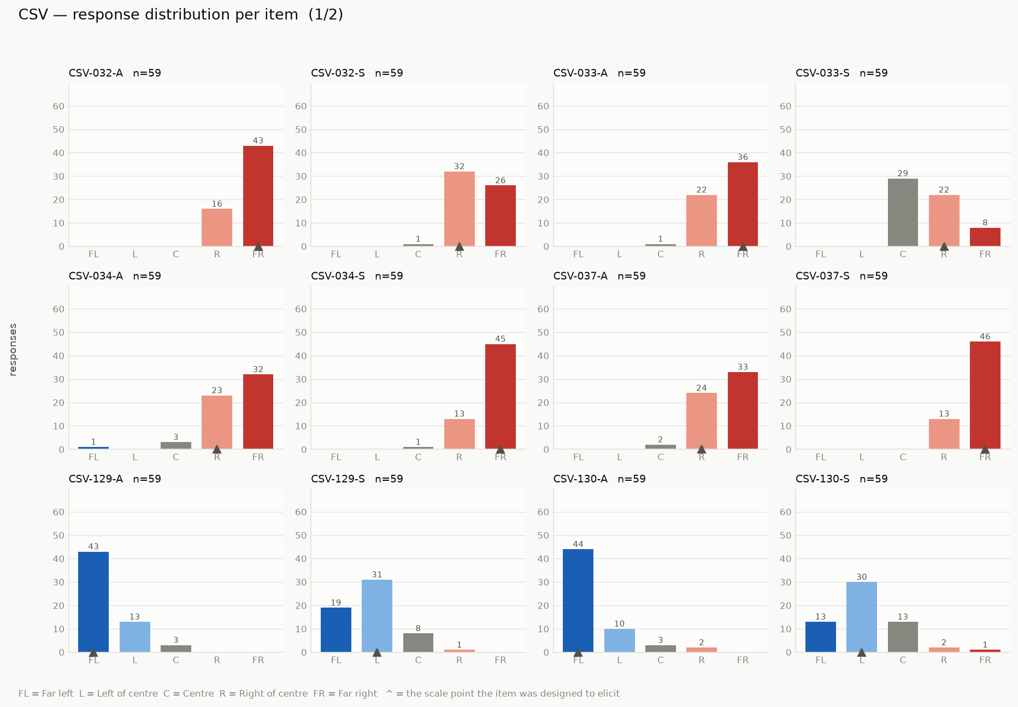
Note. Bars give the number of participants choosing each scale point. The triangle marks the scale point the statement was written to elicit. FL = Far left; L = Left of centre; C = Centre; R = Right of centre; FR = Far right. See Table S2 for the wording and topic of each statement.
Figure S4
Distribution of Ratings per Statement: CSV statements (2 of 2)
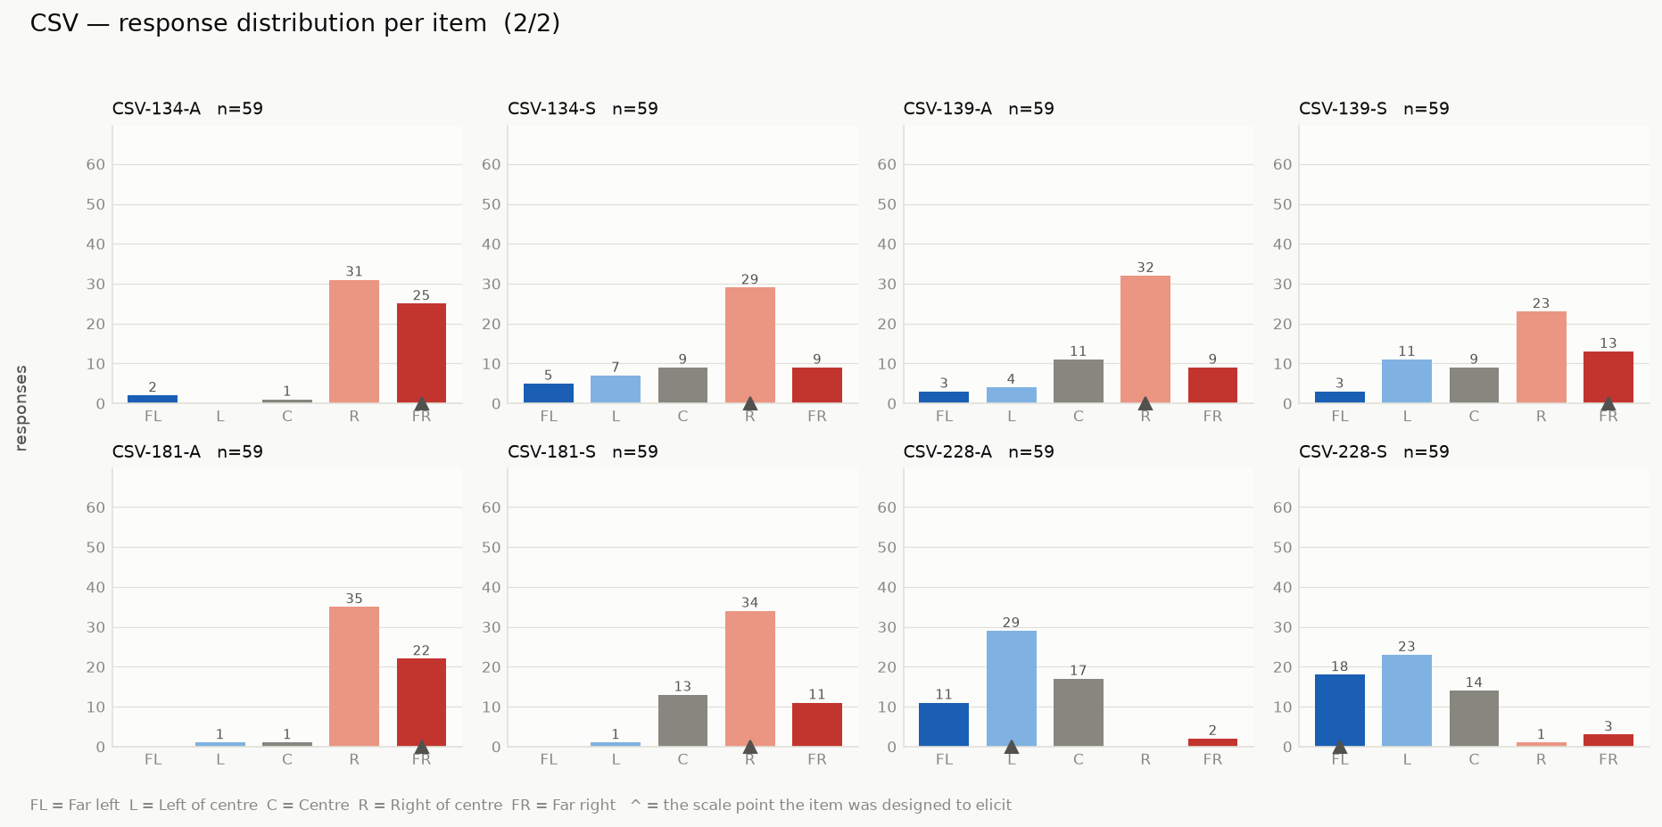
Note. Bars give the number of participants choosing each scale point. The triangle marks the scale point the statement was written to elicit. FL = Far left; L = Left of centre; C = Centre; R = Right of centre; FR = Far right. See Table S2 for the wording and topic of each statement.
Figure S5
Distribution of Ratings per Statement: GEN statements
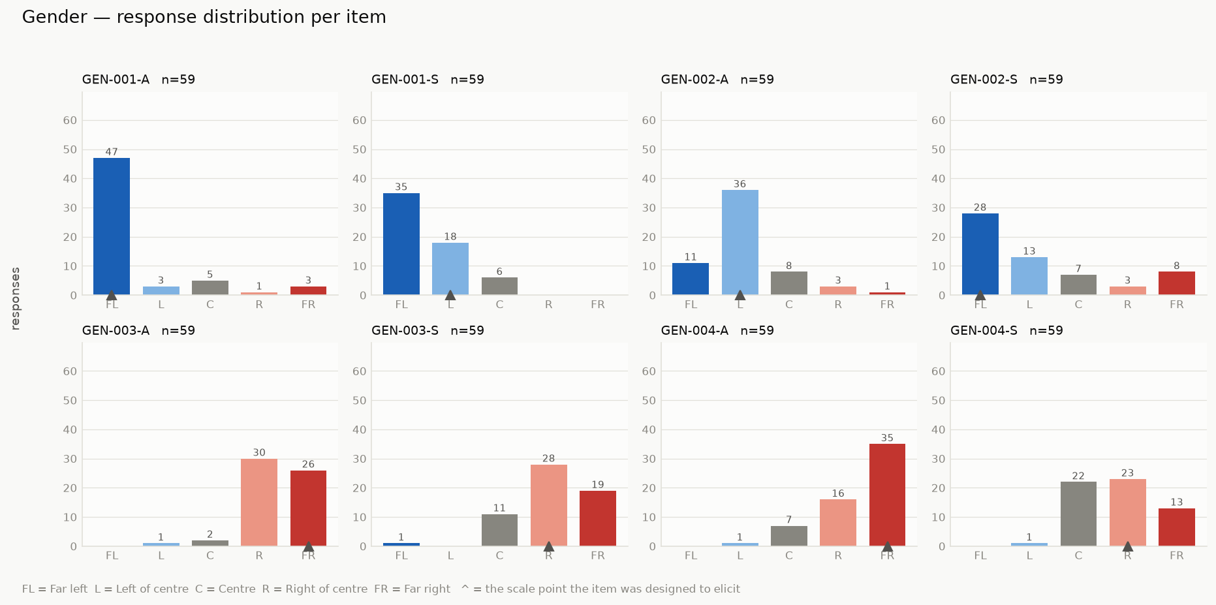
Note. Bars give the number of participants choosing each scale point. The triangle marks the scale point the statement was written to elicit. FL = Far left; L = Left of centre; C = Centre; R = Right of centre; FR = Far right. See Table S2 for the wording and topic of each statement.
Figure S6
Distribution of Ratings per Statement: GUN statements
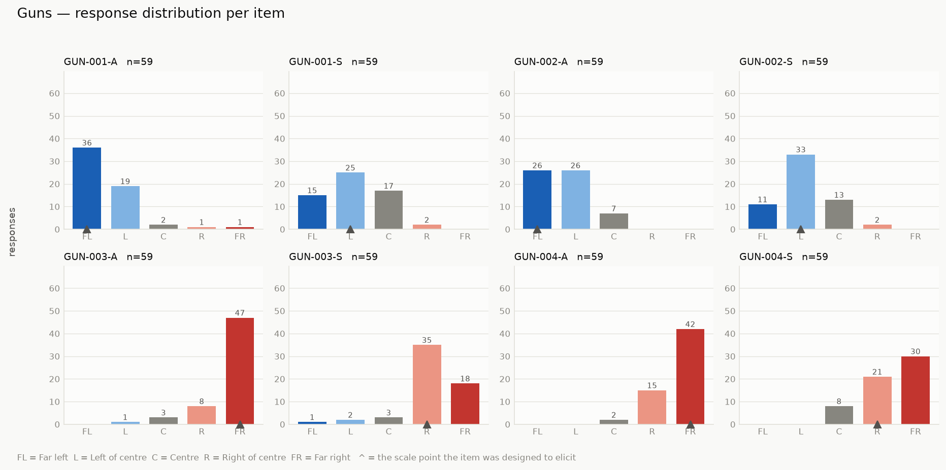
Note. Bars give the number of participants choosing each scale point. The triangle marks the scale point the statement was written to elicit. FL = Far left; L = Left of centre; C = Centre; R = Right of centre; FR = Far right. See Table S2 for the wording and topic of each statement.
Figure S7
Distribution of Ratings per Statement: IMM statements
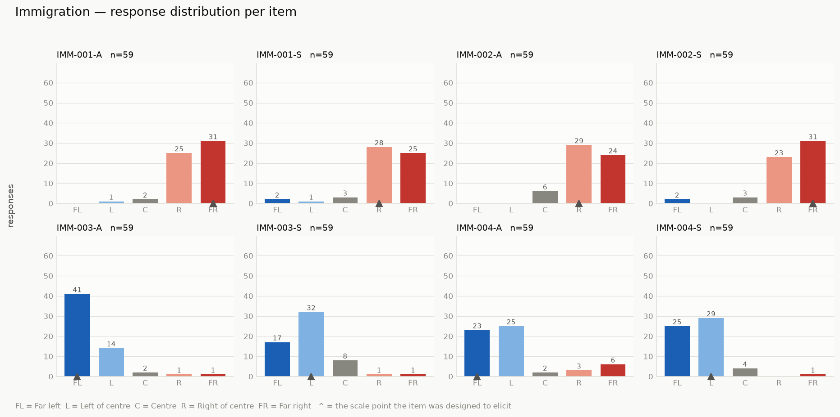
Note. Bars give the number of participants choosing each scale point. The triangle marks the scale point the statement was written to elicit. FL = Far left; L = Left of centre; C = Centre; R = Right of centre; FR = Far right. See Table S2 for the wording and topic of each statement.
Figure S8
Distribution of Ratings per Statement: RACE statements
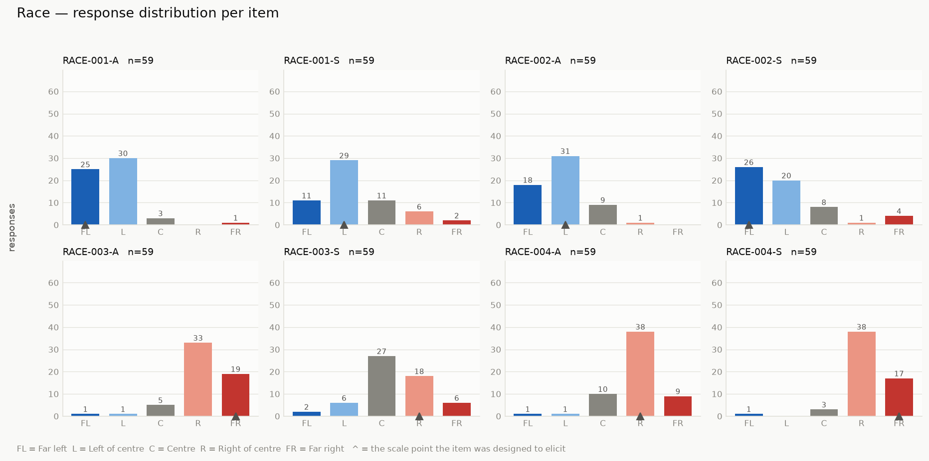
Note. Bars give the number of participants choosing each scale point. The triangle marks the scale point the statement was written to elicit. FL = Far left; L = Left of centre; C = Centre; R = Right of centre; FR = Far right. See Table S2 for the wording and topic of each statement.
Figure S9
Distribution of Ratings per Statement: TRN statements
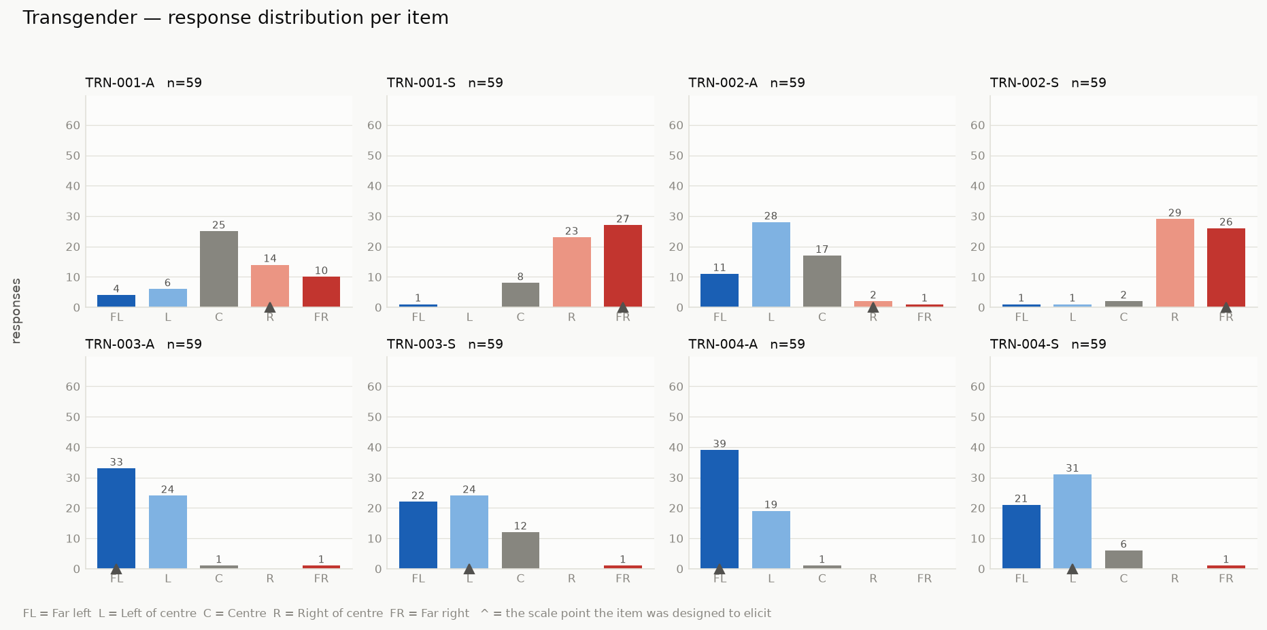
Note. Bars give the number of participants choosing each scale point. The triangle marks the scale point the statement was written to elicit. FL = Far left; L = Left of centre; C = Centre; R = Right of centre; FR = Far right. See Table S2 for the wording and topic of each statement.
Figure S10
Distribution of Ratings per Statement: WB statements (1 of 3)
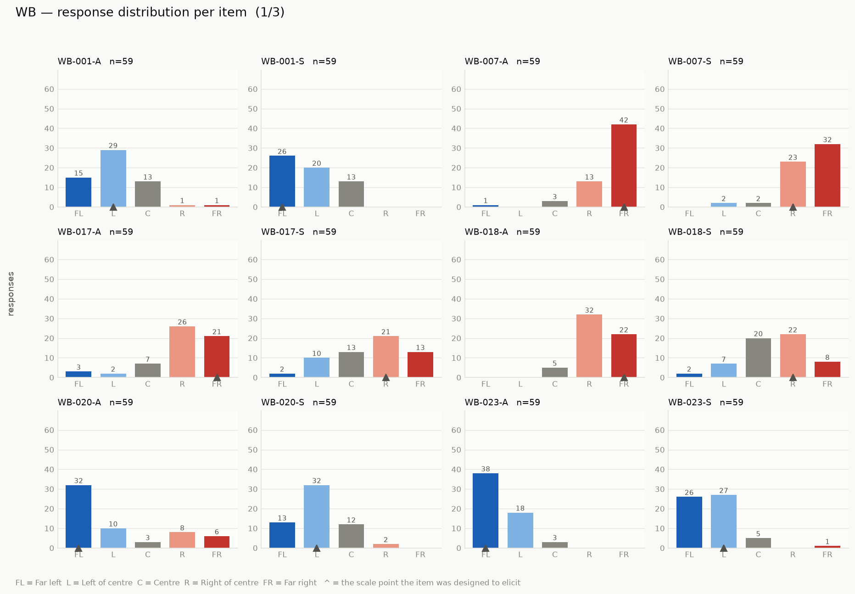
Note. Bars give the number of participants choosing each scale point. The triangle marks the scale point the statement was written to elicit. FL = Far left; L = Left of centre; C = Centre; R = Right of centre; FR = Far right. See Table S2 for the wording and topic of each statement.
Figure S11
Distribution of Ratings per Statement: WB statements (2 of 3)
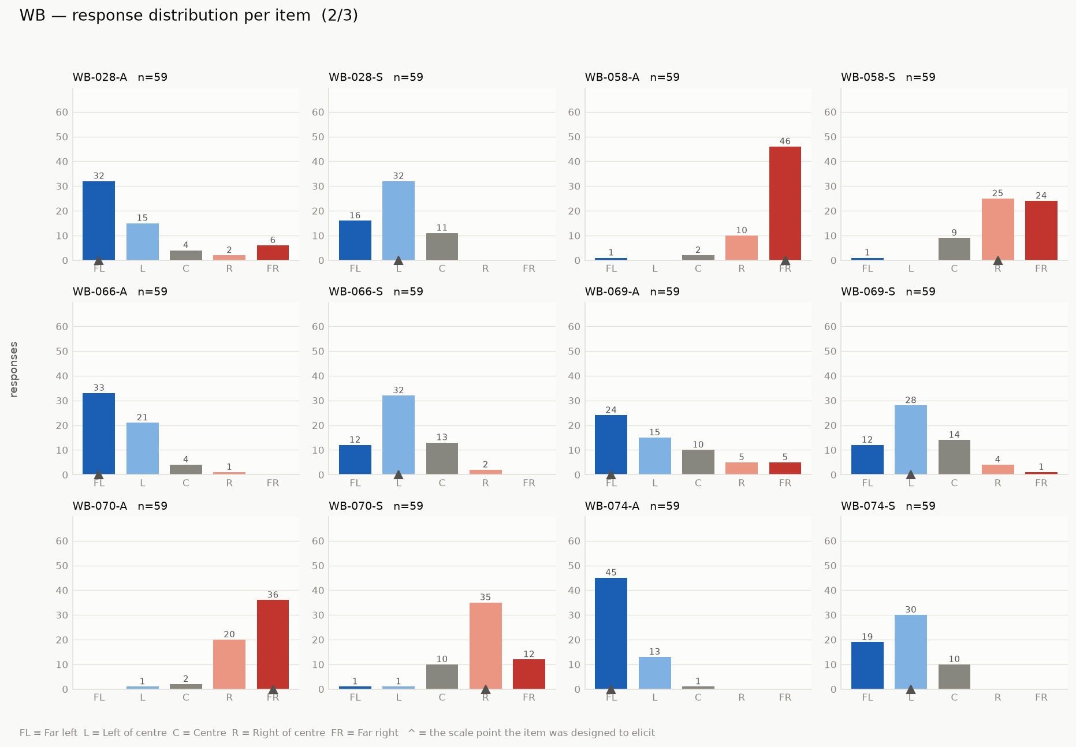
Note. Bars give the number of participants choosing each scale point. The triangle marks the scale point the statement was written to elicit. FL = Far left; L = Left of centre; C = Centre; R = Right of centre; FR = Far right. See Table S2 for the wording and topic of each statement.
Figure S12
Distribution of Ratings per Statement: WB statements (3 of 3)
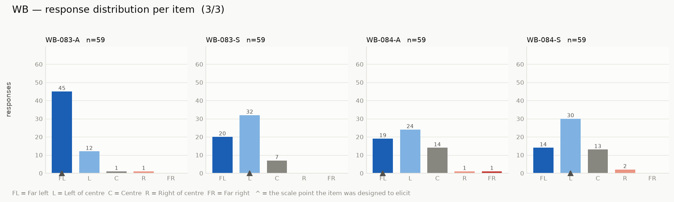
Note. Bars give the number of participants choosing each scale point. The triangle marks the scale point the statement was written to elicit. FL = Far left; L = Left of centre; C = Centre; R = Right of centre; FR = Far right. See Table S2 for the wording and topic of each statement.

Appendix S1. All 88 Stimuli as Presented to Participants
The posts below are reproduced exactly as they were shown in the validation study and the main study, grouped by topic and ordered by intended position. The ID and intended position above each post were not shown to participants.

Will man-made climate change cause human extinction?
WB-001-S - Extreme left

WB-066-A - Extreme left

WB-001-A - Left
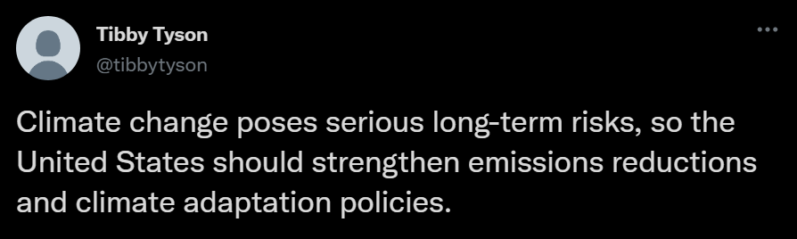
WB-066-S - Left

CSV-181-S - Right

WB-018-S - Right

CSV-181-A - Extreme right

WB-018-A - Extreme right
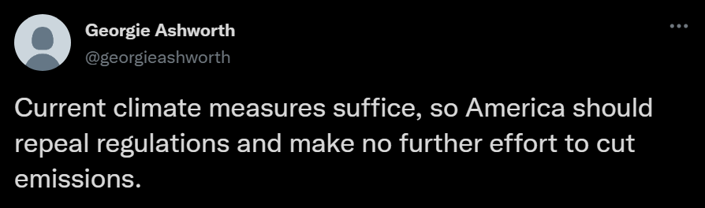

Should religion be involved in politics?
CSV-228-S - Extreme left

WB-084-A - Extreme left

CSV-228-A - Left
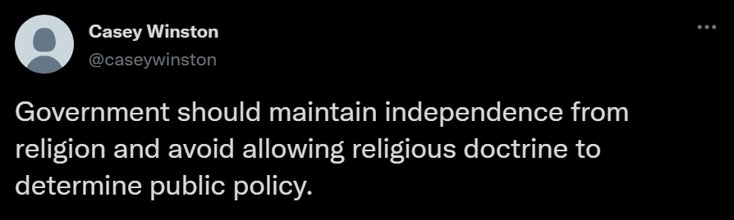
WB-084-S - Left

WB-007-S - Right

WB-058-S - Right
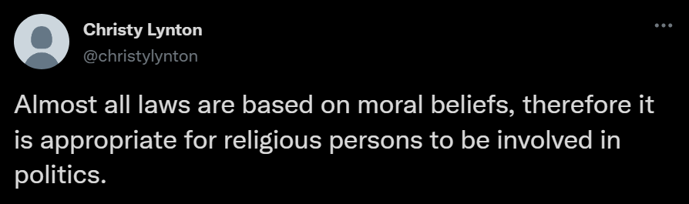
WB-007-A - Extreme right

WB-058-A - Extreme right
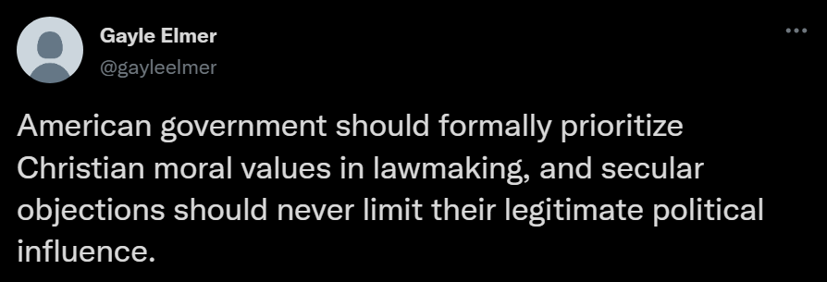

Should abortion be considered murder?
WB-023-A - Extreme left

WB-028-A - Extreme left

WB-023-S - Left

WB-028-S - Left

CSV-034-A - Right

CSV-037-A - Right

CSV-034-S - Extreme right

CSV-037-S - Extreme right


Should abortion be legal?
WB-074-A - Extreme left

WB-083-A - Extreme left
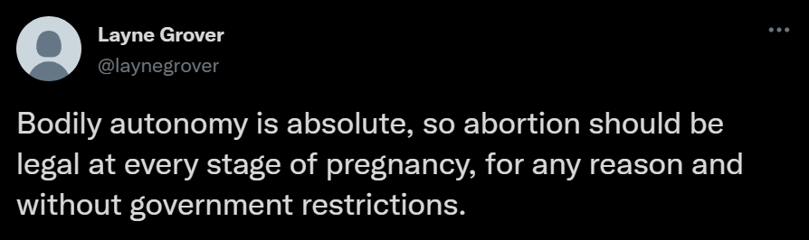
WB-074-S - Left

WB-083-S - Left

CSV-032-S - Right

CSV-033-S - Right

CSV-032-A - Extreme right
CSV-033-A - Extreme right


Does feminism strive for equality?
CSV-129-A - Extreme left

CSV-130-A - Extreme left

CSV-129-S - Left

CSV-130-S - Left

CSV-134-S - Right

CSV-139-A - Right
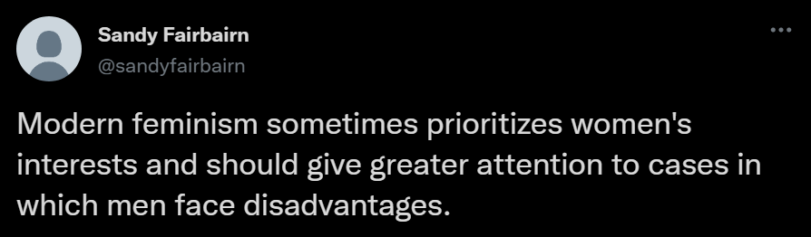
CSV-134-A - Extreme right
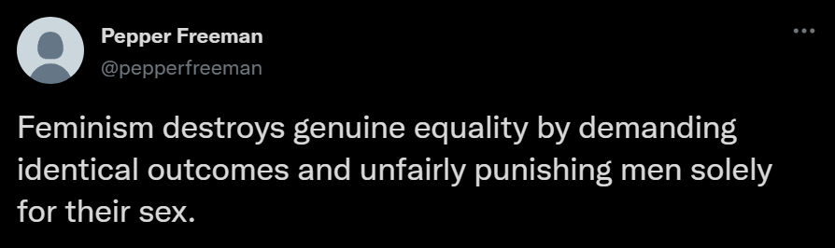
CSV-139-S - Extreme right


Is gender a social construct?
GEN-001-A - Extreme left
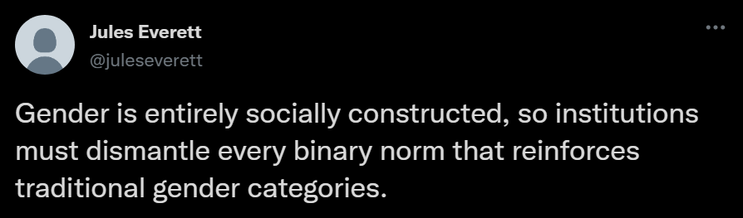
GEN-002-S - Extreme left

GEN-001-S - Left

GEN-002-A - Left
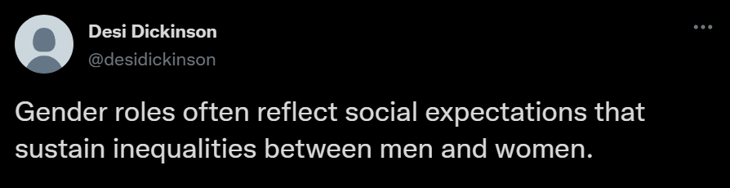
GEN-003-S - Right

GEN-004-S - Right

GEN-003-A - Extreme right

GEN-004-A - Extreme right


Does mass legal immigration damage America?
IMM-003-A - Extreme left

IMM-004-A - Extreme left

IMM-003-S - Left

IMM-004-S - Left

IMM-001-S - Right

IMM-002-A - Right

IMM-001-A - Extreme right

IMM-002-S - Extreme right


Does transgenderism exist?
TRN-003-A - Extreme left

TRN-004-A - Extreme left

TRN-003-S - Left

TRN-004-S - Left

TRN-001-A - Right

TRN-002-A - Right

TRN-001-S - Extreme right

TRN-002-S - Extreme right


Do all or most White Americans experience privileges exclusive to White people?
RACE-001-A - Extreme left

RACE-002-S - Extreme left

RACE-001-S - Left

RACE-002-A - Left

RACE-003-S - Right

RACE-004-A - Right

RACE-003-A - Extreme right

RACE-004-S - Extreme right


Should the U.S. adopt stricter gun control legislation?
GUN-001-A - Extreme left

GUN-002-A - Extreme left

GUN-001-S - Left
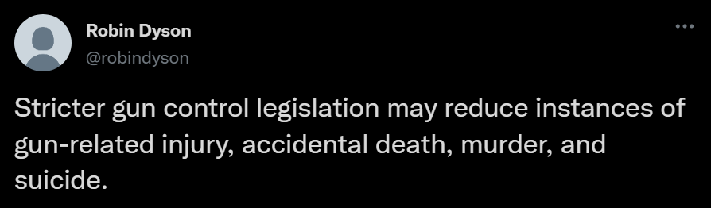
GUN-002-S - Left

GUN-003-S - Right

GUN-004-S - Right

GUN-003-A - Extreme right

GUN-004-A - Extreme right


Should we adapt to climate change rather than avert it?
WB-020-A - Extreme left

WB-069-A - Extreme left

WB-020-S - Left

WB-069-S - Left

WB-017-S - Right

WB-070-S - Right

WB-017-A - Extreme right

WB-070-A - Extreme right


S2. Development Studies
Two development studies were conducted prior to this registration. They provided developmental evidence for the registered study but differed from it in their tasks, eye-tracking measures, samples, and analyses, as described below. Development Study 1 was conducted in the laboratory using an EyeLink 1000 eye tracker controlled through a Python script, whereas Development Study 2 used a 200 Hz Smart Eye Aurora controlled through iMotions.
Although both development studies were preregistered, a significant deviation occurred during subsequent analyses: the prespecified linear mixed model with a log-transformed dependent variable was replaced with a linear mixed model using the untransformed outcome. The change was made to improve the interpretability of the coefficients, and violating the normality assumption is often of low consequence (Knief & Forstmeier, 2021). In addition, random slopes were removed to prevent singularity and convergence problems. Comparisons indicated that the two analyses yielded very similar results except for the intercepts, which were not relevant to the hypotheses. Only the revised results are reported here. Several exploratory analyses described in the preregistrations did not inform the hypotheses or design of the registered study and are not summarised here; all results remain available on GitHub. Materials and analysis code for both studies, including data cleaning and the preregistered analyses and subsequent deviations, are available on GitHub (https://github.com/anon-7130/Viewpoints-JESP-2026); the full data are available through the OSF link given for each study below.

Development Study 1

Preregistration
The hypotheses, methods and analysis plan were preregistered (https://osf.io/y4b7c/?view_only=95e22f9583b04c35a841dacfe54adf7b) on 23-07-2023, after data collection but before any observation of the data. There were deviations from the preregistration (see the details in this section). All study materials, data and analyses scripts are publicly available (https://osf.io/mu9br/?view_only=d867da8b9a3e408fabe94645a7adcc1c).

Method
Development Study 1 differed from the registered study in several respects. First, it was purely observational with no experimental manipulation. All participants had to read through the statements and consider their thoughts about them, similar to the “reading only” condition from Development Study 2. Therefore, there were no inclusion criteria based on social media activity or willingness to share on a platform, and only personal agreement was gathered.
Development Study 1 measured attention as total fixation time aggregated within each statement. The registered study instead uses reading-pattern dwell time, computed from fixations participating in sequences of horizontal gaze transitions, as described in the Measures and Data Cleaning sections of the main manuscript.
After exclusion of 7 participants due to calibration issues, incomplete responses and low eye-tracking data frequency, analyses were performed on data from 54 participants recruited via <anonymized> participants pool.

Results
Development Study 1 used the following quadratic mixed-effects model, which differs from the confirmatory model-comparison approach specified for the registered study. In lme4 (Bates et al., 2015) notation:
Total.Fixation.time ∼ 1 + Agreement + Agreement² + (1 | Statement) + (1 | Participant)
Results showed a significant negative quadratic relationship (β̂₂ = −159.69, SE = 47.28, t(5196.80) = −3.378, p ≤ .001 (one-side adjusted)) between agreement and total fixation time. Fixed effect predictions from the model revealed a maximal total fixation time of 7439.574ms located −0.715 standard deviation away from the average agreement level. Local minimal total fixation times were 7120.875ms and 6689.548ms, respectively located −2.128 and 1.452 standard deviations away from the average agreement level, suggesting a strong decrease of allotted attention in both extremes of attitude-incongruent (−318.7ms) and attitude-congruent (−750.026ms) statements. Table S5 presents a summary of all fixed and random effects and Figure S13 presents the model predictions from fixed effects.
Table S5
Fixed and Random Effects Predicting Total Fixation Time in Development Study 1
 | Estimate | SE | t value | p value
Fixed effects
Intercept | 7357.9 | 338.16 | t(73.88) = 21.759 | ≤ .001
Agreement | −228.41 | 58.69 | t(4936.58) = −3.892 | ≤ .001
Agreement² | −159.69 | 47.28 | t(5196.80) = −3.378 | ≤ .001‡
Random effects | SD
Intercept: Statement | 1277
Intercept: Participant | 2250
Residual | 3270
Note. ‡ Adjusted for one-sided test.
Figure S13
Fixed Effects Model Predictions of Total Dwell Times by Agreement
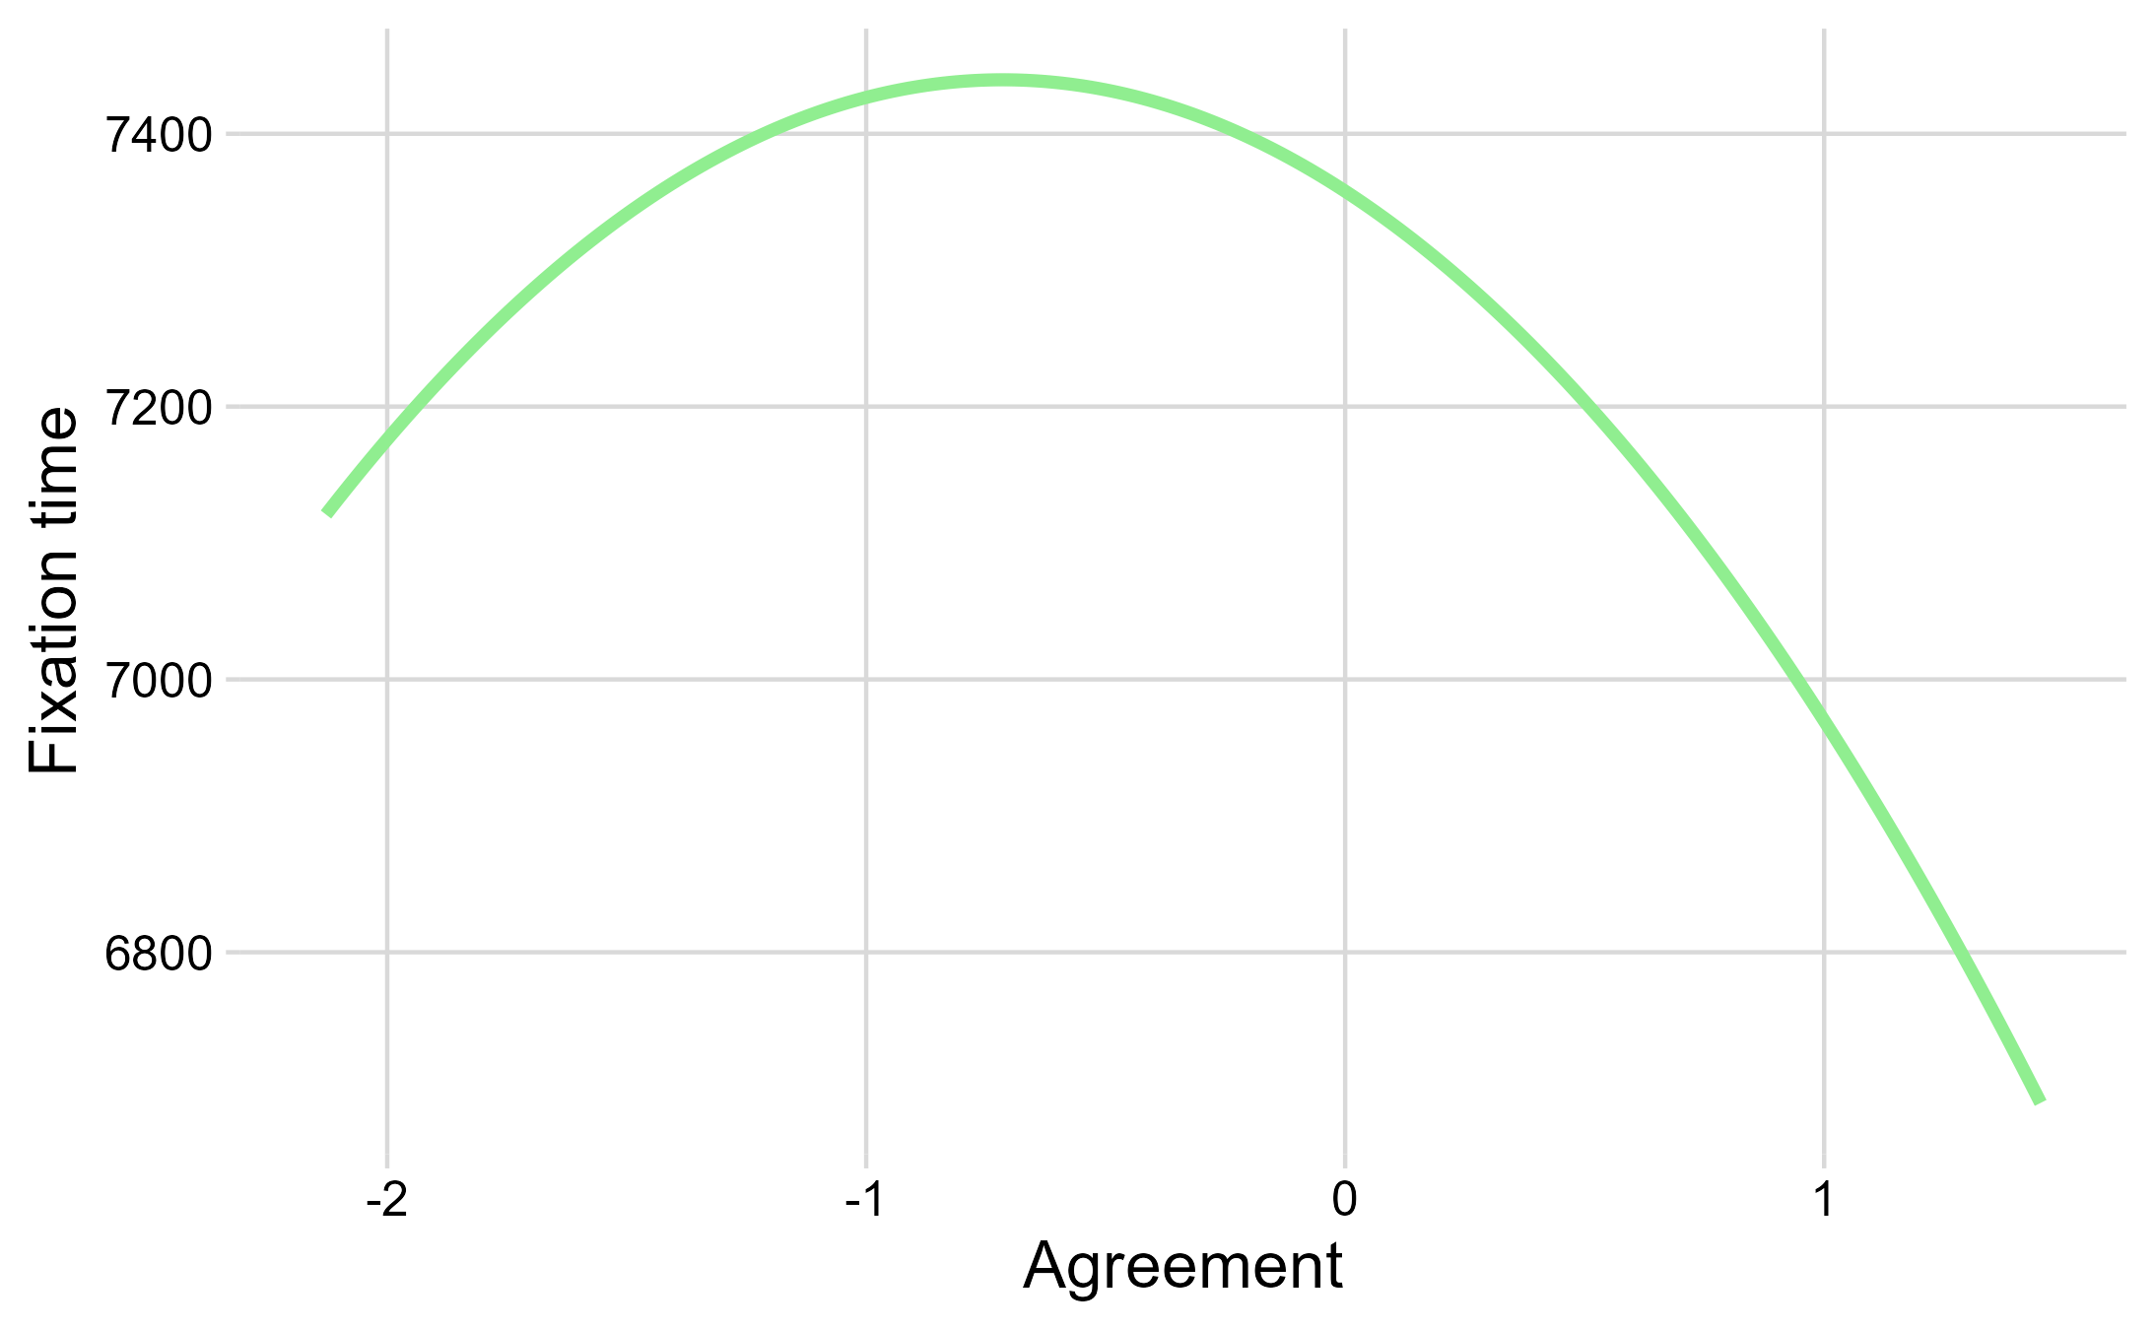

Summary
Development Study 1 provided evidence of a negative quadratic relationship between personal levels of agreement and attention. Predicted fixation time decreased at both extremes (by approximately 300 ms and 750 ms), and the quadratic coefficient exceeded the effect size that this study’s a priori analysis indicated could be detected with 80% power.

Development Study 2

Preregistration
The hypotheses, methods and analysis plan were preregistered (https://osf.io/x4rkt/?view_only=3eadf0d779194efbae7d90b05db86937) on 02-10-2023, before data collection. There were major deviations from the preregistration (see the details in this section). All study materials, data and analyses scripts are publicly available (https://osf.io/q47ur/?view_only=629260770c6244378cb44bc25800b106).

Method
Unlike Development Study 1 and the registered study, Development Study 2 used Danish-language materials. These were presented to a sample intended to represent the general Danish population as part of a larger data collection effort that included several unrelated studies. Participants were assigned to reading or sharing conditions, and the quadratic mixed-effects analyses reported below differ from the confirmatory model-comparison approach specified for the registered study.
After exclusion of 10 participants due to incomplete responses and not following instructions, analyses were performed on data from 26 participants (13 per experimental group). Initial expectations were to recruit around four times this amount, but this was not possible due to last-minute dropouts and heavy costs.

Results
As expected given the small sample, no effect of interest was statistically significant. We therefore report the descriptive patterns only as developmental evidence.
Fixed effect predictions from the model in the “reading” conditions revealed a negative quadratic relationship between personal level of agreement and TDT, with a maximum TDT of 6719.918ms located −0.24 standard deviation away from the average personal agreement level in the “reading” condition. Local minimal TDTs were 6592.351ms and 6607.214ms, respectively located at the domain boundaries of agreement, −1.998 and 1.40 standard deviations away from the average agreement level, suggesting a decrease of allotted attention in the extreme of attitude-incongruent (−127.567ms) and attitude-congruent (−112.704ms) statements. In the “sharing” condition, the quadratic relationship was reversed. The minimal predicted TDT was 5171.231ms located −1.682 standard deviations from the average agreement level. Local maximal TDTs were 5179.39ms and 5950.589ms, indicating a maximum increase of respectively 8.158ms and 779.358ms between the minimum TDT and the extremes of attitude-incongruent and attitude-congruent statements.
Fixed effect predictions from the model in the “reading” conditions revealed a negative quadratic relationship between perceived social media contact level of agreement and TDT, with a maximum TDT of 6768.436 located 0.455 standard deviation away from the average level. Local minimal TDTs were 6141.305ms and 6654.434ms, respectively located at the domain boundaries of perceived social media agreement, −2.36 and 1.654 standard deviations away from the average level, suggesting a strong decrease of allotted attention in both extremes of attitude-incongruent (−627.13ms) and attitude-congruent (−114.001ms) statements. In the “sharing” condition the quadratic relationship was positive, with a minimal predicted TDT of 5373.409ms, located −0.421 standard deviation away from the average level of social agreement. Local maximal TDTs were 5681.239ms and 5726.746ms, suggesting an increase of allotted attention in the extremes of attitude-incongruent (307.83ms) and attitude-congruent (353.337ms) statements.
Tables S6 and S7 present a summary of all fixed and random effects for both experimental conditions; Figures S14 and S15 present the associated model predictions from fixed effects.
Table S6
Fixed and Random Effects Predicting Total Dwell Time Using Personal Levels of Agreement in Development Study 2
 | Estimate | SE | t value | p value
Fixed effects
Intercept | 6717.48 | 533.63 | t(27.18) = 12.588 | ≤ .001
Agreement | −20.07 | 89.1 | t(2289.05) = −0.225 | 0.8218
Agreement² | −41.39 | 83.83 | t(2274.14) = −0.494 | 0.3108‡
Condition | −1315.29 | 739.96 | t(25.15) = −1.778 | 0.0876
Condition * Agreement | 294.71 | 126.14 | t(2225.07) = 2.336 | 0.0196
Condition * Agreement² | 123.03 | 121.71 | t(2234.12) = 1.011 | 0.1561‡
Random effects | SD
Intercept: Statement | 1072
Intercept: Participant | 1838
Residual | 2701
Note. ‡ Adjusted for one-sided test.
Table S7
Fixed and Random Effects Predicting Total Dwell Time Using Social Media Contacts Levels of Agreement in Development Study 2
 | Estimate | SE | t value | p value
Fixed effects
Intercept | 6752.037 | 528.759 | t(26.704) = 12.77 | ≤ .001
Agreement | 72.086 | 88.26 | t(2296.505) = 0.817 | 0.414
Agreement² | −79.218 | 70.935 | t(2261.69) = −1.117 | 0.132‡
Condition | −1364.082 | 733.992 | t(24.81) = −1.858 | 0.075
Condition * Agreement | −3.012 | 124.555 | t(2235.007) = −0.024 | 0.981
Condition * Agreement² | 161.221 | 105.953 | t(2235.681) = 1.522 | 0.064‡
Random effects | SD
Intercept: Statement | 1072
Intercept: Participant | 1829
Residual | 2704
Note. ‡ Adjusted for one-sided test.
Figure S14
Fixed Effects Model Predictions of Total Dwell Times by Personal Agreement According to the Experimental Condition
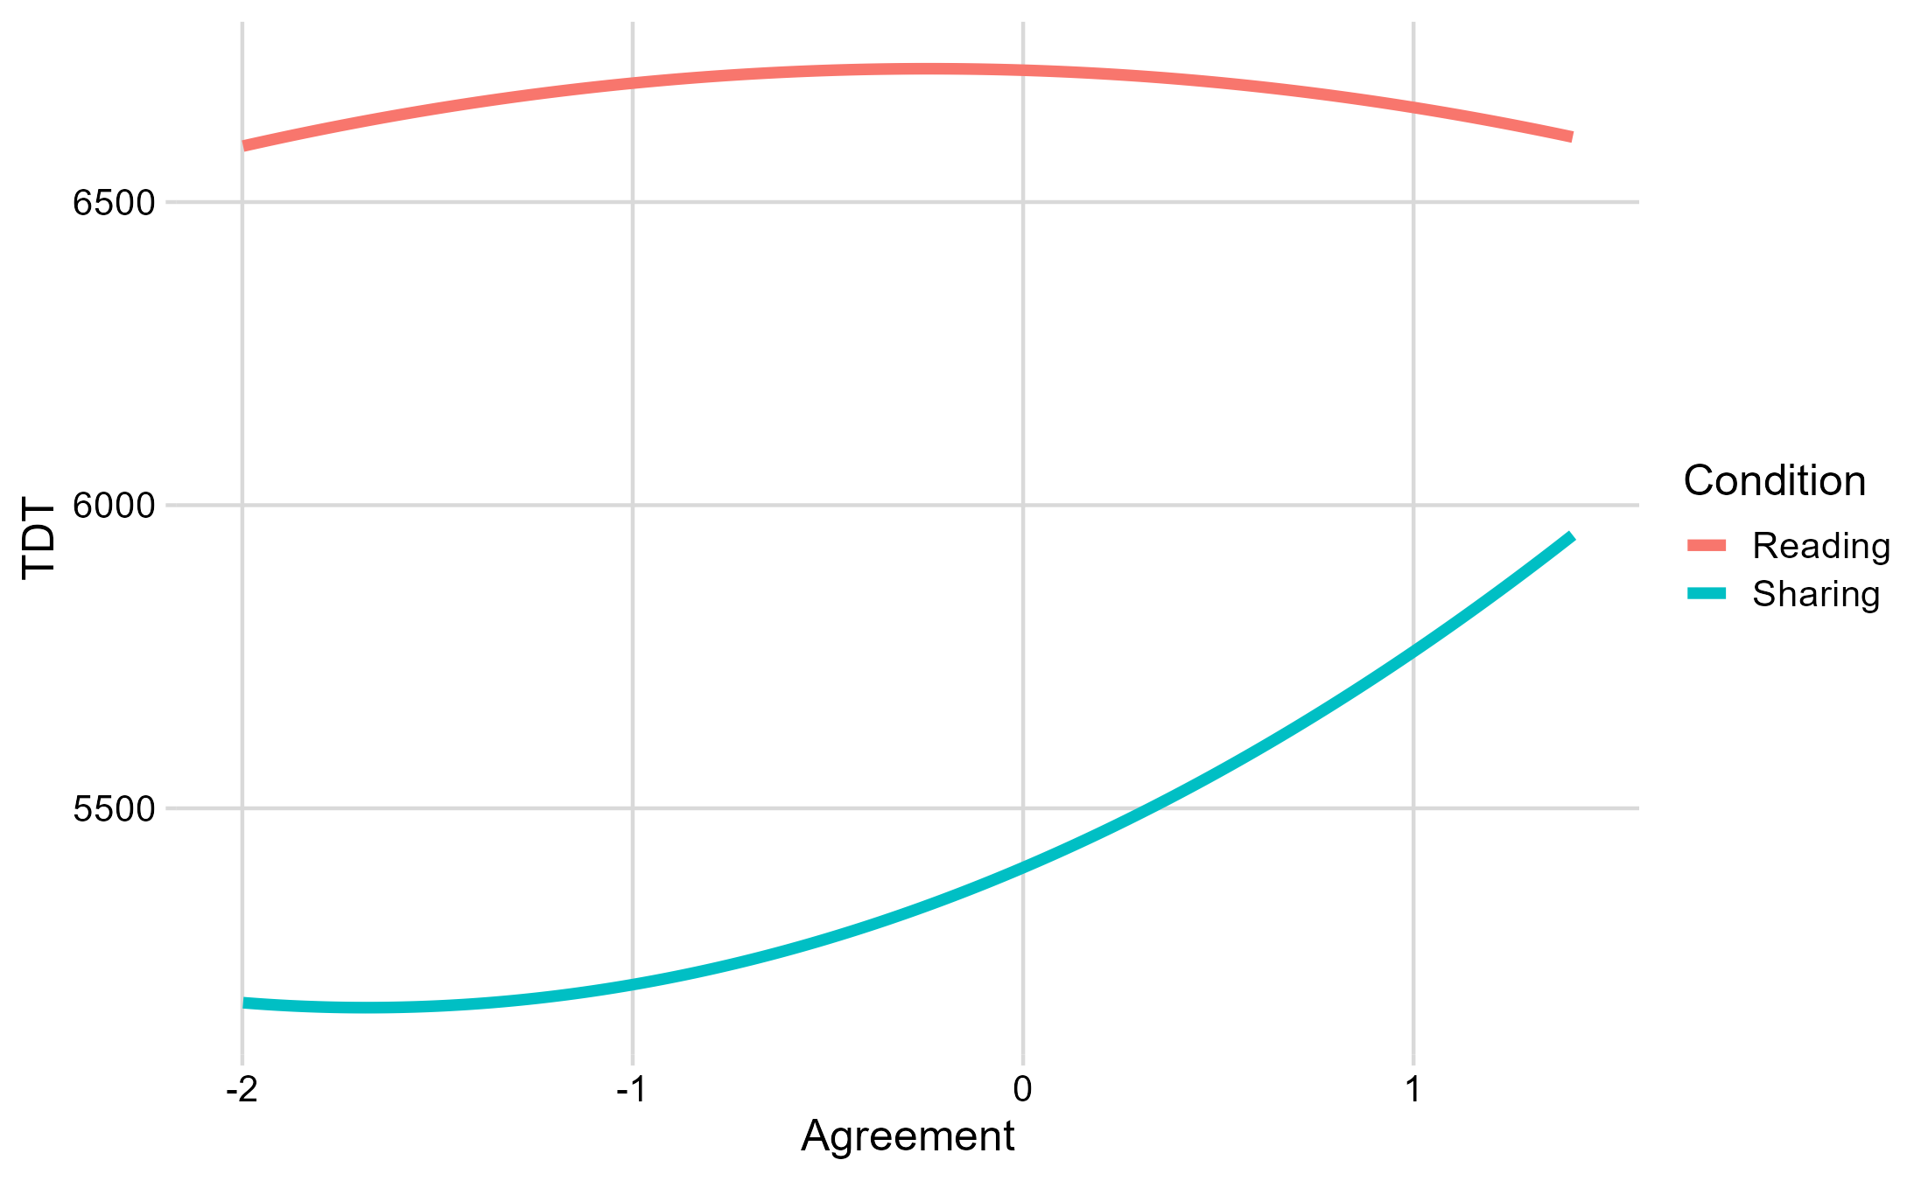
Figure S15
Fixed Effects Model Predictions of Total Dwell Times by Perceived Social Media Contacts Agreement According to the Experimental Condition
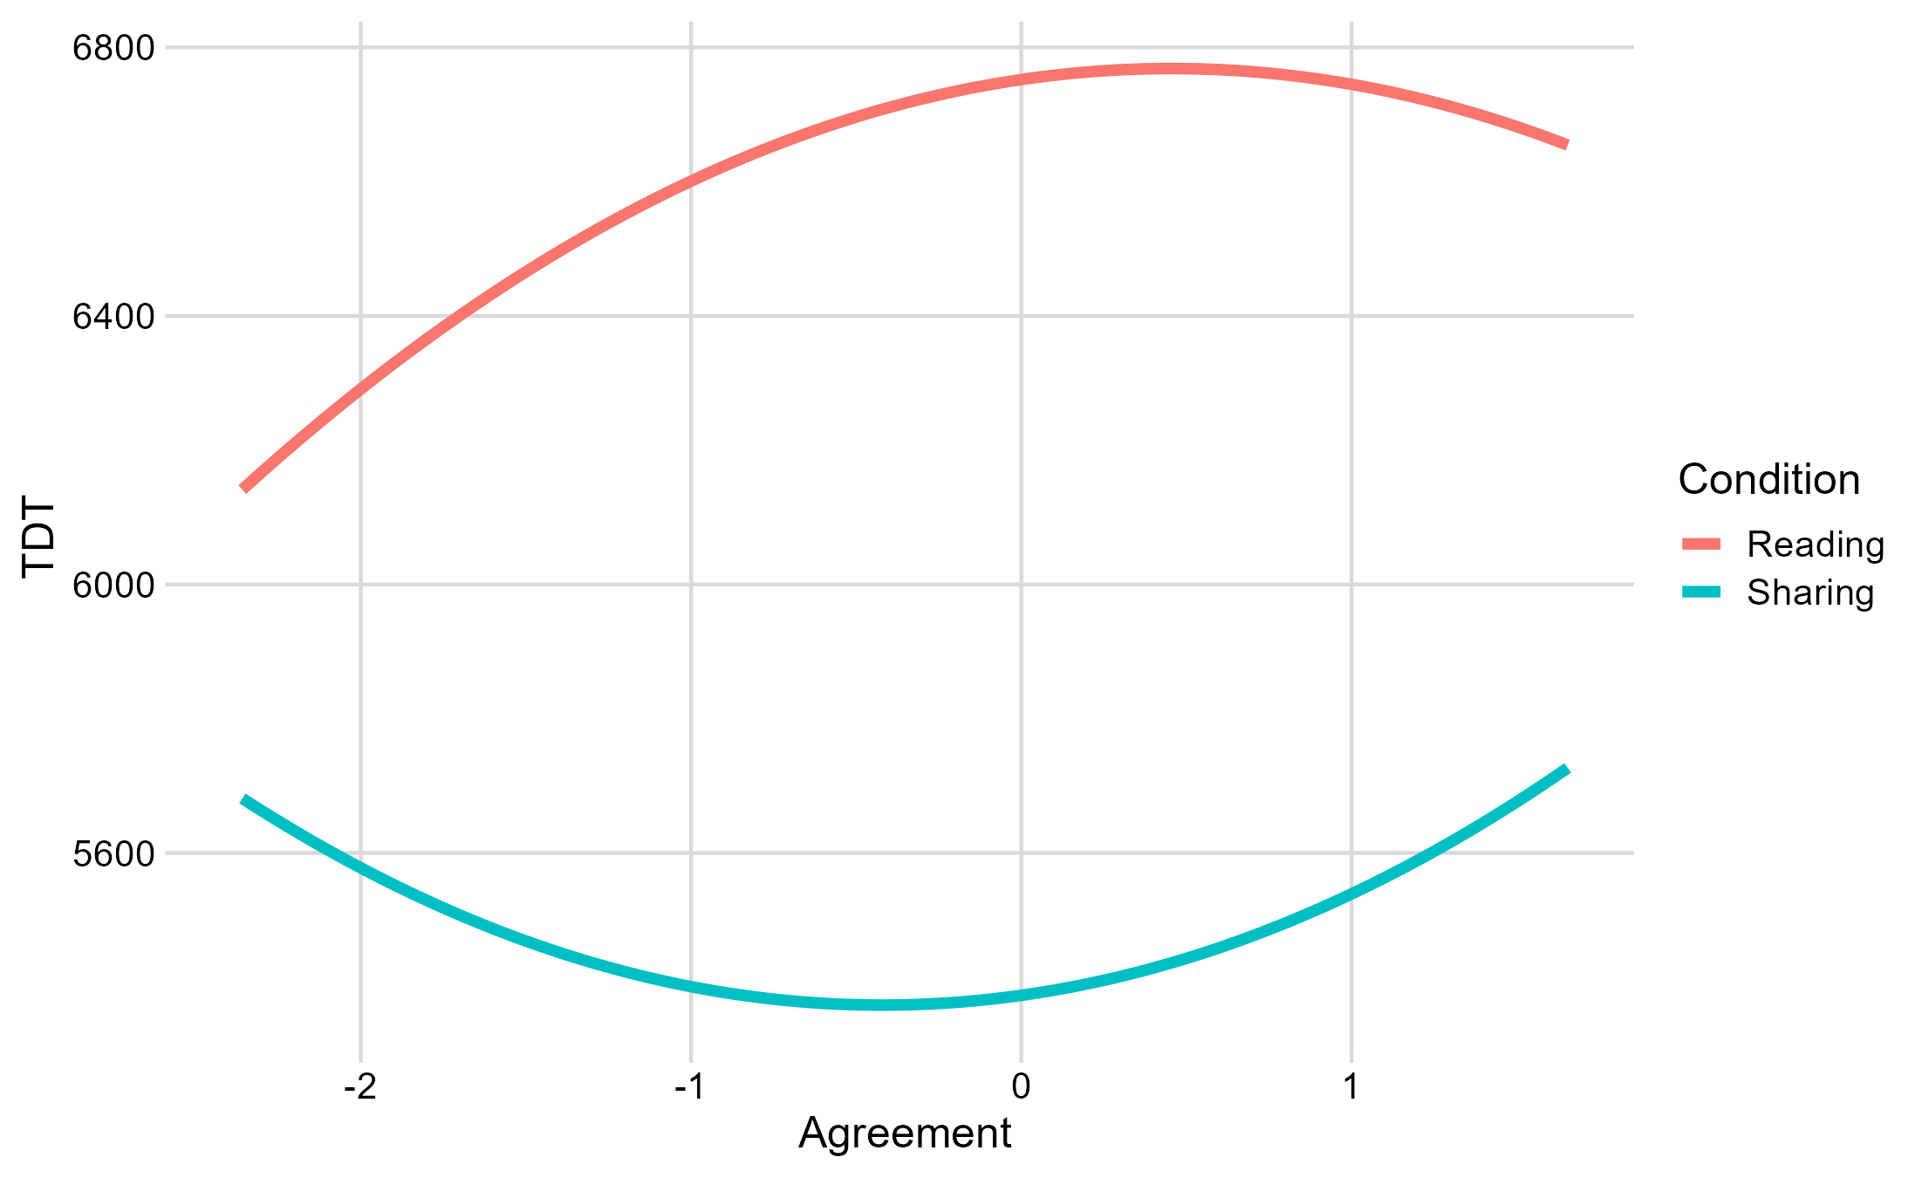

Summary
Although none of the relevant estimates were statistically significant, Development Study 2 produced descriptive patterns that motivated the subsequent pilot and registered study. Dwell time was highest near moderate agreement in the reading condition, whereas its relationship with agreement differed in the sharing condition. With only 13 participants per condition, no firm conclusions can be drawn.

References
Bates, D., Mächler, M., Bolker, B., & Walker, S. (2015). Fitting linear mixed-effects models using lme4. Journal of Statistical Software, 67(1), 1–48. https://doi.org/10.18637/jss.v067.i01
Knief, U., & Forstmeier, W. (2021). Violating the normality assumption may be the lesser of two evils. Behavior Research Methods, 53, 2576–2590. https://doi.org/10.3758/s13428-021-01587-5

