## HES NRHE Areas Download (Formerly Canmore Areas)

**Build: December 2024**

The Historic Environment Scotland (HES) NRHE Areas layer is a GIS shapefile containing the **Known Site Extents** of around 125,000+ sites in Scotland. The map shows the present extent of mapping using the Defining Scotland’s Places (DSP) methodology.

The DSP methodology was developed during a pilot mapping project in 2010 and has gone on to be adopted by the Scottish Historic Environment Data group (SHED) as its preferred technical specification for mapping the known extent of archaeological monuments in Scotland. The full technical specification is included in the download or can be found online here:

<https://canmore.org.uk/content/data-downloads>

Mapping the extent of Scotland’s monuments is an ongoing project being carried out by organisations across Scotland. Forest and Land Scotland, Scottish Borders Council, the Shetland Amenity Trust and the National Trust for Scotland have carried out mapping projects for their areas of responsibility. Midlothian, Renfrewshire and parts of Orkney were mapped as part of the original pilot and HES’ survey teams now systematically map all new sites recorded during HES field survey work to the NRHE Areas technical specification.

There are somewhere in the region of 160,000 unique archaeological records in Scotland and a similar number of architectural records. The mapping of these records continues.

HES NRHE Mapping is open data produced to the Open Government Licence v3.

<http://www.nationalarchives.gov.uk/doc/open-government-licence/version/3/>

HES aims to produce a new build quarterly. The download is provided as a shapefile. Other formats can be provided on request.

**Loading NRHE Areas using ArcMap:**

To display the data using the in-house HES style (symbology) first load the layer file:

1. NRHE_Areas.lyr

If the layer does not display you may have to reconnect the data source to the layer.

1. Right click on the layer in the table of contents and select **Properties** (See screenshot below)
2. Under source, select **Set Data Source** and browse to the **NRHE Areas** Shape file.

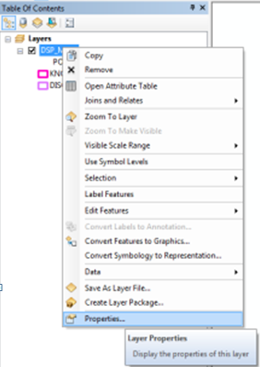

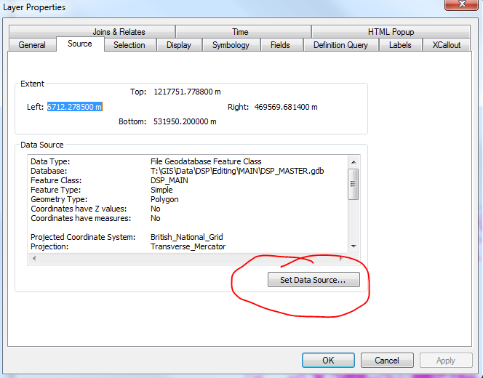

**Loading NRHE Areas using QGIS:**

1. Load the NRHE_Areas.shp shapefile

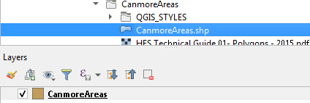

1. Right click on the **NRHE_Areas layer** and select **Propertie**.
2. In Properties select **Symbology.**
3. In the Symbology menu select **Style.**

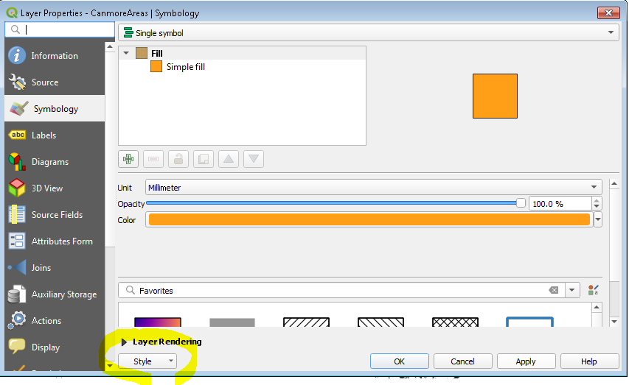

1. From the Style menu select **Load Style**.
2. From the Database Style Manager select the three dots next to **File …**

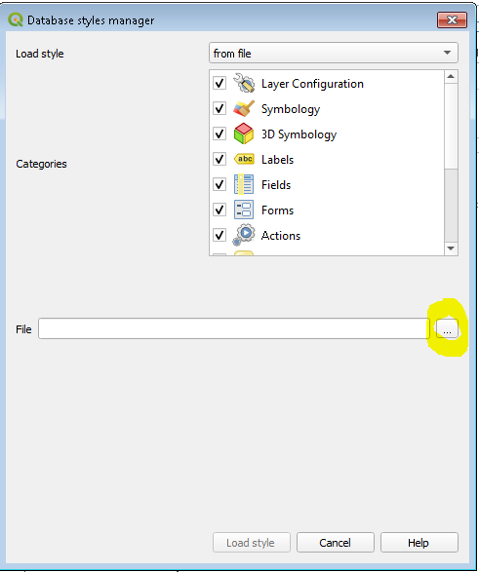

1. Navigate to the NRHE Areas download and open the **QGIS_STYLES folder** and select **NRHE_Areas** and then select **Open**.
2. In the Databaase Styles Manager select **Load Style**.
3. In Layer Properties select Apply then select **OK**.

**Methodological Updates and Known Errors**

**Error 1 - Donuts:** Some polygons in NRHE Areas have been compiled incorrectly. In some cases, where small polygons sit inside a larger polygon with the same Numlink, the polygons have been merged. This has created a situation where the smaller polygons appear as if cut out of the larger polygon. This is incorrect. We hope to resolve this situation as soon as possible. (Identified 23/08/2019)

Update: We have worked through the data in Shetland, where the problem was found to be most acute. We believe we have removed all the slivers in this area. We now intend to analyse the rest of the NRHE Areas data to see if we can identify this issue elsewhere. (Ongoing 28/02/2020)

Update: The worsted effected areas have been targeted and fixed.

(Ongoing 30/03/2021)

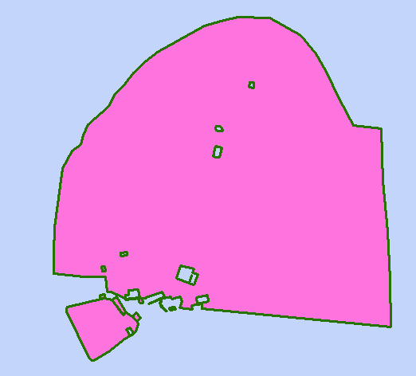

**Error 2 - Slivers:** We are aware that some clipping and merging processes have created slivers between adjoining polygons. We hope to remove these as soon as possible. (Identified 23/08/2019)

Update: We have worked through the data in Shetland, where the problem was found to be most acute. We believe we have removed all the slivers in this area. We now intend to analyse the rest of the NRHE Areas data to see if we can identify this issue elsewhere. (Ongoing 28/02/2020)

Update: The worsted effected areas have been targeted and fixed.

(Ongoing 30/03/2021)

1392 polygons with an area of less than 1m2 removed. Added 1m2 filter to the NRHE Areas build tools to remove tiny polygons (including slivers and knots) being added to NRHE Areas in the future.

(Ongoing 9/08/2022)

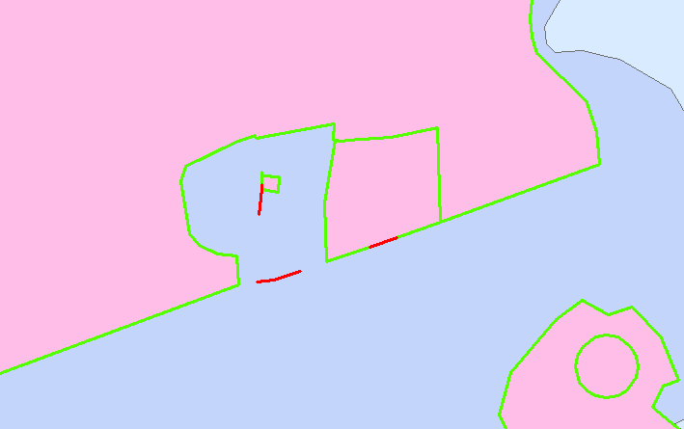

**RESOLVED Error 3 - Date:** We are aware that the COMPDATE (date of compilation) has overwritten the true date of polygon creation for many polygons in the NRHE Areas dataset. We aim to restore the true date of creation dates as soon as possible.

(Identified 23/08/2019)(Resolved 29/10/2019)

**Error 4 – WoSAS hyperlinks:** We have been unable to access and therefore validate the West of Scotland Archaeology Service hyperlinks. WoSAS links will have been removed in this build. We aim to resolve the connection issue and will add the WoSAS links back in to subsequent builds. Apologies for any inconvenience.

(Identified 03/09/2020)

Update 09/11/2020: HES is unable to resolve this issue as the issue seems to be with the WoSAS hosting provider. Investigations continue. We have reinstated the WoSAS hyperlinks. We remain unable to validate them.

(Ongoing 30/03/2021)

**RESOLVED Error 5 – Source OTHER (See notes field for details):** An update to the script populating the NOTES field related to the SOURCE: OTHER (See notes field for details), caused all the NOTES fields for this source to be populated incorrectly during the September 2020 build.

(Identified 13/10/2020)

The error in the script has been isolated and corrected and the data has been refreshed.

(Resolved 9/11/2019)

**RESOLVED Error 6 – Polygons over Mingulay offset from field survey data:**

It was noted that the polygons over the field survey data for Mingulay were slightly offset compared to the original field survey data. The polygons for this area were originally created in 2006.

(Identified 31/05/2022)

The Mingulay polygons were moved, -3.365722 m along the X axis and 3.716781 m along the Y axis, to align them back to the field survey data.

(Resolved 9/08/2022)

**SOURCE TABLE UPDATE AUGUST 2023**

The source classification, HES oblique photo collection (raster), has been split into two new classifications:

* Unrectified oblique aerial photo (raster)
* Rectified oblique aerial photo (raster)

This split recognises that not all photography used in the creation of NRHE Areas is derived from the HES archive and that there is a significant difference in ACCURACY between polygons created using rectified and unrectified imagery.

(Adopted 8/08/2023)

**RESOLVED Error 7 – Projection issue between software updates.**

Several automated processes are used in building NRHE Areas. Since the last build, the software that runs the updates was, itself, updated and one of the automated processes was rewritten. The new process was based on one written in the earlier version and this included a projection attribute to the British National Grid. In the years since this process was originally written, the British National Grid projection has been superseded by EPSG: 27700. Not updating this in the new process caused a variable drift in the polygons of around 2 to 3m, depending on where in the country one looked. Resetting the projection to EPSG 27700 has corrected the problem. (Resolved 24/08/2022)

**OS MASTERMAP UPDATE DECEMBER 2024**

Following agreement with the Ordnance Survey, Mastermap polygons are now included in the NRHE Areas build.

(Adopted 6 December 2024)

Reviewed December 2024 by MM & CD

Data Management || Heritage Information and Business Service || Heritage Directorate

Historic Environment Scotland | Àrainneachd Eachdraidheil Alba