L1 ASSIGNMENT

Name: Masih Ahmed
Branch: B.Tech CSE
Year: 2
Enrollment Number: 18117056

Problem 1-

Write a C program to create a student management system, where the students’ information are stored in a doubly circular linked list, as shown in Figure 1. The structure of each node from the list is shown in Figure 2. Initially, the circular doubly linked list is empty and the student personal data is entered from the filename “StudentData.xlsx” that contains the data of 13 students (name, D.O.B., address and phone no) in tabular form. The StudentData.xlsx file can be converted into a CSV file using Libreoffice or into any other file format readable from your C program. The program should have the following operations: insert, delete, search, modify, sort and print. While inserting, a unique roll number in the linked list is assigned to each student, where the starting roll number should be 101 and the list should always be in sorted according to their roll number (ascending order). However, when a deletion operation is performed, the roll number of the deleted student node is stored in a queue named unusedRollNo. These deleted roll numbers from the unusedRollNo queue will be allotted to the new students on next insertion operations.

Problem 2-

Write a C Program for resizeable deque using dynamic memory allocation, where a deque can perform the insertion and deletion operations at its both ends. The capacity of the deque depends on the number of elements currently stored in it, according to the following two rules: ● If an element is being inserted into a deque, when it is already full, then its capacity is doubled of its current size.
● After removing an element from a deque, if the number of elements are equal to half of the capacity of the deque, then its capacity is made half of its current size.
The program should have the following three functions: insert(), delete() and print(). The function print() should display the current size of the deque (capacity of deque) in terms of number of bytes.

Problem 3-

Given three 2D arrays (for red, green and blue color pixels) of a digital image. For a particular image pixel, the color shade of that pixel is Red if the pixel value at that position of the matrix corresponding to RED is greater than that of GREEN and BLUE. Same goes for GREEN and BLUE shades also. Write a C program that can perform following operations on the given image file:
● Remove all Red shades.
● Remove all Green shades.
● Remove all Blue shades.
● RedOnly: Preserve any red shades in the image, but remove all green and blue.
● GreenOnly: Preserve any green shades in the image, but remove all red and blue.
● BlueOnly: Preserve any blue shades in the image, but remove all red and green.
Write a function pixelValue() that has x and y as two parameters and displays the current pixel (RED, GREEN and BLUE) values of the input image at the point with coordinates (x, y), where x and y are the row and column numbers in that image file, respectively.

ALGORITHMS AND DATA STRUCTURES

Problem 1-
- A circular doubly linked list has been employed using structures, where each node is dynamically allocated and inserted into the list
- A queue is used to store the deleted roll numbers which will later be used to allot
- Bubblesort algorithm to sort the list in O(n^2) time in alphabetical order
- Time taken: 0.000727 sec

Problem 2-
- A dequeue has been used, which allows insertion and deletion at both ends of the queue
- The dequeue is a dynamically allocated array that doubles or halves its size as per the given conditions
- Insertion and deletion from left required shifting the array to the right and left repsectively in order to accomodate the change
- realloc() has been used to change the size of the dequeue
- Time taken: 0.001269 sec

Problem 3-
- Due to large memory demand, the three 2D arrrays were allocated dynamically using heap memory
- Each function goes through the entire 2D array once, hence having a time complexity of O(n)
- File handling has been done using fscanf using comma to be the format of the data
- Time taken: 0.370428 sec
PROBLEM 1

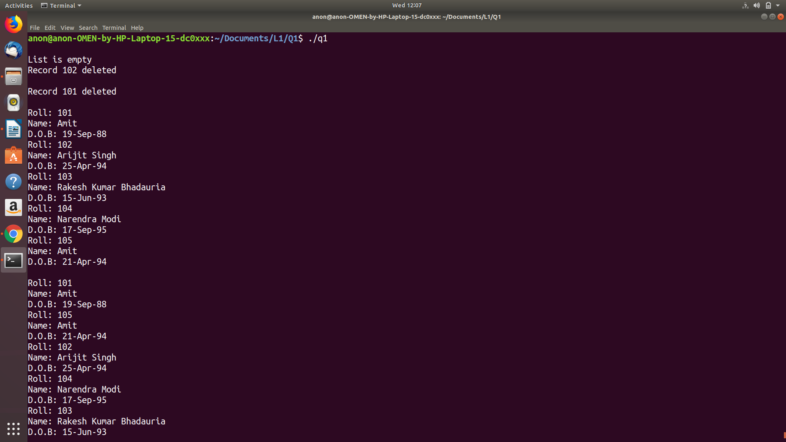
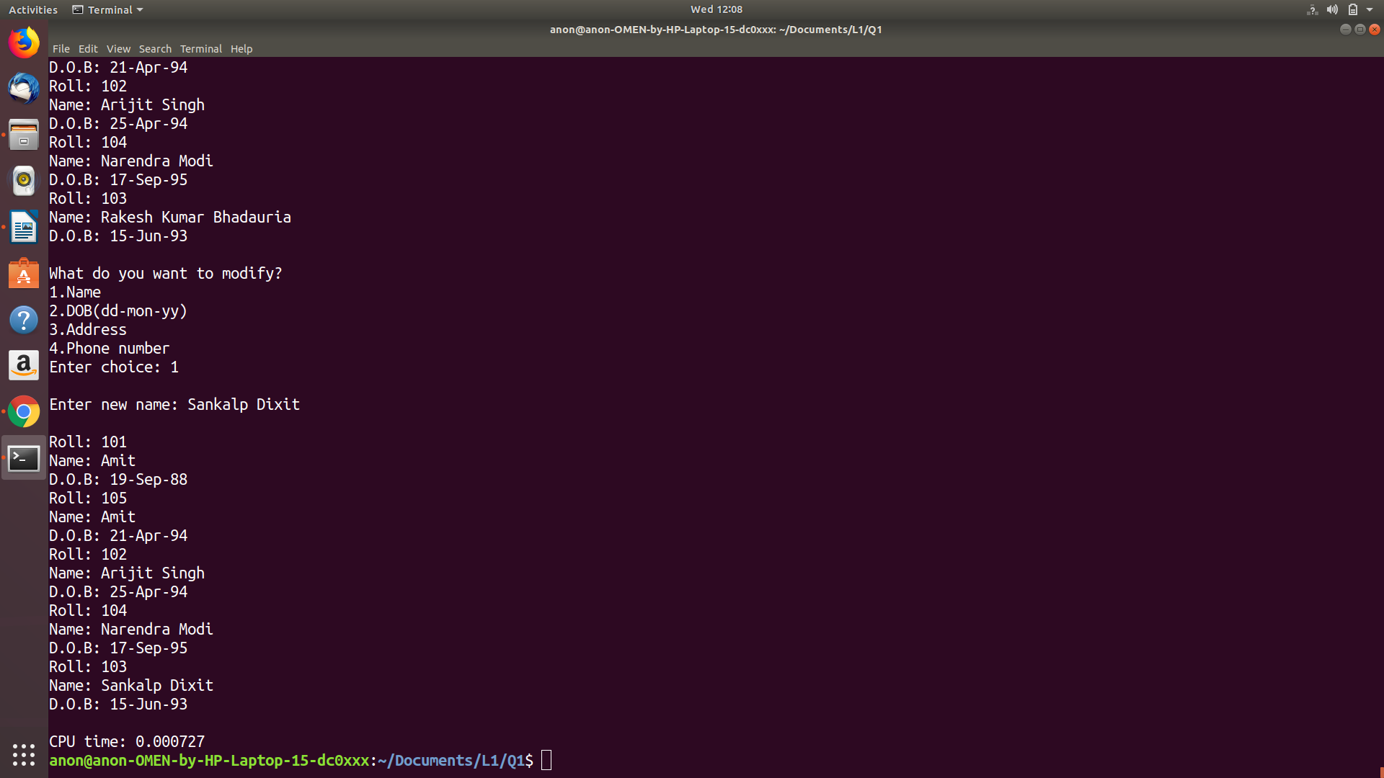

PROBLEM 2

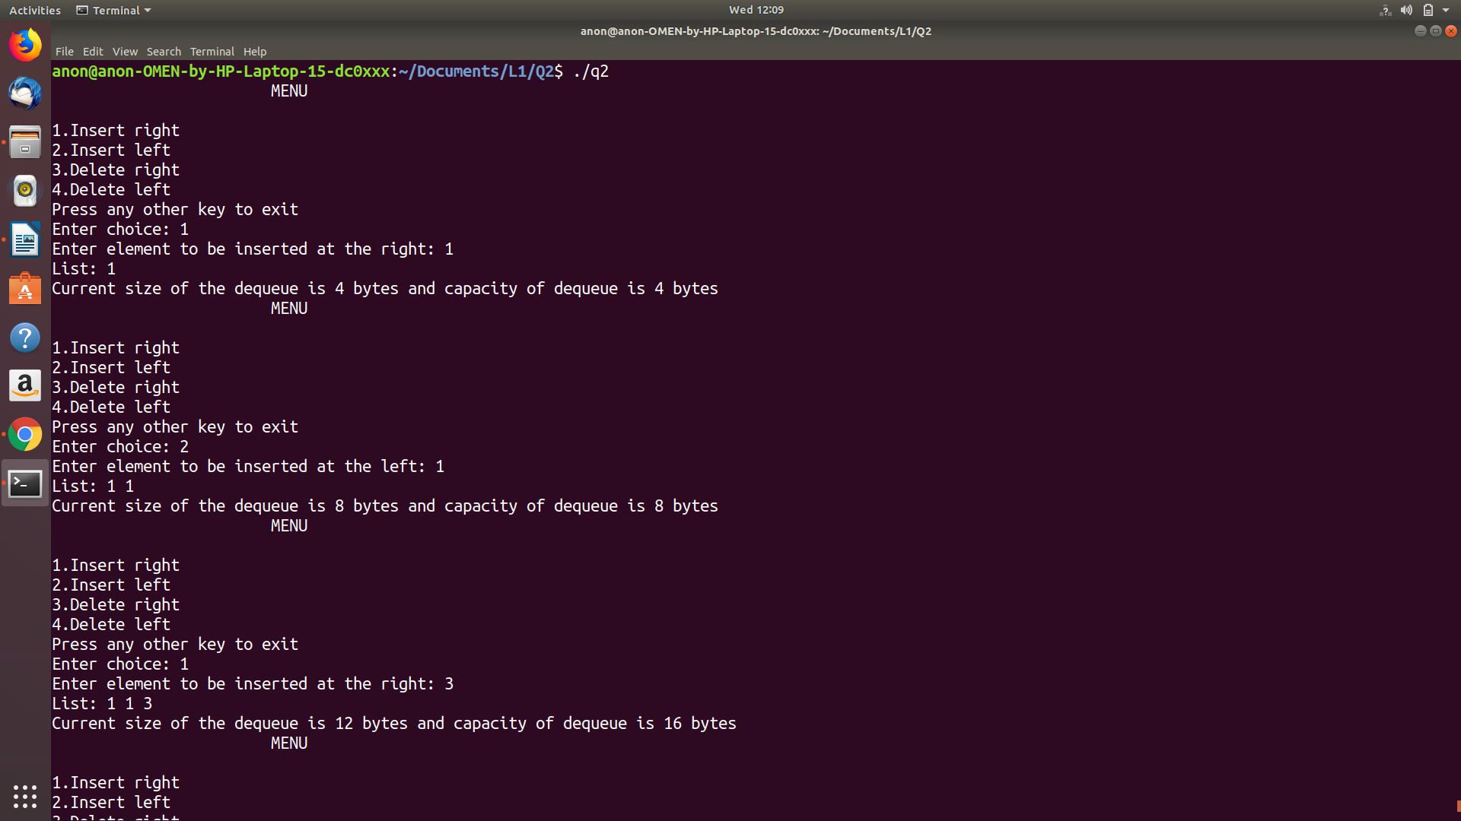

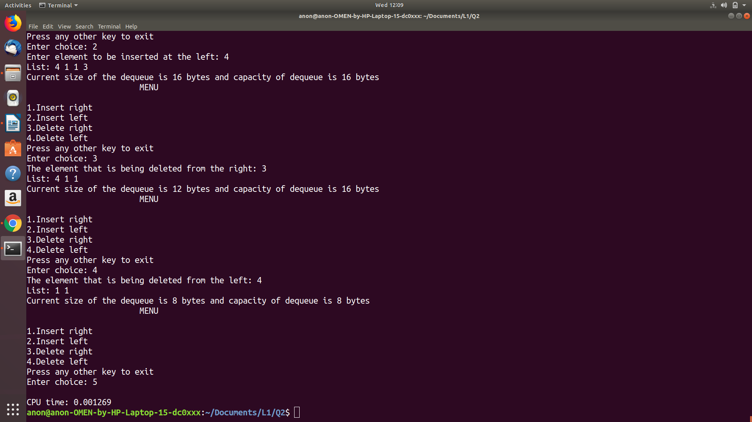

PROBLEM 3

