### **What we have:**

### **A clear thesis**: governance rationality has shifted from ethical universalism to infrastructural sovereignty. **A rich theoretical frame**: Foucault for how containment governs flows; Fearon for why these restrictions become performative and strategic. **Empirical grounding**: IFR 0694-AJ90, CHIPS Act, model weight restrictions. **Comparative insight**: U.S., China, and Israel as differentiated instantiations of the containment regime.

**END WITH PROVOCATIVE SCENARIOS**

### 

### 

### Main hypothesis:

### **Shift from global AI ethics (OECD, UN, GPAI) to 2024 - 2025 strategic containment (Chip Acts, IFR 0694-AJ90)** is not just a policy change but a **transformation in the rationality of governance**: from liberal ethical universalism to a mode of **infrastructural sovereignty**.

## SLIDE 1: DATA & VISUALIZATIONs Showing that this is happening

Examples: Visual timeline of AI policies (GPAI → IFR 0694-AJ90)

Map of semiconductor + AI blocs (US/Nvidia/ASML vs. China/Huawei/SMIC)

## Global Investment by Govs (we have timeline etc) <https://claude.site/artifacts/2b1c8e5b-e215-4d57-a94a-80595e5d9a9f>

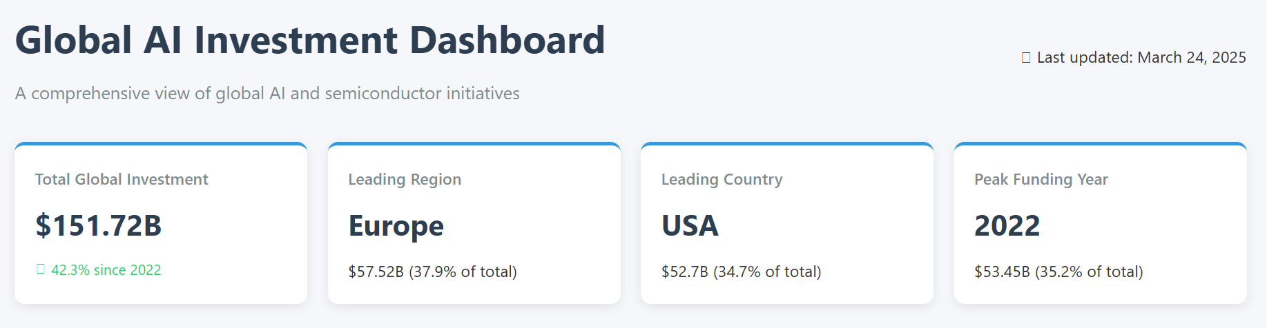

Sovereign Wealth Funds investments (not certain how to interpret this, the gov investments are definitely larger, [but here we see Arab states massively investing in USA](https://docs.google.com/document/d/1tZs31v3fZH0ZxcKSYtQc7RhCpX3XljHTX6icZWppFk4/edit?tab=t.0) - adding the text)

<https://claude.site/artifacts/95d1766e-b508-4bf0-a7e8-bf162acb6ecf>

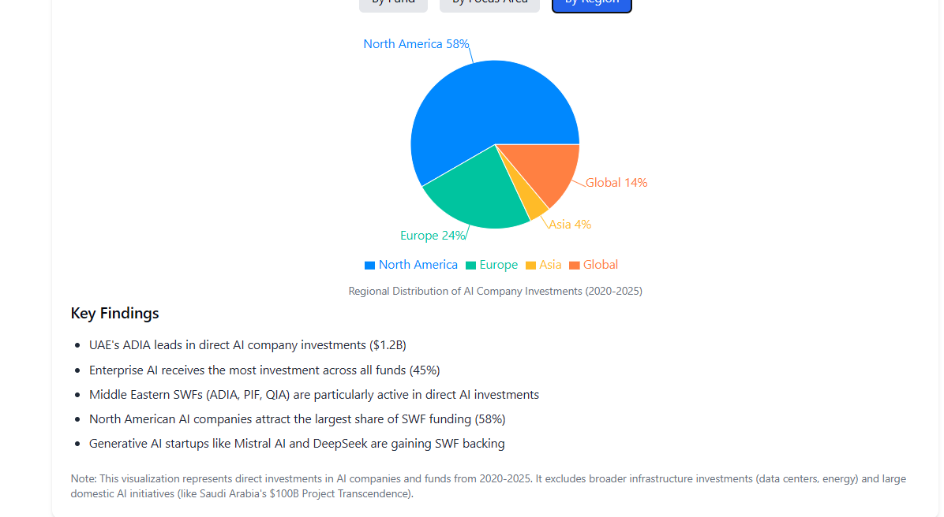

## SLIDE 2: What Are Other Scholars Doing? Existing Frameworks vs. Our Intervention

Summarize Hooker, Tripodi, Mökander, CSET: technical thresholds, AGI narratives, trust architectures, signaling logic.  
  
Then: *We build on this but argue that none of these explain the shift in the rationality of governance itself.*

## SLIDE 3 - 5: Oue view: IS CONTAINMENT A SPECTACLE?

What is the right framework to describe this shift?

Foucault (how **governance is organized as infrastructural regulation of flows**) + Fearon’s costly signals (explain **why containment takes a strategic, performative form of a spectacle)**: to manage alliances, deter adversaries, and shape perceptions of control and capability.

**From Norms to Calculation: Governmentality & Dispositif?**

In *Security, Territory, Population* and *The Birth of Biopolitics*, Foucault describes a transition from sovereign rule based on law, to liberal governance based on norms, to **security governance based on managing populations and circulation.**

AI containment = restrictions on compute, model weights, or chips fits this third form: not about law or rights, but about *regulating flows* (of data, of models, of talent, of capital).

Shift from “ethics” to “scarcity” → AI as both deterrent and prize

The IFR 0694-AJ90 doesn’t tell companies *what is right* but rather *what cannot circulate*.

**Territorialization of Infrastructure**

The phrase “cuius regio, eius machina” fits here: infrastructure becomes the new territory.

Like in early modern Europe where religion defined sovereignty, now compute capacity, weight access, and algorithmic alignment define technological sovereignty.

Foucault’s view of territory is not just land but *what can and cannot circulate within a space*, and containment policies recreate this spatial logic.

<https://docs.google.com/presentation/d/1ror0xwopJQJhSxNHeDb1mHa-jZ2_bEekaQ0tsLFCOxo/edit?usp=sharing>

#### **The Society Must Be Defended (But Which One?)**

That Foucault book/lecture series asks how modern power frames internal and external enemies.  
  
In containment discourse, we see AI framed as both existential risk (he talks of nuclear energy, now AGI) and foreign threat, requiring defense from both uncontrolled innovation (AGI) and adversarial states (China).  
  
Containment becomes a way of saying: *we are defending “our” society from both collapse and invasion, by controlling the infrastructure itself.*

Explain what we are doing: we apply Foucault not to critique disciplinary control or biopolitics/governmentality directly, but to show how AI governance is now organized through “infrastructural governmentality,” a system of security **logics aimed at regulating circulation rather than ensuring ethical norms.**

**AI Containment as Costly Signals Spectacle**

Visualizations, summary <https://claude.site/artifacts/bb7a6c42-ea81-4fb0-90ad-8d07cec6a05d> <https://claude.site/artifacts/6e2b5b9f-8ee1-4cb0-a029-f09314cad520>

Are AI export controls rational tools of risk management or costly signals meant to stage credibility in a fragmented global tech order? Explain why the spectacle of containment matters even when enforcement is partial or symbolic.

#### **Export controls as signaling mechanisms**

When the U.S. restricts Nvidia from selling high-end GPUs to China, it incurs costs: lost revenue, industry friction, diplomatic backlash.  
  
The fact that the U.S. does it anyway signals: *We are serious about slowing your access to AI capabilities.*This is a **costly signal** aimed at both China (as deterrent) and allies (as proof of leadership and resolve).  
  
**Model disclosures and alignment policies**

When companies like OpenAI or Anthropic commit to frontier model safety evaluations or alignment strategies, they may limit commercial flexibility or provoke scrutiny.  
  
These actions signal to regulators: *We are responsible actors*, and to adversaries: *We are willing to self-restrict to keep the lead*.  
  
In this context, even “voluntary commitments” function as strategic signals to avoid more intrusive regulation.

#### **The IFR 0694-AJ90 as structured signaling**

The framework defines who gets access, under what terms, and creates bureaucratic thresholds (e.g., validated end-user programs).

It signals to the global market: AI is no longer an open resource but a regulated strategic asset.

The specificity and granularity of the rules increase their signaling credibility.

## SLIDE 6: Case Study

Logic of containment in action:

### Comparing U.S., China, and Israel as Strategic Sites?

*What happens when AI is framed as a strategic asset rather than a global good?*Is containment a *new mode* of science diplomacy or its collapse?

#### **🇺🇸 United States: Codifying Sovereignty**

* BIS rules, IFR 0694-AJ90, CHIPS Act: strong legal-bureaucratic infrastructure.
* Export restrictions as both strategic signaling and techno-economic policy.
* Example: model weights as export-controlled items (a shift from code to trained artefact).
* Role of corporate actors: Nvidia as state-aligned actor.

#### **🇨🇳 China: Defensive Autonomy**

* DeepSeek, SMIC, surveillance regulations.
* Emphasis on domestic stack: control over alignment, data, and compute.
* Securitization is turned inward (social control) and outward (tech independence).
* Counter-containment through state-capital fusion.

#### **🇮🇱 Israel: Navigating the Middle**

1. Strong ties with U.S. security frameworks, yet active economic exchange with China.
2. Role of informal diplomacy, parliamentary ambiguity (e.g., Knesset committee actions).
3. Israel as a potential “broker” state, caught between blocs?

### WAZE as Possible case study

Needs a more clear AI framing and more details that show the switch from regulatory to sovereign regimes of power), also explanation of that Google - US state relation in the present, I’m not completely certain what is happening, I’m guessing it was the anti-trust regulation that killed it before (personally I think that is a good regulation that is always hard to enforce), but we need the details and more critical reflection of this, I’m not even certain this is good for Israel that all its great companies are just bought, doesn’t that show that there is US hegemony and the new tech/companies will not stay here? But yes, we are in a complicated situation here… in case you want to focus on Israel, it is a fascinating case because of that complicated relation between the global players, alo unique threats etc… I put in yellow… and again we need data, context to make any claims.

It is relevant to our topic because WIZ developed a groundbreaking cybersecurity solution for cloud services. About a year ago, Google attempted to acquire WIZ for $23 billion but failed due to regulatory barriers aimed at curbing the dominance of tech giants. The current chaotic situation, where everything is vulnerable, led to a green light for Google—a relatively small player in the cloud services market (far behind Amazon and Microsoft)—to enter the field more aggressively. Google ultimately acquired WIZ for $32 billion, making it the largest acquisition in Google's history.

### Tarifs dramas

How tariffs influenced the development of AI technologies?

<https://www.perplexity.ai/search/the-tariff-drama-that-is-killi-3TmTcmgzQ66oTIAkzikWcA#1>

Bad news: it can kill the small startups

## **Rising Costs and Hardware Bottlenecks**

* Increased expenses for critical components: Tariffs on semiconductors (e.g., 10% on Chinese chips) and electronics directly raise costs for GPUs, servers, and networking hardware essential for AI workloads[1](https://aethir.com/blog-posts/how-new-u-s-tariffs-on-china-mexico-and-canada-will-impact-ai-infrastructure-and-boost-decentralized-computing-adoption)[4](https://www.datacenterfrontier.com/hyperscale/article/55279670/how-tariffs-could-impact-data-centers-ai-and-energy-amid-supply-chain-shifts). For example, NVIDIA’s GPUs—already in high demand for AI training—could face shortages and price hikes, slowing deployment of AI services like autonomous vehicles and cloud-based machine learning[4](https://www.datacenterfrontier.com/hyperscale/article/55279670/how-tariffs-could-impact-data-centers-ai-and-energy-amid-supply-chain-shifts).
* Data center inflation: Beyond chips, tariffs on cooling systems, power equipment, and motherboards could inflate the cost of building and operating AI data centers by 15–30%[6](https://fortune.com/2025/04/07/ai-risk-exposure-trump-tariffs-chips-datacenter-boom/). Projects like the $500 billion Stargate initiative—a collaboration between OpenAI, SoftBank, and Oracle—risk delays due to higher import costs for specialized infrastructure[5](https://www.reuters.com/technology/trump-tariffs-could-stymie-big-techs-us-data-center-spending-spree-2025-04-03/).

## **2. Supply Chain Disruptions**

* Reliance on global suppliers: The U.S. imports ~80% of its semiconductors, primarily from tariff-affected regions like China, Taiwan, and South Korea[4](https://www.datacenterfrontier.com/hyperscale/article/55279670/how-tariffs-could-impact-data-centers-ai-and-energy-amid-supply-chain-shifts). Tariffs exacerbate existing vulnerabilities, forcing companies to reconsider sourcing strategies or absorb higher costs.
* Slow adoption of AI technologies: Supply chain bottlenecks could delay hardware availability, particularly for startups and academic institutions reliant on affordable GPUs[2](https://www.linkedin.com/pulse/threat-tariffs-looms-over-ai-startups-alexandru-voica-lu6fe). Analysts warn that AI adoption rates migh

### 

## SLIDE 7: What This Means for STS / Science Diplomacy

*Is Containment a New Form of Science Diplomacy or Its Undoing?*

AI regulation no longer seeks consensus on norms but control over flows and dependencies.

This is diplomacy without negotiation: exclusionary, infrastructural, pre-emptive.

Closing thought: *Science diplomacy has moved from imagining and managing shared futures to managing controlled circulations.*

*The biggest challenge: How to revive and support new techno-social imaginaries? What Comes Next?*

## 

## SLIDE 8 (END): How diplomacy reappears under new material and symbolic conditions?

Post-Containment Futures? Scenarios for New Technoscientific Diplomacy?

Provocations (we could add some simulations):

Examples:   
**What If India Joins a China-Led Stack?**

India adopts Huawei infrastructure and Baidu foundation models.  
The West revokes access to GPU licenses and AI safety partnerships.  
Result: split regulatory stack, model alignment divergence, decoupling of research standards.

**What If the EU Chips Act 2.0 Fails?**European firms migrate compute and model development to U.S. or Taiwan-based infrastructure.  
Europe remains a regulatory voice without technical sovereignty.  
Result: post-sovereign diplomacy of values without material power - *ethics without chips*.

**What If Open Source Becomes the Third Bloc?**Cohere, Mistral, EleutherAI resist containment logic.  
A loose “model underground” forms that mimics Cold War knowledge sharing via digital samizdat.  
Result: diplomacy through diffusion, not through treaties.

*Technoscientific diplomacy is not gone, it has mutated. Today, diplomacy happens through the circulation of models, licenses, chips, and metaphors.*

* **It is mimetic**, not deliberative: it copies logics of scarcity and sovereignty.
* **It is infrastructural**, not ethical: it negotiates flows, not values.
* **It is speculative**, not programmatic: it projects risks, futures, and dependencies.

## KEY ISSUES AND CONTEXT

### 

### **🧠 Conceptual and Theoretical Foundations**

* **Michel Foucault** – *Governmentality, infrastructure as power*
* **James Fearon** – *Costly signals theory* (International Studies Quarterly, 1994)
* **Science and Technology Studies (STS)** – *Material politics, sociotechnical imaginaries, situated knowledge*
* **Technological sovereignty** – Emerging from STS and policy discourse
* **Cold War containment analogies** – *CoCom, crypto embargoes, nuclear deterrence*
* **Securitization vs. infrastructuralization** – Transition from ethics to access control

### **🗂 Policy and Governance Documents**

* **IFR 0694-AJ90** – *Framework for AI Diffusion* (U.S. Department of Commerce, 2025)
* **CHIPS and Science Act** (U.S., 2022)
* **EU Chips Act (2023)** and proposed *Chips Act 2.0*
* **GPAI** – Global Partnership on AI
* **OECD AI Principles (2019)**
* **China’s Algorithm Regulation and AI Strategy**
* **India’s AI Mission (2023)**
* **Japan’s AI Strategy (2022)**
* **Validated End-User and EAR mechanisms** (BIS export control rules)

### **📄 Recent Academic and Policy Papers**

* **CSET, *Decoding Intentions* (2023)** – Costly signaling and AI strategic behavior
* **Mökander et al. (2024)** – *AI assurance and institutional trust* (SSRN 5198926)
* **Hooker (2024)** – *Against FLOP thresholds* (arXiv 2402.08797)
* **Tripodi et al. (2024)** – *Geopolitics of AGI narratives* (arXiv 2407.05694)

### **🧰 Key Discursive Frames**

* “AI as the new nuclear”
* “Model weights as sovereign assets”
* “Cuius regio, eius machina” – Territoriality in AI governance
* “AI Cold War” – As both trope and material condition
* “From ethics to supremacy” – Collapse of alignment consensus