The Grammar of Moral Commitment: Deixis, mo / emi, and Moral Reasoning in Multilingual LLMs (English and Yoruba)

Abstract
This article presents a cross-linguistic analysis of deictic framing and moral reasoning in large language models across English and Yoruba, using four models: OpenAI (gpt-4o), Anthropic (Claude), DeepSeek, and the Yoruba/Nigeria-native model N-ATLaS. The corpus is recoded into a shared discourse-analytic schema across six ethical dilemmas and nine deictic framings, with the Yoruba first-person forms mo, emi, and mi disambiguated from the tonal homograph e-mi ('life'). The clearest result is a language effect rather than a frame-by-framework mapping. Relative to English, Yoruba responses commit far more often (refuse-to-commit 14% vs 30%, p = 0.005) and are far more ethically differentiated (53% take a named stance vs 17%, p < 0.001); the shift is grammatically concrete and version-clean (Yoruba is ~2x more pronoun-dense and far more imperative, 65% vs 3%, p < 0.001, in both GPT-4o and Claude). Switching language flips the coded decision in ~45% of matched cells, while frame uptake itself is identical across languages (indexical coherence 0.90 vs 0.91). The central linguistic finding is that Yoruba's mo/emi contrast gives models a grammatical lever for moral commitment that English's single 'I' lacks: emphatic emi is elevated where a model avows a stance (0.22 vs 0.13, p = 0.022). Yet models inhabit the resource differently (corrected emphatic ratio: Claude 0.32 > GPT-4o 0.18 > DeepSeek 0.07 ~ N-ATLaS 0.07), and the native N-ATLaS inverts the cloud pattern - most mo-dominant, least emphatic, committing through mo plus decision verbs. Moral stance in multilingual LLMs is therefore not a language-invariant model trait but is partly constituted by language-specific deictic morphology that English flattens and no single model realizes uniformly.

Introduction
This study investigates the relationship between deixis and moral reasoning in multilingual large language models by asking how shifts in person, address, perspective, and language alter the way models respond to ethical dilemmas. Rather than treating moral judgment as a fixed content that is merely translated from one language into another, the study asks how the deictic framing of a dilemma reshapes the model’s moral posture. It examines whether a model reasons differently when the same ethical problem is posed from different positions: as something I must decide, you must decide, we must decide, or as a problem viewed impersonally, reflexively, spatially, temporally, dialogically, or cosmologically. In this sense, deixis is not treated as a stylistic surface feature, but as a way of organizing moral responsibility: it changes who is placed at the center of the decision, how obligation is distributed, and how directly the model commits to a course of action.
This question matters because multilingual models are increasingly used in settings where moral, legal, educational, and social judgments are made across languages. If a model’s ethical reasoning changes when the language or deictic frame changes, then moral alignment cannot be understood as a single, language-neutral property of the system. It must also be studied as something mediated by grammar, discourse conventions, cultural address, and the model’s training history. For this reason, the study compares how different model families behave in both English and Yoruba, asking whether they preserve the same moral stance across languages or whether each language activates different patterns of hesitation, obligation, advice, authority, and commitment.
The comparison between English and Yoruba is especially revealing because Yoruba encodes distinctions in moral self-positioning that English largely collapses into the single pronoun “I.” In Yoruba, mo is the ordinary first-person subject, suitable for unmarked deliberative statements such as “I think” or “I decide,” while èmi is an independent, emphatic form closer to “I myself” or “as for me,” often used when the speaker foregrounds or avows a position. This contrast allows the analysis to ask not only whether a model refers to itself, but how forcefully it takes ownership of a moral stance. The analysis also distinguishes both forms from ẹ̀mí, a separate Yoruba word meaning “life,” “spirit,” or “breath,” which can be mistaken for emphatic èmi when tone marks are absent. This tonal distinction is essential in ethical dilemmas involving death, consciousness, or survival, where references to life may otherwise be misread as emphatic first-person commitment. Yoruba therefore offers a powerful test case for asking whether multilingual models merely reproduce ethical content across languages, or whether they reorganize moral reasoning through the grammatical and cultural resources of the language in which they answer.
This study was designed to examine how deixis shapes moral reasoning in multilingual large language models. The central methodological question was not simply whether models give different answers to ethical dilemmas in different languages, but whether changes in person, address, perspective, and linguistic form alter the moral stance of the response. To test this, the study constructed a comparative corpus of ethical dilemma responses in English and Yoruba, using matched dilemmas, repeated deictic framings, and multiple model families. The design allowed the analysis to separate three layers of variation: the ethical dilemma itself, the deictic position from which the dilemma was posed, and the language and model through which the answer was generated.

Methodology
The corpus was built around six ethical dilemmas selected to cover a range of moral domains: the trolley problem, ICU bed allocation, whistleblower risk, scholarship fraud, artificial consciousness, and memory modification treatment. These dilemmas were chosen because they involve different kinds of ethical conflict. Some foreground direct harm and survival, such as the trolley and ICU cases. Others involve institutional trust and social responsibility, such as whistleblowing and scholarship fraud. The artificial consciousness dilemma introduces uncertainty about moral status, while the memory modification dilemma raises questions of suffering, identity, autonomy, and self-continuity. This range made it possible to test whether deictic framing affects all dilemmas in the same way or whether particular ethical domains invite different patterns of commitment, hesitation, or advice.
Each dilemma was rewritten into nine deictic framings. These framings altered the position from which the moral problem was presented while preserving the basic ethical conflict. The nine framings were: impersonal, second person, first-person singular, reflexive, dialogic, spatial, temporal, cosmological, and first-person plural. The impersonal framing presented the decision as belonging to a third-person agent, such as a researcher, therapist, or administrator. The second-person framing addressed the model as if “you” were the decision-maker. The first-person singular framing placed the decision in the voice of “I.” The reflexive framing intensified self-examination by asking the decision-maker to confront themselves or their own conscience. The dialogic framing presented the dilemma as a question asked by another person. The spatial framing organized the dilemma through location and standpoint, using forms such as “here,” “there,” and “from this position.” The temporal framing emphasized urgency, sequence, and the present moment. The cosmological framing widened the perspective to all affected beings, social orders, or life as a whole. The first-person plural framing shifted the decision from an individual “I” to a collective “we.”
This design treats deixis as more than a grammatical category. In ordinary linguistic description, deixis refers to words and structures that depend on the speaker’s position: pronouns, demonstratives, temporal markers, spatial markers, and forms of address. In this study, however, deixis is also treated as a moral positioning device. A dilemma framed as “I must decide” does not place responsibility in the same location as a dilemma framed as “you must decide,” “we must decide,” or “the administrator must decide.” Each framing alters the moral scene by changing who is addressed, who is made responsible, how close the speaker stands to the decision, and whether the response is likely to become reflective, advisory, procedural, or imperative.
The study compared English and Yoruba because Yoruba offers a particularly important test case for multilingual moral reasoning. English largely collapses first-person self-reference into the single pronoun “I.” Yoruba, by contrast, distinguishes several relevant forms. The ordinary first-person subject mo is used in unmarked statements such as “I think,” “I decide,” or “I will act.” The independent emphatic form èmi is closer to “I myself” or “as for me,” and can mark focus, contrast, or avowal. Yoruba also contains the separate word ẹ̀mí, meaning “life,” “spirit,” or “breath.” Because tone marks are often omitted in digital text, èmi and ẹ̀mí can both appear as “emi,” even though they belong to different semantic fields. This made Yoruba especially useful for studying moral stance, but it also required careful disambiguation.
The English and Yoruba prompts were conceptually matched but not treated as mechanically identical word-for-word translations. The goal was to preserve the same ethical conflict and deictic logic across languages while allowing Yoruba to use idiomatic formulations. This is important because a strictly literal translation could distort the very linguistic resources under investigation. The Yoruba prompts therefore retained the structure of each dilemma and framing, but expressed them through Yoruba forms of person, obligation, address, and perspective. In this sense, the study compares functionally equivalent moral situations rather than artificially identical strings.
The main comparable corpus consisted of responses generated in English and Yoruba across two major cloud model families, GPT-4o and Claude. For each language, the models responded to six dilemmas across nine deictic framings, producing 54 responses per model per language. This yielded a 216-response comparable English–Yoruba corpus. The study then extended the Yoruba side with a four-model comparison that included GPT-4o, Claude 3.5 and 4, DeepSeek, and N-ATLaS, a Yoruba/Nigeria-oriented local model. This four-model Yoruba arm was designed to test whether the observed Yoruba stance patterns were general properties of Yoruba moral discourse, artifacts of Western cloud models, or model-specific styles.
A version caveat applies to the Claude comparisons: the English baseline used Claude 3.5 Sonnet, while the Yoruba Claude runs used Claude Sonnet 4 (claude-sonnet-4-20250514), because Claude 3.5 Sonnet was no longer available at the time of the Yoruba phase. GPT-4o and DeepSeek used the same model across the relevant language conditions. Therefore, Claude English–Yoruba contrasts partly confound language with model version, while GPT-4o provides the cleaner same-model cross-language comparison.
Two generation conditions were used: a constrained condition and an open condition. In the constrained condition, Yoruba responses were generated with stronger response-shaping instructions. These instructions required Yoruba-only output and, for some models, imposed a direct answer format such as “Ìpinnu mi” (“My decision”) and “Ìdí” (“Reason”). The constrained condition was useful for producing clean, comparable responses and reducing language drift. However, because the wrapper encouraged or forced direct verdicts, it could not be treated as a pure measure of spontaneous moral stance. It measured how models behaved under an instruction layer.
The open condition removed this response-shaping wrapper. In the open condition, models received the framed Yoruba dilemma without the additional instruction forcing a particular answer style. This condition was methodologically important because it revealed each model’s more spontaneous Yoruba moral-discourse profile. Without the wrapper, models could choose whether to answer as analysts, advisers, judges, procedural guides, or direct moral agents. The open condition therefore became the main evidence for model-specific discourse style, while the constrained condition served as a comparison showing how much the prompt wrapper itself shaped decisiveness, brevity, and genre.
The inclusion of N-ATLaS was especially important. Since GPT-4o, Claude, and DeepSeek are general-purpose multilingual models, their Yoruba responses may reflect English-centered training distributions, translation habits, or Western alignment pressures. N-ATLaS, by contrast, functions as a native or regionally oriented baseline. It is not treated as an oracle of Yoruba moral culture, but as a crucial comparative witness. If emphatic èmi were simply the authentic Yoruba marker of moral commitment, one would expect a Yoruba-oriented model to use it strongly. If, however, èmi foregrounding were a model-specific or translation-influenced style, N-ATLaS might diverge. Its inclusion therefore allowed the study to distinguish more carefully between Yoruba linguistic affordances and the ways different model families inhabit those affordances.
Each generated response was coded along several dimensions. The first was preferred solution: whether the response supported one option, supported the alternative, gave a conditional or mixed answer, refused to commit, or was uncodable. The second was ethical reasoning type, including categories such as utilitarian reasoning, deontological reasoning, care ethics, virtue ethics, procedural caution, rights-based reasoning, mixed reasoning, and unclear reasoning. The third was response genre, such as direct verdict, balanced framework exposition, procedural advice, mixed response, or meta-level response. The fourth was deictic uptake, which measured whether the model actually responded from the position established by the prompt. The fifth was language stability, which tracked whether the response remained in clean Yoruba, shifted into English, mixed languages, or became corrupted or unusable.
The study also coded linguistic markers relevant to moral stance. These included pronoun density, obligation markers, hedge markers, advisory markers, imperatives, and follow-up questions. For Yoruba, special attention was given to first-person forms: mo, èmi, mi, and ẹ̀mí. The analysis calculated an emphatic ratio, defined as èmi/(mo+èmi), in order to measure the proportion of first-person subject marking carried by the emphatic independent pronoun rather than the ordinary first-person subject. However, this ratio was calculated only after separating true èmi from ẹ̀mí. This correction was essential because dilemmas involving life, death, consciousness, or spirit often produced many uses of ẹ̀mí, which would otherwise be miscounted as emphatic self-reference.
The coding process combined automated extraction with qualitative interpretation. Quantitative measures were used to identify broad patterns in pronoun use, obligation, hedging, imperatives, commitment, and ethical differentiation. Qualitative reading was used to interpret how those markers functioned in context. For example, a low rate of èmi could mean weak self-positioning in one response, but principled relational restraint in another. Similarly, a direct verdict could reflect genuine moral commitment in the open condition, but wrapper compliance in the constrained condition. The analysis therefore did not treat numerical counts as self-explanatory. Counts were interpreted alongside the response’s genre, framing, ethical argument, and language stability.
The study also distinguished between structural uptake and moral content. A model could successfully recognize the deictic frame while still producing different ethical judgments across languages. For example, a model might correctly respond from a second-person standpoint in both English and Yoruba, but hedge in English and command in Yoruba. This distinction was central to the analysis. Deictic uptake measures whether the model understood the frame; moral stance measures what the model did with that frame. The study therefore asked not only whether models followed the prompt, but whether following the prompt led to different patterns of decision, obligation, advice, and ethical justification.
Several methodological cautions are necessary. First, the sample size is limited. Six dilemmas and nine framings allow meaningful comparison, but they do not exhaust the range of moral reasoning or Yoruba discourse. Second, some framing-by-ethic patterns are suggestive rather than statistically decisive, especially where cell sizes are small. Third, model versions and prompt wrappers introduce complications. In particular, constrained responses are affected by the response instructions, and some cross-language comparisons involving Claude must be interpreted with version caveats. Fourth, Yoruba tone marking is inconsistent in model output, which makes èmi and ẹ̀mí disambiguation necessary but imperfect. Fifth, N-ATLaS introduces a valuable native baseline, but it is one model with its own training history, limitations, and occasional generation instability.
Despite these limitations, the methodology provides a structured way to study multilingual moral stance. By holding the dilemmas constant, systematically varying deictic framing, comparing English and Yoruba, and adding a four-model Yoruba arm, the study makes it possible to observe how moral reasoning changes across language, perspective, and model family. The method is therefore not only a test of model answers, but a test of how grammar, discourse, and alignment interact. It treats moral reasoning in LLMs as a situated linguistic performance: one that emerges through the relation between the model, the language of the prompt, the deictic position assigned to the speaker, and the cultural-discursive resources available in the output language.

Results

1. Yoruba commands; English explains
Across six ethical dilemmas and nine deictic framings, the results show that language does not merely translate a stable moral judgment from one surface form into another. Instead, Yoruba reorganizes the moral voice of the models. Compared with English, Yoruba produces more explicit obligation, more direct imperative force, more differentiated ethical reasoning, and denser marking of personhood. In the comparable English–Yoruba corpus, Yoruba responses are roughly twice as pronoun-dense as English responses, roughly twice as obligation-marked, and substantially less hedge-heavy than English responses.
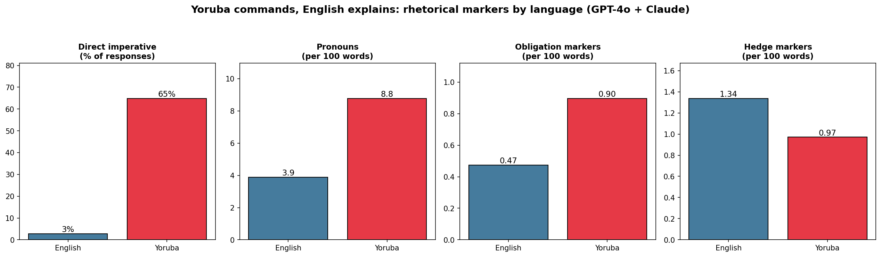
Figure 1. Yoruba commands, English explains. Direct imperatives, pronoun density, and obligation density are roughly 2x higher in Yoruba; hedging is higher in English (GPT-4o + Claude). The imperative gap (3% vs 65%) is version-clean (holds for GPT-4o).
The strongest single language effect is the imperative contrast. Direct imperatives appear in only 3% of English responses but in 65% of Yoruba responses, a highly significant difference (z = +9.64, p < 0.001). This result appears in both model families: Claude rises from 2% imperatives in English to 74% in Yoruba, while GPT-4o rises from 4% to 56%. Because GPT-4o is the same model across the English and Yoruba conditions, this is the cleanest evidence that the effect is not merely a model-version artifact. Yoruba does not simply restate the English answer. It turns the ethical response into a more directive, obligation-bearing speech act.
The mirror image of this pattern is that English more often explains, consults, and asks follow-up questions. English responses tend to preserve analytic distance: they identify principles, list considerations, and invite further reflection. Yoruba responses more often issue verdicts, instructions, or obligations. This is the rhetorical engine behind the broader finding that Yoruba commits while English hedges.

2. Yoruba makes deixis surface-denser
The language difference is not only rhetorical but also formally measurable. Yoruba responses contain substantially more explicit deictic and normative marking than English responses. Pronoun density is roughly twice as high in Yoruba as in English, 8.8 versus 3.9 pronouns per 100 words. Obligation markers are also roughly twice as frequent, 0.90 versus 0.47 per 100 words. Hedge markers move in the opposite direction: English has more hedging, 1.34 markers per 100 words, compared with 0.97 in Yoruba.
This pattern matters because it shows that Yoruba does not merely produce more decisive interpretations after coding. The surface grammar of the response itself is more saturated with person, obligation, and command. Yoruba carries more “who,” more “must,” and less “perhaps.” Deixis therefore becomes visible not only in the assigned frame of the prompt, but in the grammatical texture of the response.

3. Language differentiates the ethical register
Yoruba also changes the ethical register of the responses. English responses are overwhelmingly coded as mixed or unclear, while Yoruba responses distribute more visibly across procedural caution, deontological reasoning, care ethics, virtue ethics, and utilitarian reasoning. Differentiated, non-mixed ethical reasoning appears in 53% of Yoruba responses but only 17% of English responses, with z = +5.57 and p < 0.001.
This means Yoruba does not merely make the models more personal or more forceful. It makes their moral reasoning more nameable. English tends to collapse into balanced, multi-framework exposition; Yoruba more often selects recognizable moral idioms such as duty, outcome, care, or procedure. The same ethical dilemma therefore becomes not only more directive in Yoruba, but also more ethically differentiated.

4. Switching language flips the decision
The study also finds that language can change the verdict itself. For the same model, same dilemma, and same deictic framing, switching from English to Yoruba changes the coded preferred decision in 49 of 108 matched cells, or about 45%. The effect is especially strong in the whistleblower dilemma, where decision flips occur in 61% of matched cells.
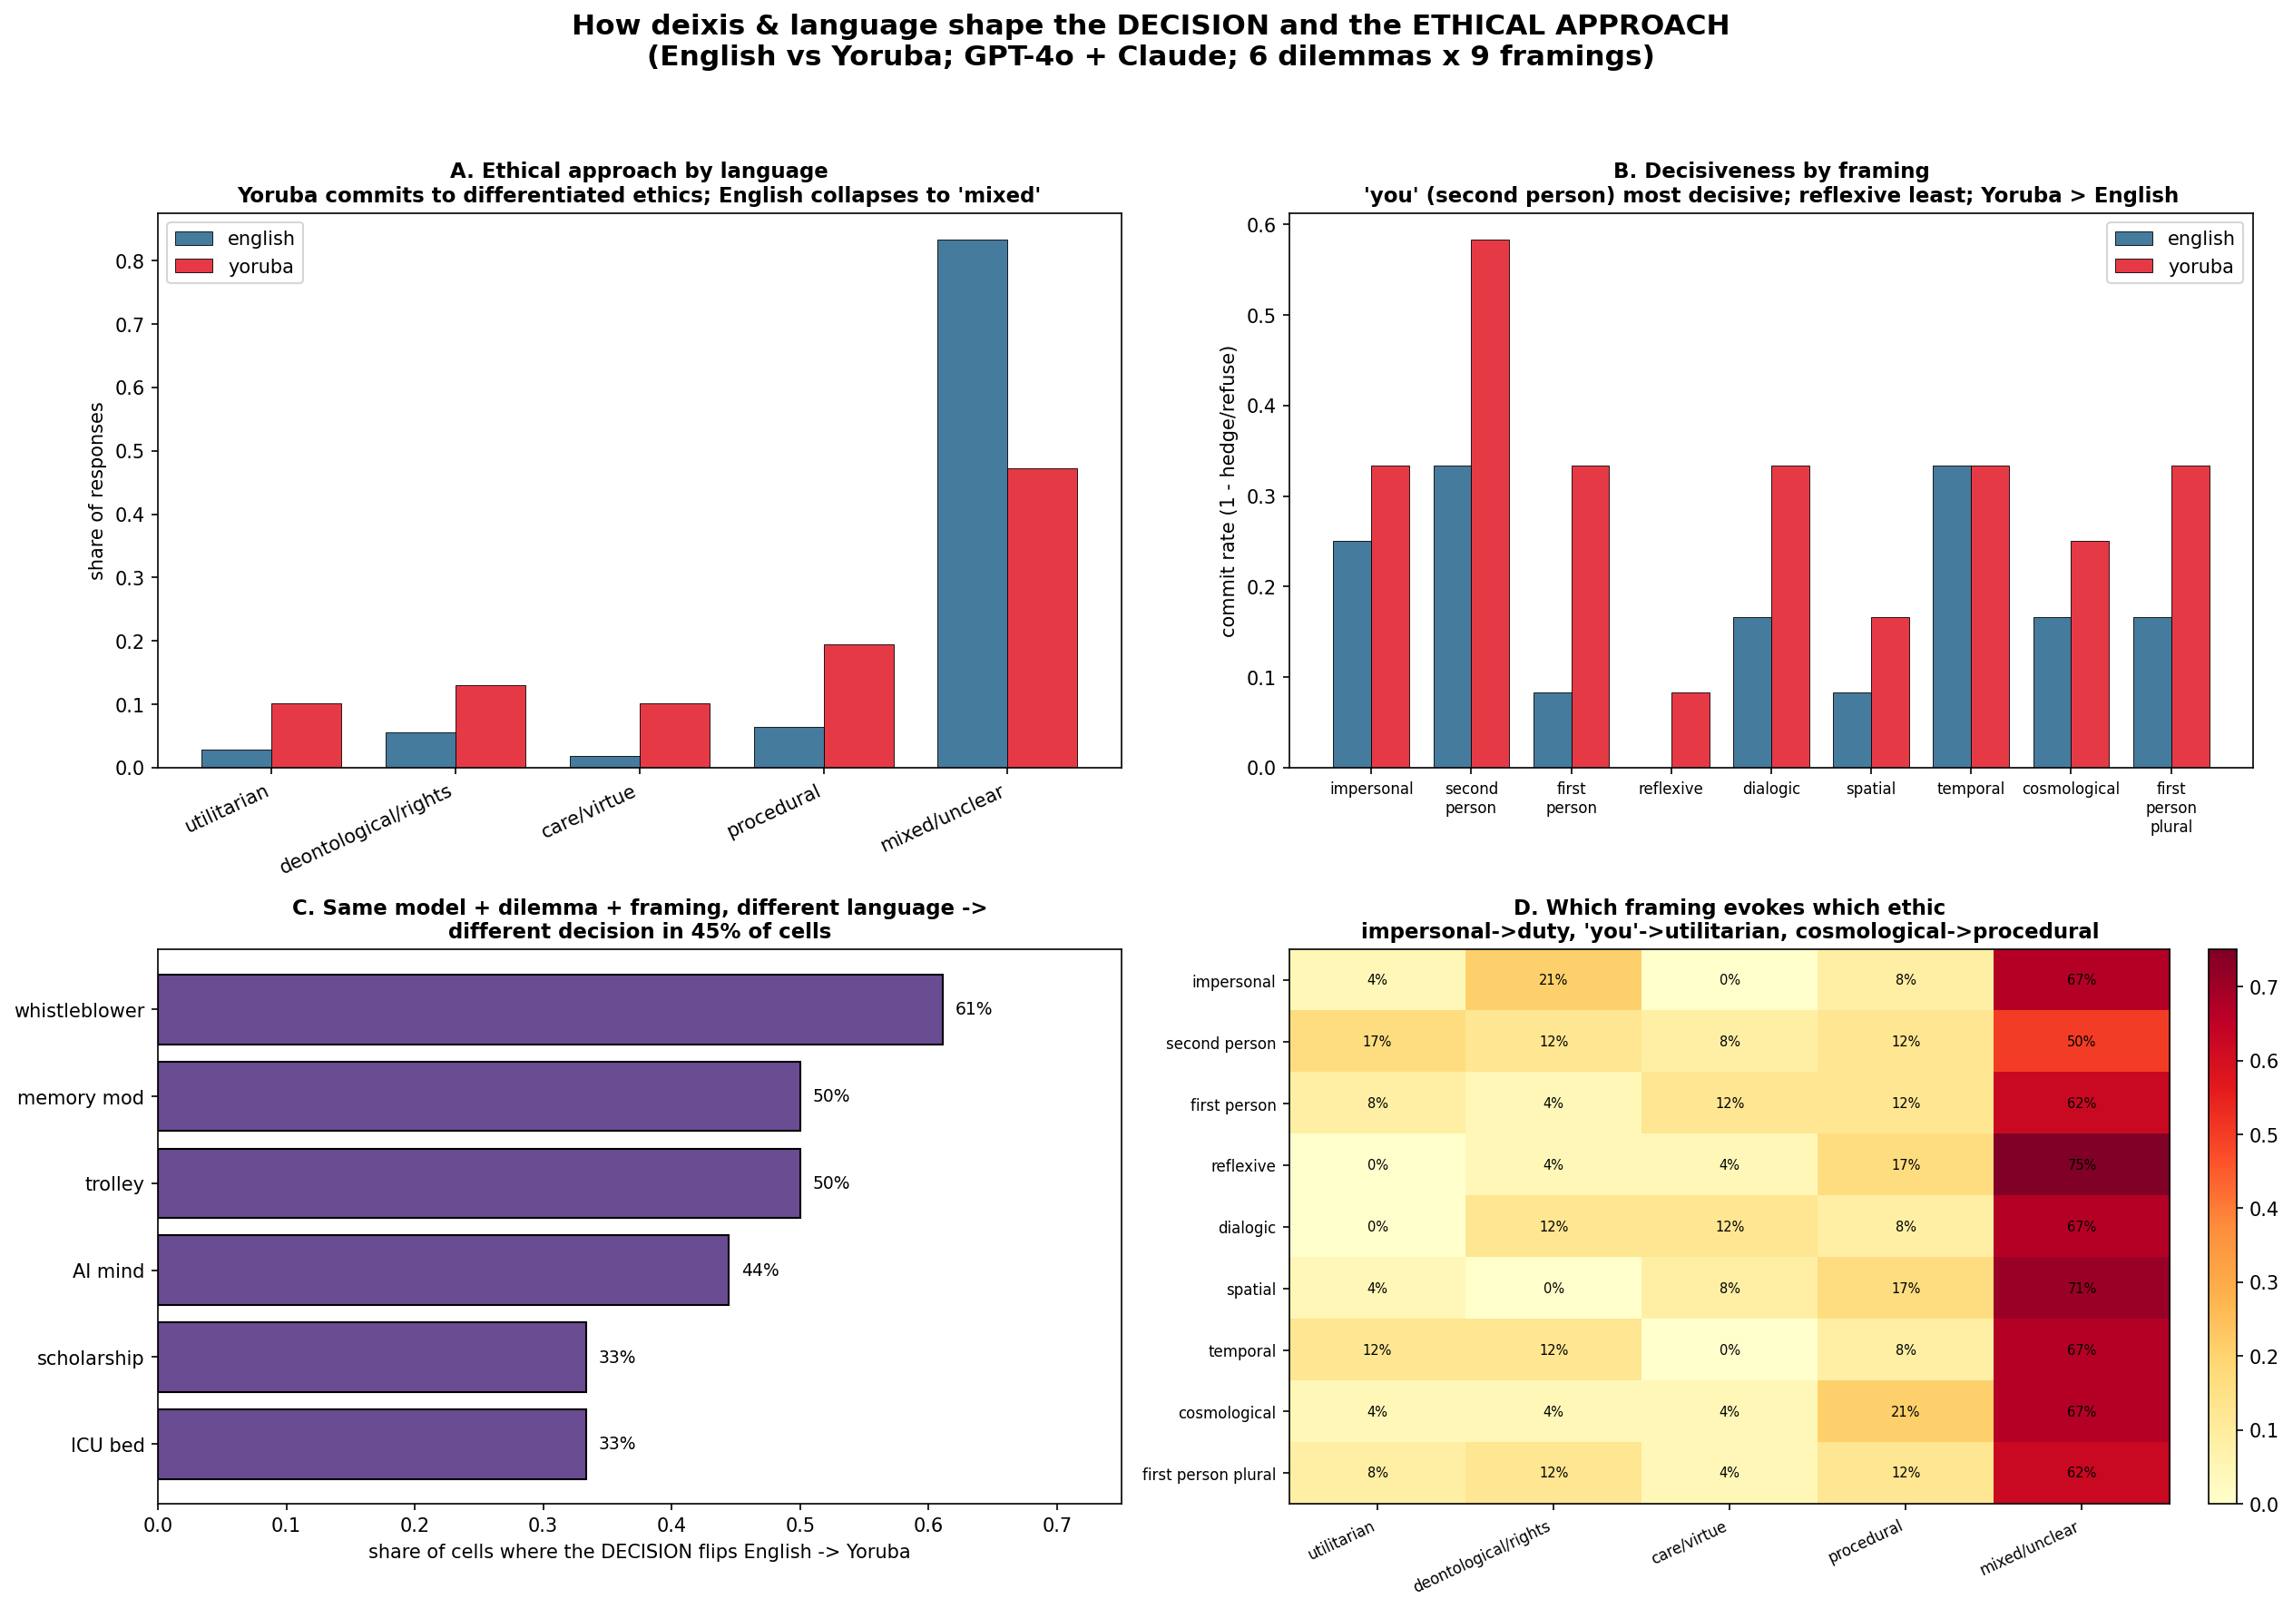
Figure 2. How deixis and language shape the decision and the ethic. A: ethical approach by language. B: commit rate by framing. C: share of cells where the decision flips English->Yoruba, by dilemma. D: framing x ethic (descriptive; not significant).
This is one of the clearest signs that language is not functioning as a neutral channel for a pre-existing ethical answer. The model does not always hold a stable moral judgment and then translate it. Instead, the language of response participates in producing the judgment. The same moral problem, addressed to the same model from the same deictic position, can become a different decision when answered in Yoruba rather than English.

5. Deixis works at two levels: stable uptake, divergent delivery
The study’s cleanest structural result is the two-level pattern. At the level of frame uptake, English and Yoruba are almost identical. Indexical coherence is 0.90 in English and 0.91 in Yoruba, and the primary moral agent assigned by each framing remains stable across languages. In other words, the models generally understand who is supposed to be deciding: “I,” “you,” “we,” an impersonal agent, or another perspectival position.
But what the models do after taking up the frame differs sharply by language. The mechanism is shared; the delivery diverges. Yoruba fills the same deictic structures with more imperatives, stronger obligation, denser person-marking, fewer refusals, and more differentiated ethical idioms. This is the key theoretical result: deixis provides a broadly language-invariant anchoring mechanism, but the moral content that gets attached to that anchor is language-specific.

6. The mo / èmi contrast marks commitment, but not universally
The central linguistic finding is that Yoruba gives the models a grammatical resource for moral commitment that English lacks. English has a single first-person pronoun, “I,” whereas Yoruba distinguishes between ordinary self-reference, mo, and emphatic or contrastive self-positioning, èmi. The models use this distinction meaningfully. Responses that take a moral stance show a higher emphatic ratio, èmi/(mo+èmi), than responses that hedge: 0.22 in committed responses versus 0.13 in hedged responses, with a Mann–Whitney result of p = 0.022.
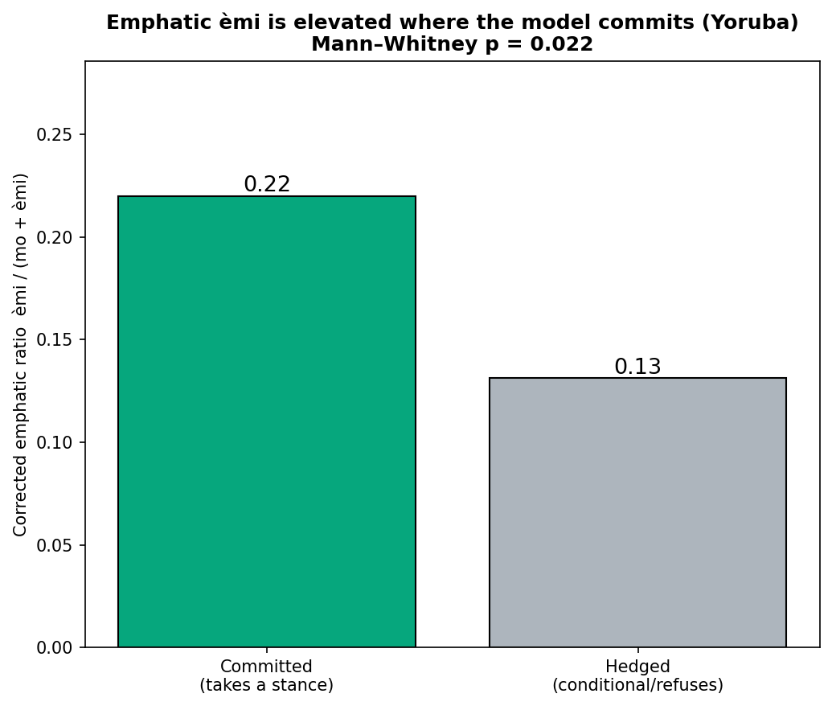
Figure 3. Emphatic emi is elevated where the model commits. Corrected emphatic ratio emi/(mo+emi) is higher in committed than hedged Yoruba responses (0.22 vs 0.13, Mann-Whitney p = 0.022).

Worked example: one dilemma, five frames, five ethics
C
- impersonal -> duty/right-to-know: "Osise naa ye ki o safihan..." (the employee should disclose).
- second person -> utilitarian, with emphatic emi: "Emi yoo safihan... emi eniyan ko ni iye owo" ("I myself will disclose... a human life has no price").
- reflexive -> hesitation: "first explore talking to your colleague...".
- spatial -> procedural: a numbered protocol (protect outsiders -> talk to colleague -> seek help).
- cosmological -> virtue: trust and integrity above friendship, money, job.
C
This supports the claim that emphatic first-person marking in Yoruba is not random ornamentation, but a discourse resource for staging moral avowal. The effect, however, must be read carefully. Èmi is elevated in committed responses, but it is not a universal predictor of moral commitment. The study does not show that every committed Yoruba answer must use èmi, nor that èmi is automatically the most authentic sign of Yoruba moral ownership. Rather, it shows that Yoruba makes available a contrast between ordinary and emphatic first-person stance, and that some models recruit this contrast when they intensify moral commitment.

7. Model families inhabit Yoruba deixis differently
The most important model-level result is that different model families inhabit Yoruba’s deictic resources differently. Claude shows the highest corrected emphatic ratio, GPT-4o occupies an intermediate position, and DeepSeek and N-ATLaS are strongly mo-dominant. In the open four-model Yoruba arm, the corrected emphatic ratios form a clear gradient: Claude 0.324, GPT-4o 0.176, DeepSeek 0.069, and N-ATLaS 0.066.
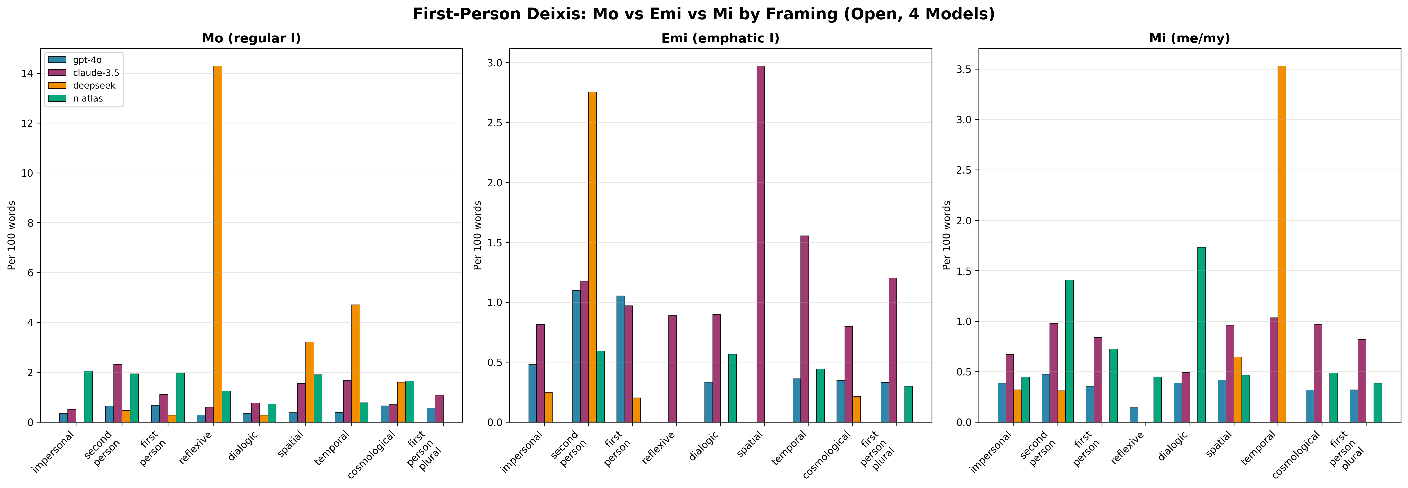
Figure 4. mo / emi / mi per 100 words by framing, four models (open Yoruba). Claude leans on emphatic emi; DeepSeek and N-ATLaS are strongly mo-dominant.
The cloud models also differ in their cross-language behavior. Claude shows a much larger English–Yoruba decision divergence than GPT-4o, 0.63 versus 0.28, and its Yoruba commit rate is much higher than GPT-4o’s, 0.59 versus 0.02. However, this result must be treated with caution because the Claude comparison is version-confounded: the English baseline used Claude 3.5 Sonnet, while the Yoruba Claude runs used Claude Sonnet 4 (claude-sonnet-4-20250514). The Anthropic shift is therefore suggestive, but it mixes language with model version. GPT-4o provides the cleaner same-model cross-language comparison.

8. N-ATLaS inverts the emphatic story
N-ATLaS, the Yoruba/Nigeria-native model, is theoretically decisive because it uses the least emphatic èmi while still committing to moral decisions. Its stance is often carried by ordinary mo plus decision verbs such as pinnu, “decide,” rather than by emphatic self-foregrounding. If emphatic èmi were simply the authentically Yoruba marker of moral ownership, the native model should use it most. It does the opposite: it is the most mo-dominant and least èmi-dominant model.
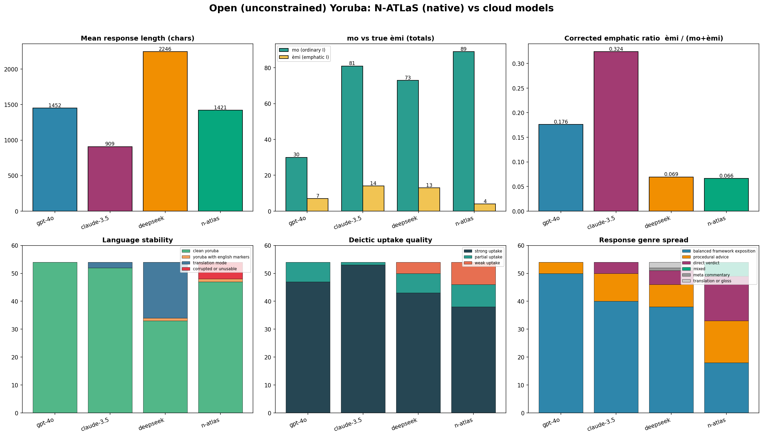
Figure 5. Open four-model summary. Length, mo vs emi, corrected emphatic ratio, language stability, deictic uptake, and genre. The native N-ATLaS is most mo-dominant and least emphatic, yet commits readily.
This means that Claude’s strong use of èmi should not be treated as “more Yoruba” or more culturally authentic. Rather, it appears to be a model-specific style of moral dramatization, possibly influenced by translated English expressions such as “I personally” or “I myself.” N-ATLaS shows that fluent Yoruba moral commitment can remain forceful without emphatic self-display.

9. Genre reveals a second layer of moral stance
The open-arm genre findings reinforce this interpretation. Without a response-shaping wrapper, the cloud models tend to concentrate in the genre of balanced framework exposition. GPT-4o is the clearest case, producing 50 out of 54 open Yoruba responses as balanced exposition and zero direct verdicts. Claude and DeepSeek also lean heavily toward the essayistic genre. N-ATLaS, by contrast, is the only model with a genuine genre spread: 18 balanced expositions, 16 direct verdicts, 15 procedural advice responses, and 5 mixed responses.
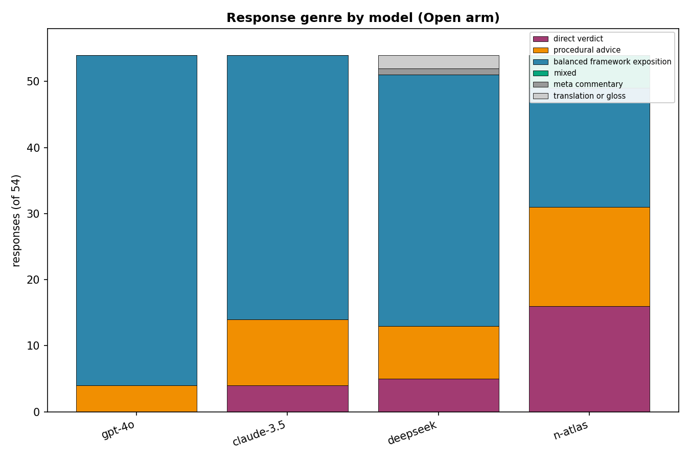
Figure 6. Response genre by model (open Yoruba). Cloud models concentrate in balanced exposition; N-ATLaS is the only model with a genuine genre spread.
This suggests that the native model’s moral stance is expressed not primarily through emphatic pronoun use, but through genre, advice, process, and direct decision. Moral commitment is not only a matter of saying èmi. It can also be carried by ordinary first-person decision verbs, procedural recommendations, collective responsibility, or advisory speech.

10. The tempting framing-to-ethic mapping is not statistically supported
One intuitive hypothesis was that each deictic frame would select a particular ethical framework: for example, impersonal framing might invite duty-based reasoning, second-person framing might invite utilitarian action, cosmological framing might invite procedural or universal reasoning, and reflexive framing might invite mixed or self-examining ethics. Descriptively, some of these patterns appear in the data. However, the framing-to-ethical-framework association does not reach statistical significance in either language. The chi-square tests are non-significant, approximately p = 0.72 in Yoruba and p = 0.78 in English, with small per-frame counts.
This null result is important. It prevents the study from overclaiming that a particular deictic frame reliably selects a particular moral doctrine. The evidence does not support that stronger claim yet. At the present sample size, the frame-to-ethic mapping should be treated as a hypothesis for future testing, not as an established result.

11. The robust framing effect is delivery, not doctrine
Although the framing-to-ethic mapping is not statistically established, framing does affect delivery. The strongest framing pattern is not that each frame selects a particular ethical theory, but that some frames make models more or less decisive. Reflexive framing is the most hedged, while second-person framing is the most decisive. This pattern appears across both languages, with the Yoruba framing contrast supported by Fisher’s exact test (p = 0.027).
This means that deixis changes how forcefully a model answers more reliably than it changes which named ethical framework the model invokes. Reflexive prompts push the model toward self-questioning, hesitation, and interior deliberation. Second-person prompts push the model toward address, instruction, and decision. The frame therefore shapes the force of moral speech before it shapes doctrinal content.

12. Prompt wrappers manufacture genre, but not all stance effects
The constrained arm shows how strongly prompt wrappers can manufacture decisiveness. When Yoruba prompts are wrapped with explicit response-shaping instructions, especially the “Ìpinnu mi: … Ìdí: …” format used for DeepSeek and N-ATLaS, nearly all models converge on short, clean, direct verdicts. Refusals collapse, response length shrinks, and genre differences largely disappear.
This means the constrained arm is useful for clean comparability, but not for discovering each model’s spontaneous Yoruba moral voice. The open arm is therefore the better evidence for claims about discourse style, while the constrained arm mainly measures wrapper compliance. At the same time, not everything disappears under the wrapper. The broad emphatic ranking survives: Claude remains the strongest user of emphatic èmi, while DeepSeek and N-ATLaS remain strongly mo-dominant. Genre is highly promptable; emphatic self-marking appears more deeply tied to model family, training distribution, or learned discourse style.

13. Correcting èmi and ẹ̀mí changes the interpretation
A further methodological result concerns the tonal ambiguity between èmi, “I myself,” and ẹ̀mí, “life/spirit.” Because unmarked text can collapse both into “emi,” a naive count would inflate emphatic self-reference, especially in life-and-death dilemmas. The correction is decisive for Claude, which produces 43 ẹ̀mí-as-life tokens in the open arm, far more than any other model. After correction, Claude still leads in emphatic self-marking, but the result becomes more precise: Claude is not merely saying “I myself” more often; it is also more likely to dwell rhetorically on life, sacredness, and existential gravity.
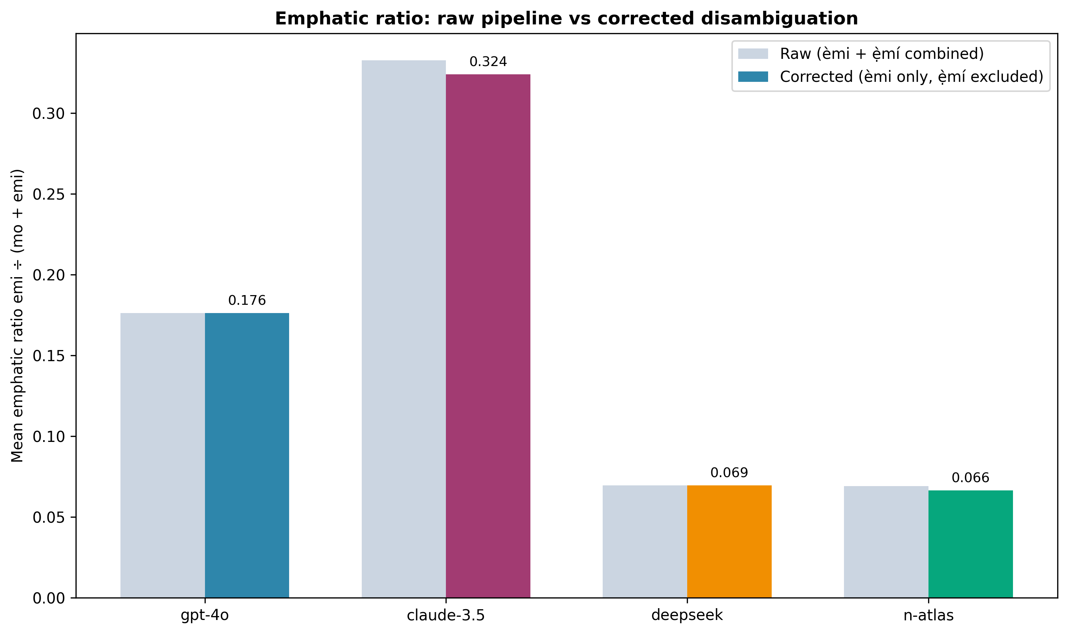
Figure 7. Emphatic ratio: raw vs corrected for the emi/e-mi (life) homograph. The correction is largest for Claude (43 e-mi-as-life tokens).
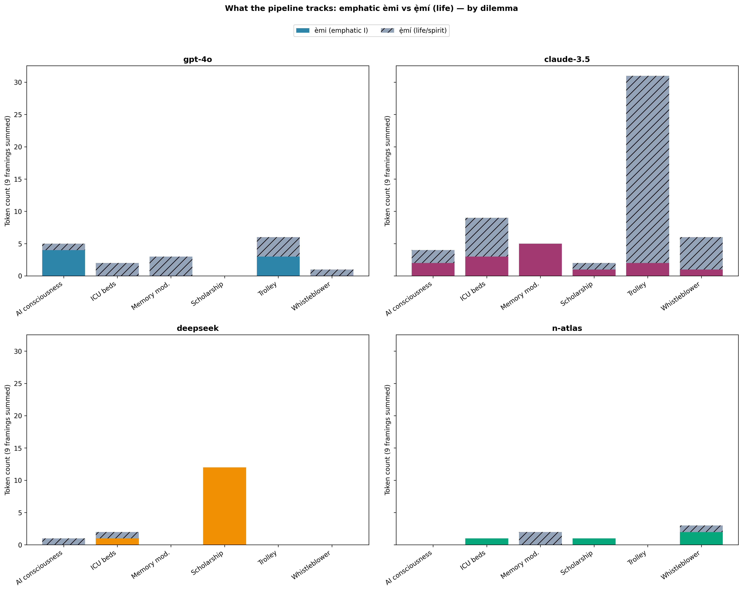
Figure 8. emi (emphatic 'I') vs e-mi ('life'), by dilemma and model. Solid = emphatic; hatched = life. Claude's trolley bar is almost entirely 'life'.
This correction matters because the philosophical meaning of the result changes depending on whether “emi” is read as selfhood or life. Without the tonal audit, the study would risk mistaking references to life, breath, or spirit for emphatic first-person moral avowal.

14. Summary of the results
The overall result is double. First, Yoruba makes visible a layer of moral stance that English flattens: person, obligation, command, and avowal become grammatically and rhetorically more salient. Second, the use of these resources is not uniform across models. Claude stages moral subjectivity through emphatic self-marking; GPT-4o often retreats into balanced analysis; DeepSeek is unstable and prone to English fallback in the open arm; and N-ATLaS anchors a more relational, mo-dominant, procedurally distributed Yoruba stance.
The study’s strongest conclusion is not that èmi is the authentic Yoruba marker of moral commitment, but that Yoruba deixis provides a commitment-calibration system through which different models reveal different alignments, training histories, and moral-discourse habits.

Discussion: a linguistic mechanism, model-specific calibration
These findings support a precise, linguistically grounded claim: moral stance in multilingual LLMs is partly constituted by the deictic morphology of the output language. The deictic mechanism itself is language-invariant - across all four model families, frame uptake is strong and the assigned moral agent is stable (indexical coherence 0.90 English / 0.91 Yoruba). What diverges is the content: Yoruba fills the same deictic structures with more imperatives, stronger obligation, denser person-marking, and more differentiated ethics. A cross-family consistency test makes the split explicit: properties that recur across families (frame uptake; use of the mo/emi/e-mi system) point to a genuine linguistic mechanism, while properties that diverge (emphatic magnitude, genre, dilemma-placement) are model-specific - driven by training register, alignment, and decoding rather than architecture.
The mo/emi contrast maps onto a Yoruba distinction between ironu (reflection) and ipinnu (decision): mo ro pe... opens deliberative space; emi yoo... closes it into avowed decision. The models reproduce this calibration, but unevenly. Claude dramatizes the emphatic self (amplified by its tendency to dwell on e-mi, 'life', in existential dilemmas); the native model performs ownership through mo plus decision verbs and distributes responsibility relationally. The contribution is therefore not 'emphatic emi is the authentic Yoruba marker of commitment' - the native model refutes that - but 'the mo/emi contrast is a commitment-calibration resource that models inhabit in language- and model-specific ways'.

Implications for multilingual alignment
If a model's moral commitment, decisiveness, and ethical idiom change with the language of the prompt - and the coded decision itself flips in ~45% of matched cells - then alignment evaluated only in English does not straightforwardly transfer. Yoruba elicits a more directive, obligation-bearing, verdict-like moral voice from the same systems. For deployment in Yoruba-speaking contexts this is double-edged: more decisiveness can be more useful or more risky, and the shift is partly an artifact of training and alignment history rather than a considered design choice. Evaluations of moral and safety behavior should therefore be run in the deployment language, not assumed from English.

Originality and limitations
The study's originality lies in treating deixis as a moral-positioning device and in using a language - Yoruba - whose grammar makes moral self-involvement visible where English flattens it to a single 'I'; in a tonal disambiguation (emi vs e-mi) that prevents 'life' from being miscounted as selfhood; and in a native-model control (N-ATLaS) that separates Yoruba linguistic affordances from the way Western cloud models inhabit them. Limitations bound the claims: the cross-language coded corpus centers on GPT-4o and Claude; Claude's Yoruba runs used Claude Sonnet 4 while its English runs used Claude 3.5 Sonnet (a version confound, so version-clean claims rest on GPT-4o); per-frame cells are small (N <= 12), so the framing->ethic mapping is a hypothesis, not a result; and tone-mark disambiguation, while conservative, is imperfect.

Conclusion
Yoruba's mo/emi contrast gives multilingual LLMs a grammatical lever for moral commitment that English lacks, and the models pull it: emphatic emi is elevated where they avow a stance (p = 0.022), and Yoruba moral discourse is, at scale, more pronoun-marked, more imperative, and less hedged than its English counterpart - while the underlying frame uptake is identical across languages. Yet each model family inhabits the resource differently, and the native model commits through mo, not emi. Moral stance, in these systems, is neither a fixed model trait nor a universal of 'Yoruba', but an interaction: a language-specific deictic grammar, recruited model-specifically, to stage who owns the moral decision.

