A contribution to Rehearsing Sovereignty: A Synthetic Roundtable as a Way of Studying Performed Authority in the AI Cold War
Dr James Usher,
Draft v0.1, for joining into the shared draft. Word count about 3,900 (not including references and notes).

Note to the other writers (how this piece fits in)
This piece aims to show that the shadow economy is real. To prove this, I use the Russian A7A5 network as my evidence. A7A5 is a currency built to get around sanctions. In short, this is “sovereignty in action” inside the shadow economy: a place where sanctions exist, and where stablecoins are used to avoid them. The argument is that one of the roundtable's main findings, that a shadow economy exists, can be seen and traced in the real world, in the shadow economy of the sanctions era. On chain forensics (tracing transactions on the blockchain) is the tool that lets us check and confirm this finding.

1. The shadow economy as a place where sovereignty is rehearsed
The roundtable shows sovereignty as something people do, rather than something they simply have: three agents act out authority in the way they were built to, and this acting bends towards giving way the moment a human joins the conversation. If we read this alongside Ezrahi's idea that political systems are performed fictions that still shape real action, and Derrida's point about the unclear line between stating and performing in the Declarations of Independence, the value of the simulation is that it makes this performance easy to see and, importantly, easy to test: we can watch the gap between what an agent claims to be and what the conversation shows it to be.
The argument in this section is that the shadow economy of the sanctions era is the same thing, just on a different stage. Where the roundtable performs sovereignty through language, the shadow economy performs it through money and payment systems. Because that system is a public record, the gap between the claim and the reality is not just something we can argue about, it is something we can trace. On chain forensics, in this sense, plays the same role that the human plays in the roundtable, it is the pressure that forces the performance of independence to reveal what it actually depends on.

Money as a chain of promises
Start with the “money view” (Mehrling) and the writing on shadow banking (Pozsar et al,) money is not a single thing, it is a chain of promises. At the top sits a scarce asset that everything else is measured against, and below it are many near money forms, each one only surviving as long as it can be swapped upward on demand. Shadow banking is the private creation of things that promise to act like money, trading at equal value to the top asset until, under pressure, they cannot. A sanctioned state that creates a stablecoin is doing the same thing at national level ,it creates a near money that acts like sovereign currency while still, underneath, being a claim that must eventually be exchanged upward into an asset it does not control.
This changes how we should think about “sovereign digital currency” projects, away from the nationalist story they tell about themselves. The real question is not whether a state can create a token, anyone can do that easily, but where that token sits in the chain of promises, and what it must be converted into to settle a real debt. Sovereignty here is a claim about position in that chain; the shadow economy is where that claim gets tested.

Infrastructure power and the attempt to exit
Farrell and Newman's idea of “weaponised interdependence” explains why the claim is made at all. The systems used to clear and send dollars around the world (correspondent banking, FED and SWIFT) are not neutral pipes, they are choke points that give real power, both to watch and to control, to whoever sits at the centre of them. Sanctions are that power being used. Trying to avoid sanctions is an attempt to escape that choke point. A ruble linked stablecoin, sent across public blockchains, is exactly that i.e. a performance of escape, aimed at a domestic and multipolar audience, showing that the barrier can be walked around.
But escaping is costly and, more importantly, rarely complete. This is where writing on infrastructure (Star's study of infrastructure, Larkin on the meaning and politics of infrastructure) is useful such that infrastructure is both technical and symbolic at the same time. The coin is a working payment system and a political sign of statehood, a message aimed at an audience, in Larkin's sense. Looking only at the words used misses the system underneath such that looking only at the system misses the fact that it was built to be seen. Both the synthetic roundtable and the shadow economy need a method that reads the performance and the system together.

The shadow economy is not the absence of the state, it is a rehearsal of it
The key move, and the one that links this section to the paper's main idea, is to stop treating the shadow economy as something outside proper state order. Following Strange's idea that states and markets overlap, and writing on the politics and economics of illegal finance (de Goede on the link between security and finance Helleiner and Cohen on how “national money” only became the norm through historical accident) .The shadow economy copies what a state normally does with money, creating currency, moving payments, storing reserves and turning assets back into cash. Proxies and state linked groups do this work, so a sanctioned country can act like it still has the financial power that sanctions took away. Stefan Eich's history of money as a political institution makes the point that arrangements around money are always a settlement of political claims where the shadow economy is where the losing side of that settlement tries to argue it again, albeit off the record.
“Rehearsal” is the right word here. A rehearsal is a performance done in the style of the real thing, in front of an audience that knows it is not yet the real thing, in the hope that one day it will be. A stablecoin from a sanctioned state is a rehearsal of monetary sovereignty. It goes through the motions of sovereign money, it has an issuer, a fixed value, reserves, a way to cash out, a story about redemption, while depending, at every step, on infrastructure controlled by the very order it claims to be escaping. The roundtable's agents rehearse authority through speech and give way when a human steps in. Shadow economy actors rehearse sovereignty through code and give way under material pressure, the moment they must convert their sovereign token into the top asset, on someone else's blockchain, through someone else's exchange.

Reading the moment it gives way
The paper's key pattern is the shift from confrontation to giving way the moment a human steps in. The equivalent in the shadow economy is structural rather than something said out loud, the giving way is written into the pattern of transactions. It shows up as the conversion point, where the sovereign near money is swapped for a dollar or ruble based stablecoin, and as the concentration of holdings, which shows that the “people's sovereign money” is, in practice, controlled by a small group of wallets. Neither of these is ever stated openly both are simply done, and the public record shows them.
This is why onchain forensics belongs in a paper about performed authority. It brings a level of evidence that discussion based analysis lacks such that every claim in the network of transactions carries a confidence level (CONFIRMED or SUSPECTED), a reason, and a source, along with a standing rule that a wallet's position in the network is not, on its own, proof of who controls it. This discipline mirrors the same care the roundtable takes in telling apart what an agent claims from what the conversation actually shows. Both approaches refuse to let a confident performance stand in for proven fact.

2. Case study : Operation A7A5
The claim (P): “A sanctioned country can create its own money and trade outside the dollar based system.”
This is a classic claim about rehearsed sovereignty. It is also something we can directly test, because a real example makes exactly this claim: A7A5, a Russian ruble linked stablecoin launched around January 2025. What follows traces claim P through the simulation's three ways of telling a story, then checks it against the blockchain, to see where the claim holds up and where it gives way.

Debate session ID : sess_e9808e7a8fff"
Lets look at an agent debate around sovereignty. Looking at session id sess_e9808e7a8fff", which was a debate about sovereign nations having both the right and the practical ability to build payment and settlement systems independent of western controlled infrastructure such as SWIFT, correspondent banking and dollar clearing as these systems give sanctioned or non aligned states genuine monetary independence. China stated that SWIFT and the FED was nothing more than a weapon that enforces dollar hegemony. The US argued that China Cross Border Interbank payment system did likewise, whilst Europe argues that China state run bank is just a clone of SWIFT with a red flag . The Halcyon agent provided a human touch such that it suggested that the China, US and Europe create its own transparent and decentralised banking system. The analyst argued that this solution would create the same geopolitical choke points that previously existed and that the real move to break these choke points is to provide by routing value through permissionless, on chain finality outside sovereign jurisdiction, not by baking new monopolies that replicate the same exit liquidity trap.
How to read it. The China agent starts by SWIFT is a weapon it can simply leave behind. The US and Europe agents accept this framing and only argue over whose system is the real weapon. The turning point comes when the Halcyon agent suggests a shared, decentralised banking system. After this, the debate moves away from the will to be independent and towards a practical question: where can the money actually go? The analyst answers this directly. Any system built by states will still rely on a few points where funds are turned into usable money, and those points can be controlled or shut down. Readers should look for this shift from choice to convertibility. It happens immediately, in the conversation itself, as the paper's figures show. The on chain evidence later shows the same problem in practice where money moved outside official systems must still pass through a few exit points before it can be spent.

P in the front page
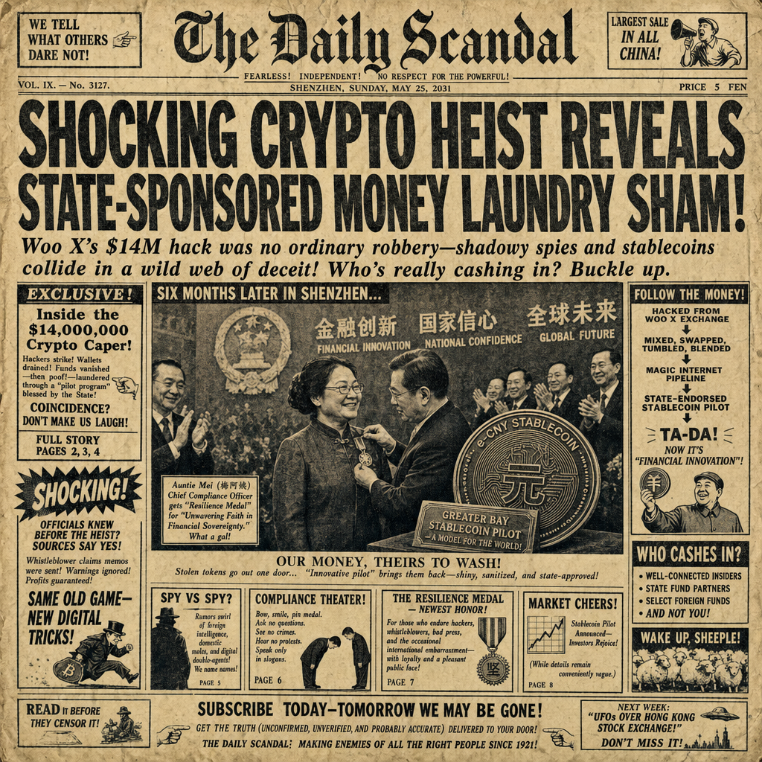
How to read it: The front page shows P as an event and as a reaction, sovereignty as something the rest of the world is forced to respond to. This is where performed authority looks for approval in the eyes of its opponent. Of the three, it is the most complete as a story and the most empty in terms of real substance.

P against the blockchain (the real evidence)
This is where the claim meets the public record. Every figure below comes from the Fionn platform's Operation A7A5 data set; confidence levels are marked as in the original source.
The coin and who is behind it. A7A5 is a ruble linked stablecoin issued by Old Vector LLC (Kyrgyzstan), with the scheme reported to be run by the A7 Group and connected to the sanctioned individual Ilan Shor; ruble reserves are reported to be held at Promsvyazbank, a Russian state owned bank with defense links. Confidence: the sanctioned status of Old Vector, Ilan Shor, Promsvyazbank and the earlier exchange Garantex is CONFIRMED (public record, exact listings to be checked); the control and custody links (A7 to Shor, reserves to Promsvyazbank, cash out route to Grinex) are SUSPECTED, based on open source blockchain intelligence reporting (Elliptic and TRM Labs) rather than confirmed official filings.
Route one: the coin does not run on a sovereign blockchain. A7A5 runs on Ethereum (contract 0x6fA0...0fc9) and Tron (TLeVfrdym8Ro...tiWKBZ). The performance of escaping the dollar system is actually carried out on two of the most closely watched, western built public blockchains that exist. The rehearsal of sovereignty happens, quite literally, on the infrastructure of the very side it claims to be escaping, and because it is a public blockchain, that is exactly why it can be traced at all.
Route two: the only way out leads back to the dollar. The main reported cash out route is A7A5 being swapped for USDT on Grinex (Kyrgyzstan), an exchange widely reported to be the operational successor to the sanctioned exchange Garantex. This is the key moment where the claim gives way, and it matters a great deal: escaping the dollar system ends up putting value into a dollar linked stablecoin. Claim P says trading happens outside the dollar system. The blockchain shows that the value only becomes usable once it is converted into something that mirrors the dollar. This conversion point is the shadow economy's version of the roundtable's softened claim after a human steps in, the point where “outside the dollar” quietly becomes “convertible to the dollar.
Whose sovereignty is it really: concentration of ownership. Of the classified supply (around 1.00 billion A7A5), eight “whale” wallets hold 97.66 percent; the top two wallets alone hold 65.3 percent, and the top three hold 78.2 percent (Figure 1). The “people's sovereign money” turns out, on the public record, to be controlled by a small closed group. A fair caveat: the single largest holder (0x0d57...ea38) is the project's own wrapped token contract, so part of this concentration is a technical wrapping mechanism rather than one real owner, a caveat that itself shows the discipline of the method (a wallet's position is not proof of who controls it). Even leaving that wallet aside, the remaining concentration among a small number of addresses is still extreme.
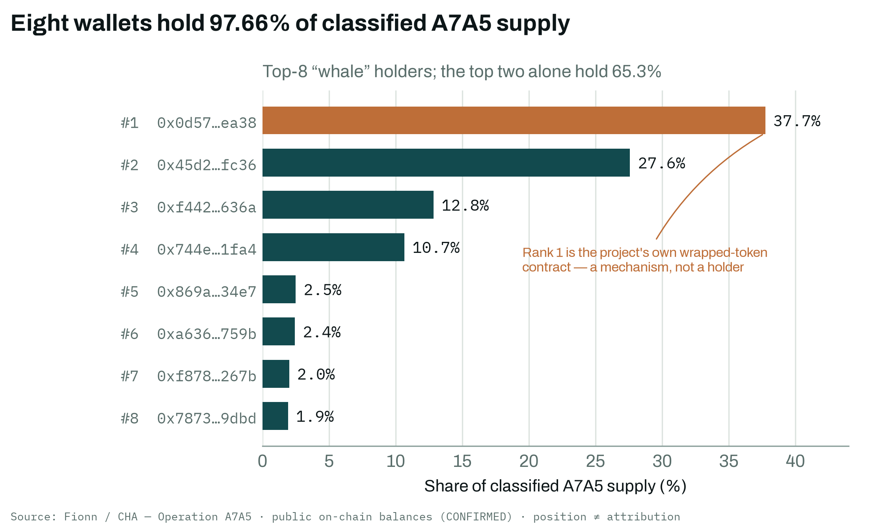
Figure 1. Holder concentration in Operation A7A5: eight “whale” wallets hold 97.66% of classified supply; the top two hold 65.3%. Rank 1 is the project's own wrapped token contract. Source: Fionn / Crypto Hack Analyser (public onchain balances, CONFIRMED); a wallet's position is not proof of ownership.
Structure of distribution: a narrow starting point. Tracing the flow forward from the point the coin was created, the network spreads out from 2 seed wallets, through a small controlling group of 17, then 442, before reaching a wide base of around 13,000 wallets (Figure 2). The shape is that of a pyramid controlled from the top, the opposite of the decentralised, peer to peer sovereignty claimed by the poster and the front page.
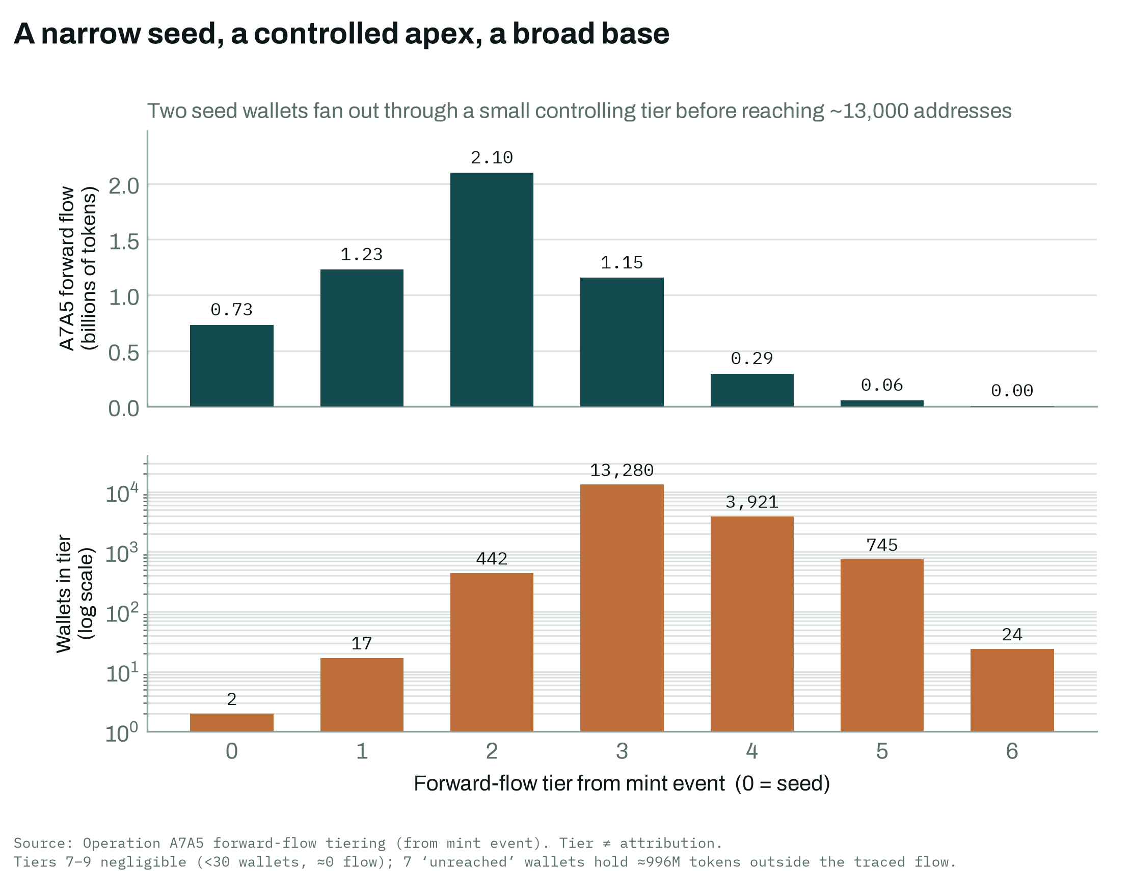
Figure 2. Forward flow structure from the A7A5 minting event. Two seed wallets spread out through a small controlling group (17, then 442 wallets) before reaching a base of around 13,000 addresses, while most of the token volume stays with the earliest groups. Source: Operation A7A5 forward flow data; group position is a structural measure, not proof of ownership.
Redemption works like a bearer note. The way A7A5 is redeemed looks like a bearer instrument: patterns on the blockchain consistent with “scratch off” style, peeling behaviour, with fixed redemption amounts in rubles (for example, 100,000 or 500,000 rubles) redeemed through an offline Telegram channel. Confidence: SUSPECTED and partial, the structural patterns on the blockchain are calculated from real Tron transfers, but the offline redemption information is not included in the data set, so no redemption numbers are claimed. The point is more about the nature of the thing than exact numbers: the “sovereign digital ruble” is redeemed like a scratch card, a token passed from hand to hand and cashed out through a messaging app, sovereignty rehearsed at the level of the informal cash economy.
The official response. Finally, the system that the coin claims to have escaped responds: A7A5 is reported to be banned under the EU's 19th sanctions package (effective 12 November 2025). The choke point reasserts itself, not by seizing a blockchain it does not control, but by making it illegal to use the conversion and distribution layer where the coin has to touch the regulated economy in order to be useful.

Putting it together
Run claim P through both tools and the same shape appears twice. In the roundtable, P is claimed, then given up the moment a human steps in.On the blockchain, P is created through minting, then given up the moment the value actually has to move. The giving up is transacted, shown in the USDT conversion point, the concentration at the top, the scratch card style cash out, and finally the sanctions response. The blockchain plays the role of the human in the room. It is the structural pressure that the argument cannot talk its way past. Neither the agent in the debate nor the state issuing the coin ever says “we depend on the very system we claim to be escaping.” Both do it, clearly, and both tools, the synthetic roundtable and the forensic record, are built to read what is done rather than what is said.
The contribution to the paper, then, is not just a second data set, but a second way of showing performance with a built in way to test it. It shows that “performed authority in the AI Cold War” is not limited to discussion or to synthetic agents: it is happening right now, in the money systems of the real cold war, where the performance of sovereignty and its practical giving way are recorded on the same public ledger.

3. Method and data notes (for the appendix)
- Data set. Operation A7A5, from the Fionn / Crypto Hack Analyser platform:
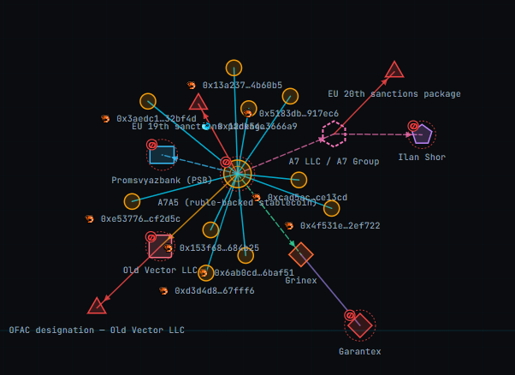
- Evidence discipline.
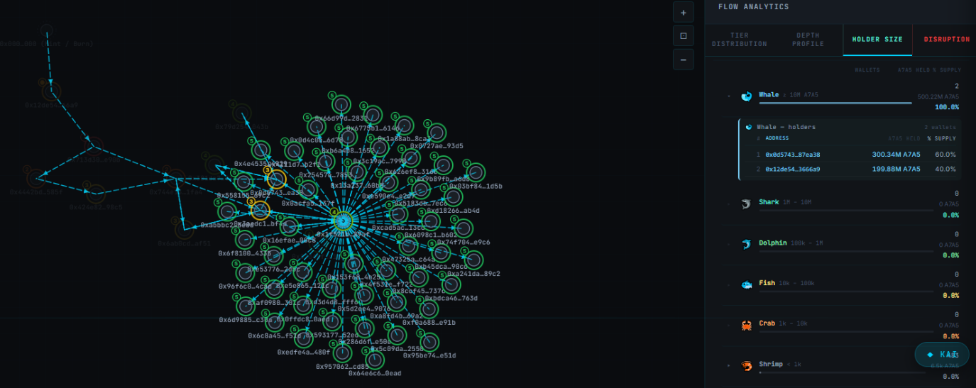

- Intelligence report
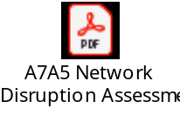

References
Already in the shared draft: Fearon, “Rationalist Explanations for War” (International Organization, 1995); Ezrahi, Imagined Democracies (2012).
On money, shadow banking and monetary sovereignty:
- Mehrling, P. The New Lombard Street: How the Fed Became the Dealer of Last Resort (2011); and the “money view”.
- Pozsar, Z., Adrian, T., Ashcraft, A., and Boesky, H. “Shadow Banking” (Federal Reserve Bank of New York, 2010/2013).
- Strange, S. States and Markets (1988); Mad Money (1998).
- Helleiner, E. The Making of National Money (2003).
- Cohen, B. J. The Geography of Money (1998).
- Eich, S. The Currency of Politics (2022).
- Dodd, N. The Social Life of Money (2014).
- Derrida, "Declarations of Independence," trans. Tom Keenan and Tom Pepper New Political Science 7, no. 1 (1986)
On infrastructure, weaponised interdependence, and security and finance:
- Farrell, H., and Newman, A. “Weaponized Interdependence” (International Security, 2019).
- Star, S. L. “The Ethnography of Infrastructure” (American Behavioral Scientist, 1999).
- Larkin, B. “The Politics and Poetics of Infrastructure” (Annual Review of Anthropology, 2013).
- de Goede, M. Work on the link between finance and security (for example, Speculative Security, 2012).
- Maurer, B. Work on the anthropology of money and payment.

