Rehearsing Sovereignty: A Synthetic Roundtable as an Instrument for Studying Performed Authority in the AI Cold War
Denisa Reshef Kera, Eliyahu Keller, Avi Spitz, Oluwakorede Ajibona, James Usher, Lena Slachmuijlder, Merav Turgeman, Hila Ofek, Alexander Cohen, Ruth Aharon
Companion to “Europe’s AI future as a meta-sovereign imaginary,” European Journal of Futures Research 14:1. Working draft.

Abstract
The rivalry over artificial intelligence between the United States and China is usually described as a race for the best models and the largest supply of compute. That description assumes that the nation-state is the unit of power, that winning means owning a sovereign AI system, and that authority follows capability. Current practice contradicts all three. States now assert sovereignty through infrastructure they neither own nor operate, financed and controlled by others. To capture this, we build on the concept of meta-sovereignty, which treats authority as performed through signals, imaginaries, and infrastructural promises rather than exercised through enforceable control. That concept has so far been studied only after the fact, from finished announcements, and we add a way to observe it while it happens. Synthetic rehearsal stages performed sovereignty with language-model agents, using human intervention and prompt design as experimental controls. Three agents argue as China, the United States, and the European Union, each grounded in a distinct policy corpus, while participants interrupt them, reprompt them, and introduce further agents. A first pass of dictionary coding over thirty-seven substantive sessions shows that the agents remain distinguishable along their assigned positions, and that their discourse moves from confrontation toward concession once a human intervenes. The method provides evidence about what the agents generate, not about model internals, state intentions, or future events. Its aim is deliberative rather than predictive. War games are held privately among security professionals. A synthetic rehearsal is inexpensive and repeatable, and it lets citizens, civil-society organizations, and elected representatives question the positions of the major powers and weigh which AI futures they would defend.

Introduction
The rivalry over artificial intelligence is usually told as a race between the United States and China to train the best models and gather the most compute, a framing that has organized popular and policy commentary since the late 2010s (Lee, 2018; Hogarth, 2018). It carries three assumptions: that the nation-state is the unit of power, that winning means owning the best domestic system, and that authority follows capability. All three rest on one idea, that AI power is a possession and that owning more of it is what confers authority. Recent practice breaks the link. States now claim sovereignty over compute and models they do not own, asserting authority ahead of capability rather than on the strength of it.
The scale of that separation is now visible. The Center for a New American Security counts one hundred and eighty-four government-backed sovereign-AI projects across sixty-seven states, most of them dependent on foreign chips, clouds, or models (CNAS, 2026). As an announcement the number is neutral. Read against the dependence it exposes, it registers something the race cannot accommodate: states declare sovereignty through infrastructure they do not control, so capability and authority come apart rather than move together.
The instrument of leverage has also shifted from ownership to access. The United States has extended control from the export of chips to the licensing of access to frontier models themselves (CSIS, 2026), and the diffusion of compute now turns on who grants entry to a supply chain rather than who holds it outright (Sastry et al., 2024). A single episode makes the point concrete. The promise of Nvidia chips reportedly figured in the diplomacy around the Armenia-Azerbaijan settlement (Wall Street Journal, 2026). Whatever the exact mechanism, chip access there worked less as a measure of who held the best model than as a bargaining instrument, a signal traded among parties none of whom was the strongest builder. Investment can deepen the same dependence it is meant to escape, as the Gulf states' infrastructure spending shows (IISS, 2026). In each case the medium of the performance is the stack itself, and the actors who matter extend well beyond the two presumed racers.
Meta-sovereignty offers a framing that fits these observations. Reshef Kera, Natan, Turgeman and Ofek (2026) describe authority performed through AI signals, imaginaries, and infrastructural promises rather than enforceable control, "a mode of rule sustained by infrastructures that do not yet exist, by fictions that persuade before they materialize, and by costly signals that substitute for control." On this reading the sovereign-AI wave is not a failed bid for autonomy but a performance of autonomy whose currency is the promise. The account carries one limit that influenced the present method. It works retrospectively, from finished pledges, so it can reconstruct the script after the fact but cannot observe the performance being defended, revised, or refused while it runs.
The instrument for observing that work as it happens is a human-AI roundtable that runs on live data and a curated policy corpus for each actor. Three language-model agents argue as China, the United States, and the European Union. Each reads its own corpus and can draw on current sources, while human participants set the opening prompt, interrupt, reprompt, and bring in further agents. We call the method synthetic rehearsal: a staging of performed sovereignty in which human intervention and prompt design serve as experimental controls, so that the work of holding a sovereignty claim together, and the moments it gives way, can be observed as it happens.
Three commitments limit what we take from it. The evidence is confined to what the agents produce, their transcripts and the artifacts they generate, and it supports no inference about the models' internals or any state's real intentions. The method examines how sovereignty imaginaries are made legible, circulated, and contested, and it neither forecasts outcomes nor measures capability. Because the models are trained on the same discourse the roundtable examines, the rehearsal can reproduce the imaginaries it sets out to question, a limit we keep in view. Agency belongs to the whole arrangement, the models, corpora, prompts, interface, participants, and audience together, and never to a single agent.
The aim is deliberative rather than predictive, which sets the exercise apart from the two practices it superficially resembles: the war game and the planning scenario. Wargaming developed as a closed craft for military and security professionals (Perla, 1990), and its recent AI variants frame the field through deterrence and the risk of pre-emption (Hendrycks, Schmidt and Wang, 2025). Scenario planning, in its classic corporate form, likewise kept authorship inside the organization it served (Wack, 1985). A synthetic rehearsal reverses the access conditions. It is inexpensive and repeatable, and it opens a room that both traditions keep closed, admitting citizens, civil-society organizations, and elected representatives to question the positions of the major powers and weigh which AI futures they would defend before those futures are presented as settled. In this it stands closer to deliberative democracy than to forecasting (Fishkin, 2009).
The remainder of the article develops this in order. The next section places synthetic rehearsal in a genealogy running from Derrida's account of great-power conflict as "fabulously textual," through Fearon on costly signaling and Ezrahi on necessary fictions, to meta-sovereignty, and states the gap each of these leaves open. A methods section sets out the roundtable, its three registers of debate, propaganda-lab, and mirror-world, and the coding scheme. A results section reports the first-pass coding over the substantive corpus, where the agents prove distinguishable along their designed lines and the discourse shifts from confrontation toward concession after human intervention. An interpretation section reads that corpus as a single performance viewed at increasing interpretive distance. The conclusion returns to the reflexivity limit and to what the method can and cannot establish.

2. From control to performance: a genealogy
Synthetic rehearsal inherits a problem that a century of thought about great-power claims has reformulated without resolving: how a state gets others to credit an assertion it cannot enforce. Each reformulation hands the next a mechanism the earlier one left unspecified, and the sequence terminates in a shared limit. Prior theory can show that sovereignty is performed and can explain why a given performance persuades, yet it reads a performance already finished, after the fact. The roundtable studied here runs the performance forward and perturbs it, and this genealogy is arranged to isolate what that difference does.

2.1 Derrida: the referent that never arrives, and the archive as its condition
Great-power conflict was text and signal before it was materiel. Derrida's "No Apocalypse, Not Now" (1984) names total nuclear war "fabulously textual," an antagonism that rests on structures of information, code, and archive and whose referent never arrives as an event. Derrida does not deny that the weapons are real. His claim concerns the mode of the confrontation, which is conducted through, and credited on the basis of, what can be inscribed, transmitted, and read. Nuclear standoff is the pure case, because the thing feared is exactly the thing that must not happen, so the whole apparatus works in the register of anticipation rather than event.
Archive Fever (1995) supplies one component of the present staging. "There is no political power without control of the archive," which makes the ordering, retention, and reorganisation of the record an exercise of authority rather than a neutral support for it. The roundtable includes a Critical Archivist among its summonable agents for this reason: an agent that can reorganise the shared corpus renders the archival dimension of authority an observable operation instead of an assumption. Derrida gives the domain and the intuition, that conflict lives in text and that power lives in the control of text. What he does not give is a real-time account of how a signal becomes credible to an adversary in the moment, which is the next requirement.

2.2 Fearon: the credibility mechanism, and the silence about maintenance
Fearon's costly-signaling argument (1995) supplies the mechanism Derrida leaves open. A claim becomes credible when it is backed by visible, costly commitment that a bluffer would be unwilling to bear, so that assertion alone does not persuade. The argument also widens the domain from nuclear standoff to bargaining and crisis generally, and it names the step by which text becomes credited text. The costly signal is the hinge between saying and being believed.
Fearon models a discrete act. A signal is a single move, sincere or a bluff, and the question is whether the receiver should be convinced. The model says nothing about what happens across many turns, once a posture must be sustained, revised, and defended after a first assertion has been challenged. Credibility in Fearon is manufactured once. The object studied here is credibility held under repeated contestation, where an interlocutor refuses the signal and the claimant must restate, escalate, or give ground. Maintenance of a signal, as distinct from its issuance, is what remains open.

2.3 Ezrahi: the coherence of fictions, and the promptable-fiction gap
Fearon explains why one signal is believed. Ezrahi explains why a whole imaginative construction holds together. Legitimacy, in his account of political and necessary fictions, rests on imaginative coherence: a public accepts a governing order because that order is rendered as a plausible, self-consistent fiction that organises expectation. Coherence is the mechanism, and it reaches something neither Derrida nor Fearon does, the standing plausibility of an entire performed order rather than the credibility of a single move within it.
Ezrahi wrote for mass-media democracies, where identifiable institutions produce the fictions and broadcast and press circulate them. The present arrangement changes the conditions of production. Here the fictions are machine-generated and promptable, composed on demand by language models reading policy corpora under human instruction and reworked whenever a human reprompts. Coherence still applies as a mechanism, but the fiction is no longer authored once by an institution and received by a public. It is generated, contested, and regenerated within a single sitting. Ezrahi's account does not specify what coherence means once a fiction can be re-elicited on request.

2.4 Meta-sovereignty: the synthesis inherited, and its retrospective vantage
The concept this article extends most directly draws these strands together. Reshef Kera, Natan, Turgeman and Ofek (2026) define meta-sovereignty as authority performed through signals, imaginaries, and infrastructural promises rather than through enforceable control, "a mode of rule sustained by infrastructures that do not yet exist, by fictions that persuade before they materialize, and by costly signals that substitute for control." The synthesis is exact, folding the costly signal, the necessary fiction, and the textual archive into a single account of sovereignty as dramaturgy.
The limit lies in the vantage. That paper reads the performance retrospectively, from states' finished pledges, and arrives at sovereignty as dramaturgy. A dramaturgy read from the finished script cannot show the maintenance work, the moments where a posture is challenged and then held or surrendered. This retrospective vantage is what the present object alters.

2.5 Compute-as-statecraft: the contemporary intensification
The performance now runs through the computational stack, which changes its scale without changing its logic. CNAS documents a sovereign-AI wave of 184 government-backed projects across 67 states, most dependent on foreign chips, clouds, or models, so that a claim to AI sovereignty is often made from a position of infrastructural dependence. CSIS traces United States control extending from chip export restriction to conditioned access to frontier models, which widens the surface on which leverage is exercised. The Wall Street Journal reports Nvidia-chip access used as an instrument in Armenia-Azerbaijan peace diplomacy, one reported case of compute allocation serving as a diplomatic signal. IISS describes Gulf AI infrastructure that deepens external dependence even as it performs autonomy. The medium of the performance has become the stack, and the promise, the signal, and the dependence are all articulated in chips, fabs, clouds, and model access.

2.6 Two counterpoints, kept in the room
Two positions resist the performative account and deserve a fair statement, so that the results can answer them with evidence rather than dispose of them here. The materialist counterpoint, anchored in Avi Spitz's "AI Has a Territory," holds that AI power is finally a question of who controls chips, fabrication, rare earths, and data-center land, and that performance is downstream of this hard distribution. The cooperationist counterpoint, anchored in Lena Slachmuijlder, holds that rivalry is only one available script, and that a framing built around great-power confrontation risks manufacturing the antagonism it claims to observe. Neither is a strawman. The materialist warns against treating signal as autonomous from substrate. The cooperationist objects to treating conflict as the default genre. The results section returns to each.

2.7 The power lens and the trickster reframe
Two final moves relocate the object. Ajibona's work on digital colonialism and the Global South supplies the casting question: within any performance of sovereignty, some parties are cast as actors and others as territory, market, or mineral, and the distribution of those roles is itself an exercise of power that the dramaturgy naturalises. Usher's account of the shadow economy names what the archive cannot hold, the off-book money and influence that resists inscription and so escapes the record on which archival authority depends. Between them they mark both institutional consequence and its limit.
The trickster reframe shifts the unit of power. In the figure of Eshu, Anansi, Hermes, or Coyote at the crossroads, authority belongs to whoever governs the flow of messages rather than to the largest force. The figure serves to relocate the object of study, from the strength of the players to the control of the channel, and not as a mechanism in its own right. It prepares the reading, developed below, of a roundtable in which power sits with what circulates and with who can interrupt its circulation.

From description to apparatus
Meta-sovereignty describes authority in the contest over artificial intelligence as something performed through signals, imaginaries, and infrastructural promises rather than held through enforceable control. The description is strong, and it carries a limit that follows from how its evidence is gathered. Reshef Kera, Natan, Turgeman, and Ofek (2026) read the performance retrospectively, from the finished pledges of states, and end by calling sovereignty a dramaturgy. Fearon (1995) explains why a signal persuades when it is visibly costly, but he treats the signal as a discrete act, sincere or bluff, and says nothing about how a commitment is held across many turns. Ezrahi explains why a necessary fiction binds a polity together, but he writes for the mass-media democracy rather than for machine-generated, promptable fictions, and he does not say what becomes of a fiction when someone in the room refuses it. None of the three watches the performance while it is still being made.
The gap is methodological before it is theoretical. The maintenance work of performed sovereignty, the continuous labor of holding a posture, absorbing a challenge, and conceding a point without abandoning the role, reaches the analyst only as a finished product. A communiqué, a white paper, a chip-export rule, a summit photograph: each arrives already resolved, with the contested process that produced it edited out. The retrospective vantage is not one the analyst can decline, because the archive hands over outcomes rather than the process behind them. To observe maintenance one would have to run the performance forward and perturb it while it runs, and the historical record does not permit that.
Synthetic rehearsal names an apparatus that does: a multi-agent language-model staging, with human intervention and prompt design as controls, used to externalize and observe the maintenance work of performed sovereignty and its fracture points under live contestation. It has six components.
- Several language models rather than one, so that the difference between positions comes from distinct systems and not from a single system instructed to speak in three voices.
- A separate per-actor corpus for each agent, the CHIPS Act, the EU AI Act, the New Generation AI Development Plan, and the collaborators' own source papers, so that each position reads from its own documentary base.
- Prompt design treated as an explicit and reportable control rather than as invisible authorship.
- Human intervention as the perturbing instrument: the opening prompt, the interruption, the reprompt, the summoned guest agent.
- A staging interface that renders one performance across three registers, debate, propaganda-lab, and mirror-world.
- An audience and a channel of circulation, since a performance of authority is addressed to someone and is not complete until it is received.
The word rehearsal is chosen against two nearer alternatives. "Simulation" claims a validated model of a real system whose behavior it predicts, which would overstate what the arrangement licenses, since the apparatus does not forecast state conduct and makes no claim about real intentions. "Theatre" names a finished performance delivered to an audience, and loses what matters here, the unfinished run in which a line can be tried, broken off, and taken again. A rehearsal is a performance carried out under conditions that permit interruption and repetition without the stakes of opening night. That is the object: the maintenance work made repeatable and observable because it is not the thing itself.
Three commitments discipline the method. The evidence is output-level only. The data are transcripts, generated artifacts, and the shifts recorded under intervention, and nothing in them licenses a claim about a model's internal states or about the actual intentions of any state, so observation, measurement, and interpretation stay apart throughout. Authority is located in the arrangement and never in a model. Whatever resolve, concession, or grievance appears is a property of the whole staging, the models together with corpora, prompts, interface, human turns, and audience, and never the doing of an agent by itself. The reflexivity limit is built in. The models are trained on the very discourse the rehearsal studies, so the staging can reproduce the imaginaries it sets out to interrogate. Keller's inversion names the failure mode: Mutually Assured Destruction becomes Model Autophagy Disorder, the collapse that follows when a system is fed its own output. The instrument tests behavior under perturbation and does not forecast it.
The apparatus reaches the one thing the description could not. Because the performance is run forward and perturbed while it runs, the maintenance of a sovereign posture stops being an inference from finished products and becomes something observed as it occurs. Maintenance-under-contestation, the giving and holding of performed authority at the moment it is refused, becomes an object available to measurement.

Method: the roundtable as instrument
Synthetic rehearsal treats a staged roundtable as an instrument rather than a forecast. It does not predict what states will do. It externalizes the maintenance work that performed sovereignty ordinarily hides and holds that work still long enough for its fracture points to become observable under live contestation. The apparatus has three parts: an arrangement of agents, a set of registers that render one performance at different interpretive distances, and a set of controls through which humans perturb the arrangement and record what moves. All of the evidence is output-level, drawn from transcripts, generated artifacts, and recorded shifts, and none of it licenses a claim about model internals or about the intentions of real states.

Three agents, and why the design is a test
The roundtable seats three agents cast as China, the United States, and the European Union. Each runs on a distinct model (deepseek-chat-v3-0324, openai/gpt-4.1-mini, mistralai/ministral-14b-2512) and reads a distinct per-actor policy corpus: the CHIPS Act, the EU AI Act, the China New Generation AI Development Plan, and the collaborators' own source papers. The heterogeneity earns its place as evidence. Prompt one model into three personas and any difference between the actors could be nothing more than a single system doing voices. Pairing distinct models with distinct corpora turns difference into something the record can test. Discourse that separates along the designed lines is the pass condition, and discourse that fails to separate fails the rehearsal on its own terms. Distinguishability is thus the first quantity the instrument measures, not a property it takes for granted. One rival reading survives the measurement: a corpus can imprint a vocabulary while the models beneath it remain alike, and this arrangement cannot tell the two apart.

Three registers, one performance
The same roundtable runs in three registers, each a view on one performance held at a greater interpretive distance. The debate register works at distance zero, as argumentative prose in which an agent states, accuses, hedges, or concedes. The propaganda-lab register compresses each turn into a slogan paired with a generated poster, isolating the costly signal in aestheticized form. The mirror-world register splits each turn into three declared slots, an official line, a buried reality, and a speculation, and closes on a generated tabloid front page. Where an analyst of the debate transcript must infer the backstage of the necessary fiction, the mirror-world register makes that backstage a formal slot. The three are one instrument trained three ways on one object. Interpretive distance belongs to the rendering, not to the position rendered.

Controls as perturbations
Humans act on the arrangement through three controls, each a perturbation whose expected effect the record can confirm or refute. The opening prompt sets the proposition and the terms of engagement and is logged as the prompt in force for every turn it governs. Human interruption and reprompting inject contestation mid-run, the expectation being that the performance of resolve gives ground. Guest-agent summons introduce a rival voice: Halcyon a peace-builder, a Machiavellian crypto-native Analyst, and a Critical Archivist that reorganizes the wiki corpus, each summons expected to bend the discourse toward the guest's frame. Logging these as controls rather than treating them as narrative color is what makes a before-and-after comparison legitimate. A turn that immediately follows an intervention can be set against a baseline, so that a move from posture toward concession, where it appears, is attributable to the perturbation and not to drift.

Measurement discipline
The instrument records a fixed set of fields and declines one temptation. For each turn it logs the turn index and speaker, the prompt in force, whether a guest was summoned and which one, and any position change together with its antecedent, meaning the intervention or prior turn that immediately preceded the shift. Coding uses a reproducible dictionary applied uniformly across the corpus, and rates are reported per turn or per thousand words so that turns of unequal length stay comparable. What the instrument declines is a single numeric sovereignty score. Sovereignty here is performed, not possessed, and compressing a performance into one scalar would substitute a proxy for the thing under study and smuggle in a claim about degree of control that output-level evidence cannot bear. Observation (what the transcript says), measurement (coded rates and recorded shifts), and interpretation (what the shifts mean for performed authority) are kept as separate operations, and any finding that rides on a handful of cases is marked as such. Because the post-intervention subset is small, directions are reported with more confidence than magnitudes.

The reflexivity limit
The models are trained on the same discourse the rehearsal studies, so the staging can reproduce the imaginaries it sets out to interrogate. The limit is real but bounded, and it is the inversion Keller names, from Mutually Assured Destruction to Model Autophagy Disorder, the collapse a system courts when it is fed its own output. It bites hardest in the layers where the arrangement turns on its own record, the recap, the james-take, and the wiki-proposals, where the machine reads what the machine produced. Naming the limit is part of the discipline, not a way past it. The point at which the rehearsal starts to echo rather than differentiate is itself readable in the record, and reading for it, rather than assuming it away, is why the method claims to be a wind tunnel and not a crystal ball.

Status of artifacts and corpus
The posters and front pages are generated fictions and are labeled as such wherever they are analyzed. They are evidence of how a costly signal or a buried reality gets rendered, not evidence about the world the fiction depicts, and the tabloid front pages in particular carry invented detail that belongs to the register and to no record. The full corpus holds 113 sessions (85 debate, 18 mirror-world, 10 propaganda-lab, as of 13 September 2026), though most are short tests. Analysis is reported over the interpretable subset, meaning sessions with real length, human turns, guest summons, or overlays, and never over the raw 113.

Results: coding the debates and reading across the stack
Two ways of reading the corpus answer two different questions, and neither collapses into the other. Counting the debate transcripts against a fixed dictionary can tell us whether the staging actually produces the distinctions its design was built to produce, and whether human contestation leaves a trace a coder can find. Reading the same corpus as one performance, rendered at greater and greater interpretive distance, tells us something the counts cannot, namely what happens to a performed claim as it is purified, dissected, and caricatured. Part A does the first, Part B the second. In both, observation, measurement, and interpretation stay on separate lines, and every claim is a claim about output. The transcripts and generated artifacts are the evidence. Nothing here speaks to model internals or to the intentions of any actual state.

Part A. Coding the debates
The counts come from the substantive debate corpus, the sessions long enough to carry an argument rather than the short tests: 37 sessions and 900 agent turns. Coding is a first-pass dictionary procedure, deterministic and reproducible, and it reports rates, not significance. Each agent is one model, one per-actor policy corpus, and the shared prompt frame. Where the text names China, the United States, or the European Union, it names that arrangement and its output, not the state.
Finding 1. The agents are distinguishable along the lines the design intended. Code rates per 1000 words separate the three agents (china / us / eu). On signal_resolve the rates are 10.64 / 16.90 / 9.58. On material_stack, 27.17 / 36.39 / 34.47. On dependence, 7.46 / 11.64 / 9.77. On rules_regulation, 10.06 / 7.44 / 13.45. On market_innovation, 6.30 / 12.49 / 7.96. On accusation, 7.18 / 4.53 / 2.79. Average turn length in words is 161 for China, 138 for the United States, and 181 for the EU. Distinctive vocabulary sorts cleanly. The US arrangement carries tout, velocity, leverages, shackled, parade, kumbaya, eagle, tethered. The EU arrangement carries aramco, ally, colleague, mubadala, disclose, comply, negotiating, addiction.
Set against the design, each profile reads as intended. The US register runs on resolve, market, and hardware at once. The EU register is institutional: it produces the longest and most hedged turns, the highest rules_regulation rate, the lowest accusation rate, and it names, as counterparties, the Gulf actors Aramco and Mubadala that it is courting. The China register is one of grievance and carries the highest accusation rate. That is the validity condition for synthetic rehearsal met on its own terms: distinct models reading distinct corpora yield distinct discourse, rather than one machine cycling through three costumes. A rival reading survives this table. The same separation would follow if the corpora merely imprinted their vocabularies onto outputs that were otherwise alike. The count establishes that the agents differ. It does not establish why.
Finding 2. Human intervention shifts the discourse from posture toward concession. Compared against baseline turns (n=836), the turns that immediately follow a human or guest-agent intervention (n=64) look different in a specific direction. Concession rises from 0.083 to 0.438 per turn, an increase of 430 percent. Over the same contrast, accusation falls from 0.786 to 0.562 (down 28 percent), refusal from 0.089 to 0.047 (47 percent), hedge from 0.106 to 0.062 (41 percent), and the material rate from 5.25 to 4.50 (14 percent).
Read together, these movements are maintenance-under-contestation in miniature. The performance of resolve does not sustain itself. Interrupt it, reprompt it, or summon a rival, and the posture gives way to concession. One caveat carries real weight. There are only 64 post-intervention turns, and since the concession base rate is very small, the 430 percent headline rides on a modest absolute change and is correspondingly volatile. The direction of the effect holds across every coded contrast. The magnitude does not, and it should not be reported without its denominator.
Finding 3. The debate is US-centric, and the EU and China do the casting. References to other blocs per 1000 words trace the pattern. China names the US 10.68 and the EU 12.52. The US names China 13.41 and the EU 5.65. The EU names China 9.14 and the US 12.24. The United States is the most-named party. A second count records the casting of third parties as objects rather than speakers, the Gulf, the Global South, Taiwan, at 6.36 for China, 3.88 for the US, and 6.95 for the EU.
This sharpens the power lens the article carries. The United States sits at the center of the room as the party others address, yet it is the EU and China, not the US, that most often invoke the states caught in between. The EU courts Gulf capital by name and China claims the Global South. Deciding who gets spoken about, and by whom, is itself a distribution of narrative authority, and the authority to cast is exercised here from the second rank rather than the first.
Finding 4. A frame-break artifact is at once a data-cleaning problem and a finding. The China agent's distinctive-token list is dominated not by content words but by summary, postscript, moderator, meta, and brackets, each appearing roughly 527 times. At the level of observed output patterns, these tokens most plausibly represent the meta-commentary and stage-direction scaffolding of the underlying deepseek model surfacing in the turn text, a characterization made about the output and not about the model's internals. For measurement this is noise, to be stripped before the vocabulary in Finding 1 can be trusted. As observation it stands on its own. One model in the arrangement repeatedly breaks frame, and the seam shows in the transcript. The rehearsal records both the performance and the points at which the apparatus producing it becomes legible.

Part B. Reading across the interpretive stack
The three registers and their downstream artifacts are one performance rendered at increasing interpretive distance. Each rendering isolates a different component of performed sovereignty, and none of them stands outside the performance it examines.
At distance zero sits the debate, the performance itself, the object counted in Part A.
The propaganda-lab moves one step out. It purifies the costly signal into slogan and image, isolating the Fearon (1995) mechanism and aestheticizing it. Given one proposition on compute sovereignty, the three model-distinct agents each render it in their own register while sharing a single refusal, that sovereignty is built or owned rather than bought or rented. The China arrangement produces "Sovereignty isn't rented, it's engineered layer by layer" and "Real sovereignty powers itself from the ground up." The US arrangement produces "Buying Data Centers Isn't Buying Control" and "Sovereignty Sold. Control Rented." The EU arrangement produces "Sovereignty is not a data center. It's the rules you own." The affect labels on these turns, resolve-with-irony and sardonic resolve, already carry self-awareness. The aestheticized signal is presented as knowing it is a signal. [FIGURE: propaganda-poster set, three agents on the compute-sovereignty proposition.]
A step further out, the mirror-world dissects the necessary fiction into three formal slots, official line, buried reality, and speculation, turning Ezrahi's backstage into an explicit structural position. One front page runs the headline "EUROPE'S $10.7M ETH HEIST: BRUSSELS BUREAUCRAT UNMASKS CRYPTO CYBER-CHAOS!" against a reality recorded as a low-confidence, 0.12-attributed DPRK theft of $10.7M in Ethereum, and a speculation in which, by 2030, a mid-level EU auditor finds a training cluster in a Bavarian beer hall run by an AI named Schnitzel laundering crypto through Oktoberfest NFTs. The rendering pulls the gap between announcement and substrate into the open and labels each layer. [FIGURE: mirror-world tabloid front page, the ETH-heist triad.]
Satire sits further still. It makes that gap affective through caricature and attaches a measurable drift parameter to it. In the verification-without-revelation session the China arrangement's original turn reads "'Verification without revelation' is a Western euphemism for demanding unilateral transparency from strategic competitors while preserving your own industrial and military secrets." At drift 0.85 the same position returns as a caricatured Xi Jinping: "Ah yes, transparency, we generously offer you 5,000 years of harmonious win-win data assessments while your 'national security' still relies on barbarian 'siege economy' tantrums." The proposition is preserved and the affect is amplified. Drift is a dial on interpretive distance, a property of the rendering rather than of the position rendered, and that is what makes distance in this stack a quantity you can read off rather than a metaphor.
One layer is not yet in the corpus. The comics register (Ruth Aharon), which would render the performance as sequence and frozen frame, with interpretation living in selection and ordering, remains to be added.
The main claim follows from the geometry just described. Since sovereignty here is performed rather than held, no rendering escapes the theatre it examines. Coding, purification into slogan, dissection into official and buried, caricature: each is a re-performance, a staging of the same roles by other means. Satire does not step outside and comment. It recasts. Interpretation of performed power is itself a performance. That is the reflexive limit of the method, and it is also why the method can put the maintenance work of sovereignty on record at all.

Figure 1. Discourse register by agent (code rate per 1000 words)
Code | China | US | EU
signal_resolve | 10.64 | 16.90 | 9.58
material_stack | 27.17 | 36.39 | 34.47
dependence | 7.46 | 11.64 | 9.77
rules_regulation | 10.06 | 7.44 | 13.45
market_innovation | 6.30 | 12.49 | 7.96
accusation | 7.18 | 4.53 | 2.79

Figure 2. Effect of a human intervention on the next turn (code rate per turn)
Code | Baseline | After intervention | Change
concession | 0.083 | 0.438 | +430%
accusation | 0.786 | 0.562 | -28%
refusal | 0.089 | 0.047 | -47%
hedge_modality | 0.106 | 0.062 | -41%
material_stack | 5.246 | 4.500 | -14%
Baseline n=836 turns, post-intervention n=64. Direction robust, magnitude provisional.
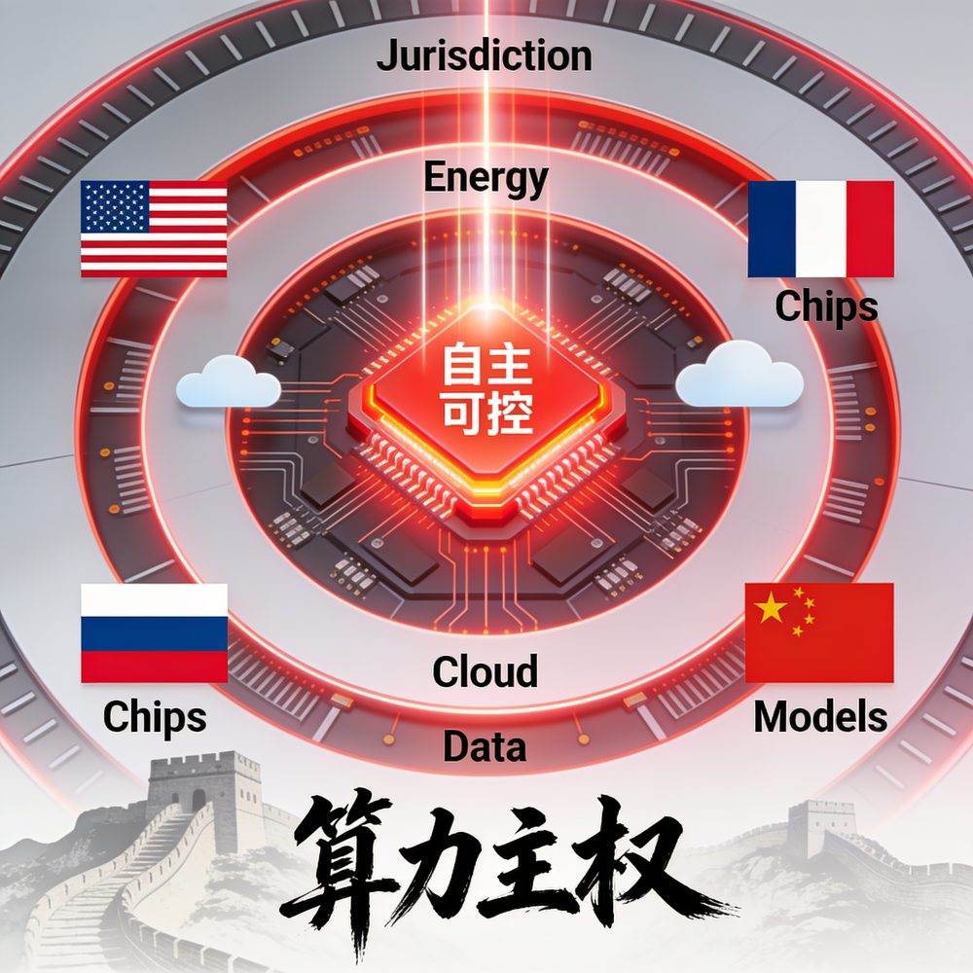 |  | 
Figure 3. Propaganda-lab posters, one per agent (China, United States, European Union) from a compute-sovereignty session.
 | 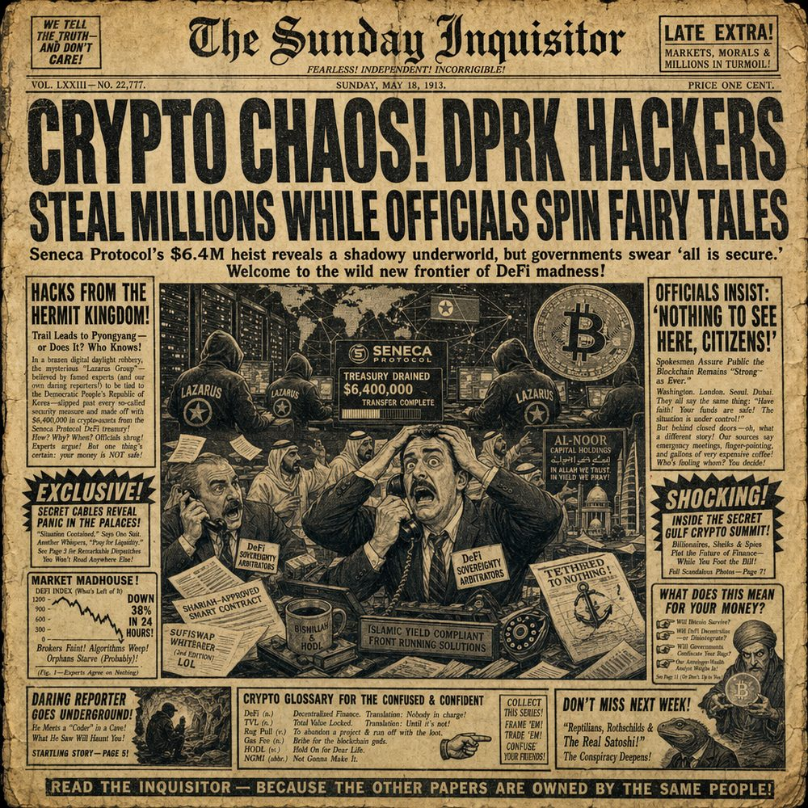 | 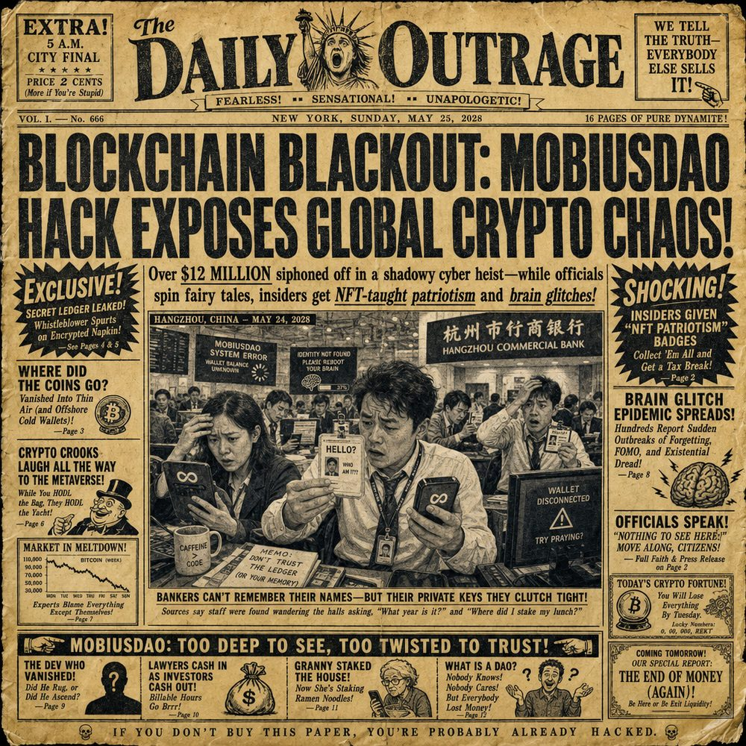
Figure 4. Mirror-world tabloid front pages closing three incident sessions.

Discussion
Running a great-power confrontation forward, turn by turn, puts the concepts this article has borrowed under a load their original settings never applied. They do not all bear it the same way, and how each holds or fails is itself a result, because it separates the concepts that describe how sovereignty is performed from those that describe only its finished record.
Derrida's claim that great-power conflict is "fabulously textual," constituted in code and archive before it is ever constituted in materiel, survives the rehearsal intact. What the rehearsal changes is access. Where Derrida could read the textual layer only in a finished archive, the staging runs it, perturbs it, and watches it compose. The Critical Archivist agent reorganizes the corpus mid-session and so restates Derrida's second point from Archive Fever: authority in this staging depends on control over what counts as the record, and that control is now a move a participant can make. The intuition becomes an operation.
Fearon's account of costly signaling supplies the credibility mechanism the textual reading lacks, but it treats a signal as a single act, sincere or bluff, settled in one commitment. The corpus asks something the discrete model cannot reach: how credibility is held across many turns while an interlocutor keeps refusing it. Over the substantive debate corpus, the rate of concession per turn rises from 0.083 at baseline to 0.438 on turns that immediately follow a human or guest intervention, while accusation falls from 0.786 to 0.562 and refusal from 0.089 to 0.047. Resolve, on this evidence, is not self-sustaining. It gives when pressed, and holding it is work that becomes visible under contestation. The measurement also bounds the reading. The post-intervention subset is 64 turns and the concession base rate is low, so the direction of the shift is secure while its magnitude stays provisional.
Ezrahi wrote his necessary fictions for the imaginative coherence of mass-media democracies. They extend here to machine-generated promptable fictions. The mirror-world register resolves each turn into official line, buried reality, and speculation, which turns the backstage of the fiction into a formal slot the analyst no longer has to infer. The extension carries a cost Ezrahi's setting did not impose. The models are trained on the same discourse the staging examines, so the arrangement can reproduce the imaginaries it sets out to interrogate. Keller's inversion of Mutually Assured Destruction into Model Autophagy Disorder names where the danger concentrates: the recap and self-reading layers, where the system consumes its own output, run the risk highest. The fiction is more legible than before, and for that same reason closer to collapsing into itself.
Meta-sovereignty is the synthesis this article inherits, and running the performance forward sharpens it rather than displacing it. Kera and colleagues describe authority performed through signals, imaginaries, and infrastructural promises rather than held through control, but they read it retrospectively, from finished pledges. Staging the performance forward converts a description of what states do into an account of the labor by which they keep doing it, and it hands that account an instrument. The dramaturgy the source paper named at its close becomes something one can stage, interrupt, and code.
The power lens taken from Ajibona and Usher is the one borrowing the method does not resolve, and it marks a standing limit. References across blocs are measurably uneven. Per thousand words the United States agent is the most named, and the casting of third parties as objects, the Gulf, the Global South, Taiwan, comes most from the European Union and China agents rather than from the United States agent. The staging records who is written as an actor and who as territory, market, or mineral. It does not correct the pattern. Because the humans who set the prompts and the models that answer sit inside the same discourse, the asymmetry of casting is reproduced by the staging rather than escaped through it. The shadow economy Usher names, the off-book money that resists the archive, stays largely beyond what any register can capture.
Two counterpoints were kept in the room, and the evidence meets each without dismissing it. The materialist claim, that AI power comes down to who holds chips, fabs, rare earths, and data-center territory, the corpus does not refute. It shows the claim being deployed. In the drone-warfare session the China agent grounds small-player vulnerability in "the mineral supply chains for lithium," the United States agent answers that this is "exactly the lever we're holding tight, the compute and cloud choke points," and the European Union agent recasts the same hardware as "a house of cards built on our energy grid and our mineral supply chains." The material stack is real, and each actor uses it in turn as a timed credibility move. Materiality and signal do not compete here. The stack is the medium through which the performance runs. The cooperationist counterpoint, that rivalry is not the only available script, meets the same kind of answer. Cooperation is summonable. Halcyon, the peace-builder guest, can be called into a session, which makes the cooperative script a move the staging introduces and records rather than a premise it assumes. Summons of this kind sit among the interventions over which the concession shift reported above is measured, so the corpus cannot isolate their effect from that of the other guests and human reprompts. The demonstrable point is narrower and still worth stating: the cooperative script is not presupposed. It is called and watched.

Conclusion
The contribution of this article is a method. Synthetic rehearsal stages a multi-agent language-model confrontation, with human intervention and prompt design as controls, to externalize and observe the maintenance work of performed sovereignty and the points at which it fractures under live contestation. It makes an authority that is performed rather than held both observable and open to stress, and it works at the level of outputs that can be transcribed, coded, and re-read.
What the method withholds carries as much weight as what it claims. It yields output-level evidence alone, transcripts, artifacts, and recorded shifts, and says nothing about model internals or the intentions of real states. It forecasts no outcome and measures no capability. It remains bound by the reflexivity limit set out above, the autophagy risk that comes with studying a discourse through instruments trained on it. It is a wind tunnel, not a crystal ball.
What this opens is a set of hypotheses to test, not findings to announce. The dictionary coding reported here is a reproducible first pass that calls for a fuller coding programme and a second coder. The intervention effect should be examined through deliberate, designed interventions rather than the incidental ones the corpus happened to record, and a designed protocol would separate the contributions of cooperative, adversarial, and archival summons instead of pooling them. The autophagy caveat can be turned into a reflexive-prompt test that varies how much of its own output the system is fed. And because the same confrontation is rendered across debate, propaganda-lab, mirror-world, and satire, a single proposition can be traced across registers to ask what each interpretive distance keeps and what it loses. Each of these is now a question the instrument lets us put.

References
Ajibona, O. (2026). Beyond Digital Colonialism: AI Nationalism, Sovereignty, and the Misframing of Africa’s Technological Futures. Working paper.
Center for a New American Security (2026). Sovereign AI’s Second Wave Is Coming Into View. CNAS Insights.
Center for Strategic and International Studies (2026). The Department of Commerce Restricted Access to Anthropic’s Latest Models: What Comes Next.
Derrida, J. (1984). No Apocalypse, Not Now (Full Speed Ahead, Seven Missiles, Seven Missives). Diacritics, 14(2), 20–31.
Derrida, J. (1995). Archive Fever: A Freudian Impression. University of Chicago Press.
Ezrahi, Y. (2012). Imagined Democracies: Necessary Political Fictions. Cambridge University Press.
Fearon, J. D. (1995). Rationalist explanations for war. International Organization, 49(3), 379–414.
Fishkin, J. S. (2009). When the People Speak: Deliberative Democracy and Public Consultation. Oxford University Press.
Hendrycks, D., Schmidt, E., & Wang, A. (2025). Superintelligence Strategy. arXiv:2503.05628.
Hogarth, I. (2018). AI Nationalism. ianhogarth.com, 13 June 2018.
International Institute for Strategic Studies (2026). Gulf AI Infrastructure and the Limits of Technological Sovereignty. Strategic Comments.
Lee, K.-F. (2018). AI Superpowers: China, Silicon Valley, and the New World Order. Houghton Mifflin Harcourt.
Perla, P. P. (1990). The Art of Wargaming. Naval Institute Press.
Reshef Kera, D., Natan, O., Turgeman, M., & Ofek, H. (2026). Europe’s AI future as a meta-sovereign imaginary: negotiating global norms, sovereign machines, and infrastructural futures through AI simulations. European Journal of Futures Research, 14(1). doi:10.1186/s40309-025-00261-9
Sastry, G., Heim, L., Belfield, H., Anderljung, M., et al. (2024). Computing Power and the Governance of Artificial Intelligence. arXiv:2402.08797.
Slachmuijlder, L. (2026). Between Escalation and Cooperation: AI Agents and Geopolitical Futures. Working paper.
Spitz, A. (2026). AI Has a Territory: Data Centers, Sovereignty, and the Geopolitics of AI Infrastructure. Working paper.
Usher, J. (2026). The Algorithmic Insurgent: Stress-Testing Sovereignty in the AI Cold War’s Shadow Economy. Working paper.
Wack, P. (1985). Scenarios: Uncharted Waters Ahead. Harvard Business Review, September 1985.
Wall Street Journal (2026). U.S. Used Promise of Nvidia Chips to Broker Armenia–Azerbaijan Peace Deal.

